Chapter- I

INTRODUCTION

The contribution of the livestock & poultry sub-sector to GDP at constant prices was 2.58 percent in FY 2010-11.The estimated contribution to GDP during FY 2011-12 from this sub-sector was 2.50 percent. Though the share of the livestock & and poultry sub- sector in GDP is small, it has immense contribution towards meeting the daily protein (animal protein) requirements.

According to the estimate of the Department of Livestock Services, the population of poultry (projected) rose to 28 crore 85 lakh 66 thousand respectively in 2011-12. Following table shows the growth of poultry population of the country over the past few years.
Table-1: Growth of poultry in Bangladesh
Poultry  (number in lakh) | Financial year(FY)
 | 2005-06 | 2006-07 | 2007-08 | 2008-09 | 2009-10 | 2010-11 | 2011-12
Chicken | 1948.2 | 2068.9 | 2124.7 | 2213.94 | 2280.35 | 2346.8 | 2428.66
Growth rate(%) | - | 5.83 | 2.63 | 4.03 | 2.91 | 2.83 | 3.37
Duck | 381.7 | 390.8 | 398.4 | 412.34 | 426.27 | 441.20 | 457.00
Growth rate (%) | - | 2.33 | 1.91 | 3.38 | 3.38 | 3.27 | 3.46
Total poultry | 2329.9 | 2459.7 | 2523.2 | 2626.28 | 2707.12 | 2788.06 | 2885.66
Total growth rate (%) |  | 5.28 | 2.51 | 3.93 | 2.99 | 2.90 | 3.38
Source: Department of Livestock Services, MoFL

From the above statistic poultry farming in Bangladesh is a growing industry. But one of the major constrain in the development of poultry farm is outbreak of diseases. Among all diseases coccidiosis and necrotic enteritis are very common in our country and most important diseases in poultry industry (Karim et al.,1994). Coccidiosis is considered as a devastating disease which is characterized by bloody diarrhoea and high mortality. The causal agent of coccidiosis damage intestinal tract particularly small intestine and caeca resulting in defective digestion, absorption, dehydration, blood loss and increased susceptibility to other diseases particularly to necrotic enteritis.

In Bangladesh coccidiosis is a serious problem of young chicks and causes a lot of economic loss in poultry industry. It inflicts heavy mortality each year mainly in broiler and also in the grower raised in the deep litter. The causal agents of coccidiosis in chickens belongs to the genus Eimeria.

Coccidiosis mainly occurred under overcrowding condition with moist and warmth temperature which favors sporulation of coccidian oocysts. Thus coccidiosis is especially important under intensive poultry operations. Apart from causing diseases & losses subclinical infection (i.e mild infections without showing symptoms) causes defective feed conversion and emaciation.

Coccidiosis is largely a disease of young birds than older, because immunity rapidly develop after repeated exposure of oocyst and provide protection against later infection. Outbreaks are very common between 3-6 weeks of age and are rarely seen in flocks of less than 3 weeks (jagadeesh Babu et al.,1974).

There is no cross immunity (cross protection)between the species of Eimeria and later outbreak may be result of different species. Coccidiosis may be mild, resulting from ingestion of a few oocysts and may go unnoticed or may be severe due to ingestion of million of oocysts. Sometimes mild infection may turn into serious outbreak causing great financial loss. Therefore all young chickens should provide continuous anticoccidial drugs at low level to prevent infection. Immunity is not important in broiler because these birds kept only for 5-6 weeks of age.
Most of the cases coccidiosis is accompanied by necrotic enteritis. Necrotic enteritis is caused by Clostridium perfringens type A or C. This is an opportunistic organism remain gut lumen with beneficial flora. Eimeria species hamper intestinal integrity and create opportunity for Clostridium perfringens to worse the intestinal damage. Due to necrotic enteritis intestinal lumen filled with viscid mucoid mass and prevent absorption of nutrient from gut lumen. As a result most of the feed ingredients pass through droppings in undigested condition. Although birds take feed regularly but unable to get actual body weight due to wastage of feed result in increase FCR and economic loss of farm owner.

Therefore the present study was undertaken with the following objectives:
- Determine the prevalence of coccidiosis and necrotic enteritis complex among commercial broiler birds.
- To make differential diagnosis between coccidiosis and necrotic enteritis.

Chapter- II

REVIEW OF LITERATURE

The poultry industry occupies an important position in the provision of animal protein (meat and egg) to man and generally plays a vital role in the national economy as a revenue provider. Poultry is one of the most intensively reared of the domesticated species and one of the most developed and profitable animal production enterprises (Obiora, 1992). Its importance in national economies of developing countries, in the improvement of the nutritional status and income of many small scale farmers particularly those with small land holdings as well as landless, whose contribution has been recognized by various scholars and rural development agencies for the last two decades. (FAO, 1987; Creevey, 1991; Kitalyi,1998).

According to Calnek, (1997) chicken production is constrained by many extrinsic factors among which malnutrition, poor management and the absence of biosecurity are outstanding. Losses have also been attributed to limited housing and veterinary care services. Furthermore, poor genetic potential due to lack of selection and predation are also potential threats to productivity. Moreover,it has been reported that parasitic infection or their concurrent infections result inimmune-suppression, especially in response to vaccines against some poultry diseases.Studies in other countries had shown that the prevalence of parasitic infestations invillage chicken flocks is close to 100%, and in most cases individual birds' harbor more than one parasite type (Permin et. al., 2007).

Infection by coccidiosis in chicken
According to the state of Queensland, (1995) coccidiosis is one of the more common and costly diseases in poultry. The death rate can be quite high, both in chicks and in adults. It is characterized by droopiness, paleness of the comb, diarrhea and occasional appearance of blood in droppings. Coccidiosis in chickens is caused by several different species of coccidian (genus Eimeria), which are single celled parasites that live in the gut wall of their host. These coccidia are host-specific: turkeys and other species are not infected by fowl coccidia and vice-versa. The different species of coccidia live in different parts of the gut and can be divided into those causing intestinal coccidiosis (the majority) or caecal coccidiosis (one species). For this to effectively occur, coccidia undergo a life cycle in the host.

General life cycle of coccidia
According to Murray and Hanson, 1998) Stages of coccidia in chickens appear both within the host as well as outside. The developmental stages in the chicken give rise to a microscopic egg (called an oocyst) which is passed out in the droppings. Under proper conditions of temperature and moisture the oocyst develops within one to two days to form a sporulated oocyst which is capable of infecting other chicken. At this stage the ooycst contains eight bodies (called sporozoites), each of which is capable of entering a cell in the chicken's intestine after the oocyst is eaten. When sporozoites enter the cells, they divide many times producing either a few or many offspring (merozoites). The numbers produced depend on the species of coccidia involved. Each merozoite in turn may enter another intestinal cell. This cycle may be repeated several times. Because of this cyclic multiplication, large numbers of intestinal cells are destroyed. Eventually, the cycle stops and sex cells (male and female) are produced. The male fertilizes the female to produce an oocyst which ruptures from the intestinal cell and passes in the droppings. Thousands of oocysts may be passed in the droppings of an infected chicken. Therefore, poultry raised in crowded or unsanitary conditions are at great risk of becoming infected by Eimeria species. Various strains of Eimeria species cause different pathological manifestations as described in the next
paragraphs.

Coccidian parasites
Different Eimeria species occupy different ecological sites of the alimentary canal (Long, 1990).The small intestine is the most popular site for most coccidia in chickens. This is because the organ is very long, providing a large number of enterocytes and allowing enormous multiplication of the parasites usually without causing too much damage (Long, 1990). These strains include; E. tenella, E. necatrix, E. brunetti, E. maxima, E. acervulina, E. mitis, E. hagani, E. praecox.

Eimeria tenella affects young chicks most commonly from the age of 6-12 weeks. The affected chick suffers from acute coccidiosis a disease in which bloody diarrhea is conspicuous and death losses are often high (Brunner and Hagan, 1961). The oocysts are small, broadly ovoid, with a little difference between the two ends. They measure 19.5 to 16.5 to 22 microns with an average of 19 by 22.6 microns (Brunner and Hagan, 1961). Gross lesions of E. tenella are confined to the caeca and consist of the presence of haemorrhages on the outside or inside of the wall of the caeca, free-blood or a chocolate-colored fluid content inside the caeca with a thickening of its wall or the presence of a large core of cellular debris and blood. E. tenella can kill birds so dead birds in a flock with increased mortality should always be examined for the presence of lesions compatible with E. tenella infection or caecal coccidiosis.

Eimeria necatrix species is the most pathogenic for chicken. The damage caused by this species is most likely to occur in birds and immediate death losses are not so frequently found. The disease takes a longer course and there for called chronic coccidiosis. The oocysts are broadly oval. Some are somewhat egg shaped, with one end more pointed than the other, measuring11.3 to 18.3 by 13.2 to 22.7 microns, averaging to14.2 by 16.7 microns (Brunner and Hagan, 1961). E. necatrix develops in the small intestine (early stages) and later in the cecum (sexual stages) like E. tenella, it develops within deeper tissues of the small intestine and is a major pathogen of poultry. However, E. necatrix causes a more chronic disease than E. tenella and does not produce as many oocysts. Therefore, a longer time is usually required for high levels of environmental contamination. Birds heavily infected with E. necatrix may die before any marked change is noticed in weight or before blood is found in the feces. Eimeria brunette has somewhat egg shaped oocysts with a thick lining on the inner surface of the oocysts.They measure 20.7 to 30.3 microns in length and 18.1 to 24.2 microns in width (Brunner and Hagan, 1961).

Eimeria maxima receive its name from the size of its oocysts, which are larger than any other Eimeria species. They have a yellow colour and the shells often have a rough surface (Brunner and Hagan, 1961). E. maxima produce few marked changes in the small intestine until the fifth day after infection. After which, in severe infections, numerous small hemorrhages occur along with a marked production of thick mucus. The intestine loses tine and becomes flaccid and dilated. The inner surface is inflamed and the intestinal content consists of a pinkish mucoid secretion. Lesions of E. maxima comprise multiple petechial (pin-point size) haemorrhages often seen from the outside of the mid-gut area, in addition, segmental ballooning or enlargement of the mid-gut with presence of orange-tainted mucous may be noted. However, unless the lesions are typical they are harder to identify than those caused by E. acervulina and E. tenella and therefore it is highly desirable to confirm its presence by identifying the presence of coccidial oocysts (eggs) in a scraping from the mid gut under a microscope.

Eimeria acervulina has egg shaped oocysts whose diameters are not known (Brunner and Hagan, 1961). E. acervulina is less pathogenic than E. tenella or E. necatrix. E. acervulina is responsible for sub-acute or chronic intestinal coccidiosis in broilers, older birds and chickens at the point of lay. The clinical signs consist of weight loss and a watery, whitish diarrhea. At postmortem, greyish-white, pin-point foci or transversely elongated areas are visible from the outer (or serous) surface of the upper intestine. The foci consist of dense areas of oocysts and gamete (male and female sex cells) production. Gross lesions caused by E. acervulina are usually the most prevalent and are usually confined to the upper small intestine (duodenum), although they may extend to the mid-gut (jejunum). The lesions have a unique appearance, consisting of white patches or transverse white lines inside the gut that may already be observed from the outside. E. accervulina and E. maxima develop in epithelial cells, primarily in the upper part of the small intestine.

Eimeria mitis species is occasionally pathogenic. It develops in the upper part of the small intestines and to a lesser extent in the lower part and sometimes even in the ceaca. The oocysts are nearly spherical in shape and their diameters are not known (Brunner and Hagan, 1961).
Eimeria hagani oocysts are broadly oval with both ends equal in breadth (Brunner and Hagan 1961).
Eimeria praecox species is practically nonpathogenic with oocysts which are oval in shape (Brunner and Hagan, 1961).

Spread of coccidiosis
Coccidiosis is spread when the bird eat feed contaminated with material from an infected bird, that contain the infective stage (small egg-like bodies called oocysts). The oocysts in the droppings need moisture and warmth to mature before they can infect other birds, but in the right conditions, can do so very quickly (24 hr). Oocysts can remain alive in poultry sheds for more than a year and they are very resistant to most disinfectants. Birds of almost any age may be affected, but problems are not common in chicks under three weeks of age because the parasites take time to build up in sufficient numbers to cause problems.

Signs and symptoms
Infected birds exhibit depression, loss of weight condition, paleness, ruffled feathers, drooping wings, pale and dry flanks and occasional slight whitish soiling around the vent, diarrhea and bloody droppings. Often, a large percentage of the chickens are sick die suddenly before the above symptoms become obvious. The general performance of birds may be affected without the disease causing obvious signs.

Post-mortem findings vary depending on the species of Eimeria responsible for the infection.

In caecal coccidiosis, which is caused by Eimeria tenella, the blind gut (caeca) becomes swollen, filled with blood and cheesy plugs. In intestinal coccidiosis, the damage will vary depending on the Eimeria species. Other signs include white streaks or spots in the upper part of the intestine, a ballooned and blood-filled intestine, reddish spots, inflammation and dead tissue in the lower part of the small intestines.

Diagnosis and drug sensitivity testing:
As indicated, next to the fact Eimeria are very effective parasites, one of the main reasons coccidiosisis still a major problem, is the difficult diagnosis. The classical parasitological methods of diagnosis arelabor intensive and therefore costly. Oocyst per gram (OPG) counts in faeces or litter have a poor relationwith the impact of the parasite on the performance of a flock. Identification of different species based onmorphology of oocysts is very challenging and requires expertise. Lesion scoring is an interpretationbased on macroscopic visible lesions caused by Eimeria, usually following a scoring system from zero tofour (Johnson and Reid, 1970). The individual scores for all the species are usually compiled for a certainnumber of birds (e.g. six) per flock resulting in a Total Mean Lesion Score (TMLS). The method isextremely labor intensive, sometimes subjective and only reliable when performed by skilled people. The correlation between lesion scores and performance is believed to be stronger than with OPG but still thereis a difficult appreciation of the level of lesions towards impact on performance, especially at subclinicallevels. A limitation is for instance the fact that E. mitis, although quite pathogenic, does not cause typicallesions and is mostly disregarded when using this method.

Lesion scoring still remains the most frequently applied diagnostic method today. The seven species of Eimeria infecting chickens are considered notequally important. Generally, it is agreed upon that from the species recognized in broiler chickens, themost pathogenic are E. acervulina, E. maxima and E. tenella. The latter is, amongst broiler farmers, the best known. It infects the caeca and because of its deep development in the mucosa and subsequent widespread damage with distinct gross lesions and loss of blood in the faeces, it is easily recognized also by farmers. On the other hand, when performing field necropsies on a larger scale, E. tenella appears to bethe least prevalent of the three species mentioned. Also, the damage is being limited to the caeca, relativeless important parts of the gut with regard to digestion and absorption, thus effects on growth and feedconversion rate. Diagnosis of clinical disease caused by E. tenella is quite easy and action (therapy on theshort term, change of preventive means on the long term) can be swift. These facts make its impact on theproductivity of the broiler industry is relatively limited compared to the other species, although manybroiler farmers associate coccidiosis only with caecal coccidiosis. This is a good example of perceptionnot being in accordance with the facts. E. acervulina and E. maxima, both much more prevalent, are lessperceived to be related with clinical coccidiosis in the field. E. acervulina is causing white lesions induodenum and in heavier infections also more caudal, interfering even with the ability for E. maxima to develop (Mathis, 2005). E. maxima causes petechiae in the midgut. To assess the level of damage causedby these two species, lesion scoring can be performed. An important debate is still ongoing on what levels are to be considered clinical (and requiring treatment) and what levels are subclinical. Some consider lesions higher than 1.5 per species as indicative for clinical disease, and levels below as subclinical, not requiring treatment. E. praecox and E. mitis are not scored for and are completely disregarded using the lesion scoring method, although both species are shown to be able to cause losses through an increased feed conversion rate and in the latter case even morbidity (Gore and Long, 1982; Fitz-Coy and Edgar,1992; Williams, 1998).
Moreover, it has been demonstrated there can be a poor relation between macroscopic and microscopic lesions, emphasizing using macroscopic lesion scoring alone is not suitable to detect all economical relevant coccidiosis infections (Idris et al, 1997). It is frequently disregarded that all macroscopic, but also microscopic lesions, in fact any infection of coccidia, requires an invasion and thus destruction of host cells. This is both true when the parasitical life cycle can complete, but even so when an intervention of the immune system occurs. In the latter case not only host cells are destroyed, but also the activation of the immune system requires use of nutrients that cannot be addressed to the conversion of nutrients into meat, the ultimate goal of broiler production. As a consequence it is important to understand that any level of coccidiosis is causing a real, but difficult to quantify, loss in performance. As coccidiosis is a disease that cannot currently be eradicated, the objective of coccidiosis prevention is finding the economical optimal balance between costs of diagnosis, prevention, treatment and development of host immunity while trying to keep the subclinical loss as low as possible. It is clear that producers achieving a better balance will have a competitive advantage over other producers.

Necropsy sessions are performed in cooperation with the pharmaceutical industry in a number of countries. Basically, such systems consist of a planned, organized and benchmarked assessment of the lesion scores and gut health on poultry complex (group of farms on the same anticoccidial program) basis. A number of times per year and always at the same laboratory, preferably the same, well-trained specialists assess a significant number of poultry houses, thus improving the reproducibility compared to a field lesion scoring session. This methodology is suitable for assessing the overall efficacy of the anticoccidial program, including reduced sensitivity and resistance of drugs in use. In order to make firmer conclusions, session data are compared with historical data. A nice overview of advances in diagnosis of coccidiosis and analysis in genetic variation in Eimeria is given by Morris and Gasser (2006). This review covers both biochemical and molecular methods such as multilocus enzyme electrophoresis, southern blot analysis, pulsed-field gel electrophoresis and several PCR techniques. These techniques are a major addition for scientific research and more practical applications such as establishing vaccine quality control, but unfortunately, the lack of a rapid, low-cost and especially quantitative test is preventing their broad scale use. The main application of these techniques for field diagnosticians today is the possibility of defining presence of species currently disregarded such as E. praecox and E. mitis. Still, the lack of the quantitative aspect of the techniques is preventing an accurate appreciation of different coccidial species certainly with the widespread use of ionophores that also allow some multiplication of sensitive parasites.

A very innovative technique can be found on a website (Gruber et al., 2007) and is called Coccimorph. This is a computational approach for parasite diagnosis, in this case Eimeria spp. from chicken and rabbit. Images from sporulated oocysts from a confirmed species were assessed on different features: curvature characterization, size and symmetry and internal structure characterization. Users can upload their digital images from unidentified oocysts and have the program identify the species concerned. This is very accessible and the low cost is a major advantage. A disadvantage is only sporulated oocysts can be identified, which limits the use of this technique to litter sample identification only. Anticoccidial sensitivity testing (AST) is a well-known technique to try to assess resistance of a certain coccidial isolate to different anticoccidial drugs (McDougald, 1987; Chapman, 1998; Naciri et al., 2003; Peek and Landman, 2003). Although a valid method for a certain isolate, this technique is not routinely used. The main reasons are the long duration and very high cost associated with the complicated, in vivo character of the test. The short period of testing (usually about six days) without allowing the initially naive birds to recover from an artificially high infective dose makes interpretation of the results not easy. One way to decrease the cost is using strains originating from different houses in one AST. In this way, a worst case result for the different strains may give good information on what anticoccidials could be effectively used on a big portion of farms part of a broiler complex. By meta-analysing AST results from strains with a known drug history, a better knowledge can be obtained on how fast resistance is induced how long it remains established in a certain coccidial population and on whether there is cross-resistance amongst drugs.

Prevention and control of coccidiosis
There are basically two means of prevention of coccidiosis: chemoprophylaxis and vaccination.Chemoprophylaxis using so-called anticoccidial products (ACP) or anticoccidials in the ration is by far the most popular: it is estimated that 95% of the broilers produced (Chapman, 2005) receive anticoccidials. Sometimes the term ‘coccidiostats’ are used with regard to ACP but in reality most of the ACP currently on the market are coccidiocidal and not just static.

Generally two groups of anticoccidials are considered, ionophorous antibiotics or ‘ionophores’ and synthetically produced drugs, also denominated as ‘chemicals’. Chemicals were the first type of drugs being used in treatment and later on in prevention of coccidiosis. In 1948, sulphaquinoxaline was the first drug administered in the feed continuously and at lower doses (Chapman, 2003, McDougald, 2003). Other chemicals followed in the years after, allowing the poultry industry to expand and upscale production. Most of the initially marketed chemicals have disappeared from the market. The main reason for this is the rapid selection for resistance in coccidia when these chemicals were used, requiring their judicious use, switching to another drug before resistance has built up. This limits the commercial potential which, in combination with increasingly high costs associated with registration of anticoccidials, explains the short life-cycles of some chemicals. There are a couple of chemicals that are marketed today, such as amprolium, nicarbazin, robenidin, diclazuril, zoalene, decoquinate, halofuginone. The fact that they are still being marketed is a demonstration of their value to the poultry industry and thus an indication of the more limited potential for resistance build-up compared to the ones which disappeared. The resistance status of chemicals can be assessed using ASTs (McDougald et al., 1987; Peek and Landman, 2003; Naciri et al., 2004). If coccidiocidal, chemicals can and are in practice often used in order to reduce the infection pressure of coccidiosis (De Gussem, 2005), in a so-called clean-up program. Clean-up programs and consequent reduced (subclinical) infection pressure is expected to have a positive impact on performance. To achieve this, chemicals are preferably used during a complete grow-out, a so-called full program. Some producers do not, in order to limit risk for resistance, use chemicals in full program, but switch from one chemical to another in the same grow-out, in a so called shuttle program. Switching after a certain grow-out from one anticoccidial to another or to a shuttle program is called rotation (Chapman, 2005). However, most popular ACPs are carboxylic true ionophores. The main reason for their popularity is the relatively limited risk for complete resistance to these products, at least compared to the risk for resistance towards chemicals. Indeed, after introduction of the first ionophore on the market, monensin, in the 1970’s it is remarkable to see that these drugs are still predominant in the prevention of coccidiosis. An explanation for this slow acquisition of resistance to ionophores is the fact that they allow for some leakage of sensitive oocysts. This leads to a less stringent resistance selection than with chemicals. The mode of action of the different ionophores is similar: they facilitate cation transport across the parasitic cell membrane.

This causes ionic gradient and content modifications (Gumila et al., 1996) with parasite cell death as a final consequence. Based on their cation selectivity, transport rate capacitity and structure, three classes of ionophores can be discriminated (Presmann, 1976; Westley, 1982), monovalent, monovalent glycoside and divalent ionophores. The ones registered and marketed worldwide are the monovalent ionophores monensin, salinomycin, narasin, the monovalent glycosides maduramicin and semduramicin and the divalent ionophore lasalocid. One of the main debates still ongoing amongst coccidiologists is the ability for acquiring resistance to one drug by the use of another drug, the so-called cross resistance (Chapman, 2007). Evidence of incomplete cross resistance within a certain ionophore class is illustrated by the fact that, after years of use of the monovalent ionophore monensin, resistance to narasin in United States was encountered before the product was commercially launched (Weppelman et al., 1977). Several papers indicate this cross resistance is less obvious between products of different classes, for instance between maduramicin and monovalent ionophores or between lasalocid and monovalent ionophores (McDougald, 1987; Bedrnik et al., 1989; Marien et al, 2007). The debate is of particular importance when defining rotation programs: stricto sensu rotating between one monovalent drug to another can be considered rotation, but taken into account the above described incomplete cross resistance within a class of ionophores, the relevance of this type of rotation could be questioned. Therefore, relevant or true rotation for anticoccidials could be suggested to be between classes of ionophores or chemicals. Some producers do not use rotation programs, although a majority of producers has accepted this principle as valuable in order to maintain and safeguard the efficacy of anticoccidials. (Chapman, 2005) pointed out that one of the reasons producers can afford limited rotation, thus working with not fully effective drugs, is the importance of immunity towards coccidiosis. This might be true when drugs are used to prevent clinical coccidiosis, but to control subclinical coccidiosis this is probably an inadequate strategy. As solid flock immunity is achieved, in built up litter conditions, only at 6 to 7 weeks of age (Chapman, 1999), subclinical levels will cause economical damage. Logically deducting, a more efficient anticoccidial will cause lower levels of subclinical coccidiosis, thus less economical damage. Subclinical damage is therefore considered by some coccidiologists today to be the most important reason for rotation programs. Live vaccination, as indicated higher, is today less applied in broiler production. Two types of vaccines are discriminated, attenuated and virulent (Chapman et al., 2002). Attenuated vaccines lack a part of the life cycle (less asexual reproductive cycles) of the original strain they were derived from, and as a consequence have a lower reproductive and pathogenic potential. This is a major advantage towards performance of virulent coccidial vaccines, but because of the lower reproductive potential of attenuated vaccines, production costs are significantly higher. Another discrimination to be made are vaccines consisting of anticoccidial-sensitive strains and others made of more or less resistant strains. The main advantage of the live ACP sensitive vaccines is their ability to alter the level of resistance in a certain coccidial population. There are several reports on this very interesting feature of vaccines (Mathis, 2003; Chapman and McFarland, 2004; Mathis and Broussard, 2006; Peek and Landman, 2006), still many questions remain on how many consecutive grow-outs should be applied to overcome or prevent resistance to the different anticoccidials marketed. Also the stability of this resensitized populations are not well known. Still, the approach of live vaccination to optimize the efficacy of anticoccidials is very important and next to simple resting (Chapman and McFarland, 2003) of anticoccidials the only method known to help reducing the portion of resistant parasites in a given coccidial population. For the design of anticoccidial programs, above aspects of resistance and restoration of sensitivity may be used to optimize rotation and shuttle programs. A first consideration is on the definition of shuttle and rotation programs. Strictly spoken, changing from one drug to another is enough to talk about shuttle or rotation, but in view of the cross resistance described, a more narrow definition would suggest rotation and shuttle to be more valid if switching from one class of drug to another. Indeed, no proof exists that a shuttle between two monovalent ionophores will slow down resistance development; therefore no indication exists to perform this type of shuttles. Another consideration is on giving a simple rest to anticoccidials: as proven by Chapman and McFarland (2003), resting monovalent ionophores is advantageous to the efficacy of a coccidial population towards the ionophore previously used, but cross resistance might invalidate this rest. Therefore, in order to substantially control coccidiosis, and also subclinical losses, prudent use of anticoccidials might include consolidation of ionophores from the same class in the same shuttle or to simply use full programs, and after this use of a class, rotating away, ideally to chemicals or vaccines. For practical reasons, also another class of ionophores can be considered for a next phase in a rotation program. Still a lot of research is needed to better validate these seemingly obvious ideas.

Interaction of coccidiosis with microbial intestinal flora
Over the last years, interesting research models have been developed to study impaired gut health in the absence of growth promoters. Indeed, one of the main concerns for poultry integrations is the vast majority of flocks suffering from several degrees of gut disorders (Van Immerseel, 2004). These disorders are poorly defined, variable in etiology, severity and appearance. Nomenclature is very diverse but some popular terms to describe this condition of impaired gut health are dysbacteriosis, bacterial enteritis (BE), small intestinal bacterial overgrowth, clostridiosis and wet litter.
Signs during necropsy associated with the conditions described are
_ thin, fragile, often translucent intestinal walls,
_ ballooning of the gut,
_ hyperaemia of the mesenteric blood vessels and blood vessels on the serosal side of the intestine,
_ flaccid gut edges after incision, lack of tonus
_ watery or foamy contents,
_ poorly digested feed particles at the end of the gastro-intestinal tract (GIT)
_ multi-coloured oily aspect of the gut contents in contact with the mucosa

During a visit in a typical affected poultry house, following are frequently encountered signs:
_ wet litter, initially in patches under drinking or feeding lines where condensation is typical, in more severe cases wet litter is generalized
_ greasy aspect of the wet litter
_ droppings with greasy and poorly digested feed particles are common
_ Initially and typically feed consumption is stalling, while water consumption shows daily
increase following standards for the breed concerned, causing an increased water:feed ratio
(WFR). During a typical episode of bacterial enteritis the WFR is exceeding 2 in normal ambient conditions. In a later phase, also water consumption is stalling.
_ Because of wet litter, birds have dirty feathers
_ Feeding and drinking activity is reduced
Because in affected animals, Clostridium perfringens (Cp) has been isolated in much larger numbers and more proximal in the GIT than in healthy birds, BE is often associated with NE, a condition also associated with Cp. Three predisposing factors are associated with BE: feed factors known to cause BE, (subclinical) coccidiosis and management. Most of the research models combine two of these predisposing factors namely (i) feed known to instigate BE and (ii) subclinical coccidiosis. Models usually combine the instigating feed components with a consequent coccidial challenge sometimes with an additional Cp challenge to exacerbate BE. Some researchers claim models to be as efficient without the additional Cp challenge. Clostridium perfringens is a very common and very abundant bacterial species in the caeca, even in normal conditions and it is assumed that Cp is able to relocate to more proximal locations in the gut whenever the conditions are appropriate: availability of nutrients for Cp. It is however not clear yet whether Cp is the cause or rather a consequence or indicator of BE: a lack of knowledge of the exact pathogenesis of the condition exists, or even, a lack of knowledge of the several possible pathogeneses that can lead, to a similar outcome described as BE. The well-known impairment of digestive function caused by coccidia is therefore probably a main factor in conditioning the guts for Cp to grow. In several models, attenuated Eimeria strains are used, indicating that subclinical coccidiosis is sufficient as a predisposing factor. Still, other factors impairing digestion and absorption of nutrients, such as enzymatic dysfunction, viral infections or mycotoxins are likely to be equally effective as a predisposing factor, although in practical conditions and with current knowledge, subclinical coccidiosis is
believed by many to be the most important one. As a consequence, the last commonly recognized predisposing factor, poor management, is probably not so important in inducing the disease but more important in defining the degree of severity of BE and the subsequent impact on the zoo technical performance of a flock. A very important debate is ongoing in the role that ACP have in prevention of BE. A publication on reduction of Cp counts in the intestinal tract (Elwinger et al., 1998)of birds medicated with narasin, a monovalent ionophore, strongly suggest the positive impact of ionophore compounds on reducing the impact of BE. This reduction of Cp counts is a consequence of the well known antibacterial activity of ionophorous compounds. Minimal inhibitory concentrations (MIC) for the different ionophores are to be found in several publications. However, as it is not proven that Cp is the main etiologic agent of BE or rather an opportunistic bacterium, no conclusions can be made whether ionophores have a direct preventive effect on BE. Maybe they simply reduce the effects of one of the consequences of BE, Cp proliferation. This discussion might seem not so relevant at first sight, but in practice one of the main drivers on the choice of ACP in anticoccidial programs is this presumed effect on BE. A few questions remain unanswered in rightfully assessing the role of ionophores in prevention of BE:
1. All over the world, the vast majority of anticoccidial programs consist of ionophores. As indicated by the large number of antibiotic treatments through drinking water, BE is still considered one of the main problems in poultry production. What would be the number of antibiotic treatments if ACP were used that have anticoccidial activity, equivalent to ionophore efficacy, but not the antibacterial activity? Maybe the number of treatments would be higher in absence of the antibacterial activity exerted by the ionophores, but yet there is neither clear evidence nor numbers.
2. As (subclinical) coccidial infections are known to be a predisposing factor of BE, what would be the number of treatments if an ACP existed that had no antibacterial activity but was able to very effectively suppress coccidial infections? Some of the chemicals would apply to this category of ACP.
3. Even if assuming Cp is a cause and not a consequence of BE, are the differences in Cp MIC for the different ionophores relevant? As all ionophores are used at concentrations in the gut that approach or largely exceed Cp MIC, there is no inference or even an indication that this is a valid hypothesis.
4. Is, when using the same ionophores because of the (maybe perceived) important role in prevention of BE, there a risk of installing a vicious circle through overuse of ionophores, reduced anticoccidial sensitivity (not resistance), higher coccidial challenge thus a more prominent role of coccidiosis as predisposing factor for BE?

Necrotic enteritis:
The disease necrotic enteritis was first described in chickens in England in 1961 and since that time has been reported in the majority of countries around the world. Necrotic enteritis has been identified in broilers , laying hens, turkeys and quail. Necrotic enteritis has been estimated to affect up to 40% of the commercial broiler flocks and is believed to cost the industry about 5¢ per broiler in the united states (McDevitt et al, 2006).

Cause
Necrotic enteritis is caused by toxins produced by Clostridium perfringens as it grows in the intestinal tract of birds. Clostridium perfringens is a bacterium that grows under anaerobic conditions ( in the absence of oxygen) and produces spores that are highly resistant to drying, heat, acid and other harsh conditions. The spores produced by this organism are commonly found in water , soil, feed, manure and other environmental sources. Although small numbers of Clostridium perfringens are also commonly found in the intestinal tract of healthy broilers, they do not cause disease. Under normal conditions the “good bacteria” in the intestinal tract keep the Clostridium perfringens population small in number. However when conditions change in the intestinal tract Clostridium perfringens number increase, toxins are produced and the disease appears. While anything that causes intestinal irritation can lead to necrotic enteritis, stress, intestinal disease (particularly coccidiosis),intestinal parasites (especially round worms), and immune suppression by mold toxins(mycotoxins), chicken anemia virus, Gumboro disease or Marek’s disease have all been specially linked to the disease.

Symptoms
Necrotic enteritis is commonly seen in 2-5 week old broiler chickens raised on litter and in 7 to 12 week old turkeys. At times the only symptom the clinical (severe) disease is the rapid and unexplained death of the bird. When symptoms such as severe depression, decreased appetite, dark colored diarrhea, closed eyes or ruffled feathers appear they are often short-lived because birds die rapidly. Dead birds appear dehydrated and seem to rot very quickly from the inside out. When dead birds are opened it may appear that the bird has coccidiosis, but the intestine are ballooned with gas, fragile and contain a foul-smelling brown fluid. Early in the disease intestines may contain ulcers or lightly yellow spots on the surface. Later in the disease the interior surface of the intestines may contain what seems to be a tan to yellow colored membrane that is often said to resemble a “Turkish towel”. The disease will linger in the flock for 5 to 10 days, causing 2 to 50% mortality(Merck Veterinary Manual, 1998). While symptoms of the clinical (severe) form of necrotic enteritis are fairly easy to recognize, the sub-clinical (mild) form of the disease is not so easily recognized. Birds with mild necrotic enteritis may simply look like they don’t feel good and/or may gain or perform poorly (Kaldhusdal and Lovland, 2002). Yet scientists believe that the mild form of necrotic enteritis has a much greater impact on flock performance and profitability than the severe form.

Prevention ,control and treatment
Antibiotics such as bacitracin, penicillin or lincomycin can be used to treat the necrotic enteritis but it is often impossible to effectively use antibiotics since the disease progresses so rapidly and the toxins involved produce irreversible intestinal damage. Thus it is most often easier to prevent necrotic enteritis rather than treat it. Unfortunately it is not always possible to address every situation that may lead to the onset of the disease. Still in view of the performance and economic issues involved it is important to address all the issues possible, including keeping bird stress to a minimum, maintaining feed storage and delivery systems, vermin control and coccidiosis control. Any factor that causes stress in the bird can alter the intestinal environment, allowing Clostridium perfringens to grow and produce toxin. While stress can come from innumerable sources, the proper set-up and management of poultry house environment is the most obvious method of controlling stress. Since it provides the power and raw materials required for the bird to grow, it is also important to properly handle feed. Feed that has been allowed to become old, damp or wet will encourage mold growth and possibly toxin (mycotoxin) production and should not be used. Almost all mycotoxins reduce disease immunity in the bird and certain mycotoxins are known to irritate the intestinal tract. Even if mycotoxins are not present, moldy feed is unpalatable and contains fewer nutrients that fresh feed. Hence it is important to ensure that feed handling and storage equipment is properly maintained. Rodents and wild birds (vermin) are often found to transmit disease organisms and parasites. Since such microbes and pests can either cause disease or stress in the flock, it is imperative that these vermin be controlled. Intestinal damage from the disease coccidiosis can easily allow an opening for necrotic enteritis to develop. Thus it is extremely important to ensure that coccidiosis does not develop in the flock. While all poultry companies maintain coccidiosis control programs, inadequate management practices can threaten these programs. Perhaps the most important management practice involved in the control of necrotic enteritis is the regular collection and disposal of the dead. If the dead are not frequently collected, the cannibalism will occur, exposing other birds to large number of Clostridium perfringes, spreading the disease.

Chapter- III

MATERIALS AND METHOD

Target population: Commercial broiler and layer birds brought from different regions of Chittagong district for postmortem examination in Thana Veterinary Hospital, Kotwali were considered as reference population.

Source population: commercial broiler and layer birds affected with coccidiosis and necrotic enteritis complex which revealed at postmortem examination in Thana Veterinary Hospital were considered as source population.

Study area and duration: The study was conducted from 5th May 2013 to 3rd July 2013 in Thana Veterinary Hospital, Kotwali, Chittagong. A total number of 168 postmortem cases of different diseases were observed during this tenure. Among them 76 cases were found affected with coccidiosis and necrotic enteritis complex. The other cases were IBD, CRD, Brooder Pneumonia, Mycotoxicoses, Colibacillosis, Visceral gout, ILT and broiler ascites.

Case definition: Coccidiosis is an important protozoal disease which is clinically characterized by bloody diarrhoea, reduce body weight, poor feed conversion, high mortality, and microscopically by presence of oocyst in the feces and tissue scraping of intestinal mucosa. The disease can also diagnosis by postmortem examination based on presence of hemorrhage in caeca or small intestine with clotted blood. Caeca may be greatly enlarged or distended with thickened mucosa covered with white plaques.

Necrotic enteritis is a bacterial disease caused by Clostridium perfringens Type A or C, which is clinically characterized by ruffled feathers (sad looking bird), reluctant to move, eyes closed, dark colored diarrhoea, reduced growth rate, increase FCR and sudden death. The disease can also diagnosis by postmortem examination based on fibro-necrotic enteritis in the jejuna wall, intestine are ballooned with gas, fragile and contain a foul smelling brown fluid. Early in the disease intestine may contain ulcers or lightly yellow spots on the surface. Later in the disease the interior surface of the intestine may contain what seem to be a tan to yellow colored membrane that is often said to resemble a ‘Turkish Towel’.

Methods of study: A total number of 168 postmortem cases were observed at Thana Veterinary Hospital, Kotwali, Ctg. Coccidiosis and necrotic enteritis complex were diagnosed by clinical history, clinical signs and postmortem findings. To detect coccidiosis affected birds I compared the postmortem findings with following lesions: in case of caecal coccidiosis presence of haemorrhages on the outside or inside of the wall of the caeca, free-blood or a chocolate-colored fluid content inside the caeca with a thickening of its wall or the presence of a large core of cellular debris and blood. In case of mid intestinal coccidiosis presence of multiple petechial hemorrhages often seen from the outside of the mid gut area, segmental ballooning or enlargement of the mid gut with presence of orange tainted mucous. In case of duodenal coccidiosis presence of grayish-white, pin-point foci or transversely elongated areas visible from the outer(serous) surface of the intestine. The lesion have a unique appearance consisting of white patches or transverse white lines inside the gut that may observed from the outside.

Caecal and small intestinal scrapings were collected from coccidian suspected birds and examined under microscope. The total number of affected birds were recorded daily based on age, strain and according to farm size.

To detect necrotic enteritis at first I searched the following clinical signs among live birds registered at TVH, such as ruffled feathers, (sad looking birds) reluctant to move, eye closed, dark colored diarrhoea, reduced growth rate, undigested feed particle in feces. After being confirmed about these signs I went on postmortem examination of the suspected birds. I compared the postmortem findings with following lesions to ensure about presence of necrotic enteritis such as intestinal lumen filled with undigested feed particles, impaction of intestinal lumen with viscid mucoid mass, ballooning with gas, fragile, presence of foul smelling brown fluid and lightly yellow spots or ulceration on intestinal surface.

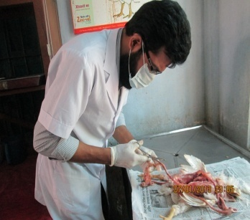
Evidence of postmortem findings:

Fig:1- Iam doing postmortem examination at TVH

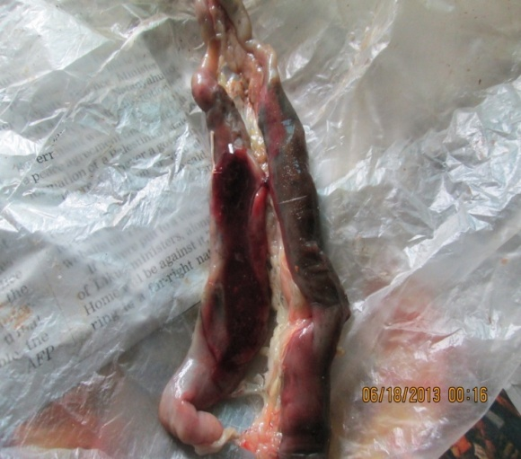

Fig:2-Caecal coccidiosis-presence of clotted blood within ceaca

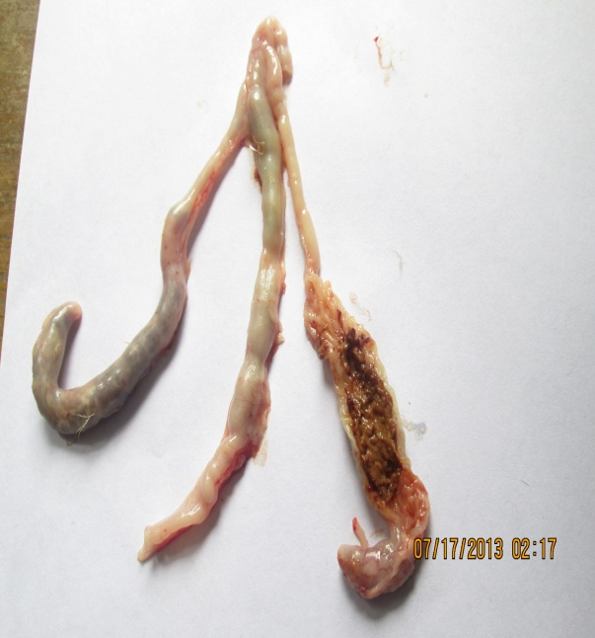

Fig:3-ceacal coccidiosis- thickening of ceacal wall & presence of large core of cellular debris

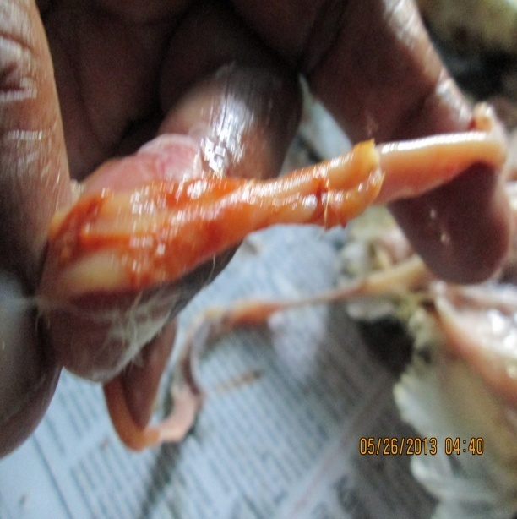  Fig:4- Mid intestinal coccidiosis. | 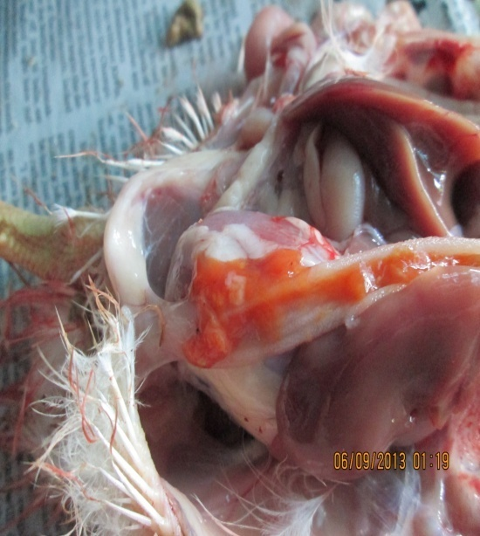  Fig:5- Presence of blood within jejunam.
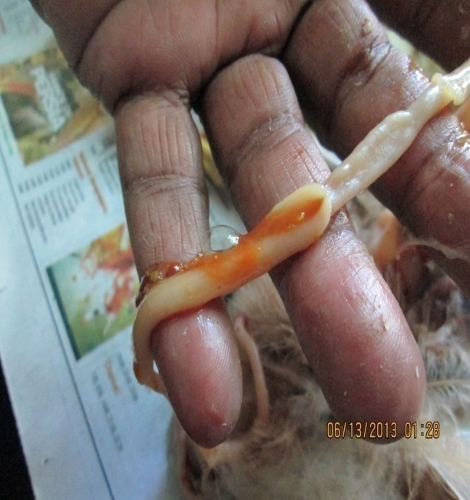  Fig:6-Presence of orange tainted mucus within gut lumen. | 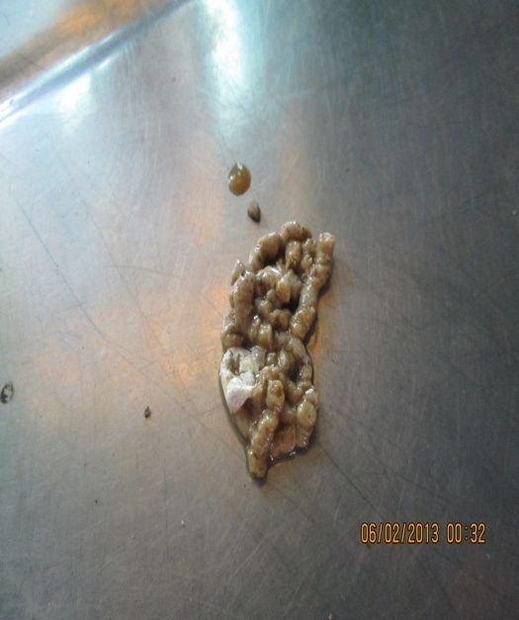  Fig:7-Typical droppings of coccidiosis affected bird.

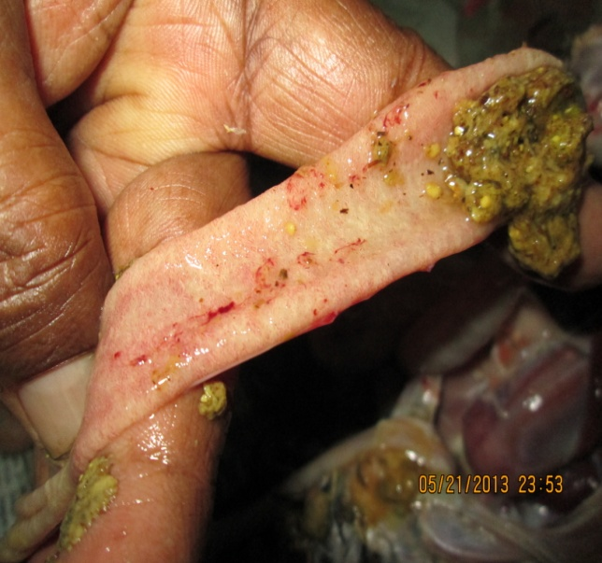Fig:8- Necrotic enteritis- presence of undigested feed particle within gut lumen. | 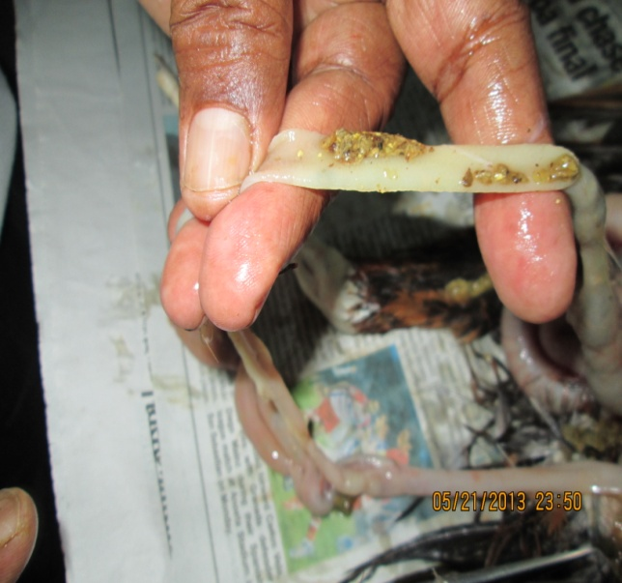Fig: 9-Necrotic enteritis.
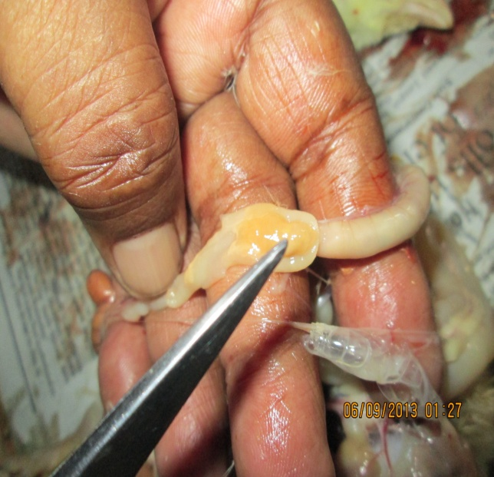Fig:10 Intestinal lumen impact with viscid mucoid mass. | 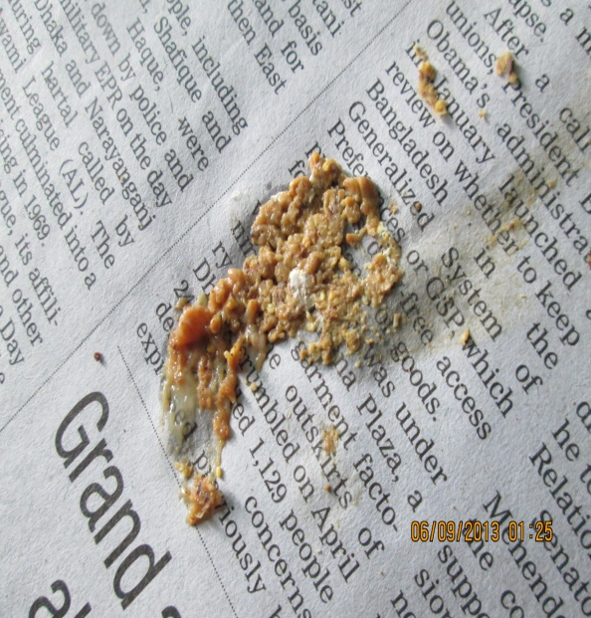  Fig:11 Undigested feed particle in droppings of Necrotic enteritis affected bird.

Table 2-Differentiation between coccidiosis and necrotic enteritis:
Point of differentiation | coccidiosis | Clostridial necrotic enteritis
Clinical signs | Infected birds exhibit depression, loss of weight condition, paleness, ruffled feathers,  drooping wings, pale and dry flanks and occasional slight whitish soiling around the vent,  diarrhea and bloody droppings. Often, a large percentage of the chickens are sick die  suddenly before the above symptoms become obvious. | ruffled feathers, (sad looking birds) reluctant to move, eye closed, dark colored diarrhoea, reduced growth rate, undigested feed particle in feces, increased FCR, excess water in the feces.
Postmortem findings | in case of caecal coccidiosis presence of haemorrhages on the outside or inside of the wall of the caeca, free-blood or a chocolate-colored fluid content inside the caeca with a thickening of its wall or the presence of a large core of cellular debris and blood. In case of mid intestinal coccidiosis presence of multiple petechial hemorrhages often seen from the outside of the mid gut area, segmental ballooning or enlargement of the mid gut with presence of orange tainted mucous. In case of duodenal coccidiosis presence of grayish-white, pin-point foci or transversely elongated areas visible from the outer(serous) surface of the intestine. The lesion have a unique appearance consisting of white patches or transverse white lines inside the gut that may observed from the outside. | intestinal lumen filled with undigested feed particles, impaction of intestinal lumen with viscid mucoid mass, ballooning with gas, fragile, presence of foul smelling brown fluid and lightly yellow spots or ulceration on intestinal surface.
Microscopic examination: During study period oocyst demonstrated by microscopic examination of the mucosal scrapings. A small amount of mucosal scrapings diluted with saline placed on a slide. Then covered with a cover slip and examined under microscope. Many stages of coccidian oocyst were seen in smears taken from suspected lesion.
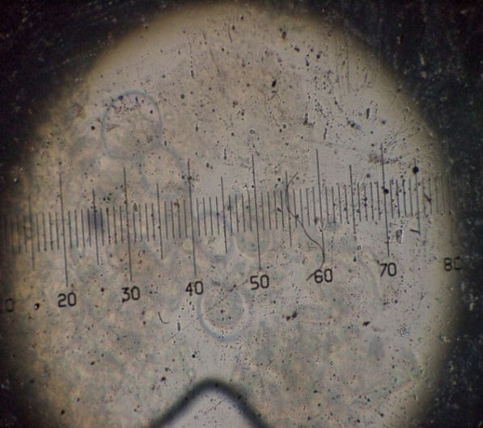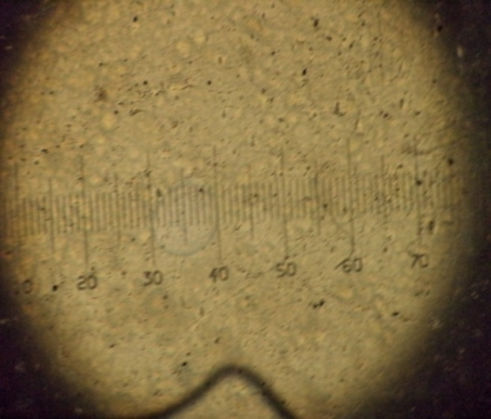
Figure :12- Oocyst of Eimeria tenella under microscope.

Measuring the prevalence: A total number of 168 postmortem cases of commercial broiler birds were observed at Thana Veterinary Hospital. These cases were categorized according to age, strain and size of the flock. Prevalence of coccidiosis and necrotic enteritis were calculated by the following way

$$Prevalence =\frac{total number of birds affected with coccidiosis and necrotic enteritis complex}{total registered birds at TVH.}$$

After calculation of prevalence a two-tailed fisher’s exact test was performed in a 2x2 contingency table to find out any statistical association of the cases of coccidiosis-necrotic enteritis complex with age of the birds, strain and size of the flock.

Chapter- IV

RESULTS

In Thana Veterinary Hospital overall 168 postmortem cases were observed. Among them 76 cases were affected with coccidiosis-necrotic enteritis complex and others were affected with IBD, visceral gout, aspergillosis, CRD, colibacillosis, ILT and broiler ascites. The prevalence of coccidiosis-necrotic complex among broiler birds and it’s association with age, strain and flock size are presented here.

Table 3-Different postmortem findings at a glance:
Postmortem  findings | Coccidiosis+  Necrotic  enteritis | Coccidiosis+  Necrotic  Enteritis+  airsacculitis | Necrotic  enteritis | Coccidiosis+  Necrotic  Enteritis+fowl  typhoid | IBD+coccidiosis | Necrotic  Enteritis+  Mycotoxi  coses
No.of affected birds | 29 | 08 | 04 | 03 | 12 | 04
Postmortem  findings | IBD | IBD+coccidiosis+ necrotic  enteritis | CRD+IBD | IBD+ airsacculitis | Aspergillosis/  Brooder  pneumonia | Asperegill  osis+  coccidiosis
No.of affected birds | 14 | 12 | 06 | 04 | 05 | 03
Postmortem  findings | Aspergillosis  +right ventricular  failure | CCRD+immune  suppresion | Visceral  gout | Visceral gout+coccidiosis | colisepticemia | Colisepticemia+  coccidiosis
No.of affected birds | 06 | 06 | 14 | 04 | 11 | 03
Postmortem  findings | CCRD+ hydro pericardium syndrome | Broiler ascites  +RVF(right  Ventricular  Failure) | CRD+SDS(sudden death  Syndrome) | ILT(infectious  laryngo tracheitis)
No.of affected birds | 03 | 08 | 04 | 01

Table 4-Prevalence of coccidiosis-necrotic enteritis complex among affected birds
Total number of observed postmortem cases | Total number of birds affected  with coccidiosis-necrotic enteritis complex | Total number of birds affected with other diseases | Prevalence of coccidiosis-necrotic enteritis complex
168 | 76 | 92 | 45.24%

Table 5-Prevalence of coccidiosis-necrotic enteritis complex among different age groups
Age groups | Coccidiosis-necrotic enteritis (+) | Coccidiosis-necrotic enteritis(-) | Total | Prevalence  (%) | P value
20 to below 20 days | 58 | 52 | 110 | 52.73% | 0.0090
Above 20 days | 18 | 40 | 58 | 31.03%
Total | 76 | 92 | 168

Prevalence of coccidiosis was higher(52.73%) among 20 to below 20 days age group birds than those of above 20 days age group birds(31.03%). P value was determined by the Fisher’s exact test method using graph pad QuickCalcs software. This P value(0.0090) was less than 0.05 indicate that there was presence of strong association between age and prevalence of coccidiosis-necrotic enteritis complex. At early stages birds remain very much susceptible to coccidiosis-necrotic enteritis complex as they do not get any previous exposure to causal agent. With the increase of age birds get recurrent infection and become resistant. This finding also supported by earlier report of Diriba Oljira, Achenef Melaku and Basaznew Bogale(2012).

Table 6-Prevalence of coccidiosis-necrotic complex among different flock size
Flock size | Coccidiosis-necrotic enteritis (+) | Coccidiosis-necrotic enteritis(-) | Total | Prevalence  (%) | P value
More than 1000 birds | 64 | 66 | 130 | 49.23% | 0.0648
Less than 1000 birds | 12 | 26 | 38 | 31.58%
Total | 76 | 92 | 168

Prevalence of coccidiosis-necrotic enteritis complex was higher (49.23%) within large flock size. P value was determined by the Fisher’s exact test method using graph pad QuickCalcs software. But the P value (0.0648) was greater than 0.05 indicated the relation between flock size and prevalence of coccidiosis-necrotic enteritis complex was not quite statistically significant. This finding was not supported by report of A. Adhikar, R. Gupta and G.R. Pant, 2008.It might be due to small sample size or inability to present equal sample from both flock size. In larger flock size prevalence is much higher due to exposure to huge burden of sporulated oocyst.

Table 7-Prevalence of coccidiosis-necrotic enteritis complex among different strain of commercial broiler birds
Strain | Coccidiosis-necrotic enteritis (+) | Coccidiosis-necrotic enteritis(-) | Total | Prevalence  (%) | P value
Cobb-500 | 40 | 59 | 99 | 40.40% | 0.1569
Hubbard classic | 36 | 33 | 69 | 52.17%
Total | 76 | 92 | 168

Apparently prevalence of coccidiosis-necrotic enteritis complex was higher among Hubbard classic strain than Cobb-500. But the P value (0.1569) was greater than 0.05 indicated that relation between commercial strain and prevalence of coccidiosis-necrotic enteritis was not statistically significant.

Chapter- V

DISCUSSION

Coccidiosis is classified as a intestinal disease affecting the small intestine and caecal affecting the large intestine (caeca). Coccidiosis disease is most likely when young stocks are concentrated under conditions which permit the accumulation and sporulation of large number of oocysts. At least nine species of Eimeria are known to occure in poultry (Jordan and Pattison,1996). In my study most of the cases were infected with Eimeria tenella, Eimeria maxima and Eimeria brunetti. Specially cases affected with Eimeria maxima and Eimeria brunetti were much higher then those of affected with Eimeria tenella. As mid intestinal coccidiosis caused by Eimeria maxima and Eimeria brunetti and caecal coccidiosis caused by Eimeria tenella most of the cases of my study area were mid intestinal coccidiosis. Only three cases of caecal coccidiosis were identified among 76 positive cases. In addition most of the cases were affected with necrotic enteritis . In every positive case it was common that intestine filled with bloody mucus and undigested feed particles.

Overall prevalence of coccidiosis-necrotic complex was 45.24% among broiler birds regisrered at Thana Veterinary Hospital. It was revealed that younger birds were much more susceptible to coccidiosis than adult one. The prevalence of coccidiosis-necrotic enteritis complex among birds less than 20 days of age was 52.73% whereas among birds of more than 20 days of age it was 31.03%. Diriba, et al.(2012) also said that younger birds are more susceptible then adult one. It is usual as because younger bird do not get recurrent exposure with coccidian oocyst like adult birds. Flock wise prevalence of coccidiosis was higher(49.23%) among birds brought from large flock(more than 1000 birds) size. This finding is supported by A. Adhikar, et al. 2008. To measure statistically significant association between variables and outcome Fisher’s exact test method was used with the help of GraphPad QuickCalcs software. Association with different strain was not statistically significant. It might be due to small sample size, inability to represent equal number of cases in each variable due to lack of sufficient cases.
However the most prominent finding of my study was frequent association of necrotic enteritis with coccidiosis. So it is essential to prescribe both type of treatment to clinically confirmed cases.

Chapter- VI

CONCLUSION

From current study it may be concluded that apparent prevalence of coccidiosis among broiler birds in the study area was 45.24%. In most of the cases necrotic enteritis was found with coccidiosis affected birds. This is usual because there is an association in pathogenicity between coccidiosis & necrotic enteritis. However most of the doctor provide prescription only for coccidiosis and necrotic enteritis. As a result though the birds recovered from coccidiosis but suffer from necrotic enteritis and the farmer do not get optimum result. Because birds continuously loss weight due to inability to absorb nutrient from gut due to impaction with viscid mucoid mass, subsequently FCR is increased. So birds affected with coccidiosis should be treated in addition with treatment of necrotic enteritis to get optimum result. It was also proved that coccidiosis was most prominent among younger birds due to lack of recurrent exposure to infection.

Chapter- VII

REFERENCES
Adhikari, B., Gupta, R. and Pant, G. R. 2008. Prevalence and identification of coccidian parasite (Eimeria species) in layer chicken of Ratnanagar municipality, Chitwan District, Nepal. Journal Naturue Historie Musuem. 23, 45–50.

Anjum, A. D., 1990. Prevalence of the poultry diseases in and around Faisalabad and their their relationship to weather. Journal Pakistan Veterinary. 10: 42–45.

Aryal, M. P. 2001. Epidemiological study on Eimeria species in natural outbreak of chicken coccidiosis at IAAS Rampur and its vicinity. Advances in Agriculture Research in Nepal at Society of Agriculture Scientists (AAS), Nepal: 168–175.

Ashenafi, H., Tadesse, S., Medhin, G. and Tibbo, M. 2004. Study on coccidiosis of scavenging indigenous chickens in Central Ethiopia. Tropical Animal Health and Production, 36: 693–701.

Baumann, M. P. O., Staubach, C. P. J., Nyakahuma, D., Patzelt, R. J. 1994. Coccidia species status and associations with hygiene risk factors in commercial poultry units in Kampala and Entebbe areas, Uganda. The Kenya Veterinarian, 18: 101–103.

Bhanushi, J. K. and Long, P. L. 1985. Eimeria tenella infection: Does it affect humoral immune responses to heterologous antigens?. Journal of Parasitology, 71: 850–852.

Biggs, P. M. 1982. The world of poultry diseases. Journal of Avian Pathology. 11: 281–300.

Braunius, W. W. 1980. Monitoring the biological performance in broilers with special regard to subclinical coccidiosis. Archiv fur Geflugelkunde, 44: 183–187.

Bumstead, N. and Millard, B. 1987. Genetics of resistance to coccidiosis: Response of in bred chicken lines to infection by Eimeria tenella and Eimeria maxima. British Poultry Science, 28: 705–715.

Calnek, B.W., H.J. Barnes, C.W. Beard, L.R. McDougald, and Y.M. Saif, eds. 1997. Diseases of poultry, 10th edition. Iowa State University.

Castanon, C.A.B., Fernandez, S.,Fraga, J.S., Fontoura, L.F. and Gruber,A.(2007). Coccimorph: a real-time diagnostic tool based on automatic image recognition of protozoan parasites of the genus Eimeria. Proceedings of the World Association for the Advancement of Veterinary Parasitology, 19-23 August 2007,Gent-Belgium.

Chapman, H.D. (2007). Rotation programmes for coccidiosis control. International Poultry Production, 15: 7-9.

Chapman, H.D. and Mcfarland J.L.(2003). Rotation programmes with Diclazuril and coccidiosis vaccine. Proc. 52nd WPDC, Sacramento, March 8-11,2003.

Chapman, H.D.(2003). Origins of coccidiosis research in the fowl-the first fifth rears. Avian Diseases; 47; 1-20.

Chapman, H.D.(2005). Perspectives for the control of coccidiosis in poultry by chemotherapy and vaccination. Proccedings of IXth International Coccidiosis Conferences, Foz du Iguassu, September 19-23,2005.

Chapman, H.D., Cherry, T., Danforth, H., Richards, G., Shirley, M., Willims, R.(2002). Sustainable coccidiosis control in poultry production: the role of live vaccines, international Journal of Prasitology 32; 617-629.

Elwinger, K., Berndtson, E., Engstrom, B., Fossum,O., Waldenstedt, L.C.(1998). Effect of antibiotic growth promoters and anticoccidials on growth of Clostridium perfringens in the caeca and on performance of broiler chickens. Acta Veterinaria Scandinavia,39,433-441.

Farooq, M., Durranil, F. R., Waheedullah, W., Sajjad, A. and Asghar, A. 1999. Prevalence of coccidiosis in broilers in the subtropical environment http/www.priory. com/vet/ broolers. Htm

Franco, R. M. B. 1993. Survey of avain coccidioosis from two layers poultry farms in Campinas, Brazil. Arquivo Brasileiro de Medicina Veterinaria zootechia, 45: 557–571.

Gross, W. B. 1985. Effect of social environment and oocyst dose on resistance and immunity to Eimeria tenella challenge. Journal of Avian Diseases, 29: 1018–1029.

Idris A.B., Bounous D.I., Goodwin M.A., Brown J., Krushinskie E.A., (1997). Lack of correlation between microscopic lesion scores and gross lesion scores in commercially grown broilers examined for small intestinal Eimeria spp. Coccidiosis. Avian Diseases 41(2): 388-91.

Johnson, J. and Reid, W.M.(1970). Anticoccidal drugs: lesion scoring techniques in battery and floor pen experiments with chickens. Experimental Parasitology 28: 30-36

Jordan, F. T. W. 1995. Poultry diseases. Third edition, The Cambridge University. Press. Pp. 226–236.

Mathis, G.F.(2003). Vaccine can decrease anticoccidial resistance. World Poultry, special supplement coccidiosis , 4, 22/23.

Maximillian, P. O. B. 2004. Assessment of economic impact caused by poultry coccidiosis in small and large poultry farms in Debre Zeit, Ethiopia. International Journal of Poultry Science, 3: 715–718.

Mcdougald , L.R.(2003). Coccidiosis. Disease of poultry(11th edn.) Iowa State University Press, Ames, FA, USA.

McDougald, L. F. and Mattiello, R. A. 1997. Survey of coccidia on 43 poultry farms in Argentina. Journal of Avian Diseases, 41: 923–929.

Morris,G.M. and Gasser, R.B. (2006). Biotechnological advances in the diagnosis of avian coccidiosis and the analysis of genetic variation in Eimeria. Biotechnology Advances 24: 590-603

Naciri, M., Chausse, A.M., Fort, G., Bernardet,N., Nerat, F., and Degussem,K. (2004). Value of anticoccidial sensitivity tests (ASTs) in the prevention of chicken coccidiosis. XXII World’s Poultry Congress, Istanbul June, 8-13, 2004.

Permin, A. and Hansen, J. W. 1998. Epidemiology, Diagnosis and Disease Control of Poultry Parasites. Rome, Italy: FAO.

Rose, M. E. 1987. Immunity to Eimeria infections. Journal of Veterinary Immunology and Immunopathology. 17: 333–343.

Shirley, M. W. 1995. Eimeria species and strains of chickens. Guidelines on Techniques in Coccidiosis Research. European Commission, Directorate General XII, Science Research and Development, Agriculture Biotechnology, L-2820 Luxemburg, Pp. 1– 34.

Van Immerseel, F., Debuck, J., Pasmans, F., Huyghebaert, G., Haesebrouck F., Ducatelle, R. (2004). Clostridium perfringens in poultry: an emerging threat for animal and public health. Avian Pathology: 33(6): 537-549

Weppelman, R.M.,Olson, G.Smith, D.A., Tamas,T., Van Inderstine, A.(1977). Comparison of anticoccidial efficacy, resistance and tolerance of narasin, monensin and lasalocid in chicken battery trials. Poultry Science 56(5): 1550-1559

Williams, R.B.(1999). A compartmentalized model for the estimation of the cost of coccidiosis to the world’s chicken production industry. International Journal for Parasitiology, 29(8) : 1209-1229

Williams,R.B.(1998). Epidemiological aspects of the use of live anticoccidial vaccines for chickens. International Journal for Parasitology, 28(7): 1089-98

