Obstetrical Emergency: Causes, Diagnosis, and Treatment in Domestic cat: 2 case study
A case report submitted in partial of the requirement for the fulfillment of the Degree of
Doctor of Veterinary Medicine (DVM)
A clinical report submitted by
Meshing Marma
Roll No. : 17/65
Reg. No. : 01904
Intern ID:87
Session: 2016-2017

Faculty of Veterinary medicine
Chattogram Veterinary and Animal Sciences University
Chattogram-4225
Obstetrical Emergency: Causes, Diagnosis, and Treatment in Domestic cat: 2 case study
A clinical report submitted as per approved styles and contents
Approved by
Supervisor
Dr. Mir Md. Afzal Hossain
Senior Veterinary Surgeon
Teaching and Training Pet Hospital and Research Centers
Faculty of Veterinary medicine
Chattogram Veterinary and Animal Sciences University
Chattogram-4225

Table of contents
Acknowledgements……………………………………………………………………..5
Abstract…………………………………………………………………………………6
Chapter 1: Introduction…………………………………………………………………6
Chapter 2: Methods and Materials ……………………………………………………..8
2.1: Case 1 …………………………………………………………………………..…9
2.1.1: Case Discussion……………………………………………………………..……9
2.1.1.A: History………………………………………………………………………….9
2.1.1.B: Clinical examination……………………………………………………………9
2.1.1.C: Anesthesia…………………………………………………………………...…10
2.1.1.D: Surgical technique……………………………………………..………………10
2.1.1.E: Postoperative care……………………………………………...………………11
2.2: Case 2…………………………………………..……………………..……………11
2.2.1: Case description………………………………….………………………………12
2.2.1.A: History………………………………………………….……………………..12
2.2.1.B: Clinical examination………………………………….……………………….12
2.2.1.C: Physical examination……………………………...…………………………..13
2.2.1.D: Anesthesia………….………………………………………………………….13
2.2.1.E: Surgical procedure……………….……………………………………………13
2.2.1.F: Postoperative care……………………………………………………………..14
Chapter 3: Result and Discussion………………………...…………………………… 14
Chapter 4: Conclusion……………………………….…………………………………15
Reference……………………………………..….…………………………………15-16

Figures
Figure 1: Distressed queen……………………………………………………………. 9
Figure 2: Radiographic Examination…………………………………………………..9
Figure 3: Exposed Uterus…………………………………………………………….10
Figure 4: Deformed fetus……………………………………………………………..10
Figure 5: Live Fetus………………………………………………………………….10
Figure 6: Injured pregnant queen…………………………………………………….11
Figure 7: Radiographic examination ………………………………………………....11
Figure 8: uterus………………………………………………………………………12
Figure 9: Necrosed and undeveloped fetus…………………………………………...12
Figure 10: Interdermal suture…………………………………………………………13

Acknowledgements
It gives me great pleasure to thank everyone who helped make this internship a successful by offering their support and contributions. My profound gratitude is out to professor Dr. Md. Lutfur Rahman, dean faculty of veterinary medicine at Chattogram Veterinary and Animal Sciences University for his unwavering support, motivation, encouragement.
Secondly I would like to convey my gratitude to our director of external affairs, professor Dr. A.K.M. Saifuddin, Chattogram veterinary and animal sciences university for organizing our internship.
I like to thank my supervisor Dr. Mir Md. Afzal Hossain, senior veterinary surgeon at TTPHRC for his insightful advice. In order to achieve the goals of this study I am grateful to the owner of the study area for cooperation in participating and responding to questions.

Abstract
Comparing to other pet and farm animals the rate of dystocia is relatively lower in cat. But when cats experience dystocia, medical, surgical, or manual intervention is necessary. A stray and Persian cat, had dystocia as a result of an accident and uterine inertia. Here, we report the C-section that was performed on her.At the Teaching, Training, and Pet Hospital and Research Center (TTPHRC), two cat cases of dystocia were presented. The first case involved a single kitten that the queen had given birth to 24 hours prior, but the newborn died soon after. She was unable to give birth to the other fetuses. In the alternative scenario, a stray cat fell from a high floor and was unresponsive, not exhibiting any signs of parturition.In both situations, the cats appeared weak, had stopped eating, and were not trying to move. It was discovered that both cats had fetuses after an ultrasonographic (USG) examination. Fetal movements were scant or absent. The cats were diagnosed with dystocia because of uterine inertia.The two cats underwent C-sections. In the first case, two live fetuses and a malformed fetus without a head were discovered. In the second instance, the fetuses were all dead when surgery was performed due to their premature birth. While there were no uterine complications in the first case, the second case had a more complex predicament. The fetuses had necrosed, and the uterus had produced gas. In order to stop maternal toxemia and septicemia from developing,an ovariohysterectomy was performed. Both queens made a full recovery.

Key words: High rise syndrome, dystocia, USG, ovariohysterectomy.

Chapter 1: Introduction

In Bangladesh, nowadays as a pet, cats are most popular. Due to their inherent cleanliness, easy management and more acceptance than dogs for religious reasons, cats are more favorable than other pets. The number of cats varies from 1 to 20 based on the owners' financial, geographic, and living arrangements. 25% of patients at TTPHRC with reproductive issues per month ended in C-sections, ovariohysterectomy because of dystocia, or pyometra.
Pyometra, which affects intact queens, is an acute or persistent suppurative inflammation of the uterine wall. Endometrial hyperplasia, endometrial gland cystic dilation, and an accumulation of purulent discharge in the uterine lumen are its defining features (Hollinshead F et al 2016).
The inability to deliver a fetus naturally and without help is referred to as dystocia (Purohit., et al 2004).
Fetal abortion, stillbirth, and pregnancy loss are all possible outcomes in cats due to fetal mummification, embryonic or fetal resorption etc (Lefebvre et al., 2015).
Other factors of dystocia are neurological problem by born or accident, size of fetus, and uterine torsion. Fetal autolytic alterations, which result in fetal fluid absorption and fetal mummification, are frequently caused by the death of a fetus during the middle or last third of gestation that does not luteolyze and abort from the body of the queen (Antoine D et al., 2002).
According to the foetal development, the termination of pregnancy is defined by two distinct phrases. The first is embryonic death, which occurs most frequently in early pregnancy caused by different types of bacteria like Ecoli. The second type of death happens during the foetal ossification process (Maksimović A et al., 2020). The majority of cases involving dystocia and pyometra were treated with c-sections and ovariohysterectomy.

Ovariohysterectomy, a sterilization procedure for cats that involves removing both the ovaries and the uterus (DeTora M et al., 2011).
Ovariohysterectomy is a surgical form of contraception that also serves as a means of preventing disorders of the reproductive system (Boursie J. F et al., 2018).

Radiography is the most often utilized diagnostic method in small animal practice. This is not only for the assessment of dystocia but also for the detection of skeleton in a healthy pregnancy. Maternal or fetal factors, including as fetal malposition, monstrous, or anatomical anomalies of the maternal pelvic canal, can result in dystocia (Limmanont C et al., 2019).
Ultrasonography is yet another helpful resource for obstetric cases. By observing the appearance of the embryonic sac, a cat's early pregnancy can be identified between the ages of 15 and 29 days (Limmanont C et al., 2019). Triggered ovulation, a distinctive reproductive attribute specific to cats, is triggered by a high number of coituses or mating, both of which are essential for the LH peak. Ten days after mating, ultrasonography is used to most accurately diagnose pregnancy in felines. By day 14, the embryo may be seen, and by day 17, a distinctive C-form emerges(Beccaglia M et al., 2016).
Here we report on surgical management of persian and domestic cats due to uterine inertia, high rise syndrome accidents in Dhaka.

Chapter 2: Method and Materials

The most frequently reported problem in veterinary medicine is with their reproductive organs. Every day, cases involving gynecological problems are admitted to the veterinary hospital. The study in question was carried out at the Teaching and Training Pet Hospital and Research Center (TTPHRC), where a total of 116 pregnancies-related exams were performed from January to May in a row, on a schedule of 17, 21, 32, 21, and 25. 28 of those cases included challenging pregnancies that ended in termination or required an urgent C-section and ovariohysterectomy. The month of May in TTPHRC is the subject of the study. Out of 25 pregnancies at the time, 7 developed complications due to High Rise Syndrome, dystocia, or other unintentional causes.
Cats are a commonly accepted pet in the city of Dhaka, hence the prevalence of gynecological cases in cats is significant. The life of the fetus in a disturbed mother is discovered via ultrasound technology. In this case, radiography is used to count the number of fetuses. Ovariohysterectomy was performed only when pyometra or the potential for pyometra from a necrosed fetal membrane was present.

2.1: Case 1
2.1.1: Case discussion
2.1.1. A: History: A one-year-old Persian cat was brought to the TTPHRC with a miscarriage complain. It was unable to birth the remaining fetus and delivered one dead fetus at home just one day prior. The pregnant queen, who weighed 4.5 kg, was in agony.
2.1.1. B: Clinical Examination: During Ultrasonography, multiple fetuses were discovered. Each fetus was missing the fetal heart. Radiography was performed to check the no. and position of fetus, one head of a fetus was missed in radiography. After dystocia was determined to exist, surgery was authorized to treat the condition.

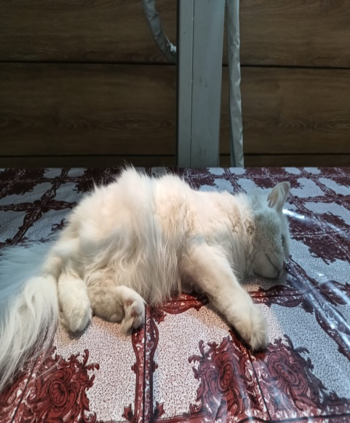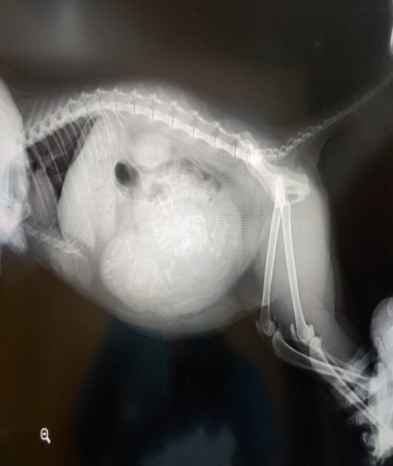
Fig 1: Preoperative condition of queen Fig 2: Radiographic examination

2.1.1. C: Anesthesia: Pre-anesthetic xylazine (Inj. Xylazine 20mg/ml) was injected into the queen at a dose of 1 mg/kg body weight, The level of anesthesia was established by confirming the pupil dialation. IV saline was connected. Ketamine (Inj. Ketamine HCL 50mg/ml) at 10 mg/kg body weight iv was administered for the induction of anaesthesia.
2.1.1. D: Surgical technique:
Preparation of patient was performed by shaving, cleaning, and three rounds of unidirectional povidon iodine, savlon, povidon iodine, and savlon disinfection were performed on the lower abdomen. The surgical region was covered with a sterile drapper and clamped with a towel. An incision is performed on the skin 2 inches below the umbilicus, followed by subcutaneous tissue, linea alba, and peritoneum. Identification of the uterus and retrieval of the uterus and fetus. Forceps were used to compress the ovary on both sides while avoiding the major blood arteries in the uterine membrame artery. The uterus was cut longitudinally, and fetuses were discovered. Two viable fetuses were discovered, and a third had an absent head and a malformed body. After the fetuses were removed and examined, the uterine horns and body were tied to ensure proper bleeding control, and the ovariohysterectomy procedure was then started. The suture of choice is absorbable polygalactine 2-0. To stop bleeding, crushing was done before to release. Simple continuous sutures were used to seal the peritoneum, muscles, and subcutaneous tissue.
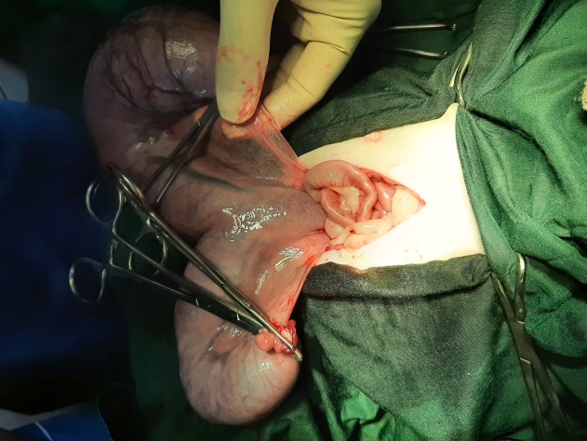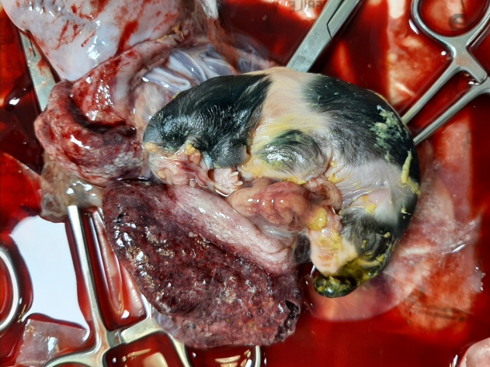
Fig 3: Exposed Uterus Fig 4: Deformed fetus

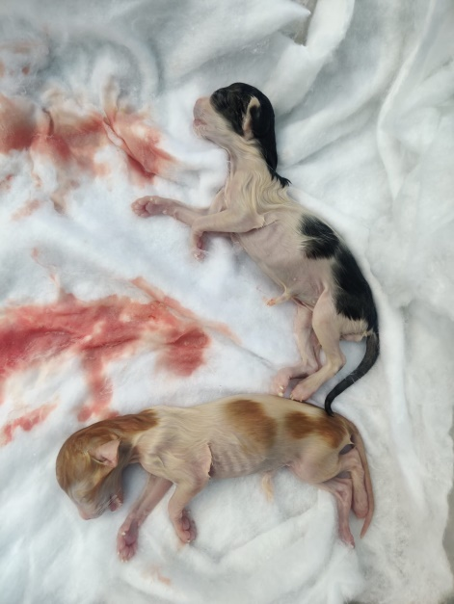
Fig 5: Live fetus.

2.1.1. E: Postoperative care
The queen received intramuscular injections of antibiotic ceftriaxone 50mg/kg (Inj. Trizon IM 500mg) for seven days, meloxicam 0.2mg/kg (Inj. Melvet) pain reliever subcutaneous injection, 0.2 ml, SID, for 3 days and antihistamine diphenhydramine hydrochloride 1mg/kg (Inj. Phenadryl). Adviced to maintain E. collar to stop licking the wound.

2.2: Case 2
2.2.1: Case discussion
2.2.1.A: History: A pregnant stray cat with a history of falling and leg problems was discovered and brought to TTPHRC. The rescuer didn't know how long the mishap had been going on.
2.2.1.B: Clinical Examination: The patient exhibited reflexive pain throughout its body, particularly in its limbs. Ultrasonography examination revealed several fetal sacs, but no fetal heart beat. To count the number of fetuses within the queen, radiography was used. A left hind limb injury was discovered, and the temperature was below normal at 96.9 degrees Fahrenheit. In order to raise body temperature, dexamethasone sodium phosphate 0.5mg/kg (Inj. Roxadex 5mg/ml) and Dextrose solution (Inj. DNS) were administered right away. Amino acid (Inj. Amino vit plus) was recommended for weakness. Due to the complexity of the situation, surgery was postponed for 24 hours to allow time for health monitoring.

.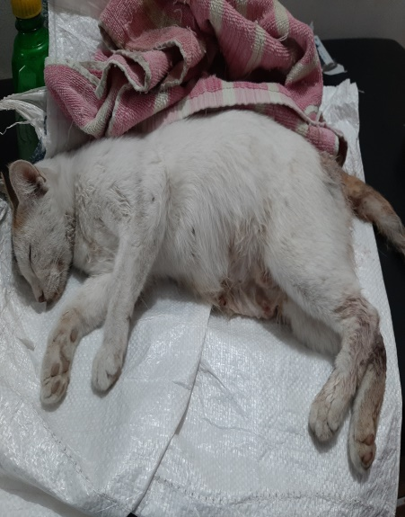 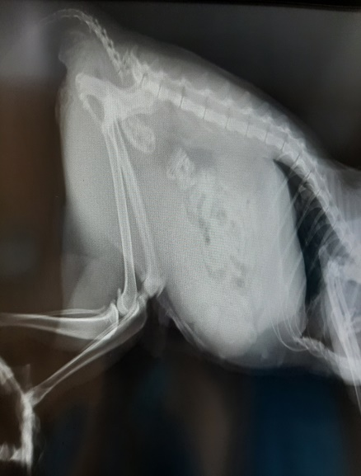
Fig 6: Preoperative condition of case 2 Fig 7: Radiographic Examination

2.2.1.C: Physical examination:
After a day of monitoring, the queen was bought and the temperature was determined to be a normal 100 degrees.

2.2.1.D: Anesthesia:
In order to prepare the patient for surgery, xylazine (Inj. Xylazine 20mg/ml) was injected at a rate of 1mg/kg body weight, and the maintenance dose of ketamine (Inj. Ketamine HCL 50mg/ml) was administered at a rate of 10 mg/kg body weight.
2.2.1.E: Surgical procedure:
Hair was first shaved off before cleansing with Savlon and Povidon Iodine began the surgical procedure. A 2-inch incision was created below the umbilicus. Linea alba, subcutaneous layer, and peritoneum are all gradually reached. It was discoveredand removed from the pelvic cavity. Major blood vessels were avoided when using artery forceps to clamp the uterine membrane with ovary. The uterine horn was incised longitudinally. The underdeveloped, necrosed fetuses were discovered on their way to mummification. The fetuses were taken out of both horns. To finish the ovariohysterectomy, uterine horn and body were both ligated. The repair of bleeding was examined and tracked. Simple continuous sutures were used to seal the peritoneum, muscles, and subcutaneous tissue, and inter dermal suture given to close the skin.

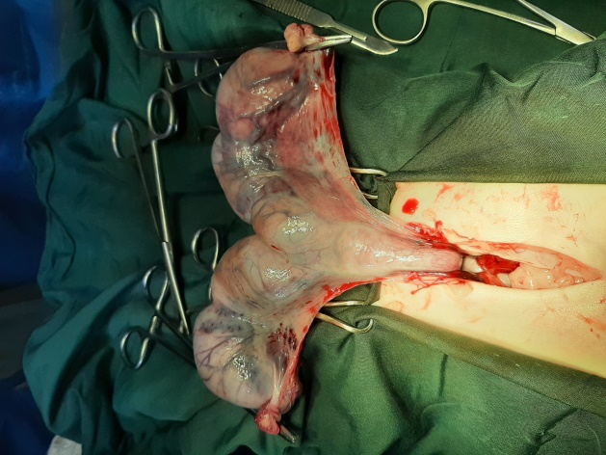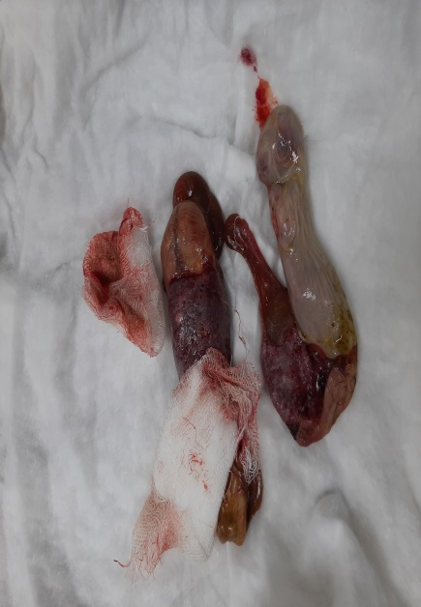
Fig 8: Exposed Uterus Fig 9: Necrosed and undeveloped fetus

2.2.1.F: Postoperative care:
By administering DNS 5% after surgery, the general anesthetic induction was gradually reduced. For seven days, antibiotic ceftriaxone 50mg/kg (Inj. Topcef 500mg) was to be administered intramuscularly. Dexamethasone Sodium Phosphate (Inj. Roxadex 5mg/ml) was administered intravenously for 3 days at a dose of 0.2 ml. 0.2 ml of intramuscular injection of antihistamine, diphenhydramine HCL (Inj. Phenadryl 20mg/ml)for 7 days. Vitamin C (Inj. Mega C) at 0.9 ml intramuscular for 7 days was advised for rapid recovery. and a calcium supplement in tablet form, taken at 1/3 strength for 21 days. To stop wound licking, it was advised to put on an E.collar.

Chapter 3: Results and Discussion

The fetuses in the cases above were removed via C-section, and an ovariohysterectomy was then performed. The cats were able to resume normal feeding and feces after 7 days. Following a number of the queen's requirements and conditions, the C-section was performed. This comprises a correct history taker and a cat's clinical checkup.
When dystocia occurs in queen two types of treatment are available: medication and surgical intervention. (Pretzer,2008, Traas,2008). A laparohysterotomy, or incision of the abdomen and uterus, is used to deliver the fetus during a C-section, a significant surgical procedure. The dam's physical state and the duration of her dystocia are the primary determinants of the C-section's outcome (TalukdarA.K..,et al,2021). Noteworthy is the fact that cats have been observed to physiologically prolong parturition durations to 48 hours. (Jutkowitz, 2006; Sparkes et al., 2006).
In the first instance, the distressed queen gave birth to the first fetus in less than 36 hours and then failed to exhibit any signs of giving birth. Three fetuses remained after radiography and ultrasound inspection, albeit one of them was deformed and showed no signs of life. Given the queen's deteriorating health, an emergency C-section was carried out. In the second instance, the cat had a history of falling from a tall building and becoming unresponsive for an ambiguous period of time. Upon inspection, all of the fetuses had no vital signs and gas had formed around the ones that had already passed away. Therefore, all of the mummified fetuses were extracted and an emergency C-section was performed in order to save the cat.
The physical state and duration of the dam's dystocia are the primary determinants of the C-section's outcome (Talukdar A.K.,et al,2021). In our study the C-section was done in both before and after 36 hours of dystocia. The main purpose to do the procedure was to relieve the distress of cat that was facing difficulty in parturition

Chapter 4: Conclusion
No part of the entire Cesarean section procedure is covered in detail in this article. Specifically, there are numerous variances and exclusions to every recommendation in anesthetic protocols. Time is the most critical factor in the management of dystocia because it allows for the most optimal fetal and maternal survival through prompt intervention. Prompt surgical intervention is advised when medical management of dystocia has failed or is not advised. As a result, our operation was successful, and both cats' successful recoveries were reported.

Reference
Max A. , Jurka P. , Bartyzel B. J. , Grzegrzolka B.”Fetal mortality in dogs and cats not related to spontaneous abortions”- Folia PomeranaeUniversitatisTechnologiaeStetinensis. Agricultura, Alimentaria, Piscaria et Zootechnica, vol.33, 2015, pp: 81-88.
Limmanont C. , Ponglowhapan S. , Tanhan P. ,Sirinarumitr T. , KaitkanokeSirinarumitr K. “Fetal Head Diameter in Dogs and Cats Measured by Radiography and Ultrasonography”- Thai J Vet Med, vol.49, no.2, 2019, pp:175-182.
DeTora M., McCarthy R. J. “Ovariohysterectomy versus ovariectomyfor elective sterilization of female dogs and cats:is removal of the uterus necessary?”- JAVMA, vol. 239, no. 11, 2011, pp:1409-1412

Boursie J. F., BassaninoJ., Leperlier D. “Effectiveness of a bipolar vessel sealant device for ovariohysterectomy in cats with pyometra”-Journal of Feline Medicine and Surgery, vol. 20, 2018, pp:1119-1123.
Lefebvre R. C.” Fetal mummification in the major domestic species: current perspectives on causes and management”- Veterinary Medicine: Research and Reports, vol. 6, 2015, pp: 233-244.
Beccaglia, M., Alonge, S., Trovo’, C. and Luvoni, G.C. “Determination of gestational time and prediction of parturition in dogs and cats: an update.”- Reprod Dom Anim, vol.51,2016, pp: 12-17.
Antoine D., Murugavel K. ,Alphonse R. M. D. ,Raju M. S. “Feline fetal mummification”- The Indian Journal of Animal Reproduction, vol.23, no. 2, 2002, pp: 200-201.
Maksimović, A., D. Preldžić, I. Lutvikadić, A. Zahirović, Dž. HadžijunuzovićAlagić, D. Čamo “ An unusual case of ectopic abdominal pregnancy in a bitch - a case report. “ -Vet. Arhiv, vol. 90, 2020, pp: 535-541.
Purohit G.N., Gaur M. “Dystocia and its management in the bitch and queen- a review” - Journal of Canine Practice and Research, vol.4, 2004, pp: 90-100.

Hollinshead F, Krekeler N. Pyometra in the queen: To spay or not to spay? Journal of Feline Medicine and Surgery. 2016;18(1):21-33.
Talukder A.K, Das Z.C. , Rahman M. A. ,Rahman M. T : “Caesarean section followed by ovariohysterectomy in a Bangladeshi domestic cat: A surgical intervention for management of dystocia due to partial primary uterine inertia” -Veterinary medicine and science , vol. 7, 2021, pp: 1564-1568.
Pretzer, S. D. Medical management of canine and feline dystocia. Theriogenology, vol. 70(3), 2008, pp: 332–336.
Trass A.M. Surgical management of canine and feline dystocia- Theriogenology, vol. 70(3), 2008, pp; 337-342.
Jutkowitz, L.A. Reproductive emergencies. Veterinary clinics: Small Animal Practice, vol. 35(2), 2005, pp: 397-420.
Sparkes, A. H., Rogers, K., Henley, W. E., Gunn-Moore, D. A., May, J. M., Gruffydd-Jones, T. J., & Bessant, C. “A questionnaire-based study of gestation, parturition and neonatal mortality in pedigree breeding cats in the UK.”- Journal of Feline Medicine and Surgery, 2006, vol. (3), pp: 145–157.

