

**A Study of Antioxidant and Antimicrobial Activity of Orange Peel Extract on Improvement of the Shelf Life of Chicken Products**

**Rupiya Chakma**

Roll No.: 0121/12

Registration No.: 981

Session: January – June, 2021

**A thesis submitted in the partial fulfilment of the requirements for the degree of Master of Science in Food Chemistry and Quality Assurance**

**Department of** [**Applied Chemistry and Chemical Technology**](https://cvasu.ac.bd/office/dept-of-applied-chemistry-and-chemical-technology)

**Faculty of Food Science and Technology**

**Chattogram Veterinary and Animal Sciences University Chattogram-4225, Bangladesh**

**JUNE, 2023**

**Authorization**

I hereby state that I am the only author of the thesis. I also authorize the Chattogram Veterinary and Animal Sciences University (CVASU) to lend this thesis to other institutions or individuals for the purpose of scholarly research.

I further authorize the CVASU to reproduce the thesis by photocopying or by other means, in total or part, at the request of other institutions or individuals for the purpose of scholarly research.

I, the undersigned and author of this work, announce that the **electronic copy** of this thesis provided to the CVASU Library is an accurate copy of the print thesis submitted within the limits of the technology available.

**Rupiya Chakma**

**JUNE, 2023**

**A Study of Antioxidant and Antimicrobial Activity of Orange Peel Extract on Improvement of the Shelf Life of Chicken Products**

**Rupiya Chakma**

Roll No.: 0121/12

Registration No.: 981

Session: January-June, 2021

**This is to certify that we have examined the above Master’s thesis and have found that is complete and satisfactory in all respects and that all revisions required by the thesis examination committee have been made**

**……………………………………………**

**Dr. Md. Kauser-UL-Alam**

**Supervisor**

**Associate Professor and Head**

**Department of Food Processing and Engineering**

**Faculty of Food Science and Technology**

**…………………………………………**

**Monsur Ahmad**

**Chairman of the Examination Committee**

**Associate Professor and Head**

**Department of Applied Chemistry and Chemical Technology**

**Faculty of Food Science and Technology**

**Chittagong Veterinary and Animal Sciences University, Khulshi, Chattogram-4225, Bangladesh**

**JUNE, 2023**

**PLAGIARISM VERIFICATION**

**Thesis Title:** A study of antioxidant and antimicrobial activity of orange peel extract on improvement of the shelf life of chicken products.

Name of the Student: Rupiya Chakma

Roll number: 0121/12

Reg. No.: 981

Department: Applied Chemistry and Chemical Technology

Faculty: Food Science and Technology

Supervisor: Dr. Md. Kauser-Ul-Alam

This is to report that as per the check …… of the content of the above thesis is stated to be plagiarized and is covered/not covered as per plagiarism policy and institutions issued from CASR, Chattogram Veterinary and Animal Sciences University. The report has been sent to the coordinator, CASR via email.

The thesis may/may not be considered for the evaluation.

----------------------------------------

**Dr. Md. Kauser-Ul-Alam**

**Supervisor**

**Associate Professor and Head**

**Department of Food Processing and Engineering**

**Faculty of Food Science and Technology**

**Chattogram Veterinary and Animal Sciences University**

**ACKNOWLEDGEMENTS**

First and foremost, I would like to express my gratitude to "Almighty," whose favors have made it possible for me to successfully complete my study and dissertation in this area as well as this thesis writing for the Master of Science degree (MS) in Food Chemistry and Quality Assurance.

I would also like to express my sincere gratitude to Professor **Dr. Md. Ashraf Ali Biswas**, Dean of the Faculty of Food Science and Technology at Chattogram Veterinary and Animal Sciences University (CVASU), for providing the necessary scope and funding to complete the work throughout the entire period, Professor **Dr. A.S.M. Lutful Ahasan**, Vice Chancellor of CVASU, for his outstanding support, as well as **Monsur Ahmad**, Associate Professor and Head of the department of Applied Chemistry and Chemical Technology, for his support.

I would like to express my sincere gratitude, appreciation, and respect to my supervisor, **Dr. Md. Kauser-Ul-Alam**, (Associate Professor and Head of the Department of Food Processing and Engineering), for his inspiration, academic assistance and guidelines in carrying out the research tasks.

My sincere gratitude goes out to the Department of Applied Chemistry and Chemical Technology, the Department of Food Processing and Engineering, the PRTC Laboratory and CVASU for their unfailing inspiration and helpful collaboration in carrying out the research tasks in those laboratories precisely.

Last but not least, I would like to offer my sincere appreciation and respect to my friends and family for their tremendous sacrifices, blessings, and support. I would like to mention the financial support from the research and extension affairs of CVASU for their kind cooperation.

**The author**

**JUNE, 2023**

Table of contents

Chapter 1: Introduction 9

Chapter 2: Review of literature 14

2.1 Plant description 14

2.2 Geographical distribution 15

2.2.1 Fossil-Record 15

2.2.2 Origin 15

2.2.3 Present distribution 16

2.2.4 Lands and climate conditions of Bangladesh 16

2.3 Nutritional value 17

2.5 Pharmacological profile 20

2.6 Antioxidant activity of orange peel extract 21

2.6.1 Flavonoids 21

2.6.2 Vitamin C 23

2.6.3 Phenolic compounds 23

2.7 The antioxidant properties of orange peel extract and how they can mitigate oxidation in chicken products 24

2.8 Antimicrobial activity of orange peel extract 26

2.9 Extraction technique of OPE 26

2.10 Medicinal impact of citrus peel 27

2.11 Previous research on orange peel extract in food preservation 29

2.11.1 Use of orange peel extract in food preservation 29

Chapter 3: Materials and methods 31

3.1 Study area 31

3.2 Experimental design 31

3.3 Fruits were used in this study 32

3.5 Collection of orange 32

3.6 Drying and grinding 32

3.7 Preparation of aqueous extract 32

3.8 Preparation of ethanolic extract 33

3.9 Preparation of stock 33

3.10 Preparation and components of agar mueller-hinton agar (MHA) 33

3.11 Blood agar 33

3.12 Collection of E. coli and Staphylococcus aureus 34

3.12.1 E. coli identification/ diagnosis 34

3.12.2 Staphylococcus identification/ diagnosis 34

3.13 Antimicrobial discs 34

3.14 In vitro testing of extract for antimicrobial activity 35

3.14.1 Measurement of antimicrobial activity of orange peel extract by agar disc diffusion assay 35

3.15 Estimation of antioxidant activity of orange peel extract 35

3.15.1 Determination of total phenolic content (TPC) of OPR, OPP and OPE 35

3.15.2 Determination of total flavonoids content (TFC) of OPR, OPP and OPE 36

3.15.3 DPPH radical scavenging capacity of OPR, OPP and OPE 37

3.16 Sample collection and preparation 37

3.16.1 Collection of chicken Breast 37

3.16.2 Collection of chicken Breast 37

3.17 Observation of shelf-life of orange peel extract powder and orange peel powder incorporated chicken nuggets 39

3.18 Sensory evaluation during first day of storage period of chicken nuggets 39

3.19 Statistical analysis 40

Chapter 4: Results 41

4.1 Determination of bioactive compounds of OPR, OPP and OPE 41

4.2 Antibacterial Activity of OPE by disc diffusion method 42

4.3 Proximate composition of OPP and OPE incorporated chicken nuggets 43

4.4 Shelf life of chicken nuggets by microbial analysis (by diagnosis/identification of bacteria) 44

4.5 Sensory evaluation during first day of storage period of chicken nuggets 46

Chapter 5: Discussion 48

5.1 Strength of the study 51

5.2 Limitations of the study 51

Chapter 6: Conclusion 52

Chapter 7: Recommendation and future perspectives 53

References 54

Appendix 65

Appendix A: Antioxidant capacity of orange peel 65

Appendix B: Total flavonoid content (TFC) of orange peel 66

Appendix C: Total phenolic content (TPC) of orange peel 67

Appendix D: Photo gallery 68

Brief Biography 75

**List of tables**

Table 1: Classification of Citrus sinensis (According to Bentham and Hooker) 14

Table 2: Nutrient composition of sweet orange 17

Table 3: Phytoconstituents present in various plant parts. 19

Table 4: Recipe (Preparation of chicken nuggets using OPE & OPP) 38

Table 5: Test results of bioactive compunds and antioxidant capacity analysis of OPR, OPP & OPE 41

Table 6: Result of the zone of inhibition of OPE 43

Table 7: Proximate analysis data of OPP and OPE incorporated chicken nuggets 44

Table 8: Microbial analysis of chicken nuggets (For *Staphylococcus aureus*)………. 45

Table 9: Microbial analysis of chicken nuggets (For *E. coli*)………………………... 46

Table 10: Hedonic scale scoring test results for nuggets samples prepared by orange peel extract and peel powder 47

**List of figures**

Figure 1: Orange (Malta) 14

Figure 2: Flow chart of experimental design 31

**Abbreviation**

|  |  |
| --- | --- |
| CVASU | Chattogram Veterinary and Animal Sciences University |
| ANOVA | Analysis of Variance |
| AOAC | Association of Official Analytical Chemists |
| FAO | Food and Agricultural Organization |
| OPR | Orange Peel Raw |
| OPP | Orange Peel Powder |
| OPE | Orange Peel Extract Powder |
| 1%PE | 1% Orange Peel Extract Powder Incorporated Chicken Nuggets |
| 1%PE | 2% Orange Peel Extract Powder Incorporated Chicken Nuggets |
| 2%PP | 2% Orange Peel Powder Incorporated Chicken Nuggets |
| TAO | Total Antioxidant |
| TPC | Total Phenolic Content |
| TFC | Total Flavonoid Content |
| MIC | Minimum Inhibitory Concentration |
| DPPH | 2,2-diphenyl-1-picrylhydrazyl |
| GAE | Gallic Acid Equivalent |

**Abstract**

The research work was focused on examining the potential of orange peel extract as an antioxidant and antibacterial agent and increasing the shelf life of chicken meat products. The antioxidant activity of orange peel extract powder (OPE) was found to be highly effective. The effectiveness of OPE in the removal of hydroxyl and superoxide anion radicals was also found to be remarkably high. Additionally, it exhibited notable efficacy in terms of lowering power and iron chelation capability. The methods used in this research work were aqueous extraction method for extraction of bioactive compounds from orange peel powder for incorporation in chicken products, ethanolic extraction method for determination of bioactive compounds and antioxidant capacity. The compound OPE showed significant antibacterial efficacy against *Staphylococcus aureus*, with a minimum inhibitory concentration of 1%. However, no inhibitory effect was observed against *Escherichia coli,* but it can reduce the growth of *E. coli*. The incorporation of OPE into commonly consumed chicken meat products resulted in a notable extension of their shelf life by approximately 2 to 3 weeks when subjected to refrigerated storage conditions, the application of OPE has shown efficacy in the management of oxidative rancidity in the above chicken products. The presence of phytochemicals and antioxidants in various substances has been found to have a direct correlation with their positive impact on human health.

**Keywords:**Antioxidant, antimicrobial activity, chicken products, orange peel extract, shelf-life

# **Chapter 1: Introduction**

The spoilage of meat commonly occurs because of either microbial proliferation or chemical degradation. Lipid oxidation has a significant role in the meat business within the context of chemical deterioration *(Raghavan and Richards, 2007*). Lipid oxidation has been found to have negative impacts not only on sensory characteristics such as colour, texture, odour, and flavour but also on the nutritional composition of meat (*Nunez de Gonzalez et al., 2008*). Prior to the cooking process, the lipids present in meat undergo a chemical reaction known as autoxidation, as observed by *Angelo et al. (1990)*. This reaction requires the presence of oxygen, which acts as an oxidizing agent, as highlighted by *Rojas and Brewer (2008).*

Antioxidants have been widely employed as a prevalent approach to mitigating lipid oxidation *(Tang et al., 2001)*. The endogenous antioxidants found in meat are recognized as the natural antioxidant systems. On the other hand, exogenous antioxidant systems encompass a wide range of synthetic and natural antioxidants incorporated into meat products throughout their processing stage *(Decker and Mei, 1996).* Fresh meats' most significant endogenous systems encompass tocopherols, carnosine, lipoic acid, and other enzymatic *systems (Decker and Mei, 1996).*

Synthetic antioxidants, including butylated hydroxy anisole (BHA), butylated hydroxytoluene (BHT), tert-butyl hydroquinone (TBHQ), and propyl gallate (PG), have been employed as antioxidants in meat and poultry products for several years *(Formanek et al., 2001; Jayathilakan et al., 2007; Biswas et al., 2004)*. The current examination of synthetic antioxidants has focused on their potential toxicological impacts (*Raghavan and Richards, 2007*; *Naveena et al., 2008; Nunez de Gonzalez et al., 2008*), corresponding with the growing prevalence of environmentally conscious consumption *(DeSilva, 1996; Smid and Gorris, 1999).* Using natural antioxidants is growing as a novel approach to ensure food safety, promoting an honest and environmentally friendly impression. As a consequence of this, scholars and individuals involved in the food processing industry have been motivated to seek out naturally occurring antioxidants that possess a wide range of antibacterial and antioxidant properties *(Ahn et al., 2002; Baratta et al., 1998; Tomaino et al., 2005).*

The growing recognition among consumers regarding the potential health consequences of using synthetic additives has prompted them to establish stringent criteria for their food choices. These criteria emphasize the importance of nutritional value, superior quality, and the absence of chemical antioxidants or preservatives. These demands come from concerns about safety and potential health risks. These reasons have prompted meat companies to utilize plant-derived additives inside animal systems as a viable substitute for synthetic counterparts. Consequently, using fruits, vegetables, herbs, and various plant extracts or powders has been a prevalent practice in preserving meat products. This approach aims to enhance the overall quality of these goods and prolong their shelf life, as supported by studies conducted by *Beya et al. (2021) and Sallam et al. (2021).*

Natural antioxidants mainly originate from botanical sources, encompassing plants, fruits, and vegetables, which serve as abundant reservoirs of phytochemicals, including ascorbic acid, carotenoids, flavonoids, and various phenolic compounds such as flavonoids, phenolic acids, alcohols, stilbenes, tocopherols, and tocotrienols. Citrus fruits and trash have significant value due to their high content of diverse carotenoids, flavonoids, dietary fiber, sugars, polyphenols, essential oils, ascorbic acid, and trace elements *(Sharma et al., 2017).* Citrus fruits and their byproducts are widely consumed in both developed and developing countries due to their favored flavor, pleasant taste, economic accessibility, and growing recognition of potential health benefits *(Ting, 1980).*

Regarding this matter, using fruit peels as natural additives in producing meat products serves multiple purposes. Firstly, it enhances the shelf longevity of these products by effectively delaying the growth of microorganisms and the oxidation of lipids. Additionally, this practice enables the creation of cost-effective and highly nutritious meat products with favorable sensory attributes and desirable physicochemical properties. According to the findings of *Marı´n et al. (2002),* an essential number of these materials possess the potential to serve as functional components in the development of nutritious food products. On the other hand, it is worth noting that fruit by-products include a significant amount of bioactive chemicals, which can serve as natural additions to food, antioxidants, antimicrobials, colourants, flavourings, and thickening agents *(Ayala-Zavala et al., 2011).*

Various meat products have incorporated numerous plant-derived natural antioxidants. In their study, *Shah et al. (2014)* examined multiple extracts, including tea catechins, aloe vera, mustard, ginseng, rosemary, fenugreek, and sage, as additives in pig patties. Additionally, they investigated the efficacy of date pit extract in ground beef, broccoli powder in goat meat nuggets, and moringa leaf extract in both goat and pork patties. Oranges are widely recognized as one of the most consumed citrus fruits worldwide. Notably, the peel of an orange constitutes around 30% of the overall fruit mass. This peel is particularly significant due to its remarkably high concentration of flavonoids, as highlighted in a study by *Sawalha et al.* in 2009. Incorporating functional chemicals with antioxidant qualities found in the orange peel can potentially enhance meat products' quality and nutritional content by inhibiting oxidative alterations. In their study, *Devatkal et al. (2010)* included extracts derived from kinnow rind, pomegranate rind, and seed powders as ingredients in cooked goat meat patties. In a study by *Hasani and Javadian (2016)*, the joint carp fillet was treated with orange peel extract. This treatment was found to decrease lipid oxidation during refrigerated storage effectively. In their recent study, *Demir and Agaoglu (2021)* investigated the antioxidant and antibacterial properties of artichoke (Cynara scolymus) powder extract in minced meat samples during frozen storage.

Compounds derived from spices, fruits, herbs, and hulls have been found to possess efficacious properties that inhibit harmful oxidative reactions in food products. Hence, it has been shown that plant extracts containing natural antioxidant components exhibit greater efficacy than several prominent synthetic antioxidants *(Dziezak, 1989).* The topic of interest in this study is spices, as discussed in the article titled "Food Technology" (43, 102-116, n.d.) and the works of *Smith and Rillema (1975)* and *Zhang et al. (2010).*

Citrus fruits are essential as horticultural crops, boasting an annual worldwide production of 80 million tons (Dictionary-of-Iranian-Plant-Names, n.d.). According to previous studies conducted by *Pandey et al. (2011)* and *Al-Ani et al. (2010),* it has been observed that citrus fruit juices and orange peels possess antibacterial properties that are effective against bacteria and fungi. Approximately 60% of the global citrus production is comprised of oranges. In 2008, Egypt witnessed the production of 3.23 million tons of citrus fruit, explicitly focusing on cultivating 2.14 million tons of orange. A significant portion of this output is concentrated in the industrial extraction of citrus juice, resulting in substantial quantities of by-products such as peel and segment membranes. The peels of fruits constitute approximately 50 to 65% of the overall weight and serve as the predominant by-product. If left untreated, it undergoes decomposition, emitting unpleasant odors, soil contamination, insect attraction, and the potential for significant environmental pollution *(Bampidis & Robinson, 2006).*

Hence, it is probable to consider orange and lemon peels as potential therapeutic constituents for food items, including meat pastes, baked foods, and yogurt. Oranges are recognized as one of the most often consumed citrus fruits globally. Notably, the peel of an orange constitutes around 30% of the overall fruit mass. Notably, this peel has the highest concentration of flavonoids, as shown in a study conducted by *Sawalha et al.* in 2009. Incorporating functional chemicals containing antioxidant qualities found in orange peel can enhance meat products' quality and nutritional content by inhibiting oxidative alterations.

Consequently, there is a notable tendency towards exploring and utilizing orange and lemon peels, commonly referred to as "citrus waste," as functional constituents possessing antioxidant and antimicrobial properties. These constituents are employed in processing wholesome meat products to enhance oxidative stability, prolong meat quality, extend shelf life, and meet consumer preferences for natural and safe food items *(Hassan et al., 2017).* In addition to sugars, acids, and polysaccharides, oranges are a significant provider of phytochemicals, including phenolics, ascorbic acid, and carotenoids. The previously mentioned substances, commonly referred to as nutraceuticals, improve health advantages by mitigating the occurrence of chronic ailments such as cancer and cardiovascular diseases *(Diplock, 1994; Faulks & Southon, 2001).*

The present study aimed to assess the antibacterial efficacy of extracts derived from the peel of the *Citrus sinensis* L plant against two pathogenic bacteria, namely *Escherichia coli* and *Staphylococcus aureus*. In this study, we examined the impact of incorporating orange peel powder at two different concentrations (1% and 2%) on several quality attributes and shelf-life of ground "chicken nuggets" stored under refrigeration at a temperature of 4±1°C. Additionally, we studied the antimicrobial activity of the chicken nuggets for 7, 14, and 21 days.

**Specific Objectives**

* To observe the shelf life of OPP & OPE incorporated chicken products
* To assess the antimicrobial susceptibility of orange peel extract against *E. coli* and *Staphylococcus aureus*.
* To determine the TPC, TFC, and antioxidant capacity of orange peel powder and peel extract

# **Chapter 2: Review of literature**

## **2.1 Plant description**

*Citrus sinensis* belongs to the Rutaceae family. The Rutaceae family includes various plants, including herbs, shrubs, and trees, characterized by glandular punctate structures. These plants are known for their distinct and often potent aroma. The family consists of approximately 150 genera and around 1,500 species. These traits are additionally distinguished by the frequent presence of winged petioles and spines (*Perea, 2016-17*). The sweet orange (*Citrus sinensis L. Osbeck*) is a compact perennial tree that typically reaches a height of 7.5 meters. However, in certain instances, it can grow as tall as 15 meters (*Etebu et al., 2014*). It is important to note that this species is distinct from closely related varieties such as the sour orange (C. aurantium C. reticulata) and mandarin orange.

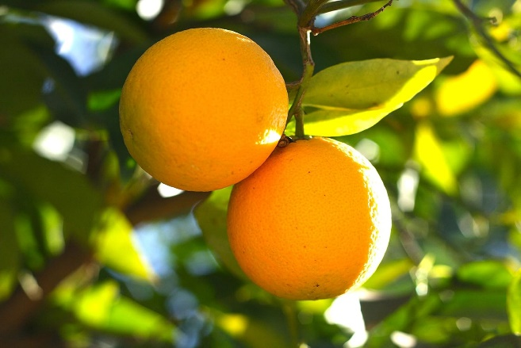

**Figure 1: Orange (Malta)**

**Table 1: Classification of *Citrus sinensis* (According to Bentham and Hooker)**

|  |  |
| --- | --- |
| Domain | Eukarya |
| Kingdom | Plantae |
| Subkingdom | Tracheobiontas |
| Division | Magnoliophyta |
| Class | Rosidae |
| Subclass | Sapindales |
| Order Family | Rutaceae |
| Genus Species | Citrus |
| Species | Sinensis |
| Genetic group | Citrus fruit |
| Scientific  Local name | *Citrus sinensis*  Sweet orange |

### 

## **2.2 Geographical distribution**

### **2.2.1 Fossil-Record**

In 1753, Carl Linnaeus classified Citrus as the genus encompassing the orange species. The analysis of chloroplast DNA indicated that the chloroplast genome of sweet orange originated from pummelo. The pummelo fruit serves as the maternal progenitor of the orange fruit. *Valentina Perea* (2016-17) states that the mandarin is the most closely related paternal parent.

**2.2.2 Origin**

In 314 B.C., the Pomelo and Mandarin fruits underwent a process of hybridization, resulting in the emergence of two distinct varieties of citrus fruits: (1) Bitter orange and (2) Sweet orange. Approximately 7,000 years ago, both species originated in southern Asia and dispersed over the Silk Road, eventually reaching western Asia and extending their distribution to Europe. The primary objective of these individuals during the 15th century was to assist in medicine. By the 16th century, Spanish adventurers began to propagate and promote them. The individuals transported the orange plants to the "New World" (America), where missionaries in Florida established several orange orchards. Subsequently, the orange trees were introduced to California, a region renowned for its extensive orange plantations. The fruit species known as *Citrus sinensis* had already attained a significant reputation and popularity before the onset of the 20th century. Subsequently, its utilization was restricted solely to substantial occasions such as Thanksgiving or Christmas. In contemporary times, oranges have gained considerable popularity on a global scale. Legumes are widely recognized for their nutritional value and are highly favoured due to their abundant vitamin content, which is crucial in bolstering the human immune system (*Perea*, 2016-17)

### **2.2.3 Present distribution**

According to *Milind P. and Dev C. (2012)*, the primary orange production areas in the United States of America are in the South and East Asian regions, with Argentina, Brazil, and Mexico leading the way. Similarly, the Mediterranean basin, including Spain, Italy, Turkey, and Egypt, is a significant orange production zone led by China, India, and Japan. According to *FAOSTAT* *(2001)* and *Valentina Perea* *(2016-17),* the current global production of Citrus stands at approximately 98.7 million tons of fresh fruit, with oranges accounting for 62 percent of this total.

The Food and Agriculture Organization (FAO) reports that the sweet orange is farmed globally, occupying over 3.8 million hectares of land and producing 75.5 million tons (*FAOSTAT* 2020). According to *FAOSTAT* (2020), Brazil, India, and China are the primary nations contributing alongside 16.7, 9.8, and 7.6 million tons. The United States of America is closely behind, contributing 4.8 million tons to the overall production.

### **2.2.4 Lands and climate conditions of Bangladesh**

Due to its abundant water resources and humid climatic conditions, the region is highly conducive to developing Citrus fruits such as oranges. According to the Bangladesh Bureau of Statistics (*BBS, 2012*), the whole extent of land dedicated to orange cultivation in Bangladesh amounts to around 2427.13 acres, resulting in a total output of 36,756 tons. Notably, the Sylhet regions exclusively contribute to an area of 84.21 acres under orange cultivation, yielding a production of 1005 tons. According to data from the Bangladesh Bureau of Statistics (BBS) in 2014-15, the production of sweet oranges in Bangladesh constituted 40 thousand tons, contributing to the overall fruit production.

## **2.3 Nutritional value**

One orange supplies 12.5% of the recommended daily dietary fibre intake. Research has demonstrated this intervention's potential in lowering elevated cholesterol levels, hence contributing to the prevention of atherosclerosis. The fibres also have a role in regulating blood sugar levels. The potential rationale behind including oranges as a nutritious snack option for individuals with diabetes can be elucidated. The natural fructose content found in oranges can be beneficial to mitigate postprandial hyperglycaemia. The dietary fibres in oranges prevent the contact of cancer-causing substances with the colon's cellular structures. According to a study conducted by Milind P. and Dev C. in 2012, it has been suggested that *Citrus sinensis* may have potential benefits in alleviating constipation or diarrhoea symptoms in individuals with irritable bowel syndrome.

**Table 2: Nutrient composition of sweet orange**

|  |  |
| --- | --- |
| **Composition** | **Amount** |
| Energy | 197 kJ (47 kcal) |
| Sugars | 9.35 g |
| Dietary fibre | 2.4 g |
| Fat | 0.12 g |
| Protein | 0.94 g |
| Water | 86.75 g |
| Vitamin A equiv. | 11 µg (1%) |
| Thiamine (Vitamin B1) | 0.087 mg (8%) |
| Riboflavin (Vitamin B2) | 0.04 mg (3%) |
| Niacin (Vitamin B3) | 0.282 mg (2%) |
| Pantothenic acid (Vitamin B5) | 0.25 mg (5%) |
| Vitamin B6 | 0.06 mg (%) |
| Folate (Vitamin B9) | 30 µg (8%) |
| Choline | 8.4 mg (2%) |
| Vitamin C | 53.2 mg (64%) |
| Vitamin E | 0.18 mg (1%) |
| Calcium | 40 mg (4%) |
| Iron | 0.1 mg (1%) |
| Magnesium | 10 mg (3%) |
| Manganese | 0.025 mg (1%) |
| Phosphorus | 14 mg (2 |
| Potassium | 181 mg (4%) |
| Zinc | 0.07 mg (1%)) |

(Source: USDA Nutrient Database (2014)

**2.4 Phytoconstituents**

The orange fruit contains a concentration of essential oil amounting to 1.5%. According to *Milind P. and Dev C. (2012),* the following compounds were found to be present: D-limonene (90%), Citral, sinesal, n-nonanal, n-decanal, n-dodecanal, geranyl acetate, anthranil acid, citronellal, linalyl acetate, and methyl ester.

**Table 3: Phytoconstituents present in various plant parts**

|  |  |  |
| --- | --- | --- |
| **SL No** | **PHYTOCONSTITUENTS** | **PLANT PART** |
| 1 | Flavone glycosides:  Neo -hesperidin, Naringin, Hesperidin, Narirutin  Triterpene.  Limonene, Citral  Pigment:  Anthocyanin, Beta-cryptoxanthin, Cryptoxanthin, Zeaxanthin and Rutin, Eriocitrin, Homocysteine Polymethoxylted flavones.  Tangeritin and Nobiletin  Flavonoids  Citacridone, Citabrsine and Noradrenaline | Fruit Peel |
| 2 | Terpenoids, Linalool, b element | Leaves |
| 3 | Triterpenes, Limonene | Flowers |
| 4 | Vitamins:  B1, B2, B3, B5, B6 and Vitamin C  Minerals:  Calcium, Iron, Magnesium, Phosphorous, Potassium | Fruits |

   (Source: *Milind P. and Dev C., (2012))*

## **2.5 Pharmacological profile**

The organic compound exhibits anti-carcinogenic effects. Limonene in oranges can decrease the likelihood of developing breast, colon, lung, skin, and oral cancers. It provides a safeguard against the development of cardiovascular illnesses. The orange fruit contains cardiovascular-protective compounds such as vitamin C, flavonoids, and carotenoids. Oranges possess notable antioxidant capabilities. Oranges have phenolic compounds, pectin, vitamin C, and flavonoids. This source is effective in the prevention of colds, coughs, and ear infections. The research article published in the esteemed British Journal of Nutrition revealed that women's consumption of 500 millilitres of orange juice per day resulted in a notable increase in urine pH value and citric acid excretion.

Consequently, this substantial effect contributed to a significant reduction in the likelihood of developing calcium oxalate stones. The researchers mitigated the possibility of developing kidney stones. Typhoid poses an important public health challenge, particularly in poorer nations. The anti-typhoid activity of orange fruit can be attributed to the presence of flavonoids such as citacridone, citrine, and saponins. The substance exhibits anti-typhoid properties. Oranges are used as a means of alleviating fever. In treating dermatological conditions, the roasted pulp is formulated into a poultice. In the treatment of acne, the application of a freshly obtained peel is topically administered to the affected skin. In the countries of Italy and France, individuals consume a decoction made from dried plants and flowers as a means of alleviating spasms. In China, a medicinal preparation consisting of husked orange seeds is recommended for treating urinary disorders. Therefore, it exhibits antimicrobial properties. Regularly consuming orange juice has been found to decrease the incidence of infection caused by Helicobacter pylori (*H. pylori*), hence serving as a preventive measure against the formation of ulcers. The substance has characteristics that are effective in treating ulcers. The essential oil derived from *Citrus sinensis* is used as a sedative by aromatherapy practitioners.

A group of researchers discovered that sweet orange oil possesses anxiolytic properties. The substance exhibits an anxiolytic effect. The larvicidal activity of the importance can be attributed to the presence of saponins. The anti-diabetic action of Citrus fruit peels can be attributed to bioflavonoids, including hesperidin and narangin. The primary antifungal components of *Citrus sinensis* are limonene (84.2%), linalool (4.4%), and myrcene (4.1%). Orange essential oil is a highly effective inhibitor of fungal biodegradation and storage. Therefore, it possesses antifungal characteristics. The anti-inflammatory action of Citrus sinensis can be attributed to the presence of poly-methoxy-flavones. The efficacy of Citrus sinensis in promoting healing is contingent upon its diverse array of phytonutrients, including Citrus flavones, hydroxycinnamic acids, anthocyanins, and other polyphenols. Hesperidin, a prominent flavone found in oranges, has demonstrated potential in mitigating elevated blood pressure and cholesterol levels in animal-based research. Most phytonutrients are predominantly in the peel and inner white pulp instead of the liquid orange center. The advantageous component is frequently eliminated during the processing of oranges into juice. Consumption of carotenoids, specifically zeaxanthin and beta-cryptoxanthin phytonutrients, has significantly decreased the likelihood of developing rheumatoid arthritis. The consumption of elevated levels of zeaxanthin and cryptoxanthin was found to be associated with a 52% reduced risk of developing rheumatoid arthritis. Therefore, according to *Milind P. and Dev C. (2012),* it possesses therapeutic and anti-arthritic characteristics.

## **2.6 Antioxidant activity of orange peel extract**

According to a study conducted by *Contini et al. (2014)*, recent research has demonstrated that citrus peel extract exhibits a more excellent antioxidant activity than synthetic antioxidants. Furthermore, it has been found to possess potent inhibitory effects on lipid oxidation. Plant materials include antioxidant properties due to several active phytochemicals, such as vitamins, flavonoids, terpenoids, carotenoids, coumarins, lignin, saponin, and plant sterols. The bioactive chemicals found in orange peel extract (OPE) include flavonoids, phenolic acids, and terpenoids *(Gualdani et al., 2016).*

### **2.6.1 Flavonoids**

Flavonoids are a class of polyphenolic chemicals characterized by their phenyl benzopyrone structure, which consists of two benzene rings (C6) connected by a linear three-carbon chain (C3) and containing a carbonyl group at the C position. Despite being commonly considered non-nutritive substances, flavonoids have attracted significant attention from researchers due to their probable involvement in preventing major chronic diseases. The group of glycosides known as citrus flavonoids comprises hesperidin and naringin, along with a separate group of O-methylated aglycones of flavones, namely nobiletin and tangerine. These two compounds, nobiletin and tangerine, are rather prevalent polyethoxylated flavones (PMFs) (*Li et al., 2014).*

Citrus fruit contains three distinct categories of flavonoids, namely flavanones, flavones, and flavanols. According to a study conducted by *Londono-Londono et al. (2010)*, the analysis of nine flavedo extracts using high-performance liquid chromatography (HPLC) revealed that the flavanone glycoside hesperidin was consistently detected at the highest concentrations (ranging from 83 to 234 mg/g FW) in all of the extracts. The flavanone glycosides poncirin, didymin, narirutin, and the flavone glycosides diosmin and isorhoifolin were detected in all flavedo extracts. However, the flavanone glycoside naringin was found exclusively in the Mandarin variety (*Toma´s-Barbera´n and Clifford, 2000*). Numerous research studies have elucidated the correlation between the structure and antioxidant activity of different subclasses of flavonoids found in citrus extracts. According to *Di-Majo et al*. *(2005),* empirical data indicates that the antioxidant efficacy of citrus flavonoids is significantly impacted by glycosylation, O-methylation, and O-glycosylation. The health-related properties of citrus flavonoids encompass a range of beneficial effects, such as anticancer, antiviral, and anti-inflammatory actions, as well as the ability to reduce capillary fragility and inhibit human platelet aggregation (*Huet, 1982; Benavente-Garcia et al., 1997*). Epidemiological investigations have demonstrated that consuming dietary citrus flavonoids decreases the likelihood of developing coronary heart disease.

Furthermore, it is worth noting that this substance has gained increasing recognition for its potential as an anti-carcinogenic and anti-inflammatory drug, primarily due to its ability to inhibit lipid peroxidation. The numbers 11 and 12 are being referenced. The rationale behind the interest in these types of chemicals stems from their pharmacological activity as radical scavengers. The user did not provide any text to rewrite.

According to *Elan Govan et al. (1994) and Hirano et al. (1994),* the anticancer properties of citrus flavonoids can be attributed to their selective cytotoxicity, anti-proliferative effects, and ability to induce apoptosis. According to *Stapleton and Walbot* (*1994),* flavonoids possess anti-mutagenic properties, enabling them to safeguard DNA by effectively absorbing UV light. *Bracke et al.* *(1989)* reported the observed inhibitory effects of Citrus flavonoids on tumoral development and cell proliferation in cardiac and hepatic tissue of syngenetic rats. Flavonoids have been observed to exhibit a protective effect on DNA through direct interactions with tumoral agents, such as in the case of induced chromosomal damage caused by bleomycin (*Heo et al., 1994*). Hesperidin, a flavonoid, is found in orange peels and exhibits anti-inflammatory activities.

### **2.6.2 Vitamin C**

A single orange supplies 116% of the recommended daily intake of vitamin C. Vitamin C serves as the principal water-soluble antioxidant, effectively inhibiting the production of free radicals within the body and safeguarding the tissues in the aqueous milieu, including both intracellular and extracellular compartments. Using unsalted and unsweetened orange juice is linked to a decrease in the severity of inflammatory ailments such as asthma, osteoarthritis, and rheumatoid arthritis. In the year 1688, the Journal of Pharmacognosy and Phytochemistry was established. Vitamin C is essential for maintaining optimal immune system functionality. Vitamin C has been found to possess beneficial properties in preventing colds and coughs. *Parle and Chaturvedi (2012)* state that the user's text must be completed and provide more information. The positive impact of consuming citrus fruits on human health can be attributed to their antioxidant and anti-radical capabilities (*Betoret et al., 2009*).

### **2.6.3 Phenolic compounds**

According to Hegazy and Ibrahium (2012), orange peels are a significant dietary source of antioxidant phenolic compounds. Phytochemicals, particularly phenolics found in fruits and vegetables, are recognized as substantial bioactive molecules with established health-promoting properties. Research findings have indicated that plant phenolics are not solely confined to the consumable portions of plants. Still, their occurrence and diverse biological impacts have also been documented in non-consumable plant components. The cellular processes behind the beneficial effects of phytophenolics in promoting health and preventing diseases encompass various mechanisms, including cell differentiation, deactivation of pro-carcinogens, maintenance of DNA repair, suppression of N-nitrosamine production, and modulation of estrogen metabolism, among other factors (*Shahidi, 1997*). The primary methods by which phenolics in functional foods exert their antioxidant effects encompass the activities of free radical scavenging and metal chelation. Reactive oxygen species (ROS), including the superoxide radical (O2-), hydrogen peroxide (H2O2), hypochlorous acid (HOCl), and the hydroxyl radical (OH•), have been implicated in the pathophysiology of various human diseases. (*Halliwell, 1996; Halliwell et al., 1992; Aruoma, 1994, 2003*) have been cited in the literature. Lipid oxidation and auto-oxidation are the primary factors contributing to the deterioration of food, particularly meat products. For a considerable period, synthetic antioxidants have been employed to hinder the process of lipid oxidation. This oxidation can induce alterations in various aspects of meat quality, including but not limited to color, flavor, odor, texture, and nutritional composition (*Fernandez et al., 1997*). *Devatkal et al.* *(2010*) effectively substituted them with kinnow rind powder extract to address the drawbacks associated with using synthetic antioxidants in meat products. The findings of their study demonstrated that these extracts possess a significant abundance of phenolic compounds, which exhibit considerable efficacy in scavenging free radicals. Consequently, the researchers concluded that citrus powder extracts hold promise as a safer substitute for synthetic antioxidants. *Benamrouchea and Madania (2013)* conducted a study to validate the antioxidant properties of by-products, specifically peels and leaves, derived from two orange kinds (*Citrus sinensis L.* and *Citrus aurantium L.*) farmed in Algeria.

**2.7 The antioxidant properties of orange peel extract and how they can mitigate oxidation in chicken products**

Research studies have examined the antioxidant capabilities of orange peel extract and its ability to prevent oxidation in chicken products. These studies present scientific data supporting the effectiveness of orange peel extract as an antioxidant and its influence on growth performance, gene expression, antioxidant status, microbial activity, plasma biochemicals, carcass features, and overall levels of oxidative stress. The present study conducted by *Hassan et al. (2022)* aimed to assess the impact of dietary supplementation with ascorbic acid (AA), orange peel powder (OPP), and orange peel extract (OPE) on the growth of rabbits exposed to high temperatures. The study conducted by the researchers revealed that adding AA (ascorbic acid) to the diet led to the attainment of the most favorable feed conversion ratio (FCR). Moreover, the supplementation of OPE, omega-3 polyunsaturated fatty acids and omega-6 polyunsaturated fatty acids resulted in a decrease in concentrations of total cholesterol, low-density lipoprotein (LDL), and very low-density lipoprotein in blood plasma. Furthermore, these dietary interventions resulted in reductions in triglycerides, total lipids levels, hydrogen peroxide levels, malondialdehyde levels (a biomarker of lipid peroxidation), as well as *Staphylococcus aureus* and *Escherichia coli* counts in the cecum of the rabbits.

Additionally, the administration of OPE supplements resulted in enhanced expression of the superoxide dismutase gene and insulin-like growth factor-1. This study provides evidence that using oxidative plant extract can improve rabbit performance by augmentation of antioxidant enzyme activity. In a recent study conducted by *Hassan et al. (2021),* the researchers examined the effects of dietary supplementation with orange peel extract (OPE) and tomato pomace extract (TPE) on the growth of male rabbits. The investigators noted that the supplements contained substantial quantities of ascorbic acid. Dietary supplements containing OPE and TPE enhanced the growth performance and antioxidative status.

Additionally, the levels of ascorbic acid in both plasma and meat were regulated, and there was a reduction in plasma total cholesterol and LDL concentrations. Additionally, these supplements were found to elevate plasma protein and globulin concentrations. The study's findings indicate that adding OPE to the diet can significantly improve the growth performance and antioxidant status of juvenile rabbits.

The study conducted by *Akbarian et al. (2015)* aimed to examine the impact of nutritional supplementation with lemon peel extract (LPE), orange peel extract (OPE), and Curcuma xanthorrhiza essential oil (CXEO) on broiler chicks that were raised in an environment with high ambient temperature *(Akbarian et al., 2015)* . The study revealed that the administration of OPE at a dosage of 400 mg/kg resulted in a notable enhancement in erythrocyte glutathione peroxidase and superoxide dismutase activity. Additionally, it was observed that this supplementation led to elevated plasma growth hormone levels and increased concentrations of serum phosphorus, total protein, and chloride. Conversely, there was a decrease in serum low-density lipoprotein (LDL) and cholesterol levels in chickens at 38 days old. The administration of CXEO at a dosage of 400 mg/kg demonstrated a notable elevation in bronchitis antibody titers. This study posits that adding OPE may mitigate the physiological alterations caused by elevated ambient temperatures. The research above substantiates the antioxidant attributes of orange peel extract and its capacity to alleviate oxidation in poultry-based products. The authors provide evidence that the inclusion of orange peel extract in the diet can lead to improvements in growth performance, reduction in oxidative stress markers such as malondialdehyde levels, enhancement of antioxidant enzyme activities, specifically superoxide dismutase activity, and modulation of lipid profiles by decreasing total cholesterol and LDL concentrations while increasing high-density lipoprotein (HDL) concentrations (*Akbarian et al., 2015; Hassan et al., 2021, 2023*). Nevertheless, it is crucial to acknowledge that these studies possess several limitations, like small sample numbers or specialized settings, such as a hot climate. Hence, additional investigation is required to substantiate these findings across varying circumstances.

## **2.8 Antimicrobial activity of orange peel extract**

An antimicrobial agent is a chemical compound that can either kill or impede the proliferation of specific categories of microorganisms, including bacteria, fungi, and protozoans. Antimicrobial medications can induce microbial death or hinder the expansion of microorganisms. Disinfectants refer to antimicrobial agents employed to treat inanimate surfaces. Citrus fruit products exhibit antibacterial properties against both bacteria and fungi. The citrus product plays a significant physiological role because of its substantial commercial value in the global food and pharmaceutical industries. Previous studies have demonstrated the inhibitory effects of the substance on the growth of gram-positive and gram-negative bacteria (*Chen et al., 2022; Czech et al., 2021*). The antibacterial properties can be ascribed to the existence of several substances, such as limonene, flavanone glycosides (hesperidin, naringin), and polyethoxylated flavones (sinensetin, tangeretin) (*Lin et al., 2021*).

## **2.9 Extraction technique of OPE**

 The present study employed ultrasound-assisted extraction to acquire carotenoids from orange peel, with olive oil as the solvent. The obtained carotenoids were encapsulated within Ca-alginate beads to enhance their stability and safeguard their antioxidant properties. The findings from the encapsulated extracts demonstrated promise as natural antimicrobials for food preservation. The utilization of several organic acids in the aqueous extraction process of pectin from sour orange peel led to discernible differences in the physicochemical, structural, and functional characteristics of the extracted pectin. The specific acid utilized influenced the pectin's methylation, acetylation, molecular weight, and rheological behaviour. The present study aimed to explore the impact of functional coatings, including chitosan, orange peel extract, and olive cake extract, on the quality parameters of cucumbers during cold storage. The samples that were coated displayed enhanced physicochemical characteristics in comparison to the ones that were not covered. The utilization of functional coatings has been found to effectively maintain the quality features of cucumbers during the storage period. The physicochemical, structural, and functional characteristics of pectin isolated from wampee fruit peel were evaluated using various organic acids. The pectin extracted using hydrochloric acid exhibited elevated levels of methylation and acetylation while demonstrating a reduced molecular weight compared to alternative acids. The different types of acids showed minimal impact on surface shape. However, they did influence, as indicated by previous research, rheological behavior, and antioxidant activity, as indicated by a study aimed to assess the efficacy of various extraction techniques, specifically methanolic and ethanolic procedures, regarding their impact on the phytochemical composition of freshly squeezed orange juice. The methanolic extract exhibited elevated concentrations of flavonoid glycosides, whereas the ethanolic section demonstrated increased amounts of polyethoxylated flavones (PMFs). The extraction process affected fresh juice's nutritional content.

## **2.10 Medicinal impact of citrus peel**

Oranges possess abundant essential minerals such as iron, chlorine, manganese, zinc, salt, phosphorous, iodine, and calcium. They include folic acid, potassium, beta-carotene, amino acids, pectin, and dietary fiber. An individual orange contains over 170 phytonutrients and more than 60 flavonoids that possess various qualities such as anti-tumor, anti-inflammatory, blood clot inhibiting, and antioxidant effects. According to *Cha et al. (2001*), these features contribute to general health enhancement. *Citrus sinensis L*, commonly known as sweet oranges, possesses significant utility in promoting human health. They are employed in managing arteriosclerosis, prevention against cancer, treatment of gastric ulcers, decreasing serum cholesterol levels, avoiding kidney stones, enhancing the immune system, and controlling hypertension. The health benefits mentioned can be attributed to the presence of vitamins, particularly vitamin C, as well as several phytochemical components such as synephrine, liminoids, hesperidin flavonoid, polyphenols, pectin, and others (*Etebu E. and Nwauzoma A. B., 2014)*. Orange has been found to possess skin-protective properties, aiding in maintaining a youthful appearance and promoting a radiant and rejuvenated complexion (*Tsuda et al., 2004*). Citrus fruits are predominantly utilized within many businesses. However, the peels are commonly discarded without being effectively used. It is imperative to employ appropriate methodologies to convert orange peel and pulp into value-added goods. According to *Arora and Kaur (2013)*, there is potential for reducing environmental contamination.

According to a recent analysis, it has been determined that including Citrus fruits, such as oranges, in one's diet can safeguard against cardiovascular tissues. This protective effect is attributed to folate inside the peels of *Citrus sinensis*. To mitigate the presence of cardiovascular risk factors, it is imperative. Orange peels possess anti-carcinogenic properties. The orange peel contains flavonoids that have the potential to inhibit the RLIP76 protein. The RLIP76 protein exhibits a significant association with both obesity and cancer. The orange peel provides advantageous properties regarding its anti-allergic and anti-inflammatory effects. Histamines are chemical substances responsible for eliciting allergic reactions. However, certain compounds in the peels of Citrus sinensis can potentially block the release of histamines, rendering them a food source with significant anti-allergic properties. They assist anyone seeking to achieve weight loss through natural means. Orange peels and orange peel extract may offer supplementary advantages for those with diabetes and those seeking weight reduction.

This phenomenon can be attributed to the presence of pectin in the peels of Citrus sinensis, which serves as a natural source of dietary fibre and contributes to the reduction of postprandial glycemic response. They facilitate the passage of kidney stones. The orange peels include a bioactive compound known as D-limonene, which has been found to possess properties that aid in the dissolution of kidney stones. Applying orange peel extract combined with milk effectively reduces the appearance of black spots on the skin. In addition to its primary function as a skin toner, it can also serve as a secondary application. These interventions led to enhancements in both the digestive process and metabolic function. According to Ayurvedic principles, using orange peel has been associated with enhanced digestive processes and heightened metabolic activity. Orange peels have been found to possess properties that make them suitable for usage as a mouth freshener. Additionally, chewing orange peels or gently rubbing them on teeth has been seen to provide potential benefits in teeth whitening and addressing issues related to tooth sensitivity. D-limonene, a biological compound found in the peels of *Citrus sinensis*, can counteract stomach acid and promote regular peristalsis (*Insights Care, 2021*).

## **2.11 Previous research on orange peel extract in food preservation**

### **2.11.1 Use of orange peel extract in food preservation**

Using orange peel extract in food preservation has garnered significant interest owing to its prospective antibacterial and antioxidant characteristics. Numerous research investigations have examined the impact of orange peel extract on various food products and microorganisms. The effects of incorporating bitter orange peel extract into flavoured milk during storage were reviewed in a study by *Jalilzadeh-Afshari et al. (2021*). The study's findings indicated that augmenting the bitter orange peel extract content positively impacted the flavoured milk's viscosity, antioxidant activity, and sensory attributes. The research conducted by *Jalilzadeh‐Afshari and Fadaei (2021)* presents empirical support for the prospective utilization of orange peel extract as a naturally derived supplement in dairy products. The study conducted by *El-Messery et al. (2019)* focused on examining the effects of including encapsulated orange peel extract into functional yoghurt. During the experiment, yoghurt was supplemented with orange peel extract and subsequently analysed to determine its encapsulation efficiency, phenolic content, physiochemical properties, and texture changes throughout cold storage. The study's findings indicated that encapsulated orange peel extract resulted in a notable encapsulation efficiency while having no significant impact on the physiochemical or textural aspects of the yogurt. According to the research conducted by *Shehata et al. (2021)*, it has been demonstrated that incorporating encapsulated orange peel extract into yoghurt can effectively serve as a functional ingredient. The study conducted by *Shehata et al. (2021)* aimed to examine the antioxidant and antibacterial properties of extracts obtained from sweet orange peels. The analysis employed UPLC-ESI-MS/MS methodology. The study's findings indicated that sweet orange peels possess diverse polyphenolic chemicals that exhibit antioxidant properties. According to *Shehata et al. (2021*), the extracts showed significant antibacterial properties against food-borne viruses, suggesting their potential application in food preservation. In their recent study, *Pangallo et al. (2021)* examined the utilization of pomegranate peel extract to manage citrus fruit degradation throughout preharvest and postharvest, particularly during storage. The study's findings indicate that using pomegranate peel extract, either as a pre-harvest application or as a postharvest dipping therapy, exhibited efficacy in reducing the occurrence of decay on oranges. According to *Pangallo et al. (2014*), the study's findings indicate that using pomegranate peel extract may be a viable alternative for managing postharvest infections in citrus fruit orchards. The survey conducted by *Asha et al. (2015)* aimed to examine the antioxidant properties of orange peel extract in ghee (butter oil) under varying storage temperatures. The study's findings showed that using orange peel extract effectively displayed antioxidant properties and hindered the process of lipid oxidation in ghee throughout its storage period. According to a study conducted by *Asha et al. (2015)*, it has been proposed that using orange peel extract as a natural antioxidant may potentially prolong the shelf life of ghee. The literature also explores the utilization of citrus processing waste, specifically orange peels, for diverse purposes such as the production of biomethanol or bioethanol, soil improvement, compost generation, and extraction of valuable compounds for applications in the food, cosmetic, and pharmaceutical industries *(Zema et al., 2018*). The act of valuing citrus processing waste has the potential to make a positive contribution towards the reduction of environmental impact and the enhancement of sustainability.

**Chapter 3: Materials and methods**

**3.1 Study area**

The research study was carried out between July 2023 and September 2023 in the laboratory of Food Processing and Engineering, Applied Chemistry and Chemical Technology and the PRTC Laboratory at Chattogram Veterinary and Animal Sciences University (CVASU) in Bangladesh. The *E. coli* and *Staphylococcus aureus* microorganisms utilized in this experiment were obtained from the Research Laboratory.

**3.2 Experimental design**

The study was undertaken to evaluate the effects of ethanolic extract of orange peel at different concentrations.

**Figure 2: Flow chart of experimental design**

**3.3Fruits were used in this study**

|  |  |  |  |
| --- | --- | --- | --- |
| **Scientific Name** | **Local Name** | **Family** | **Fruit part used** |
| *Citrus sinensis* | Malta | Rutaceae | Peel |

**3.4 Materials**

Orange, FC reagent, DPPH, sodium carbonate, aluminium chloride, methanol, ethanol, filter paper, bacterial cultures – *E*. *coli*, *Staphylococcus*, zipper bag, plastic cup, cheesecloth, aluminium foil, tissue etc.

**3.5 Collection of orange**

Mature and fresh oranges were collected from the local market of Khulshi, Chatogram, in July 2023.

**3.6 Drying and grinding**

The oranges underwent a complete washing process using tap water. The orange peel was initially separated from the pulp, followed by the segmentation of both the pulp and peel into smaller pieces. Subsequently, the specimen was dried within a cabinet drier for 5-6 days under ambient conditions at 30˚C. The dry materials were ground thoroughly using a grinder to acquire a powdered form. The powdered form of the peels was maintained in a securely sealed bag with a zipper closure.

**3.7 Preparation of aqueous extract**

Orange peel extract was prepared by using the aqueous extraction method, 15 g of the powdered orange peel was soaked separately in 200 ml of distilled water at room temperature for 24 hours under shaking conditions. The extract was then filtered using cheesecloth and then concentrated to dryness using a cabinet dryer at 50ºC. The section (extract) yield is weighed on the weighing balance. Then, the dried extract was grinded properly using a grinder to obtain the fine powdered form. The powdered extract was transferred to a zipper bag and kept at 4º C before use.

**3.8 Preparation of ethanolic extract**

**Ethanolic extraction**

1. 2gm raw peel paste in 20 ml ethanol for 3 days (OPR-Orange peel raw)
2. 2gm peel powder in 20 ml ethanol 3 days for (OPP-Orange peel powder)
3. 2gm peel extract in 20 ml ethanol for 3 days (OPE-Orange peel extract)

Following the completion of the procedure, the mixture was subjected to agitation and subsequently stored in a cooling and dark environment for three continuous nights. Later, the combination underwent the process of filtration. The raw orange peel, powder, and extract were each filtered separately using Whattman's No. 1 filter paper. Subsequently, the filtrates were transferred into an Erlenmeyer flask to facilitate subsequent analysis.

**3.9 Preparation of stock**

For the preparation of stock, 2-3 colony of bacteria was taken in a 5 ml of brain heart infusion (BHI) broth which was freshly prepared. Then incubate the broth at 37°C overnight in an incubator for bacterial growth. After that, 700 μL was taken from the overnight culture, and 300 μL of 50% glycerol was mixed in the Eppendorf tube for long-term preservation at -40°C.

**3.10 Preparation and components of agar mueller-hinton agar (MHA)**

To prepare 1000 mL of mueller-hinton agar (MHA), 10 g of tryptone, 15g of nutrient agar, 5 g of sodium chloride, and 5 g of yeast extract were weighed and added to the conical flask, 1000mL of distilled water was added and mixed. To dissolve all ingredients completely, boil for 10 minutes, sterilize by autoclaving for 15 minutes, and then subculturing the test microorganisms.

**3.11 Blood agar**

To prepare 1000 mL of Blood agar, 10 g of Casein, 15g of nutrient agar, 5 g of sodium chloride, and 2 g of yeast extract were weighed and added into the conical flask 1000mL of distilled water was added and mixed. To dissolve all ingredients completely, they were boiled for 10 minutes, and sterilized by autoclaving for 15 minutes. Then add 50 ml of cow blood when the temperature decreases to 45-50°C and mix well. Then the agar is used for subculturing of the test microorganisms.

**3.12 Collection of *E. coli* and *Staphylococcus aureus***

*E-coli* and *Staphylococcus aureus* cultures were collected from the Research Lab were used as the test microorganisms.

**3.12.1 *E*. *coli* identification/ diagnosis**

Samples were prepared by taking 1gm of chicken nuggets and 9ml of peptone water, then mixed them welly. After that, samples were incubated for 24 hours at 37°C. By inoculating the loop, streaking was done in MacConkey agar, then incubated for 24 hours at 37°C. As pink colony was seen, then it was subjected to streak in eosin methylene blue (EMB) agar and incubate at 37°C overnight to observe the final outcome. After 24 hours, a green metallic sheen, was seen in EMB agar media which is indicative of the presence of *E. Coli.*

**3.12.2 *Staphylococcus* identification/ diagnosis**

Samples were prepared by taking 1gm of chicken nuggets from frozen stock using the sterile loop (kept frozen stocks on ice or in a cooler to minimize alterations in temperature, which otherwise may affect the viability of the frozen stock) and 9ml of peptone water, then mixed them welly. After that, samples were incubated for 24 hours at 37°C. Transfer the samples onto MSA agar plate using the loop, streaking across the plate from left to right and top to bottom in order to obtain isolated colonies. Invert the plates and incubate overnight (12 to 16 hr) at 37°C. If a yellowish colony forms, then it indicates the presence of *Staphylococcus aureus*.

**3.13 Antimicrobial discs**

Each of the discs was cut from Whattman’s No.1 filter paper with an approximate diameter of 6 mm using a puncher. The prepared filter paper disc was sterilized by autoclaving at 121°C for 15 minutes and impregnated with 30μl extract of the experimental plant. The orange peel extract was dissolved in 0.2% DMSO (Di-Methyl-Sulp-Oxide) to prepare two different concentrations: 50μL, and 100μL. A total of 2 types of doses were prepared of these 2 concentrations.

**3.14 In vitro testing of extract for antimicrobial activity**

**3.14.1 Measurement of antimicrobial activity of orange peel extract by agar disc diffusion assay**

The antibacterial activity test of crude extracts and fractionated compounds of experimental orange fruit peel against *E. coli* and *S. aureus*. Were carried out by the disc diffusion method. The Sterile Muller Hinton agar was prepared for each organism as follows.

A 20-millilitre sterile muller hinton agar (MHA) was aseptically dispensed into sterilized Petri dishes while maintaining the agar molten temperature range of 45-50°C. Following the solidification of muller hinton agar, a volume of 0.1 ml of the test organism was evenly distributed across the surface of the MHA plate. Before that, the orange peel extract was immersed in a solution of 20 ml of ethanol to facilitate the extraction of bioactive compounds. Subsequently, disc preparation was conducted using sample solutions of 100 and 50 microliters, respectively. Later, the filter paper discs were positioned equidistantly on the surface of the agar plate, maintaining 15 mm from the plate's edge, according to the methodology outlined by Clutterbuck et al. (2007). To achieve complete contact with the agar surface, gentle pressure was applied to each disc, and subsequently, each container was inverted and placed in a temperature-controlled incubator set at 37°C for 24 hours. The assessment of antimicrobial susceptibility was conducted at the 24-hour mark by quantifying the zone of inhibition in millimetres using a plastic ruler. The Macternal Turbidity Standard, an internationally recognized standard, was employed to inoculate bacterial concentrations.

**3.15 Estimation of antioxidant activity of orange peel extract**

**3.15.1 Determination of total phenolic content (TPC) of OPR, OPP and OPE**

The method employed by *Al-Owaisi et al. (2014)* to determine the total phenolic content (TPC) of the extracts involved using the Folin-Ciocalteu (FC) reagent method with slight modifications. During the experimental procedure, 1 millilitre of ethanolic extract was combined with 1.5 millilitres of FC reagent within a falcon tube. The resulting mixture was then incubated at ambient temperature for three minutes. Subsequently, a volume of 1.5 millilitres of a sodium carbonate (Na2CO3) solution with a concentration of 7.5% was introduced, and the resulting combination was left undisturbed for 60 minutes. The absorbance measurement was conducted at a specific wavelength of 765 nm using a UV-VIS Spectrophotometer (UV-2600, Shimadzu Corporation, USA). The blank reference for this measurement was C2H5OH. The extracts' total phenolic content (TPC) was quantified using a mathematical method that establishes the correspondence between TPC and milligrams of gallic acid equivalents (GAE) per gram of extracts. The measurements were repeated three times to determine the means and standard deviation to improve the precision and dependability of the results.

**3.15.2 Determination of total flavonoids content (TFC) of OPR, OPP and OPE**

Determining the total flavonoids content in the samples was conducted using the aluminium chloride colorimetric method, as outlined in the study by Chang et al. (2002). To create the extract stock solution with a concentration of 1 mg/ml, a volume of 1.5 ml of 95% ethanol (C2H5OH) was used and placed in a test tube. Subsequently, this solution was diluted in increments of 0.5 ml aliquots. Then, a volume of 0.1 ml of a 10% aluminium chloride AlCl3 solution, 0.1 ml of a 1 mol/L solution of potassium acetate, and 2.8 ml of distilled water were introduced into the test tube. The answer was allowed to stand at ambient temperature for 30 minutes. A proportional quantity of distilled water containing 10% aluminium chloride was employed in place of the void in the position of the hole. The absorbance measurement was conducted using a UV-visible spectrophotometer (UV-2600, Shimadzu Corporation, USA) at a specific wavelength of 415 nm. The extracted samples' overall flavonoid content was quantified by comparing their absorbance values against a standard curve constructed using quercetin. The outcome was quantified in terms of quercetin equivalents (QE) per gramme of extract (mg QE/g) or total flavonoid content (TFC). The measurements were reproduced three times to compute the means and standard deviation to enhance accuracy and dependability.

**3.15.3 DPPH radical scavenging capacity of OPR, OPP and OPE**

The assessment of the antioxidant capacity of orange peel extract was conducted following the established methodology outlined in a previous study by Ali et al. (Yıldırım et al., 2001). The stable 2, 2-diphenyl-1- picrylhydrazyl radical (DPPH) was used to test the free radical scavenging activity. A 0.5 ml ethanol of freshly produced DPPH was introduced into 3 ml of diluted orange peel extract to initiate the extreme antioxidant reaction. The reduction in absorbance was measured at a wavelength of 517nm. A correlation exists between the test substance's absorbance and scavenging action. The radical scavenging activities were expressed as a percentage of inhibition and calculated according to the following formula equation:

DPPH radical scavenging activity (%) = [Abs control – {Abs sample/Abs control}]x100

Where,

Abs control is the absorbance of the sample at t = 0 min

Abs sample is the absorbance of the sample at t = 30 min

**3.16 Sample collection and preparation**

**3.16.1 Collection of chicken Breast**

Chicken breasts were collected from the Super shop “Swapna “at Khulshi, Chatogram, in July 2023.

**3.16.2 Collection of chicken Breast**

**Product name: Chicken nuggets**

**Ingredients**

Chicken breast meat, onion, garlic, salt, pepper, egg, wheat flour, bread crumb, orange peel extract powder (OPE), orange peel powder (OPP)

**Table 4: Recipe (Preparation of chicken nuggets using OPE & OPP)**

|  |  |
| --- | --- |
| **Ingredients** | **Amount** |
| Chicken | (4*125gm) = 500gm |
| Onion | 2 nos (paste) |
| Garlic | 1 teaspoon |
| White pepper | ½ teaspoon |
| Salt | 1 teaspoon |
| Orange peel extract powder (OPE) | 3.75gm (1.25gm for 1%PE, 2.50gm for 2%PE) |
| Orange peel powder (OPP) | 2.50gm for 2%PP |
| Egg | 2 nos |
| Wheat flour | 250gm |
| Bread crumb | 1 cup |

**Production process**

1.     700 gm of chicken breast meat was taken in a container.

2.     After that, it was washed with clean water.

3.    Bones were removed from chicken breast meat, and only chicken flesh meat was taken (boneless chicken =500gm)

4.     Chopping the breast meat with a sharp knife

5.    Garlic paste, onion paste, salt, and white pepper were all added in a container with well-chopped chicken and mixed them well.

6.     Rest it for 1 hour in the freezer.

7.     Then separate the mixture into 125gm (for control-no PE), 125gm (for 1% PE), 125gm (for 2% PE), 125gm (for 2% PP)

8.     Add/ incorporate 1.25gm PE (1% of 125gm mixture), 2.50gm PE (2% of 125gm mixture), and 2.50gm PP (2% of 125gm mixture) in 3 separate mixtures.

9.     Then, shape the mixtures into nuggets and shape.

10.  Shaped nuggets, then rolled in wheat flour, dipped in egg, then again rolled in bread crumb.

11.  Then, store prepared raw nuggets at (0-4°C.) temperature.

**3.17 Observation of shelf-life of orange peel extract powder and orange peel powder incorporated chicken nuggets**

Shelf-life observation was accomplished by microbial quality checking of peel extract and peel powder incorporated chicken nuggets(*E. coli* and *Staphylococcus aureus* identification).

Samples- Control (chicken nuggets contain no PE or PP), 1% PE (1% OPE incorporated chicken nuggets), 2% PE (2% OPE incorporated chicken nuggets), 2% PP (2% OPP incorporated chicken nuggets)

Control – 3 samples (for checking in 7 days, 14 days & 21 days)

1% PE – 3 samples (for checking in 7 days, 14 days & 21 days)

2% PE – 3 samples (for checking in 7 days, 14 days & 21 days)

2% PP – 3 samples (for checking in 7 days, 14 days & 21 days)

Total samples: 3×4=12 samples

**3.18 Sensory evaluation during first day of storage period of chicken nuggets**

The sensory attributes of the OPE samples were evaluated. The samples were evaluated based on colour, flavour, texture, and general acceptability. The models' acceptability level was assessed by a 1–7 point hedonic rating test. A total of 20 individuals were selected as panellists for the review process. These individuals were drawn from the academic, student, and staff populations of the Department of Food Processing and Engineering at Chattogram Veterinary and Animal Sciences University. Before the review, the panellists were given instructions on the process. Each of the 20 panellists was allocated a fraction from every sample. According to Amerine et al. (2013), the taste panellists utilised a rating scale of 1 to 7 to evaluate the model regarding various attributes, including colour, appearance, smell, texture, taste, flavour, and overall acceptability. The scale was defined as follows: 1 denoted an extreme dislike, 2 indicated a moderate disapproval, 3 represented a slight dislike, 4 signified a neutral stance, 5 showed a little liking, 6 denoted a mild taste, and 7 described an extreme appreciation.

**3.19 Statistical analysis**

The data underwent sorting, coding, and recording processes within a Microsoft Excel 2019 spreadsheet. Descriptive statistics, namely the mean and standard deviation, were computed for the bioactive chemicals, namely total phenolic content (TPC), total flavonoid content (TFC), and 2, 2-diphenyl-1-picrylhydrazyl (DPPH) activity. The antioxidant capacity and analysis were also subjected to the same statistical analysis. Subsequently, a statistical analysis was performed using Tukey's pairwise comparison analysis within the SPSS software (version 25.0), employing One-way ANOVA methods. This analysis aimed to evaluate the level of variation with a 95% confidence interval. The statistical analysis was performed with a significance level of 5% (≤ 0.05).

**Chapter 4****: Results**

**4.1 Determination of bioactive compounds of OPR, OPP and OPE**

Bioactive components and antioxidant capacity were analyzed by using a UV-visible spectrophotometer. Results were subjected to descriptive statistical analysis followed by Tukey.s comparison analysis. There are significant differences among the samples. For flavonoid content, the highest value is 182.088 mg/100gm in the OPE sample and the lowest value is 38.532mg/100gm in the OPR sample. The polyphenol content is ranged from 0.555 to 1.445 mg/100gm. The highest & and lowest amount of polyphenol was found in OPE and OPR samples and they were 1.445 & 0.555 mg/100gm respectively. For The antioxidant capacity, the highest value is 31.266 mg/100gm in the OPE sample and the lowest value is 9.310mg/100gm in the OPR sample. OPP sample contains medium value of polyphenol, flavonoids, and antioxidant capacity. OPE samples have relatively higher amounts of flavonoids, and antioxidant capacity compared to all other samples. All the value shares a significant variance among them. Results are shown in the below table:

**Table 5: Test results of bioactive compounds and antioxidant capacity analysis of OPR, OPP & OPE**

|  |  |  |  |
| --- | --- | --- | --- |
| **Samples** | **Total flavonoids content (TFC) (mg QE/100g)** | **Total polyphenol content (TPC) (mg GAE/100g)** | **Antioxidant Capacity (% Inhibition)** |
| OPR | 38.532 ± 0.072c | 0.555 ± 0.000a | 9.310 ± 0.008b |
| OPP | 89.259 ± 0.117c | 0.865 ± 0.000a | 15.170 ± 0.015b |
| OPE | 182.088 ± 0.300c | 1.445 ± 0.001a | 31.266±0.035b |

Results are presented as mean (ME) ± SD. *Different superscripted letters (a, b, c) in each column show statistically significant differences (p-value < 0.05) for all the samples. Where, SD = Standard Deviation, ME = Mean

OPR: Orange peel raw

OPP: Orange peel powder

OPE: Orange peel extract powder

**4.2 Antibacterial Activity of OPE by disc diffusion method**

As reported by *Vashney et al. (2012)*, the maximum observed zone of inhibition against *E. coli* was measured at 12 mm, surpassing the findings of the present study, which recorded a zone of inhibition of 9 mm. In a separate study conducted by *Praveen et al. (2012*), it was shown that the zone of inhibition for *S. aureus* measured 22 mm, a value that exceeds the measurement obtained in the present study (17 mm). The discs with concentrations of 50 mg/μL and 100 mg/μL were ineffective in producing any observable zone of inhibition when tested against *E. coli* isolates. These variances may arise due to disparities in the quality of orange peel extract or differences in extraction performance. In our study, we have found that for *Staphylococcus aureus*, two different concentrations of the extract were tested, 50 and 100. At the 50 concentrations, a zone of inhibition with a diameter of 7 mm was observed, indicating a moderate inhibitory effect against *Staphylococcus aureus*. However, when the concentration was increased to 100µL, the zone of inhibition expanded to 11 mm, suggesting a stronger inhibitory effect against this bacterium. In the case of *E. coli,* neither of the concentrations (50 or 100µL) of the extract resulted in any zone of inhibition. This signifies that the extract, at these tested concentrations, did not exhibit any inhibitory effect on the growth of *E. coli.* In summary, the results indicate that the extract has notable antimicrobial activity against *Staphylococcus aureus*, with a stronger effect at a higher concentration. However, it does not demonstrate any inhibitory effect on *E. coli* at the concentrations tested. These findings provide valuable insights into the extract's selective antimicrobial properties against specific bacterial strains and can have implications for its potential applications.

**Table 6: Result of the zone of inhibition of OPE**

|  |  |  |
| --- | --- | --- |
| **Microbes** | **Extract used in disc.** **(µL)** | **Zone of inhibition** **(mm)** |
| *Staphylococcus aureus* | 50 | 7mm |
| 100 | 11mm |
| *E. coli* | 50 | No zone of inhibition |
| 100 | No zone of inhibition |

The table presents the results of an antimicrobial assay, where different concentrations of an extract were used in disc diffusion tests to assess their inhibitory effect on two microbial strains- *Staphylococcus aureus* and *Escherichia coli (E. coli).*

**4.3 Proximate composition of OPP and OPE incorporated chicken nuggets**

The proximate composition of a given sample encompasses many constituents such as fat, moisture, fibre, protein, carbs, ash, mineral content, and total energy. The food and pharmaceutical business demonstrate significant interest in these components to develop and regulate various food and non-food items and quality control (QC) measures. To ensure quality control, many approaches are utilized that are both speedy and precise, with the specific method chosen based on the characteristics of the sample. According to a publication from 2017, the analysis of many components, such as moisture content, crude protein and fibre, ash, fat content, total carbs, free amino acids, mineral content, and starch, collectively determine the comprehensive nutritional value of a sample. This assessment is crucial in establishing the model's suitability for nutraceutical and functional food applications. The table displays the proximate makeup of orange peel extract. The table presents the parameters of control: 1% PE, 2% PE, and 2% PP. Out of all the samples of orange peel extract, it was observed that the sample with a concentration of 2%PP demonstrated a higher fat content (63.533±0.709) and lower values for salt content (0.333 ±0.057). The 1% peel extract (PE) sample demonstrated higher ash and moisture content levels, specifically 70.700± 0.100 and 2.466±0.057, respectively. The 2% PE sample had higher protein, collagen, and salt levels, specifically 19.166±0.057, 0.666±.057, and 1.466±0.057, respectively. The collagen content is consistent between the 2% PE and 2% PP samples, although it is comparatively lower in the 1% PE sample, with a value of around (0.000±0.000).

**Table 7: Proximate analysis data of OPP and OPE incorporated chicken nuggets**

|  |  |  |  |  |  |
| --- | --- | --- | --- | --- | --- |
| **Parameter** | **N** | **Control** | **1%PE** | **2%PE** | **2%PP** |
| Fat | 9 | 1.066±0.152a | 1.333±0.208b | 59.466±2.218d | 63.533±0.709c |
| Moisture | 9 | 47.133±1.929c | 70.700±0.100a | 59.466±2.218d | 63.533±0.709b |
| Protein | 9 | 18.000±0.519c | 17.966±0.251b | 19.166±0.057a | 18.800±0.000a |
| Collagen | 9 | 0.633±0.057a | 0.000±0.000a | 0.666±0.057a | 0.666±0.057a |
| Salt | 9 | 0.433±0.115b | 1.166±0.115b | 1.466±0.057a | 0.333 ±0.057a |
| Ash | 9 | 1.033±0.057a | 2.466±0.057a | 1.466±0.057a | 1.966±0.251b |
| Valid N (list wise) | 27 |  |  |  |  |

Results are presented as mean (ME) ± SD. *Different superscripted letters (a, b, c, d) in each column show statistically significant differences (p-value < 0.05) for all the samples. Where, SD = Standard Deviation, ME = Mean

Control = Chicken products contain no OPE or OPP

1%PE = 1% orange peel extract powder (OPE) incorporated chicken nuggets

2%PE= 2% orange peel extract powder (OPE) incorporated chicken nuggets

2%PP= 2% orange peel powder (OPP) incorporated chicken nuggets

**4.4 Shelf life of chicken nuggets by microbial analysis (by diagnosis/identification of bacteria)**

The storage period of assessment are categorized as 7 days, 14 days and 21 days. The treated samples exhibited less inhibition against *E. coli* at all time points. In contrast, the chicken nuggets treated with orange peel extract powder (OPE) and orange peel powder (OPP) displayed a less inhibition against *E. coli* throughout the study, regardless of the concentration used (1% PE, 2% PE, 2% PP). Similarly, in the treated samples, a strong inhibition of *Staphylococcus aureus* was consistently observed throughout the study period. Interestingly, the chicken nuggets treated with orange peel extract powder (OPE) and orange peel powder (OPP) also exhibited robust and consistent inhibition of *Staphylococcus aureus,* regardless of the concentration used (1% PE, 2% PE, 2% PP). The microbial analysis data suggests that with respect to *Staphylococcus aureus* and *E. coli,* the shelf life of the chicken nuggets appears to be well-preserved for at least 21 days, as indicated by the absence of significant bacterial growth or contamination. The consistent inhibitory effects against *Staphylococcus aureus* observed in treated samples indicate that these chicken nuggets maintain their microbiological quality over the course of the study. However, it's important to note that shelf life can be influenced by a variety of factors, including storage conditions and packaging, and further tests may be necessary to determine the shelf life under real-world conditions.

**Table 8: Microbial analysis of chicken nuggets (For *Staphylococcus aureus*)**

|  |  |  |  |  |
| --- | --- | --- | --- | --- |
| **Storage period (Days)** | **Control** | **1% PE** | **2% PE** | **2% PP** |
| 7 | _ | _ | _ | _ |
| 14 | ++ | _ | _ | _ |
| 21 | +++ | _ | _ | _ |

+++Strongly present, ++medium present, +slightly present, -absent

Control = Chicken products contain no OPE or OPP

1%PE = 1% orange peel extract powder (OPE) incorporated chicken nuggets

2%PE = 2% orange peel extract powder (OPE) incorporated chicken nuggets

2%PP = 2% orange peel powder (OPP) incorporated chicken nuggets

**Table 9: Microbial analysis of chicken nuggets (For *E. coli*)**

|  |  |  |  |  |
| --- | --- | --- | --- | --- |
| **Storage period (Days)** | **Control** | **1% PE** | **2% PE** | **2% PP** |
| 7 | ++ | + | + | + |
| 14 | +++ | ++ | ++ | ++ |
| 21 | +++ | +++ | +++ | +++ |

+++Strongly present, ++medium present, +slightly present

Control = Chicken products contain no OPE or OPP

1%PE = 1% orange peel extract powder (OPE) incorporated chicken nuggets

2%PE = 2% orange peel extract powder (OPE) incorporated chicken nuggets

2%PP = 2% orange peel powder (OPP) incorporated chicken nuggets

**4.5 Sensory evaluation during first day of storage period of chicken nuggets**

A total of 20 panelists, comprising an equal number of males and females, were given three nuggets that had been made using distinct orange peel extracts. Each panel member individually assessed the perceived data about the samples and documented their ratings on the designated evaluation sheets that were supplied. The sections above were subjected to a comparative analysis with regard to their colour, visual appearance, olfactory characteristics, texture, taste, flavour, and overall level of acceptability. The results underwent descriptive statistical analysis, followed by ANOVA (Analysis of Variance) and Tukey's comparison analysis.

**Table 10: Hedonic scale scoring test results for nuggets samples prepared by orange peel extract and peel powder**

|  |  |  |  |
| --- | --- | --- | --- |
| **Sensory properties** | **Sample** | | |
| 1% PE | 2%PE | 2%PP |
| Colour | | 6.25 ± 0.55a | 5.30 ± 0.57a | 5.55 ± 0.75b |
| Appearance | | 6.10 ± 0.78b | 5.25 ± 0.63a | 5.25 ± 1.02c |
| Smell | | 5.55 ± 1.05c | 5.25 ± 0.96b | 4.75 ± 0.85a |
| Texture | | 6.20 ± 0.69a | 4.80 ± 0.83b | 4.20 ± 1.05c |
| Taste | | 6.30 ± 0.57a | 5.20 ± 0.83b | 5.05 ± 1.19c |
| Flavour | | 5.90 ± 0.85b | 4.90 ± 0.85b | 5.00 ± 0.72a |
| Overall Acceptability | | 6.30 ± 0.57a | 5.05 ± 0.60b | 4.65 ± 0.87c |

**Legends:** Results are presented as mean (ME) ± SD. *Different superscripted letters (a, b, c) in each column show statistically significant differences (p-value < 0.05) for all the samples. Where, SD = Standard Deviation, ME = Mean

Control = Chicken products contain no OPE or OPP

1%PE = 1% orange peel extract powder (OPE) incorporated chicken nuggets

2%PE = 2% orange peel extract powder (OPE) incorporated chicken nuggets

2%PP = 2% orange peel powder (OPP) incorporated chicken nuggets

**Chapter 5****: Discussion**

Numerous investigations have been undertaken to explore the properties of the orange peel, with a particular focus on the sweet orange variety (*Citrus sinensis*). These studies have sought to assess its potential impact on human health, specifically in relation to its antioxidant, antibacterial, and anti-inflammatory properties. It has been observed that these properties align with the effects of ascorbic acid, ciprofloxacin, and aspirin, respectively. The potential correlation between the presence of alkaloids, flavonoids, tannins, saponins, and steroids in the peels of extra-sweet oranges has been explored in a study conducted by *Omodamiro* and *Umekwe* in 2013. The elements of lipid oxidation, microbiological growth, and color changes play a significant role in determining the shelf-life and subsequent consumer acceptance of fresh meat (*Hayes et al., 2010; Pavelková et al., 2013*). Phenolic compounds found in natural preservatives have been shown to have the ability to protect the human body from free radicals and slow down the development of several chronic diseases. Additionally, these compounds have been found to inhibit lipid oxidation and microbiological growth in food products, making them effective in preserving food quality (*Camo et al., 2008; APHA, 2001*).

In a study conducted by *Hegazy et al*. (2012), the total phenolic content (TPC) of orange peel extract was determined using three different solvents: ethanol, methanol, and acetone. The TPC values obtained were 169.56 mg GAE/g, 165.38 mg GAE/g, and 145.79 mg GAE/g dry weight, respectively. The ethanol extract of orange peel exhibited a reduced total phenolic content compared to the findings reported by *Casquete et al.* *(2015*), which measured 222.76 mg GAE/100 g. Nevertheless, our conclusions exhibited a more significant magnitude compared to the study conducted by *Irkin et al. (2015),* who reported a value of 11.08± 9.55 mg GAE/100 g. In a survey conducted by *Yerlikaya et al.* *(2017),* the researchers documented the total phenolic content of bitter orange to be 8.31 g GAE/100 g. Bioactive compounds (TFC, TPC) and antioxidant capacity of orange peel extract and orange peel powder were measured using the UV-Vis spectrophotometry method.

Phenolic compounds are often recognized as secondary metabolites in a wide range of vegetables, fruits, and other substances. These molecules primarily serve as a reservoir of polyphenols, including phenolic acids, flavanols, flavanones, and flavones *(Singh et al., 2020; M'hiri et al., 2015).* Researchers are primarily focused on these compounds due to their antioxidative properties and the correlation between their usage and the prevention of various illnesses and disorders. Total flavonoid content (TFC) OPR, OPE, and OPP were recorded at 38.532 ± 0.072, 89.259 ± 0.117, and 182.088 ± 0.300 as mg QE/100g respectively. Total polyphenol content (TPC) of OPR, OPE, and OPP were found 0.555 ± 0.000, 0.865 ± 0.000, and 0.865 ± 0.000 as mg GAE/100g respectively. And the antioxidant capacity (% inhibition) of orange (OPR, OPE, and OPP) were found 9.310 ± 0.008, 15.170 ± 0.015, and 31.266 ± 0.035 respectively. In the comparison of total flavonoid content (TFC), total polyphenol content (TPC), and antioxidant capacity among the three samples (OPR, OPP, and OPE), it is evident that OPE stands out as the leader in all three categories. OPE exhibits the highest Total flavonoid content with a value of 182.088 mg QE/100g, the highest Total Polyphenol Content at 1.445 mg GAE/100g, and the highest Antioxidant Capacity with a % Inhibition value of 31.266%. Following OPE, OPP presents intermediate values for TFC, TPC, and Antioxidant Capacity, with TFC at 89.259 mg QE/100g, TPC at 0.865 mg GAE/100g, and an Antioxidant Capacity of 15.17%. OPR, on the other hand, ranks the lowest in all three parameters, featuring the lowest TFC at 38.532 mg QE/100g, the lowest TPC at 0.555 mg GAE/100g, and the lowest Antioxidant Capacity at 9.310%. These results collectively underscore the exceptional potency of OPE in terms of flavonoid and polyphenol content, as well as its remarkable antioxidant capacity, making it a standout candidate for potential health benefits and applications in various industries. Flavonoids are accountable for the manifestation of antioxidant and immune-stimulatory characteristics. *Cragg et al. (1999) and Khanna et al. (2003)* have identified alkaloids, glycosides, flavonoids, and saponins as antibiotic compounds found in plants. These compounds serve as defense mechanisms employed by plants to combat pathogens.

The treated samples exhibited less inhibition against *E. coli* at all time points. In contrast, the chicken nuggets treated with orange peel extract powder (OPE) and orange peel powder (OPP) displayed a less inhibition against *E. coli* throughout the study, regardless of the concentration used (1% PE, 2% PE, 2% PP). Similarly, in the treated samples, a strong inhibition of *Staphylococcus aureus* was consistently observed throughout the study period. Interestingly, the chicken nuggets treated with orange peel extract powder (OPE) and orange peel powder (OPP) also exhibited robust and consistent inhibition of *Staphylococcus aureus,* regardless of the concentration used (1% PE, 2% PE, 2% PP). The microbial analysis data suggests that with respect to *Staphylococcus aureus* and *E. coli,* the shelf life of the chicken nuggets appears to be well-preserved for at least 14 days, as indicated by the absence of significant bacterial growth or contamination. The consistent inhibitory effects against *Staphylococcus aureus* observed in treated samples indicate that these chicken nuggets maintain their microbiological quality over the course of the study.

Proximate composition- the 2% PP sample has the highest fat content (63.533 ± 0.709), which is greater than the 2% PE sample (59.466 ± 2.218) and both are significantly greater than the Control (1.066 ± 0.152) and 1% PE (1.333 ± 0.208) samples. The percentage increase in fat content from the Control to 2% PP is substantial. The 1% PE (70.700 ± 0.100) and 2% PP (63.533 ± 0.709) samples have higher moisture content compared to the Control (47.133 ± 1.929) and 2% PE (59.466 ± 2.218) samples. The 1% PE sample exhibits the highest moisture content, representing a significant percentage increase compared to the Control. The 2% PE sample (19.166 ± 0.057) shows a higher protein content compared to the other samples. It is greater than the control (18.000 ± 0.519), 1% PE (17.966 ± 0.251), and 2% PP (18.800 ± 0.000) samples, with a notable percentage increase. The 2% PE and 2% PP samples (0.666 ± 0.057) have the same collagen content, which is greater than the control (0.633 ± 0.057) and 1% PE (0.000 ± 0.000) samples. The percentage change for collagen content is significant, showing an increase in both 2% PE and 2% PP samples. The 2% PE sample (1.466 ± 0.057) has the highest salt content, which is greater than the control (0.433 ± 0.115), 1% PE (1.166 ± 0.115), and 2% PP (0.333 ± 0.057) samples. The percentage change in salt content from the Control to 2% PE is substantial.The 1% PE sample (2.466 ± 0.057) exhibits the highest ash content, which is greater than the control (1.033 ± 0.057), 2% PE (1.466 ± 0.057), and 2% PP (1.966 ± 0.251) samples. The percentage increase in ash content from the control to 1% PE is notable. These comparisons highlight the variations in each parameter across the different samples, indicating the impact of orange peel extract (OPE) and orange peel powder (OPP) on the nutritional composition of chicken nuggets.

Sensory quality of orange peel samples (OPE, OPR, and OPP) based on color, appearance, smell, texture, taste, flavor, and overall acceptability were evaluated. Among them, Color- The first sample (1% PE) has the highest rating for color at 6.25 ± 0.55, followed by the third sample (2% PP) at 5.55 ± 0.75, and the second sample (2% PE) at 5.30 ± 0.57. Sample 1% PE is rated the highest in terms of color. Appearance- Sample 1% PE also has the highest rating for appearance at 6.10 ± 0.78, followed by both 2% PE and 2% PP at 5.25 ± 0.63 and 5.25 ± 1.02, respectively. Smell- Sample 1% PE is rated the highest for smell at 5.55 ± 1.05, followed by 2% PE at 5.25 ± 0.96, and 2% PP at 4.75 ± 0.85. Texture- The first sample (1% PE) has the highest texture rating at 6.20 ± 0.69, followed by the second sample (2% PE) at 4.80 ± 0.83 and the third sample (2% PP) at 4.20 ± 1.05. Taste- Sample 1% PE is rated the highest for taste at 6.30 ± 0.57, followed by 2% PE at 5.20 ± 0.83 and 2% PP at 5.05 ± 1.19. Flavor- Sample 1% PE has the highest flavor rating at 5.90 ± 0.85, followed by 2% PE at 4.90 ± 0.85, and 2% PP at 5.00 ± 0.72. Overall Acceptability- Sample 1% PE has the highest overall acceptability rating at 6.30 ± 0.57, followed by 2% PE at 5.05 ± 0.60 and 2% PP at 4.65 ± 0.87. In summary, based on this sensory evaluation data, it appears that the 1% PE sample generally has the highest ratings across most sensory properties and overall acceptability, while the 2% PP sample tends to have lower ratings in various categories. The 2% PE sample falls in between these two extremes in most cases.

**5.1 Strength of the study**

* Determine the zone of inhibition on both gram-positive and gram-negative isolates.
* Shelf life was seen in 1% PE, 2%PE & 2%PP in 3 batches such as 7 days, 14 days and 21 days.
* TFC, TPC and DPPH were done to see the antioxidant activity of orange peel powder and orange peel extract powder.

**5.2 Limitations of the study**

* A specific compound of the extract was measured.
* The sample size was small.
* An in vivoexperiment was not done.
* The human pathogen was not introduced.
* A human clinical trial could not be conducted to confirm its effectiveness.

**Chapter 6: Conclusion**

Agro-industrial by-products, such as orange peel, are considered to be valuable sources of phenolic chemicals, which exhibit remarkable antioxidant and antibacterial properties. Frozen ready-to-eat meat products are indeed accessible in urban areas of Bangladesh. However, it is essential to keep in mind that the availability of such goods is limited due to the high cost associated with freezing. Hence, the implementation of orange peel extract treatment on meat products, enabling their preservation at refrigerated temperatures, would yield advantages for both the producer and the consumer. This study demonstrates the potential commercial application of underutilized orange peel as a natural preservative within the food sector. Efficient extraction techniques will be necessary to retrieve phenolic chemicals from agro-industrial waste. The presence of phytochemicals and antioxidants in various substances has been found to have a direct correlation with their positive impact on human health. The objective of preservation should not be restricted solely to ensuring food safety; instead, it is imperative to prioritize the production of healthy food. As a potential avenue for further investigation, the present study should be extended to consist of an analysis of alterations in the antioxidant activity and phytochemical content of supplementary peel extract samples.

**Chapter 7: Recommendation and future perspectives**

In Bangladesh, orange is cultivated in some areas but is not a major fruit. However, as the country is experiencing growth in the food industry, orange peel has potential for future applications in this sector.

* Due to the presence of excellent health benefits, orange peel extract can be a potential value-added product for health-conscious people and also the prospect of being a super sports drink.
* Orange peel extract powder prepared by cabinet drying is recommended for higher retention of bioactive compounds, including flavonoids, polyphenols, anthocyanin, pectin, and vitamin C.
* Orange jelly is a novel product and can be marketed as an attractive value-added product in future.
* Further product optimization, shelf life and cost-benefit studies are suggested to develop and improve commercial orange peel extract powder with fortification for drinking purposes and jelly formulation.

Overall, the future perspective of orange peel extract powder in Bangladesh looks promising, and there are opportunities for the country to explore its potential applications in the food sector. However, more research and development are needed to fully understand the benefits and potential uses of this fruit in Bangladesh.

**References**

Ahmad, S. R., Gokulakrishnan, P., Giriprasad, R., & Yatoo, M. A. (2015). Fruit-based Natural Antioxidants in Meat and Meat Products: A Review. Critical Reviews in Food Science and Nutrition, 55(11), 1503–1513.

Ahn, J., Grun, I. U., & Fernando, L. N. (2002). Antioxidant Properties of Natural Plant Extracts Containing Polyphenolic Compounds in Cooked Ground Beef. Journal of Food Science, 67(4), 1364–1369.

Akbarian, A., Golian, A., Kermanshahi, H., De Smet, S., & Michiels, J. (2015). Antioxidant enzyme activities, plasma hormone levels and serum metabolites of finishing broiler chickens reared under high ambient temperature and fed lemon and orange peel extracts and C urcuma xanthorrhiza essential oil. Journal of Animal Physiology and Animal Nutrition, 99(1), 150–162.

Angelo, A. J. St., Crippen, K. L., Dupuy, H. P., & James, C. (1990). Chemical and Sensory Studies of Antioxidant‐Treated Beef. Journal of Food Science, 55(6), 1501–1505.

Anupong, W., On-uma, R., Jutamas, K., Joshi, D., Salmen, S. H., Alahmadi, T. A., & Jhanani, G. K. (2023). Cobalt nanoparticles synthesizing potential of orange peel aqueous extract and their antimicrobial and antioxidant activity. Environmental Research, 216, 114594.

Asha, A., Manjunatha, M., Rekha, R. M., Surendranath, B., Heartwin, P., Rao, J., Magdaline, E., & Sinha, C. (2015). Antioxidant activities of orange peel extract in ghee (butter oil) stored at different storage temperatures. Journal of Food Science and Technology, 52(12), 8220–8227.

Bai, J., Manthey, J. A., Ford, B. L., Luzio, G., Cameron, R. G., Narciso, J., & Baldwin, E. A. (2013). Effect of extraction, pasteurization and cold storage on flavonoids and other secondary metabolites in fresh orange juice. Journal of the Science of Food and Agriculture, 93(11), 2771–2781.

Bampidis, V. A., & Robinson, P. H. (2006). Citrus by-products as ruminant feeds: A review. Animal Feed Science and Technology, 128(3–4), 175–217.

Baratta, M. T., Dorman, H. J. D., Deans, S. G., Biondi, D. M., & Ruberto, G. (1998). Chemical Composition, Antimicrobial and Antioxidative Activity of Laurel, Sage, Rosemary, Oregano and Coriander Essential Oils. Journal of Essential Oil Research, 10(6), 618–627.

Bashir, A., Jabeen, S., Gull, N., Islam, A., Sultan, M., Ghaffar, A., Khan, S. M., Iqbal, S. S., & Jamil, T. (2018). Co-concentration effect of silane with natural extract on biodegradable polymeric films for food packaging. International Journal of Biological Macromolecules, 106, 351–359.

Beya, M. M., Netzel, M. E., Sultanbawa, Y., Smyth, H., & Hoffman, L. C. (2021). Plant-Based Phenolic Molecules as Natural Preservatives in Comminuted Meats: A Review. Antioxidants, 10(2), 263.

Calabrò, M. L., Galtieri, V., Cutroneo, P., Tommasini, S., Ficarra, P., & Ficarra, R. (2004). Study of the extraction procedure by experimental design and validation of a LC method for determination of flavonoids in Citrus bergamia juice. Journal of Pharmaceutical and Biomedical Analysis, 35(2), 349–363.

Chen, J., Han, X., Wu, Y., Liu, L., Yu, J., Li, J., Zhang, Y., & Xu, Y. (2022). Comparative study on characteristics of mandarin peel extracts by biological processing. Archives of Microbiology, 204(8), 512.

Chen, X.-M., & Kitts, D. D. (2017). Flavonoid composition of orange peel extract ameliorates alcohol-induced tight junction dysfunction in Caco-2 monolayer. Food and Chemical Toxicology, 105, 398–406.

Czech, A., Malik, A., Sosnowska, B., & Domaradzki, P. (2021). Bioactive Substances, Heavy Metals, and Antioxidant Activity in Whole Fruit, Peel, and Pulp of Citrus Fruits. International Journal of Food Science, 2021, 1–14.

De Silva, K. T., De Silva, T. K., & Organization, U. N. I. D. (1995a). A Manual on the Essential Oil Industry. United Nations Industrial Development Organization.

De Silva, K. T., De Silva, T. K., & Organization, U. N. I. D. (1995b). A Manual on the Essential Oil Industry. United Nations Industrial Development Organization.

Dziezak, J. D. (1989). Spices. Food Technology, 43, 102–116. (n.d.).

Ebeid, T. A., Aljabeili, H. S., Al-Homidan, I. H., Volek, Z., & Barakat, H. (2023). Ramifications of Heat Stress on Rabbit Production and Role of Nutraceuticals in Alleviating Its Negative Impacts: An Updated Review. Antioxidants, 12(7), 1407.

Ebrahimzadeh, M. A., Hosseinimehr, S. J., Hamidinia, A., & Jafari, M. (2008). (n.d.). Determination of flavanoids in citrus fruit. Pharmacologyonline, 1, 15-18.

El-Messery, T. M., El-Said, M. M., Shahein, N. M., El-Din, H. M. F., & Farrag, A. (2019). Functional Yoghurt Supplemented with Extract Orange Peel Encapsulated Using Coacervation Technique. Pakistan Journal of Biological Sciences, 22(5), 231–238.

Farahmandfar, R., Tirgarian, B., Dehghan, B., & Nemati, A. (2020). Changes in chemical composition and biological activity of essential oil from Thomson navel orange (Citrus sinensis L. Osbeck) peel under freezing, convective, vacuum, and microwave drying methods. Food Science & Nutrition, 8(1), 124–138.

Flamini, G., Pistelli, L., Nardoni, S., Ebani, V., Zinnai, A., Mancianti, F., Ascrizzi, R., & Pistelli, L. (2019). Essential Oil Composition and Biological Activity of “Pompia”, a Sardinian Citrus Ecotype. Molecules, 24(5), 908.

Formanek, Z., Kerry, J. P., Higgins, F. M., Buckley, D. J., Morrissey, P. A., & Farkas, J. (2001). Addition of synthetic and natural antioxidants to α-tocopheryl acetate supplemented beef patties: Effects of antioxidants and packaging on lipid oxidation. Meat Science, 58(4), 337–341.

Gopalakrishnan, K., Chandel, M., Gupta, V., Kaur, K., Patel, A., Kaur, K., Kishore, A., Prabhakar, P. K., Singh, A., Shankar Prasad, J., Bodana, V., Saxena, V., Shanmugam, V., & Sharma, A. (2023). Valorisation of fruit peel bioactive into green synthesized silver nanoparticles to modify cellulose wrapper for shelf-life extension of packaged bread. Food Research International, 164, 112321.

Gowe, C. (2015a). Review on Potential Use of Fruit and Vegetables By-Products as a Valuable Source of Natural Food Additives.

Gowe, C. (2015b). Review on Potential Use of Fruit and Vegetables By-Products as a Valuable Source of Natural Food Additives.

Gualdani, R., Cavalluzzi, M., Lentini, G., & Habtemariam, S. (2016). The Chemistry and Pharmacology of Citrus Limonoids. Molecules, 21(11), 1530.

Hassan, F. A., Elkassas, N., Salim, I., El-Medany, S., Aboelenin, S. M., Shukry, M., Taha, A. E., Peris, S., Soliman, M., & Mahrose, K. (2021). Impacts of Dietary Supplementations of Orange Peel and Tomato Pomace Extracts as Natural Sources for Ascorbic Acid on Growth Performance, Carcass Characteristics, Plasma Biochemicals and Antioxidant Status of Growing Rabbits. Animals, 11(6), 1688.

Hassan, F. A., Shalaby, A. G., Elkassas, N. E. M., El-Medany, S. A., Hamdi Rabie, A., Mahrose, K., Abd El-Aziz, A., & Bassiony, S. (2023). Efficacy of ascorbic acid and different sources of orange peel on growth performance, gene expression, anti-oxidant status and microbial activity of growing rabbits under hot conditions. Animal Biotechnology, 34(7), 2480–2491.

He, Q., Yang, Z., Gong, B., Wang, J., Xiao, K., & Yang, S.-T. (2017). Quality Evaluation Focusing on Tissue Fractal Dimension and Chemical Changes for Frozen Tilapia with Treatment by Tangerine Peel Extract. Scientific Reports, 7(1), 42202.

Hernández, A., Ruiz-Moyano, S., Galván, A. I., Merchán, A. V., Pérez Nevado, F., Aranda, E., Serradilla, M. J., Córdoba, M. D. G., & Martín, A. (2021). Anti-fungal activity of phenolic sweet orange peel extract for controlling fungi responsible for post-harvest fruit decay. Fungal Biology, 125(2), 143–152.

Hosseini, S. S., Khodaiyan, F., & Yarmand, M. S. (2016). Aqueous extraction of pectin from sour orange peel and its preliminary physicochemical properties. International Journal of Biological Macromolecules, 82, 920–926.

Ishfaq, M., Akhtar, B., Muhammad, F., Sharif, A., Akhtar, M. F., Hamid, I., Sohail, K., & Muhammad, H. (2021). Antioxidant and Wound Healing Potential of Essential Oil from Citrus reticulata Peel and Its Chemical Characterization. Current Pharmaceutical Biotechnology, 22(8), 1114–1121.

Ivanovska, A., Gajić, I. S., Lađarević, J., Milošević, M., Savić, I., Mihajlovski, K., & Kostić, M. (2022). Sustainable Dyeing and Functionalization of Different Fibers Using Orange Peel Extract’s Antioxidants. Antioxidants, 11(10), 2059.

Jahani, R., Behnamian, M., Dezhsetan, S., Karimirad, R., & Chamani, E. (2023). Chitosan nano-biopolymer/Citrus paradisi peel oil delivery system enhanced shelf-life and postharvest quality of cherry tomato. International Journal of Biological Macromolecules, 225, 1212–1223.

Jalilzadeh‐Afshari, A., & Fadaei, V. (2021). Characterization of flavored milk containing bitter orange peel extract and Gaz‐angubin. Food Science & Nutrition, 9(1), 164–171.

Jayathilakan, K., Sharma, G., Radhakrishna, K., & Bawa, A. (2007a). Antioxidant potential of synthetic and natural antioxidants and its effect on warmed-over-flavour in different species of meat. Food Chemistry, 105(3), 908–916.

Jayathilakan, K., Sharma, G., Radhakrishna, K., & Bawa, A. (2007b). Antioxidant potential of synthetic and natural antioxidants and its effect on warmed-over-flavour in different species of meat. Food Chemistry, 105(3), 908–916.

Karre, L., Lopez, K., & Getty, K. J. K. (2013). Natural antioxidants in meat and poultry products. Meat Science, 94(2), 220–227.

Kharchoufi, S., Parafati, L., Licciardello, F., Muratore, G., Hamdi, M., Cirvilleri, G., & Restuccia, C. (2018). Edible coatings incorporating pomegranate peel extract and biocontrol yeast to reduce Penicillium digitatum postharvest decay of oranges. Food Microbiology, 74, 107–112.

Lin, X., Cao, S., Sun, J., Lu, D., Zhong, B., & Chun, J. (2021). The Chemical Compositions, and Antibacterial and Antioxidant Activities of Four Types of Citrus Essential Oils. Molecules, 26(11), 3412.

Malik, A., Najda, A., Bains, A., Nurzyńska-Wierdak, R., & Chawla, P. (2021). Characterization of Citrusnobilis Peel Methanolic Extract for Antioxidant, Antimicrobial, and Anti-Inflammatory Activity. Molecules, 26(14), 4310.

Marín, F. R., Soler-Rivas, C., Benavente-García, O., Castillo, J., & Pérez-Alvarez, J. A. (2007). By-products from different citrus processes as a source of customized functional fibres. Food Chemistry, 100(2), 736–741.

Min, K. Y., Kim, H. J., Lee, K. A., Kim, K.-T., & Paik, H.-D. (2014). Antimicrobial activity of acid-hydrolyzed Citrus unshiu peel extract in milk. Journal of Dairy Science, 97(4), 1955–1960.

Mitsagga, C., Petrotos, K., & Giavasis, I. (2021). Antimicrobial Properties of Lyophilized Extracts of Olive Fruit, Pomegranate and Orange Peel Extracts against Foodborne Pathogenic and Spoilage Bacteria and Fungi In Vitro and in Food Matrices. Molecules (Basel, Switzerland), 26(22), 7038.

Nagy, S., & Attaway, J. A. (Eds.). (1980). Citrus Nutrition and Quality (Vol. 143).

Naveena, B. M., Sen, A. R., Vaithiyanathan, S., Babji, Y., & Kondaiah, N. (2008). Comparative efficacy of pomegranate juice, pomegranate rind powder extract and BHT as antioxidants in cooked chicken patties. Meat Science, 80(4), 1304–1308.

Nuñez De Gonzalez, M. T., Hafley, B. S., Boleman, R. M., Miller, R. K., Rhee, K. S., & Keeton, J. T. (2008). Antioxidant properties of plum concentrates and powder in precooked roast beef to reduce lipid oxidation. Meat Science, 80(4), 997–1004.

Omeroglu, P. Y., Acoglu Celik, B., & Koc Alibasoglu, E. (2022). The Effect of Household Food Processing on Pesticide Residues in Oranges (Citrus sinensis). Foods (Basel, Switzerland), 11(23), 3918.

Pangallo, D., Šaková, N., Koreňová, J., Puškárová, A., Kraková, L., Valík, L., & Kuchta, T. (2014). Microbial diversity and dynamics during the production of May bryndza cheese. International Journal of Food Microbiology, 170, 38–43.

Pangallo, S., Li Destri Nicosia, M. G., Scibetta, S., Strano, M. C., Cacciola, S. O., Belgacem, I., Agosteo, G. E., & Schena, L. (2021). Preharvest and Postharvest Applications of a Pomegranate Peel Extract to Control Citrus Fruit Decay During Storage and Shelf Life. Plant Disease, 105(4), 1013–1018.

Qiu, L., Ma, H., Luo, Q., Bai, C., Xiong, G., Jin, S., Wang, J., Zu, X., Li, H., & Liao, T. (2022). Preparation, Characterization, and Application of Modified Starch/Chitosan/Sweet Orange Oil Microcapsules. Foods, 11(15), 2306.

Raghavan, S., & Richards, M. (2007). Comparison of solvent and microwave extracts of cranberry press cake on the inhibition of lipid oxidation in mechanically separated turkey. Food Chemistry, 102(3), 818–826.

Rahman, S. (n.d.). Handbook of food preservation (2nd ed). Taylor & Francis.

Rojas, M. C., & Brewer, M. S. (2008). Effects of natural antioxidants on oxidative stability of frozen, vacuum packed beef and pork. Journal of Food Quality, 31(2), 173–188.

Sallam, K. I., Abd-Elghany, S. M., Imre, K., Morar, A., Herman, V., Hussein, M. A., & Mahros, M. A. (2021). Ensuring safety and improving keeping quality of meatballs by addition of sesame oil and sesamol as natural antimicrobial and antioxidant agents. Food Microbiology, 99, 103834.

Sarmast, E., Fallah, A. A., Habibian Dehkordi, S., & Rafieian-Kopaei, M. (2019). Impact of glazing based on chitosan-gelatin incorporated with Persian lime (Citrus latifolia) peel essential oil on quality of rainbow trout fillets stored at superchilled condition. International Journal of Biological Macromolecules, 136, 316–323.

Shehata, M. G., Awad, T. S., Asker, D., El Sohaimy, S. A., Abd El- Aziz, N. M., & Youssef, M. M. (2021). Antioxidant and antimicrobial activities and UPLC-ESI-MS/MS polyphenolic profile of sweet orange peel extracts. Current Research in Food Science, 4, 326–335.

Smith, R. D., & Rillema, J. A. (1975). Guanylate cyclase and cyclic-GMP phosphodiesterase activities in mammary glands of mice during pregnancy and lactation. Proceedings of the Society for Experimental Biology and Medicine. Society for Experimental Biology and Medicine (New York, N.Y.), 150(3), 763–765.

Sorrenti, V., Randazzo, C. L., Caggia, C., Ballistreri, G., Romeo, F. V., Fabroni, S., Timpanaro, N., Raffaele, M., & Vanella, L. (2019). Beneficial Effects of Pomegranate Peel Extract and Probiotics on Pre-adipocyte Differentiation. Frontiers in Microbiology, 10, 660.

Tang, S., Kerry, J. P., Sheehan, D., Buckley, D. J., & Morrissey, P. A. (2001). Antioxidative effect of added tea catechins on susceptibility of cooked red meat, poultry and fish patties to lipid oxidation. Food Research International, 34(8), 651–657.

Tomaino, A., Cimino, F., Zimbalatti, V., Venuti, V., Sulfaro, V., De Pasquale, A., & Saija, A. (2005). Influence of heating on antioxidant activity and the chemical composition of some spice essential oils. Food Chemistry, 89(4), 549–554.

Ullah, S., Khalil, A. A., Shaukat, F., & Song, Y. (2019). Sources, Extraction and Biomedical Properties of Polysaccharides. Foods, 8(8), 304.

Van Buren, J. B., Puga, K. J., Hoffman, K. C., Nasados, J. A., Bass, P. D., & Colle, M. J. (2023). Water binders in beef patties increase yield and extend shelf life. Translational Animal Science, 7(1), txad091.

Wang, M., Meng, D., Zhang, P., Wang, X., Du, G., Brennan, C., Li, S., Ho, C.-T., & Zhao, H. (2018). Antioxidant Protection of Nobiletin, 5-Demethylnobiletin, Tangeretin, and 5-Demethyltangeretin from Citrus Peel in Saccharomyces cerevisiae. Journal of Agricultural and Food Chemistry, 66(12), 3155–3160.

Wang, Z., Yang, B., Chen, X., Huang, P., Chen, K., Ma, Y., Agarry, I. E., & Kan, J. (2022). Optimization and comparison of nonconventional extraction techniques for soluble phenolic compounds from brocade orange (Citrus sinensis) peels. Journal of Food Science, 87(11), 4917–4929.

Yıldırım, A., Mavi, A., & Kara, A. A. (2001). Determination of Antioxidant and Antimicrobial Activities of Rumex crispus L. Extracts. Journal of Agricultural and Food Chemistry, 49(8), 4083–4089.

Zappia, A., Spanti, A., Princi, R., Imeneo, V., & Piscopo, A. (2023). Evaluation of the Efficacy of Antioxidant Extract from Lemon By-Products on Preservation of Quality Attributes of Minimally Processed Radish (Raphanus sativus L.). Antioxidants, 12(2), 235.

Zema, D. A., Calabrò, P. S., Folino, A., Tamburino, V., Zappia, G., & Zimbone, S. M. (2018). Valorisation of citrus processing waste: A review. Waste Management, 80, 252–273.

Zhang, Y., Yang, L., Zu, Y., Chen, X., Wang, F., & Liu, F. (2010). Oxidative stability of sunflower oil supplemented with carnosic acid compared with synthetic antioxidants during accelerated storage. Food Chemistry, 118(3), 656–662.

**Appendix**

**Appendix A: Antioxidant capacity of orange peel**

**Standard curve**



**Sample graph**

**Appendix B: Total flavonoid content (TFC) of orange peel**

**Standard curve**



**Sample graph**

**Appendix C: Total phenolic content (TPC) of orange peel**

**Standard curve**



**Sample graph**

**Appendix D: Photo gallery**

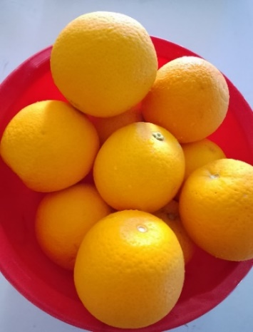 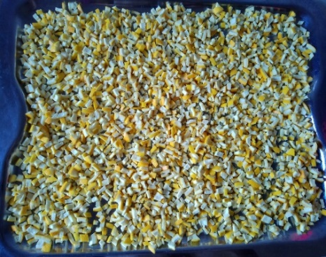 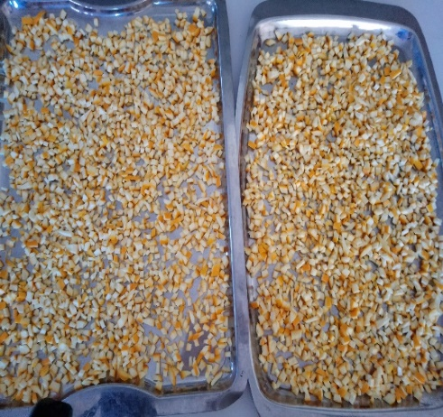

Dried orange peel

Cut pieces of orange peel

Collection of fresh orange (Malta)

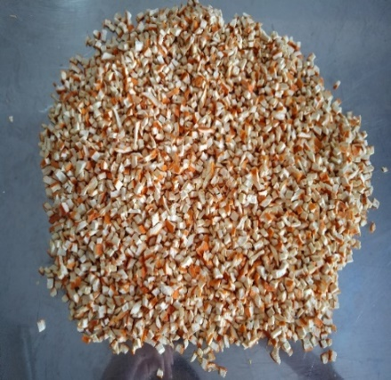 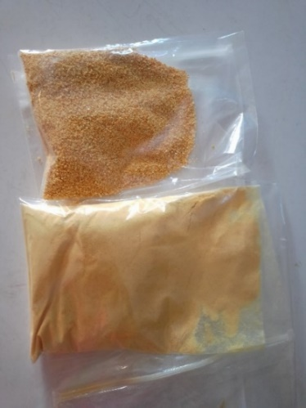 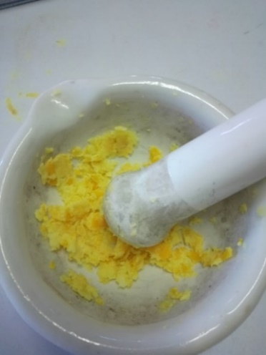

Grinded & sieved orange peel powder

Raw peel paste preparation

Dried orange peel

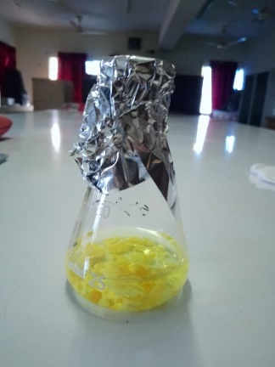 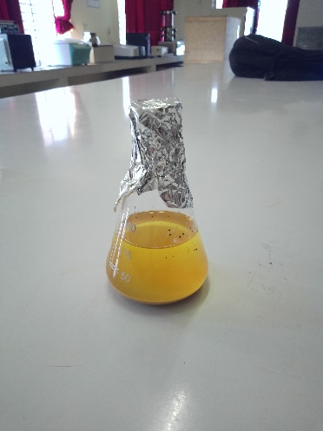 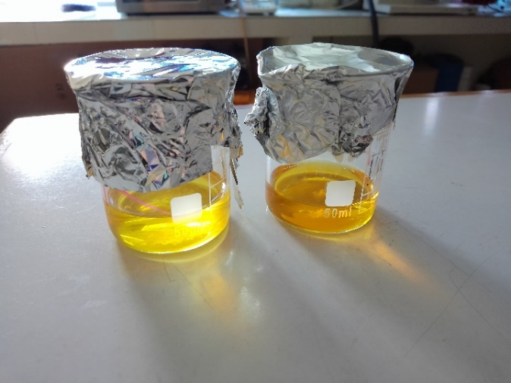

Filtered extract (Raw & Dried)

Ethanolic extraction (Peel powder)

Ethanolic extraction (Raw peel)

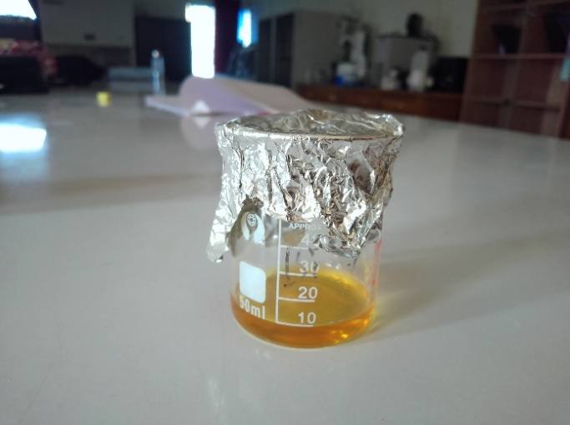 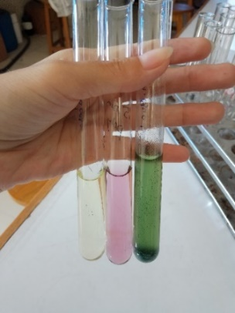 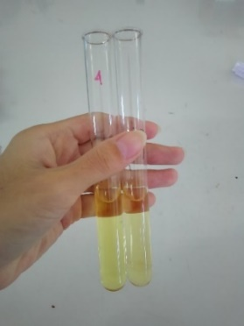 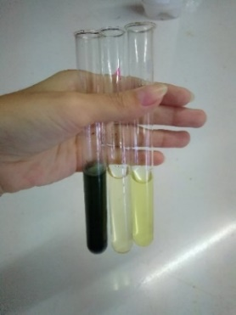

Sample preparation for determination of TFC, TPC & Antioxidant capacity

Aqueous extract

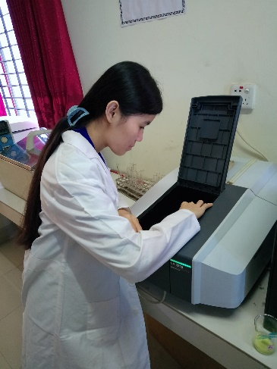 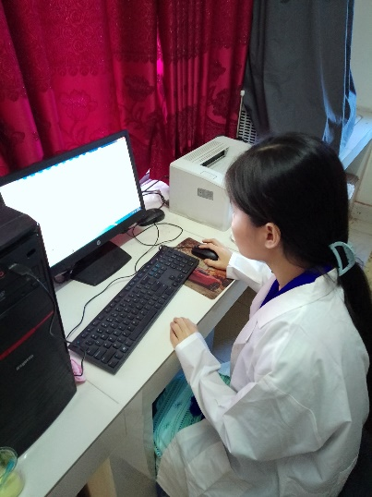 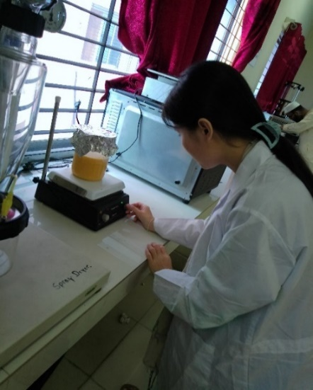

Sample insertion in UV spectrophotometer

Setting up stirring machine

Taking UV absorbance readings

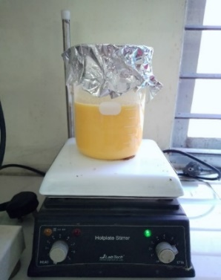 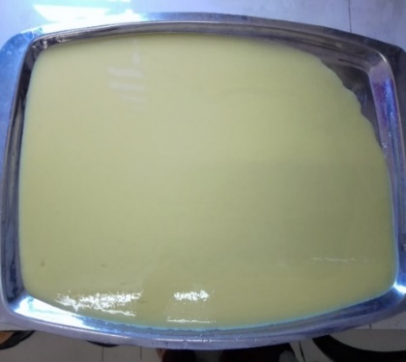 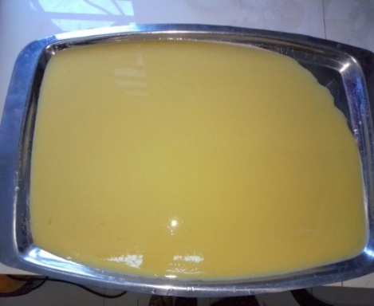

Aqueous extraction of peel powder under stirring condition

Filtered aqueous extract

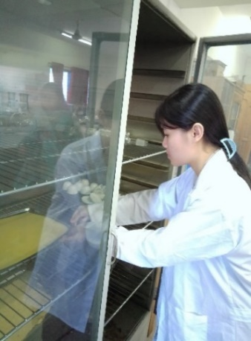 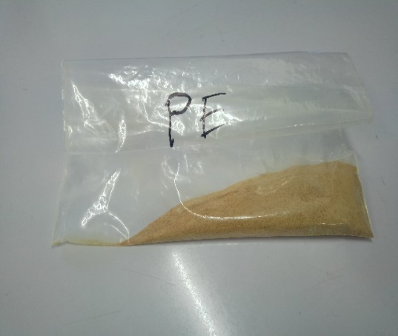 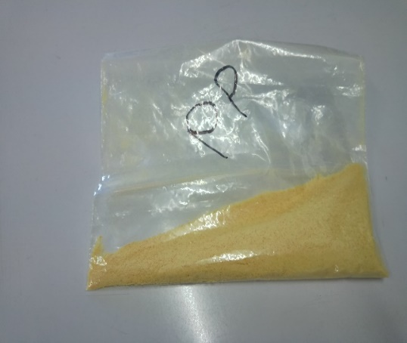

Inserting for drying of aqueous extract

Peel powder

Peel extract powder

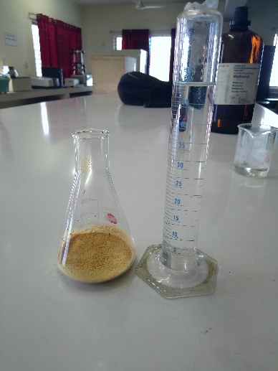 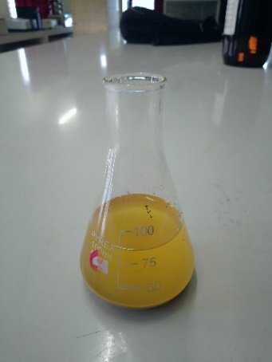 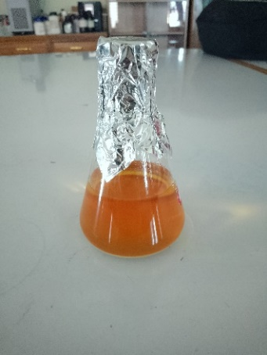

Sample preparation of peel extract by methanolic extraction method for testing antimicrobial activity

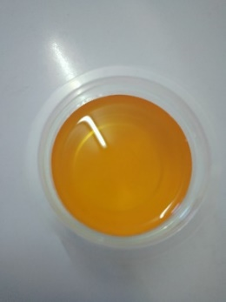 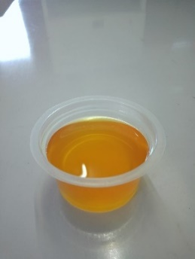 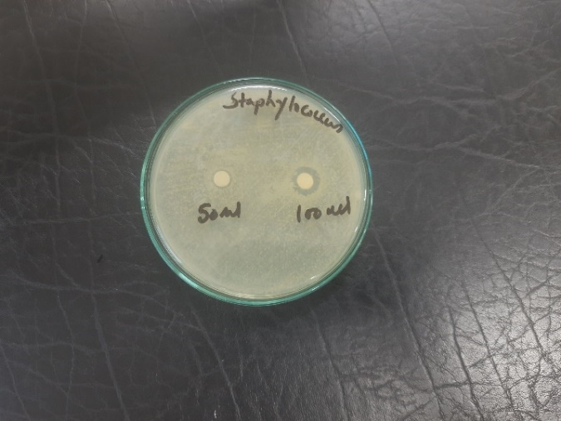 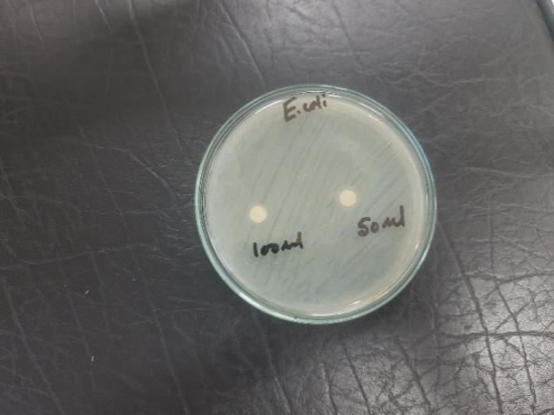

Zone of inhibition testing of peel extract against *E. coli* by Disc Diffusion method

Filtered methanolic extract solution

Zone of inhibition testing of peel extract against *Staphylococcus* by Disc Diffusion method

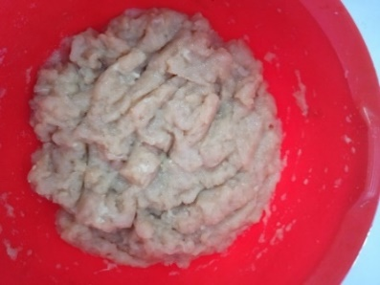 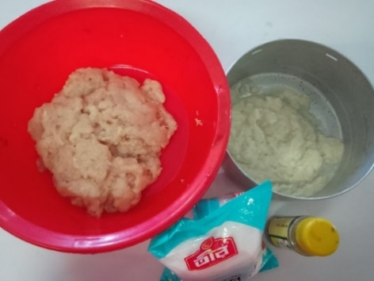 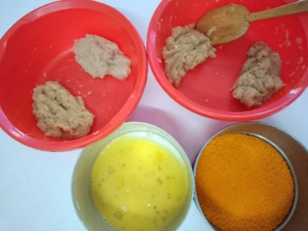

Product development - peel extract and peel powder incorporated chicken nuggets preparation

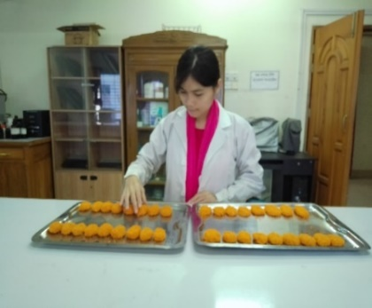 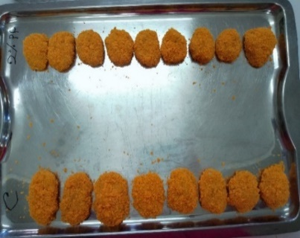 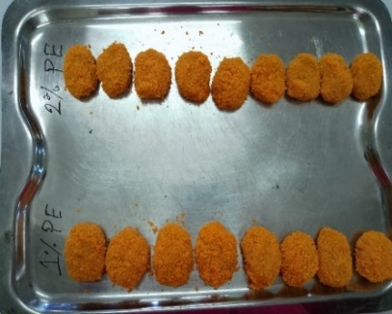

Prepared chicken nuggets (Control, 1% PE, 2% PE, 2% PP)

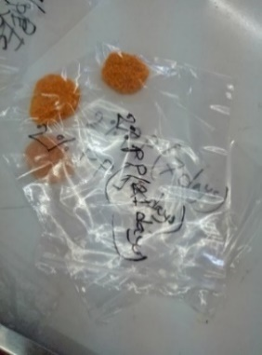 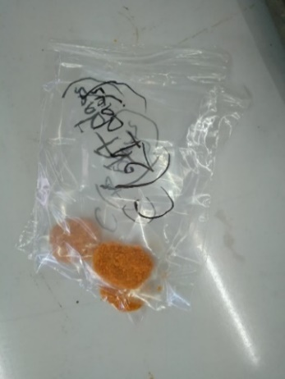 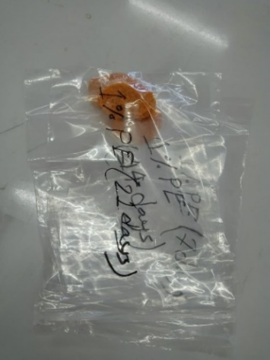 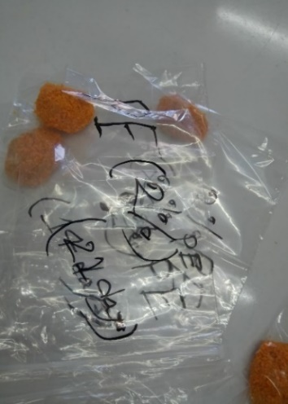

Packaged samples for observing shelf life

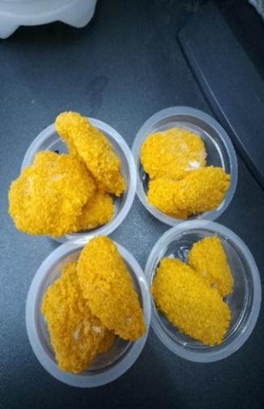 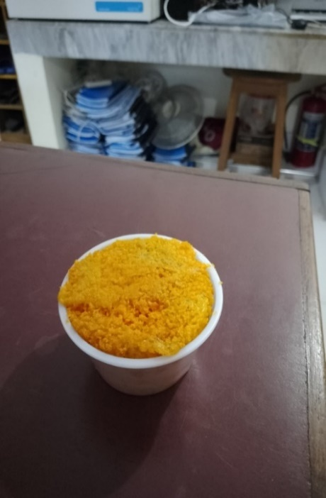 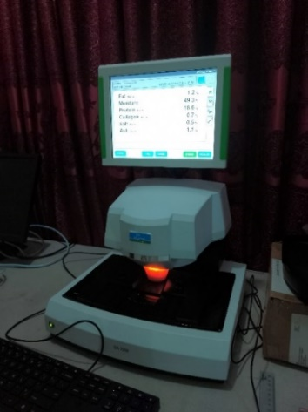 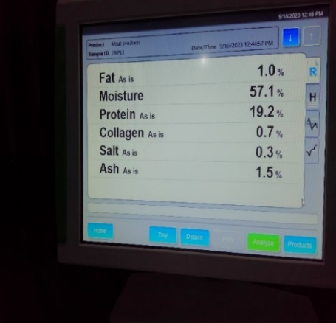

Proximate analysis (nutritional evaluation) of products by using Perkin Elmer NIR machine

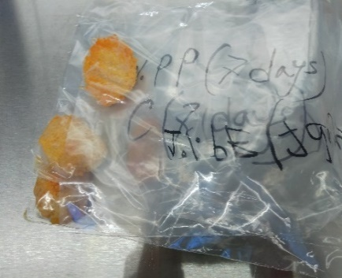 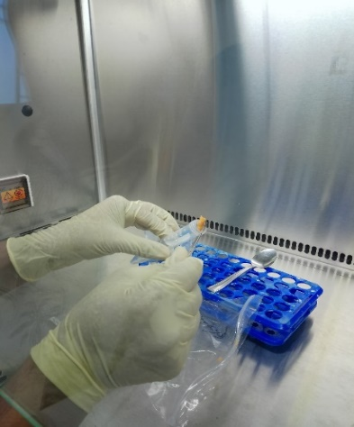 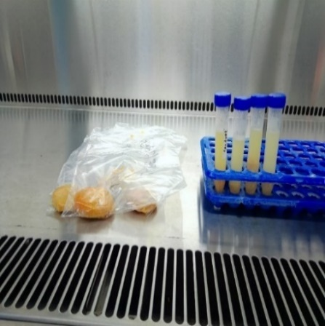 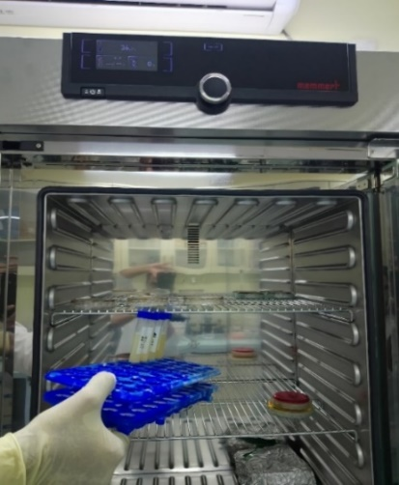

Shelf life observation of products by observing bacterial growth and bacterial identification

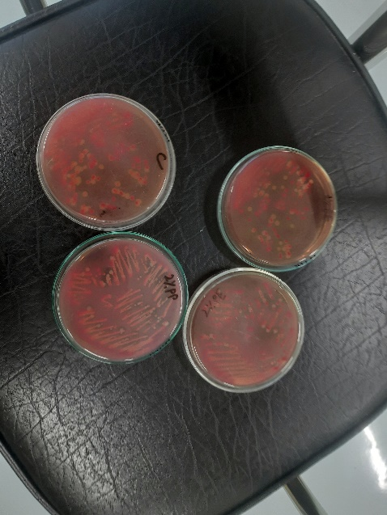 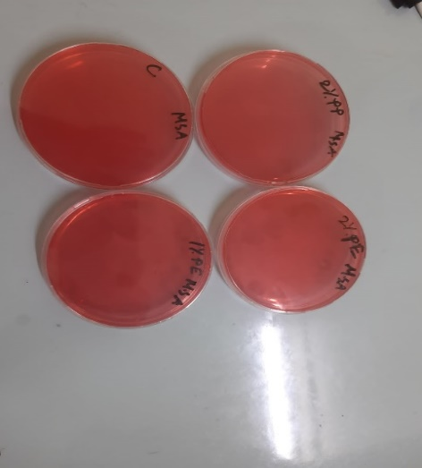 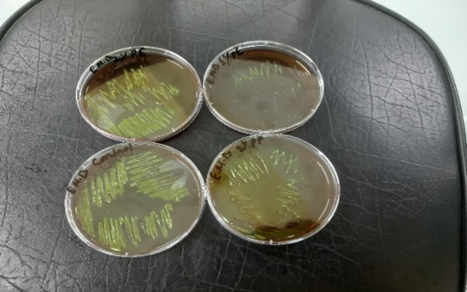

Incubation results of *E. coli* in EMB agar after 7 days

Incubation results of *Staphylococcus* in MSA after 7 days

Incubation results of *E. coli* in MacConkey agar after 7 days

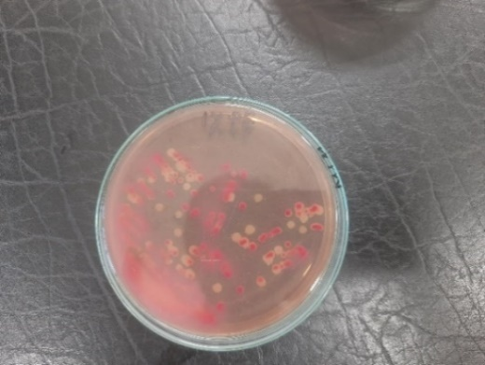 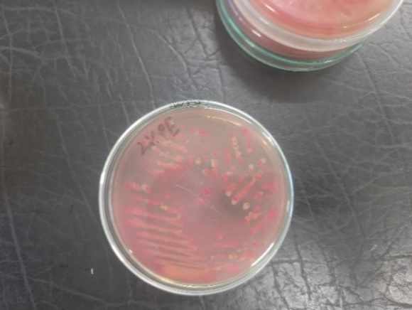 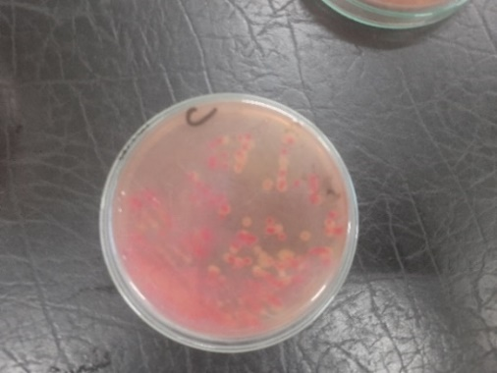 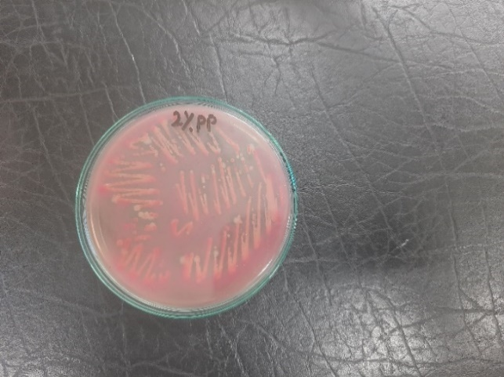

Incubation results of *E. coli* in MacConkey agar after 7 days

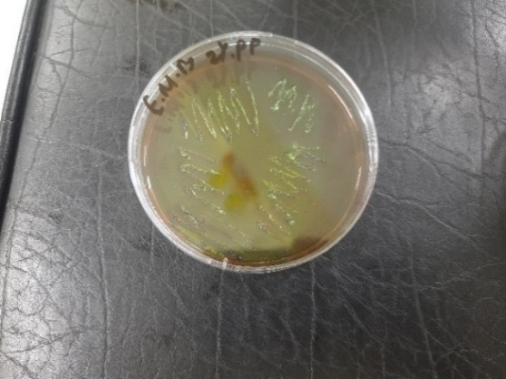 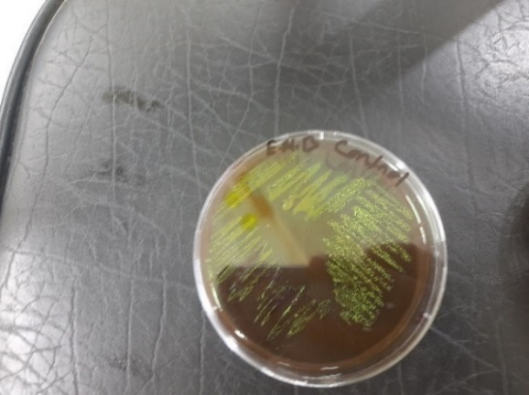 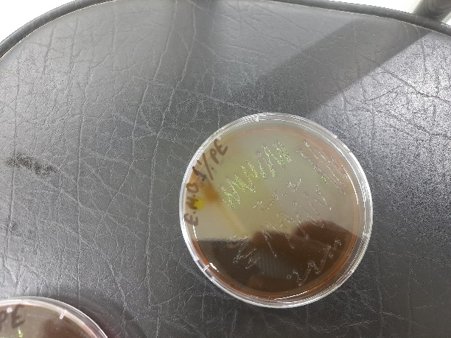 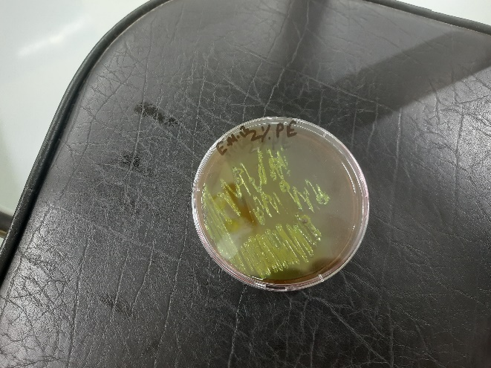

Incubation results of *E. coli* in EMB agar after 7 days

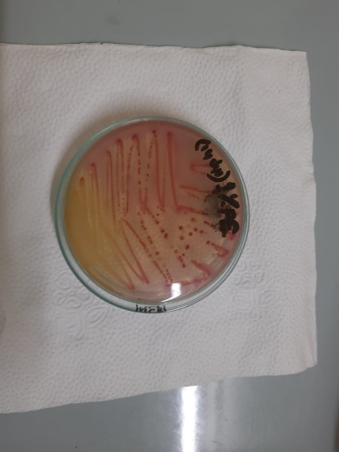 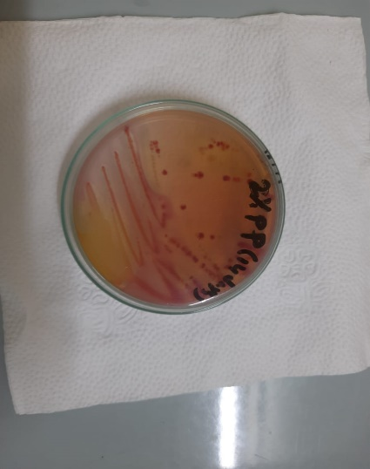 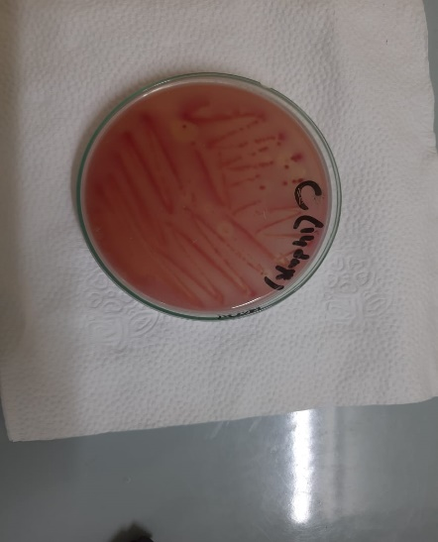 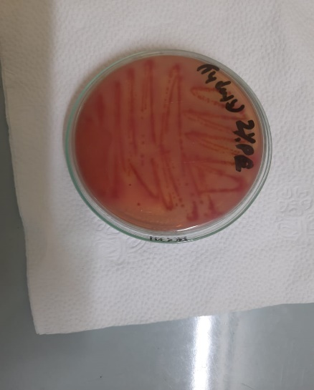

Incubation results of *E. coli* in EMB agar after 14 days

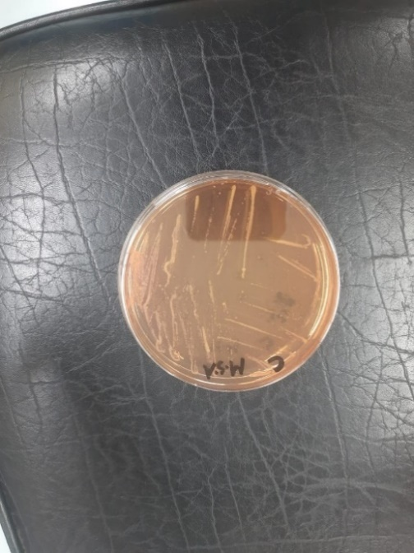 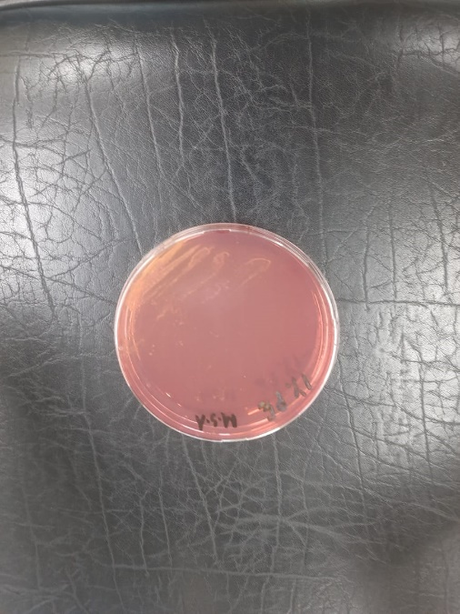 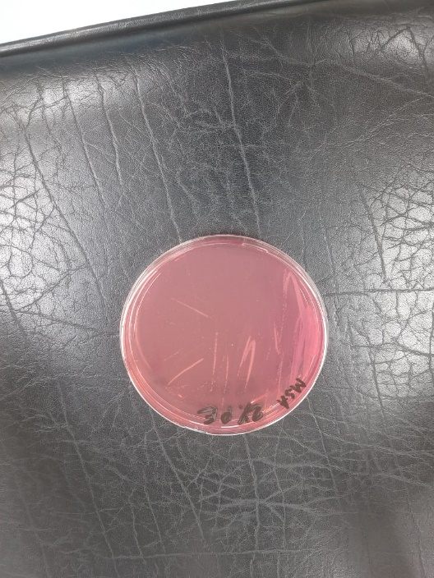 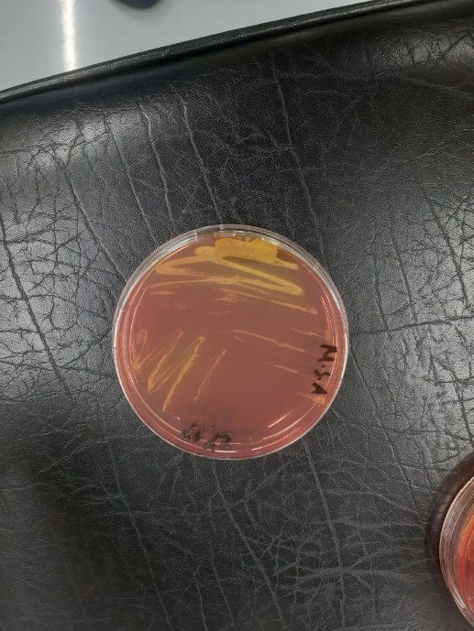

Incubation results of *Staphylococcus* in MSA after 14 days

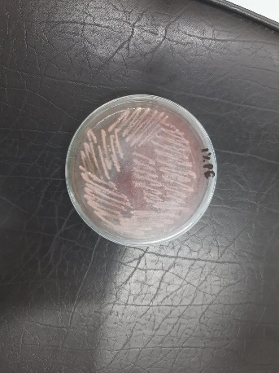 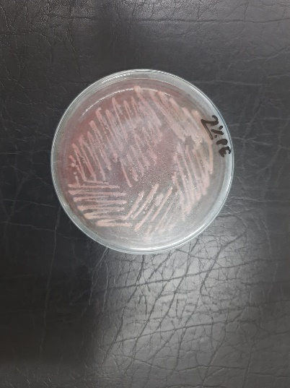 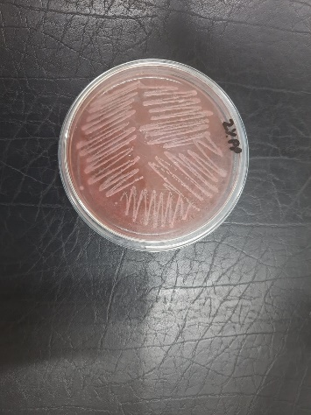 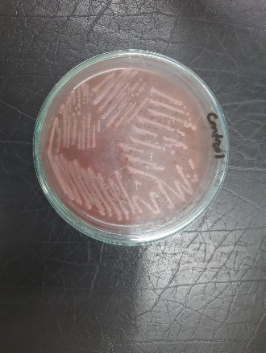

Incubation results of *E. coli* in EMB agar after 21 days

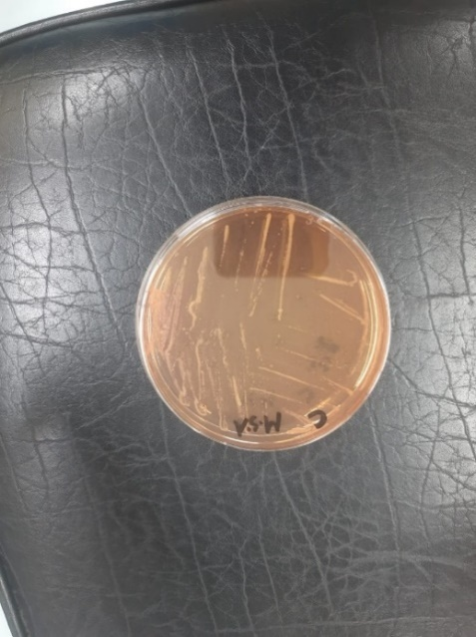 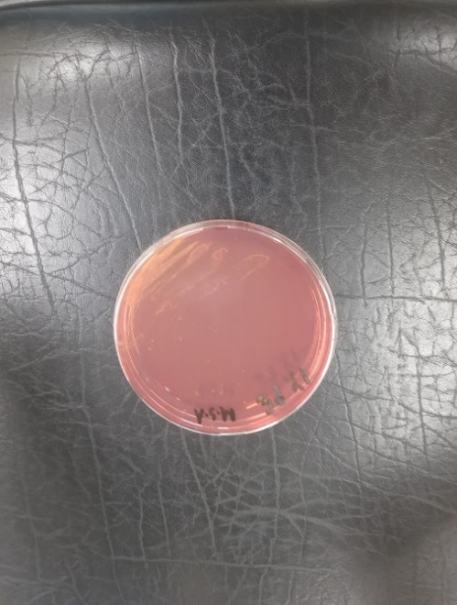  

Incubation results of *Staphylococcus* in MSA after 21 days

**Brief Biography**

At Rangamati Govt. Girls’ High School in Rangamati, Rupiya Chakma took the Secondary School Certificate Exam in 2013, and at Rangamati Govt. College, she passed the Higher Secondary Certificate Exam in 2015. She received her B.Sc. (Honors) in Food Science and Technology from the Faculty of Food Science and Technology at Chattogram Veterinary and Animal Sciences University in Chattogram, Bangladesh. She is currently a student at Chattogram Veterinary and Animal Sciences University (CVASU), where she is pursuing a Master of Science in Food Chemistry and Quality Assurance. She is extremely interested in working in the food industry, enhancing people's health through appropriate direction and advice, and raising knowledge of nutrition, food quality and food safety among the public.