CHAPTER III
MATERIALS AND METHODS
3.1. Location and duration of the study:
The study was conducted at Teaching Veterinary Hospital at CVASU from first July 2014 to 30th september 2014.
3.2. Sample size
The study was conducted on natural PPR infected goats of various age, sex and breed randomly over the study period. A number of cases were recorded in questionnaire. In those cases goats were randomly selected, examined, treated and follow up was taken in questionnaire.

3.3. Recording of signs and symptoms:
Different exposed signs and symptoms were recorded carefully by close inspection like erosion of oral mucosa, discharges from eyes, nose, mouth, rough coat, soiled hind quarter, anorexia, depression. Temperatures were recorded by indirect palpation per rectum by thermometer and every case tabulated. Indirect auscultation was performed to hear the lung and tracheal sound to coincide with the symptoms of pneumonia. Skin fold test were performed to take the rough estimation of the degree of dehydration. Presumptive diagnosis was made on the basis of the anamnesis and observed clinical signs and symptoms.

3.4. Criteria for diagnosis of PPR
In this study, population groups were divided in two, depending upon the early stage and later stage of clinical signs and symptoms. PPR consists of 5 phases of infection cycle as incubation period, prodromal phase, erosive phase, pneumonic phase, diarrhoea and death (BLRI, 1999). Here prodromal and erosive phase was considered as early stage and pneumonic phase and diarrhea as later stage of infection. Infected animal of early stage showed sharp rise of temperature (104°F-106°F), impaired appetite, depression, erected hair, serous nasal discharge, sneezing, congestive oral mucosa and later erosion in the lip, buccal mucosa, gum, dental pad, palate, tongue and nasal passage.

Whereas in later stage, the animal showed mucopurulent to purulent nasal discharge which may encrusted and matted over the mouth. Pneumonia, severe dyspnoea, diarrhoea with dark brown colored fluid faeces with necroting debrise streaked with blood. Temperature regresses with advancing dehydration and emaciation.
3.5. Postmortem examination:
Three dead animals were subjected for postmortem examinations. A PPR case was tentatively diagnosed if postmortem examinations revealed the presence of the changes: consolidated and pneumonic lungs, erosive and hemorrhagic enteritis, characteristics Zebra striping in the mucosa in the colon, necrosis and hemorrhagic plugs in the cecum. (Chauhan et al., 2009)
3.6. Presumptive diagnosis:
On the basis of anamnesis, clinical examinations sometimes supported with postmortem examination findings presumptive diagnoses of PPR cases were made.
3.7. Follow up treatment
Symptomatic treatments were given from the two hospitals in 3 major groups, listed in section 3.8. In addition to prescribing an antibiotic for every case antihistaminic and physiological saline were also recommended. The treatment of a PPR case continued until recovery or death of an animal if the owner brought the animal to the hospital in the subsequent days following registration to a hospital as a case of PPR.
The therapy regime was-
- Sulphadimidine (Diadin® ACI) @ 0.2 g per body wt. (3ml per 5 kg body wt.) in the first dose and ½ of the initial dose in subsequent days, Intravenously.
- Gentamycin, sulphonamide, streptomycin combination (Gentasone plus® Chemist) @ 10mg per kg body wt. (1ml per 10kg body wt.), Intramuscularly daily.
- Promethazine hydrochloride (Dellergen® Renata ) @ 10mg per kg body wt. (2ml per 10kg) IM daily.
- Riboflabin (Tab.Ribosin)@ apply localy after grinding.
- Intravenous fluid therapy(0.9% Sodium chloride solution)
3.8. Medication history:
Based on the medication histories all the PPR-affected goats were divided into three groups:
Group I: Goats receiving parenteral(I/V) sulphonamide with other symptomatic therapy.
Group II: Goats receiving parenteral(I/M) Gentamycin, sulphonamide, streptomycin combination with other symptomatic therapy.
Group III: Goats receiving parenteral (I/M) Ciprofloxacin with other symptomatic therapy.
A response to a treatment as the outcomes - recovery from the disease or death was the success or failure of a treatment given under any of the three groups mentioned above
3.9. Vaccination history of PPR:
Each owner was asked about previous vaccination history of his/her goat suffering from PPR
3.10. Statistical analysis:
The obtained data were stored and coded accordingly using Microsoft Excel-2007. The data were exported from MS Excel-2007 to STATA/IC-11.0 (Stata Corporation College Station) for analysis. The results were expressed in percentage with P-value for Chi- Square (χ²) Test. Significance was determined when P<0.05. The proportional prevalence of was estimated by the formula of Thrusfield (1995).

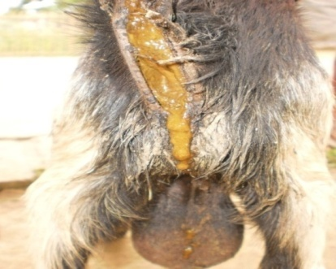
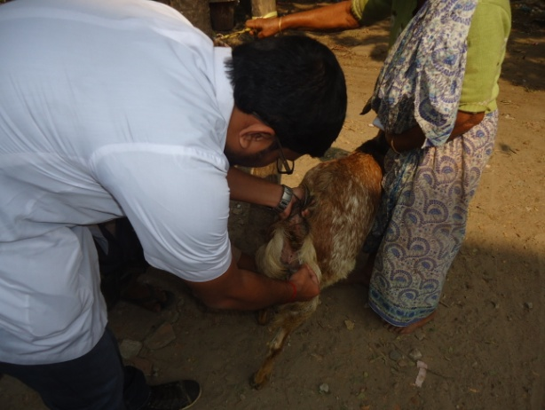

Fig 4: Recording of temperature Fig 5: Severe diarrhoea

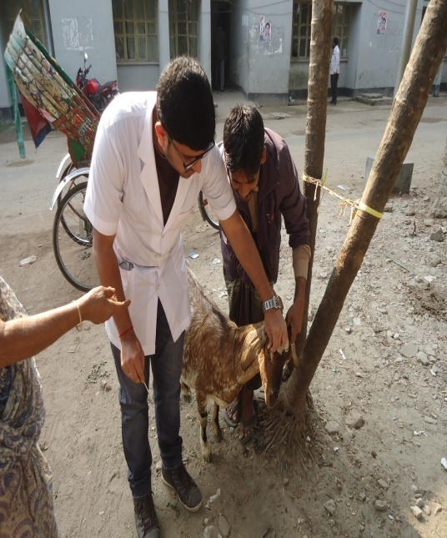
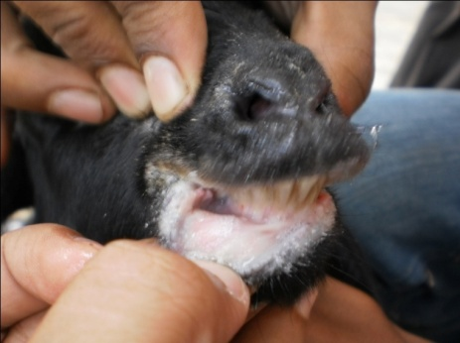

Fig 6: Erosion in lips, buccal mucosa Fig7: Skin fold test measuring dehydration

