A CLINICAL REPORT ON DIAGNOSIS, PREVALENCE AND TREATMENT ASSESSMENT OF PASTE DES PETITS RUMINANTS (PPR) IN GOAT AT SAQ TEACHING VETERINARY HOSPITAL
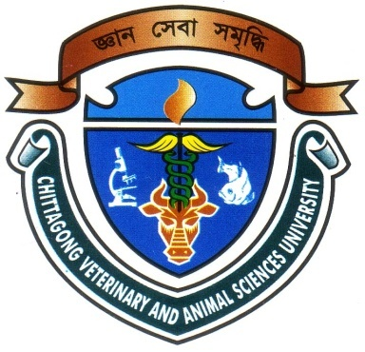

A Clinical Report Presented in Partial Fulfillment of the Requirement for the Degree of Doctor of Veterinary Medicine (DVM)

A Report submitted

By

Examination Roll No: 09/55

Registration No: 463

Intern ID: C-27

Session: 2008-2009

Faculty of Veterinary Medicine

Chittagong Veterinary and Animal Sciences University

Khulshi, Chittagong-4225
January, 2015
IV

A CLINICAL REPORT ON DIAGNOSIS, PREVALENCE AND TREATMENT ASSESSMENT OF PASTE DES PETITS RUMINANTS (PPR) IN GOAT AT SAQ TEACHING VETERINARY HOSPITAL

A Clinical Report Submitted as per approved style and content

--------------------------  (Signature of Author)  Saurav kumar ghosh  Roll No: 09/55  Reg.No: 463  Intern ID: C-27  Session: 2008-2009 | -------------------------------  (Signature of Supervisor)  Professor Dr. AMAM Zonaed Siddiki,  Department of Pathology  & Parasitology  Faculty of veterinary medicine

Chittagong Veterinary and Animal Sciences University

Khulshi, Chittagong-4225

January, 2015

