**Chapter-IV**

**PHOTO GALLERY**

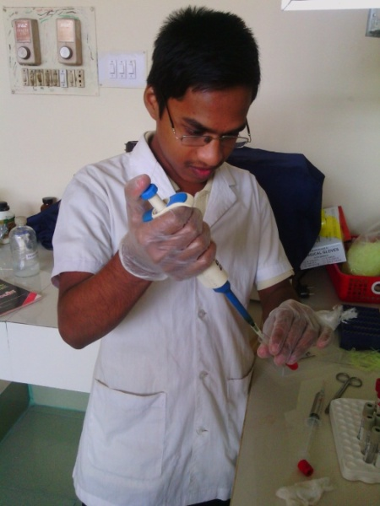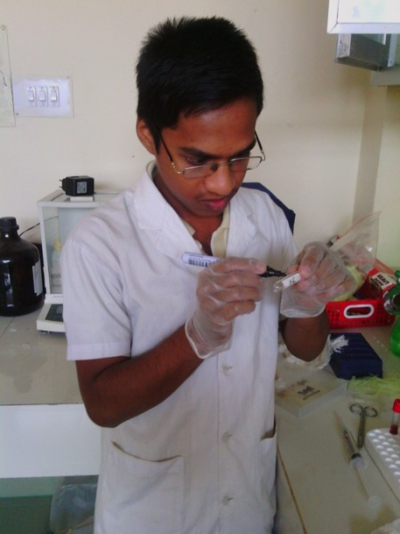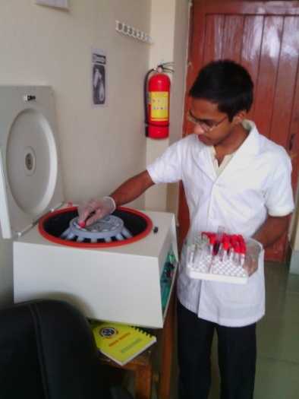

3

4

2

1

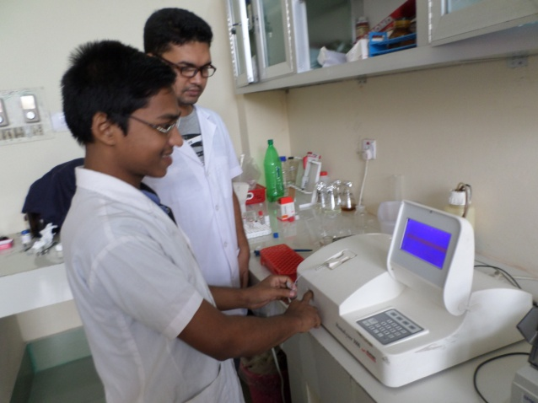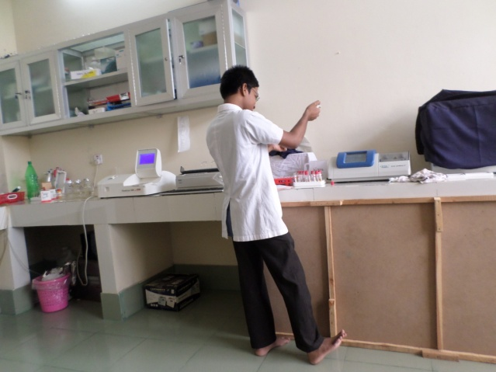

5

**Images:**

1. Separation of Serum 2. Numbering of Vial 3. Centrifugation of blood 4. Taking the analyzer reading 5. Working in the Biochemistry Laboratory.