Clinical Assessment of Metabolic Profile of Lactating Dairy Cows in Different Number of Lactations.

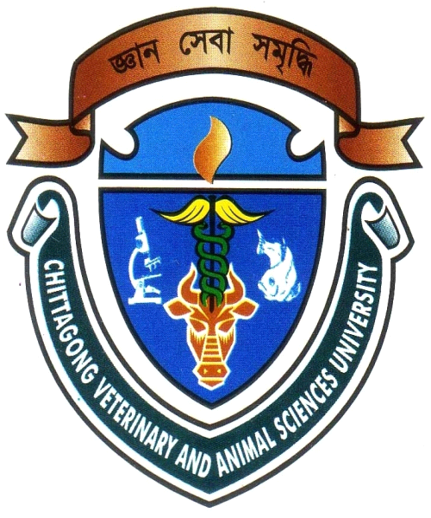

A Clinical Report Submitted by:
Internship ID: D-38
Roll No. : 08/104
Registration No. : 364
Session : 2007-2008

A Partial fulfillment of the requirements for the Degree of Doctor of Veterinary Medicine (D.V.M)

Faculty of Veterinary Medicine,
Chittagong Veterinary and Animal Sciences University,
Khulshi, Chittagong - 4225.

January, 2015.
Clinical Assessment of Metabolic Profile of Lactating Dairy Cows in Different Number of Lactations.

A Production Report Submitted As Per Approved Style and Content

…………………………………………
Signature of Supervisor
Dr. Sharmin Chowdhury
Associate Professor
Dept. of Pathology and Parasitology,
Chittagong Veterinary and Animal Sciences University.

…………………………………….....
Signature of Author
Mohammad Mahibullah
Intern ID: D-38
Roll No: 08/104
Registration No: 364
Session: 2007-2008

Date of Submission: 18-01-2015

