Chapter III
MATERIALS AND METHODS

3.1 Study area and study period
The study was conducted during June to December 2014 under the Department of Physiology, Biochemistry and Pharmacology, Chittagong Veterinary and Animal Sciences University (CVASU), Chittagong, Bangladesh. The farm shed was situated just opposite to physiology laboratory, east-north corner of the 2nd floor of academic building no-1, CVASU. The shed was experimentally selected due to its well planned management practices, intensive monitoring, easy convenience to regular data record and availability of specialized veterinarians.

3.2 Study design
An experimental case-control study had been undertaken to assess comparative efficacy on medicinal plant extract and synthetic antifungals for treating aspergillosis in broilers (Figure 1).
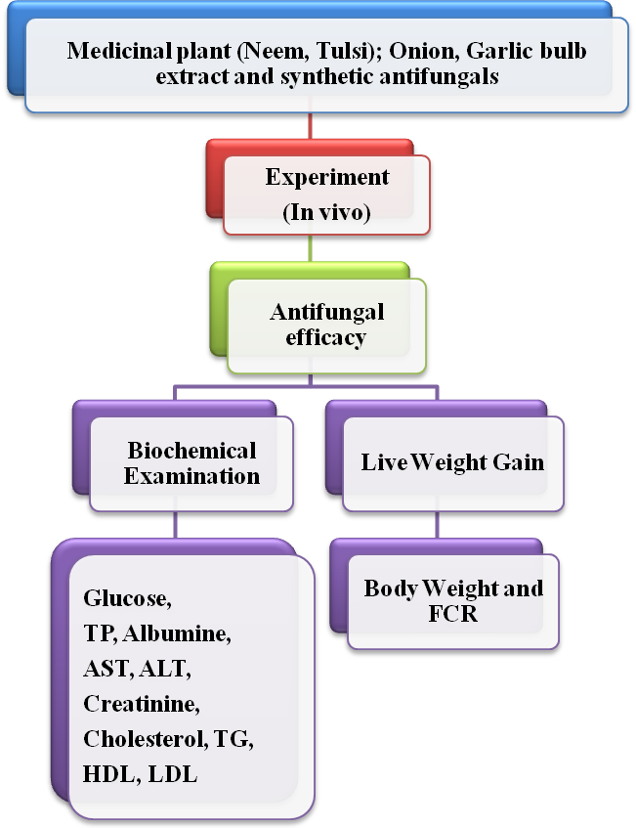

Figure 1: Flow chart of study design

3.3 Collection of plant materials
Fresh leaves of neem (Azadirchta indica A. Juss) and Tulsi (Ocimum tenuiflorum or Ocimum sanctum) were collected from the garden of medicinal plants, Chittagong Veterinary and Animal Sciences University. Fresh onion (Allium cepa) and one cell fresh garlic (Allium sativum) were collected from Bangladesh Agriculture Development Corporation (BADC), Kalurghat, Chittagong.

3.4 Drying, grinding and collection of bulbs
Collected plant leaves were thoroughly washed by cleaning and discarding all the unwanted materials and aged leaves. Then the leaves were air-dried for one week and further dried in oven at 100°C for ½ hours in order to remove moisture content of the leaves. Dust was prepared by pulverizing the dried leaves with the help of mortar and pestle. A 25-mesh diameter sieve was used to obtain fine dust and preserved them into airtight plastic bag until being used. On other hand, collected onion and garlic were peeled off all the membrane to elicit the bulb of the cell. After bringing out the bulbs, these were kept on airtight plastic container until being used.

3.5 Preparation of plant extract
60gm of neem leaves dust were taken into two 500ml beaker separately where one beaker consists of 35gm neem leaves dust and mixed with 385ml ethanol and another was 25gm neem leaves dust and 275ml ethanol (1gm:11ml). Then the mixture was stirred for 30 minutes by a magnetic stirrer (1000 rpm) and left for 45days. On other side, 16.5gm of tulsi leaves dust were taken into 500ml beaker on which all the dust were mixed with 363ml ethanol (1gm:22ml). Then the mixture was stirred for 30 minutes by a magnetic stirrer (1000 rpm) and left for 30days as usual. After that, all the mixture was filtered through Whatman no.1 filter paper separately. Then the filtered materials were taken into a round bottom flask of rotator vacuum evaporator and condensed by evaporation of solvent from filtrate in a water bath at 50°C for ethanol up to final volume of 5ml. After the evaporation of solvent from filtrate, the condensed greenish extracts were preserved in tightly corked-labeled bottle and stored in a refrigerator (4°C) until screening being performed for antifungal property.

3.6 Preparation of onion and garlic extract
Collected bulb of onion and garlic were cleaned and discarded the perished cells. About 250g onion bulb was taken into a mortar and grinded manually using pestle. Then, this sample was grinded through mixer grinder and squeezed aseptically by for collection of onion juice. After that, centrifuged (3000rpm) through the juice and collected the supernatant as onion bulb extract. This extract was taken into eppendorf tube and stored in a refrigerator (0°C) until screening being performed for antifungal property. Moreover, 500g garlic bulb was taken into a beaker and added 50ml distilled water in it. Then this sample was grinded from beginning to end by using mixer grinder and collected the juice of garlic bulb as an extract. After collection extract was kept in tightly corked-labeled bottle and stored in a refrigerator (0°C) until screening being performed for antifungal property.

3.7 Preparation of Aspergillus spp.
Aspergillus spp. was isolated from a former project which was conducted in the Department of Microbiology and Public Health, Chittagong Veterinary and Animal Sciences University, Chittagong. This fungus was inoculated into 5 broiler chicks (3 days old) through directly drinking Aspergillus containing water. After 2 days, 2 chicks were died and other 3 chicks showed symptoms like gasping, rapidly breathing, snoozing and drowsiness. On post mortem of dead chicks, “sagu” nodules were observed at lungs, air sac and pericardium. These samples were cultured into Saboured Dextrose Agar (SDA) (Oxoid). After incubation of plates for 3 days at 30°C, fungi, hyphal tips and spores were grown (Conner et al., 1992). Colonies were white at first but later turn green to dark green, flat and velvety. Pure cultures of Aspergillus spp. were obtained by transferring selected colonies from previously isolated medium and repeated sub-culturing according to Smalla et al., 1998. This isolated strain of Aspergillus spp. was used for experimental purposes of this study.

3.8 Antifungal efficacy
Experiment was performed on in-vivo antifungal trial of ethanol extracted neem and tulsi leaves; onion and garlic bulb extract comparing with synthetic antifungals (0.1% CuSO₄, Nystatin Sulphate; Nystat®- ACME Laboratories, Bangladesh) in broilers and their effect on meat and certain biochemical parameters.

3.8.1 Reference population
Broilers of Chittagong district were considered as a reference population.

3.8.2 Source population
Day old chicks (Cobb-500) of M. M. Agha Poultry (Raufabad, Oxygen, Chittagong) were used as a source population.

3.8.3 Selection of chicks as study population
A total of 150 day old “A” grade healthy chicks (Cobb-500) were purchased from M. M. Agha Poultry as pre-contract basis for this study.

3.8.4 Management of chicks
After purchasing these chicks were placed in a chick guard (brooding house) for 11 days. On brooding period, temperature was maintained as 95°F and Humidity was 65% for 1st week. On next week, temperature was 88-90°F and Humidity was 70%. They were provided commercially available starter feed (M. M. Agha Poultry) for 13 days (2950 Kcal/Kg ME; 22.7% CP). After 11 days, these grower chicks were housed into cages according to their groups of treatment intervention. From 14 to 26 days, they were given manually mixed mash feed where present 3080 Kcal/Kg ME and 21% CP. After 26 days, they were again provided the readymade pellet feed (Anchor Special, Elia feeds Ltd, Sector-9, Uttara, Dhaka) which containing 3050 Kcal/Kg ME and 22% CP. Appropriate vaccination schedule was maintained against different viral diseases. According to vaccination schedule, during purchasing the chicks were sprayed by Marek’s vaccine; on Day 3, BCRDV (DLS, LRI, Mohakhali, Dhaka) were given as eye drop which was boostered on day 22. On Day 11, Gumboro vaccine, BAU 404 strain (DLS, LRI, Mohakhali, Dhaka) was also dropped on one eye of every chicks. Everyday ad libitum water mixed with various vitamins (Vitamin B₁, B₂, B₆, B₁₂, C, A, D₃, E, K₃); minerals (Ca, P, Se, Zn, Nicotinamide); electrolytes (Na, K), enzymes (Calphozyme®), phytozyme, probiotics (Flavomycin), extract of Yucca schidigera (Yuka®- Opsonin Pharma Ltd., Barisal), glucose, saline were provided alternatively to those chicks, grower and broiler. No antimicrobials, anticoccidials, salmonils, toxinils were used during the study period of farming.

3.8.5 General monitoring task
All chicks were cautiously handled from the very beginning of starting the farm. Mainly the chicks were placed into its chick guard at the period when the temperature is not too hot or nor too cold, mainly at dawn or dusk. Especially late autumn (not autumn, not the winter) was the period in which the study was performed. On the brooding period, the chicks were monitored every two hours interval, checked the temperature and humidity of chick guard. The floor of chick guard was maintained by rice husk and paper materials. The paper containing droppings were removed by changing the paper every twelve hours interval for first 5 days of brooding. From 6 to 11 days, only rice husk was used as litter material and it was maintained by changing the layer of the litter on every 24 hours interval. After 11 days, chicks were housed in cages according to their group. From 11 to 21 days, the droppings of the birds were carefully removed by washing the tray once in a day and after 21 days; trays of the cages were washed twice in a day. Birds were excreted a lot of nitrogenous substances and these nitrogenous substances are converted to ammonia which irritated respiratory tract of birds. As a result, birds were infected to various organisms, felt discomfort and consumed less amount of feed. So, proper ventilation was maintained for comfort of the birds. The research was going so smoothly that, no infected organism was attacked to the farm at brooding stage. But it was regretful to state that, 2 birds were died at day 7 due to crop impaction. Post mortem findings were indicated as too much feed was accumulated at crop and the birds were died due to asphyxia. At day 13 and 16, two birds were died due to confining the birds into cages. Congested lung in post mortem lesion indicated that birds were died due to suffocation.

3.8.6 Treatment intervention
The seven bird groups (T₀-T₆) designed as follows (Figure 2). Each bird group consists of 21 birds (except T₃ or Neem group on which having 20 birds).
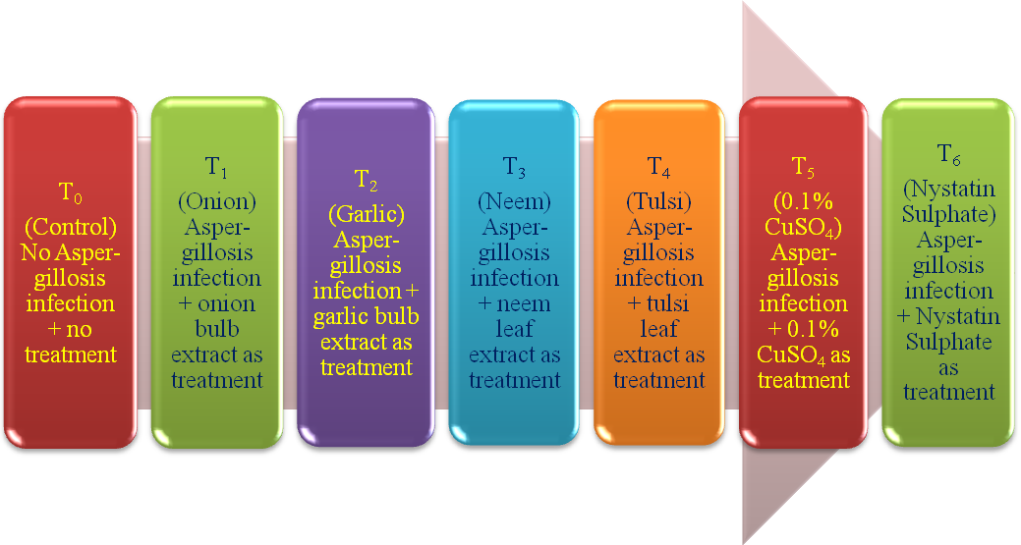
Figure 2: Layout of treatment intervention

3.8.7 Introducing infection
The infection of Aspergillus spp. was introduced to all birds (T₁ to T₆ group) through feeding (mash feed) and direct drinking of Aspergillus spp. containing water. On feed, infection load was 0.2g/kg feed. It was provided to all birds (except control) at day 16 whole mash feed. On that day, in total 12 kg feed was given to the birds which wanted to be infected (control excluded). 2kg fresh feed was provided to 21 birds of control. On water, 0.1g Aspergillus spp. was mixed with 80ml distilled water and 4 drops (0.25ml) water was dropped onto the mouth cavity of all birds (T₁ to T₆). At day 20, re-infection of Aspergillus spp. was introduced through drinking different concentration of Aspergillus spp. containing water. Different concentration means high concentration as 0.22g/80ml distilled water, medium concentration as 0.17g/80ml distilled water and low concentration as 0.12g/80ml distilled water. On each group, 21 birds were divided into 3 sub-groups where high (red colored tarsal), medium (black colored tarsal) and low (colorless or yellow colored tarsal) concentrations of Aspergillus spp. were ingested.

3.8.8 Monitoring after infection
Aspergillosis is a production hampering contagious disease. It deteriorates the health and growth of broiler. The incubation period of Aspergillus spp. (in vivo) is 4-7 days. Mainly 17-23 days old grower chicks are infected to this disease. The symptoms aspergillosis infected broilers are gasping, suffocation, dyspnoea, coughing and mucus through nostrils. The infected birds are sitting silently other than normal birds, does not want to ingest feed and having huge thirst-that’s why they want to drink extra drinking water. Post mortem findings are whitish/yellowish “sagu” nodules at lungs, air sac, pericardium, heart and other different organs; congested lung. Ascites is another lesion which found at chronic stage of infection. It was very regretful that, at day 20, one bird of T₃ (neem) group was died due to suffocation and mucus at nostrils where post mortem lesion was congested lung. At day 27, another bird of T₂ (garlic) group was died. Post mortem findings of that dead bird were ascites (accumulation of huge water at abdomen), fragile heart, congested lung, enlarged spleen and cyst at liver. It was monitored that except T₀ (Control) group, almost all the birds of T₁ to T₆ group were taking breath through gasping, felt suffocation, abruptly taking huge water. Body growth was retardated due to less amount of feed ingestion. On every group, 3 different sizes body growth was reflected (maximum, average and minimum). Average body growth was observed in control group birds.

3.8.9 Treatment and post monitoring
After showing sign-symptom, treatment was started from 22nd day age of the birds. In control group, as there was no infection so no treatment intervention was followed. Other groups (T₁ to T₆), birds were treated according to their treatment lay out. On every group 3ml drugs (plant extracts and synthetic antifungals) were administered through water of night. Following the treatment, the birds were feeding normally, weight regained to average and turned to diminish the sign-symptom of aspergillosis. This treatment was continued up to 27 days of the growth of broiler.

3.8.10 Collection and preservation of sample
On day 18 (after infection exposure), day 25 (during treatment period) and day 30 (post treatment period) blood sample was collected for biochemical assessment particularly to evaluate Glucose, TP, Albumin, lipid tests (HDL, LDL, TG, Cholesterol) liver function tests (ALT, AST) and kidney function test (Creatinine). Mainly, Blood sample was collected from jugular vein/ wing vein of 3 birds of each group; 1.5ml blood placed into vacutainer without containing anticoagulant. Individual blood sample without EDTA on each vacutainers were given unique identity number and group name. After collection, samples were immediately transferred to research laboratory of CVASU for serum separation and biochemical assessment.

3.8.11 Drug efficacy through weight measurement and FCR calculation
Every chick was weighed initially while they were placed into the chick guard at day 1. To check the appropriate growth, randomly 15 chicks (10%) were again weighed at day 5 and day 10. After placing the chicks into cages, on every day in the afternoon 5 random birds of each group was weighed. Feed Efficiency or Feed Conversion Ratio (FCR) is the unit of feed consumed per unit weight increase.
Unit of feed consumed
Feed efficiency or FCR =
Unit of weight increased

3.8.12 Separation of serum
Approximately 1.5ml of blood was aseptically collected from jugular vein via venipuncture by proper restraining of birds. Collected blood samples were kept in vacutainer without anticoagulant for smooth coagulation. After 24 hours the coagulated blood sample was centrifuged using portable centrifuge for 20 minutes at 3000 rpm. Obtained serum samples were shifted to the eppendorf tube by using micropipette and given unique identification no. The obtained serum samples were stored in -20ºC until analysis for biochemical test.

3.8.13 Biochemical assay of serum sample
Proper aseptic measures were done at the time of serum analysis in the laboratory. Serum and all reagents were thawed by keeping at room temperature approximately 30minutes before the analysis. The serum samples were vortexed for mixing component of serum uniformly. The Serum Glucose, Total Protein (TP), Albumin (Alb), Triglyceride (TG), Cholesterol, HDL, LDL, AST, ALT, Creatinine were assayed by using automated Biochemical analyzer (Humalyzer-3000, Germany) according to directions provided by the manufacturer of kit. Randox kits were used to determine glucose, TP, Alb, TG, Cholesterol, AST, ALT, Creatinine; Biorex kits for HDL, LDL. A total number of 63 serum samples were analyzed (21 in each lot as described in blood sampling protocol).

3.8.13.1 Carbohydrate assay (Serum Glucose)
Colorimetric spectrophotometric methods were used for determination of glucose Concentrations (Barham and Trinder, 1972).

3.8.13.2 Total Protein assay
Colorimetric spectrophotometric methods were used for determination of albumin and total protein (Doumas, 1975).

3.8.13.3 Albumin assay
Albumin is based on the principle of competitive bindings between albumin and albumin reagent. Bromocresol green forms with albumin in citrate buffer a colored complex. The absorbance of this complex is proportional to the albumin concentration in the sample.

3.8.13.4 Lipid profile

3.8.13.4(a) Cholesterol assay
Colorimetric spectrophotometric methods were used for determination of cholesterol concentrations (Roeschlau et al., 1974).

3.8.13.4(b) Triglyceride assay
Triglycerides were determined after enzymatic hydrolysis with lipases. The indicator is a quinoneimine formed from hydrogen peroxide, 4- aminophenezone and 4- Chlorophenol under the catalytic influences of peroxidease.

3.8.13.4(c) LDL assay
LDL is based on the principle of competitive bindings between LDL and LDL reagent. Low density lipoproteins are precipitated by the addition of heparin at their isoelectric point (PH 5.04). The HDL and LDL remain in the supernatant and can be determined by enzymatic methods.
LDL Cholesterol = Total Cholesterol – Cholesterol in the supernatant. The absorbance of this complex is proportional to the LDL concentration in the sample.

3.8.13.4(d) HDL assay
Low density lipoprotein (LDL and VLDL) and chylomicron fractions are precipitated quantitatively by the addition of phosphotangstic acid in the presence of magnesium ions. After centrifugation, the cholesterol concentration in the HDL (high density Lipoprotein) fraction, which remains in the supernatant, is determined.

3.8.13.5 Liver function tests [Aspartate aminotransferase (AST) and alanine aminotransferase (ALT)]
AST and ALT activity was determined according to the method described by Reitman and Frankel (1957).

3.8.13.6 Creatinine concentration
Creatinine was determined by the method described by Husdan and Rapoport (1968).

3.9 Statistical analysis
Data were entered into a spread sheet of MS Excel-2007. The data were sorted, cleaned and coded using the excel program before exporting to STATA-11 (STATA Corp, USA) for analysis. A one way ANOVA (Analysis of Variance) and student t-test were performed to compare the result of different groups according to weight and biochemical parameters. p values of ≤0.01 and ≤0.05 were considered statistically significant.

