**ASSESSMENT OF BIOCHEMICAL ALTERATION OF ASPERGILLOSIS AFFECTED BROILERS TREATED WITH MEDICINAL PLANT EXTRACTS AND SYNTHETIC ANTIFUNGALS**

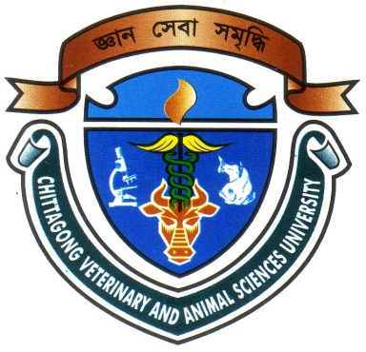

**Report presented in partial fulfillment of the requirement for the degree of Doctor of Veterinary Medicine.**

|  |
| --- |
| A Report Submitted by  Roll no.: 09/05  Intern ID No.: A-01  Reg. No.: 417  Session: 2008-2009 |

**Faculty of Veterinary Medicine**

**Chittagong Veterinary and Animal Sciences University**

**Zakir Hossain Road, Khulshi, Chittagong-4225**

**January, 2015**

**ASSESSMENT OF BIOCHEMICAL ALTERATION OF ASPERGILLOSIS AFFECTED BROILERS TREATED WITH MEDICINAL PLANT EXTRACTS AND SYNTHETIC ANTIFUNGALS**



**e**

**Clinical Report Submitted as per approved style and content**

**--------------------------------------------- ---------------------------------------------**

|  |  |
| --- | --- |
| Signature of the student  **(Mohammad Rostum Ali)**  Roll No: 09/05  Reg. No: 417  Intern ID: A-01  Session: 2008-2009 | Signature of the supervisor  **(Dr. A. K. M. Saifuddin)**  **Professor and Head**  Dept. of Physio., Biochem. and Pharmacology  Faculty of Veterinary Medicine  Chittagong Veterinary and Animal Sciences University |

**Faculty of Veterinary Medicine**

**Chittagong Veterinary and Animal Sciences University**

**Zakir Hossain Road, Khulshi, Chittagong-4225**

**January, 2015**