CHAPTER-I
1. INTRDUCTION
The skin is the largest organ of the body with many different functions as thermoregulation, immune protection, sensory perception, vitamin D production and it acts as a barrier between the animal and the environment. Besides all of these important functions and the diseases that affect directly the skin, it may also share or reflect pathologic processes from other tissues. Due to these characteristics, dermatologic problems are among the most commonly seen disorders in veterinary hospitals. Dogs suffer from many problems which effect their skin. It is important to understand that the skin is an organ, just as the liver and kidneys are organs. Good health and proper function of the skin is dependent on the health and function of the other organs which make up our dog’s bodies. Diseases which effect the skin can be placed into one of two categories: primary and secondary skin disease. Primary skin diseases are those which effect the skin directly, such as mange or flea and tick hypersensitivities. Secondary diseases are those which initially involve other organs and thereby effect the skin, such as hypothyroidism. Healthy dogs do not easily develop skin infections. The cutaneous barrier and the immune system are pillars of a very effective host defence system. If an infection takes place, either one or both of these are defective. Physical trauma is the most common reason for compromised barrier function and frequent consequences of such trauma are abscesses and deep tissue infections. Diseases such as atopic dermatitis in dogs or severe malnutrition with deficient intake of fatty acids may all compromise the cutaneous barrier. The immune system may not be completely matured in puppies and young dogs, facilitating diseases such as impetigo, particularly when nutrition is suboptimal or severe endoparasitism occurs. Stress may also be immunosuppressive and in some animals can contribute to the development of skin infections. Immunosuppression due to endocrine diseases such as hypothyroidism is seen in middle-aged to older dogs. Despite this multitude of possible predisposing factors, the most common causes for secondary bacterial infections in small animals are hypersensitivities.

Skin diseases were identified by inspection and further examined for more precise diagnosis to categorize the nature of the disease whether it might be bacterial/viral/fungal/parasitic. Needle puncture was also performed if required. Temperature, pulse, respiration were taken through other scientifically clinical method. The dermatological signs were classified into one of the following categories with minor modifications: alopecia, scaling or crusting, erythema, macular, popular or pustular eruptions, otitis, draining tracts and non-healing wounds, erosive or ulcerative lesions, pigmentary abnormalities, nail disorders, ectoparasites observed by the owner or the clinician, cutaneous swellings and thickening of the foot pads. All masses and swellings involving the skin were classified as dermatological, apart from mammary tumors and swellings that clearly involved other body systems (such as joint effusions or dental abscesses).

Several clinical studies have indicated that dermatological disorders make up a large proportion of the small animal patients. It has been estimated that from 20% to 75% of the cases seen in the average small animal practice have skin problems as a chief or concurrent owner complaint. There is certainly inconsistency among these various studies. For instance, in the methods of describing different types of skin disorders.. In this report small animal consultations in general practice that were observed and recorded, 44 animals involved that had a dermatological problem. Marked differences were noted in the frequency of the most common skin disorders. . It was revealed that 35 dogs are adult. Out of 35 dogs 22 dogs are male and 13 dogs are female. Total 9 puppies were brought. Out of 9 puppies 5 are male and 4 are female. The dogs were categorized with 0-2 years, 2-3 years and more than 3 years. Mostly the older aged dogs were affected with different diseases (50%), 0-2 years aged dogs (18.18%),2-3 years (31.81%). overall prevalence of diseases on male and female were similar (Male 50% and Female 50%). Males were mostly infested with ectoparasites (tick, mite, fly, flea) and affected with demodecosis, hard mass, pustules, erythrymatous lesion. On other hand, females were infected with tick and mite infestation, alopecia, pyometra, Maggot wound, Corneal itching etc.Canine skin disorders like bacterial and allergic dermatitis, neoplasia, ectoparasitism and immunemediated dermatitis were found to be the most commonly diagnosed dermatological problems. However, parasitic infestations, bacterial infections and neoplasia were accounted for the majority of the diagnoses in India. Overall, in dogs, flea infestations, bacterial infections, allergic skin diseases have been reported as the most dermatological conditions. Native/Non descriptive breeds were mostly infected with various skin diseases (36.36%). Tick infestation, Pyometra were more prominent and more frequently observed on that breed. Other affected dogs were Pug (11.36%), Spitz (11.36%), Boxer (9.09%), Pekingese (6.81%), Doberman (4.54%), Dalmatian (4.54%), Dachshund (4.54%).

OBJECTIVES
The specific objectives of the study are as follows:
- To study the prevalence of skin diseases of dog presented in Madras Veterinary College, India .
- Classification of skin diseases on the basis of age,sex and breed.
- To study the prevention and treatment strategy of skin diseases of dog in Madras Veterinary College, India

CHAPTER-II
2. REVIEW OF LITERATURE
Review of literature gives the guidelines from the past researchers and provides a foundation to the theoretical framework for present investigation. The review of past literature makes the investigator to get an insight into the methods and procedures to be followed. The following discussion that studies conducted so far mostly focused on cost and returns, in some areas with productivity, re-productivity and some management aspects. Researches dealing with performance of such information is not limited in number. However some of the studies, which are more relevant to the present study, are given below-
The risk of zoonotic infection by canine intestinal parasite may be high in Bangladesh (Tarafder and Samad, 2010).
On recurrent pyoderma, dogs with a history of more than three episodes of skin infections in a period of one year were selected. The associated conditions and (or) underlying factors revealed upon thorough investigation were demodicosis, Malassezia dermatitis, flea infestation, hypothyroidism, keratinization disorder (seborrhea), combination of Malassezia dermatitis and tick infestation, and a combination of scabies and tick infestation. Therapy was given with cefpodoxime with clavulanic acid along with appropriate simultaneous medication for the underlying associated conditions. In all the cases response to therapy was excellent. Improvement was noticed by 9 to 19 days and 17 to 21 days in recurrent superficial and deep pyoderma, respectively. In one dog, relapse occurred by 45 days due to the associated condition of hypothyroidism which was confirmed through laboratory findings. Cefpodoxime with clavulanic acid proved to be an effective, safe, and convenient antibiotic for the treatment of recurrent pyoderma in dogs without any side effects (Sudhakara Reddy et al., 2014).
Adult ticks were found throughout the year, but immatures were absent in January and February. The adult tick population increased from July to August, whereas the load of immatures increased in early July and peaked in September, which suggests that R. sanguineus develops one generation per year in this area. The mean number of immature ticks per infested dog was higher than that of adults from March to October 2008. Ears, interdigital areas and armpits were the most frequent attachment sites of adult ticks. At the last follow-up, a total of 2266 ticks were collected and identified as R. sanguineus. The results suggest that R. sanguineus develops one generation per year in the study area, but that it infests dogs in all seasons. This information should be taken into account when planning control programmes against this tick species and the pathogens it transmits. (Lorusso et al., 2010).
The most common forms of external parasites of dogs are usually lice, fleas, ticks and mites. This study recorded 11.88% dogs infested with ticks, 9.84% with flea, 0.90% with lice and 3.76% with different types of mange. It appears that all age groups of dogs are affected with lice, tick, flea and mites but only mange mites showed significantly (p > 0.05) higher prevalence in dogs above 36 months (2.34%) in comparison to aged between 7 to 36 months (1.36%) and up to 6 months (0.05%) age groups.(Tarafder and Samad, 2010).

However, higher prevalence rate of fleas and mange mites have been reported elsewhere (Rodriguez-Vivas et al., 2003; Durden et al., 2005) who reported Demodex canis (23.0%) as a most frequent mite, followed by Sarcoptes scabei var canis (7.0%) and Otodectes cynotis (3.5%) in Mexico. Seasonal frequency of ectoparasites infestations has also been reported (C. E. Desch et al., 2008).

Canine cyclical flank alopecia (CFA), also referred to as seasonal flank alopecia, recurrent flank
alopecia, and flank alopecia, is a rare dysplastic disease that occurs predominantly at the lateral flank folds .Affected dogs normally demonstrate, during consecutive years, loss of hair coat at the end of autumn, with spontaneous regrowth by spring . Clinically, CFA is characterized by bilateral symmetrical alopecia and altered quality of the hair coat, which may be darker or lighter than normal, and is normally dry, dull, and dishevelled . Manifestations of the disease are more frequently observed at the folds of the lateral flank , but the dorsal midline, the cranial ribcage, and auxiliary locations may also be affected . Characteristic histopathological findings of biopsy specimens from affected animals confirm the diagnosis after the participation of hormonal-based diseases has been excluded (BASSETT et al., 2005).

The distribution and prevalence of tick infestations of domestic dogs in Great Britain were examined. A total of 173 veterinary practices were recruited to monitor tick attachment to dogs in their local areas between March and October 2009. Practices selected five dogs at random each week from those brought to the surgery and undertook a thorough, standardized examination for ticks. Each veterinary practice participated for 3 months before being replaced. Any ticks identified were collected and a sample sent to the investigators for identification, along with a clinical history of the dog. A total of 3534 dogs were examined; 810 dogs were found to be carrying at least one tick. Ixodes ricinus (Linnaeus) (Acari: Ixodidae) was identified in 72.1% of cases, Ixodes hexagonus Leach in 21.7% and Ixodes canisuga Johnston in 5.6% of cases. Five samples of Dermacentor reticulatus (Fabricius) (Acari: Ixodidae) were also found, adding to the growing evidence that an established population of D. reticulatus now exists in south-eastern England. Almost all the ticks found were adults. Overall, 19.2% of the veterinary practices reported no tick detections, 50% reported that ≥14.9% of the dogs seen were infested and 14.6% reported that >50% of the dogs inspected carried ticks. The estimated incidence of tick attachment was 0.013 per day in March (lowest) and 0.096 per day in June (highest). A number of risk factors affected the likelihood of tick attachment on dogs. Gundog, terrier and pastoral breed groups were more likely to carry ticks, as were non-neutered dogs. Dogs with shorter hair were less likely to have ticks, and dogs were most likely to carry a tick in June. This study is of value because, unusually, it presents the results of a randomized sample of dogs and gives a prevalence which is higher than those previously recorded in Great Britain (F. D. Smith et al. 2011).

Tick-borne diseases are common occurrences in both the medical and veterinary clinical settings. In addition to the constraints related to their diagnosis and clinical management, the control and prevention of these diseases is often difficult, because it requires the disruption of a complex transmission chain, involving vertebrate hosts and ticks, which interact in a constantly changing environment. We provide a contemporary review of representative tick-borne diseases of humans and discuss aspects linked to their medical relevance worldwide.Finally, we emphasize the importance of a One Health approach to tick-borne diseases, calling physicians and veterinarians to unify their efforts in the management of these diseases, several of which are zoonoses. (Filipe Dantas-Torres et al. 2012).

P B Hill, of the Royal School of Veterinary Studies, University of Edinburgh, a specialist in veterinary dermatology, states that skin diseases ‘show striking breed predilections.’30 In Hill’s textbook, Small animal dermatology. A practical guide to the diagnosis and management of skin diseases in dogs and cats (2002), breed related skin diseases are listed for 56 dog breeds plus the Persian cat The textbook by (Jennings S 1953) , tells us that the Cocker and Springer Spaniels, West Highland White Terrier, Basset and Shar Pei are predisposed to seborrhoea, a disease that is initiated by overproduction of the skin’s sebaceous glands. Starting with mild scaling, the disease progresses to dry generalized seborrhoea in the Irish setter and Dobermann and to greasy, smelly skin with itchy patches in the Cocker Spaniel, West Highland White Terrier, Basset Hound and Shetland Sheepdogs are predisposed to dermatomyositis, an ulcerative dermatitis that causes very painful lesions in the groin and axilla (corresponding to the human armpit) and sometimes in the eyelids, mouth, anus and external genitalia. (P B Hill et al. 2002)

According Mueller, Boxers have an increased risk of 5.8 times for allergic skin disease and an increased risk of 4.3 times for food hypersensitivity. Golden Retrievers have an increased risk of 2.3 times for both allergic skin disease and pyotraumatic folliculitis (‘hotspot’ or ‘wet eczema’). The Old English Sheepdog, which is bred to have copious fur on its feet, has a increased risk of 28.9 times for pododemodicosis (a skin disease caused by infection of the feet with the Demodex mite).These established facts of the greatly increased risk of skin disease for some pedigree dogs underline the need to reform breedstandards and breeding practices. In particular, breed standards that require or encourage skin folds clearly damage the welfare of the dogs and cannot be justified(Mueller et al.2003)
Canine demodicosis is a dermatologic disease that occurs when mites colonize the hair follicles and sebaceous glands . Demodex canis was the main causative agent of canine demodicosis and it is characterized by the presence of large numbers of Demodex mites. The three recognized canine Demodex mites are Demodex canis, Demodex injai, and Demodex cornei . Scabies is a transmissible andzoonotic ectoparasitic skin infection caused by tiny mites of the species Sarcoptes scabiei. It is transmitted readily among the animals, often even throughout an entire household, by skin to skin contact. The parasite commonly affects young dogs and dogs with poor nutrition but can affect healthy dogs that are exposed to the mites.( D.W. Scott et al.,)

CHAPTER-III

3. MATERIALS AND METHODS
3. 1. Area and Study Population
Chennai is a district which is situated at the north of the Tamil Nadu state in India. The latitude and longitude of Madras Veterinary College (MVC) is 13°08′57′′N 80°26′66′ respectively. The study was conducted on dogs residing at different areas of Chennai. All dog breeds under Madras Veterinary College (MVC) Chennai were examined thoroughly. The examined dogs mostly were exotic such as Spitz, German Shepherd , Bull dog, Dalmatian, some were street dogs and few were cross with exotic. A total of 44 dogs of different age brought to the MVC ,Chennai during 3 July 2014 to 17 July 2014 and were treated in this study.
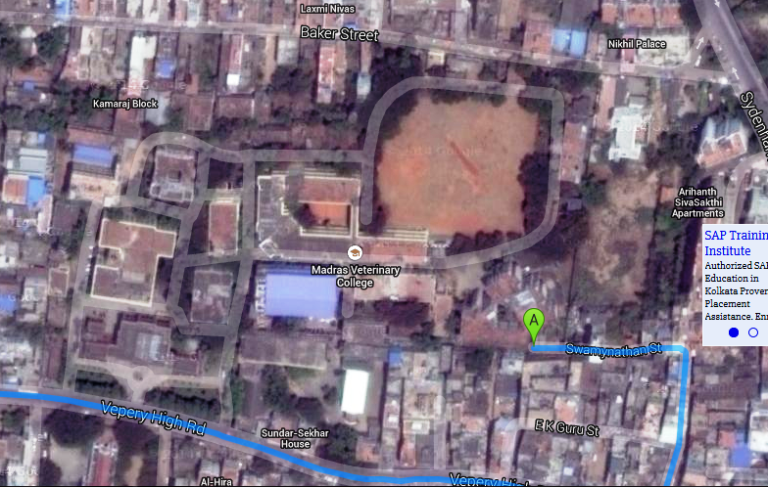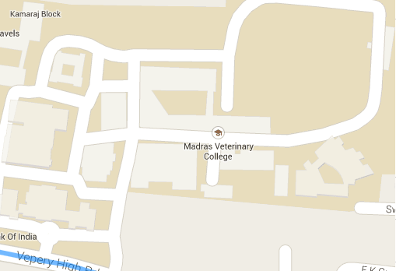
Figure 1: Map of working area Madras Veterinary College (MVC)

3. 2. Dog data collection from registered record sheet of MVC
In order to collect data, a structured questionnaire was carefully prepared on the basis of the objectives. It was a cross sectional study and the questionnaire was designed to comprise mostly closed ended questions to ease data processing, minimize variation and improve precision of responses. The questionnaire was filled up by repeated questioning to the owner, personal observation of patient and taking records from register book. Important data recorded including owner’s complaint, breed, age, sex, body condition, weakness, onset and duration of illness of the dog. Other information sought included history of birth, de-worming, vaccination, pregnancy status, parity, housing pattern, diet, environmental condition. Clinical examinations were performed according to questionnaire designed mentioning about temperature, respiration, pulse, hair coat, skin, general attitude of animal etc.

3. 3. Dog’s demographic information
The dogs' breed, sex and age were recorded to determine whether they were associated with the likelihood of dogs exhibiting dermatological problems. The dogs' breed was assessed according to the official breed standard.

3. 4. Case Identification
The sequential procedure of clinical diagnosis of the patient:
i. Owner’s complaint
ii. Anamnesis: History was taken about the skin diseases of the patient, onset and duration of illness from owner. Identify the pre-disposing factors of diseases.
iii. Clinical examination of patient; It includes-

A. Inspection
Distant Inspection: Firstly the general attitude of the patient (alertness/ dullness/ depression) was carefully inspected. Following this, the body condition of the animal (Cachectic/ poor/ fair/ good/ fat/ over fat) was observed. In addition, posture and gait (normal or defective) were examined according to the condition of the dog.

Close Inspection: Following distant inspection, the patient was closely examined by visual examination, parting of hair/fleece, light palpation and close direct inspection to detect hair coat and skin abnormalities. Skin lesions, nature of lesions (foul odorous discharge, crusts, scale and dandruff), location/ distribution of those lesions were also studied. In addition, external parasites (eg. ticks, lice, flea, flies and larvae of flies) identified during examination were documented.

B. Clinical examination and determination
Skin diseases were identified by inspection and further examined for more precise diagnosis to categorize the nature of the disease whether it might be bacterial/viral/fungal/parasitic. Needle puncture was also performed if required. Temperature, pulse, respiration were taken through other scientifically clinical method.
The dermatological signs were classified into one of the following categories with minor modifications: pruritus, alopecia, scaling or crusting, erythema, macular, popular or pustular eruptions, otitis, draining tracts and non-healing wounds, erosive or ulcerative lesions, pigmentary abnormalities, nail disorders, ectoparasites observed by the owner or the clinician, cutaneous swellings and thickening of the foot pads. All masses and swellings involving the skin were classified as dermatological, apart from mammary tumors and swellings that clearly involved other body systems (such as joint effusions or dental abscesses).
C. Laboratory diagnosis
Multiple skin scrapings were taken from all the dogs with a history of pruritus. Ectoparasitic infestations were diagnosed by clinical examination, coat brushings, hair plucks and skin scrapings. Other tests included biochemical and hematological profiles, endocrine function tests, impression smears, insect control trials, and skin biopsies, which were also used to diagnose autoimmune skin disorders. Pyoderma and/or Malassezia dermatitis were diagnosed using cytology and culture. Cases in which a diagnosis was not made during the consultation were classified as ‘unspecified’. The dermatological cases were further analyzed by investigating the frequency with which different diagnostic tests were undertaken and by determining the prevalence of the different etiological categories and the specific diagnoses.

A diagnosis or recommendation for treatment was made based on the clinical signs, physical examination and dermatological diagnostic procedures. The most common tests were hematology and biochemistry skin scrapings, otoscopic examination, cytology, bacterial culture and sensitivity, biopsy and coat brushings.

Table 1. Diagnostic procedures performed to investigate dermatological problems in 44 animals seen in general practice
Diagnostic procedure | Number
Hematology/biochemistry | 18
Skin scrapings | 12
Otoscopic examination | -
Cytology | 2
Bacterial culture and sensitivity | 2
Biopsy | -
Coat brushings | -
Wood’s lamp | -
Radiography | 2
Food trial | 14
Total Thyroxine/Free Thyroxine | -
Estrogen/Progesterone | -
Total | 46

Except for a small number of patients one or more diagnostic procedures were performed in 44 other patients.

3. 5. Data Analysis
All the data that were collected were entered into MS excel (Microsoft office excel-2007, USA). Data management and descriptive analysis was done by means of creating histogram and pie charts.
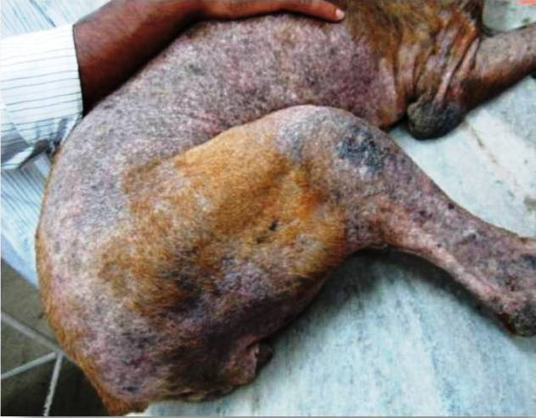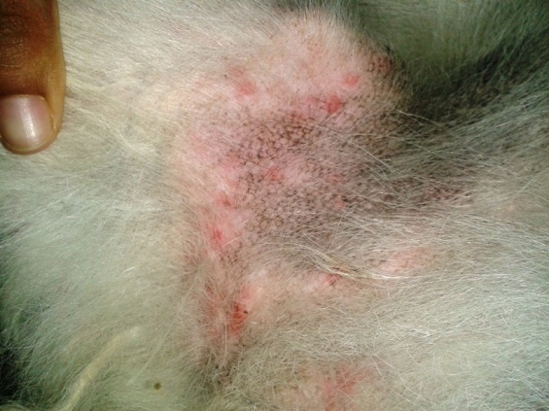
Figure 3: Erythemic lesion
Figure 2: Demodecisis
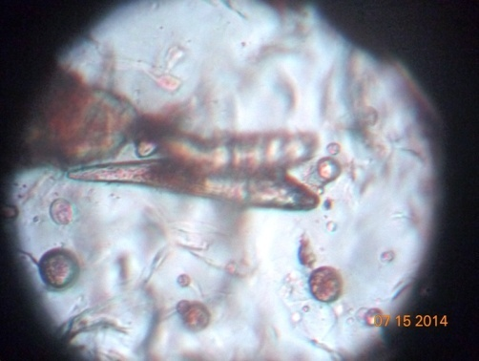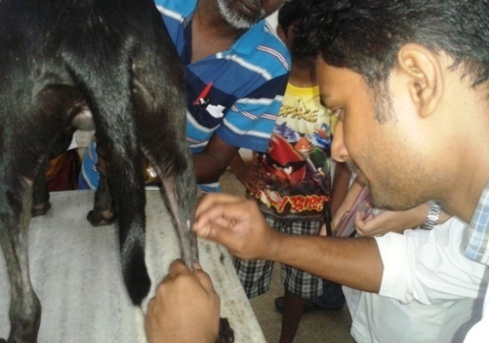
Figure 5: Allergic dermatitis
Figure 4: demodex canis

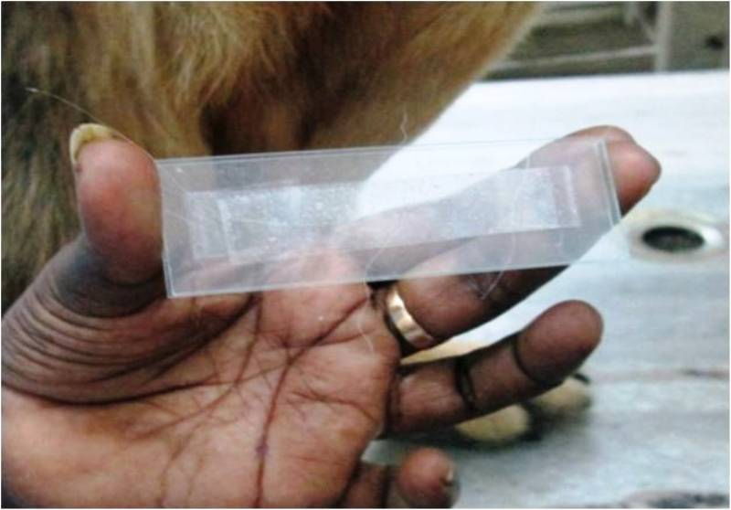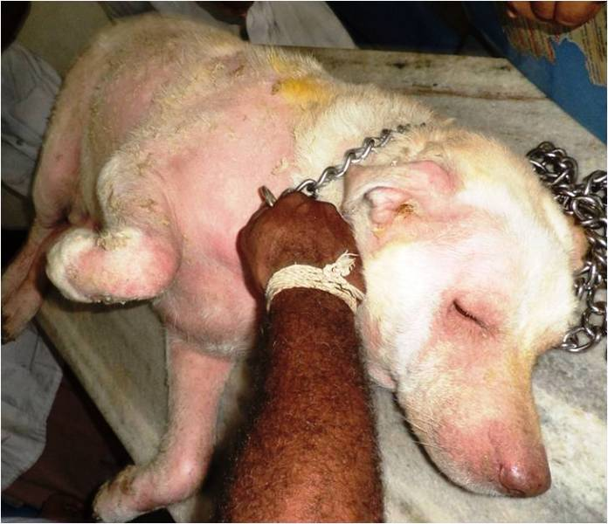
Figure 7: Allergic dermatitis
Figure 6: Tape impression slide
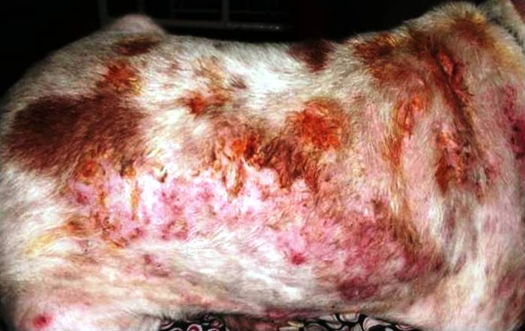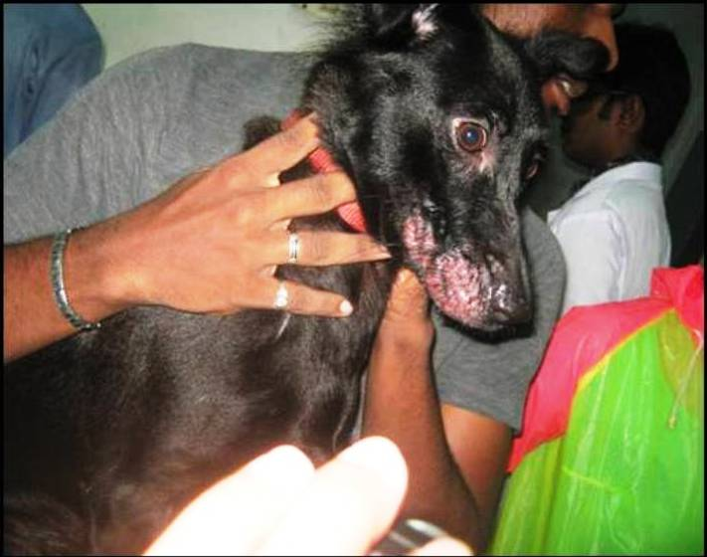
Figure 8:Recurrent pyoderma
Figure 9: Food allergic dermatitis

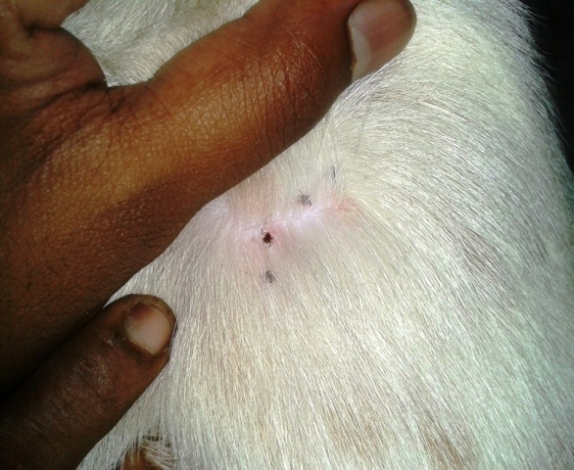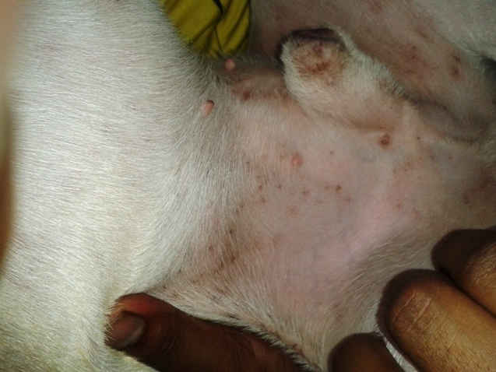
Figure 11: Erythematous lesion
Figure 10: Tick infestation

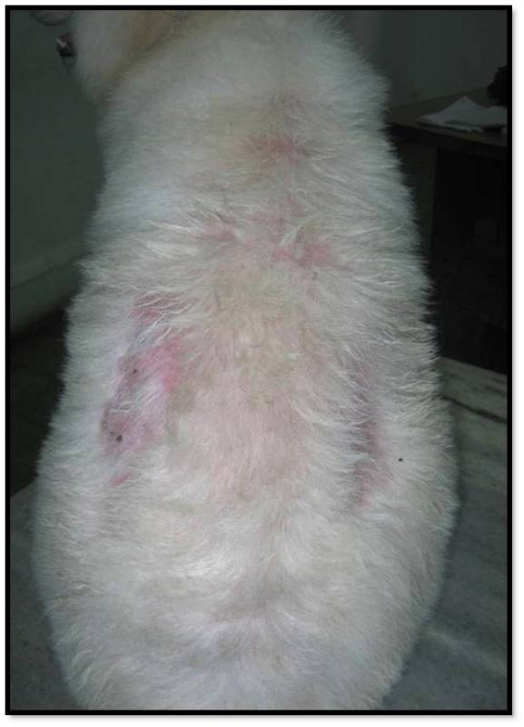
Figure 12: Bilateral alopecia
CHAPTER–IV
4. RESULTS
A total of 44 affected dogs were brought to Madras Veterinary College (MVC) ,Chennai where 35 dogs are adult.Out of 35 dogs 22 dogs are male and 13 dogs are female.Total 9 puppies were brough. Out of 9 puppies 5 are male and 4 are female. Tick infestation, Pyometra, Ehrlichiosis, Edema, Hard mass were very much common to the affected dogs.

Table 2: Different breeds presented in the Madras Veterinary College

SL | BREED | ADULT |  | PUPPY |  | Total | REMARKS
 |  | MALE | FEMALE | MALE | FEMALE
1 | ND | 4 5 |  | 4 3 |  | 16 | -
2 | Pug | 2 2 |  | 1 |  | 5 | -
3 | Spitz | 2 3 |  |  |  | 5 | -
4 | Boxer | 2 2 |  |  |  | 4 | -
5 | Labrador | 2 |  |  |  | 2 | -
6 | German shepherd | 2 |  |  |  | 2 | -
7 | Pekingese | 1 1 |  | 1 |  | 3 | -
8 | Doberman | 2 |  |  |  | 2 | -
9 | Great dane | 1 |  |  |  | 1 | -
10 | Dalmatian | 2 |  |  |  | 2 | -
11 | Dachshund | 2 |  |  |  | 2 | -

Table 3: Different diseases presented in the Madras Veterinary College
SL | Name of the disease | Number of cases | Diagnosis
1 | Tick infestation | 14 | clinical
2 | Pyometra | 7 | clinical
3 | Soft tissue swelling | 1 | clinical
4 | Prostatic abscess | 1 | clinical
5 | Maggot wound | 1 | clinical
6 | Purulent lesions | 2 | clinical
7 | Ehrlichiosis | 4 | clinical&Hematology
8 | Edema | 3 | clinical
9 | Pustules | 1 | clinical
10 | Erythrymatous lesion | 1 | clinical
11 | Alopecia | 1 | clinical
12 | Pyoderma | 1 | clinical
13 | Hard mass | 3 | clinical
14 | Corneal itching | 1 | clinical
15 | Hygroma | 1 | clinical
16 | Demodecosis | 2 | Lab test
Total number of cases is greater than 44 because some of them had more than one condition.

Figure 13: Diseases observed in the affected dogs

The above table and pie diagram show that the prevalence of clinical diseases and disorders of dogs were multidimensional (Table 3 and Figure 13 ). Tick infestation and Pyometra were more prominent than others such hygroma,soft tissue swelling, maggot wound, Ehrlichiosis, Demodecosis, Alopecia etc.
Table 4: Skin diseases prevalence on the basis of breeds
Name of the breed | No. of affected (diseased) | Prevalence (%)
ND | 16 | 36.36
Pug | 5 | 11.36
Spitz | 5 | 11.36
Boxer | 4 | 9.09
Labrador | 2 | 4.54
German shepherd | 2 | 4.54
Pekingese | 3 | 6.81
Doberman | 2 | 4.54
Great dane | 1 | 2.27
Dalmatian | 2 | 4.54
Dachshund | 2 | 4.54

Figure 14: Diseases according to breed of dogs & its prevalence

The above table and graph (Table 4 and Figure 14) indicates Native/Non descriptive breeds (36.36%) were mostly infected with various skin diseases. Tick infestation, pyometra were more prominent and more frequently observed on that breed. Other affected dogs were Pug (11.36%), Spitz (11.36%), Boxer (9.09%), Pekingese (6.81%), Doberman (4.54%), Dalmatian (4.54%), Dachshund (4.54%). In case of Dalmatian, they were habitually infested with ectoparasites.

Table 5: Skin diseases prevalence on the basis of age
Disease |  | - years | - Years | >3years | Total | Prevalence(%)
Tick infestation | - |  | 10(71.42%) | 4(28.57%) | 14 | 31.38%
Pyometra | - |  | 1(14.28%) | 6(85.71%) | 7 | 15.90%
Soft tissue swelling | - |  | - | 1(100%) | 1 | 2.27%
Prostatic abscess | - |  | - | 1(100%) | 1 | 2.27%
Maggot wound | 1(100%) |  | - | - | 1 | 2.27%
Purulent lesions | 1(50%) |  | 1(50%) | - | 2 | 4.54%
Ehrlichiosis | 2(50%) |  | - | 2(50%) | 4 | 9.09%
Edema | 1(33.33%) |  | - | 2(66.66%) | 3 | 6.81%
Pustules | 1(100%) |  | - | - | 1 | 2.27%
Erythrymatous lesion | 1(100%) |  | - | - | 1 | 2.27%
Alopecia | - |  | - | 1(100%) | 1 | 2.27%
Pyoderma | - |  | - | 1(100%) | 1 | 2.27%
Hard mass | - |  | - | 3(100%) | 3 | 6.81%
Corneal itching | - |  | - | 1(100%) | 1 | 2.27%
Hygroma | 1(100%) |  | - | - | 1 | 2.27%
Demodecosis | - |  | 2(100%) | - | 2 | 4.54%

Table 6: Age wise distribution and prevalence of disease in dog.
Age | No. of affected dogs | Prevalence (%)
0-2 years | 8 | 18.18%
2-3 years | 14 | 31.81%
> 3 years | 22 | 50%

Figure 15 : Age wise distribution of diseases and disorders in dog & prevalence

A total of 44 affected dogs were brought to Madras Veterinary College (MVC) ,Chennai where the dogs were categorized with 0-2 years, 2-3 years and more than 3 years. Mostly the older aged dogs were affected with different diseases (50%), 0-2 years aged dogs (18.18%),2-3 years (31.81%) (Table 5 & 6 and Figure 15). Tick infestation were very common(31.38%), pyometra(15.90%), soft tissue swelling(2.27%), prostatic abscess(2.27%), maggot wound(2.27%), purulent lesions(4.54%), ehrlichiosis(9.09%), edema(6.81%), pustules(2.27%), erythrymatous lesion(2.27%), alopecia(2.27%), pyoderma(2.27%), demodecosis(4.54%)

Table 7: Skin diseases prevalence on the basis of sex
Name of diseases | Male | Female
Tick infestation | 8 (57.14%) | 6 (42.85%)
Pyometra | 0 | 7 (100%)
Soft tissue swelling | 0 | 1(100%)
Prostatic abscess | 1(100%) | 0
Maggot wound | 0 | 1 (100%)
Purulent lesions | 1 | 1 (50%)
Ehrlichiosis | 2 (50%) | 2(50%)
Edema | 2(66.66%) | 1 (33.33%)
Pustules | 1 (100%) | 0
Erythrymatous lesion | 1(100%) | 0
Alopecia | 1 (100%) | 0
Pyoderma | 0 | 1(100%)
Hard mass | 2(66.66%) | 1 (33.33%)
Corneal itching | 0 | 1 (100%)
Hygroma | 1(100%) | 0
Demodecosis | 2(100%) | 0
Total | 22 (50%) | 22 (50%)

It is observed that the overall prevalence of diseases on male and female were similar (male 50% and female 50%). The above table shows that males were mostly infested with ectoparasites (tick, mite, fly, flea) and affected with demodecosis, hard mass, pustules, erythrymatous lesion. On other hand, females were infected with tick and mite infestation, alopecia, pyometra, maggot wound, corneal itching etc.

CHAPTER-V
5. DISCUSSION
The study provides an insight into the prevalence and clinical aspects of various skin diseases in a population Madras Veterinary College (MVC) ,Chennai and some of the factors that may be associated with the occurrence of dermatological problems in a veterinary clinical sample of domestic dogs. A total of 44 affected dogs were brought to Madras Veterinary College (MVC) ,Chennai where 35 dogs are adult.Out of 35 dogs 22 dogs are male and 13 dogs are female.Total 9 puppies were brough. Out of 9 puppies 5 are male and 4 are female. the prevalence of clinical diseases and disorders of dogs were multidimensional .Tick infestation and Pyometra were more prominent than others such hygroma,soft tissue swelling,maggot wound, Ehrlichiosis, Demodecosis, Alopecia etc. The table and graph indicates Native/Non descriptive breeds (36.36%) were mostly infected with various skin diseases. Tick infestation, Pyometra were more prominent and more frequently observed on that breed. Other affected dogs were Pug (11.36%), Spitz (11.36%), Boxer (9.09%), Pekingese (6.81%), Doberman (4.54%), Dalmatian (4.54%), Dachshund (4.54%). In case of Dalmatian, they were habitually infested with ectoparasites.

The dogs were categorized with 0-2 years, 2-3 years and more than 3 years. Mostly the older aged dogs were affected with different diseases (50%), 0-2 years aged dogs (18.18%),2-3 years (31.81%) . Tick infestation were very common(31.38%), pyometra(15.90%), soft tissue swelling(2.27%), prostatic abscess(2.27%), maggot wound(2.27%), purulent lesions(4.54%), ehrlichiosis(9.09%), edema(6.81%), pustules(2.27%), erythrymatous lesion(2.27%), alopecia(2.27%), pyoderma(2.27%), demodecosis(4.54%).The overall prevalence of diseases on male and female were similar (Male 50% and Female 50%). The above table shows that males were mostly infested with ectoparasites (tick, mite, fly, flea) and affected with demodecosis, hard mass, pustules, erythrymatous lesion. On other hand, females were infected with tick and mite infestation, alopecia, pyometra, Maggot wound, Corneal itching etc.

Diagnostic procedures performed to investigate dermatological problems in 44 animals seen in general practice. Hematology/biochemistry has done in 18 dogs, skin scrapings in12, cytology in 2, bacterial culture and sensitivity in 2, radiography in 2 and food trial in14 dogs. The most common primary final diagnoses were tick infestation, pyometra, , ehrlichiosis, demodecosis, alopecia, hygroma, soft tissue swelling, maggot wound etc. There were no apparent age or sex predilections for dermatological disease as a whole.

CHAPTER- VI
6. CONCLUSION
While skin diseases on dogs received significant attention for several reasons in the very recent years, much less is known about the prevalence and associated risk to humans of these skin problems in general. Based on a review of the available data on the epidemiology of skin diseases of dogs in India, it was concluded that the dog skin problems are the most poorly covered. The present results, including the implications of transmission of pathogens by ticks and fleas, suggest that further studies should be conducted at Madras Veterinary College (MVC) ,Chennai especially to estimate the potential risk of relevant arthropod-borne diseases.

LIMITATIONS

During my study period at Madras Veterinary College (MVC) the following limitations were observed:
- Due to the short duration of the assigned period the relation of different types of skin diseases and disorders with the season cannot be studied.
- Small number of sample population. So it cannot be studied widely.
- Most of the diseases and disorders were mainly diagnosed by taking clinical history from owner and by observing the clinical findings.

REFERENCES
BASSETT, R. T., BURTON, G.G., ROBSON, D. C(2005). Recurrent flank alopecia in a Tibetan terrier. Australian Veterinary Journal. 83, 276 – 279.

C. E. Desch and A. Hillier, “Demodex injai: a new species ofhair follicle mite (Acari: Demodecidae) from the domestic dog (Canidae),” Journal of Medical Entomology, vol. 40, no. 2, pp. 146–149, 2003.

D.W. Scott,W. M.Miller, and C. E.Griffin( 2001).Parasitic skin disease,” in Muller and Kirk’s Small Animal Dermatology, C. di Berardino, Ed., pp. 423–516, , 6th edition, 2001.

F. D. Smith et al. (2011)Biochemical journal 438,103-110

Filipe Dantas-Torres et al( 2012)Are vector borne pathogen co-infections complicating the clinical presentation in dogs?,Parasites and vectors:6

Griffin CE (1993) Canine atopic disease. In Current Veterinary Dermatology (eds CE Griffin, KW Kwochka, JM McDonald). Mosby Year Book, St. Louis, pp. 90–120.

Jennings S (1953) Some aspects of veterinary dermatology. Vet Rec 46:809–816

Marsella R, Olivry T (2001) The ACVD task force on canine atopic dermatits (XXII): nonsteroidal anti-inflammatory pharmacotherapy. Vet Immunol Immunopathol 81:331–341.

Morris DO, DeBoer DJ (2003) Evaluation of serum obtained from atopic dogs with dermatitis attributable to Malassezia pachydermatis for passive transfer of immediate hypersensitivity to that organism. Am J Vet Res 64:262–266.

Miller WH, Scott DW, Wellington JR et al. (1993) Evaluation of the performance of a serologic allergy system in atopic dogs. J Am Anim Hosp Assoc 29:545–550

Mueller RS Olivry T, Prelaud P, Heripret D et al. (1990)Allergic contact dermatitis in the dog: principles and diagnosis. Vet Clin North Am: Small Animal Pract 20:1443–1456.

Mueller RS Olivry T, (2003) Evidence-based veterinary dermatology: a systematic review of the pharmacology of canine atopic dermatitis. Vet Dermatol 14:121–146.

MUELLER, R. S. (2003) Noninflammatory alopecia in dogs. Veterinary Medicine. 98, 518- 533.

Lorusso, Rivierre C, Murphy KM et al. (2003) Maintenance treatment of canine atopic dermatitis with cyclosporin: decreasing dosages or increasing intervals? (Abstract) Vet Dermatol 14:220.

Lorusso, T, Steffan J, Fisch RD et al. (2002) Randomized controlled trial of the efficacy of cyclosporin in the treatment of atopic dermatitis in dogs. J Am Vet Med Assoc 221:370–377.

P B Hill et al.( 2002) A practical guide to the diagnosis and management of skin diseases in dogs and cats.

Scott DW, Miller WH, Griffin CE (1995) Immunologic skin diseases. In Muller and Kirk’s
Small Animal Dermatology, 5th edn. WB Saunders, Philadelphia, pp. 543–666.

Shaw SC, Wood N, Freeman J et al. (2004) Estimation of heritability of atopic dermatitis in Labrador and Golden Retrievers. Am J Vet Res 65:1014–1020.

Scott DW, Miller WH, Reinhart GA et al. (1997) Effect of an omega-3/omega-6 fatty acidcontaining commercial lamb and rice diet on pruritus in atopic dogs: results of a single-blinded study. Can J Vet Res 61:145–153.

Scott DW, Miller WH, Griffin CE (2001) Dermatologic therapy. In Muller and Kirk’s Small Animal Dermatology, 6th edn. WB Saunders, Philadelphia, pp. 207–273.

Shoorijeh et al., (2008) Giardia spp.and Sarcocystis spp. tatus in pet dogs. 25 (2): 154-158

Sudhakara Reddy et al.,( 2014) Efficacy of cefpodoxime with clavulanic acid in the treatment of recurrent pyoderma in dogs.

S. Reddy and K. N. Kumari, “Demodicosis and its successful management in dogs,” Indian Journal of Field Veterinarians, vol. 6, no. 2, pp. 48–50, 2010.

Tarafder and Samad, et al. (2004)Prevalence of clinical diseases of pet dogs and risk perception of zoonotic infection by dog owners in Bangladesh 8(2):163-17
Taugbol O, Baddaky-Taugbol B, Saarem JW (1990) The fatty acid profile of sub cutaneous fat and blood plasma in pruritic dogs and dogswithout skin problems. Can J Vet Res 62:275–278.

Thomsen MK, Kristensen F (1986) Contact dermatitis in the dog: a review and clinical study.
Nordisk Veterinaer Medicin 38:129–134.

White PD (1991) Contact dermatitis in the dog and the cat. Semin Vet Med Surg (Small Animal) 6:303–315.

