CHAPTER-1

INTRODUCTION

Bangladesh is an agriculture based country in the world where Livestock has been an important component of the mixed farming system practiced in Bangladesh for centuries. Livestock plays an important role on the agricultural economy of Bangladesh. The non-crop agriculture sector has registered significantly higher growth rate over the last few years. The crop sector showed an annual growth rate of 1.2% while fisheries, livestock and forestry sub-sectors experienced 5.3, 5.6 and 4.0% growth rate respectively, (Mondal, 1999). The share of the livestock sub-sector in GDP at constant prices was 2.92%, which was 17.2% of agriculture and forestry rector in FY- 2005-2006. The share of this sector is projected at 2.95% of GDP, which would be 17.7% of agriculture and forestry sector in FY- 2006-2007. Among the sub-sectors of the broad agriculture sector, the growth of the live stock sector is the highest. The value of livestock industry is enourmous. It is reported to be the fasted growing agriculture sector, with livestock now being the worlds largest land user. In Bangladesh at present, there are about 22.90 million cattle 1.26 million buffaloes, 21.56 million goats, 2.78 million sheep, 212.47 million chickens, 39.84 million duck in our country (Anon, 2009). In recent year, this sector has been playing an increasingly important in the economy uplift effort of Bangladesh. It is a labor intensive and quick yielding sector which augments growth and alleviates poverty.
In spite of its substantial importance much less attention has been given in the development of this sectors compared to the crop sector most probably due to the lack of proper knowledge about the methods and problems of production and utilization of livestock in our country. In addition livestock disease is one of the main important hindrances towards the development of the livestock. As a result the direct impact of animal disease includes loss & productivity, through the death or slaughter of the animals, reduce production of milk, meat & reduce productive capacity. Afazuddin (1985), estimated TK.108,067.75 as an annual economic loss due to various parasitic diseases at Savar military dairy farm. Parasitism claims to be the mail obstructer in livestock rearing in Bangladesh (Jabber and Green, 1983).
Besides, parasitic disease, some other important infectious diseases live FMD, PPR, mastitis and non-infectious diseases like milk fever, dystocia, acidosis, Pregnancy toxemia etc causes a great loss in the economy of Bangladesh.
Indirect impact includes lass of export market, effect on human health, effect on social status etc.
Dinajpur district is one of the important sites for livestock population especially at Parbatipur Thana and the most of the common livestock diseases are frequently found in this area. That’s why this study was conducted at the Parbatipur Upazilla for two months during internship training program with the following objectives:
- To determine the prevalence of different diseases and disoarders of livestock (calves, cows, bulls, goats and poultry).
- To study the infection with different demographic variable (age, sex etc).

CHAPTER-2

REVIEW OF LITERATURE
1. Prevalence of different diseases and disorders of Livestock (Calves):
Shearer (1986) recorded abscess of the umbilicus in 10 calves, and treated by laparotomy and excision. Amin et al., (1988) reported diarrhea in calves, caused by enterotoxaemia and enteropathogenic strain of Escherichia coli of the 266 diarrheic samples examined bacteriologically, only 16 (6.02%) yielded Escherichia coli infection. Hossain and Hossanin (1989) conducted pathological examination of 142 dead calves, of which 22 (15.49%) was diagnosed pneumonia as the cause of death. M.A.Rashid, M. Nooruddin,M.and Dey A.S.(1996) reported that higher prevalence of the disease was recorded in young calves, up to 5 months of age, labourer, animal attendant and house wife, 30-50 years old people in monsoon season. .. Chowdhury et al., (1993) receded 6.6% Neoascaris vitulorum in calves at Savar. 44% sub-clinical Neoascasis vitulorum infection with infection rate aged between 1 to 3 months (60%) than 4 to 6 months (28%) old calves. Karim et al.,(1996). Gautum et al., (1976) reported that early 3 months of age was the most susceptible for Ascarid infection incase of transmammary transmission of Neoascaris vitulorum. Hanif et al., (2003) reported that out 145 diarrheic calves of which 98 (67.58%) were frond to be affected with gastro intestinal parasitic infestation. Baruah et al., (1985) detected the larvae of Neoascaris vitulorum appeared in the colostrums and milk of cows, sampled at 17^{1h} days of post-partum. Cheng (1986) reported that as in some ascariasis infestation, verminous pneumonia and hemorrhages results from the migration of the larvae through the lungs. These symptoms are more frequently encountered. Hanif et al. (2003) reported that out of 145 diarrheic calves of which 98 (67.58%) were found to be affected with gastrointestinal helminthes parasitic infestation. The occurrence of Neoascaris vitulorum was 4.82%. Karim et al. (1996) reported that 44% sub-clinical Neoascaris vitulorum infestation with infestation rate with aged between 1 to 3 months (60%) higher than 4 to 6 months (28%) old calves. Rajkhowa et al., (2005) revealed that the number of animals found positive for parasitic infections was 70.27%. Overall incidence of different parasites recorded was Strongyles (54.05%), Toxocara vitulorum and Strongyloides papillosus (18.91%), Coccidia sp. (13.51%), Fasciola sp., Fascioloides spp. And Dictyocaulus sp., (10.81%), Schistosoma bovis (5.40%), Schistosoma indicum (2.70%) and Paramphistomum sp. and Moniezia expansa (5.40%).
2. Prevalence of diseases and disorders of livestock (cattle, buffaloes):
Ali and Ahmed (1968) reported the occurrence of Milk fever in ruminants for the first time from East Pakistan, now Bangladesh (Mymensingh district) Muller and Owens (1974) reported an overall incidence of retained placenta in Holstein cows. Rogoziewice and Jaskowski (1976) reported 9% incidence rate of retained placenta in cows with variable incidence rates of different farms, seasons and year. Sinha et al., (1978) reported an overall 14.1 % incidence rate of retained placenta in cows with highest incidence during summer (March to June) months (26.0%). Pharos (1981) recorded the gastro-intestinal parasites in calves aged 12-18 months and concluded that gastro-intestinal parasitism in the investigated Pabna area had not been problem in this group of cattle. The role played in Mastitis. Malhotra and Kapur (1982) conducted epidemiological studies on mastitis which revealed the masitogenie agents like Staphylococci, Streptococci, E. colli and pseudomonas spp. were widespread on different body sites of the cows, milker’s hands, milking cans and in the milk samples. Samad and Shahidullah (1984) reported 1.9% clinical incidence of bovine Basesiosis in the district of Mymensingh. They found Acaprin as an effective therapeutic agent against bovine Babesiosis. Amin and Samad (1987) detected that 10.98% diarrhoeic syndrome producing cattle had one more groups of nematode infection. The highest prevalence rate of nematode infection in cattle was recorded during summer (12.72%). Shukla and Parekh (1987) reported 3.35% incidence rate of utero-vaginal prolapse in cows. They observed that 100 days milk production and reproductive performance were severely affected by utero-vaginal prolapse. Joosten et al., (1988) estimated the economic losses caused by retained placenta and amount of 471Lit. per year for a 100-cow’s farm with an average incidence of the condition 6.6% . The loss was calculated due to increased calving interval, increasing culling rate, loss of milk production, and cost of Veterinary treatment and drugs. Kamaruddin and Pandit (1988) recorded that Foot and Mouth disease appeared commonly in endemic and occasionally in epidemic patterns in cattle population of Bangladesh. The disease was reported from almost all districts throughout the year and the number of FMD incidents varied from district to districts throughout the year with a higher frequency in Dhaka, Faridpur and Mymensingh. Occurrence of FMD also varied from month to month or season to season with higher seasonal incidence for September, October, November and April (Pre-to post-monsoon season). Nooruddin and Dey (1990) recorded an overall 62.0% of 13,421 cattle, and 28.8% of 5,771 goats affected with skin diseases. Das et al., (1992) recorded 24.4% incidence rate of Foot diseases in bovines in West Bengal. They found regular overgrown hoof (9.8%) as the most common foot disorder, followed by scissors claw (5.5%), interdigital lesion (0.7%) and eruption of sole (0.6%). Rahman and Ramage (1969) reported that the causative organisms are ubiquitous in name and persists long time in the cow Yard or banns and there is chance of constant udder infection under poor hygienic management systems .Mossel (1962) reported that a bacterial count of over 200 per ml or ≥ 5,00,000 leukocytes in fresh milk are usually the indication of cellular, inflammation of the udder by Staphylococcus spp.
Sard1978) reported that FMD virus enters the body either by inhalation or ingestion. If then passes into the blood stream and is carried via circulation to the predilection site, under favorable condition & provided sufficient virus is present the cells of the predilection site one invaded and the virus multiples until the cells finally rupture resulting uremia associated with excretion of virus from the respiratory tract and the faces, urine, serum, saliva and milk
Rahman et al., (first edition.) reported that Fascioliasis eased by Fasiola hepatica and gigantica. But in Bangladesh Fascioliasis occur only by Fasciola gigantica. It is under phylum: Platyhelminthes, class. Trematoda and Fasciolidae family. Dolman (1969) reported that recordedaloss of 15000 head in IIIinois when a disastrous epizootic of Babesiosis broke out among native cattle. The mortality rate among affected reached 90%. Kuttler et al., (1988) reported that continuous in- vitro passage of Babesia bovis has been shown to induce a level of attenuation similar to that seen with the passage of the organism in splenectomozed calves. Infection with that attenuated organism has been reportetd to prevent clinical infection following a challenge with virulent Babesia bovis. Pande (1935) reported that Stephanofilariasis or Humpsore is a chronic ulcerative, granulomatous dermatitis of cattle caused by filarial worm Stephanofilaria assamensis, located on or near the hump & neck region of cattle. Patnaik (1973), reported that more than one species of flies infested the humpsore lsions and only Musca conducens was vectors of Stephanofilaria assamensis .
3. Prevalence of different diseases and disorders of livestock (Sheep and goats).
Qadir (1967) recorded Haemonchus contortus, Qesephagostamum columbianum, Strongyloides spp., Trichuris spp., Trichostrongylus spp,. Mymensingh slaughter house. Incidence throughout the year was high with Haemonchous contortus and Oesophagostmum without any significant seasonal variations. Banerjee et al., (1985) recorded 5.8% and 42.22% prevalence rates of pneumonia and other lung affections in goats detected at slaughter and postmortem examination, respectively in India. Dewan and Das (1988) suggested that Urolithiasis could be prevented either by adding 4% sodium chloride in concentrate ration or provided water and green pasture (grass) and leaves. In Bangladesh, Dr Taylor identified the first PPR outbreak during 1993. Sill et al., (1995) reported PPR spread throughout the country and had devastating effects in organized Goat Farms. Reader and Obi (1999) reported that PPR was not clearly recognizable up to 1972, but the true extend of the disease has become apparent in recent years and is still being clarified. Debnath, (1995) reported that PPR thought that the disease might have come from India. Shah et al., (1983) reported that PPR in goat has been recorded in 1993 from the border belt areas of Southwestern districts (Sathkhira, Jessore and Barguna) of Bangladesh. It has been reported that the Black Bengal goats (67.24%) are more susceptible to PPR that Jamunapari breed (32.76%). Debnath (1995) reported that epidemic areas morbidity rate has been estimated to be 80% to 90% accompanied by a mortality rate of 50% to 80%. Islam et al., (2001) reported that in endemic condition, PPR may be less dramatic or may occur as a sub clinical or even in apparent form. Debnath (1995) reported that paste des petits ruminants (PPR) are a contagious disease of sheep and goats caused by a morbilli virus of the Paramyxoviridae family. Debnath (1995) recorded that transmission of disease is occurred by close contact, secretion and excretion of sick animals to the healthy. The discharges from the eyes, nose and mouth as well as the loose faeces contain large amounts of virus. Although sub clinical infections can be experimentally induced in goats, they do not transmit the disease to susceptible pigs or goats. Sill et al., (1995) reported that PPR can induce abortion and morbidity and mortality is more frequent in young animals. It can also infect large animal, white tailed deer. Reader et al., (1977) reported that PPR virus was excreted from all routes at the onset of clinical symptoms, with titer increasing from organs most seriously affected during the course of the disease. The quantity of virus execrated was substantial and would account for the rapid spread of the disease in flocks of goats. Rahman and samad (1984) studied the diseases of goat in some areas of Bangladesh and reported 12% mastitis 10%, Colibacillosis, 5% Salmonellosis and 7% Otitis externa. Rahman et al., (1984) reported that clinical findings of mastitis are with only mild changer in either the milk or the udder, with the gross changes in the milk or udder. Udder grossly enlarged and may be more than 2º F above normal. Rahman et al., (º1984) recorded in Salmonellosis, animals showed profound depression, dullness, prostration, high fever (105-107º) F with sever fluid diarrhea, sometimes dysentery and extreme weakness. The temperature commonly drops upon initiation of diarrhea. Sometimes brownish,watery diarrhea with shreds and flakes of fibrin and sloughing mucosa and streak of fresh blood. Roy (1950) reported that sub acute Fascioliasis manifested by weight loss and pallor of the mucous membranes, submandibular edema. Rahman et al., (1972) reported that clinical findings of chromic fascioliasis indicate that lose weight, develop submandibular edema (Bottle-jaw), chronic diarrhea and emaciated. Garrels (1975) reported that clinical pathology in case of acute fascioliasis, severe norm chromic anemia and hypoalbuminemia observe in goats. In the sub acute and chronic diseases, rapid weight loss with a severe hypo chromic, macrositic anemia will be seen. In Bangladesh, Bhuyan (1970) investigated Fascioliasis in which 12.92% of goats were infested with Fasciola gigantica. Rahman et al., (1972) studied goat disease of Mymensingh and reported 8.3% Fascioliasis among goat population. Rahman and Razzak (1973) examined fecal samples of 833 goats. A total of 16.3% animals were positive for Fasciola infection. Rahman et al., (2002) revealed that the study of association between gastrointestinal (G.I.) Strongyle infection in Bengal goats wits season and geographic location. Blood et al., (1989) reported that the chemical composition of urethral calculi varied and appeared to depend too largely on the dietary intake of individual elements. Calcium, ammonium and magnesium carbonate were the common constituent of calculi of cattle and sheep at pasture. Blood et al., (1989) reported that clinical findings of Urolithiasis manifested by a syndrome of abdominal pain with kicking at the belly, treading with the hind feet and swishing of the tail repeated twitching of the penis, sufficient to shake the prepuce, unsuccessful efforts to urinate, accompanied by straining, grinding of teeth and passage few drop of bloodstained urine. Urinary bladder is distended and retention of urine .Mia (1967) reported that the prevalence of Urolithiasis was found comparatively higher during autumn (11.37%) and winter (13.4%) seasons in the urban areas of Dhaka. Ali et al., (1987) recorded 2.17% incidence of respiratory disorders in Black Bengal goats and Koul et al., (1988) reported 24.24% mortality in Bengal goat due to pneumonia. Nooruddin et al., (1987) reported higher prevalence of skin disease (26.80%) in Black Bengal goats under rural condition of Bangladesh. The prevalence of sheep and goats of Dhaka and Mymensingh district of Bangladesh were studied. Huq and Mollah (1969) reported that the prevalence of lice on sheep and goats in Mymensingh and Dhaka were found 40.57% in sheep and 36.20% in goats respectively. Both young & adult are equally infested. Debnath (1995) reported in present conditions goats are affected with a serious exotic killer disease namely Peste des Petits Ruminants (PPR). Gibbs et al., (1979) reported that Peste des Petits Ruminants (PPR) is a contagious disease of goats and sheep is caused by a mobilli virus of he Paramyxoviridae family.

CHAPTER-3
MATERIALS AND METHOD

3.1. Study area:
The study was carried out at Parbatipur Upazila in Dinajpur district.
3.2. Reference/target population: All animals under Parbatipur Upazila in Dinajpur district.
3.3. Source of population: Several village, union and sadar Thana under Parbatipur Upazila with household raising at least one domesticated ruminants (goat) with history and clinical sign of various diseases to be source population.
3.4. Study population: A total 324 animals were studied
3.5. Duration of study: The study was conducted from 08.02.2014 to 09.04.2014 directed nine weeks.
3.6. Study design: It was a cross sectional study.
3.7. Population and tools used for data collection:
About 324 different animals at different ages and sex were registered from different areas of Parbatipur Upazila Veterinary Hospital in Dinajpur district during the part of internship period. Mainly the patients were treated in two ways- one was clinics at which farmers willingly came with the patients, another was at field where v.s. along with me went to the field. A structured record keeping sheet was used for registration of diseases with their diagnosis, their demographic information, and nature of feeding apart from owner, which is given below:
3.8. Case definition of various diseases: Certain clinical signs, general examination, inspection, palpation, percussion, auscultation, etc methods were used to diagnose diseases.
3.9. Detection of diseases either by clinical or other methods of examination:
3.9.1: PPR (peste des petis ruminants):
It is called 3D diseases for having symptom of diarrhea, dyspnea, and death
Initially manifested by a febrile syndrome, chacterized by—
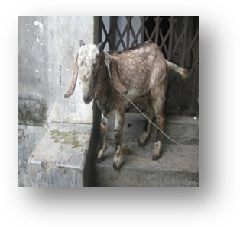
  - High fever (107-108°F)
  - Dried exudates on muzzle, rhinitis & conjunctivitis
  - Hind quarter is soiled with liquid feces.
  - Ulceration on lips & tongue and respiratory distress.

TREATMENT:
1. Inj. gentamycine (Gentason plus), 5 mg/kg body wt, imly
2. Inj. antihista (Hista vet) -10 mg/kg, Imly
3. Inj.Metamisole (Fevasole) 40-50 mg /kg, imly

3.9.2: Pneumonia:
Firstly we took history from the owner, then the following points were noted to diagnosis:
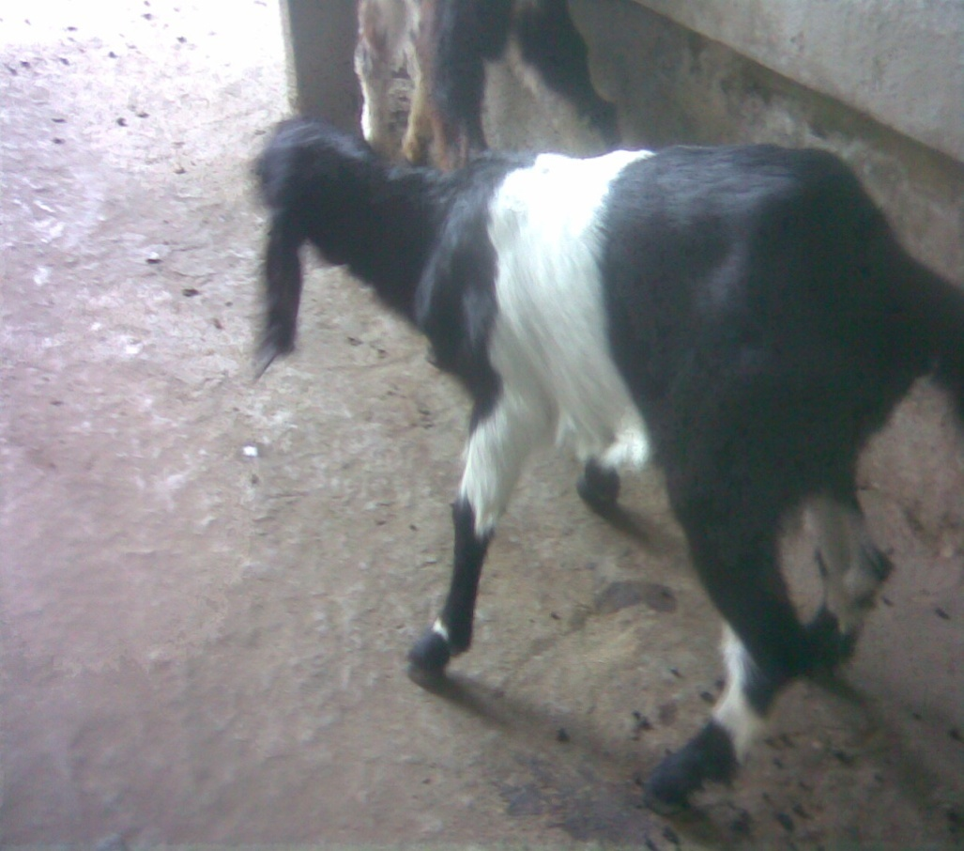
- High rise of temperature (105°F).
- Severe dyspnea, moist rales.
- Nasal secretion.
- Vesicular murmur & rough body coat.

TREATMENT
1. Inj. amoxicillin (Amoxi vet) -10 mg/kg body wt, imly
2. inj. Antihistaminic (Hista vet) -10 mg/kg body wt ,im
3.9.3: Rabies: Goat showed more aggression and continuous bleating followed by
- Profuse salivation, increased temperature.
- Afraid of drinking water.
- Posterior paralysis & frequent urination.

Treatment:
1.inj. Rabicin 2 ml in two sites, im
2.ing. streptomycin +penicillin, im
3.inj. antihistaminic 10 mg/kg body wt ,im

3.9.4: Goat pox: Papules are covered within the whole body,head and udder followed by,
    - Red maculae’s appear on the hairless part of skin.
    - High fever, totally off feed.
    - Mucous membrane of eye, nose, lips and vulva become necrotic.
Treatment:
1. Inj. Goat pox vaccine
2. Pulv. Nabanol in affected area

3.9.5: Tetanus: In generally wound was located in its hind quarters, other signs were:
- Stiff gait, apathy to feed.
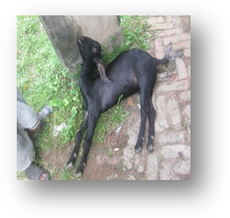
- Developed saw horse stance.
- Mouth was closed due to locked jaw.
Treatment:
1. inj. ATS 1ml, ivly at a time
2. inj. penicillin(Bipen vet) -20000 IU ,imly
3. inj. antihistaminic(Hista vet) 10 mg/kg, imly
4. inj.xylazine,0.1-0.3 mg/kg, imly

3.9.6: Colibacillosis: Mainly kid were infected which shown the following manifestations:
- Depression, in appetence.
- Shunked eyes, Tucked up abdomen.
- Yellowish brown to grayish white feces.
- Soiling of anal,perianal and hind quarter

3.9.7: Salmonellosis: Diagnosis conducted by the signs bellow:
- Fever, anorexia, depression.
- Profuse watery faeces with blood clot & mucous.
- Abdominal pain.
Treatment: (salmonellosis +colibacillosis)
1.inj. streptomycin (Strepcin-G) 10 mg/kg body wt,im
2. inj. Normal saline – iv
3.inj. antihistaminic (Astavet), 10 mg/kg

3.9.8: Mastitis: Diagnosis conducted by the signs bellow:
- Udder was swollen, goat was restless due to pain in touch.
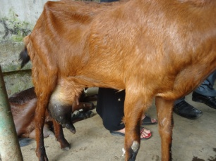
- Milk became watery& brown fluid with flakes.
- Redness of udder and teat with fever.
Treatment:
1. inj. Gentamycin (Gentason plus) 5 mg/kg body wt,im or
Syn.two tubes -Intra mammary infusion
2.inj. antihistaminic(Astavet)

3.9.9: Retention of placenta: Fetal membranes should be considered retained if they are not passed by 24 hours after calving. Retained placenta increased incidence in cattle abnormal calving, as in twins, forced extraction, abortion, induced parturition and premature birth. The condition has also been associated with nutritional factors such as vitamin deficiency (carotin, vitamin A and vita E) minerals deficiencies or imbalances (calcium and phosphorus). Major pathogenic conditions affecting place tom separation include immature placetomes associated with shortened gestation, edema associated with caesarian section or uterine torsion and placentitis associated infection like brucellosis, bovine rhinotracheitis, enzootic abortion, and salmonellosis etc. Uterine atony associated with milk fever and hydropic condition also contributes to the incidence of retained placenta.

Treatment:
1.inj. oxytocin (Oxin) ,1-3 ml, s/c,(1 ml contain 10 IU )

3.9.10: Bloat: Diagnosis conducted by the signs bellow:
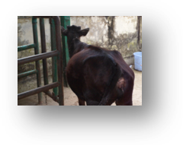
- Abdomen became distended
- Restless, arched back was found
- Rapid & deep breathing
- Try to kick belly
Treatment:
1. Liq. No bloat, ¼ orally
2. inj. NS, i/v
3. inj. sodium bicarbonate 7.5%, 0.75 mg/kg or 8-10 ml/kg body wt, Iv
4. inj. Dexamithasone (Dexavet), 0.3 mg/kg,im

3.9.11: Simple indigestion:
- History of heavy seasonal harvesting crops feeding.
- Ceased rumen movement.
- Lacrimation, depression, weak and emaciation and pot belly appearance.

3.9.12: Wound: The area become lacerated, redness and oozing of blood is observed.
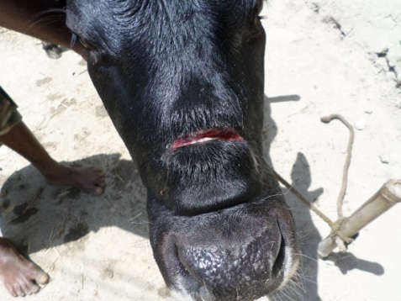

Treatment:
1. Washing with povidone iodine
2. inj. ketoprofen (Kop vet), 1ml /33 kg body wt, im

3.9.13: Urolithiasis: In general the diagnosis is based on clinical history and following clinical signs:
- Ceased urination
- Restlessness
- Kicking towards the abdomen
- Abnormal gait & posture
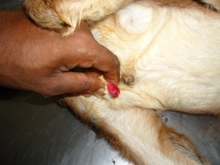
Treatment:
1. syp.Bujuri-p, 16 drops+0+16 drops,orally
2. syp. Fimoxyl, 16 drops +16 drops+16 drops, orally
3. apply vaselin on urethral opening

3.9.14: Fascioliosis: Diagnosis conducted by the signs bellow:
- Goats infested fasciola became lazy, dull & depressed.
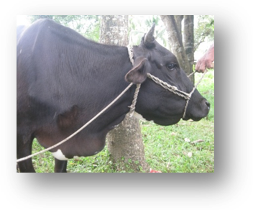
- Anemic with rough & off colored skin coat.
- Bottle jaw is located under the mandible.
- Faeces wera loose consistency, pot belly appearance.
- Pale mucous membrane was observed.
Treatment:
1. Bol. Triclabendazole (Fasinex) ,10-15 mg /kg body wt
2. Bol. appetizer (2-4p for large animal, 1-2 for small animal)
3.9.15: Coenurosis (Gid disease): The clinical sign which helped to diagnosis were:
- Partial blindness in one eye.
- Dullness and clumsiness
- Head pressing,ataxia,incomplete mastication
Treatment: Surgically removed
3.9.16: Navel Infection: This infection was diagnosed by following symptoms-
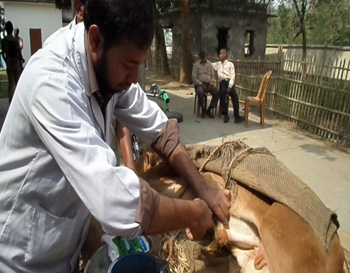
- Foul discharge
- Muscular stiffness
- Swollen navel cord
Treatment:
1. Inj. Penecilline (Bipen vet) ,20000 IU /kg body wt, im
2. inj. antihistaminic (Astavet) ,10 mg/kg,im
3. Dressing+ gauge insertion
3.9.17: Pyometra –Following signs were observed
- m/m pale
- Inappetance,coughing ,puss came out through vagina
Treatment:
1. Irrigation of uterus with potassium permanganate
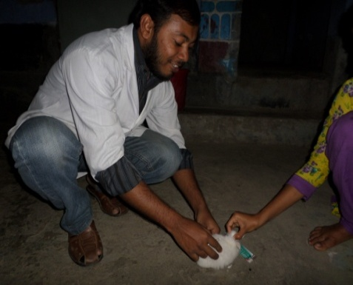
2. inj. Tetracycline (Otetra vet) ,10 mg /kg, imly
3.Inj. Metronidazole(Metro IV) ,10 mg/kg ,ivly

3.9.18: Menge infestation in Rabbit:
- Rough and drycoat
- Alopecia,redness,itching
Treatment:
1. Dressing with povidon iodine
2.inj. Ivermectin(Amectin) ,0.02mg /kg body wt, s/cly
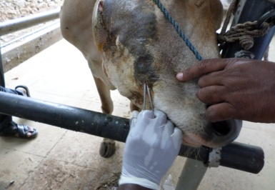

3.9.19: Actinomycosis/Lumpy jaw:
- Swollen jaw
- Pain on palpation
- Presence of pyogenic tract

Treatment:
1.Dressing the pyogenic tract and seton insertion with potassium iodide
2.inj. DNS 5%,iv; 3. Inj. Meloxicam, 8 ml/100 kg,imly

3.9.20: Congenital and other anomalies: Atresia ani and other several deficiency cases were observed during the period of study. Congenital absence or abnormal narrowing of a body opening. Artesia of the alimentary tract can occur at most point along the tract. This causes blockage of the tract and marked abdominal distention soon after birth. Death normally occurs within days. Atresia ani is quite common and in believed to be inherited. It can be surgically corrected in some areas of the colon has been recorded in horses.Atresia ani is recorded as a congenital defects in newborn animals. It occurs mainly sporadic and animal die at 7 to 19 days of age unless the defect is corrected surgically.
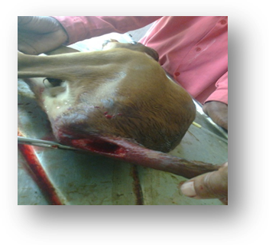

Atresia ani:
- Anus is closed
- Abdomen looks like tympanic
- Repeated straining
3.9.21:Abscess :Abcess was diagnosed by following clinical signs-
- Tumor like growth
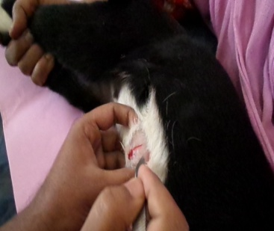
- Pain on palpation
- Pus came out through needle puncture
Treatment: 1.Surgically pus removed
2.Seton insertion
3.inj. Streptomycine ,10 mg/kg body

CHAPTER-4
RESULTS AND DISCUSSION
4.1: The number and percentage of clinical diseases and disorders were recorded during 9 weeks represented in the tables. Total 186 affected goats were brought to Veterinary Hospital at parbatipur upazilla in Dinajpur viral disease, bacterial disease, ectoparasitic disease, endoparasitic disease, reproductive disease, surgical disease and other disorders,congenital problems,protozoal diseases was 22.49%, 31.27%, 11.791%, 16.65%, 4.77%, 6.32%,.53% and 2.68% respectively.
Table 1: Overall frequency of distribution of clinical diseases and disorders of Goat population on the basis of category of diseases
Category of  disease |  | Name of disease | Kid(age)  6 months | 1—2 years | Above  2 years | Total (%)
Viral diseases |  | PPR  Rabies  Pox | 6(3.22%)  --  2(1.07%) | 12(6.451%)  3 (1.61%)  -- | 17(9.13%)  2(1.07%)  -- | 35(18.81%)  5(2.68%)  2(1.07%)
Bacterial  diseases |  | Pneumonia  Tetanus  Colibacillosis  Salmonellosis  Mastitis  Urolithiasis  catarrhact  Pyometra | 12(6.45%)  3(1.61%)  7(3.7%)  5(2.68%)  --  --  --  -- | 3(1.61%)  --  3(1.61%)  2(1.07%)  --  3(1.61%)  3(1.61%)  -- | 2(1.07%)  --  2(1.07%)  --  9 (4.8%)  3(1.61%)  --  2(1.07%) | 17(9.13%)  3(1.61%)  12(6.13%)  7(3.7%)  9(4.8%)  6(3.22%)  3(1.61%)  2(1.07%)
Other disorders |  | Bloat  Indigestion  Wound | --  --  -- | 5(2.68%)  2(1.07%)  -- | 11(5.9%)  2(1.07%)  2(1.07%) | 16(8.58%)  4(2.14%)  2(1.07%)
parasitic  cases |  | Mange  pediculosis  Fascioliosis  Coenurosis | --  --  --  -- | --  --  4(2.15%)\  3(1.61%) | 4(2.15%)  7(3.76%)  8(4.30%)  5(2.68%) | 4(2.15%)  7(3.76%)  12(6.45%)  8(4.29%)
Reproductive  case |  | Retained  Placenta  Enestrous | --  -- | --  -- | 2(1.07%)  7(3.7%) | 2(1.07%)  7(3.7%)
Surgical case  &  Non specific |  | Fracture  Hoof enlargement  Surgery | --  -- | 2(1.07%)  4(2.14%) | --  2(1.07%)  4(2.14%) | 2(1.07%)  2(1.07%)  8(4.28%)
Congenital |  | Atresia ani | 1(.53%) | -- | -- | 1(.53%)
Protozoal diseases | Babesiosis  Coccidiosis |  | --  3(1.61%) | 2(1.07%)  -- | --  -- | 2(1.07%)  3(1.61%)

The above table shows the overall frequency of distribution of clinical diseases & disorders of studied population on the basis of category of diseases and age wisely. Among viral diseases prevalence of PPR (18.81.5%) was high. Among bacterial diseases pneumonia (9.13%) was high. In case of metabolic diseases Bloat (8.58%) was high.
Table 2: Frequency distribution of diseases in goat according to sex.

Name of diseases | Male | Female
PPR | 16(8.6%) | 19(10.21%)
Pox | 2(1.07%) | --
Rabies | 2(1.07%) | 3(1.8%)
Pneumonia | 10(5.37%) | 7(3.7%)
Tetanus | 3(1.4%) | --
Colibacillosis | 9(4.8%) | 3(1.4%)
mastitis | -- | 9(4.8%)
Bloat | 5(2.68%) | 11(5.91%)
Indigestion | 5(2.68%) | 4(2.15%)
Wound | 2(1.07%) | --
Retained placenta | -- | 2(1.07%)
Urolithiasis | 6 (3.22%) | --
Fascioliasis | 2(1.07%) | 10(5.37%)
Gid disease | 6 (3.22%) | 2(1.07%)
Mange | 2 (1.07%) | 2(1.07%)
Hoof enlargement | 1(0.53%) | 1(0.53%)
Salmonellosis | 3(1.4%) | 4(2.15%)

Above table shows the Frequency distribution of diseases of goats according to sex. In that study period the frequency distribution of disease of male and female were 65.02% and 34.97% respectively. The prevalence of disease of male (65.02%) was higher than female.

Table 3: Temporal distribution of clinical diseases and disorders in goat.
Name of diseases | No. of affected | Prevalence (%)
Viral disease | 42 | 22.58
Bacterial disease | 53 | 28.49
Ectoparasitic disease | 11 | 5.91
Endoparasitic disease | 25 | 13.44
Surgical disease | 12 | 6.45
Reproductive disease | 9 | 4.8
Other disorders | 33 | 17.74

The above table shows that the prevalence of clinical diseases and disorders of goat viral disease, bacterial disease, ectoparasitic disease, endoparasitic disease, reproductive disease, surgical disease and other disorders was 22.58%, 28.49%, 5.91%, 13.44%, 6.45%, 4.8% and 17.74% respectively. In this study period bacterial (28.49%) disease was high.
Graph-1. No of affected goats and prevalence (%) of diseases

Table 4: Age wise distribution of clinical diseases and disorders in goat
Age | No. of affected animal | Prevalence
6 month | 39 | 20.96%
1-2 years | 51 | 27.41%
Above > 2 years | 96 | 51.61%

Above the table and graph shows that the prevalence of clinical diseases and disorders in goat. In case of age up to 6 months, 1-2 years, above 2 years, was 20.96%, 27.41%, and 51.61% respectively. In that study period the prevalence of clinical diseases and disorders was high in above 2 years.
Graph-3: Age wise distribution of clinical diseases and disorders in goat.
Prevalence of clinical diseases and disorders in calves:
Nine major diseases were recorded among 55 sick calves examined during the period of study and results are presented in the following table. In table it is evident that 47.27% (n=26)calves were affected with parasitic infestation,3.63% (n=2) with pneumonia, 5.43% (n=3) with abscess, 9.09% (n=5) with Foot and mouth disease,1.81% (n=1) with papillomatosis, 7.27%(n=4) with navel ill, 1.81% (n=1) with salmonellosis, 7.27% (n=4) with colibacillosis,16.36% (n=9) with skin diseases.

Table 5: Prevalence of different diseases and disorder in calves.
SL  NO. | Diseases and disorders | Calves  (N=55) | Prevalence  ( %)
1. | Parasitic infestation | 26 | 47.27
2. | Respiratory disorder(pneumonia) | 2 | 3.63
3. | Abscess | 3 | 5.45
4. | Foot and Mouth Diseases | 5 | 9.09
5. | Papillomatosis | 1 | 1.81
6. | Navel ill | 4 | 7.27
7 | Salmonellosis | 1 | 1.81
8. | Colibacillosis | 4 | 7.27
9. | Skin diseases | 9 | 16.36

Graph 3: Prevalence of different diseases in calves

Prevalence of different diseases and disorders in cattle:
Among 59 cows and bulls (cows-48 and bulls-11), 12 common diseases were recorded., of the 59 sick cows and bulls 38.9% (n=23) affected with parasitic infestation, 5.08% (n=3) with pneumonia, 15.7% (n=8) with Foot disease 8.5% (n=5) with mastitis, 11.9% (n=7) with F.M.D 3.5% (n=2) with Fascialiosis, 3.4% (n=2) with Babesiosis 1.7% (n=1) with milk fever, 1.7% (n=1) with uterine prolapse 5.08% (n=3) with RP, 5.08% (n=3) with hump sore.
The whole recorded diseases were classified into 4 groups like parasitic, Bacterial, viral, and other diseases. The prevalence of parasitic is 52.54% (n=28), Bacterial 8.48 %( n=05), viral 11.87% (n=7) and others 32.20% (n=19) (like fungal, protozoan etc.).
Table 6: Prevalence of different diseases and disorder of cattle:
SL  NO. | Diseases and disorders | Cattle  (N=59) | Frequency  (%)
1. | Parasitic infestation | 23 |  | 38.9
2. | Respiratory disorder | 3 |  | 5.08
3. | Foot diseases | 8 |  | 13.56
4. | Foot and Mouth Diseases | 7 |  | 11.9
5. | Mastitis | 5 |  | 8.5
6. | Babesiosis | 3 |  | 5.08
7 | Fascioliasis | 2 |  | 3.4
8. | Retained placenta | 3 |  | 5.8
9. | Milk fever | 1 |  | 1.7
10 | Humpsore | 3 |  | 5.8
11 | Uterine prolapse | 2 |  | 3.4

Graph 4: Prevalence of cattle diseases

Table 7: Frequency of diseases according to age in-case of cattle
Type of diseases | Name of diseases | 6 months | 1-2 years | Above 2 years
Bacterial diseases | Mastitis | 0 | 0 | 8.45(5)_
Viral diseases | Foot and Mouth  Diseases | 8.45(5) | 1.69(1) | 1.69(1)
Parasitic diseases | GI parasites | 13.56(8) | 5.08(3) | 6.78(4)
Parasitic diseases | Liver flukes | 5.08(3) | 1.69(1) | 6.78(4)
Parasitic diseases | Babesiosis | 0 | 0 | 5.08(3)
Parasitic diseases | Humpsore | 0 | 1.69(1) | 3.39(2)
Others diseases | Pneumonia | 1.69(1) | 3.39(2) | 0
Others diseases | Milk fever | 0 | 0 | 1.69(1)
Others diseases | Foot root | 3.39(2) | 6.78(4) | 3.39(2)
Others diseases | Uterine prolapse | 0 | 0 | 1.69(1)

Prevalence of different disease and disorders in case of poultry:
A total number of 24 cases of which 19 broiler and 5 ducks were examined through the entire study period.The prevalence of Infectious Bursal Disease (42.8%), Newcastle disease(21.05%), Colibacillosis (10.52%), Coccidiosis (15.72%), salmonellosis (10.52%) were found in broiler and duck plague(40%),duck viral hepatitis (60%) were found in duck. Prevalence of the different diseases of broiler and ducks are given in Table:

Table 8 -: Prevalence of different diseases of poultry (broiler and duck)
Sl. No. | Name of Diseases | Prevalence of Poultry Diseases (%)
Sl. No. | Name of Diseases | Broiler |  | Duck
Sl. No. | Name of Diseases | No. of cases | Prevalence (%) | No. of cases | Prevalence (%)
01 | Infectious Bursal Disease (IBD) | 8 | 42.10 | --
02 | Newcastle Disease (ND) | 4 | 21.05 | --
03 | Colibacillosis | 2 | 10.52 | --
04 | Coccidiosis | 3 | 15.78 | --
05 | Duck viral hepatitis | -- | -- | 2 | 40
06 | Aspergillosis |  |  | --
07 | Duck plague | -- |  | 3 | 60
08 | Salmonellosis | 2 | 10.52 | --
Total |  | 19 | 100 | 5 | 100
Graph: Prevalence (%) of diseases of birds
Discussion

The different clinical examination techniques and laboratory methods were used to determine the prevalence of diseases and disorders in cattle (Calves, Cows, bulls) goats and poultry during this two months period of my internship program at Parbatipur Veterinary Hospital, a total of 55- calves, 59- cow and bulls, 186 goats, and 24 poultry were examined clinically. From the 55 calves, 59 cattle, 186 goats, 24 poultry examined, 9 major diseases and disorders were recorded in calves, 11 in cattle, 15 in goats, 8 in poultry during this two month investigation period. The results of these recorded diseases and disorders are classified in 4 major groups and are discussed as follows:-
- Bacterial diseases:
1. Clinical mastitis: Clinical mastitis was recorded in both cows- 5 (8.5%) and goats 9(4.8%) during this 8 weeks investigation period. The clinical occurrences of mastitis in cow and goats have been reported form Bangladesh (Rahman and samad, 1984) but a systemic study on this disease has not yet been in Bangladesh. However, this disease has a great economic importance to the dairy industry. In India, mastitis causes great financial loss and has been estimated as Rs. 52.9 cores of rupees every year (Singh and Baxi, 1982). Epidemiological studies on mastitis reveal that mastitogenic agents are widespread on different body sites of cows and goats, milks hands, milking cows and in the milk samples. Moreover, teat apices are found to be the most common site from when these organisms have been isolated (Malhotca and kapur, 1982). In USA the losses/cow per year has been estimated to exceed US $ 100.00. There fore, research would be required to control this disease in Bangladesh.

2. Navel-ill:
Navel-ill was only recorded in calves 4(7.27%) during 8 weeks investigation period. It is very much common in calves rather than other animals and it is occur due to the infection of the umbilicus of newborn, but this disease has not been reported in literature from Bangladesh. However, it is common occur within 2-5 days of calves after birth and characterized by the painful and umbilicus and draining purulent materials as described by Shearer (1986).
3. Tetanus: Tetanus was recorded in goat 3 (1.61%) during my 8 weeks study period. However, this disease occurs in all farm animals all over the world mainly as individual sporadic cases although outbreaks are occasionally reported in sheep (Rao et al, 1978). Clostridium tetany spores require anaerobic condition at the wound site of germination. Local tissue necrosis may help for the establishment of vegetative infection (Smith and Maciver, 1979). Toxigenic strains of (Clostridium tetani) causative agent of tetanus have been isolated from the soil samples collected from different districts of west Bengal (Das et al., 1976). It is as very fatal disease, so it should be controlled.

4. Salmonellosis: During 8 weeks study period, only 1(1.81%) Salmonellosis was recorded in calves and 7(3.7%) in goat. It is characterized by fowl smelling yellowish diarrhea, nasal and ocular discharge omphalitis etc. It is one of the important zoo noses due to bacterial agents (Haudler, 1975). Out break of Salmonellosis have been reported elsewhere (Greene and Dempsey, 1986)

5. Colibacillosis: Colibacillosis was recorded in calves 4 (7.27%) and 12(6.13%) in goat. It is one of the most common diseases of farm calves caused by Escherichia coli. It has world wide distribution and has been recorded form all states of India (Ansar et al., 1981). It is most common in calves under 3 days of age but occasionally occur in several ages where there is a mixed infection with viral enter pathogens. The study recorded 7.27% Colibacillosis in calves associated with infection, which is much lower than that of 32.43% rate recorded by Amin et al., (1988) who investigated this disease in calves under farm condition.

6. Actinomycosis: Actimycosis was recorded only in goats 8 (2.79%) during my 8 weeks study period at parbatipur Upazilla .It is a chronic disease and caused by Actinomycosis bovis. The disease is world wide distributed and has been recorded form various past of India (Ray, 1978). It is a sporadic disease and localization of the disease has been observed in the testis of bull and brain and lungs of cattle (Ryfff, 1953, Bellazi 1954, kimball, 1954)

B. Viral diseases:
1. FMD: (Foot and Mouth Disease):- Foot and mouth disease is an acute febrile diseases highly contagious disease of all cloven footed animals. It was recorded in calves 5 (9.09%) and adult cattle 7 (11.9%) but not in sheep and goats during my 8 weeks study period at Parbatipur Upazilla. It has a great economic importance and the losses inflicted are estimated to be not less than 25 millions annually (Datta and Dhanda, 1951). The loss through milk is valued at 14 million per year (Minett, 1948, Mullick, 1949). So, it must be controlled from the country.

2. Peste des Petits Rumnants: (PPR): It was recorded only in goat 35 (18.81%) during my study period. It is highly acute contagious disease of small ruminants. Muddy floor and poor drainage system are the most vulnerable risk factor to occur the disease. Rainy season is most susceptible to occur the disease as accompanied with dry season (Islam et al., 2001). In PPR decrease percentage of lymphocyte because the virus has affinity to the lymphoid tissue and destroy lymphocytes.
According to area the proportionate prevalence of major viral disease was occurred at parbatipur Upazilla.

B .Parasitic Diseases:
Out of 324 animals most of the animals were affected with parasitic diseases.
1. Gastro-intestinal nematodiasis:
Gastro-intestinal nematodes in cows and bulls 23 (38.9%) and 26(47, 27%) in calves.
It is a very common disease to all class of ruminants. About 10.98% diarrheic cattle had one or more groups of nematode infection, Amin and Samad (1987). A definitive diagnosis is made on the microscopic examination of the fecal sample to detect the characteristics nematode eggs.
2. Fascioliasis (liver fluke):
Fascioliasis was recorded in adult cows 2(3.4%) during my 8 weeks study period. at Thana veterinary hospital. The clinical occurrence of fascioloasis in association with diarrhea. In ruminants have been reported from Mymensingh (Samad et al., 1979). Islam and Samad, (1989) at the 21.00% sub clinical prevalence of fascioliasis in cattle reported by Howlader et al., (1990) which is higher than the clinical incidence of 3.4% recorded in cattle in this study.
The occurrence of higher rate of a clinical infection of fascioliasis during summer or (May to July) and autumn (August to October) months on both cows and goats are in conformity with carlees report of Quadir (1981b) who reported the peak infection period of fasciola infection during July to September.

3. Babesiosis:
Babesiosis was recorded in only 3(5.08%) cows during my study period. It is a protozoan disease and caused by Babesia bigemina. However, comparatively lower prevalence rate (0.16%) of clinical Babesiosis in cattle has been reported from other pasts of Bangladesh by Samad (1988 b). The clinical Prevalence of Babesiosis in cattle had been recorded in all four seasons of the year in this study but comparatively higher prevalence rates recorded during summer and autumn (1.23%) in comparison to winter (1.02%) and Spring (1.10%) months. These finding are in conformity with the easier report of Samad and Shahidullah (1984) who reported highest prevalence of clinical Babesiosis in cattle during summer and lowest in winter season correlates with the prevalence of large number of ticks in Summer and less in winter months.

D. other diseases (Multifactorials):
1. Reproductive diseases:
Retained placenta was recorded in only 3 (5.08%) cows, during the study period. However, the highest incidence rate of 24.23% and 39.15% retained placenta has been reported in Savar Dairy cows complicated with brucellosis (Dewan and Rahman, 1987), (Samad et al., 1989). It is usually associated with infections of hormones, vitamin and trace elements (Jooster et al., 1988).
Pyometra was recorded only 2 (1.07%) in goat but not in other animals during my study. The high prevalence of rate of pyometra during autumn, summer and winter seasons might be due to occurrence of highest number of pregnancy and parturition during this season in Bangladesh.
Uterine prolepses were recorded only in 1 (1.7%) cows but not in other animals during my study period. However, the incidence of 14.30% utero-vaginal prolapses in cow (Mayeed et al., 1988), 3.35% in cows (Shekla and pasekh, 1987). It is one of the major reproductive disease causing great economic loss in farm animals.

2. Urolithiasis:
Urolithiasis was only recorded in 4 (1.39%) goats but not in other animals during my study period. The clinical occurrence of urinary obstruction due to Urolithiasis in castrated goats (Blood et. al. 1989) has been reported from Mymensingh. The high prevalence rate of Urolithiasis in fatty goats in the urban areas in Dhaka might be due to stall feeding with excessive wheat bran which is rich in phosphate (Blood et at., 1989).

3. Skin diseases; Clinical examination revealed that 9 (9.6%) calves, 28 (9;78%) goats, 7 (27.72%) sheep had clinical skin disease during my study period The higher prevalence of skin diseases in Black – Bengal goals under rural condition in Bangladesh ( Nooruddin et al., 1987) It caused bacterial, virus, dermatoplytes, allergy and mange mite injections Nooruddin et al., 1987) skin diseases due to dermatitis were found all the found all the four season but highest prevalence was recorded during spring seasons . Mia and Hossain (1967b) reported that hump sore to the common skin diseases, followed by démodé tic mange in cattle and papillomatosis in adult cattle (7-8%) of Bangladesh.

4. Respiratory diseases: Pneumonia was recognized as the major respiratory disease of goats e it was recorded as 23 (8.04%) e. 3(5.08%) in cows during my study period. It was recorded with or without femes. though pneumonia was recorded in all season but highest prevalence were obsessed during winter season (Ali et al., 1987), recorded 2.17 incidence of respiratory disorders in Black- Bengal goats and (Leoul et al., 1988) recorded 24.24% mortality in Black –Bengal goats due to pneumonia.

5. Foot diseases: It was recorded in (9.8%) in calves 8 (13.56%) in, cattle, 17(5.94%) in goats but not in sheep buffaloes dazing my study period. It causes the lameness of the farm animal. Saikia et al., (1992) reposted 13. 96% incidence rate of foot disease in bovine in Assar and Das et al., (1992) reported 24.40% foot diseases in bovine from west Bengal. It is occurring due to booth infectious and non infectious sources.

6. Abscess: Abscess was recorded only in 3 (3.7%) calves but not in other animal during my study period. There seems to be no published inland reports on the incidence of abscess in animals, though it is commonly encountered in veterinary practices in Bangladesh. However, both subcutaneous and internal abscesses hare been reported in animals elsewhere (Ramakrishna et al., 1982 Singh et al., 1988).
CHAPTER-5
LIMITATION OF THE STUDY

During my study period at Parbatipur Upazila under Dinajpur district, the following limitations were observed:
- Due to the short duration of the assigned period the relation of different types of diseases and disorders with the season can not be studied.
- Small number of sample population. So it can not be studied widely.
- Lack of laboratory diagnosis facilities.
- All the diseases and disorders were mainly diagnosis by taking clinical history from owner and by observing the clinical findings. If Lab diagnosis was available then the accuracy of the result will be more significant

CHAPTER-6
CONCLUSION
The study was conducted at Parbatipur Upazilla in Dinajpur district to measure and evaluate the prevalence of general diseases and disorders of livestock population in relation to ages, sexes, breeds etc in study area based on history, anamnesis and clinical findings. Among these diseases PPR is highly contagious and devastating viral disease in case of goat, parasitic in case of cattle and calves. Control of the viral of an epidemic disease like PPR, pox will require various tools availability of an efficacious vaccine will be most important prerequisite. So vaccination program will be very much effective to control diseases. However Poor management, inadequate drugs, lack of awareness of farmers, malpractise of farming, different topographic region, different places and environment enhances the high incidence and prevalence of diseases and disorders.
CHAPTER-7
REFERENCES
Bangladesh Bureau of statistics (BBS, 2006) goat rearing prospect in Bangladesh.
Babaloa AR, Schillorn WS and van CM (1976). An investigation on the incidence of Goat pox. Bang. Vet. J: 9 (1-4)
Bhuiyan, Ahmed MU, Mian AS and Rahman A (1970). Studies on the diseases of goats in Bangladesh. Tropical Animal health production: 842
Bhuiyan, Amin MR and Islam MR (1998). Effect of successful fertility in goats due to reproductive disorder. Bang. Vet. J. 17: 20-23.
Blood DC, Alicata JE, Swanson LE and Olander HJ (1989). Effect of dietary intake of calcium, ammonium and magnesium carbonate in goats induced urolithiasis.
Debnath NC (1995), peste des petits ruminants (PPR). An overview, proceeding of the BSVER symposium on eradication of Rinderpest and related disease. 2 Dec. 1995, Dhaka. PP (9-13).
Dixon GP Carter, cole JR (1963). Investigation of liver fluke of goat in Quensland, Australia. Academic press, San Diego.
Food and Agicultural organization (FAO,2006) goat rearing and income issue.
Frody G (1959). The incidence of liver fluke and gastro intestinal parasites goat in Kenya. Bull. Epzi. Dis Afr, 7: 179-182.
Garrels G (1975). Gastrointestinal parasite infestation of goat some village of Dhaka and Tangail district in Bangladesh. Bang. Vet. J. 9 (1-4): 9-10 .
Ghosh SK (1985). Development and hatching of eggs of Fasciola gigantica Cobbold, 1955 M.Sc. vet. Bangladesh Agricultural University, Mymensingh.
Hannan MA, Ahmed MD and Haq MM (1985). Observation of production loss due to indigestion of goats. Journal pathology. 37: 14-19.
Hossain MA, Ali KM, and Hashim MA (1985). Pyometra in a doe.
Hossain MA, Shahidullah M, and Ali MA (1986). A report on surgical diseases and reproductive disorders reported at the Veterinary Hospital of Bangladesh Agricultural University, Mymensingh. Bang. Vet. J. 20: 1-5.
Ikeme MM and Obioha F (1973). Fasciola gigantica infestation of goat in East Nigeria. Bull. Epiz Dise. Afr 21 (3): 259-264.
Islam MR, Shahidullah M, Rahman MA, Das PM, and Dewan ML (2001).
Koul GL, Somvansha S and Biswas JC (1988). Mortality pattern in Black Bengal goats. Indian Vet. J. 65: 847-849.
Koul PS, Sarma AR and Singh J (1988). Effect of pneumonia of goats. Journal of pathology. 98: 56-59.
Magzoub MR and Adam WT (1977). The incidence of cutaneous papillomatosis among goat population of Sudan. Bri. Vet. J: 133 (6): 600.
Mia AS (1967). Urinary calculi in farm animals and its surgical treatment.
Mia, Taimur MJFA and Nanday P (1967). The distribution and Epidemiology of Urolithiasis of goat. Bang. Vet. J. 41: 50-54
Mondol, Bhuiyan MA and Chowdhury SMZH (1974), prevalence of Corneal opacity observed in urban area in Mymensingh. Bang. Vet. J. 19: 50-61.
Nooruddin M, Haque MH, Barik MA and Islam SMN (1987). Prevalence of skin diseases in Black Bengal goats. Bang. Vet. J. 4: 5-9
Pak. J. Vet. Sci. 120- 123.
Qadir ANMA (1981). An observation on the seasonal influence on gastrointestinal nematode infects in goat under farm conditions.
Qadir ANMA (1981). A preliminary study on the epidemiology of fascioliasis in goats. Bang. Vet. J. 15: 7-12.
Rahman A and Razzak (1973). Correlation of Fasciola gigantica infection with faecal eggs counts in Black Bengal goat. Bang. Vet. J. 8: 1-3.
Rahman A, Ahmed MU, Hossain MA, and Sil BK, (1974). Observation on experimental gastro-intestinal infection of goat in Mymensingh.
Rahman A, Chowdhuri SS, Gupta PP and Yadam CL (1975). Ovservation of liver due to Fasciola gigantica infections in goat. Bangladesh Agricultural University. Bang. Vet. J. 6: 27-32.
Rahman A, Howlander and Jahans (1972): Fluke infestations of goat in some selected villages of Bangladesh. Bang. Vet. J. 7: 45-47.
Rahman MM and Samad MA (1984). A note on the incidence of mastitis in Black Bengal goats. Bang. Vet. J. 8: 11.
Rahman MM, Samad M, and Majibur R (1984). Examination of goat in some areas associated with bacterial diseases of Bangladesh.
Raser CM (1986), Peste des petits ruminants (PPR). The marck veterinary manual 6th edition U.S.A: 402-403.
Reader and Obi RS (1999). Prevalence of peste des petits ruminants of goat in rural area of Dhaka. Ind. Vet. Med. J. 13:50-51
Richard YP and Adams MP (1982). Sulpher drug used in peste des petits ruminants for prevention of bacterial infection. Ame. Vet. J. 61: 50-53.
Samad, M.A. (2000). Veterinary practitioners guide, LEP publication.07 pp (231-268).
Slatter,Douglas; (1985), Test book of small animal surgery,2nd edition, vol.pp-(433-435).
Vermont, J. (2004). Topic in cattle Medicine.

APPENDIX
This Case Sheet was used for Prevalence Study
CASE SHEET
CASE NO. DATE:
OWNERS DATA:
NAME:
ADRESS:
OCCUPATION:
PATIENTS DATA:
AGE:
SEX:
BREED:
WEIGHT:
OWNERS COMPLAIN:
CLINICAL SIGNS:
TENTATIVE DIAGNOSIS:
TESTS:
RESULT:
CONFIRMATORY DIAGNOSIS:
TREATMEMT SIGNATURE

