**ACKNOWLEDGEMENT**

I am ever grateful and very much obliged to the Almighty without whose grace it would have never possible to pursue this study in this field of science and to complete report writing for the degree of Doctor Of Veterinary Medicine.

I would like to show my deepest sense of gratitude, sincere appreciation and profound regards to my respectable supervisor **Professor Dr. K. Nurul Islam,** Head, Department of Anatomy and Histology for his keen inspiration and suggestions to conduct the study.

I would like to give special thanks **to Dr. Bibek Chandra Sutradhar**, Director Research and Extension, of CVASU for their keen assistance during the research works.

I am also grateful **to Md. Rezaul Karim**, Farm owner of Razu Poultry Farm and Dhali vi, Lab attendant, Department of Anatomy and Histology for their co-operation and friendly help during the study period.

I am also very much grateful to **HEQEP (Higher Educational and Quality Enhancement Program)**, for its all types of technical support in my research work.

I also express my profound appreciation and heartfelt gratitude **to Professor Dr. Md. Kabirul Islam Khan**, Dean, Faculty of Veterinary Medicine, CVASU, Chittagong-4225, for his incisive comments, suggestions, sincere co-operation and necessary correction in completing the final research report.

I am also expresses my gratitude and deep sense of respect to **DR. Subrata kumar Shill**, Lecturer, Department of Anatomy and Histology, Chittagong Veterinary and Animal Sciences University.

**The Author**

January, 2015

**ABSTRACT**

The objective of this study was to investigate the postnatal development of the segments of small intestinal (Duodenum, Jejunum and Ileum) in “Cobb-500” broilers from day 1 to day 32. Five groups of Cob-500 broilers were taken at day 1, day 7, day 14, day 28 and day 32. Five apparently healthy broilers were taken in each group. They were killed, their digestive tracts were dissected, small intestine were collected and described and the shape, size and diameter of Duodenum, Jejunum and Ileum were recorded. Samples from different segments were prepared and stained with haematoxylin and eosin staining technique to study the histology under light microscope. The average length (cm) and diameter (mm) of Duodenum, Jejunum and Ileum were significantly higher in chickens at day 32 than that at day28, day 14, day7 and day 1.

The villi of small intestine were lined by simple columnar epithelium. The apical parts of villi of the Duodenum were slightly pointed and the basal parts of the villi were thicker than jejunum and ileum, whereas, the villi of the jejunum was longer than Duodenum and the villi of Ileum had more pointed apical end than Duodenum. The numbers of goblet cells were numerous in number in Ileum than Duodenum and Jejunum. The average lengths and widths of villi of the Duodenum, Jejunum and Ileum of small intestine were significantly higher in chickens at day 32 than that at day 28, day 14, day 7 and day 1. The number of goblet cells in lamina epithelium and intestinal glands of the lamina propria were numerous in number at day 32 than that at day 28, day 14, day 7 and day 1.

**Keywords:** Broiler, Postnatal development, Duodenum, Jejunum, Ileum, Villi.

**Table of Contents**

|  |  |
| --- | --- |
| **TITLE** | **PAGE** |
| ACKNOWLEDGEMENT | iii |
| ABSTRACT | iv |
| TABLE OF CONTENTS | v |
| LIST OF TABLES | vii |
| LIST OF FIGURES | viii |
| LIST OF ABBREVIATIONS | ix |

|  |  |  |  |  |  |
| --- | --- | --- | --- | --- | --- |
| **CHAPTER** | **TITLE** | | | | **PAGE** |
| CHAPTER I | INTRODUCTION | | | | 1 |
| CHAPTER II | REVIEW OF LITERATURE | | | | 4 |
| 2.1 | Parts of digestive tract | | | 4 |
| 2.2 | The alimentary canal (Anatomy and Histology) | | | 4 |
| 2.3 | Small Intestine | | | 6 |
| 2.3.1 | | Duodenum | 6 |
| 2.3.2 | | Jejunum and Ileum | 7 |
| 2.4 | Species Differences | | | 7 |
| CHAPTER III | MATERIALS AND METHODS | | | | 8 |
| 3.1 | Selection of study population | | | 8 |
| 3.2 | Source of broilers | | | 8 |
| 3.3 | Experimental design | | | 8 |
| 3.4 | Management | | | 8 |
| 3.5 | Determination of live weight of bird | | | 8 |
| 3.6 | Sacrificing of broilers | | | 9 |
| 3.7 | Collection of sample | | | 9 |
| 3.8 | Sample preservation | | | 9 |
| 3.9  3.10 | Preparation of samples for histological study  Staining of slides | | | 9  10 |
| 3.11 | Mounting | | | 11 |
| 3.12 | Measurement of the parameter of the samples (Gross and histological) | | | 11 |
| 3.13 | Data analysis | | | 11 |
| CHAPTER IV | RESULTS AND DISCUSSION | | | | 14 |
| 4.1 | Post natal development (Gross characteristics) of the small intestine of broilers | | | 14 |
|  | 4.1.1 | Duodenum | | 14 |
| 4.1.2 | Jejunum | | 15 |
| 4.1.3 | Ileum | | 16 |
| 4.2 | Histology of different segments of the small intestine of broilers | | | 17 |
|  | 4.2.1 | Duodenum | | 17 |
| 4.2.2 | Jejunum | | 18 |
| 4.2.3 | Ileum | | 18 |
| CHAPTER V | CONCLUSION | | | | 25 |
|  | REFFERENCES | | | | 26 |

**LIST OF TABLES**

|  |  |  |
| --- | --- | --- |
| **TABLE NO.** | **TITLE** | **PAGE** |
| 1 | Gross morphometry of Duodenum | 14 |
| 2 | Gross morphometry of Jejunum | 15 |
| 3 | Gross morphometry of Ileum | 16 |
| 4 | Histomorphometry of Duodenum | 17 |
| 5 | Histomorphometry of Jejunum | 18 |
| 6 | Histomorphometry of Ileum | 18 |

# LIST OF FIGURES

|  |  |  |
| --- | --- | --- |
| **FIGURE NO.** | **TITLE** | **PAGE** |
| 1 | Broiler chick | 12 |
| 2 | Slaughter by Halal method | 12 |
| 3 | Intestine for taking length and width | 12 |
| 4 | Sample preservation | 12 |
| 5 | Paraffin block | 12 |
| 6 | Sectioning of block | 12 |
| 7 | Hot water bath | 13 |
| 8 | Slide warmer | 13 |
| 9 | Staining with H and E stain | 13 |
| 10 | Microscopic examination | 13 |
| 11 | U – shaped Duodenum holding pancreas within its arm | 14 |
| 12 | Meckel’s Diverticulum which act as a mark of demarcation between Jejunum and Ileum | 15 |
| 13 | Comparative presentation of the length (cm) of the segments of small intestine according to age | 19 |
| 14 | Comparative presentation of the diameter (mm) of the segments of small intestine according to age | 19 |
| 15 | Comparative presentation of the muscle diameter (µm) of the segments of small intestine according to age | 20 |
| 16 | Comparative presentation of the length of villi (µm) of the segments of small intestine according to age | 20 |
| 17 | Comparative presentation of the width of villi (µm) of the segments of small intestine according to age | 21 |
| 18 | Photograph of Duodenum | 22 |
| 19 | Photograph of Jejunum | 23 |
| 20 | Photograph of Ileum | 24 |

# LIST OF ABBREVIATIONS

|  |  |
| --- | --- |
| ABBREVIATIONS | ELABORATIONS |
| Cm | Centimeter |
| mm | Milimeter |
| µm | Micrometer |
| % | Percentage |
| min | Minutes |
| H & E stain | Hematoxylin and Eosin stain |
| Std. error | Standard error |
| 95% CI | 95% Confidence interval |

# CHAPTER I

# INTRODUCTION

The anatomy of the avian GI tract is believed to markedly influence the utilization of feed processed by it. The anterior portion of the tract is adapted for ingestion, storage, and partial digestion of starch and proteins. . The structure of the avian intestine is similar to that of other monogastrics except that lacteals are not found. Damage to the intestinal epithelium may decrease nutrient absorption, whereas epithelial replacement may result in improved nutrient utilization. The digestive tract of chickens comprises of the crop, the muscular stomach (gizzard) and intestines.

The length and weight of the small intestine varied between the different species of birds (Hassouna, E.M.A. et al., 2001). Nutrient absorption is important at all stages of life. The small intestine, especially the crypts and villi of the absorptive epithelium, play significant roles in the final stages of nutrient digestion and assimilation. Studies on the small intestine have revealed that the size of the small intestine and its digestive activities are altered during development in animals (King et al., 2000; Fan et al., 2002; Wang et al., 2003; Adeola and King, 2006; Olukosi et al., 2007a, b).

Differential development of the absorptive epithelium may be responsible for changes in absorption capacity of birds (Verdal et al., 2010). Available strains of broilers (eg. Cobb-500, cobb-700, arbor acress, lohman etc.) are the result of genetic modification. They grow fast with better feed conversion ratio (FCR) than any other indigenous variety of chicken. Histology of digestive tract of chickens were described by Aitken (1958); Calhoun (1954); Hassouna (2001 ).

After hatching, the small intestine of poultry grows faster, weight-wise, than total body mass. In broiler, small intestine relative growth reaches its peak between six and ten days of age, independently of the presence of food (Mateos et al., 2004; Sklan, 2004). However, feed intake stimulates the development of the gastrointestinal tract (GIT) (Gracia et al., 2003), and duodenum develops earlier than the Jejunum and the Ileum (Uni et al., 1999).

The weight of the small intestine of birds increase more rapidly than the body weight (Nitsan et al., 1991). However, this process of rapid relative intestinal growth is maximal between six to eight days of age in poults and 6 to 10 days of age in chicks (Sell et al., 1991; Noy and Sklan, 1998). The small intestinal mucosa in chicks indicates that villus height of Duodenum reaches a plateau at six to eight days of age, but only after 10 or more days of age in both the Jejunum and Ileum (Noy and Sklan, 1997). Geese have a greater digestive capability than other types of poultry and appear to digest dietary fiber more efficiently (Hsu et al., 2000).

Scanning electron microscopy (SEM) has given a new dimension to the study of gastrointestinal morphology in numerous mammalian species and chickens. Studies on intestines with the SEM revealed plate-like shaped villi in bovine and broiler intestines (Musgrave et al., 1973; Bayer et al., 1975). The intestinal villi of fowl vary in shape with age, from finger-like to leaf-like forms, and closely resemble those found in mammals (Bayer et al., 1975).

In broilers, morphological development and consequent maturation of the small intestine occur during the first 10 days of life. Villi area and size rapidly increase between one and two days of age, and then their growth rate gradually decreases, reaching a plateau between 5 and 10 days post-hatch (Uni et at., 1996). However, the proliferation of intestinal epithelial cells in broilers is not limited to the crypts; it also occurs along the villi during the first week of life (Uni et al., 1998a). The changes that occur in the intestine prepare the chicks to use the nutrients supplied by exogenous feeding (Uni et al., 1998b).

Some previous studies have examined the posthatch development of digestive organs in the broiler and indicated that intestine weight increased relatively faster than BW (Pinchasov and Noy, 1996).

In general, to understand or speculate on the capacity of the small intestines to absorb nutrients, it is important to examine the morphological changes occurring there in during development. However, as mentioned above, some studies have focused on changes in the size of the small intestine during development, but a few have investigated the morphological changes occurring in the small intestine. Therefore, in this study, we examined the morphological changes occurring in the small intestine during the development of Broiler chicks of different ages, to understand or speculate on the role of the small intestine according to body weight.

Therefore, the present study was conducted to describe the anatomy (size, shape, length and diameter) and histology of different segments of small intestine of broilers of different age groups that may be a basis for further study on nutritional modulation in the field of Veterinary science in Bangladesh.

**Objectives**

1. To know the anatomical development of small intestine.

2. To know the histological development of small intestine.

# CHAPTER II

# REVIEW OF LITERATURE

The **digestive system** in the domestic fowl is very simple but efficient when compared to many other species like cattle. In the process of evolution, those avian species that developed simple but effective digestive systems were more able to fly and hence survive — the simple digestive system would very likely be lighter in weight. Because of the simplicity in the structure and function it is necessary that the diet provided to fowls be of high quality to be easily digested especially if the birds are to attain the productive performance expected of them (Noy YA, Geyr A, Skian D, 2001).

2.1 Parts of digestive Tract

The digestive system consists of the alimentary canal along which the food passes after eating to where the residual wastes are eliminated from the body, together with the liver and the pancreas. The digestive system is responsible for the ingestion of food, its breakdown into its constituent nutrients and their absorption into the blood stream, and the elimination of wastes from that process. The liver produces bile and is associated with the metabolism of nutrients together with a number of other functions. The main function of the pancreas is the production of digestive enzymes and special compounds called hormones.

2.2 The alimentary canal

2.2.1 Anatomy

The alimentary canal is a long tube like organ starting at the beak and ending with the vent or cloaca in the abdominal region. The small intestine begins at the exit from the gizzard and ends at the junction of the small intestine, caeca and colon. It is relatively long and has a constant diameter. Of the three parts of the mammalian small intestine — the duodenum, jejunum and ileum, only the duodenum can be easily distinguished in the fowl. There is no clear demarcation between the jejunum and ileum and the small intestine appears as one long tube. Generally the alimentary canal has layers of muscle running lengthwise and around it and is lined with mucous membranes. Glands producing important digestive juices are found in different locations of the canal. The nutrients from the food, after digestion, are absorbed through the wall of the alimentary canal into the circulatory system for transport to the liver or other parts of the body. The waste remaining is eliminated from the body via the cloaca or vent.

Much of the digestion of the food and all of the absorption of the nutrients takes place in the small intestine and hence its structure is quite important. Generally the alimentary canal has layers of muscle running lengthwise and around it and is lined with mucous membranes. According to Poult. Sd. 80:912- 919, the structure is as follows:

1. Serosa — a serous membrane on the outside of the intestine.

2. A layer of longitudinal muscle — fibres run along the length of the intestine.

3. A layer of circular muscle — three times as thick as the longitudinal muscle. Located between the two muscle layers are:

* Blood vessels.
* Lymph vessels.
* A network of nerve fibres.

4. An ill-defined sub-mucosa — the areolar of the oesophagus.

5. Mucous membrane consisting of:

* A thick muscularis mucosae of longitudinal and circular muscle.
* Corium — many glands, lymphoid tissue, muscle fibres and a variety of free cells.
* Epithelium or surface.

The small intestine has a number of very important functions:

1. Produces a number of enzymes involved in the digestion process

2. Site of much of the digestion of the food

3. Site of much of the absorption of food

Scanning electron microscopy (SEM) has given a new dimension to the study of gastrointestinal morphology in numerous mammalian species and chickens. Studies on intestines with the SEM revealed plate-like shaped villi in bovine and broiler intestines (Musgrave et al., 1973; Bayer et al., 1975). The intestinal villi of fowl vary in shape with age, from finger-like to leaf-like forms, and closely resemble those found in mammals (Bayer et al., 1975). A study of the intestinal villus surface (Yamanchi and Isshiki, 1991) indicates that meat-type chickens develop more villus surface area as early as one day after hatching and have larger villi, wider microvilli and more activated epithelial cell extrusions on the duodenal and jejunal villus surface at ten days of age than egg-type chickens. The greater absorptive areaand intestinal cell activation of villi are related to the faster growth rate in the meat-type than egg-type chickens (Yamauchi et al., 1992).

**2.3 Small Intestine**

The small intestine of poultry grows faster, weight-wise, than total body mass. In broiler, small intestine relative growth reaches its peak between six and ten days of age, independently of the presence of food (Mateos et al., 2004; Sklan, 2004). However, feed intake stimulates the development of the gastrointestinal tract (GIT) (Graciaet at., 2003), and duodenum develops earlier than the Jejunum and the Ileum (Uni et at., l999). The small intestine is made up of the duodenum (also referred to as the duodenal loop) and the lower small intestine. The remainder of the digestion occurs in the Duodenum, and the released nutrients are absorbed mainly in the lower small intestine.

**2.3.1 Duodenum**

After the Duodenum the small intestine forms a coil and is suspended from the dorsal wall of the abdominal wall by a thin membrane — the mesentery. This membrane carries the blood vessels associated with the intestine (Yamauchi K, Hida S. Isshiki Y, 1992). The Duodenum starts at the gizzard and forms an elongated loop about 20 centimetres long. The pancreas lies between the arms of the loop and being attached to each arm of the Duodenum actually holds the two arms together (Noy Y, Sklan D, 1995).

Lymphoid tissue in the duodenum is very plentiful and is usually located in the corium. The lymphoid tissue collects the lymph — the lymph vessels transport a special fluid other than blood that is found in the spaces between cells and tissues till it passes into the blood system (Yamauchi K, Hida S, Isshiki Y, 1992). Bile ducts from the gall bladder attached to the liver and two to three pancreatic ducts enter the small intestine by a common papilla at the caudal end (closest to the rear) of the duodenum. The pancreas, a very important organ in the process of digesting food, is located closely associated with the Duodenum being attached to each side of the duodenal loop and lying between the two arms (Noy Y, SklanD, 995).

The Duodenum receives digestive enzymes and bicarbonate (to counter the hydrochloric acid from the proventriculus) from the pancreas and bile from the liver (via the gall bladder). The digestive juices produced by the pancreas are involved primarily in protein digestion. Bile is a detergent that is important in the digestion of lipids and the absorption of fat-soluble vitamins (A, D, E, and K).

**2.3.2 Jejunum and the Ileum**

The lower small intestine is composed of two parts, the Jejunum and the Ileum. The Meckel’s diverticulum marks the end of the Jejunum and the start of the Ileum. The Meckel’s diverticulum is formed during a chicken’s embryonic stage. In the egg, the yolk sac supplies the nutrients needed for the embryo to develop and grow. Right before hatch, the yolk sac is taken into the navel cavity of the embryo. The residual tiny sac is the Meckel’s diverticulum (Uni Z, Ganot S, Sklan D, 1998).

The jejunum and the ileum, together about 120 cm long commence at the caudal end of the duodenum where the bile and the pancreatic duct papilla is located and terminates at the ileo-caecal-colic junction. This junction is where the small intestine, the two caeca and the colon all meet. This portion of the small intestine is similar in structure to the duodenum except that:

1. It is suspended in the mesentery.

2. The villi are shorter.

3. There is less lymphoid tissue.

**2.4 Species Differences**

The **duck** and goose have several loops of’U’ shaped jejunum. **Pigeons** have a circular mass of jejunum with inner and outer turns. Long caeca are present in the **turkey** and **chicken. Pigeons** and song birds have short caeca. **Parrots** do not have caeca. The dorsal and ventral lobes of the pancreas are connected dorsally in **poultry.**

# CHAPTER III

# MATERIALS AND METHODS

The present experiment was undertaken to find out the postnatal development (anatomical and Histological) of small intestine of “Cobb —500” broilers.

The experiment was carried out in the laboratory of Department of Anatomy and Histology, Faculty of Veterinary Science, Chittagong Veterinary and Animal sciences University (CVASU).

**3.1 Selection of study population**

A total of 25 (twenty five) chickens-”Cobb-500” broiler chickens of both sexes.

**3.2 Source of broilers**

These broilers were collected from “Rejaul poultry farm, Chittagong”. The physical examinations of the birds were performed and the healthy birds were selected for the collection of the sample. The chickens had no developmental disorders and detectable diseases that may influence this study.

**3.3 Experimental design**

After collecting they were carried directly into the laboratory of Department of Anatomy and Histology, Faculty of Veterinary Science, Chittagong Veterinary and Animal sciences University (CVASU), Chicken.

These birds were divided into five groups according to their age having 5(five) birds in each group - group I (day 1), group II(day 7),group III(day 14),group lV(day 28) and group V(day 32).

**3.4 Management**

After collection, all the chickens were reared in a cage, in the department of Anatomy and Histology, Faculty of Veterinary Science, Chittagong Veterinary and Animal Sciences University (CVASU). Optimum temperature, lighting and ventilation were maintained. Water and feed were provided adlibitum. All procedures were approved by the Animal Care and Welfare Committee of our institute.

**3.5 Determination of live weight of bird**

Live weight was measured using sensitive electronic balance (Mettler Toledo B154, ± 0.00l g, China) prior to sacrifice of the broilers. in the laboratory of Department of Anatomy and Histology, Faculty of Veterinary Science, CVASU.

**3.6 Sacrificing of broilers**

The birds were sacrificed by Halal method.

**3.7 Collection of sample**

After ceasation of respiration and heartbeat, the abdomen was cut open, and the entire small intestine from the pylorus to the ileocecal sphincter, was removed for gross and histological study. The small intestine comprises 3 segments. The first segment, termed the Duodenum, extends from the pylorus to the pancreas and forms a loop surrounding most of the pancreas. The second segment is the Jejunum that extends from the distal portion of the duodenal loop to Meckel’s diverticulum. The third segment is the ileum that extends from Meckel’s diverticulum to the ileocecal junction, with its distal portion connected to a pair of ceca via mesenteric tissue. The total length and diameter of the Duodenum, Jejunum, and Ileum were determined in those broilers of different ages.

Furthermore, tissue samples (approximately 2 cm) were obtained from the midpoints of the 3 segments. Samples were collected from each group per day.

**3.8 Sample preservation**

Intestinal samples were placed into 10% buffered neutral formaldehyde solution (pH 7.4) and shaken for 24 h for fixation.

**3.9 Preparation of samples for histological study**

**3.9.1 Dehydration**

For histological study, dehydration is necessary for ideal consistency of tissue for sectioning or cutting thin slice. For this all samples were dehydrated gradually by increasing concentrations of ethyl alcohol ((70%, 80%, 90%, 95%, 100%) for 3 hour each.

**3.9.2 Cleaning**

From absolute alcohol the samples were passed through successive changes of xylene until the alcohol from the tissue was replaced by xylene. The following reagents were used-

Alcohol + xylene (50%) —2 hours

Xylene 1st use —2 hours

Xylene 2nd use — 2 hours

**3.9.3 Infiltration in paraffin**

After cleaning, the samples were placed in melted paraffin in the oven usually at 58 — 60º c. Heat causes evaporation of xylene and the space in the tissue become infiltrated with paraffin.

**3.9.4 Preparation of block**

After infiltration the samples were placed in between two L- Shaped angles, which was filled with melted paraffin. Before hardening of paraffin, an identifying tag was added with each block.

**3.9.5 Sectioning**

The small embedded paraffin block with tissue was sectioned by the hand rotatory microtome to a thickness about 6 µm. (1 micro miter = 1/1000mm, 10 mm= 1 cm).

**3.9.6 Floating of section in water bath**

After sectioning, the ribbons like sections were floated in luke warm water bath for stretching, below melting temperature of paraffin.

**3.9.7 Attaching of section on glass slide and drying**

The well spread ribbon of sections from water bath were transferred to glass slides treated with adhesive - egg albumin and dried.

**3.10 Staining of the slides**

Following steps were followed for staining the tissue for H and E stain:

**3.10.1 Deparaffinization**

For dissolving the paraffin in the sections the following reagents were used

Xylene — 1, for 3 minutes

Xylene —2, for 3 minutes

**3.10.2 Rehydration**

All samples were rehydrated gradually by decreasing concentrations of ethyl alcohol (100%, 100%, 95%, and 70%) for 5 minutes each. Then washed in running water for 5 min.

**3.10.3 Hematoxilin staining**

Then the slides were stained by Hernatoxylin for 15 min and then was running water until clearing.

**3.10.4 A few dips (2-4) in 1 % acid alcohol**

To remove the excess stain this spep was done. Then washed in running water for 5 minutes.

**3.10.5 Eosin (1%) staining for 1 min.**

**3.10.6 Redehydration**

All slides were redehydrated gradually by increasing concentrations of ethyl alcohol ((70%, 95%, 100%, 100%) for 5min each.

**3.10.7 Cleaning and removal of Alcohol**

Finally, the following reagents were used to clean and remove the alcohol:

Alcohol (5 1%) + xylene (50%) — 5 min

Xylene 1 — 4 min

Xylene 2 — 4 min

**3.11 Mounting**

After staining, tissue sections with glass slide were protected by thin cover slip attached to the slide with “Canada Balsam” - a mounting medium- Mounted slides were allowed to harden.

**3.12 Measurement of the parameter of the samples (2ross and histological)**

For gross measurement the length of the Duodenum, Jejunum, Ilium were taken by using “cm — scale” and diameter were taken by using “Slide caliperse”.

For histological study, the prepared slides were examined under the microscope and their photographs were taken. The muscle diameter, length & width of villi of Duodenum, Jejunum and Ilium were taken from the photographs of their microscopic slides using “Canvas 14” software.

**3.13 Data analysis**

The observed data against each parameter were put in :Microsoft excel sheet” and then analysed to find out the mean, Std error, 95% level of CI.

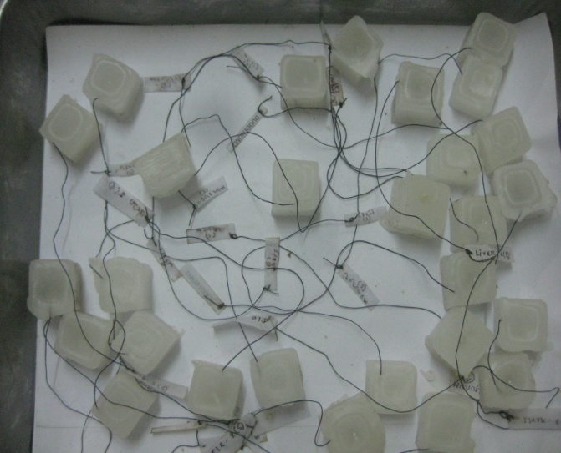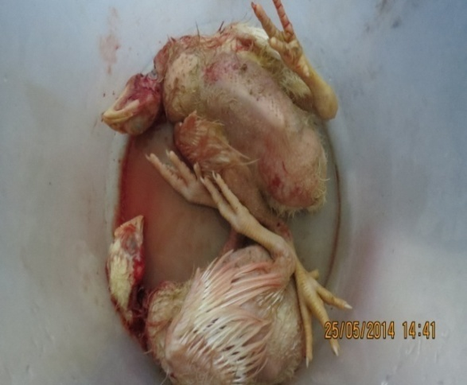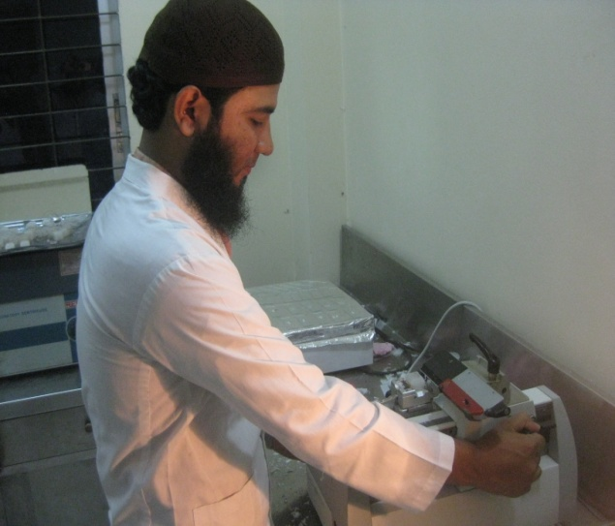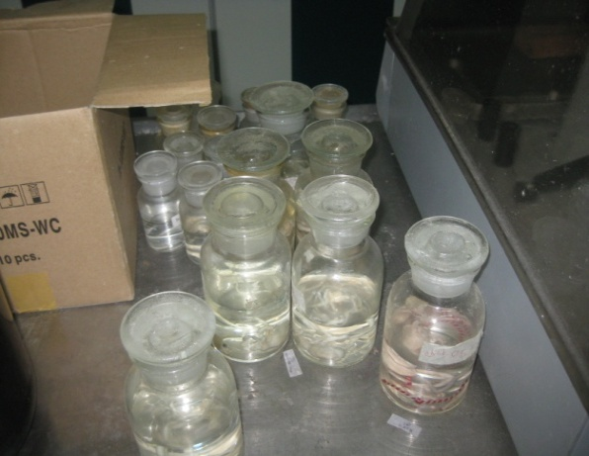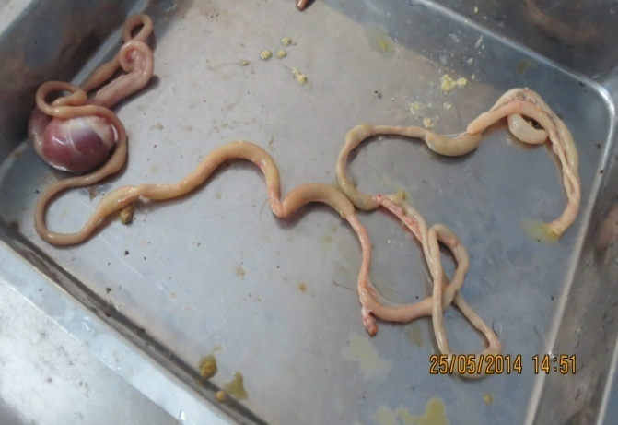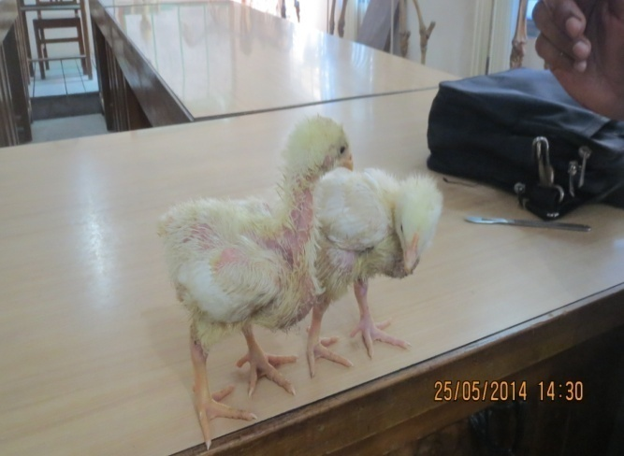

Fig-6 : Sectioning of block

Fig-2 : Slaughter by halal method

Fig-1 : Broiler chick

Fig-3 : Intestine for taking length and width.

Fig-4 : Sample preservation

Fig-5 : Paraffin block

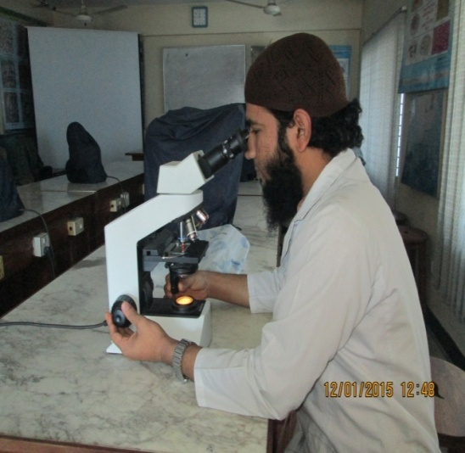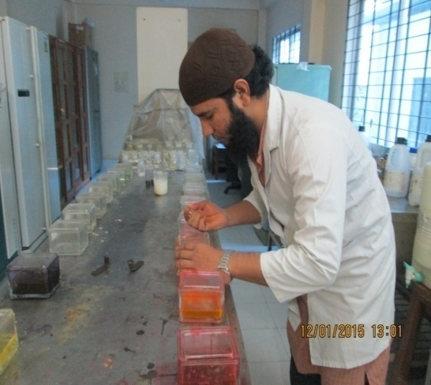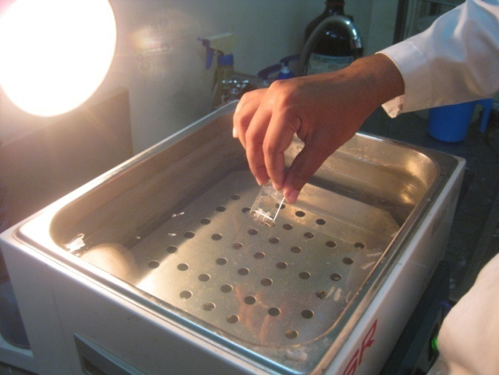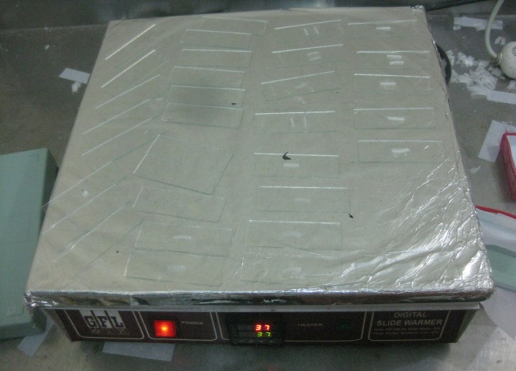

Fig-7 : Hot water bath

Fig-8 : Slide warmer

Fig-9 : Staining with H and E stain

Fig-10 : Microscopic Examination

# CHAPTER IV

# RESULTS AND DISCUSSION

**4.1 Post natal development (Gross characteristics) of the small intestine of broilers**

**4.1.1 Duodenum**

The Duodenum started at the gizzard and formed an elongated loop. The **pancreas** lies between the arms of the loop and being attached to each arm of the Duodenum actually holds the two arms together. After the duodenum, the small intestine formed a coil and was suspended from the dorsal abdominal wall the by a thin membrane — the mesentery. This membrane carried the blood vessels associated with the intestine.

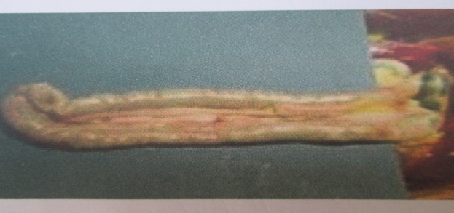

**Fig-11: U-shaped Duodenum holding pancreas within its** arm

The average lengths of Duodenum found given below in the table.

Table 1: Gross morphometry of Duodenum

|  |  |  |  |  |
| --- | --- | --- | --- | --- |
| Age (days) | Length (cm) | | Diameter (mm) | |
| Mean ± Std error | 95% CI | Mean ±Std error | 95% CI |
| 1 | 15.74± 0.63 | 14.43-17.04 | 2.62±0.19 | 2.24- 3.01 |
| 7 | 16.64±0.72 | 15.15-18.13 | 4.68±0.39 | 3.86- 5.50 |
| 14 | 20±0.35 | 19.32—20.68 | 5.4±0.15 | 5.09-5.71 |
| 28 | 20.5 ±0.46 | 19.54 -21.50 | 5.98 ±0.18 | 5.61 —6.34 |
| 32 | 28.06±1.29 | 25.38—30.74 | 6.88±0.29 | 6.28—7.48 |

This observation was similar with Hassouna (2001), where, the author stated that the length of the duodenal loop and its parts as well as its shape and extension varied in birds. This observation is quiet similar to Nasrin a al,.(2012), where the author stated that the length of Duodenum increased gradually with age.

In the above chart 95% CI (Confidence Interval) means that if the sample number increased, the length and diameter will be within the following range according to respective age groups.

As a example for day 1 in case of length the 95% confidence level is 14.43 cm to 17.04 cm, that means the length of Duodenum in case of day old chicks it will vary between 14.43 cm to 17.04 cm.

**4.1.2 Jejunum**

There was no clear demarcation between the Jejunum and Ileum. Meckel’s Diverticulum was a constant feature about half way along the small intestine appearing as a small projection on the outer surface of the small intestine. This projection was where the yolk stalk attached during the development of the embryo.

**Fig-12 : Meckel’s Diverticulum in the digestive tract of a chicken, which acts as a mark of demarcation between Jeiunum and Ileum.**

The average lengths of Jejunum found given below in the table.

Table 2: Gross morphometry of Jejunum:

|  |  |  |  |  |
| --- | --- | --- | --- | --- |
| Age (days) | Length (cm) | | Diameter (mm) | |
| Mean ± Std error | 95% CI | Mean ±Std error | 95% CI |
| 1 | 35±1.1 | 32.94-37.06 | 2.88±0.09 | 2.7—3.06 |
| 7 | 50.2±2.52 | 49.68—55.76 | 4.84±0.16 | 4.52-5.16 |
| 14 | 69.4± 1.37 | 66.16-72.63 | 5.22±0.14 | 4.93 -5.51 |
| 28 | 76.4±2.16 | 71.94-80.85 | 5.56±o.13 | 5.29—5.83 |
| 32 | 90.2±4.94 | 79.99—100.4 | 6.58±0.69 | 5.15—8 |

Among all the segments of the small intestine the length (cm) of Jejunum was highest and also in case of diameter (mm). The growth rate of Jejunal length was very rapid comparatively to Duodenum.

This observation is quiet similar to Nasrin et at,.( 2012), where the author stated that the length of Jejunum increased rapidly with age. This observation was also similar with Hassouna (2001), where, the author stated that in all bird species the jejunum was the longest part of the small intestine.

**4.1.3 Ileum**

The last part of the small intestine is the Ileum. The average lengths and diameter found of ileum were given below in the table.

Table 3: Gross morphometry of Ileum:

|  |  |  |  |  |
| --- | --- | --- | --- | --- |
| Age (days) | Length (cm) | | Diameter (mm) | |
| Mean ± Std error | 95% CI | Mean ±Std error | 95% CI |
| 1 | 17.2± 1.07 | 14.99— 19.4 | 2.7±0.09 | 2.52—2.88 |
| 7 | 15.4 ± 1.03 | 14.76—17.73 | 3.88 ± 0.11 | 3.93—4.39 |
| 14 | 19.7±0.37 | 18.93—20.47 | 4.16±0.14 | 4.1 —4.9 |
| 28 | 26.4±0.93 | 24.49—28.31 | 4.88±0.12 | 4.71—5.32 |
| 32 | 40 ± 2.53 | 34.78—45.22 | 5.48 ± 0.32 | 5.09 -6.98 |

The growth rate of Ileum was faster than Duodenum but slower than Jejunum.

This observation was similar with Hassouna (2001), where, the author found that lowest mean percentage of the length of ileum to the total length of the small intestine in chicken (2.7%).

**4.2 Histology of different segments of the small intestine of broilers**

**4.2.1 Duodenum**

The villi of the Duodenum of chicken studied were lined by simple columnar epithelium. This observation was similar with Aitken (1958), Nasri et al. (2012), where the author stated that in small intestine, the surface epithelium was simple columnar. The apical parts of villi of the Duodenum were slightly pointed and the basal parts of the villi were wider.

The average lengths and width of villi and muscle diameter of Duodenum were found given in the table below.

Table 4: Histomorphometry of Duodenum:

|  |  |  |  |  |  |  |
| --- | --- | --- | --- | --- | --- | --- |
| Age (Days) | Length of villi (µm) | | Width of villi (µm) | | Muscle layer diameter (µm) | |
| Mean Std error | 95% CI | Mean Std error | 95% CI | Mean Std error | 95% CI |
| 1 | 100.3 6.69 | 98.96-101.72 | 18.02 ± 3.3 | 17.32—  18.68 | 20.44 ± 2.92 | 19.83—  21.04 |
| 7 | 127.6 ± 2.47 | 122.57-  132.78 | 18.79 ± 3.54 | 18.06—  19.53 | 26.24 ± 5.08 | 25.19—  27.27 |
| 14 | 128.7 ± 6.7 | 114.17—  142.69 | 20.45 ± 3.75 | 19.71 —  21.26 | 27.7 ± 1.85 | 27.32—  28.08 |
| 28 | 146.52 ± 2.3 | 141.73—  151.32 | 20.52 ± 7.06 | 18.93—  22.09 | 30.46 ±3.15 | 29.81—  31.11 |
| 32 | 143.62 ± 1.29 | 140.96—  146.31 | 19.15 ±9.47 | 17.19—  21.1 | 30.53 ± 5.45 | 29.41 —  31.66 |

The chart represents that lengths and width of villi of the Duodenum increased with the age. Most of the development occurred within the 1st week of the age, according to this study. The intestinal glands became more prominent with response to their age. The numbers of goblet cells in lamina epithelium and intestinal glands in the lamina propia were more at day 28 than that at day 14 and at day 7.

The muscle surrounding the Duodenum reached at its highest diameter with their age ,it is also similar to Hassouna (2001) and the range was 29.41 —31.66 µm.

**4.2.2 Jejunum**

The villi of the Jejunum of chicken studied were lined by simple columnar epithelium, which were shorter and broader than that in Duodenum. Most of the villi had sharp apical part and wide basal part.

Tables 5: Histomorphometry of Jejunum:

|  |  |  |  |  |  |  |
| --- | --- | --- | --- | --- | --- | --- |
| Age (Days) | Length of villi (µm) | | Width of villi (µm) | | Muscle layer diameter (µm) | |
| Mean ± Std error | 95% CI | Mean ± Std error | 95% CI | Mean ± Std error | 95% Cl |
| 1 | 132.97±9.21 | 131.07—  134.87 | 24.34±2.99 | 20.15—20.54 | 22.58±  2.55 | 12.05—  13.19 |
| 7 | 168.24±9.64 | 189.25—  192.84 | 24.91 ±6.73 | 22.61 —28.38 | 31.94±  5.1 | 30.97—  32.98 |
| 14 | 169.8±7.9 | 167.27—  170.51 | 21.34±2.11 | 21.35—25.65 | 41.34±  5.02 | 40.27—  41.56 |
| 28 | 191.58 ±3.8 | 161.71 -  172.45 | 28.92 ± 7.3 | 26.07—30.68 | 41.17 ±  1.77 | 40.83—  42.41 |
| 32 | 282.39±4.9 | 290.18—294.61 | 38.49±9.68 | 32.50—38.49 | 75.34±1.67 | 73.48—  79.11 |

The numbers of goblet cells in lamina epithelium and intestinal glands in the lamina propia were more at day 32 than that at day 28 and day 14.

**4.2.3 Ileum**

The lining epithelium was same to Duodenum and Jejunum. Most of the villi had blunt apical part and wide basal part.

Table 6: Histomorphometry of Ileum:

|  |  |  |  |  |  |  |
| --- | --- | --- | --- | --- | --- | --- |
| Age (Days) | Length of villi (µm) | | Width of villi (µm) | | Muscle layer diameter (µm) | |
| Mean ± Std error | 95% CI | Mean ± Std error | 95% CI | Mean ± Std error | 95% Cl |
| 1 | 140.59±6.32 | 133.36—  135.87 | 18.79±3.54 | 16.62—19.5 | 21.23±  4.75 | 20.25—  22.29 |
| 7 | 191.44 ± 10.1 | 189.33—  193.52 | 20.54 ± 3.76 | 19.7—21.26 | 26.62 ±  6.52 | 25.27—  27.96 |
| 14 | 168.86±7.95 | 167.23—  175.93 | 21.44±2.12 | 20.9—21.8 | 28.14±  5.23 | 27.01—  29.18 |
| 28 | 212.68±5.56 | 189.39—  213.87 | 28.6±6.9 | 27.7—30.6 | 30.52±  3.06 | 29.89—  31.14 |
| 32 | 274.19±  8.74 | 267.15—  303.24 | 35.5±7.87 | 33.9—37.1 | 30.77±  5.68 | 29.59—  31.94 |

**Fig-13 : Comparative presentation of the length (cm) of the segments of small intestine according to age.**

The chart represents that in case of Duodenum its length increased very slowly comperatively to Jejunum.The growth rate of Jejunal length was very rapid. The length of ileum increased faster than Duodenum but slower than Jejunum.

**Fig-14 : Comparative presentation of the diameter of the segments of small intestine according to age.**

The chart indicates that the diameter of the three segments of small intestine was highest at days 32 and lowest at day 1.So the relationship of the age and diameter of the small intestine is significant.

**Fig-15 : Comparative presentation of Postnatal development of muscle diameter of the segments of small intestine of broilers.**

The chart shows that the post natal development of muscle layer diameter of the Duodenum, Jejunum and Ileum were increased as they became aged. The differences was that in case of the Jejunum the rate of growth was much more higher than the Duodenum and Ileum.

**Fig-16 : Comparative prasantation Postnatal development of villus length of the segments of small intestine of** **broilers.**

The chart shows that the postnatal development of villi length of the Duodenum, Jejunum and Ileum were increased as they became aged. The differences were that in case of the Jejunum the rate of growth was much more higher than the Duodenum and Ileum.

**Fig-17 : Comparative prasantation Postnatal development of width of villi of the segment of small intestine of** **broilers.**

The chart shows that the postnatal development of width length of the Duodenum, Jejunum and Ileum were increased as they became aged. The differences was that in case of Jejunum the rate of growth was much more higher than Duodenum and Ileum.

**Fig-19 : Duodenum at day 7**

**Fig-18 : Duodenum at day 1**

**Fig-20 : Duodenum at day 14**

S= Serosa, IG= Intestinal Gland, ME= Muscularis Externa, V= Villi

**Fig-22 : Duodenum at day 32**

**Fig-21 : Duodenum at day 28**

S= Serosa, IG= Intestinal Gland, ME= Muscularis Externa, V= Villi

**Fig-27 : Jejunum at day 32**

**Fig-26 : Jejunum at day 28**

**Fig-24 : Jejunum at day 7**

**Fig-25 : Jejunum at day 14**

**Fig-23: Jejunum at day 1**

S= Serosa, IG= Intestinal Gland, ME= Muscularis Externa, V= Villi

**Fig-32 : Ileum at day 32**

**Fig-31 : Ileum at day 28**

**Fig-30 : Ileum at day 14**

**Fig-29 : Ileum at day 7**

**Fig-28 : Ileum at day 1**

# CHAPTER V

# CONCLUSION

During the postnatal development of the cobb-500 broilers their body weight increased day by day. Subsequently the intestinal weight also increased. Along with the intestinal weight the length and diameter were also increased. The average length and diameter of Duodenum, Jejunum and Ileum of small intestine were significantly higher at day 32 than that at day 28, day 14 and day 7.

Histologically, variations found in the villus length and width and also in muscle diameter during the postnatal development of the small intestine segments ( Duodenum, Jejunum and Ileum). The average length and widths of villi of duodenum, Jejunum and Ileum of small intestine were higher at day 32 than that at day 28, day 14 and day 7. The villi became shorter and broader and the depths of intestinal gland decreased considerably in ileum than that of duodenum and jejunum. The number of goblet cells increased in ileum than that of duodenum and jejunum with the advancement of age. In the present study, the villus height and width in all segments of the small intestine increased with age, and these results were similar to those of previous studies (Fry et al., 1962; Holt et al., 1984; Miller et al., 2007; Wang et al., 2008).

# REFFERENCES

Aitken, R.N.C. 1958. Ahistochemical study of the stomach andintestne of the chicken. Journal of Anatomy, 435-466.

Bayer RC, Chawan CB,Bird FH. Musgrave SD 1975. Characteristics of the absorptive surface of the small intestine of the chicken from 1 day to 14 weeks of age. Poultry science. 54:155-169.

Bradley, O.C. and GraHame, t. 1950. The structure of the fowl. Pathology 35, 12-32.

Calhoun, M. Lois. Microscopic anatomy of the digestive system of the chicken. Ames. Iowa: Iowa state college Press.

Chewan, C. B., Bird, F. H. and Gerry, R. W. 1978. Relationship between intestinal movements and pancreatic juice secretion in the domestic chicken. Poultry science. 57:1084-1086.

Gridley, M.F. 1969. Manual of histologic and special staining technique. MacGraw-Hill Book Cpmpany, 28-29, 82-83.

Hassouna, E.M.A. 2001. Some anatomical and morphometrical studies on the intestinal tract of chicken, duck, goose, turkey, pigeon, dove, quail, sprarrow, heron, jackdaw, hoopoe, kestrel and owl. Assiut Veterinary Medical journal. 44: 47-78.

Nitsan Z, Avraham GB, Zorfe Z, Nir 1991. Growth and development of the digestive organs and some enzymes in the broiler chicks after hatching. Broiler Poultry Science. 32:515-523.

Noy, Y , Sklan, D. 1995. Digestion and absorption in young chicks. Poultry Science. 74:366-373.

Noy, y ,and Sklan, D. 1997. Post hatch development in poultry. J. Appl. Poultry Research. 6:344-354.

Noy, Y ,Geyr A, Sklan D. 2001. The effect of early feeding on growth and small intestinal development in the post hatch poultry. Poultry Science. 80:912-919.

Noy,Y , and Sklan, D. 1996. Uptake capacity for glucose,methionine and oleic acid in the proximal small intestine of posthatch chicks.Poultry science. 75:998-1002.

Sklan, D, shachaf, B. Baron, J. and Hurwitz, S. 1978. Retrograde movement of digesta in the duodenum of the chick: Extent, frequency and nutritional implication. J. Nurt. 108: 1485-1490.

Uni, Z, Ganot, S, Sklan, D. 1998. Posthatch development of mucosal function in the broiler small intestine. Poultry Science. 77:75-82.

Uni, Z,Noy Y ,Sklan, D.1998. Development of small intestine in heavy and light strain chicks before and after hatching.Broiler Poultry Science. 37:63-71.

Uni, Z., A. Smirnov, and Sklan, D.2003. Pre and post hatch development of goblet cells in the broiler small intestine: Effect of delayed access to feed. Poultry Science. 82:320-327.

Uni, Z., and Sklan, D. 1995. Post hatch changes in morphology and function of the small intestine in heavy and light strain chicks. Poultry Science. 74:1622-1629.

Uni, Z., Platin, R. and Sklan, D. 1999. Cell proliferation in chicken intestinal epithelium occurs both in the crypt and along the villus. J. Comp. Physiol.[B] 168: 241-247.

Verdal, H. de, Mignon-Grasteau, S., Jeulin, C., Bihan-Duval, E. Le, Leconate, M., Mallet, S., Martin, C. and Narcy, A. 2010. Digestivetract measurements and histological adaptation in broiler lines for digestive efficiency. Poultry Science. 89: 1955-1961.

Yamauchi K, Hida S, Isshiki Y. 1992. Post hatching developmental changes in the ultrastructure of the duodenal absorptive epithelial cell in 1,10 and 60 d-old chickens, with special references to the mitochondria. Broiler Poultry science. 33:475-488.

Yamauchi K, Isshiki Y. 1991. Scaning electric microscopic observations on the intestine villai in growing White Leghorn and broiler chickens from 1 to 30 days of age. Broiler Poultry Science. 32:67-78.

Yamauchi K, Nakamura E, Isshiki Y.1993. Development of the intestine villai associated with the increased epithelial cell mitosis in chickens. Animal science Technology. 64:340-350.