Chapter 1
Introduction
Milk is the nature’s almost perfect food. According to Walstra et al., (2006) milk contains average 87.25% water and 3.80% fat, 3.50% protein, 4.80% of lactose and 0.65% minerals. Besides, these milk contains considerable amount of fat soluble vitamins (Vitamin A, D, E, K) and water soluble vitamins (Vitamin B complex and Vitamin C). The nutritive value of milk depends on its freshness, cleanliness, purity and wholesomeness. Milk is a perishable product. The shelf-life of milk is best defined as the time during which the product remains wholesome and exhibits no physical or organoleptic defects. At least three aspects of quality contribute to shelf-life: product safety together with the organoleptic and physical properties. Product safety is paramount and the product must constitute no hazard to the consumer (Muir, 1996). Shelf life of the milk can be differed due to various causes. The main associated features for the reason are the microbial activity in the milk. Milk is not drawn from the cow under aseptic conditions and adventitious contamination by bacteria does occur. If these organisms are pathogens, i. e. capable of causing disease, their presence in milk limits shelf-life to the period in which their numbers do not exceed the infective level. Temperature is the necessary environmental factor for the growth of microorganism. Different microorganisms grow at different temperature (Patil et al., 2014; Yano et al., 2014). The temperature normally starts to change as soon as the milk leaves the refrigerator cabinet and increases while the consumer completes the shopping and during the drive home, before being returned to a refrigerator bin the consumer’s home (Sadhu, 2018).
To preserve this nutritious drink for marketing is a problem for milk trader. The milk trader often fails to maintain its keeping quality after procurement of milk in raw condition from rural area to bring it to urban area. They use some local techniques to preserves cow's milk in raw condition during transportation by putting water hyacinth leaves and date leaves etc. in milk. But these techniques do not give satisfactory results and also makes the quality of milk unhygienic. Sometimes thesse techniques bring changes in the quality of milk in raw condition which makes it unsuitable for consumption. But marketing of some portion of this milk is difficult because expensive pasteurizations techniques are not available in remote area of Bangladesh. As a result, a lot of milk is deteriorated during transportation.
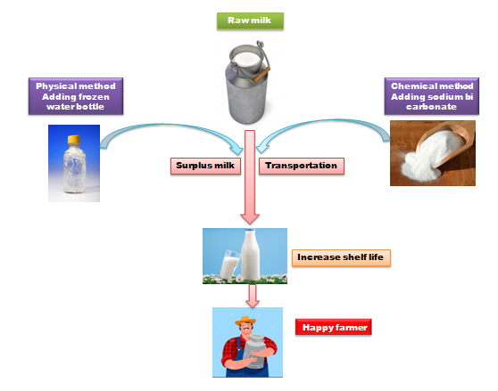
Figure 1: Traditional methods of milk preservation

In Bangladesh, due to environmental conditions it is very difficult to preserve milk without applying any technique. Lambert (2001) stated that cooling is the most feasible method to save milk from bacterial deterioration. There may have lot of chances to spoil the milk during transportation due to lack of cooling facilities, unhygienic milk production practices at farm level and improper transport facilities (El Zubeir et al., 2010). But in Bangladesh perspective chilling facility is not available in the rural areas. So, milk chilling is a costly operation for the producers. In the alternative of the costly operation, milk producers are applying a unique technique of using frozen water bottle to lower the milk temperature for short time preservation. Because lower temperature inhibits bacterial growth. To increase the shelf life of raw milk, below 4 °C chilling is recommended and commonly adopted practice all over the world (Ajmal et al., 2018). To the best of my knowledge no proper scientific study had performed regarding the use of frozen water bottle for milk preservation.
Sodium bicarbonate (NaHCO₃) is a cheap chemical available in local market, present in powder form, white in color and very easy to handle. Haddadin et al., (1996) from a preliminary study found that sodium bicarbonate is useful for short time preservation of milk. It is expected that handling of this chemical will be very easy by the farmers with minimal hazardous effects on public health. Product safety is paramount and the product must constitute no hazard to the consumer. In Bangladesh, milk chilling facility is not available. In remote milk producing areas refrigeration facility is not adequate. So milk producers face a big issue regarding milk perishability during marketing, which cause a huge financial loss. Most of the farmers or vendors are illiterate and they do not know how to preserve milk scientifically. So, a well established short time milk preservation technique needs to be occupied by the local milk producers of Bangladesh. By aiming this regards following objectives were set to conduct the study.
Objectives of the study:
- To observe the efficacy of different level of NaHCO₃ as milk preservative.
- To develop/initiate a technique for the preservation of cow's milk in raw condition using frozen water bottle as traditional method of milk preservation.
- To check the effect of NaHCO₃ and frozen water bottle on milk quality (acidity percentage).

Chapter 2
Review of Literature
2.1 Introduction
To make the milk safe for public health and also to increase its shelf life it is very important to preserve milk scientifically. Due to lack of proper milk preservation facilities, a huge quantity of milk undergoes spoilage every year in our country. Milk can be preserved for a while for human consumption by using some chemical substances such as hydrogen peroxide (H₂O₂), sodium bicarbonate (NaHCO₃) (Hossain et al., 2011), etc. and by regulating the temperature i.e. cooling, pasteurization and boiling. Cooling and pasteurization facilities are not available throughout the country. At the same time, heated boiled milk is not also popular in our country. Established dairy farms have modern facilities for milk preservation but small farmers or the poor formers or vendors or goalas who live in rural areas have no such types of facilities for milk preservation. This chapter summarizes the milk preservation technique and also describes the efficacy of methods of milk preservation.
2.2 Milk
Milk is synthesized in specialized cells of the mammary gland and is virtually sterile when secreted into the alveoli of the udder (Tolle, 1980). Milk is a food of high nutritious value. It promotes growth and maintenance of body tissue. Milk is produced from the mammary glands of mammals and it is a soul food for offspring of mammals. It contains in a balanced form all the necessary and digestible elements for building and maintaining the human and animal body. About 87% of milk composition consists of water and 13% are nutritionally important components, such as proteins, carbohydrates, lipids, minerals and vitamins. It is reported that, daily consumption of one liter of cow's milk furnishes an average man approximately all the fat, calcium, phosphorous and riboflavin, one third of vitamin A, ascorbic acid, and thiamine, one fourth of the calories, and with the exception of iron, copper, manganese and magnesium, all the minerals needed daily (Tolle, 1980). It is excellent source of high-quality protein, vitamins and minerals. It represents one of the best natural sources of essential amino acids for human nutrition. Moreover, milk is an outstanding source of calcium and phosphorus to build bones and teeth. Similarly, milk is the most nutritious and it can attribute for the growth, reproduction, energy source, maintenance and repairs of body. Also, due to having various properties, it can be easily converting into different milk products and to use it as an ingredient for other food items (Bezie, 2019)
2.3 Shelf life of milk
Due to the treatment process, high microbial load in milk is unexpected in the pasteurized or the UHT milk. After the date of manufacture, the recommended date of consumption for the pasteurized and the UHT milk is 7 days and 6 months, respectively (Table 1). But the poor initial milk quality, defective processing or problem in preservation at the consumer side may deteriorate milk quality before the original date of expiry (Dey et al., 2013). The Bangladesh Standards and Testing Institution (BSTI) has set various chemical and sanitary requirements for the pasteurized milk (BSTI, 2002).
The shelf-life of a dairy product is best defined as the time during which the product remains wholesome and exhibits no physical or organoleptic defects. At least three aspects of quality contribute to shelf-life: product safety together with the organoleptic and physical properties. Product safety is paramount and the product must constitute no hazard to the consumer (Muir, 1996). Milk is a nutritious medium that presents a favorable environment for the growth of spoilage and pathogenic microorganisms. Therefore, milk as a raw material has a short shelf life and needs to be processed.
Table 1: Shelf life of milk after different heat treatment (Bezie, 2019)
Parameters Reference enzyme | HTST pasteurization | ESL (Extended shelf life) |  | UHT
 | Phosphatase (-) |  | Phosphatase (-) |  | Phosphatase (-)
Storage conditions | Refrigerated | Refrigerated |  | Room temperature
Packaging | Clean | Aseptic |  | Aseptic
Shelf-life | 10-14 d | 30-60 d |  | >6 months
Temperature used | 72°C | 70-90°C |  | 135-150°C

2.4 Factors affecting shelf life of milk
Shelf life of the milk can be differed due to various causes. The main associated features for the reason are the microbial activity in the milk. Temperature is the necessary environmental factor for the growth of microorganism. Different microorganisms grow at different temperature (Patil et al., 2014; Yano et al., 2014). The temperature normally starts to change as soon as the milk leaves the refrigerator cabinet and increases while the consumer completes the shopping and during the drive home, before being returned to a refrigerator bin the consumer’s home (Sadhu, 2018). The milk processing consists of following steps: agitation, mixing, and cooling at the farm; clarification, separation, and standardization; pasteurization; homogenization; packaging; all done by sanitation (Massoud et al., 2016).
It was shown that microbiological criteria determined shelf-life and that methods of controlling shelf-life depend on moderation of the growth of and subsequent degradation by spoilage micro-organisms. In contrast, the shelf-life of intermediate and long-life dairy products is largely determined by enzymatic degradation or by chemical deterioration (Yano et al., 2014).
The most notable feature of the spoilage bacteria found in raw milk is their almost universal ability to produce extracellular degradative enzymes. While the bacteria-mostly Gram –ve psychrotrophs are readily killed by pasteurization of the milk, such heat treatment has little effect on the extracellular degradative enzymes. In this section the effect of ultra high temperature (UHT) processing, a heat treatment designed for sterilization, on proteinase, lipase and phospholipase activity will be discussed (Sadhu, 2018).
2.5 Microbiology of milk
Milk is not drawn from the cow under aseptic conditions and adventitious contamination by bacteria does occur. If these organisms are pathogens, ie, capable of causing disease, their presence in milk limits shelf-life to the period in which their numbers do not exceed the infective level. The dairy industry regards food safety as a critical feature of its products, and careful control of processing and storage conditions can ensure that the hazard to the consumer is vanishingly small. While the growth of pathogenic bacteria in dairy products is not a determinant of shelf-life, the growth of spoilage bacteria is. Such bacteria will degrade the milk constituents by means of extracellular and intracellular enzyme activity. Four types of enzyme activity are encountered such as:
- Lactose may be fermented to lactic acid resulting in soured product
- Lipids are hydrolysed by lipase-both microbial and the native milk enzyme and, as a result, rancidity develops Proteinase activity results in breakdown of milk proteins with both physical and organoleptic effects, principally gelation and the development of intense bitter flavours
- Finally, phospholipases can attack the milk fat globule membrane which stabilizes the native emulsion of milk fat. As a result, churning of the fat occurs and the phenomenon is widely known as ‘bitty cream’
The safety of milk has been the overriding concern of the modern dairy industry. Early work focused attention on eradication of brucellosis and tuberculosis and these scourges have been completely eliminated by a rigid policy of slaughter for all animals found to have evidence of the disease or exposure to it. The frequency of milk-borne disease is now very low and is almost exclusively associated with the consumption of raw milk or products made from raw milk. The most significant pathogens found in raw milk and in milk products are shown in Table 2.
Table 2: Pathogenic microorganism of raw milk (Dey et al., 2013).
Pathogenic microorganism | Survive below 6° C | Survive at pasteurization temperature
Staphylococcus aureus | No | No
Campylobacter jejuni | No | No
Clostridium spp | No | Yes (Spore)
Salmonella spp | No | No
Escherichia coli | No | No
Yersinia enterocolitica | Yes | No
Bacillus cereus | Yes | Yes (Spore)
Listeria monocytogenes | Yes | No

Staphylococcus aureus and a number of pathogenic streptococci are a common cause of udder disease in the dairy cow. Where such disease is present the pathogens may then occur in the milk. Milk from cows with clinical symptoms does not get into the normal supply but, in the case of subclinical mastitis, small numbers of organisms may enter the raw milk. This problem is well recognized and the level of subclinical mastitis in the dairy herd is regularly and routinely measured by estimation of the somatic cell count. The level of somatic cells in milk is a good index of udder health. In addition to these preventive measures, if staphylococci do enter the milk supply they do not multiply at refrigeration temperature and are readily destroyed by pasteurization. Some pathogens grow readily at refrigeration temperature. Escherichia coli is such an organism and is fairly often found in raw milk. Some strains produce enterotoxin or verotoxin. Notably, Yersinia enterocolitica and Listeria monocytogeneshave been implicated as a cause of milk and cheese-borne disease.
Among the microbial populations, Gram-ve bacteria usually account for more than 90% in cold raw milk that has been stored including psychrotrophic species of Pseudomonas, Achromobacter, Aeromonas, Serratia, Alcaligenes, Chromobacterium, Flavobacterium and Enterobacter (García-Armesto and Sutherland, 1997; Sørhaug and Stepaniak, 1997; Ryser, 199; Martins et al., 2006). The presence of indicator bacteria and some other bacteria in lesser number determines the safety and quality of milk and milk products (Uddin et al., 2011).

2.6 Factors affecting microbial load
The bacteria in milk which has been freshly drawn from a healthy cow are largely derived from the environment within which the cow is kept and from the equipment through which the milk passes and in which it is stored.
Beyond this stage of milk production, microbial contamination can generally occur from the exterior of the udder and from the surface of milk handling and storage equipment. Bacterial contamination of raw milk can originate from different sources: air, milking equipment, feed, soil, feces and grass (Coorevits et al., 2008; Marjan et al., 2014). The number and types of micro-organisms in milk instantly after milking are affected by factors such as animal and equipment cleanliness, season, feed and animal health (Uddin et al., 2011). It is hypothesized that the various ways in feeding and housing strategies of cows may influence the microbial quality of milk (Coorevits et al., 2008). The water used for rinsing milking machine and equipment may also be responsible for the presence of high load of micro-organisms including pathogens in raw milk (Islam et al., 2018). Most of the milk in Western Europe is cooled and refrigerated promptly after milking. As a result, conditions favour the survival and subsequent growth of organisms adapted to a low temperature environment. Many such bacteria have an optimum growth temperature between 20°C and 30°C but can also grow at refrigeration temperature. They are known collectively as psychrotrophs.
2.7 Natural milk preservation
Lactoperoxidase system that inheridate in milk can protect milk from bacterial action for a certain amount of time. Lactoperoxidase (LP) is a glycoprotein that presents by nature in colostrums and milk (Kussendrager and van Hooijdonk, 2000; Conner et al., 2002). This LP system has been proven to be effective against both gram-positive and gram-ve bacteria (Naidu, 2000; Marks et al., 2001). LP system becomes active with the presence of hydrogen peroxide and thiocyanate. Lactoperoxidase system has been considered as an important side in defense mechanism in mammals (Boots and Floris, 2006). Lactoperoxidase is copious in raw milk, whereas, thiocyanate and hydrogen peroxide are present at low concentrations and can be depleted. The antimicrobial activity of LP is exerted through the oxidation of thiocyanate (SCN) by hydrogen peroxide producing oxidation products as hypothiocyanite (OSCN) (Carlsson et al., 1983; Le Nguyen et al., 2005) and hypthiocyanous acid (HOSCN), which show antimicrobial action (Sermon et al., 2005). Lactoperoxidase catalyzes the chemical reaction in milk of inorganic and organic substrates with the help of H₂O₂ (Al-Baarri et al., 2011).
2.8 Cause of milk perishability
Milk is a valuable nutritious food that has a short shelf-life and requires careful handling. Milk is highly perishable because it is an excellent medium for the growth of microorganisms, particularly bacterial pathogens that can cause spoilage and diseases in consumers. Milk processing allows the preservation of milk for days, weeks or months and helps to reduce food-borne illness. After the stage, milk production, microbial contamination can generally occur from the exterior of the udder and from the surface of milk handling and storage equipment. Bacterial contamination of raw milk can originate from different sources: air, milking equipment, feed, soil, feces and grass (Coorevits et al., 2008).

2.9 Methods of milk preservation
Table 3: Milk preservation techniques.
Methods of milk preservation
Physical Methods | Chemical methods
Cooling | LP system (Adding H₂O₂)
Heating  - Boiling  - Pasteurization | NaHCO₃

2.9.1 Physical methods
2.9.1.1 Cooling
Normally milk contains bacteria coming from the animal’s udder, milk vessels and handling persons. When the milk leaves the udder, bacteria grow well at the ambient temperature (20-40°C) and milk starts deteriorating. Bacterial growth factor goes down to 1.05 at 5°C and 1.00 at 0°C. Critical temperature for bacterial growth is 10°C. The growth factor at 10°C is 1.80 which rises to 10.0 at 15°C. Hence freshly drawn raw milk should be promptly cooled to 5°C or below and held at that temperature till it is processed. Milk chilling is a costly operation and not available in rural areas, milk producers applying a unique technique of using frozen water bottle to lower the milk temperature for short time preservation. Because bacterial growth inhibits at lower temperature.
In many Asian and African countries, most of the milk is produced on small farms. On an average basis, about 10–15 L milk is produced on each farm. Chilling facilities are usually installed to cater the milk of about 15–25 villages. The distance between the place of milk production and milk chilling facilities is about 10–12 KM. On an average basis, it takes about 2 h to reach milk from the point of production to the chilling facility. During this period, several chemical changes take place in raw milk. Due to perishable nature of milk, immediate chilling of raw milk on the farm is recommended, however, due to several reasons in developing countries, practically it is impossible to chill the milk on the farm. To increase the shelf life of raw milk, below 4 °C chilling is recommended and commonly adopted practice all over the world (Ajmal et al., 2018). In Bangladesh, due to environmental conditions it is very difficult to preserve milk without applying any technique. Lambert (2001) stated that cooling is the most feasible method to save milk from bacterial deterioration. There may have lot of chances to spoil the milk during transportation due to lack of cooling facilities, unhygienic milk production practices at farm level and improper transport facilities (El Zubeir et al., 2010).
There are some traditional methods of milk cooling, such as milk can immersion. The milk from pails is poured directly into cans through a strainer. The cans of milk are gently lowered into a tank holding cold water. The water level in the tank should be lower than the level of milk in cans to prevent water entering into the milk. In this method, a much smaller refrigeration unit is needed. The cans are kept cooled at the desired temperature (5-7°C) and the capacity of the unit is 200-280 liters of milk.
Another popular method is surface cooling of milk tank. The milk is distributed over the outer surfaces of the cooling tubes from the top by means of a distributor pipe and flows down in a continuous thin stream. The cooling medium mostly chilled water is circulated in the opposite direction through inside of the tubes. Cooled milk is collected below in a receiving trough, from which it is discharged.
Bulk tank coolers are run by mechanical refrigeration system which cools the milk rapidly. These coolers maintain the temperature automatically during storage. Milk can be poured directly from milking pails into the tanks. This method is suitable for handling 500-2500 L milk/day. It is widely used at village level milk collection centers in India. From the Bulk milk cooler (BMC), the milk is pumped to the insulated tankers for transportation to dairy plants. The BMC uses horizontal or vertical cylindrical tanks with inner jacket and insulated body on the other side. There is provision of inner shell of the tank or direct expansion refrigerant coil for cooling. Milk is directly poured into the tank or pumped into the tank. Milk remains in contact with the inner shell of the tank cooling it to 4°C. The agitator is provided for uniform cooling.

2.9.1.2 Boiling
Temperature is the necessary environmental factor for the growth of microorganism. Different microorganisms grow at different temperature (Patil et al., 2014; Yano et al., 2014). The temperature normally starts to change as soon as the milk leaves the refrigerator cabinet and increases while the consumer completes the shopping and during the drive home, before being returned to a refrigerator bin the consumer’s home (Sadhu, 2018). Heat treatment remains the primary factor that determines the span of the shelf-life. Heat treatment is the most widely used processing technology in the dairy industry. Its main purpose is to destroy microorganisms, both pathogenic and spoilage, to ensure the milk is safe and has a reasonable shelf-life. Despite the developments of alternative technologies such as high-pressure processing and pulsed electric field technology for destroying microorganisms, thermal treatment remains the method of choice for most bactericidal treatments in the dairy industry, and in the processing of other foods (Schmidt et al., 2012).
2.9.1.3 Pasteurization
The dairy industry uses various means and technologies aimed at achieving an extension in product shelf-life. Some commonly used methods include heat treatment of fluid milk products for a pre-determined time and temperature. The Dairy industry has been commonly applying a pasteurization process known as HTST (High-Temperature Short-Time) which uses a combination of time-temperature of 72 °C for at least 15 seconds (Bezie, 2019). Pasteurization and ultra-high temperature processes altered the composition of the milk slightly, decreasing total fat and total solids and increasing urea (Tallini, 2015). The fat, fat-soluble vitamins, carbohydrates and mineral’ of milk are essentially unaffected by heat treatment. Proteins and water-soluble vitamins are the components which are mainly affected by the heat treatment (Bezie, 2019).
The dairy industry has adopted newer processing technologies that can increase the shelf life of fluid milk beyond its traditional life with minimal adverse effects on its quality and taste (generally referred to as Extended Shelf-life (ESL) milk). Examples include Higher-Heat-shorter-time (HHST) is one means of extending the shelf-life of milk to over 50 days at refrigerated storage conditions (IDF, 2012).
2.9.2 Chemical method
2.9.2.1 Hydrogen peroxide (To activate Lactoperoxidase system)
Milk contains many essential nutrients, such as carbohydrates, proteins, lipids, minerals and vitamins and therefore, acts as an ideal medium for rapid proliferation of harmful microorganisms (Saha et al., 2003). Lactoperoxidase (LP) is a glycoprotein that presents by nature in colostrums and milk (Kussendrager and van Hooijdonk, 2000; Conner et al., 2002). This LP system has been proven to be effective against both gram-positive and gram-ve bacteria (Naidu, 2000; Marks et al., 2001). LP system becomes active with the presence of hydrogen peroxide and thiocyanate. Lactoperoxidase system has been considered as an important side in defense mechanism in mammals (Boots and Floris, 2006). Lactoperoxidase is copious in raw milk, whereas, thiocyanate and hydrogen peroxide are present at low concentrations and can be depleted.
The antimicrobial activity of LP is exerted through the oxidation of thiocyanate (SCN) by hydrogen peroxide producing oxidation products as hypothiocyanite (OSCN) (Carlsson et al., 1983; Le Nguyen et al., 2005) and hypthiocyanous acid (HOSCN), which show antimicrobial action (Sermon et al., 2005). Lactoperoxidase catalyzes the chemical reaction in milk of inorganic and organic substrates with the help of H₂O₂ (Al-Baarri et al., 2011). To activate LP system, H₂O₂ is recommended by FAO/WHO as a standard method for inhibiting bacterial growth in raw milk (CAC, 1991). Hydrogen peroxide is the accepted chemical to activate LP system in milk to prevent bacterial proliferation (Ozer et al., 2003). Hydrogen peroxide has toxicant effect when exposed to mammalian cells. But mammalian cells can be insured from this toxicity in the presence of LP and SCN¯, if low concentrations of H₂O₂ are used (Pruitt and Kamau, 1991).
Saha et al. (2003) and Rokhsana et al. (2007) claimed a positive influence of adding H₂O₂ to milk with respect to preservation. Rokhsana et al. (2007) were able to extend the self-life of milk up to 11 h by adding 0.05% H₂O₂ at 20°C though the concentration/grade/purity of H₂O₂ was not declared. On the other hand, Saha et al. (2003) concluded that 0.04 to 0.05% H₂O₂ (30 w/v) was enough to extend the self-life of milk up to 24 hour. Seifu et al. (2005) stated that LP system is the most effective technique of milk preservation where refrigeration facilities are not easy to manage. In Bangladesh, maintaining cooling chain is inaccessible due to inadequate electricity supply and extra cost involvement.
2.9.2.2 Sodium bi carbonate
Sodium bicarbonate (NaHCO₃) is a cheap chemical available in local market, present in powder form, white in color and very easy to handle. Haddadin et al. (1996) from a preliminary study found that sodium bi carbonate is useful for short time preservation of milk. It is expected that handling of this chemical will be very easy by the farmers and there will be no hazards effects on public health. Local goalas or vendors or farmers are using this chemical for milk preservation but scientifically its feasibility as milk preservative has not been carried out widely. Hence, this experiment was conducted to monitor the usefulness of sodium bi carbonate (NaHCO₃) as milk preservative. The study of Rahman et al., (2018) revealed that 0.5% NaHCO₃ is enough to preserve milk samples upto 19 hours.
2.10 Effect of milk preservation on milk composition
Pasteurization and then the commercial sterilization increased the pH of milk, with consequent decrease in acidity. This increased pH can be explained by lower whey protein associating with the micelles. Pasteurization and ultra-high temperature processes altered the composition of the milk slightly, decreasing total fat and total solids and increasing urea (Tallini, 2015).
The fat, fat-soluble vitamins, carbohydrates and mineral’ of milk are essentially unaffected by heat treatment. Proteins and water-soluble vitamins are the components which are mainly affected by the heat treatment (Sharma, 1980). This contrasts the report of Tallini, (2015). Pasteurized and ultra-high temperature milks kept protein and lactose content similar to raw milk. Lactose seems to be little affected by traditional heat processing procedures or during drying. Pasteurization alone appears to cause no change in the vitamin A and carotene content of milk, but when this process is followed by evaporation as in the manufacture of condensed milk, there are loses of 20% of the vitamin A, although carotene is not affected. Vitamin E content of milk is not influenced by pasteurization or evaporation but a loss of 9 % may occur after drying and reconstitution. Vitamin D also appears to suffer no loss during heat processing of milk. There is no loss of vitamins of the B-complex group riboflavin, nicotinic acid, pyridoxine, pantothenic acid and biotin by heat treatment. But the losses of BI (thiamin), B12 and C increase from 10-20% in pasteurization and UHT treatment, to 90 %loss of B12 in bottle sterilization and evaporation (Sharma, 1980). Pasteurization temperature, ranged from 72 to 94 °C /15s had no effect on the microbiological and sensory shelf-life of aseptically packaged milk into plastic bottle, which lasted 11 d under storage at 9 °C (Petrus, 2012). According to Tallini, (2015), under the most favorable processing and storage conditions, this HTST pasteurization process is capable of extending the shelf-life of milk for up to 3 weeks de-pending on the initial microbiological quality of the raw milk. UHT process is a recent introduction for the production of sterilized milk (Sharma, 1980), which uses a high temperature (>135 °C) for 1-2 seconds (IDF, 2012)
The fat, fat-soluble vitamins, carbohydrates and mineral’ of milk are essentially unaffected by heal treatment. Proteins and water-soluble vitamins are the components which are mainly affected by the heat treatment (Bezie, 2019). Pasteurization and ultra-high temperature processes altered the composition of the milk slightly, decreasing total fat and total solids and increasing urea (Tallini, 2015). The fat, fat-soluble vitamins, carbohydrates and mineral’ of milk are essentially unaffected by heal treatment. Proteins and water-soluble vitamins are the components which are mainly affected by the heat treatment (Bezie, 2019)
2.11 Public health significance
Product safety is paramount and the product must constitute no hazard to the consumer. While nutritionists may argue over the nuances of overconsumption of some milk constituents, such as fat, there is general acceptance that milk and dairy products are highly nutritious and make a major contribution to a well balanced diet.
Therefore in order to protect the public health, microbiological assessments have an important role to play in the dairy industry. This will also reduce economic losses by the early detection of insufficient processing, packaging or refrigeration.
The milkmen in Bangladesh mostly produce milk in non-standardized way and usually supply to the consumers from the urban and rural areas (Marjan et al., 2014). As a consequence of adulteration in milk both the dilution in the amount of milk solids as well as the introduction of various pathogens takes place. So it is very much imperative to process the milk in such a way so that it assures the safety as well as the wholesomeness of the milk quality is maintained (Hossain et al., 2010; Marjan et al., 2014).
2.12 Conclusion
From this section of review, it is clear that numerous scientists around the globe have tried to develop/improve milk preservation technology in order to reduce the spoilage of milk which usually occurs during transportation and keeping long time without applying any scientific technique before marketing. So it is very important to carry out research work for developing a suitable method of milk preservation for our milk traders. The present study was undertaken to preserve milk sample by frozen water bottle and NaHCO₃. To the best of my knowledge no proper scientific study had performed regarding the use of frozen water bottle for milk preservation. This experiment will explore the keeping quality of NaHCO₃ and frozen water bottle as a short term preservative of milk under rural condition of Bangladesh where scientific cooling or pasteurization facilities are not available.

Chapter 3
Materials and Methods
3.1 Study area
This study was conducted at the Chattogram Metropolitan area (Kalamia Bazar, Bakolia, Chandgaon, Sitakundu) (Figure 2). From different commercial dairy farms and milk collection centre were selected for sample collection. This city is known for its hilly terrain that stretches throughout the district. The location of the city is 22°22’0” N 91.98°E on the bank of Karnaphuli river. It has a subtropical monsoon climate characterized by wide seasonal variations in rainfall, moderately warm temperatures, and high humidity.
Figure 2: Chattogram Metropolitan Area
3.2 Study period
The time frame of the study was between January, 2020 to September, 2020. When the ambient temperature was ranged from 25 to 42 degree celcius.
3.3 Target population
All farm level milk producers and milk suppliers along with household milk producer of Chattogram Metropolitan area.

3.4 Sample collection
The raw milk sample for the desired test were collected from commercial dairy farm, pooled milk samples from milk suppliers and household animal rearers. For the test of shelf life by using different preservatives and to check the milk constituents in the examined milk 5 liter samples from each type were collected (Figure 3, 4).
3.5 Addition of different preservatives
To check the milk preservation efficacy two types of preservation method were checked. These were Sodium bi carbonate (NaHCO₃) and frozen water bottles (Figure 5, 6). A total of five trials were performed.
3.5.1 Sodium bi carbonate (NaHCO₃)
The collected milk samples after thoroughly mixing was divided into four equal parts. Out of four parts, one was kept as whole milk without NaHCO₃ (control) and the other three parts were preserved with different levels of NaHCO₃ such as milk sample with 0.1% NaHCO₃; milk sample with 0.2% NaHCO₃ and milk sample with 0.3%NaHCO₃. And all milk samples were tested for its shelf life and change in milk constituents every one hour interval when the room temperature was between 28-35$°$C. (Table 4)
Table 4: Addition of NaHCO₃ and its efficacy in different concentration.
Test no. | (Time) | 0.1% | 0.2% | 0.3% | Control
1 | (8 AM) | After 1 hour of addition | After 1 hour of addition | After 1 hour of addition | After 1 hour
2 | (9 AM) | After 2 hour of addition | After 2 hour of addition | After 2 hour of addition | After 2 hour
3 | (10 AM) | After 3 hour of addition | After 3 hour of addition | After 3 hour of addition | After 3 hour
4 | (11 AM) | After 4 hour of addition | After 4 hour of addition | After 4 hour of addition | After 4 hour
5 | (12 PM) | After 5 hour of addition | After 5 hour of addition | After 5 hour of addition | After 5 hour
6 | (1 PM) | After 6 hour of addition | After 6 hour of addition | After 6 hour of addition | After 6 hour
7 | (2 PM) | After 7 hour of addition | After 7 hour of addition | After 7 hour of addition | After 7 hour
8 | (3 PM) | After 8 hour of addition | After 8 hour of addition | After 8 hour of addition | After 8 hour
9 | (4 PM) | After 9 hour of addition | After 9 hour of addition | After 9 hour of addition | After 9 hour
10 | (5 PM) | After 10 hour of addition | After 10 hour of addition | After 10 hour of addition | After 10 hour
11 | (6 PM) | After 11 hour of addition | After 11 hour of addition | After 11 hour of addition | After 11 hour
12 | (7 PM) | After 12 hour of addition | After 12 hour of addition | After 12 hour of addition | After 12 hour
13 | (8 PM) | After 13 hour of addition | After 13 hour of addition | After 13 hour of addition | After 13 hour
14 | (9 PM) | After 14 hour of addition | After 14 hour of addition | After 14 hour of addition | After 14 hour

3.5.2 Use of frozen water bottles
Plastic water bottle of 250 ml were collected and cleaned properly to remove all types of foreign materials from the external and internal surface. After that this bottles were filled upto its top portion with clean water and kept in freezer for 24 hours. Frozen water bottles were used to enhance the shelf life of the milk sample.
The collected sample was divided into three portions of 1 liter, 1.5 liter and 2 liters of milk. And in each container one frozen water bottle were kept. One milk container was kept without water bottle as control.
And all milk samples were tested for its shelf life and change in milk constituents every half an hour interval when the room temperature was between 28-35$°$ C (Table 5).
Table 5: Addition of frozen water bottle and its of efficacy in different amount of milk.
Test no. | Time | 1 liter milk container | 1.5 liter milk container | 2 liter milk container | Control (Without frozen bottle)
1 | (8.30 AM) | After 1/2 hour of addition | After 1/2 hour of addition | After 1/2 hour of addition | After 1/2 hour
2 | (9 AM) | After 1 hour of addition | After 1 hour of addition | After 1 hour of addition | After 1 hour
3 | (9.30 AM) | After 1.5 hour of addition | After 1.5 hour of addition | After 1.5 hour of addition | After 1.5 hour
4 | (10 AM) | After 2 hour of addition | After 2 hour of addition | After 2 hour of addition | After 2 hour
5 | (10.30 PM) | After 2.5 hour of addition | After 2.5 hour of addition | After 2.5 hour of addition | After 2.5 hour
6 | (11 PM) | After 3 hour of addition | After 3 hour of addition | After 3 hour of addition | After 3 hour
7 | (11.30 PM) | After 3.5 hour of addition | After 3.5 hour of addition | After 3.5 hour of addition | After 3.5 hour
8 | (12 PM) | After 4 hour of addition | After 4 hour of addition | After 4 hour of addition | After 4 hour
9 | (12.30 PM) | After 4.5 hour of addition | After 4.5 hour of addition | After 4.5 hour of addition | After 4.5 hour
10 | (1 PM) | After 5 hour of addition | After 5 hour of addition | After 5 hour of addition | After 5 hour
11 | (1.30 PM) | After 5.5 hour of addition | After 5.5 hour of addition | After 5.5 hour of addition | After 5.5 hour

3.6 Determination of milk constituents
After collecting the milk samples from all sources important milk constituents such as fat, protein and specific gravity were tested.
3.6.1 Determination of milk fat
Fat percentage was determined by volumetric method (Gerber method).10ml of concentrated sulfuric acid (H₂SO₄) was taken in butyrometer and 10.75 ml of well mixed milk sample was added to it. After that 1 ml of amyl alcohol was added and shaken the butyrometer until the disappearance of white particles. Centrifuge was done at 1100 RPM for 5 minutes and reading was recorded by keeping the butyrometer in vertical position (Kleyn et al., 2001) (Figure 16).
3.6.2 Determination of protein percentage
Protein percentages of the milk samples were measured by the following procedure. 10 ml well mixed milk sample was taken in a conical flask and 0.4 ml potassium oxalate was added to it (Figure 13) and kept the mixture for two minutes. 2-3 drops of phenolphthalein indicator was added and titration was done against 0.1 N sodium hydroxide solution upto the appearance of faint pink color (Figure 14).
2ml formaldehyde solution was added to the mixture and kept for 30 minutes. After adding 2-3 drops of phenolphthalein indicator, titration was done by the same procedure (Figure 15) according to Pyne, (1932).

Total required alkali (NaOH) was recorded and percentage protein was calculated by,
Protein percentage= ml of alkali (NaOH) required for titration×1.70
3.6.3 Determination of specific gravity
Milk sample was mixed well after that milk was poured into the lactometer jar upto its brim. The lactometer was placed to the jar in rotating moment and the reading was taken at Stationary phase (Figure 8). The temperature of the milk was recorded with the help of dairy thermometer (Figure 7). Corrected Lactometer Reading (CLR) was calculated by adding 0.1 for each °F above 60°F or deducting 0.1 for each °F below 60°F.
3.7 Alcohol precipitation test (APT)
To determine the shelf life of the milk sample. Alcohol precipitation test were conducted in the milk sample at different time interval as shown in table 4 and 5.
1 ml of ethyl alcohol was taken in a test tube after that 1ml of well mixed milk sample was also added to the test tube (Figure 9). Finally, the test tube was shaken and observed for the presence of precipitated protein.
Presence of precipitated protein indicates the positive result of APT (Figure 10).
3.8 Acidity test
Acidity test was done by the titration method,
The milk sample was mixed well. 10 ml milk was taken in a porcelain beaker. 2-3 drops of phenolphthalein indicator was added to the sample. After that titration was done (Figure 11) by using 0.1N NaOH solution up to the appearance of faint pink color (Figure 12). The same procedure was repeated for 3 times. The volume of alkali used for each titration was recorded.
$$\% of Acidity= \frac{ml of alkali used×\left(N\right) ofNaOH×0.09}{ml of milk sample}×100$$

3.9 Total viable count (TVC)
Serial dilution
Test tubes containing 9 ml of physiological (0.9% NaCl) saline water were autoclaved before use. Tenfold serial dilution of the milk samples was prepared in autoclaved saline water (Figure 17). Initially, 1 ml of milk was mixed with 9 ml of saline water in a test tube in order to dilution 10⁻¹ and mixed with 9 ml of saline in it by repeated pipetting in order to make tenfold dilution (Figure 18, 19). Again, 1 ml from the 10⁻¹ test tube was transferred to 10⁻² labeled test tube and mixed with 9 ml saline solution in it by repeated pipetting. This action was repeated for the test tubes labeled as 10⁻³, and 10⁻⁴.
Spread plate technique
After finishing serial dilution, four plate count agar plates were labeled as 10¹, 10², 10³ and 10⁴. From each of the diluted sample test tubes 0.02 ml of sample from the test tubes labeled 10⁻¹, 10⁻², 10⁻³ and 10⁻⁴ were added on the respective plates and the drops were spread using spread plate technique with a spreader (Figure 20). All plates were then incubated at 37°C for 24-48 hours (Figure 21). After incubation, the plates having colonies were counted and noted down (Figure 22).
3.10 Data collection
During the APT test at all specified time, positive or negative results in case of all categories of milk were recorded in excel sheet. After that all types of test results of the sample such as milk constituent (fat, protein and specific gravity), acidity test and microbial count were recorded in excel sheet systematically for further analysis.
3.11 Data analysis
All obtained data were included in Microsoft excel 2007 spread sheet to evaluate statistical analysis and analyzed by using STATA-2013 (StataCorp, 4905, Lakeway Drive, College Station, Texas 77845, USA).

Picture gallery
Figure 4: Milk preservation technique

Figure 3: Sample collection

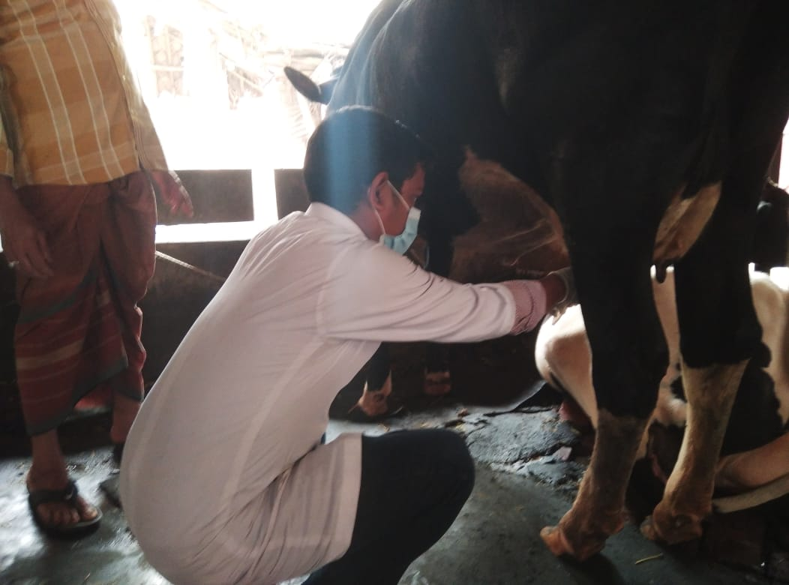
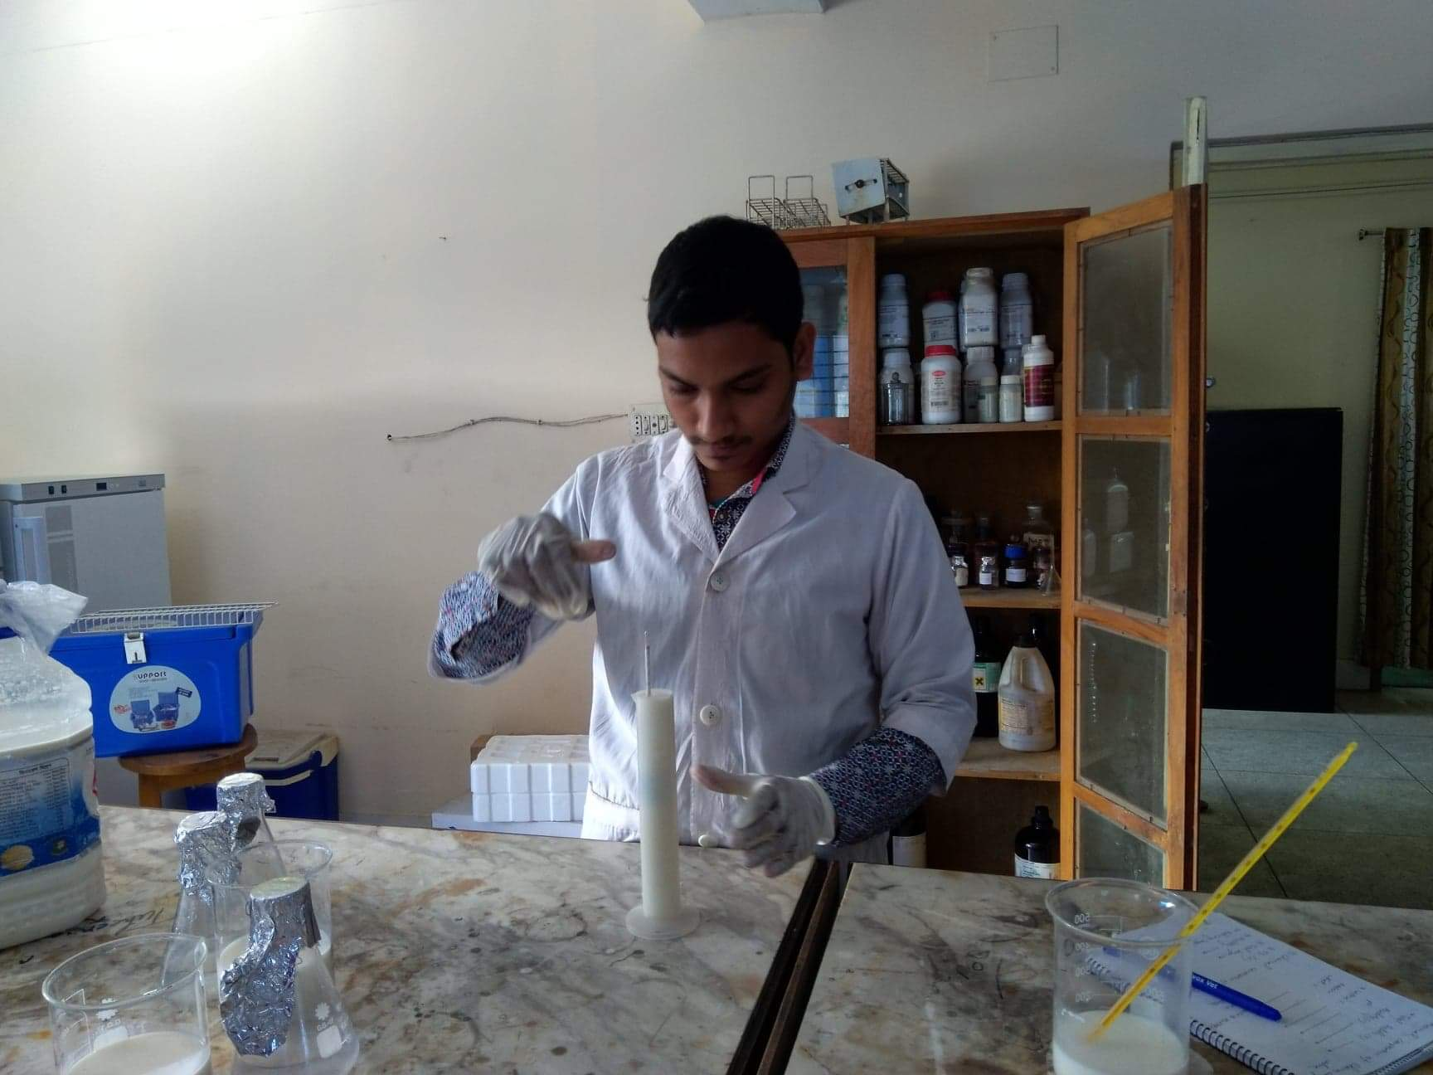
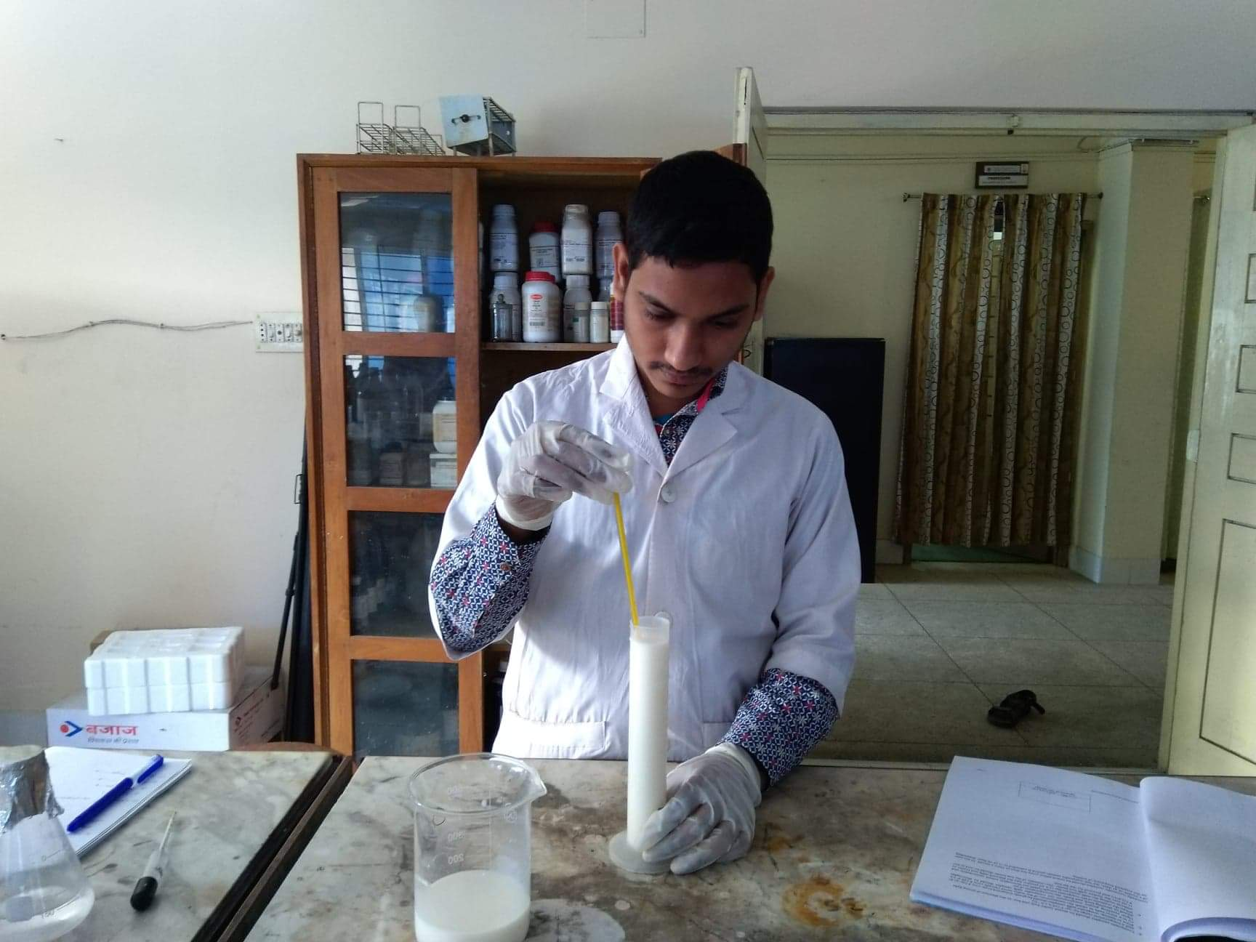
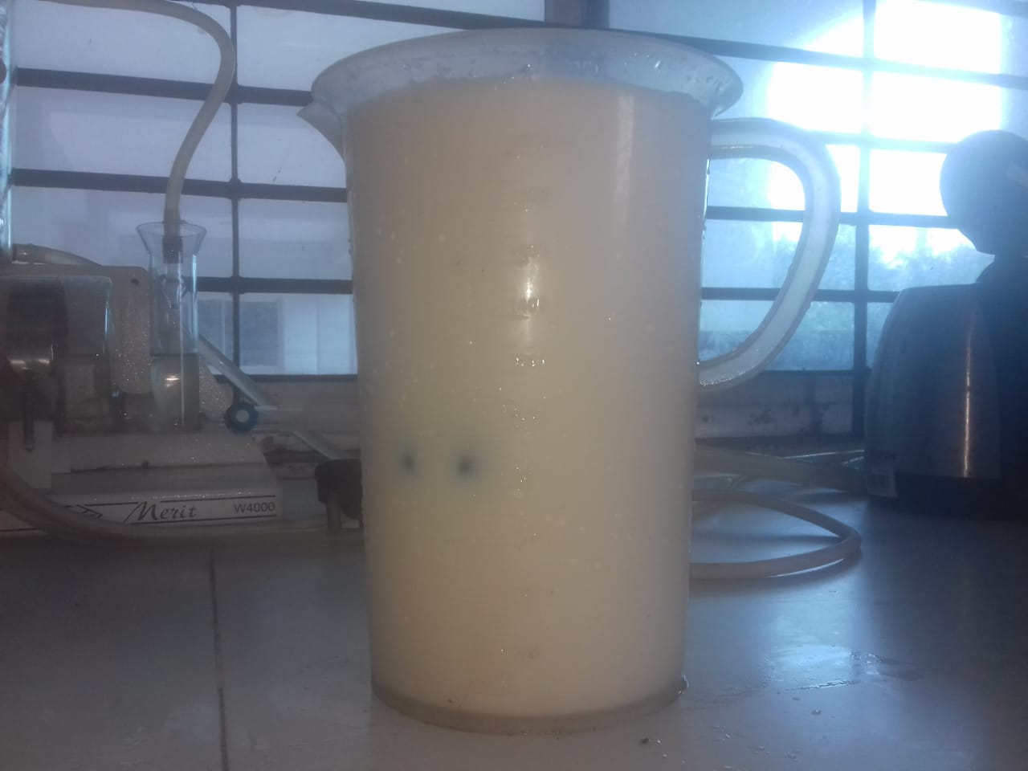
Figure 6: Milk sample preserved with NaHCO₃

Figure 5: Milk sample preserved with frozen water bottle
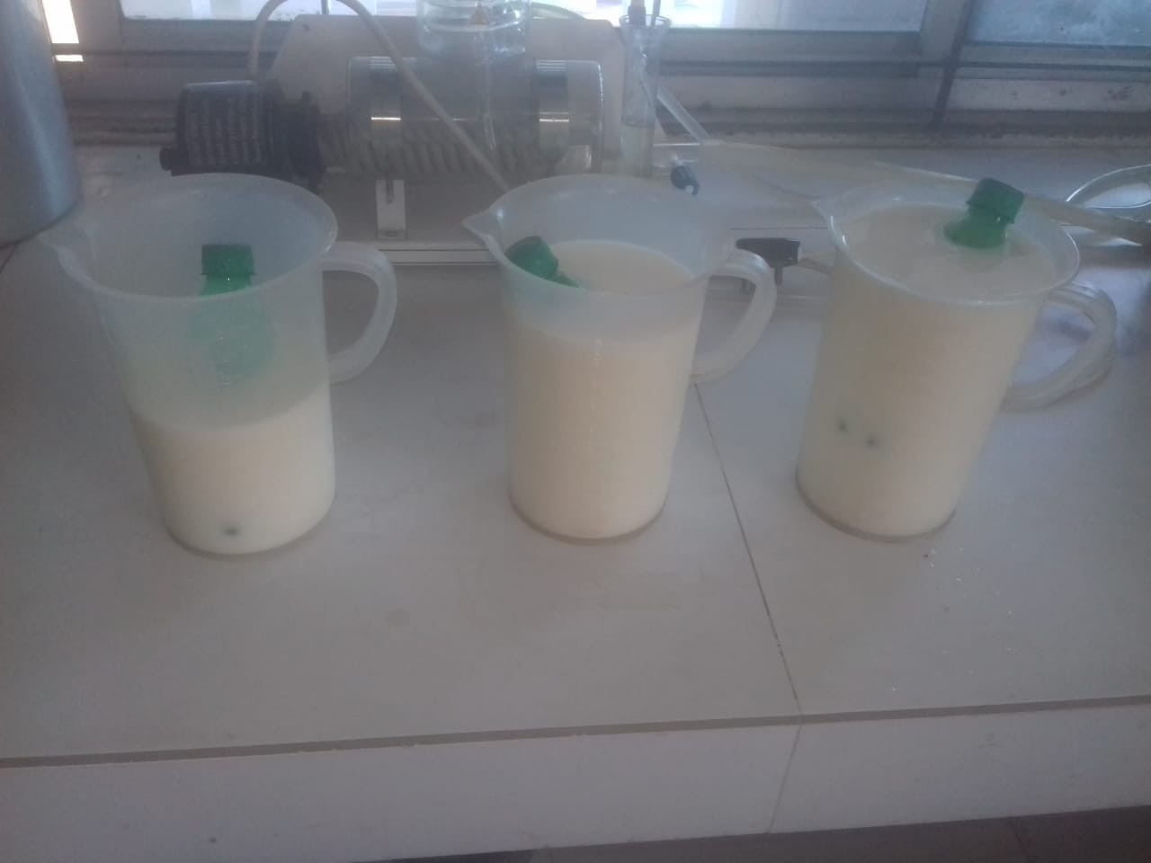
Figure 8: Lactometer reading

Figure 7: Temperature of milk

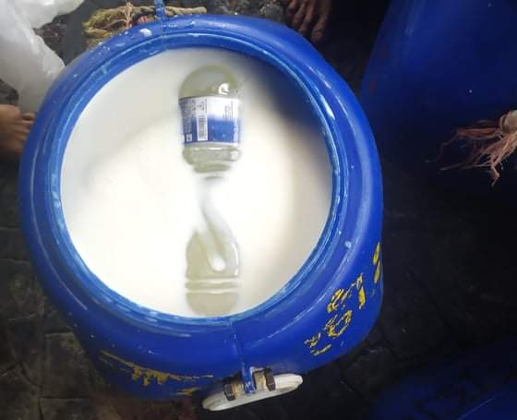

Figure 10: Positive sample in APT

Figure 9: Alcohol precipitation test

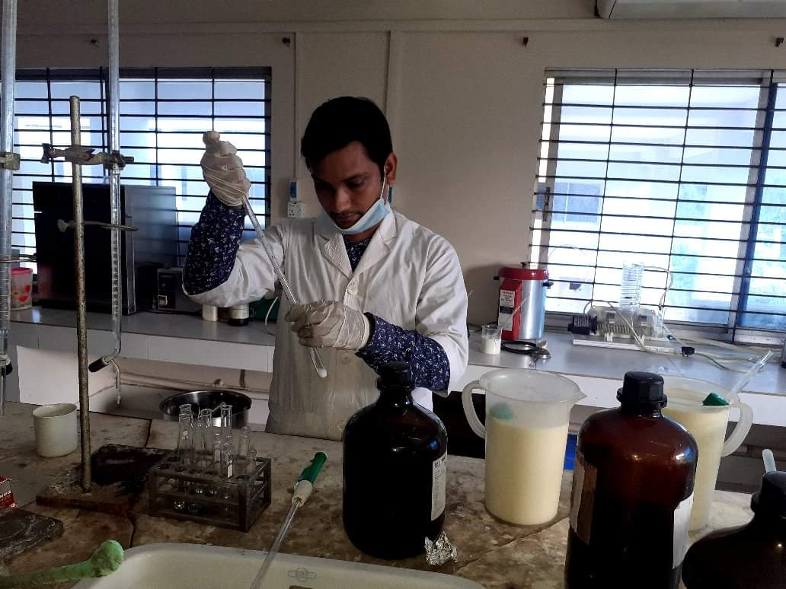

Figure 13: Adding potassium oxalate

Figure 12: Faint pink color in acidity test

Figure 11: Titration for acidity test

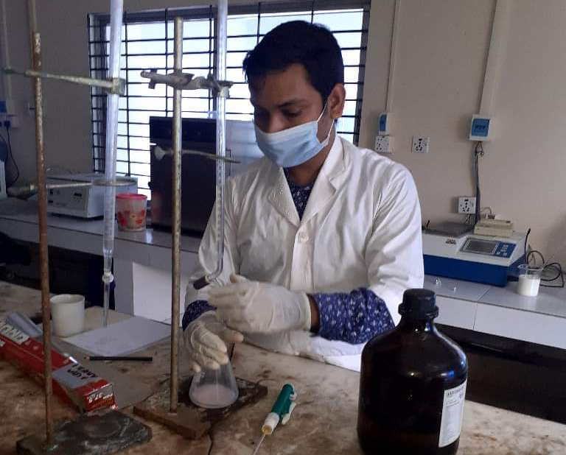
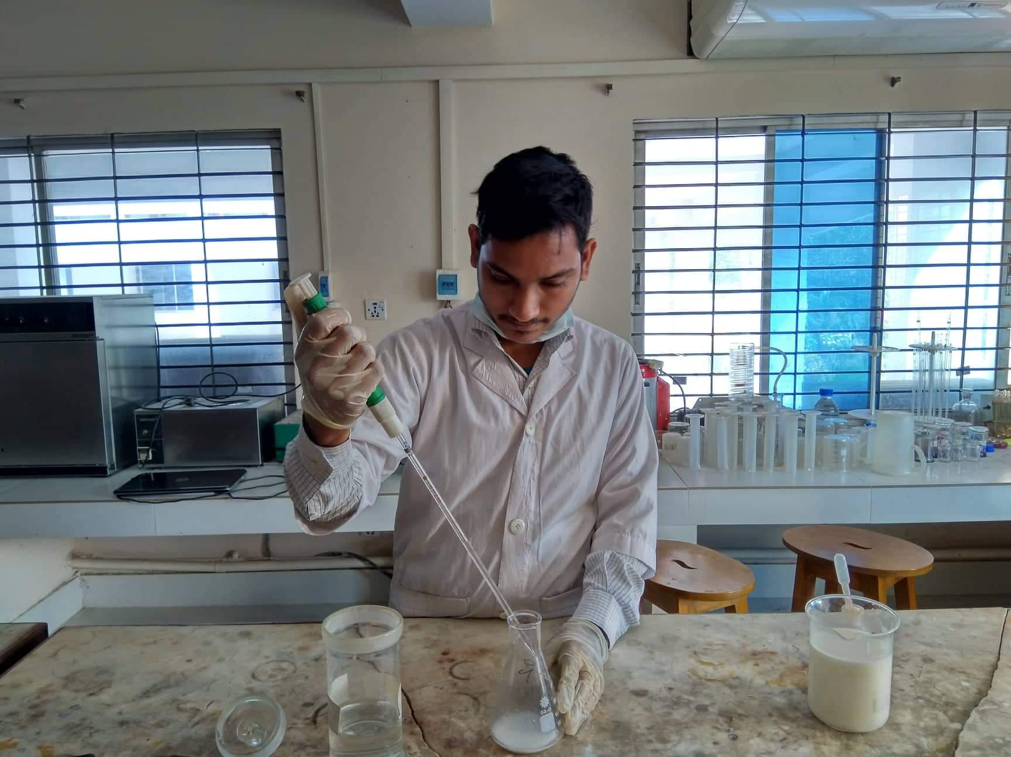
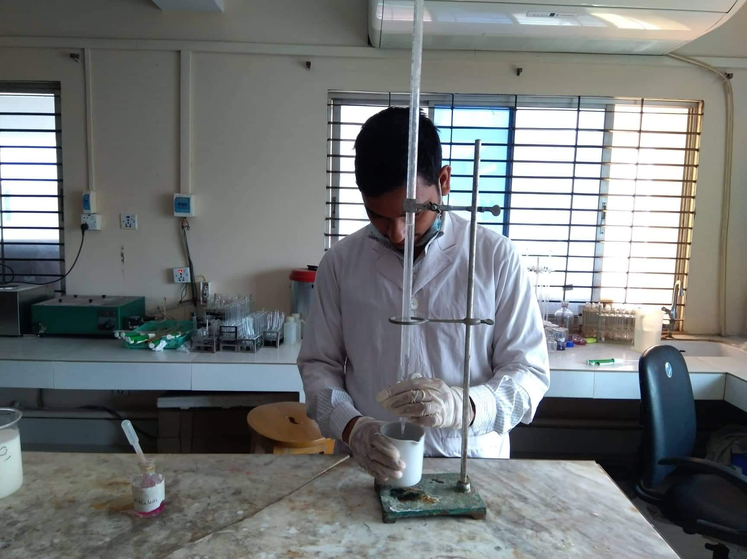
Figure 14: Titration for protein percentage test

Figure 16: Observing reading of fat

Figure 19: Vortexing

Figure 18: Mixing

Figure 17: Dilution

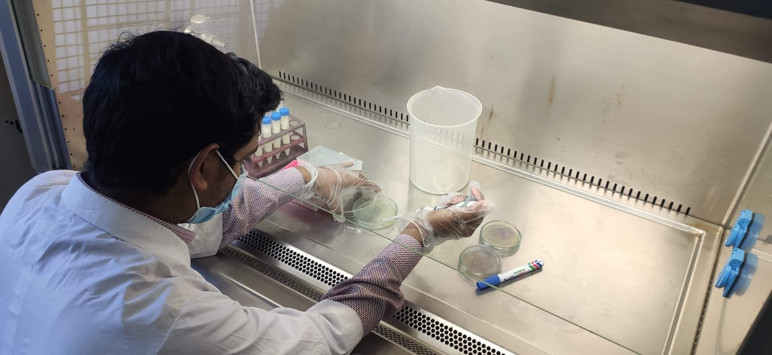
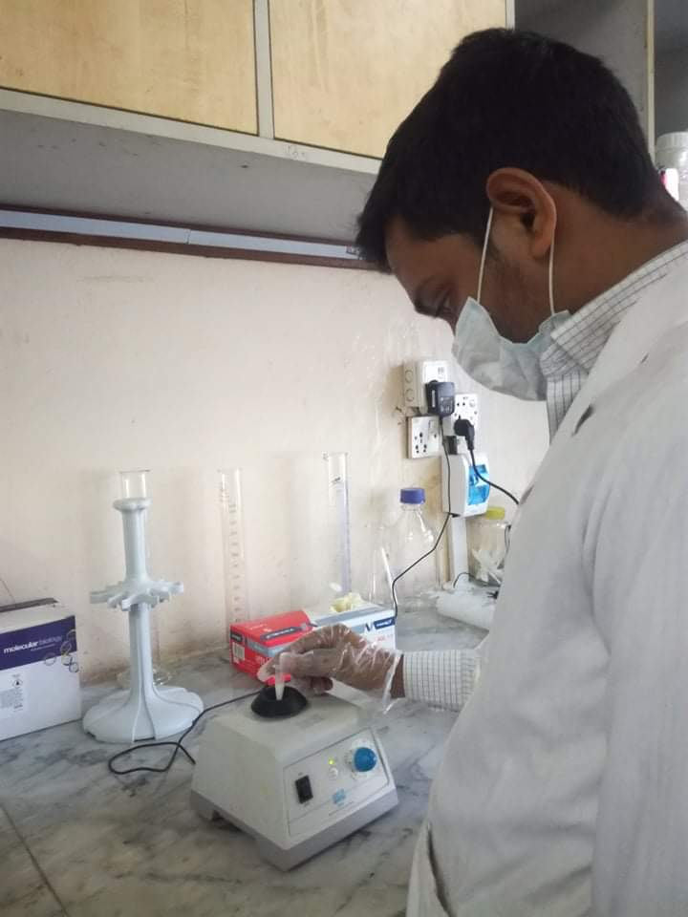
Figure 20: Inoculation

Figure 15: Faint pink color in protein test

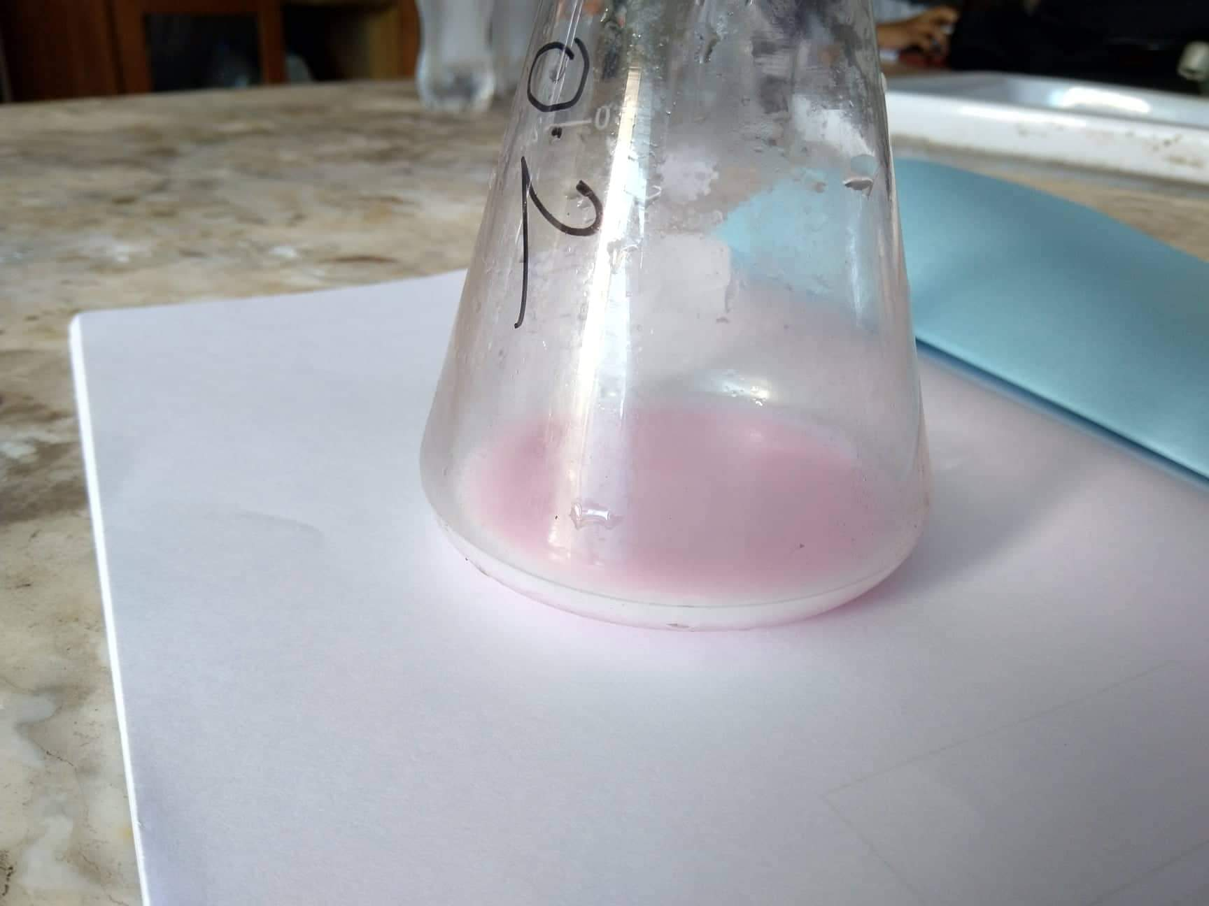

Figure 21: Incubation

Figure 22: Counting the colony

Chapter 4
Results
4.1 Chemical and microbial standard of the collected milk samples for preservation
The collected milk samples for preservation with NaHCO₃ and frozen water bottle were tested for chemical composition. It contained 3.4±0.13% milk fat, 3.57±0.11% protein, 2.77±0.09% casein, Titratable acidity 0.138±0.03 and specific gravity 1.032±0.01. In case of the microbial standard the milk possessed total viable count of 7.8±0.21×10⁴ CFU/ml (colony forming unit) (Table 6)
Table 6: Quality of the milk samples before milk preservation
Parameter | Obtained Value (Mean±SD) | Standard Value  (Eckles et al., 1971)
Fat | 3.4±0.13% | 3.8%
Protein | 3.57±0.11% | 3.5%
Casein | 2.77±0.09% | 2.8%
Titratable acidity | 0.138±0.03 | 0.14
Specific gravity | 1.032±0.01 | 1.038
Total viable count (TVC) | 7.8±0.21×10⁴ CFU/ml | 5.5×10⁶ CFU/ml

4.2. Determination the shelf life of frozen water bottle added milk
After adding 250 ml frozen water bottle in different volume of milk APT were performed to check the shelf life. From the results it was observed that, at 3 hours control milk sample was positive in APT. In case of 1L (25%) milk, 1.5L (16.67%) milk and 2L (12.5%) milk positive results for APT were obtained after 5 hour, 4.5 hour and 4 hours, respectively (Table 7).
Table 7: APT of milk samples preserved with frozen water bottle
Test no. | Time | Time interval (h) | Control | APT results after adding 250 ml frozen water bottle
 |  |  |  | 25% (1L) | 16.67% (1.5L) | 12.5% (2L)
1 | 8.30 AM | 1/2 | -ve | -ve | -ve | -ve
2 | 9.00 AM | 1 | -ve | -ve | -ve | -ve
3 | 9.30 AM | 1.5 | -ve | -ve | -ve | -ve
4 | 10.00 AM | 2 | -ve | -ve | -ve | -ve
5 | 10.30 AM | 2.5 | -ve | -ve | -ve | -ve
6 | 11.00 AM | 3 | +ve | -ve | -ve | -ve
7 | 11.30 AM | 3.5 | +ve | -ve | -ve | -ve
8 | 12.00 AM | 4 | +ve | -ve | -ve | -ve
9 | 12.30 PM | 4.5 | +ve | -ve | -ve | +ve
10 | 1.00 PM | 5 | +ve | -ve | +ve | +ve
11 | 1.30 PM | 5.5 | +ve | +ve | +ve | +ve

4.3 Determination of acidity percentage of milk preserved with frozen water bottle
In case of frozen water bottle immerged milk, the highest titratable acidity observed was 0.256±0.007 (after 5.5 hours of addition) and the lowest was 0.1404±0.002 (after half hour of addition). (Table 8)
Table 8: Acidity percentage of milk samples persevered with frozen water bottle
Test no. | Time | Time interval (h) | Acidity percentage after adding 250 ml frozen water bottle |  |  |  | P value
 |  |  | Control (mean±SD) | 25% (1L) (mean±SD) | 16.67% (1.5L) (mean±SD) | 12.5% (2L) (mean±SD)
1 | 8.30 AM | 1/2 | 0.149ª ± 0.005 | 0.140^{b} ± 0.007 | 0.142 ± 0.001 | 0.144 ± 0.002 | 0.0264  (*)
2 | 9.00 AM | 1 | 0.159ª ± 0.006 | 0.142^{b} ± 0.002 | 0.146 ± 0.001 | 0.148 ± 0.002 | 0.000  (***)
3 | 9.30 AM | 1.5 | 0.171ª ± 0.003 | 0.144^{b} ± 0.002 | 0.153 ± 0.001 | 0.159 ± 0.005 | 0.000  (***)
4 | 10.00 AM | 2 | 0.183ª ± 0.002 | 0.145^{b}± 0.008 | 0.158±0.001 | 0.163 ±0.014 | 0.0001  (***)
5 | 10.30 AM | 2.5 | 0.192ª ± 0.005 | 0.149^{b} ± 0.004 | 0.161 ± 0.009 | 0.169 ± 0.005 | 0.0001  (***)
6 | 11.00 AM | 3 | 0.211ª ± 0.005 | 0.159^{b} ± 0.008 | 0.180 ± 0.016 | 0.185 ± 0.017 | 0.0073  (**)
7 | 11.30 AM | 3.5 | 0.214ª ± 0.001 | 0.174^{b} ± 0.125 | 0.201 ± 0.009 | 0.209 ± 0.004 | 0.0015(**)
8 | 12.00 AM | 4 | 0.245ª ± 0.013 | 0.186^{b}± 0.021 | 0.205 ± 0.008 | 0.215 ±0.005 | 0.0030(**)
9 | 12.30 PM | 4.5 | 0.239ª ± 0.017 | 0.198^{b} ± 0.005 | 0.211 ± 0.005 | 0.219 ± 0.004 | 0.0072  (**)
10 | 1.00 PM | 5 | 0.251ª±  0.002 | 0.201^{b}± 0.005 | 0.221±0.002 | 0.231±0.005 | 0.0001  (***)
11 | 1.30 PM | 5.5 | 0.286ª± 0.001 | 0.211^{b}± 0.007 | 0.247± 0.009 | 0.256± 0.002 | 0.0024  (**)

[Here, a= highest value, b= lowest value, SD= Standard deviation, **= statistically significant (p<0.01), ***= statistically significant (p<0.001)].

4.4 Determination the shelf life of NaHCO₃ added milk
After adding 0.1%, 0.2% and 0.3% NaHCO₃ in milk APT were performed to check the shelf life. From the results it was observed that, at 4th hours control milk sample was positive in APT. In case of 0.1%, 0.2% and 0.3% NaHCO₃ added milk positive results for APT were obtained after 11 hour, 13 hour and 14 hours, respectively. (Table 9).
Table 9: APT of milk samples preserved with NaHCO₃
Test no. | Time | Time interval (h) | Control | APT results after adding different percentage of NaHCO₃
 |  |  |  | 0.1% | 0.2% | 0.3%
1 | 8.00AM | 1 | -ve | -ve | -ve | -ve
2 | 9.00 AM | 2 | -ve | -ve | -ve | -ve
3 | 10.00AM | 3 | -ve | -ve | -ve | -ve
4 | 11.00 AM | 4 | +ve | -ve | -ve | -ve
5 | 12.00 AM | 5 | +ve | -ve | -ve | -ve
6 | 1.00 PM | 6 | +ve | -ve | -ve | -ve
7 | 2.00 PM | 7 | +ve | -ve | -ve | -ve
8 | 3.00 PM | 8 | +ve | -ve | -ve | -ve
9 | 4.00 PM | 9 | +ve | -ve | -ve | -ve
10 | 5.00 PM | 10 | +ve | -ve | -ve | -ve
11 | 6.00 PM | 11 | +ve | +ve | -ve | -ve
12 | 7.00 PM | 12 | +ve | +ve | -ve | -ve
13 | 8.00 PM | 13 | +ve | +ve | +ve | -ve
14 | 9.00 PM | 14 | +ve | +ve | +ve | +ve

4.5 Determination the acidity percentage of milk preserved with NaHCO₃
In case of NaHCO₃ added milk, the highest Titratable acidity was observed was 0.311±0.001 in case of 0.1% NaHCO₃ added milk after 14 hour of addition and the lowest was observed was 0.123±0.001 in case of 0.3% NaHCO₃ added milk after 1 hour of addition (Table 10).
Table 10: Acidity percentage of milk samples persevered with NaHCO₃
Test no. | Time | Time interval (h) | Acidity percentage after adding different percentage of NaHCO₃ |  |  |  | P value
 |  |  | Control (0.0%) (mean ± SD) | 0.1% (mean ± SD) | 0.2% (mean ± SD) | 0.3% (mean ± SD)
1 | 8.00AM | 1 | 0.143ª ± 0.211 | 0.135 ± 0.002 | 0.132 ± 0.005 | 0.123^{b} ± 0.001 | 0.000  (***)
2 | 9.00 AM | 2 | 0.151 ª ± 0.003 | 0.140 ± 0.001 | 0.138 ±0.022 | 0.125^{b} ± 0.001 | 0.000 (***)
3 | 10.00AM | 3 | 0.168 ª ± 0.003 | 0.141 ± 0.002 | 0.142 ± 0.005 | 0.126 ^{b} ± 0.003 | 0.000 (***)
4 | 11.00 AM | 4 | 0.189 ª ± 0.003 | 0.151 ± 0.003 | 0.146 ± 0.005 | 0.138 ^{b} ± 0.003 | 0.000 (***)
5 | 12.00 AM | 5 | 0.219 ª ± 0.003 | 0.155 ± 0.005 | 0.153 ± 0.003 | 0.137 ^{b} ± 0.002 | 0.000 (***)
6 | 1.00 PM | 6 | 0.234 ª ± 0.002 | 0.159 ± 0.003 | 0.162±  0.001 | 0.141 ^{b} ± 0.001 | 0.000 (***)
7 | 2.00 PM | 7 | 0.247 ª ± 0.003 | 0.164 ± 0.005 | 0.165 ± 0.003 | 0.144 ^{b} ± 0.003 | 0.000 (***)
8 | 3.00 PM | 8 | 0.264 ª ± 0.001 | 0.171 ± 0.003 | 0.174 ± 0.003 | 0.151 ^{b} ± 0.003 | 0.000 (***)
9 | 4.00 PM | 9 | 0.273 ª ± 0.003 | 0.187 ± 0.005 | 0.181 ± 0.003 | 0.159 ^{b} ± 0.003 | 0.000 (***)
10 | 5.00 PM | 10 | 0.297 ª ± 0.003 | 0.191 ± 0.005 | 0.187 ± 0.005 | 0.171 ^{b} ± 0.003 | 0.000 (***)
11 | 6.00 PM | 11 | 0.315 ª ± 0.003 | 0.196 ± 0.005 | 0.191± 0.005 | 0.183 ^{b} ± 0.003 | 0.000 (***)
12 | 7.00 PM | 12 | 0.378 ª ± 0.003 | 0.218 ± 0.005 | 0.198 ± 0.003 | 0.189 ^{b} ± 0.003 | 0.000 (***)
13 | 8.00 PM | 13 | 0.386 ª ± 0.002 | 0.263 ± 0.005 | 0.271 ± 0.003 | 0.211 ^{b} ± 0.003 | 0.000 (***)
14 | 9.00 PM | 14 | 0.414 ª ± 0.001 | 0.311 ± 0.001 | 0.293 ± 0.003 | 0.265 ^{b} ± 0.001 | 0.000 (***)

[Here, a= highest value, b= lowest value, SD= Standard deviation, ***= statistically significant (p<0.001)].

Chapter 5
Discussion
In this study milk fat were recorded 3.4%. In the study of El-Leboudy et al., (2017) found milk fat 3.57%, which is closer to the findings of present study. Commercially, the fat of milk is unquestionably the most valuable constituent of milk. Milk having a fair amount of fat is more valuable as a food than milk which is poor in fat. The Food and Drug Administration (FDA) requires not less than 3.25% milk fat for fluid whole milk. The U.S. Public Health Service (USPHS) Milk Ordinance and Code also recommended a minimum of 3.25% butterfat in farm milk (Graf 1976). The BSTI (2002) requirement for fat content of pasteurized milk is a minimum of 3.5%.
Present study discovers the protein percentage in raw milk was 3.57%. In the study of Hamid et al., (2003) the protein content of the raw milks varied from 3.07% to 3.57%. Lingathurai et al., (2009) reported slightly higher (3.77%) protein content. These results support the findings of present study. This finding is also close to BSTI (2002) norms. In the study of El-Leboudy et al., (2017), found milk protein 3.8, which is slightly higher than the present study. This might be due to different breed of the cow.
In this study specific gravity of the milk was recorded 1.032. Average specific gravity was within the normal range of specific gravity of milk. Generally the specific gravity of fresh milk are within the range of 1.027 to 1.035 having an average value of 1.032 (Kober et al, 2015). Adulteration of milk by adding water decreased its specific gravity. In our experiment, the average specific gravity of milk samples was within the normal range but slightly below the average specific gravity of milk (1.032). This might be due to high fat and slightly low SNF content of milk. Eckes et al. (1951) stated that as milk fat is the lightest constituents of milk, the more that is present, lower the specific gravity will be and in a like manner, the greater the percentage of SNF, the heavier the milk will be. Similar type of specific gravity was obtained by Biswas (1997) for BAU dairy farm milk. In the study of Rahman et al., (2018) specific gravity of milk samples was 1.030, which is also close to the present findings.
Total viable count for the raw milk sample in this study was 7.8×10⁴ CFU/ml. The reason of high bacteria count in raw milk is well-known as good growth medium that supports the growth of several microorganisms because of its high water content, nearly neutral pH and variety of available essential nutrients that renders it as one of the best media for microbial growth and multiplication (Soomro et al., 2002). The total viable bacterial count is the number of bacteria in a sample that can grow and form countable colonies on Nutrient agar after being held at 37°C for 24 hours (Banik et al., 2014). The most frequent cause of high bacterial load is normally as a result of poor cleaning of the milking system. Bacterial count may be high due to milking dirty udders, maintaining an unclean milking and housing environment and failing to rapidly cool milk to less than 40°F. Aaku et al. (2004) and Arenas et al. (2004) have found 5.5×10⁶ CFU/ml and 10⁶ to 10⁷cfu/ml of the total number of microorganisms in pooled raw milk, respectively, which were comparatively lower than this experiment. Hossain et al. (2011) conducted an experiment in India and found that the bacterial count in raw milk ranged from 1.75×10⁶ to 1.22×10⁸ CFU/ml and Banik et al., (2014) found high bacterial load in raw milk sample which was ranged from 5.2×10⁸ to 1.3×10⁷ CFU/ml.
In this study, in case of frozen water bottle immerged milk, the highest titratable acidity observed was 0.256 (after 5.5 hours of addition) and the lowest was 0.1404 (after half hour of addition). On the other hand in case of NaHCO₃ the highest Titratable acidity was observed was 0.311 in case of 0.1% NaHCO₃ added milk after 14 hour of addition and the lowest was observed was 0.123 in case of 0.3% NaHCO₃ added milk after 1 hour of addition. The high amount of acidity along with time might be due to within a short time after milking, the acidity increases perceptibly due to bacterial activity. The difference in acidity was due to metabolic activities of microbes. Longer period of storage is also responsible for higher titratable acidity which in turn effects on the bacteriological quality of raw milk (Mennane et al. 2007). Titratable acidity is a measure of freshness and bacterial activity in milk. Titratable acidity of milk has long been recognized and employed as an indicator of quality (Hossain et al. 2011). It is expressed in terms of percentage lactic acid since lactic acid is the principal acid produced by fermentation after milk is drawn from the udder. Fresh milk, however, does not contain any appreciable amount of lactic acidand therefore an increase in acidity is a rough measure of its age and bacterial activity (O'Mahony 1988). The degree of bacterial contamination and the temperature at which the milk is kept are the chief factors influencing acid formation. Therefore, the amount of acid depends on the cleanliness of production and the temperature at which milk is kept. For this reason, determination of acid in milk is an important factor in judging milk quality. Acidity affects taste as well. When it reaches about 0.3%, the sour taste of milk becomes sensible. At 0.4% acidity, milk is clearly sour, and at 0.6% it precipitates at normal temperature. At acidity over 0.9%, it moulds (Hossain et al., 2011). Some other study also agree the findings, Popescu and Angel (2009) reported that high quality milk has to have less than 0.14 percent acidity. Elmagli and El Zubeir (2006) observed a greater range of acidity (0.14 to 0.86%) in pasteurized milks. Rahaman et al., (2018) reported mean acidity of experimental samples was 0.15. Generally acidity of normal milk samples are within the range of 0.10 to 0.20 (Eckles et a., 1951). Similar types of acidity (0.13%) were reported by Biswas (1997) for BAU dairy farm milk. Acidity test of milk is a good indicator, of milk quality. Fresh milk shows an acidity of about 0.15% which is due to the presence of citrate, phosphate, carbon-dioxide and milk casein. If the milk samples are kept for several hours without pasteurization or cooling or any kind of heat treatment then its lactose undergoes fermentation and produces lactic acid in milk. This additional acidity is known as developed acidity and is responsible for quick spoilage of milk.
In the present study, after adding 0.1%, 0.2% and 0.3% NaHCO₃ in milk APT were performed to check the shelf life. From the results it was observed that, at 4th hours control milk sample was positive in APT. In case of 0.1%, 0.2% and 0.3% NaHCO₃ added milk positive results for APT were obtained after 11 hours, 13 hours and 14 hours, respectively. In this study the shelf life of milk was determined by APT, in other studies shelf life was determined by COB test. So the findings compared with the findings of COB test. Haddadin et al. (1996) also stated in the favor of the present findings, from a preliminary study they found that sodium bicarbonate is useful for short time preservation of milk. Hamid et al., (2003) found that, the COB test was positive at 13.05, 14.08, 15.30 and 17.01 hours for whole milk (fresh), 0.1, 0.15 and 0.2 percent NaHCO₃ treated milk samples, respectively. In the other study of Rahman et al., (2018) stated that, control samples spoiled after 11.25 hours but that of 0.3, 0.4 and 0.5 percent NaHCO₃ treated samples spoiled after 16.75, 17.75 and 18.75 hours, respectively.
After adding 250 ml frozen water bottle in different volume of milk APT were performed to check the shelf life. From the results it was observed that, At 3 hours control milk sample was positive in APT. In case of 1L (25%) milk, 1.5L (16.67%) milk and 2L (12.5%) milk positive results for APT were obtained after 5 hours, 4.5 hours and 4 hours, respectively. No other available similar studies was performed by using such technique so present findings cannot be compared. But this technique is helpful to preserve milk for short time, this might be due to it helps to lower the temperature of milk which subsequently slower the bacterial growth and inhibit developed acidity of milk.

Chapter 6
Conclusions
In conclusion, this study showed that after addition of 0.1%, 0.2% and 0.3% NaHCO₃, at 4th hours control milk sample found positive in APT. In case of 0.1%, 0.2% and 0.3% NaHCO₃ added milk positive results for APT were obtained after 11 hours, 13 hours and 14 hours, respectively. On the other hand, after addition of 250 ml frozen water bottle in different volume of milk, at 3 hours control milk sample was positive in APT. In case of 1L (25%) milk, 1.5L (16.67%) milk and 2L (12.5%) milk, positive results for APT were obtained after 5 hours, 4.5 hours and 4 hours, respectively. In case of frozen water bottle immerged milk, the highest titratable acidity observed was 0.256 (after 5.5 hours of addition) and the lowest was 0.140 (after half hour of addition). In the case of NaHCO₃ the highest titratable acidity was observed 0.311 in 0.1% NaHCO₃ added milk after 14 hours of addition and the lowest titratable acidity was observed 0.123 in 0.3% NaHCO₃ added milk after 1 hour of addition. For the preservation of milk NaHCO₃ and frozen water bottle can be used in rural areas where pasteurization and chilling facility are not present. So 0.3% NaHCO₃ is enough to maintain the shelf life of raw milk up to 13 hours. 25% (250 ml bottle in 1L milk) of frozen water bottle addition can lower the temperature of milk up to 10° C in hot and humid condition (ambient temperature 35 °C) and 12.5% (250 ml bottle in 2L milk) of frozen water bottle addition can lower the temperature of milk up to 16° C in hot and humid condition (ambient temperature 35 °C). 250ml frozen water bottle can enhance the shelf life of 1 liter (25%) milk up to 5 hours. It can be said that using of frozen water bottle for milk preservation is more health friendly than the chemical preservation method (NaHCO₃) under rural condition of Bangladesh.

Chapter 7
Recommendations
Following recommendations can be announced after the study,
- From the results of the five repeated trials of the procedure, it can be recommended that, for the preservation of milk NaHCO₃ can be used in rural areas where pasteurization and chilling facility are not present. 0.3% NaHCO₃ is enough to maintain the shelf life of raw milk upto 13 hours. It is well known that sodium bicarbonate is a cheap and available alkaline substance used mostly in the bakery for preparation of different types of cakes, breads and biscuits. So, it is expected that handling of this chemical will be very easy by the farmers and there will be no hazards effects on public health.
- If farmer want to avoid chemical use for short transportation simple frozen water bottle immersion can enhance the shelf life. 250ml frozen water bottle can enhance the shelf life of 1 liter (25%) milk up to 5 hours.

Chapter 8
References

Aaku, E. N., Collison, E. K., Gashe, B. A., & Mpuchane, S. (2004). Microbiological quality of milk from two processing plants in Gaborone Botswana. Food Control, 15(3), 181-186.
Ajmal, M., Nadeem, M., Imran, M., Abid, M., Batool, M., Khan, I. T., Tayyab, M. (2018). Impact of immediate and delayed chilling of raw milk on chemical changes in lipid fraction of pasteurized milk. Lipids in Health and Disease, 17(1), 1-10.
Arenas, R., González, L., Bernardo, A., Fresno, J. M., & Tornadijo, M. E. (2004). Microbiological and physico-chemical changes in Genestoso cheese, a Spanish acid curd variety, throughout ripening. Food Control, 15(4), 271-279.
Bangladesh Standards and Testing Institution. (2002). Bangladesh standard: Specification for pasteurized milk. Bangladesh Standards and Testing Institution, Tejgaon Industrial Area, Dhaka.
Banik, S. K., Das, K. K., &Uddin, M. A. (2014). Microbiological quality analysis of raw, pasteurized, UHT milk samples collected from different locations in Bangladesh. Stamford Journal of Microbiology, 4(1), 5-8.
Bezie, A. (2019). The effect of different heat treatment on the nutritional value of milk and milk products and shelf-life of milk products.A Review. Journal of Dairy and Veterinary Sciences, 11(5), 1-8.
Biswas, A. A. (1997). Effect of banana (Musa sapientum) leaf on the keeping quality of raw milk (Doctoral dissertation, MS Thesis).
Boots, J. W., & Floris, R. (2006).Lactoperoxidase: From catalytic mechanism to practical applications. International Dairy Journal, 16(11), 1272-1276.
BSTI (2002) BDS 1702: 2002. Bangladesh Standard: Specification for pasteurized milk. pp. 2-3, Bangladesh Standards and Testing Institution, Tejgaon Industrial Area, Dhaka.
Carlsson, J., Iwami, Y., & Yamada, T. (1983).Hydrogen peroxide excretion by oral streptococci and effect of lactoperoxidase- thiocyanate -hydrogen peroxide. Infection and Immunity, 40(1), 70-80.
Codex Alimentarius Commission.(1991). Guidelines for the preservation of raw milk by use of the lactoperoxidase system (CAC GL 13/91).
Conner, G. E., Salathe, M., & Forteza, R. (2002). Lactoperoxidase and hydrogen peroxide metabolism in the airway. American Journal of Respiratory and Critical Care Medicine, 166 (supplement_1), S57-S61.
Coorevits, A., De Jonghe, V., Vandroemme, J., Reekmans, R., Heyrman, J., Messens, W., ...& Heyndrickx, M. (2008). Comparative analysis of the diversity of aerobic spore-forming bacteria in raw milk from organic and conventional dairy farms. Systematic and Applied Microbiology, 31(2), 126-140.
Dey, S., & Karim, M. H., (2013). Study on physicochemical and microbial quality of available raw, pasteurized and UHT milk during preservation. International Journal of Science Inventions Today, 2(2), 150-7.
Eckles, C. H., Combs, W. B., & Macy, H. (1951). Milk and milk products. Milk and Milk Products., (4th edition).
El-Leboudy, A., Amer, A. A., El-Makarem, H. S. A., & Ibrahim, E. K. (2017). Chemical and microbiological status of raw milk sold at local markets. Alexandria Journal of Veterinary Sciences, 55(1), 125-132.
Elmagli, A. A. O., Ibtisam, E. M., & Zubeir, E. L. (2006). Study on the hygienic quality of pasteurized milk in Khartoum State (Sudan). Research Journal of Animal and Veterinary Sciences, 1(1), 12-17.
El-Zubeir, I. E. M., El-Hassen, M. E. M., & Sanaa, O. Y. (2010).Preservation of raw milk of Khartoum State (Sudan) by the lactoperoxidase system. International Journal of Dairy Science, 5(4), 327-332.
Foster, E.M., Nelson, F.E., Speck, .M.L., Doetsch, R.N. & Olson, J.C. (1958). Dairy MicrobiologyMacMillan Co. Ltd., London.
GARCÍA-ARMESTO, M. R., & SUTHERLAND, A. D. (1997).Temperature characterization of psychrotrophic and mesophilic Bacillus species from milk. Journal of Dairy Research, 64(2), 261-270.
Graf, T. F. (1976, January). Market implications of changing fat content of milk and dairy products. In Fat Content and Composition of Animal Products: Proceedings of a Symposium (p. 189). National Academies Press.
Haddadin, M. S., Ibrahim, S. A., & Robinson, R. K. (1996). Preservation of raw milk by activation of the natural lactoperoxidase systems. Food Control, 7(3), 149-152.
Hamid, M. A., Islam, M. N., & Hossain, M. A. (2003). Effect of sodium bicarbonate on the keeping quality of milk. Journal of the Bangladesh Agricultural University, 1(452-2018-3707), 71-79.
Hossain, T. J., Alam, M. K., & Sikdar, D. (2011). Chemical and microbiological quality assessment of raw and processed liquid market milks of Bangladesh.
IDF (2012) Shelf-life of Dairy Products. Idf factsheet 2012, Obtained from https://www.fil-idf.org/wp-content/uploads/2016/04/IDF-Factsheet-SCMH-Shelf-life-of-Dairy-Products-1.pdf [Cited on 5th December, 2020]
Islam, M. A., Roy, S., Nabi, A., Solaiman, S., Rahman, M., Huq, M, & Ahmed, N. (2018). Microbiological quality assessment of milk at different stages of the dairy value chain in a developing country setting. International Journal of Food Microbiology, 278, 11-19.
Jay J M (2003) Modern food microbiology. 4th Edition, First Indian Edition: 1996, Reprint: 2003, p. 447, CBSPublishers & Distributors, New Delhi.
Kleyn, D. H., Lynch, J. M., Barbano, D. M., Bloom, M. J., & Mitchell, M. W. (2001). Determination of fat in raw and processed milks by the Gerber method: collaborative study. Journal of AOAC International, 84(5), 1499-1508.
Kober, AKMH, Bari, MS, Morshed, S & Momin. (2015). MM, Evaluation of nutritional quality, contamination, adulteration and preservative quality of different sources of milk. Bangladesh Journal of Veterinary and Animal Sciences, 3(1&2), 25- 29,
Kussendrager, K. D., & Van Hooijdonk, A. C. M. (2000). Lactoperoxidase: physico-chemical properties, occurrence, mechanism of action and applications. British Journal of Nutrition, 84(S1), 19-25.
Lambert, J. C. (2001). Global lactoperoxidaseprogramme: The lactoperoxidase system of milk preservation. Bulletin of the International Dairy Federation, 365, 19-20.
Le Nguyen, D. D., Ducamp, M. N., Dornier, M., Montet, D., &Loiseau, G. (2005).Effect of the lactoperoxidase system against three major causal agents of disease in mangoes. Journal of Food Protection, 68(7), 1497-1500.
Lingathurai, S., Vellathurai, P., Vendan, S. E., &Anand, A. A. P. (2009).A comparative study on the microbiological and chemical composition of cow milk from different locations in Madurai, Tamil Nadu. Indian Journal of Science and Technology, 2(2), 51-54.
Marjan, S., Das, K. K., Munshi, S. K., & Noor, R. (2014). Drug-resistant bacterial pathogens in milk and some milk products. Nutrition and Food Science. 7(3), 149-152.
Marks, N. E., Grandison, A. S., & Lewis, M. J. (2001). Challenge testing of the lactoperoxidase system in pasteurized milk. Journal of Applied Microbiology, 91(4), 735-741.
Martins, M. L., Pinto, C. L., Rocha, R. B., De Araujo, E. F., & Vanetti, M. C. (2006). Genetic diversity of Gram--ve, proteolytic, psychrotrophic bacteria isolated from refrigerated raw milk. International Journal of Food Microbiology, 111(2), 144-148.
Massoud, R., Belgheisi, S., & Massoud, A. (2016). Effect of high pressure homogenization on improving the quality of milk and sensory properties of yogurt: a review. International Journal of Chemical Engineering and Applications, 7(1), 66.
Mennane, Z., Ouhssine, M., Khedid, K., & Elyachioui, M. (2007). Hygienic quality of raw cow’s milk feeding from domestic waste in two regions in Morocco. International Journal of Agriculture and Biology, 9(1), 46-48.
Muir, D. D. (1996). The shelf‐life of dairy products: 1. Factors influencing raw milk and fresh products. International Journal of Dairy Technology, 49(1), 24-32.
Naidu, A. S. (Ed.). (2000). Natural food antimicrobial systems.CRC press.p. 3–132
O'Mahony, F. (1988). Rural dairy technology: Experiences in Ethiopia (Vol. 4). ILRI (aka ILCA and ILRAD).
Özer, B., Grandison, A., Robinson, R., & Atamer, M. (2003). Effects of lactoperoxidase and hydrogen peroxide on rheological properties of yoghurt. The Journal of Dairy Research, 70(2), 227.
Patil, S. S., Zagare, M. S., Ghorade, I. B., & Deshmukh, A. M. (2014). Isolation of pathogens from dairy products and effect of temperature on pathogens. Paripex-Indian Journal of Research, 3(1), 76-79.
Petrus, R. R., Freire, M. T. D. A., Setogute, L. D. C., & Higajo, V. M. (2012). Effect of pasteurization temperature and aseptic filling on the shelf-life of milk. Alimentos e NutriçãoAraraquara, 22(4), 531-538.
Popescu, A., & Angel, E. (2009). Analysis of milk quality and its importance for milk processors. Scientific Papers Animal Science and Biotechnologies, 42(1), 501-506.
Pruitt, K. M. (1991). The lactoperoxidase systems of bovine and human milk. Oxidative Enzymes Foods, 138-174.
Pyne, G. T. (1932). The determination of milk-proteins by formaldehyde titration. Biochemical Journal, 26(4), 1006.
Rahman, M. M., Islam, M. N., ur Rashid, M. H., & Masum, A. K. M. (2018). Effects of sodium bicarbonate on milk preservation. Research in Agriculture Livestock and Fisheries, 5(1), 75-85.
Rokhsana, F., Das, U. K., Yeasmin, R., Nahar, A., &Parveen, S. (2007). Studies on the preservation of raw cow s milk by chemical method. Bangladesh Journal of Scientific and Industrial Research, 42(3), 317-326.
Ryser, E. (1999). Microorganisms of importance in raw milk. Michigan Dairy Review, 8, 7-9.
Sadhu, S. P. (2018). Effect of cold chain interruptions on the shelf-life of fluid pasteurised skim milk at the consumer stage. Brazilian Journal of Food Technology, 21.
Sadhu, S. P. (2018). Effect of cold chain interruptions on the shelf-life of fluid pasteurised skim milk at the consumer stage. Brazilian Journal of Food Technology, 21.
Saha, B. K., Ali, M. Y., Chakraborty, M., Islam, Z., & Hira, A. K. (2003). Study on the preservation of raw milk with hydrogen peroxide (HO). Pakistan Journal of Nutrition, 2(1), 36-42.
Schmidt, V. S., Kaufmann, V., Kulozik, U., Scherer, S., &Wenning, M. (2012). Microbial biodiversity, quality and shelf life of microfiltered and pasteurized extended shelf life (ESL) milk from Germany, Austria and Switzerland. International Journal of Food Microbiology, 154(1-2), 1-9.
Seifu, E., Buys, E. M., & Donkin, E. F. (2005). Significance of the lactoperoxidase system in the dairy industry and its potential applications: a review. Trends in Food Science & Technology, 16(4), 137-154.
Sermon, J., Vanoirbeek, K., De Spiegeleer, P., Van Houdt, R., Aertsen, A., & Michiels, C. W. (2005). Unique stress response to the lactoperoxidase-thiocyanate enzyme system in Escherichia coli. Research in Microbiology, 156(2), 225-232.
Sharma, R. K. (1980) Effect of Heat Treatment on the Nutritive Value of Milk. Indian Dairyman 32(8): 6l9-621.
Soomro, A. H., Arain, M. A., Khaskheli, M., & Bhutto, B. (2002). Isolation of Escherichia coli from raw milk and milk products in relation to public health sold under market conditions at Tandojam. Pakistan Journal of Nutrition, 1(3), 151-152.
Sørhaug, T., & Stepaniak, L. (1997). Psychrotrophs and their enzymes in milk and dairy products: quality aspects. Trends in Food Science & Technology, 8(2), 35-41.
Tallini, R. A. (2015). Effects of pasteurization and ultra-high temperature processes on proximate composition and fatty acid profile in bovine milk. American Journal of Food Technology, 10(6), 265-272.
Tolle, A. (1980). The microflora of the udder..In factors influencing the bacteriological quality of raw milk. International Dairy Federation Bulletin, 120. p 4
Tullah Al-Baarri, A. N., Ogawa, M., & Hayakawa, S. (2011). Application of lactoperoxidase system using bovine whey and the effect of storage condition on lactoperoxidase activity. International Journal of Dairy Science, 6(1), 72-78.
Uddin, M. A., Motazzim-ul-Haque, H. M., & Noor, R. (2011). Isolation and identification of pathogenic Escherichia coli, Klebsiella spp. and Staphylococcus spp. in raw milk samples collected from different areas of Dhaka City, Bangladesh. Stamford Journal of Microbiology, 1(1), 19-23.
Yano, M., Shimadzu, H., & Endo, T. (2014). Modelling temperature effects on milk production: a study on Holstein cows at a Japanese farm. Springer Plus, 3(1), 1-11.

Biography

This is Sourav Sen. I have born in Chattgogram district of Bangladesh. I have successfully completed my S.S.C. from Chattogram Board on 2008 and H.S.C from Chattogram Board on 2010. Currently I’m Master’s student of Dairy science under the Department of Dairy and Poultry sciences, Faculty of Veterinary Medicine, Chattogram Veterinary and Animal Sciences University (CVASU). Now I am preparing myself for BCS viva.

