# ABSTRACT

The present study was aimed to know the anatomy ( shape, length and diameter) and histology of different segment of small intestine (Duodenum, Jejunum and Ileum) of Japanese Quail. Two groups of japanese quail were studied, group one: 5 male(1 to 5) another group: 5 female(1 to 5). Gross anatomy was studied after dissection. Histomorfology was studied using Hematoxyeline eosine staining technique.

The duodenum was the first segment and was in the form of a ‘U’ shaped loop (Fig.1) The jejunum was arranged in the form of coils suspended by mesentery. Ileum was observed as a straight portion of small intestine located in between two caeca and was the shortest of all the three. The average length and diameter of small intestine of male 1, male 2, male 3, male 4, male 5 were 61.5, 54.7, 61.5, 49.0, 51.7cm and 3.7, 3.8, 3.0, 4.1, 3.9 cm and female 1, female 2, female 3, female 5 were 30.0, 33.0, 30.0, 28.0, 28.5, 33.5 cm and 3.3, 3.6, 3.3,3.3, 3.8 cm (table-1)

The histomorphological features of small intestine of quail wall contained only three tunics *viz*. tunica mucosa, tunica muscularis and tunica serosa. The mucosa of the small intestine was thrown into finger like projections known as villi which were finger shaped in duodenum, tongue shaped in jejunum and spatula shaped in ileum. Lamina propria formed the bulk of lumen of villus and contained connective tissue fibres and cells. The shape and pattern of intestinal glands varied in different segments and these were lined by columnar, goblet, enterochromaffin and vacuolated cells. Tunica muscularis presented inner longitudinal, middle circular and outer longitudinal smooth muscle layers.

**Key Words:** Anatomy, Histology, Small intestine, Quail

**Chapter-I**

**INTRODUCTION**

Due to easy maintenance, early sexual maturity, shorter generation interval and high rate of egg production, Japanese quail has become a useful bird in the field of research. The current study was planned to explore anatomy and histomorphology of small intestine of Japanese quail.

Small intestine functions both as a digestive and mucosa associated lymphatic organ. The intestine has a number of specializations in its structural frame work to increase surface area available for absorption. Alteration and impairment within the digestive system, both in structure and function, has a profound effect on the performance of birds (McLelland, 1979). Keeping in view the above factors, the present research was planned to study the gross anatomical and histological structures of small intestine of Japanese quail.

Klasing (1999) studied the avian gastrointestinal anatomy and found that the avian gastrointestinal tract is a double-ended open tube (as seen in mammals) that begins at the beak and finishes at the vent. In sequential order it is composed of a mouth, oesophagus, crop, proventriculus, ventriculus (gizzard), intestine, caeca, rectum and cloaca The author found that the duodenal loop of the intestine encircles the pancreas and receives the pancreatic and hepatic ducts. The epithelium of the intestine contains villi and intestinal crypts.

Taylor (2000) stated that, in general, the jejunum is thought to begin just after the ascending duodenal loop begins to turn back on itself, where the jejunal branches of the cranial mesenteric artery begin. The ileum is thought to begin at the vitelline (Meckel’s) diverticulum and end at therecto-caecal junction.

**Chapter-II**

**REVIEW OF LITERATURE**

The digestive system in the quail is very simple but efficient when compared to many other species like cattle. In the process of evolution, those avian species that developed simple but effective digestive systems were more able to fly and hence survive — the simple digestive system would very likely be lighter in weight. Because of the simplicity in the structure and function it is necessary that the diet provided to fowls be of high quality to be easily digested especially if the birds are to attain the productive performance expected of them (Noy YA, Geyr A, Skian D, 2001).

**2.1 Parts of digestive Tract:**

The digestive system consists of the alimentary canal along which the food passes after eating to where the residual wastes are eliminated from the body, together with the liver and the pancreas. The digestive system is responsible for the ingestion of food, its breakdown into its constituent nutrients and their absorption into the blood stream, and the elimination of wastes from that process. The liver produces bile and is associated with the metabolism of nutrients together with a number of other functions. The main function of the pancreas is the production of digestive enzymes and special compounds called hormones.

**2.2 The alimentary canal:**

**2.2.1 Anatomy;**

The alimentary canal is a long tube like organ starting at the beak and ending with the vent or cloaca in the abdominal region. The small intestine begins at the exit from the gizzard and ends at the junction of the small intestine, caeca and colon. It is relatively long and has a constant diameter. Of the three parts of the mammalian small intestine — the duodenum, jejunum and ileum, only the duodenum can be easily distinguished in the fowl.

There is no clear demarcation between the jejunum and ileum and the small intestine appears as one long tube. Generally the alimentary canal has layers of muscle running lengthwise and around it and is lined with mucous membranes. Glands producing important digestive juices are found in different locations of the canal. The nutrients from the food, after digestion, are absorbed through the wall of the alimentary canal into the circulatory system for transport to the liver or other parts of the body. The waste remaining is eliminated from the body via the cloaca or vent.

**2.2.2 Histology:**

Much of the digestion of the food and all of the absorption of the nutrients takes place in the small intestine and hence its structure is quite important. Generally the alimentary canal has layers of muscle running lengthwise and around it and is lined with mucous membranes. According to Poult. Sd. 80:912- 919,the structure is as follows:

1. Serosa — a serous membrane on the outside of the intestine.

2. A layer of longitudinal muscle — fibres run along the length of the intestine.

3. A layer of circular muscle — three times as thick as the longitudinal muscle. Located between the two muscle layers are:

o Blood vessels.

o Lymph vessels.

o A network of nerve fibres.

4. An ill-defined sub-mucosa — the areolar of the oesophagus.

5. Mucous membrane consisting of:

o A thick muscularis mucosae of longitudinal and circular muscle.

o Corium — many glands, lymphoid tissue, muscle fibres and a variety of free cells.

o Epithelium or surface.

The small intestine has a number of very important functions:

1. Produces a number of enzymes involved in the digestion process

2. Site of much of the digestion of the food

3. Site of much of the absorption of food

Scanning electron microscopy (SEM) has given a new dimension to the study of gastrointestinal morphology in numerous mammalian species and chickens. Studies on intestines with the SEM revealed plate-like shaped villi in bovine and broiler intestines (Musgrave et al., 1973; Bayer et al., 1975). The intestinal villi of quail vary in shape with age, from finger-like to leaf-like forms, and closely resemble those found in mammals (Bayer et al., 1975). The greater absorptive are intestinal cell activation of villi are related to the faster growth rate in the meat-type than egg-type chickens (Yamauchi et al., 1992).

**2.3 Small Intestine**

The small intestine of poultry grows faster, weight-wise, than total body mass. In broiler, small intestine relative growth reaches its peak between six and 10 days of age, independently of the presence of food (Mateos et al., 2004; Sklan, 2004). However, feed intake stimulates the development of the gastrointestinal tract (GIT) (Graciaet at., 2003), and duodenum develops earlier than the jejunum and the ileum (Uni et at., l999).The small intestine is made up of the duodenum (also referred to as the duodenal loop) and the lower small intestine. The remainder of the digestion occurs in the duodenum, and the released nutrients are absorbed mainly in the lower small intestine.

**2.3.1 Duodenum**

After the duodenum the small intestine forms a coil and is suspended from the dorsal wall of the abdominal wall by a thin membrane — the mesentery. This membrane carries the blood vessels associated with the intestine (Yamauchi K, Hida S. Isshiki Y, 1992). The duodenum starts at the gizzard and forms an elongated loop about 20 centimetres long. The pancreas lies between the arms of the loop and being attached to each arm of the duodenum actually holds the two arms together (Noy Y, Sklan D, 1995).

Lymphoid tissue in the duodenum is very plentiful and is usually located in the corium. The lymphoid tissue collects the lymph — the lymph vessels transport a special fluid other than blood that is found in the spaces between cells and tissues till it passes into the blood system (Yamauchi K, Hida S, Isshiki Y, 1992). Bile ducts from the gall bladder attached to the liver and two to three pancreatic ducts enter the small intestine by a common papilla at the caudal end (closest to the rear) of the duodenum. The pancreas, a very important organ in the process of digesting food, is located closely associated with the duodenum being attached to each side of the duodenal loop and lying between the two arms (Noy Y, SkIanD, 995).

The duodenum receives digestive enzymes and bicarbonate (to counter the hydrochloric acid from the proventriculus) from the pancreas and bile from the liver (via the gall bladder). The digestive juices produced by the pancreas are involved primarily in protein digestion. Bile is a detergent that is important in the digestion of lipids and the absorption of fat-soluble vitamins (A, D, E, and K).

**2.3.2 Jejunum and the ileum**

The lower small intestine is composed of two parts, the jejunum and the ileum. The Meckel’s diverticulum marks the end of the jejunum and the start of the ileum. The Meckel’s diverticulum is formed during a quail’s embryonic stage. In the egg, the yolk sac supplies the nutrients needed for the embryo to develop and grow. Right before hatch, the yolk sac is taken into the navel cavity of the embryo. The residual tiny sac is the Meckel’s diverticulum (Uni Z, Ganot S, Sklan D, 1998).

The jejunum and the ileum, together about 120 cm long commence at the caudal end of the duodenum where the bile and the pancreatic duct papilla is located and terminates at the ileo-caecal-colic junction. This junction is where the small intestine, the two caeca and the colon all meet. This portion of the small intestine is similar in structure to the duodenum except that:

1. It is suspended in the mesentery.

2. The villi are shorter.

3. There is less lymphoid tissue.

**2.4 Species Differences:**

The duck and goose have several loops of’U’ shaped jejunum. Pigeons have a circular mass of jejunum with inner and outer turns. Long caeca are present in the turkey and chicken. Pigeons and song birds have short caeca. Parrots do not have caeca. The dorsal and ventral lobes of the pancreas are connected dorsally in poultry.

**Chapter-III**

**MATERIALS AND METHODS**

The current study was carried out on 10 birds of either sex divided into two groups respectively. After recording the live body weight, the birds were sacrificed and the topography of small intestine was studied. The gross parameters of small intestine like weight, length and width of each segment were recorded.

The experiment was carried out in the laboratory of Department of Anatomy and Histology, Faculty of Veterinary Science, Chittagong Veterinary and Animal sciences University (CVASU).

**3.1 Selection of study population**

A total of 10(ten) Japanese Quails of both sexes.

**3.2 Source of quails:**

These quails were collected from “Reazuddin Bazar”, Chittagong”. The physical examinations of the birds were performed and the healthy birds were selected for the collection of the sample. The quails had no developmental disorders and detectable diseases that may influence this study.

**3.3 Experimental design:**

After collecting they were carried directly into the laboratory of Department of Anatomy and Histology, Faculty of Veterinary Science, Chittagong Veterinary and Animal sciences University (CVASU).

These birds were divided into two groups according to their sex having 5(five) birds in each group - group I (male), group II(female).

**3.4 Management:**

After collection, all the quails were reared in a cage, in the department of Anatomy and Histology, Faculty of Veterinary Science, Chittagong Veterinary and Animal Sciences University (CVASU). Water and feed were provided adlibitum. All procedures were approved by the Animal Care and Welfare Committee of our institute.

**3.5 Determination of live weight of bird:**

Live weight was measured using sensitive electronic balance (Mettler Toledo B154, ± 0.OOlg, China) prior to sacrifice of the broilers. in the laboratory of Department of Anatomy and Histology, Faculty of Veterinary Science, CVASU.

**3.6 Sacrificing of quails:**

The birds were sacrificed by Halal method.

**3.7 Collection of sample:**

After ceasation of respiration and heartbeat, the abdomen was cut open, and the entire small intestine from the pylorus to the ileocecal sphincter, was removed for gross and histological study. The small intestine comprises 3 segments. The first segment, termed the duodenum, extends from the pylorus to the pancreas and forms a loop surrounding most of the pancreas. The second segment is the jejunum that extends from the distal portion of the duodenal loop to Meckel’s diverticulum. The third segment is the ileum that extends from Meckel’s diverticulum to the ileocecal junction, with its distal portion connected to a pair of ceca via mesenteric tissue. The total length and diameter of the duodenum, jejunum, and ileum were determined in those quails .

Furthermore, tissue samples (approximately 2 cm) were obtained from the midpoints of the 3 segments. Samples were collected from each group per day.

**3.8 Sample preservation:**

Intestinal samples were placed into 10% buffered neutral formaldehyde solution (pH 7.4) and shaken for 24 h for fixation.

**3.9 Preparation of samples for histological study:**

**3.9.1 Dehydration:**

For histological study, dehydration is necessary for ideal consistency of tissue for sectioning or cutting thin slice. For this all samples were dehydrated gradually by increasing concentrations of ethyl alcohol ((70%, 80%, 90%, 95%, 100%) for 3 hour each.

**3.9.2 Cleaning:**

From absolute alcohol the samples were passed through successive changes of xylene until the alcohol from the tissue was replaced by xylene. The following reagents were used-

Alcohol + xylene (50%) —2 hours

Xylene 1st use —2 hours

Xylene 2nd use — 2 hours

**3.9.3 Infiltration in paraffin:**

After cleaning, the samples were placed in melted paraffin in the oven usually at 58 — 600 c. Heat causes evaporation of xylene and the space in the tissue become infiltrated with paraffin.

**3.9.4 Preparation of block:**

After infiltration the samples were placed in between two L- Shaped angles, which was filled with melted paraffin. Before hardening of paraffin, an identifying tag was added with each block.

**3.9.5 Sectioning:**

The small embedded paraffin block with tissue was sectioned by the hand rotatory microtome to a thickness about 6 um. (1 micro miter = 1/1000mm, 10 mm= 1 cm).

**3.9.6 Floating of section in water bath:**

After sectioning, the ribbons like sections were floated in luke warm water bath for stretching, below melting temperature of paraffin.

**3.9.7 Attaching of section on glass slide and drying:**

The well spread ribbon of sections from water bath were transferred to glass slides treated with adhesive - egg albumin and dried.

**3.10 Staining of the slides:**

Following steps were followed for staining the tissue for H & E stain:

**3.10.1 Deparaffinization:**

For dissolving the paraffin in the sections the following reagents were used

Xylene — 1, for 3 minutes

Xylene —2, for 3 minutes

**3.10.2 Rehydration:**

Aall samples were rehydrated gradually by deccreasing concentrations of ethyl alcohol (000%, 100%, 95%, 70%) for 5 minutes each. Then washed in running water for 5 min.

**3.10.3 Hematoxilin staining**

Then the slides were stained by Hernatoxylin for 15 mm and then was running water until clearing.

**3.10.4 A few dips (2-4)in 1 % acid alcohol:**

To remove the excess stain this spep was done. Then washed in running water for 5 minutes.

**3.10.5 Eosin (1%) staining for 1 mm.**

**3.10.6 Redehydration:**

All slides were redehydrated gradually by increasing concentrations of ethyl alcohol ((70%, 95%, 100%, 100%) for 5min each.

**3.10.7 Cleaning & removal of Alcohol**

Finally, the following reagents were used to clean and remove the alcohol-

Alcohol (5 1%) -4- xylene (50%) —5 mm

Xylene 1 —4 mm

Xylene 2 —4 mm

**3.11 Mounting:**

After staining, tissue sections with glass slide were protected by thin cover slip attached to the slide with “Canada Balsam” - a mounting medium- Mounted slides were allowed to harden.

**3.12 Measurement of the parameter of the samples (2ross & histological):**

For gross measurent the length of the Duodenum, Jejunum, Ilium were taken by using “cm — scale” and diameter were taken by using “Slide caliperse”.

For histological study, the prepared slides were examined under the microscope and their photographs were taken. The muscle diameter, length & width of villi of Duodenum, Jejunum and Ilium were taken from the photographs of their microscopic slides using “Canvas 14” software.

**3.13 Data analysis:**

The observed data against each parameter were put in :Microsoft excel sheet” and then analysed to find out the mean, Std error, 95% level of CI.

**Chapter-IV**

**RESULTS & DISCUSSION**

**4.1. Gross anatomy of small intestine**

The small intestine appeared as a thintube like structure after exposing the abdominal cavity. Duodenum was clearly visible towards the right side of abdominal cavity, whereas jejunum and ileum were partly covered by duodenal loop .

The duodenum was in the form of a ‘U’ shaped loop (Fig. 2). The loop consisting of a descending and an ascending limb enclosed pancreas. Ventrally, the duodenum appeared as a bulged part of small intestine. It started from the antero-dorsal aspect of the gizzard and ended at the terminal point of ascending limb towards the anterior aspect of the abdominal cavity. The duodenum on its left side was related to the right side of gizzard and dorsally it covered jejunum, caecum and ileum whereas, on the right side it was in contact with the right lobe of liver and lateral body wall. Two bile ducts and two pancreatic ducts opened towards the loop side of the ascending limb of duodenum as reported by Menaha and Sabiha (2003).

The jejunum arranged in the form of coils (jejunal loops) which were suspended by mesentery towards the dorsal part of abdominal cavity. Ventrally, jejunum was in contact with duodenum and gizzard. The jejunum was always the longest part of small intestine. Ileum as a straight portion was the shortest of the small intestine located in between two caeca. Similar observations had been reported earlier in Japanese quails (Fitzgerald, 1969) and fowl (Nickel *et al*., 1977; Verma *et* *al*., 1998).

**4.1.a. Biometric study:** The length and width of varioussegments of small intestine in the experimental birds are mentioned in table 1. From the current study it could be revealed that there was a significant increase in the gross parameters of small intestine of all the segments in case of birds from 3rd to 6th week as reported earlier (Shi-Hou *et al*., 1998). The current study revealed the higher relativegrowth rate of duodenum when compared to jejunum and ileum as observed by Dror *et al*. (1977).

Further, it was observed that duodenum achieved its maximum length in the early post hatch period, whereas jejunum and ileum achieved during late post-hatch period as reported by Verma *et al.* (1998) in fowl.

The weights of duodenum, jejunum and ileum were 0.79±0.02, 1.58±0.64 and 0.32±0.01 g, respectively at male and 2.18±0.13, 3.16±0.29 and 10.67±0.06 g female. The maximum weight of duodenum was observed during early post-hatch period and it had a positive correlation with length. The width of duodenum was maximum and slightly higher than the jejunum and least in ileum. Similar findings were reported by Verma *et* *al.* (1998) in fowl. This finding may be related to the rateof absorption of small intestine, as most of the absorption takes part in duodenum as compared to jejunum and ileum. Meckle’s diverticulum was observed as a small rounded structure with a conical tip in the distal part of jejunum and its size decreased in mature birds as reported earlier (Fitzgerald, 1969).

**Table 1. Mean values of length and width of small Intestine in different sex groups of Japanese quails**

|  |  |  |  |  |  |  |  |  |
| --- | --- | --- | --- | --- | --- | --- | --- | --- |
| Sex group | Length(cm) | | | | Width/ Diameter(cm) | | | |
| Duodenum | Jejunum | Ileum | Total | Duodenum | Jejunum | Ileum | Total |
| Male 1 | 15.5 | 37.0 | 9.0 | 61.5 | 1.5 | 1.2 | 1.0 | 3.7 |
| Male 2 | 14.2 | 36.0 | 8.5 | 54.7 | 1.6 | 1.2 | 1.0 | 3.8 |
| Male 3 | 16.0 | 37.5 | 8.0 | 61.5 | 1.5 | 1.3 | 1.2 | 3.0 |
| Male 4 | 10.0 | 32.0 | 7.0 | 49.0 | 1.4 | 1.5 | 1.3 | 4.1 |
| Male 5 | 11.5 | 32.2 | 8.0 | 51.7 | 1.6 | 1.3 | 1.0 | 3.9 |
| Female 1 | 12.3 | 30.0 | 7.3 | 49.6 | 1.5 | 1.1 | 1.0 | 3.5 |
| Female 2 | 12.5 | 33.0 | 7.0 | 52.5 | 1.5 | 1.3 | 1.1 | 3.3 |
| Female 3 | 14 | 30.0 | 8.0 | 52.0 | 1.2 | 1.4 | 1.0 | 3.6 |
| Female 4 | 15.5 | 28.5 | 6.8 | 51.1 | 1.3 | 1.0 | 1.0 | 3.3 |
| Female 5 | 12.0 | 28.0 | 7.5 | 47.5 | 1.3 | 1.5 | 1.0 | 3.8 |

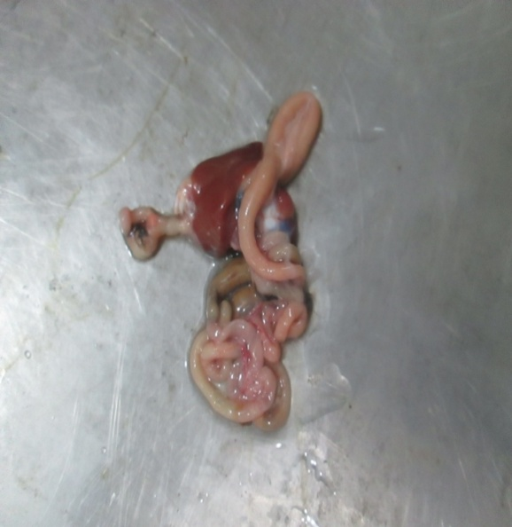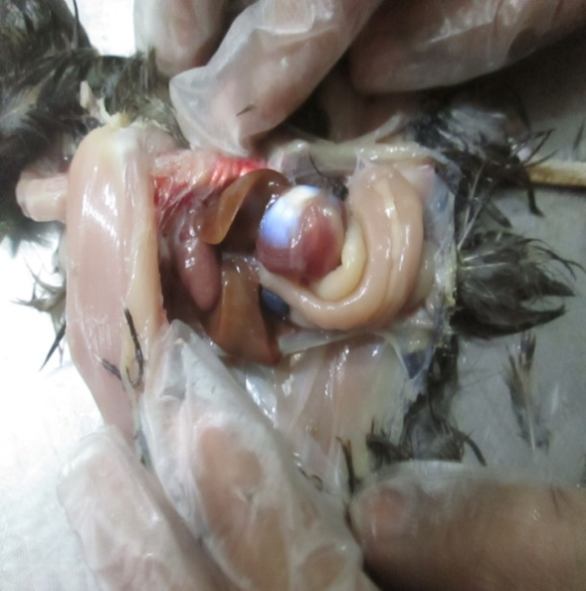

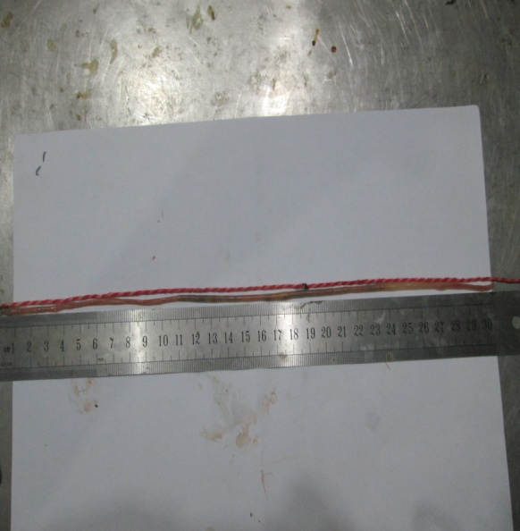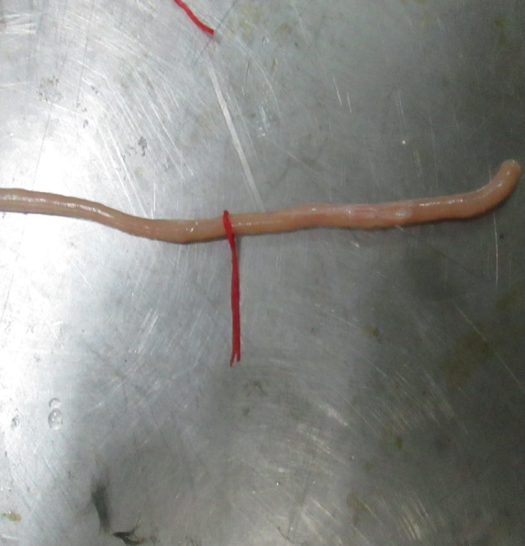 4.**2 . Histology of different segments of the small intestine of quails:**

**Fig. 5:Measuring length of jejunum**

**Fig. 4:Measuring diameter of duodenum**

**Fig. 2:Isolated alimentary tract of quail.(U-Shape duodenum, tip of arrow)**

**Fig. 1:Alimentary tract of quail**

**Fig.3:Small intestine of quail showing ileum (A), gizzard (B), duodenal loop (C), jejunal loop (D) and mesentric blood vessel (E).**

The wall of small intestine contained three tunics *viz*. tunica mucosa, tunica muscularis and tunica serosa. The tunica submucosa was absent as reported earlier by Hodges (1974) and McLelland (1979) in fowl and Kachave *et al*. (2009) in broilers and layers. The tunica mucosa presented a simple columnar epithelium followed by lamina propria. Lamina muscularis mucosae was absent as reported earlier ( Sivakumar and Vijayaragavan, 1989). In contrast, the lamina muscularis mucosae has been reported in quail (Fitzgerald, 1969) and domestic fowl (Hodges, 1974). Lamina propria was consisted of dense irregular connective tissue having with reticular fibres, a few collagen fibres, smooth muscle fibers and numerous capillaries. These muscle fibres originated from inner longitudinal layer of tunica muscularis as reported earlier in quails (Fitzgerald, 1969) and fowl (Hodges, 1974; McLelland, 1979).

The small intestine is conveniently divided into three main regions namely , the duodenum, the jejunum and the ileum. All the three divisions show the usual tunicae namely; mucosa, submucosa, musculosa and serosa. The mucosa of the intestine is thrown in to villi which show a marked variation in density, shape and size in the different regions of the intestine. Intestinal villi gradually decrease in length and size moving from the duodenum to the ileum.

The mucosa is built up of a lamina propia of loose connective tissue supporting the mucosal membrane which is thrown in to deep, narrow finger- like villi in the duodenum while the villi are relatively short, somewhat broad and numerous in the ileum .

The mucosa consists of a simple columnar epithelium and a tunica propria. The muscularis mucosa is represented by a narrow part of longitudinally arranged smooth muscle fibers to wards the side of the submucosa, but on the side of the lamina propria, it is represented by vertically arranged smooth muscle fiber strands . The columnar cells possess elongated nuclei and a clear cytoplasm.

Goblet cells frequently occur amongst the columnar or absorptive cells. Each cell is rounded or oval in shape. The goblet cells are more numerous in the ileum than in the duodenu m . The goblet cells increase from the duodenum towards the rectum.

The goblet cells are positive to the stains specific for mucus . Lymphocytes are scattered amongst the bases of the columnar epithelial cells . They are small more or less spherical and their nuclei are rounded and darkly stained . Crypts of Lieberkühn , in the from of simple tubular stands, occur at the bases of the vili, being more numerous and too crowded in the duodenum.They are built of cells similar in structure to those of the mucosal epithelium.

The cores of the villi are fromed of the areolar connective tissue of the tunica propria. They contain bloodvessels and capillaries , lymph vessels and numerous darkly stained lymphocytes .

The submucosa is thin , narrow and hardly distinguished in some regions. The submucosa connective tissue hold s few bloodvessels . The muscularis mucosa is composed of thin layer of longitudinal muscle fibers which merges gradually in to the submucosa an d extends into the core of the villi. The musculosa consists of two smooth muscle layers ; outer longitudinal layer and a thick circular muscle layer. All muscle fibers are of the unstriated type . Two muscle layers surround the intestine , the inner circular an d outer longitudinal layers that allow mixing and propulsion of the digesta through the intestinal tract. The serosa is made up of flattened simple squamous epithelium

**Chapter-V**

**CONCLUSION**

In this study, we examined the anatomical and histometrical change occuring in the small intestine in male and female quail. The average length and diameter of small intestine of male were higher than female. The numbers of goblet cells increased in duodenum and jejunum. These findings might be helpful for antomical, cell biological and there researches.

**Chapter-VI**

**REFERENCES**

Bayer RC, Musgrave et al. 1973. Characteristics of the absorptive surface of the small intestine of the quail from 1 day to 14 weeks of age. Poult. Sci. 54: 155-169

Dror, Y., Nir, I., and Zafria Nitzan. 1977. The relative growth of intestinal organs in light and heavy breeds. British Poultry Science 18: 493-496. Fitzgerald, T.L. 1969.

El-Sayyad HIH. (1995): Structural analysis of the alimentary canal ofhatchingyoungs of the owl Tytoalbaalba. Journal of the Egyptian German Society Zoology., 16(C): 185-202.

Fitzgerald, T.L., 1969. *The Coturnix Quail Anatomy and* *Histology*. The Iowa State University Press, Ames, Iowa.

Getty R. (1975): Sisson and Grossman’s the Anatomy of the Domestic Animals. Saunders, vol. 5thedn, W. B .Saunder Company. Philadelphia. USA. pp . 1874- 1875.

Graciaet at. (2009) : Feeding structures in birds. In, feeding in domestic vertebrates: from structure to behavior. Edn V. Bels. Wallingford, UK, Combridge.

Hodges RD. (1974) :The Histology of the Fowl.: Academic Press, pp. 35–88.

Hodges, R.D. 1974. *The Histology of Fowl*. Academic Press, London.

Hume I. (1998): Optimization in design of the digestive system. In: Weibel E, Taylor R & Bolis L . (eds) Principles of Animal Design: 212- 219, Cambridge University Press, Cambridge.

Imai M, Shibata T, Moriguchi K, Yamamoto M, Hayama H. (1991): Proventricular glands in fowl. Okajimas Folia Anatomica. Japonica. 68: 155-160.

Kachave, C.D., Bhosle, N.S., Mamde, C.S. and Lambate, S.B. 2009. Histological observations on small intestine in broiler and layer of poultry birds. *Royal VeterinaryJournal of India* **5**: 5-9

McLelland, J. 1979. Avian Digestive System. In Form and Function of Birds. (Eds.) A.S. King and J. McLelland. Vol. 1, Academic Press, London.

Menaha, P. and Sabiha, H.B. 2003. Gross and micro-anatomical studies of the small intestine of guinea fowl. M.V.Sc. thesis submitted to Tamil Nadu Agricultural University, Coimbatore (T.N.).

Mukherjee, L.K. 1992. *A Procedure Manual for Routine* *Diagnostic Tests*. Vol. 3, Medical Laboratory Technology.

Nickel, R., Schummer, A. and Seiferle, E. 1977. Anatomy of the Domestic Birds. Verlag Paul Parey, Berlin. Panse, V.G. and Sukhatme P.V. 1989. Statistical Method for Agricultural Workers. 4th edn., ICAR, New Delhi.

Noy, Y, Sklan, D. 1995. Digestino and absorbtion in the young chick. Poult. Sci. 74:366-

Noy, Y, Sklan, D. 1997. Post hatch development in poultry . J.Appl. Poult. Res. 6:344-354.

Shi-Hou J., Corless, A. and Sell, J.L. 1998. Digestive system development in post hatch poultry. World’s Poultry Science Journal 54: 335-345.

Sivakumar, M. and Vijayaragavan, C. 1989. *Microanatomical* *studies on the small intestine of Japanese quail* The Coturnix Quail Anatomy and Histology. The Iowa State University Press, Ames.

Taylor M.( 2000): Anatomy and physiology of the gastrointestinal tract for the avin practitioner.

Uni Z., Ganot, S, S klan, D. 1998.Posthatch development of mucosal function in the quail small intestine. Poult. Sci. 77:75-82.

Verma, D., Malik, M.R., Parmar, M.L. and Taluja, J.S. 1998. Morphometery of intestine in pre and post-hatch fowl (Gallus domesticus). Indian Journal of Veterinary Anatomy 10: 61-69.

Yamauchi K, Hida S, Isshiki Y. 1992. Post- hatching development changes in the ultrastructure of the duodenal absorptive epithelial cell in 1, 10 and 60 d- old chickens.