Staphylococcus aureus Associated Mastitis in A Dairy Goat: A Case Report

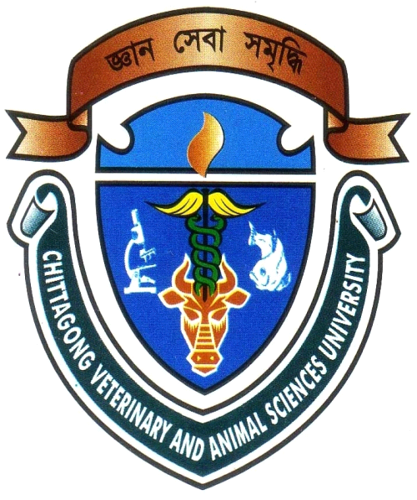

A CLINICAL REPORT SUBMITTED
BY
ROLL NO: 08/34
INTERN ID: E-45
REG NO: 376
SESSION: 2007-2008

A PART OF FULLFILLMENT OF THE REQUIREMENTS FOR THE DEGREE OF
DOCTOR OF VETERINARY MEDICINE (DVM)

CHITAGONG VETERINARY AND ANIMAL SCIENCES UNIVERSITY
CHITTAGONG-4225
Staphylococcus aureus Associated Mastitis in A Dairy Goat: A Case Report

A Report Submitted as per Approved Style and Content

Signature of author  Md.Abdul Karim Mojumder  Intern ID: E-45  Roll No.: 2008/34  Reg. No.: 376  Session: 2007-2008 | Signature of supervisor  Dr. Himel Barua  Associate Professor  Department of Microbiology and  Veterinary Public Health  CVASU

CHITAGONG VETERINARY AND ANIMAL SCIENCES UNIVERSITY
KHULSHI, CHITTAGONG
JANUARY, 2015

