INTRODUCTION
Bangladesh is an over populated, rural and agrarian country in the world and livestock has been an important component of the mixed farming system practiced in Bangladesh for centuries. About 80% of our population is employed in agriculture and livestock farming. Twenty percent people are involved in livestock sector as permanent occupation. The contribution of Livestock in the magnitude of Gross Domestic Product (GDP) is about 16.23% in Bangladesh (BBS, 2008).

But the livestock diseases and disorders of animals are the most important hindrance towards livestock development in our country. The present population of cattle, goat and sheep are 22970000, 22400000 and 2870000 respectively (DLS, 2010). Most of the animals are weak, emaciated and non satisfactory productive performance due to mainly malnutrition and diseases.

In addition livestock disease is one of the main important hindrances towards the development of the livestock. As a result the direct impact of animal disease includes loss and productivity, through the death or slaughter of the animals, reduce production of milk, meat and reduce productive capacity. It was estimated that, TK.1,08067.75 as an annual economic loss due to various parasitic diseases at Savar military farm. Parasitism claims to be the main obstacle in livestock rearing in Bangladesh.

The companion animals have been becoming an important part of modern society and their population has also been tremendously increased in Bangladesh. With the rapid development of economy and urbanization in Bangladesh, the number of companion animals is continuously increasing. Nevertheless, the pet diseases have becoming one of the major veterinary public health concerns and showing growing impact on human health due to the close contacts between humans and pets. Therefore, a better understanding of the distribution and classification of pet diseases and their medical interventions could be the basis of promoting rational veterinary applications and will also provide useful reference to public health sector.

Shahedul Alam Quadery Teaching Veterinary Hospital (SAQTVH) in Chittagong Veterinary and Animal Sciences University (CVASU) plays an important role of public service to animal welfare since 1996. A remarkable number of patients of different species are visited in this hospital each year because of easy and reliable treatment facilities. Therefore, SAQTVH in CVASU is one of the ideal and reliable sources of information about animal diseases and manifestations in the study area.

People from the neighboring areas bring their sick animals to the Veterinary hospital every day. Analysis of the case record gives a comprehensive idea about the disease problems at local areas. The objectives of the present study were to determine prevalence of different clinical diseases and disorders of animals visited the Veterinary Hospital with visual representation for easy understanding, visual comparison between the prevalence of diseases and disorders according to sex and age in major species. This study helps to understand the prevalence of common clinical diseases and manifestations recorded in SAQTVH in the district of Chittagong, Bangladesh during the period of 2011 and 2012.

REVIEW OF LITERATURE

In the semiarid region of northeastern Brazil during the period of 2000 to 2011, out of a total of cases of gastrointestinal disorders in small ruminants 71.7% occurred in goats and 28.1% in sheep (LIRA, Milena A. Aragão de et al., 2013).
At Teaching Veterinary Hospital in CVASU in 2012, Medicinal cases constituted highest percentage (goats 74.66% and cattle 66.35%) in comparison to surgical (goats 16.84% and cattle 24.04 %) cases and gynae-obstetrical (goats 8.50% and cattle 9.62%) cases. Among the medicinal cases, highest percentage was recorded with the diseases of digestive system (goats 16.85% and cattle 20.83%) followed by parasitic diseases (goats 15.22% and cattle 12.82%), infectious diseases (goats 11.95% and cattle 12.18%), general systemic states (goats 7.91% and cattle 6.73%), disease of the respiratory system (goats 9.57% and cattle 4.16%), urinary system (goats 3.31% and cattle 1.28%), special sense organs (goats 3.99% and cattle 1.28%) and noninfectious diseases (goats 5.83% and cattle 4.17%). (MA Parvez et al., 2014).
At Patuakhali Science and Technology University Veterinary Clinic, Babugonj, Barisal during the period from January 2008 to December 2011, highest prevalence of medicinal cases (goats 81.0% and cattle 84.1%) in comparison to surgical (goats 17.9% and cattle 11.2%) and gynae-obstetrical (goats 1.1% and cattle 4.7%) cases (Rahman et al., 2012).
At Bangladesh Agricultural University Veterinary Clinic, the frequency of medicinal cases highest (goats 76.91% and cattle 90.76%) in comparison to surgical cases (goats 19.42% and cattle 3.78%) and gynae-obstetrical cases (goats 3.67% and cattle 5.46%) (Samad, 2001).

At Patuakhali Science and Technology University Veterinary Clinic, Babugonj, Barisal in 2008 to 2011, digestive disorders (goats 22.9% and cattle 14.2%), parasitic diseases (goats 20.04% and cattle 50.4%), infectious diseases (cattle 4.6%), respiratory disorders (goat16.8%) and eye infection (goats 13.5%) but in case of infectious diseases of goats 11.8%, respiratory disorders in cattle 5.5%, least recorded cases like nutritional deficiency, musculo-skeletal disorders, urogenital disorders and skin diseases had similar findings (Rahman et al., 2012).

At Bangladesh Agricultural University Veterinary Clinic, 60.55% digestive disorders and 14.92% skin diseases in calf (Samad et al., 2002).

At Upazilla Veterinary Hospital in Ulipur under Kurigram district during mid October to mid December in 2008, anorexia syndromes (goats 6.09% and cattle 3.17%), digestive disorders (goats 8.69% and cattle 11.5%), respiratory disorders (goats 6.96% and cattle 6.03%) and skin diseases (goats 9.56% and cattle 6.60%) but in case of viral diseases, FMD found highest in cattle and PPR in goats (Kabir et al., 2010).

At Chandanaish upazilla of Chittagong district in 2010-2011, Prevalence of digestive disorders 47.05%, infectious diseases 7.84%, respiratory disorders 6.20% and surgical affection 5.22% in cattle (Pallab et al., 2012).

At Teaching Veterinary Hospital in CVASU in Chittagong, Prevalence of clinical diseases and disorders in 2012 were highest in old animals (goats 38.0% and cattle 34.3%) followed by adult (goats 35.5% and cattle 33.0%) and lowest in kid and calf (goats 26.5% and cattle 32.7%) (MA Parvez et al., 2014).

At Teaching Veterinary Hospital in CVASU in Chittagong, In case of viral diseases FMD comprises higher in number in adult and old cattle than young calf over other viral diseases in 2012 (MA Parvez et al., 2014).

Loss of appetite was the most common owners complain rather than any other diseases and disorders at TVH in CVASU in 2012. In case of respiratory disorders, higher prevalence was found in upper respiratory tract infection in adult goats rather than young and old (MA Parvez et al., 2014).

There was highest and significant number of female goats and cattle were registered at TVH in CVASU in 2012 over the male goats and cattle (MA Parvez et al., 2014).
At University Teaching Pet Hospital at Xi’an in Chaina during the period of 2011 to 2013, among all the dogs and cats, respiratory disorders (15.99%) were common in dogs (15.61%) and cats (23.33%); followed by skin disease (dermatitis) (14.85%), canine parvovirus disease (14.36%) and gastrointestinal disease (12.56%) (Chen Chen et al., 2014).

In US and Australia the most common diseases occurring in dogs and cats are musculoskeletal, dental disease, diseases of gastrointestinal tract and obesity (Freeman et al., 2006).

At Khagrachari Sadar Veterinary Hospital during 2006 to 2010, among viral diseases FMD was found high due to movement of cattle for different purposes (M. H. Ali et al., 2011).

At Chandanaish upazilla of Chittagong district in 2010-2011, highest prevalence was recorded with digestive disorders (47.05%), followed by parasitic infection (26.79%), infectious diseases (7.84%), respiratory disorder (6.2%), surgical affections (5.22%), metabolic disorder (4.24%), ectoparasitic infection (1.96%) and others (0.65%) (M.S. Pallab et al., 2012).

At Patuakhali Science and Technology University Veterinary Clinic, Babugonj, Barisal during the period from 2008 to 2011, digestive disorders (22.9%) were found to be highest among the different categories of diseases in goats. Abscess was recorded in 1.1% cattle and 1.3% goats. Castration was recorded in 2.2% bull calves and 31.3% male kids. Myiasis was recorded in 24.7% cattle and 16.4% goats (M. A. Rahman et al., 2012).

Karim et al., 1996; Gautum et al., 1976 reported that early 3 months of age was the most susceptible for Ascarid infection in case of transmammary transmission of Neoascaris vitulorum.

Hanif et al., 2003 reported that out 145 diarrheic calves of which 98 (67.58%) were frond to be affected with gastro intestinal parasitic infestation.

Noor uddin et al., 1990 recorded an overall 62.0% of 13,421 cattle, and 28.8% of 5,771 goats affected with skin diseases. Das et al., 1992 recorded 24.4% incidence rate of foot diseases in bovines in West Bengal. They found regular overgrown hoof (9.8%) as the most common foot disorder, followed by scissors claw (5.5%), interdigital lesion (0.7%) and eruption of sole (0.6%).

MATERIALS AND METHODS
The study was conducted on 1006 animals (goats 771, cattle 75, dog 119, cat 28, rabbit 6, sheep 4, deer 2 and monkey 1) with clinical signs that were recorded at SAQTVH in CVASU, in Chittagong district of Bangladesh during the period of 2011 and 2012. The animals were registered with specific individual case registration number having full information of age, sex, breed, Body Condition Score (BCS), clinical signs, history etc. Data regarding every patient are recorded in a data record sheet at SAQTVH. Data record sheets were collected from the SAQTVH for the period 2011 to 2012 and information regarding each patient was entered into a spread sheet (Microsoft Excel).

The collected data were exported to analytical software STATA 12.1 (STATA Corp. Texas, USA). Frequency and percentages were calculated using the specific STATA command (tab). Graphs and plots were generated using STATA and Microsoft Excel.

RESULTS AND DISCUSSION
A total of 1006 animals of eight different species were registered at SAQTVH in the year of 2011 and 2012. Among them, the highest number (771) was goat, and lowest (1) was monkey. Distribution of number of different species is presented in Figure 1.
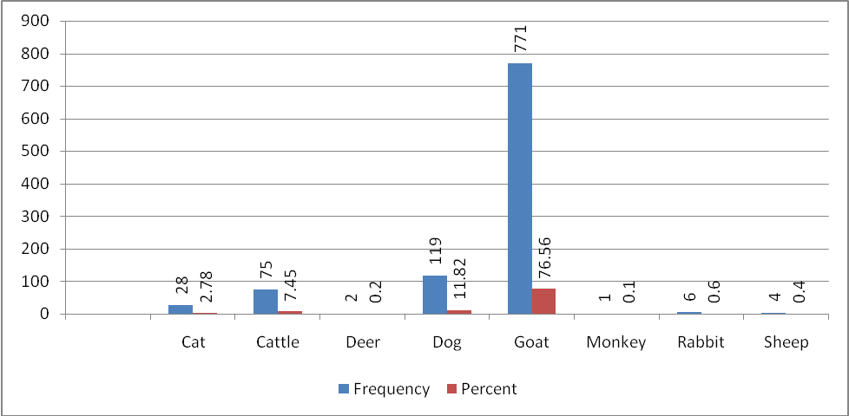
Figure 1: Distribution of different species attended the SAQTVH during the years 2011 and 2012.

The frequency of dog and cattle were 119 (11.82) and 75 (7.45) respectively.The frequency of other patients were 28 (2.78%) of cat, 6 (0.6) of rabbit, 4 (0.4%) of sheep, 2 (0.2) deer and 1(0.1%) monkey.

Figure 2: Box plot showing the minimum, maximum and median age (month) of the six main species attended at the SAQTVH during the years 2011 and 2012.

In figure 2, the box plot shows the distribution of age of major six species attended the SAQTVH. In case of cat, the lower and upper extremes were 1 and 36 months and median value was 8 months with the exception of one case of 60 months. In cattle, the lower and upper extremes were 1 and 60 months and the median value was 13 months with one exception of 74 months. In dog the lower and upper extremes were 1 and 108 months and median value was 15 months with one exception of 120 months. In goat the lower and upper extremes were 1 and 37 months and median value was 11 months with some exception of 40, 48, 52, 54, 60, 65, 72 and 85 months. In rabbit the lower and upper extremes and median values were close which is around 7 months with one exception of 13 months. In sheep, the lower and upper limits were 1 and 12 months and median value was 10 months.

Figure 3: Box plot showing the minimum, maximum and median body weight (KG) of the six main species attended at the SAQTVH during the years 2011 and 2012

There was a wide variation of body weight among the species attended in SAQTVH (Figure 3). In case of cat, the lower and upper extremes were 1 and 9 kg and median value was 7kg with the exception of two cases of 18 and 25kg. In cattle, the lower and upper extremes were 8 and 200 kg and the median value was 50 kg with two exceptions of 250 and 300 kg. In dog the lower and upper extremes were 1 and 30 kg and median value was 12 kg with one exception of 40 kg. In goat the lower and upper extremes were 1 and 35 kg and median value was 15 kg with some exception of 40, 45, 50, 60, 102, 150 and 170 kg. In rabbit the lower and upper extremes were 1 and 3 kg and median value was 2 kg. In sheep the lower and upper extremes were 1 and 15 kg and median value was 8 kg.
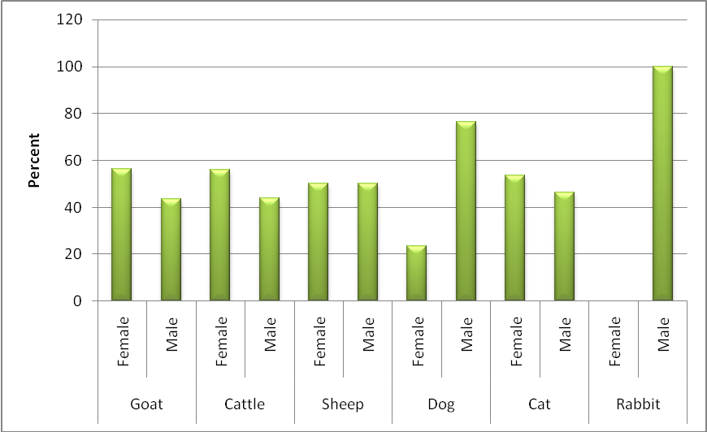
Figure 4: Distribution of sex among different species attended at the SAQTVH
In figure 4, the result represents the frequency of male and female patients of different species that were attended at SAQTVH during 2011 and 2012. In case of goat, cattle, sheep, dog and cat, the female patients were 58%, 58%, 50%, 25% and 55% respectively and male patients were accordingly 42%, 42%, 50%, 75% and 45%. In case of rabbit 100% patients were male.

Figure 5: Visual comparison between the percent of species visited SAQTVH in 2011 and 2012
The comparison of percent of different species visited at SAQTVH between the year 2011 and 2012 are presented in Figure 5. It was indicated that there were more number of patients visited in 2011 than 2012. In 2011 the percent of patients of goat, cattle, dog and cat were 79%, 85%, 80% and 75% respectively. On the other hand in 2012 the percent of patients of goat, cattle, dog and cat were 21%, 15%, 20% and 25% respectively.
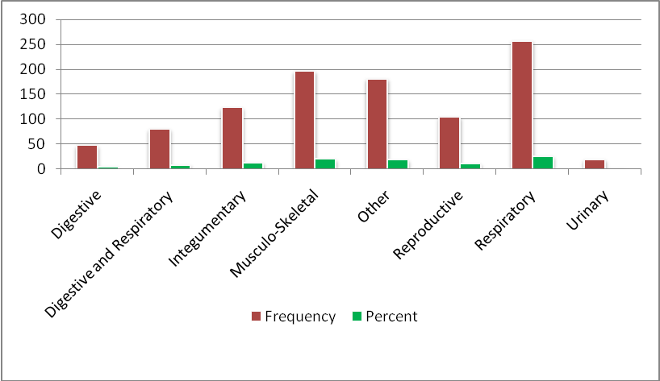
Figure 6: Histogram showing the frequency and percent of animals visited the SAQTVH with different systems affected during the years 2011 to 2012.
The frequency and percent of animals affected with different systems are shown in Figure 6. There was highest number of animals affected with respiratory tract infection (25%). The frequency of affected animals with musculo-skeletal system, integumentary system, reproductive system, digestive and respiratory system, digestive system, urinary system and other system were 20%, 13%, 10%, 7%, 4.5%, 2% and 17% respectively.

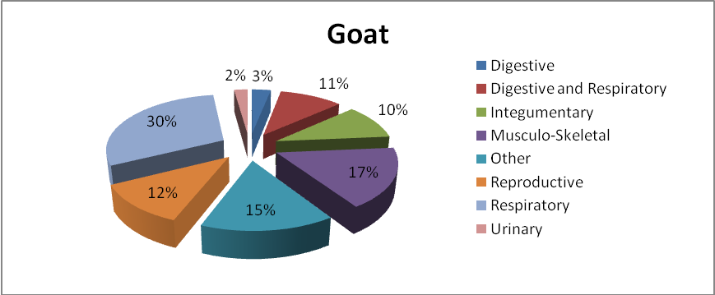 Figure 7: Piechart showing the percent of goats with different systems affected visited the SAQTVH during the study period.
In figure 7 the piechart was drawn to show the percent of goats with different systems affected visited during the study year at SAQTVH. The graph shown that the highest number of goats were affected with respiratory system (30%). Goats affected with other systems were included musculo-skeletal system (17%), reproductive system (12%), digestive and respiratory system (11%), integumentary system (10%), digestive system (3%), urinary system (2%) and other systems (15%).

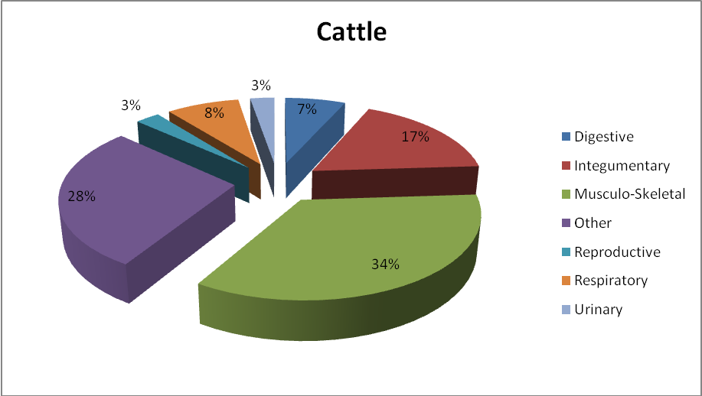
Figure 8: Piechart showing the percent of cattle with different systems affected visited the SAQTVH during the study period.

In figure 8 the piechart was drawn to show the percent of cattle with different systems affected visited during the study year at SAQTVH. The graph shown that the highest number of cattle were affected with musculo-skeletal system (34%). Cattle affected with other systems were namely integumentary system (17%), respiratory system (8%), digestive system (7%), reproductive system (3%) and urinary system (3%) and other systems (28%).
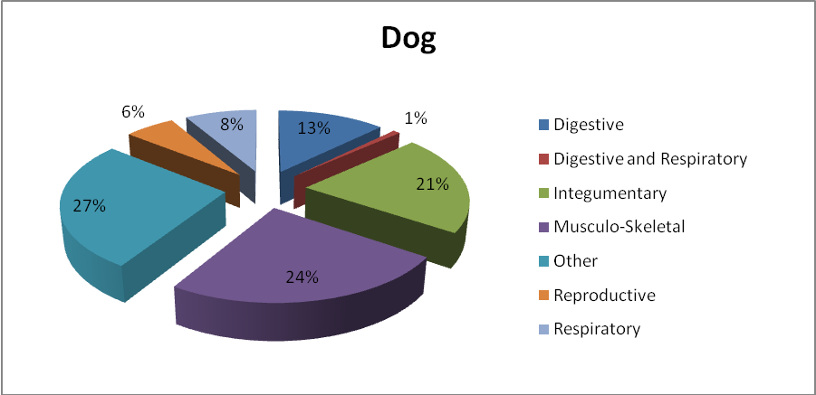
Figure 9: Piechart showing the percent of dogs with different systems affected visited the SAQTVH during the study period.
In figure 9 the piechart was drawn to show the percent of dog with different systems affected visited during the study years at SAQTVH. The graph shown that the highest number of dog were affected with musculo-skeletal system (24%). Dog affected with other systems were accordingly integumentary system (21%), digestive system (13%), respiratory system (8%), reproductive system (6%) and digestive and respiratory system (1%) and other systems (27%).

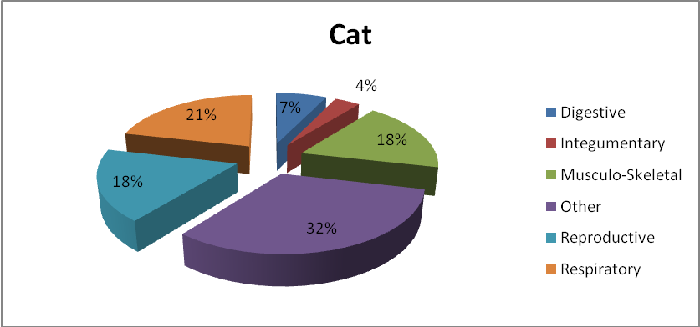
Figure 10: Piechart showing the percent of cats with different systems affected visited the SAQTVH during the study period.
In figure 10 the piechart was drawn to show the percent of cat with different systems affected visited during the study year at SAQTVH. The graph shown that the highest number of cat were affected with respiratory system (21%). Cat affected with other systems were accordingly musculo-skeletal system (18%), reproductive system (18%), digestive system (7%), integumentary system (4%) and other systems (32%).

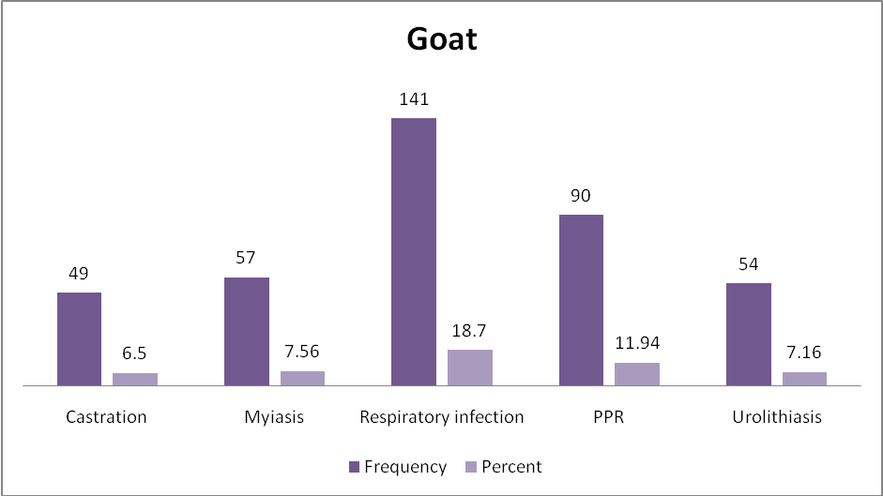
Figure 11: Histogram showing the frequency and percent of goats visited the SAQTVH with the most common problems (showing only those problems occurred in more than 5% animals).
In figure 11 the histogram shows the frequency and percent of goats visited the SAQTVH with the most common problems (showing only those problems occurred in more than 5% animals). The graph shows that, highest number of goats were affected with respiratory tract infection 141 (18.7%). The frequency of affected goats with PPR, myiasis, urolithiasis and castration was 90 (11.94%), 57 (7.56%), 54 (7.16%) and 49 (6.5%), respectively.

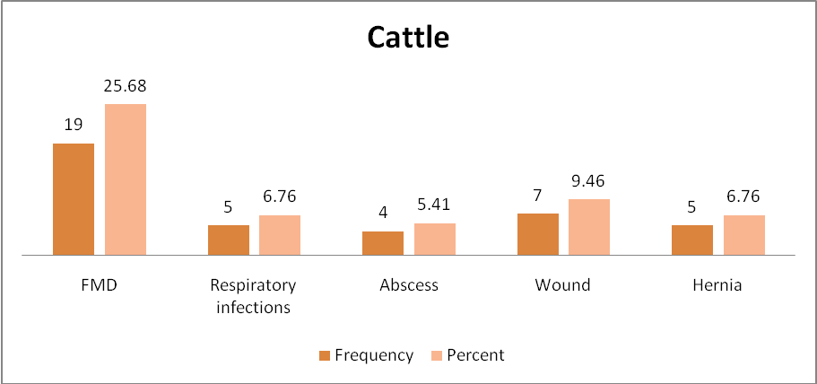
Figure 12: Histogram showing the frequency and percent of cattle visited the SAQTVH with the most common problems (showing only those problems occurred in more than 5% animals).
In figure 12 a histogram was drawn to show the frequency and percent of cattle visited at the SAQTVH with the most common problems ( showing only those problems occurred in more than 5% animals). The graph shows that, highest number of cattle were affected with FMD 19 (25.68%). The frequency of affected cattle with wound, abscess, hernia and respiratory infections was 7 (9.46%), 5 (6.76%), 5 (6.76%) and 4 (5.41%) respectively.

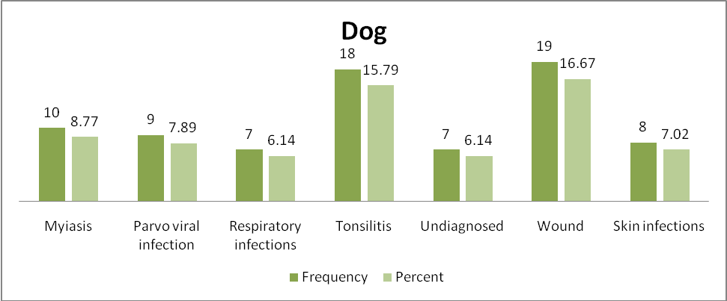 Figure 13: Histogram showing the frequency and percent of dogs visited the SAQTVH with the most common problems (showing only those problems occurred in more than 5% animals).
In figure 13 a histogram was drawn to show the frequency and percent of dog visited at the SAQTVH with the most common problems ( showing only those problems occurred in more than 5% animals). The graph shows that, highest number of dogs were affected with wound 19 (16.67%). The frequency of affected dogs with tonsilitis, myiasis, parvo viral infection, skin infection, respiratory infections and undiagnosed was 18 (15.79%), 10 (8.77%), 9 (7.89%), 8 (7.02%), 7 (6.14%) and 7 (6.14%) respectively.

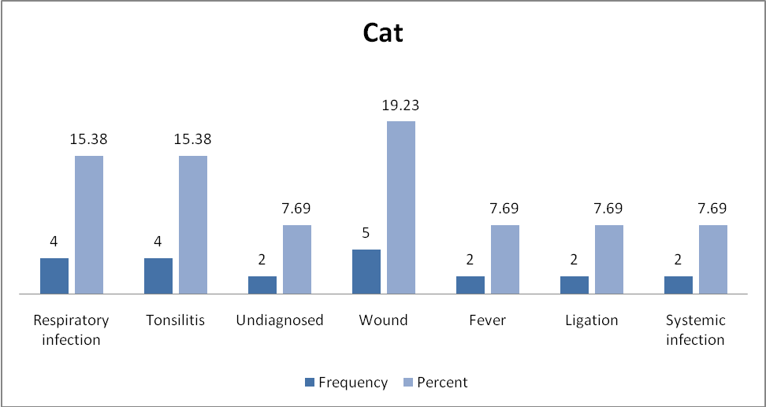
Figure 14: Histogram showing the frequency and percent of cats visited the SAQTVH with the most common problems (showing only those problems occurred in more than 5% animals).

In figure 14 a histogram was drawn to show the frequency and percent of cat visited at the SAQTVH with the most common problems ( showing only those problems occurred in more than 5% animals). The graph shows that, highest number of cat were affected with wound 5 (19.23%). The frequency of affected cat with tonsilitis and respiratory infection was 4 (15.38%). Rest of the cat were affected with fever, ligation, systemic infection and undiagnosed was 2 (7.69%).

CONCLUSION

Diseases and disorders of animals which were recorded at the SAQTVH shows that more or less different diseases are present in both young and adult, male and female animals but some of the specific systems were more affected in some animals such as respiratory system in goat and cat, musculo-skeletal system in cattle and dog. The knowledge derived from this study will increase our understanding about the presence of different clinical diseases of animals in the study area. With the gathered knowledge, further targeted and specific studies can be constructed and conducted with specific aim and objectives. Data were represented with different graphs and plots (visual representation) for easy understanding of the distribution of different health related problems in the study population.

REFERENCES
BBS (2008). Statistical year book on Bangladesh. Bangladesh Bureau Statistics, Ministry of Planning, Dhaka.
Chen Chen, Abdul Rasheed Baloch, Jinxin He, Xiaoying Zhang (2014). A retrospective study on pet diseases and their medical interventions in Xi’an, China. Life Sci J; 11(9):971-975].
DLS (2010). Annual Report of Directorate of Livestock Services, Bangladesh.

Das, U.S., Moitra., S.L. and Chakroborty, M.K., 1992: Investigation of incidence of bovine foot disorders in West Bengal-An abattoir study. Indian Veterinary Journal. 69:180-181.

Freeman LM, Abood SK, Fascetti AJ, Fleeman LM, Michel KE, Laflamme DP, Bauer C, Kemp BL, Doren Van JR, Willoughby KN (2006). Disease prevalence among dogs and cats in the United States and Australia and proportions of dogs and cats that receive therapeutic diets or dietary supplements. J Am Vet Med Assoc; 229: 531-34.

Gautum, O.P., Malik, P.D. and Singh. D.K., 1976: Neoascaris vitulorum larvae in colostrums or milk of buffaloes. Current Science, 45: 350.

Karim, R., Rafiq, K., Mostafa, M. and Hasan, Q., 1996: Bangladesh Veterinary Journal. 32: 71-73

Kabir MH, Reza MA, Razi KMA, Parvez MM, Bag MAS and Mahfuz SU (2010). A report on clinical prevalence of diseases and disorders in cattle and goat at the Upazilla Veterinary Hospital, Ulipur, Kurigram. Internatioal Journal of Bio Research 2: 17-23.

LIRA, Milena A. Aragão de et al., (2013). Diseases of the digestive system of sheep and goats in the semiarid region of Brazil. Pesq. Vet. Bras. [online]. vol.33, n.2, pp. 193-198.
MA Parvez et al (2014). Clinical diseases and manifestations of goats and cattle recorded at Teaching Veterinary Hospital in Chittagong Veterinary and Animal Sciences University. Bangladesh Journal Veterinary Medicine 12 (1): 73-81.
M. H. Ali , M. K. J. Bhuiyan and M. M. Alam (2011). Retrospective epidemiologic study of diseases in ruminants in Khagrachari hill tract district of Bangladesh. Bangladesh Journal Veterinary Medicine 9 (2): 145-153.

M. A. Rahman, M. A. Islam, M. A. Rahman, A. K. Talukder, M. S. Parvin and M. T. Islam (2012). Clinical diseases of ruminants recorded at the Patuakhali Science and Technology University Veterinary Clinic. Bangladesh Journal Veterinary Medicine 10(1&2): 63-73 .

Nooruddin, M., Haque, A. S., 1990: Further study on the prevalence of skin diseases in domestic ruminants in Bangladesh. Bangladesh Veterinary Journal. 7: 75-81.

Pallab MS, Ullah SM, Uddin MM and Miazi OF (2012). A cross sectional study of several diseases in cattle at Chandanaish Upazilla of Chittagong district, Bangladesh Scientific Journal of Veterinary Advances 1: 28-32.

Rahman MA, Islam MA, Rahman MA, Talukder AK, Parvin MS and Islam MT (2012). Clinical diseases of ruminants recorded at the Patuakhali Science and Technology University Veterinary Clinic. Bangladesh Journal of Veterinary Medicine 10 (1&2): 63-73.

Samad MA (2001). Observations of clinical diseases in ruminants at the Bangladesh Agricultural University Veterinary Clinic. Bangladesh Veterinary Journal 35: 93-120.

Samad MA, Islam MA and Hossain A (2002). Patterns of occurrence of calf diseases the district of Mymensingh in Bangladesh. Bangladesh Veterinary Journal 36: 01-05.

