**INTRODUCTION**

Bangladesh is an agricultural country and livestock has been an important component of the mixed farming system practiced in Bangladesh for centuries. About 80% of our population is employed in agriculture and livestock farming. Twenty percent people are involved in livestock sector as permanent occupation. The contribution of Livestock in the magnitude of Gross Domestic Product (GDP) is about 16.23 % in Bangladesh (BBS, 2008). The economy of the country largely depends in agriculture. Livestock being one of the components of agriculture plays a vital role in national economy.

Livestock now a day’s become a component to support the Government national program of poverty reduction, income generation, creation of employment of youths and women, food security of the vast majority people of Bangladesh. Livestock is considered as an efficient tool for poverty reduction throughout the world. It is estimated that about 75% of the World’s 1.5 billion poor live in rural areas of the developing world and 66% of these people keep livestock.

The magnitude of contribution of the livestock sector to the GDP is 2.6% in Bangladesh and 80% rural people rear indigenous animals. The present population of cattle, goat and sheep are 23 million, 22.4 million and 2.8 million respectively (DLS, 2010). Livestock sector provides full time employment to approximately 20% and part time employment to approximately 50% of the rural population of Bangladesh. It also generates an adequate amount of foreign currency every year by exporting hides and skin and their products. Besides, per capita income of Bangladesh is 750 US dollar and 49% of the total population of Bangladesh is malnourished. Per capita requirement of protein cannot be fulfilled by our protein sources. So, continuous protein deficiency causes various nutritional deficiency diseases followed by infectious diseases and reproductive disturbances. If the livestock sector develops, it will be able to fulfill the existing requirement of protein for the country. Approximately 36% protein requirement is fulfilled by livestock sector. The management practices of animals and geo-climatic condition of Bangladesh are favorable for the occurrence of various diseases and disorders. The incidence of diseases varies with the species, ages, sex of the animals and season of the year (Hoque and Samad, 1996; Samad, 2001).

In recent year, this sector has been playing an increasingly important in economy uplift effort of Bangladesh. It is a labor intensive and quick yielding sector which much less attention has been given in the development of this sector compared to the crop sector most probably due to the lack of proper knowledge about the methods and problems of production and utilization of livestock in our country. In addition livestock disease is one of the main important hindrances towards the development of the livestock. As a result the direct impacts of animal disease include loss of productivity, through the death or slaughter of the animals, reduce production of milk, meat and reduce productive capacity. The problem of diseases is a major drawback production not only for our individual countries but also for international trade. Parasitism claims to be the main obstructer in livestock rearing in Bangladesh. Besides parasitic diseases, some other important infectious diseases like FMD, PPR, mastitis and non-infectious diseases like milk fever, dystocia, acidosis, pregnancy toxemia etc causes a great loss of export market, effect on human health, effect on social status etc.

Sirajganj district is one of the important sites for livestock population especially at Shahzadpur Thana and the most of the common livestock diseases are frequently found in the area. Therefore, a study was conducted at the Shahzadpur Upazilla for two months during internship training program with the following objectives:

• To determine the prevalence of different diseases and disorders of livestock population

• To know the frequency of common diseases of livestock

Chapter-II

**REVIEW OF LITERATURE**

Brscic et al. (2012) reported that the prevalence of respiratory disorders in veal calves after postmortem and in vivo and the potential risk factors associated with them. This cross-sectional study was carried out in the veal meat-producing countries in Europe.

Islam (2013) reported that the prevalence of most common surgical affections in calves and goat at Jhenidah sadar. This study also reported that the risk factors (age, sex and breed) related to most common surgical affections in calves and goat.

Lago, et al. (2006) reported that calf respiratory disease and pen microenvironments in naturally ventilated calf barns in winter and this study was reported that the factors that were significantly associated with a reduced prevalence of respiratory disease were reduced pen bacterial counts.

The general recommendations for natural ventilation of livestock buildings in winter season to reduce the respiratory disorders like enzootic pneumonia of calves.

Lateef, et al. (2005) reported that out of 145 diarrheic calves, 98(67.58%) were to be affected with gastrointestinal parasitic infestation.

Garrels, G. (1975) revealed that the number of animals found positive for parasitic infestations was 70.27%. Overall incidence of different parasites recorded was strongyles (54.05%), Toxocara vitulorum and Strongyloides papillosus (18.91%), Coccidia sp (13.51%), Fasciola sp, Fasciooloides sp and Dictyocaulus sp (10.81%), Schistosoma bovis (5.40%), Schistosoma indicum (2.70%) and Paramphistomum sp and Moniezia expansa (5.40%).

Kabir et al (2010) reported that the clinical prevalence of diseases and disorders in cattle and goat by using general examination, physical examination clinical examination, microscopic examination and using common laboratory techniques at the Ulipur Upazilla Veterinary Hospital in Kurigram district.

Kabir et al. (2009) reported that the Prevalence of zoonotic parasitic diseases on the basis of age, sex and breed of domestic animals (cattle and goats buffaloes and sheep ) in different abattoir of Comilla and Brahmanbaria region in Bangladesh.

Islam et al (2001) reported that in endemic condition, PPR may be less dramatic or may occur as a sub clinical or even apparent form.

Debnath (1995) recorded that transmission of diseases is occurred by close contact, secretion and excretion of sick animals to the healthy. The discharges from the eyes, nose and mouth as well as the loose feces contain large amounts of virus. Although subclinical infections can be experimentally induced in goats, the do not transmit the diseases to susceptible pigs or goats.

Sill et al (1995) reported that PPR spread throughout the country and had devastating effects in organized Goat Farms.

Brown et al (1991) reported that PPR was not clearly recognizable upto 1972, but the true extend of the disease has become apparent in recent years and is still being clarified.

Debnath (1995) reported about the conditions of goats, that are affected with a serious exotic killer disease namely Peste des Petits Ruminants (PPR).

Das (1986) reported incidence of abscess (6.24%). Navel ill (3.6%), wart (0.61%), corneal opacity (8.58%), gangrenous mastitis (3.90%).

Paul et al (1993) revealed that the study of association between gastrointestinal (G.I)

Strongyle infection in Bengal goats wits season and geographic location

Ali et al (2011) reported that the retrospective epidemiologic study of diseases in ruminants in Khagrachari Hill Tract district of Bangladesh. This study was reported that the prevalence of diseases was high (42.3%) in rainy season (June-October) followed by (32.5%) in winter (November-February) and lowest (25.2%) in summer season (March- May). Gastrointestinal diseases 61.6 % (2458 cases) was seen highly prevalent among all groups of animals which were followed by infectious diseases 10.4% (416 cases), skin diseases 9.4 % (377 cases), respiratory diseases 8.27% (330 cases) and reproductive diseases 7.93% (cases).

Janeiro (2011) reported that the occurrence and epidemiology of outbreaks of foot rot and other foot diseases in goat and sheep by inspected the environmental conditions, general hygiene, pastures, and disease control measures in semiarid region of northeastern Brazil. This study also reported that Dichelobacter nodosus and Fusobacterium necrophorum are main cause of foot rot.

Akhtar et al (1995) reported on-farm health monitoring of small ruminants: design, data and disease frequencies. This report was also conducted that the incidence risk was highest for diarrhoea, enterotoxaemia, cough/nasal discharge, labored breathing with elevated body temperature, and abortion. Significant and strong associations were recorded between digestive disorders and death, and between respiratory disorders and death.

Khajuria, et al (2003) reported that the Epidemiology of Haemonchosis in sheep and Goats under different managemental conditions. These Epidemiological studies were undertaken at slaughterhouses, livestock farms and veterinary hospitals under the different climatic conditions existing in Punjab province

**Chapter –III**

**MATERIALS AND METHOD**

The study was conducted at Upazilla Veterinary Hospital, Shahzadpur, Sirajganj to determine the general clinical prevalence of diseases and disorders in livestock, poultry and birds. The study period was 8 weeks starting from February to April, 2014.

The sick animals brought for the treatment to this hospital were registered at first in the registered book. The owner complains as well as animals descriptions were recorded in the registered book.

**Reference population**

All the livestock that were brought in Shahzadpur Upazilla Veterinary hospital were considered to be reference population.

**Source of population**

Household raising at least one calf, cattle, goat, sheep with history and clinical sign of diseases were considered to be the study population.

**Study population**

52 calf, 79 cattle, 103 goat and 15 sheep, 521 poultry and 16 rabbits were recorded in that period.

**Population and tools used for data collection**

The sick animals brought for the treatment to this hospital were registered at first in the registered book. There were two ways of to have attended patients, one was clinic at which farmers willingly came with the patient with their complaints and another was at field where veterinary surgeon along with me went to the field for registration of diseased animals. The age and other clinical history of sick animal were determined by asking the owner. A total of 249 animals including 52 calf, 79 cattle, 103 goat and 15 sheep were available during my internship period and general clinical examination were conducted according to the merit of the cases. Sick animals are considered significantly for the diagnostic purposes were collected.

**Registration form**

|  |  |  |  |  |  |  |  |  |  |
| --- | --- | --- | --- | --- | --- | --- | --- | --- | --- |
| Type of patient | Address | Species | Sex | Age | Body weight | Owners complain | Tentative diagnosis | Treatment | Prognosis |
|  |  |  |  |  |  |  |  |  |  |
|  |  |  |  |  |  |  |  |  |  |
|  |  |  |  |  |  |  |  |  |  |

**Detection of diseases either by clinically or physical examination**

**P.P.R (Peste des petits Ruminants**)

P.P.R is very common and fetal diseases of goat. The main feature of this disease is-

• High fever (106-107°F),

* Necrotic erosion with ulceration on the lips and tongue
* Oculo- nasal discharge
* Profuse diarrhea and
* Respiratory distress

**Urolithiasis**

Urolithiasis was diagnosed mainly in castrated goats with history and owner’s complaint and is characterized by-

* Complete retention of urine
* Distention of urinary bladder
* Followed by rupture of urinary bladder

**Tetanus**

Tetanus is caused by the toxin Clostridium tetani .It is clinically characterized by-

* Hyperesthesia
* Convulsion
* Stiff gait
* Lock jaw

**Navel ill**

Inflammatory lesions on the umbilicus in calves within three months of age were

Considered as navel ill and is characterized by –

* Swollen and pain on umbilicus
* Draining of pus

**Milk fever**

Milk fever is a metabolic disorder of dairy cows. It is occurred due to the deficiency of calcium .It was diagnosed by

* Hyperesthesia
* Animal unable to stand

Retained placenta

Retained placenta most commonly found in cows, buffaloes and goats. Animal was considered to have her placenta retained

if she was unable to expel it within 12 hours of parturition.

**Mastitis**

Inflammation of mammary gland is characterized by physical/chemical/bacteriological change in milk and pathological change in mammary gland. It is diagnosed by-

* Anorexia, high fever
* Curd like consistency in milk
* Swollen udder

**Rhinoconjuntivitis**

Rhinoconjuntivitis is caused by Moraxela bovis. It is characterized by –

* Conjunctivitis
* Reddish discoloration of eye
* Swelling of eyeball
* Lacrimation
* Photophobia

**Papillomatosis**

Cutaneous wart is a contagious viral disease and is characterized by-

* Cauliflower like growth on udder teat and the eye, face.

**Fowl Pox**

Pox is the highly infectious and contagious viral zoonotic disease characterized by sequential skin lesion macule-papule-vesicle-pastule-scar.

**Babesiosis**

Babesiosis is a haemoprotozoan disease of ruminants and it is diagnosed by-

* Fever
* Dark, red to brown or coffee color or raw color urine
* Anemic patient
* Pale mucous membrane

**Fascioliasis**

Fascioliasis is more common parasitic disease in Bangladesh and it is occurred by

Fasciola gigantica. Clinical signs are-

* Bottle jaw
* Pale mucous membrane
* Anaemia
* Steatorrhoea
* Diarrhoea

**Ephemeral Fever**

It is a highly contagious febrile viral disease of ruminants characterized by-

* Shifting lameness
* Muscular shivering
* Swelling of peripheral lymphnode

**Abscess**

Abscess is the circumscribed cavity containing pus. It was

diagnosed by the palpation and needle puncture

**Coccidiosis**

It is a protozoal disease caused by Eimeria sps. The main feature of this disease high fever, bloody feces, extremely weak animal.

**Dermatitis : it is a** skin disease caused by nutritional deficiency

**Chapter- IV**

**RESULT AND DISCUSSION**

Clinical investigation was conducted to determine the general clinical prevalence of diseases in calf, cattle, goat, sheep, poultry and rabbit at Shahzadpur Upazilla Veterinary Hospital from February to April, 2014.

**Prevalence of clinical diseases and disorders in calf**

The number and percentage of cases each of the major groups of diseases with their prevalence are presented in Table 1.

Ten major diseases were recorded among 52 sick calves examined during the period of study and results are presented in the table1. The findings showed that 28.7% (n=16) calves are infected by corneal opacity, 14.3% (n=8) with calf scour, 9.6% (n=5) with navel ill dermatitis, scabies 0f each, 5.7% (n=3) with arthritis& fracture, 3.8% (n=2) with atresia ani, 1.9% (n=1) with urolithiasis, 1.9% (n=1) with abscess. The whole recorded diseases of calves were classified into groups like parasitic, bacterial, protozoal, neural disorders and other diseases.

**Table 1: Prevalence of different diseases and disorder of calf (N=52)**

|  |  |  |
| --- | --- | --- |
|  | | |
| Diseases and disorders | Calf | Frequency |
| Abscess | 1 | 1.9% |
| Urolithiasis | 1 | 1.9% |
| Corneal opacity | 16 | 28.7% |
| Myiasis | 3 | 5.7% |
| Navel ill  Dermatitis | 5  5 | 9.6%  9.6% |
| Scabies  Arthritis | 5  3 | 9.6%  5.7% |
| Atresia ani | 2 | 3.8% |
| Fracture | 3 | 5.7% |
| Calf scour | 8 | 14.3% |

**Graph 1: prevalence of various diseases and disorders in calf.**

**Prevalence of clinical diseases and disorders in cattle**

Sixteen major diseases were recorded among 79 sick cattle examined during the period of study and results are presented in the table 2. It is evident that 13.9% (n=11) cattle were affected with acidosis, 6.3% (n=5) with abscess, 5.1% (n=4) with corneal opacity, 3.8% (n=3) with coccidiosis, 6.3% (n=5) with dystocia, 1.3% (n=1) with myiasis, 13.9% (n=11) with mastitis, 3.8% (n=3) with retained placenta, 3.8% (n=3) with dermatitis, 1.3% (n=1)with lumpy jaw, 3.8% (n=3) with papillomatoasis, 2.5% (n=2) with foot rot, 5.1% (n=4) with lice infestation, 16.7% fascioliasis and 7.6 % repeat breeding are observed. The whole recorded diseases of cattle were classified into groups like parasitic, bacterial, viral protozoal and other diseases.

**Table 2: Prevalence of different diseases and disorders of cattle (n=79)**

|  |  |  |
| --- | --- | --- |
| Diseases and disorders | Cattle(79) | Frequency |
|  |  |  |
| Acidosis | 11 | 13.9% |
| Abscess | 5 | 6.3% |
| Corneal opacity | 4 | 5.1% |
| Coccidiosis | 3 | 3.8% |
| Dystocia | 5 | 6.3% |
| Myiasis | 1 | 1.3% |
| Mastitis | 11 | 13.9% |
| Retained placenta | 3 | 3.8% |
| Dermatitis | 3 | 3.8% |
| Lumpy jaw | 1 | 1.3% |
| Papillomatosis | 3 | 3.8% |
| Foot rot | 2 | 2.5% |
| Lice infestation | 4 | 5.1% |
| Scabies | 3 | 3.8% |
| Fascioliasis | 14 | 16.7% |
| Repeat breeding | 6 | 7.6% |

**Graph 2: prevalence of various diseases and disorders in cattle.**

**Prevalence of clinical diseases and disorders in goat**

Twenty major diseases were recorded among 103 sick goats examined during the period of study and results are presented in the table3. The results showed that 1.9% (n=2) goats are infected by scabies, 1.9% (n=2)with dermatitis, 2.9% (n=3) with urolithiasis, 2.9% (n=3) with prolapse, 3.8% (n=4) with lice infestation, 1.9% (n=2) with tetanus, 2.9% (n=3) with mastitis, 7.7%(n=8) with acidosis , 29.1% (n=30) with PPR, .9% (n=1)with atresia ani, 17.4% (n=18) with corneal opacity, 3.8% (n=4) with lice infestation, 2.9 % (n=3) with retained placenta, 1.9% (n=2) with conjunctivitis, 3.8% (n=4) with Dystocia, 1.9% (n=2) with myiasis, 17.4%(n=18) with corneal opacity,0.9% (n=1) with abscess, .9% (n=1) with udder edema, 6.8% (n=7) with pneumonia, and 9.7% (n=10) with fracture. The whole recorded diseases of goat were classified into groups like parasitic, bacterial, viral, protozoal, reproductive diseases and other diseases.

**Table: 3**

**Prevalence of different diseases and disorder of goat (n=103**)

|  |  |  |
| --- | --- | --- |
| Diseases and disorders | Goat | Frequency (%) |
|  |  |  |
| Scabies | 2 | 1.9 |
| Dermatitis | 2 | 1.9 |
| Urolithiasis | 3 | 2.9 |
| Uterine prolapse | 3 | 2.9 |
| Lice infestation | 4 | 3.8 |
| Retained placenta | 3 | 2.9 |
| Pyometra | 1 | .9 |
| Mastitis | 3 | 2.9 |
| Acidosis | 8 | 7.7 |
| Conjunctivitis | 2 | 1.9 |
| Tetanus | 2 | 1.9 |
| Dystocia | 4 | 3.8 |
| Myiasis | 2 | 1.9 |
| Corneal opacity | 18 | 17.4 |
| Abscess | 1 | .9 |
| Udder edema | 1 | .9 |
| Pneumonia | 7 | 6.8 |
| PPR | 30 | 29.1 |
| Atresia ani | 1 | .9 |
| Fracture | 10 | 9.7 |

**Graph 3: Prevalence of various diseases and disorders in goat**

**Prevalence of clinical diseases and disorders in sheep**

Four major diseases were recorded among 15 sick sheep examined during the period of study and results are presented in the table 4. It is evident that 20% (n=3) sheep with retained placenta, tetanus, 13.3% (n=7) with myiasis, 53.3% (n=8) with PPR, 13.3% (n=2) with dystocia. The whole recorded diseases of sheep were classified into groups like parasitic, bacterial, viral and other diseases.

**Table 4: Prevalence of different diseases and disorder of sheep (n=15)**

|  |  |  |
| --- | --- | --- |
| Diseases and disorders | Sheep | Frequency (%) |
|  |  |  |
| Retained placenta | 3 | 20% |
| Myiasis | 2 | 13.3% |
| PPR | 8 | 53.3% |
| Dystocia | 2 | 13.3% |

**Graph 4**: graphical presentation of various diseases and disorders in sheep

Prevalence of clinical diseases in poultry

Six major diseases were recorded among 521 sick poultry examined during the period of study and results are presented in the table 4. It is evident that 45.5% (n=237) infected with fowl pox, 3.3% (n=17) infected with new castle disease, 1.3% (n=7) with salmonellosis, 44.1% (n=230) with lice infestation, 2.2% (n=11) with coccidiosis and 3.6% (n=19) with fowl cholera.

**Table 5: Diseases and disorders in poultry**

|  |  |  |
| --- | --- | --- |
|  | | |
| Diseases | Number of poultry(n=521) | Frequency (%) |
|  |  |  |
| Fowl pox | 237 | 45.5 |  |
| New castle diseases | 17 | 3.3 |  |
| Salmonellosis | 7 | 1.3 |  |
| Lice infestation | 230 | 44.1 |  |
| Coccidiosis | 11 | 2.2 |  |
| Fowl cholera | 19 | 3.6 |

**Graph 5**: prevalence of various diseases in poultry

**Table 6: Pet animal rabbit diseases and disorders (n=16)**

|  |  |  |  |  |
| --- | --- | --- | --- | --- |
|  | Diseases | Number | Frequency (%) | Treatment & management |
|  | Scabies  Dermatitis | 7 | 43.75 | Dressing & ivermectin |
| 2 | 12.5 | Vitamin A& Zinc preparation |  |
|  | Fracture in hind leg | 1 | 6.25 | Bandage |  |
|  | Uterine prolapse | 1 | 6.25 | Prolapse correction |  |
|  | 5 | 31.25 | Dressing &medicine |  |
|  | | | |

**Graph 6**: graphical presentation of various diseases and disorders in rabbit

**Table 7:** Prevalence of diseases according to sex in case of livestock (Calf, cattle, goat, sheep)

Total two hundred fourty nine sick animals (calf, cattle, goat and sheep) were recorded in the hospital. Among the recorded animals 52 were calves, 79 were cattle, 103 were goats and 15 were sheep. The sick animals (calf, cattle, goat and sheep) are classified according to their sex and the results of frequency are presented in the table 4. It is evident that among 52 calves were infected by various diseases and among them 42 (80.7%) were male and 10 (19.3%) were female. Similarly among 79 cattle 22 (27.8%) were male and 57 (57.15%) were female, among 103 goats 52 (50.5%) were male and 51 (49.5%) were female, among 15 sheep 7 (46.6%) were male and 8(53.3%) were female.

Table 8: Prevalence of diseases according to sex in case of livestock (calf, cattle, goat , sheep)

|  |  |  |  |  |  |  |  |  |
| --- | --- | --- | --- | --- | --- | --- | --- | --- |
| Diseases and disorders | Calves(52) | | Cattle(79) | | Goat (103) | | Sheep(15) | |
| Male(42)  (80.7%) | Female (10)  (19.3%) | Male(22)  (27.8%) | Female(57)  (72.15%) | Male (52)  (50.5%) | Female  (51)  (49.5%) | Male  (7)  (46.6%) | Female  (8)  (53.3%) |
| Acidosis | - | - | 2(2.5%) | 9(11.4%) | 5(4.8%) | 3(2.9%) | - | - |
| Abscess | 1(1.9%) | - | 3(3.8%) | 2(2.5%) | - | 1(.9%) | - | - |
| Urolithiasis | 1(1.9%) |  | - | - | 3(2.9%) | - | - | - |
| Corneal opacity | 13(25%) | 3(5.7%) | 3(3.8%) | 1(1.3%) | 11(10.6%) | 7(6.8%) | - | - |
| Coccidiosis | - | - | - | 3(3.8%) | - | 2(1.9%) | - | - |
| Dystocia |  | - | - | 5(6.3%) | - | 4(3.8%) | - | 2(13.3%) |
| Myiasis | 3(5.7%) | - | - | 1(1.3%) | 1(.9%) | 1(.9%) | 2(13.3%) | - |
| Mastitis | - | - | - | 11(13.9%) | - | 3(2.9%) | - | - |
| Retained placenta | - | - | - | 3(3.8%) | - | 3(2.9%) | - | 3(20%) |
| Navel ill | 5(9.6%) | - | - | - | - | - | - | - |
| PPR | - | - | - | - | 17(16.5%) | 13(12.6%) | 5(33.3%) | 3(20%) |
| Tetanus | - | - | - | - | 2(1.9%) | - | - | - |
| Udder edema | - | - | - | - | - | 1(.9%) | - | - |
| Pneumonia | - | - | - | - | 2(1.9%) | 5(4.8%) | - | - |
| Dermatitis | 5(9.6%) | - | 2(2.5%) | 1(1.3%) | - | 2(1.9%) | - | - |
| Lumpy jaw | - | - | - | 1(1.3%) | - | - | - | - |
| Milk fever | - | - | - | 1(1.3%) | - | - | - | - |
| Papillomatoasis | - | - | 3(3.8%) | - | - | - | - | - |
| Foot rot | - | - | 2(2.5%) | - | - | - | - | - |
| Lice infestation | - | - | 3(3.8%) | 1(1.3%) | 1(.9%) | 3(2.9%) | - | - |
| Scabies | 2(3.8%) | 3(5.7%) | 3(3.8%) | - | 2(1.9%) | - | - | - |
| Fascioliasis | - | - | 1(1.3%) | 13(16.4%) | - | - | - | - |
| Arthritis | 2(3.8%) | 1(1.9%) | - | - | - | - | - | - |
| Atresia ani | 1(1.9%) | 1(1.9%) | - | - | 1(.9%) | - | - | - |
| Horn fracture | - | - | - | - | 1(.9%) | - | - | - |
| Repeat breeding | - | - | - | 6(7.6%) | - | - | - | - |
| Fracture | 3(5.7%) | - | - | - | 7(6.8%) | 3(2.9%) | - | - |
| Calf scour | 6(11.5%) | 2(3.8%) | - | - | - | - | - | - |

**Graph 7**: prevalence of various diseases in male and female

**Common management procedure and drug used for the following disease**

|  |  |
| --- | --- |
| Dieases and disorders | Management or drug used |
|
| Acidosis | Sodium bicarbonate 7.5% i/v& saline |
| Abscess | Removal of pus, dressing with povidine iodine& penicillin antibiotic |
| Urolithiasis | Removal of liths, sodium bicarbonate therapy |
| Corneal opacity | 1% silver nitrate solution & autohemotherapy |
| Coccidiosis | Sulphinalamide drug |
| Dystocia | Use of Vaseline and traction |
| Myiasis | Camphor, oil of turpentine, removal of larva& dasting of sulphinalamide |
| Mastitis | Removal of milk &Intramammary infusion |
| Retained placenta | Manual removal of placenta, i/u infusion of metronidasole, oxytetracycline |
| Navel ill | Removal of pus &antibiotic therapy |
| PPR | Ppr antiserum &antibiotic therapy, |
| Tetanus | No effective treatment |
| Udder edema | frusemide |
| Pneumonia | Respiratory drug & bronchodilator |
| Dermatitis | Vitamin A, &Zinc preparation |
| Lumpy jaw | Removal of pus, dressing of affected area, penicillin antibiotic |
| Uterine prolapse | Push back the uterus, cross mattress suture |
| Papillomatosis | Autohemotherapy &vaccination |
| Foot rot | Dressing, CuSO4 footbath, painkiller, &antibiotic |
| Lice infestation | Dipping in pyrethroids mixed water carefully& ivermectin injection |
| Scabies | Ivermectin injection |
| Fascioliasis | Triclabendazole |
| Arthritis | Antibiotic therapy |
| Atresia ani | Opening of anus |
| Hematoma | Opening of swollen part &removal of fluid |
| Repeat breeding | Proper nutrition, medication, and destruction of cyst |
| Fracture | Bandage &medication |
| Calf scour | Sulfur drug |

**DISCUSSION**

The different clinical examination techniques and laboratory methods were used to determine the prevalence of diseases and disorders in calves, cattle, goats and sheep during this two months period of my internship program at Upazilla Veterinary Hospital, Shahzadpur. A total of 52 calves, 79 cattle, 103 goat, 15 sheep were examined clinically

The results of these recorded diseases and disorders are discussed as follows-

**Peste des petits ruminants (PPR)**

PPR was recorded in goats 103 (29.1%) and in sheep 8 (53.3%) during 2 month period.

Peste des Petits Ruminants (PPR) is a paramyxo-virus. The clinical signs and post- mortem lesions in small ruminants suffering from PPR resemble to rinderpest. PPR infection has a four- to five-day incubation period, followed by pyrexia lasting six to eight days. Symptoms include oral necrosis, catarrh, nasal discharge and diarrhoea. In goats experimentally infected with PPR virus, Gibbs et al. (1979) found that nasal excretion of the virus occurred three days after infection and excretion in saliva, urine and faeces at five days. Pyrexia commenced at three days, but no clinical signs of illness were observed until four days. In the same Series of experiments, nasal excretion also occurred at five days. This work would suggest that the disease is spread primarily through the respiratory system. Many animals die within a week of the onset of pyrexia, and the terminal stages of illness are frequently complicated by secondary pneumonia. Survivors may develop dermatitis, with a scab formation similar to that seen in contagious pustular dermatitis. The treatment of clinical cases of PPR consists mainly secondary bacterial pneumonia with drugs, but this is unlikely to be effective unless applied at the early stages of the disease.

**Mastitis**

Mastitis is defined as an inflammation of the mammary gland or udder. The term mastitis is from the Greek word mastos, for breast, and itis, for inflammation. The response to injury to the udder of sheep is called inflammation. Mastitis is the reaction of milk - secreting tissue to injury produced by physical force, chemicals introduced into the gland or most commonly from bacteria and their toxins. Mastitis is defined into groups such as– Udder infection- The udder cavity is invaded by microorganisms which cause inflammation. Subclinical mastitis- No swelling of the udder is not detected nor is there observable abnormalities in the milk. Special screening tests, such as the California Mastitis Test (CMT), Wisconsin Mastitis Test (WMT) and the catalase test will show changes in the milk. This type of mastitis is referred to as "hidden." It is based on an estimation of somatic cell counts. Clinical mastitis -Can be mild or acute, and there is the presence of leukocytes (white blood cells) in the milk. Mild clinical mastitis- involves abnormality in the milk such as flakes, clots, and a watery or other unusual appearance. A hot or sensitive udder may be slight or absent, however there may be signs of swelling. Severe clinical mastitis- involves a hot, hard sensitive udder that is quite painful. The onset is sudden and the ewe may become ill showing signs of fever (105° -107° F), rapid pulse, depression, weakness and loss of appetite. When the whole system of the ewe is affected, the condition is referred to as acute systemic mastitis or bluebag. Chronic mastitis -A persistent udder infection exists most of the time in the subclinical form occasionally can develop into the clinical form before returning to the subclinical. The results are hard lumps in the udder from the "walling off" of bacteria and the forming of connective tissue Rosenberger, G., ( 1979). .The primary cause of mastitis in cattle, goats and sheep are microorganisms such as Streptococcus sp., Staphylococcus sp., Pasteurella sp. and coliforms, Escherichia coli, Enterobacter sp., and Klebsiella sp. Recent studies at the University of Missouri it was reported that in case of subclinical mastitis identified

Staphylococcus, sp., Streptococcus sp. and Micrococcus sp. are found in bacterial cultures (Pharo, H.J., (1987). Nineteen microorganisms have been identified as causative agents of mastitis in cattle. Yeast and fungus have also been found frequently infecting the udder.

**Navel-ill**

Navel-ill was recorded in calves 2 (9.6%) during 2 month period. It is very much common in calves rather than other animals and it is occurred due to the infection of the umbilicus of new born. However, it is common occur within 2-5 days of calves after birth and characterized by the painful umbilicus and draining purulent materials (Radostits et al, 2000).

**Tetanus**

Tetanus was recorded in goat 1(1.9%) in this study during my UVH period. However, this disease occurs in all farm animals all over the world. Clostridium tetani spores require anaerobic condition at the wound site of germination. Local tissue necrosis may help for the establishment of vegetative infection . Toxigenic strains of (Clostridium tetani) causative agent of tetanus have been isolated from the soil samples collected from different districts of West Bangle (Kulkarni, D.D., 1996). It is as very fatal disease, so it should be controlled.

**Foot and Mouth Disease (FMD)**

FMD is an acute febrile diseases highly contagious disease of all cloven footed animals. It was recorded in cattle 2 (2.89%) during my study period. It has a great economic importance and the losses are estimated to be not less than 25 millions annually . So, it must be controlled from the country.

**Abscess**

Abscess was recorded only in 1(1.9%) calves in my study period. It is commonly encountered in veterinary practices in Bangladesh. However, both subcutaneous and internal abscesses have been reported in animals (Singh et al, 1988).

**Fascioliasis (Liver fluke)**

Fascioliasis was recorded in 9 (16.7%) in my study period at Shahzadpur Veterinary Hospital. The clinical occurrence of fascioliasis in association with diarrhea (Radostits et al, 2000). Howlader et al (1990) reported that 21.00% subclinical prevalence of fascioliasis in cattle. The occurrence of higher rate of a clinical infection of fascioliasis during summer (May to July) and autumn (August to october) months.

**Coccidiosis**

Coccidiosis was recorded in cattle 3 (3.8%) in my study. Coccidia have been identified by oocyst culture in Ghana and coccidial oocysts are commonly mentioned in faecal worm egg counts throughout the humid zone. However, no symptoms occur under extensive traditional husbandry systems where the disease is overshadowed by helminthiasis. Occasional clinical cases are reported among young kids and lambs, especially when they are housed and managed intensively (Animal Health).

**Tick Infestation**

Tick infestation was recorded in cattle 3 (3.8%) and in calves 6 (7.41%) in my study. Ticks are the most common. They cause local lesions and damage from blood-sucking and transmit a number of diseases, such as heartwater also recorded a case of tick paralysis in a sheep experimentally infested with Amblyomma larvae (Nooruddin M 1990), though it is not known whether this occurs among the general population of small ruminants in the humid zone.

**Parasitic Infestation**

Parasitic infestation was recorded in calves, cattle, goat and sheep 62 (76.54%), 26(37.68%), 168(49.70%) and 7(38.89%) respectively in my UVH study.

Cestodes found among sheep and goats such as Moniezia expansa, M. benidini are often reported among young animals, with M. expansa the more common species. There is some disagreement concerning their importance: some authorities consider them relatively harmless, while others claim that they cause serious problems, perhaps overlooking concurrent nematode infestations. Hydatidosis (Echinococcus spp.) were encountered, though cysts of other tapeworm genera were sometimes noted in post- mortems. The epidemiology of these infestations and their importance in relation to small ruminant production have received attention.

Trematodes identified among small ruminants such as Fasciola gigantica, Schistosoma bovis and Paramphistomum spp. Liver fluke infestation (F. gigantica) occurs in both sheep and goats and is occasionally listed in abattoir records as a reason for condemning liver, but it is not as important a problem among small ruminants as among cattle. S. bovis has been reported in Senegal and Paramphistomum spp. in Ghana( Assoku, R.K.G., 1981).

The most important helminth parasites identified among small ruminants are the nematodes, including Haemonchus contortus, Trichostrongylus colubriformis, T. axei, Cooperia pectinata, C. curticei, Ostertagia marshali, Gaigeria pachyscelis, Chabertia ovina, Skrjabirema ovis, Trichuris globulosus, T. ovis, Oesophagostomum columbianum, Strongyloides papillosus and Bunostomum spp.( Asanji, M.F., 1987) . Of these, H. contortus is considered the most serious, particularly affecting young animals during the rainy season.

**Urolithiasis**

Urolithiasis was recorded in3 (2.9%) goats. The clinical occurrence of urinary obstruction due to Urolithiasis in castrated goats (Radostits, 2000) has been reported. The high prevalence rates of urolithiasis in fatty goats (Radostits, 2000) also have been reported

**Retained Placenta**

Retained placenta was recorded in goat 1(0.29%) during my study. It is usually associated with hormones, vitamin and trace elements (Ali, 2011 et al). However, retained placenta in cow is the highest cases in the field

**Chapter- V**

**CONCLUSION**

In conclusion the parasitic infestation of livestock (calf, cattle, goat, and sheep) was very high during the study period (February to April, 2014). On the other hand, viral disease such as PPR in goat and FMD in cattle was the most common diseases. Among the bacterial diseases black quarter and clinical mastitis was more common. Protozoal diseases such as babesiosis and coccidiosis were also found. The prevalence of these parasitic, bacterial, viral, protozoal diseases occur due to the lack of deworming. The reproductive diseases like retained placenta was more common in cow and goat. The knowledge of proper husbandry, awareness of vaccination and practices of proper hygienic management is necessary to reduce the frequency of various diseases. The present findings suggest that goat was more susceptible with PPR in the study area.

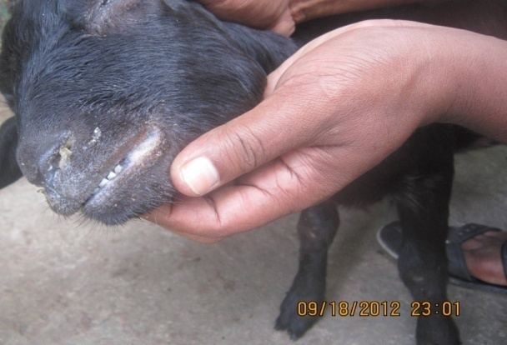

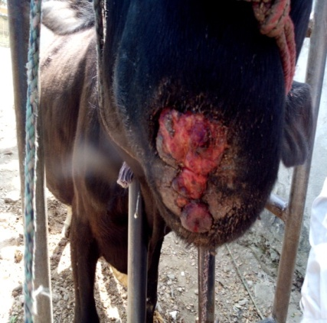

Figure 1:Mastitis in goat

Fig 3: Mastitis milk test

fig 5:PPR i

Figure 2: Nasal discharge in goat (PPR)

Figure 1: Lumpy jaw in cow

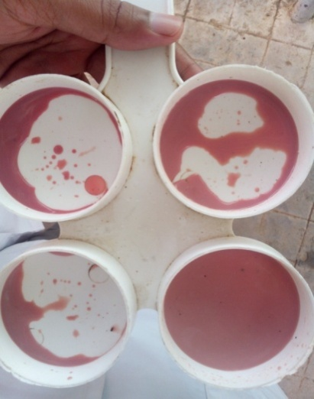

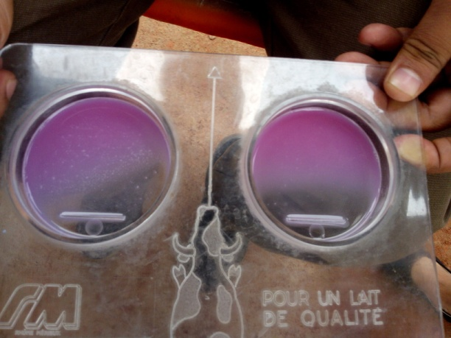

Figure 4: strip cup test

Figure 3: Mastitis test (CMT)

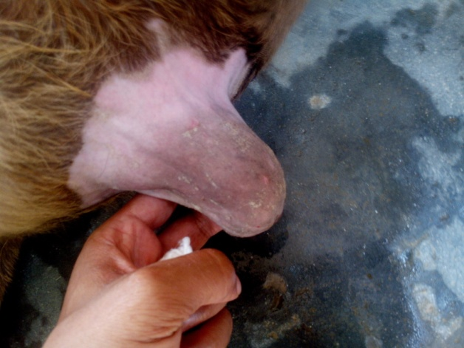

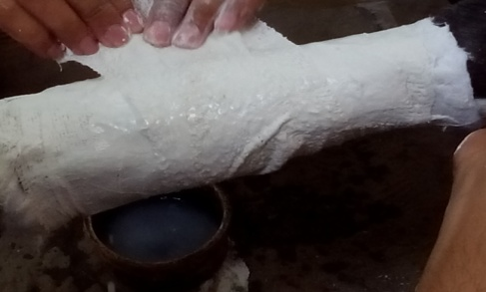

Figure

Fig 5: Hernia in calf

Fig 6: Fracture management

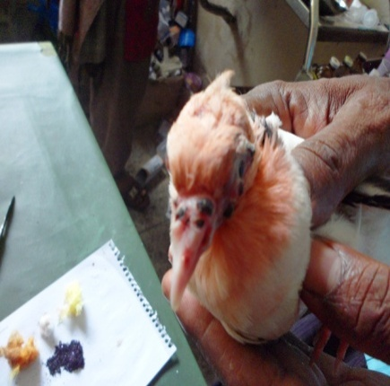

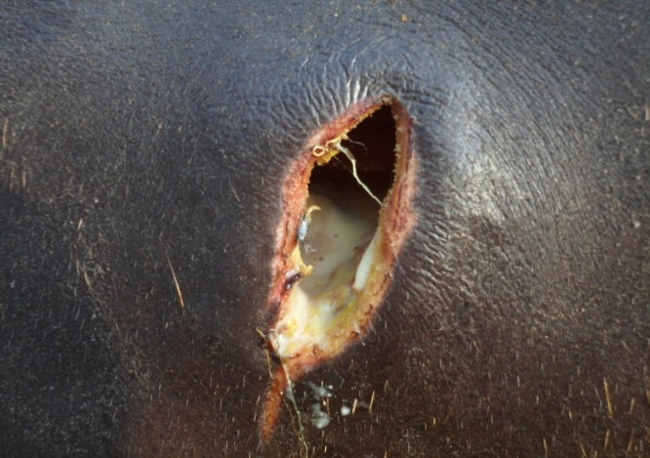

Fig 8: Pigeon pox

Fig 7: Abscess in buffalo

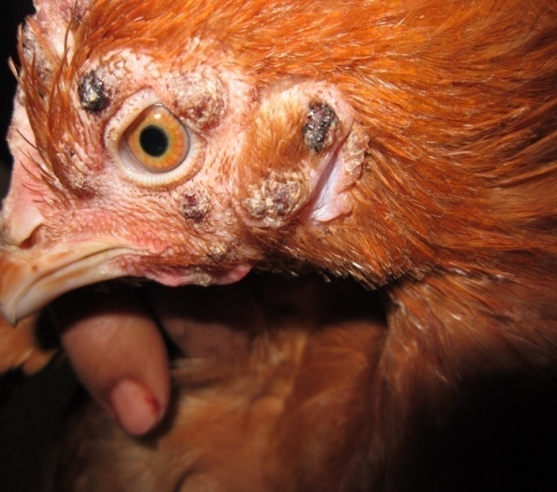

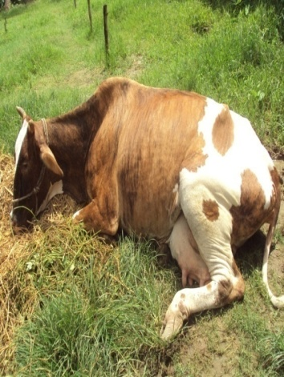

Fig 9: Milk fever

Fig 10: Fowl pox



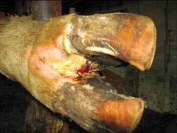

Fig 12:Papillomatoasis in cow

Fig 11:Foot rot

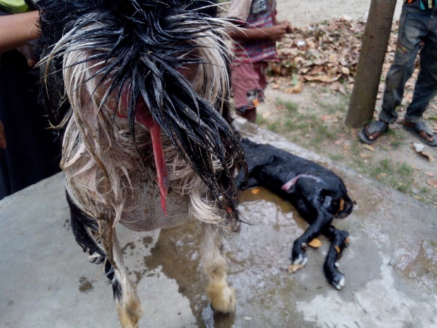

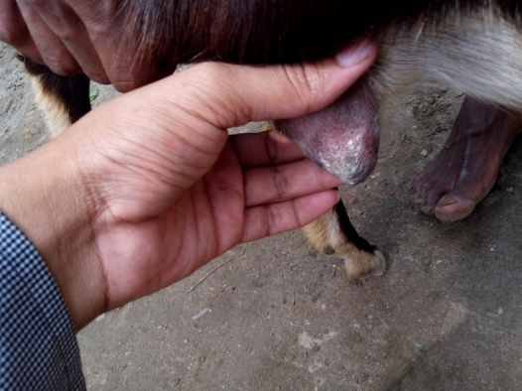

Figure 2:lumpy jaw in cow

Figure 14: Retained placenta in goat

Figure 13: Mastitis in goat

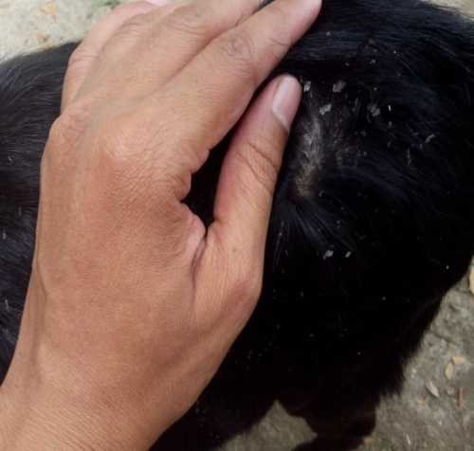

Figure 15: Dermatitis in goat

**References**

Akhter, S., & Ali, S., (1995). Monitoring of bovine health problems of small dairy herds in Islamabad Capital Territory: design, data and disease frequencies. Trop. Anim. Hlth Prod., 26,193-198

Ali, M.H., Bhuiyan, M. K. J., and Alam M.M., (2011). Retrospective epidemiologic study of diseases in ruminants in Khagrachari Hill Tract district of Bangladesh. Bangl. J. Vet. Med.. 9 (2): 145 – 153

Asanji, M.F., and Williams, M.O., (1987). A qualitative and quantitative survey and seasonal dynamics of gastrointestinal helminth parasites of livestock in Sierra Leone. Bull. Anim. Hlth. Prod. Africa, 35: 191 200

Assoku, R.K.G., (1981). Studies of parasitic helminthes of sheep and goats in Ghana. Bull. Anim. Health Prod.Afr. 29:1–10

Blood, D. C., Rodostis, O. M., and Gay, C. C., 1995. Veterinary Medicine.8th Edn. Ballier Tindall, UK: 837

Blood, D.C., and Rodistis, O.M., (2000). Veterinary Medicine. 9th edn. W.B Sounders

CO. Ltd., London

Brown, C.C., Mariner, J.C., and Olander, H.J., (1991). An immunohistochemical study of pneumonia caused by peste des petits ruminants virus. Veterinary Pathology 28 : 166- 170.

Brscic, M., Leruste, H., Heutinck, L.F.M., (2012). Prevalence of respiratory disorders in veal calves and potential risk factors.J Dairy Sci 95(5):2753-64

Das, B.C., and Hashim M.A., (1996). Studies on surgical affections in calves. Bangladesh Veterinary Journal 30: 53-57

Debnath, N.C., (1995). Peste des petits ruminants (PPR): an overview. Proceedings of the BSVER Symposium on Eradication of Rinderpest and Related Diseases. 2 December, 1995, Dhaka. pp. 9-13.

D.L.S., (2010). Personal communication With Project Director, Animal Health Care, Management and Expansion Project, DLS, Dhaka.

Garrels, G., (1975). Gastrointestinal parasitic infestation of cattle in some villages of Dacca and Tangail districts in Bangladesh.Bangladesh Vet. J. 9:9-10

Gibbs, E.P.J., Taylor, W.P., Lawman, M.J.P., and Bryant, J., (1979). Classification of peste des petits ruminants virus as the fourth member of the genus Morvillivirus. Intervirology 11 : 268-274

Hoque ,M.S., and Samad, M.A., (1996). Prevalence of clinical diseases in dairy cross-bred cows and calves in the urban areas in Dhaka. Bangladesh Veterinary Journal 30: 118- 129

Howlader, M.M.R., Chowdhury ,S.M.Z.H., Taimur ,M.J.F.A., and Johan, S., (1990). Fluke infestations of cattle in some selected villages of Bangladesh . Bangladesh Veterinarian 7: 45-47

Islam, K. M. E., (2013). Prevalence of Common Surgical Affections in Calves and Goat at Jhenidah Sadar

Janeiro, (2011). Foot rot and other foot diseases of goat and sheep. Pesq. Vet. Bras. vol.31 no.10

Kabir, M.H.B., (2009). Prevalence of zoonotic parasitic diseases of domestic animals in different abattoir of Comilla and Brahman Baria region in Bangladesh

Kabir, M.H., et al (2010). A report on clinical prevalence of diseases and disorders in cattle and goat at the Upazilla Veterinary Hospital,Ulipur,Kurigram. Int. J. BioRes. 2(11): 17-23

Khajuria, J.K., Kapoor, P.R., (2003). Prevalence of parasites in sheep and goats at Kathua- Jammu. J. Vet. Parasitol. 17: 121–126

Kulkarni, D.D., Bhikane, A.U., Shaila, M.S., Varalakshmi, P., Apte, M.P., and Narladkar, B.W., (1996). Peste des petits ruminants in goats in India. Veterinary Record 138 : 187-188

Lago, A., et al (2006). Calf Respiratory Disease and Pen Microenvironments in Naturally Ventilated Calf Barns in Winter J. Dairy Sci. 89:4014–4025

Lateef, M., Iqbal, Z., Jabbar, A., Khan, M.N., Akhtar, M.S., (2005). Epidemiology of trichostrongylid nematode infections in sheep under traditional husbandry system in Pakistan. Int. J. . Samad, M.A., (2000). Veterinary Practitioner’s Guide. 1st Pub. No. 07, BAU Campus, Mymensingh

Nooruddin, M., and Dey, A.S .,(1990). Further study on the prevalence of skin diseases in domestic ruminants of Bangladesh. Bangladesh Veterinarian 7: 75-81

Pal, R.A., and Qayyum, M., (1993). Prevalence of gastrointestinal nematodes of sheep and goats in upper Punjab, Pakistan. Pak. Vet. J., 13: 138-141

Rahman, MA., Islam ,M.A., Rahman, M.A., Talukder, A.K., Parvin ,M.S., and Islam, M.T., (2012). Clinical diseases of ruminants recorded at the Patuakhali Science and Technology University Veterinary Clinic. Bangladesh Journal of Veterinary Medicine 10(1&2): 63-73.

Radostits, O. M.,et. al. (2000). Veterinary Medicine. A Text hexachloride and proflavine hemisulphate with cetrimide

Rosenberger, G., ( 1979). Clinical Examination of Cattle. 2nd edn., Verlag Poul Parey,

Germany.

Samad, M.A., Bari, A.S.M., and Bashar, S.A., (1988). Gross and histopathological studies on bovine babesiosis in Bangladesh. Indian Journal of Animal Science 58: 926-928

Samad ,M.A., (2001). Observations of clinical diseases in ruminants at the Bangladesh Agricultural University Veterinary Clinic. Bangladesh Veterinary Journal 35: 93-120

Samad ,M.A., Islam, M.A., and Hossain ,A., (2002). Patterns of occurrence of calf diseases in the district of Mymensingh in Bangladesh. Bangladesh Veterinary Journal 36: 01-05

Samad, M.A., (2008). Animal Husbandry and Veterinary Science. 1st pub., LEP pub No. 11. BAU Campus, Mymensingh.

Sil, B.K., Rahman, M.F., and Taimur, M.J.F.A.,(1995).Observation on outbreaks of peste des petits ruminants in organised goat farms and approach of its treatment and prevention.

Second BSVER Annual Scientific Conference, Programme and Abstracts, Dhaka, 2-3 December, 1995. p. 10

Singh, K. B., Nauiyal, D. C., Oberoi, M.S., and Baxi, K.K., (1996). Seasonal occurrence of clinical mastitis. Indian Journal of Dairy Science 49(8): 534-536

Singh, R. P., B. P., Sreenivasa, P., Dhar, L. C.,Shah and S. K., Bandyopadhyay, 2004. Development of monoclonal antibody based competitive-ELISA for detection and titration of antibodies to peste des petits ruminants (PPR) virus. Vet. Microbiol. 98:

3–15

Sutradhar,B.C., Hossain, M.A., and Alam, M.R., (2000). Incidence of bloat and it response to certain drugs in cattle. Bangladesh Veterinarian 17: 37-41