**A Case Report on Surgical Correction and Management of**

**Atresia Ani in a newborn Calf in SAQTVH,CVASU**

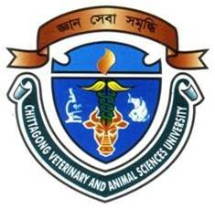

A clinical report submitted by

Md.Abdullah Al Mamun

Intern ID:54

Roll No: 2012/50

Reg. No: 784

Session: 2011-2012

Report presented in partial fulfillment for the Degree of

Doctor of Veterinary Medicine(DVM)

**Faculty of Veterinary Medicine**

**Chittagong Veterinary and Animal Sciences University,**

**Khulshi, Chittagong-4225**

**September, 2018**

**A Case Report on Surgical Correction and Management Atresia Ani in a newborn Calf in SAQTVH,CVASU**



A clinical report submitted as per approved style and content

|  |  |
| --- | --- |
| **Signature of the Author**  **Md. Abdullah Al Mamun**  Intern ID: 54  Roll No: 2012/50.  Reg. No: 784  Session: 2011-2012. | **Signature of the Supervisor**  **Prof. Dr. Kh.Nurul Islam**  Department of Anatomy and Histology  Faculty of Veterinary Medicine,  Chittagong Veterinary and Animal  Sciences University, Khulshi, Chittagong-4225. |

**Faculty of Veterinary Medicine**

**Chittagong Veterinary and Animal Sciences University,**

**Khulshi, Chittagong-4225**

**September 2018**

**CONTENT**

|  |  |  |
| --- | --- | --- |
| **No.** | **Name of the contents** | **Page** |
| 1 | Abstract | 1 |
| 2 | Introduction | 2-3 |
| 3 | Materials and Methods | 4-5 |
| 4 | Results | 6 |
| 5 | Discussion | 6-7 |
| 6 | Conclusion | 7 |
| 7 | Acknowledgement | 8 |
| 8 | References | 9-10 |
| 9 | Biography | 11 |

**ABSTRACT**

Page:1

A 5 day old male calf with the complain of non-passage of faeces since birth was brought to the SAQTVH,CVASU.On clinical observation,it was found that the calf was not having anal opening.There was soft subcutaneous swelling below the ischial arch with distension of abdomen .The signs of straining,depression,tenesmus and abdominal pain were observed.The case was diagnosed as Atresia Ani and referred to surgery. 2% Lidocaine hydrochloride (JasocaineR,JaysonPharmaceuticals,Bangladesh) was used for local anaesthetics and Diazepum for sedation.. Then the cage was surgically corrected by making a permanent anal orifice. Surgical intervention is the only technique of choice for the treatment in such acute abdominal discomfort and it was attempted successfully in this present case.Postoperative treatment is Inj amoxicillin @10mg/kg ,IM for 5 days and Inj Meloxicam 0.5mg/kg ,SC for 5 days..This surgery is recommended for all ruminant as it saves life.

**Key words:Calf,AtresiaAni,CongenitalDefect,Surgery.**

**INTRODUCTION**

Page:2

Atresia ani is common congenital defect in domestic animal in Bangladesh.About 23% congenital cages in calves is atresia ani.Atresiaani is ocured more commonly in indeginous calves than crossbred calves. If we consider it by percentage, indigenous calves affected with atresia ani is about 71.74% and the crossbred were 28.26%.

Atresia ani is a congenital defect of the anorectum, resulting in anal canal closure and /or abnormal routing of feces (Bright & Bauer, 1994).Atresia ani, (imperforate anus) is a congenital abnormality characterized by persistence of the anal membrane resulting in a thin membrane covering the normal anal canal or is the failure of the anal membrane to break down(Merei.et.al,2001).Among large animals congenital atresia ani most often occurs in pigs and calves.Congenital defects, abnormalities of structure or function present at birth, may be caused by genetic or environmental factors, or a combination of both; in many cases, the causes are unknown(Servet et al., 2009).The most common bovine environmental teratogens include toxic plants consumed by the dam and maternal-fetal viral infections during gestation. Congenital malformation sometimes leads to perinatal mortality, and it may also decrease maternal productivity and reduce the value of the defective neonates. Severe defects results in abortion of the calf or a return to service of the calf and cow. Congenital anomalies have been estimated to occur in 0.2%–5% of calves..al,2001) .Reported most congenital malformations was atresia ani and most frequently encountered in male calves and pigs.

The term atresia describes congenital occlusion of the lumen of the digestive tract. Failure of the anal membrane to break down during the development gives rise to the condition termed imperforated anus and some times termed as atresia ani (McGeady et al., 2006).

There are four major types of intestinal atresia. Type I atresia is a mucosal blockage within the intestinal lumen. In animals with type II atresia, the proximalsegment of intestine terminates in a blind end and the distal segment beings similarly with two ends being joined by a fibrous cord devoid of lumen. Type IIIa atresia is similar to type II except that the proximal and the distal intestinal segments blind ends are completely separated and there is a mesenteric defect corresponding to the missing segment of intestine. Animals with type IIIb atresia have a coiled distal segment of intestine. Type IV atresia involves multiple sites of atresia (Kilic and Sarierler 2004; Rahal et al. 2007).

Atresia ani is fatal affection to the male unless surgical correction is carried out to provide anal opening, in female rectum frequently break through to vagina forming a rectovaginal fistula and thus permit defecation via the vulva (Norrish and Rennie, 1968).

Page:3

Atresia ani was reported as a possible genetic defect in Swedish Highland Cattle, Holsteins, and other breeds. Atresia ani is the most common intestinal defect in sheep and is believed to be due to an autosomal recessive gene. In a series of 64 cases of atresia ani in sheep, 42 (62%) were associated with defects of other body systems, especially the urogenital and musculoskeletal systems (Newman et al.1999; Ghanem et al., 2004; Kiliç and Sarierler 2004; Loynachan et al. 2006; Rahman et al. 2006; Magda and Youssef 2007; Bademkıran 2009).

Affected animals may survive for up to 10 days and can be identified by their depression, anorexia, colic, marked gradual abdominal distension and lack of feces (Radostitis et al., 2000).

Atresia ani should be treated by surgical operation to solve the problem, improve body weight gain, and reduce economic loss caused by this defect (Servet et al., 2009).

The present report describes a case of atresia ani and its successful surgical correction in a calf.

**MATERIALS AND METHODS**

Page:4

**History and clinical observation:**

A 5days old male,non descript cattle calf, and weight is 18kg.The calf was not having anal openingand non-passage of faeces since birth was brought .There was soft subcutaneous swelling below the ischial arch with distension of abdomen .The signs of straining,depression,tenesmus and abdominal pain.

**Instruments and appliances**

Surgical handle and blade, straight scissors, forceps, blade, nylon thread, catgut, draping cloth, towel clips, tissue forceps, probe, traumatic needle, needle holder, syringe, anaesthetic agent like 2% Lidocaine hydrochloride (JasocaineR, Jayson Pharmaceuticals, Bangladesh) and antiseptic like 0.001% potassium permanganate (PPM).

**Preparation of the patient:**

The animal was placed on the operation table in lateralrecumbency and was restrained physically by the assistants. The operation site was clipped, shaved and drapped using sterile surgical towel. The site was finally painted with tincture of idodine.

**Surgical procedure:**

The calf was positioned on lateral recumbency (Fig. 2).At first diazepam was used for sedation at the dose of The perineum was infiltrated with 6-7 ml 2% lidocaine, and after routine aseptic preparation of the surgical field, a cruciate incision, (2.5 × 2.5 cm), was made through the skin and subcutaneous tissue at the site where the anus should normally be situated. Careful blunt dissection was used to locate the rectal pouch, which was secured to the skin edge with 4 full-thickness sutures of nylon, then the rectum was incised and its mucosa was sutured to the skin with simple interrupted sutures. After that, the rectum was irrigated to wash the meconium (Fig. 3) by 0.001% PPM using Duche Cane. PPM results mechanical irritation to the intestinal mucosa, thus straining occur, which helps in early expulsion of meconium. Finally, the rectal pouch was sutured to the skin.

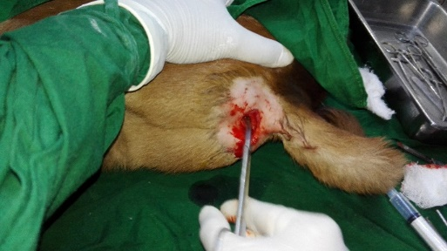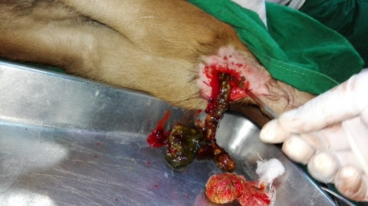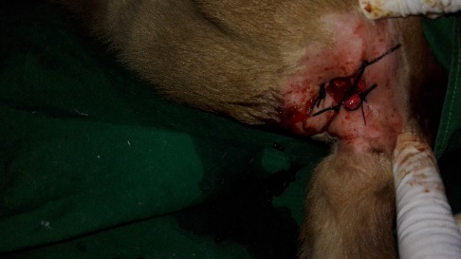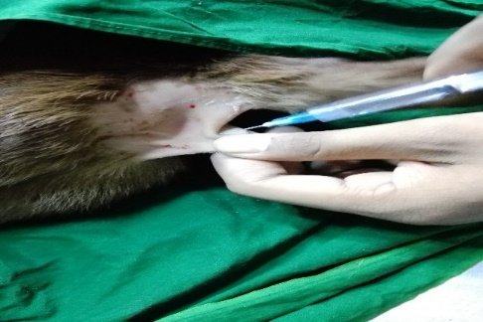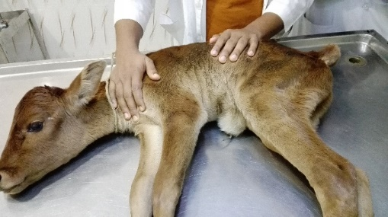

Page:5

1.Restraining of animal 2 Infiltration of anaesthetics

3. Making anal opening 4. Removing faeces

5.Suture completed

Figure:Surgical procedure

Page:6

**Post operative care:**

After surgery followingthe following antibiotic and anti-inflammatory drugs were prescribed.

1)Amoxicilin @ 10 mg/kgbodyweight,Intrmuscularly for 5days.

2)[Meloxicam@0.5mg/kg](mailto:Meloxicam@0.5mg/kg) body weight,subcutaneously for 5 days.

**RESULTS**

Anal reconstruction was performed satisfactory. After postoperative period, wounds fully healed without any significant complications. No clinical side effects were observed after surgery except mild sign of digestive discomfort without any need for further treatment.Defecation was normal soon after surgery. Fecal passage was achieved without any need of spescific care or interference which improved animal health and body weight gain. Full function anal stoma was achieved after wound healing at about one month after surgery.

**DISCUSSION**

Atresia ani has been reported to be a heritable condition in pigs and calves (Kilic et al. 2004). Based on this all treated animals were not considered for breeding; they were slaughtered at six months of age. A genetic basis has been documented for some cases of atresia ani, but the specific cause in sporadic cases in domestic species and humans is not always known (Johnson et al.1980; Newman et al.1999). Some authors Johnson et al. (1983), Leipold (1986) and Noh et al. (2003) reported that the most congenital anomalies of digestive system observed in calves were atresia ani and atresia recti. Besides, the anomalies of urinary system such as renal agenesis, polycystic kidney and skeleton system such as cocygeal or sacral vertebral agenesis were observed at the same time in calves. However, in this study animal was suffering from atresia ani only and was treated by anal reconstruction. Atresia ani is a fatal affection to the male unless surgical intervention occurs to provide new anal stoma. In some females, fecal pressure result in rectum break through vagina forming a rectovaginal fistula and thus permit defecation via vulva, therefore affected female does not require a further care or surgical correction, and may not be identified (Norrish and Rennie, 1968). Four major types (I, II, IIIa, IIIb and IV) of intestinal atresia have been described involving different intestinal segments (Kilic and Sarierler 2004; Rahal et al. 2007). Anal reconstruction was relatively painless using sedation and local anesthesia and was not invasive surgery. In the present study during suckling period the feces was soft and normally excreted, once the newborn animal changed diet a normal pellet like feces was excreted and no postoperative complications were found. This finding showed that the new anal orifice increased in size with age and was able to excrete feces in spite of absence of anal sphincture.

Page:7

**CONCLUSION**

Surgical correction(Anal reconstruction) is the only treatment for atresia ani in newborn animal.This surgery saves life of newborn.It is effective and economic.It is recommended for all ruminant as it saves life.

**Acknowledgement**

Page:8

All praises are due to “Almighty Allah” who enabled the author to complete this report successfully.

The author express his deep sense of gratitude, heartfelt respect and immense indebtness to his supervisor Prof. Dr.Kh.Nurul Islam, Department Anatomy and Histology, Chittagong Veterinary and Animal sciences University for his valuable advice, scholastic guidance, suggestions, inspiration and who was involved with this report through its inception.

I would like to express my deep sense of gratitude and thanks to Professor Mr. Md. Abdul Halim, Dean, Faculty of Veterinary Medicine, Chittagong Veterinary and Animal Sciences University for his valuable suggestion & inspiration.

The author is deeply owe, Professor Dr. Md. AhasanulHoque, Department, of Medicine and Surgery ,Chittagong Veterinary and Animal Sciences University.

The author wishes to express his gratitude to the Professor and Director of External Affairs, Dr. A.K.M Saifuddin ,Chittagong Veterinary and Animal Sciences University, for his supervision and kind co-operation during the period of internship.

I also express thank to my friends for their help and co-operation during the tenure of writing of this report. The author is immensely grateful to all of them, although it is not possible to mention every one by name.

**The Author**

**REFERENCES**

Page:9

1. Aziz S., Mohammadi R. and Mohammadpour I. 2010. Surgical Repair and Management of Congenital Intestinal Atresia in 68 Calves. Veterinary Surgery., 39:115–120, 2010

2. Bademkiran S, IcenH and Kurt D. Congenital rectovaginal fistula with atresia ani in a heifer: A case report. YYÜ Vet FakDerg.2009; 20(1): 61-64.

3. Belge A, Gönenci R, Selçukbiricik H et al. BuzağılardaDoğmasalAnomaliOlguları. YYÜ Vet FakDerg.2000; 11(2): 23–26.

4. Dreyfuss DJ and Tulleners EP. Intestinal atresia in calves: 22 cases (1978-1988). J. Am. Vet. Med. Assoc. 1989; 4: 508–513.

5.Ghanem M., Yoshida C., Isobe N., Nakao T., Yamashiro H., Kubota H., Miyake Y. I. and Nakada K. 2004. Atresia Ani with Diphallus and Separate Scrota in a Calf: A Case Report. Theriogenology., 61, 1205–1213.

6. Kumar H, Sharma AK,Dass LL et al. Atresia aniwith scrotal anomaly in a Goat. Veterinary World, 2009; 2(2): 68.

7. Konig E. and Liebich H. 2006. Veterinary Anatomy of Domestic Mammals 3rd ed. Sachattauer, New york, USA. 13. MereiJ,BatihaA and Hani IB. Renal anomalies in the VATER animals. J. Pediatr. Surg. 2001; 36 (11):1693-1697.

8. Leipold H.W. 1986. Neonatal Disease and Disease Management. Congenital Defects in Cattle. In: Current Veterinary Therapy 2. Food. AnimPract, 89–99.

9. Loynachan A.T., Jackson C.B., Harrison L.R. 2006. Complete Diphallia, Imperforate Ani (Type 2 Atresia Ani), and an Accessory Scrotum in a 5-Day-Old Calf. J Vet Diagn Invest,. 18, 408–412.

10. Modi LC, Patel PA, Patel SP, Patel GG, Joshi AH, Suthar DN. Prevalence of Reproductive Problems in Buffalo in Mehsana Milk-Shed Area of Gujarat. IJAVMS. 2011; 5(4): 424-428. doi:10.5455/ijavms.20110801094631

11. Maria L. and Karen M. T. 2005. Atresia Ani in the Dog: A Retrospective Study. Journal of the American Animal Hospital Association., 41:317-322.

12. Newman S.J., Bailey T.L., Jones J.C., DiGrassie W.A. and Whittier W.D.1999. Multiple Congenital Anomalies in a Calf. J Vet Diagn Invest., 11, 368–371.

Page:10

13. Noden DM and Lahunta A. The embryology of domestic animals, developmental mechanisms and malformations, Williams & Wilkins, London 1985; 306-315.

14. Noh DH, Jeong WI, Lee CS et al. Multiple congenital malformations in a Holstein calf. J Comp Pathol,2003; 129 (4): 313–315.

15. Nixon, M.M. (1972). Anorectal anomalies with an international proposed classification. Post grad Med. 10:11-127

16. Oehme FW and Prier JE. Textbook of large animal surgery. Williams & Wilkins, Baltimore, U.S.A, 1974; 447-448.

17. Rahal SC, Vicente CS, Mortari AC et al. Rectovaginal fistula with anal atresia in 5 dogs. Can Vet J. 2007; 48: 827–830.

18. Simon S, Justin William MB, Rao GD etal.Congenital Malformations in ruminantsandits surgical management. Veterinary World. 2010; 3(3): 118-119

19. Suthar DN, ChaudharySR, PatelPB et al. Surgical Management of Atresia Ani in a cow calf. Veterinary World. 2010; 3(8): 380-381.

20. Van Der Gass, I and Tibboel, D. (1980). Intestinal atresia and stenosis in animals: a report of 34 c a s e s . Congenital malformation in Vet. Pathol. 17: 565-574.

Page:11

**BIOGRAPHY**

|  |  |
| --- | --- |
| **Name** | Md.Abdullah Al Mamun |
| **Present position and affiliation** | Intern student, 18th Batch, FVM, Chittagong, Veterinary and Animal Sciences University. |
| **Educational background and year** | Doctor of Veterinary Medicine in 2017 (appeared), Chittagong Veterinary and Animal Sciences University.I completed my S.S.C with GPA 5 and H.S.C with GPA 4.80 from Shah Waliullah Institute and HajeraTaju Degree College respectively. |
| **Research interest** | Poultry and Large Animal Sector. |
| **Aim** | Establish a private veterinary clinics and establish a poultry and a dairy farm. |