STUDY ON PROFITABILITY OF SONALI BIRD REARING ENTERPRISES AT DUMURIA UPAZILA UNDER
KHULNA DISTRICT

MD MOSHIUR RAHMAN
Roll No: 17/110
Reg. No: 01888
Intern ID-81
Session: 2016-17

Department of Agricultural Economics and Social Sciences
Faculty of Veterinary Medicine

Chattogram Veterinary and Animal Sciences University
Khulshi, Chattogram, Bangladesh
STUDY ON PROFITABILITY OF SONALI BIRD REARING ENTERPRISES AT DUMURIA UPAZILA UNDER
KHULNA DISTRICT

MD MOSHIUR RAHMAN
Roll No: 17/110
Reg. No: 01888
Intern ID-81
Session: 2016-17

……………………………….
Prof. Md. A. Halim
Supervisor

Department of Agricultural Economics and Social Sciences
Faculty of Veterinary Medicine
Chattogram Veterinary and Animal Sciences University
Khulshi, Chattogram, Bangladesh
TABLE OF CONTENTS
CHAPTER NO. | CHAPTER CONTENTS | PAGE NO.
Abstract |  | iv
Acknowledgment |  | v
List of Abbreviations |  | vi
CHAPTER-I:  1.1  1.2  1.3 | INTRODUCTION | 01-02
 | Background of the study | 01
 | Objectives of the study | 02
 | Limitations of the study | 02
CHAPTER-II: | Materials and Methods | 03-04
2.1  2.2  2.3  2.4  2.5 | Study period and study population | 03
 | Study area | 03
 | Sampling methods | 03
 | Methods of data collection | 03
 | Data Analysis Technique | 04
CHAPTER III: | RESULTS AND DISCUSSIONS | 05-11
3.1  3.2  3.3  3.4 | General description of the farm | 05
 | Common management practices in studied Sonali farms | 05-06
 | Productivity and mortality | 07
 | Economic efficiency parameter | 08-11
CHAPTER IV:  4.1  4.2  4.3 | PROBLEMS, CONCLUSIONS AND RECOMMENDATIONS | 12-17
 | Conclusions | 12
 | Farming problems | 12
 | Policy recommendations | 13
 | References  Appendix | 14-15  16-17
 | Biography | 18

ABSTRACT

A few poultry farms in the Dumuria Upazila of the Khulna District analyzed Sonali chicken farm productivity and mortality between April 2023 and May 2023.
As a consequence, farms 2, 3, 4, 5, 6, and 7 produced, respectively, 2448, 3860, 1937, 3308, 1453, and 2139 live birds that could be sold, whereas farm 1 produced 3408 live birds that could be sold. Farm 1, Farm 2, Farm 3, Farm 4, Farm 5, Farm 6, and Farm 7 were the farms where fatalities were noted. Birds reared on smaller farms consumed more feed than those raised on larger farms. Large farms have much higher profitability components than medium and small farms in terms of the variances in profitability components at the farm level. In terms of output, financial success, and long-term viability for the country's commercial poultry industry, the current research on Sonali chicken farming in Dumuria Upazila is largely positive.

Keywords: Farm size, Benefit-cost ratio, profitability, Performance, Sonali chickens,

ACKNOWLEDGEMENT
The author would like to express his deepest sense of gratitude and all sorts of praises to the Almighty Allah for the blessing, the Omnipotent, Omnipresent, and Omniscient, whose blessings have enabled him to complete this dissertation. Allah had bestowed upon the author to do this work.
Any task or responsibility completed brings pleasant sentiments. However, the completion of this task, which counts as a partial fulfillment of the requirements for the Doctor of Veterinary Medicine (DVM) degree at CVASU, has not only brought me pleasure but also given me the confidence to go further and opened up new avenues for my knowledge. It is a privilege to mention the names of the individuals and the organizations for whom I am grateful while standing at this opening.
I would like to extend my gratitude to my supervisor, Professor Md. A. Halim, Dept. of Agricultural Economics & Social Science, Chattogram Veterinary and Animal Sciences University. My heartfelt thanks to him for his valuable guidance, suggestion, supervision, and encouragement during the entire period of this study to complete this production report.
I would like to express my deep sense of gratitude and thanks to Professor Dr A.S.M Lutful Ahasan honorable vice chancellor and Professor Dr. Mohammad Lutfur Rahman, Dean, Faculty of Veterinary Medicine, CVASU for arranging this type of research work as a compulsory part of this internship program.
I express my sincere gratitude and thanks to Professor Dr. A. K. M. Saifuddin, Director of External Affairs, for his supervision and kind co-operation during the period of internship.
I want to extend my sincere gratitude and appreciation to Dr. Fazlul Karim Firoz a veterinarian at the Digholia Upazilla Livestock Office in Khulna, for his kind assistance, advice, and suggestions while I was gathering data from the Upazilla Veterinary Hospital.

Thanks to owners of farms, owners of animals, and attendance that has helped me in collecting data for this study.

The Author

List of Abbreviations
GDP-Gross Domestic Product
RIR -Rhode Island Red
GC-Gross cost
GR-Gross return
NP-Net profit
DOC-Day old chick
LW-Live weight
FCR-Feed Conversion Ratio
IBD-Infectious Bursal Disease
BCR-Benefit Cost Ratio
EEP-Economic Efficiency Parameters
DLS-Department of Livestock Services
Chapter- I
Introduction
1.1: Background of the study
Poultry farming has turned out to be a promising dynamic enterprise with enormous potential for rapid poverty reduction in Bangladesh. Poultry farming provides a substantial economic contribution and generates self-employment opportunities for the unemployed youth generation. A noticeable development has taken place in poultry farming in Bangladesh. The overall contribution of the broad agriculture sector at the constant price was 19.95 percent of GDP in 2010/11 In the agriculture sector, the contribution of crops, livestock, and forestry were 11.24, 2.57 and 1.71%, respectively Commercial or intensive poultry farming has now turned into a profitable business in Bangladesh (BER, 2011)
The poultry industry in Bangladesh has made significant progress during the last two decades where commercial poultry started in 1980 in Bangladesh. Commercial poultry increased significantly during 1980-1990 (6%) and 1990-2000 (8%) in this country (Chowdhury, 2013)
Sonali chicken, the crossbred of Fayoumi female and RIR (Rhode Island Red) male developed in 1986, has been reported to perform better with respect to egg and meat production, rapid growth, and low mortality under scavenging, semi-scavenging and intensive farming system. It has been taking its place besides the indigenous hens due to its adaptability and acceptability in the climatic conditions of Bangladesh (Uddin et al., 2014). Sonali, with a phenotypic appearance similar to local chicken has higher market demand than exotic breed.
As an important segment of livestock production, the sonali chicken industry in Bangladesh is considered a great avenue for economic growth and simultaneously creates numerous employment opportunities. In addition to indigenous chicken, a crossbred of RIR x Fayoumi with phenotypic appearance similar to local chicken called ‘Sonali’ was introduced in northern part of the country through two projects called Small Holder Livestock Development Project (SLDP) and Participatory Livestock Development Project (PLDP) during 1996-2000. About 76 percent of Sonali beneficiary has improved their conditions by rearing this type of poultry (Hossen et al., 2012).
Sonali chicken farming would be an excellent and appropriate way to promote the nutritional and economic security of the people living in rural, tribal and inaccessible areas in a sustainable manner.
Some research have been conducted about hatchability, fertility, growth rate, and mortality rate of Sonali chicken and a few researches have been done on the comparative analysis of sonali chicken breed with other poultry breeds. Saleque and Saha (2013) conducted a study on the production and economic performance of small-scale Sonali bird farming for meat production in Bangladesh; Hossen et al. (2012) conducted a study on the problems and prospects of Sonali chicken farming in different village levels of Joypurhat district in Bangladesh; Miazi et al. (2012) examined a study on fertility and hatchability of Fayoumi and Sonali chicks.

1.2 : Objectives of the study
The overall objective of the study to highlights the production, management and economic performances of the Sonali Chickens farming enterprises with a view to submit an internship production report for partial fulfillment of the DVM degree under Faculty of Veterinary Medicine(FVM) in Chattogram Vetrinary and Animal Sciences University (CVASU). The specific objectives of the study were as follows:
- To assesses the overall production and management systems of the studied Sonali Chicken farms;
- To estimates and assess the farm profitability of sonali Chicken farming enterprises;
- To identify the farming problems with their remedial measures for policy recommendation in the study areas.
1.3: Limitations of the Study
The main study restriction was the gathering of all pertinent data from the respective poultry farmers during a single visit due to a lack of time and resources. Information was obtained from the farm's most recent batch of Sonali chickens that were raised. The farmer did not give their full cooperation during the data collection process. He made a concerted effort to hide the real status of agriculture and trick us with numbers. On the other hand, the main problem was that due to personal family concerns, there weren't any chickens at some farms for data collection and timely completion of the study report.
Chapter-II
Materials and Methods
2.1: Study period and study population
The study was carried out for the period of 1 month from 25 April 2023 to 25 May 2023 at Khulna district. 07 Sonali farms from Dumuria Upazilla during internship placement period at ULDC for the study to evaluate the performance and profitability of Sonali chickens.

2.2: Study Area
Dumuria Upazila in the Khulna District of Bangladesh was chosen for the study to compare the profitability of chicken farming over the course of the year 2023.

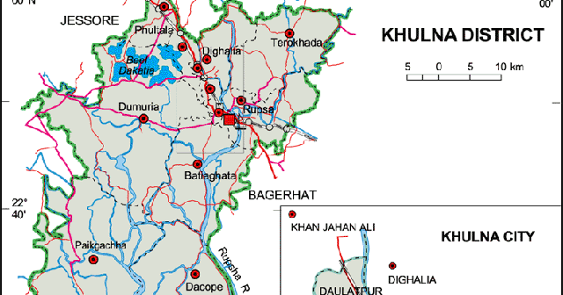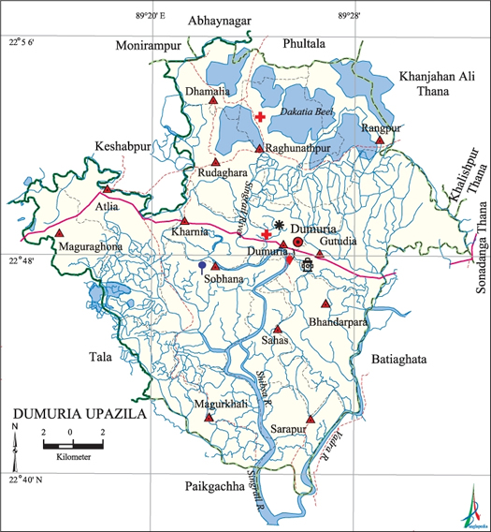
Figure 1: Location of the study area.

2.3 Sampling methods:

07 commercial poultry farms were selected that raise min. 1000 birds in a single batch from Dumuria Upazila under Khulna District arbitrarily. Before sampling a personal seating program was done with respective DLS personnel and their opinion of the farms were selected for detailed study.

2.4 Methods of data collection:
Through the use of direct meetings, data were acquired and recorded in a poll. The schedule was constructed taking into consideration the locations of the exams. The survey was pre-tested before being sent out and was accordingly improved. A coordinated survey was created in order to collect more sterile information about various homesteads.

2.5 Data Analytical Techniques
The collected data were analyzed after coding, decoding, and summarizing. Descriptive and Analytical statistical studies were conducted to measure the cost and return of the farms.
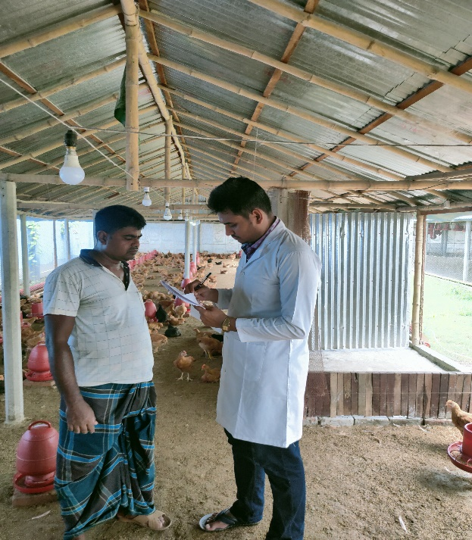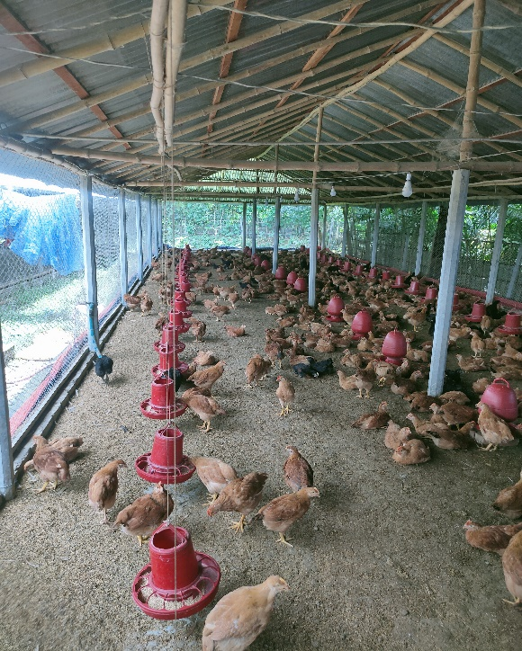
Figure 2: Data collection (DOC cost, Feed cost, live weight, selling price, etc.) from poultry farmers.

Chapter-III

Result and Discussion
3.1: General description of the farm:
In this part we examined the reared farm’s chicken numbers of the immediate previous flock of birds and their respective profitability with identified farming constraints. In Table-3.1 showed that out of 07 farms four (4) medium size farms ranged 1001-2999 whose mean birds’ production was found 2300 ± 122.4745, and three (3) large size farm ranged above 3000 birds whose mean birds’ production is 3600±282.8427, respectively.

Table 3.1: Analysis of mean Sonali production according to farm size

Farm size | No. birds produced (Mean±SE) | Farm No.
Small (<1000) | 0 | 0
Medium (1000-2999) | 2300±122.4745 | 4
large (>3000) | 3600±282.8427 | 3

3.2: Common management practices in studied Sonali farms:
Most of the studied farms located near the farm family residence and managed by utilizing family efforts and practicing locally adopted management system. The observed common management practices in the Sonali chicken farming system of the studied farms have been shown in Table -3.2. The common parameters of the farm management system were examined on farm housing, feedings, drinking, veterinary caring, and environmental types like as floor, roof, sidewall, rearing system, litter material, feeder type, feed type, amount of feed per day, drinker type, sue of fan, treatment, vaccination & deworming and farm biosecurity system etc.

Table 3.2: Management practices of the selected Sonali farm:
Variables | Categories | No of Farm | Percentage
Floor | Concrete | 7 | 100
 | Muddy | 0 | 0
Roof | Iron sheets | 7 | 100
 | Bamboo | 0 | 0
Sidewall | Wire netting | 7 | 100
 | Bamboo splint | 0 | 0
Rearing system | Floor | 7 | 100
 | Case | 0 | 0
 | Free range | 0 | 0
Litter material | Rice husk | 7 | 100
 | Saw dust | 0 | 0
Feeder type | Hanging plastic feeder | 3 | 42.85
 | Bucket | 4 | 57.14
 | Attached | 0 | 0
Feed type | Self-prepared | 0 | 0
 | Readymade mash | 0 | 0
 | Readymade pellet | 7 | 100
Amount of feed per day | 40-50 gm | 3 | 42.85
 | 50-60 gm | 4 | 57.14
Drinker type | Hanging drinker | 1 | 14.28
 | Pot | 6 | 85.71
 | Attached | 0 | 0
Sue of fan | Yes | 7 | 100
 | No | 0 | 0
Treatment | Vet | 1 | 14.28
 | Quack | 2 | 28.56
 | All | 4 | 57.14
Vaccination & Deworming | Regular | 7 | 100
 | Irregular | 0 | 0
Biosecurity | Strictly followed | 1 | 14.28
 | Moderately followed | 3 | 42.85
 | Not followed | 3 | 42.85

Source: Field survey, 2023

3.3: Productivity and Mortality:
The production and mortality of Sonali chickens in particular poultry farms are shown in Table 3.3. Result revealed that farm 1 produced 3408 birds, farm 2 produced 2448 birds, farm 3 produced 3860 birds, farm 4 produced 1937 birds, farm 5 produced 3308 birds, farm 6 produced 1453 birds, and farm7 produced 2139 birds respectively. The mortality rate was higher in farm 3 (3.50%) and lower in farm 2 (2.08%).

Table 3.3: Productivity and mortality of Sonali chicken of studied farm
Farm | No. of birds | No. of dead birds | Mortality (%) | No. of birds produced
Farm1 | 3500 | 92 | 2.62 | 3408
Farm2 | 2500 | 52 | 2.08 | 2448
Farm3 | 4000 | 140 | 3.50 | 3860
Farm4 | 2000 | 63 | 3.15 | 1937
Farm5 | 3400 | 92 | 2.70 | 3308
Farm6 | 1500 | 47 | 3.13 | 1453
Farm7 | 2200 | 61 | 2.77 | 2139
Source: Field survey, 2023

Fig 1: Graphical presentation of mortality percentage from farm- 1 to farm- 7.

3.4: Economic efficiency parameters:
Table 3.4 illustrates farm-level EEP for Sonali chickens, including bird age at selling, feed consumption per bird per day (FCBD), and live weight (LW) in the study area. The selling age of the birds for the examined farm ranged from 55 to 61 days, and daily feed intake by the Sonali chickens ranged from 55 gm to 65 gm, with birds reared in smaller farms consuming more feed than those reared in larger farms.

Table 3.4: Some economic efficiency parameters of Sonali chicken in the studied farm:
Farm | Birds age at selling (days) | Feed  consumption per bird per day (gm) | Live weight  (LW)  (gm)
Farm 1 | 59 | 59 | 900
Farm 2 | 58 | 57 | 890
Farm 3 | 61 | 55 | 910
Farm 4 | 57 | 61 | 950
Farm 5 | 58 | 58 | 930
Farm 6 | 55 | 65 | 850
Farm7 | 57 | 63 | 890
Source: Field survey, 2023
Profitability estimate:
Table 3.5 shows the number of birds produced per farm, the GC per bird, the GR per bird, and the benefit-cost ratio per bird. The highest and lowest GC per bird were found in farms 5, 7, and 6 (Tk. 172), respectively, whereas the highest and lowest GR per bird were found in farms 6 (Tk. 220) and 3 (Tk. 195), respectively. As a result, farm 6 had the highest BCR value (1.37), while farm 3 had the lowest (1.14).

Table 3.5: Profitability estimate per bird of studied farm
Farm | No. of birds produced | Gross cost per bird (Tk) | Gross return per bird (Tk) | Benefit-cost ratio per bird
Farm 1 | 3408 | 165 | 210 | 1.27
Farm 2 | 2448 | 168 | 215 | 1.27
Farm 3 | 3860 | 170 | 195 | 1.14
Farm 4 | 1937 | 167 | 200 | 1.19
Farm 5 | 3308 | 172 | 205 | 1.19
Farm 6 | 1453 | 160 | 220 | 1.37
Farm7 | 2139 | 172 | 214 | 1.24
Source: Field survey, 2023

Farm-level variations in profitability components (Table 3.6) revealed that each component had extremely significant variability for Sonali chickens produced and marketed in Chuknagar. GC per flock, GR per flock, and NP per flock are shown in Table 3.6 suggesting that the GC (635828 Tk), GR (806416 Tk), and NP (170588 Tk) were significantly higher in farm 3 than those of the other farms understudied.

Table 3.6: Profitability estimate per flock of studied farm
Farm | No. of birds produced | Gross cost per bird (Tk) | GC per flock (TK) | Gross return per bird (Tk) | GR per flock (Tk.) | NP per flock (Tk.)
Farm 1 | 3408 | 165 | 562320 | 210 | 715680 | 153360
Farm 2 | 2448 | 168 | 411264 | 215 | 526320 | 115056
Farm 3 | 3860 | 170 | 656200 | 195 | 752700 | 96500
Farm 4 | 1937 | 167 | 323479 | 200 | 387400 | 63921
Farm 5 | 3308 | 172 | 568976 | 205 | 678140 | 109164
Farm 6 | 1453 | 160 | 232480 | 220 | 319660 | 87180
Farm7 | 2139 | 172 | 367908 | 214 | 457746 | 89838
Source: Field survey, 2023

The size of the farm or flock, as well as the stocking density, have been discovered to affect the production and profitability of poultry birds. Small flocks had higher LW, FCR, and cost per bird than medium and large flocks, however net profit per flock was in the order of large flocks > medium flocks > small flocks (Tahawy et al.,2017). Similarly, the flocking density was found to be favorably associated with daily weight increase, economic performance, and bird welfare (Bergeron et al.,2020).
Sonali chicken production in commercial farms has been rising in Bangladeshi districts such as Joypurhat, Mymensingh-Gazipur, Bogura, and Naogaon since 2010 (Huque et al.,2012, Uddin et al.,2014, FAO,2015), where Sonali performed better than other birds in terms of adaptability and BCR. Furthermore, Sonali chickens were chosen over local fowl. Moreover, Sonali DOCs accounted for around 35% of all commercial broiler and layer output in the country (SAC,2017). Sonali chickens were found to have a relatively high meat content in a handful of recent studies and to be the fastest-growing section of poultry in Bangladesh (Modak et al.,2019, NEA, 2020). These reports back up the current findings on the farm-level production of Sonali hens in the study area.
For 1000 broiler birds, the estimated GC, GR, and net profit (NP) were Tk. 99429, 109961, and 3631, respectively (Akhter et al.,2009). Sonali had the highest BCR of 1.11, followed by RIR and Fayoumi (1.10 each) and Cobb 500 (1.09) (Islam et al., 2012), with the average GC and GR for broilers per farm per year being Tk. 301142 and 431400, respectively. The BCR for broiler farming was substantially higher, at 1.80. For 1000 Sonali hens in Gazipur District, the average GC and GR values were assessed to be Tk. 120613 and Tk. 172672, respectively, with a projected BCR of 1.4 (Haque et al.,2012). Sonali intensive meat-producing breed had 1.49 BCR compared to commercial broiler (1.22) and commercial layer (1.11) farms, indicating that Sonali birds are a successful endeavor (Modak et al.,2019), however A popular breed called Vanaraja in Assam, India had a substantially higher BCR of 2.60 (Islam et al.,2012).
Government farms had a profitability index (PI) ranging from -0.09 to -0.13, whereas private farms had a PI ranging from 0.18 to 0.52. When compared to Fayoumi and RIR breeds, Sonali was the most popular and cheapest (Islam et al.,2012). Sonali hens in Bangladesh's northern districts were estimated to have an NP of Tk. 27.58±2.40, a BCR of 1.25±0.02, and a profitability index (PI) of 0.20±0.01(Islam et al,2014). Sonali chicken rearing was a profitable activity, as evidenced by its higher BCR (Sumy et al.,2014), according to data from Brahmanbaria, Shariatpur, and Sylhet districts. In the Mymensingh district, GC, GR, and profitability metrics for broiler production likewise demonstrated that chicken production was lucrative (Chowdhury et al.,2015).
In the present study, the GC per flock of Tk. 562320, Tk. 411264, Tk 656200, Tk 323479, Tk 568976, Tk. 232480 and Tk 367908 were estimated for Farm 1, Farm 2, Farm 3, Farm 4, Farm 6, and Farm 7 respectively. Moreover, the GR per flock of Tk. 715680, Tk. 526320, Tk. 752700, Tk. 387400, Tk. 678140, Tk. 319660, Tk 457746, and the NP per flock of Tk. 153360, Tk. 115056, Tk. 96500, Tk. 63921, Tk. 109164, Tk. 87180, Tk 89838 respectively for farm 01 to farm 07 have been assessed. Variations in stocking density, farm management procedures, and selling age of birds may have resulted in apparent disparities between our findings and those of the aforementioned papers.

Chapter IV
CONCLUSIONS, PROBLEMS AND RECOMMENDATIONS
4.1: Conclusions:
According to the explanation above, Chuknagar and Dumuria upazila in the Khulna district are completely reasonable and advantageous zones for broiler and Sonali farming. Then, and only then, is it possible to establish broiler ranches, providing employment opportunities for those who are unemployed while also supplying them with the protein they require. The government must take the necessary actions and play a big role in the establishment of a poultry zone nearby by resolving all obstacles and giving the current ranch owners more opportunities. In each upazila in Bangladesh, the government can implement a plan to create a farmhouse that locals can use as a model for raising chickens.
4.2: Farming problems:
- The price of chicks is higher, there is no government hatchery in this area.
- There is a shortage of government vaccines, and the dealer does not maintain a cool chain of vaccine
- The price of feed and medicine is increasing day by day.
- The farmer does not have proper knowledge of farm management. There are not enough facilities to receive training.
- The prevalence of IBD (Infectious bursal disease) is higher in the study area. The vaccine provided by the dealer is not working well.
- The unstable market is a great concern for all farmers in my area.
- Insufficient bank loan. The interest rate of NGOs and other loans is so high.
- Our national policy is so weak that hampers the development of Sonali
farming.

4.3: Policy recommendations:
The farmers suggested the following solutions to solve Sonali farming's issues and increase Sonali farming's profitability:
- The government needs to check the reasonable price of day-old chicks and poultry feed.
- In order for poultry farm owners to receive credit on easy terms, facilities of the institutional advance should be provided.
- Hatcheries should increase their day-old chick stock.
- For proper habitation, nourishment, infectious disease prevention, advertising, and the board, DLS should provide temporary training to the owners of the poultry farms.
- Sellers and specialists need to be trained in order to keep up with the constantly evolving nature of information sources.
- If there should be a case of poultry creation, the public authority needs to design a plan to get rid of unanticipated development advertisements and antimicrobials. The use of such antibiotics or antibiotics development advertisements have to be avoided with awareness.
- The government should offer loans to the poultry industry with simple terms and conditions. Financial institutions' assistance will enable owners of broiler farms to make improved broiler housing facilities and buy contemporary tools and equipment.
- A significant issue in maintaining the Sonali business is the timely availability of high-quality day-old chicks. Therefore, the breeder farms should make the appropriate arrangements to ensure that day-old chicks are promptly available at the doorsteps of the sonali farms at a fair, steady price all year long.

REFERENCES

Akhter, S., Rashid, M. H. A., & Uddin, H. (2009). Comparative profitability analysis of broiler farming under Aftab Bahumukhi farm limited supervision and farmers' management. Progressive Agriculture, 20(1-2), 231-236.
Bergeron, S., Pouliot, E., & Doyon, M. (2020). Commercial poultry production stocking density influence on bird health and performance indicators. Animals, 10(8), 1253.
BER (Bangladesh Economic Review) (2011). Economic Advisers Wing, Finance Division, Ministry of Finance, Government of Peoples Republic of Bangladesh, Dhaka.
Chowdhury, S. D. (2013). Opportunities and Challenges Facing Commercial Poultry Production in Bangladesh Eighth International Poultry Show and Seminar. WPSA-BB, Dhaka, Bangladesh.
Chowdhury, M. S. R. C., & Chowdhury, M. M. (2015). Profitability analysis of poultry farming in Bangladesh: A case study on trial upazila in Mymensingh district. Developing Country Studies, 5(19), 107-114.
Hossen, M. F., Siddque, M. A. B., Hamid, M. A., Rahman, M. M., & Moni, M. I. Z. (2012). Study on the problems and prospects of Sonali (poultry) farming in different village levels of Joypurhat District in Bangladesh. Small, 500, 1000.
Islam, M. S., & Hossen, M. (2021). Status of Sonali Chicken Farming in Rajshahi Division, Bangladesh: An Updated Survey. IAR J. Agric. Res. Life Sci, 2(3), 20-29
Islam, M. S., Kabir, A., & Dutta, R. K. (2012). Productivity, cost-benefit analyses, market prices and constraints to poultry farming in the northern Districts of Bangladesh. J. Life Earth Sci, 7, 21-27.
Modak, M., Chowdhury, E. H., Rahman, M. S., & Sattar, M. N. (2019). Waste management practices and profitability analysis of poultry farming in Mymensingh district: A socioeconomic study: Poultry waste management, its impacts & BCA. Journal of the Bangladesh Agricultural University, 17(1), 50-57.
Miazi, O. F., Miah, G., Miazi, M. M., Uddin, M. M., Hassan, M. M., & Faridahsan, M. (2012). Fertility and hatchability of Fayoumi and Sonali chicks. Scholarly Journal of Agricultural Science, 2(5), 83-86.
Sumy, M. C., Khan, M. K. I., & Islam, M. M. (2014). Viability and profitability of different segments in the poultry model chain in Bangladesh. Livestock Research for Rural Development, 26(10).
Tahawy, A. A. S., Taha, A. E., & Adel, S. A. (2017). Effect of flock size on the productive and economic efficiency of Ross 308 and Cobb 500 broilers. European Poultry Science/Archiv für Geflügelkunde, 81(176).
Uddin, M. T., Mitu, S. J., & Begum, I. A. (2014). Production of Sonali chicken in selected areas of Gazipur district economic study. Bangladesh Journal of Animal Science, 43(1), 56-61.

APPENDIX
Title: Study on Sonali farming in Chuknagar ,Dumuria Upazila, Khulna .

Questionnaire
1. A. Name of the farm.................................................
B. Name of the owner/Farmer/Employee.................
C. Address: Village.........Union...............................
P.O..............Thana.............District…...
D. Farmer’s education..............................................
- Husbandry practice:
  - Housing: a. Brooder house b. Grower cum finisher house
  - Feeding:
    - Collection of feed...........................................
    - Storage of feed …..........................................
    - Types of feed...................................................
    - How many times feed supplied daily............?
  - Watering:
    - Source of water
    - Frequency of water supply
D. Litter materials...................................................
E. Ventilation
a. Sufficient. Insufficient
F. Lighting schedule………………………………

G. Biosecurity.......................................................
H. Foot bath: ……………………………………...
3. Number of sheds....................................................
- Incidence of diseases……………………………..
- Management of disease condition:
  - Self-management
  - Quack
  - Veterinary doctor
6. Health programmed:
a. Vaccination
b. Anthelmintic
7. Mortality rate: .............................................................
8. Marketing system: ………………………………….
9. Cost & return: ………………………………………
10. The farm is profitable or not......................................

Name of the interviewee............... Name of the interviewer...........
Date............................................... Date: ……………....................
Signature....................................... Signature....................................

BIOGRAPHY
Name | MD. MOSHIUR RAHMAN
Present status | Intern student, Faculty of Veterinary Medicine  (FVM), Chattogram Veterinary and Animal Sciences University (CVASU).
Educational background | HSC (2016), Bangladesh Navy school and college, Khulna.  SSC (2014), Bangladesh Navy school and college, Chattogram.
Research Interest | Poultry nutrition and feeding.

