Chapter I
Introduction
Cryptorchidism is one of the major important pathological defects that affect reproduction in dogs, as well as other animal species. It is characterized by the failure in the descent of one (unilateral) or both (bilateral) testis from the abdominal cavity to the scrotum. Besides the failure in the descent of the testis, BURKE, (1986) suggests that cryptorchidism may also be the failure to maintain the normal position of the testis in the scrotum.

The descent of the testes usually take place before day 14 after the birth (Flanders et al., 2000, Fossum, 2002). The descent of the testes can takes place a little later, by the 6th month of life (Cox, 1986). In nearly 75% of cases in dogs, it is a one-sided cryptorchidism with a sharp tendency for retaining the right testicle. The retention of the right abdominal testis is observed nearly twice as frequently as the left one (Flanders et al. 2000, Fossum, 2002). In dogs, this anomaly is found in miniature, small and big breeds. It is assumed that some dogs are genetically predisposed to the ailment. The disease is directly transmitted from males to male offspring, where a female can be a carrier of a recessive gene. It is inherited as a sex-limited autosomal recessive trait (Flanders et al. 2000, Fossum, 2002). It is recommended to wait about six months of age before declaring a dog cryptorchid. The reason for the six months wait is that the inguinal rings of most dogs are closed by 6 months of age, precluding movement of the testes from the abdomen to the inguinal canal if that has not already occurred (Johnston et al., 2001).

The condition is normally found in several species like cattle, pigs, sheep, horses, dogs, cats, rabbits and humans ( Amann & Veeramachaneni, 2007). It create sufferings for animal and also for patient owner because of reduce sperm production of male (Blanchard et al., 2006) or even sterility (Mueller & Parks, 1999; Bladon, 2002), increased risk for tumors (Amann & Veeramachaneni, 2006), more complicated castration procedures and increased costs. Frequency of the occurrence of a missing testis in the scrotum is 1–10% with a 2.7 times higher risk in small breeds of dogs, such as the Poodle, Terrier, Dachshund, Chihuahua and Sheltie (White 2005; Pendergrass and Hayes, 1975). Yates et al. (2003) found in their study a frequent occurrence of cryptorchism in German shepherds, Staffordshire bullterriers and Boxers.

The incidences of cryptorchidism are 0.8-9.7% in dogs. In terms of breed predisposition in dogs, the incidence of cryptorchidism is highest in Chihuahuas, Boxers, and German Shepherds, with incidences of 30.4, 20.6, and 14.0%, respectively (Yates et al., 2003). The retained testis may be localized in the prescrotal or inguinal region or in the abdominal cavity and undescented testes were most commonly found in right inguinal region in case of dog. The free position of the retained testis in the abdominal cavity presents a higher risk of its torsion (Wallance and Cox, 1980; Pearson and Kelly, 1975). Concurrently, undescended testes are 13.6 times more often affected by neoplasia than testes positioned in the scrotum (Hayes and Pendergrass, 1976). Though surgery for removal of cryptorchid testes is well described in the veterinary literature, approaches to diagnosis and localization of ectopic testes have not been extensively described. This lack, coupled with the increasing number of animals that present with an unknown neutering history (e.g., rescue animals), emphasizes the need for a discussion of a thorough clinical approach to cryptorchidism.

This report describes a systematic approach to the diagnosis and surgical treatment of cryptorchidism in dog, including the integration of the history; physical examination; and diagnostic imaging to make a definitive diagnosis.

Chapter II
Materials and Method
2.1 Ethical statement:
This surgery was approved by the ethical committee of Veterinary unit, Khon Kaen University. The patient got the permission to be submitted in the surgery unit of Teaching VeterinaryHospital, Khon Kaen University. All ethical issue was followed during surgery.
2.2 Study area and Duration:
The presented case study was conducted at Teaching Veterinary Hospital (TVH), Khon Kaen University (KKU), Khon Kaen , Thailand on 24 May, 2018.

2.3 Case history:
In TVH of Khon Kaen University, a one year old dog of 19 kg body weight was presented smaller scrotum than the normal size according to his age. The body growth and feeding behavior was normal.

2.4 Clinical findings:
After Clinical examination it was found that there were no testes in the scrotum. Other clinical findings were normal.

2.5 Imaging technique:
Presumptive diagnosis was done by the help of clinical findings and physical examination. Then diagnosis was confirmed by the help of X-ray and Ultrasonography. The testes were located in the abdominal cavity.

2.6 Pre- Anesthetia and Patient prepation
The dog was premedicated by the using of Atropine sulphate (0.02 mg/kg i.v., Atropine sulphate) and Xylazine (0.5-1.0 mg/kg i.v., X-LAZINE). After premedication, the inguinal region was perfectly shaved and aseptically prepared.

2.7 Anesthesia:
The patient was anesthetized by the using of gaseous anesthesia that was 1-2% Isoflurane in pure oxygen. The animal was placed as dorsal recumbence.

2.8 Surgical procedure:
After aseptic preparation of members of surgery team and surgical site, 4 to 6 cm incision was performed in the ventral abdomen, approximately 2 to 4 cm lateral to the prepuce but just medial to the nipples. Then abdominal cavity was open and, small and large blood vessels were sealed by electrocautarizer for the hemostate. After finding the testes, the testes were exposed outside the body and ligation was done in the avascular and vascular part of spermatic cord. After that crushed the spermatic cord and testes were removed from the body. Closing of the rectus abdominal muscle was done by simple continous suture and skin was closed by the simple interrupted suture with absorbable suture material (e.g., polydioxanone).

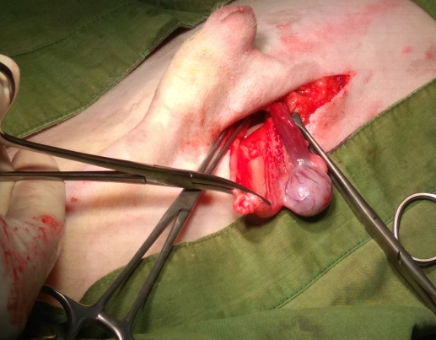
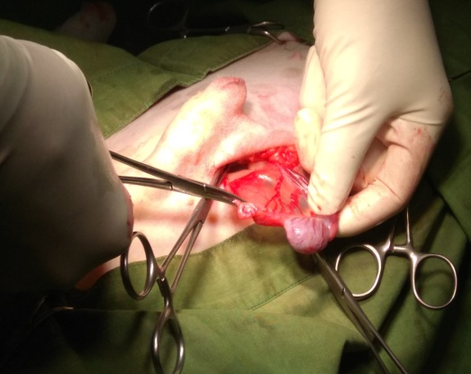
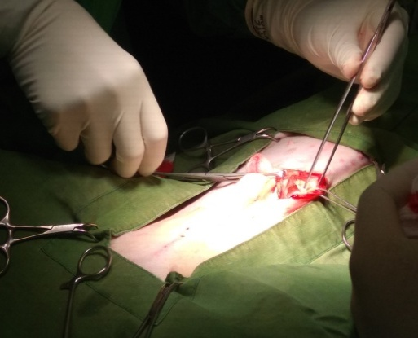
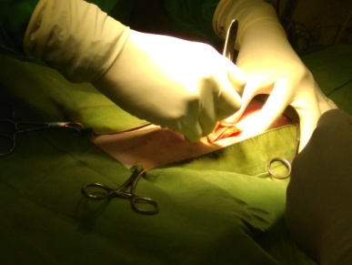
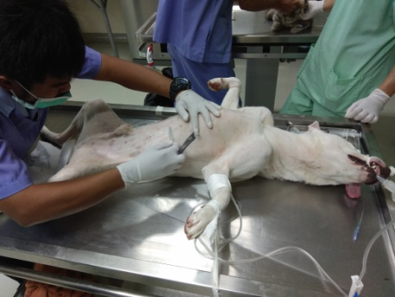
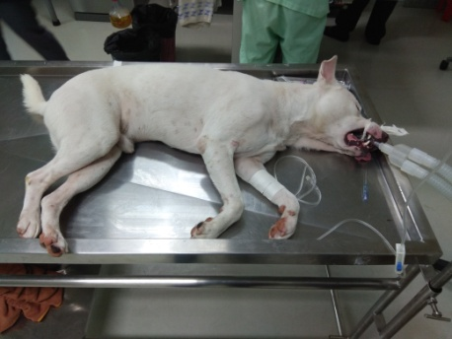
A
C
B
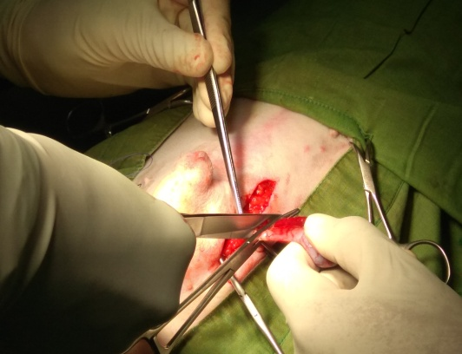
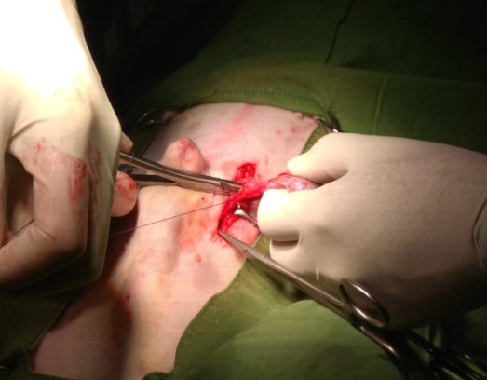
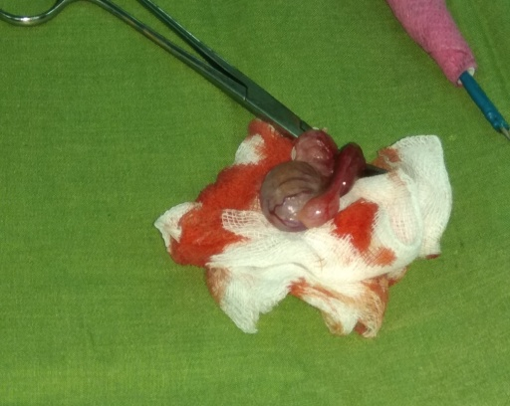
Figure 1- Surgical procedure: A. Gaseous anesthesia, B. Shaving of animal, C. Incision lateral to the prepuce, D. Opening the abdominal cavity, E. Undescented testis, F. Avascular and vascular part of Spermatic cord, G. Ligation of Spermatic cord, H. Crusing of Spermatic cord and removal of testis, I. Removal cryptorchid testes.
G
H
I
D
F
E

Chapter IV
Result and Discussion

Chapter V:
Results and Discussions

After the surgery, there was no lesion found in the incision site. Further there was not found any complication.

In our study, laparoscopically assisted cryptorchidectomy (4-6 cm long incision) was done in the ventral abdomen, approximately 2 to 4 cm lateral to the prepuce but just medial to the nipples which is more similar with 2–3 cm long incision that was described by Kirby (1980) and fully different with approximately 0.5 cm long incision that was described by (Miller et al., 2004). Due to small incision (0.5 cm) there was less chance to produce trauma and herniation of abdominal visceral organs compared to other laparoscopic long incision method. In addition of this our method was best because there was less time required to identify the testis compared with 0.5 cm small incision method.
Laparoscopically assisted extraction of the testis from the abdomen has been formerly described by (Pena et al., 1998) and ( Gallagher et al.,1992) who ligated the blood vessels and ductus deferens using special clips or fibres and performed the ligature inside the abdominal cavity. On the other hand, Miller et al. (2004) modified the method in that after the identification and grasping of the retained testis, they first removed it from the abdominal cavity and only subsequently ligated the funicle with blood vessels and separated the testis. In our case, there are more similarity with Miller et al. (2004) .

It is recommended during laparoscopically assisted extraction of the cryptorchid testis of the patient to tilt the head lower (approximately by 20°) and slightly to the other side of the retained testis (Miller et al. 2004). In our patients, this tilting was not necessary as the cases the retained testis was easily and quickly identified in the standard dorsal position of the patient.
Based on our experience with one patient clinically treated using the above mentioned method, laparoscopically assisted cryptorchidectomy appears as a very efficient and suitable method of castrating the cryptorchid testis of dogs in which both testis were not found by palpation in the scrotum or the inguinal region. Our method was effectively facilitates and speeds up this procedure. Theoretically potential complications may be found by prospective further studies.

Chapter V
Conclusions

Laparoscopically assisted cryptorchidectomy was more useful method to correct the bilateral cryptorchid testes. It was more easy, less time consuming, more effective, more reliable method for correction of bilateral cryptorchidism. Imaging technique like X- ray and ultrasonography proved to be the useful diagnostic method for detection of the cryptorchid testis and most specific treatment of bilateral cryptorchidism is laparoscopically assisted cryptorchidectomy.

The most practical solution to correct bilateral cryptorchidism would have been to follow the laparoscopically assisted cryptorchidectomy.

Chapter VI
References
- Amann, R.P., & Veeramachaneni, D.N.R., 2007. Cryptorchidism in common eutherian mammals. Reproduction 133, 541-561

- Bergin, W.C., Gier, H.T., Marion, G.B., Coffman, J.R., 1970. A Developmental Concept of Equine Cryptorchism. Biology of Reproduction. 3, 82-92

- BURKE, T. J., 1986. Causes of infertility. In: Small animal reproduction and infertility. ed1. Lea & Febiger. Philadelphia, 233-235

- Cox, J.E., Redhead, P.H., Dawson, F.E. 1986. Comparison of the measurement of plasma testosterone and plasma oestrogens for the diagnosis of cryptorchidism in the horse. Equine Veterinary Journal 18(3), 179-182

- Flanders, JA., Schlafer, DH., Yeager, AE., 2000. Diseases of the canine testes. In: Bonagura JD (ed) Kirk’s current veterinary therapy XIII small animal practice. Saunders WB, Philadelphia, 945-947

- Fossum, TW., 2002. Surgery of the reproductive and genital systems. In: Fossum TW (ed) Small Animal Surgery (2nd ed.) Mosby, Philadelphia, 620-622

- Gallagher, LA., Freeman, LJ., Trenka-Benthin, S., 1992. Laparscopic castration for canine cryptorchidism Vet Surg 21, 411–412

- Hayes, HM., Pendergrass, TW., 1976. Canine testicular tumors: epidemiologic features of 410 dogs. Int J Cancer 18, 482 – 487

- Hoskins, JD., Taboada, J., 1992. Congenital defects of the dog. Comp Contin Educ Pract Vet. 14, 873-897

- Howard, PE., Bjorling, DE., 1989. The intersexual animal: Associated problems. Probl Vet Med. 1, 74-84

- Ivankovichad, A., Zahed, B., 1974. Cardiovascular collapse during gynecological laparoscopy. Ill Med J 145, 58–61

- Johnston, SD., Root Kustritz, MV., Olson PNS 2001. Disorders of the canine testes and epididymes. In Canine and Feline Theriogenology. Philadelphia WB Saunders, 312 – 332

- Kirby, FD., 1980. A technique for castrating the cryptorchid dog or cat. Vet Med 75, 632

- Leipold, H.W., DeBowes, R.M., Bennett, S., Cox, J.H., Clem, M.F., 1986. Cryptorchidism in horses: genetic implications. Proceedings of the annual convention of the American Association of Equine Practitioners 31, 579-589

- Miller, NA., Van, SJ., Rawling, CA., 2004. Use of laparoscopic- assisted cryptorchidectomy in dogs and cats. JAVMA 224, 875 – 878

- Motew, M., Ivankovich, AD., Bienarz, J., 1973. Cardiovascular effects and acid base and blood gas changes during laparoscopy. Am J Obstet Gynecol 115, 1002–1012

- Pearson, H., Kelly, DF., 1975. Testicular torsion in the dog. a review of 13 cases Yates, D., Hayes, G., Heffernan, M., Beynon, R., 2003. Incidence of cryptorchidism in dogs and cats. Vet Rec 152, 502 – 50

- Pena, FJ., Anel, L., Dominiguez, JC., 1998. Laparoscopic surgery in a clinical case of seminoma in a cryptorchid dog. Vet Rec 142, 671–672.

- Romagnoli, SE., 1991: Canine cryptorchidism. Vet Clin North Am Small Anim Pract 21, 533–544

- Seed, RF., Shakespeare, TF., Muldoon, MJ., 1970. Carbon dioxide homeostasis during anaesthesia for laparoscopy. Anaesthesia 5, 223–231

- Wallance, LJ., Cox VS 1980. Canine cryptorchidism. In: Kirk RW (ed.): Current veterinary therapy VII- small animal practice. Philadelphia: WB Saunders, 1244-1246

- White, RAS., 2005. The male urogenital system. In: Williams JM, Niles JD (ed.): BSAVA Manual of canine and feline abdominal surgery, Gloucester, 270

- Yates, D., Hayes, G., Heffernan, M., Beynon, R., 2003. Incidence of cryptorchidism in dogs and cats. Vet Rec 152, 502 – 504

ACKNOWLEDGEMENT

The author is ever grateful and indebted to the Almighty Allah without whose grace it would have never been possible to pursue this study in this field of science and to complete this Clinical report writing for the Degree of Doctor of Veterinary Medicine (DVM).
The author would like to thanks his reverend and beloved teacher and supervisor, DR. Sazeda Akter, Lecturer, Dept. of Medicine and Surgery, Chittagong Veterinary and Animal Sciences University for her valuable advice, suggestions and kind co-operation during the study period.
The author would like to thanks to the Director of External affairs, Professor Dr. A.K.M. Saifuddin, Department of Physiology, Biochemistry & Pharmacology, Faculty of Veterinary Medicine, Chittagong Veterinary and Animal Sciences University for his suggestion.
The author expresses his sincere gratitude and gratefulness to Assosiate Professor Dr. Chuchart Kamollerd, Dean, Faculty of Veterinary Medicine, Khon Kaen University, Thailand for his valuable advice, inspiration, cordial co-operation, valuable suggestion during the study period.

The Author
September, 2018

Brief biography of the author

I’m Md. Alauddin, an intern student at Chittagong Veterinary and Animal Sciences University (CVASU), originate from Comilla, Chittagong. After completing one year intern period, I will receive my Doctor of Veterinary Medicine (DVM) degree with lots of real life experiences. As an intern student I’ve received clinical training from Khon Kaen University, Khon Kaen, Thailand and Madras Veterinary College, and Veterinary College & Research Institute, Namakkal, Tamilnadu, India. I’ve a great enthusiasm in research and have done some clinical research works. I’ve published one scientific paper in Journal of Veterinary Science & Technology titled by “Comparative Study on Newcastle Disease and Infectious Bursal Disease in Chicken Submitted to Upazilla Veterinary Hospital, Bogra Sadar, Bangladesh”. I have more interest on genetics, theriogenology, medicine, surgery, microbiology and epidemiological field area.

