Chapter 1: Introduction

Bangladesh has 24 million cattle, out of which 6 million are dairy cattle of local and crossbreed (DLS-2008). In the rural area, cattle are kept mainly for draught purpose. Only a limited number of farmers have cow for milk production. Maximum cattle are nondescriptive type, which do not belong to any specific breed and termed as indigenous cattle.They are smaller in size and their milk production capacity is lower than that of exotic breeds. The number of cross bred cattle is increasing with spread of artificial insemination practices throughout the country. The average milk production of local cow is very low and it varies between 300 to 400 liters per lactation period of 180 to 240 days. Generally crossbred cows yield from 600 to 800 liters per lactation of 210 to 240 days(Islam, 1992).Generally higher milk productions are found in third or fourth number of lactation. The most economic traits of the milk producing animals are average body weight, milk yield, calving interval etc.Now a day the demand for crossbred cows is very high because of higher production of milk. The milk production of indigenous cattle is low as compared to improved breed of cattle (Hossainet al., 1982).
Bangladesh suffers from an acute shortage of livestock products like milk, meat and eggs. The domestic demand for milk has been rising faster than the domestic production of milk. Availability of milk only 33.95ml per head per day as the maximum requirement recommened per head per day is about 250ml milk (DLS-1991). This is due to poor genetic makeup of native stock lack of adequate nutrient supplied in the diet. Hence Bangladesh Government has given the priority on the development of dairying at farmers’ level to increase the supply of milk from small dairy farms.
Feeding practices of livestock in Bangladesh are very poor. There is no recognized standard feeding system. The farmers neither have scientific knowledge nor are following any feeding standard to satisfy the nutrient requirements of the cows. These animals are kept mainly in the stall with limited grazing on the roadside, embankment slope; fallow land and paddy straw are their staple food. Husbandry practices and health care of these animals are poor (Jabbar and Raha., 1984).Due to lack of available grazing lands, stall-feeding is practised and sometimes cattle are tethered on the roadsides and fallow land. Seasonal and fluctuating supply of rice straw and green grass creates a great problem in feeding dairy cattle (Rahmanet al., 1998).
Dairy probability is directly related to the level of milk production which is very frequently affected by suboptimal reproductive performance of dairy cows (Rahmanet al; 1995). The better performance with regard to the reproductive and productive efficiency of cow included age at 1st calving service, parturition at 1st service & conception interval, daily milk yield, stage of lactation, number of lactation. The reproductive performance of the crossed bred cows may differ from that of local indigenous cows with different geographical areas where harsh environment condition are exit (Garcia 1988, Jahan et al., 1990). There are several factors which affect the milk production of householder’s cattle of which parity place an important role for production performance of lactating cows. In Bangladesh very small numbers of research works have been done by various scientists to increase the milk production under village management condition, we need to conduct more research work. For this reason the present study was under taken to evaluate the production performance of smallholder’s lactating cows on the basis of body weight, feeding strategy, rearing system health management with following objectives:
- To describe the farming status, breed status, health management of the smallholder’s lactating cattles.
- To determine milk production performance of indigenous & crossed breed lactating cows under village management condition.

Chapter 2: Materials and method
The study was conducted in four selected Upazila in Comilla district during April to August 2016 and the dataset used in this study was obtained from individual farmers of rural household’s cattle farm. The farmers do not keep records in the register book and account of their operation of their animals, therefore, data for milk production, and number of lactation and stage of lactation of cows were obtained from the farmers by interview with them. They gave data from their memory. In this study the information for individual lactating cows were collected like other survey work from the farmers. The following steps were taken in conducting the study.
2.1 Study area:
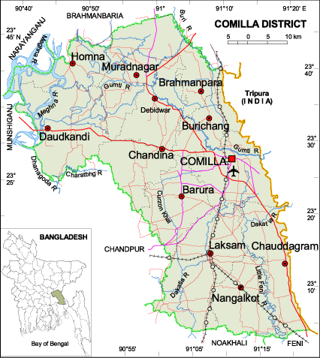
Farms were selected from four Upazila (ComillaSadar, Nangalkot, Barura and Chandina) in Comilla district. The data of 38 indigenous cows and 60 crossed breeds were collected from these Upazila.

Figure 1: Graphical view of study area

2.2 Data collection:
Data were collected using a predefined questionnaire. The questionnaire was developed in accordance with the objective of the study. Questionnaire was prepared to accrue the desired information from the farmers and identifying the characteristics of indigenous cows. The questionnaire contains the following economic traits of the indigenous cows for example BCS score, rearing system, feeding system, number of lactation, stage of lactation, average milk yield/day (lit). The data collected through direct interviewing method farmers.
2.3. Data analysis:
All raw data were entered into Microsoft office 2007 Excel worksheet. Descriptive statistics for different variables were analysed using Analysis Toolpack from Excel. Other statistical analyses were performed using GraphPad Prism version 7.00 for Windows, GraphPad Software, La Jolla California USA, www.graphpad.com”.

Chapter3: Results

3.1 Farming status:
3.1.1 Rearing system
Cows are mostly of crossbred along with some indigenous and all animal reared in semi-intensive system. Most of the farmers have no own fodder land. Cattle of separate ages are not being kept into separate shed. In these farms, there is no calf shed, heifer shed and milch cow shed. Only 5% percent of the farmers provide half building and rest 95% of the farmers used tin shed and straw shed to house their cattle. On the basis of floor type, 65% of farmhouse was found with pacca (with bricks) and the rest had unpaved floor.
3.1.2 Population structure
The mean number of animal per farm in the study area was 4. The dairy farms under study area consisted of different types of cattle, the percentage of which is present in Table 1. It was observed that the percentages of milch indigenous and crossbred cows were 39 and 61 respectively. The average body score was 4. Average body weight of individual cow was 175± 3.5 kg.

Table 1: Different categories of dairy cattle in the small scale dairy farms
Type of animal | Crossbred |  | Indigenous
 | No % | No %
Milch cow | 60 61 | 38 39

3.1.3 Feeds and feeding system
The dairy cattle in the study area were indigenous and cross breed, there were two systems of feeding, which are practiced by the dairy owners to feed their cattle. 44 % farmers followed pasture based grazing system and 56% farmers followed cut and carry method. All calves were fed milk by suckling. No farmer was found using bottle to provide milk to calves. It was noted that average 1.92± 0.07kg concentrate provided for per cow. The main livestock feed at the study area was rice straw. Most of the farmers (80%) used untreated straw.The average amount of Here we observed thataverage roughage10.18± 0.14kg for per cow.

3.2. Daily milk yield
The mean daily milk production of indigenous and crossbred was 2.23±0.16 liters and5.39±0.41 liters respectively (Table2). The differences between indigenous and crossbred daily milk yield were statistically significant (p<0.0001). The mean value along with their standard error (SE) of actual milk yield of cross and local breed is presented. There was a variation in milk yield per day with the different stage of lactation. The calculated mean values of 1st stage, 2nd stage, 3rd stages are 4.14±0.35, 4.43±0.60, 2.3±0.54 respectively. From average daily milk production curve based on stage of lactation, milk production was high in 2nd stage of lactation (fig-2). In the study, the mean values of 1st to 5th lactation are 3.49±0.38, 5.21±0.64, 4.11±0.74,4±0.73, 3.9±0.67 liter, respectively. Here daily milk production was increased in 2nd lactation (fig-3).

Table 2: Daily milk yield in crossbred and indigenous cattle
 | Breed/type
 | Crossbred | Indigenous | P value
Daily Milk yield (Liter)  (Mean±Standard error) | 5.39±0.41 | 2.23±0.16 | <0.0001

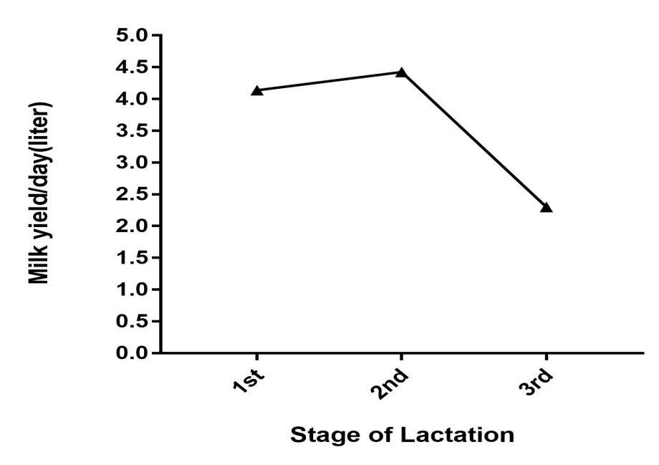

Figure 2: Average daily milk production curve based on stage of lactation

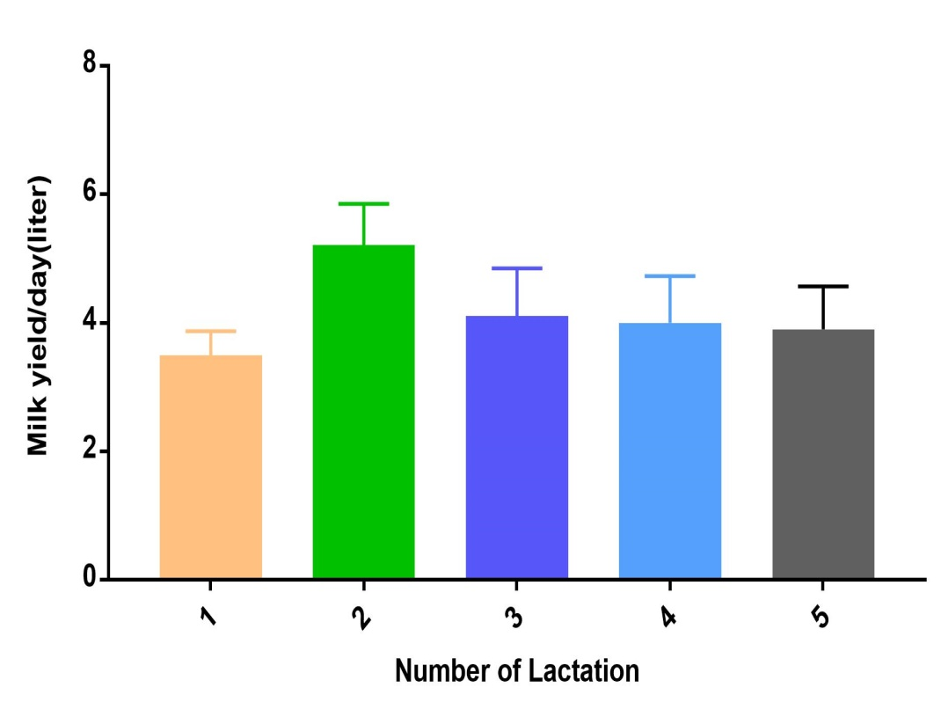

Figure 3: Daily milk yield per lactation
3.3. Health monitoring and other management
Health problems are closely linked to the kind of environment in which cattle are reared, the management methods used and to genetic factors related to disease resistance in the animal population. It was revealed that provided the vaccine (HS, BQ, Anthrax, FMD, Cholera) in maximum household cattle. In the present study regular deworming occurred. It was observed that 87% farmer used artificial insemination and13% both naturally and artificial insemination method to inseminate their cows.

Chapter4: Discussion

4.1. Farming status
This study indicated that the semi-intensive system was the most suitable for the daily milk yield2.23±0.16 and5.39±0.41 liters respective for indigenous and crossbred cows. Since the condition was performed at a particular point time, the current estimate may not be adequate to compare with other works.From the study it has been observed that 95% of the farmers used tin shed and straw shed to house and rest of 5% percent of the farmers provide half building for their cattle. In another region of the same district, (Hossainet al; 2004) observed that 63% farmers provided closed house and 63% farmers used paved floor.
Unless supplemented with a protein concentrate, cattle grazing natural pasture lose body weight (Topps and Oliver 1993) with cyclic ovarian activity ceasing when cows lost 20-30 % of their mature weight due to under nutrition. Inadequate level of nutrition has been found to be the most important factor influencing length of post partumanoestrus in cows grazing tropical rangeland (Topps and Oliver 1993).From the present study44 percent farmers followed pasture based grazing system and 56 percent farmers followed cut and carry method. Grazing systems offer only limited potential for intensification of dairy production. In this study farmers are not cultivated any fodder. Because of most important constraints regarding fodder cultivation are scarcity of land, scarcity of seed/cutting and lack of knowledge.
4.2. Daily milk yield
It was revealed that the highest milk production from crossbred and indigenous cows was 15 and 3 liters/day, respectively, and lowest milk production from crossbred and indigenous cows were 2 and 0.5 liters/day, respectively. Average daily milk yield/cow/farm was 5.39±0.41and 2.23±0.16 liters for a crossbred and indigenous dairy cow, respectively.Sahaet al., (2008) found that, the dailymilk yield mean of L×SL were 8.90±2.1 liters per day and 12.54±3.50 liters for L×HF crossbreed cows.The milk yield was highly significantly (P<0.0001) affected by above feeding management.Ahmed (2006) observed that feeding significantly (P<0.01) increased the milk yield.There was a variation in milk yield with the different stage of lactation.In curve of lactation stage, here increased milk yield in 2nd stage. Finding of Alam et al.(2009) and Khan et al.(2012) were similar to the results of the study.The effects of parities on milk yield per day arevaried in calculated value. Significantly the highest milk yields per day were found in 2nd lactation & have somewhat difference in third & fourth parities. The significant lowest milk yield per day in the first parity, Clark & Davis (1980), Peters & Riley (1982) observed similar findings.

4.3 Health monitoring and others
In our country, low-cost, effective vaccines are usually available to protect against rinderpest, contagious bovine pleuropneumonia and local strains of foot-and-mouth disease. Such sporadic or regional diseases as anthrax, blackleg and haemorrhagicsepticaemia can also be prevented by regular immunisations, but vaccines for these diseases are not always of high quality or uniformly available. With some vaccines, the costs may exceed the expected benefits (McCauley, 1983).In the present study regular deworming occurred. Disease is an important constraint on all forms of livestock production and especially for calves (Perry et al.,1984), which frequently suffer from respiratory and enteric diseases. In the study, there was observed that 30% calves were suffered from above diseases. Chronic diseases such as dermatophilosis greatly depress milk production (Oduye, 1975) and increase mortality in all age groups.In this study, observing results that 87% cows were inseminated artificially and 13% both naturally and artificially which is similar to the observation by Hossainet al; (2004), who found that 93% cows were inseminated artificially.

Conclusion
Study on farming status and milk production of cow in smallholdings in four upazila of Comilla region, revealed that most of the small holder farmers are landless. Our findings indicate that there is lack of fodder field or pasture to rear cattle on pasture based method. Farmers prefer to rear crossbred cattle than indigenous because the milk production crossbred animals are higher than indigenous cattle as observed in our study and previous studies. Daily milk production is varied based on stage of lactation and parity. In case of small dairy farming, the farmer are facing a lot of problems such as scarcity of feeds and fodder, high price of concentrate and lack of technical knowledge.As small-scale farming comprises the most of the dairy production in Bangladesh, therefore, it is necessary to take proper initiative to improve production in small-scale cattle farming which will ultimately improve national production.

References
Ahmed, T.U. 2006: Studies on nutritional status of dairy cows of Bangladesh and improvement their productive and reproductive performance in Baghabarighat area through nutritional manipulation. PhD Thesis, Department of Animal Nutrition, Faculty of AnimalHusbandry, Bangladesh Agricultural University, Mymensingh.
Ali, M.H., Khan, M.A.S., Islam, M.N., Khan M.K.I., Rashid.,M.M. andKhatun, M.J. 2000. Comparative performance study on the crossbreeds and indigenous cows under small holder dairy farming. Pak. J. Bio. Sci., 3: 795-798.
Clark,J.H. and Davis,B. (1980) some aspects of feeding high producing dairy cows. Journal of Dairy Science 63: 873-875.
Debnath, G.K., Kober, A.K.M.H., Chanda, T., Chanda, G.C., Bari, M.S.A. 2014.Comparative Study on theQuality of Available Brand and Non Brand Fluid Milk Consumed by the People of Chittagong City of Bangladesh. International Journal of Natural Sciences, 4(1): 16- 20.
DLS 2008.Annual report on livestock, Division of livestock statistics, Ministry of Fisheries and
FAO., 1994. Production Year Book Rome, Italy.
Hossain, M.A. andRoutledge, S.F. (1982), Performance of crossbred &local cattle under village condition in Pabna district of Bangladesh. Proceeding of maximum livestock production from minimum land ,seminar,pp: 161-167
Hossain, Z.M.A., Hossain, S.M.J.,Rashid, M.M., Sultana N. andAli, M.H.2004. Study on the present management condition of private dairy farm at RangpurSadar Thana in Bangladesh. J. Biol. Sci., 3.
Islam, M.A., 1992. A comparative economic analysis of milk cows and buffaloes in two selected village of Mymensingh district in Bangladesh. M.Sc. Thesis. Department of Agricultural Finance, Bangladesh Agricultural University, Mymensingh, Bangladesh.
Jabbar, M.A. andRaha, S.K. 1984. Consumption pattern of Milk and Milk products in Bangladesh.The Bangladesh. J. Agri. Eco., VII (2): 29-44.Livestock, Farmgate, Dhaka, Bangladesh.
Khan, M.K.I,.Blair, H.T. and Lopez, N-Villalobos, 2012.Laction curves of different cattle breeds under cooperative dairying conditions in Bangladesh. J ApplAnim Res, 40: 179-185.
McCauley, E H. 1983. Animal diseases in developing countries: Technical and economic aspects of their impact and control. AGR Tech. Note No. 7. World Bank, Washington DC.
Oduye, O.O. 1975. Incidence, economic effect and control of bovine streptothricosis in Nigeria.Bull. Off. Int. Epiz.83(11–12): 1125–1129.
Perry, B.D., Mwanaumo, B., Sehels, H.F., Eicher, E. and Zamam M R. 1984.A study of health and productivity of traditionally managed cattle in Zambia.Prev. Vet. Med.2: 633–653.
Rahman, M.M., Akhtar, S., Hossain, M.M. 1998: The availability of livestock feeds and feeding practices followed by the farmer of some areas of Mymensingh District. BangladeshJournal of Animal Science 27 119-126.
Saha, A.K., Adhikary, G.N and Haque, M. N. 2008. The reproductive and productive performance ofdifferent crossbred dairy cows at Government .
Topps, J.H and Oliver J 1993 Animal foods of Central Africa. Zimbabwe Agricultural Journal, Technical Handbook number 2.

Acknowledgements

All praises are due to the Almighty God, whose blessings have been enabled the author to accomplish this word.

The author expresses her wholehearted senses of gratification, a sincere appreciation to her respected teacher and internship supervisor, Dr. Ashutosh Das, Associate Professor, Department of Genetics and Animal Breeding, Chittagong Veterinary and Animal Sciences University whose ingenuous and scholastic advice, judicious recommendations, constructive criticism, continuous encouragement and untiring assistance have guided the author from the beginning of inception of intern studies until to the completion of this report.
The author is also grateful to honorable professor Dr. Md. AhasanulHoque, Dean, Faculty of Veterinary Medicine of Chittagong Veterinary and Animal Sciences University and professor Dr.A.K.M. Saifuddin, Director of External Affairs Chittagong Veterinary and Animal Sciences University for arranging this type of research work as a compulsory part of this internship programme.

The author
October 2016

Biography
I am Shanchita Rani Paul, daughter of Mr. Santosh Chandra Paul and Mrs. Nomita Rani Paul. I passed Secondary School Certificate examination in 2008 (G.P.A-5.00) followed by Higher Secondary Certificate examination in 2010 (G.PA-5.00). Now I am an intern veterinarian under the Faculty of Veterinary Medicine in Chittagong Veterinary and Animal Sciences University. In the future I would like to work as a veterinary practitioner and do research on animal diseases in Bangladesh.

