Chapter-1: Introduction

The economy of Bangladesh is agro based. About 21.77% of Gross Domestic products (GDP) come from agriculture sector of which livestock alone share 7.23%. (BBS, 2005-2006). Bangladesh have 24.7 million cattle, 0.86 million buffalo, 1.34 million sheep and goat, 195 million poultry (DLS, 2006). Livestock is one of its important components which provide protein, solve unemployment and earn foreign exchange (Taylor and Roese, 2006; Cole, 1996). Livestock are recognized as an integral component in cereal dominated cropping system of Bangladesh. Feed shortage is one of the main constraints in exploiting the genetic potential of indigenous livestock species. Due to inadequate availability and lack of scope of green grass production, rice straw has become a major feed resource for ruminant animals.
In Bangladesh cattle feed mainly on low quality roughage including natural grazing and agro-industrial by products such as straw, sugarcane by-products and other similar feeds. These feeds are deficient in protein, energy, minerals and vitamins. At certain time of the year, quality of grazing deteriorates due to seasonal influence. Thus livestock productivity consequently declines and in this cases lactation cease unless supplements are offered. Livestock feed decreases day by day in Bangladesh due to the shortage of grazing area also. In such cases any unconventional sources may act as an alternative. In commercial dairying, feed cost alone accounts 60-70% of total production cost (Bulbul and Hossain, 1989). Therefore, this is a demand of time to explore locally available cheaper alternative feed resources such as areca sheath to reduce feed cost.
The Betel nut (Areca catechu) is used by human population for chewing along with betel leaves (locally called ‘paan’).Beside Bangladesh; the betel nut cultivation is common in parts of tropical Pacific, Asia and east Africa. Betel nut, common names is areca nut, supari in Bangla, adike, pakk, vakalu. In Bangladesh, a bumper production of betel nut and a fair price for the produce have put a big smile on the growers' faces in Ukhia and Teknaf of Cox's Bazar in this year. In Ukhia and Teknaf, around 12,000 families are involved in betel nut cultivation on some 5,000 acres of land, said the agriculture officers and locals. The weather of the two upazilas situated near the Bay-of-Bengal and their soil having adequate salinity have been a blessing for them. Wholesalers of Firingi Bazar in Chittagong town told that the trading of betel nut was very profitable and hassle-free (Daily star, Jan 6, 2016). Bhola, historically known for big betel nut growing area in the country, has plantation over 7750 hectares of land, said officials at the Department of Agricultural Extension (DAE). The agriculture officers said that the soil of Bangladesh is suitable for cultivation of this crop, widely used with betel leaf. The Betel nut cultivation as a commercial crop has increased at the cost of paddy and other cereals.

The fallen areca leaf sheath is available seasonably (September to June) in sizeable quantity. Areca leaf sheath, as an alternate resource, has been evaluated for use as a fodder. Presently areca leaf sheath is used for making plates/cups, fuel and composting. Areca leaf sheath is shed periodically from the tree and it can be potentially used as dry fodder in ruminants. Areca nut tree sheds about 10 leaves (sheaths) per year. Around four lakh hectares of land is under betel nut cultivation and it is estimated that 5400 million leaves sheaths are shedded annually. Each areca leaf sheath weighs around 200-300g and assuming an average weight of 250g. The potential availability of areca leaf sheath in Bangladesh is about 200,000 tonnes per year. Areca leaf sheath can totally replace rice straw in total mixed rations in cattle and sheep (Gowda et al., 2012). Areca sheath can be used as sole roughage to an extent of 40-50% of the total mixed ration in dairy cattle rations. The sheaths should be dried properly and chaffed before feeding (Gowda et al., 2012). Most of them are not used by farmers due to lack of knowledge of farmers on areca leaf sheath. In addition, most of the farmers are not known about the nutritive value of areca sheath at all. If the nutritive value and potentiality of areca leaf sheath discover, farmers of that area can utilize areca leaf sheath as an unconventional feed in livestock sector to minimize feed cost and maximize production.
Therefore, the current study was undertaken to evaluate the areca sheath as cattle feed with the following objectives:
- To determine the nutritive value of areca leaf sheath.
- To compare nutritive quality of areca sheath with rice straw.
- To assess the utility of areca leaf sheath as dry fodder in feeding system of cattle.

Chapter-2: Methods and Materials
The investigation on “Nutritional quality of areca leaf sheath” was carried out from 9.08.2016 to 1.09.2013.This study conducted in the Animal Nutrition laboratory under the department of Animal Science and Nutrition, Chittagong Veterinary and Animal Sciences University, Khulshi, Chittagong, Bangladesh.
2.1 Objective of the study:
The report has been done as a part of the internship program. The report was based on the determination of proximate analysis & evaluation of areca sheath and also compare with value for knowing the economic analysis of areca sheath as unconventional feed.
2.2 Study area:
There are lots of small and large scale farm in Patyia, Chittagong and Comilla district where most of the farmer usually feed their livestock with unconventional feed along with conventional based on availability. Therefore, areca leaf sheath as an unconventional feed available in these areas were selected as the study area.
2.3 Collection of sample:
Areaca leaf sheath (Areca catechu) was collected from 10 tress in Patyia, Chittagong and Comilla district (photo-1, photo-2). After collection of dry areca sheath from tree, rib of leaves were cut-off and discarded thinking that it is not convenient feed. Dusts also were removed.
2.4 Preparation and processing of experimental sample:
Due to its long and wider surface area (Photo-3), it’s needed to be shredded to smaller pieces of about 2×10mm in size. Homogenous samples were prepared by chopping (photo-4) and proper mixing and stored in air tight container for proximate analysis. Approximately 50 gm fresh sample was prepared for analysis (Photo-4).

2.5 Analysis of Nutrient composition of areca leaf sheath:
The feed samples were analyzed for proximate composition (photo gallery) such as, Dry matter (DM) moisture, crude protein (CP), crude fat (EE), crude fibre (CF), Nitrogen free extract (NFE), total mineral matter (ash) and sand silica, expressed in percentage in the animal nutrition laboratory in Chittagong Veterinary and Animal Sciences University, Chittagong, Bangladesh as per AOAC (1990).
2.5.1 Moisture
Five grams of raw sample was weighed into a previously weighed petridish and dried in an oven at 105°C till a constant weight was attained (Anon., 1990 )
Initial weight (g) – Final weight (g)
Moisture % = ---------------------------------------------× 100
Sample weight (g)
2.5.2 Crude protein (CP)
The nitrogen content of sample was estimated by Microkjeldahl method in Parnas and Wagner apparatus (Anon., 1990). The crude protein content was calculated by multiplying with factor 6.25 and expressed on per cent basis.
(Initial reading - Final reading ) × Normality of HCL × 14.007 × 6.25
Protein % = ------------------------------------------------------------------------------------ × 100
Sample weight (g)
2.5.3 Crude fat (EE)
Moisture free sample was weighed in moisture free thimbles and crude fat was extracted by refluxing in soxhlet apparatus using petroleum ether as solvent. Per cent crude fat was calculated by difference (Anon., 1990).
Initial weight (g) – Weight after extraction (g)
Crude fat % = --------------------------------------------------------- × 100
Sample weight (g)
2.5.4 Crude fibre (CF)
Fat free sample was hydrolyzed with dilute sulphuric acid (0.255 N) and dilute alkali (0.313 N) to estimate crude fibre by employing the methods of Mayanard (1970).
Weight residue with crucible (g) – Weight of ash with crucible
Crude fibre %=--------------------------------------------------------------------------- ×100
Weight of fat free sample (g)
2.5.5 Total mineral matter (Ash)
Total mineral matter (ash) was determined by igniting samples in muffle furnace at 600°c for 3 - 4 hours ( Anon., 1990). The total mineral matter was expressed as per cent.

Weight of crucible with ash (g)
Total mineral matter % = -------------------------------------------- × 100
Weight of crucible with sample (g)
2.5.6 Nitrogen Free Extract (NFE):
The NFE content was calculated by deducting the sum of the values for moisture, crude protein, crude fat, crude fibre and total mineral matter in 100 (Raghuramulu et al., 1983)
Metabolizable energy (ME):
The metabolizable energy content was calculated by mathematical formula as per Mass (1984), DM basis.
ME = 912.0 + 0.0081CP + 0.023EE - 0.018Ash -0.012 (T. ash) (MJ/KG)
ME = MJ/Kg × 239 (kcal/kg)
Table-1. The nutrient composition of areca sheath found elsewhere of the world (Gowda et al, 2012)
Nutrients | CP% | ADF% | NDF% | EE% | ASH% | ME% | Silica%
Areca catechu | 3.5 | 47.7 | 71.3 | 0.07 | 6.40 | 7.2 | 3.30
Statistical analysis:
All data were recorded after chemical analysis. The recorded data were tabulated for further analysis and average value were analyzed by using Microsoft excel 2007.
Comparison and evaluation of areca sheath:
After proximate analysis, the composition and nutrition value was compared between rice straw and areca sheath. The feeding effect of areca sheath was observed in lactating cattle, replacing rice straw. This study was conducted for evaluating areca sheath as a dry fodder supplementing about 30% dry matter requirement for cattle (Gowda et al, 2012)

Photo Gallery

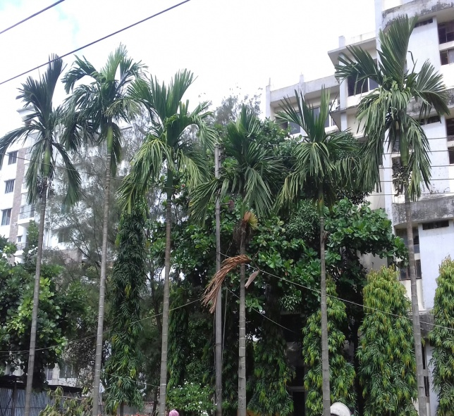
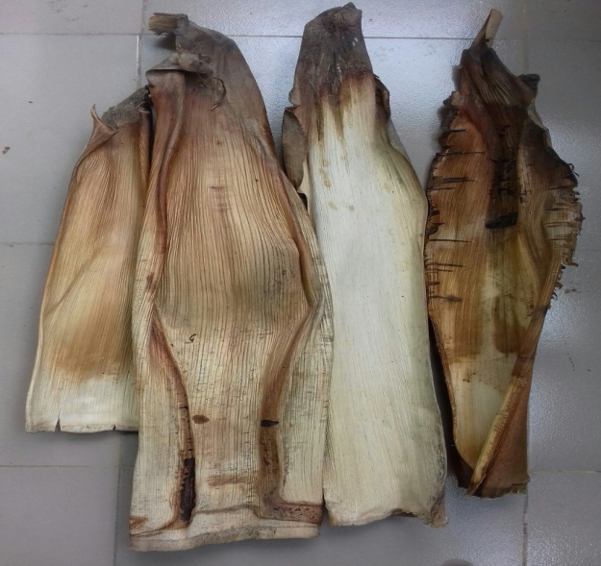

Photo 03: Shedded areca sheath (whole)
Photo 01: Areca trees
(Areca catechu)

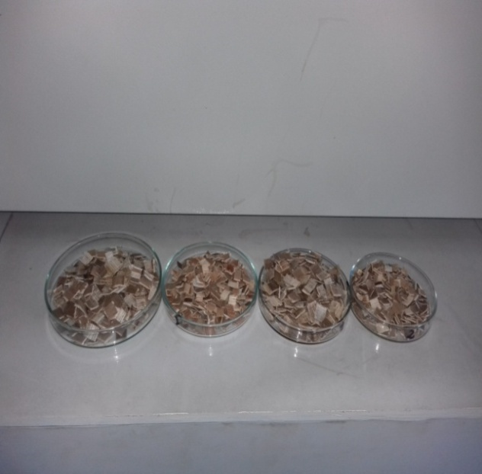
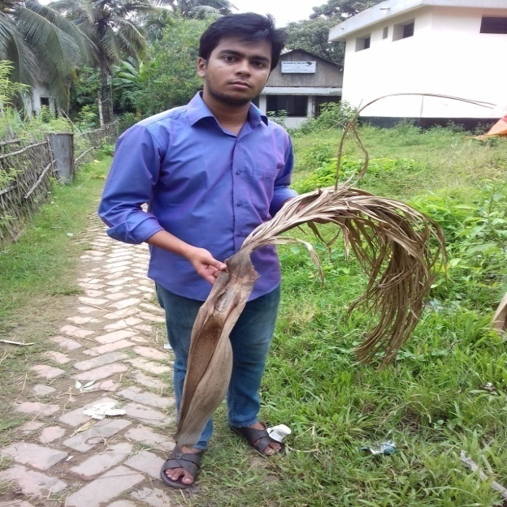

Photo 04: Prepared sample
Photo 02: Fallen sheath collection
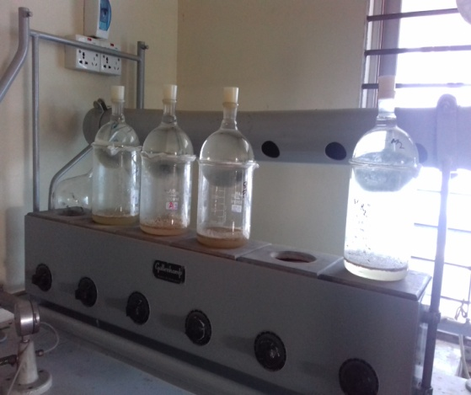
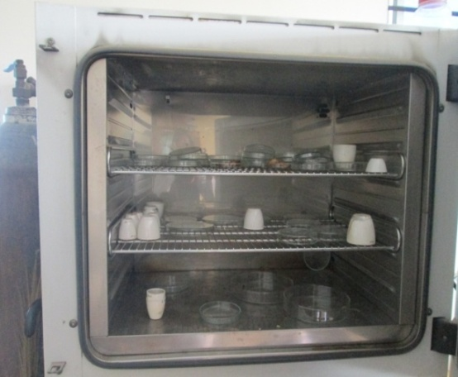
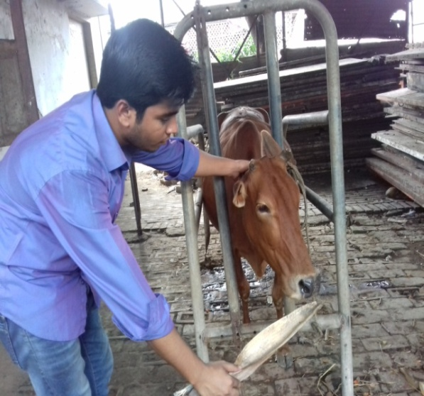
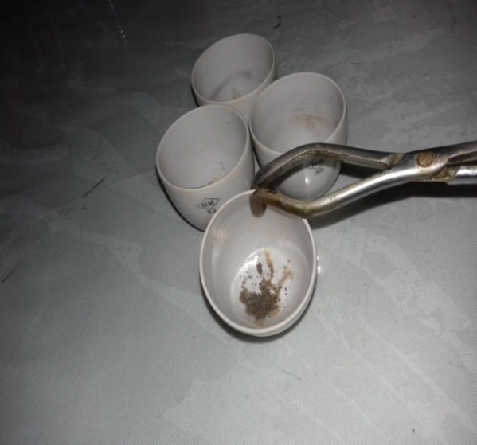
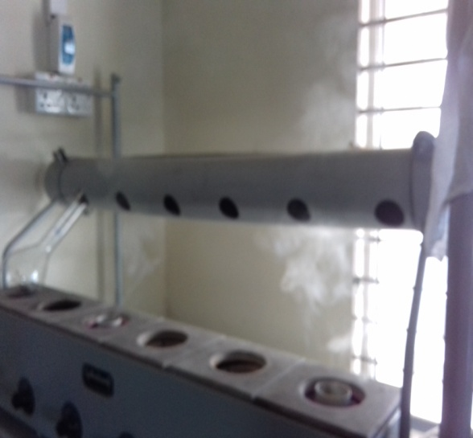
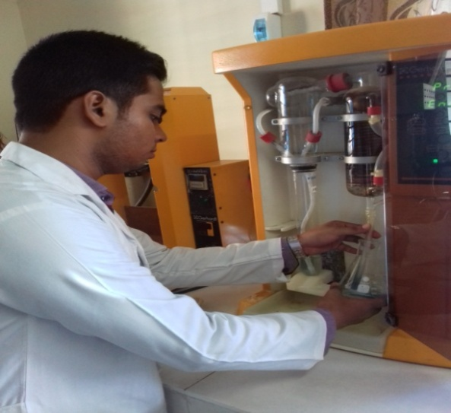
Photo 09: Estimation of Sand silica
Photo 08: Estimation of Ash
Photo 07: Estimation of CP
Photo 06: Estimation of CF
Photo 05: Estimation of DM

Photo 10: Provided areca sheath to cattle
Chapter-3: Results
Estimated of proximate value of areca sheath and noted down the value after finishing task in laboratory, CVASU.
Moisture/ DM content:
From the table-3.1 it was found that the moisture of the collected sample was 11.9% or the DM content of that was found as 88.2% on DM basis.
Crude protein (CP):
It was found that the CP content of supplied sample was found as 1.9% on DM basis.
Crude fibre (CF):
From laboratory work, it was found that crude fibre content of areca sheath was found as 59.5% on DM basis (Table 3.1)
Crude fat (EE):
Observed fat percentage of the study sample was 0.1% on DM basis (Table-3.1).
Total Ash:
The value of total ash of the collected study sample was found as 3.9% on DM basis.
Nitrogen Free Extract (NFE):
The calculated NFE of supplied sample was found as 20.9% on DM basis (Table-3.1)
Sand Silica:
It was found that the percentage of sand silica was 2.9 of the study sample after estimated ash percentage of areca sheath (Table-3.1).
Metabolizable Energy (ME) value:
The ME content of the study sample was found as 9.52 calculated by Mass (1984) formula.
Table-3.1: Nutrient composition of Areca sheath found in laboratory
Parameter | DM% | CF% | CP% | EE% | Ash% | NFE% | ME  (Kcal/kg) | Sand silica %
Nutrients of Areca sheath | 88.2 | 59.5 | 1.9 | 0.1 | 3.9 | 22.72 | 2275.28 | 2.2
Table-3.2: Comparison of the nutrition value between areca sheath and rice straw
Components | Areca sheath |  | Paddy straw #
 | *Laboratory analysis | Referral value #
Crude protein (%) | 1.9 | 3.5 | 3.8
Ether extract (%) | 0.1 | 0.07 | 0.1
Ash (%) | 3.9 | 6.4 | 17.1
Silica (%) | 2.2 | 3.2 | 13.6
NFE (%) | 22.72
Neutral detergent fiber (%) |  | 71.3 | 72.1
Acid detergent fibre (%) |  | 47.7 | 51.1
Metabolisable energy (MJ) | 9.52 | 7.52 | 7.31
Total digestible nutrients (%) | Not done due to time constraints | 49.3 | 48.2
Lignin (%) |  | 3.9 | 5.1
Oxalic acid (%) |  | 0.34 | 0.56
Tannin (%) |  | 0.4-0.89 | 0.73-1.03
Calcium (%) |  | 0.25-0.60 | 0.16-0.28
Phosphorus (%) |  | 0.06-0.08 | 0.06-0.07
Magnesium (%) |  | 0.30-0.49 | 0.11-0.13
Sulfur (%) |  | 0.61-0.75 | 0.25-0.35
Copper (ppm) |  | 15-23 | 5-7
Zinc (ppm) |  | 8-12 | 6-8
Iron (ppm) |  | 90 | 211
Manganese (ppm) |  | 45 | 40
Cobalt (ppm) |  | 2 | 1.5
*Done in the laboratory of Animal Nutrition under the department of Animal Science and Nutrition, CVASU
#Data collected from www.feedipedia.org/node
Chapter-4: Discussion
Areca sheath can totally replace paddy straw in total mixed rations in sheep and cattle. Areca sheath can be used as sole roughage to an extent of 40-50% of the total mixed ration in dairy cattle rations. So, It is important to know the nutrient composition of areca sheath for live stock feeding system.
In this study, the DM content of the supplied areca sheath sample was found as 88.2% (Table-3.1) which was supported by Gowda et al, 2012 study. The CP content of supplied sample was found as 1.9% (Table -3.1). The CP content found of this study was a bit lower than the findings of Gowda et al (2012). They estimated the CP content of areca sheath as 3.5% (Table-3.1) which is higher than calculated value. From above table it was found that crude fibre content of areca sheath as 59.5% (Table-3.1). The ether extract content of areca sheath was found as 0.1% (Table-3.1) which was almost similar of Gowda et al (2012). The total ash content of areca sheath was found as 3.9% (Table-3.1) which was not similar with the referral value. The total ash content of areca sheath found of this study was not positively supported by Gowda et al (2012). They estimated the ash content of areca sheath as 6.4% (Table-3.2), that was not similar to current study. The NFE content of areca sheath was 22.72% (Table-3.1).The sand silica of supplied sample was 2.2% (Table-3.1) which was near the value 3.3% (Table-3.2) of Gowda et al (2012).

After laboratory analysis of the areca sheath composition, compared with the referral value and the composition of paddy straw, it was indicated that areca sheath samples for nutritional composition showed almost similar composition to paddy straw and content of some minerals like calcium, copper and sulfur were better in areca sheath (Table-3.2). Areca sheath was also low in oxalic acid and tannin content. The National Institute of Animal Nutrition and Physiology (NIANP) in Bengaluru, India has developed a technology for using dried and shredded areca sheath in the form of total mixed ration (TMR: Crude protein 13%, Total digestible nutrients 58%) along with suitable proportion of concentrate mixture to support milk production. Feeding processed areca sheath to lactating animals, replacing paddy straw, had proved an economic value. On the technical guidance of NIANP scientists, the dairy farmers in Karnataka region have started using shredded areca sheath as a component of total mixed ration. Using this technology had reduced the cost of feeding dry fodder and also increased milk yield by 7-10% and milk fat by 0.2-0.3 units ( Gowda et al, 2012).
From the above discussion, it can be concluded that the areca sheath have a good potentials as to be used as the partial replaced of rice straw to maintain the daily feeds of the cattle in Bangladesh.

Conclusion

This study was conducted to popularize the areca sheath as dry roughage for cattle. In this regards, the proximate analysis of areca sheath was done, where the CP, CF, EE, NFE, Ash, Sand silica of study sample found 1.9%, 59.5%, 0.1%, 22.72%, 3.9%, and 2.2% respectively. The laboratory analysis of areca sheath samples for its nutritional composition showed almost similar composition to paddy straw (CP, EE, CF). Areca sheath was also low in silica and total ash content. It was revealed that similar nutritional composition and minerals are better in areca sheath than rice straw. It also described that dried sheath has a positive effect on ruminant instead of fresh as the thin plastic-like film adhering loosely to the inner side of the fresh sheath is not digested and could lead to impaction. It can assist farmers in ensuring sustainable production of least cost diets for cattle. The use of unconventional feed resources such as areca sheath and other strategies may reduce pressure on the demand for conventional feed ingredients and promote achievement.

Limitations
- Due to short duration of the study period, it’s not possible to take strong decision in further analysis of the chemical composition of areca sheath.
- Digestibility trial was not done on cattle due to short time and resource.

Chapter-5: References
AOAC, 1990. Official Methods of Analysis. 15th Edn., Association of Official Analytical Chemists. Arlington, Virginia, USA.
Anonymous, 1990. Official methods of Analysis of the association of official analytical chemists. 20th Edn., AOAC, Washington, D.C.
Bulbul, S.M. and Hossain, M.D. 1989. Probable problems of poultry feed formulation in Bangladesh. Poultry Advisor, 12 (3): 27-29.
BBS, 2005. World Bank, 2008. I Xist, 2008. BBS, 2005-2006., DLS, 2006.
Cole, H.H. 1996. Introduction to Livestock production. 2nd Edn. Freeman and co, SanFrancisco and London.
http://www.thedailystar.net/backpage/betel-nut-sees-bumper-yield-197587
http://www.feedipedia.org/node
http://www.nianp.res.in/Documents/Event/Arecasheath.pdf
Maynard, A.J. 1970. Methods in Food Analysis. Academic Press, New York, pp. 176.
N.K.S. Gowda, S. Anandan, D.T. Pal, N.C. Vallesha, S. Verma and K.T. Sampath, 2012. Technology to use areca sheath as an alternate dry fodder for dairy animals – A Success story. Indian Dairyman, 64 (10): 58-61
Raghuramulu, N. Madhavan Nair, K., Kalayanasundaram, S. 1983. A Manual of Laboratory Techniques. Hyderabad:National Institute of Nutrition, pp. 32-33.
Taylor, G. and Roese, G. 2006. Basic pig husbandry. NSW, New South Wales.

Work done on areca sheath in India
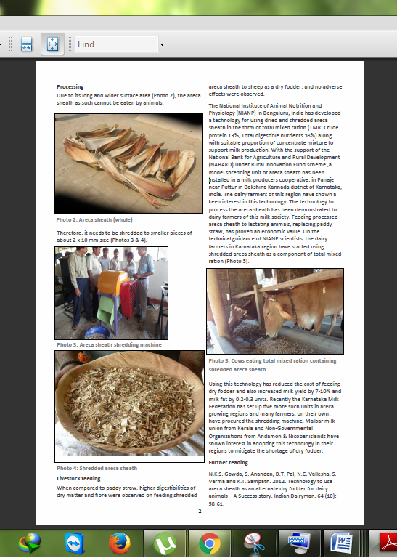
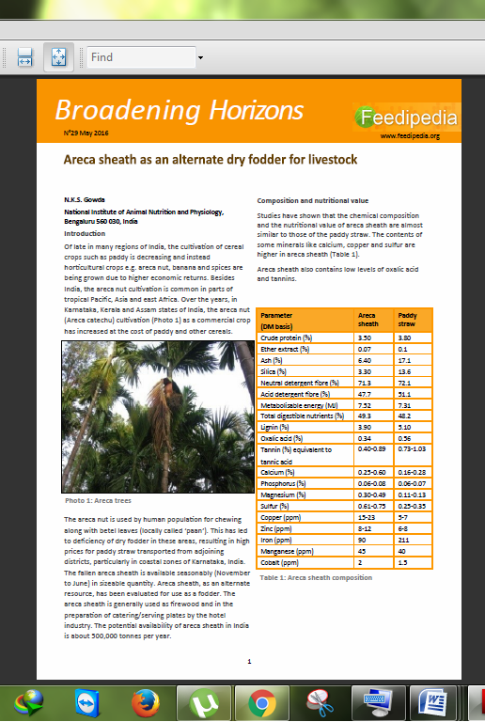

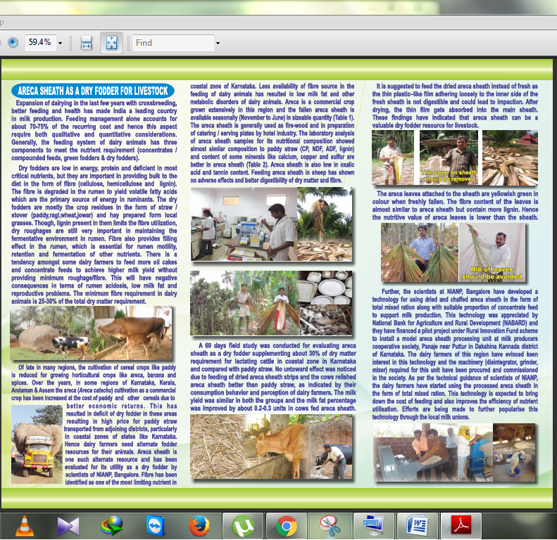
www.feedipedia.org/node
www.nianp.res.in/Documents/Event/Arecasheath.pdf
Acknowledgements
All praises are due to the Almighty Allah, whose blessings have been enabled the author to accomplish this word.
It is deemed as a proud privilege and extra terrestrial pleasure to express author ever indebtedness, deepest sense of gratitude and profound regards to his supervisor and teacher Dr. Md. Hasanuzzaman, Professor, Department of Chittagong Veterinary And Animal Sciences University for his scholastic guidance, sympathetic supervision, valuable advice, constant inspiration, affectionate feeling, radical investigation and constructive criticism in all phases of this study and preparing the manuscript also.
Special thanks to other teachers and staff, Department of Animal Science and Animal Nutrition, for their valuable advice and co-operation. I would like to express my deep sense of gratitude and thanks to Vice Chancellor Professor Dr. Goutam Buddha Das, Professor. Dr. Md. Ahasanul Hoque, Dean, Faculty of Veterinary Medicine, Chittagong Veterinary and Animal Sciences University.

The Author
01/11/16

Biography
I am Robiul Hossen Rubel, son of Mr. Abul Hasem and Mrs. Hosne Ara Begum. I passed Secondary School Certificate examination in 2007 (G.P.A-5) followed by Higher Secondary Certificate examination in 2009 (G.PA-4.60). Now I am an intern veterinarian under the Faculty of Veterinary Medicine in Chittagong Veterinary and Animal Sciences University. In the future I would like to work as a veterinary practitioner and do research on clinical animal diseases in Bangladesh.

