CHAPTER I

Introduction

The Griffon vulture (Gyps fulvus) is a large Old World vulture in the bird of prey family Accipitridae. It is also known as the Eurasian griffon. It is not to be confused with a different species, Rüppell's griffon vulture (Gyps rueppellii).
Table: Vultures of Bangladesh.
Scientific name | English name | Local name
Gyps bengalensis | White-rumped Vulture  [Indian White-backed Vulture] | Shakun
Gyps fulvus | Eurasian Griffon  [Griffon Vulture] | Shakun
Gyps indicus | Long-billed Vulture  [Indian Long-billed Vulture] | Shakun
Sarcogyps calvus | Red-headed Vulture  [King Vulture] | Raj Shakun
Aegypius monachus | Cinereous Vulture  [Black Vulture] | Shakun
Neophron percnopterus | Egyptian Vulture  [Scavenger Vulture] | Shakun

Description
The griffon vulture is 93–122 cm (37–48 in) long with a 2.3–2.8 m (7.5–9.2 ft) wingspan. In the nominate race the males weigh 6.2 to 10.5 kg (14 to 23 lb) and females typically weigh 6.5 to 11.3 kg (14 to 25 lb), while in the Indian subspecies (G. f. fulvescens), the vultures average 7.1 kg (16 lb). Extreme adult weights have been reported from 4.5 to 15 kg (9.9 to 33.1 lb), the latter likely a weight attained in captivity. Hatched naked, it is a typical Old World vulture in appearance, with a very white head, very broad wings and short tail feathers. It has a white neck ruff and yellow bill. The buff body and wing coverts contrast with the dark flight feathers.
Behaviour
Like other vultures, it is a scavenger, feeding mostly from carcasses of dead animals which it finds by soaring over open areas, often moving in flocks. It establishes nesting colonies in cliffs that are undisturbed by humans while coverage of open areas and availability of dead animals within dozens of kilometres of these cliffs is high. It grunts and hisses at roosts or when feeding on carrion.
The maximum recorded lifespan of the griffon vulture is 41.4 years for an individual in captivity.
It breeds on crags in mountains in southern Europe, North Africa, and Asia, laying one egg. Griffon vultures may form loose colonies. The population is mostly resident. Juveniles and immature individuals may migrate far or embark on long-distance movements.

Physiology
Griffon vultures have been used as model organisms for the study of soaring and thermoregulation. The energy costs of level flight tend to be high, prompting alternatives to flapping in larger birds. Vultures in particular utilize more efficient flying methods such as soaring. Compared to other birds, which elevate their metabolic rate to upwards of 16 times their basal metabolic rate in flight, soaring griffon vultures expend about 1.43 times their basal metabolic rate in flight. Griffon vultures are also efficient flyers in their ability to return to a resting heart rate after flight within ten minutes.
As large scavengers, griffon vultures have not been observed to seek shelter for thermoregulation. Vultures use their bald heads as a means to thermoregulate in both extreme cold and hot temperatures. Changes in posture can increase bare skin exposure from 7% to 32%. This change allows for the more than doubling of convective heat loss in still air. Griffon vultures have also been found to tolerate increased body temperatures as a response to high ambient temperatures. By allowing their internal body temperature to change independently of their metabolic rate, griffon vultures minimize their loss of water and energy in thermoregulating. One study in particular (Bahat 1995) found that these adaptations have allowed the Griffon vulture to have one of the widest thermal neutral zones of any bird.

CHAPTER II

Materials and Methods

2.1. Methods:
- Visiting of the zoo
- Observation
- Photography
- Interview of the authority.

2.1. Study area
Different zoo (Dhaka Zoo, Khulna Zoo, Rangpur Zoo) and safari park (Bangabondhu Sheikh Mujib Safari Park, Dulahazr, Cox’sBazar, Bangabondhu Safari Park, Gazipur) of Bangladesh.

2.2. Study design
A cross-sectional study was done by pre-questionnaire.

2.3.Griffon Vulture Related information:

2.3.1. Feeding
Feeds only on carrion of large and medium-sized animals. When one bird finds a
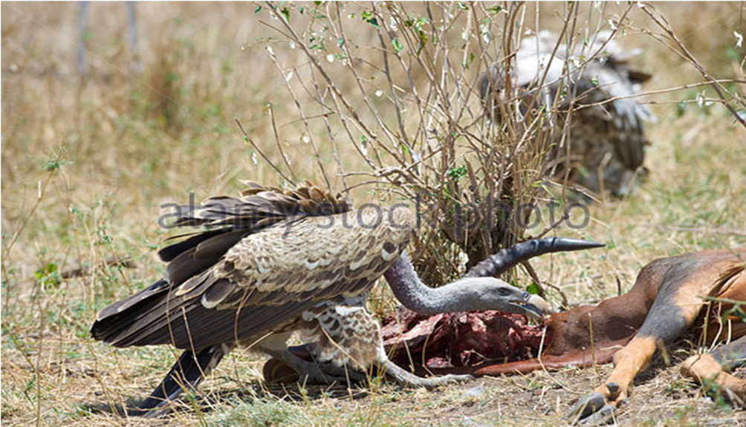

Figure: Feeding of vulture
dead animals, other vultures often see the bird going down and follow it. In areas with healthy populations, a dead animal can attract large numbers of vultures within a short time. Griffon Vultures also visit landfills in search of food. yps vulture species across Asia.
2.3.2. Breeding
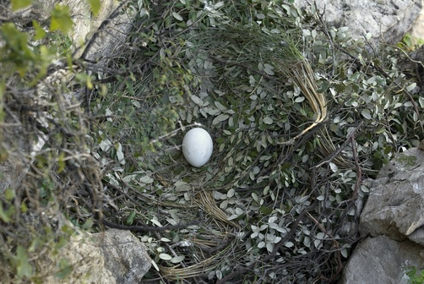
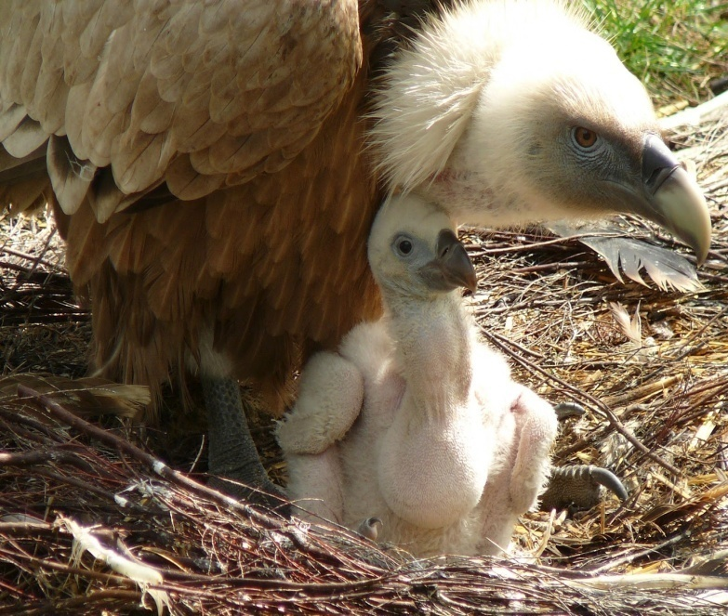
First breeding with 4 or 5 years. Griffon Vultures normally breed in colonies in cliffs. In some places like the Monfragüe National Park in Spain, the Griffon Vulture also breeds in tree nests build by the Cinereous Vulture. Only 1 egg is laid. Incubation time is between 47 and 57 days and the young spend between 113 and 159 days in the nest. Like most raptors, the young is dependent on its parents for a few weeks after fledging.

Figure: Breeding of vulture

2.3.3. Vaccination
No vaccination is done in the captive Griffon vulture in any zoo of Bangladesh.

2.3.4. Habitation

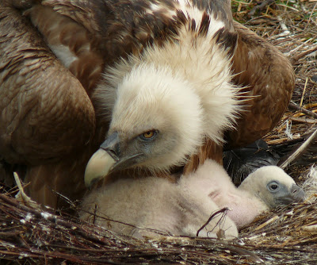
Needs cliffs for nesting and abundant food in form of carrion of large and medium-sized animals (livestock like cows or sheep and wild mammals like deer).
The landscape should support the building of thermals [Mebs & Schmidt 2006] as the large vultures prefer the energy-saving gliding and soaring over active flight.

Figure:

2.4 Data collection
All the data were collected with a pre-prepared questionnaire and by asking questions to the zoo and safari park authority. Web visiting, Reading related articles also contributed in gather the whole data and to complete the study.

CHAPTER III

Results and Discussion

Number of Griffon Vulture in Bangladesh
The local vulture population has been on a steady decline due to an excessive use of veterinary medicines.
A research in 2012 shows that the vulture population in the country has been reduced by 60% between 2008 and 2012 and 98% in the last two decades due to lack of food, habitation and excessive use of animal drugs.
Griffon Vultures are found in the country, though they are very few in numbers now.

Distribution
Nowadays, vultures are mostly seen in Sylhet division, greater Mymensingh and some parts of the world’s single largest mangrove forest, the Sundarbans.Griffon vultures are rarely be seen.

Threats
Illegal persecution, especially through poisoning is a serious threat in some areas, for example on the Balkan but also in Spain. Food shortage as a result of removing dead livestock (cows, sheeps, pigs) from the countryside can also threaten populations.

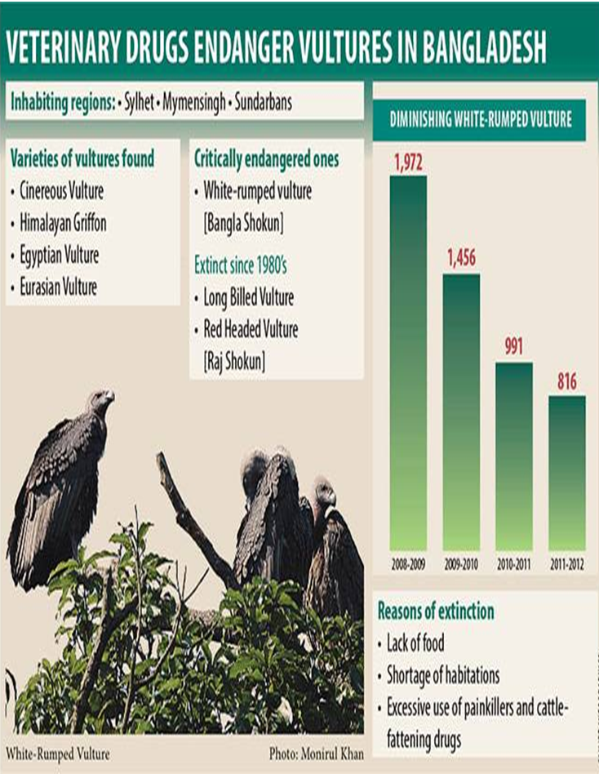

Conservation
Extensive farming that keeps livestock in the open (instead of keeping them in stables all the time) and leaves dead animals there for vultures is important, at least in some areas where there are not enough dead wild mammals like deer, boars or chamois.
European laws that forced all farmers to remove dead animals that died on their farmland have now been changed so that it is again possible - under certain rules - to leave dead animals in the countryside for vultures and other raptors like eagles or kites.
Illegal shooting and poisoning must be stopped. Reintroduction programs can be very successful. In France, there are successful reintroduction programs in the Alps and in the Massif Central and the Griffon Vulture is now established there again as a breeding species.

Ten year conservation plan for endangered vultures
The government will announce a 10-year conservation action plan (2016-2025) to protect the country’s endangered vultures from extinction. IUCN Bangladesh and Bangladesh Forest Department jointly organized the national workshop on ‘Bangladesh Vulture Conservation Action Plan’ at the auditorium of the Forest Department in the capital.
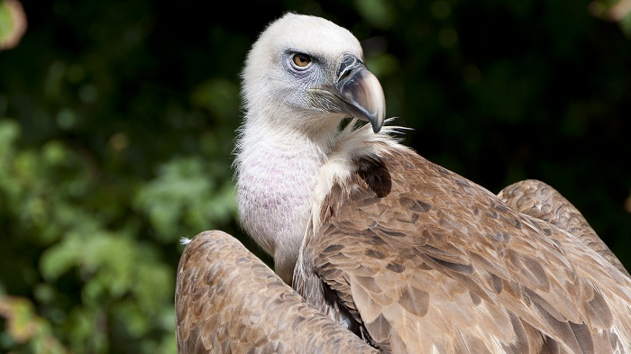

The workshop was arranged to present the draft ‘Bangladesh Vulture Conservation Action Plan’ to scientists, experts and other stakeholders to receive their suggestions to finalise the proposed action plan.About the present status of vulture population, they said there are only 268 White-rumped vultures and about 100 Himalayan Griffon vultures in Bangladesh.
To save Asia’s critically endangered vultures from extinction IUCN Bangladesh in collaboration with the Forest Department has taken an initiative titled ‘White-rumped Vulture conservation in Bangladesh: Establishment of toxic drug free Vulture Safe Zones (VSZ)’. The initiative is a subproject of the World Bank-funded ‘Strengthening Regional Cooperation for Wildlife Protection Project’.

Safe Zone for Vulture in Bangladesh
The Government of Bangladesh has declared two safe zones for Vultures where ‘zero tolerance' will be shown towards using ‘Diclofenac’ and other harmful veterinary drugs under article 20 (1) of Wildlife (Conservation and Security) Act 2012. The designated areas are Sylhet, parts of Dhaka and Chittagong covering an area of 19,663.18 sq km (1,966,318 ha) as Vulture Safe Zone-1 and Khulna, Barisal and parts of Dhaka covering an area of 27,717.26 sq km (2,771,726 ha) as Vulture Safe Zone-2 (VSZ).
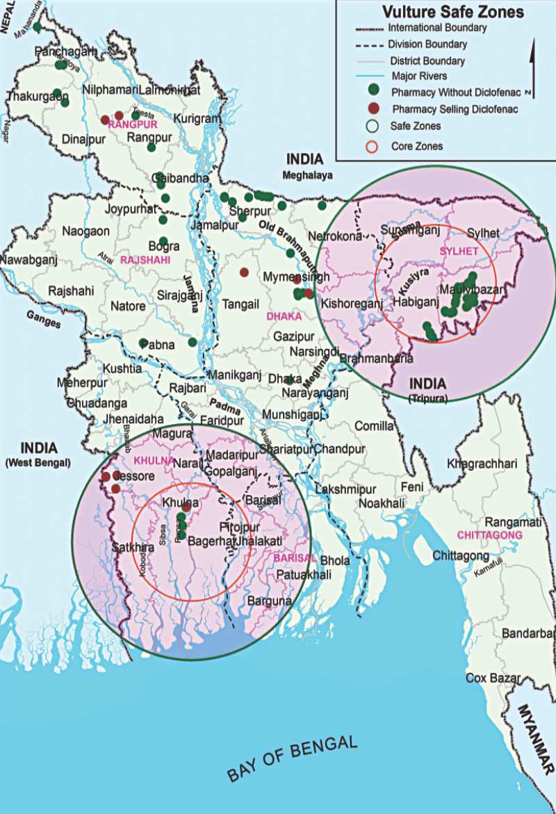
Figure: Safe zone for vulture in Bangladesh

CHAPTER IV

Recommendations and Limitations

Recommendations
- Govt. departments should take proper steps to make sure the conservation of the Griffon vulture in Bangladesh.
- Use of veterinary drugs should be controlled.
- Keeping people abstain from destroying the natural habitats.
- In zoo and safari parks the griffon vulture should take proper care and should look for the appropriate breeding strategy.

Limitations

- The study period was too short.
- Difficulty in communication.
- The data about the griffon vulture were passively collected relying on the articles available.

CHAPTER V

Conclusion
Today the situation has come to the point that only about 500 of the majestic birds are now left in Bangladesh. Things could have been on a continuous decline unless environmentalists started raising alarms. The government also woke up to the concern and banned production and use of diclofenac. And then a Bangladesh National Vulture Recovery Committee was formed. And a Vulture Safe Zone was declared where no harmful medicines would be allowed for cattle and nesting trees would be maintained. The government needs to develop an up to date action plan to conserve the species. We need also to support our conservation partners, showing farmers that there are alternative drugs to diclofenac that are just as effective in treating cattle.

CHAPTER VI

References

Ali, S. and Ripley, S.D., 1987. Compact handbook of the birds of India and Pakistan. Oxford University Press, Delhi, 296-314.
BirdLife International (2013). "Gyps fulvus". IUCN Red List of Threatened Species. Version 2013.2. International Union for Conservation of Nature. Retrieved 26 November 2013.
BirdLife International/European Bird Census Council. 2000. European bird
populations: estimates and trends. BirdLife Conservation Series no. 10.
BirdLife International,Cambridge, UK.
del Moral, J.C. (ed.). 2009. [The Griffon Vulture: breeding population in
2008 and census method]. Seguimiento de Aves no. 30. SEO/BirdLife
International, Madrid, Spain. (In Spanish with English summary)
Donázar, J.A. 1993. [The vultures of Spain: biolgy and conservation]. J.M.
Reyero, Madrid, Spain. (In Spanish)
http://archive.dhakatribune.com/environment/2014/mar/16/study-abuse-veterinary-drugs-endangering-vulture-species
http://easylearnrs.blogspot.com/2012/12/bangabandhu-sheikh-mujib-safari-park.html
http://en.banglapedia.org/index.php?title=Vulture
http://www.birdlife.org/europe-and-central-asia/ban-veterinary-diclofenac-now-faq
http://www.globalraptors.org/grin/SpeciesResults.asp?specID=8264
http://www.newsnaturebd.com/bangladesh-to-take-10-year-conservation-plan-to-save-vulture
http://www.thedailystar.net/news-detail
http://www.world-birds.com/birds/a/bangladesh
https://en.wikipedia.org/wiki/Griffon_vulture
Lerner, H.R., and D.P. Mindell. 2005. Phylogeny of eagles, Old World
vultures, and other Accipitridae based on nuclear and mitochondrial DNA Molecular Phylogenetics and Evolution 37:327-346.

