Chapter 1: Introduction

Biosecurity is a practice designed to prevent the spread of diseases from one farm to another. It can be defined as the exclusion, eradication and effective management of risks posed by pests and diseases to the economy, environment and human health (Biosecurity Council., 2003). It is the cheapest, most effective means of disease control available. No disease prevention program will work without it.
It is accomplished by maintaining the facility in such a way that there is minimal traffic of biological organisms (virus, bacteria, rodents, etc.) across its border. Risk management of biological hazards such as pests, pathogens and diseases can be broadly divided into actions which: i) take place before the biological hazard has materialised (preventive measures); ii) take place during an outbreak (eradication or control); and iii) aim at reducing the consequences in the presence of the hazard (control or adaptation).
However, biosecurity is a weakest link public good, where the total amount of protection approximately equals the level of the weakest provider (Burnett., 2005 and Perrings et al., 2002). The EU has formulated the new Common Animal Health Policy 2013, with the slogan “prevention is better than cure” (European Communities official publication., 2007). This promotes a shift in policy from eradication to prevention.
It matters little that everyone else in the production chain undertakes high biosecurity, if one of the key agents (’the weakest link’) does little to prevent the entry of diseases. Hence, incentives for high biosecurity in production systems should be built into appropriate policies. Although a few studies have assessed preventive actions against alternative strategies (Heikkilä., 2011), the farm-level costs of preventive biosecurity have rarely been assessed.
There is no study take place in our country to measure the expenses of farm biosecurity. A good biosecurity status requires investments in prevention. In order to assess the efficiency of biosecurity as a whole, we also need to
account for the costs which ensue at those times when there are no disease outbreaks. However, the farm-level expenses of preventive biosecurity measures have generally not been calculated.
A number of recent studies have identified key on-farm biosecurity measures in the production of beef (Brandt et al., 2008), pork (Casal et al., 2007 and Ribbens et al., 2008) and poultry (East., 2007 and Garber et al., 2007). There have also been studies assessing the benefits of preventive actions in general (Finnoff et al., 2007), as well as studies on farm-level economics related to optimal control of animal diseases (Chi et al., 2002 and Hennessy., 2007).
The farm-level expenses are important for at least four reasons. First, many management practices are in place even in the absence of an outbreak, but an outbreak may increase these expense. Costly preventive actions may reduce the resources required and the costs of eradication in the event of a disease outbreak, although this impact has rarely been studied. Second, farm-level biosecurity provides the foundation for biosecurity in the entire production chain. This is particularly important in a system such as the EU, where the production strategy is based on biosecurity and safety in the entire production chain. Third, the farm-level costs in part determine the incentives which producers have in providing biosecurity, which is to a large extent a weakest (or weaker) link public good (Perrings et al., 2002). Identifying these costs can help in designing incentive schemes for better biosecurity. Finally, the EU is currently looking into several cost-sharing schemes related to animal diseases (European Commission., 2006).
As no study has been done regarding expenses of biosecurity in poultry farm, I contribute towards filling the information gap regarding the current expenses of biosecurity at farm level by examining the expenses incurred by preventive biosecurity for Finnish poultry farms.
The aims of the study are:
1) To estimate the total level of monetary and labour costs of preventive biosecurity in poultry farms.
2) To identify the largest and smallest cost components within the farms.

Chapter 2: Materials and Methods

The condition regarding poultry diseases in general is relatively good in Bangladesh compared to many other countries in worldwide (Heikkilä et al., 2008 and Evira., 2010). All parts of the food chain, including feed, the animal and food industry as well as the government, are rationally committed to the policy of preventive biosecurity. The prevalence of Salmonella in Finish poultry is normally below 1% and as for other poultry diseases, in 2015 there were a lot of cases of Newcastle disease, Gumboro and few cases of avian influenza or infectious bronchitis diseases have found (Evira., 2010). The overall mortality rates in broiler production are also low.
This study was completed in some villages (Kelishahar, Haidgaon and Kochuai) of patiya upazilla and involved interviews with 20 broiler poultry farms. All the producers participated in the study voluntarily. They were selected with the assistance of veterinarians and some local people who provided the contact details as well as gave assistance in influencing the producers to participate. They give different information regarding the details of production, including some aspects of biosecurity.
The data were collected through a survey of the farms and concerned the 2015 production year. The questionnaire was designed with the extensive help and consultation of experts in poultry production, and it dealt with different types of actions related to biosecurity at the farm level. Only actions primarily taken for disease management purposes were included in the questionnaire. The questions were divided into 19 categories.
The questions were asked to the producers roughly through visiting of the farm. Personal interviews were required in order to present the complex issues logically to the producers, as well as to avoid double counting of different types of costs (Babbie., 1992). The interview was semi-structured and all the producers answered the same set of questions, but their answers were not restricted in any way. Further questions were asked to check the consistency of the answers. For instance, if the producer indicated a certain component costing 100 taka per month, it was mentioned that this would mean an annual cost of 1,200 taka, and the producer was asked whether this was correct.
The biosecurity costs were calculated for each of the categories using Microsoft Excel (Microsoft Corporation, Redmond). The costs were divided into direct monetary costs and costs in terms of labour. These were also transformed into costs per bird per year, where the annual number of birds produced was used.
A summary of data was given in table 1:
Broiler producer
 | Birds/year | Density(sq.ft) | Birds/Batch | Batch/year
Mean | 13800 | 1 | 1725 | 8
Minimum | 6400 | 1 | 800 | 8
Maximum | 24000 | 1 | 3000 | 8

The variation in the total cost per bird was assumed to depend on the size of the production unit measured in terms of the number of birds produced annually. The labour cost also calculated in this study that cost was given monthly.
The data for this study were collected by semi-structured interviews, which were all carried out by the same person in order to ensure inter-farm comparability. I believe that personal interviews, despite being time-consuming, are the best way to gather relatively complex data on disease prevention in a comparable way. A written questionnaire could result in more responses and thus more data to test, but the quality of the data would suffer, hence resulting in problems with statistical testing. As a result of this type of data acquisition, the amount of data collected cannot be extremely large. However, our dataset covers about 20 broiler producers. I also believe that the quality of the data more than compensates for the modest quantity

Photo Gallery
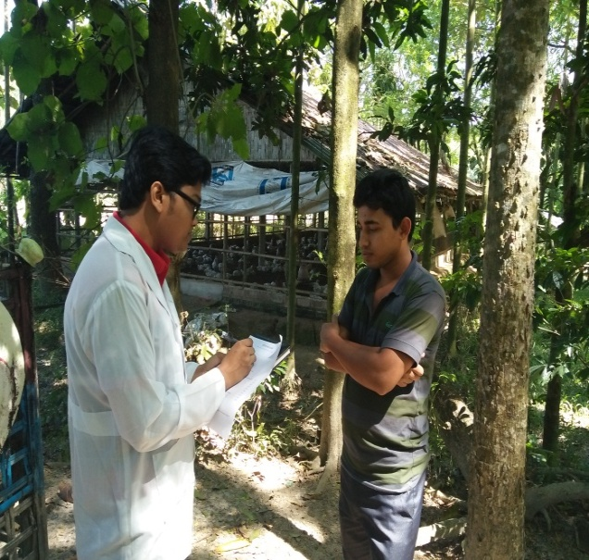
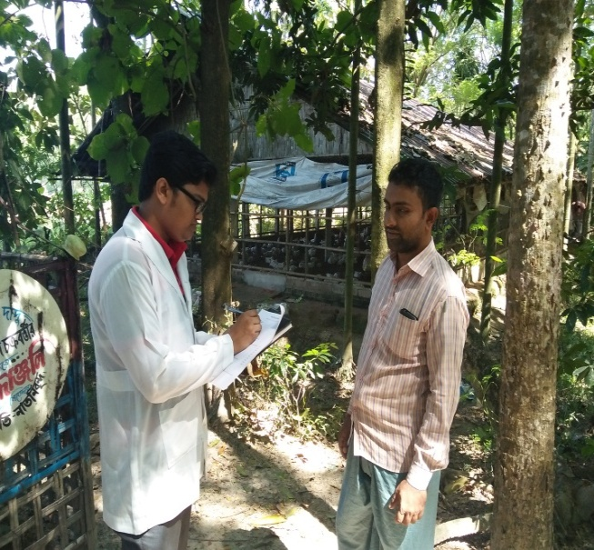
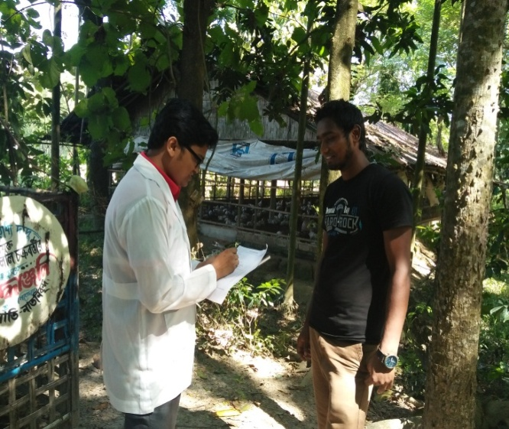
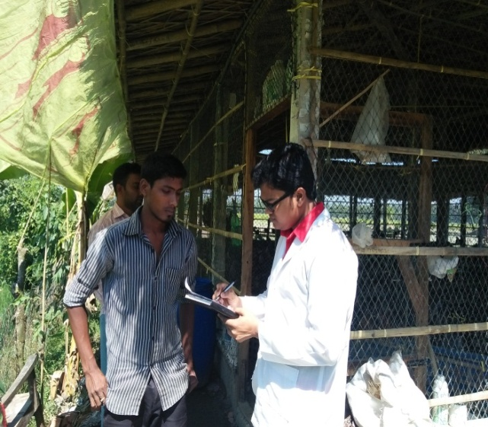
Fig 2.1: Collecting Data through asking Questions.
Chapter 3: RESULTS

Table 2: The expenses of biosecurity per bird per batch in broiler farm were given below:
No. of  Farm | Flock  Size | A  Tk | B  Tk | C  Tk | D  Tk | E  Tk | F  Tk | G  Tk | H  Tk | I  Tk | J  Tk | K  Tk | Total  Cost  Tk
1 | 1800 | 0 | 16.67 | 0.16 | 0.13 | 0.31 | 2.78 | 0.22 | 0.44 | 1.38 | 0 | 4.22 | 26.31
2 | 1400 | 0.09 | 18.14 | 0.14 | 0.36 | 0.28 | 2.85 | 0.28 | 0.35 | 1.43 | 0 | 3.57 | 27.5
3 | 800 | 0 | 21.12 | 0.25 | 0.625 | 0.25 | 3.125 | 0.5 | 0.375 | 1.5 | 0 | 5.62 | 33.36
4 | 3000 | 0 | 16.33 | 0.33 | 0 | 0.5 | 2.33 | 0.13 | 0.33 | 0.5 | 0.16 | 3.33 | 23.94
5 | 2000 | 0 | 16 | 0.15 | 0.125 | 0.275 | 3 | 0.2 | 0.4 | 1 | 0 | 3.75 | 24.9
6 | 1400 | 0 | 16 | 0.14 | 0.4 | 0.28 | 2.8 | 0.3 | 0.36 | 1.45 | 0 | 3.6 | 25.33
7 | 900 | 0 | 16.67 | 0.22 | 0 | 0.22 | 2.22 | 0.44 | 0.33 | 1.11 | 0 | 3.33 | 24.54
8 | 2500 | 0 | 16 | 0.4 | 0.2 | 0.6 | 2.8 | 0.16 | 0.32 | 0.4 | 0.2 | 3.2 | 24.28
9 | 1200 | 0.1 | 20 | 0.16 | 0.25 | 0.33 | 1.67 | 0.42 | 0.42 | 1.67 | 0.33 | 2.5 | 27.82
10 | 1500 | 0 | 19 | 0.13 | 0.35 | 0.3 | 2.9 | 0.28 | 0.35 | 1.43 | 0 | 3.57 | 28.31
11 | 3000 | 0 | 16 | 0.33 | 0 | 0.52 | 2.35 | 0.13 | 0.33 | 0.5 | 0.16 | 3.35 | 23.67
12 | 1800 | 0.1 | 16 | 0.14 | .12 | .265 | 2.9 | 0.2 | 0.4 | 1 | 0 | 3.73 | 24.85
13 | 900 | 0 | 15.6 | 0.21 | 0 | 0.20 | 2 | 0.44 | 0.33 | 1.11 | 0 | 3.34 | 23.23
14 | 2300 | 0.1 | 16.2 | 0.3 | 0.2 | 0.6 | 2.7 | 0.15 | 0.32 | 0.4 | 0.2 | 3.1 | 24.28
15 | 1500 | 0 | 18 | 0.13 | 0.35 | 0.31 | 2.9 | 0.28 | 0.35 | 1.43 | 0 | 3.6 | 27.35
16 | 1000 | 0 | 16.67 | 0.22 | 0 | 0.22 | 2.22 | 0.44 | 0.33 | 1.11 | 0 | 3.33 | 24.54
17 | 1500 | 0 | 16 | 0.14 | 0.4 | 0.28 | 2.8 | 0.3 | 0.36 | 1.45 | 0 | 3.6 | 25.33
18 | 2800 | 0 | 16.33 | 0.33 | 0 | 0.5 | 2.33 | 0.13 | 0.33 | 0.5 | 0.16 | 3.33 | 23.94
19 | 1200 | 0.1 | 19 | 0.16 | 0.3 | 0.33 | 1.67 | 0.42 | 0.42 | 1.67 | 0.33 | 2.5 | 26.9
20 | 1500 | 0 | 16 | 0.14 | 0.4 | 0.28 | 2.8 | 0.3 | 0.36 | 1.45 | 0 | 3.6 | 25.33
Average cost= 25.28

Where, A= Biosecurity plan, B=Preventive medication, C=Pest control, D=Equipment, E=Additional cleaning, F=Construction plan and invest, G=Health monitoring program, H=Operational hygiene, I=Time period to keep premises empty, J=Production monitoring, K=Control and inspection, Tk=Taka.

The average total cost of preventive biosecurity for the broiler producers in our sample population was 25.28 taka per bird (90% confidence interval 23.23-33.36 taka per bird). For broiler producers, the direct monetary cost was on average 21.77 taka per bird (86% of costs) and the labour cost 3.5 taka per bird (14%). On a per bird per rearing day basis, the corresponding figures were 0.84 taka (30 days rearing) for broiler producers. Time period for keeping the production premises empty was also included in the results, as there were cases where the production premises had been kept empty for a prolonged period of time for disease management purposes. The costs per bird in relation with keep premises empty were 1.25 taka (4.97%). The figure illustrates that only a few categories produce the majority of the expenses. The main constituent of the costs was preventive medication, which includes vaccines, the use of coccidiostats in broiler feed as a preventive measure to control coccidiosis and the use of prophylaxis antibiotics etc. for the prevention of diseases. The two other larger components were additional cleaning and construction plan and invest. The smallest cost components for the broiler producers included the biosecurity plan, operational hygiene and health monitoring programme, equipment cost which can hardly be affected by the producer. Pest control education and production monitoring had a small share of total expenses for the broiler producers.

Table 3: The costs per bird for preventive biosecurity measures in Finnish poultry were given below:
Cost per bird (taka)
Broiler producer | mean | median | maximum | minimum
 | 25.28 | 25.33 | 33.36 | 23.23

Prevention biosecurity is the main expenses of biosecurity whereas labour expenses contribute second largest cost in biosecurity.

Where, A= Biosecurity plan, B=Preventive medication, C=Pest control, D=Equipment, E=Additional cleaning, F=Construction plan and invest, G=Health monitoring program, H=Operational hygiene, I=Time period to keep premises empty, J=Production monitoring, K=Control and inspection, Tk=Taka.

Chapter 4: Discussion

This study represents one of the first attempts to determine the total farm-level costs of biosecurity during a disease-free period. Our results indicate that the average cost of biosecurity is some 25.28 taka per bird for broiler producers (0.84 taka per bird per rearing day). For a batch of 3000 broilers, the total cost would be 71820 taka.
Table 4: The average cost of biosecurity in each category of broiler producers per bird was given below:
Category | A | B | C | D | E | F | G | H | I | J | K
Tk/bird | 0.02 | 17.08 | 0.209 | 0.21 | 0.34 | 2.56 | 0.28 | 0.36 | 1.12 | 0.07 | 3.51
% of cost | 0.09 | 67.46 | 0.82 | 0.82 | 1.34 | 10.1 | 1.12 | 1.42 | 4.42 | 0.3 | 13.82

The results also indicate that the work time devoted to biosecurity represents some 4.97% of the total expenses on broiler farms biosecurity. The results are also qualitatively in line with those of studies undertaken on cows and pigs in the United States, where in all cases it was found that the cost of medication and biologics were the primary constituents of the disease prevention costs (Sischo et al., 1986-87, Miller and Dorn., 1990).

Fig 4.2: The percentage of cost of biosecurity in each category per bird

Where, A= Biosecurity plan, B=Preventive medication, C=Pest control, D=Equipment, E=Additional cleaning, F=Construction plan and invest, G=Health monitoring program, H=Operational hygiene, I=Time period to keep premises empty, J=Production monitoring, K=Control and inspection, Tk=Taka.

The result also indicated that higher the number of birds, the lower the cost per bird. In other words, larger units incur lower expenses of preventive biosecurity per bird. Besides, higher percentages of cost were found in case of preventive medication, control and inspection, construction plan and invest 67.46%, 13.82% and 10.1% respectively.
The rest of other categories contributed very little percentage of total cost, where time period to keep premises empty contributed 4.42% of total cost.
In the dataset, bird density varied from 1 to 2 birds per ft². If the bird density on the costs was examined, it was found that bird density was positively related to the labour costs of biosecurity. This suggests that when the bird density is higher, greater labour resources need to be invested in their health and welfare and hence disease prevention. This may due to for instance, to the fact that the potential disease pressure is higher when the bird density is high.
In the analysis the preventive medication cost was found highest because the producers use too many medicines for the prevention of diseases.

.

Conclusion

After completing the study, we got an idea of how the costs are currently distributed. I investigated the costs paid by the producers for preventive biosecurity, determined the largest cost components. My results indicate that the average cost of biosecurity is some 25.28 taka per bird for broiler producers. For broiler producers the main constituents of the costs were preventive medication, control and inspection and construction plan and invest where preventive medication cost is the highest cost in comparison to other expenses in biosecurity. I also found that, the higher the number of birds, the lower the expenses of biosecurity per bird. This impact is primarily due to decreasing labour costs rather than direct monetary costs.

Limitations

Although the main objective in the current study was to examine the expenses of preventive biosecurity at the level of poultry production farms, we also had some methodological issues in mind. In the future, the current methodology and the questionnaire could be applied: 1) to investigate the costs at other points in the poultry production chain as well as to determine how much the chain as a whole is investing in biosecurity and 2) to explore the costs for different types of animal production chain. However, for application in other countries, some modifications need to be made. Poultry production legislation and practices vary country to country, and national regulations may differ. Hence, the questionnaire used in this study may require some revision to be applicable elsewhere.
The average size of the farms in the sample is somewhat smaller than the average size of all broiler farms in Bangladesh. If the farm size increases the cost of biosecurity will be decreased.

References

Babbie E: The practice of social research. 6 edition. Belmont, California: Wadsworth Publishing Company; 1992.
Biosecurity Counci: Tiakina Aotearoa. Protect New Zealand: the biosecurity strategy for New Zealand New Zealand: Biosecurity Council; 2003.
Brandt AW, Sanderson MW, DeGroot BD, Thomson DU, Hollis LC: Biocontainment, biosecurity, and security practices in beef feedyards. J Am Vet Med Assoc 2008, 232:262-269.
Burnett KM: Introductions of invasive species: failure of the weaker link. Northeastern Agricultural and Resource Economics Association’s (NAREA) workshop on Invasive Species, Annapolis, Maryland; 2005.
Casal J, De Manuel A, Mateu E, Martin M: Biosecurity measures on swine farms in Spain: perceptions by farmers and their relationship to current on-farm measures. Prev Vet Med 2007, 82:138-150.
Chi JW, Weersink A, VanLeeuwen JA, Keefe GP: The economics of controlling infectious diseases on dairy farms. Can J Agr Econ 2002, 50:237-256.
East IJ: Adoption of biosecurity practices in the Australian poultry industries. Aust Vet J 2007, 85:107-112.
European Commission: Evaluation of the Community Animal Health Policy (CAHP) 1995-2004 and alternatives for the future. Final report. Brussels: European Commission; 2006.
European Communities: A new Animal Health Strategy for the European Union (2007-2013) where “Prevention is better than cure”. COM 539,: final. Luxembourg: Office for Official Publications of the European Communities; 2007, 2007.
Evira: Eläintaudit Suomessa 2009 (Animal diseases in Finland,: Eviran julkaisuja 8/2010. Helsinki: Evira; 2009, 2010.
Finnoff D, Shogren JF, Leung B, Lodge D: Take a risk: preferring prevention over control of biological invaders. Ecol Econ 2007, 62:216-222.
Garber L, Hill G, Rodrigues J, Gregory G, Voelker L: Non-commercial poultry industries: surveys of backyard and gamefowl breeder flocks in the United States. Prev Vet Med 2007, 80:120-128.
Heikkilä J, Niemi JK: Eläintautivahinkojen rahoitusvaihtoehdot: käytännöt, kannustimet ja kustannukset (Alternatives for financing animal disease epidemics: principles, practice and propositions). MTT:n selvityksiä 168. Helsinki: MTT Agrifood Research Finland; 2008.
Heikkilä J: Economics of biosecurity across levels of decision-making: a review. Agron Sust Devel 2011, 31:119-138.
Hennessy DA: Biosecurity and spread of an infectious animal disease. Amer J Agr Econ 2007, 89:1226-1231.
Miller GY, Dorn CR: Costs of dairy cattle diseases to producers in Ohio. Prev Vet Med 1990, 8:171-182.
Miller GY, Dorn CR: Costs of swine diseases to producers in Ohio. Prev Vet Med 1990, 8:183-190.
Perrings C, Williamson M, Barbier EB, Delfino D, Dalmazzone S, Shogren J,Simmons P, Watkinson A: Biological invasion risks and the public good: an economic perspective. Cons Ecol 2002, 6:1.
Ribbens S, Dewult J, Koenen F, Mintiens K, De Sadeleer L, de Kruif A, Maes D: A survey on biosecurity and management practices in Belgian pig herds. Prev Vet Med 2008, 83:228-241.
Sischo WM, Hird DW, Gardner IA, Utterback WW, Christiansen KH, Carpenter TE, Danaye-Elmi C, Heron BR: Economics of disease occurrence and prevention on California dairy farms: a report and evaluation of data collected of the national animal health monitoring system, 1986-87. Prev Vet Med 1990, 8:141-156.
QUESTIONNAIRE
Measuring the Expenses of Biosecurity

- Name of the farm : …………………………………………………………..
- Owner’s name : ………………………………………………………..
- Education : ………………………………………………………….
- Address : ………………………………………………………….
- Contact no. :……………………………………………………………
- Types of farm : Broiler/ Layer/ Breeder
- Flock size : …………………………………………………………
- Biosecurity condition of the farm: Excellent/ Good/ Fair
- Cost of biosecurity plan (advisor fee for designing) : ….…….……..BDT
- Cost of preventive medication (vaccination, coccidiostate, probiotic, etc.......BDT
- Cost of pest control (pesticides, Trap) :…………….....BDT
- Cost of equipments (vaccine gun, clothing, shoe) : ………………BDT
- Cost of additional cleaning (gassing, fumigation) : ………………BDT
- Cost of construction plan and invest : ………………BDT
- Cost of health monitoring program : ………………BDT
- Cost of operational hygiene : ………………BDT
- Cost of time period to keep premises empty : ………………BDT
- Cost of production monitoring (sick birds, lab cost, diseases): ……………...BDT
- Cost of control and inspection (Labour cost) : ……………..BDT

________________________
Signature of Information collector

Acknowledgements

The author wishes to acknowledge the immeasurable grace and profound kindness of Almighty “GOD” the supreme authority and supreme ruler of universe, who empowers the author to complete the work successfully.

The author feels proud in expressing his deep sense of great gratitude and indebtedness to respected teacher and supervisor Prof. Shahnaz Sultana, Dept. of Agricultural Economics and Social Science, Faculty of Veterinary Medicine, Chittagong Veterinary and Animal Sciences University for her trustworthy and scholastic supervision.

The author is ever grateful to Professor Dr. Md. Ahasanul Hoque, Honorable Dean, Faculty of Veterinary Medicine, Chittagong Veterinary and Animal Sciences University and Professor Dr. A.K.M. Saifuddin, Director, External Affairs, Chittagong Veterinary and Animal Sciences University, for arranging such type of research work as a compulsory part this internship programme and providing kind support in this regard.

The author gratefully admits the help of the people of Patiya upazilla who provide the information and valuable suggestion during the entire period of the study.

The author expresses thanks and warmest sense of gratitude to his parents and all well-wishers.

The Author
November, 2016

Biography
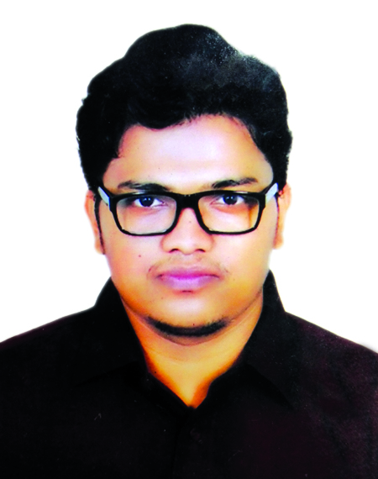

I am Probir Deb, son of Mr. Prodip Kumar Deb and Mrs. Baby Deb. I passed my Secondary School Certificate examination in 2008 followed by Higher Secondary Certificate examination in 2010. Now I am an intern veterinarian under the Faculty of Veterinary Medicine in Chittagong Veterinary and Animal Sciences University. In the future, I would like to work as a veterinary practitioner and do research on Cancer in Bangladesh.

