**A Clinical Case Report on Rumenotomy of a cow in Chittagong, Bangladesh**



**A Clinical Report Submitted By**

**MINHAZUL ISLAM**

**Roll No: 13/06,**

**Reg No: 00912**

**Intern ID: 06**

**Session: 2012-2013**

A Clinical report presented in partial fulfillment of the requirements for the Degree of Doctor of Veterinary Medicine (DVM) under faculty of Veterinary medicine.

**CHITTAGONG VETERINARY AND ANIMAL SCIENCES UNIVERSITY**

**Khulshi, Chittagong-4225**

**A Clinical Case Report on Rumenotomy of a cow in Chittagong, Bangladesh**



A Clinical report presented in partial fulfillment of the requirements for the Degree of Doctor of Veterinary Medicine (DVM) under faculty of Veterinary medicine

|  |  |
| --- | --- |
| **Signature of Author**  **MINHAZUL ISLAM**  Roll. No: 13/06  Registration No:00912  Internship ID: 06  Session: 2011-12 | **Signature of Supervisor**  **Dr. Bibek Chandra Sutradhar**  Professor  Dept. of medicine and surgery  Chittagong Veterinary and Animal Sciences University  Khulshi,Chittagong-4202 |

**Table of contents**

|  |  |  |  |
| --- | --- | --- | --- |
| **Chapter** | **Contents** | | **Page No** |
|  | Abstract | | V |
| Chapter 1 | Introduction | | 5 |
| Chapter 2 | Case presentation | | 6 |
|  | 2.1 | Study area |
| 2.2 | Study detail |
| 2.3 | Diagnosis |
| 2.4 | Treatment |
| Chapter 3 | Materials and method | | 7-8 |
|  | 3.1 | Required materials |
| 3.2 | Preparation of patient |
| 3.3 | Rumenotomy |
| 3.4 | Abdomen closure |
| 3.5 | Post-operative management |
| 3.6 | Complication management |
| Chapter 4 | Results and Discussion | | 9 |
|  | Conclusions and recommendations | | 10 |
|  | Summary and importance | | 11 |
|  | Acknowledgements | | 12 |
|  | References | | 13-14 |
|  | Biography | | 15 |

**Abstract**

Rumenotomy is a routine procedure for the treatment and diagnostic purpose in ruminants. This case report describes the management of bloat in cattle. One of the methods of correcting bloat is rumenotomy. The animal was stabilized with fluids and electrolytes preoperatively. Surgical site was prepared after clipping the hair and cleansing the skin with antiseptic. Para-vertebral nerve block by using 2% lignocaine hydrochloride was done. A long skin incision starting about eight to ten centimeters below the transverse process of the lumbar vertebrae was made vertically. The abdominal muscles and peritoneum were also incised corresponding to the skin incision. The rumen was fixed with the stay suture with the skin or towel clump. After removing the content of the rumen, it was closed by double lambert suture. Then closing the peritoneam and muscle with cat gut by simple continuous pattern. Skin was sutured with nylon using cross mattress suture. There was no complication after seven days of our follow-up observation. Results indicated that rumenotomy can be an effective in treating or relieving complications secondary to forestomach disorders in cattle. Bovids undergoing rumen surgery had a favorable prognosis for survival and production.

**Key words:** Rumenotomy, Bloat, Surgical management.

**Introduction**

Bloat is a seasonal problem in both dairy and beef cattle. Bloat is the accumulation of excess gas in the rumen and can develop in less than one hour due to production of gas which is trapped in rumen. The condition is usually precipitated by the rapid consumption of lush legume pasture. Bloat is caused by an increase in the gas pressure within the rumen as these feeds are fermented. Bloat is two types such as frothy bloat and free gas bloat. Clinical signs include anorexia, distension of abdomen, frequently stand up and sit down, strain to urinate and defecate, reluctant to move etc. Bloat is a matter of concern for the farmers as it causes economic loss which decreases the milk production through decreasing the feed consumption and decreasing digestibility. It causes the severe respiratory distress which may leads to death in severe case. The commonest treatment of bloat is passing stomach tube or anti bloat medicine in mild or medium cases. In a few cases a trochar and cannula punched through the side into the rumen will relieve gassy bloat when a stomach tube has not worked. For frothy bloat anti-foaming agents that disperse the foam should be given by stomach tube to cure frothy bloat. But in severe cases rumenotomy is suggested. There are four method of rumenotomy. They are-Stay suture rumenotomy (SSR), Rumen skin clamp fixation (RSCF), Rumen skin suturing fixation (RSSF), Weingarth's ring rumenotomy (WRR) .Animal can die in severe cases of bloat. A dairy cow has great economic value to a farmer. The importance of the study is to increase the milk production of the farm, reduce the economic loss of farm through the saving the life of animal.

The objective of the study was to perform rumenotomy to cure the animal suffering from bloat.

**Case Study**

Female cattle of 2.5 years and about 450kg in the farm were informed with the history of swollen abdomen, loss of appetite and were in downers cow syndrome. The cow belongs to a dairy farm at chawkbazar, Chittagong, Bangladesh. Bloat can be diagnosed in many ways such as-feeding history, clinical sign, rectal palpation etc. My diagnostic procedure was taking the feeding history and the clinical sign. According to history, there was distension of abdomen, reduce feed intake for last few days and were in downers cow syndrome. Distension is usually more obvious in the upper left flank, although the whole of the rumen can be enlarged. The animal is uncomfortable and get up and lay down frequently. Ultrasound examination and further laboratory examination were not available. By clinical sign it can be said that the case is bloat.

There are many treatment procedure of bloat depends on the type of bloat. As it is severe case the animal was undergo rumenotomy for the correction. As there are four types of rumenotomy, Stay suture rumenotomy is more preferable. Surgery was performed at the farm. Shave the incision area and Para-vertebral nerve block. Line block at the incision line and incise at paralumbar fossa after antiseptic wash. Expelling out of the ruminal content and closing of the rumen. There may be many complications if proper post-operative care does not take. Broad sprectum antibiotic, analgesic and antiseptic wash of incised area were preferred.

**Materials and method**

Rumenotomy is a clean contaminated operation. For the rumenotomy, an operation room is necessary.As there was no operation room we performed the operation outside. The materials required for the rumenotomy are trimmer or blade for shaving, Anaesthetic (2% lidocaine), sterilized drapper, surgical instrument, suture etc.

We performed Paravertebral anaesthesia (60ml) at 1st, 2nd and 4th lumbar vertebra. After that, shave of the surgical area with blade to reduce the contamination by hair. Then line block (10ml) by 2% lidocaine at the incision line was done. Before incision antiseptic wash of the operation site properly. Then drapping of the surgical site by sterilized drapper. Vertical incision was done on para-lumbar fossa at left side of the rumen. Incise chronologically skin, subcutaneous tissue, muscle, peritoneam and then exteriorization of rumen. Wash the edge of rumen with normal saline. Stay suturing of the rumen to fix and incision of rumen. The incise edges was fixed with towel clump. Then around the ruminal contents was expelled out manually. After removing the ruminal content the rumen is closed by double lambert suture, then peritoneum by simple continuous suture and muscle also continuous suture. Then subcutaneous suture and skin suture for closing the skin. Post-operative complications were checked by post-operative care. Antibiotic, saline, antihistaminic and pain killer admin as post-operative management. Antiseptic wash of the incised area routinely. Suture was removed after 14days.

At best, rumen surgery is considered a clean contaminated surgery since a hollow viscous is penetrated. [Fubini and Ducharme 2004] recommended that the commonest complications should be wound dehiscence and hemorrhage. Others included fever, edema, slipped ligature, wound infection, peritonitis, death, intestinal obstruction/adhesion and physiological bloat. Antibiotics and analgesic are recommended in any surgery that is considered less than clean.Haven et al. showed that prophylactic use of penicillin significantly decreased the incidence of abscess formation following rumenotomy. He also demonstrated that an initial antibiotic dose at the time of surgery was all that was necessary, and continuing the therapy for several post-operative days had no significant decrease on the incidence of abscess and infection rate.

[Johnston and Morris (1987] recommended post-operative fluid therapy (oral and intravenous) complemented with administration of analgesics to treat dehydration, shock, electrolyte imbalance and to moderate the vigor of peristalsis of the bowel in intestinal surgery

**Result and discussion**

Prognosis is favourable. Single abdominal abscesses (reticulum, liver) also carry a favorable prognosis if they could be drained or resected. [Herzog *et al.* 2004].suggested extensive adhesions in the cranial abdomen were not necessarily associated with a poor prognosis. If the adhesions did not involve the vagus nerve, ruminal motility did not appear to be greatly impaired by the presence of adhesions. This might be because of the rumen wall was protected from restricting adhesions by the superficial layer of the greater omentum. There were not any post-operative complications. The animal has become cure after post-operative care.

Bloat is more susceptible to cattle feed legume grass and imbalance of roughage concentrate ratio. All the animal of the farm were supplied roughage and concentrate. Any change of the ratio will cause bloat or other complications. The animal with bloat was completely correct after surgery. If performed correctly, the rumenotomy procedure can be a safe and effective way to retrieve ingested foreign bodies and address other problems of the ruminant forestomachs (Andrew j niehaus). Bovids undergoing rumen surgery had a favorable prognosis for survival and a fair prognosis for potential return to production (hartinack AK, 95 cases, (1999-2000).

The case of bloat detected in dairy farm in a 2.5 year cow was interesting. Positive result of the surgical treatment in such a complication found appropriate to share.

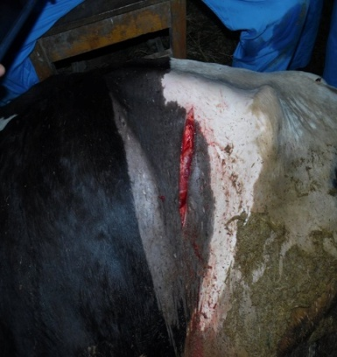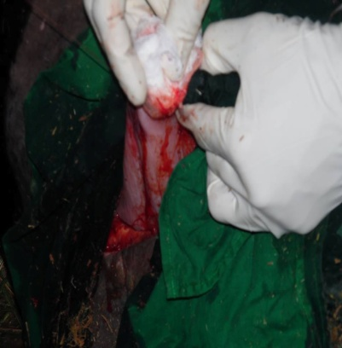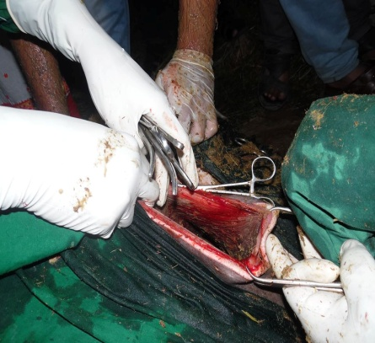

**Conclusion and Recommendations**

The stomachs of ruminants are closely associated anatomically and functionally, and diseases of one usually affect the others. Disorders such as bloat have no doubt plagued keepers of ruminant livestock since livestock were domesticated. Radiography, Ultrasonography and laparoscopy are the advanced diagnostic tools for ruminal disorder in bovine. Commonest complications are wound dehiscence, hemorrhage, edema, slipped ligature, wound infection, peritonitis, death, intestinal obstruction/adhesion and physiological bloat. Major economic importance due to severe loss of production and production ability and sometimes death of the animal needs a great attention for ruminal disorders in cattle. Therefore, based on the above conclusion the following recommendations are forwarded:

Create awareness among the cattle stockholders to give up excess feeding of poor roughage, concentrates and sugarcane which are the predisposing causes for bloat in bovine. Understanding the causes of bloat disorders in cattle and implementing current advanced surgical management practices may spare the production and economic losses associated with ruminal disorders.

Superior clinical examination and diagnostic tools should give due attention with veterinary professionals in management and control of bloat before it reaches risk stage. The ruminants’ owners should be advised not to allow their ruminants to freely wander in streets especially in the cities and as much as possible to prevent nutritional deficiencies.

Further studies should be conducted for controlling of visceral pain during rumenotomy with newer techniques.

The postoperative complications encountered in all animals if any should be recorded and managed accordingly.

**Summary and importance**

Rumenotomy is the most preferable method of the correction of bloat. The surgery is a clean contaminated surgery .So, there are many chances for post-operative complication. Post-operative cares should be emphasized the cow with bloat become cure without any post-operative complication.

Bloat is common problem in the dairy farms of Bangladesh. As feed consumption, defecation, physiological processes interrupted, milk production greatly fall down. Through rumenotomy we can corrected bloat which play an important role in the economic status of country.

**Acknowledgement**

The author is very grateful and indebted to the almighty Allah without whose grace it would have never been possible to pursue this study and to complete this clinical report writing for the degree of doctor of veterinary medicine (DVM). The author would like to thanks his reverend and beloved teacher and supervisor **professor Dr. Bibek Chandra Sutradhar**, Professor, Dept. of medicine & surgery, Chittagong Veterinary and Animal Sciences University for his valuable advice, suggestions and kind co-operation during the study period. The author would like to thanks to the Director of External affairs, **Professor Dr. AKM Shaifuddin**, Dept. of Physiology, Biochemistry and Pharmacology, Chittagong Veterinary and Animal Sciences University for his effective suggestion.

**References**

1. Hofmeyr F, Oehme F. Textbook of Large Animal Surgery. The digestive system. In: 2nd ed. Baltimore: Williams & Wilkins, 1988, 448.

2. Kumar R, Lakkawar A, Nair M, Varshney K. Gastrointestinal obstruction in cows. Indian Vet. J. 2003; 80:318-319.

3. Makhdoomi D, Singh A, Singh M, Krishnamurthy D. Intestinal obstruction in ruminants: A review. Indian J. Vet. Surg., 1995; 16:81-82

4. Ducharme N. Surgery of the bovine forestomach compartments. Vet Clin North Am., (Food Anim Pract), 1990; 6:371-397.

5. Hawkins L. Bovine Digestive Diseases *In*: Large Animal Digestive Diseases notes. LAMS 5350, 2002, 22-24.

6. Fubini S, Smith D. Failure of omasal transport due to traumatic reticuloperitonitis and intra abdominal abscess. *Compend. Contin. Educ. Prac. Vet.*, 1982; 4:492-494.

7. Carter R, Grovum W. A review of the physiological significance of hypertonic body fluids on feed intake and ruminal function: salivation, motility and microbes*. J. Anim. Sci.* 1990; 68:2811-2832.

8. Cheng K, McAllister T, Popp J, Hristov A, Mir Z, Shin H. A review of bloat in feedlot cattle. J Anim. Sci. 1998; 76:299-308.

9. Erdman R. Dietary buffering requirements of the lactating dairy cow: A review. J. Dairy Sci*.* 1988; 71:3246-3266.

10. Fubini S, Ducharme N. Surgery of ruminant forestomach compartment. In Farm Animal Surgery. S.L. Fubini and N.G. Ducharme (Eds), Saunders, Elsevier, 2004, 161-240.

11. Fubini S, Ducharme N, Erb H, Smith D, Rebhun W.. Failure of omasal transport attributable to perireticular abscess formation in cattle: 29 cases J. Am. Vet. Med. Assoc., 1980-1986, 1989; 194:811-814.

12. Johnston J, Morris D. Comparison of duodenitis, proximal jejunitis and small intestinal obstruction in horses: 68 cases (1977-1985). J Am. Vet. Med. Assoc., 1987; 191:849-854.

13. Herzog K, Kaske M, Bischoff C, Kehler W, Hoeltershinken M, Starke A *et al*. Post-surgical development of inflammatory adhesions and reticular function in cows suffering from traumatic reticulo peritonitis. Dtsch Tierarztl Wochenschr*,* 2004; 111:57-62.

**Biography**

This is **Minhazul Islam**, son of **Md. Tazul islam and Jesmin akter**. I am from comilla district. I have completed S.S.C in 2009 and H.S.C in 2011.I got admitted into Doctor of Veterinary Medicine(DVM) course under Chittagong Veterinary and Animal Sciences University in 2012-2013 session. As an upcoming Veterinarian I would like to dedicate my rest of the life for the welfare of animals. I am keen to be a field veterinarian as well as a skilled poultry practitioner.