CHAPTER – I
INTRODUTCTION
The Kangayam breed of cattle of Tamilnadu is the best known for its superior draught qualities, adaptation to poor nutrition and longevity (Kandasamy, 2001). Fibrosarcoma has been reported as mushroom-shaped growths, commonly protruding out from the vulva (Musal et al., 2007). It is a type of sarcoma, a malignant tumor of soft tissue that connects, supports or surrounds other structures and organs of the body. They are malignant tumors of fibroblasts that show no other evidence of cell differentiation. Immunohistochemically, fibrosarcoma can be separated from other spindle cell tumors (Maxie, 2007; Meuten, 2004). These tumors are common in dogs and cats and uncommon in other domestic species. There are unusual mesenchymal tumors of the bovine vagina, although these can be found in any location of the body (Maxie, 2007). The most important effect of these tumors on the cattle industry is the increased culling rate due to metastases of tumor cell to the other critical organs, such as the lungs, liver and draining lymph nodes, which in turn causes severe complications (Yeruham et al., 1999). Tumours of the female genital tract in cattle have been reported from various regions of the world (Cotchin, 1960; Anderson & Sandison, 1969; McEntee & Nielsen, 1976; Bastianello, 1982; Meyers & Read, 1990). In a tumor study, Cotchin (1960) surveyed tumours of farm animals, and observed 20 vaginal tumours. These included seven fibromas, seven lipomas, three fibromyomas, two leiomyomas and one fibropapilloma. In another survey from Turkey, one fibromyoma was determined among nine tumours in the vaginas of cows (Kokuuslu et al., 1980). Vaginal tumors in cattle have been reported from many countries (Saut et al., 2013; Kuru et al., 2016). However, reports on bovine fibrosarcoma compared with other tumors of cattle are very rare (Yeruham et al., 1999; Musal et al., 2007; Birgit et al., 2004). It is important to recognize whether these neoplasms are benign or malignant, and to differentiate between them and other conditions, such as hyperplasia, granulation tissue or abscessation (Kang & Holmberg, 1983). Vagina tumors may be associated with dystocia (Noakes et al., 2009); and dysurea (Watanabe et al., 2002) also, temporal infertility might occur in cases of a very large neoplasm, due to vaginal obstruction and/or inability to successfully breed. They can be found in any location of the body. However, they are uncommon tumours of the cow vagina (Moulton, 1990). It has been claimed that the surgical removal of tumors such as fibrosarcoma rarely leads to metastasis (Maclachlan & Kennedy 2002), but no studies found any complication or metastasis after extirpating a fibrosarcoma with surgical removal or cauterization.
The purpose of this report was to describe the surgical treatment and post operative management of vaginal tumor in a cow.

CHAPTER – II
MATERIALS & METHODS

2.1. Study animal:
This study was carried out on a four-and-half-years old Kangayam cow having some problems of infertility and so on. She was white in color, having 380kg of body weight and she had completed 2 parturitions.
2.2. Clinical findings:
Clinical examination revealed no other abnormalities, and appetite was normal. Physically, she was in good condition as temperature, respiration, pulse rate and heart rate were within normal limits. She was in standing position for several days and had a difficulty in urination. Frequent sanguineous discharge from the vagina was noticed. A tumor like vaginal mass was detected on vaginal palpation that was attached to lateral wall of vagina not protruding through vagina. The uterus, cervix and other areas of vagina showed no palpable growth. The mass was congested. On palpation, it was hard in consistency with a broad sessile-based and lobulated cauliflower like appearance that occupied the vaginal lumen. Its mucosal surface was wet, ulcerated and frequently was bled.
2.3. Diagnosis procedure:
A tentative diagnosis was made from the history and rectal palpation. Pervaginal examination was also done for the diagnosis of the case. However, vaginal tumor was confirmed by ultrasonography of the pelvic cavity of the cow.
2.4. Surgical techniques:
2.4.1. Patient preparation:
The cow was fasted for 24 hours prior to the operation. The animal was placed in the chute in standing position and was restrained physically by the assistants. Then washing of the perineal region with clean water and 10% iodine solution.

2.4.2. Anesthesia:
Regional anesthesia (High epidural anesthesia) was done by 2% lidocaine at lumbo-sacral vertebral space (Figure: 1). 9ml of 2% lidocaine was given at the rate of 5mg/Kg body weight. Additional local infiltration anaesthesia, within the vaginal mucosa surrounding the pedicle of the tumoral mass, was performed with the same anaesthetic agent using a volume of approximately 15-20ml. Anesthesia was perfectly working at standing condition for the surgery.
2.4.3. Surgical treatment:
The animal was restrained in standing position. A thin plastic strip was inserted into the vagina for the removal of fluid from the vagina (Figure: 2). After removal of vaginal fluid, vulvar labia were retracted from either side and clamped with uterine forceps and tumor mass was revealed (Figure: 3). Then the area was flushed with iodine. A suture was given with No. 2 plain catgut in simple interrupted pattern between the tumor and wall of vagina for the control of hemorrhage (Figure: 4). An oval incision was made on the mucosal surface at a distance of approximately 2cm from the margin of the mass (Figure: 5). Following this, blunt dissection with scissors was used to increase the depth of the incision without interfering with the edge of the mass. Tumor was excised and the surgical wound was sutured with No. 2 plain catgut in simple interrupted pattern. (Figure: 6) The major blood vessels were ligated. Finally, the tumor mass was removed from the vaginal wall. (Figure: 7) For histopathology, the mass was fixed in 10% neutral-buffered formalin and routinely processed. Tissue sections were stained with hematoxylin and eosin (H&E). 500ml normal saline was administrated intravenously during the surgery as fluid therapy.
2.4.4. Post operative management:
This consisted of a course of antibiotic for 5 days. The animal was kept under supervision. The cow was treated postoperatively with the combination of penicillin-streptomycin at a dose rate of 30,000 IU/kg for the penicillin and 10 mg/kg streptomycin for 5 days. Meloxicam was given as NSAID at the rate of 0.5mg/Kg body weight and chloramphenicol maliate was given as antihistamine at the rate of 5mg/Kg body weight. All medications were administrated intramuscularly.

CHAPTER – III
RESULTS AND DISCUSSION
Tumors of the vagina and vulva of cattle are not uncommon. Fibropapillomas are the most commonly encountered type of tumours in the vagina and vulva of the cow. They do not directly lead to infertility but may interfere with breeding and partuition, and then can be associated with dystocia (Noakes et al., 2009). They are usually pedunculated and may be removed surgically (Musal, 2007; Noakes, 2009). Besides fibropapillomas, cases of squamous cell carcinoma, leiomyoma, fibroma, haemangioma, leiomyosarcoma and melanoma have also been reported in the vagina and vulva of cows. However, fibroma and fibrosarcoma are rarely observed in the vagina or vulva (Yeruham et al., 1999). Such tumors can cause gynecological and urological issues depending on their size (Colak et al., 1997). Ovarian tumors are relatively frequent in animals, especially in bitches, cows and mares, while the tumors of the other anatomical segments of the female genital system have a significantly lower incidence (Meuten, 2004). Fibrosarcomas can be found in any location of the body but they are unusual mesenchymal tumors of the bovine vagina (Musal, 2007). Fibromas, fibro-papillomas and fibrosarcomas have been reported as mushroom-shaped growths, and can be attached either by a broad base or by a long pedicle that allows part of the tumour to protrude from the vulva (Yeruham et al., 1999). Tumors in the vagina such as fibrosarcoma can lead to infertility by preventing mating; they can also cause difficult births (Colak et al., 1997). However, fibrosarcoma is an uncommon tumor in bovines (Pandey et al., 1984). The tumours are commonly located on the anterior vaginal wall, and are usually multiple as seen in this study. The clinical signs of fibroleiomyomas are usually few, but under certain circumstances, such as large size and anatomic location, they may cause tenesmus, obstruction of the urethra, and vaginal bleeding (Brodey & Rozsel, 1967; Nikolajsen & Toft, 1987; Haibel et al., 1990; Park et al., 2007).
In this case, there was a vaginal tumor mass located on the right lateral vaginal wall. . The dimensions of the mass were 8.5× 4 × 5.4 cm and 100gm in weight. The mass had a lobulated and ulcerated wet surface with a mucoid, sanguinous discharge (Figure: 8). In cross section, the mass was homogenously creamy in color with foci of necrosis or hemorrhage (Figure: 9). It interfered with the estrous cycle as the cow showed no estrus sign for a period of more than one year. Moreover it interfered with the urination too. It produced some pressure on vaginal floor at the time of recumbency so that the cow was reluctant to sit.
Fibrosarcomas can be found in any location of the body but they are unusual mesenchymal tumors of the bovine vagina (Musal, 2007). Fibromas, fibro-papillomas and fibrosarcomas have been reported as mushroom-shaped growths, and can be attached either by a broad base or by a long pedicle that allows part of the tumour to protrude from the vulva (Yeruham et al., 1999). In this case there was no protrudation of the tumor from vagina. Tumors in the vagina such as fibrosarcoma can lead to infertility by preventing mating; they can also cause difficult births (Colak et al., 1997). Moreover, removing breeding animals from the herd can cause financial losses because of the potential of tumor metastasis to other organs (Yeruham et al., 1999). Approximately 10-50% of the genital tumours originated from smooth muscle, out of them only 10% are considered as malignant in small ruminant (Hulland, 1990). A study performed on the prevalence of vaginal and vulvar tumors in dairy cows (n=1.100) found tumors of the vagina or vulva in 24 cows (Yeruham et al., 1999). In this case from microscopic study we have found this vaginal tumor as vaginal fibrosarcoma which was considered as malignant tumor. The growth was composed of spindle-shaped fibroblastic tumor that formed interlacing and intersecting bundles. The neoplastic cells showed pleomorphism, karyomegaly with slight nuclear hyperchromatism.
In case of epidural anesthesia the combination of xylazine and lidocaine produces analgesia of quicker onset and longer duration than xylazine administered alone and of longer duration than lidocaine administered alone. (Meyer et al, 2007). In this case lidocaine was used along as the surgery was performed in standing condition for a short duration. From other study we also found that local epidural anaesthesia was performed with the administration of 8ml of 2% lidocaine (Musal, 2007).
From previous studies, this type of vaginal mass was extirpated by the surgical operation (Hamali & Ashrafihelan, 2010). This suggests that a favorable prognosis may be expected following a proper extirpation of pedunculated tumoral mass in cow; avoiding tumor metastasis, as deduced by previous studies (Musal et al., 2007; Hamali & Ashrafihelan, 2010; Kuru et al., 2016). In this case also the mass was successfully removed as excision of the tumor mass was easy and successful with minimal hemorrhage. The cow was recovered after two weeks of surgery. She was reexamined after two months and there was no recurrence of tumor mass had found.
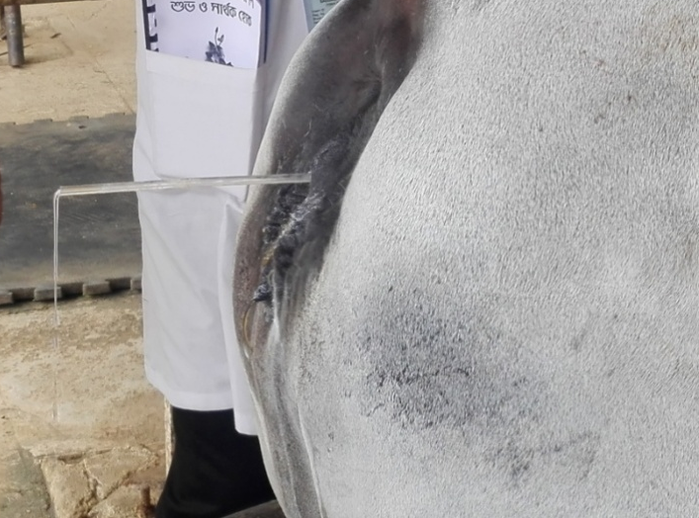
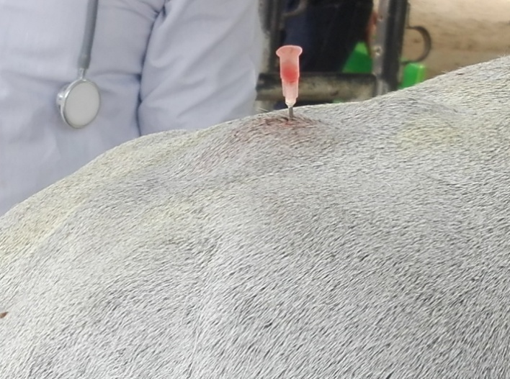
Pictorial presentation of some activities during surgery
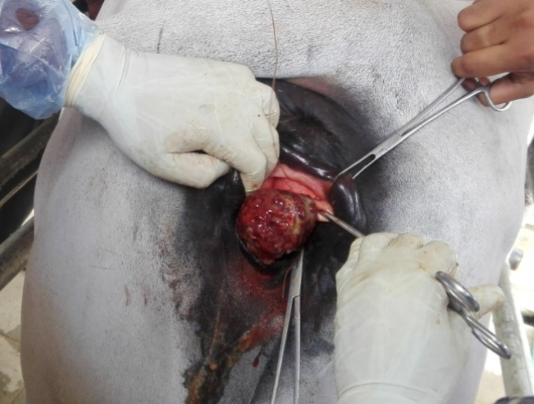
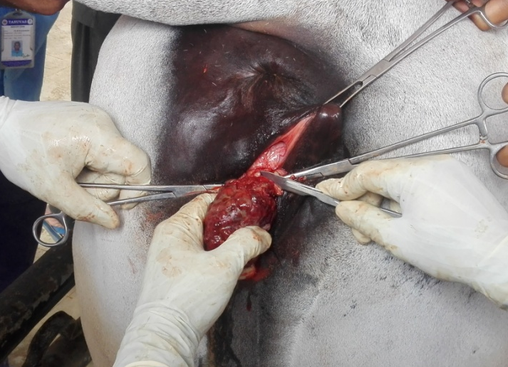
Figure 2: Removal of Urine through inserting Plastic Strip
Figure 6: Suturing of the Incised Wound
Figure 5: Incision for the Removal of Tumor Mass
Figure 4: Ligation between the Tumor and Wall of Vagina
Figure 1: Epidural Anesthesia in Cow
Figure 3: Revealing of Vaginal Tumor
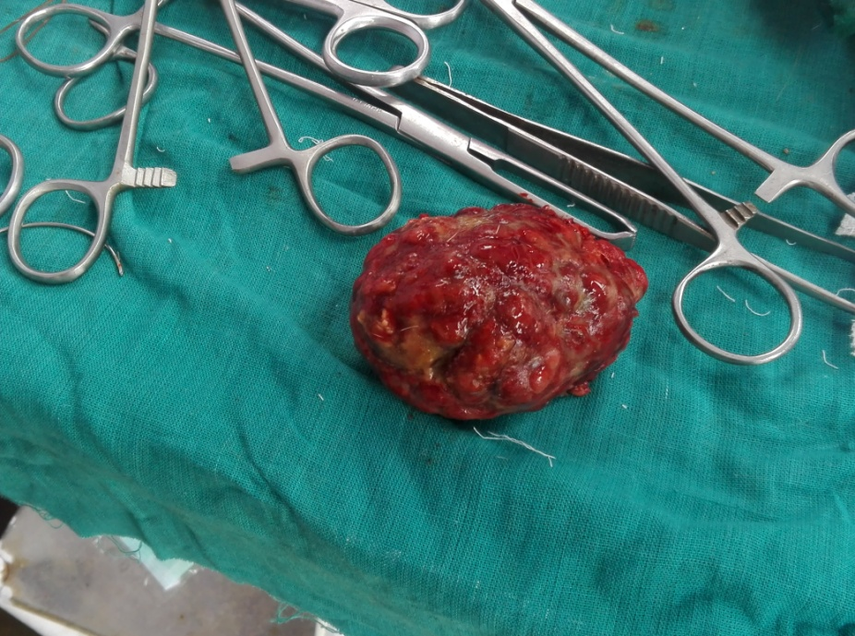
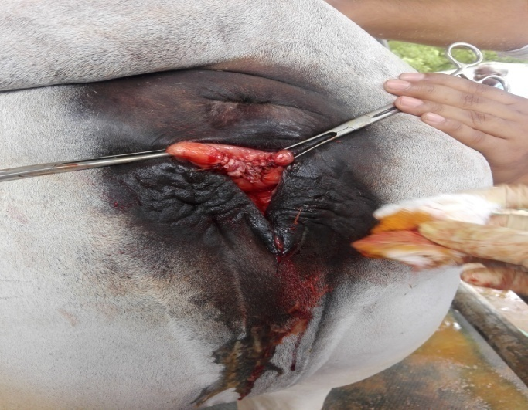
Figure 7: Status after Removal of Tumor Mass
Figure 8: Macroscopic View of Tumor Mass

Figure 9: Cut Section of Tumor Mass

CHAPTER – IV
CONCLUSION
This study demonstrates that if the vaginal tumor is diagnosed in its early stages and removed by an appropriate surgical approach, local recurrence and systemic spread can be prevented and the prognosis may be satisfactory.

CHAPTER-V
REFERENCES
- Anderson, L.J.; Sandison, A.T. (1969). Tumors of the female genitalia in cattle,sheep and pigs found in a British abattoir survey. J. Comp. Path. 79: 53-63.

- Bastianello S.S. (1982). A survey on neoplasia in domestic species over a 40-year period from 1935 to 1974 in the Republic of South Africa. Tumors occurring in cattle. J Vet Res. 49(4):195-204.

- Birgit, M.; Kofler, J.; Huber, J. and Schilcher, F. (2004). Neoplasms of the extremities in cattle-clinical findings, surgical treatment and outcome in 10 cases. Proceedings of the 13 International Symposium and 5 Conference on Lameness in Ruminants 11 -15 February 2004, Maribor, Slovenija, pp: 4-6.

- Brodey R.S., Roszel J.F. (1967): Neoplasms of the canine uterus, vagina and vulva: A clinicopathologic survey of 90 cases. Journal of the American Veterinary Medical Association, 151, 1294–1307.

- Colak A., Sağlam Y., Kamiloglu A., Karaman M., 1997. Vaginal tumor in a cow cases. Caucasian University Veterinary Faculty Magazine, 3, 93-96.

- Cotchin E. (1960): Tumours of farm animals: A survey of tumours at the Royal Veterinary College, London, during 1950–60. Veterinary Record, 72, 816–823.

- Haibel G.K., Constable P.D., Rojko J.L. (1990): Vaginal leiomyofibromatosis and goiter in a goat. Journal of the American Veterinary Medical Association, 196, 627–629.

- Hamali H and Ashrafihelan J, (2010). Vaginal fibrosarcoma in cow (A case report). Inter J Vet Res 4:225-228.

- Hulland, T.J. 1990. Tumors of muscle. In: Tumors of Domestic Animals (J.E. Moulton, editor), 3rd edn.,University of California Press, Berkeley, CA, pp 88-101.

- Kandasamy, N. (2001) "Kangayam breed of cattle: present status and management practices." In Indigenous Cattle and Their Role in the New Millennium, Proceedings of the Workshop Organized by TANUVAS, IDA and NDRI on, pp. 24-25.

- Kokuuslu C., Erer H., Unal E.F. (1980): Tumors of vagina and vulva in cows (in Turkish). Ankara University, Veterinary Faculty Derg., 27, 3–4, 431–439.

- Kuru M, Beytut E, Kaya S, et al., (2016). Vaginal fibrosarcoma in a brown swiss cow. Atatürk Üniversitesi Vet Bilimleri Dergisi 11:327-331.

- MacLachlan, N.J. and Kennedy, P.C., 2002. Tumors of the genital systems. Tumors in domestic animals, pp.547-573.

- Maxie, M.G. (2007). Jubb, Kennedy, and Palmer's Pathology of Domestic Animals. Academic Press, 5th edition, Saunders Elsevier, USA. Vol. 2, pp: 764-766.

- McEntee K, Nielsen SW, 1976. Tumours of the female genital tract. Bull World Health Org 53:217.

- Meuten, D.J. (2004). Tumors in domestic animals. 4th edition, Iowa state press, Ames, Iowa, USA. pp: 290-292.

- Meyers S.A, and Read WK. (1990). Squamous cell carcinoma of the vulva in a cow. J Am Vet Med Assoc.; 196(10):1644-1646.

- Meyer, H., et al. (2007) "High caudal epidural anaesthesia with local anaesthetics or α2‐agonists in calves." Journal of Veterinary Medicine Series A 54.7: 384-389.

- Moulton, J.E., 1990. Tumors of the mammary gland. Tumors in domestic animals, pp.518-552.

- Musal, B., Ulutas, P. and Aydogan, A., 2007. Vaginal fibrosarcoma in a cow. Irish veterinary journal, 60(7), p.424.

- Nikolajsen I.L., Toft P. (1987): Vaginal fibromyomas. A report of two cases. Acta Obstetricia et Gynecologica Scandninavica, 66, 83–84.

- Noakes, D.E.; Parkinson, T.J. and England, G.C.W. (2009). Arthur's veterinary Reproduction & Obstetrics. 9th edition, Philadelphia, W.B. Saunders. pp: 407.

- Pandey GS, Sharma RN, Chizyuka HGB (1984). Study of bovine neoplasms in Zambia. Bull Anim Hlth Prod Afr 1984; 32:289-291.

- Park S.J., Choi S.J., Han K.H., Park K.H., Chung H., Song J.M. (2007): Leiomyoma of the vagina that caused cyclic urinary retention. Acta Obstetricia et Gynecologica Scandninavica, 86, 102–110.

- Saut JPE, Oliveira PMd, Nasciutti NR, et al., 2013. Vaginal leiomyosarcoma in a cow from Uberlândia, Minas Gerais, Brazil. Ciência Rural 43:897-901.

- Watanabe, Y., Nishi, S., Fujiki, M., Yasuda, N., Kamimura, S., Sakamoto, H and Hamana, K. (2002) Surgical Removal of a Vaginal Fibroma in a Pregnant Japanese Black Cow. J. Jpn.Vet. Med. Assoc., 55: 427-429.

- Yeruham, I., Perl, S., Orgad, U. and Yakobson, B. (1999). Tumors of the vulva and vagina in cattle - a 10-year survey. Vet. J. 158: 237-239.

ACKNOWLEDGEMENT

The author is ever grateful and indebted to the Almighty God without whose grace it would have never been possible to pursue this study in this field of science and to complete this Clinical report writing for the Degree of Doctor of Veterinary Medicine (DVM).
The author would like to thanks his reverend and beloved teacher and supervisor Professor Dr. Bibek Chandra Sutradhar, Dept. of Medicine and Surgery, Chittagong Veterinary and Animal Sciences University for his valuable advice, suggestions and kind co-operation during the study period.
The author would like to thanks to the Director of External affairs Professor Dr. A.K.M. Saifuddin, Department of Physiology, Biochemistry & Pharmacology, Faculty of Veterinary Medicine, Chittagong Veterinary and Animal Sciences University for his suggestion.
The author expresses his sincere gratitude and gratefulness to Professor Dr. Selvaraju, M. from Veterinary College and Research Institute at Namakkal in Tamil Nadu state of India for his valuable advice, inspiration, cordial co-operation, valuable suggestion during the study period.

The Author
September, 2018

BIOGRAPHY

I’m Bhubon Chandra Halder, an intern student at Chittagong Veterinary and Animal Sciences University (CVASU), originate from Joypurhat, Rajshahi. After completing one year intern period, I will receive my Doctor of Veterinary Medicine (DVM) degree with lots of real life experiences. As an intern student I’ve received clinical training from Madras Veterinary College and Veterinary College & Research Institute, Namakkal, Tamilnadu, India. I’ve a great enthusiasm in research and have done some clinical research works. I’ve published one scientific paper in Journal of Veterinary Science & Technology titled by “Comparative Study on Newcastle Disease and Infectious Bursal Disease in Chicken Submitted to Upazilla Veterinary Hospital, Bogra Sadar, Bangladesh” and another in Journal of Dairy, Veterinary & Animal Research titled by “Prevalence of Dermatophytosis in Rabbits at SAQTVH, Chittagong, Bangladesh.” I have an interest on veterinary anesthesiology and small animal surgery.

