CHAPTER-I

INTRODUCTION

Hyperadrenocorticism (HAC), or Cushing’s syndrome, is an endocrinological disorder resulted from chronic exposure to excessive concentrations of glucocorticoids. There are three types of Cushing’s syndrome that can be iatrogenic or spontaneous. Spontaneously occurring HAC may be associated with inappropriate secretion of adrenocorticotropic hormone (ACTH) by the pituitary gland [ pituitary-dependent HAC (PDH) ] or a primary adrenal disorder (adrenal-dependent HAC).PDH resulting from pituitary tumors that synthesize and secrete excessive amounts of ACTH.HAC occurs commonly in middle-aged dogs, but it’s rare in cats. Any breed of dogs can develop HAC, but Poodles, Dachshund, Maltase and small terriers have the highest prevalence of PDH. Some clinical manifestations of HAC in dogs are polyuria, polydipsia, increased appetite, abdominal obesity, weight gain, fatigue, muscle atrophy and skin problems. Laboratory findings include sterss leukogram, low blood urea and an increase in serum activity of the enzymes such as alkaline phosphatase (ALP) and alanine aminotransferase (ALT). Common test of HAC for screening dogs are the ACTH stimulation test, the low-dose dexamethasone suppression test (LDDST) and the urine cortisol: creatine ratio. No test has 100% diagnostic accuracy, nevertheless. ACTH stimulation test is more reliable than others in diagnosis of HAC. Moreover, some test were done to differentiate between types of HAC. Diagnostic imaging is also advisable in all cases of suspected or proven HAC. Treatment can be divided into two parts: surgical and medical therapy with drugs such as milostane or trilostane. Herein, I report PDH in two pet, Maltase dogs, which describes historically.

Neurotransmitters from central nervous system (CNS) modulate the release of hypophysiotropic hormones, such as corticotropin releasing hormone (CRH) and arginine vasopressin (AVP),from neurons in the hypothalamus. Both CRH and AVP are considered the predominant stimulating neurohormones for ACTH secretion in vivo.CRH consists of 41 amino-acids, and its structure is identical in human, dogs, rats, and horses.CRH and AVP are released into the hypothalamohypophyseal portal blood system and travel to the corticotropic cells in the anterior pituitary, where they stimulate the release of ACTH. ACTH is a single-chain polypeptide comprising 39 amino acids. The amino acids sequence of ACTH is highly conserved. Canine ACTH differs from human ACTH by only one amino acid residue, at position 37.It is synthesized from a well-characterized precursor molecule, pro-opiomelanocortin (POMC), which also gives rise to a variety of other peptides coreleased with ACTH.

(Textbook of Veterinary Internal Medicine, 6th edition, Stephen J. Ettinger, Edward C. Feldman)

CHAPTER-II

CASE DESCRIPTION

2.1 Clinical case:
Two pet dogs which were 9-year-old and 10-year-old, female,Maltase dogs were referred to the Isehara Animal Hospital of Kanagawa prefecture of Tokyo in Japan with a history of polyphagia, weight gain, polyuria, polydipsia and hair loss. Detailed history delineated that the case had exercise intolerance and panting at rest.

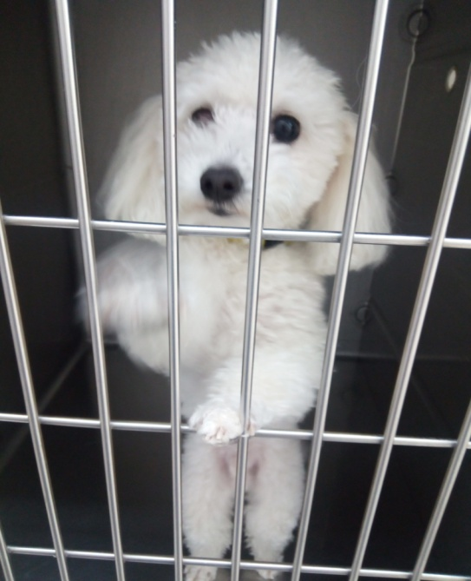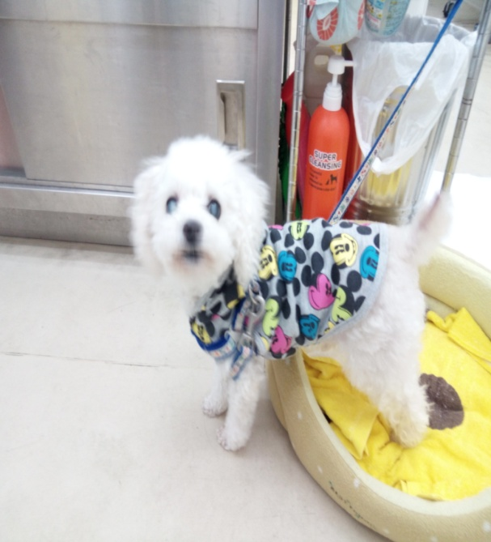
Figure 1:Two Maltase dogs as a sample of case study with Cushing’s disease

2.2 Physical Examination:On physical examoination, abdominal distance causing pot-bellied appearance were seen. Dermatological signs, incliding truncal and bilaterally symmetric alopecia, thin hypotonic skin, comedones, bruising, hyperpigmentatin and calcinosis cutis on the dorsal midline were observed. In accordance to the clinical signs, the Cushing’s syndrome was suspected until to be confirmed. Here, I am showing that the percentage of clinical findings with Cushing’s syndrome.

Table 1:Clinical Signs In Dogs With Cushing’s syndrome:
Clinical signs Incidence (% of case)
Polydipsia/polyuria 80-91
Truncal and bilaterally symmetrical alopecia 60-74
Abdomen distantion(pot belly) 67-73
Hepatomegaly 51-67
Polyphagia 46-57
Muscle weakness 14-57
Anrstrous 54
Muscle atrophy 35
Comedones 25-34
Panting 30
Hyperpigmentation 23-30
Calcinosis cutis (dorsal midline) 8-15
Bruising and hyperpigmentation 7

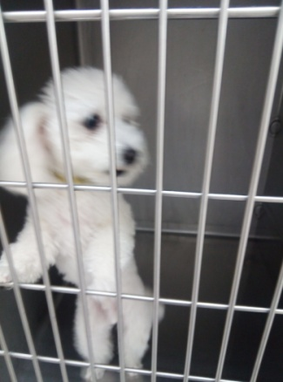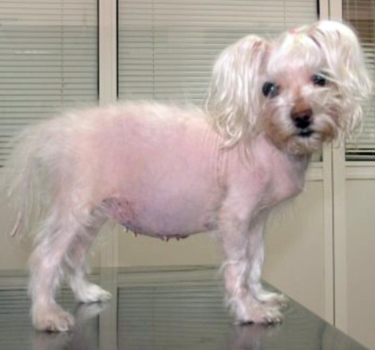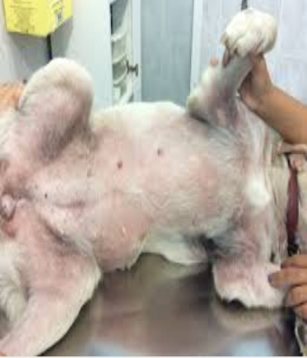
Figure 2:Observable clinical signs in dogs

2.3 Clinicopathologic Findings :When the results of the clinical examination lead to a presumptive diagnosis of Cushing’s syndrome, further diagnosis testing is required, including hematology, a biochemical profile, urinalysis, radiography and when applicable, ultrasonography. A definite diagnosis of Cushing’s syndrome necessitates specific tests. Therefore, blood sample was collected for clinicopathologic studies.

Hemogram:
Hematologic investigations showed stress leukogram that means neutrophilia without a left shift, lymphopenia, eosinopenia, monocytosis and mild erythrocytosis.

Under the influence of increased glucocorticoids ,most dogs develop a so-called stress leukogram, which is characterized by neutrophilia without a left shift, lymphopenia, eosiniphilia, and monocytosis. Neutrophilia does not imply greater resistance to infection in affected dogs,because cell function is impaired. Not all changes are present in dogs with hyperadrenocorticism, but lymphopenia and eosinopenia are the most consistent abnormalities. It should be emphasized that a stress leukogram is a nonspecific findings that occurs in many sick dogs .In our clinics,87% of the dogs with hyperadrenocorticism have thrombocytosis, with counts ranging from 403,000 to 1,140,000platelets/µL.

Biochemical profile: In biochemical profile investigations , high serum ALP activity, mild to moderate ALT activity, hypercholesterolemia, hypertriglyceridemia and hyperglycemia were also observed.

About 85% to 95% of dogs with hyperadrenocorticism show increases in serum alkaline phosphatase (ATP)activity. This is partly due to the induction of a glucocorticoid isoenzyme, which is unique to the dog and is a hyperglycosylated form of the intestinal isoenzyme. Some maintain that determination of the levels of this isoenzymeis a valuable test in the diagnosis of hyperadrenocorticism. In 50% to 80% of dogs, a mild increase in alanine aminotransferase (ALT) activity is seen(less than 400 IU/L) which is attributed to hepatocellular leakage associated with cell swelling or minor necrosis. Mild to moderate increases in the cholesterol and triglyceride concentration are common (50% to 90%) of dogs) and are believed to be the result of increased lipolysis. Often affected dogs have alterations in glucose metabolism, although only about 10% of dogs develop overt diabetes mellitus. The blood urea nitrogen and creatinine concentration are low as a result of dieresis in about 30% to 50% of cases. Mild increases in the sodium concentration and mild decreases in the potassium concentration occur in few dogs with Cushing’s syndrome.

Urinalysis: In urinalysis, no abnormality was found in the urinalysis except low urine specific gravity (<1.020).In 85% Cushing’s syndrome, the urine specific gravity of samples obtained at home is less than 1.015 to 1.020.

Radiography: In radiography investigation, mild generalized intestinal lung patterns and hepatomegaly were detected.
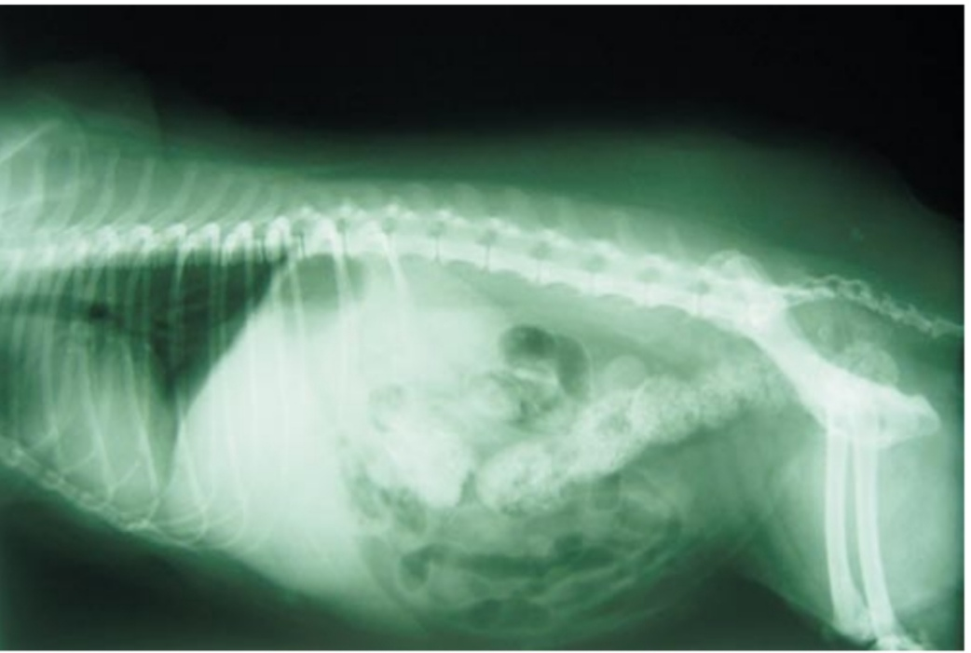
Figure 3 :Lateral radiographic view of the thorax and abdomen showing mild generalized interstitial lung patterns and hepatomegaly

Ultrasonography: Bilaterally symmetric normal-sized adrenal glands were also diagnosed in the ultrasonography.

Table 2:Frequently Encounted Clinicopathologic Abnormalities In Dogs with Hyperadrenocorticism:
Clinicopathologic Incidence Findings (%of cases)
Increased ALP 85-95
Hyperlipidemia 50-90
Increased ALT 50-80
Decreased BUN 30-50
Fasting hyperglycemia 30-40
Hypophosphatemia 38
Urine specific gravity(<1.015-1.020) 80
Proteinuria(UPC>1.0) 60-80
Urinary tract infection 40-50
Glucosuria 10
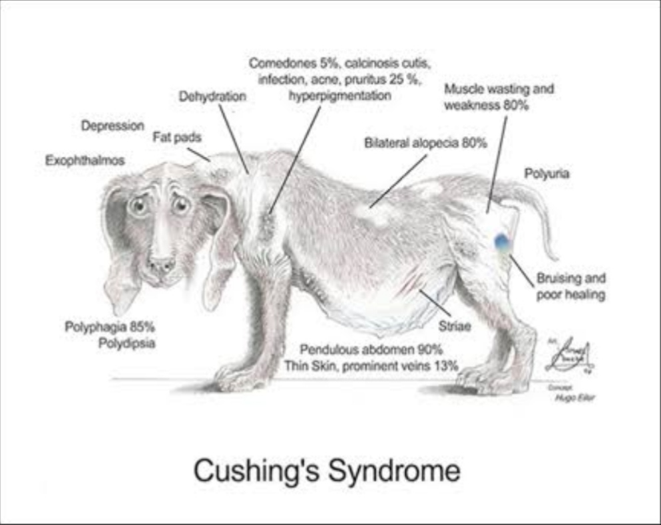
Figure 4:Cliniopathologic Abnormalities in dogs

2.4 Test And Other Diagnostic Investigation: Unfortunately, owner refused other diagnosed tests, including CT scan and magnetic resonance imaging (MRI), because of financial problems. Then, endocrine testing was performed. Then i have done one test which is ACTH stimulation test to the two dogs of Cushing’s syndrome for diagnosis of Cushing’s syndrome in Isehara Animal Hospital, Japan.

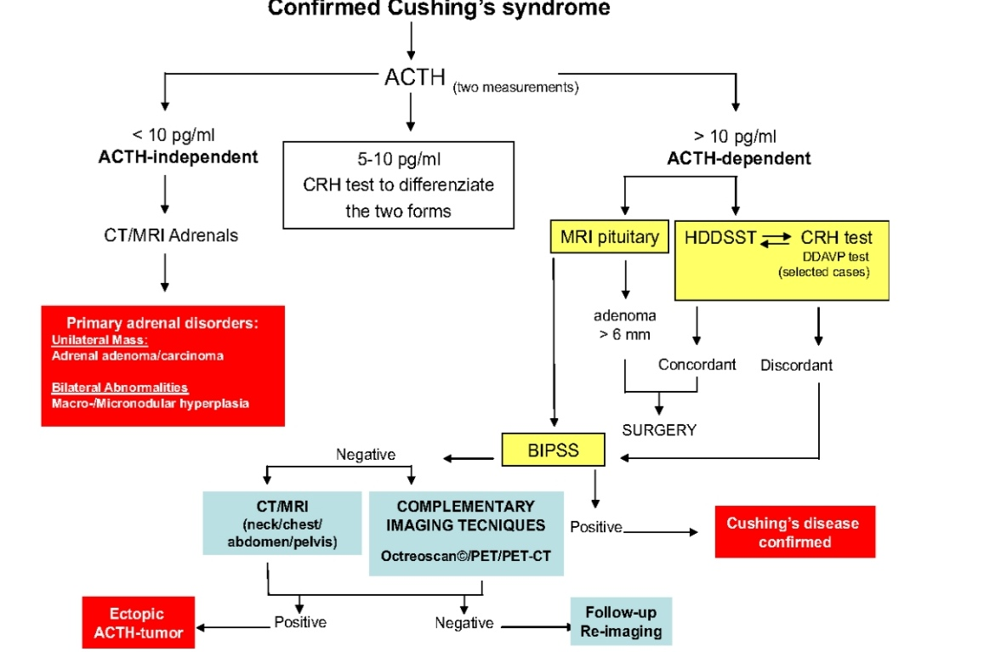
Figure5:Diagnostic algorithm Of Cushing’s syndrome

ACTH stimulation test: The ACTH stimulation test, which measures the response of the adrenal glnads to maximum ACTH stimulation, is a test of adrenal gland reserve. The major function of this test is to diagnose or rule out hypoadrenocorticism. It has a sensitivity of 60% to 85% and a specificity of 85% to 90%.The sensitivity is higher (up to 85%) for the diagnosis of PDH than for the diagnosis of FAT(approximately 60%).However, it is not possible to differentiate PDH from an FAT by means of the ACTH stimulation test on an individual case basis.

Several test protocols have been described that use either aqueous porcine ACTH gel (Acthar® Gel,Questcor Pharmacuticals, Inc, Union City, USA; not available in certain countries) or a synthetic polypeptide containing the first 24 aminoacids of ACTH(Cortrosyn, Synacthen). Plasma samples are obtained before and 2 hours after intramuscular injection of 2.2IU/kg of ACTH gel to determine the cortisol concentration. With the synthetic preparations, most protocols recommend collection of plasma before and 1hour after intramuscular or intravenous administration of 250µg of synthetic ACTH. However, maximum stimulation of the adrenal glands can also be achieved with a dosage of 5µg of synthetic ACTH per kilogram of body weight. Reconstituted ACTH can be stored in plastic syringes at ̵ 20 ̊C for 6 months. The normal baseline cortisol concentration is 0.5 to 6 µg/dL, and the normal post-ACTH cortisol concentration is 6 to 17 µg/dL. Post-stimulation cortisol values between 17 and 22 µg/dL are considered borderline; values above 22µg/dL are consistent with hyperadrenocorticism. There are several reasons to use of this test despite its relatively low sensitivity.
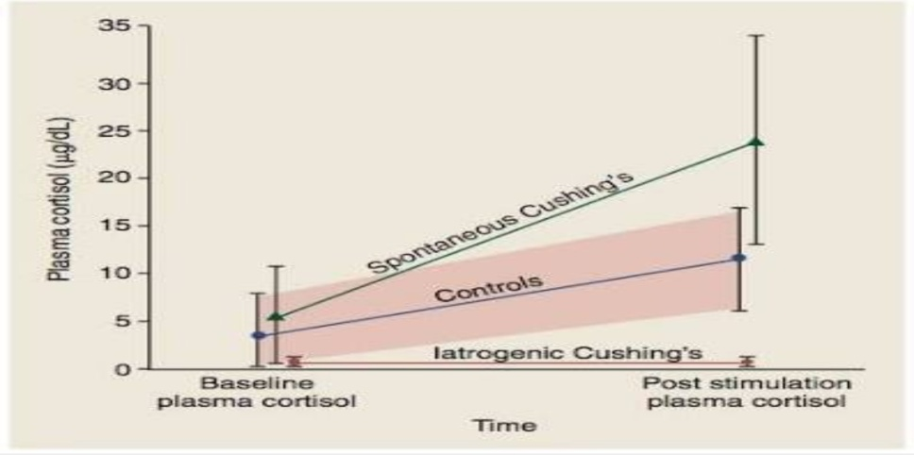
Figure 6: Mean radioimmunoassay (RIA) plasma cortisol Concentration (±2 SD) determined before and 1 hour after administration of synthetic ACTH in control dogs, dogs with spontaneous hyperadrenocorticism, and dogs with iatrogenic hyperadrenocorticism
First, it is the only test to differentiate between iatrogenic and naturally occurring hyperadrenocorticism. Second, because the test is frequently used to monitor medical therapy, it appears helpful to know the stimulation capacity of the adrenal glands prior to treatment. A possible third reason was recently revealed. It has been hypothesized that some dogs with hyperadrenocorticism that have normal ACTH stimulation results, in fact have a derangement of the steroid synthesis pathway; this would lead to abnormally increased precursor concentrations but normal concentrations of the end product, cortisol. Preliminary evaluations revealed that 17-hydroxprogesterone, one of the precursors, showed an exaggerated response to ACTH stimulation in dogs with Cushing’ syndrome, which had abnormal or normal cortisol responses. Further studies are needed to confirm whether the measurement of 17-hydroxprogesterone or other precursor concentrations is helpful in the diagnosis of canine Cushing’s syndrome.
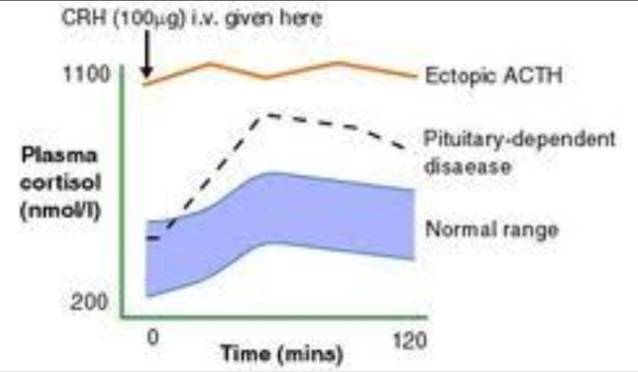
Figure 7:Clinical decision making flow chart

2.5 Treatment And Expected Outcome Of treatment plan: The two dogs were recovered by therapeutic intervention with trilostane (initial induction 30 to 50 mg/kg/day, administered for 10 days followed by a maintenance dosage of approximately 50 mg/kg/week, divided into two equal doses).Recheck was done at 4 months later, and no other complication were identified at this time. All experimental procedures involving animals were conducted in accordance to the Guide for Care and use of Laboratory Animals published by the National Institute of Health (NIH publication No. 85-23, revised 1985) and approved by the local ethics committee of Isehara Animal Hospital of Tokyo in Japan.

The method of treatment must be carefully chosen based on the cause of the disease(PDH or an FAT),the age and condition of the dog, and whether concomitant disease is a factor. The cost and availability of treatment methods, as well as the frequently of follow-up evaluation, are also important considerations.

I have treated with trilostane to the two dogs of Cushing’s syndrome affected in Isehara Animal hospital, Japan.

Trilostane, the use of trilostane for the treatment of canine PDH was first reported in 1998.Trilostane is an orally administered competitive inhibitor of 3-beta-hydroxysteroid dehydrogenase. This enzyme system mediates the conversion of pregnenolone to progesterone in the adrenal gland. Cortisol, aldosterone, and androstenedione are produced from progesterone via various biochemical pathways. Trilostane inhibits progesterone and blocks the synthesis of its end products.

We have used trilostane for nearly 4years in the treatment of PDH and have found that about 80% of dogs have a good to excellent response. The time required for a noticeable response to triloatane is similar to that for mitotane. Improvements include a rapid decrease in polydipsia, polyuria, and polyphagia and a rapid increase in activity level, as well as delayed improvement in the haircoat, skin condition, and abdominal muscle tone. Some dogs may show transient worsening of dermatologic problems before clinical improvement becomes obvious;this may also occur with mitotane. The ACTH stimulation test deyermines adrenal reserve and therefore is suitable for evaluating the extent of enzyme inhibition during treatment and for calculating dosage adjustment.

When the ACTH stimulation test is performed 2 to 6 hours after drug administration, the target range of the post-ACTH cortisol level is 1 to 2µg/dL; this corresponds with the low end of the desired range for dogs treated with milostane.

Several of our dogs Had post-ACTH cortisol levels between 0.5 and 1µg/dL for months without showing signs of hypoadrenocorticism.Two explanation for this may be that (1)trilostane is known to decrease the cortisol concentration for only a few hours;and (2)steroid precursors;which have accumulated as a result of enzyme inhibition,may have certain glucocorticoid-like effects that prevent signs of hypocortisolism even when the cortisol concentration is low. Frequently adjustments in the dosage of trilostane (both increases and decreases) are required, particularly during the first few weeks of treatment. Adjustment should be made in increments of 20 to 30 mg/dog.
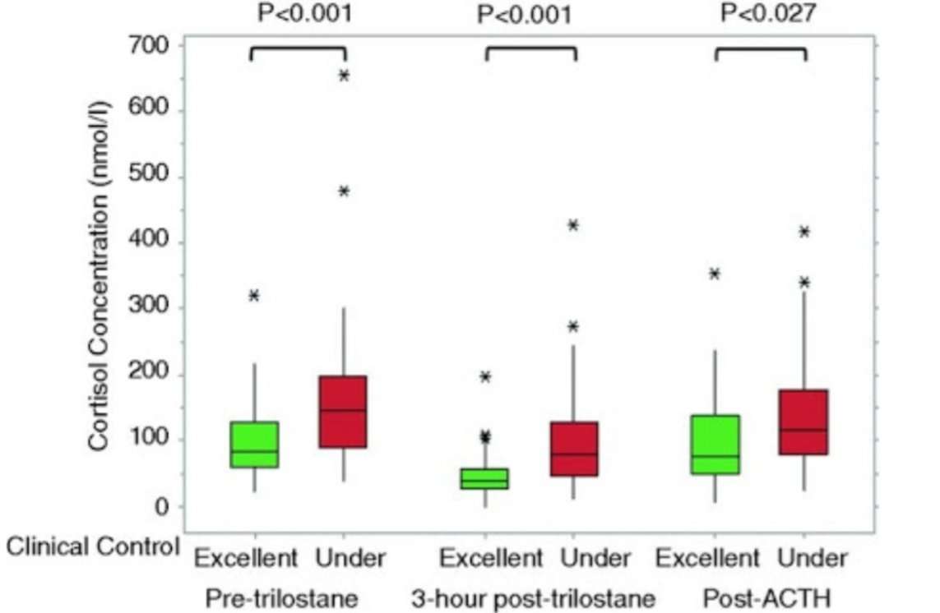

Figure 8:Trilostane dosing and monitoring

The effective dosage of trilostane differs markedly among dogs with PDH, possibly because of a significant variation among individual in 3-beta-hydroxysteroid dehydrogenase activity in the adrenal glands. However, the response to treatment appears to stabilize over a period of time, after which dosage adjustment are seldom necessary.
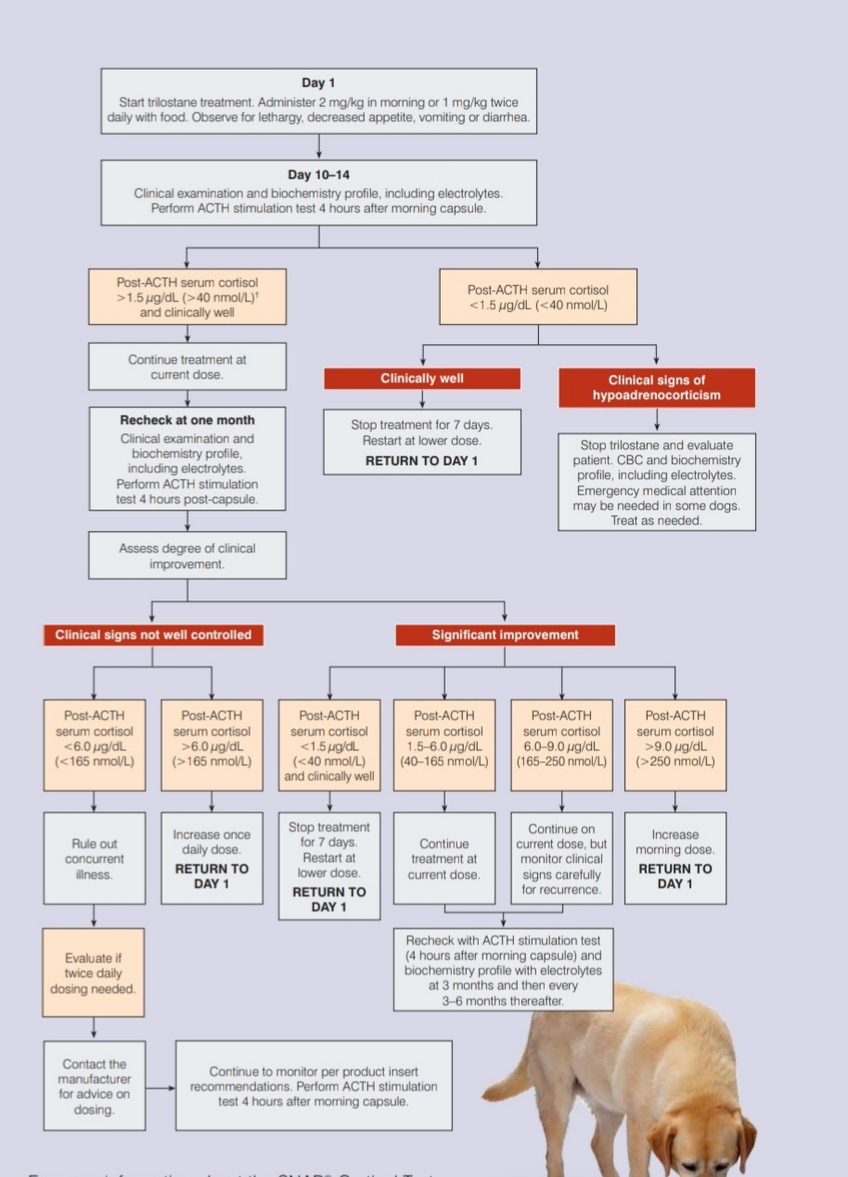
Figure 9:Monitoring the medical treatment of dogs with Cushing’s disease

2.6 Problem faced by treating Trilostane:
Most common side effects of Trilostane include:-
- Reduced appetite
- Vomiting
- Diarrhea or loose stool
- Lethargy/dullness
- Weakness
CHAPTER-III

DISCUSSIONS

One of the most endocrinopathies of dogs is Cushing’s syndrome or HAC.PDH is recognized as the commonest types of it. despite major importance, this endocrine disease is often unrecognized. In the present study, I report PDH in a 9-year-old and 10-year-old, female, Maltase dogs.

In spite of rare human cases,HAC or Cushing’s syndrome is a common endocrinological syndrome in dogs with an estimated incidence of 1 to 2 cases/1000dogs/year. As I describe here, PDH occurs more in middle aged to older and smaller dogs. In contrary, corticotroph carcinoma of the pituitary was reported in an 11-months-old dogs by Gestier et al.,2009.In comparison to my report in two female Maltase dogs, no strong sex predilection was described regarding PDH. This study was similar to other researches reporting polyphagia, polyuria and polydipsia as the most clinical symptoms (up to 90% of dogs), which were distinctly reported by this dog’s owner. Increased appetite is attributed to the glucocorticoid excess. Moreover, high glucocorticoids interferences with the antidiuretic hormone action, causes polyuria and following polydipsia. Exercise intolerance and panting of those dogs may be attributed to decreased pulmonary compliance and muscle weakness. As I report in this case, affected dogs may have abdominal distention causing pot-bellied appearance due to hapatomegaly and large bladder together with fat redistribution to the abdominal mesentery. Consistent with the results of other studies, I observed the dermatologic signs, including truncal and bilaterally symmetric alopecia, thin hypotonic skin, comedones, bruising and hyperpigmentation. Calcinosis cutis as dystrophic calcium deposition in the dermis and subcutis were felt like firm, irregular plagues on the dorsal midline of this case. In comparision to our results, recurrent pyoderma with malassezia and HAC or Cushing’s syndrome reported in a Lhasa Apso dog in another study,2011.In contrary, endocrinologically-inactive (silent) pituitary corticotroph (ACTH-containing) carcinoma was diagnosed with the absence of clinical signs in a 11-month-old neutered female Weimaraner by Gestier et al.,2009.
Similar to other studies, stress leukogram, high ALP and ALT activities, hypercholesterolemia, hypertriglyceridemia and hyperglycemia were seen in hematologic investigations of the current case.High blood cortisol concentration results in a stress leukogram but this abnormality is not specific and can observe by other disease. High serum ALP activity,as the most consistent finding,is 85% to 95% of HAC or Cushing’s syndrome in dogs. Accordance with other studies ,low urine specific gravity <1.020 of the mentioned case is attributed to the polyurial. In the present case, thorax and abdomen radiographic findings,including mild generalized intestinal lung patterns and hepatomegaly (the most consistent radiographic finding) were similar to other reports. Although, ultrasonographic size of adrenal glands was in the normal range,absence of adrenomegaly did not rule out PDH in this case.CT and MRI are the only reliable methods of evaluating the size of either the adrenals or the pituitary glands. Therefore, CT scanning and MRI are essential to evaluate these abnormalities .Unfortunately, owner refused these diagnosed tests because of financial problems.

Incidence rates of endocrinopathies, especially HAC or Cushing’s syndrome underestimated due to careless examination and little attention to perform diagnostic endocrine tests. In the current case, increased corticotropic hormone than the reference range; so, HAC or Cushing’s syndrome may be misdiagnosed as hypothyroidism. I performed the ACTH stimulation test because it is the test of choice for the diagnosis of Cushing’s syndrome in dogs in Isehara Animal Hospital, Japan.For medical management, trilostane is documented as effective treatment for PDH. Compared with finding, Sudhakara Reddy and Nalini Kumari determined ketoconazole as effective treatment for Cushing’s syndrome. Transsphenoidal hypophysectomy was performed to treat PDH in another study. Selective pituitary or ectopic corticotroph tumor resection is also considered as the treatment of choice for PDH in human cases.

CHAPTER-IV

CONCLUSION

In this case, I have got that a case of pituitary-dependent hyperadrenocorticism in a 9-years-old and a 10-years-old, female, two pet dogs. The animals were admitted due to polyphagia,, weight gain, polyuria, polydipsia, hair loss, exercise intolerance and panting at rest. On physical examination, abdominal distention, truncal and bilaterally symmetric alopecia, thin hypotonic skin, comedones, bruising, hyperpigmentation and calcinosis cutis on the dorsal midline were observed. Hematologic investigations showed stress leukogram, high serum alkaline phosphatase activity, mild to moderate alanine aminotransferase activity, hypercholesteromia, hypertriglyceridemia and hyperglycemia. Mild generalized intestinal-lung patterns and hepatomegaly were detected in radiographs. Bilaterally symmetric normal-sized adrenal were also diagnosed in ultrasonography and after doing ACTH stimulation test, I got hyperadrenocorticism in two dogs. Finally, the two dogs were successfully treated with trilostane and recovered those dogs within 6 months.

CHAPTER-V

LIMITATIONS OF THIS CASE STUDY

In this study, there were some limitations (which may cause some variations in this study result) such as:
1.The case was very short .
2.The sample size was only two dogs.
3.In this study, I did not do Low Dose Dexamethasone suppression test which is also important confirmatory test for Cushing’s syndrome.
4.There was not done any CT scan and MRI analysis due to owner’s financial problems.

Recommendations
Based on this study, following recommendations are given for the owner of the animals.

From this Cushing’s syndrome, I have observed that unfortunately this condition is something that has to be managed for the rest of those dog’s life. It will require a huge change in diet and continuous monitoring of any changes in those pet’s well-being. Any adverse reaction to medicines or herbs should be addressed immediately to keep our beloved pooch healthy and safe. Even a lack of energy or overall lethargy might be a sign of a reaction. If dogs are not eating but has vomit and diarrhea, then we should call our veterinarian immediately. we should also be very careful in introducing new treatments, especially natural ones that may not be agreed upon by the veterinarian first. There are cases of herbals medication reacting to chemical based ones, so watch out before mixing them all. Our care and attention are crucial in our dog’s continuous good health. If not treated, the disease will become worse and end up with infections, problems with some organs and much more. But if we religiously find the best way to keep our pet’s health in tip shape, we may already see a huge difference in dog’s life in as little as 4 to 6 months. The lost hair will even grow back, albeit longer. If the disease is already under control, we can expect our dog to retain its strength and liveliness. However, be prepared that our beloved pooch will no longer live beyond a decade, also because they are already old.

At first, the patient should be checked the normal level of corticotrophin hormone by doing ACTH stimulation test and for controlling, Trilostane drug should be given regularly. Besides this treatment, we have to give the dogs supportive diet and also avoid the normal dietary system, because the supportive diet also helps the controlling of Cushing’s disease in dogs.

As with humans, diet may have a profound influence on the health of dog. Commercial foods, while handy, actually contain a lot of other things that may not be optimum for pet’s health. Simply put, there are grains, fillers, and other additives that our pooch does not need but may be hazardous to its health. A basic change to a raw diet or a grain and potato-free, high protein one (may also be found in some canned foods)may already improve dogs’s overall health.

Some swear by a raw diet consisting of raw meat and vegetables. All grains should be removed to reduce the carbohydrates in the diet, and this includes treats.

Beyond that, three ingredients are believed to be very beneficial to dogs with Cushing’s disease.

The first is Milk thistle, which is a European medical plants. This plant has silymarin that is mainly used by vets for dogs that have liver disease. It is recommended due to its antioxidant capability and its ability to aid bile flow through the liver. A daily dose of 10 mg per pound of body weight is recommended. Milk thistle may be found in local drug stores.

The second, fish oil, is quite the all-rounder when it comes to treating disease. Fish oil directly affects the skin and the fats or lipids circulating the blood. More than that, it will help our pet infection.

The third is a combination of herbs from traditional Chinese veterinary medicine (TCVM).This blend is specifically called Ophiopogon Formula. It reduces the symptoms of Cushing’s disease, among a long list of others.

CHAPTER-VI

REFERENCES

A textbook of Veterinary Internal Medicine, 6th Edition, Stephen J. Ettinger, Edward C. Feldman.
Cushing’s disease can trouble older dogs- Canis Major
Cushing’s Disease in Dogs- PetMD.
de Bruin C1, Meij BP, Kooistra HS, Hanson JM, Lamberts SW, Hofland LJ. Cushing’s disease in dogs and humans. Horm Res 2009;71:140-3.
Dona Scott-Natural Remedies For Cushing’s Disease In dogs-Dogs Naturally Magazine.
Gestier S, Cook RW, Agnew W, Kiupel M. Silent pituitary corticotroph carcinoma in a young dog. J Comp Pathol 2012;146:327-3.
Gilor C, Graves TK. Interpretation of Laboratory tests for canine Cushing’s syndrome. Top Companion Anium Med 2011;26:98-108.
Hitoshi Ikeda, DVM, Director, JAHA Certified Veterinary Surgeon, All Heart Animal Referrals, Kanaimachi Machida, Tokyo, Japan.
Mari Misawa, Director Of JBVP, Veterinarian, Isehara Animal Hospital, Kanagawa prefecture, Tokyo, Japan.
Melian C, Perez-Alenza MD, Peterson ME. Hyperadrenocorticism in dogs. In: Ettinger SJ, Feldman EC, editors. Textbook of Veterinary Internal medicine.7th ed. St. Louis: Elsevier Saunders;2010, p.1479-83.
Stephen J. Ettinger, DVM, California Animal Hospital, Los Angeles, California.
Sudhakara Reddy B, Nalini Kumari K. Recurrent pyoderma with Malassezia and hyperadrenocorticism in a dog. Indian J Field Vet 2011;7:44-5.
Takuo Ishida, Head of JBVP, Medical Director at Akasaka Animal Hospital, Consultant (Pathology) at IDEXX Labratories, Suginami-ku,Tokyo,Japan.
Yasunori Arawatari, DVM, Hiratsuka Animal General Medical Center, Daikan-cyo, Hiratsuka- shi, Kanagawa prefecture, Tokyo, Japan.

ACKNOWLEDGEMENT

The author wishes to acknowledge the immeasureable grace and profound kindness of almighty “Allah” the supreme authority and supreme ruler of universe, who empowers the author to complete this task successfully. The author also wishes to thank the another respected sir, Takuo Ishida, Head of JBVP, Medical Director of Akasaka Animal Hospital in Japan who has arranged to go to Japan. The author also wishes to thank the supervisor of Japan, Mari Misawa for helping in collection of data, others different diagnostic facilities to make this study possible. The author feel proud in expressing his deep sense of gratitude and indebtedness to internship supervisor ,Dr. Mohammad Alamgir Hossain, Professor, Department of Pathology and Parasitology, Faculty of Veterinary medicine, Chittagong Veterinary and Animal Sciences University for her trustworthy and scholastic supervision to make this report. The author wishes to thank the respected teacher, Dr. Mizanur Rahman, Professor, Head of Department of Medicine and Surgery, Faculty of Veterinary Medicine, Chittagong Veterinary and Animal Sciences University for helping to go to Japan. The author express thanks and warmest sense of gratitude to his parents and all well-wishes.

The author
September,2018

BIOGRAPHY

I am Tajmima Sultana Mukta, daughter of Md. Abdul Alim and Zaheda Alim. I passed my Secondary School Certificate (SSC) examination from Vidyamoyee Government Girls High School, Mymensingh, Dhaka Board in 2010 and Higher Secondary Certificate (HSC) examination from Muminunnesa Government Womans College, Mymensingh, Dhaka Board in 2012.I enrolled for Doctor of Veterinary Medicine (DVM) degree in Chittagong Veterinary and Animal Sciences University (CVASU), Chittagong, Bangladesh in 2012-2013 sessions. At present I am doing my Internship program which is compulsory for awarding my degree of Doctor of Veterinary Medicine (DVM) from Chittagong Veterinary and Animal Sciences University. In the near future I would like to work and have massive interest in pet animal medicine, management and rearing system.

