PREPARATION OF LEAST COST DOG BISCUIT BY USING AVAILABLE FEED INGREDIENTS

MD. IMRAN AHMED
Roll No. 0213/04
Registration No.163
Session: 2013-2014

A thesis submitted in the partial fulfillment of the requirements for the degree of Master of Science in Animal Science

Department of Animal Science and Nutrition
Faculty of Veterinary Medicine
Chittagong Veterinary and Animal Sciences University
Chittagong-4225, Bangladesh

June 2015

PREPARATION OF LEAST COST DOG BISCUIT BY USING AVAILABLE FEED INGREDIENTS

This is to certify that we have examined the above Master’s thesis and have found that is complete and satisfactory in all respects, and that all revisions required by the thesis examination committee have been made

Md. Imran Ahmed
Roll No. 0213/04
Registration No.163
Session: 2013-2014

-------------------------------------------------  (Prof. Dr. Md. Hasanuzzaman)  Supervisor | -----------------------------------------------  (DR. Mahabub Alam)  Co-supervisor
-----------------------------------------------

(Prof. Dr. Md. Hasanuzzaman)
Chairman of the Examination Committee

Department of Animal Science and Nutrition
Faculty of Veterinary Medicine

Chittagong Veterinary and Animal Sciences University
Chittagong-4225, Bangladesh

June 2015

Authorization
I hereby declare that I am the sole author of the thesis. I also authorize the Chittagong Veterinary and Animal Sciences University (CVASU) to lend this thesis to other institutions or individuals for the purpose of scholarly research. I further authorize the CVASU to reproduce the thesis by photocopying or by other means, in total or in part, at the request of other institutions or individuals for the purpose of scholarly research.
I, the undersigned, and author of this work, declare that the electronic copy of this thesis provided to the CVASU Library, is an accurate copy of the print thesis submitted, within the limits of the technology available.

Md. Imran Ahmed
June, 2015

Acknowledgement
I would like to express my deepest sense of gratitude and all sorts of praises to the Almighty Allah for the blessing, the Omnipotent, Omnipresent and Omniscient, whose blessing have enabled me to complete this desertation. He had bestowed upon me to do this work.

I am immensely pleased to place on record my profound gratitude and heartfelt thanks to my research supervisor, Professor Dr. Md. Hasanuzzaman, Head, Department of Animal science and Nutrition, Chittagong Veterinary and Animal Sciences University (CVASU), who suggested the problem, extended all facilities, provided inspiring guidance and constructive criticism for the successful completion of this research work. I deem it as my privilege to work under his able guidance, I ever remain grateful to him.

The author feel much pleasure to convey the profound thanks to his co-supervisor, DR. Mahabub Alam, Lecturer, Department of Animal Science and Nutrition, CVASU for his valuable advice, scholastic guidance and full time support in data analysis and valuable advices during research work.
I am grateful to Coordinator, Advance Studies and Research and Director, for his support & help work during research.

Thanks are also to Aditya Chowdhury Avi, intern student of 15th Batch. The Lab. technicians and other supporting stuffs of Department of Animal Science and Nutrition, and the Department of Physiology, Biochemistry and Pharmacology for their laboratory and physical support.

My sincere thanks also go to my friends specially DR. Md. Moksedul Momin, DR. Ashif Imtiaz shawn, DR. Nur-E-Azam, DR. Shohel-Al-Faruk for their encouragement throughout the thesis work.

Last but not the least, the author expresses his deepest sense of gratitude, cordial respect of feelings to his beloved family members for their immense sacrifice, blessings and encouragement.

The Author
Table of Contents

Authorization iv
Acknowledgement v
List of Tables viii
List of Plates xi
List of abbreviations and symbols xii
Abstract xiii
Chapter-1: Introduction 1
Chapter-2: Review of literature 4
2.1 Nutrients and their requirement 4
2.1.1 Proteins 4
2.1.2 Protein requirement 5
2.1.3 Carbohydrates 5
2.1.4 Requirement of carbohydrates 6
2.1.5 Dietary Fiber 6
2.1.6 Fats 7
2.1.7 Fatty Acids Requirement 8
2.1.8 Water 8
2.1.9 Calcium and Phosphorus Requirement 9
2.2 Health Management 9
2.2.1 Oral Health 9
2.2.2 Weight Maintenance 9
2.2.3 Appetite 10
2.2.4 Digestive Health 10
2.3 Palatability of food 10
2.3.1 Palatability 10
2.3.2 Palatability Enhancers 11
2.3.3 Role of Olfaction in Palatability 11
2.4 Ingredient Selection 12
2.4.1 Chicken meal 13
2.4.2 Soyabean meal 14
2.4.3 Fish Meal 14
2.4.4 Other ingredients in dog food 15
Chapter-3: Materials and Methods 17
3.1 Study area and period 17
3.2 Experimental Plan 17
3.3 Survey 18
3.4 Identification and collection of different samples 18
3.5 Analysis of proximate components selected ingredients 18
3.6 Selection of ingredients for dog biscuits 19
3.7 Processing of dead poultry meat as protein source in feed (Fig: 2) 20
3.7.1 Collection of dead carcass 20
3.7.2 Weighing of dead carcass 20
3.7.3 Dressing of carcass 20
3.7.4 Weight of dead carcass 20
3.7.5 Sterilization 20
3.7.6 Drying 20
3.7.7 Grinding 20
3.8 Formulation of dog biscuits 22
a. Dough for biscuits 23
b. Molding of the biscuits 23
c. Plating the molded biscuits 23
d. Putting the raw biscuits in oven 23
e. Raw biscuits in oven 23
f. Ready dog biscuits 23
3.9 Preparation of dog biscuit 23
3.10 Palatability trail 24
3.11 Target animals and age groups 25
3.12 Dog catching and handling 25
3.13 Feed requirement of dogs 25
3.14 Feeding trial 27
3.15 Weight gain 27
3.16 Collection of Blood samples 27
3.16.1 Hematological Analysis 28
3.17 Biochemical Analysis 30
3.18 Digestibility comparison of formulated biscuits and commercial dog food 31
Plate 9: feeding of puppies and collection of feaces 31
3.19 Statistical analysis 31
Chapter-4: Results and Discussion 32
4.2 Screening of the available Ingredients: 32
4.2 Chicken intestine and chicken intestine with skin 33
4.3 Chicken meal 33
4.4 Fish Scale 33
4.5 Quantification of available chicken meal (dead bird) of CVASU 34
4.6 Growth trial 35
A comparative growth trial was conducted with prepared dog biscuit and available dog feed. 35
4.6.1 Food offered 35
4. 6.2 Body weight and body weight gain of dogs 35
4.7 Metabolic profile test 37
4.7.1 Liver function test 37
4.7.2 Kidney function test 41
4.7.3 Blood mineral test 43
4.8 Hematological changes 45
4.9 Digestibility 46
4.10 Cost analysis of prepared biscuits 48
Chapter-5: Conclusion 50
Chapter-6: Recommendation 52
References 53
Annexure-1: Proforma of Record Sheet (Questionnaire) 65
Annexure- 2: Procedure of biochemical analysis 66
Brief Biography of the Student 72

List of Tables

Table 1: Layout of the experiment 20
Table 2: Physical composition of prepared biscuits 24
Table 3: Nutritional composition of prepared biscuit 24
Table 4: Chemical composition (%) of identified protein source byproducts that may be used as dog food ingredients 34
Table 5: Production of dead chicken in Pathology and Pharmacology lab of CVASU 36
Table 6: Quantification of collected and usable meat in a period of 5 weeks 36
Table 7: Daily offered food (gm/puppies) in different treatment group. 37
Table 8: Trends of Body weight (kg) of different treatment groups 37
Table 9: Body weight gain (kg/week/dog) of experimental dogs of different treatment groups 38
Table 10: SGPT level (U/L) in the Blood serum of the experimental cows dogs fed different dietary food 39
Table 11: Bilirubin level (mg/dl) of dogs under different dietary treatment groups 40
Table 12: Serum glucose level (mg/dl) of dogs under different dietary treatment groups 41
Table 13: Serum total protein level (g/dl) of dogs under different dietary treatment groups 42
Table 14: Serum albumin level (mg/dl) of dogs under different dietary treatment groups 42
Table 15: Serum creatinine level (mg/dl) of dogs under different dietary treatment groups 43
Table 16: Serum urea level (mg/dl) of dogs under different dietary treatment groups 44
Table 17: Serum calcium level (mg/dl) of dogs under different dietary treatment groups 45
Table 18: Serum phosphorus level (mg/dl) of dogs under different dietary treatment groups 46
Table 19: Values (Mean±SE) of different hematological parameters in different treatment groups 47
Table 20: Percentage (Mean±SE) of digestibility of different nutrient in commercial food and prepared biscuit 48
Table 21: Comparison of cost of biscuits using dead chicken (taka /kg) and Fresh chicken (taka /kg) 50
Table 22: Cost of producing 1 kg biscuit 50
Table 23: Performance and economics of prepared biscuits 50

List of Plates

Plate 1 : Proximate estimation of different nutrients 19
Plate 2: Total process of collection of dead poultry to grounded dried meat 21
Plate 3: Preparation of biscuit 23
Plate 4: Offering newly formulated biscuits to local dogs for palatability test 24
Plate 5: Feeding trial of the puppies 26
Plate 6: Weighing of dog 27
Plate 7: Collection of blood and performing metabolic profile test and heamato-biochemical test 28
Plate 8: Layout of sample analysis 30
Plate 9: Feeding of puppies and collection of feaces 31

List of abbreviations and symbols
Abbreviation | Elaboration
DM | Dry matter
ME | Metaboligable energy
CP | Crude protein
CF | Crude fiber
EE | Ether extract
NFE | Nitrogen free extract
EPA | Eicosapentaenoic acid
DHA | Docosahexaenoic acid
RBC | Red blood cell count
PCV | Packed cell volume
TRBC | Total red blood cell
WBC | White blood cell
Hb | Haemoglobin
TEC | Total erythrocyte count
TLC | Total Leukocyte count
ESR | Erythrocyte sedimentation rate
SE | Standard error
NS | Non significant
< | Less than
> | Greater than
e.g | Example
Ml | Millilitre
Mg | Milligram
Kg | Kilogram
$ | Dollar
et al. | And his associates
etc. | Et cetera
Gm | Gram
% | Percentage
i.e. | That is
Tk | Taka (Bangladeshi taka)
SGPT | Serum Glutamic pyruvic transaminase
TP | Total Protien
AAFCO | Association of American Feed Control Officials
BRAC | Bangladesh Rural Advancement Commission
AOAC | Association of Official Analytical Chemists.
Sig. | Significance
Ref. | Reference
MS | Master of Science
Ctg | Chittagong
CVASU | Chittagong Veterinary and Animal Sciences University
CMP | Chittagong Metropoliton
SPC | Soy protein concentrate

Abstract

The current research work was undertaken for a period of six months to screen out the available feed resources at CMP (Chittagong Metropoliton) areas usable for dog biscuit. The two areas found suitable for this purpose viz. Jhawtola bazaar and CVASU on the basis of their availability. Four different types of samples were chicken intestine, chicken intestine with skin, fish scale and dead chicken carcass collected from the study areas. Chemical analyses of the samples were carried out in for dry matter (DM), crude protein (CP), crude fiber (CF), nitrogen free extracts (NFE), ether extracts (EE) and total ash in the animal nutrition laboratory at Chittagong Veterinary and Animal Sciences University, Chittagong, Bangladesh. Results indicated that, all samples had substantial amount of proximate components that might have been used as alternative feed resource in dog food. Among them the dead chicken meal found to be better for the preparation of dog biscuit as compared to the chicken intestine or fish scale. The another trial was conducted to test the prepared dog biscuit with the objectives of formulating a least cost palatable dog biscuit using locally available ingredients in Bangladesh, which confirm the main nutritional requirements and to determine its influence on growth rate of local breeds. A total of 18 puppies (between 08-12 weeks of age) were used in this study. Feed offered, body weight gain, metabolic profile test, serum electrolyte concentrations and hematological analysis were done on weekly basis to determine nutritional status. It was found that the body weight gain and feed intake had a significant (P<0.05) and positive relationship. It was found that the weight gain of puppies which were fed using homemade food was 1.62 ± 0.04 kg whereas 2.02 ± 0.27 kg and 2.11± 0.13 kg was the weight gain of puppies which were fed using commercial food and prepared biscuits, respectively. Result of metabolic profile test, serum electrolyte concentration, hematological analysis and digestibility revealed no significance difference between groups those were fed commercial food and prepared biscuits and cost comparison reveal prepared biscuit was too economic than the commercial food. In conclusion, both commercial food and prepared biscuits showed similar result in terms of weight gain, metabolic profile test, serum electrolyte concentration, hematological analysis and digestibility.

Key words: Dog biscuit, local ingredients, metabolic profile, hematological analysis

Chapter-1: Introduction
Globally dog population is likely to be between 700 million to over one billion (Hughes and Macdonald, 2013), and the most abundant member of order Carnivora (Gompper, 2013). Domestic dog (Canis lupus familiaris) is the first domesticated animal and one of the most widely kept working and companion animals in history (Larson et al., 2012; Ovodov et al., 2011) and a famous quote always goes with this animal that "dog is man’s best friend" (Udell et al., 2014). In developed countries the pets are always fed good food. But now in developing countries people are keeping pet dogs and try to feed them according to their income limits. This is reason dog food industries are booming very fast. One of the most important facets of life cycle of pet dogs is nutrition that constitutes an essential determinant of the health and welfare of the animals. The clinical well-being of an animal thus depends greatly on the provision of balanced diet. Concepts in nutrition are expanding to include an emphasis on the use of foods to promote a state of wellbeing with better health and to reduce the risk of diseases (Bontempo, 2005). Dogs and cats are living longer and are better fed than ever before (Reid and Peterson, 2000). In the developing countries, most of the owners depend upon homemade diets to feed their dogs. The feeding and nutrition of pet dogs are quite different compared to developed countries, attributable to divergent social, economical and cultural factors (Vijayakumar et al., 2004). However, there is virtually no information available on the nutritional aspects of pet dogs in Bangladesh.

Of the total production of pet food around the world, dog food accounted 61% in 2007 (Dilrukshi et al., 2009). In 2013, total exported pet food sales amounted to US$11,401,631,000 or 0.1% all exported products. In the worldwide pet food industry, the top exporters of pet foods were France ($1523 million), United States ($1364 million) and Germany ($1133 million) as stated by worldstopexports.com, (2014). Four top importers of pet food are Japan, United States, Canada, and the European Union (EU), who account for almost 58 percent of global imports. Japan is the biggest global importer of pet food at $827 million in 2012. Canada was also the third largest global pet food importer behind Japan and the United States at $572 million. The global pet food market is estimated by Euromonitor at $72 billion in retail sales in 2012, which is an increase of $17 billion from just five years ago (USDA Commercial agricultural service, 2013). The Association of American Feed Control Officials (AAFCO) is a commercial enterprise which establishes the nutritional standards for complete and balanced pet food, and the responsibility of pet food companies to formulate their products according to the appropriate AAFCO standard. AAFCO does not authorize analysis, endorse or confirm pet foods in any way (AAFCO, 2015).

There are three basic forms of pet food: dry, semi-moist and moist. Water content varies between the three forms: dry foods consisting of 3-11% moisture, semi-moist foods at 25-35% moisture and moist foods ranging from 60-87% moisture (Hand et al., 2010). Nutritional requirements of dog is very unique, varies with age, physiological condition, breed, gender, activity, temperament, environment and state of metabolism (Schenck, 2011). From a nutritional point of view, growth is the most important time in a dog's life. By two months of age, pups can be fed with puppy food. This is very critical phase of life-growth; skeletal development is at its peak for the first six months of life. Puppies in their active growth period should be providing a high-quality diet that fulfills their definite nutritional needs. Growing dogs show omnivorous feeding behavior and so, their diet should be comprised of all nutrients. A puppy food which fulfills all requirements is called a “Balanced” or “Complete” diet. The amount of food a puppy requires changes during growth and depends on the puppy's nutritional deficiencies and/or imbalances during this period are more devastating than at any other time (Hawthorne et al., 2004; Schenck, 2011). At this point of age, dog develops a functioning immune system, radically adds bone and muscle mass, and rising proper socialization behaviors. This is the critical time to make sure proper nutrition. Growth diets have been formulated to meet the increased requirements of puppies.

According to FAO (2014) there is 2.2 ×10¹⁰ poultry, 1.6×10⁹ cattle and buffalo and 2.1× 10⁹. Farming systems produce a significant quantity of mortalities that need to be disposed safely. In developing countries approximately 80 percent of the population lives in rural areas (Kumar, 1989). The majority of animals are being slaughtered and processed locally or in tiny slaughter grits. The offal requires a technology for the processing and the proper utilization. Most of the fat and soft tissues are used for eating purposes in developing countries. This reduces the quantity of offal with 10-15% of the live weight killed. In developing countries the occurrence of natural death of livestock is relatively more due to a combination of inadequate on feeding practices, lack of knowledge of management needs and poor allocation of vaccines (Ali and Hossain, 2012). And high number of mortality rather leads to hygienic problems than to environmental hazards as dead animals are mostly scattered over huge open areas (Verheijen et al., 1996). According to Gerber et al. (2007) the dead poultry should be disposed off or to utilize properly in order to prevent environment pollution as well as healthy environment for the neighborhood.

Scavenging animal such as road dogs who are mainly the prime eater of dead poultry usually suffer for endocrine systems. The excretion of hormones from poultry has been cited as a possible cause of endocrine disturbance in wildlife (University of Maryland, 2006). The microorganisms found in animal wastes, like Cryptosporidium, can also create significant public health threats. As an example, in 1993 after a severe rainstorm, Milwaukee's drinking water supply caused 100 deaths and sickened 430,000 people due to an outbreak of cryptosporidium (EPA, 2015).

The available Trustworthy brands for growing puppy are beyond of our people due to limiter income. In livestock farming system usual mortality of animals is an unavoidable consequence. Poultry industry in Bangladesh is developing rapidly since 1980 but significant level of mortality (25%) (Ali and Hossain, 2012). At present, 2.9 ×10⁹ poultry farms contain total population of poultry is 200-220 million and the daily waste produced from this industry is 15-20 million ton (Bhuyian, 2007). The other farming systems produce a significant quantity of mortalities that need to be disposed of safely. Dead animal carcasses can be utilized as protein sources for preparing dog biscuits. Other protein sources can be used are fish of low price, residue of dry fish, by products of fish processing industries etc. The locally available cereals grain like rice, potato, soybean, maize, sorghum wheat, etc. and their milling by-products as a carbohydrate source may be used as raw materials to prepare dog biscuits. Considering the above facts the current study was undertaken with the following objectives:
- To identify the locally available potential food ingredients for dog food
- To prepare least cost dog biscuit
- To evaluate the response of dog on prepared biscuit in comparison to commercial and homemade food.

Chapter-2: Review of literature
Nutritional requirement of dog depends on its intensity of activity, Different energy requirements dogs with different levels of activity, source of energy etc. In case of working dog prime fuel source is fat. Muscle fibers produce energy through aerobic fatty acid oxidation. A carbohydrate-free, high-fat diet conferred advantages for prolonged, strenuous running performed by a group of sled dogs (Kronfeld et al., 1977).There are Different guidelines for daily energy requirements of dogs each activity level, including recommendations for low activity, neutered and overweight pets. Health issues are connected with lifestyle, Inactive lifestyle potential for obesity. It is important that inactive dogs are fed a well-balanced diet and that feeing guidelines are followed and the pets’ weights are monitored (Baldwin et al., 2010; Schenck, 2011). Adult body size figures significantly on the age at which different life stages begin (Baldwin et al., 2010). Small-breed dogs reach adulthood by 12 months of age; large breeds at about 18 months and giant breeds in up to 24 months. . There are certain risks associated with switching to adult diets too early, as pets may not receive enough nutrients and energy for growth. Adult food may contain higher calcium than the maximum requirement for a growing animal, which could lead to skeletal problems, especially with giant-breed puppies. Puppies should not be fed any adult diet that has been acidified to produce a urine pH in adult dogs between pH 6–6.5. This is because of the increased risk of metabolic acidosis and slower development, especially for larger dogs that are still growing (German, 2006).

2.1 Nutrients and their requirement

2.1.1 Proteins
Proteins have a lot of functions. They are very important in muscle function, are the major structural components of collagen, are enzymes that catalyze metabolic reactions, and serve as hormones. Proteins also act as carrier substances in the blood and contribute to the regulation of acid - base balance (Case et al., 2010). In addition, proteins are important in immune system function. Proteins are composed of 22 different amino acids, most of which can be synthesized in the body nonessential amino acids. However, 10 amino acids cannot be made in the body, and these are termed essential amino acids. These amino acids must be provided by the diet. An essential amino acid is one that the body cannot synthesize at a rate fast enough for normal growth or maintenance (Hand et al., 2010). Dietary protein is the principal source of nitrogen and provides the amino acids that are used for protein synthesis. Animals require most of their dietary nitrogen to be in the form of specific amino acids. Different protein sources have different levels of essential amino acids (Kallfelz, 1989; Baldwin et al., 2010). Organ and muscle meats, whole egg, and soybeans are examples of protein sources with high levels of essential amino acids in the proper proportions. Soy proteins in most commercial pet foods have high digestibility values and are comparable to animal proteins (Huber et al., 1994; Pond et al., 1995; Wiernusz et al., 1995; Zuo et al., 1996).

2.1.2 Protein requirement
The protein requirement of canine vary for protein quality, amino acid composition, diet energy density, activity level, and nutritional status can all affect the protein requirement. Growing animals have a higher protein requirement. Canine diets contain 22% protein for maintenance and 28% protein for growth and reproduction (NRC, 2006).

2.1.3 Carbohydrates
Carbohydrates provide a primary source of energy for most pet foods, including starches, sugars, and fiber. Dietary carbohydrate contributes approximately 3.5 kcal ME per gram. Sources of carbohydrate in pet foods mainly include maize, rice, potato, wheat, soybean, oats, barley, quinoa, and sorghum (Case et al., 2010). Vegetables are also considered a source of carbohydrate but are much less digestible than the common starches due to fiber. The most soluble and palatable carbohydrates are starches and sugars in plants. The resource and kind of processing determines the carbohydrate’s digestibility (Scaglione and Gellman, 1988). Rice is highly digestible by dogs, but raw wheat, oats, and potato are poorly digested. Maize has a poorer digestibility in comparison to rice. Digestibility of all starches increases if cooked. Sugars are sometimes included in pet foods and can be highly digestible in small quantities. Excess sugars are not completely digested and can cause diarrhea (Bednar et al., 2001). Carbohydrate is stored in limited quantity in the body as glycogen. If overindulgence of carbohydrate is occurred then mostly is stored as body fat. There is no established dietary requirement for carbohydrates. As long as there is adequate dietary carbohydrate, carbohydrate will used as the energy source, thus let protein to be used for growth and tissue repair rather than energy. Dogs can put up with high levels of carbohydrate with no difficulty. If excessive carbohydrate is fed, diarrhea can happened because the small intestine cannot digest and absorb all the carbohydrate present. Some dogs can also have insufficient enzyme activity in the small intestine for proper digestion of carbohydrate (Shields Jr and Bennett, 2000). Dogs may not readily digest galactosides, those are carbohydrates found in soybeans. Galactosides are digested by unique intestinal enzymes specific for galactosides, and this enzyme activity may be little if small galactoside has been fed (Rackis, 1974). Fermentation produces gas, so consequence of flatulence is not uncommon. Fermentation also produces short - chain fatty acids (SCFA) that help support nutrition for the colon and promote water and salt absorption (Kerl and Johnson, 2004).

2.1.4 Requirement of carbohydrates
NRC (2006) and AAFCO (2006) reported that diet should contain ME in between 3000 to 4000 Kcal pet kg of food. Diet is formulated keeping the amount of the Kcal in amount

2.1.5 Dietary Fiber
Dietary fiber affects carbohydrate digestion and absorption. Plant materials such as cellulose, hemicellulose, lignin, and pectins are main component of Dietary fiber. Dietary fibers are insoluble or soluble (Sunvold et al., 1995b; Bednar et al., 2001). Insoluble fibers are the structural building material of cell walls. Insoluble fiber is found in whole wheat flour, bran, grains, and vegetables. The bonds present in insoluble fibers cannot be broken down by the enzymes in the intestinal tract and thus cannot be absorbed. Water - soluble fibers are all other nonstructural and indigestible plant carbohydrates (Silvio et al., 2000). Soluble fibers such as pectin, guar gum, and carboxy-methylcellulose soak up water and form gels; gastric emptying is become slowly, reduce nutrient absorption, and increase the intestinal transit rate. Increase of dietary fiber cause reduction in digestibility of carbohydrates, proteins and fats, also affects absorption for some vitamins and minerals. Water - insoluble fibers such as wheat cereal bran and cellulose reduce digestion and absorption the least. Increase of fecal volume cause by fiber and promotes more frequent defecation. Fiber from cereal grains also increases fecal volume by absorbing water (Muir et al., 1996). Bacteria present in the large intestine have the ability to partially break down some fiber sources. This fermentation creates short – chain fatty acids (SCFA) such as acetate, propionate, and butyrate. Soluble fibers are highly fermentable, whereas insoluble fibers are not fermented. Pectin, guar gum, oat bran, and some vegetable fibers are readily fermented. The SCFAs produced during fiber fermentation do not contribute significantly to the energy provided by the diet. However, they do serve as an energy source for the intestinal epithelial cells (Sunvold et al., 1995a). Fatty acids also promote colonic salt and water absorption. Excess fermentable fiber results in diarrhea caused by large amounts of SCFAs. Fiber is rarely added to diets, yet these diets provide enough fiber to supply colonic nutritional needs. In the wild, dogs consume diets containing very little fiber. Thus, dogs probably have a low requirement for fiber (Hill, 1998). The amount of dietary fiber can be altered for different conditions; for example, an increased amount is often recommended for diets designed for weight reduction. Fiber reduces the digestibility of other nutrients and may reduce appetite or hunger by filling the stomach. If fiber is increased, then there must be added attention to the rest of the diet to ensure that it is balanced and that enough will be consumed to meet nutritional needs. Increased fiber can also cause an increase in stool volume (Burrows et al., 1982). According to AAFCO (2006) and NRC (2006) maximum 5% fiber can be offered in dog food.

2.1.6 Fats
Dietary fat contributes approximately 8.5 kcal ME per gram of fat. Digestibility of fat is typically high and can be greater than 90% (Ahlstrøm and Skrede, 1998). In dogs, the minimum nutrient requirement for fat is 8% of the diet in adults, and 12% for growth and reproduction (NRC, 2006). As fat increases in the diet, the energy content rapidly increases. Since most pets will eat to satisfy their caloric needs, providing energy - dense diet with higher fat content will typically decrease the volume of food ingested. High - fat diets are important to supply the energy needs of very active dogs, hard - working dogs, and lactating animals. Dietary fat contributes to the palatability of the diet, and the texture and “mouth - feel” of the diet. Fat can provide significant portion the diet’s energy and is also important for the absorption of fat – soluble vitamins. Feeding highly palatable diets that are high in fat can contribute to overeating and obesity (Kienzle et al., 2001). Excessive dietary fat can overwhelm digestion and cause steatorrhea (the passage of undigested fat). Excess dietary fat reduces food consumption, which can cause deficiency of other nutrients unless those dietary levels increase (German, 2006).

2.1.7 Fatty Acids Requirement
The omega-3 fatty acids eicosapentaenoic acid (EPA) and docosahexaenoic acid (DHA) are derived from alpha linolenic acid in case of human. Puppies are limited in regards to converting linolenic acid into EPA and DHA; (Dog and Nutrition, 2006) therefore, these should be provided in the diet where a minimum requirement is recognized. Sources of EPA and DHA include organ meats like liver, algae (used to produce DHA supplements for vegetarians), poultry and egg yolks (Baldwin et al., 2010). Some other sources are alpha linolenic acid is found in flaxseeds (linseeds), soybeans, walnuts and green leafy vegetables. EPA and DHA are highly concentrated in oily fish. The omega-6 fatty acid arachidonic acid is derived from linoleic acid. Linoleic acid is found in fruits and vegetables as well as in certain nuts and seeds, however, arachidonic acid is only found in meat especially in liver (Dog and Nutrition, 2006). In dogs, linoleic acid should be provided at 1% of the dry weight of the diet for maintenance, growth, and reproduction (Simopoulos, 1991).

2.1.8 Water
The most essential nutrient for dogs is water. A dog can lose all its body fat and one - half its protein and still survive. Signs of deficiencies of other nutrients can take long periods of time to develop; however, this is not the case with a deficiency of water. In dogs, clinical signs of water deficiency can occur with as little as a 5% loss of body water. Death can occur if 15% of body water is lost. A supply of fresh, good - quality water should be available at all times. The average dog requires between 50 and 90 ml water per kilogram of body weight per day approximately 1 to 2 cups per 10 lb body weight per day (Ramsay et al., 1977).

2.1.9 Calcium and Phosphorus Requirement
Puppies need 5.8 times more calcium (Ca) and 6.4 times more phosphorus (P) than adults (Baldwin et al., 2010; Schenck, 2011), to develop healthy bones and teeth. Insufficient calcium results in tooth loss, skeletal deformity and lameness in growing animals. However, maximizing calcium is not the best practice; rather, it is the Ca: P ratio that is important. A Ca: P ratio of up to 2:1 can be safely tolerated during growth by small and medium dog breeds. In giant breeds, a lower value of 1.5:1 is prudent because of susceptibility to osteochondrosis.

2.2 Health Management

2.2.1 Oral Health
Periodontal disease is the most common disease in smaller breeds. Compared to body size Small dogs’ teeth are relatively larger and the teeth are more tightly packed in the mouth. Life span also contributes to poor oral health as the incidence of periodontal disease increases with age. Specific treats and main meals support oral health by helping to maintain healthy teeth and gums. Plaque and calculus build-up that lead to gingivitis and periodontal disease can reduced using dental chews and specially designed kibbles. Specific kibble sizes and shapes may improve oral health; feeding large kibble to small dogs reduced calculus build up by 33% in four weeks (Wiggs and Lobprise, 1997).

2.2.2 Weight Maintenance
Energy requirement according to body size varies breed to breed. Small dogs normally require more energy per kilogram of body weight; some other factors, such as overfeeding energy-dense foods or treats, may increase the risk of obesity. An exercise regimen and restricting energy intake is introduced to maintain a healthy body weight. Ingredients that promote healthy weight maintenance include L-carnitine to promote fat utilization rather than fat storage, B vitamins to increase energy metabolism and conjugated linoleic acid (German, 2006).

2.2.3 Appetite
Different dogs have different appetite. Choice of feed also varies from dog to dog. Choice of food are depends on these thing appearance, taste, flavor, colour, size, shape, moisture and nutrient profile etc. As dog mainly puppies are very picky in nature these elements of food plays vital for selection.(Tôrres et al., 2003).

2.2.4 Digestive Health
Length and size of digestive system of dog vary to size of dog. Compared to small dogs large dogs have a relatively short digestive system. The digestive tract of small breed 7% of body weight, compared to 2.8% in large breeds. Food stays longer in the digestive tract of large dogs than in smaller breeds, due to its volume. In addition, permeability of the small intestine and digestibility of fiber is greater in large breeds compared to small breeds. Increased permeability means electrolytes re-enter the lumen, increasing water absorption. This could lead to increased amounts of fluid entering the colon and in fecal water excretion. Large dogs often have poor feces quality due to high moisture content and a greater number of defecations(Stevens and Hume, 2004). Omega-3 fatty acids (EPA and DHA) also play a role in intestinal quality. Dietary fiber appears to normalize gut transit time in dogs and regulate normal bowel function. Added dietary fiber decreases transit time in dogs with normal or slow gut transit; transit time is increased in dogs with rapid gut transit(Dog and Nutrition, 2006). Gastric dilation-volvulus (GDV) is a critical condition also known as bloat, stomach torsion or twisted stomach. Dogs fed once per day are twice as likely to develop GDV as those fed twice per day. Prevention of GDV includes awareness of signs (swollen stomach, non-productive vomiting and retching, restlessness, abdominal pain and rapid shallow breathing), feeding dogs two to three times per day, placing the food dish on the floor, making sure water is available at all times but limiting immediately after feeding, and avoiding excitement and exercise one hour before and two hours after feeding(Brockman et al., 1995).

2.3 Palatability of food

2.3.1 Palatability
The important measure of performance of pet food is palatability. The term palatability has been generally defined several ways; as the subjective pleasure associated with eating a particular food (Araujo et al., 2004), and as an all-encompassing term that covers all perceptions derived at the time a food is being consumed (Kitchell, 1977). The term of acceptance, is defined as if a food is palatable enough to be consumed in adequate amount to sustain the subject’s body weight in a neutral state (Hand et al., 2010).According to (Thombre, 2004) acceptance as the concept that the animal voluntarily has the food into the mouth and consumes the food. Not only the flavor but also the perception of form, temperature, size, texture and consistency of the tested food as important factors of palatability (Kitchell, 1977). Palatability places an important to the owners to decide what food they going to offer to their pet weather they continue the existing food or changed it (Sanderson et al., 2005).

2.3.2 Palatability Enhancers
In addition to protein hydrolyses and digests animal proteins, emulsified meats, animal fats, baked flavors and moisture increase palatability. Some Flavors are considered to be negative such as vegetable oils, fibers, vegetable protein meals, vitamins, minerals and bitter tasting drugs (Thombre, 2004). Dogs usually like fats, sugars, meat ingredients and digests. When formulating dry foods, if such ingredients are added to the food that will improve the palatability (Hand et al., 2010).

2.3.3 Role of Olfaction in Palatability
According to Thombre (2004), flavor of food stuff usually refers to its odor (olfaction), attributes of taste (gustation) and other traits such as mouth feel, as olfactory system of dog is very developed it’s important to understand how olfaction influences the palatability. olfactory epithelia of generally people have about three to four cm² (Hand et al., (2010), With a tremendous density of central nervous system neurons related to olfaction, dogs olfactory epithelia varies from 18 to 150 cm²(Dodd and Squirrel, 1980).) dogs with highly developed olfactory system gives has the ability to detect extremely low concentrations (1 x 10⁻¹¹ molar) of some solutions (Kalmus, 1955). How humans perceive taste (Le Coutre, 2003) provides perception on this. Visual and olfactory signals of food are mainly attracted by the human, when the food is in the mouth only the gustatory sense tells either to spit it or to swallow. According to (Kitchell, 1977) to recognize flavor and differentiate between flavors these capabilities of an animal are dependent on anatomic and physiologic substrates as well as on psychological phenomena. The sensation that is arising from the stimulation of chemo receptors located in the oral, pharyngeal and laryngeal cavities are defined as taste or gestation. The effects of volatile substances in food on olfactory receptors situated in the nasal cavity are described as odor or smell. An research done by (Houpt et al., 1978) titled The Role of Olfaction in Canine Food Preferences gives a important insights into this particular phenomenon. With two food experiments that done on dogs comes to a conclusion that, only smell cannot uphold a food preference. It must be paired with another sensory input, most likely taste.

2.4 Ingredient Selection
Ingredients used to formulate food for the dogs should have high digestibility and biological value. Foods with lower in digestibility have a tendency to produce increased flatulence and larger stool volumes. Moreover, ingredients that are of animal origin are better digested by dogs than are ingredients of plant origin(Huber et al., 1986). Dog food should be formulated using basic information on the nutrient composition for all food ingredients. This information such as content of calories, protein, fat, carbohydrate, fiber, amino acids, vitamins, and minerals for each ingredient included in the diet (Case et al., 2010). There are several sources for obtaining Nutrient composition of foods to be precise the U.S. Department of Agriculture (USDA) or from sophisticated human diet formulation software (Food Processor SQL, ESHA Research, Salem, OR). Dietary requirements for the dog are published yearly by the Association of American Feed Control Officials (AAFCO). Dietary requirements are determined by the Canine and Feline Nutrition Expert subcommittees of AAFCO, and these values differ from those of the National Research Council (NRC) Committee on Animal Nutrition. The NRC establishes minimum nutrients needed for growth based on highly purified diets. The AAFCO requirements take into account differences in ingredient digestibility and sources of vitamins and minerals. The AAFCO Dog and Cat Food Nutrient Profiles are used to substantiate the adequacy of foods that are “complete and balanced”. Minimum levels and maximum levels for some nutrients have been determined. Nutrient levels are expressed on a DM basis and are also corrected for ME of the diet. Formulating a complete and balanced pet food is not a simple task due to the fact that many amino acids, vitamins, and minerals must be considered (AAFCO, 2006; NRC, 2006). That’s why while formulating a diet for dog needs experts advice and certain things about dog should be considered more precisely its age, weight and physiological status (Baldwin et al., 2010).

2.4.1 Chicken meal
According to the (AAFCO), Chicken meal is the dry rendered product from a combination of clean chicken flesh and skin with or without bone, consequent from whole carcasses of chicken, restricted of feathers, heads, feet and entrails (Funaba et al., 2005). A meal in general is "an ingredient which has been ground or otherwise reduced in particle size (AAFCO Food Inspector Manual, 2014)." Chicken meal is ground up chicken meat that has been carefully dried to a moisture level of 10%. The protein content is 65% and the fat level is 12%. Regular chicken contains about 70% water with 18% protein and 5% fat. To create chicken meal, ingredients are placed into large vats and cooked (Funaba et al., 2005). This rendering process not only separates fat and removes water to create a concentrated protein product; it also kills micro organisms. Because meat can be rid of infectious agents through the rendering process, “4D” animals (dead, dying, diseased or disabled) are allowable chicken meal ingredients. The possible inclusion of these ingredients makes chicken meal always considered unfit for human consumption (Aldrich, 2006). Chicken meal is mainly used in pet foods. Protein content of it is much higher than regular chicken because most of the water has been removed. Typically when it comes to pet food, all of the ingredients (meats, grains, fat, vitamins and minerals) are mixed together and put through a machine for cooking or baking. The result is the pet food coming out of the machine and it is subsequently dried. The final pet product has a moisture level of around 12% (Dilrukshi et al., 2009). The processing of chicken meat along with the other ingredients essentially is converting it to chicken meal. There are some characteristics of regular chicken meat that make it less flexible for use as an ingredient compared to chicken meal. High moisture content of chicken limits the amount that can be formulated into a complete finished food. Chicken meal, however, can be used in a finished food at levels much greater than chicken meat. Chicken meal provides roughly 4 to 5 times the nutrients as the same weight of chicken meat because of the differences in moisture. So a pet food made of chicken meat may only have 20% of the chicken in the final product, providing only 3.6% protein. An equivalent proportion of chicken meal would provide 13% protein (Funaba et al., 2005).

2.4.2 Soyabean meal
Pet foods are usually prepared as the sole food source for pets. That’s why; all essential nutrients need to be available in the food, including protein, energy, vitamins and minerals. A balanced diet should be nutritionally complete and balanced, digestible, palatable and safe. The use of plant protein ingredients in pet food has been on the rise in current years. Soybean meal is a frequently used plant protein ingredient because of its high nutritional value and consistent supply. Soy protein concentrate (SPC) can be used in dry extruded, semi-moist or canned pet food. The recommended inclusion level is 10 to 25% (Félix et al., 2013). The reason for choosing soybean meal is high protein content and balanced amino acid profile and high protein and amino acid digestibility. Soy proteins in most commercial pet foods have high digestibility values and are comparable to animal proteins (Huber et al., 1994; Zuo et al., 1996). Clapper et al. (2001) discover that the apparent ileal digestibility of crude protein and amino acid was higher for SPC than for poultry meal. These authors suggested that SPC could be a viable alternative to poultry meal as a protein source in dry extruded canine diets. A similar result was reported by Zuo et al. (1996), who observed, the total amino acid digestibility was higher in a diet containing low-oligosaccharide soy protein compared to a diet containing poultry meal in dogs. Wiernusz et al. (1995) found that processing soybean meal into SPC increased crude protein digestibility (89.8%) as compared to soy flour (87%) and soy grits (86.7%). Soybean products are good protein sources for both adult and growing dogs, provided they are heat treated before diet extrusion (Félix et al., 2013).

2.4.3 Fish Meal
Fish meal is an increasingly common ingredient in pet foods. While there are a few exclusionary diets in which fish meal is the feature protein ingredient, by and large, fish meal is added only secondarily as a protein source (Dust et al., 2005; Davidsson, 2007). Fish meal, relative to most other protein meals, has a high level of protein with a correspondingly high protein digestibility. Typical fish meals contain upwards of 19 percent ash which can be problematic for puppy, large breed, or therapeutic diets. Besides being a source of high quality protein, fish meal also contains about eight to 12 percent fat which is rich in omega-3 fatty acids including eicosapentaenoic acid (EPA) and docosahexanoic acid (DHA). Thus, in most diets its primary purpose is to serve as a vehicle to deliver fatty acids. There are indications that these longer chain omega-3s may be needed (Pike and Miller, 2000). While the more direct method for the inclusion of these fatty acids would be through fish oils, the use of fish meal serves an additional purpose. Stabilizing the more highly unsaturated oils, like fish oil, can be quite difficult, especially when surface applied to pet foods. The volatile omega-3 fatty acids found in fish meal seem to be easier to stabilize in a pet food application than those in the surface applied oil the reason is unknown (De Silva and Turchini, 2008). This is doubly true for those companies attempting to utilize marine oils simultaneous to claiming to be naturally preserved. The predominant fish meals available and used by the pet food industry in the United States are Gulf and capelin and herring meals from the North Atlantic mackerel meal from Chile and Atlantic menhaden meals, and. Freshwater fish meals, such as catfish from the Mississippi delta region, are also found in some pet foods (Puustinen et al., 1985; Pike and Miller, 2000). Further, the different fish meals are not necessarily interchangeable as they can dramatically affect palatability. There are very little data in the literature on the nutrient utilization of fish meal by dogs. This is one case where utilizing nutrient availability data from aquaculture and swine is probably appropriate and applicable. Results from these species would suggest that fish meal is a very high quality protein source for dogs with few negatives aside from compositional considerations like ash and stability (Dust et al., 2005).

2.4.4 Other ingredients in dog food
Besides these ingredients there are some other ingredients are used in dog food. Grounded maize and wheat (Miller and Hansen, 1975; Brown and Coe, 1999). Maize is a nutritionally superior grain compared with others used in pet foods because it contains a balance of nutrients not found in other grains. Maize provides a highly available source of complex carbohydrates and substantial quantities of linoleic acid, an essential fatty acid important for healthy skin. Maize also provides essential amino acids and fiber (Bren, 2001; Hand et al., 2010). They act as plant energy source in food. The egg is also a great source of protein; it helps build muscle, strengthen the hair, and repair tissue (Bechtel, 1973). Flavor and food color also used to increase the palatability of food which gives food more delicious look and looks attractive to eat. In the food the main priority is the palatability and olfactory acceptance resulting in the acceptance or rejection of the food. If pet food, biscuits or treats do not taste or smell good, the pets will simply not eat them, although its healthy and nutritious (Greenberg and Spiegel, 1973). Artificial coloring is used in some pet food to give it a more desirable and consistent appearance. The reason why it’s using is the quality, digestibility and nutrition of the product is unaffected by the use of artificial coloring. Some colors are derived from natural sources, such as beet powder and turmeric. Small amounts of dyes are used to produce the color (Repholz and Kanade, 1990).

2.5 Previous work on pet food trial
Many pet food trials were conducted to refine pet food or to evaluate the quality of pet food. Evaluation of food was done considering basic criterion like digestibility of food, growth of dog and overall physical condition of dog. Average digestibility coefficients in dogs reported in literature Dry matter 82.3 ± 5.17 %, Crude protein 82.2 ± 4.50 %, Ether extract 92.8 ± 2.60 (Vhile et al., 2007). Krogdahl et al.(2004) also conducted pet food trial on other Carnivore members to evaluate its digestibility in other carnivore species and average digestibility coefficients in dogs Dry matter 81.69±1.56%, Crude protein 76.64 ± 4.50 %, Ether extract 99.36±0.18 .Crude fiber 19.86±11.
In another experiment, Dilrukshi et al., (2009) fed imported food and newly formulated food to pets and found the mean growth rate of 0.0586 kg/day ± 0.022 in formulated feed groups whereas 0.0628 kg/day ± 0.019 was the weight gain in imported feed group. There was no any significance in terms of electrolyte concentration in blood serum in formulated and imported feed trials.
Guevara et al. (2008) evaluated commercial pet food digestibility using mink as a model and average digestibility coefficients in dogs and found that the DM digestibility ranged from 91.1% to 93.4% among high price pet foods and from 91.1% to 92.5% among low price pet foods. Crude protein digestibility ranged from 72.7% to 79.7% among high price pet foods and from 73.9% to 80.4% among low price pet foods. Crude Fiber digestibility ranged from 1.7% to 3.2% among high price pet foods and from 1.9% to 3.2% among low price pet foods. Ether extract digestibility ranged from 15.2% to 19.7% among high price pet foods and from 14.9% to 18.6% among low price pet foods.

Chapter-3: Materials and Methods

3.1 Study area and period
The study was undertaken for a period of 6 months from November 2014 to April 2015 at in the Chittagong Veterinary and Animal Sciences University, and Jhaotola bazar Chittagong, Bangladesh. The study samples were collected from, Jhawtola bazaar of Chittagong Metropoliton Area. The reason for choosing Jhawtola Bazar, it’s a renowned bazaar in Chittagong and every type’s of meat sold there and slaughter done besides the Bazar. And Chittagong Veterinary and Animals Sciences University has one of the best veterinary hospitals along with skilled practitioners. Daily lots of dead poultry came here to diagnose diseases. These large number of dead poultry meat were used as prime protein source for the feed and the feeding trial was done to check the growth performance and digestibility of dog food prepared from the collected ingredients available in those areas.

3.2 Experimental Plan
The total experiment was divided three stages:
- Identification and collection animal waste that can be used as protein source
- Analyzed the proximate component of collected sample
- Formulate dog biscuits using the collected samples and did biological trial on dogs to check the growth performance and digestibility with comparison to a commercial dog food.
A feeding trial was also conducted with 18 puppies for 21 days where body weight gain of every week was recorded as well as blood sample of each puppy was collected. In that experiment, total 18 puppies were allocated to three treatment groups (T₀, T₁ and T₂) with three replications, each having 2 puppies per replication. The trial was conducted with completely randomized design (CRD).
.

Table 1: Layout of the experiment
Dietary treatment groups | No. of puppies |  | Total no. of puppies per treatments
T₀ (Commercial food) | T₀R₁ | 2 | 6
 | T₀R₂ | 2
 | T₀R₃ | 2
T₁ (Prepared biscuits) | T₁R₁ | 2 | 6
 | T₁R₂ | 2
 | T₁R₃ | 2
T₂ (Homemade food) | T₂R₁ | 2 | 6
 | T₂R₂ | 2
 | T₂R₃ | 2
Grand total = |  |  | 18

3.3 Survey
A survey was conducted to identify the available dog biscuits, other foods and to record their prices in different markets of Bangladesh. Another survey was conduct among pet owners to identify the types of food they offered their dogs.

3.4 Identification and collection of different samples
A screening program was performed to identify the available feed ingredient to prepare dog biscuit. Poultry offal’s and fish scale were collected from different selling shops. Dead poultry carcasses were also collected from CVASU post mortem labs.

3.5 Analysis of proximate components selected ingredients
Chemical analyses of the samples were carried out in triplicate for DM, CP, CF, NFE, EE and Ash (Plate - 1) in the animal nutrition laboratory in Chittagong Veterinary and Animal Sciences University, Chittagong, Bangladesh as per AOAC (1994).

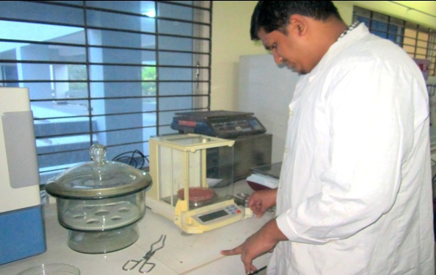 | 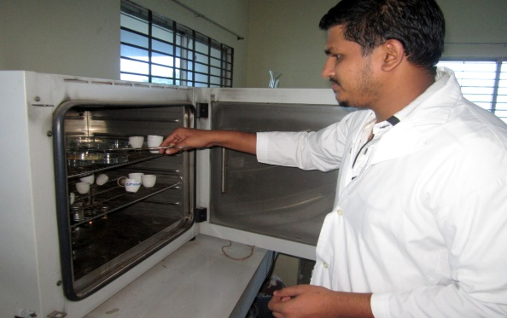
- Taking sample weight | - Estimation of Dry matter
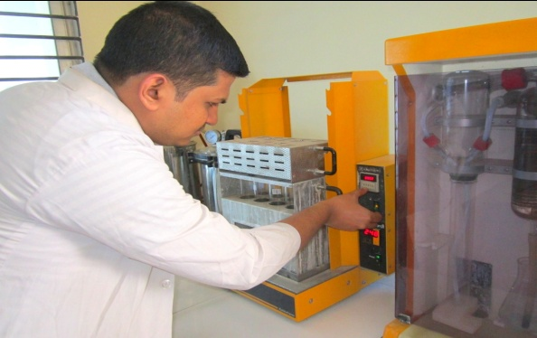 | 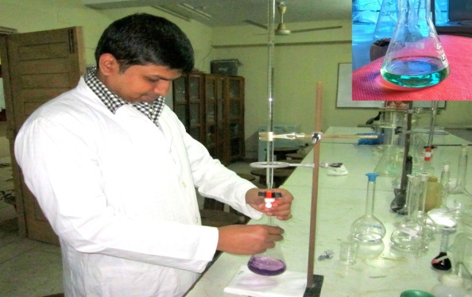
- Crude protein estimation | - Crude protein estimation
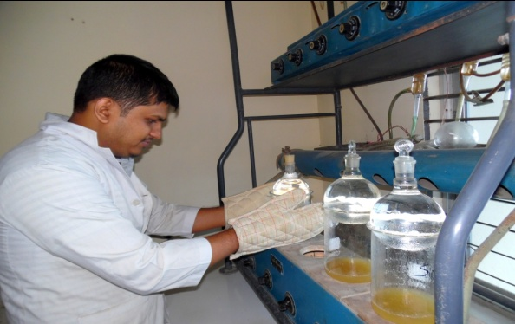 | 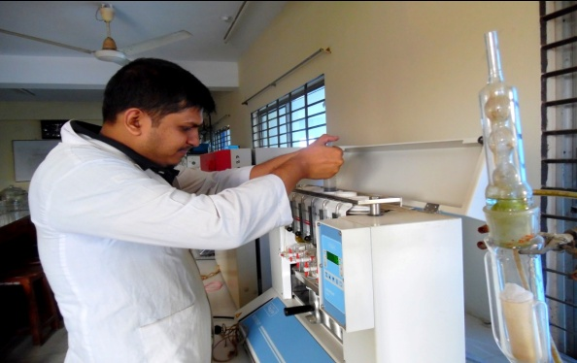
- Crude fiber estimation | - Ether extract estimation

Plate 1 : Proximate estimation of different nutrients

3.6 Selection of ingredients for dog biscuits
Ingredients were selected considering its economical value and availability of those ingredients as prime protein in the biscuits. Considering that points it was found that meat of dead poultry carcass that regularly came for post mortem in the Department of Pathology and Pharmacology would be the suitable ingredients for choosing as the prime protein source in the biscuits.

3.7 Processing of dead poultry meat as protein source in feed (Fig: 2)

3.7.1 Collection of dead carcass
Two bucket was placed in the department of pathology and pharmacology to collect the dead poultry after post mortem. Dead birds were immediately collected after post mortem.

3.7.2 Weighing of dead carcass
Weight of dead poultry was measured and noted in the register book in order to quantify the total collection.

3.7.3 Dressing of carcass
Carcass was dressed properly and only meat portion was stored. Sometimes soft cartilage also kept as they were easily grounded after drying.

3.7.4 Weight of dead carcass
Again weight of dressed carcass was taken to identify the dressing percentage and noted in register book to quantify the dressing percentage.

3.7.5 Sterilization
Sterilization of that dressed meat was done to make it free from microorganisms.

3.7.6 Drying
Drying of sterilized meat was done to improve the storability as well as dried meat could be easily grounded.

3.7.7 Grinding
After drying the meat was grounded and stored for use it as ingredient of biscuits.

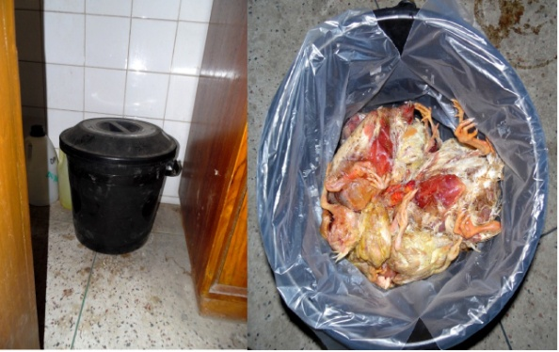 | 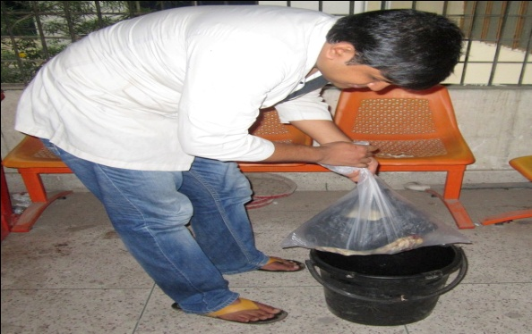
- Collection busket | - Collection of daily dead poultry
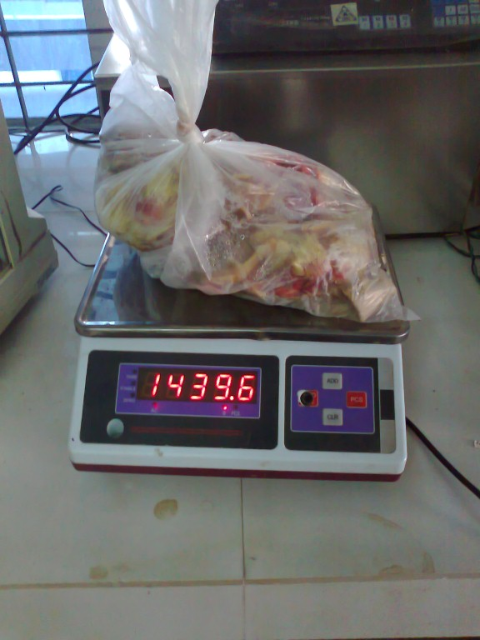 | 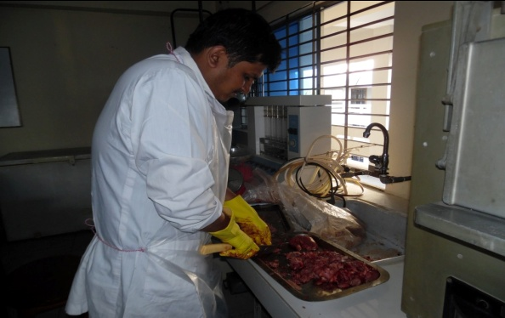
- Weighing of dead poultry | - Dressing dead carcass
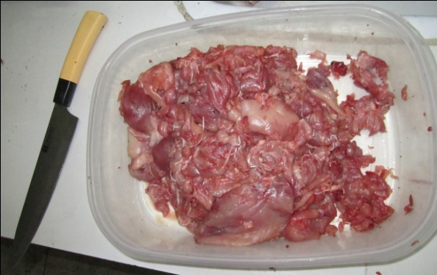 | 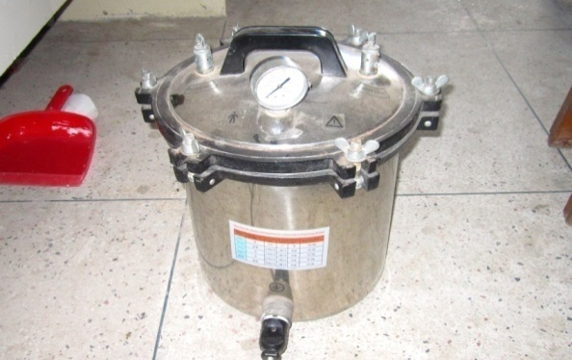
- Separation of pure meat | - Sterilization of meat
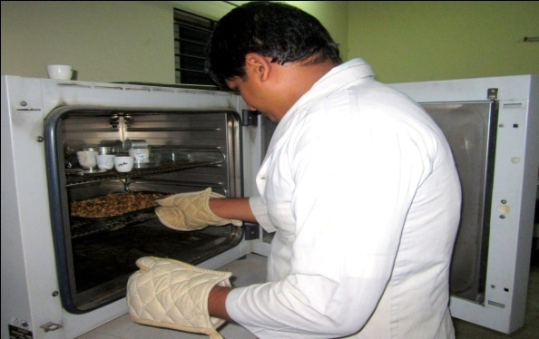 | 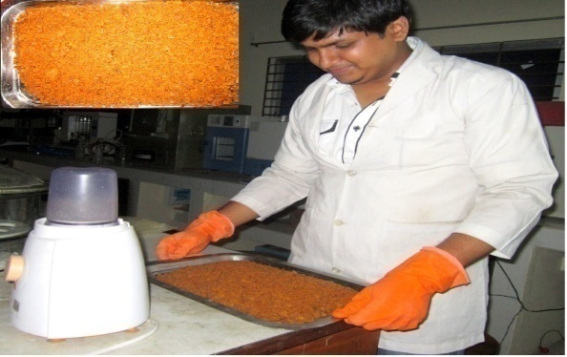
- Oven drying of meat | - Grinding of dried meat

Plate 2: Total process of collection of dead poultry to grounded dried meat

3.8 Formulation of dog biscuits
Biscuit was formulated on the basis of requirement of different nutrients and energy in puppy according to the standard of Association of American Feed Control Officials (AAFCO, 2006). The parameters those were considered in ration formulation are Metabolizable energy, Crude protein, Crude fiber, Vitamins and Minerals. Supplementation with different nutrient will also be performed to balance the nutritional composition of prepared dog food.
Table 2: Ingredients composition of prepared biscuits
Ingredients (kg/100kg) | Amount (kg)
Grounded maize | 22
Grounded wheat | 19.5
Grounded soybean meal | 25
Grounded dry chicken meat | 19
Animal Fat | 6
Vegetable oil | 6
Common salt | .25
Vitamin mineral premix | .25
Egg | 2 pieces
Total | 100

Table 3: Nutritional composition of prepared biscuit
Estimated Chemical composition (DM basis)
Metabolizable Energy (Kcal/kg) | 3384
Crude Protein (%) | 28.5
Crude Fiber (%) | 2.7
Ether Extract (%) | 13
Ash (%) | 4.6

According to AAFCO (2006) puppy food must contain minimum 28% of protein, energy density in between 3-4 kcal ME/g DM, maximum level of crude fiber 5%, minimum level of Crude fat 10%.

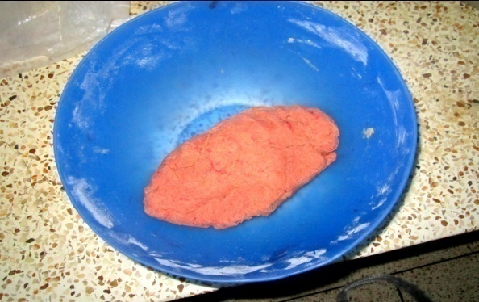 | 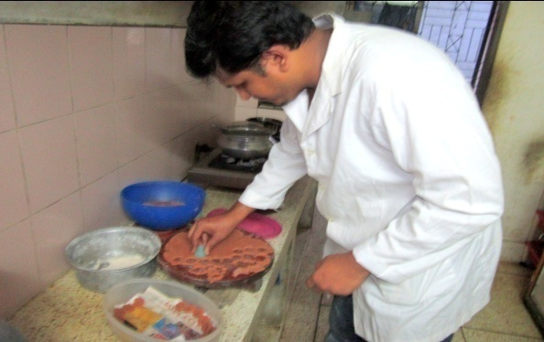
Dough for biscuits | Molding of the biscuits
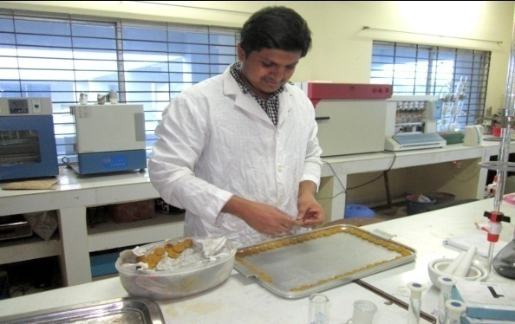 | 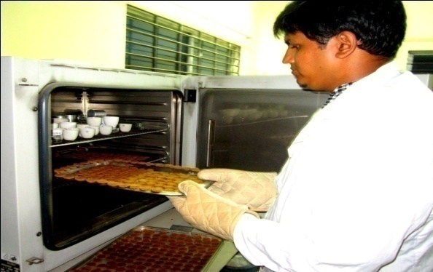
Plating the molded biscuits | Putting the raw biscuits in oven
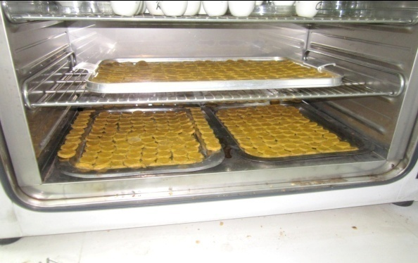 | 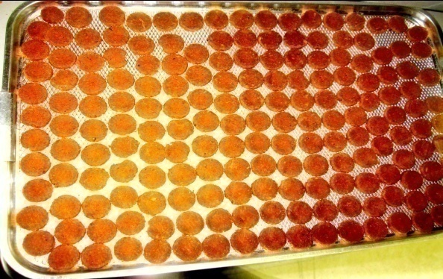
Raw biscuits in oven | Ready dog biscuits

Plate 3: Preparation of biscuit

3.9 Preparation of dog biscuit
All the solid ingredients were dried in hot air oven at 105$℃$ for overnight followed by grinding with a mechanical grinder. Specific amounts of dry and liquid ingredients were measured accurately. The fat was mixed in a mixing bowl with dry powdered ingredients. These ingredients were kneaded well to prepare proper dough. The dough was rolled into the sheets of suitable thickness on a wooden board by wooden roller and the sheet was cut into biscuits in the desired shape by mould cutter. The cut biscuit was dried at 105$℃$ in a hot air oven for about 4 hours. The biscuits was cooled and packed in moisture- proof jars (Fig: 3).
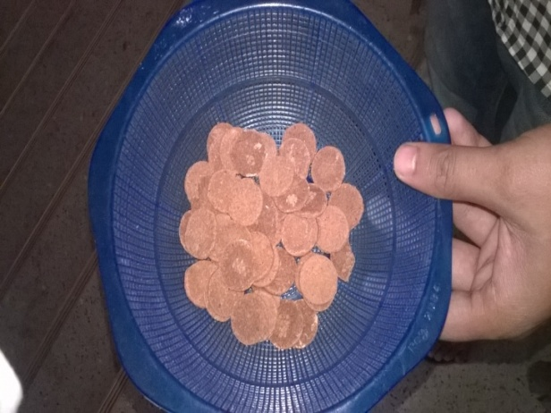 | 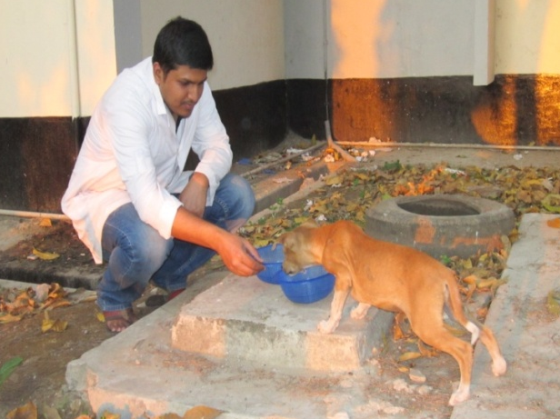
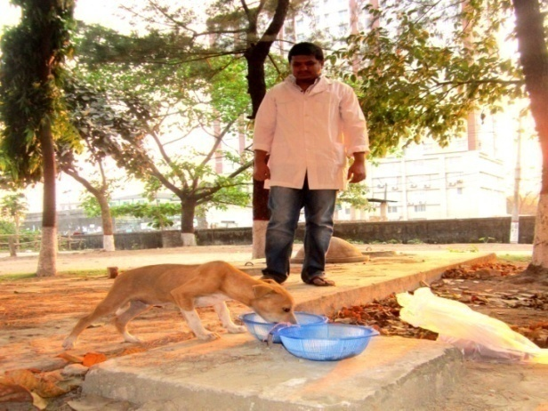 | 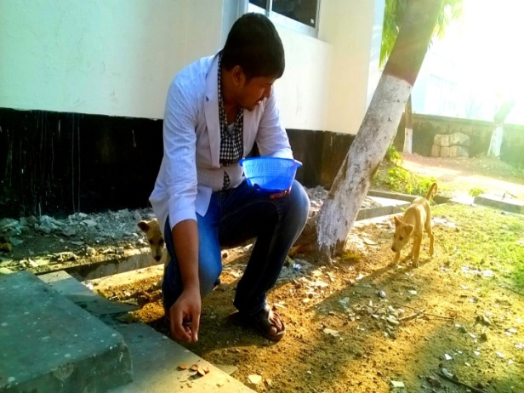
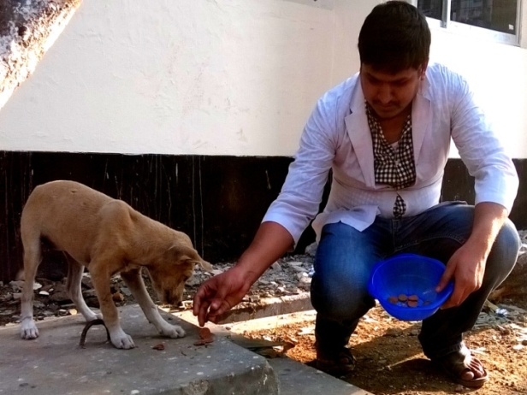 | 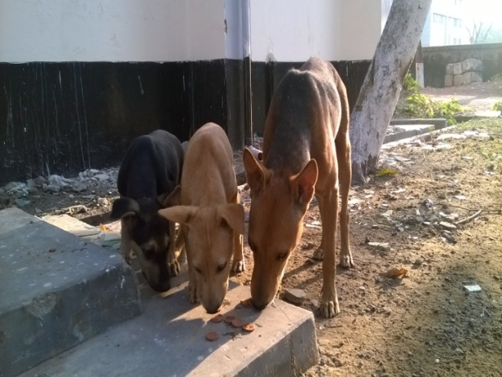
Plate 4: Offering newly formulated biscuits to local dogs for palatability test

3.10 Palatability trail
After formulation of biscuits a palatability trail was conducted to find out whether the dogs liked it or not (Plate: 4). For increasing the palatability artificial color and artificial flavor was added in the biscuits. After satisfactory result in the palatability trial main feeding trial was started.

3.11 Target animals and age groups
A total of eighteen (18) stray puppies from CVASU were selected for this study as target sample were selected between age groups 3-4 months and they were from 6 different parents. The approximate age of the stray puppies was estimated by examining the teeth. According to the statement Cynthia et al. (2011) dogs having all white and shiny permanent teeth without worn off cups on the incisors were considered as young (below one year on age).

3.12 Dog catching and handling
The process of dog handling and catching was done by humane method (also as ‘ethological’ handling). The process is defined as causing the minimum stress possible during the procedure to both the animal and the people involved (FAO, 2014). In order to achieve humane handling, the individual dog’s behavior and the immediate environment was taken into account.

3.13 Feed requirement of dogs
Daily feeding requirement was estimated by determining daily need of Metabolizable energy.
Resting energy requirement (RER) of puppies was done as follows: According to Schenck (2011) the basic requirement for all dogs:
RER = 70× (Body weight in kilograms) ^{0.75}

Daily energy requirement for dog was depend on the age, weight, physiological status. For a growing puppy the Daily Energy Requirement (DER) is
DER= 3×RER (Schenck, 2011)

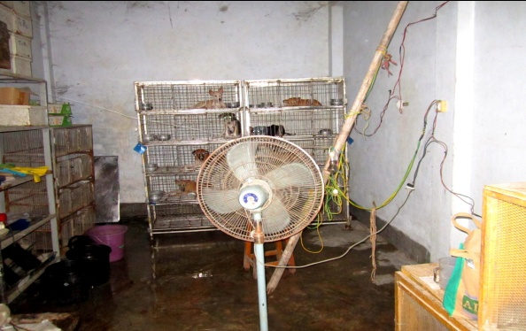 | 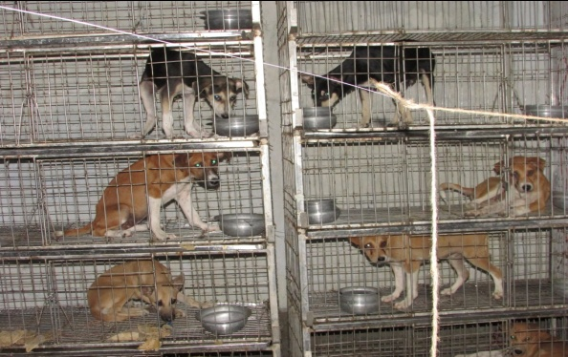
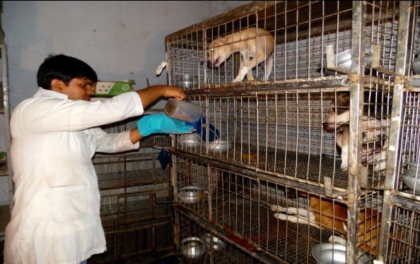 | 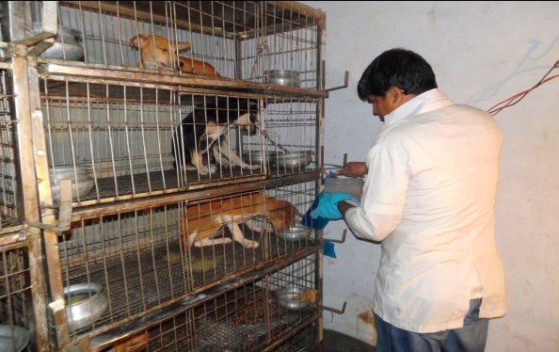
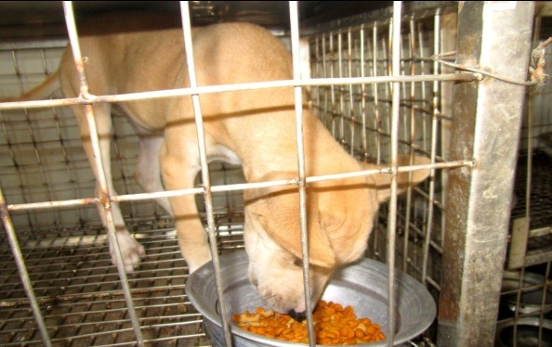 | 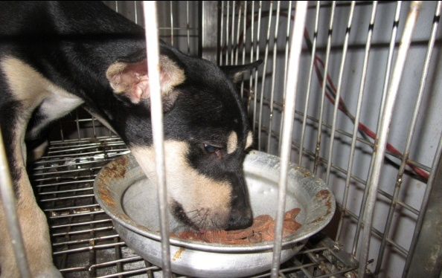
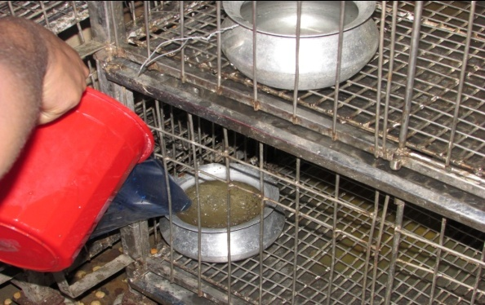 | 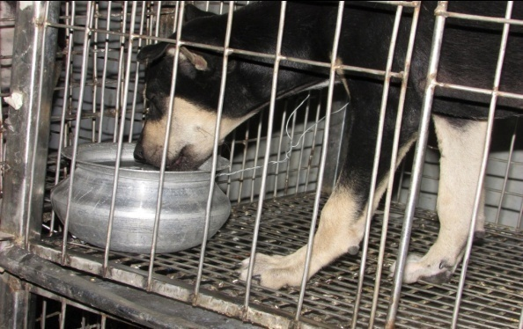

Plate 5: Feeding trial of the puppies

3.14 Feeding trial
A total of 21days (April 09th to April 29th 2015) feeding trial was conducted on preselected street puppies. Trial was conducted with three different groups of dogs: (i) with newly formulated dog biscuit, (ii) with the market available dog biscuit (iii) with traditional foods. All three groups were maintained in Department of Animal Science and Nutrition Laboratory. Feeding was provided 2 times in a day. The timing was 9.00 a.m. in the morning and 7.00 p.m. in the evening. Regular ad-lib. drinking water was provided (Plate: 5).

3.15 Weight gain
Weekly body weight was taken to estimate the weight gain and also for the feed requirement. Weighing was done by electronic scale (± 10gm) in the morning while in empty gut (Plate: 6).
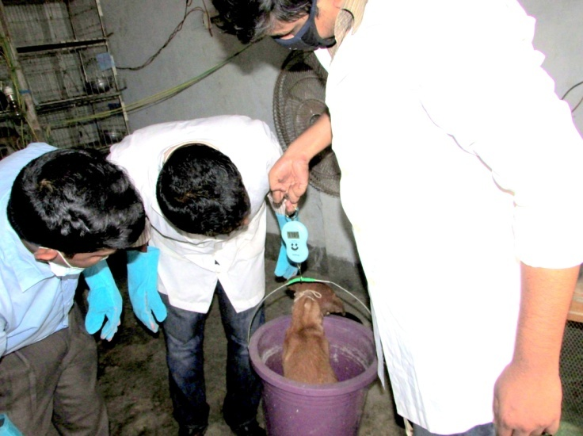
Plate 6: Weighing of dog

3.16 Collection of Blood samples
Blood was collected on weekly basis to do hematological and biochemical analysis. Blood were collected through cephalic vain puncture in two sterile vacutainer (3 ml for each). One containing EDTA (anticoagulant) for hematology and another do not contain anticoagulant which was used for serum separation for biochemical analysis. During blood collection the collection site was disinfected with 70% alcohol solution (Fig: 7).
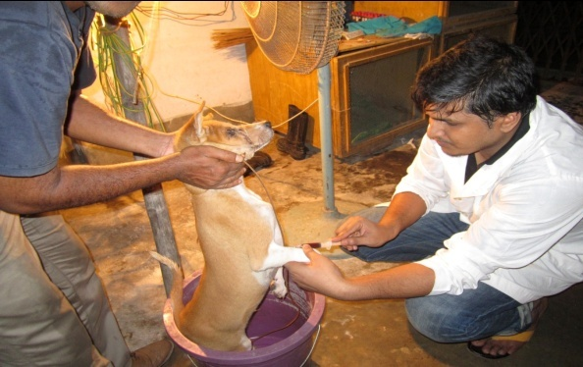 | 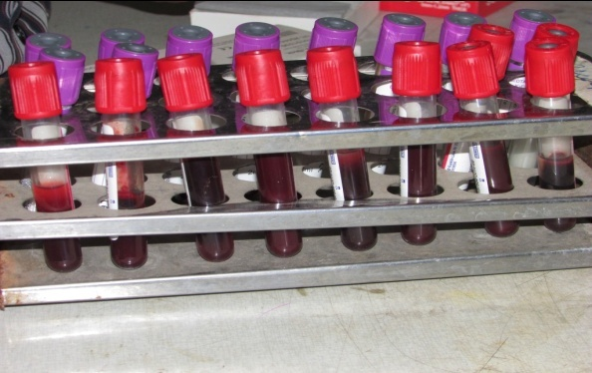
- Collection of dog blood | - Blood in the vacutainer
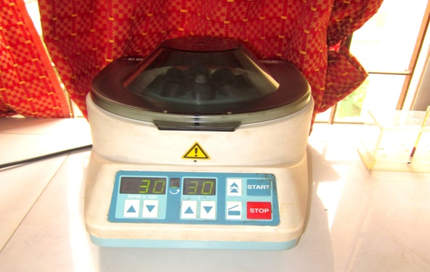 | 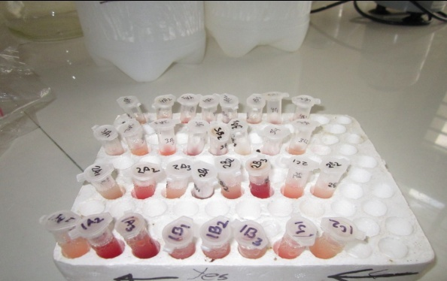
- Centrifuged the blood | - Serum sample
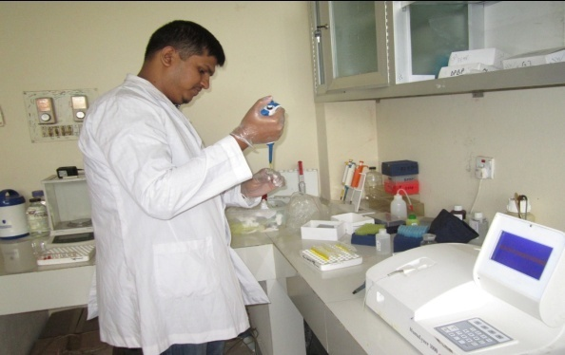 | 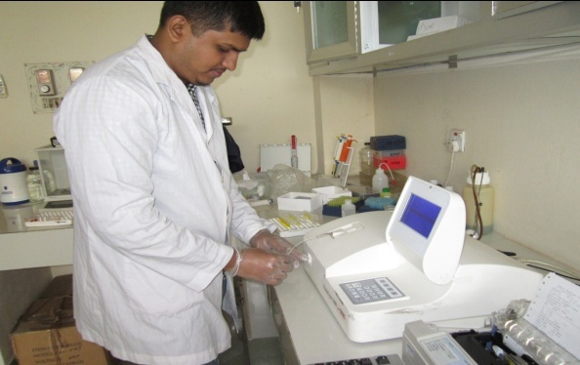
- Adding reagent to serum sample | - Analysis the serum sample

Plate 7: Collection of blood and performing metabolic profile test and heamato-biochemical test

3.16.1 Hematological Analysis
The samples collected with anticoagulant were analyzed for routine examination of blood as per Weiss and Wardrop (2011). The samples were analyzed within 24 hours of collection. Hemoglobin (Hb), Packed cell volume (PCV), Erythrocyte sedimentation rate (ESR), Total leukocyte count (TLC), Total Erythrocyte count (TEC) and Differential leukocyte count (DLC) were performed in Physiology laboratory of Chittagong Veterinary and Animal Sciences University (CVASU).

3.16.1.1 Haemoglobin
Haemoglobin (Hb) was determined by acid hematin method. Hb is converted to acid hematin by dilute HCl which in solution brown in colour. The intensity of this colour depends on the amount of acid hematin in solution which in turn depends on Hb concentration. The colour of the solution is matched against brown tinted glass filter by direct vision and the results were expressed as gm/100ml blood (gm %).

3.16.1.2 Packed Cell Volume (PCV)

Blood samples were centrifuged in a haematocrit tube. The RBC (Sp. gr. =1.09) being heavier than plasma (Sp. gr. = 1.03) get pack towards the bottom of the tube by centrifugal force. The reading of the percentage of blood that is red cells was then noted.

3.16.1.3 Erythrocyte Sedimentation Rate (ESR)
ESR was estimated by Wintrobe’s method. Blood samples were added to hematocrit tube up to the mark 10. The RBC (Sp. gr. = 1.09) being heavier than plasma (Sp. gr. = 1.03) settle down gradually towards the bottom of the tube. The rate in mm at which the RBC settles was noted at the end of certain period.

3.16.1.4 Total Erythrocyte Count (TEC)
The number of RBC was estimated by using Neubaur Haemocytometer. The blood was diluted 200 times with Hayem’s solution. Red blood cells were then counted into Neubaur Haemocytometer under microscope in diluted blood. The TEC in undiluted blood was calculated by multiplying volume correction factor and dilution factor. The results were expressed as number of RBC per ml of blood.

3.16.1.5 Total Leukocyte Count (TLC)
The blood was diluted with 0.1N HCl which destroys the red cells and stains the nuclei of WBC. White blood cells (WBC) were then counted into a Haemocytometer under microscope in diluted blood. The TLC in undiluted blood was calculated by multiplying volume correction factor and dilution factor. The results were expressed as number of WBC per ml of blood.

3.16.1.6 Differential Leukocyte Count (DLC)
A small drop of blood used to make a thin film of blood on a glass slide. Blood film was then stained with Wright’s stain. The different white blood cells on stained film were then counted under microscope based on their morphology. The results were expressed as percentages of different white blood cells.

3.17 Biochemical Analysis
The biochemical analysis was performed from the preserved serum sample. The samples were allowed to be in room temperature before starting the analysis. The serum bilirubin, serum albumin, SGPT, serum glucose, serum creatinine, blood urea, total protein (TP), Calcium (Ca), and Phosphorus (P) were estimated by using biochemical analyzer (Humalyzer-3000 Chemistry Analyzer, semi automated Benchtop chemistry photometer) in biochemistry laboratory of CVASU. For each parameter the commercial kit of RANDOX Company were used and followed for the manufacture’s procedure (http://www.randox.com/reagent).
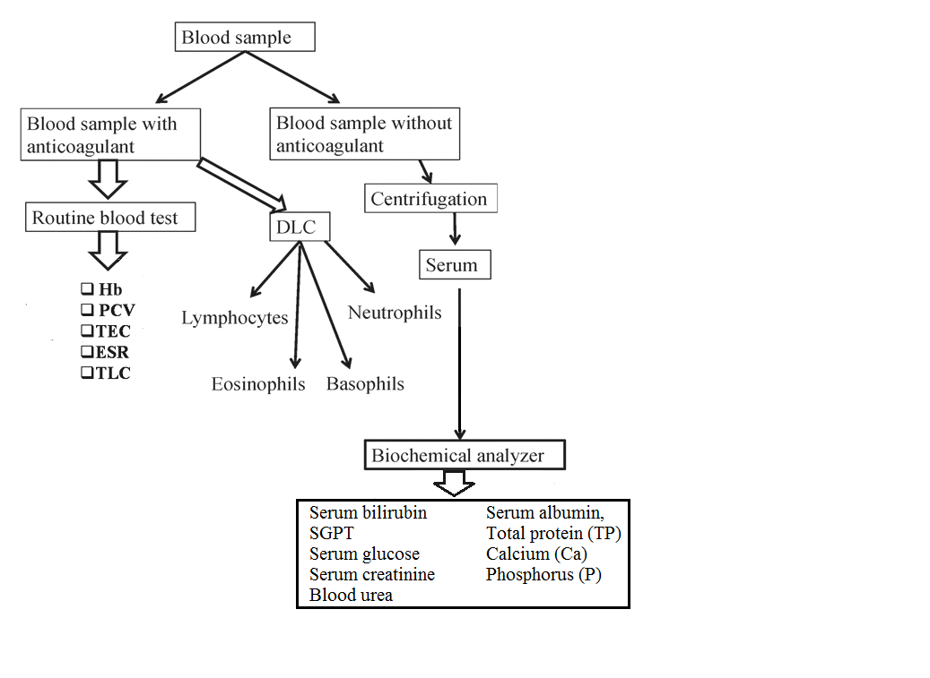

Plate 8: Layout of sample analysis

3.18 Digestibility comparison of formulated biscuits and commercial dog food
Group digestibility trial was done in order to find the digestibility comparison between newly formulated biscuits and commercial dog food. 3 days collection trial was done after 14 days of adjustment period. Digestibility comparison was done between prepared biscuits and commercial dog food. For digestibility trial total feces of each group of puppies was collected and mixed properly (Plate: 9). Sample was taken from that mixed feces and proximate analysis was done of that feces sample. From that value of proximate analysis digestibility of certain nutrient was estimated. The formula that used to estimate digestibility mentioned below:

Nutrient intake – Nutrient voided
Digestibility = × 100 %
Nutrient intake
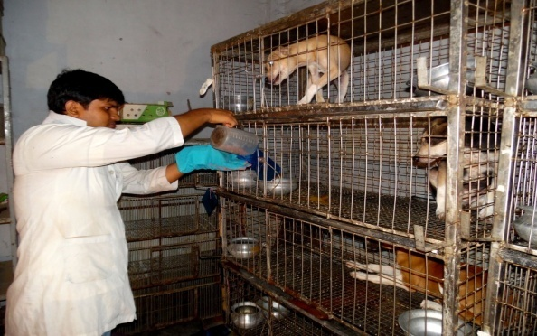 | 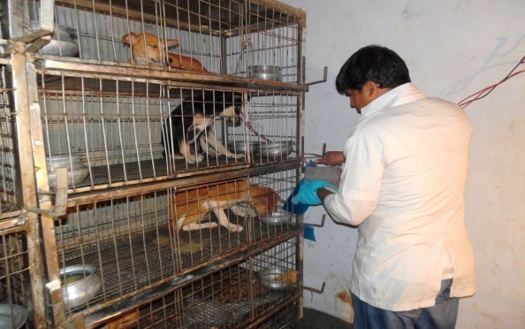
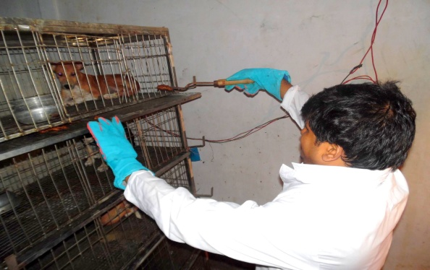 | 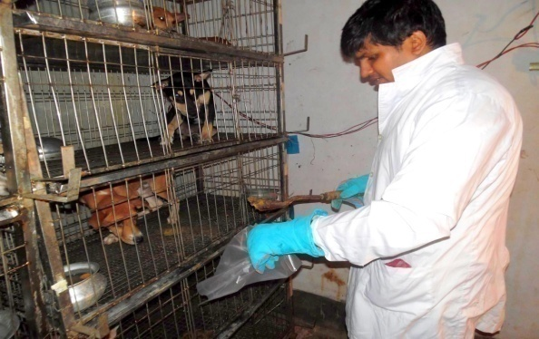
Plate 9: Feeding of puppies and collection of feaces

3.19 Statistical analysis
The collected data were imported in Microsoft Excel 2007. Descriptive analysis of different parameters was done. Comparison of different variable of three different treatment groups was performed by one way ANOVA by using SPSS 16. Comparisons of digestibility trial of two groups were completed by T-test using STATA 11 software.

Chapter-4: Results and Discussion
This was an experimental study designed to formulate a nutritionally balanced and palatable dry dog-food using available ingredients with low price. This study also designed a comparative feeding trial with the newly formulated dog food and others food to observe the growth performance and vital organ (liver and kidney) functions of the dog.
4.1 Survey
A survey was conducted and found that 90% dog owner offered “Pedigree” as the main food to their Pets and the rest 10% used “Nutripet” to their dogs. In some cases (1-2%) the lower class people used to their normal food as they took to their dogs.

4.2 Screening of the available Ingredients:
Screening was done to search for the available ingredients to prepare dog biscuit and found that the dead chicken is one of the major sources for the purpose. From the overall experiment it was found that the dead chicken meal contains highest percentage of CP (65.67±0.72) as compared to the other available ingredients. Chemical composition of selected ingredients is presented in table 4.
Table 4: Chemical composition (%) of identified protein source byproducts that may be used as dog food ingredients
English name | ME*  (Kcal/kg) | DM  (%) | CP  (Mean±SE)  (%) | CF  (Mean±SE)  (%) | EE  (Mean±SE)  (%) | NFE  (Mean±SE)  (%) | Ash  (Mean±SE)  (%)
Pure chicken intestine | 4687.73±60.01 | 80.5 | 47.69±0.25 | 0.32±0.02 | 38.25±0.79 | 9.47±0.68 | 4.28±0.08
Chicken intestine with skin | 5107.73±26.82 | 84.2 | 41.21±0.76 | 0.54±0.01 | 47.12±0.15 | 8.67±0.56 | 2.45±0.11
Fish scale | 2477.83±73.74 | 48 | 61.87±0.96 | 0.38±0.04 | 4.7±0.26 | 3.64±0.69 | 29.34±0.05
Chicken meal | 2996.93±73.44 | 35 | 65.67±0.72 | 2.6±0.06 | 2.4±0.1 | 20.77±0.84 | 8.57±0.03
^{ME}Metabolizable energy ; ^{DM}Dry matter; ^{CP}Crude protein, ^{CF}Crude fibre, ^{NFE}Nitrogen free extract, ^{EE}Ether extract; *ME was determined by Lodhi et al. (1976)

In present study the chemical composition of selected ingredients were done to evaluate the comparative nutritional value and to make a decision whether they suitable for protein source in dog food or not.

4.2 Chicken intestine and chicken intestine with skin
In present study chicken intestine contain 4687.7 Kcal/kg ME, 47.69±0.25% CP, 0.32±0.02% CF, 38.25±0.79% EE, 4.28±0.08% Ash and chicken intestine with skin contain 5107.7 Kcal/kg ME, 41.21±0.76% CP, 0.54±0.01% CF, 47.12±0.15% EE, 2.45±0.11% Ash (Table-4). The result is a bit differed with other investigators 70.0±0.001% CP, 7.640±0.002% EE, 0.210±0.001% CF, 4.330±0.001% Ash, 529.8±0.01 Kcal/100g ME (Giri et al., 2010; Tabinda and Butt, 2012) but very close with poultry by product meal which was made of chicken intestine 57.75% CP, 28.93%, 11.54% Ash and 1.26% CF (Sevgili and Ertürk, 2004).

4.3 Chicken meal
In present study chicken meal contain 2996.9 Kcal/kg ME, 65.67±0.72% CP, 2.6±0.06% CF, 2.4±0.1% EE, 8.57±0.03% Ash (Table-4) in which protein percentage is similar to Aldrich (2007) who mentioned chicken meal is ground up chicken meat that has been carefully dried and protein content is 65%. Similar type result also found in the study of Robert and Adrian (2014) , they observed chicken meal with skin contains 60 % CP, 8 % EE, 20% Ash, A Study of Rawles et al. (2011) showed turkey meal also have almost same nutrient value as 66.6 % CP, 1.3% CF, 11.1% EE and 8.6 % Ash. Considering the above information chicken meal might be use as a good source of protein for dog food.

4.4 Fish Scale
The term fish meal means a product obtained by drying and grinding or otherwise treating fish or fish waste to which no other matter has been added. The current study investigated the nutritional quality of fish scale. The chemical composition of fish scale that found in present study were 61.87±0.96% CP, 0.38±0.04 % CF, 4.7±0.26% EE, 29.34±0.05% Ash (Table-4). The CP and CF contents of fish scale estimated under this study are almost similar with the findings of Moghaddan et al. (2007) with a slight deviation of the value of the EE and Ash content. In another study by Khan et al. (2012), the chemical analysis of fish meal samples revealed that average gross energy, fat, dry matter, crude protein, fiber and ash contents were 4,417 cal/g, 21.88%, 91.03%, 55.79%, 7.26% and 20.75%, respectively and the range of the value of gross energy, fat, dry matter contents, protein, fiber contents, ash, and phosphorous varied from 4,118 to 4,883 cal/g, 9.9 to 29.52%, 88.43 to 93.29%, 37.49 to 66.57%, 2.23 to 12.67%, 12.74 to 28.22% and 0.1 to 1.0%, respectively. Protein contain of fish scale estimated in present study had almost same with other literatures. So it can be use as protein source in dog food.

4.5 Quantification of available chicken meal (dead bird) of CVASU
The production of dead chicken and quantification are presented in Table 5 and 6.
Table 5: Production of dead chicken in Pathology and Pharmacology lab of CVASU
Week | Raw chicken (kg/day)(Mean±SE) | Usable meat from the dead chicken (kg/day)(Mean±SE)
Week 1 | 2.46 ± 0.68 | 1.4± 0.39
Week 2 | 2.09±0.35 | 1.21±0.27
Week 3 | 2.61 ± 0.48 | 1.49 ±0.26
Week 4 | 3.80 ± 1.2 | 2.1 ± 0.64
Week 5 | 2.16±0.85 | 1.39±0.59

Here usable meat refers those portions of meat that were kept for using as a protein source in dog biscuits.
Table 6: Quantification of collected and usable meat in a period of 5 weeks
Total collection (kg) | Usable meat (kg)
51.18 | 29.37

A five week collection period was considered to collect dead chicken from Department of Pathology & Parasitology, and Department of Physiology, Biochemistry & Pharmacology. A total of 51.18kg dead chickens were collected and after dressing 29.37kg usable meat were obtained with a dressing percentage of 57.38% (Table-5). Weekly collection was ranges from 2.09±0.35 kg to 3.80 ± 1.2kg dead chickens (Table-6). All the collected usable meat was used for the research purpose i.e. formulation of dog biscuit.

4.6 Growth trial

A comparative growth trial was conducted with prepared dog biscuit and available dog feed.

4.6.1 Food offered
The food that was offered to the puppies was maintained nutritional level as 3-4 Kcal/gm of ME and 28% CP according to the standard requirements suggested by AAFCO (2006). However, food was offered by following the feeding rule of Schenck (2011), every week after weighing the body weight, feeding was adjusted with the weight gain after satisfying the maintenance requirements of the experimental dogs.The amount of daily offered food presented in table 7.
Table 7: Daily offered food (gm/puppies) in different treatment group.
Average feeding amount (Mean±SE)
Treatment group | Day (1-7) | Day (8-14) | Day (15-21)
T₀ | 233.68±13.38 | 261.33±17.91 | 276.33±18.22
T₁ | 235.66±14.72 | 262.33±12.20 | 277.33±11.55
T₂ | 231±1 | 252.67±1.20 | 267.33±1.45
T₀=Diet containing commercial food; T₁=Diet containing prepared biscuits; T₂=Diet containing homemade food. SE= Standard Error.

4. 6.2 Body weight and body weight gain of dogs
Trends of body weight & body weight gain of experimental dogs are presented in table 8 & 9.
Table 8: Trends of Body weight (kg) of different treatment groups
Week | Dietary treatment groups
 | T₀ (Mean±SE) | T₁ (Mean±SE) | T₂ (Mean±SE)
Initial day | 5.96±0.46 | 6.18±0.5 | 5.42±0.03
1st | 6.89±0.63 | 7.12±0.43 | 6.09±0.04
2nd | 7.44±0.67 | 7.71±0.41 | 6.56±0.05
3rd | 7.98±0.71 | 8.29±0.39 | 7.03±0.03
T₀=Diet containing commercial food; T₁=Diet containing prepared biscuits; T₂=Diet containing homemade food. SE= Standard Error.
Table 9: Body weight gain (kg/week/dog) of experimental dogs of different treatment groups
Week | Dietary treatment groups |  |  | Sig
 | T₀ (Mean±SE) | T₁ (Mean±SE | T₂ (Mean±SE)
1st | 0.94ª±0.19 | 0.95ª±0.08 | 0.67^{b}±0.02 | *
2nd | 0.55±0.04 | 0.58±0.03 | 0.47±0.01 | NS
3rd | 0.54±0.04 | 0.58±0.03 | 0.47±0.02 | NS
Total | 2.02ª±0.27 | 2.11ª±0.13 | 1.62^{b}±0.04 | *
T₀=Diet containing commercial food; T₁=Diet containing prepared biscuits; T₂=Diet containing homemade food. SE= Standard Error; Means with different superscripts in the same row differ significantly (p> 0.05), NS= Non-Significant (P>0.05); *= Significant (P<0.05)

The mean growth rate of puppies in group T₀ (Commercial food) and T₁ (Prepared biscuit) showed a significantly higher growth rate (2.02±0.27kg/week/puppy and 2.11±0.13kg/week/puppy respectively) than puppies in group T₂ (Homemade food) (1.62±0.04kg/week/puppy). This could be due to inadequate nutritional composition of homemade food. During the adaptation period (1st week) there was significantly higher growth rate (0.94kg±0.19 kg/week/puppy) and 0.95kg±0.08 kg/week/puppy, respectively in group T₀ and T₁ than group number T₂ (0.67kg±0.02 kg/week/puppy) was observed. The result is somewhat similar with the research works of Dilrukshi et al. (2009), who mentioned the weight gain as 1.27±0.43 kg/week/puppy in imported feed and 0.25kg±0.17 kg/week/puppy in homemade food. The present study found that, there was no significant difference (p>0.05) in growth rate of puppies during 2nd and 3rd week though rate of weight gain was higher in T₀ &T₁ group that were fed commercial food and prepared biscuit than the T₂ group that was fed homemade food. The mean weight gain (kg/week/puppy) were 0.58±0.03 in prepared biscuits group where 0.54kg/week ±0.04 was the mean weight gain of commercial food group which was slightly higher than Dilrukshi et al. (2009) found mean weight gain (kg/week/puppies) 0.41 ±0.15 in formulated food and 0.43± 0.13 in imported food. Again in this study there was no significance difference in total mean weight gain (kg/week/puppies) between the groups that were fed prepared biscuits (2.11 ±0.13) and commercial food (2.02 ±0.27). This may be the consequence of similar nutritional, mainly energy and protein balance in prepared biscuit and commercial food.

4.7 Metabolic profile test
Mean and standard deviation values of blood profile in dogs are shown in tables 10 to 18. The values obtained in this research work are well compared with those of the literature reference (Kaneko et al., 1997). However, some differences were found among the studied groups. Plasma and/or serum biochemical profiles were used routinely for clinical and metabolic evaluation of animals. Biochemical plasma profiles have been extensively used in Veterinary Medicine for clinical evaluation procedures in individuals, as well as in populations (Payne and Payne, 1987). When properly interpreted, plasma biochemical values give important information concerning clinical status, nutritional balance, deficit condition, treatment monitoring and prognostics.

4.7.1 Liver function test

4.7.1.1 Serum glutamate pyruvate transaminase (SGPT)
The SGPT level (U/L) remained non-significant during the experimental period (Table 9). The maximum mean value of SGPT level (78.60$±21.70$) was found in T₂ group in 3rd week; the minimum level (21.13$±0.52$) was also found in T₂ group in the initial day of experiment.

Table 10: SGPT level (U/L) in the Blood serum of the experimental cows dogs fed different dietary food
Week | Dietary treatment Groups |  |  | P Value | Reference value*
 | T₀ (Mean±SE) | T₁ (Mean±SE | T₂ (Mean±SE)
Initial day | 22.27± 0.87 | 30.03± 4.02 | 21.13± 0.52 | 0.07 | 23-66
1st week | 58.5±13.52 | 73.45±33.07 | 60.43±15.33 | 0.31
2nd week | 38.4±12.97 | 39.57±3.36 | 64.0±14.06 | 0.27
3rd week | 35.57±15.63 | 39.83±13.23 | 78.60±21.70 | 0.23
T₀=Diet containing commercial food; T₁=Diet containing prepared biscuits; T₂=Diet containing homemade food. SE= Standard Error; *Ref. value Kaneko et al. (1997).

Occurrence of all biochemical reactions and continuation of life is supported by enzymes. Therefore, changes in enzyme activities are considered to be an indicator of the health of an organism (Grant and Kachmer, 1976; Boyd, 1984). Liver is the main organ controlling metabolism in entire body. SGPT is the specific enzymes of the liver which increases in the serum by the destruction of the cell membrane and cell necrosis in acute liver disease and due to accumulation of toxic substances (Dunman and Erden, 2004). In present study, serum SGPT was more or less in normal range and did not differ significantly (p>0.05) among the treatment groups. Although the serum SGPT level was slightly increased in the T₂ group in 3rd week but that is goes well according to Clermont and Chalmers (1967) and Boyd (1984) moderate increase in the serum SGPT level does not indicate any hepatic damage in the dog. Interpretation can be drawn from the results of SGPT level in different treatment group that the prepared dog biscuit had no adverse effect on liver.

4.7.1.2 Serum bilirubin
The serum bilirubin appeared normal and did not differ significantly during the experimental period (1st to 3rd week) (Table-11).
Table 11: Bilirubin level (mg/dl) of dogs under different dietary treatment groups
Week | Dietary treatment groups |  |  | P Value | Reference value*
 | T₀ (Mean±SE) | T₁ (Mean±SE) | T₂ (Mean±SE)
Initial day | 0.13$±0.02$ | 0.13$±0.02$ | 0.03±0.003 | 0.77 | 0.1-0.8
1st week | 0.23±0.06 | 0.07±0.03 | 0.07±0.03 | 0.07
2nd week | 0 | 0 | 0
3rd week | 0.03±0.03 | 0.03±0.03 | 0.17±0.03 | 0.47
T₀=Diet containing commercial food; T₁=Diet containing prepared biscuits; T₂=Diet containing homemade food. SE= Standard Error; * Ref. value Kaneko et al. (1997).

Bilirubin is a yellow pigment that is a by-product of the breakdown of hemoglobin. Hemoglobin is found in red blood cells and is responsible for carrying oxygen to the tissues. The liver converts the hemoglobin to bilirubin which is then secreted in the bile (Zeman et al., 1981). In current study, there was no significant (p>0.05) changes in the serum bilirubin level indicating the experimental dogs in all treatment groups had normal liver function activity ((Bostwick and Meyer, 1995; Kozaki et al., 1998).

4.7.1.3 Serum glucose
The serum glucose appeared normal and did not differ significantly at the initial day of the experiment. But later the glucose level was fall drastically (1st week to 3rd week) in all treatment groups. Among the different treatment groups the lowest and highest level of glucose were (14.37±5.68) and (52.03±10.06), respectively in the next consecutive three weeks (Table-12)which are way below from the reference value as mentioned by Kaneko et al. (1997).
Table 12: Serum glucose level (mg/dl) of dogs under different dietary treatment groups
Week | Dietary treatments groups |  |  | P Value | Reference value*
 | T₀ (Mean±SE) | T₁ (Mean±SE | T₂ (Mean±SE)
Initial day | 69.17± 0.58 | 77.57± 16.86 | 75.30± 5.28 | 0.84 | 65-118
1st week | 28.47±10.04 | 25.27±7.33 | 17.17± 2.77 | 0.57
2nd week | 14.37ª±5.68 | 52.03^{b}±10.06 | 37.23 ^{b} ±6.36 | 0.04
3rd week | 21.93ª± 1.43 | 46.77 ^{b} ±4.68 | 32.93 ^{b} ±6.84 | 0.03
T₀=Diet containing commercial food; T₁=Diet containing prepared biscuits; T₂=Diet containing homemade food. SE= Standard Error. Means with different superscripts in the same row differ significantly (p> 0.05) * Ref. value Kaneko et al. (1997).

Glucose is a major source of energy for most cells of the body, including brain cells. A blood glucose test measures the amount of a sugar called glucose in a sample of blood. The blood glucose level were differ insignificantly (p>0.05) among different treatment groups.. In the initial day of the experiment the level of glucose was within the range of reference value (Kaneko et al., 1997). But in the later period although there were no significance difference (p>0.05) among the group but the level of glucose was too lower than the reference value (Kaneko et al., 1997). This might be due to the environmental effect as dogs were reared in a cage with restriction of movement that goes with interpretation of Payne and Payne (1987) blood metabolites may suffer important variations within the same species due to many factors, mainly, feeding regimen, age, physiological status, habitat and environmental stress. According to Bush (1991) and Boyd(1984) variation in the biochemical level can be occurred in any species due alteration of natural habitat.

4.7.1.4 Total protein (TP)
Serum TP (g/dl) level were significantly differ among the different treatment groups in the initial day of experiment but insignificantly differ at 1st week and onwards (Table-13). During the study period the TP level of the experimental dogs were remain normal except T1 group where the TP was slightly higher than the reference value (Kaneko et al., 1997) at 1st week.

Table 13: Serum total protein level (g/dl) of dogs under different dietary treatment groups
week | Dietary treatment groups |  |  | P Value | Reference value*
 | T₀ (Mean±SE) | T₁ (Mean±SE | T₂ (Mean±SE)
Initial day | 7.10 ^{b} ±0.32 | 5.37ª±0.12 | 7.17 ^{b} ±0.09 | 0.01 | 5.4-7.1
1st week | 6.30±0.64 | 8.47±0.78 | 7.87±0.84 | 0.20
2nd week | 6.73±0.27 | 6.73±0.22 | 6.20±0.06 | 0.19
3rd week | 5.57±0.35 | 7.37±0.74 | 5.80±1.33 | 0.37
T₀=Diet containing commercial food; T₁=Diet containing prepared biscuits; T₂=Diet containing homemade food. SE= Standard Error. Means with different superscripts in the same row differ significantly (p> 0.05)* Ref. value Kaneko et al. (1997).

Total protein is done to diagnose nutritional problems, kidney disease or liver disease. Although the serum total protein did not differ significantly (p>0.05) in the experimental weeks and those were also within the range of reference value (Kaneko et al., 1997). There was significance difference (p>0.01) in the serum total protein level on the initial day among the treatment groups. As the experimental dogs was captured a day before due to lack of proper nutrition and food, stray dogs might had variation in total protein (Shakhar et al., 2010). According to the interpretation of Grant and Kachmer (1976), Boyd (1984) and Bush (1991), the test results showed that the dogs were not suffered any kind of liver or kidney diseases during the 3 weeks of experiment.

4.7.1.5 Serum albumin
The serum albumin in all treatment groups appeared in normal level and did not differ significantly during the experimental period (1st to 3rd week) (Table-14) and the values were within the range of reference value (Kaneko et al., 1997).
Table 14: Serum albumin level (mg/dl) of dogs under different dietary treatment groups
Week | Dietary treatment groups |  |  | P Value | Reference value*
 | T₀(Mean±S) | T₁(Mean±SE) | T₂(Mean±SE)
Initial day | 2.97± 0.22 | 2.50± 0.47 | 2.80± 0.26 | 0.63 | 2.6-3.6
1st week | 2.83±0.16 | 3.23±0.32 | 3.63±0.30 | 0.18
2nd week | 2.73±0.12 | 2.83±0.09 | 2.67±0.03 | 0.45
3rd week | 2.60±0.17 | 3.13±.027 | 2.97±0.14 | 0.30
T₀=Diet containing commercial food; T₁=Diet containing prepared biscuits; T₂=Diet containing homemade food. SE= Standard Error.* Ref. value Kaneko et al. (1997).
Albumin is a protein made by the liver. A serum albumin test measures the amount of this protein in the clear liquid portion of the blood. Throughout the study there were no significance deference (P >0.05) of serum albumin among the treatment groups. Albumin level in serum directly indicates absorbance of dietary protein of the animal. Low serum albumin in clinically healthy dogs may indicate long-term protein deficiency intake, as a consequence of a diminished synthesis of hepatic albumin (Bush, 1991; Duncan et al., 1994). Among the dogs of different treatment numerically lower and higher level of albumin was 2.60±0.17 mg/dl and 3.63±0.30 mg/dl. In both cases serum albumin level was in between the reference value (Kaneko et al., 1997) indicates the dogs were free form liver disease and the body was absorbing enough protein (Meyer et al., 1992; Duncan et al., 1994).

4.7.2 Kidney function test

4.7.2.1 Serum creatinine
The serum creatinine appeared in normal level and did not differ significantly during the experimental period (1st to 3rd week) and the values were within the reference value (Table-15).
Table 15: Serum creatinine level (mg/dl) of dogs under different dietary treatment groups
Week | Dietary treatment groups |  |  | P Value | Reference value*
 | T₀ (Mean±SE) | T₁ (Mean±SE) | T₂ (Mean±SE)
Initial day | 0.53±0.33 | 0.53±0.07 | 0.40±0.10 | 0.38 | 0.5-1.5
1st week | 0.73±0.35 | 1.13±0.13 | 1.33±0.18 | 0.28
2nd week | 0.67±0.14 | 0.76±0.03 | 0.90±0.06 | 0.28
3rd week | 0.93±0.17 | 0.77±0.03 | 1.27±0.03 | 0.08
T₀=Diet containing commercial food; T₁=Diet containing prepared biscuits; T₂=Diet containing homemade food. SE= Standard Error* Ref. value (Kaneko et al., 1997)

A key finding in renal disease is the elevation of serum creatinine (Perrone et al., 1992). The majority of serum creatinine originates from the endogenous conversion of phosphocreatine in muscle. Creatinine is not reutilized in body. It is modified by conditioning and muscle disease and distributed throughout the compartment of total body water. Creatinine concentration is not affected significantly by diet, protein catabolism and urinary flow (Boyd, 1984; Bush, 1991; Duncan et al., 1994). In present study, there was no significance difference (p>0.05) among the three treatment groups and creatinine level of all groups were in the normal level with reference value (Kaneko et al., 1997) thus indicating no renal disorders in experimental dogs.

4.7.2.2 Serum urea
The serum urea appeared normal and did not differ significantly during the initial day of the experiment. But later the serum urea level was elevated drastically at 1st week and onwards. The lowest and highest concentration of serum urea were 43.5±9.49 mg/dl87 and 80±13.34mg/dl (Table-16), respectively which are higher than the reference value standard (Kaneko et al., 1997).

Table 16: Serum urea level (mg/dl) of dogs under different dietary treatment groups
Week | Dietary treatments groups |  |  | P Value | Reference value*
 | T₀ (Mean±SE) | T₁ (Mean±SE | T₂ (Mean±SE)
Initial day | 31.47±6.84 | 28.13±1.99 | 27.20±1.6 | 0.76 | 10-28
1st week | 75.5±10.80 | 82.23±9.50 | 87.80±13.34 | 0.75
2nd week | 43.5±9.49 | 51.8±6.33 | 75.36±22.40 | 0.34
3rd week | 47.9±9.43 | 53.8±0.64 | 77.93±15.50 | 0.18
T₀=Diet containing commercial food; T₁=Diet containing prepared biscuits; T₂=Diet containing homemade food. SE= Standard Error. * Ref. value Kaneko et al. (1997).

There was no significant difference (p>0.05) in the different dietary group neither in the initial day nor in the experimental weeks. In the initial day the level of urea was in the normal with the reference value (Kaneko et al., 1997). But during 1st week to 3rd of experiment the level of urea was too high comparing to reference value, though there was no significance differences (p>0.05) among the three treatment groups. As all the treatments groups were provided different diet but the environment and rearing place was same. And there was no significance difference (p>0.05) among the groups it can be said that increase in urea level not because of diet. From the interpretation of creatinine value it was assured that there was no renal failure in the groups. This elevation might be due to the environmental effect as dogs were reared in a cage with restriction of movement that goes with interpretation of (Payne and Payne, 1987) blood metabolites may suffer important variations within the same species due to many factors, mainly, feeding regimen, age, physiological status, habitat and environmental stress. According to Bush (1991) and Boyd (1984) variation in the biochemical level can be occurred in any species due alteration of natural habitat.

4.7.3 Blood mineral test

4.7.3.1 Calcium
The calcium level in serum appeared in normal level and did not differ significantly during the experimental period (1st to 3rd week) and the values are within the reference value (Table-17).

Table 17: Serum calcium level (mg/dl) of dogs under different dietary treatment groups
week | Dietary treatment groups |  |  | P Value | Reference value*
 | T₀ (Mean±SE) | T₁ (Mean±SE | T₂ (Mean±SE)
Initial day | 10.57±0.30 | 8.47±1.46 | 11.03±0.96 | 0.25 | 9-11.3
1st week | 11.53±0.41 | 11±0.44 | 11.2±0.52 | 0.72
2nd week | 10.5±0.21 | 9.87±0.28 | 11.3±1.21 | 0.43
3rd week | 10.27±0.30 | 10.7±0.87 | 9.8±0.23 | 0.54
T₀=Diet containing commercial food; T₁=Diet containing prepared biscuits; T₂=Diet containing homemade food. SE= Standard Error. * Ref. value Kaneko et al. (1997).

Calcium is an important nutrient that the body needs to maintain many of its organs. Bones, the heart, intestines, and muscles are just a few of the organs that rely on a healthy blood calcium level in order to act properly (Bontempo, 2005). The biochemical analysis result of calcium showed that there was no significance difference (p>0.05) in calcium level among the groups. All the values of each group were in the range of reference value (Kaneko et al., 1997). In this study calcium was in normal level in each group throughout experiment thus indicates that mineral deposition was working normally.

4.7.3.2 Phosphorus
Phosphorus level was high from the initial days of experiment (Table-18) but there were no significance differences (p>0.05) among the groups.

Table 18: Serum phosphorus level (mg/dl) of dogs under different dietary treatment groups
week | Dietary treatments groups |  |  | P Value | Reference value*
 | T₀(Mean±SE) | T₁(Mean±SE | T₂(Mean±SE)
Initial day | 9.23±0.29 | 8.7±0.51 | 11.27±1.1 | 0.10 | 2.6-6.2
1st week | 23.26±2.76 | 26.5±2.02 | 27.93±2.84 | 0.47
2nd week | 23.07±4.57 | 14.3±0.89 | 14.9±1.43 | 0.12
3rd week | 17.3±2.92 | 17.7±2.52 | 16.17±1.18 | 0.89
T₀=Diet containing commercial food; T₁=Diet containing prepared biscuits; T₂=Diet containing homemade food. SE= Standard Error.*Ref. value Kaneko et al. (1997).

A phosphate test measures the amount of phosphate in a blood sample. Phosphate is a charged particle (ion) that contains the mineral phosphorus. The body needs phosphorus to build and repair bones and teeth, help nerves function, and make muscles contract. It is important for nerve signaling and muscle contraction (Irving, 2012). In this study the level of blood phosphorus was always high comparatively in the initial days the level of phosphorus was less than the next 3 weeks, though there was no significant differences(p>0.05) among the three treatment groups. As all the treatments groups were provided different diet but the environment and rearing place was same. And there was no significant difference (p>0.05) among the groups it can be said that increase in phosphorus level not because of diet.. This elevation of phosphorus might be due to the environmental effect as dogs were reared in a cage with restriction of movement that goes with interpretation of Payne and Payne (1987) blood metabolites may show important variations within the same species due to many factors, mainly, feeding regimen, age, physiological status, habitat and environmental stress (Boyd, 1984; Bush, 1991; Duncan et al., 1994). Though phosphorus was too high than the reference value thus compare with Rørtveit et al. (2015) higher values in puppies compared to adults were found for phosphorus.

4.8 Hematological changes
Table 19: Values (Mean±SE) of different hematological parameters in different treatment groups
Variable | Time period | Dietary treatment groups |  |  | P value | Reference value*
 |  | T₀ (Mean±SE) | T₁ (Mean±SE) | T₂ (Mean±SE)
HB  (g/dl) | Initial day | 6.1±0.06 | 7.3±0.70 | 7.47±0.42 | 0.16 | 12-19
 | 1st week | 7.37±0.42 | 7.03±0.12 | 7.37±0.22
 | 2nd week | 7.80±1.53 | 10.03±0.89 | 8.4±0.7
 | 3rd week | 7.60±1.36 | 9.70±0.70 | 7.47±0.62
PCV  (%) | Initial day | 19.33±1.45 | 33±2.52 | 29±1.52 | 0.01 | 25-34
 | 1st week | 40±6.08 | 52.33±2.84 | 52.33±2.72
 | 2nd week | 25.67±1.20 | 40.67±2.33 | 42±4.62
 | 3rd week | 25.33±1.20 | 38.33±1.45 | 39±3.46
TLC  (10³/µl) | Initial day | 7.5±0.42 | 9.07±1.54 | 8.33±1.48 | 0.69 | 6-17
 | 1st week | 7.47±0.42 | 9.2±1.03 | 8.03±1.59
 | 2nd week | 7.70±0.46 | 9.13±0.61 | 8.03±1.09
 | 3rd week | 7.73±0.48 | 9.17±1.02 | 8.3±1.07
TEC  (10⁶/ µl) | Initial day | 10.6±0.35 | 11.73±0.43 | 11.03±0.80 | 0.41 | 5.6-18.7
 | 1st week | 10.47±0.59 | 11.17±0.49 | 11.87±0.59
 | 2nd week | 10.13±0.48 | 10.97±0.37 | 10.70±0.71
 | 3rd week | 10.37±0.60 | 10.83±0.34 | 11.17±0.67
Lymphocyte (%) | Initial day | 28±4.04 | 26±3.79 | 17.67±2.96 | 0.18 | 8-21
 | 1st week | 35.33±7.88 | 30.67±6.96 | 28.33±1.67
 | 2nd week | 33±3.51 | 24.33±4.48 | 27.67±0.33
 | 3rd week | 32.33±3.33 | 25.67±4.33 | 29±1
Monocyte (%) | Initial day | 7±2.52 | 3.67±1.20 | 4.67±0.67 | 0.40 | 2-10
 | 1st week | 10.67±2.33 | 9±2.52 | 7.33±0.67
 | 2nd week | 3.67±0.33 | 2.67±0.33 | 3.33±0.33
 | 3rd week | 3.67±0.33 | 2.67±0.33 | 3.33±0.33
Neutrophil (%) | Initial day | 51.67±3.84 | 61.67±3.48 | 72±3.05 | 0.02 | 58-85
 | 1st week | 51.33±8.84 | 52.33±5.36 | 53.67±2.96
 | 2nd week | 55±3.51 | 62.67±5.36 | 59.11±2.02
 | 3rd week | 56±3.51 | 63.33±4.33 | 60±1.54
Eosinophil (%) | Initial day | 12.67±3.71 | 8.33±2.03 | 5.67±2.33 | 0.28 | 0-9
 | 1st week | 2.67±0.88 | 11±3.21 | 10.67±3.71
 | 2nd week | 8.33±0.88 | 10±1.73 | 9.33±1.76
 | 3rd week | 8±0.58 | 8±0.58 | 9±0.58
Baso  phil  (%) | Initial day | 0.67±0.33 | 0.33±0.33 | 0 | 0.30 | 0-1
 | 1st week | 0 | 0.67±0.67 | 0.67±0.33
 | 2nd week | 0 | 0.33±0.33 | 0
 | 3rd week | 0 | 0.33±0.33 | 0
T₀=Diet containing commercial food; T₁=Diet containing prepared biscuits; T₂=Diet containing homemade food. * Ref. value Kaneko et al. (1997)

Hematological changes in this study showed almost no significant differences (p>0.05) except PCV and neutrophil (p<0.05) count. Complete blood counts are done to monitor overall health, to screen for some diseases, to confirm a diagnosis of some medical conditions, to monitor a medical condition, and to monitor changes in the body caused by medical treatments (Bourgès‐Abella et al., 2014). In the current study complete blood count done mainly to observe the overall health condition of the experimental dogs and to justify whether the newly prepared biscuit have the potentiality to create food allergy symptoms to the dogs. All the hematological parameters were within the range of reference value except Hb. The research work conducted by Weiss and Wardrop (2011) and Rørtveit et al. (2015) showed lower Hb levels in puppies compared to adults. From the above discussion it can be concluded that the dogs are in good health in terms of hematological parameters. As the eosinophil counts were within the range of reference value in all dietary treatment groups, the comments may be drawn that the newly prepared dog biscuit are safe interms of food allergy (Lund et al., 1999).

4.9 Digestibility
Digestibility values provide information on the relative amounts of nutrients in the diet that can be really used by the animal and, additionally, serve as an index of overall quality of the ingredients of the diet. In order to calculate nutrient digestibility, it is important to quantify the exact amount of nutrient consumed by the animal and the amount that is excreted in the feces. The difference between these two quantities, divided by the amount consumed, represents the quantity that has been digested. The digestibility coefficient that is obtained with this method is an “apparent” rather than a “true” value. In fact, feces contain a variable quantity of nutrients of non-dietary origin such as enzymes, pancreatic juice, bile, mucus, sloughed intestinal cells, and bacteria (Phillipson, 1971; Hendriks and Sritharan, 2002).

Table 20: Percentage (Mean±SE) of digestibility of different nutrient in commercial food and prepared biscuit
Digestibility (%) | Commercial food  (Mean±SE) | Prepared biscuit (Mean±SE) | P value
Dry matter | 81.88±0.41 | 81.07±0.44 | 0.25
Crude protein | 72.54±0.64 | 69.45±1.55 | 0.14
Crude fiber | 23.99±1.92 | 14.42±2.06 | 0.02
Ether extract | 90.6±0.24 | 90.98±0.22 | 0.3
SE= Standard Error
In this study there was no significance difference (p>0.05) in Dry matter (DM) digestibility between commercial food and prepared biscuits. Dry matter digestibility of commercial food and prepared biscuits were 81.88±0.41% and 81.07±0.44% respectively. The findings of DM digestibility is comparable with the findings of different researcher (Cipollini, 2008; Krogdahl et al., 2004; Vhile et al., 2007; Guevara et al., 2008). The DM digestibility value that revealed in current study is comparatively lower than Sabchuk et al. (2012).

Crude protein (CP) digestibility was estimated for commercial food and prepared biscuits were 72.54±0.64% and 69.45±1.55%, respectively. Which was slightly lower than the findings of Krogdahl et al. (2004) they found the Crude protein digestibility ranged from 72.7% to 79.7% among high price pet foods and from 73.9% to 80.4% among low price pet foods. There was no significant differences (p>0.05) between digestibilty of commercial food and preapred biscuits.

Again crude fiber (CF) digestibility of commercial food and prepared biscuits was 23.99±1.92 and 14.42±2.06% respectively. Which was compared with Cipollini (2008) that found crude fiber digestibility in pet food ranged from 16.82 ± 2.22% to 26.87 ± 7.32%. But there was significant difference (p<0.05) between crude fiber digestibility of commercial food and prepared biscuits. That was might be due excess grain in the prepared biscuits as monogastric animals can digest less fiber from the grain (Farrell et al., 1978).

Digestibilty of ether extract (EE) between groups of commercial food and prepared biscuit were differ nonsignificant (p>0.05). Ether extract digestibility of commercial food and prepared biscuits was 90.6±0.24% and 90.98±0.22% respectively. The findings of EE digestibility are comparable with the findings of different researcher (Krogdahl et al., 2004;Vhile et al., 2007; Guevara et al., 2008). Sabchuk et al. (2012) found digestibility of EE in metabolic cage trail was range 74.4% to 84.6%. In a study (Gugołek et al., 2014) of farm silver fox and farm Raccoon dogs was fed on commercial pet food and EE digestibility was 99.40±0.09% and 99.33±0.26% respectively.

4.10 Cost analysis of prepared biscuits
Table 21: Comparison of cost of biscuits using dead chicken (taka /kg) and Fresh chicken (taka /kg)
Dead chicken | Fresh chicken
75 | 206

Table 22: Cost of producing 1 kg biscuit
Ingredient | Unit Price | Amount (gm) | Cost (taka)
Ground maize | 26 | 220 | 5.72
Ground wheat | 38 | 195 | 7.41
Animal fat | 100 | 60 | 6
Soybean oil | 100 | 60 | 6
Ground soybean meal | 48 | 250 | 12
Vitamin mineral premix | 120 | 0.025 | 0.30
salt | 28 | 0.025 | 0.07
Egg | 8 | 2 pieces | 16
Baking powder | 565 | 20 | 11.3
Chicken meal** | ** | 190 | **
Other* |  |  | 10.2
TOTAL |  | 1000 | 75
*Other (food color, food flavor, labor cost).
** If the chicken is collected as live then chicken meal 131 taka/190gm. Then the cost will be 206 taka /kg.

Table 23: Performance and economics of prepared biscuits
 | Commercial food | Prepared biscuits
 |  | Dead chicken | Fresh chicken
Cost of food (taka/ per kg) | 525 | 75 | 206
Cost for gaining 1kg body weight(BDT) | 1403 | 193 | 530
Average weight gain in 21 days (kg) | 2.02±0.27 | 2.11±0.13
Daily Average food consumption (gm/Dog) | 257.11±16.45 | 258.44±12.81
Average total food consumption 21 days (kg/dog) | 5.40±0.35 | 5.42±0.27

In this study the economics of commercial food and prepared biscuits shows that prepared biscuits cost 75 taka/kg if dead and 206 taka/kg if used fresh chicken both are too cheap than the commercial food (525 taka/kg) (Table-21). As we used dead chicken which were collected from Department of Pathology & Parasitology and Department of Physiology, Biochemistry & Pharmacology, did not any cost but if we used fresh chicken meat from market is used then cost of biscuits per kg would be 206 taka. On the other hand growth performance was almost similar or sometime better in prepared biscuits (2.11±0.13 kg/dog) than the commercial food (2.02±0.27 kg/dog). Also there were no significant differences of daily feed intake between group which were fed on commercial food (257.11±16.45 g/dog) and prepared biscuits (258.44±12.81 g/dog) were found. There was huge difference in cost of gaining per kg body weight; prepared biscuits cost only 193 taka (530 taka incase of using fresh chicken) where as commercial food cost 1403 taka. In the study period dog those were fed on commercial food consumed 5.40±0.35 kg/dog and dogs in the prepared biscuits group consumed 5.42±0.27 kg/dog. So while considering both performance and economics it can be said that prepared biscuits shows better result than commercial food.

Chapter-5: Conclusion
The study investigates availability of pet food in the CMP areas and found that most of the elite pet owners rearing their dog by using Pedigree as the main food. After complete screening of the locally available unconventional ingredients, the results revealed that the locally available unconventional ingredients are good sources of energy, protein and minerals. Among the four ingredients, chicken meal found very good source for preparing of dog biscuit. From the growth trial, the positive and significant relationships between weight gain and feed intake was found. It can also be said that the mean weight gain in prepared biscuits and commercial food was significantly higher than the homemade food though feed intake in all treatment was not differed significantly. Thus indicated similar performance of prepared biscuits and commercial food and clearly both treatment groups did better performance than the homemade food.

Further, no significant difference was found between prepared biscuits and commercial food in metabolic profile test and haematobiochemical parameters. Most of the serum parameters appeared normal in the treatment groups except serum glucose, blood urea and phosphorus level in blood. In heamtobiochemical test all parameters were normal in all treatment groups. According to the result of serum parameters none of these three treatment groups influenced the normal level of serum bilirubin, SGPT, serum albumin, total protein which clearly indicated functional liver. Similarly normal level of creatinine reflected the soundness of the functioning of kidney. Again calcium level in serum was also in the normal level thus indicated proper mineral utilization in system. Though serum glucose, blood urea and phosphorus level in blood was differ from normal level but there was no significant difference among the treatment groups. This might be negative effect of long time rearing in the metabolic cage. Environment in metabolic cage was more stressful than the normal habitat of dog.
Digestibility value refers to the index of overall quality of the ingredients of the diet. Digestibility of DM of prepared biscuits and commercial food was 81.07±0.44% and 81.88±0.41% respectively which were significant. Significant digestibility value was also in CP 69.45±1.55% and 72.54±0.64% of prepared biscuits and commercial food respectively. While insignificant level of digestibility in CF 14.42±2.06% and 23.99±1.92% in prepared biscuits and commercial food respectively. This might be due execs grain in the prepared biscuits as monogastric animal can digest less fiber from grain sources. Ether extract digestibility of commercial food and prepared biscuits was 90.6±0.24% and 90.98±0.22% respectively.

Similarly, the prepared biscuits were found much cheaper than the commercial food. There was huge difference in the making cost or price of food. Commercial food price is 525 taka/kg where prepared biscuits cost only 75 taka/kg (206 taka /kg if fresh chicken was used). Another major difference in cost of gaining per kg body weight, prepared biscuits cost only 193 taka (530 taka if fresh chicken was used) where as commercial food cost 1403 taka. In the study period dog those were fed on commercial food consumed 5.40±0.35 kg/dog food and gained 2.02±0.27 kg/dog body weight. On the other hand dogs in the prepared biscuits group consumed 5.42±0.27 kg/dog food and gained 2.11±0.13 kg/dog body weight.

Finally, it can be said that in terms of nutrition, performance and economics prepared biscuits shows better result than commercial food for nourishing dog.

Chapter-6: Recommendation
It was a pilot study; there are some constraints and technical limitations, lack of research space for dog as feeding research in dog are done in cannel and give proper space for free movement. Metabolic cage trial was done only for digestibility but in this study whole trial was done on metabolic cage. It was stressful for the dog to live such small place for long time.

Feed should be refined more add multiple animal protein source such as fish meal, meat and bone meal which will make the food more nutritious and less cost.

Sterilization was done to avoid microbial contamination but lack of toxin testing facility; we could not achieve 100% pure chicken meal. So toxin test should be done in future research. As metabolic profile test and heamatobiochemical test refers no deviation from the normal value thus indicates dogs were in healthy condition.

Finally, it can be said that the dog biscuits may be prepared from chicken meal effectively.

References
AAFCO, 2006. American association of food control officials. Official publication of the Association of American Feed Control Officials; 2006.
AAFCO, 2015. American association of food control officials. http:// petfood . aafco. org/. Accessed on 22/05/2015.
Aberle, E., Forrest, J., Gerrard, D., Mills, E., 2001. Meat grading and evaluation. Principles of Meat Science. 4th ed. Kendall/Hunt Publishing Company, Dubuque, IA, 303.
Ahlstrøm, Ø., Skrede, A., 1998. Comparative nutrient digestibility in dogs, blue foxes, mink and rats. The Journal of nutrition 128, 2676S-2677S.
Aldrich, G., 2006. Rendered products in pet food. Essential rendering, 159.
Aldrich, G., 2007. USA poultry meal: Quality issues and concerns in pet foods. Nutritional Biotechnology in the Feed and Food Industries, 467.
Ali, M.M., Hossain, M.M., 2012. Problems and Prospects of Poultry Industry in Bangladesh: An Analysis. American International University-Bangladesh, Office of Research and Publications (ORP).
AOAC 1994. Association of Official Analytical Chemists. Official Methods of Analysis, (17th edn). Gaithersburg, Maryland, USA.
Araujo, J.A., Studzinski, C.M., Larson, B.T., Milgram, N.W., 2004. Comparison of the cognitive palatability assessment protocol and the two-pan test for use in assessing palatability of two similar foods in dogs. American journal of veterinary research 65, 1490-1496.
Baldwin, K., Bartges, J., Buffington, T., Freeman, L.M., Grabow, M., Legred, J., Ostwald Jr, D., 2010. AAHA nutritional assessment guidelines for dogs and cats. Journal of the American Animal Hospital Association 46, 285-296.
Bechtel, P., 1973. Process for producing a canned egg in meat pet food. Google Patents.
Bednar, G.E., Patil, A.R., Murray, S.M., Grieshop, C.M., Merchen, N.R., Fahey, G.C., 2001. Starch and fiber fractions in selected food and feed ingredients affect their small intestinal digestibility and fermentability and their large bowel fermentability in vitro in a canine model. The Journal of nutrition 131, 276-286.
Bhuyian, M., 2007. Environment-friendly poultry waste management: prospect of organic fertilizer (Poribesh sohayok poultry borjo babosthapona, joybo sarer sombhabona). Farm House (A monthly Agribusiness Magazine), Dhaka-1212 1, 35-36.
Bontempo, V., 2005. Nutrition and health of dogs and cats: evolution of petfood. Veterinary Research Communications 29, 45-50.
Bren, L., 2001. Pet food: The lowdown on labels. FDA Veterinarian Newsletter 16.
Brockman, D., Washabau, R., Drobatz, K., 1995. Canine gastric dilatation/volvulus syndrome in a veterinary critical care unit: 295 cases (1986-1992). Journal of the American Veterinary Medical Association 207, 460-464.
Brown, B.W., Coe, P.N., 1999. Method of making pet snack food. Google Patents.
Burrows, C., Kronfeld, D., Banta, C., Merritt, A.M., 1982. Effects of fiber on digestibility and transit time in dogs. Journal of Nutrition 112, 1726-1732.
Bostwick, D., Meyer, D., 1995. Bilirubin and bile acids in the diagnosis of hepatobiliary disease. Kirk's Current Veterinary Therapy XII Small Animal Practice. WB Saunders Co., Philadelphia, Pennsylvania, 736-740.
Bourgès‐Abella, N.H., Geffré, A., Deshuillers, P.L., Braun, J.P.D., Trumel, C., 2014. Changes in hematology measurements in healthy and diseased dog blood stored at room temperature for 24 and 48 hours using the XT‐2000iV analyzer. Veterinary Clinical Pathology 43, 24-35.
Boyd, J.W., 1984. The interpretation of serum biochemistry test results in domestic animals. Veterinary Clinical Pathology 13, 7-14.
Bush, B., 1991. Interpretation of laboratory results for small animal clinicians. Blackwell Scientific Publications Ltd.
Case, L.P., Daristotle, L., Hayek, M.G., Raasch, M.F., 2010. Canine and feline nutrition: a resource for companion animal professionals. Elsevier Health Sciences.
Cipollini, I., 2008. Pet food: quality and quality improvement. Journal of Animal Science 2007, 85(11): 3033-3044
Clapper, G., Grieshop, C., Merchen, N., Russett, J., Brent, J., Fahey, G., 2001. Ileal and total tract nutrient digestibilities and fecal characteristics of dogs as affected by soybean protein inclusion in dry, extruded diets. Journal of animal science 79, 1523-1532.
Clermont, R.J., chalmers, T.C., 1967. The transaminase tests in liver disease. Medicine 46, 197-207.
Cynthia, M., Kahn, M., Line, S., Susan, E., Aiello, B., 2011. Marck Veterinary Manual, Online Ed. Merck Sharp and Dohme Corp, a subsidiary of Merck & Co., Inc. Whitehouse Station, NJ, USA.
Davidsson, K., 2007. Cited by G. Valdimarsson in “Fish in the global food supply chain.”. In, World Seafood Congress, Dublin, September, 25-27.
De Silva, S.S., Turchini, G.M., 2008. Towards understanding the impacts of the pet food industry on world fish and seafood supplies. Journal of Agricultural and Environmental Ethics 21, 459-467.
Dilrukshi, H., Jayaweera, B., Gamika, A.P., 2009. Formulation of dog food using locally available ingredients. Wayamba Journal of Animal Scicence.
Dodd, G., Squirrel, D., 1980. Structure and mechanism in the mammalian olfactory system. In, Symposia the Zoological Society of London, 35-36.
Dog, N.R.C.A.H.C.o., Nutrition, C., 2006. Nutrient requirements of dogs and cats. National Academies Press.
Duncan, J.R., Prasse, K.W., Mahaffey, E.A., 1994. Veterinary laboratory medicine: clinical pathology. Iowa State University Press.

Dust, J.M., Grieshop, C., Parsons, C., Karr-Lilienthal, L., Schasteen, C., Quigley, J., Merchen, N., Fahey, G., 2005. Chemical composition, protein quality, palatability, and digestibility of alternative protein sources for dogs. Journal of Animal Science 83, 2414-2422.
EPA, 2015. United states Environment protection Agency. http://www.epa.gov/ region9/animalwaste/problem.html. Accessed on 22/05/2015.
FAO,2014. http://faostat3.fao.org/download/Q/QA/E. Accessed on 22/05/2015.
FAO, 2014. Dog population management. Report of FAO, WAP and IZSAM expert meeting, animal production and health, Rome Italy.
Farrell, D., Girle, L., Arthur, J., 1978. Effects of dietary fibre on the apparent digestibility of major food components and on blood lipids in men. Australin Journal of Experimental Biology and Medicle Sciences officials 56, 469-479.
Félix, A., Zanatta, C., Brito, C., Sá Fortes, C., Oliveira, S., Maiorka, A., 2013. Digestibility and metabolizable energy of raw soybeans manufactured with different processing treatments and fed to adult dogs and puppies. Journal of animal science 91, 2794-2801.
Funaba, M., Oka, Y., Kobayashi, S., Kaneko, M., Yamamoto, H., Namikawa, K., Iriki, T., Hatano, Y., Abe, M., 2005. Evaluation of meat meal, chicken meal, and corn gluten meal as dietary sources of protein in dry cat food. Canadian Journal of Veterinary Research 69, 299.
Gerber, P., Opio, C., Steinfeld, H., 2007. Poultry production and the environment—a review. FAO publishing Web. http://www. fao.org/ag/againfo/home/events/ bang kok2007/docs/part2/2_2. pdf.
German, A.J., 2006. The growing problem of obesity in dogs and cats. The Journal of Nutrition 136, 1940S-1946S.
Giri, S.S., Sahoo, S.K., Mohanty, S.N., 2010. Replacement of by-catch fishmeal with dried chicken viscera meal in extruded feeds: effect on growth, nutrient utilisation and carcass composition of catfish Clarias batrachus (Linn.) fingerlings. Aquaculture International 18, 539-544.
Gompper, M.E., 2013. The dog-human-wildlife interface: assessing the scope of the problem. Free-Ranging Dogs and Wildlife Conservation, 9-23.Gracey JF (1986). Meat Hygiene. 8th Edition, English Language Book Society. Bailliere Tindall, UK, P. 495-497.
Grant, G., Kachmer, J., 1976. Fundamentals of clinical chemistry. WB Saunders, Philadelphia, 358-374.
Greenberg, J., Spiegel, L., 1973. Compositions for enhancing flavor of pet foods. Google Patents.
Guevara, M.A., Bauer, L.L., Abbas, C.A., Beery, K.E., Holzgraefe, D.P., Cecava, M.J., Fahey Jr, G.C., 2008. Chemical composition, in vitro fermentation characteristics, and in vivo digestibility responses by dogs to select corn fibers. Journal of Agricultural and Food Chemistry 56, 1619-1626.
Gugołek, A., Strychalski, J., Konstantynowicz, M., Zwoliński, C., 2014. Comparative analysis of nutrient digestibility and nitrogen retention in wild and farmed canids. Annals of Animal Science 14, 307-314.
Hand, M., Thatcher, C., Remillard, R.L., 2010. Small animal clinical nutrition: an iterative process. Hand MS, Thatcher CD, Remillard RL, et al. Small Animal Clinical Nutrition 5, 3-21.
Hawthorne, A.J., Booles, D., Nugent, P.A., Gettinby, G., Wilkinson, J., 2004. Body-weight changes during growth in puppies of different breeds. The Journal of nutrition 134, 2027S-2030S.
Hendriks, W.H., Sritharan, K., 2002. Apparent ileal and fecal digestibility of dietary protein is different in dogs. The Journal of Nutrition 132, 1692S-1694S.
Hill, R.C., 1998. The nutritional requirements of exercising dogs. The Journal of Nutrition 128, 2686S-2690S.
Houpt, K.A., Hintz, H.F., Shepherd, P., 1978. The role of olfaction in canine food preferences. Chemical Senses 3, 281-290.
Huber, T., LaFlamme, D., Comer, K., Anderson, W., 1994. Nutrient digestion of dry dog foods containing plant and animal proteins. Canine Practice (USA).
Huber, T., Wilson, R., McGarity, S., 1986. Variations in digestibility of dry dog foods with identical label guaranteed analysis. The Journal of the American Animal Hospital Association (USA).
Hughes, J., Macdonald, D.W., 2013. A review of the interactions between free-roaming domestic dogs and wildlife. Biological Conservation 157, 341-351.
Irving, J., 2012. Calcium and phosphorus metabolism. Revista Brasileira de Zootecnia 41, 118-122.
Kallfelz, F.A., 1989. Evaluation and use of pet foods: General considerations in using pet foods for adult maintenance. Veterinary Clinics of North America: Small Animal Practice 19, 387-402.
Kalmus, H., 1955. The discrimination by the nose of the dog of individual human odours and in particular of the odours of twins. The British Journal of Animal Behaviour 3, 25-31.
Kaneko, J., Harvey, J., Bruss, M., 1997. Clinical biochemistry of domestic animals. Clinical biochemistry of domestic animals. Annals of Animal Science 14, 307-314
Kerl, M.E., Johnson, P.A., 2004. Nutritional plan: matching diet to disease. Clinical Techniques in Small Animal Practice 19, 9-21.
Khan, T., Khan, N., Ashraf, M., Qureshi, N., Mughal, M., Abbas, G., 2012. Source, Production and Chemical Composition of Fish Meal in Pakistan. Journalof . Veterinari Animal Science 2, 65-71.
Kienzle, E., Dobenecker, B., Eber, S., 2001. Effect of cellulose on the digestibility of high starch versus high fat diets in dogs. Journal of Animal Physiology And Animal Nutrition 85, 174-185.
Kitchell, R., 1977. Taste perception and discrimination by the dog. Advances In Veterinary Science And Comparative Medicine 22, 287-314.
Kozaki, N., Shimizu, S., Higashijima, H., Kuroki, S., Yamashita, H., Yamaguchi, K., Chijiiwa, K., Tanaka, M., 1998. Significance of serum delta-bilirubin in patients with obstructive jaundice. Journal of Surgical Research 79, 61-65.
Krogdahl, Å., Ahlstrøm, Ø., Skrede, A., 2004. Nutrient digestibility of commercial dog foods using mink as a model. The Journal Of Nutrition 134, 2141S-2144S.
Kronfeld, D., Hammel, E., Ramberg, C., Dunlap, H., 1977. Hematological and metabolic responses to training in racing sled dogs fed diets containing medium, low, or zero carbohydrate. The American Journal of Clinical Nutrition 30, 419-430.
Kumar, M., 1989. Handbook of rural technology for the processing of animal by-products (FAO Agricultural Services Bulletin No. 79). Rome: FAO of the United Nations.
Larson, G., Karlsson, E.K., Perri, A., Webster, M.T., Ho, S.Y., Peters, J., Stahl, P.W., Piper, P.J., Lingaas, F., Fredholm, M., 2012. Rethinking dog domestication by integrating genetics, archeology, and biogeography. Proceedings of the National Academy of Sciences 109, 8878-8883.
Le coutre, J., 2003. Taste: the metabolic sense. Food technology 57, 34-39.
Lodhi, G., Singh, D., Ichhponani, J., 1976. Variation in nutrient content of feedingstuffs rich in protein and reassessment of the chemical method for metabolizable energy estimation for poultry. The Journal of Agricultural Science 86, 293-303.
Lund, C., Kuhl, S., Mischke, R., Günzel-Apel, A., 1999. [Reference values of the red blood profile in beagle, German shepherd and golden retriever puppies]. Berliner und Munchener tierarztliche Wochenschrift 113, 447-453.
Meyer, D.J., Coles, E.H., Rich, L.J., 1992. Veterinary laboratory medicine: interpretation and diagnosis. Journal of animal science 74, 1641-1648
Miller, T.A., Hansen, C.J., 1975. Pet food product and method for forming same. Google Patents. The American Journal of Clinical Nutrition 30, 419-430.
Muir, H.E., Murray, S., Fahey, G., Merchen, N., Reinhart, G., 1996. Nutrient digestion by ileal cannulated dogs as affected by dietary fibers with various fermentation characteristics. Journal of Animal Science 74, 1641-1648.
Nassiri Moghaddam, H., Danesh Mesgaran, M., Jahanian Najafabadi, H., 2007. Determination of chemical composition, mineral contents, and protein quality of Iranian Kilka fish meal. Intenational Journal of Poultry Science 6.
National research council of the national academies, 2006. Your dog's
nutritional needs. National academies press
Ovodov, N.D., Crockford, S.J., Kuzmin, Y.V., Higham, T.F., Hodgins, G.W., van der Plicht, J., 2011. A 33,000-year-old incipient dog from the Altai Mountains of Siberia: Evidence of the earliest domestication disrupted by the Last Glacial Maximum. PLoS One 6, e22821.
Payne, J.M., Payne, S., 1987. The metabolic profile test. Oxford University Press.
Perrone, R.D., Madias, N.E., Levey, A.S., 1992. Serum creatinine as an index of renal function: new insights into old concepts. Clinical chemistry 38, 1933-1953.
Phillipson, A., 1971. Endogenous losses of nutrients. Proceedings of the Nutrition Society 30, 61-66.
Pike, I., Miller, E., 2000. Fish Advantages: Fish meal and oil as a source of omega-3 fatty acids in petfood. Petfood Industry 8, 18-22.
Pond, W.G., Church, D.C., Pond, K.R., 1995. Basic animal nutrition and feeding. John Wiley and Sons.
Puustinen, T., Punnonen, K., Uotila, P., 1985. The fatty acid composition of 12 North‐European fish species. Acta Medica Scandinavica 218, 59-62.
Rackis, J.J., 1974. Biological and physiological factors in soybeans. Journal of the American Oil Chemists’ Society 51, 161A-174A.
Rahman, M., 2007. Development of Convenient composting method using broiler litter. Dept. of Animal Science.
Ramsay, D.J., Rolls, B.J., Wood, R.J., 1977. Thirst following water deprivation in dogs. American Journal of Physiology-Regulatory, Integrative and Comparative Physiology 232, R93-R100.
Rawles, S., Thompson, K., Brady, Y., Metts, L., Aksoy, M., Gannam, A., Twibell, R., Ostrand, S., Webster, C., 2011. Effects of replacing fish meal with poultry by‐product meal and soybean meal and reduced protein level on the performance and immune status of pond‐grown sunshine bass (Morone chrysops× M. saxatilis). Aquaculture Nutrition 17, e708-e721.
Repholz, K.M., Kanade, P.G., 1990. For producing center-filled pet food products. Google Patents.
Robert, N.V., Adrian, R., 2014. Characteristics of meat and bone meal used as animal feed (pet food). Studia Universitatis" Vasile Goldis" Arad. Seria Stiintele Vietii (Life Sciences Series) 24, 239.
Rørtveit, R., Saevik, B.K., Eggertsdóttir, A.V., Skancke, E., Lingaas, F., Thoresen, S.I., Jansen, J.H., 2015. Age‐related changes in hematologic and serum biochemical variables in dogs aged 16–60 days. Veterinary Clinical Pathology 44, 47-57.
Rutgers, H., Stradley, R., Johnson, S., 1988. Serum bile acid analysis in dogs with experimentally induced cholestatic jaundice. American Journal of Veterinary Research 49, 317-320.
Sabchuk, T.T., Félix, A.P., Comin, J.G., Alarça, L.G., Oliveira, S.G.d., Maiorka, A., 2012. Digestibility and behavior of dogs housed in kennels or metabolic cages. Revista Brasileira de Zootecnia 41, 118-122.
Sales, J., Janssens, G., 2003. Acid-insoluble ash as a marker in digestibility studies: a review. Journal of Animal and Feed Sciences 12, 383-400.
Sanderson, S.L., Finco, D.R., Pogrelis, A.D., Stacy, L.M., Unger, C.F., 2005. Owner impressions of three premium diets fed to healthy adult dogs. Journal of the American Veterinary Medical Association 227, 1931-1936.
Scaglione, F., Gellman, G., 1988. Dietetic dog biscuits containing vegetable hulls. Google Patents.
Schenck, P., 2011. Home-Prepared Dog and Cat Diets. John Wiley & Sons. Chaper-3, 63-67
Sevgili, H., Ertürk, M., 2004. Effects of replacement of fish meal with poultry by-product meal on growth performance in practical diets for rainbow trout, onchorynchus mykiss. Akdeniz Üniversitesi Ziraat Fakültesi Dergisi 17, 161-167.
Shakhar, C., Pattanaik, A., Kore, K., Sharma, K., 2010. Appraisal of feeding practices and blood metabolic profile of pet dogs reared on homemade diets. Animal Nutrition and Feed Technology (India).
Shamsuddoha, M., Sohel, M.H., 2004. Problems and prospects of poultry industry in Bangladesh: A study on some selected areas. The Chittagong University Journal of Business Administration 19.
Shields Jr, R.G., Bennett, J.P., 2000. Breed-specific canine food formulations. Google Patents.
Silvio, J., Harmon, D.L., Gross, K.L., McLeod, K.R., 2000. Influence of fiber fermentability on nutrient digestion in the dog. Nutrition 16, 289-295.
Simopoulos, A.P., 1991. Omega-3 fatty acids in health and disease and in growth and development. The American Journal of Clinical Nutrition 54, 438-463.
Stevens, C.E., Hume, I.D., 2004. Comparative physiology of the vertebrate digestive system. Cambridge University Press.
Sunvold, G., Fahey, G., Merchen, N., Reinhart, G., 1995a. In vitro fermentation of selected fibrous substrates by dog and cat fecal inoculum: influence of diet composition on substrate organic matter disappearance and short-chain fatty acid production. Journal of Animal Science 73, 1110-1122.
Sunvold, G., Fahey, G., Merchen, N., Titgemeyer, E., Bourquin, L., Bauer, L., Reinhart, G., 1995b. Dietary fiber for dogs: IV. In vitro fermentation of selected fiber sources by dog fecal inoculum and in vivo digestion and metabolism of fiber-supplemented diets. Journal of Animal Science 73, 1099-1109.
Tabinda, A.B., Butt, A., 2012. Replacement of fish meal with poultry by-product meal (chicken intestine) as a protein source in grass carp fry diet. Pakistan Journal Zoology 44, 1373-1381.
Thombre, A.G., 2004. Oral delivery of medications to companion animals: palatability considerations. Advanced Drug Delivery Reviews 56, 1399-1413.
Tôrres, C.L., Hickenbottom, S.J., Rogers, Q.R., 2003. Palatability affects the percentage of metabolizable energy as protein selected by adult beagles. The Journal of Nutrition 133, 3516-3522.
Tryfonidou, M., Holl, M., Vastenburg, M., Oosterlaken-Dijksterhuis, M., Birkenhäger-Frenkel, D., Van den Brom, W., Hazewinkel, H., 2003. Hormonal regulation of calcium homeostasis in two breeds of dogs during growth at different rates. Journal of animal science 81, 1568-1580.
Verheijen, M.,Wiersema, D., Hulshoff Pol L.W, 1996. J. De Wit International Agriculture Centre Wageningen, The Netherlands January, 1996 . FAO Document Repository. The environmental impact of the animal product processing industries. (http://www.fao.org/wairdocs/lead/x611 4e/x 6114 e03.htm ) Accessed on 24/05/2015.
Vhile, S., Skrede, A., Ahlstrøm, Ø., Hove, K., 2007. Yttrium oxide (Y2O3) as an inert marker in digestibility studies with dogs, blue foxes and mink fed diets containing different protein sources. Journal of animal physiology and animal nutrition 91, 381-389.
Udell, M.A., Lord, K., Feuerbacher, E.N., Wynne, C.D., 2014. A Dog’s-Eye View of Canine Cognition. Domestic Dog Cognition and Behavior: The Scientific Study of Canis familiaris, 221.
University of Maryland. 2006. Broiler production and the environment. College Park, MD, USA, College of Agriculture and Natural Resources, University of Maryland. available at http://www.agronext.iastate.edu/immag/info/eb368 poultryprod. pdf Accessed on 24/5/2015.
USDA Foreign agricultural service, 2013 http://www.fas.usda.gov/data/processed-product-spotlight-pet-food. Accessed on 24/5/2015.
Weiss, D.J., Wardrop, K.J., 2011. Schalm's veterinary hematology. John Wiley & Sons.Chapter 6: 132-137.
Wiernusz, C., Shields, R., Van Vlierbergen, D., Kigin, P., Ballard, R., 1995. Canine nutrient digestibility and stool quality evaluation of canned diets containing various soy protein supplements. Veterinary Clinival Nutrition 2, 49-56.
Wiggs, R.B., Lobprise, H.B., 1997. Veterinary Dentistry: principles and practice. Lippincott-Raven Publishers.
worldstopexports.com,2014.http://www.worldstopexports.com/dog-cat-food-exports-country/3487. Accessed on 24/5/2015
Zeman, R., Taylor, K., Rosenfield, A., Schwartz, A., Gold, J., 1981. Acute experimental biliary obstruction in the dog: sonographic findings and clinical implications. American Journal of Roentgenology 136, 965-967.
Zuo, Y., Fahey, G., Merchen, N., Bajjalieh, N., 1996. Digestion responses to low oligosaccharide soybean meal by ileally-cannulated dogs. Journal of Animal Science 74, 2441-2449.

Annexure-1: Proforma of Record Sheet (Questionnaire)

Department of Animal Science and Nutrition
Faculty of Veterinary Medicine
Chittagong Veterinary and Animal Sciences University, Bangladesh

Title: Preparation of least cost dog biscuit by using locally available ingredients

- Name of dog owner with address and mobile no: ……………………………
- Breed: ………………………………………………………………………….
- Sex of the dog: ………………………………………………………………
- Age of dog: …………………………………………………………………..
- Type food offered:
- Commercial food
- Homemade food
- Ingredients use in homemade food:
a)
b)
c)
d)
- Body condition
- Under weight
- Normal
- over weight
- Appearance
- Dull
- Spontaneous
- Lethargy
- Others information (Any special circumstances):

-------------------------------- ------------------------------
(Signature of respondents) (Signature of interviewer)

Annexure- 2: Procedure of biochemical analysis
Biochemical tests
Different biochemical test were performed using the commercial kits of RANDOX company (http://www.randox.com/reagent). The biochemical tests were performed according to manufacturer’s direction. A brief description of the procedures is given below:
1. Serum glucose
Assay Principle
Glucose was determined after enzymatic oxidation in the presence of glucose oxidase (GOD). The hydrogen peroxide formed reacts, under catalysis of peroxidase (POD), with phenol and 4-aminophenazone to form a red – violet quineimine dye as indicator.
Reaction
$$Glucose+ O_{2}+ H_{2}O \underset{→}{GOD} Gluconic acid+ H_{2}O_{2}$$
$$2H_{2}O_{2}+4-aminophenazone+Phenol \underset{→}{POD} Quinoneimine+4H_{2}O$$
Procedure
The sterile eppendorf tubes were taken. Then 1000μl glucose reagent was taken in an eppendorf tube and 20 μl of sample serums were taken in each eppendorf tube. The eppendorf tube was then kept in room temperature for 20 minutes. Then all eppendorf tubes containing sample serum reagent was examined by automated humalyzer and the reading was taken. The standard value was used as a compared tool.
The test was then run with water blank and glucose standard provided by manufacturer. Absorbance of sample and standard was performed against reagent blank with the wavelength 500nm and expressed as mg/dl after calculation as follows-
$Glucose conc.= \frac{A_{sample}}{A_{standard}} ×standard conc.({mg}/{dl})$.
2. Total Protein
Cupric ions, in an alkaline medium, interact with protein peptide bonds resulting in the formation of a colored complex. Absorbance of the sample was measured and of the standard () against the reagent blank at the wavelength of 546nm (530-570nm). The concentration was calculated as follows-
$TP\left(g/{dl }\right)= \frac{A_{sample}}{A_{standard}} ×Standard conc.(g/{dl}$)

3. Serum Bilirubin
Principle:
Albumin-bound bilirubin is released by a detergent. The total bilibrubin reacts with diazotized 2,4- dichloroaniline to form a red azo dye as indicator.
Procedure:
Assay:
Wavelength: 546 nm, Hg 546 nm
Optical path: 1 cm
Temperature: 20- 25ᴼC
Measurement: against sample blank
Pipetting Scheme
Pipette into cuvettes
 | Normal assay |  | Paediatric assay
 | Sample | Sample blank reagent | Sample | Sample blank reagent
Specimen | 100 µl | 100 µl | 20 µl | 20 µl
Working reagent | 1000 µl | - | 1000 µl | -
Sample blank reagent | - | 1000 µl | - | 1000 µl

Mix and allow to stand for at least 10 min. at 20-25ᴼC protected from light. Measure absorbance of sample against the sample blank within 60 min;
∆A_{sample} = ∆A_{sample} - ∆A_{sample blank}
Calculation of the Bilirubin Concentration
 | Normal assay |  | Paediatric assay
Bilirubin conc. | c (mg /dl) | c (µmol/L) | c (mg /dl) | c (µmol/L)
546 nm, Hg 546 nm | ∆A_{sample} × 214 | ∆A_{sample} × 58 | ∆A_{sample} × 12.5 | ∆A_{sample} × 992

4. Serum albumin
Principle:
Bromocresol green forms with albumin in citrate buffer a coloured complex. The absorbance of this complex is proportional to the albumin concentration in the sample.

Procedure:
Assay:
Wavelength: Hg 546 nm, 578 nm
Optical path: 1 cm
Temperature: 20-25ᴼC
Measurement: Against reagent blank. Only one reagent blank per series is required.
Pipetting Scheme
Pipette into cuvettes | Reagent blank | Sample or Standard
Sample / Standard | - | 10 µl
Colour reagent | 1000 µl | 1000 µl

Mix, incubate for 5 min. at 20-25ᴼC. Measure the absorbance of the sample and standard against the reagent blank within 30 min.
Calculation of Albumin concentration:
C = 4 × $\frac{∆Asample}{∆Astandard}$ (gm/ dl)
Or
C = 40 × $\frac{∆Asample}{∆Astandard}$ (gm/ L)

5. Serum SGPT
Principle:
α-oxoglutarate reacts with L-aspartate in the presence of AST to form L-glutamate plus oxaloacetate. The indicator reaction utilizes the oxaloacetate for a kinetic determination of NADH consumption.
α-oxoglutarate + L-aspartate $\frac{AST}{MDH}$ L-glutamate + oxaloacetate
oxaloacetate + NADH + H⁺ L- malate + NAD⁺

Procedure:
Aspirate fresh ddH₂O and perform a new Gain Calibration in flow cell mode. Select AST in the Run Test screen and carry out a water blank as instructed.
Pipette into a test tube:
Sample | 0.05 ml
Reagent | 0.5 ml
Mix and aspirate into the Rx Monza.
Calculation:
To calculate the AST activity use the following formulae:
U / I = 1746 × ∆A 340 nm/min
U / I = 1780 × ∆A Hg 334 nm/min
U / I = 1746 × ∆A Hg 365 nm/min
Ref: Randox Laboratories Limited.
6. Serum Creatinine
Principle:
Creatinine in alkaline solution reacts with picric acid to form a coloured complex. The amount of the complex formed is directly proportional to the creatinine concentration.
Stability and Preparation of Reagents:
1. CAL. Standard
2. Picric Acid
3. Sodium Hydroxide
Mix equal volumes of Solutions (Picric acid + Sodium Hydroxide). Stable for 3 days at + 15 to + 25ᴼC.
Calibration for Rx Monza
Recommended on change of reagent lot or as indicated by quality control procedures, using supplied CAL Standard in kit or Randox Calibration Serum Level 3.
A₂- A₁= ∆A_{sample} or ∆A_{standard}

Concentration of creatinine in serum or plasma.
$\frac{∆Asample}{∆Astandard}$ × Standard conc. ( µmol/L) = µmol/L
$\frac{∆Asample}{∆Astandard}$ × Standard conc. ( mg/dl) = mg/dl
Ref: Randox Laboratories Limited.
7. Blood Urea
Principle:
Uric acid + O₂ + 2H₂O ^{uricase} Allantoin + CO₂ + H₂O₂
2H₂O₂ + 3,5-dichloro-2-hydroxybenzenesulfonic acid + 4-aminophenazone
^{peroxidase} N-(4-antipyryl)-3-chloro-5-sulfonate-p-benzo-quinoneimine.

Procedure:
Using fresh ddH₂O perform a new Gain Calibration in cuvette mode. Select Uric acid in the Run Test screen and carry out a water blank as instructed.
Pipette into a cuvette
 | Reagent Blank SO | Standard SI | Sample
ddH₂0 | - | - | -
Standard | - | 10µl | -
Sample | - | - | 10µl
Reagent | 500µl | 500µl | 500µl
Mix, incubate for 15 min at 20-25ᴼC or 5 min at 37ᴼC.
Calculation
Uric acid Concentration = Standard conc. × $\frac{Asample}{Astandard}$ (µmol / L)
Uric acid Concentration = Standard conc. × $\frac{Asample}{Astandard}$ ( mg / dl )
Ref: Randox Laboratories Limited.
8. Serum calcium
Principle:
Calcium ions form a violet complex with O-Cresolphthalein complexone in an alkaline medium.
Reagents
All reagents were pre-prepared and ready for use. The buffer and chromogen were mixed together and kept at +2 to +8ᴼC.
Procedure:
After measuring the sample absorbance (A_{sample}) according to the assay procedure, one drop of EDTA was added to the samples to make it colorless. After 10 second the absorbance of sample was taken again.
Therefore, A_{sample} (corrected) = A_{sample} - A_{sample/EDTA}
Pipette into test tubes:
 | Reagent Blank | Standard | Sample
Sample | - | - | 25µl
Distilled Water | 25µl | - | -
Standard | - | 25µl | -
Working Reagent | 1.0 ml | 1.0 ml | 1.0 ml
The absorbance of the sample (A_{sample}) and standard (A_{standard}) against the reagent blank were measured after 5 to 50 minutes.

Calculation
Concentration (mmol/L) = $\frac{Asample}{Astandard}$ × 2.50
Concentration (mg/dl) = $\frac{Asample}{Astandard}$ × 10
9. Serum Phosphorus
Inorganic phosphate reacts with aluminium molybdate in the presence of sulfuric acid to form phosphomolybdic complex which is measured at 340nm.
$PO_{4}^{3-}+ H^{+}+ (NH_{4})_{6}{Mo}_{7}O_{24} \underset{→}{P_{1}} Phosphomolybdic Complex$
Absorbance of sample and standard was measured against reagent blank at 340nm.

Brief Biography of the Student
This is Md. Imran Ahmed; son of Md. Ghazanfar Ali and Parvin Banu. He has passed the Secondary School Certificate Examination in 2004 followed by Higher Secondary Certificate Examination in 2006.He obtained his Doctor of Veterinary Medicine Degree in 2011 (held in 2013) from Chittagong Veterinary and Animal Sciences University (CVASU), Bangladesh. Now, he is a candidate for the degree of MS in Animal and Poultry Nutrition under the Department of Animal Science and Nutrition, Faculty of Veterinary Medicine, CVASU.

