CHAPTER I
Introduction
Fermentation is a metabolic process that converts sugar to acids, gases or alcohol. It occurs in yeast and bacteria, and also in oxygen-starved muscle cells, as in the case of lactic acid fermentation. Grape juice is obtained from crushing and blending grapes into a liquid. The juice is often sold in stores or fermented and made into wine, brandy, or vinegar. The fruits are available throughout the year. An alcoholic beverage made from fermented grapes or other fruits. Due to the natural chemical balance, grapes ferment without the addition of sugars, acids, enzymes, water, or other nutrients. Yeast consumes the sugar in the grapes and converts it to ethanol and carbon dioxide (Johnson H., 1989).
Cider is made from apple juice which has undergone two different kinds of fermentation. The first fermentation is carried out by yeasts which have either been added deliberately or which are naturally present on the apple skins. This fermentation converts sugars to ethanol and the higher alcohols (fusel alcohols). Barley, a member of the grass family, is a major cereal grain. It was one of the first cultivated grains and is now grown widely. The objective of this study was to examine the ethanol yield potential of three barley varieties Xena, Bold, and Fibar in comparison to two benchmarks, corn and wheat (F.W. Beech., 1990).
Fermentation technology is the oldest of all biotechnological processes. The term is derived from the Latin verb fevere, to boil--the appearance of fruit extracts or malted grain acted upon by yeast, during the production of alcohol. Fermentation is a process of chemical change caused by organisms or their products, usually producing effervescence and heat. Microbiologists consider fermentation as 'any process for the production of a product by means of mass culture of micro-organisms' (Gary Higton and John S. Rockey., 2001).
Biochemists consider fermentation as 'an energy-generating process in which organic compounds act both as electron donors and acceptors'; hence fermentation is ‘an anaerobic process where energy is produced without the participation of oxygen or other inorganic electron acceptors’.One process by which carbon-containing compounds are broken down in an energy yielding process. Fermentation occurs during times of low oxygen supply and is therefore known as a type of anaerobic respiration. The anaerobic enzymatic conversion of organic compounds, especially carbohydrates, to simpler compounds , especially to ethyl alcohol, resulting in energy in the form of adenosine Triphosphate (ATP). The process is used in the production of alcohol, bread, vinegar and other food or industrial products (Carlos Ricardo Soccol and Ashok Pandey., 1999).
Fermentation occurs widely in bacteria and yeasts, the process usually being identified by the product formed, for example, acetic, alcoholic, butyric and lactic fermentation are those that result in the formation of acetic acid, alcohol, butyric acid and lactic acid, respectively. This Process that is important in anaerobic conditions when there is no oxidative phosphorylation to maintain the production of ATP (Adenosine triphosphate) by glycolysis. During fermentation pyruvate is metabolised to various different compounds ( Kathy Zahler and Krystal Sanders., 1999).
Homolactic fermentation is the production of lactic acid from pyruvate; alcoholic fermentation is the conversion of pyruvate into ethanol and carbon dioxide. Heterolactic fermentation is the production of lactic acid as well as other acids and alcohols (Gary S. Tucker., 1998).
Fermentation is the pathway following glycolysis, a metabolic process in cellular respiration in which cells creates ATP. Unlike the Krebs cycle, glycolysis and fermentation are anaerobic processes, meaning that they do not require the presence of oxygen to occur. Types of fermentation include alcoholic fermentation and lactic acid fermentation. Similarly, both alcoholic and lactic acid fermentation require pyruvic acid and NADH as reactants (Levine and Miller, 2010). However, alcoholic fermentation produces ethanol, NAD+, and carbon dioxide, whereas lactic acid fermentation produces NAD+ and lactic acid. Fermentation is vital for many organisms, such as yeasts, certain molds, and bacteria, because it allows them to obtain energy required to carry on life processes. Alcoholic fermentation is especially important for human beings, as it is used to produce alcoholic beverages, bread, and many other everyday items (Alba-Lois., 2010). On the other hand, lactic acid is a waste product of certain bacteria, which is utilized to create cheese, yogurt, sour cream, and many other important industrial items. Additionally, humans resort to lactic acid fermentation when oxygen is limited. Bacterial fermentation is also used in the medical industry to create certain antibiotics. Yeast, a single-celled organism that utilizes sugar as a food source, produces energy substances through the breakdown of sugar molecules (Charles Negy., 2006).
In the case of the action of yeast on fruit or grain extracts, NADH is regenerated by the reduction of pyruvic acid to ethanol. Different microbial taxa are capable of reducing pyruvate to a wide range of end products. Thus, the term fermentation has been used in a strict biochemical sense to mean an energy-generation process in which organic compounds act as both electron donors and terminal electron acceptors. The formulation of media to be used in culturing the process organism during the development of the inoculums and in the production fermenter and the extraction of the product and its purification disposal of effluents produced by the process. Fermentation technology is an important component of most ‘old’ and ‘new’ biotechnology processes and will normally involve complete living cells (microbe, mammalian or plant), organelles or enzymes as the biocatalyst, and will aim to bring about specific chemical and/or physical changes in biochemical materials derived from the medium (Dawes and Large., 1982).

1.1 Objectives:
- To develop different types of fermented beverage.
- To observe the shelf life of fermented products.

CHAPTER II
Review of Literature
2.1 Fermentation technology
The term ‘fermentation’ is derived from the latin verb, fevere, to boil. Fermentation technology is one of the oldest food technologies that have been used for several thousand years as an effective and low cost means for preserving foods and beverages. Food fermentation is of prime importance in the developing countries where the limitation of resources encourages the use of locally available fermented food products for additional nutrition. These fermented products are more common among people belonging to rural areas, without much awareness about the microflora involved in their production. In the past few years, great emphasis has been given to identify unknown microflora associated with these products. This microflora involves a combination of bacteria, yeast and fungi which have been reported by several workers from various fermented foods viz. kinema, bushera and togwa (Mugula et al., 2003).
The most important organism associated with fermentation is yeast.Yeasts as a group of microorganisms have been commercially exploited as a fermentative species to carry out alcoholic fermentation, especially Saccharomyces cerevisiae.
The importance of this microorganism has urged many scientists to study the factors governing its growth, survival and biological activities in different ecosystems (Heard and Fleet., 1985). S. cerevisiae plays a prominent role in controlling the quality and flavor of the final product in wine fermentations (Joshi et al., 2009) and that’s why, it has received considerable attention in fermentation industry. To obtain the best strain, knowledge of S. cerevisiae diversity associated with a particular fermented product in a given area, is of prime importance.
A brief review of literature pertaining to the present research problem is presented under the following sub-headings:
2.2 Laboratory analysis:
The bacteria were identified by their phenotypic characters like morphology, mode of glucose fermentation, growth at various temperatures, pH, salt concentrations, carbohydrate fermentation pattern, cell wall protein or whole cell protein analysis. However, these methods are not accurate as the phenotypic characters depend on the environmental conditions which are not reproducible. Thus, additional genotypic characterisations of isolates are also essential to identify the organisms.
2.3 Lactic Acid Bacteria in Fermentation:
Fermented foods are from plant or animal source which is processed by fungi or bacteria that thrive over on the surface of the source. LAB are isolated from various fermented products kimchi, doenjang, dongchimi (Lim and Im., 2009), kallappam, koozh, morkuzhambu (Kumar et al., 2010). They are widely distributed in nature and have a strong capability to survive in any environmental conditions (Liu et al., 2011b).
Fermented foods can be classified as cereal based, vegetable based, vegetable/fruits based, fish based, meat based of which cereal based fermented food are widely popular in Asian countries and are extensively studied. Lactobacillus is the predominate organism in this type of fermented foods that modifies the organoleptic properties of the fermented foods (Rathore et al., 2012). The organic acid produced by them has a role in preservation and gives a special taste to the food. The diacetyl compounds produced during metabolism gives a unique flavour to the food (Liu et al., 2011b). During the process of fermentation LAB produce vitamins like riboflavin, thiamine, folic acid, etc., and enhance the digestibility (Ghosh and Chattopadhyay., 2011) and increase the free amino acid content in the food (Ding et al., 2009) theremy increasing its nutritional value.
In addition to fermented foods, lactic acid bacteria also play a vital role in fermentation of medicine which was evidenced by isolation of Lact. acidophilus Kanjika, fermented rice which is used as food and also as medicine (Reddy et al., 2007). Ayurvedic medicine kutajarista a traditional fermented decoction of Holarrhena antidysentrica is widely used for the treatment of various diseases like indigestion, amoebic dysentery, diarrhoea, piles, intestinal parasite infestation and problems, fever, (Sekar and Mariappan., 2008) and Lact. plantarum isolated from this decoction ameliorates the cellular damages caused by Aeromonas veronii (Kumar et al., 2011a). Thus, fermentation not only enhances the nutritive and but also the medicinal value of food making them as functional foods.
The functional foods are processed food fortified with health benefit components like vitamins, flavones and a well-known example is addition of iodine to table salt. Fermentation plays a major role in formulation of functional foods. Soymilk fermented with probiotic strains increase free amino acid contents, vitamin B6, γ-aminobutyric acid, isoflavone (Liu et al., 2012). The antioxidant activity of the LAB fermented soymilk was also higher than that of unfermented soymilk (Wang et al., 2006) which was because of changes in conjugation of flavone and soyasaponins in soymilk (Hubert et al., 2008). In cereals fermented with Lact. rhamnosus and Saccharomyces cerevisiae, the total phenolic content and antioxidant activity was increased (Dordevic et al., 2010). Not only in fermented milk and cereals but fermented fruits also have significant increase in antioxidant property which also inhibits intestinal glucose and sugar uptake enzymes (Wu et al., 2011) produced during fermentation. Ankolekar et al., (2011) has observed a significant increase with antioxidant activity, -glucosidase and angiotensin converting enzyme inhibitors in the fermented apple juice.α LAB possesses many enzymes like polyphenol oxidase, which modify the phenolic content in the food thereby increasing the functionality. By successive cleavage, gallatonines were converted into gallic acid, while flavanol glycosides like kaempferol and quercetin were converted into aglucones and bioactive polyphenol (Duckstein et al., 2012; Santos et al., 2012) which has higher antioxidant and antimicrobial activity. Recently dihydrodaidzein racemase has been identified in Lactococcus which is involved in conversion of daidzein, a phytoestrogen, into equol which has beneficial effects in human (Shimada et al., 2012). Certain other enzymes responsible for metabolism of phenolic content were discussed by Rodriguez et al., (2009). Further characterisation of these enzymes will help in improvement of food quality and in development of functional foods.
2.4 Lactic acid bacteria and its metabolites
Lactic acid bacteria are known to produce several metabolites that are beneficial for humans and sometime detrimental. One of the well-known end products is lactic acid which is used as preservative. Besides lactic acid, they also produce variety of compounds like diacetyl, acetoine, butanediol, flavone, organic acids and various volatile components which depend on the sources of fermentation. During fermentation process, they metabolise certain flavanol glycoside in the plant materials into 4-hydroxybenzoic acid, gallic acid (Duckstein et al., 2012) that exhibit antimicrobial activity (Broberg et al., 2007) and antioxidant activity (Duckstein et al., 2012). Ganzle et al., (2009) reviewed metabolic pathways of various carbohydrate and their end products that exhibit antifungal activity. Some organisms like Lact. buchneri, Lact. reuteri, and Ped. pentosaceus produce propionate and propanediol that are industrially useful and exhibit antimicrobial activity.
2.5 Baking traits
The potential characteristics of a particular baker’s yeast are determined by its strain. There are six hundred different species of yeast that have been identified in nature but only S. cerevisiae is commonly used for baking. An unlimited number of S. cerevisiae strains are possible and there are several thousand that have already been selected for baking. All S. cerevisiae yeasts have certain similarities, including the substances they use for growth, how they reproduce and their appearance under the microscope. In an individual strain differences like how much sugar it can tolerate, how quickly it can grow and how sensitive it is to calcium propionate are also important. Commercial S. cerevisiae strains are domesticated under artificial selection conditions. These domestication events are dependent on the desired function of the yeast: baking, brewing, wine making, or bioethanol production (Fay and Benavides 2005; Legras et al., 2007).
2.6 Brewing traits
Pure brewer’s yeast cultures are produced at industrial level to meet the demands of brewing industry. Usually two Saccharomyces species are used: Saccharomyces uvarum, which is used for the production of several types of beer with bottom fermentation (lager yeasts), and S. cerevisiae which conducts top fermentation (ale yeasts). Top fermenting yeasts are used for the production of ales like stouts, porters, wheat beers etc. and bottom fermenting yeasts are used for lager beers like Pilsners, Bocks, American malt liquors etc. (Goldammer, 2000). Selection of a yeast strain with the required brewing characteristics is vital from both economic and product quality point of view. The criteria for yeast selection will vary according to the requirements of brewing equipment and beer style, but they are likely to include: rapid fermentation, stress tolerance, flocculation, rate of attenuation, beer flavour and stability against mutation and degeneration (Kanwar and Keshani., 2014).
Temperature is one of the most important parameters for the performance of alcoholic fermentation because it may affect the kinetics of the process as well as the final quality of the product. Fermentation temperature greatly affects yeast growth, fermentation rates and production of volatile compounds. In general, fermentation rates increase with increasing temperature (>29ºC) due to elevated ethanol toxicity (D’Amato et al., 2006), (Beltran et al., 2007) demonstrated that low temperature fermentations altered nitrogen transport and metabolism, and suggested that coordination between carbon and nitrogen metabolisms may be hampered.
The pH of a growth medium is another important parameter for the successful progress of fermentation because it influences yeast growth as well as ethanol formation, besides sensory quality of the alcoholic product. pH has been found to affect malic acid, an important volatile compound that affects titrable acidity. While studying the interaction of pH, alcohol concentration and wine matrix on malolactic fermentation (MLF), wine matrix showed greatest impact on the rate of MLF, followed by pH and alcohol (Paul and Hoger., 2003).
2.7 Organoleptic studies using apple cider
The ability to produce palatable effervescent beverage and wine by alcoholic fermentation of natural fruit juices is a demonstration of inherent ingenuity of man. Apple cider is a fermented beverage made from apples. Apples and several other fruits have the balanced quantities of acid, tannin, nutritive salts for yeast feeding, and water to naturally produce a stable and drinkable beverage. Therefore, alcoholic beverages in most countries are adjusted in one way or the other for fermentation of local fruits to produce their wines (Okunowo et al., 2005).
There is abundance of tropical fruits in India which includes apple, guava, pineapple, plum, orange etc. These fruits are highly perishable, and susceptible to bacterial and fungal contamination as a result they fail to reach the market due to over ripeness, spoilage and mechanical damage (Ihekoroye and Ngoddy., 1985). Besides, these fruits are difficult to keep for considerable length of time; hence the ripe fruits are utilized either as fresh or processed into juice and specialty products (Oyeleke and Olaniyan., 2007). High rate wastage of these fruits especially during peak season necessitates the need for alternative preservation and post-harvest technologies towards an enhanced utilization of these fruits. The production of alcoholic beverages from common fruits could help reduce the level of post-harvest losses (Alobo and Offonry., 2009).
2.8 Bio-emulsifier production
Bio-emulsifiers are surface active biomolecules produced by microorganisms. These molecules are capable of reducing surface and interfacial tensions in both aqueous
solutions and hydrocarbon mixtures (Ferraz et al., 2012). High molecular weight bioemulsifiers produce stable emulsions without lowering surface or interfacial tension (Bognolo., 1999). Bio-emulsifiers have higher biodegradability over chemical surfactants, high selectivity, higher foaming, lower toxicity and stability at extreme temperatures, pH and salinity. Industrial applications of bio-emulsifiers are in the paint, cosmetics, textile, detergent, agrochemical, food and pharmaceutical industries (Banat et al., 2000). Despite the numerous interesting properties of bio-emulsifiers, high cost of production and low yields compared to commercially available surfactants, are major obstacles for their large scale application. Efforts are being directed towards reducing their production cost and increasing the yields by strain improvement, nutritional and environmental optimization or fermenter design as well as using cheap and renewable substrates (Mulligan, 2005). The carbon substrate is an important limiting factor in bioemulsifier production (Sen, 1997). The type of carbon substrate used for production has influenced both the quality and quantity of bio-emulsifier (Panilaitis et al., 2007; Abouseoud et al., 2008; Das et al., 2009).
2.9 Genetic diversity among Saccharomyces cerevisiae strains
Vezinhet et al., (1999) carried out ecological studies on S. cerevisiae strains isolated from the enological fermentative micro flora from two vineyards (Champagne and Loire Valley) for six consecutive years. The strain identification was performed by PFE chromosomal patterns or mitochondrial DNA restriction profiles. In both situations, a large diversity in molecular patterns was seen. Some of the strains, which were more frequently encountered over the six-year experiment, seemed to be widely distributed.
Schuller et al., (2005) developed strategies for the preservation of biodiversity and genetic resources as a basis for further strain development. A total of 1620 yeast isolates were identified using mitochondrial DNA restriction fragment length polymorphism (mtDNA RFLP) and a pattern profile was verified for each isolate, resulting in a total of 297 different profiles, belonging to the species S. cerevisiae. The strains corresponding to seventeen different patterns showed a wider temporal and geographical distribution, being characterized by a generalized pattern of sporadic presence, absence and reappearance.

2.10 Traditional fermented foods
In spite of scientific and technological revolution, the art of fermentation practiced by common man has continued, but largely remained confined to the rural and tribal areas due to (i) high cost or inaccessibility of the industry-made products in remote areas (ii) taste of the people for the traditional fermented products and (iii) their sociocultural linkages with such products (Thakur et al., 2004).
2.11 Microflora associated with fermented foods
Use of microorganisms in preparing foods from locally available plants is a traditional practice since pre-historic times (Ross et al., 2002). A variety of microorganisms are responsible for carrying out fermentation in the fermented products by playing an essential role in bringing out the biochemical changes during fermentation (Basappa and Venkataramu., 1994).
2.12 Saccharomyces cerevisiae
Taxonomists grouped yeasts into 81 genera and 590 species of which only 19 are considered relevant to wine (Ribereau-Gayon et al., 2006).
S. cerevisiae is the most important yeast species associated with fermentation and during the course of time, number of yeast species were assigned from and to the S. cerevisiae group. However, it was found that not all yeasts within this group were suitable for wine fermentations (Kurtzman and Fell., 1998).
.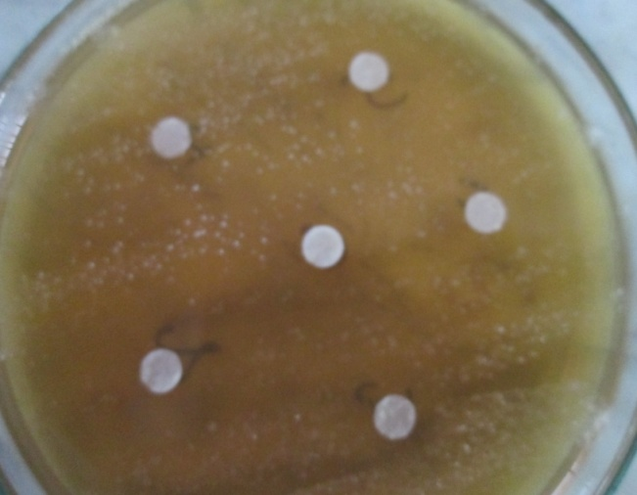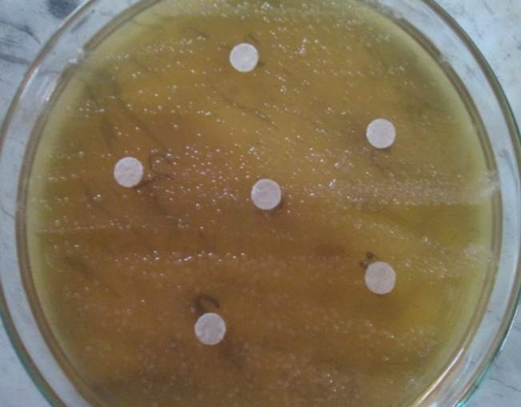
Figure no. 1: Microbiologically sterile nutrient broth of Saccharomyces cerevisiae

2.13 Diversity analysis of Saccharomyces cerevisiae strains using molecular approaches
On the basis of molecular characterization, out of forty-three yeast isolates, twentythree isolates from alcoholic beverages, fermented foods and traditional inocula were identified as S. cerevisiae, four isolates from chulli, khameer, bhaturu and phab were identified as Saccharomyces fermentati, one isolate from dhaeli as Endomyces fibuliger, six isolates from beverages and fermented foods as Debaromyces hansenii, two isolates from fermented foods as Schizosaccharomyces pombe, five isolates from apple wine as Issatchenkia orientalis, and two isolates from fermented foods were identified as Brettanomyces bruxellenis and Candida tropicalis. Earlier workers also encountered similar type of yeast strains in various traditional fermented foods and beverages in other parts of the country (Shrestha et al., 2002; Mugula et al., 2003).
2.14 Aspergillus kawachi
This Stargen enzyme cocktail containing Aspergillus kawachi α-amylase expressed in Trichoderma reesei and a glucoamylase that work synergistically to hydrolyze granular starch to glucose) (Hopf I. & Dietrich H., 2007)

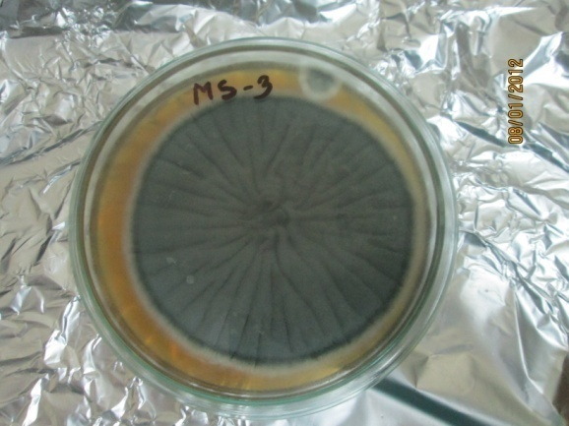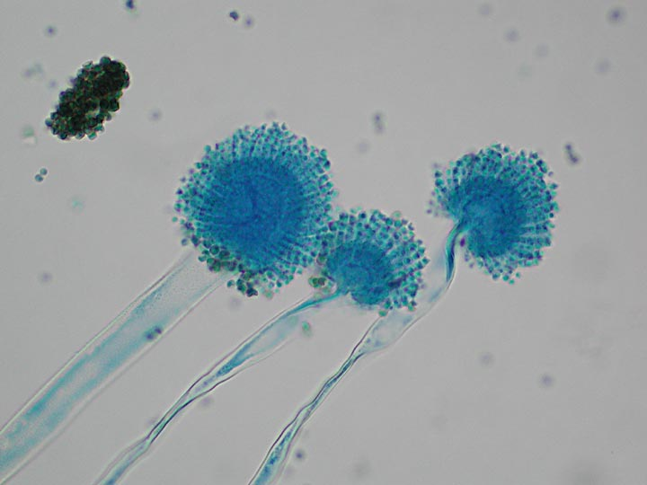
Figure no. 2: Microbiologically sterile enzyme of Aspergillus kawachi

CHAPTER III
Materials and Methods
3.1 Materials and Methods for Grape fermentation
3.1.1 Microorganism used:
Saccharomycese cerevisiae.
3.1.2 Preparation of microorganism:
Rotten grapes (2kg) were collected from local market. The grape fruit samples were processed to get juice (stum) with the help of juice machine.
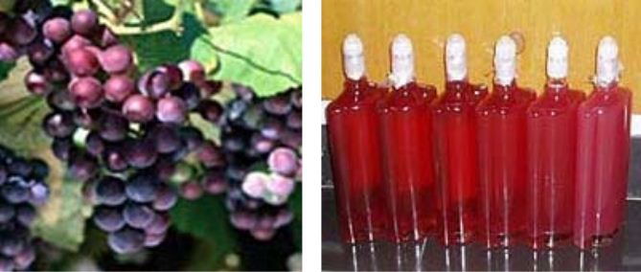Figure no. 3: Samples taken from the fermentation of grape

In order to incline the culture media, the yeast (Saccharomyces cerevisiae) was inoculated to the bean sprout juice at incubator.
In order to prevent the possible oxidative reactions, 50 mg of SO₂ and 10g of Ascorbic acids was added immediately after getting juice from juice machine.
To isolate microorganisms from the grape sample, 1ml of rotten grape juice was suspended into test tube containing 9ml distilled water.

3.1.3 Preparation for wine from grape fermentation:
Selection of grapes (Mature and undamaged grapes)

Crushing (Traditionally manual but now crushers are used)

Removal of skins (By standing, filtration or centrifugation)

Clarification phase fermented by Saccharomycese cerevisiae

Production of broth (Yeast Extract Mannitol)

Preparation of must

Fermentation

Ageing

Maturation and bottling

Packaging and storage

a) Selection of grapes:
Mature and undamaged grapes were selected for fermentation.
b) Crushing:
The grapes were handpicked and transferred to the crusher. The crusher punchers the grapes and transfers it to a de-juicer which seperates the pulp from the juice. While the skin, the stems and other remains from the crushing are used as manure, the juice was sent for fermentation.

c) Removal of skins:
The skin also determines the colour of the wine. Maceration (the time spent while skins and seeds are left with the juice) went on for a few hours or a few weeks. Pressing will then occur. One way to press the grapes was to use a ‘bladder press’ which is a large cylindrical container that contains bags that were inflated and deflated several times, each time gently squeezing the grapes until all the juice has run free, leaving behind the rest of the grapes. Solids can also be separated from juice through the use of a centrifuge. (Mpelasoka S and Marian I., 2008).
d) Clarification:
The grape juice was first chilled in the combination of stainless steel tanks and oak barrels and then fermented by adding yeast. Serial dilution was done and spreaded 1ml of each dilution on Yeast Extract Mannitol Agar media petriplates. Incubated the plates for 72 hrs at 21⁰C.After incubation, whitish colonies appeared on the media in the petriplates. Streaked the appeared white colonies on Yeast Extract Mannitol Agar media slants for future use. (Parker M and Panek A.D., 2008).
e) Production of broth (Yeast Extract Mannitol):
Prepared 500ml of broth by dissolving following constituents: Peptone-2.5g, Beef extract-1.5g, NaCl-2.5g, Yeast extract-5g, Mannitol-5g, Distilled water-500ml.
f) Inoculation of culture in broth:
Inoculated the loopful culture of Saccharomycese cerevisiae in the broth kept in the flask. Keep this flask on orbital shaker for 3 days.
g) Preparation of Must:
The grapes were crushed and the liquid was separated. Sterilised this must by pasteurization. To avoid contamination, potassium metadisulphide/carbondioxide fumes was added in the must. (Paul S et al., 2006).
h) Fermentation:
500ml of must was added in 500ml of broth. Incubated the broth for 4-5 days at 20-28⁰C in an incubator. After 4-5 days of incubation, added 8g of sucrose. Again incubated for 21 days.

i) Ageing:
After 21 days of incubation, wine was prepared which was kept in wooden vessel for 1-5 months for aroma and flavour development.
j) Maturation and bottling:
The wine was stored in tanks or oak barrels for 6-8 months for maturation. After testing the stability of the wine, it was then filtered to screen the balance fine particles.
k) Storage:
Product was filtered and pasteurized at 60⁰C for 2 minutes. Then the wine was bottled. Wine contains 10-18% alcohol.

3.2 Materials and methods of Apple fermentation
3.2.1 Microorganism used:
Saccharomycese cerevisiae.
3.2.2 Collection of sample:
For analysis two apple varieties white and red apple (2kg) were collected from local market. The fruits were harvested and transported to the processing unit stocked at room temperature (20ºC) just to the maximum maturation degree, procedures used by local producers to obtain the maximum levels of fermentable sugars.
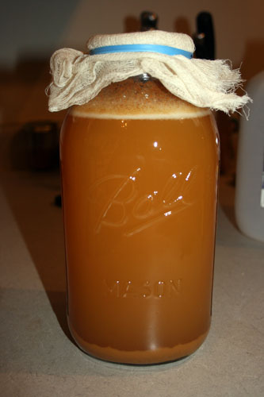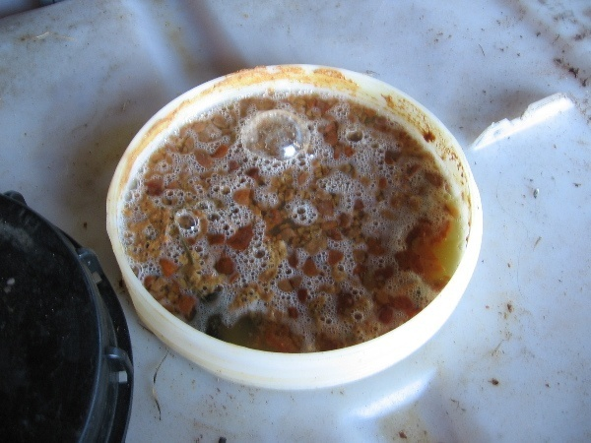
Figure no. 4: Samples taken from the fermentation of apple

3.2.3 Preparation of cider from apple fermentation:
Choose fresh apples
Clean the apples under cool running water, washing them thoroughly
Place the apple quarters into a blender, food processor or food chopper and process until smooth.

Put the apple pulp into a porous fabric bag, such as a muslin sack or jelly bag, and squeeze out the juice into a bowl.

Pour the liquid into glass bottles using a funnel.

Fill the bottles to just below the rim and use a cotton plug
Pressure builds when the bubbles from the carbon dioxide in the apple juice rise to the top of the bottle.
Store the bottled juice at 72 degrees Fahrenheit (22 degrees Celsius) for 3 to 4 days.

Strain the cider with a plastic strainer to separate the liquid and sediment
Pasteurize the fresh cider to prevent food born illnesses by heating it to 160⁰ to 170⁰ Fahrenheit (71 to 77 degrees Celsius) in a stainless steel pot

Skim the foam that forms on top due to the heat and discard.

Fill heated glass bottles with the pasteurized cider and refrigerate.
Drink the fresh cider within a week.
Freeze the fresh cider in glass or plastic freezer containers, for up to 1 year; after cooling the liquid down in the refrigerator.

a) Selection of Apples
Apples used for cider don't have to be flawless. They do, however, have to be free from spoilage. This use blemished apples and small sized apples. This can mix apple varieties together or use all one variety. The only rule was to cut out any spoilage areas on otherwise good apples (Amerine M. A. and Roessler E. B., 1983).

b) Juicing Apples
Small household appliances can be used to apple juice. Apples should be cored and cut and then processed through a food chopper, blender or food processor pasteurize it by heating to at least 160 degrees Fahrenheit. Then, pour juice into clean glass jars or bottles and refrigerate. For larger quantities, consider using a fruit press (Lambrechts M.G. & I.S. Pretorius 2000).
c) Making Sweet Cider
Begin with freshly pressed juice (not pasteurized). For clear cider, the bottled cider stand at 72 degrees Fahrenheit for 3 to 4 days. Clean bottles should be filled to just below the brim and stoppered with new, clean cotton plugs instead of a regular lid or cap. The cotton plug was used for safety. If pressure build up during the fermentation that occurs, the cotton popped out and released the pressure. Pasteurize the cider to ensure its safety by heating to at least 160 degrees Fahrenheit. Stored the cider in the refrigerator at 40 degrees Fahrenheit or lower and drink within 5 days. Freeze, after pasteurization, for longer storage (Romano et al., 1998).
d) Fermentation
The process of fermentation in alcoholic beverage has the catalyst function that turns fruit juice into an alcoholic beverage. During fermentation, yeast interacts with sugars in the juice to produce ethanol and carbon dioxide. During fermentation, there were several factors that winemakers take into consideration. In alcoholic beverage making, the temperature and speed of fermentation were important considerations as well as the levels of oxygen present in the must at the start of the fermentation.
e) Pasteurizing and Storing Cider
To pasteurize, heat cider to at least 160 degrees Fahrenheit, 185 degrees Fahrenheit at most. Measure the actual temperature with a cooking thermometer. It will taste less ‘cooked’ if it is not boiled. Skim off the foam that may have developed and pour the hot cider into heated, clean and sanitized plastic containers or glass jars. Refrigerate immediately (Romano et al., 1998).
3.3 Materials and methods of Barley fermentation
3.3.1 Microorganism used:
Aspergillus kawachi
3.3.2 Collection of sample:
Grains and microorganism were collected from local market. For analysis two grain varieties malted and unmalted grains were used.
3.3.3 Preparation of beer from barley fermentation:
Collect grains

Mill the grain malted barley

Make the mash hold the grain at 68 degrees Celsius for 1-2 hours.

Start mashing for every 1 pound (0.5 Kg) of grain heat 1 quart of water to 170 degrees Fahrenheit (76 degree Celcius)

Test the wort after about an hour

Boiling the wort bring the temperature

Fermentation

To loosen up the endosperm by degrading the endosperm cell walls and to produce enzyme for the the further degration of the content of endosperm cell during mashing

Provide for optimal conditions for enzymatic activities during mashing for solubilation of fermentable carbohydrates

To form an extract with a desired profile of sugars, desired level of protein and minor chemical constituents.

To separate the wort from spent grain (malt husk)

To sterilize wort, halting enzyme action, concentrate wort, isomerizes hop alpha acid into iso-alpha acid, reduce volatile compound

To cooling down wort temperature to fermentation temp such as from 100ºC to 14ºC

To convert fermentable sugar to ethanol, carbon dioxide and beer flavors

Add Aspergillus kawachi

Transfer to clean after 1-2 weeks

Bottling beer

a) Collection of barley
Ground grains were stored in airtight plastic bags at room temperature. This can mix barley varieties use all one variety. For analysis two grain varieties malted and unmalted grains were used. (Amerine M. A. and Roessler E. B., 1983).
b) Milling
Before mashing, the malt and other grains must be milled in order to increase the contact surfaces between the brewing liquor and malt. Unmalted grains also hamper the rate of wort recovery by increasing the proportion of insoluble aggregates of protein, hemicellulose, starch granules, and lipids (Barrett et al., 1975).
c) Mashing
To initiate mashing, the grist was mixed with water (mashing-in) at a pre-specified temperature to produce a slurry known as mash. Subsequently, the mash was heated to optimum temperatures of the technologically most important enzymes and allowed to rest. At the end of the mashing, it was necessary to separate the aqueous solution of the extract (wort) from the insoluble fraction called spent grains. For this purpose, lautering (filtration) was carried out either in lauter tuns or in mash filters of different constructions (Barrett et al., 1975).
d) Fermentation and Maturation
After pitched into chilled and aerated wort, brewing yeast will initiate assimilating fermentable sugars, amino acids, minerals, and other nutrients. From this time forth, the yeast started excreting a wide range of compounds such as ethanol, CO₂, higher alcohols, and esters, as a result of cellular metabolism. Whereas the large cut of these metabolic by products were toxic for the yeast cells at higher concentrations, they were the wanted products of beer fermentation at reasonable amounts. After cooling and aeration, the wort must be pitched (inoculated with suspended yeast cells) as fast as possible to avoid contaminations (Barrett et al., 1975).
e) Ageing:
After the fermentation process, the beer was transferred to aging tanks where many of the byproducts and solids of the fermentation process precipitate out of the beer, and the beer was allowed to mellow and mature in flavor. Ageing is the final step in the brewing process (Barrett et al., 1975).
f) Storage:
Product was transfer to clean after 1-2 weeks. Then the beer was bottled.
CHAPTER IV
Results & Discussions
4.1 Results for grape fermentation:
Various tests had been performed to check wine quality. These are as follows:
4.1.1 Test for pH:
Table No. 1: pH of wine after regular intervals of time period
Time period (in days) | pH
1st day | 6.34
15th day | 6.21
30th day | 6.13
45th day | 6.02
60th day | 5.83
75th day | 5.33
90th day | 4.90

4.1.2 Test for sugar concentration:
Table No. 2: Sugar concentration of wine after regular intervals of time period
Time period (in days) | Sugar concentration (%)
1st day | 34.52
15th day | 33.44
30th day | 32.65
45th day | 30.27
60th day | 29.53
75th day | 26.11
90th day | 24.65

4.1.3 Test for ethanol:
Table No. 3: Ethanol concentration of wine after regular intervals of time period
Time period (in days) | Ethanol concentration (%)
1st day | 5.12
15th day | 5.44
30th day | 6.15
45th day | 6.27
60th day | 7.53
75th day | 8.7
90th day | 10.65

4.2 Discussion for grape fermentation
The soluble solid contents were maintained up to 21 degree Brix and pH was adjusted to 3.5.The pH measures with a pH meter, an instrument that determines pH quickly and easily. It represents the active acidity of the wine .If the pH of a wine was too high, say 4.0 or above, the wine becomes unstable with respect to microorganisms. Low pH inhibits microorganism growth. Tartaric acid was sometimes added to fermenting grape juice to ensure that an acceptable final pH can be realized, since some acid was lost during fermentation thus reducing the total acidity and raising the pH.
Phenol sulphuric acid test was used for the determination of total percentage of sugar in fermented juice by the use of calorimeter.
This was demonstrated by those fruit juices with the highest sugar content yielding the highest potential alcohol. These data suggest other juices can ferment to potential alcohol. The quantitative estimation of ethanol in the fermented product was done by the potassium dichromate method.
Biochemical analysis includes test for pH, test for total acidity, test for reducing sugar, test for ethanol content etc. In the investigation of biochemical aspects, it was concluded that the pH of sample was decreased whereas the titrable acidity of sample was increased during fermentation process (Bai J and Huang J., 2012).
Fermentation and post-fermentation processing of grapes wine is somewhat similar to the production of white table wines. After SO₂ addition, clarification and sweetening, the must is ready for fermentation. Temperature control during fermentation was crucial to the preservation of delicate fruit flavours in the resulting wine. The fermentation temperature commonly employed by the winemakers ranges between 50⁰F to 70⁰F. Generally, lower temperatures ranging from 50⁰F to70⁰F yield favourable results. Many strains of yeasts in dried and pure culture form were available to the winemakers. Wine was prepared after 21 days of fermentation (Bai J and Huang J., 2012).
4.3 Results for Apple fermentation
4.3.1 Test for pH
Table No. 4: pH of Cider after regular intervals of time period
Time in period (in days) | pH
1st day | 4.01
15th day | 3.9
30th day | 3.8
45th day | 3.75
60th day | 3.70
75th day | 3.68
90th day | 3.60

4.3.2 Test for sugar concentration
Table No. 5: Sugar concentration of Cider after regular intervals of time period
Time in period (in days) | Sugar concentration (%)
1st day | 25.29
15th day | 24.54
30th day | 21.33
45th day | 20.62
60th day | 20.28
75th day | 19.84
90th day | 18.15

4.3.3 Test for ethanol
Table No. 6: Ethanol concentration for cider after regular intervals of time period
Fermentation (in days) | Ethanol concentration(%)
1st day | 18.01
15th day | 20.12
30th day | 22.45
45th day | 23.03
60th day | 24.45
75th day | 25.54
90th day | 26.34

4.4 Discussions of Apple fermentation
The pH measures with a pH meter, an instrument that determines pH quickly and easily. It represents the active acidity of the cider .If the pH of a cider was too high, say 4.0 or above, the cider becomes unstable with respect to microorganisms. Low pH inhibits microorganism growth.
Phenol sulphuric acid test was used for the determination of total percentage of sugar in fermented juice by the use of calorimeter.
The quantitative estimation of ethanol in the fermented product was done by the potassium dichromate method.
Apple cider was a fermented beverage made from apples. Apples and several other fruits have the balanced quantities of acid, tannin, nutritive salts for yeast feeding, and water to naturally produce a stable and drinkable beverage. The ability to produce palatable effervescent beverage and wine by alcoholic fermentation of natural fruit juices was a demonstration of inherent ingenuity of man. Therefore, alcoholic beverages in most countries were adjusted in one way or the other for fermentation of local fruits to produce their wines (Okunowo et al., 2005).

4.5 Results of Barley fermentation
4.5.1 Test for pH
Table No. 7: pH of beer after regular intervals of time period
Time period (in days) | pH
1st day | 3.54
15th day | 3.25
30th day | 3.12
45th day | 2.55
60th day | 2.45
75th day | 2.32
90th day | 2.11

4.5.2 Test for Sugar concentration
Table no. 8: Sugar concentration of beer after regular intervals of time period
Time period (in days) | Sugar concentration (%)
1st day | 21.29
15th day | 20.54
30th day | 19.53
45th day | 18.12
60th day | 17.28
75th day | 14.84
90th day | 13.15

4.5.3 Test for ethanol concentration
Table no. 9: Ethanol concentration of beer after regular intervals of time period
Time period (in days) | Ethanol concentration(%)
1st day | 4.52
15th day | 5.81
30th day | 6.1
45th day | 6.12
60th day | 6.54
75th day | 7.7
90th day | 8.65
4.6 Discussions of Barley fermentation
The pH measures with a pH meter, an instrument that determines pH quickly and easily. It represents the active acidity of the beer. If the pH of a beer was too high, say 4.0 or above, the beer becomes unstable with respect to microorganisms.
Phenol sulphuric acid test was used for the determination of total percentage of sugar in fermented juice by the use of calorimeter.
The quantitative estimation of ethanol in the fermented product was done by the potassium dichromate method.
A Study was conducted to investigate the proximate composition of fermented and
unfermented barley under the influence of fungal mold Aspergilus kawachi & Rhizopus oligosporus A-4, optimization of fermentation conditions. The activity of enzymes e.g. protease, amylase and phytase was also investigated.
The boiling time of 25 minutes was found to be suitable for the production of fermented whole grain cereal product.
4.7 Sensory Evaluation of fermented products
Sensory evaluation is a scientific discipline that applies principles of experimental design and statistical analysis to the use of human senses (sight, smell, taste, touch and hearing) for the purposes of evaluating consumer products.
4.7.1 Sensory test of wine
Table no. 10: Sensory evaluation of wine fermentation
Attribute | Color | Taste/flavor | Smell/aroma | Consistency | Overall  acceptability
1st day | 7.3 | 6.1 | 6.6 | 5.6 | 7.5
15th day | 6.8 | 6.5 | 7.2 | 4.3 | 6.4
30th day | 7.4 | 7.1 | 6.1 | 4.2 | 7.1
45th day | 7.1 | 6.8 | 7.4 | 4.9 | 6.7
60th day | 6.1 | 6.9 | 7.1 | 5.2 | 7.6
75th day | 7.2 | 6.3 | 6.8 | 6.4 | 7.6
90th day | 6.6 | 6.0 | 7.3 | 6.6 | 7.9

Wine sensory evaluation is a science, but one that has some limitations. As a research tool, descriptive sensory analysis can help researchers determine whether experimental variables in the vineyard or winery have made any differences in the final product.
4.7.2 Sensory test of cider
Table no. 11: Sensory evaluation of cider fermentation
Attribute | Color | Taste/flavor | Smell/aroma | Consistency | Overall  acceptability
1st day | 7.6 | 5.1 | 8.9 | 5.6 | 8.3
15th day | 6.8 | 5.5 | 7.2 | 7.3 | 7.8
30th day | 7.4 | 7.1 | 8.1 | 6.2 | 8.1
45th day | 7.3 | 6.8 | 8.4 | 8.1 | 8.4
60th day | 6.1 | 5.9 | 8.1 | 7.2 | 8.1
75th day | 7.2 | 5.3 | 7.8 | 8.1 | 7.2
90th day | 6.6 | 4.0 | 8.3 | 7.6 | 8.9

4.7.3 Sensory test barley
Table no. 12: Sensory evaluation of beer fermentation
Attribute | Color | Taste/flavor | Smell/aroma | Consistency | Overall  acceptability
1st day | 6.6 | 8.1 | 5.9 | 6.6 | 7.5
15th day | 6.4 | 8.5 | 6.1 | 8.3 | 8.1
30th day | 7.4 | 7.9 | 5.1 | 6.2 | 7.9
45th day | 7.3 | 7.8 | 5.4 | 8.1 | 8.4
60th day | 6.1 | 8.9 | 5.3 | 7.9 | 6.1
75th day | 7.1 | 8.3 | 4.8 | 8.1 | 8.2
90th day | 6.6 | 8.0 | 4.1 | 7.6 | 6.6

Table no. 13: Summary of sensory evaluation of grape, apple and barley fermentation
Attribute | Grape fermentation (Saccharomyces cerevisiae) | Apple fermentation (Saccharomyces cerevisiae) | Barley fermentation (Aspergillus kawachi)
Color | 6.2 | 6.6 | 6.9
Taste/flavor | 7.6 | 5.8 | 8.1
Smell/aroma | 6.3 | 7.9 | 5.6
Consistency | 5.2 | 7.4 | 7.8
Overall acceptability | 7.8 | 8.5 | 8.3

- A 9 point hedonic scale (9=excellent, 1=extremely poor)
- Overall acceptability for hedonic rate scale is 7.1 to 8.9

CHAPTER V
Conclusions
It can be concluded that the characteristics of the produced fermented beverages such as flavor, improved nutritional quality were desirable. For each product the pH, ethanol concentration and sugar concentration increases with time. By analyzing the sensory evaluation, the final result indicated that fermented beverages were acceptable. Various yeast strains influenced the fermentation behaviour, physico-chemical and sensory characteristics of the resulting wines. Thus, use of appropriate yeast strain for the preparation of plum wine is very important along with the other vinification practices. The understanding of metabolism in yeast such as S. cerevisiae has made significant progress over the past ten years but up to now, the knowledge has only been applied to the manipulation of wine yeasts. The challenge for the biotechnologist will be to apply the fundamental knowledge on metabolism to manipulate yeast strains appropriate for economic production by microbial fermentation. The apple must present a great dispersion in phenols content, with the largest values and the lowest. In apple juice with high phenols content there were observed lower levels after alcoholic fermentation. The phenols class that showed lost was of the polymeric flavan-3-ol, then high concentration, possibly because of interactions with the yeast cell wall. The other phenols class and different apple ciders did not show any modifications with the alcoholic fermentation, remaining the phenols compounds of original clarified apple juice in the cider juice.

CHAPTER VI
Recommendations and Future perspectives
Future perspectives are new idea, device or process. Perspectives are the application of better solutions that meet new requirements, inarticulated needs or existing market needs. In Bangladesh perspective, the consumption of alcohol is strictly prohibited both as a social function and as a chemical function both site. Yet, the problem of alcoholism is becoming a threat to the nation’s welfare. Information obtained from law enforcement authorities, treatment providers and other sources indicate that alcohol become quite common in Bangladesh. Fermentation alcohol is being produced by some pharmaceutical industries in Bangladesh. Moreover, some crude forms are produced and used by the poor, usually by fermentation of boiled rice, sugar-cane, and molasses. Hence, objectives are carried out highly productive fermentation sector is a prerequisite for the kind of growth acceleration envisaged in the good perspective plan for Bangladesh.
Some recommendations of this fermentation are
- Maintaining of proper handling asceptically and
- Maintenance of proper storage conditions to lengthen the short life of the period.

List of References
Johnson, H. 1989. Vintage: The Story of Wine. Simon & Schuster.
F.W. Beech., 1990. Journal of the Institute of Brewing.
Gary Higton and Neil L. Morgan., 2001. An Introduction to Industrial Microbiology.
Carlos Ricardo Soccol and Ashok Pandey., 1999. Fermentation Processes Engineering in the Food Industry.
Kathy Zahler and Krystal Sanders., 1999. TEAS Test of Essential Academic Skills TEAS Test Comprehensive Study Guide.
Gary S. Tucker., 1998. Food Preservation and Biodeterioration
Charles Negy., 2006. The Effect of Sugar Types on the Rate of Yeast Fermentation
Dawes and Large., 1982. An introduction to fermentation processes
Mpelasoka S and Marian I, 2008. Potassium nutrition in grapewines.vol.9:154-168. |.
Osborne P and Odunfa SA, 2006. Inhibition of malolactic fermentation by Saccharomyces during alcoholic fermentation under low and high nitrogen conditions.vol.12:69-78.
Mugula et al., 2003, Parker M, Panek AD, 2008. Flavonol composition of red and white wines determined by high performance liquid chromatography.vol.14, 153-161.
Muyanja et al., 2003, Paul S. 2006. The determination of urea in wine.vol.12:97-106.
Lim and Im., 2009. Fermentation process review of literature.
Rathore MS and Anurekha J. Perspectives on the probiotic potential of lactic acid bacteria.
Ghosh and Chattopadhyay, 2011. Functional Properties of Microorganisms in Fermented Foods
Reddy et al., 2007. Fermentation process review of literature.
Duckstein et al., 2012; Santos et al., 2012. Phenolic constituents from microorganisms.
Ganzle et al., 2009. Handbook of Plant-Based Fermented Food and Beverage Technology.
Fay and Benavides 2005; Legras et al., 2007. Biogeographical characterization of microorganisms.
Goldammer., 2000. Beer in Health and Disease Prevention.
Kanwar and Keshani., 2014. Review of literature for fermentation process.
Alobo and Offonry., 2009. Production of mixed fruit fermentation.
Panilaitis et al., 2007; Abouseoud et al., 2008; Das et al., 2009. Substrate Dependent Production and Isolation of microorganisms.
Vezinhet et al., 1999. Genetic diversity of Saccharomyces cerevisiae strains isolated from different grape varieties.
Schuller et al., 2005. Ecological survey of Saccharomyces cerevisiae strains.
Ribereau-Gayon et al., 2006. Review of literature for fermentation process.
Kim-Bong-Joon, 2000, Oakey H and Lott RV, 2005. The impact of closure type and storage conditions on the composition,colour and flavor properties of wine.vol.11:369-377.
Thakur et al., 2004, Levine and Miller, 2010. Flavanoid composition of wine related to wine sensory properties.
Basappa and Venkataramu, 1994; Sekar and Mariappan., 2008. Wines—their sensory evaluation. W.H. Freeman, New York.
Kurtzman and Fell, 1998. Yeast and its importance to wine aroma. South African Journal of Enology and Viticulture. 21:97-129.
Basappa and Venkataramu, 1994; Soni et al., 2001; Shrestha et al., 2002; Muyanja et al., 2003; Mugula et al., 2003 Biodiversity of wild strains of Saccharomyces cerevisiae as tool to complement and optimiz Ɲ wine quality. World J. Microbiol. Biotechnol.
Hopf I & Dietrich H, 2007. Untersuchung sortenreiner Apfelsaftaromen. Flüssiges Obst, 02, 62-67.

Appendix-1: Picture Gallery
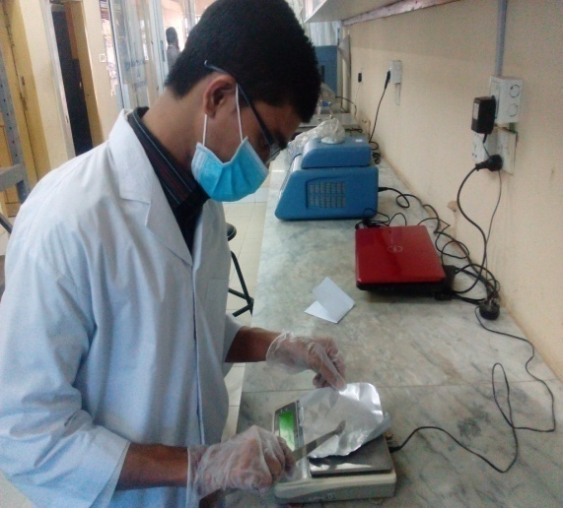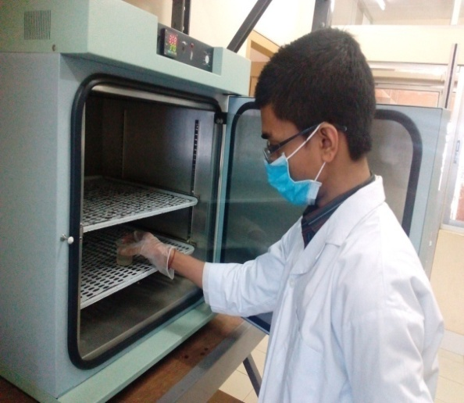
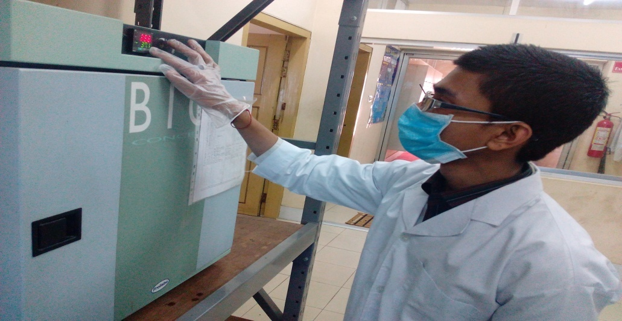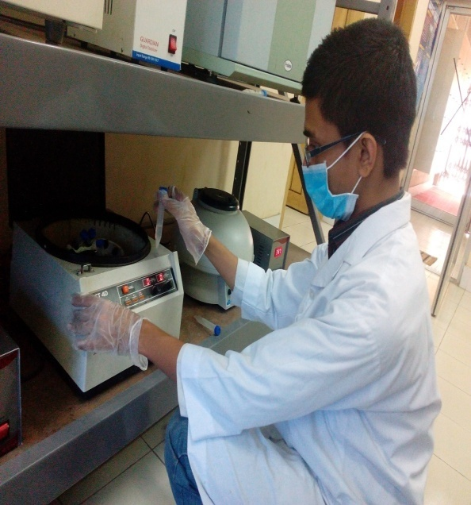
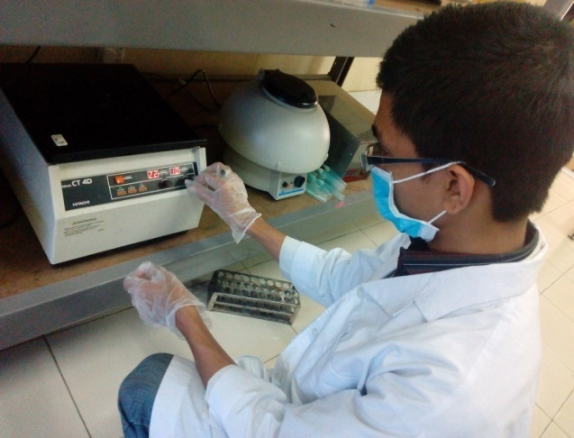

Brief Biography
Himel Dutta passed the Secondary School Certificate Examination in 2007 and then Higher Secondary Certificate Examination in 2009. He obtained his B.Sc. (Hons.) in Food Science & Technology Degree in 2014 from Chittagong Veterinary and Animal Sciences University (CVASU), Bangladesh. Now, He is a Candidate for the degree of MS in Food Processing and Engineering under the Department o f Food Processing and Engineering, Faculty of Food Science and Technology, CVASU. His career objective is to obtain and secure a challenging position as a Food Technologist in manufacturing operations and development which will utilize in depth acquired knowledge and collective experience in a dynamic team oriented environment. An energetic, dynamic, hardworking and highly self-motivated individual want to work in an environment where there is an opportunity of self assessment and self-improvement in both individual and group based work. He is willing to take up challenges in a performance based organization.

