CHAPTER-I
INTRODUCTION

Poultry industry as one of the most profitable business of agriculture provides nutritious meats and eggs for human consumption within the shortest possible time with minimum cost. However, availability of quality feed at a reasonable cost is a key to successful poultry operation Basak et al., (2002). FAO program focuses on increasing the feed base production systems to locally available feed resources in developing countries Sansoucy, (2012).
In Bangladesh, livestock is one of the most important sectors of agriculture which plays a vital role to promote national economy and human health. Poultry meat and eggs contribute approximately 33% of total animal protein supplied in the country Ahmed and Islam, (2008). During FY 2012-13, total production of meat was 25.32 million ton and egg was 51347 million in numbers as well as the estimated contribution to GDP from this subsector was 3.49%, DLS, (2012-2013). The poultry industry, as a fundamental part of animal production, is committed to supply the nation which is a cheap source of good quality nutritious animal protein in terms of meat and eggs in Bangladesh Akter and Uddin, (2009).
Poultry is one of the prospective sectors for development. It is a quick returnable enterprise that needs relatively small investment. To meet the shortage of protein supply with in a shortage possible time, expansion of the poultry sector is essential. The expansion of poultry sector depends on the profitability of chicken rearing, egg production on farmer’s level. Feed represents the major cost of farm operation. According to McNab, (2001), this cost lies between 65 to 75%. So any improvement in the performance of layers and broilers due to diet inevitability can have a profound effect on profitability.
Poultry feed is food for farm poultry including chickens, ducks, geese and other domestic birds. Feed for poultry mostly consists of grains Pattinson, (2008). The quantity and nutritional requirements of feed depend on the weight, age of the poultry as well as the season Damerow, (2012). Healthy poultry needs a sufficient amount of protein, carbohydrate, along with the necessary vitamins, dietary minerals and adequate supply of water. It should be dry, clean and contamination free. Damp feed encourages fungal growth i.e. Mycotoxicosis. Rosenberry, (2002).
Mash form of feed is specially suitable for layers. Layer mash is a feeding system designed specifically for laying hens. Layer mash is higher in protein and various minerals than other feeds. Layer feed includes higher calcium content suited to the nutritional needs of hens to produce eggs Hawthorne, (2003). About 30% to 40% of consumed feed is converted into meat and egg. The egg type chickens produce approximately 6 times more nutrient than their body weight in forms of egg Singh, (2009). A good number of feed mills in our country are producing compound poultry feeds. It was reported in 1999 that there were 40 feed mills with 900 dealers within private sector that were producing and distributing commercial poultry feeds all over the country Latif, (1999). On the other hand, some farmers used to produce poultry feeds by their own according to the requirement of their birds on the supervision of poultry consultants. Farmers don’t have facility to evaluate the quality of the prepared or compound feeds. In view of the limited availability and varying sources of different feed ingredients, the level of nutrients in the prepared feeds may differ from what is actually required. Deficiency of a particular nutrient in the ration, generally unnoticed by the farm owners can cause an undesirable effect on production and as well as on profitability.

Considering all the above mentioned points, the present study was designed with the following aims and objectives:
- To explore the quality of hand mixed feeds of Gaucia Poultry (Breeder) farm on the basis of proximate analysis in laboratory.
- To observe the growth rate of both female and male birds on the basis of feed intake.
- To provide proper knowledge of nutrition required for breeder birds (both female and male).
- To provide suggestions about better dietary management of breeder birds according to age and sex.

CHAPTER-II

MATERIALS AND METHODS

Study area and duration:

The feed sample was collected from Gaucia Poultry Farm, Potiya, Chittagong .The study was conducted during the period of October to November 2015 in the laboratory of Animal sciences and animal nutrition department, CVASU.
Study design:
This study was done by using the following study design:
Ether extraction
EE
Residue
Kjeldahl method
Heating at 1050c for 24 hours until constant weight
Ignition at 600ºc for 5 hours
CF + Ash

=
Alkali boiling for 30 mins with 1.25% NaOH
Filtrate

Residue

CF
Ash
Acid boiling for 30 mins with 1.25% H₂SO₄
Filtrate
%CP=%N ₂X6.25
DM
Moisture
Feed sample

Sampling and preparation of feed samples:
The feed samples were collected by using simple random sampling technique. During collection of feed samples several physical characteristics were observed. To make it homogenous powder the feed samples were ground by using grinder. Later on, it was mixed properly and exposed to cool down for sampling .Samples were wrapped up by polythene bags and preserved in the laboratory for proximate analysis.
Proximate Analysis:
The proximate composition of raw poultry feeds such moisture crude protein, crude fibre, crude fat and total ash content were analyzed using the procedures described by Sundaram et al., (2001).
Determination of DM and Moisture:
Five grams of poultry feed was weighed in a petridish, placed in a hot air oven at 105-110°C for a minimum of 6 h, cooled in a dessicator. The process of heating and cooling was repeated till a constant weight was obtained. The moisture was removed as vapour AOAC, (1990).
%DM =$\frac{Weight of crucible with dry sample - Weight of empty crucible}{Weight of feed sample} ×100$
%Moisture = 100 - %DM
Determination of Crude Protein (CP):
Crude protein was determined using Kjeldajhl's distillation assembly. After weighting 0.5 gm sample,one spoon catalyzer mixer (KOH, NaOH, Se) was added and digested with 10 ml concentrated H₂SO₄ in Kjeldhal digestion set. Then heat was increased gradually and continued up to clear residue (45 min to 1 hr). After cooling ,10 ml 2% boric acid solution and 2 drops mixed indicator were taken in a conical flask. 50 ml distilled H₂O was added in the digestion tube and fitted in the distillation flask. 40 ml of 40% NaOH was added there and the distillation was continued up to 100ml of distillate. The distillate was titrated against 0.1 N HCl. From the titre values the nitrogen content and crude protein were calculated multiplying by 6.25.AOAC, (1990).
% CP = $\frac{\left(Titre-Blank\right)×Normality of HCl ×14.007 ×6.25}{Wt of sample} ×100$

Determination of Ether Extracts (EE):
The crude fat (a combination of simple fat, fatty acid, esters, cornpmmd fat, neutral fat, sterols, waxes, vitamins (A, D2, E, K), carotene, chlorophyll, etc) soluble in ether was estimated by extracting in ether which was continuously volatilized at 60-80°C condensed and allowed to pass through the thimble containing the sample in a Soxhlet's apparatus AOAC, (1990).
%EE = $\frac{Initial wt-Weight after extraction}{Sample wt} ×100$

Determination of Crude Fibre (CF):

Crude fibre consisting of cellulose, hemicellulose and lignin etc was estimated by successive digestion of two grams of sample with dilute acid (1.25% H₂SO₄₎ and alkali (1.25% NaOH). The entire residue transferred into a silica crucible and kept in a hot air oven at 105°C, cooled in a dessicator, weighed and finally concordant values were obtained AOAC, (1990).
%CF=$\frac{Wt of crucible with dry sample-Wtbof crucible with ash}{Wt of feed sample} ×100$
Determination of Total Ash:
To find out the total content of mineral matter or total ash i.e., non- combustible portion of the feed, 2 g of sample was weighed accurately in a silica crucible. The sample was ignited on a burner till smoke ceases. The crucible was placed in a muffle furnace and heated to 600°C and kept for 2 h. At this temperature all organic matter was burnt leaving behind minerals. The crucible was removed from the furnace carefully and cooled in a dessicator at room temperature and weighed again AOAC, (1990).
%Ash = $\frac{Weight of crucible and ash-Weight of crucible}{Weight of feed sample} ×100$

Determination of Nitrogen Free Extracts (NFE):
The NFE content was calculated by deducing the sum of the values for moisture, crude protein, crude fibre ether extracts, total mineral matter in 100 Raghuramulu et al., (2013).
%NFE = 100 – (%Moisture +%CF + %CP + %EE + %Ash)

Determination of Metabolizable Energy (ME):
The ME was calculated by using following formula Lodhi et al., (2006).
ME (Kcal/kg) = 32.959 {%CP + (%EE × 2.25) + %NFE} – 29.20
Growth rate calculation:
Growth rate was calculated according to the record kept by authority of Gaucia Poultry Farm, Potiya , Chittagong.
Data analysis:
Data was stored in MS excel (Microsoft Word 2007) and descriptive analysis was done in this study.

CHAPTER-III
RESULTS
In Gaucia poultry farm they use hand mixed feeds for both male and female breeders. Ration used to formulate feeds is given below:
Table 1: Ration formulation chart of Gaucia poultry farm.
Name of ingredients | Starter | Grower | Breeder I | Breeder II | Male
Maize | 63.50 | 62.50 | 65.40 | 65.50 | 62.50
Soyabean meal | 27.00 | 16.70 | 22.50 | 21.50 | 15.00
Wheat bran | 4.50 | 16.00 | 0.00 | 0.00 | 15.40
Oil | 0.50 | 0.50 | 1.00 | 0.70 | 0.00
Lime stone | 0.00 | 2.00 | 5.50 | 6.50 | 0.00
Lime stone powder | 1.30 | 0.00 | 2.00 | 2.00 | 4.00
DCP | 1.73 | 1.00 | 2.00 | 2.30 | 1.50
Salt | 0.25 | 0.25 | 0.25 | o.25 | 0.25
Sodium bi carbonate | 0.15 | 0.10 | 0.15 | 0.15 | 0.15
Vitamin premix GP | 0.07 | 0.00 | 0.00 | 0.00 | 0.00
Vitamin premix BRE | 0.00 | 0.07 | 0.07 | 0.07 | 0.10
Mineral premix GP | 0.07 | 0.00 | 0.00 | 0.00 | 0.00
Mineral premix | 0.00 | 0.07 | 0.07 | 0.07 | 0.10
TGI | 0.03 | 0.02 | 0.03 | 0.03 | 0.03
Lysin | 0.12 | 0.00 | 0.05 | 0.05 | 0.16
Methionin | 0.12 | 0.10 | 0.15 | 0.06 | 0.07
Colin Chloride | 0.08 | 0.08 | 0.10 | 0.10 | 0.08
Liver tonic and salmunil | 0.20 | 0.20 | 0.20 | 0.20 | 0.20
Enzymes | 0.05 | 0.05 | 0.05 | 0.05 | 0.05
LARBATOX | 0.05 | 0.05 | 0.07 | 0.07 | 0.07
TOTAL  Source: Records kept by the Gaucia poultry farm, Potiya, Chittagong. | 100.30 | 100.70 | 100.25 | 100.50 | 100.03
After collection of feeds (Starter, Grower, Breeder I, Breeder II, Male) from Gaucia Poultry Farm, Potiya, Chittagong ,proximate analysis was done and the value of proximate component in the collected feeds are given below in tabulated form:
Table 2: Value of proximate component of feeds (Starter, Grower, Breeder I, Breeder II, Male)used in Gaucia Poultry Farm:
Parameters | Starter | Grower | Breeder I | Breeder II | Male
DM% | 88 | 90 | 89 | 88 | 90
Moisture% | 12 | 10 | 11 | 12 | 10
CF% | 3.69 | 4.45 | 2.92 | 2.86 | 4.29
Ash% | 3.44 | 3.35 | 2.88 | 2.80 | 3.20
EE% | 3.10 | 3.20 | 3.35 | 3.02 | 2.64
CP% | 18.61 | 15.66 | 16.14 | 15.7 | 14.83
NFE% | 62.13 | 65.89 | 59.77 | 59.60 | 65.16
ME(Kcal/Kg) | 2799.59 | 2660.55 | 2757.59 | 2711.64 | 2571.21

Graphical representation of proximate component of feeds:

 | Female  Table 3:Growth rate in both male and female breeders is given below |  |  |  | Male
Age  (wks) | Feed  (gm) | Body wt (gm) | Growth  (gm) |  | Feed  (gm) | Body wt (gm) | Growth  (gm)
1 | Full | 120 |  | Starter | Full | 125
2 | Full | 250 | 130 |  | Full | 295 | 170
3 | 35 | 380 | 130 |  | 38 | 475 | 180
4 | 39 | 470 | 90 |  | 42 | 660 | 185
5 | 44 | 580 | 110 |  | 46 | 815 | 155
6 | 48 | 680 | 100 | Grower | 50 | 950 | 135
7 | 51 | 770 | 90 |  | 53 | 1085 | 135
8 | 54 | 860 | 90 |  | 56 | 1200 | 115
9 | 57 | 950 | 90 |  | 59 | 1315 | 115
10 | 60 | 1040 | 90 |  | 62 | 1425 | 110
11 | 63 | 1140 | 100 |  | 65 | 1520 | 95
12 | 66 | 1240 | 100 |  | 69 | 1615 | 95
13 | 69 | 1340 | 100 |  | 73 | 1725 | 110
14 | 72 | 1450 | 110 |  | 77 | 1835 | 110
15 | 79 | 1580 | 130 |  | 81 | 1950 | 115
16 | 84 | 1710 | 130 |  | 85 | 2070 | 120
17 | 89 | 1840 | 130 |  | 89 | 2195 | 125
18 | 94 | 1980 | 140 |  | 96 | 2320 | 125
19 | 99 | 2120 | 140 | Pre-Breeder | 98 | 2445 | 125
20 | 104 | 2260 | 140 |  | 103 | 2570 | 125
21 | 109 | 2420 | 160 |  | 107 | 2695 | 125
22 | 114 | 2580 | 160 |  | 113 | 2820 | 125
23 | 120 | 2740 | 160 |  | 115-20 | 2945 | 125
24 | 1%130 | 2900 | 160 | Breeder -I | 115-20 | 3070 | 125
25 | 135 | 3060 | 160 |  | 120-25 | 3200 | 130
26 | 5% 136-42 | 3200 | 140 |  | 120-25 | 3310 | 110
27 |  | 3320 | 120 |  | 125-30 | 3385 | 75
28 |  | 3420 | 100 |  | 125-30 | 3450 | 65
29 |  | 3480 | 60 |  | 125-30 | 3490 | 40
30 |  | 3510 | 30 |  | 125-30 | 3520 | 30
31 | 60% 175 | 3525 | 15 |  | 125-30 | 3545 | 25
32 |  | 3535 | 10 |  | 125-30 | 3570 | 35
34 |  | 3555 | 20 |  | 125-30 | 3615 | 45
36 |  | 3575 | 20 |  | 132 | 3660 | 45
38 |  | 3595 | 20 | Breeder-II | 133 | 3705 | 45
40 |  | 3615 | 10 |  | 136 | 3750 | 45
50 |  | 3625 | 10 |  | 140 | 3976 | 26
46 |  | 3635 | 10 |  | 140 | 4201 | 125
64 |  | 3650 | 10 |  | 140 | 4292 | 91
CHAPTER-IV
DISCUSSION
The study was conducted with the aim of estimating the proximate components lies in the feed (Starter, Grower, Breeder I, Breeder II, Male) used in Gaucia poultry farm. Here this study observed that the feeds contain 2600-2800kcal/kg ME, 15-18% CP, 3-4.5%CF, 2.5-3.5%EE, 3-3.5%Ash, 60-65% NFE. This study was agreed with Larbier and Leclerck, (2004). He stated that feed containing 2750-2900 Kcal/kg ME, 17-18% CP, 4% CF, 3.5-4% EE and 12% Moisture may be recommended to the laying hen according to cost of minerals. A level of 15% crude protein appears to be sufficient on condition that the diet is balanced with respect to sulphur amino acid and lysine. The dietary level of calcium must be equal to 3.5% to obtain strong shells. At the end of lay, when shell strength tends to fail, the dietary levels of calcium may be reduced. The egg shell contains calcium carbonates and very little phosphorus. The yolk contains the majority of phosphorus but the amount deposited daily is much lower than calcium. So phosphorus requirement of layer is less than calcium. Recommended dietary level of phosphorus is 0.30 to 0.35%.
In this study, the growth rate of both male and female breeders was observed according to their amount of feed intake which partially agreed with Spralt and Lesson, (2007) who reported that excess intake of feed is predominantly stored as fat which gradually results in increased body weight. Excessive body weight in females is negatively correlated with hen-day-egg production. There are contradictory results about the effect of fat on egg production .The addition of fat have no effects on egg production Harms et al., (2002). In contrast Grobas et al., (20011) reported that addition of supplemental fat significantly increased egg production from 38 to 61 wk of age. With laying hens the ratio between the metabolized energy and the protein of diet should be 187:1. For a medium hybrid layer, the respective figures are 2800:15, a ratio of 186.7:1. Protein % varies from 15% for the birds on pasture in summer to 18% for high energy intensive ration.
Sainsbury, (2000) said that in construction of a ration, consideration must also be given to the content of indigestible organic material. A birds’ gut must have a fibrous content to maintain its natural functioning. In young chicks this proportion is about 3% rising to 5% in the adult. It is similar to this study because this feed contains 3-4.5% CF.
Limitations of the study:
- In this proximate analysis, we estimate total N₂, not the ultimate protein & NPN (Non Protein Nitrogenous Substance).
- Again it estimates %CP from N₂ multiplying by 6.25 assuming that all protein contains 14-18% N₂. So over & under estimation of N₂ can be happened.
- During estimation of %CF, acid & alkali boiling is going on the hemicelluloses is partially destroyed. So there can be a little variation from the real value of %CF.
- We can’t estimate vitamins, calcium and phosphorus level of feed by using this method.
- Any deviation in results may be due to environmental or experimental error.
- The study area was also limited.

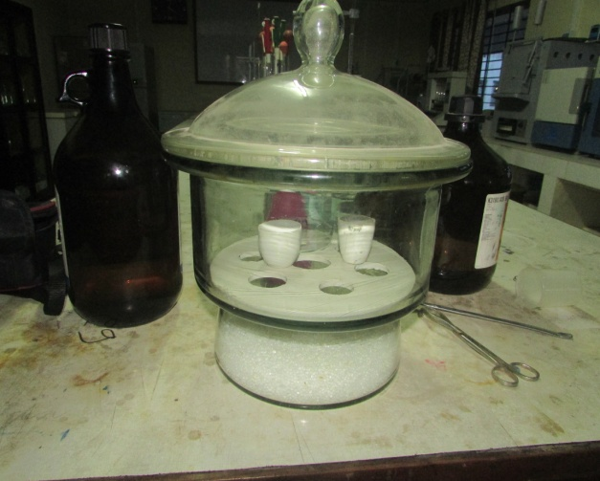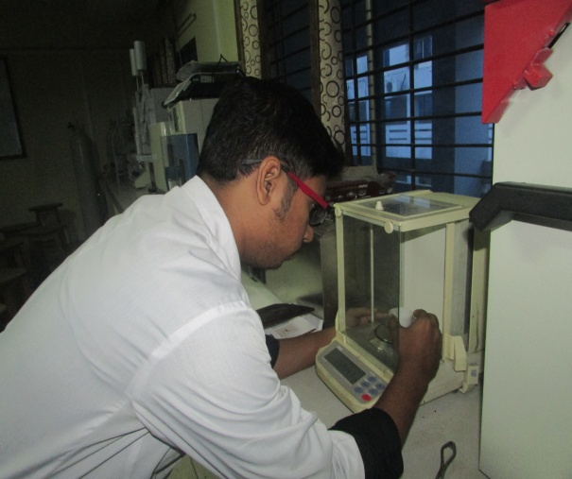
IMAGE GALLERY
Fig 2: Weighing of samples
Fig 1: Dessicator with crucible

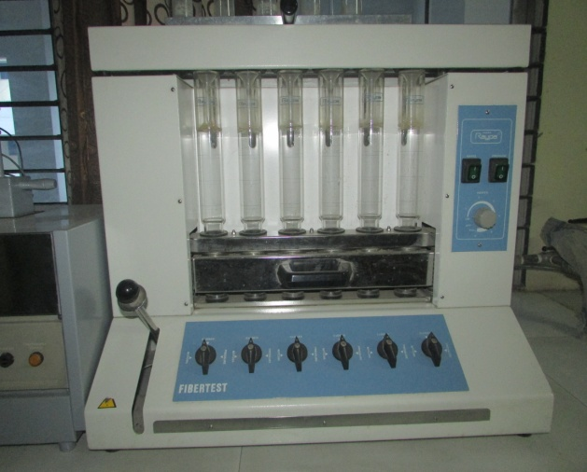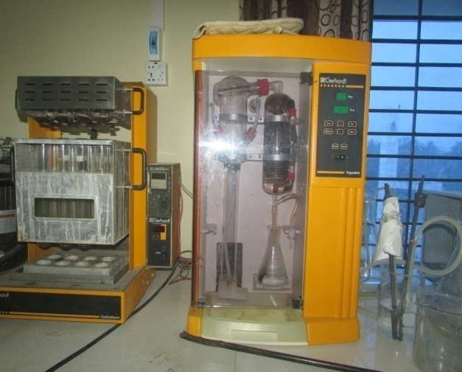
Fig 3: Estimation of EE
Fig 4: Estimation of CP

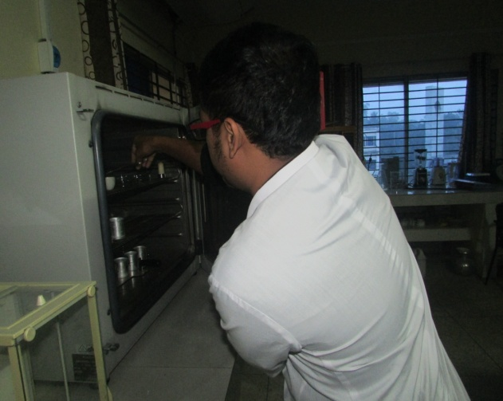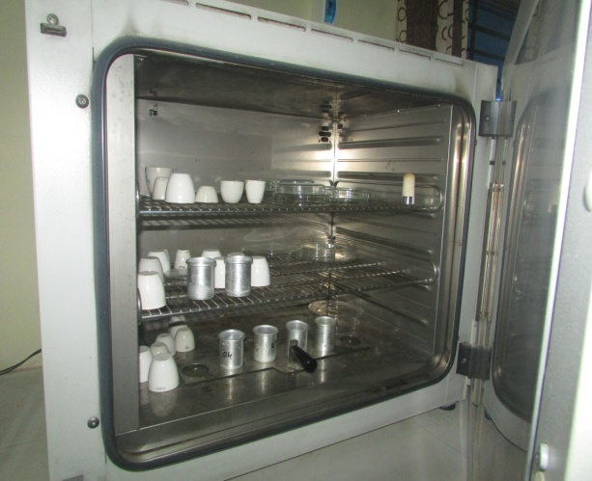
Fig 5: Estimation of DM
CHAPTER-V
CONCLUSION
Poultry requires more scientific ration than any other livestock. The deficiency of a nutrient in layer ration can greatly affect the production and quality of eggs. Fortunately the nutrient requirement of chicken is known as much detail and accurate than any other livestock. The data included in the study represents the variation among the quality of male and female breeder feeds from Gaucia poultry farm which are somewhat slightly differed from standard. Each manufactures has its own formulation which doesn’t remain constant throughout the whole year but changes according to the feasibility of the constituents of the poultry feed. The existing information about the composition and nutritive value of the layer feed permits the layer farmers to select the best one for the better growth and health of the poultry on the basis of cost and profitability. All the farm owners should be concerned during ration formulation of layer layer and breeder birds to fulfill nutrient requirement of them and hence to increase productivity of eggs and meat and to make more profit to make a happy, poverty free Bangladesh

CHAPTER-VI
REFERENCES
AOAC, 1990. Official Methods of Analysis, Association of Official Analytical Chemists, 20th edition, Washington, D. C.
Ahmed, S. and Islam, I., 2008. Backyard Poultry Development Project in 100 village proceeding of the 1st conference of Bangladesh Animal Husbandry Association, Dhaka, Bangladesh. Pp: 133-138.
Akter, A. and Uddin, S., 2009. Bangladesh Poultry Industry, Journal of Business and Technology (Dhaka), Vol. 4, No. 2, July-December. Pp:97-112.
Basak, B., A.H. Pramanik, M.S. Rahmnan, S.U. Taradar, and B.C. Roy, 2002. Azolla (Azolla pinnata) as a feed ingredient in broiler ration. Int. J. Poult. Sci., 1:
Damerow, G. 2012. The Chicken Encyclopedia: An Illustrated Reference. Storey Publication, Pp: 118-119, 135-136.
DLS (Department of Livestock Services), 2012-2013. Ministry of Fisheries and Livestock, economic review, 2013 upto February, Chapter-7_Bangla_2013, Pp: 103.
Grobas, S., Mendez, J., Blas, C. and Mateos, G. G., 2011. Laying hen productivity as affected by energy, supplemental fat, and linolic acid concentration of the diet. Poultry Science. Vol: 78. Pp: 1542-1552.
Harms, R. H., Russel, G. B. and Sloan, D. R., 2002. Performance of four strains of commercial layer with major chances in dietary energy. Journal of Applied Poultry Research. Vol: 9. Pp: 535-541.

Hawthorne,K.2003.http://www.ehow.com/info_10064312_layer-mash.htm.
Larbier, M. and Leclercq, B., 2004. Metabolism of Water and Minerals, Nutrition and Feeding of Poultry, Midlands Books Typesting Company, Leicestershire. Pp:113-115.
Latif, M. 1999. History of Poultry Industry in Bangladesh. Proceeding of the seminar of International Poultry Show. WPSA. Bangladesh Branch. Pp: 11-17.
McNab, J., 2001.Advance in poultry nutrition in the world. Proceeding of the seminar and international poultry show. WPSA. Bangladesh Branch. Pp: 52.
Pattinson, M. 2008. Poultry Diseases 6e. Elsevier Health Sciences. P.550. ISBN 978-0-7020-2862-5. Retrieved 7 November 2012.
Rosenberry, B. 2002. Critical Care of Shrimp. Feed quality. Feed international. Pp: 10.
Raghuramulu, N., Nair, M.K. and Kalyansundaram, S., 2013. A Manual of Laboratory Technique, NIN, ICMR, Hyderabad, India.
Singh R. A. 2009. Poultry feeding, Poultry production, 5th edition, Kalyani publishers, New Delhi. Pp: 197-198.
Spralt, R. S. and Lesson, S. 2007. Broiler Beeder Performance in Response to Diet Protein and Energy. Poultry Science, Pp: 683-693.
Sainsbury, D. 2000. Practical Poultry Feeding, Poultry Feed and Management, Pp: 31-38.
Sansoucy,R, 2012. The FAO program for better utilization of local feed resources in developing countries.In proc. 7th animal production.Edmonton,Canada,Pp:77-80.

