A comparative study between proximate analysis of Layer poultry feed of Namakkal and Chittagong

By
AHMED ULLAH
Roll No: 10/ 07
Reg. No: 00486
Intern ID. : A – 05
Session: 2009 – 2010

A Production Report Submitted in partial satisfaction of the requirements for the degree of
DOCTOR OF VETERINARY MEDICINE
Faculty of Veterinary Medicine.

CHITTAGONG VETERINARY AND ANIMAL SCIENCES UNIVERSITY, KHULSHI , CHITTAGONG.
A comparative study between proximate analysis of Layer poultry feed of Namakkal and Chittagong

Approved:

…………………………………………………………….
Professor Dr. Goutam Buddha Das
Dept. of Animal Science and Nutrition.
Chittagong Veterinary and Animal Sciences University.

December, 2015.

CONTENTS
Contents Page No

ACKNOWLEDGEMENTS ……………………………………………………….…. 04
LIST OF TABLES…………………………………………………………………….. 05
LIST OF FIGURES………………………………………………………………....... 05
LIST OF ABBREVIATION………………………………………………………….. 05
ABSTRACT…………………………………………………………………………....06
Chapter I INTRODUCTION………………………………………………………. …07-08
Chapter II MATERIALS AND METHODS ………………………………………….09-12
2.1 Study area ……………..………………………………………………..09
2.2 Sample collection... …………………………………………………….09
2.3 Preparation of Samples………….…………………………. ………….10
2.4 Methodology….…..…………………………………………………….10
2.4.1 Determination of Moisture……………………………………………10
2.4.2 Determination of CP………………………………………………......10
2.4.3 Determination of EE ………………………………………………….10
2.4.4 Determination of CF………………………………………………......11
2.4.5 Determination of Ash …………………………………………...……11
2.4.6 Calculation of NFE …………………………………………………...11
2.4.7 Calculation of ME …………………………………………………….12
Chapter III RESULTS AND DISCUSSION ………………………………………….13-14
Chapter IV CONCULATION……………………………………………………….....15
REFFERENCES…………………………………………………………….16-17
BIOGRAPHY……………………………………………………………….18
ACKNOWLEDGEMENT
All praises are due to “Almighty Creator” who enabled me to complete this work successfully. The author feels gratefully to his internship supervisor honorable Vice Chancellor Professor Dr. Goutam Buddha Das, Department of Animal Science and Nutrition, Chittagong Veterinary and Animal Sciences University, for his valuable advice, suggestion, kind cooperation and sympathetic supervision during study period. The author also would like to express his deepest sense of respect and appreciation to the owner of farms (Mohanur raj poultry farm, India and Kazi poultry farm, Chittagong) for providing the poultry feed samples. The author extends his appreciation to the head, teachers and laboratory attendants of dept. of Animal Science and Nutrition for helping and cooperation during experimental works in laboratoy. The author would like to thanks to all his friends and well wisher for their help, encouragement and inspiration.

The author,
September, 2015

LIST OF TABLE
Table No | Content | Page No
Table: 1 | Proximate analytical nutrients value of collected feed sample. | 13
Table: 2 | Reference values for nutrients of Layer layer feeds recommended by different researchers. | 14

LIST OF FIGURES
Figure No | Contents | Page No
Figure 1 & 2 | Estimation of crude protein | 12
Figure 3 | Estimation of EE | 12
Figure 4 | Estimation of CF | 12

LIST OF ABBREVIATION
Abbreviation and Symbol | Elaboration
% | Percent
/ | Per
Gm | Gram
Kcal/kg | Kilo-calorie per kilogram
CP | Crude protein
EE | Ether Extracts
CF | Crude Fibre
NFE | Nitrogen Free Extracts
DLS | Department of Livestock Services
H₂SO₄ | Sulfuric acid
NaOH | Sodium hydroxide
& | And

ABSTRACT
The study was carried out to acquire a comparative proximate analytical picture between layer feeds of Mohanur raj poultry farm in Namakkal and Kazi poultry farm in Bangladesh which are formulated in their farm on the basis of the requirement birds (hen). As the quality of feed is one of the main determinant factors in successful poultry farming, an attempt was made to compare the quality of both Namakkal layer feed,India and Kazi layer layer feeds, Chittagong. The feed was formulated on Layer-layer basis. The proximate analysis of these feeds showed the following composition such as moisture, crude protein (CP), crude fibre (CF), ether extracts (EE), ash and metabolizable energy (ME). The proximate analytical nutrient concentrates were moisture 10.4% and 10.1%, %CP 17.85% and 19.00%, %EE 2.4% and 4.3%, %CF 6.1% and 4.00%, % ash 6.5% and 6.3% finally ME 2650.72 Kcal/kg and 2800 Kcal/kg respectively Namakkal farm feed and Chittagong farm feed. There was significant difference observed in these feed samples with regards to some nutrient concentration. The age of the birds of two farms was also same (55-60 wkks). From this experipent, it was observed that the quality of feed used in Mohanur raj poultry farm (Namakkal) is better than Kazi poultry farm (Chittagong) and the nutrients are also closed to the standard. This experimental study may be helpful for Bangladeshi farmers and poultry nutritionists to compare between for mixed layer of Bangladesh with Indian (Namakkal) hand mixed layer feed.

Key words: proximate analysis, layer feed, poultry, Namakkal, Chittagong.

CHAPTER: I
INTRODUCTION:
Now a days the poultry farming has turned out into one of the most important business division of agriculture throughout the world. It has been rapidly as a dynamic industry in south Asia countries. The demand of layer and broiler protein is increasing for meats and eggs. Poultry is basically a source of economical, palatable and healthy food protein (Mahesar et al 2010).In India poultry eggs has high demand where about 60-70% among total demand of eggs is supplied from Tamilnadu. Livestock sector in India makes significant contribution to the country’s economy. It contributes around 7.5% to the Gross Domestic Product (GDP) and 26% to agricultural GDP (AgGDP) (GOI, 2003). The livestock sector in the last two decades has recorded a growth rate of around 5.2% per annum, which is almost twice that of agricultural sector (Singh, 2002). India ranks 4th in the world in egg production and 8th in poultry meat production. Due to environmental facilities, high demand, management facilities in India layer farming is well established. The supplied feed in Mohanur raj poultry farm in India pellet feed for starter and hand mixed feed for grower and finisher.
In Bangladesh the layer poultry farming is increasing due to high demand of animal protein source. The poultry industry, as a fundamental part of animal production, is committed to supply the nation which is a cheap source of good quality nutritious animal protein in terms of meat and eggs Akter and Uddin, (2009). Banerjee, (2005) also observed that in comparison to other livestock sectors, poultry requires less investment to start the farming. The estimated contribution to GDP during FY 2012-13 from this subsector was 3.49% (DLS, 2012-2013).Though the share of this sub sector in GDP is small; it has immense contribution to meet the daily protein needs. Among this, poultry constitutes 30% of animal protein and will increase to 40% before 2015 (IFPRI, 2000). According to DLS, the production of poultry rose to 293.235 million in 2012-2013. There are 246.6 million chickens (DLS, 2012-2013) and about 50,000 poultry farms (FFYP, 2003) available in Bangladesh presently. However from another census it was found that 12.89% poultry birds come from nonfarm source, 51.95% from small farms, 27.43% from medium farms and 7.73% from large farms (BBS, 2003).
In Bangladesh the maximum supplied feed for Layer-layer is hand mixed feed due to variation of nutrient requirements in different stage of poultry. The main feed ingredients in Bangladesh and India layer farm almost same such as maize, rice polish, soybean, protein concentrate, limestone, DCP and Lysine. Poultry feed is food for farm poultry, including chickens, ducks, geese and other domestic birds. Feed for poultry mostly consists of grain Pattison, (2008). In industrial agriculture, machinery is used to automate the feeding process, reducing the cost and increasing the scale of farming. For commercial poultry farming, feed serves as the largest cost of the operation James et al., (2010). Rosenberry, (2002) stated that, good quality feed has a several advantages over lower quality feeds i.e; better feed efficiency, faster growth rate, lower mortality, higher survivability and better meat and egg quality etc.
The poultry feed is an essential matter for better, profitable farming because the growth of birds, performance, immunity, production depend on management of accurate nutrients supplement. So the protein, energy, vitamin, mineral and other nutrients must be contained in formulated feed as their recommended requirement on the basis of their production stage. Healthy poultry require a sufficient amount of protein and carbohydrates, along with the necessary vitamins, dietary minerals, and an adequate supply of water. The feed must remain clean and dry; contaminated feed can infect poultry. Damp feed encourages fungal growth. Mycotoxin, as an example, is "one of the most common and certainly most under-reported causes of toxicosis in poultry" Pattison, (2008).
High or low level of nutrients in layer feed hampers the growth and production. Finally it will be cause of loss for farmer. According to kleyn (1992) feed cost represents 60-80% of the economic input in the economical poultry industry. Nazni (2003) reported that in poultry production the most important component is the ratio amongst the feed and egg/meat.
Therefore the objectives of the present study were,
To analytically characterize the comparative feature of nutrients of layer poultry feed of two countries like India and Bangladesh.

CHAPTER: II
2. MATERIALS AND METHODS
2.1. STUDY AREA:
The study area was in India and Bangladesh. In India, Mohanur raj poultry farm (Namakkal) and in Bangladesh kazi poultry farm (Chittagong) were selected for this study. The total experimental was performed in laboratory of Dept. of Animal science and nutrition of CVASU.
2. 2. SAMPLE COLLECTION:
For the determination of nutrients value of poultry feed, the feed samples were collected from ‘Mohanur raj poultry farm’ in India and ‘kazi poultry farm’ in Bangladesh. About 250 gm layer feed samples were collected by using simple random sampling technique. From each collected feed sample a couple of proximate analyses were performed for accurate result.

2. 3. PREPARATION OF COLLECTED SAMPLES:
First of all collected feed samples were ground to obtain a uniform particle size of feed ingredients and kept in air tight plastic bags for proximate analysis (Mahesar et al 2008)

2. 4. METHODOLOGY:
For proximate analysis of collected poultry feed samples, Association of official analytical chemists recommended methods (AOAC, 1990) were used to measure the level of moisture, crude protein (CP), crude fiber (CF), crude fat(ether extract), ash, nitrogen free extract (NFE) and metabolic energy (ME).

2. 4. 1. DETERMINATION OF MOISTURE:
This was done based on the difference between the net weight and the weight after drying to a constant weight. A clean dried Petri-dish was weighed (W1) and 5g of the samples were placed on it, and then weighed (W2). This was then placed in an oven at120 °C for 24hrs. The dish was removed and cooled in desiccators for 30 minutes and finally weighed (W3). Then moisture percentage was calculated AOAC,(1990).

2. 4. 2. DETERMINATION OF CRUDE PROTEIN (C.P.):
0.50g dried sample was weighed and transferred into the Kjeldahl digestion flask. Catalyst was added into digestion flask. Then 1.25% sulfuric acid solution was added. After digestion the sample was cooled and 40% W/V NaOH was added. The digest was transferred into the steamed out apparatus. The ammonia steam distilled into 2% boric acid solution with 3 drops of methyl red indicator. Then distilled ammonia was titrated with 0.01M Hcl. Finally N2 was calculated then C.P was calculated by following formula.
$Protein\%=\frac{\left(Titre-Blank\right) Normality of HCl 14.007 6.25}{Sample weight(g)} 100$
Here,
6.25 is the protein nitrogen conversion factor.

2. 4. 3. DETERMINATION OF CRUDE FAT / ETHER EXTRACT:
For the fat extraction approximate 2.0g finally grinded feed sample was placed in a cellulose thimble paper and fat extraction was carried out using Hexase in a 250 ml Soxhlet extractor for 3 hrs. The sample was removed and air dried. Then sample was placed in oven at 80 ̊ C a constant weight was obtained. Then extractible fat was calculated as percentage crude fat.
$EE\%=\frac{Initial weight(g)-Weight after extraction(g)}{Sample weight(g)} 100$
2. 4.4. DETERMINATION OF CRUDE FIBRE (C.F):
2gm ground feed sample was taken then boiling with adding 125 ml 1.25% H₂SO₄ under reflex for 30 minutes. After then several time washed with hot for acid free from sample. Again in this sample 125ml 1.25% NaOH was added and same treatment was subjected for removing alkali free from sample. Then it was dried to a constant weight in an oven at 100 ̊C and cooled in a desiccators and weighed. The sample was incinerated in a muffle furnace at 550 ̊C for 2 hrs until a constant weight. The crude fibre was calculated as the loss in weight on ashing AOAC,(1990).

$$\%CF =\frac{Wt of Crucible with Dry Sample-Wt of Crucible with Ash}{Weight of Feed sample} 100$$

2. 4.5. DETERMINATION OF ASH:
A crucible was dried in an oven for 24 hrs then cooled and weighed. 5gm dried sample was taken in crucible and subjected to ashing in a muffle furnace maintained at 550 ̊C until a constant weight for ash.
$\%Ash=\frac{Weight of Crucible and Ash -Weight of Crucible}{Weight of Feed sample} 100$

2. 4.6. CALCULATION OF NITROGEN FREE EXTRACTS (NFE):
Total NFE was calculated by difference [100-(%protein + %crude fibre + %crude fat+
%Moisture + %ash)] as reported by Akubor et al. (2000).

2.4.7. CALCULATION OF METABOLIZABLE ENERGY (ME)
The metabolizable energy content was calculated by using the following formula Lodhi et al.,(1976).

ME = 32.959 (% CP + % EE × 2.25 +% NFE) - 29.

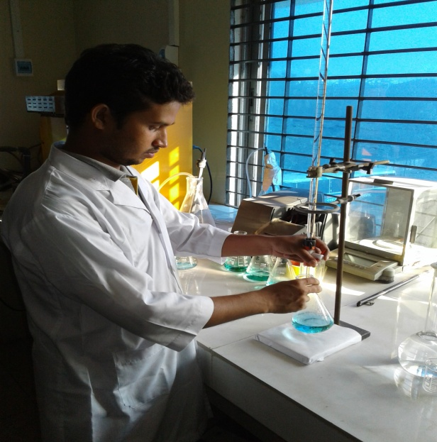
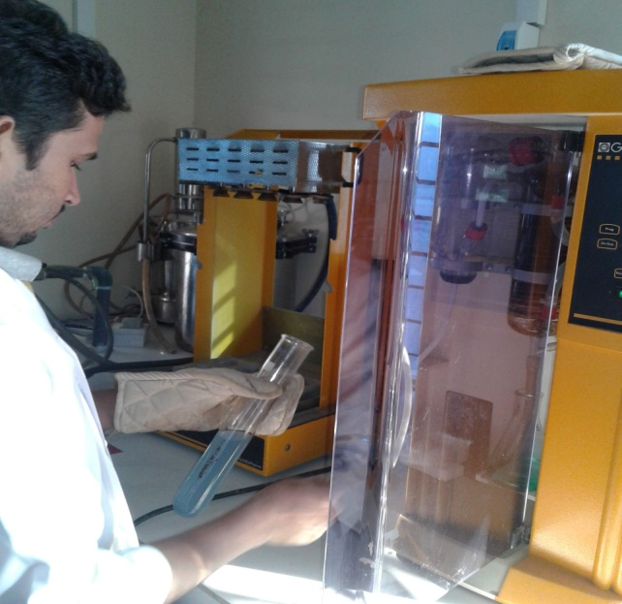
Figure 1 & 2: Estimation of Crude protein.
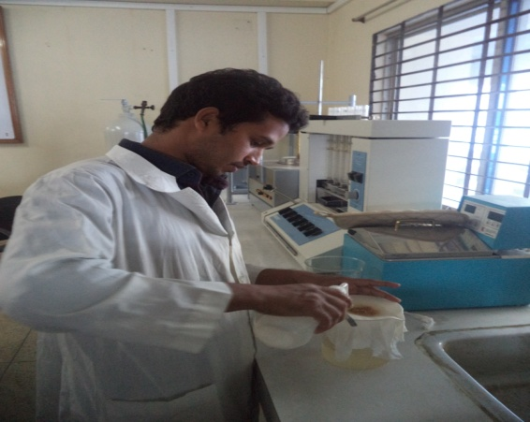
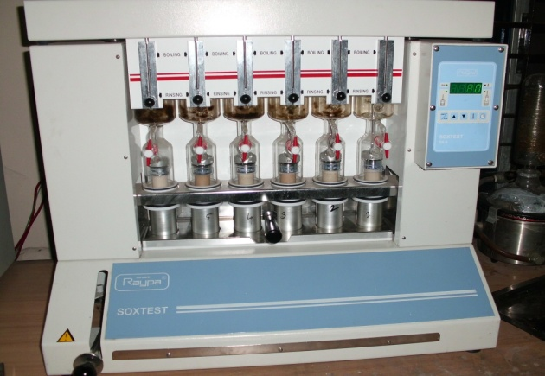
Figure 3: Estimation of EE Figure 4: Estimation of CF

CHAPTER: III
RESULT AND DISCUSSION:
Weende or Proximate Analysis is partitioning of compounds in a feed into six categories based on the chemical properties of the compounds. The six categories are: moisture, total ash (TA), crude protein (CP), crude fibre (CF), ether extracts (EE) and nitrogen-free extracts (NFE). The major nutrient component of the collected poultry feed samples are moisture, crude protein, crude fibre, ether extract, ash, NFE and metabolic energy (ME). The results of proximate composition of analyzed feed samples are shown in table-I
Table: I- Proximate analytical nutrients value of collected feed sample.
Name of samples | Moisture  % | Crude protein  % | Ether Extract  % | Crude fibre  % | Ash  % | NFE  % | ME  (Kcal/ kg)
Hand mixed feed sample of Namakkal. | 10.4 | 17.85 | 2.4 | 6.1 | 6.5 | 56.75 | 2650.72
Hand mixed feed sample of Bangladesh. | 10.1 | 19.0 | 4.3 | 4.0 | 6.3 | 56.4 | 2800.00

Standard values recommended by researchers:
Table 2. Reference values for nutrients of Layer layer feeds recommended by different researchers:

Reference | Moisture  (%) | ME  (kcal/kg) | CP  (%) | CF  (%) | EE  (%)
Larbier, M. and Leclerc, B.(1992) | 12 | 2750-2900 | 16-17 | 4 | 3.5-4.0
Banerjee, G.C. (1995) | 10 | 2700 | 18 | 8 | -
Verma D. N.(2006) | - | 2700 | 18 | - | -

Observation on the nutrient concentrations of Layer-layer poultry feed samples of two farms ( Mohanur raj poultry farm and Kazi poultry farm) were found variation in composition comparing with standard values in some nutrients.
In case of Moisture percentage both feed samples were same with standard level.
In case of ME, Mohanur feed of Namakkal feed was little amount lower than standard but in Kazi feed of Chittagong was (2800 Kcal/kg) higher than the standard level (2700 Kcal/kg).
In case CP percentage, Mohanur feed of Namakkal was standard level but in Kazi feed of Chittagong was (19.00%) higher than the standard level (17%) .
In case of EE, Mohanur feed of Namakkal was (2.40%) very lower amount than standard but in Kazi feed of Chittagong was ( 4.3%) little higher than the standard level (4.00%) .
Limitations of the study:
- In this proximate analysis, we estimate total N₂, not the ultimate protein & NPN (Non Protein Nitrogenous Substance).
- Again it estimates %CP from N₂ multiplying by 6.25 assuming that all protein contains 17-19% N₂. So over & under estimation of N₂ can be happened.
- During estimation of %CF, acid & alkali boiling is going on the hemicelluloses is partially destroyed. So there can be a little variation from the real value of %CF.
- Any deviation in results may be due to environmental or experimental error.
CHAPTER: IV
CONCLUSION:
Poultry requires more scientific ration than any other livestock. The deficiency of a nutrient in layer ration can greatly affect the production and quality of eggs. The analytical nutrients in Namakkal layer feed sample were nearly standard level and mostly ME, CP were at recommended required level but fat percentage was very low(2.4%). There are contradicted results about the effect of supplemental fat on egg production. The addition of fat has no effect on egg production. The production level was about 85% which was satisfactory to owner. The analytical nutrients in Kazi layer feed of Chittagong were higher than recommended required level mostly ME and CP were 2800 kcal/kg and 19.00% respectively which was less profitable. The production level (75%) of Chittagong farm which was less satisfactory than namakkal farm. Again higher ME may cause fat deposition in layers which cause egg bound problem. High use of protein is also renders the poultry farming unprofitable.
Recommendation
Layer farm owners should be concerned during ration formulation of layer-layer birds to fulfill nutrient requirement of them and hence to increase productivity of eggs and meat and to make more profit.

REFERENCES
Akter, A. and Uddin, S., 2009. Bangladesh Poultry Industry, Journal of Business and
Technology (Dhaka), Vol.4,No.2, July-December.
Akubor, P.I., Isolokwu, P.C., Ugbane, O., Onimawo, I.A. 2000. Proximate
composition and functional properties of African breadfruit kernel and flour blends.
AOAC, 1990. Official methods of Analysis, Association of Official Analytical Chemists, 20th
edition, Washington, D.C.
Banerjee, G.C. 2005. Poultry, A Textbook of Animal Husbandry, 8th edition, Raju Primlani
for Oxford and IBH Publishing Company Private Limited, New Delhi.
BBS, 2009. Bangladesh Bureau of Statistics, Statistical Yearbook of Bangladesh. Ministry of
Planning, Dhaka, Bangladesh.
DLS (Department of Livestock Services), 2012-2013. Ministry of Fisheries and Livestock,
Economic review, 2013 upto February, Chapter-7_Bangla_2013.
Gillespie, J.R., and Flanders, F.B., 2010. Modern Livestock and Poultry Production.
Cengage Learning.
IFPRI, 2000. www.cgiar.org/IFPRI.
Kleyn, R. 1992. Broiler feeding for better returns. Poult. Bullet. 283-286.
Lodhi, G.M., Singh, D. and Ichponani, J.S., 1976. Variation in nutrient content of feeding
stuff rich in protein and reassessment of the chemical methods of metabolizable
energy estimation. Journal of Agricultural Science.

Mahesar, S.A.,Sherazi, S.T.H., Abdul Niaz, Bhanger, M.I., Sirajuddin, Abdul
Rauf, 2010. Simultaneous assessment of zinc, cadmium, lead and copper in poultry
feeds by differential pulse anodic striping voltammetry. Food and Chemical
Toxicology.
. Nazri, M.M., 2003. Development of poultry industry. Economic review. Available
online at: Nazri, M.M.. "Development of poultry industry", Economic Review, March
2003 Issue.
Pattison, M. 2008. Poultry Diseases 6e. Elsevier Health Sciences.
Rosenberry, B. 2002. Critical care of shrimp. Feed quality. Feed international.
Singh, R.A. 2004. , Poultry nutrition, Poultry production. 5th edition, Kalyani publishers,
New Delhi.
Verma, D.N. 2006. Feeding of Poultry, Atextbook of animal nutrition, 2nd edition, Kalyani
publishers, New Delhi.

BIOGRAPHY
I am AHMED ULLAH. I live in Chittagong district of Bangladesh. After completing higher secondary education I wanted to be a doctor. Finally I admitted in Faculty of veterinary medicine of Chittagong veterinary and animal sciences university. I have completed a four year academic education from this institute and also completed some externship & internship training program with successfully. I would like to introduce myself as a doctor. I have completed all activities to publish this report with honestly and sincerely. I would like to find out the new methods and techniques to spread the veterinary sector in home and abroad.

