Status of Bulbul in Bangladesh

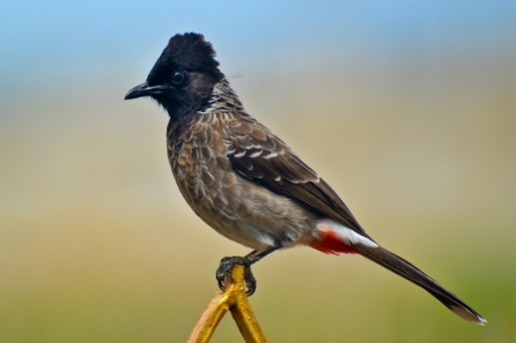
A PRODUCTION REPORT SUBMITTED
BY

Intern ID: A-07
Roll no: 10/12
Registration No: 0491

A Production Report Submitted in partial requirement for the fulfillment of the
degree of Doctor of Veterinary Medicine.

Chittagong Veterinary and Animal Sciences University

Khulshi, Chittagong-4225

December, 2015
Status of Bulbul in Bangladesh

A PRODUCTION REPORT SUBMITTED
BY

Intern ID: A-07
Roll no: 10/12
Registration No: 0491

Approved as to style and content by

..............................................
(Signature of Supervisor)
Dr. Gauranga Ch. Chanda
Professor
Department of Dairy and Poultry Science
CVASU

Chittagong Veterinary and Animal Sciences University
Khulshi-4225

December, 2015

