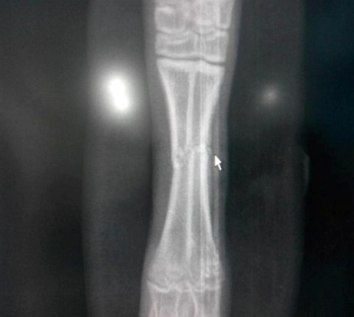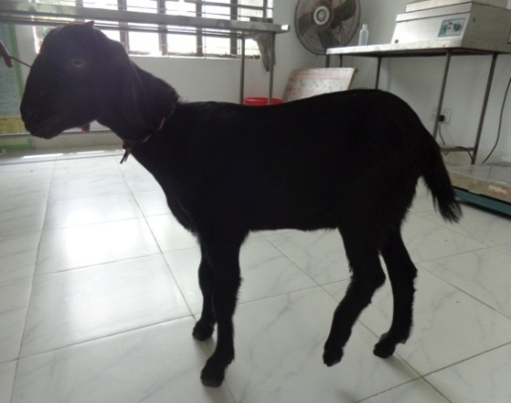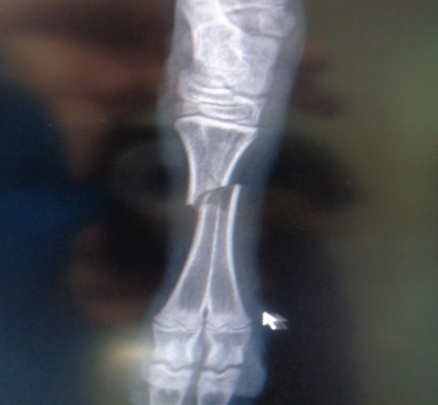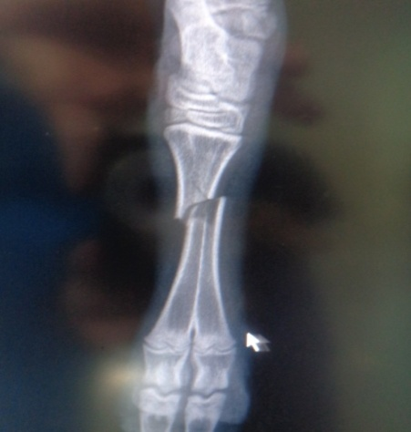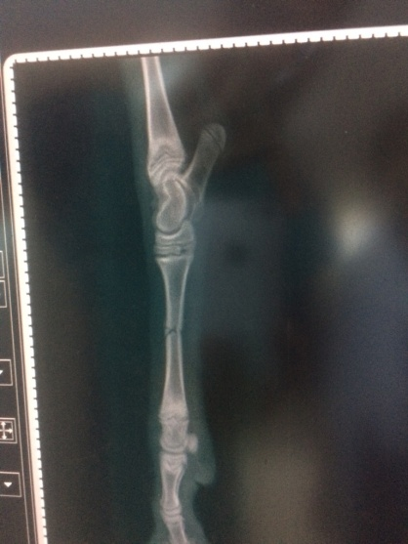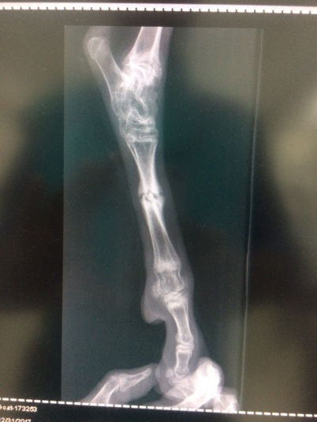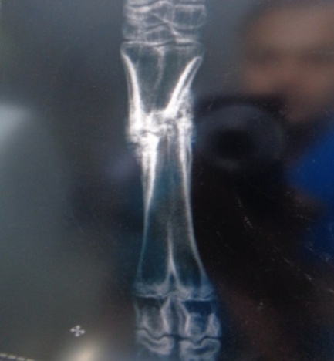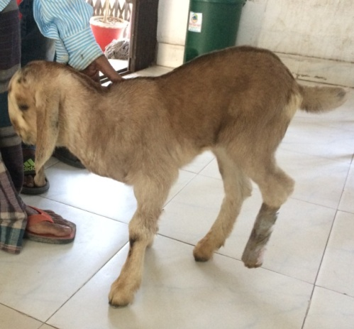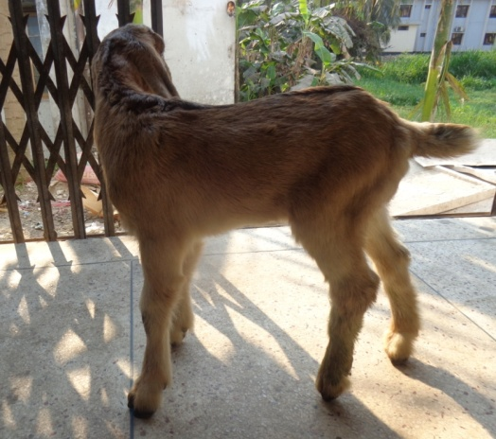

***Radiographic Evaluation of group I***

Fig.18(a): case 3; lameness grade 5, RAS 2 in pre fracture management

Fig.18(b): case 3; RAS 0 in post fracture management day 30

Fig.17(a): case 2; lameness grade 5, RAS 1 in pre fracture management

Fig.17(b): case 2; RAS 0 in post fracture management day 30

Fig.16(a): case 1; RAS 0 in post fracture management day 45

Fig.16(a): case 1; lameness grade 4, RAS 3 in pre fracture management