***Lameness grade evaluation of group I***

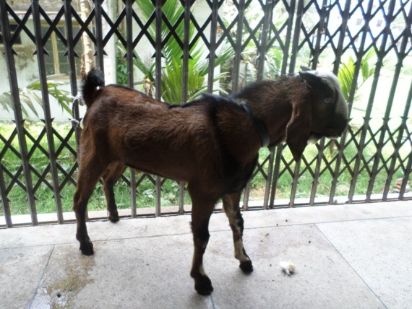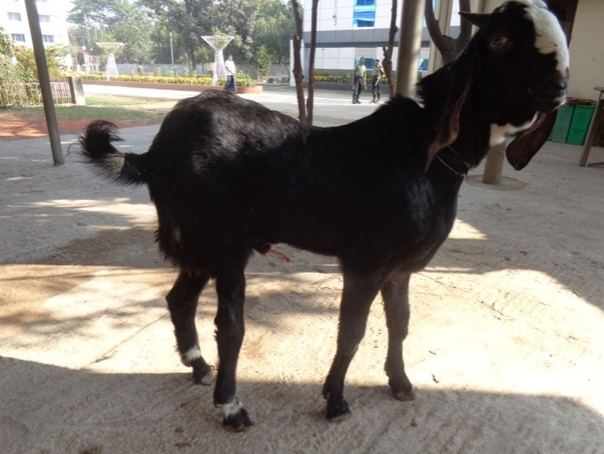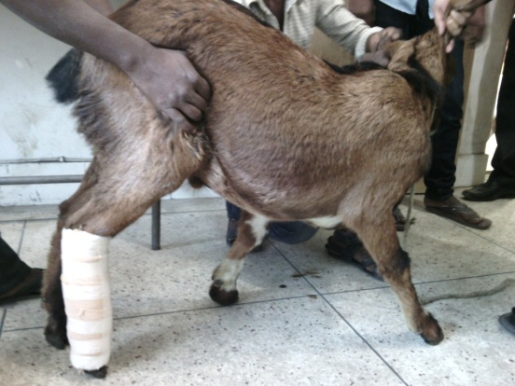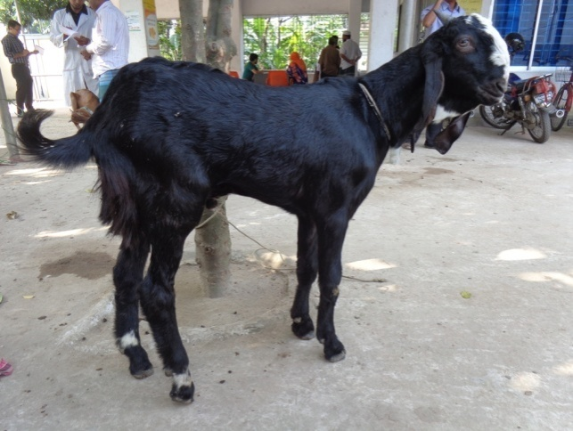

Fig.14 (b); case 7; Lameness grade 0 (full wt. bear) of Rt. hind limb in post fracture management 45 days

Fig.15 (a): case 8; Lameness grade 4 (hoof touching) of Rt. hind limb

)

Fig.15 (b); case 8; Lameness grade 2 (mild wt. bear) of Rt. hind limb in post fracture management 45 days

Fig.14 (a): case 7; Lameness grade 4 (hoof touching) of Rt. hind limb

)