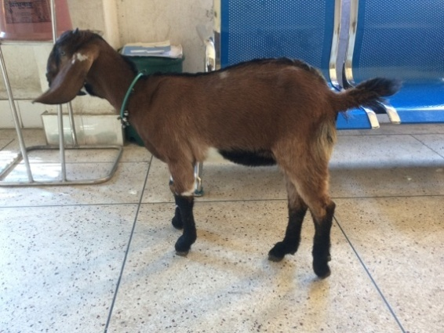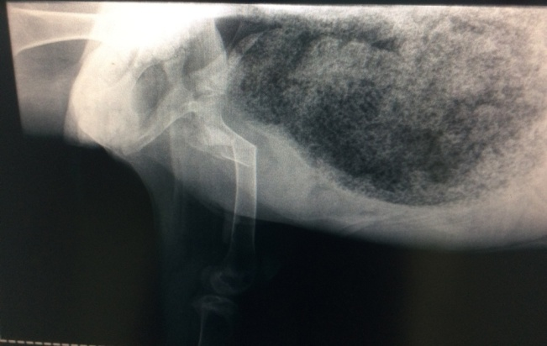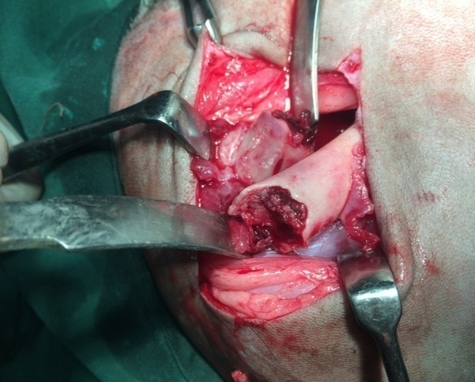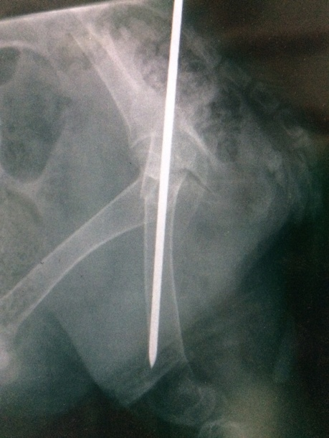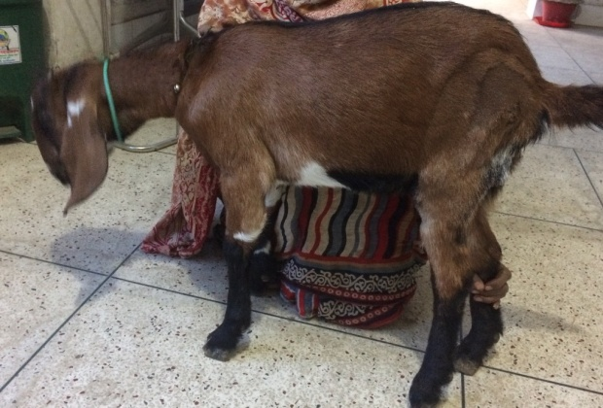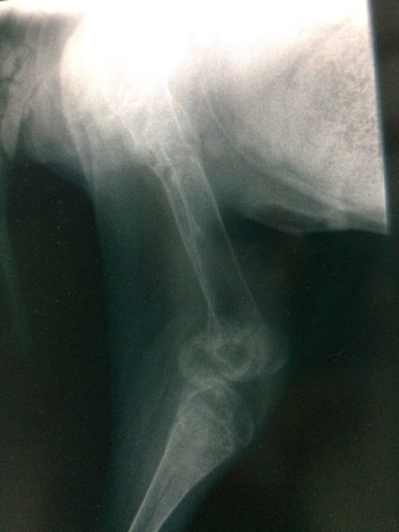

Fig.27 (c): case 4; Lameness grade 0 (full wt. bear) of Lt. hind limb, RAS 0 in day 45 PO

Fig.27 (b): case 4; surgical approach; IMP

***Lameness grade, Surgical technique and Radiographic evaluation of group II***

Fig.27 (a): case 4; Lameness grade 5 (non wt. bear) of Lt. hind limb, RAS 3 in pre fracture management