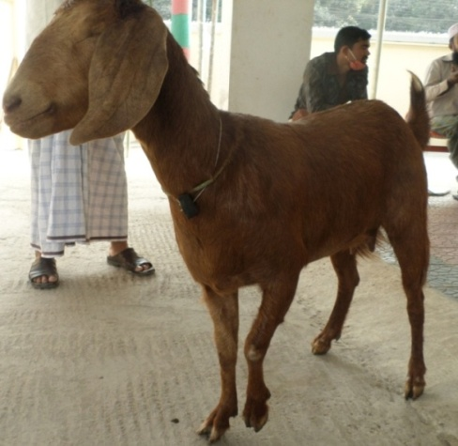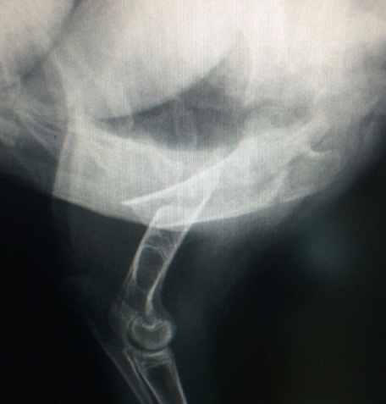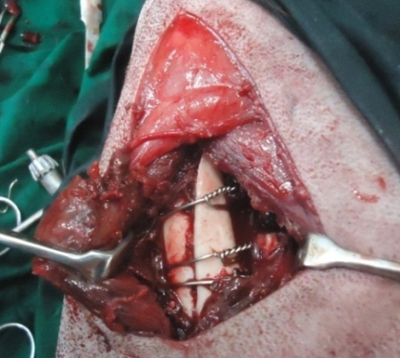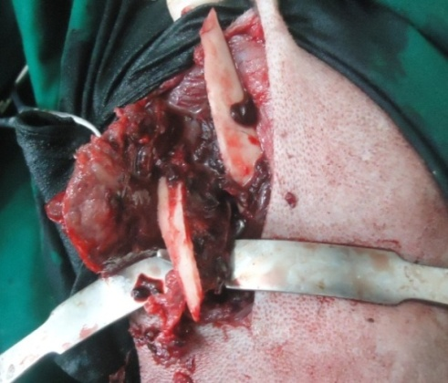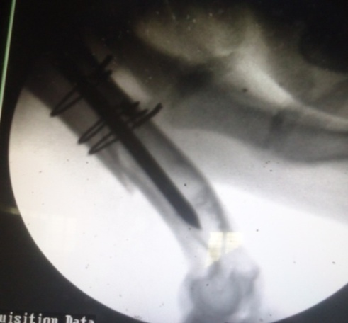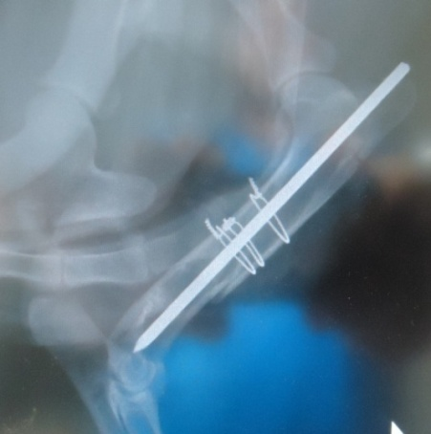

Fig.26 (c): case 3; RAS 0 in day 1 and day 30 PO

Fig.26 (a): case 3; Lameness grade 5 (non wt. bear) of Lt. fore limb, RAS 3 in pre fracture management

***Lameness grade, Surgical technique and Radiographic evaluation of group II***

Fig.26 (b): case 3; surgical approach; IMP + wiring