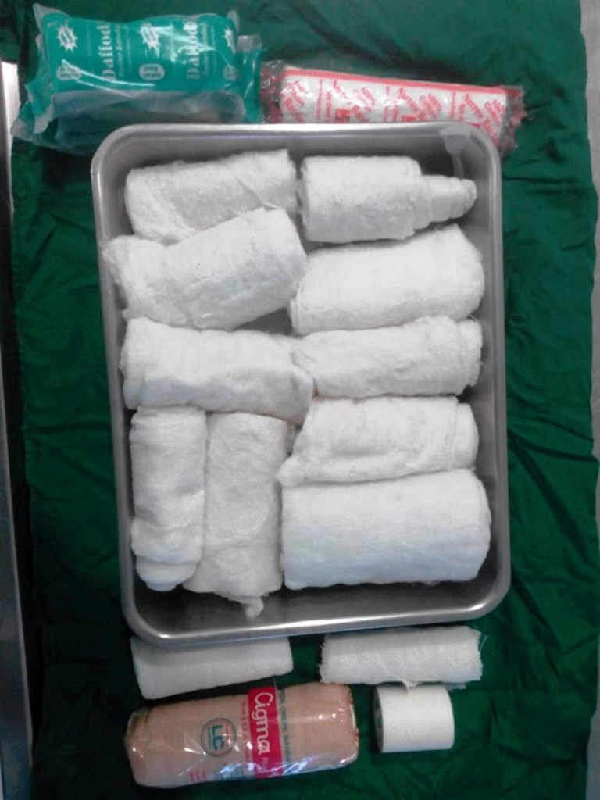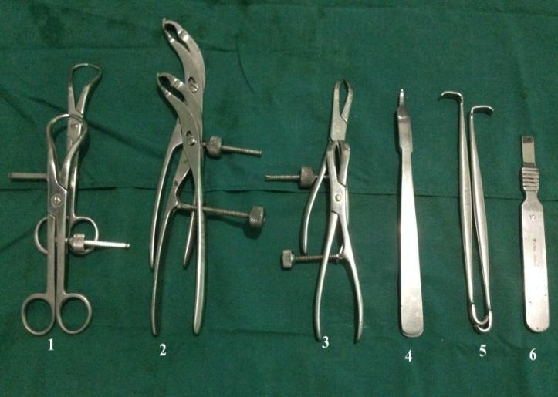

4

4

1

2

1

2

4

3

**Fig. 2: Basic orthopedic instruments** ( 1. Pointed reduction forceps, 2. Self centering bone holding forceps, 3. Serrated reduction forceps, 4. Hohmann reduction forceps, 5. Senn retractor, 6. Periosteal elevator.

**Fig. 1: External Coaptation materials:** 1. Cotton roll, 2. Roll gauze, 3. Crepe bandage, 4. Adhesive tape.

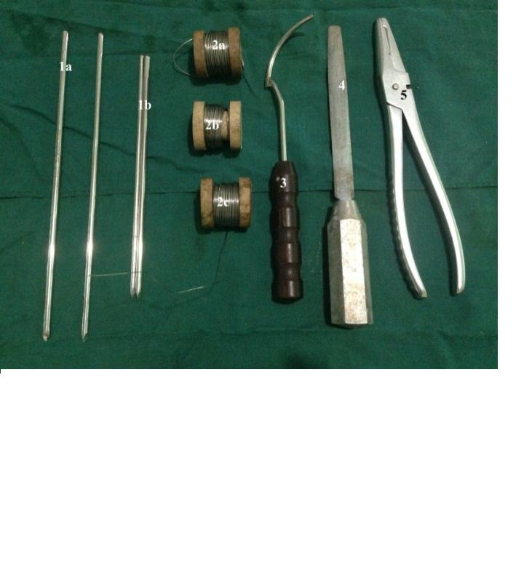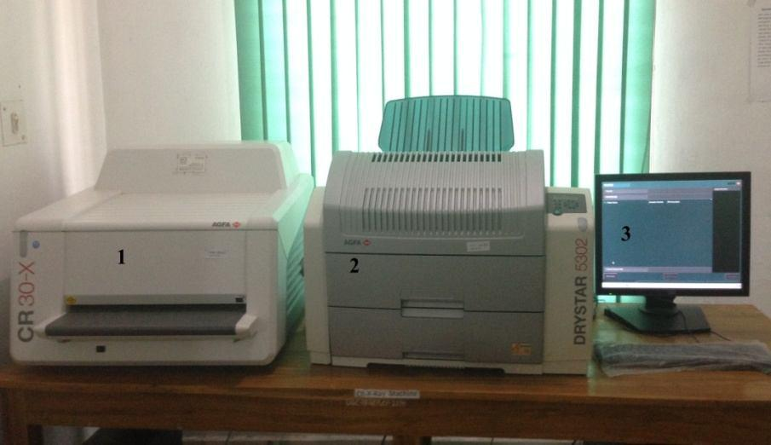

**Fig. 4: CR X-Ray machine:** 1. Scanner, 2. Printer, 3. Monitor.

**Fig. 3: instruments for intramedullary pinning** (1. Steinmann pin: a.200mm, 150mm, 2. Stainless steel wires: a. 18G, b. 20G, c. 22G, 3. Wire guide, 4. Rasp, 5. Wire cutter cum twister.