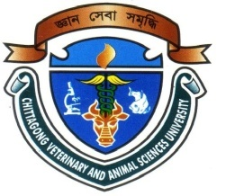

Effects of different dietary levels of vitamin E supplementation on the growth and gonadal development of Climbing Perch, Anabas testudineus (Bloch, 1792)

Md. Mehedee Hasan
Roll No. 0117/02
Registration No. 0455
Session: 2017-2018

A thesis submitted in the partial fulfillment of the requirements for the degree of Master of Science in Fish Biology and Biotechnology

Department of Fish Biology and Biotechnology
Faculty of Fisheries

Chittagong Veterinary and Animal Sciences University
Chittagong-4225, Bangladesh

JUNE 2018

Authorization

Authorization I hereby declare that I am the sole author of the thesis. I authorize the Chittagong Veterinary and Animal Sciences University (CVASU) to lend this thesis to other institutions or individuals for the purpose of scholarly research. I further authorize the CVASU to reproduce the thesis by photocopying or by other means, in total or in part, at the request of other institutions or individuals for the purpose of scholarly research.
I, undersigned, and author of this work, declare that the electronic copy of this thesis provided to the CVASU Library, is an accurate copy of the print thesis submitted, within the limits of the technology available.

(Md. Mehedee Hasan)

Effects of different dietary levels of vitamin E supplementation on the growth and gonadal development of Climbing Perch, Anabas testudineus (Bloch, 1792)

Md. Mehedee Hasan
Roll No. 0117/02
Registration No. 0455
Session: 2017-2018

This is to certify that we have examined the above Master’s thesis and have found that is complete and satisfactory in all respects, and that all revisions required by the thesis examination committee have been made

--------------------------------------------------------  (Prof. Dr. Mohammad Rashedul Alam) | -------------------------------------------------
Supervisor  Department of Physiology Biochemistry & Pharmacology | (Md. Moudud Islam)  Co-supervisor  Department of Fish Biology and Biotechnology

-----------------------------------------------
(Md. Moudud Islam)
Chairman of the Examination Committee
Department of Fish Biology and Biotechnology

Department of Fish Biology and Biotechnology
Faculty of Fisheries

Chittagong Veterinary and Animal Sciences University
Khulshi, Chittagong-4225, Bangladesh

JUNE 2018
Acknowledgments
I am indebted to Almighty Allah who enabled me to complete the research work and write up the dissertation successfully for the degree of Master of Science (MS) in Fish Biology and Biotechnology under the Department of Fish Biology and Biotechnology (DFBB), Chittagong Veterinary and Animal Sciences University CVASU.
I would like to convey my sincere thanks and gratitude to my supervisor Prof. Dr. Mohammad Rashedul Alam, Department of Physiology Biochemistry & Pharmacology, CVASU for his valuable supervision and guidance. It was really a great pleasure and amazing experience for me to work under his supervision. I really deemed it and I realized it was an opportunity for me to work under his creative guidance.
It's my pleasure to convey my profound gratitude to my co-supervisor Md. Moudud Islam, Assistant Professor and Head, DFBB, CVASU for his encouragement and cooperation at every stage of this study from its inception to completion.
I am greatly indebted to Md. Mahiuddin Zahangir, Assistant Professor, DFBB, CVASU for his valuable advice, scholastic guidance, suggestions and inspiration.
I sincerely express deepest sense of gratitude and indebtedness to our honorable Vice-chancellor Prof. Dr. Goutam Buddha Das and Prof. Dr. Mohammed Nurul Absar Khan, Dean, Faculty of Fisheries, CVASU for their supportive administrative co-ordination to fulfill my research.
I am also grateful to Dr. Sk. Ahmad-Al-Nahid, Assistant Professor Department of Fisheries Resource Management, Dr. Md Asaduzzaman, Assistant Professor, Department of Marine Bio-resource Science, CVASU for their inspiration, technical support and kind suggestion during the research work.
I sincerely thank all postgraduate students and technical staffs of DFBB for their encouragement and support during sample collection and laboratory work.
Last but not least, I express my deepest sense of gratitude to my beloved parents and friends for their sacrifice, blessings and encouragement.

The Author
Md. Mehedee Hasan
ABSTRACT
Vitamin E is one of the most important micronutrients that influence the performance of fish reproduction. The experiment was carried out for 3 months in aquarium with recirculation facilities in the wet laboratory adjacent to the Faculty of Fisheries, Chittagong Veterinary and Animal Sciences University to observe the effects of different dietary level of vitamin E on growth and gonadal development of Anabus testudineus. One and half months aged 300 A. testudineus were stocked and divided into five treatments each having three replicates. The fish were fed with feed having different levels of vitamin E viz. 0 mg (as control), 50 mg, 100 mg, 200 mg, and 400 mg vitamin E/kg feed as treatment 1 to treatment 5, respectively. Fish fed with 50 mg vitamin E/kg feed (under T₂) showed highest (9.12±0.23 g) weight gain in terms of body growth while fishes treated with 0 mg vitamin E kg⁻¹ feed under (under T₁) gave the poorest result (6.85±1.32 g). There was no significant differences (p= 0.184) between the treatment groups. Gonadosomatic index (%) was highest (0.696±0.44) in fish treated with 100 mg vitamin E/kg feed (under T₃) while 400 mg vitamin E/kg (under T₅) showed the poorest effect (0.311±0.03). No significant difference (p= 0.233) was found between the treatment groups. The overall result of this experiment suggests that inclusion of 100 mg vitamin E/kg feed is the best dose for enhancing the gonadal development of A. testudineus fish. The findings indicated that vitamin E content has a positive impact on gonadal development of this species. The present results also imply that inclusion of higher level of vitamin E exerts an antagonistic effect in terms of growth and gonadal development of this species.

Key words: Anabus testudineus, Vitamin E, Gonad, Growth, Gonadosomatic index.

CONTENTS
 |  |  |  |  |  | Page No.
Acknowledgements |  |  |  |  |  | i
Abstract |  |  |  |  |  | ii
Contents |  |  |  |  |  | iii
List of tables |  |  |  |  |  | v
List of figures |  |  |  |  |  | vi
List of plates |  |  |  |  |  | vii
List of appendices |  |  |  |  |  | viii
Abbreviations and symbols |  |  |  |  |  | ix
Chapter I
Introduction |  |  |  |  |  | 1
Chapter II
Review of literature |  |  |  |  |  | 6
Chapter III
Materials and methods |  |  |  |  |  | 11
 | 3.1 | Description of experimental system |  |  |  | 11
 | 3.2 | Preparation of aquarium and re-circulatory system |  |  |  | 11
 | 3.3 | Collection of fish and conditioning |  |  |  | 12
 | 3.4 | Experimental design |  |  |  | 13
 | 3.5 | Stocking of fish |  |  |  | 13
 | 3.6 | Cleaning procedure |  |  |  | 14
 | 3.7 | Feed formulation and preparation |  |  |  | 14
 | 3.7.1 | Selection of ingredients and diet formulation |  |  |  | 14
 | 3.7.2 | Diet preparation |  |  |  | 15
 | 3.8 | Feeding rate and frequency |  |  |  | 16
 | 3.9 | Sampling of the experimental fish |  |  |  | 16
Contents (Cont’d.)
 | 3.10 | Estimation of gonadosomatic index of broodfish |  |  |  | 17
 | 3.11 | Water quality parameters |  |  |  | 19
 | 3.12 | Parameters studied for growth and ovarian development of fish |  |  |  | 20
 | 3.13 | Statistical analysis |  |  |  | 20
Chapter IV
Results |  |  |  |  |  | 21
 | 4.1 | Effect of vitamin E on growth and gonadal development |  |  |  | 21
 | 4.1.1 | Effect on growth performance |  |  |  | 21
 | 4.1.2 | Effect on Gonadosomatic index |  |  |  | 23
 | 4.2 | Water quality perspective |  |  |  | 24
Chapter V
Discussion |  |  |  |  |  | 26
Chapter VI
Summary and conclusion |  |  |  |  |  | 28
References |  |  |  |  |  | 30
Appendices |  |  |  |  |  | 37

LIST OF TABLES
Table No. | Title | Page No.
Table 1 | Composition in each 100 ml Esco Sel-E Plus | 14
Table 2 | Proximate composition of feed (% dry matter basis) | 15
Table 3 | Formulation of experimental diets (Pearson square method) | 16
Table 4 | Physico-chemical parameters of water during experimental period | 25

LIST OF FIGURES
Figure No. | Title | Page No.
Figure 1 | Weight gain of A. testudineus reared under different dietary levels of vitamin E. (Vertical bars= ±S.D.) | 22
Figure 2 | Periodical weight gain of A. testudineus reared under different dietary levels of vitamin E (Vertical bars= ±S.D.) | 22
Figure 3 | Specific growth rate of A. testudineus reared under different dietary levels of vitamin E | 23
Figure 4 | Comparison of gonadosomatic indices of A. testudineus reared under different dietary levels of vitamin E | 24

LIST OF PLATES
Plate No. | Title | Page No.
Plate 1 | Recircuatory system and glass aquaria | 12
Plate 2 | Weighing of fish for stocking | 13
Plate 3 | Weighing of fish before dissection | 17
Plate 4 | Measurement of total length and standard length of A. testudineus | 17
Plate 5 | Dissected female A. testudineus with ovary | 18
Plate 6 | Weighing ovary of the A. testudineus | 18
Plate 7 | Microscopic observation of gonad | 18
Plate 8 | Dissected ovary of the A. testudineus | 19
Plate 9 | Measurement of water quality parameters | 20

LIST OF APPENDICES
Appendix No. | Title | Page No.
Appendix I | Growth performance of A. testudineus under different doses vitamin E | 37
Appendix II | Specific growth rate of A. testudineus under different treatments | 38
Appendix III | Gonadosomatic index (GSI) of A. testudineus under different treatments | 39

Abbreviations and Symbols
Abbreviations |  | Full
ANOVA | : | Analysis of Variance
cm | : | Centimeter
et al. | : | Associates
g | : | Gram
i.e. | : | That is
kg | : | Kilogram
L | : | Liter
ml | : | Milliliter
mm | : | Millimeter
mg | : | Milligram
mt | : | Metric ton
S.D. | : | Standard deviation
SPSS | : | Statistical package for social science
WBC | : | White blood cell
wt | : | Weight
% | : | Percent
< | : | Smaller than
> | : | Greater than
°C | : | Degree Celsius
α | : | Alpha

INTRODUCTION
Bangladesh has the third greatest aquatic fish biodiversity in Asia, due to the contributions of the three main rivers systems that flow from the Himalayas into the Bay of Bengal along with the world’s largest flooded wetland, the Bengal Delta (Hussain, 2010). Bangladesh wild fisheries represent almost 7% of the world’s inland fish production and account for 52% of the country’s fish production (DoF, 2015). Bangladesh, with its rich inland waters and river systems, has significant capture fishery and aquaculture potential. The favorable geographic position of Bangladesh comes with a large number of aquatic species and provides plenty of resources to support fisheries potential. Fish is a popular complement to rice in the national diet, giving rise to the adage Maache-Bhate-Bangali (“a Bengali is made of fish and rice”) (Ghose, 2014).
The fisheries can broadly be classified into three categories: inland capture fisheries, inland aquaculture and marine fisheries, of which the inland aquaculture sector is contributing more than 56.82% of the total production (FRSS, 2017). The fisheries sector plays a very important role in the national economy, contributing 3.65% to the Gross Domestic Product (GDP) of the country and 23.81% to the agricultural GDP (FRSS, 2017). Overall growth rate of total fish production in 2015-16 is 5.27 %. The overall growth performance from inland aquaculture shows a moderate increased trend. The fish production has increased more than five times (7.54 MT in 1983-84 to38.78 lakh MT in 2015-16) over the last three decades (FRSS, 2017). More than 2% of Bangladeshi export value comes from the inland fisheries sector. In recent years, the bulk of the production has been obtained from marine (16.78%) and freshwater (83.22%) wild capture fisheries. In 2015-2016, Bangladesh was the 5th in world aquaculture production, which accounted for half of the country’s total fish production (55.15%) (DoF, 2016). In 2014-2015, total fishery production of Bangladesh was 3,684,245 metric tons; of which 1,023,991 metric tons was obtained from inland capture fisheries, 2,060,408 metric tons from inland aquaculture and 599,846 metric tons from marine water production (FRSS, 2016).

About 41% of children less than 5 in Bangladesh are stunted, 16% acutely malnourished, 36% underweight, and approximately half of children ages 6-59 months are anemic (National Institute of Population Research and Training, 2013). Although women’s nutritional status has improved, 24% of women are still considered undernourished, and 42% have some degree of anemia (National Institute of Population Research and Training, 2013). Vitamin A, iron, and zinc deficiencies are major public health problems in the country (Roos, 2007). Annual per capita fish consumption is estimated to be 18.9 kg and accounts for about 60% of Bangladesh’s animal protein consumption (DoF, 2016). Small indigenous fish species (SIS) play an important role in supporting the livelihoods of rural poor households and are an important source of protein, vitamins, iron, calcium, and other minerals (Ahmed, 2012). SIS have high vitamin A content and serve as an important source of dietary calcium, as the fish are usually cooked and consumed whole, including bones (Ahmed, 2012).There are potentials of culture of SIS in Bangladesh. SIS is generally considered to be these fishes which grow to a maximum length of about 25 cm or 9 inches (Hossain and Afroze, 1991. Felts et al, 1996 and Wahab, 2003).There are 50-60 different SIS of Bangladesh. They are the major contributors of nutrient for the people of Bangladesh. Most of the small indigenous fish species have high nutritive value in terms of protein, micro-nutrients, vitamins and minerals. These micro-nutrients and minerals are not commonly available in other foods. On the other hand, small indigenous fish species are cooked and eaten whole with head and bones and thus provide a good source of nutrients (Thilsted et al. 1997)
Among the small indigenous fishes, climbing perch (Anabas testudineus) locally known as koi is considered to be the most economic and important fishes. The climbing perch (A. testudineus, Bloch, 1792) is a well-known member of the Anabantoidae family which derived their name for bearing labyrinth like accessory breathing organ. Koi reach sexual maturity at around 15 cm. Females laid approximately 50 to 5000 eggs of 0.6 mm size which float freely at the surface and often lay in shallow oxygen-depleted waters (Eschmeyer, 1998). Females are larger than male. Mature males are darker colored and have longer knifed edged anal fins than females (Riehl and Bacnsch, 1991). These fishes are commonly seen at between 2 and 23 cm but can grow up to 25 cm in length (Riehl and Baensch, 1991). Climbing perch have specialized labyrinth organs under their operculum which enable them to breath atmospheric air.
The climbing perch is a favorite small indigenous fish of Bangladesh. It is regarded as a highly esteemed food fish for its fine flavour, restorative value and prolonged freshness out of water. A. testudineus is a very hardy and is of considerable fisheries interest. It inhabits in paddy fields, ditches, ponds, water reservoirs, canals and haors. It can tolerate extreme environmental conditions such as low dissolve oxygen due to presence of accessory air breathing organ, wide range of temperature and other poor water conditions. Considering the importance of this species in nutritional, economics and biodiversity the cultivation of Anabas testudineus is becoming increasingly popular among the aquaculturists of Bangladesh.
Inspite of having many qualities such as high digestibility of protein, presence of vitamin, iodine and fat in muscle, very little attempt has been made to promote its breeding and culture of Koi. For the supply of quality seeds insufficient numbers the brood fish must be of good quality. So in case of broodstock management, there should be regular supply of balanced food for their growth and development. For the initiation of study on the nutrition it is necessary to determine whether spawning and egg quality are influenced by nutritional quality of broodstock diets or not. Vitamin E plays an important role in reproductive physiology in fish as it does in birds and mammals (Watanabe, 1985). Nutrition in the diet of broodfish is known to have a profound effect on gonad development, fecundity, quality of eggs and larvae. Although precise information on the nutritional requirements of broodstock for gonad maturation is scanty, it has been found that quantity and quality of feed as well as the feeding regime is important for maintenance of egg quality and successful spawning. Vitamins are one of the most effective additives to nutritionally complete diets for fish production (Gaylord et al., 1998).
Vitamin E activity is present in a group of naturally occurring closely related tocopherols. Among them, α-tocopherol has the highest vitamin E activity. DL- α-tocopherol acetate, a stable vitamin of α-tocopherol, is the most commonly used form in animal feeds (NRC, 1983). On hydrolysis of this ester, α-tocopherol is absorbed from the intestine along with dietary fats (Bjorneboe et al., 1990). As a fat-soluble antioxidant, the major function of vitamin E is to prevent peroxidation of polyunsaturated fatty acids of phospholipids and cholesterol in cellular and subcellular membranes. Most of the deficiency signs observed in fish, such as nutritional muscular dystrophy, fatty liver degeneration, anemia, erythrocyte hemolysis, hemorrhage, depigmentation, and reduction of fertility, are related to peroxidative damage to cellular membranes (NRC, 1983). As a membrane-bound antioxidant, vitamin E appears to scavenge free radicals at the site of their formation.
Vitamin E is recognized as an essential vitamin required for all classes of animals functioning predominantly as an intracellular antioxidant in maintaining the integrity of biological cell membranes (Hidiroglou et al., 1992). As a fat-soluble vitamin, it is the most effective chain-breaking, lipid-soluble antioxidant in biological membranes, where it contributes to membrane stability. It protects critical cellular structures against damage from oxygen free radicals and reactive products of lipid peroxidation. Aquatic animals have high levels of unsaturated fatty acids to maintain cell membrane fluidity especially at low temperatures; it is assumed that vitamin E plays an important role in this context (Blazer, 1992). The importance of vitamin E in fish reproduction has been reported by many scientists (Watanabe et al., 1970; Hamre and Lie, 2011; Halver, 2002 and Paul et al., 2004). For example, vitamin E caused higher gonadosomatic index, larger ova and more eggs than a control in a study of freshwater fish, Cyprinus carpio (Gupta et al., 1987). Sufficient number of fry and fingerlings of this catfish is, however, quite difficult to obtain from natural waters for stocking in the ponds. Proper techniques of mass production of fry in commercial scale seem to be the most crucial factors in expanding culture practice for this species because market price of fish bears the special preference in aquaculture.
Due to over fishing and climatic change sufficient number of fry and fingerlings of A. testudineus is, however, quite difficult to obtain from natural waters for stocking in the ponds. So the dependency of this fish fry and fingerling is increasing on hatchery production. So manipulation of breeding performance of A. testudineus can increase the seed production to fulfill the requirement of fish farmer. Considering the above realities, the present research work was undertaken to observe the effect of vitamin E on growth and gonadal development of Koi, A. testudineus.

Objectives of the study
- To evaluate the effects of dietary vitamin E (α-tocopherol) on growth performance of A. testudineus
- To observe the effect of vitamin E on gonadal development of A. testudineus

REVIEW OF LITERATURE
Prior to conduct an experiment, it is essential to know the information about the previous related work. The purpose of this chapter is to review the past studies conducted by different researchers to the related field. At present the culture practice of climbing perch has gained much popularity in Bangladesh due to its phenomenal growth, acceptable test and high market demand. A number of diversified researches regarding the use of vitamin E in different saltwater and freshwater fishes have been carried out world-wide. The following information was briefly reviewed in favor of the present study which was done around the world and relevant to the study as.
Hossain et al. (2016) carried out an experiment on effects of varying levels of dietary Vitamin E (α-tocopherol) on growth performance, proximate and fatty acid composition of juvenile silver pomfret (Pampus argenteus ). The results of the study suggested that increasing dietary supplementation of vit. E in high lipid diets enhanced the growth performance of fish and that a dietary level of 196 mg kg⁻¹ Vit. E was suitable for the growth of silver pomfret.
Sharifzadeh et al. (2015) studied on effects of vitamins E and Riboflavin (B2) and combinations of them on the hematological parameters of common carp, Cyprinus carpio L., fingerlings and this study showed that vitamin E and B2 supplements alter the hematological parameters of common carp.
Lozano et al. (2017) conducted an experiment on effect of different dietary vitamin E levels on growth, fish composition, fillet quality and liver histology of meagre (Argyrosomus regius). They found that dietary vitamin E levels did not affect meagre growth performance. Muscle fatty acid profiles showed an increment of the highly unsaturated fatty acid (HUFA) and a decrease of the saturated fatty acid with the increase of dietary vitamin E, which was accompanied with a reduction of the muscle TBARS (Thiobarbituric Acid Reactive Substance) responses. Therefore, it is suggested that diets for this species should be supplemented with 451 mg kg⁻¹ of DL-α-tocopherol acetate (496 UI of vitamin E), as determine by broken-line regression analysis of muscle TBARS, to provide good overall growth performance and improved fish quality and storage stability. Moreover, results suggest that vitamin E deficiency or excess may deteriorate fish health.
German Bueno Galaz et al. (2010) carried an experiment on effects of different dietary vitamin E levels on growth performance, non-specific immune responses, and disease resistance against Vibrio anguillarum in Parrot Fish (Oplegnathus fasciatus). They treated fishes with six casein-gelatin based semi-purified diets that contain six graded levels of DL-α-tocopheryl acetate (α-TA) at 0, 25, 50, 75, 100 and 500 mg/kg diet and fed to triplicate groups of juvenile parrot fish for 12 weeks. At the end of the feeding trial, growth performance and feed utilization of fish fed with 25 mg/kg were significantly higher compared to that of fish fed the other diets. The findings of this study suggest that parrot fish require exogenous vitamin E and the optimum dietary level could be approximately 38 mg α-TA/kg diet for normal growth and physiology.

Mollah et al. (2003) conducted an experiment on the study of different dietary levels of vitamin E on the growth and breeding performance of Heteropneustes fossilis brood fish. The effects of four dietary vitamin E levels viz. 0 (served as control), 50, 100 and 200 mg/kg feed, on the somatic growth, ovarian development of brood fish and on their breeding performance were studied. Each treatment had three replications. It was observed that body growth in terms of length and weight was best with 0 mg vitamin E/kg feed and 200 mg vitamin E/kg of feed gave poorest result. The ganadosomatic index and fecundity, however, was highest in the fish fed with 100 mg vitamin E/kg of feed. In case of breeding performance such as ovulation rate, fertilization rate, hatching rate and survival rate, the best result was obtained with 200 mg vitamin E/kg of feed. The overall result of this experiment indicates that 200 mg vitamin E/kg of feed is the best vitamin E dose for H. fossilis brood and vitamin E content has a positive impact on ovarian development.

Gammanpila et al. (2007) suggested that supplementation of vitamin C; E and Zn would improve the total number of spawns, total seed production, mean fecundity, hatching rate, sperm motility and sperm viability of O .niloticus.

Houguo et al. (2015) conducted three months feeding experiment in an in-door seawater system to investigate the effect of dietary Vitamin E on the sperm quality of turbot (Scophthalmus maximus). They suggested that dietary vitamin E, especially at the high level (721.60 mg kg^{–1}), significantly improved sperm concentration and motility duration and maintained normal sperm morphology of turbot.
Hassaan et al. (2014) studied the effect of sub-lethal toxicity of technical grade copperoxychloride, dietary Vitamin E and their interactions on growth performance, some blood parameters, DNA fragmentation and histopathological lesions of Nile tilapia (Oreochromis niloticus). After 90 days experiment on 450 fish they reported that fish fed with varied concentrations of Vitamin E neutralized the toxic effect of copperoxychloride as well as Vitamin E, significantly lowered the hematological and biochemical response and enhanced the growth parameters and feed utilization. They suggested that Vitamin E can be effectively used to decrease the toxic effect of copperoxychloride on O. niloticus and its amelioration through dietary Vitamin E supplementation.

Khara et al. (2016) studied on 480 Caspian brown trout, Salmo trutta caspius juveniles (35±5.5g) were fed by experimental diets containing different levels of Vit. C and E and control diet separately for a period of 2 months under 15 experimental treatments. They observed that survival, growth parameters (specific growth rate (SGR), percent weight gain (WG) and biomass, immunological parameters (lysozyme activity, Immunoglobulin (IgM) and total immunoglobulin (TIg)) were found to be higher in Vitamin supplemented groups than in control group. They also observeed the haematological parameters including red blood cells (RBCs), white blood cells (WBCs), haematocrit (% Hct) and haemoglobin (Hb) were higher in Vitamin treated groups than control group. They suggested that a combination of 30 mg.kg⁻¹ diet Vit. E⁺ 300 mg. kg⁻¹ Vit. C or 40 mg. kg⁻¹ vit. E⁺ 300 mg. kg⁻¹ vit. C could be a good option for obtaining appropriate growth and survival in Caspian brown trout juveniles.

Roy and Mollah (2009) carried out an experiment on effects of different dietary levels of Vitamin E (0 mg (served as control), 50 mg, 100 mg and 200 mg Vitamin E/kg feed) on the ovarian development and breeding performances of eighty female Clarias batrachus for 6 months fewer than two phases. The first phase concentrated on studying the effects of Vitamin E on ovarian development and the second phase on breeding performances.After first phase they observed that growth in terms of body weight of fish fed with 200 mg Vitamin E/kg feed was higher, while 50 mg vitamin E/kg feed gave the poorest result they also found that Gonadosomatic index and fecundity were highest in fish treated with 100 mg vitamin E/kg feed.On second phase next three month they provide same experimental diet as first phase with pituitary gland (PG) dose of 100 mg/kg body weight was used in all treatments. They found that fertilization and hatching rate the highest result (88.33±2.51 and 82.33±3.05 respectively) was obtained in T₂ (50 mg Vitamin E/kg feed). They suggested that 50 mg vitamin E/kg feed is the best dose for the breeding performance of female C. batrachus broods.

LINN et al. (2014) conducted an experiment to investigate effect of supplementation of different doses of diatary α-tocopherol (0, 100, 200, 400 mg α-tocopherol/kg diet) for juvenile red sea bream Pagrus major in relation to growth performance, tissue fatty acid composition, tissue Vitamin E content, thiobarbituric acid reactive substances (TBARS) andoxidative condition for 30 days. Both liver and muscle Vitamin E contents increased (P < 0.05) in fish fed 400 mg Vitamin E/kg, followed by 200 mg and 100 mg Vitamin E/kg diet. They also observed that tissue TBARS values were inversely related (P < 0.05) by increasing the level of Vitamin E. However they found that dietary vitamin E level did not affect on the growth performances of red sea bream.

Ispır et al. (2011) conducted an experiment on effect of dietary Vitamin E supplementation on the blood parameters of nile tilapia (Oreochromis niloticus). They evaluated the influence of diets supplemented with 0, 80, 160, 240 mg kg⁻¹ of Vitamin E on the physiological responses of nile tilapia (Oreochromis niloticus) fed for 3 months. They observed that weight were not affected by dietary Vitamin E concentrations. But they suggested that 80 mg Vitamin E kg⁻¹ is probably the most suitable concentrations for tilapia diets, although high Vitamin E diets are necessary for quantitative leukocyte increases for tilapia.

James et al. (2008) conducted an experiment on the effects of different levels of dietary vitamin E (0, 100, 200, 300, and 600 mg/kg diet) on growth, gonad weight, fecundity, and leukocyte count were studied in goldfish (Carassius auratus) for 120 days. They observed that fish fed the 300 mg Vitamin E/kg diet had the best feeding rate, weight gain, and specific growth rate. They also observed that egg weight and diameter and larvae weight and length were significantly (p<0.05) higher in fish fed 300 mg vitamin E. further they found lymphocyte and monocyte populations were highest in fish fed 300 mg vitamin E. They suggested that 300 mg vitamin E/ kg diet is the optimum level for improving reproduction and immune response in C. auratus.

Nascimento et al. (2014) provided different levels of vitamin E supplementation (200, 300, 400, and 500 mg kg⁻¹) to groups of female Oreochromis niloticus for 90 days to observe the reproductive performance. They suggested that 400 mg kg⁻¹ Vitamin E in the diet during the reproductive period of female nile tilapia are sufficient to ensure the best reproductive performance, providing efficient production of a larger number of larvae in the individuals of this species.

Tatina et al. (2010) conducted an experiment on the effects of different levels of dietary vitamins C (0, 100 and 400 mg kg⁻¹diet) and E (0, 100 and 400 mg kg⁻¹diet) on some of hematological and biochemical parameters of starlet (Acipenser ruthenus) for a 100 days period. They found that fish fed diets containing 100 mg kg⁻¹ vitamin E and 400 mg kg⁻¹ vitamin C had the highest WBC. They also observed fishes fed diets without vitamin C but different levels of vitamin E had significantly higher amounts of cholesterol compared with fish fed with other diets.

MATERIALS AND METHODS

These investigations were carried out to observe the effect of different dietary levels of vitamin E on growth and gonadal development of A. testudineus. In this experiment broodfishes were reared and maintained in the recirculatory system for 3 months by providing different dietary levels of vitamin E to observe the growth and gonadal development of A. testudineus. The experiment was conducted in aquarium with recirculation facilities in the Wet Laboratory of the Faculty of Fisheries, Chittagong Veterinary and Animal Sciences University, Chittagong for a period of 3 months during the month of August to November, 2017.
3.1. Description of experimental system
The experimental system consists of 15 rectangular glass aquaria each of size (60 x 30 x 45 cm) containing about 70 liter of water. There were another two big sized glass aquarium for conditioning and stocking of fish. All the aquaria were placed in a metal frame for easier handling and it facilitated better observation and accessibility. Underground water from deep tube well was used in the aquaria during experimental period. An adequate level of oxygen in each aquarium was maintained through artificial aeration using aerators.
3.2. Preparation of recirculatory system
The entire recirculatory system was consisted of two identical unite. Each unite had 8 glass auaria.Water was supplied from 250 L water tank by 1 HP water pump (RFL, model: RSJ 10M) through recirculatory pipe. Those recirculatory water pipe were placed upto the bottom of each aquarium. So that it could siphon sedimented waste particales along with the suspended particales of the auarium. Syphoned water was taken to the biological filtter.
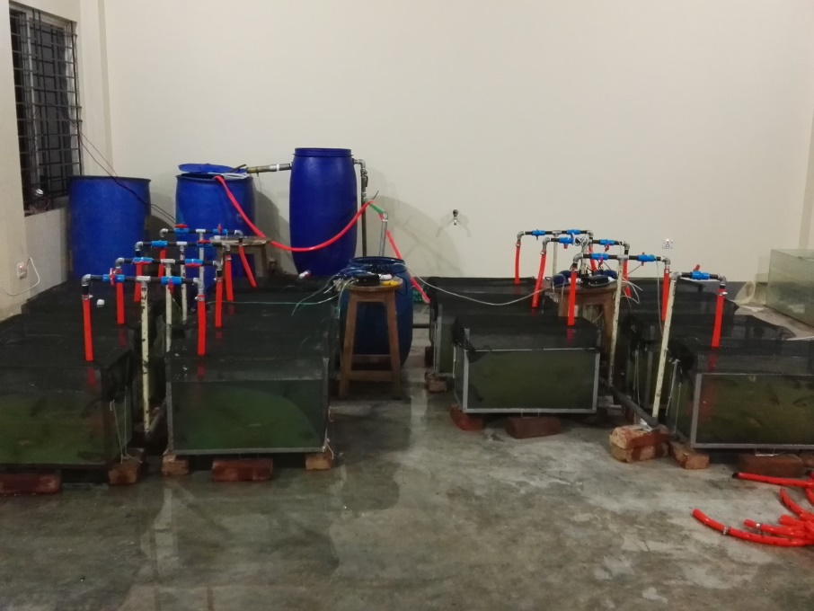
About 10% of the total water in the system was flashed out and replenished with tap water daily. The biological filter drums contained filter sponge that promoted settling of wastes by increasing retention time and provided a substrate for attachment of nitrifying bacteria. Two different sized and two different layer gravel stones were used in biological filter for filtration of water. A charcole layer was also used to remove dissolved organic molecules, chemicals, chlorine and chloramine and certain heavy metals. Water was sent direct to the bottom of the tank by the pipe. On the head of the supply pipe there was Z-pipe which made a water circulation to the bottom of the filter so that dissolved solid can esaily sedimented. Then the water passed all of the filter layer by water pressure from bottom anti-gravitationaly. At the top of the filter there was a water discharge pipe which discharge water to the main water tank. At the bottom of the filter there also had a discharge pipe. After completing filtration bottom discharge pipe valve were opened to remove the sedimented undissolved solid particals from biological filter.

Plate 1. Recircuatory system and glass aquaria
3.3. Collection of fish and conditioning
Two months aged experimental species A. testudineus were collected from Hazrat Owalish Fokir Matsho Unnoyon Hatchery (Pvt.) Ltd., Potiya, Chittagong. The collected fish were aclimatized in conditioning tank for 10 minutes. Then fish were released gently in conditioning tank for 6 days before stocking in the treatment aquaria. During conditioning sufficient oxygen supply was maintained through artificial aeration. Then healthy, strong and more or less equal sized fishes were used for the experiment.

3.4. Experimental design
To observe the effect of vitamin E on the growth and ovarian development, 15 aquariums were divided into five groups containing 3 aquariums in each group. These five groups corresponded to five experimental treatments (T₁, T₂, T₃, T₄, and T₅) and each treatment group had three replicates. Each aquarium stocked with 20 fish. Feed with five different levels of vitamin E viz. 0 mg (served as control), 50 mg, 100 mg, 200 mg and 400 mg vitamin E/kg feed were administered for studying the growth and gonadal development of fish.
3.5. Stocking of fish
The fishes were then randomly released into different treatment groups after proper conditioning. Twenty fishes were stocked in each aquarium. There were five treatments each containing three replications. Before stocking, weight of every individual fish was taken by digital precision electric balance.

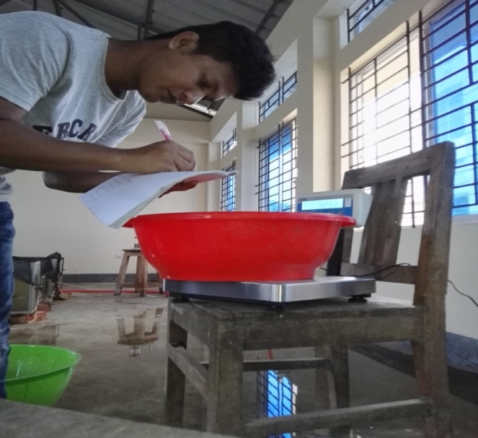

Plate 2. Weighing of fish for stocking

3.6. Cleaning procedure
The left over feed particles, faeces and debris were removed by siphoning method regularly. At the time of sampling the aquarium walls and bottoms were rubbed gently with sponge to remove the adhesive contents. After that treated with aquarium salt and thoroughly washed. Then the whole recirculatory system was filled with new water.
3.7. Feed formulation and preparation
3.7.1. Selection of ingredients and diet formulation
Fish meal, soybean meal, mustard oil cake, rice bran, corn meal, fish oil, wheat flour, vitamin and mineral premix were used for the preparation of feed. The source of vitamin E was Esco Sel-E Plus from Escopharma. Composition of vitamin E source showed in Table 1. A feed containing around 35% protein were prepared keeping all the ingredients same except vitamin E. To do this, required amount of finely ground and sieved ingredients were weighed as per formulae with a digital precision electric balance and the required amount of vitamin E were added and mixed thoroughly. After mixing all the ingredients, adequate amount of water was added and converted into pellets by pelleting machine. Between preparing different doses feed the pellate machine and related equipments were washed throughly to avoid any cross contamination. Then the pellets were dried under sunlight and stored in the plastic bag in air tight condition and kept in refrigerator. After formulation of feed, proximate composition of the formulated feeds was analyzed according to standard procedures given by Association of Official Analytical Chemists (AOAC, 1980). Proximate composition of feed showed in Table 2.
Table 1. Composition in each 100 ml Esco Sel-E Plus
Ingredients | Ammount
Vitamin E | 2.5 gm
Biotin | 20 mg
Selenium | 10 mg

Table 2. Proximate composition of feed (% dry matter basis)
Treatment | Dry matter (%) | Lipid (%) | Protein (%) | Ash (%) | Crude fiber (%) | Moisture (%) | NFE* (%)
T₁ | 91.98 | 7.41 | 34.13 | 10.51 | 5.49 | 8.02 | 34.44
T₂ | 88.32 | 6.74 | 33.16 | 11.17 | 5.34 | 11.68 | 31.91
T₃ | 92.62 | 9.17 | 33.69 | 10.64 | 5.26 | 7.38 | 33.86
T₄ | 90.50 | 9.13 | 33.25 | 11.22 | 5.32 | 9.50 | 31.58
T₅ | 90.85 | 8.72 | 33.00 | 10.99 | 5.08 | 9.15 | 33.06

*NFE=Nitrogen-free extract
3.7.2. Diet preparation
Feed was formulated by Pearson square method (Table 3). Dietary ingredients were grounded to a small particle size in a hammer mill pastel and passed through a small meshed sieve. Then all the dry ingredients individually weighted according to formulae. After that dry ingredients were thoroughly mixed for 10 minutes. The lipid sources were made premix first. Then the lipid mixture was added to the dry ingredients and mixed for another 10 minutes. The required amount of water (35-40% of the dry ingredients), was added to the premixed ingredients and mixed for another 10 minutes. The mixture was then passed through a feed pellet machine with an appropriate diameter (1.8 mm) to prepare pellets. The pellets were dried under sunlight till the diet moisture content is reduced to about 10%. After that prepared diet was stored in the plastic bag in air tight condition and kept in refrigerator for further use.

Table 3. Formulation of experimental diets (Pearson square method)
Ingredients | Inclusion level (%) | Protein content in ingredients (%) | Protein contents in diets CP (%)
Fish meal | 35 | 60 | 21
MOC | 23 | 28 | 6.44
Rice Bran | 9 | 12 | 1.08
Wheat flour | 9 | 14 | 1.26
Soybean meal | 10 | 45 | 4.5
Corn meal | 9 | 8 | .72
Fish oil | 3 | - | -
Vitamin premix | 1 | - | -
Binder | 1 | - | -
Vit. E | *** | - | -
Total | 100.00 |  | 35.00
***Vitamin E inclusion level= (0, 50, 100, 200, 400) mg/kg feed

3.8. Feeding rate and frequency
Fishes were fed two times in a day at around 9.00 a.m and 5.00 p.m. Feeding rate was 4% of total fish body weight basis. Total feed on 4% body weight basis were devided into two parts and fed the fish at morning and at afternoon. Feeds were applied dierectly to the experimental aquaria.
3.9. Sampling of the experimental fish
Sampling was done at every 15 days interval. During first sampling bulk weight was taken from all treatments. Then 6 fishes from each treatment (two fishes from each reaplicates) were taken randomly. Prior to weighing, fish were caught with a fine mesh scoop net and excess water was then removed from fish body by gently blotting on a soft tissue paper. Weighing was done by using digital precision electric balance. Then standard length and total length were measured by measuring scale.
3.10. Estimation of gonadosomatic index of broodfish
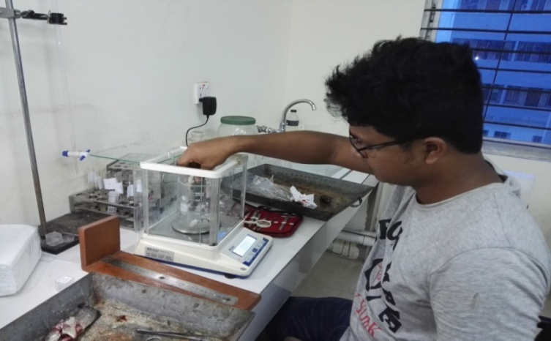
For the estimation of gonadosomatic index two fishes from each replication were taken. The total length and weight of each fish was recorded separately. Then fishes were killed by pithing on head by taking approval from Ethics committee of Chittagong Veterinary and Animal Sciences University. After that fishes were disected and carefully removed the upper fat layer in side the body cavity by forcep and brush. Then carefully gonad was taken out from the fish. Then any fat layer and blood vessel attached to the gonad were taken out by using forcep. Weighing of gonad was done by using digital precision electric balance. After that gonad was preserved in a plastic airtight vial with 10% formalin. During sampling fish were handled very carefully. The aquaria were washed and cleaned during sampling time. Any mortality of fish during the study period was recorded.

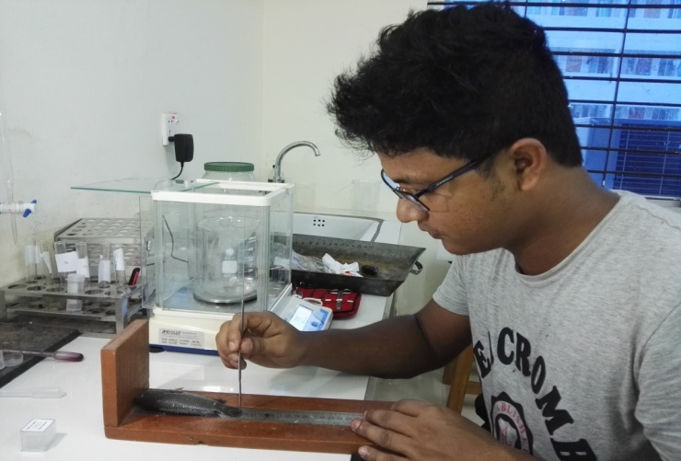
Plate 3. Weighing of fish before dissection

Plate 4. Measurement of total length and standard length of A. testudineus
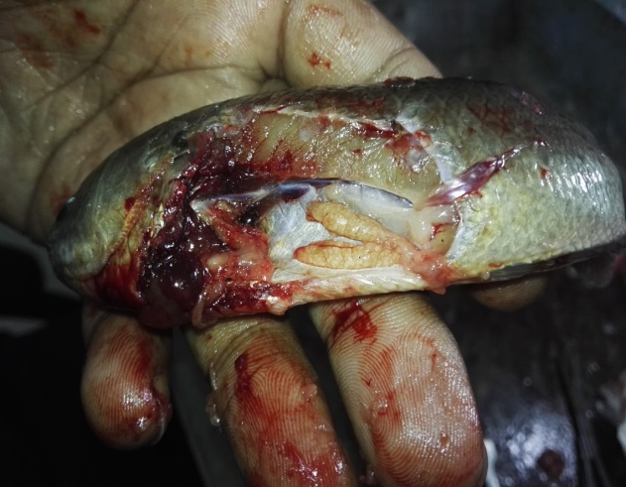

Premature stage Mature stage
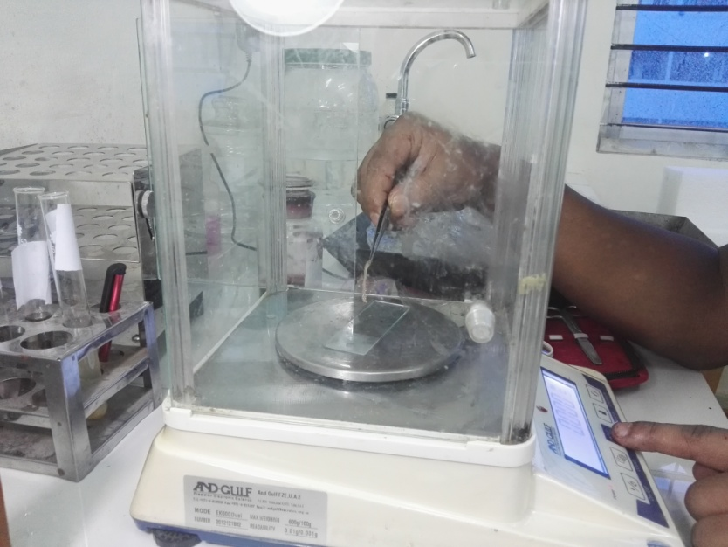
Plate 5. Dissected female A. testudineus with ovary

Plate 6. Weighing ovary of the A. testudineus
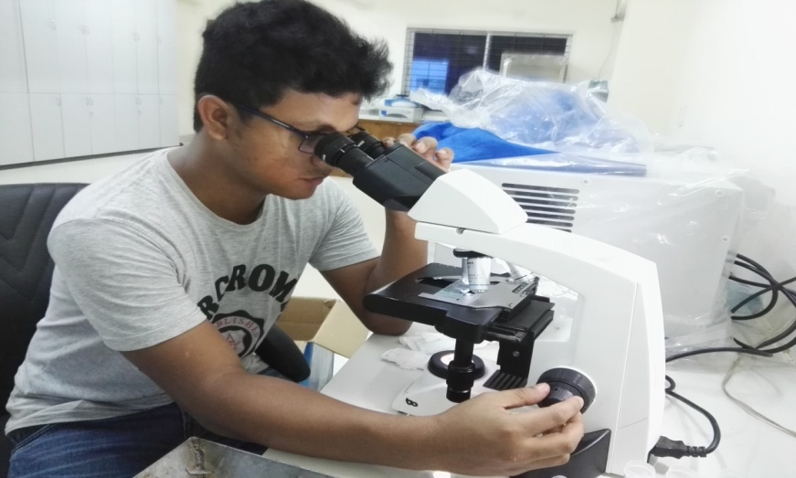

Plate 7. Microscopic observation of gonad
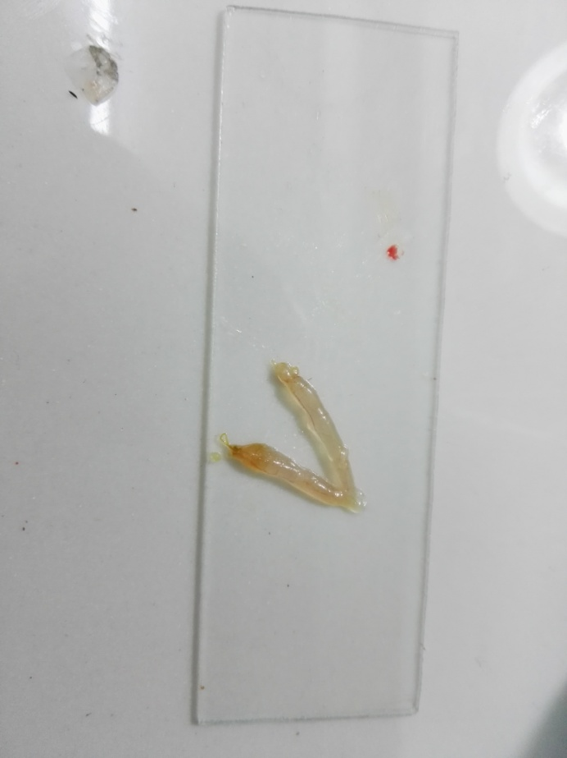

Plate 8. Dissected ovary of the A. testudineus
3.11. Water quality parameters
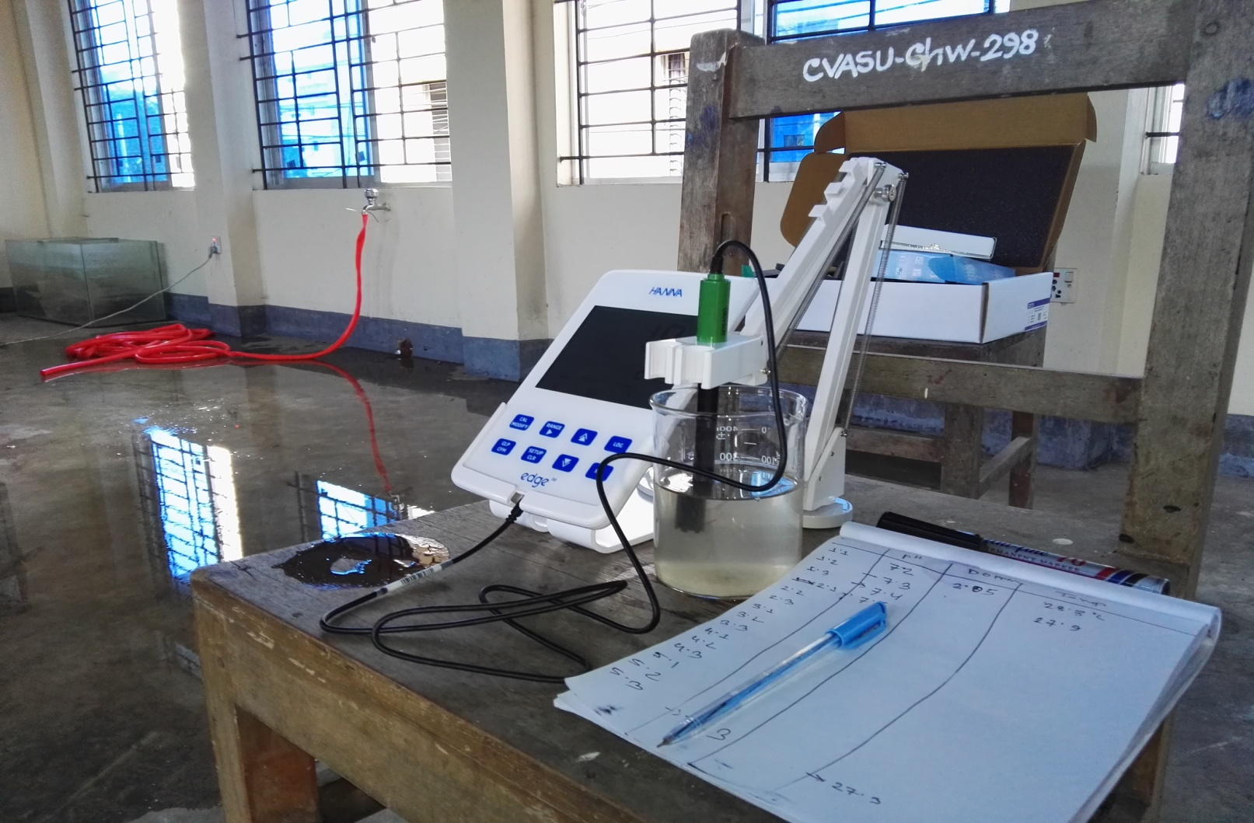
The water quality parameters as water temperature, dissolved oxygen (DO), and pH were monitored weekly throughout the experimental period. Water temperature of the aquaria was measured with the help of an oxygen meter (Waterproof Tester, model: 7031). Dissolved oxygen of the water was measured by using an oxygen meter (Waterproof Tester, model: 7031). Electronic pH meter (ORP, model 6011) was used to measure the pH of water.

Plate 9. Measurement of water quality parameters
3.12. Parameters studied for growth and ovarian development of fish
In order to study the effect of vitamin E level on the growth and ovarian development following parameters were studied.

- Length gain (cm) = Mean final length- Mean initial length

- Weight gain (g) = Mean final weight- Mean initial weight

- Specific growth rate, SGR (%)= $\frac{\log_{e}W_{2}-\log_{e}W_{1}}{T_{2}-T_{1}}×100$ (after Brown, 1957)
Where, W₁= The initial live body weight (g) at time T₁ (day)
W₂= The final live body weight (g) at time T₂ (day)

- Gonadosomatic index (GSI), GSI (%) = $\frac{Gonad weigt(g)}{Body weight(g)}×100$

3.13. Statistical analysis
All statistical analyses were performed with the aid of the computer software SPSS programme. The gain in weight, specific growth rate, gonadsomatic index were all tested using one-way analysis of variance (ANOVA). For further ensure the significant difference also data were analyzed by t-test. The level of significance was set when the P value is ≤ 0.05.
RESULTS
The results that had been found from the experiment on growth and gonadal development of A. testudineus by providing different dietary levels of vitamin E have been described providing sufficient data, figure, and information. The results have been described under different headlines like; growth performance, gonadosomatic index, water quality perspective.
4.1 Effect of vitamin E on growth and gonadal development
4.1.1 Effect on growth performance
The growth of A. testudineus fed with different dietary levels of vitamin E with feed in terms of weight gain during the experimental period is presented in Figure 1. The average initial weights in five treatments were 34.51±0.87 g, 34.45±1.22 g, 34.25±0.75 g, 34.48±0.32 g, and 33.76±0.41 g in T₁, T₂, T₃, T₄ and T₅, respectively (Appendix-I). At the end of the three months experimental period, final weight of the fishes of five treatments were 41.37±2.19 g, 43.57±0.99 g, 41.42±0.79 g, 43.04±1.56 g, and 42.93±0.87 g in treatments T₁, T₂, T₃, T₄ and T₅, respectively. In case of weight gain higher result was found in T₂ (9.12±0.23 g) followed by T₁, T₃, T₄ and T₅. Periodical weight gain of A. testudineus reared under different dietary levels of vitamin E showed that T₂ (50 mg vit. E kg⁻¹ feed) had homogenous and comparatively higher growth performance than other treatments (Figure 2.). Statistical analysis by ANOVA showed that there was no significant difference (P> 0.05) among the weight gain of T₁, T₂, T₃, T₄ and T₅ at the end of three months experimental period.
Results on the specific growth rate (SGR percent/day) of A. testudineus broodfish fed on feeds containing different levels of vitamin E has been shown in Figure 3. Result of specific growth rate was similar to that of weight gain. Statistical analysis by ANOVA shows that there was no significant difference (P> 0.05) between the different treatments on SGR (%).

Figure 1. Weight gain of A. testudineus reared under different dietary levels of vitamin E. (Vertical bars= ±S.D.)
E₀ E₅₀ E₁₀₀ E₂₀₀ E₄₀₀

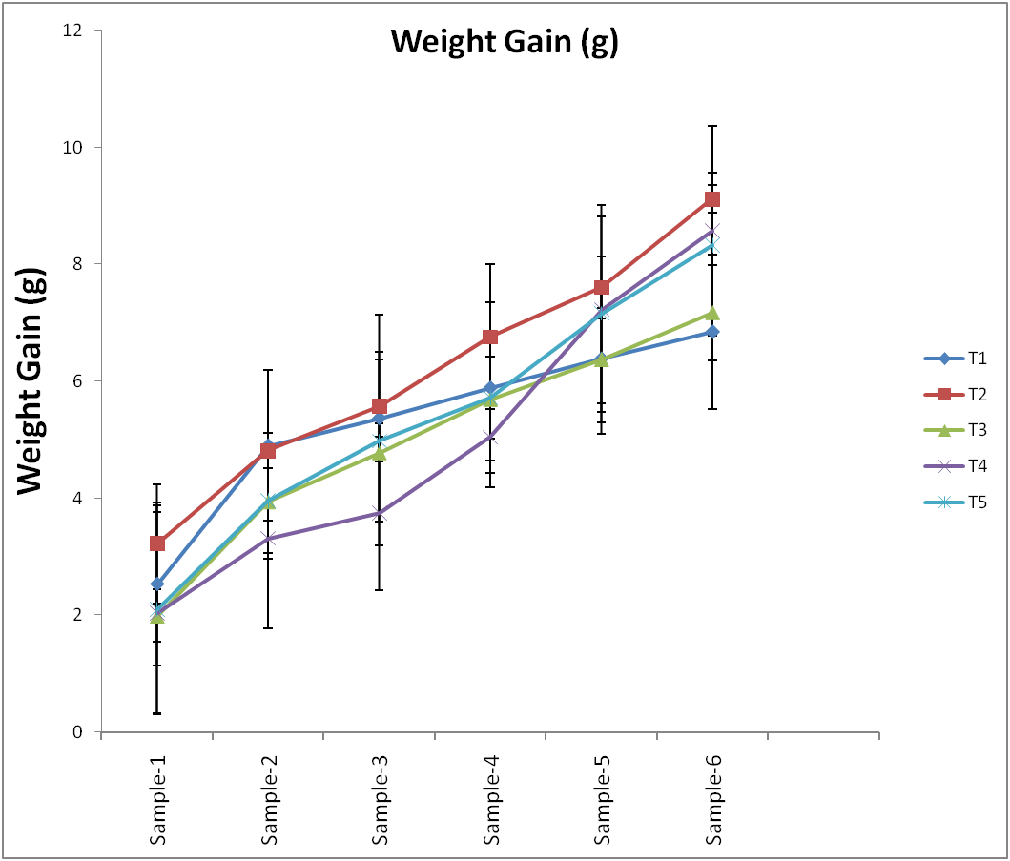
Weight gain (g)

Weight Gain (g)
E₀
E₅₀
E₁₀₀
E₂₀₀
E₄₀₀

Day-90

Day-75

Day-60

Day-45

Day-30

Day-15

Time interval
Figure 2. Periodical weight gain of A. testudineus reared under different dietary levels of vitamin E (Vertical bars= ±S.D.)

E₀ E₅₀ E₁₀₀ E₂₀₀ E₄₀₀
Specific growth rate of A. testudineus reared under different dietary levels of vitamin E. Vertical bars=±S.D.
Figure 3.

4.1.2. Effect on Gonadosomatic index
Clear indication of gonadal development of experimental fish was found from Gonadosomatic index. It is a tool for measuring the sexual maturity of fish in correlation to ovary development and testes development. At the end of this experiment the percent of gonadosomatic index (%) were 0.392±0.04, 0.568±0.18, 0.696±0.44, 0.356±0.07, and 0.311±0.03 in T₁, T₂, T₃, T₄, and T₅, respectively. Data on gonadosomatic index is presented in Figure 4. In this case highest gonadosomatic index (%) was found 0.696±0.44 in T₃ (100 mg vit. E/kg feed) followed by T₁, T₂, T₄ and T₅ (Appendix-III). The ANOVA test showed that there was no significant (P> 0.05) difference among treatments regarding gonadosomatic index.
E₀ E₅₀ E₁₀₀ E₂₀₀ E₄₀₀
Figure 4. Comparison of gonadosomatic indices of A. testudineus reared under different dietary levels of vitamin E. Vertical bar= ±S.D.
4.2. Water quality perspective
A number of water quality parameters were recorded for the experimental purposes. Mainly a physical and two chemical parameters were examined during the research period. Data on physico-chemical parameters of water i.e. temperature, pH and dissolved oxygen during the experimental period are presented in Table 4. Range of temperature, pH and dissolved oxygen in aquarium under different treatments were 27.7 to 28.2°C; 6.8 to 7.6 ppt; and 5.3 to 6.2 ppm, respectively.

Sampling No. | Parameters | T₁ | T₂ | T₃ | T₄ | T₅
1st | Temperature (°C) | 27.7 | 27.7 | 27.9 | 27.7 | 27.8
 | pH | 7.1 | 7.00 | 7.3 | 7.2 | 6.9
 | Dissolved oxygen (DO) (mg/l) | 5.9 | 6.0 | 5.7 | 6.1 | 6.2
2nd | Temperature (°C) | 28.0 | 28.0 | 28.1 | 28.0 | 28.2
 | pH | 7.1 | 7.1 | 7.0 | 7.0 | 7.0
 | Dissolved oxygen (DO) (mg/l) | 5.7 | 5.5 | 5.6 | 5.5 | 5.3
3rd | Temperature (°C) | 27.9 | 28.0 | 28.0 | 28.1 | 28.0
 | pH | 6.8 | 6.9 | 7.0 | 7.0 | 7.1
 | Dissolved oxygen (DO) (mg/l) | 6.0 | 5.9 | 6.1 | 5.8 | 5.8
4th | Temperature (°C) | 28.0 | 27.9 | 28.1 | 28.0 | 28.0
 | pH | 7.0 | 7.1 | 6.9 | 7.2 | 7.3
 | Dissolved oxygen (DO) (mg/l) | 5.6 | 5.8 | 5.4 | 5.7 | 5.9
5th | Temperature (°C) | 27.7 | 28.1 | 28.0 | 27.8 | 27.6
 | pH | 7.2 | 7.2 | 7.1 | 7.2 | 7.0
 | Dissolved oxygen (DO) (mg/l) | 5.7 | 5.5 | 5.6 | 5.7 | 5.6
6th | Temperature (°C) | 27.9 | 27.3 | 27.7 | 27.4 | 27.7
 | pH | 7.2 | 7.3 | 7.5 | 7.6 | 7.6
 | Dissolved oxygen (DO) (mg/l) | 5.6 | 5.7 | 5.9 | 5.6 | 5.9
Table 4. Physico-chemical parameters of water during experimental period

DISCUSSION
Water temperature, dissolved oxygen and pH during the brood rearing period in the aquarium were found to be in the desirable range according to Boyd (1979), Jhingran and Pullin (1985) and Rahman et al. (1982). There was no indication of the adverse effect of water quality parameter on the existence and growth of A. testudineus.
The main purpose of the present research was to find out if there is any positive impact of vitamin E on the growth and gonadal development of the female A. testudineus. The results presented for A. testudineus, indicate that there exists a positive correlation between dietary vitamin E level and gonadal development.
The results presented here for growth in terms of weight gain of broodfish indicate that there was no significant difference among the fishes treated with 0, 50, 100, 200 and 400 mg vitamin E kg⁻¹ feed. Similar results were also observed by Jarboe and Robinette (1989) who reported no significant differences in survival conversion or weight gain among the fish fed with three different dietary levels of vitamin E viz. 72 mg, l44 mg and 36 or 66 mg vitamin E/kg feed.
There were positive impact by the implementation of different dietary doses of vitamin E on gonadal development of A. testudineus on 3 months experimental period. The higher gonadosomatic index was obtained in treatment T₃ containing 100 mg vitamin E/kg feed. Other doses also showed positive result on the gonadal development of A. testudineus. Mollah et al. (2003) observed highest ganadosomatic index and fecundity of the larvae of Heteropneustes fossilis fed with 100 mg vitamin E/kg of feed. Roy and Mollah (2009) observed heigher ovarian development and effective breeding performance in Clarias batrachus fed with 50 mg vitamin E/Kg of feed.
Gupta et al. (1987) observed higher gonadosomatic index, bigger ova and complete spawning in three major carps (Labeo rohita, Catla catla and Cyprinus carpio) by feeding feed containg vitamin E in their diet. Similarly Sanchai-Sutjaritvongsanon (1987) reported that a mixture of meal, 30% soybean, 20% corn meal, 15% rice bran and 5% fish mg/kg BHT plus 100 mg vitamin E/kg feed was suitable for stimulating gonad development and spawning in goldfish (Carassius auratus). Raja James et al. (2008) observed that 300 mg vitamin E/ kg diet is the optimum level for improving reproduction and immune response in C. auratus. Therefore it seems that vitamin E requirement is species specific so for as its requirement is concerned in gonadal development and breeding performance of fish.
Stocking density is recognized as an important factor which directly affects the growth, survival and production of fish (Backiel and Le Cren, 1978). Generally higher stocking density results in the reduction of growth and survival and increases food conversion ratio (FCR), together with severe competition for food and space (Powel, 1972). During the experimental period 20 fish was stocked in 75 liter water tank to ensure the better environment.
Feeds were applied two times daily and feeding rate was 3% of total body weight. Bomfim et al. (2014) observed higher growth rate on Rachycentron canadum by feeding two times daily. Başçınar et al.(2007) observed that Salmo trutta labrax fed once a day grow lower than those fed two or three times a day. Mollah and Nurullah (1988) after detailed study conclude that feeding frequency of two times per day was suitable for rearing of C. batrachus. Thi et al.(2017) observed that the suitable feeding levels were 3 % with feeding frequency 2 times daily for larger size of A. testudineus.
In the present study, effect of vitamin E was observed on the growth and ovarian development of A. testudineus. There was no significant difference between the different treatment in case of growth and gonadosomatic index of the A. testudineus. But there was a positive effect of vitamin E was observed on gonadal development of A. testudineus. The best result obtained in treatment T₃ containing 100 mg vitamin E/kg feed on gonadal development. Other doses also showed positive result on the gonadal development of A. testudineus.
Therefore considering the result mentioned above it is evident that vitamin E had a positive impact on the gonadal development of A. testudineus and vitamin E content of 100 mg/kg of feed was the best to exert such effect. In conclusion the present study support the use of vitamin E in the diet for the improvement of reproductive performance of A. testudineus.
SUMMARY AND CONCLUSION
The experiment was conducted from 22 August to 22 November, 2017 in fish aquarium with recirculation facilities in the Wet Laboratory of the Faculty of Fisheries, Chittagong Veterinary and Animal Sciences University. The objectives of the experiment were to determine the effect of different level of dietary supplementation of vitamin E on the growth performance and gonadal development of A. testudineus fish for a period of 3 months.
Three hundred A. testudineus fish were stocked in 15 aquaria (60 x 30 x 45 cm each) divided into five treatments each having three replicates. Each of the aquaria was stocked with 20 fishes. The fish were fed with feed having different levels of vitamin E viz. 0 mg (as control), 50 mg, 100 mg, 200 mg, and 400 mg vitamin E/kg diet. The average initial weights in five treatments were 34.51±0.87 g, 34.45±1.22 g, 34.25±0.75 g, 34.48±0.32 g, and 33.76±0.41 g in T₁, T₂, T₃, T₄, and T₅, respectively (Appendix-I). At the end of the 3 months experimental period, final weight of the fishes of five treatments were 41.37±2.19 g, 43.57±0.99 g, 41.42±0.79 g, 43.04±1.56 g, and 42.93±0.87 g in treatments T₁, T₂, T₃, T₄ and T₅, respectively. During the experimental period, different growth rates were observed under different treatment. Though there was no significant difference in terms of weight gain between the different treatments but higher weight gain was observed 9.12±0.23 g in T₂ (50 mg vitamin E/kg feed), followed by T₁, T₃, T₄ and T₅ (Appendix-I). Results on the specific growth rate (% day) of A. testudineus broodfish fed on feeds containing different levels of vitamin E was similar to that of weight gain.
At the end of this experiment the percent of gonadosomatic index (%) were 0.392±0.04, 0.568±0.18, 0.696±0.44, 0.356±0.07, and 0.311±0.03 in T₁, T₂, T₃, T₄ and T₅, respectively. In this case highest gonadosomatic index (%) was found 0.696±0.44 in T₃ (100 mg vit. E/ kg feed) followed by T₁, T₂, T₄ and T₅ (Appendix-III). The ANOVA test showed that there was no significant (P> 0.05) difference among treatments regarding gonadosomatic index.
The overall result indicates that the use of 50 mg vitamin E/kg diet is the optimum dose for better gonadal development of A. testudineus fish.
Conclusion
Demand of food is increasing day by day with the increase of population throughout the world. But there is a limitation of resources. Only a proper and scientific methods can untilize this limited resources to met the increasing demand. Similarly the want of fish is increasing due to its nutritional value. But destruction of natural breeding, rearing and feeding ground of fish the natural production of fish is decreasing day by day. Commercial culture practice depends on availability of healthy broodstock and quality seeds. A considerable number of studies have been conducted to develop suitable induced breeding and larval rearing techniques for A. testudineus so that its culture practice can be popularized. To produce healthy and quality seeds it is necessary to increase gonadosomatic indices which ensure higher number and quality seeds. So it was felt necessary to investigate how the status of seeds production for this species can be improved by improving gonadal development and as such the present attempt was to find out the effect of dietary vitamin E on the growth and gonadal development of A. testudineus. At the end of this research it was found that vitamin E has a positive impact on gonadal development of A. testudineus and further research is needed to see the effects of vitamin E supplementation on breeding performance and quality of seeds. This preliminary success obtained through this research can serve as an important baseline for future research on this topic.
REFERENCES
Ahmed, T., Hossain, M. and Sanin, K.I., 2012. Global burden of maternal and child undernutrition and micronutrient deficiencies. Annals of Nutrition and Metabolism, 61(Suppl. 1), pp. 8-17.
Backiel, T. and E.D. Le cren. 1978. Some density relationship for population parameters. In: S. D. Gerking (ed), The biological basis of freshwater fish production. Black well Scientific Publications: Oxford, pp. 27-36.
Başçınar, N., Çakmak, E., Çavdar, Y. and Aksungur, N., 2007. The effect of feeding frequency on growth performance and feed conversion rate of black sea trout (Salmo truttalabrax Pallas, 1811). Turkish Journal of Fisheries and Aquatic Sciences, 7(1).
Bilguven, M., 2014.Diets of Rainbow Trout (Oncorhyinchus mykiss, W.) on the Journal of Animal and Veterinary Advances, 13(19), pp. 1120-1125.
Blazer, V.S., 1992. Nutrition and disease resistance in fish. Annual Review of Fish Diseases, 2, pp. 309-323.
Bjørneboe, A., Bjørneboe, G.E.A. and Drevon, C.A., 1990. Absorption, transport and distribution of vitamin E. the Journal of Nutrition, 120(3), pp. 233-242.
Boyd, C.E. 1979. Water quality management for pond fish culture. Elsevier Science Publishing Company. Amsterdam-Oxford, New York, pp. 318.
Bromage, S., Ahmed, T. and Fawzi, W.W., 2016. Calcium Deficiency in Bangladesh: Burden and Proposed Solutions for the First 1000 Days. Food and Nutrition Bulletin, 37(4), pp. 475-493.
Cho, C.Y., Cowey, C.B. and Watanabe, T., 1985. Finfish nutrition in Asia: methodological approaches to research and development. IDRC, Ottawa, ON, CA.
Collins, R.A. 1973. Case culture of catfish in reservoirs. Resource Publication on U.S. Department of Interior, Bureau of Sport Fish & Wildlife., 102: 115-123.
Costa‐Bomfim, C.N., Pessoa, W.V.N., Oliveira, R.L.M., Farias, J.L., Domingues, E.C., Hamilton, S. and Cavalli, R.O., 2014. The effect of feeding frequency on growth performance of juvenile cobia, Rachycentro ncanadum (Linnaeus, 1766). Journal of Applied Ichthyology, 30(1), pp. 135-139.
DoF (Department of Fisheries), 2015. Fisheries Statistical Year Book of Bangladesh 2013–2014. Fisheries Resource Survey System, Department of Fisheries, Ministry of Fisheries and Livestock, Government of the People’s Republic of Bangladesh.
DoF, 2016. National fish week, compendium (In Bengali). Dhaka: Department of Fisheries, Ministry of Fisheries and Livestock, Government of Bangladesh.
Eschemeyer, W.N., 1998. Catalog of Fishes, California Academy of Sciences, San Francisco.
Felts, R., Rajts, A. and Akteruzzaman, M., 1996. Small Indigenous Fish Species Culture in Bangladesh (Technical Report). IFADEP Sub-Project-2, Department of Fisheries, Bangladesh, pp. 52.
FRSS, 2016. Fisheries Statistical Report of Bangladesh.Fisheries Resources Survey System (FRSS), Department of Fisheries, Bangladesh.Volume 32, pp. 57.
FRSS, 2017. Yearbook of Fisheries Statistics of Bangladesh. Fisheries Resources Survey System (FRSS), Department of Fisheries, Bangladesh.Volume 33, pp. 124.
Fry, F. E., 1971. The effect of environmental factors on the physiology of fish. In: Fish Physiology. Hoar, W.S. & Randall, D. J. (eds.). Environmental reaction and behavior. Academic Press, New York. pp. 1-98.
Galaz, G.B., Kim, S.S. and Lee, K.J., 2010. Effects of different dietary vitamin E levels on growth performance, non-specific immune responses, and disease resistance against Vibrio anguillarum in parrot fish (Oplegnathus fasciatus). Asian-Australasian Journal of Animal Sciences, 23(7), pp. 916-923.
Gammanpila, M., Yakupitiyage, A. and Bart, A.N., 2007. Evaluation of the effects of dietary vitamin C, E and Zinc supplementation on reproductive performance of Nile tilapia (Oreochromis niloticus). Sri Lanka Journal of Aquatic Sciences, 12, pp. 39-60.
Gaylord, G., 1998. Re‐evaluation of vitamin E supplementation of practical diets for channel catfish, Ictalurus punctatus, production. Aquaculture Nutrition, 4(2), pp. 109-114.
Ghose, B., 2014. Fisheries and aquaculture in Bangladesh: Challenges and opportunities. Annals of Aquaculture and Research, 1 (1) (2014), pp. 1-5
Gupta, S.D., Khan, H.A., and Bhowmick, R.M., 1987. Observations on the effect of vitamin E and growth hormone on the gonadal maturity of carps.In. Fish. Soc. India, 19 (2): 26-31.
Halver, J.E., 2002. The vitamins. Fish nutrition, 3, pp. 61-141.
Hamre, K., 2011. Metabolism, interactions, requirements and functions of vitamin E in fish. Aquaculture nutrition, 17(1), pp. 98-115.
Hassaan, M.S., Goda, A.M.A., Mahmoud, S.A. and Tayel, S.I., 2014. Protective effect of dietary vitamin E against fungicide copperoxychloride stress on Nile tilapia, Oreochromis niloticus (L.), fingerlings. International Aquatic Research, 6(1), pp. 1.
He, H. and Lawrence, A.L., 1993. Vitamin E requirement of Penaeus vannamei. Aquaculture, 118(3-4), pp. 245-255.
Hidiroglou, N., Cave, N., Atwal, A.S., Farnworth, E.R. and McDowell, L.R., 1992. Comparative vitamin E requirements and metabolism in livestock. In Annales de RecherchesVeterinaires (Vol. 23, No. 4, pp. 337-359).
Hien, T.T.T., Thien, B.T., Phuong, N.T. and Wilder, M.N., 2004. Effects of feeding Rates and Frequencies on growth and Survival rates of Climbing Perch (Anabas testudineus) Fingerlings. Japan International Research Centre for Agriculture Sciences Tsukuba, Ibaraki, pp. 30-46.
Hossain, M.A. and Afroze, S., 1991. Small fishes as a resource in rural Bangladesh. Fishbyte, 9(2), pp. 16-18.
Hossain, M.A., Almatar, S.M. and Yaseen, S.B., 2016. Effects of varying levels of dietary vitamin E (α‐tocopherol) on growth performance, proximate and fatty acid composition of juvenile silver pomfret (Pampus argenteus Euphrasen, 1788). Journal of applied ichthyology, 32(1), pp. 55-60.
Hussain, M.G., 2010. Freshwater fishes of Bangladesh: Fisheries, biodiversity and habitat. Aquatic Ecosystem Health & Management, 13(1), pp. 85-93.
Ispır, U., Yonar, M.E. and Oz, O.B., 2011. Effect of dietary vitamin E supplementation on the blood parameters of Nile tilapia (Oreochromis niloticus). Journal of Animal and Plant Sciences, 21, pp. 566-569.
James, R., Vasudhevan, I. and Sampath, K., 2008. Effect of dietary vitamin E on growth, fecundity, and leukocyte count in goldfish (Carassius auratus).
Jarboe, H. H and H. R. Robinette. 1989. Effect of selected vitamin E supplementations of channel catfish production feeds. The progressive Fish Culturist, 51:91-94.
Jhingran, V.G. and R. S. V. Pullin. 1985. A hatchery manual for the common Chinese and Indian major carps. ICLARM studies and reviewers, 11: 191.
Khara, H., Sayyadborani, M. and SayyadBorani, M., 2016. Effects of α-Tocopherol (vitamin E) and Ascorbic Acid (Vitamin C) and Their Combination on Growth, Survival and Some Haematological and Immunological Parameters of Caspian Brown Trout, Salmo Trutta caspius juveniles. Turkish Journal of Fisheries and Aquatic Sciences, 16(2), pp. 385-393.
Linn, S.M., Ishikawa, M., Koshio, S. and Yokoyama, S., 2014.Effect of Dietary Vitamin E Supplementation on Growth Performance and Oxidative Condition of Red Sea Bream Pagrus major. Aquaculture Science, 62(4), pp. 329-339.
Lozano, A.R., Borges, P., Robaina, L., Betancor, M., Hernández-Cruz, C.M., García, J.R., Caballero, M.J., Vergara, J.M. and Izquierdo, M., 2017. Effect of different dietary vitamin E levels on growth, fish composition, fillet quality and liver histology of meagre (Argyrosomus regius). Aquaculture, 468, pp. 175-183.
Mehrad, B., Jafaryan, H. and Taati, M.M., 2012. Assessment of the effects of dietary vitamin E on growth performance and reproduction of zebrafish, Danio rerio (Pisces, Cyprinidae). Journal of Oceanography and Marine Science, 3(1), pp. 1-7.
Mollah, M.F. A. and M. Nurullah. 1988. Effects of feeding frequency on the growth and survival of catfish (Clarias batrachus L.) larvae. Bangladesh Journal of Fishery Research, 11 (2):9-14.
Mollah, M.F.A., M.R.I. Sarder and T. Begum. 2003. Effect of different dietary levels of vitamin E on the breeding performance of Heteropneustes fossilis (Bloch). Bangladesh Journal of Fishery Research, 7 (1): 11-20.
Mollah, M.F.A., Sarder, M.R.I. and Begum, T., 2003. Effects of different dietary levels of vitamin E on the breeding performance of Heteropneustes fossilis (Bloch). Bangladesh Journal of Fisheries Research, 7(1), pp. 11-20.
National Institute of Population Research and Training (NIPORT), Mitra Associates, and ICF International, 2013. Calverton, Maryland: Bangladesh Demographic and Health Survey.
NRC (National Research Council), 1983. Nutrients Requirements of Warm Water Fishes and Shell-fishes. National Academy Press, Washington, D.C., pp. 102.
NRC (National Research Council), 1993. Nutrient Requirements of Fish National Academy Press, Washington, D.C., USA. 196 pp.
Paul, B.N., Sarkar, S. and Mohanty, S.N., 2004.Dietary vitamin E requirement of mrigal,Cirrhinus mrigala fry. Aquaculture, 242: 529-536.
Powell, M.R. 1972. Cage and raceway culture of stripped bass in brackish water in Alabama. Proc. 26th Ann. Conf. South-east Assoc. Game Fish Comn., pp. 553.
Rahman, M.S., M.Y. Chowdhury, M.A. Haque and M.S. Haq. 1982. Limnological studies of four ponds. Bangladesh J. Fish., 2-5 (1-2): 25-35.
Reihl, R. and H.A. Baensch, 1991.Aquarium Atlas.Mergus.Melle, Germany, pp. 992.
Ribeiro Nascimento, T.S., Verardino de Stéfani, M., Braga Malheiros, E. and Dias Koberstein, T.C., 2014. High levels of dietary vitamin E improve the reproductive performance of female Oreochromis niloticus. Acta Scientiarum. Biological Sciences, 36(1).
Roy, A. and Mollah, M.F.A., 2009. Effects of different dietary levels of vitamin E on the ovarian development and breeding performances of Clarias batrachus (Linnaeus). Journal of the Bangladesh Agricultural University, 7(1), pp. 183-191.
Sanchai-Sutjaritvongsanon. 1987. Level of vitamin E content suitable for gonad developing and spawning of goldfish, Carassius auratus (Linn.). Abstracts of Master of Science Thesis. Fisheries science, 12: 2.
Seven, P.T., Yilmaz, S., Seven, I. and Kelestemur, G.T., 2012. The effects of propolis in animals exposed oxidative stress. In Oxidative Stress-Environmental Induction and Dietary Antioxidants. InTech.
Sharifzadeh, S.A., Khara, H. and Ghobadi, S., 2015.Effects of vitamins E and Riboflavin (B2) and combinations of them on the hematological parameters of common carp, Cyprinus carpio L., fingerlings. Archives of Polish Fisheries, 23(2), pp. 107-111.
Tatina, M., Bahmani, M., Soltani, M., Abtahi, B. and Gharibkhani, M., 2010.Effects of different levels of dietary vitamins C and E on some of hematological and biochemical parameters of sterlet (Acipenser ruthenus). Journal of Fisheries and Aquatic Science, 5(1), pp.1-11.
Thilsted, S.H., Roos, N. and Hassan, N., 1997. The role of small indigenous fish species in food and nutrition security in Bangladesh. Naga, The ICLARM Quarterly, 20(3-4), pp. 82-84.
Wahab, M.A., 2003. Small indigenous fish species of Bangladesh: potentials for culture and conservation. Small Indigenous Species of Fish in Bangladesh (ed. by MA Wahab, SH Thilsted & ME Hoq), pp. 1-12.
Wang, J., Xu, H., Zuo, R., Mai, K., Xu, W. and Ai, Q., 2016. Effects of oxidised dietary fish oil and high-dose vitamin E supplementation on growth performance, feed utilization and antioxidant defense enzyme activities of juvenile large yellow croaker (Larmichthys crocea). British Journal of Nutrition, 115(9), pp. 1531-1538.
Watanabe, T., Takashima, F., Ogino, C. and Hibiya, T., 1970. Requirements of young carp for tocopherol. Bull. Jpn. Soc. Sci. Fish., 36: 972- 976.
Weeks, J.P. and C.B. ogburn, 1973.Catfish Production Guide. Circ. E-18 Alabama Cooperative Extension Service, Auburn University, Auburn USA. pp. 35.
Xu, H., Huang, L., Liang, M., Zheng, K. and Wang, X., 2015.Effect of dietary vitamin E on the sperm quality of turbot (Scophthalmus maximus. Journal of Ocean University of China, 14(4), pp. 695-702.

APPENDICES
Appendix I. Growth performance of A. testudineus under different doses vitamin E
Treatment |  | Initial sampling | 1st sampling |  | 2nd sampling |  | 3rd sampling |  | 4th sampling |  | 5th sampling |  | 6th sampling
 |  | Weight (g) | Weight (g) | Weight gain | Weight (g) | Weight gain | Weight (g) | Weight gain | Weight (g) | Weight gain | Weight (g) | Weight gain | Weight (g) | Weight gain
T₁ | R₁ | 34.60 | 37.21 | 2.61 | 39.63 | 5.03 | 39.82 | 5.22 | 40.30 | 5.7 | 40.77 | 6.17 | 41.33 | 6.73
 | R₂ | 33.60 | 34.70 | 1.1 | 37.15 | 3.55 | 37.28 | 3.68 | 38.14 | 4.54 | 38.82 | 5.22 | 39.20 | 5.6
 | R₃ | 35.34 | 39.21 | 3.87 | 41.45 | 6.11 | 42.55 | 7.21 | 42.78 | 7.44 | 43.11 | 7.77 | 43.57 | 8.23
Mean±SD |  | 34.51±0.87 | 37.04±2.26 | 2.53±1.39 | 39.41±2.16 | 4.90±1.29 | 39.88±2.64 | 5.37±1.77 | 40.41±2.32 | 5.89±1.46 | 40.90±2.15 | 6.39±1.29 | 41.37±2.19 | 6.85±1.32
T₂ | R₁ | 34.37 | 36.63 | 2.26 | 38.90 | 4.53 | 39.20 | 4.83 | 39.71 | 5.34 | 41.37 | 7 | 43.53 | 9.16
 | R₂ | 33.27 | 37.56 | 4.29 | 38.39 | 5.12 | 38.52 | 5.25 | 40.94 | 7.67 | 41.17 | 7.9 | 42.60 | 9.33
 | R₃ | 35.70 | 38.80 | 3.1 | 40.48 | 4.78 | 42.33 | 6.63 | 42.96 | 7.26 | 43.63 | 7.93 | 44.57 | 8.87
Mean±SD |  | 34.45±1.22 | 37.66±1.09 | 3.22±1.02 | 39.26±1.09 | 4.81±0.30 | 40.02±2.03 | 5.57±0.94 | 41.20±1.64 | 6.76±1.24 | 42.06±1.37 | 7.61±0.53 | 43.57±0.99 | 9.12±0.23
T₃ | R₁ | 34.6 | 37.09 | 2.49 | 38.98 | 4.38 | 40.35 | 5.75 | 40.61 | 6.01 | 41.46 | 6.86 | 42.33 | 7.73
 | R₂ | 33.39 | 35.26 | 1.87 | 38.00 | 4.61 | 39.03 | 5.64 | 39.93 | 6.54 | 40.29 | 6.9 | 40.95 | 7.56
 | R₃ | 34.76 | 36.38 | 1.62 | 37.58 | 2.82 | 37.71 | 2.95 | 39.28 | 4.52 | 40.10 | 5.34 | 40.99 | 6.23
Mean±SD |  | 34.25±0.75 | 36.24±0.92 | 1.99±0.45 | 38.19±0.72 | 3.94±0.97 | 39.03±1.32 | 4.78±1.59 | 39.94±0.67 | 5.69±1.05 | 40.62±0.74 | 6.37±0.89 | 41.42±0.79 | 7.17±0.82
T₄ | R₁ | 34.68 | 36.26 | 1.58 | 37.48 | 2.8 | 38.16 | 3.48 | 40.02 | 5.34 | 40.83 | 6.15 | 41.27 | 6.59
 | R₂ | 34.11 | 38.05 | 3.94 | 39.14 | 5.03 | 39.27 | 5.16 | 39.82 | 5.71 | 43.16 | 9.05 | 44.19 | 10.08
 | R₃ | 34.65 | 35.23 | 0.58 | 36.75 | 2.1 | 37.23 | 2.58 | 38.73 | 4.08 | 41.11 | 6.46 | 43.70 | 9.05
Mean±SD |  | 34.48±0.32 | 36.51±1.43 | 2.03±1.73 | 37.79±1.22 | 3.31±1.53 | 38.22±1.02 | 3.74±1.31 | 39.52±0.69 | 5.04±0.85 | 41.70±1.27 | 7.22±1.59 | 43.04±1.56 | 8.57±1.79
T₅ | R₁ | 33.95 | 34.23 | 0.28 | 37.03 | 3.08 | 38.80 | 4.85 | 39.2 | 5.25 | 39.76 | 5.81 | 41.27 | 7.32
 | R₂ | 34.05 | 36.25 | 2.2 | 37.99 | 3.94 | 38.81 | 4.76 | 39.43 | 5.38 | 40.45 | 6.4 | 42.00 | 7.95
 | R₃ | 33.29 | 37.11 | 3.82 | 38.14 | 4.85 | 38.61 | 5.32 | 39.82 | 6.53 | 42.57 | 9.28 | 43.00 | 9.71
Mean±SD |  | 33.76±0.41 | 35.86±1.48 | 2.10±1.77 | 37.72±0.60 | 3.96±0.89 | 38.74±0.11 | 4.98±0.30 | 39.48±0.31 | 5.72±0.70 | 40.93±1.46 | 7.16±1.86 | 42.93±0.87 | 8.33±1.24

Appendix II. Specific growth rate of A. testudineus under different treatments

Treatment | Replication | Initial weight (g) | Final weight (g) | Specific growth rate (% day) | Average growth (% day) ±SD
T₁ | R₁ | 34.60 | 41.33 | 0.19 | 0.20±0.03
 | R₂ | 33.60 | 39.20 | 0.17
 | R₃ | 35.34 | 43.57 | 0.23
T₂ | R₁ | 34.37 | 43.53 | 0.25 | 0.25±0.01
 | R₂ | 33.27 | 42.60 | 0.27
 | R₃ | 35.70 | 44.57 | 0.24
T₃ | R₁ | 34.60 | 42.33 | 0.22 | 0.20±0.02
 | R₂ | 33.39 | 40.95 | 0.22
 | R₃ | 34.76 | 40.99 | 0.18
T₄ | R₁ | 34.68 | 41.27 | 0.19 | 0.24±0.05
 | R₂ | 34.11 | 44.19 | 0.28
 | R₃ | 34.65 | 43.70 | 0.25
T₅ | R₁ | 33.95 | 41.27 | 0.21 | 0.24±0.03
 | R₂ | 34.05 | 42.00 | 0.23
 | R₃ | 33.29 | 43.00 | 0.28

Appendix III. Gonadosomatic index (GSI) of A. testudineus under different
treatments

Treatment |  | Total length of fish(g) | Total weight of fish(g) | Weight of ovary(g) | GSI (% day) | Average GSI(%) | Mean GSI±SD
T₁ | R₁ | 12.6 | 36.37 | 0.154 | 0.423 | 0.423 | 0.392±0.04
 |  | - | - | - | -
 | R₂ | - | - | - | - | 0.344
 |  | 13.00 | 38.64 | 0.133 | 0.344
 | R₃ | 12.00 | - | - | - | 0.410
 |  | 11.70 | 30.50 | 0.125 | 0.410
T₂ | R₁ | - | - | - | - | 0.434 | 0.568±0.18
 |  | 12.70 | 39.18 | 0.170 | 0.434
 | R₂ | 12.90 | 44.68 | 0.220 | 0.492 | 0.492
 |  | - | - | - | -
 | R₃ | 12.40 | 30.19 | 0.363 | 1.202 | 0.778
 |  | 12.00 | 34.01 | 0.120 | 0.353
T₃ | R₁ | 13.00 | 42.98 | 0.173 | 0.403 | 0.353 | 0.696±0.44
 |  | 13.40 | 42.22 | 0.128 | 0.303
 | R₂ | 13.50 | 48.5 | 0.270 | 0.557 | 1.191
 |  | 12.10 | 34.02 | 0.621 | 1.825
 | R₃ | 11.50 | 33.24 | 0.160 | 0.481 | 0.543
 |  | 11.90 | 32.46 | 0.196 | 0.604
T₄ | R₁ | - | - | - | - | 0.288 | 0.356±0.07
 |  | 12.60 | 38.86 | 0.112 | 0.288
 | R₂ | - | - | - | - | 0.345
 |  | 11.70 | 40.63 | 0.140 | 0.345
 | R₃ | 13.10 | 42.41 | 0.185 | 0.436 | 0.436
 |  | - | - | - | -
T₅ | R₁ | - | - | - | - | 0.342 | 0.311±0.03
 |  | 13.50 | 53.50 | 0.183 | 0.342
 | R₂ | 13.60 | 49.52 | 0.149 | 0.301 | 0.301
 |  | - | - | - | -
 | R₃ | 13.30 | 48.64 | 0.141 | 0.290 | 0.290
 |  | - | - | - | -

BRIEF BIOGRAPHY OF THE AUTHOR

This is Md. Mehedee Hasan; son of Md. Mofazzal Hossen and MST. Sabina Yeasmin from Dupchanchia Upazila under Bogra district of Bangladesh. He passed the Secondary School Certificate Examination in 2010 from Nasaratpur Multi-Lateral High School, Bogra followed by Higher Secondary Certificate Examination in 2012 from Govt. Shah Sultan College, Bogra. He obtained his B.Sc in Fisheries (Hons.) Degree in 2016 from Faculty of Fisheries, Chittagong Veterinary and Animal Sciences University (CVASU), Bangladesh. Now, he is a candidate for the degree of MS in Fish Biology and Biotechnology under the Department of Fish Biology and Biotechnology, Faculty of Fisheries, CVASU.

