INTRODUCTION
Bangladesh is densely populated country where majority of people depends largely on fishes because of employment, development of national and global economy and finally meet the demand of nutritional requirement. Fish regarded as highly nutritious food source due to presence of protein and many essential nutrients in Bangladesh (Thilsted et al 1997). In Bangladesh, fish are considered as second highest share of food expenditures after rice.
The people of Bangladesh are commonly recognized in world as “Macche-Bhate Bangali”. The staple food of Bangladesh people are rice and fish (Ghose, 2014). Bangladesh is surrounded by wetland which makes most suitable regions for fisheries especially freshwater aquaculture due to its favorable climatic conditions and hydrology (Shamsuzzaman et al., 2017). Fisheries sector are divided into two broad categories such as inland fisheries and marine fisheries where inland fisheries has two sub categories named as inland capture fisheries and inland culture fisheries. The total annual fish production was estimated to be 4134434 MT in 2017, of which 2,333,352 MT (56.44%) were obtained from inland aquaculture, 1,163,606 MT (28.14%) from inland capture fisheries, and 637,476 MT (15.42%) from marine fisheries (DoF, 2017). Inland aquaculture has two familiar production systems in Bangladesh such as extensive and semi-intensive pond polyculture (Indian major carps and exotic carps) which contributes 80% of the total inland culture fisheries. Catfish (Pangasianodon hypophthalmus), tilapia, small indigenous fish species and rice-fish farming (ADB, 2005a) contributes remaining 20%. At present production of capture fisheries is decreasing drastically (Toufique; 1997) which create opportunity of natural source utilization means aquaculture expansion to meet the demand of nutritional requirement of Bangladesh people (Lewis & Gregory; 1991).
Tilapia (Oreochromis niloticus) farming can bring enormous potential in Bangladesh to meet the demand of nutrition. Tilapia has major specialties such as rapid growth rate, high market demand and increasing consumer acceptance making tilapia farming worldwide such as Asian countries including China, Indonesia, Philippines, Thailand and Vietnam (ADB, 2005b). With increasing acceptance and popularity among consumers, tilapia has become the world’s second most important cultured fish after carps and easily adapt in tropical and sub-tropical regions of the world (Shelton, 2002). It is regarded as the most significant fish species reducing the gap of increasing worldwide demand for protein sources from fish (Ng and Romano, 2013). In per 100g Tilapia contain protein (20.1 g ), phosphorus (170 mg), potassium(302 mg), selenium (41.8 mg), niacin ( 3.90 mg ), vitamin B-12 ( 1.58 mcg ), and is low in fat and saturated fat (0.77 g), omega-3 fatty acids, energies ( 96 kcal) and sodium ( 52 mg ) (Mjoun et al., 2010). In 2002, Tilapia standing on top 10 sea foods list for the first time in America’s, but it became the 5th favorite seafood after shrimp, tuna, salmon, and pollock in 2008 (NFI, 2010). Tilapia is an exotic species in Bangladesh and it is omnivore which feeds on both plankton and aquatic plants. Introduction of tilapia culture in Bangladesh has long history act as a miracle fish in aquaculture was first introduced to Bangladesh from Thailand in 1954 (Ahmed et al., 1996). The Bangladesh Fisheries Research Institute (BFRI) initiated the second introduction of tilapia to Bangladesh, also from Thailand, in 1987 (Hussain, 2004) and developed low input and low cost technologies (Das et al., 2010).Until tilapia culture is not well developed and familiar in Bangladesh due to its socioeconomic, technological, institutional and marketing constraints (Bart et al., 2004; Ganesh and Majumder, 2004).
Cage culture has been successfully introduced in Bangladesh unlike other Asian countries helping to support poor fish farmer folk. Cage culture has been successfully habituated in two districts such as Chandpur and Laxmipur. In Bangladesh, like pond culture cage culture is not a conventional technique. Cage culture is a new technology in Bangladesh but some attempts are taken to continue this technology such as collaboration of Department of Fisheries (DoF), other government/organization and NGOs continuing to promote cage culture. Technically, cage culture is a profitable and one of the easy aquaculture practices and operated in any types of aquatic environments (Gupta et al., 2012).
Aquaculture sector recently arisen in 2nd largest and most important contributors in export earnings of Bangladesh (Ghose B, 2014). Diseases become a major problem in fish culture system in Bangladesh due to improper management systems of culture practice (Rahman and Chowdhury, 1996). Disease is the key constrain to enhance the aquaculture production including cage culture. Infectious diseases are agent of fish stock losses and also effects on human welfare. To overcome this problems many aqua-drugs/ antibiotics (Chemicals including antibiotics) has been used so far. Antibiotics regarded as drugs which origin from both natural and artificial sources having capacity to kill or to inhibit growth of micro-organism which are responsible for creating disease in fish body. But the intense use of different drugs makes cultured species to resistance against those aqua-drugs. As a result the farmers are deliberately and repeatedly applying these chemicals which are detrimental for both fish and human consumption (Alderman and Hastings, 1998; Cabello, 2006). Besides fishes with higher level of antibiotic residue cannot be exported to foreign countries which is harmful for the economy of the country.
Many countries are legislating to remove both antibiotics and hormones from animal feeds. If these costly additives are removed, then new natural bioactive additive from sugarcane plants such as ‘Polyphenol’ has the potential to replace some of the functions of these additives. Polyphenols are secondary plant metabolites extracting from sugarcane plant Saccharum officinarum which has anti-oxidative, anti-inflammatory and anti-bacterial properties beneficial for the animal feed industry. It is straw colored liquid on dilution, sweet, non-astringent flavor. Polyphenol has the properties such as natural, rich in minerals and nutrients.
1.1 Objectives
The objectives of the current research are as follows:
- To observe the effects of bioactive compound (Polyphenol) in tilapia (Oreochromis niloticus) (Growth, FCR, specific growth rate, condition factor and proximate composition).
1.2 Scope of the study
This research work adds a new dimension to improve fisheries industry, production of fish and fishery product manufacturer in Bangladesh. Besides it also reduces the use of existing harmful antibiotics.

REVIEW OF LITERATURE
Before conducting a research by following experimental procedures, it is important to have a look on the previously conducted research activities on the related topics. Polyphenol acts as feed additives in farm animals due to its effects on growth, immune system etc. A review of the literature relevant to the present research work has been given below:
2.1 Aquaculture in Bangladesh
Bangladesh is one of the world’s leading fish producing countries with a total production of 41.34 lakh MT, where aquaculture contributes 56.44 percent to total production. Average growth performance of this sector is almost 5.43 percent in last 10 years. Bangladesh is ranked 5th in world aquaculture production (FAO; 2016) and it is a great achievement of the country.
Aquaculture involves farming of fish and other aquatic organisms both coastal and inland water bodies, with ‘farming’ implying some form of intervention to increase productions such as regular stocking, protection from predators and some form of private rights of the stock under intervention (Beveridge and Little, 2002). Aquaculture is also considered to have the potential of food security in Bangladesh (Jahan et al., 2009). The entire area of inland closed (culture) water fisheries bodies is 0.84 million ha with shrimp farms constituting overall pond area (384700 ha) and ox-bow lakes (5,488 ha) (DoF, 2017). Among fisheries sub-sector, the inland aquaculture has great potentials in Bangladesh due to its generally experienced fastest growth, establishment and adoption of new technologies, species, and intensification and improvement of farming systems, particularly in pond aquaculture, entirely over the country (Planning Commission, 2016).
Small-scale floodplain aquaculture popularized and contributes significantly to countries total fish production in past decades. According to Mazid (1999), 73% of rural households are directly engaged in freshwater aquaculture systems on the floodplains throughout the country. Besides capture fisheries, aquaculture can acquaint with new employment opportunities in rural unemployed people by increasing both self-employment and demand for hired labor (Karim et al.; 2006). Fish production from aquaculture is gradually increased and contributes to the foreign exchange earnings of the fisheries sector of Bangladesh like other Asian countries (Dey et al.; 2005b). Both indigenous and exotic carp species are used in inland aquaculture system such as tilapia, pangas and koi and expanded massively due to their higher growth rate and market demand. Latterly, eco-friendly integrated farming practice is also getting more emphasis.
2.2 Culture potentiality of Tilapia in Bangladesh
Oreochromis niloticus is now commercially important food fishes in the world (Lim and Webster, 2006) and grown in almost 100 countries. Global production of farmed Nile tilapia was 1.66 million metric ton (MMT) and 2.54 MMT in 2005 and 2009, respectively. Including other cichlids the production was 3.1 MMT out of global aquaculture production of 55.1 MMT (FAO, 2010). Thus tilapia and other cichlids totally contribute about 5.6% of total aquaculture production. So it appears that tilapias are likely to be higher rank in global aquaculture production next to carp production (Alam et al.; 2012). It has significant contribution in Bangladesh both poverty alleviation and livelihood support. Tilapia has major attributes which make tilapia as an ideal candidate for aquaculture (El-Sayed, 2006). Those attributes are:
- Rapid growth
- Omnivorous fish, can use high proportion of inexpensive plant sources in their feeds
- Stands well in wide range of environmental conditions (Such as temperature, salinity, low dissolve oxygen, etc.)
- Resistance against stress and diseases
- Short generation interval and
- Low supplementary feed require in natural environment and can take the commercial feed immediately after yolk-sac absorption
Tilapia farming has huge potential in Bangladesh. Farming of tilapia involves in a wide range of culture systems, including small-scale, low-input, rural ponds, semi-intensive, intensive and commercial operations (Chowdhury et al., 2007). Unused water bodies are utilized by carry out tilapia culture such as countless abandon ponds and backyard ditches are used for tilapia production. Small-scale tilapia farming requires supplementary feeds comprise as mixture of rice bran, wheat bran and mustard oil cake, those are readily available in local markets (Ahmed and Ahmed 2009). It has distinguished value of export market. Increased production of tilapia indicates that diverse blessings such as providing superfluous nutrition, additional income for the farmers and lastly more foreign exchange earnings through export.
Cage culture of tilapia is gaining popularity day by day. Recently under the Ministry of Fisheries and Livestock, Government of Bangladesh in collaboration with BRAC- an international nongovernmental organization have come forward to operate experimental cage farming in various parts of Bangladesh where tilapia will be the main species for culture.
According to Dey, 2000; Hussain et al., 2004; Bart et al., 2005, number of constraints were reported for tilapia farming including difficult production system, lack of technical support, limited availability and poor quality of seed, high price of seed and feed, low price of tilapia in markets, poor marketing facilities and less economic return compared to carp polyculture. Although a considerable number of poor farmers involve in tilapia farming due to its high growth rate, adaptability, higher market demand and consumer acceptance.
2.3 Commercial fish feed for aquaculture
Feed regarded as single most and unique input in increasing aquaculture production, profits and development (Cruz, 1996). Because growth rate of fish is significantly affected by the quality and quantity of feed that a fish consumes, feed adaptation and chemical composition (protein, fat, carbohydrate etc.) (Erfanullah and Jafri., 1998; Hassan et al., 1996; Jena et al., 1998). Commercial fish feed also named as manufacture feeds are an essential and fundamentals parts of modern aquaculture. Expansion and development of aquaculture sector are successively obtained by gradual shift from extensive and semi-intensive low input culture systems to more intensive, more productive and more profitable, feed-dependent systems. Shift from traditional to intensive systems increased the demand for commercial fish feeds resulting in the number of fish feed mills are increasing day by day. In Bangladesh, 25 commercial fish feed industries are found (Rob, 2008). Commercial aqua feeds production has been increased by 32 percent per year from 2008 to 2012, reaching about 1.07 million ton in 2012 (Rashid et al., 2013). Intensive systems are feed dependent where fish farmers increase their use of feed over time. However, increased intensity of feed use beyond a certain point may lead to environmental problems (Dey et al., 2005c).
Preparation of commercial feed has higher feed cost due to using different feed ingredients during feed formulation and the feed ingredients are not readily available in local market. So, overcome the problem of higher costs and short supply of feed need to an alternative (Bimbo and Crowtber, 1992). So, the feed needs to be justified with some feed additives during feed formulation. Feed additives are edible substances that are added deliberately to animal feeds in small quantity to enhance the feed quality so that it enhances growth performance and reduces mortality in fish (Dada, 2015). According to Luckstadt, 2006, long-term administration of antibiotics in aqua feeds as feed additives either for treatment or as growth promoters, creates the most favorable environment for multiplication of enable antibiotic resistance genes. The treated animals become capable to spreading of antibiotic-resistant bacteria in their environment. But there are strict regulations on the application of antibiotics and chemotherapeutics in aqua feeds due to bioaccumulation (Lim et al.; 2013). Only low cost live feed supplements as feed additives is highly accepted and encouraged due to its eco-friendly nature.
2.4 Effects of antibiotics in fish farming
Antibiotics have wide range of used in aquaculture and have well-known positive effects controlling bacterial infections. It has some side effects due to its excessive use and the presence of drug residues in fish products (Saglam and Yonar; 2009) which include both the fish and the environment. According to Serrano 2005, antibiotic used in fish farming had negative impact which continues to lead to antibiotic resistance in microorganisms. Intensive use of antibiotics provides selective pressure creating drug-resistant bacteria and transferable resistance genes (Rasul and Majumder, 2017) in fish pathogens and other bacteria in the aquatic environment (Schmidt et al.; 2000, Sorum; 2006). For the purpose, used of fewer antibiotics and enforced current laws and regulations helps to improvement of aquaculture sector providing a safer environment. Some natural plant extract was used in animal feed formulation for replacing antibiotics and hormone. Variety of natural growth promoters, including plant extracts, prebiotics, probiotics and organic acids, has been broadly applied worldwide with overcome the arising problems of using antibiotics ( Yang et al., 2015).

2.5 Effects of polyphenol
Recently, lot of research had been conducted to analyze the effect of polyphenol in human body and farmed animals. In recent years, there has been an increased interest in polyphenolic compounds found in plant foods due to the mounting evidence that such as beneficial effects on humans (Bennick, 2002). Polyphenols are most promising than the other secondary plant metabolites because it has anti- oxidative and gene regulatory properties (Baur et al., 2006; Chuang and McIntosh, 2011; Aguirre et al., 2014). Tangney and Rasmussen (2013) carried out a research to demonstrate the effects of Polyphenols on human body by taking coffee, cocoa, olive oil, and red wine. They observed polyphenols has immuno-modulatory and vasodilatory properties responsible for reducing cardiovascular diseases.
Kathryn (2014) performed an experiment of natural polyphenols to observe the effect of polyphenols on athlete’s body which suggest that polyphenols supplementation has potential benefit for athletes which is helpful to performing exercise or oxidative damage.
Gladine et al. (2007) conducted a research by animal feed supplementation by adding plant extract which rich in Polyphenols. Domestic animals diet required n-3 poly unsaturated fatty acids improving nutritional quality of lipids in products. But excessive concentration of n-3 poly unsaturated fatty acids in plasma increase susceptible to lipoperoxidation responsible for deteriorating various physiological functions of animals. He suggests that when animal diet contains polyphenol then it can prevent the lipoperoxidation in plasma due to its antioxidative properties because it acts as an efficient antioxidant.
Gessner et al. (2016) evaluated on the effects of plant polyphenols in farm animals because it has capacity to combat oxidative stress and inflammatory processes in animal body which makes polyphenols to most committing feed additives in feed formulation of animal diets.
Kanti and Syed (2009) attempted to reveal the impacts of human diet containing Polyphenols on human body. The results of this research concluded that polyphenol rich diets provide significant protection against the development of many chronic pathological conditions including cancer, diabetes, cardio-vascular problems and aging.
Polyphenols contain active ingredients; they exert non-specific effects on living organisms, and regulate the activity of enzymes and cell receptors (Archivio et al., 2007).
Janel and Noll (2014) performed an experiment by using polyphenol as nutritional intervention. The result of this study is polyphenol offer a new therapeutic strategy to fight liver fibrosis evident as a restructuring of the tissue or pathways related to inflammation.
2.6 Effects of polyphenol on fish
Plant protein sources are used significantly in fish feeds has expanded considerably in recent years to meet the demand for feeds and sustain the development of worldwide aquaculture production (Tacon and Metian, 2015). Several secondary plants based products used during feed formulation process ensuring better nutrient profile and provides nutritionally enriched balanced diet. These secondary compounds include heat labile (protease inhibitor, lectin) and heat stable (phytic acid, phenolic compounds, tannin and fiber) anti-nutritional factors (Drew et al., 2007). These anti-nutrients have several properties such as improvement of impair digestive function and metabolic utilization of nutrients and ultimately fish production. Only a few compounds have been studied in teleost species to better understand the anti- nutritional effects on fish physiology (Francis et al., 2001; Krogdahl et al., 2010; Couto et al., 2015).
Fish is a highly perishable food than mammal and avian meat due to its quickly loss of freshness. Lipid oxidation is responsible for deterioration of fish quality which may be reduced by the incorporation of antioxidants. Presently, consumers are becoming concerned about synthetic chemicals in foods and are interested in the use of variety of natural compounds. Peschel et al., 2006 suggested that natural sources of polyphenolic compounds have antioxidative properties that are useful for food preservation.
European seabass (Dicentrarchus labrax) is one of the most important marine fin fish and most highly studied fish species (Sanchez-Vazquezand et al., 2014). Kousoulaki et al. (2015) performed an experiment of nutritional requirements, feed management and farming protocols of European sea bass. His study summarizes that, replacement of fish meal in formulating balanced diet by a variety of plant-based ingredients showed better growth potential.
Feng et al. (2017) conducted an experiment to reveal the effects of tea polyphenol coating on the spoilage and degradation of myofibril in fish fillet during cold storage. During cold storage, the tea polyphenol showed significant effectiveness to slow down the rate of PUFA oxidation and ultimately reduce oxidative spoilage and degradation attribute of fish fillet.
Jiaojiao et al. (2017) performed an experiment by using young apple polyphenols (YAP) and to investigate the application of YAP in grass carp fillets (GCF) stored at 4°C for retarding lipid and protein degradation. The results indicated that YAP had high antioxidant activities in vitro, and the addition of YAP to GCF during low-temperature storage could significantly inhibit the microbial growth; retard the decrease in contents of fatty acids for both unsaturated and saturated ones; and minimize the degradation of salt-soluble myofibrillar protein and sulfhydryl group.

MATERIALS AND METHODS
The present study was carried out to ‘Halda Fisheries Ltd., Potenga, Chittagong’ in Bangladesh by providing facility and maintaining optimum conditions for experimental procedures during the period of August to November, 2017.
In order to achieve the objectives of this research, the following steps were followed
3.1 Sources of polyphenol
Polyphenol were supplied by the “The Products Makers (Australia Pty Ltd.)” where they mainly provide their product named as “Polygain”. Polygain contains natural polyphenol. The polyphenol content of Polygain supplied in the trial is 30,400 mg / Kg (dosage at 0.2% - 60 mg Polyphenol / kg feed, at 0.4% - 120 mg Polyphenol/ kg feed, 0.6% - 180 mg Polyphenol / kg feed)
3.2 Making of cages for ‘Tilapia’ culture
At first the materials such as plastic drum, nylon net, pipe etc. were collected in local market for making cages for conducting ‘Tilapia’ culture. The experiment was conducted for 4 months in (August to November, 2017) 16 cages. The sizes of the cages were 26 feet × 13 feet. All cages were tagged individually for proper application of treatment feed. Netting was done by nylon rope over the cages to prevent fish from birds.
3.3 Collection of experimental fish
The fry of ‘tilapia’ fish were collected in the next step. The qualities of these fry were examined to ensure good quality seed. The collection of tilapia fry were based on the health condition. ‘Halda Fisheries Ltd.’, a fish farm and hatchery beside the research area was supplied the required amount of fry.
3.4 Preparation of polyphenol mixed feed
The feed which were applied in the cages as treatment for ‘tilapia’ was prepared in a feed mill of “Halda Fisheries Ltd.” by adding appropriate amount of polyphenol.

3.4.1 Collection of raw ingredients
Raw ingredients for preparing feed were collected from local market located at Firingi Bazar, Kotoali and Chittagong Metropolitan.
3.4.2 Feed formulation
Proper amount of feed with appropriate nutrient composition ensures better growth and increased survival rate of fish. To make a feed formulation chart ‘Karl Pearson Feed Formulation Method’ was followed. ‘Fish meal’ and’ meat and bone meal’ served as the animal protein source where as ‘soya bean meal’,’ rice bran’, and ‘wheat bran’ served as plant protein source. Mustard oil cake was the main source of crude fat in the feed. ‘Rice bran’, ’wheat bran’ and ‘wheat flour provided maximum carbohydrate content to the feed. Additives such as ‘DCP (Di-Calcium-Phosphate)’, ‘Pellet binder’ and ‘soya bean oil’ were used. Inclusion level was determined by ‘Karl Pearson Formula’. Ingredients which are used for preparing feed and their inclusion level are listed in Table 1. Total energy provided by the ingredients as well as energy provided by one kg feed is listed in Table 2.
Table 1: Feed ingredients with their inclusion level
Ingredient | Inclusion (%)
Fish Meal 40% | 18.75
Fish Meal 60% | 18.75
Soya bean Meal | 10
Meat & Bone Meal | 15.63
Rice Bran | 10.63
Wheat Bran | 11.25
Mustard Oil Cake | 6.25
Maize | 5
Wheat Flour | 3.75
Total | 100
Additives
DCP | 0.5
Pellet binder | 0.5
Soybean oil | 0.5
Table 2: Feed ingredients used in experiment and energy provided by them (kcal. /kg)
Sl. No. | Ingredients Name | Protein (%) | Fat (%) | CHO (%) | Energy  (Kcal/Kg)
1. | Fish Meal -1 | 7.5 | 2.10 | 0.33 | 63.32
2. | Fish Meal -2 | 11.25 | 2.10 | 0.33 | 84.32
3. | Soybean Meal | 3.6 | 1.8 | 3.3 | 50.79
4. | Meat & Bone Meal | 7.81 | 0.70 | 0.33 | 51.78
5. | Rice Bran | 1.17 | 1.06 | 4.68 | 35.81
6. | Wheat Bran | 1.46 | 0.45 | 7.31 | 42.45
7. | Mustard Oil Cake | 1.88 | 0.81 | 2.13 | 26.93
8. | Maize | 0.4 |  |  | 2.24
9. | Wheat Flour | 0.64 | 0.15 | 2.81 | 16.5
 | Total= | 35.71 | 9.17 | 21.22 | 374.14

3.4.3 Determination of proximate composition of feed
Proximate compositions of experimental feed are shown in Table 3.
Table 3: Proximate composition of feed
Name | Percentage (%)
Moisture | 14.91
Crude protein | 35.41
Crude lipid | 8.82
Ash | 22.4

3.4.4 Feeding frequency
Broadcasting methods were followed during feeding fish in cages. Feeding rate and feeding frequency were adjusted by their body weight. Dry powdered feed were fed with fry fish and pelleted feed were provided with juvenile fish. Juvenile fish were fed with 3 times in a day.
3.5 Experimental design
The statistical design used for the experiment was completely randomized design (CRD). For the continuation of experiment, 16 cages were set in the pond where each cage contains 80 fish (Table 4). The experiment was conducted with four treatments and each treatment had four replications. The treatments were:
- 1st treatment- T₀ was without ‘Polyphenol’ or control group
- 2nd treatment- T₁ was 0.2% ‘Polyphenol’
- 3rd treatment- T₂ was 0.4% ‘Polyphenol’
- 4th treatment- T₃ was 0.6% ‘Polyphenol’

Table 4: Layout of the experiment showing the distribution of ‘tilapia’ fishes in cages and the applied treatments
Dietary treatment groups | Treatment × Replication (T_{n}× R_{n}) | No. of fishes per cage | Total no. of fish per treatments
To  (without ‘Polyphenol’-Control group) | T₀R₁ | 80 | 320
 | T₀R₂ | 80
 | T₀R₃ | 80
 | T₀R₄ | 80
T₁  (0.2% ‘Polyphenol’) | T₁R₁ | 80 | 320
 | T₁R₂ | 80
 | T₁R₃ | 80
 | T₁R₄ | 80
T₂  (0.4% ‘Polyphenol’) | T₂R₁ | 80 | 320
 | T₂R₂ | 80
 | T₂R₃ | 80
 | T₂R₄ | 80
T₃  (0.6% ‘Polyphenol’) | T₃R₁ | 80 | 320
 | T₃R₂ | 80
 | T₃R₃ | 80
 | T₃R₄ | 80
Grand total |  |  | 1280

3.6 Sampling
Sampling of the experimental fish was done in regular interval of one week. Sampling acts as important tool for checking the growth performance of fish and also adjusting the feeding rate and feeding frequency to their body weight. Growth of fish in each sampling was taken by weight of fish where weight of sampling fish was taken by using a weight machine and length of fish was taken by using measuring scale.
3.7 Field trial of the efficacy of the prepared feed
Next steps were field trial to see the effect of prepared polyphenol mixed feed for better performance (Growth performance, food conversion ratio, condition factor, specific growth rate, proximate analysis, and taste) of farmed tilapia.
3.7.1 Growth performance
The growth performances were determined by average weight and average length of fish. Not only average weight and average length of fish were measured but also weekly weight gain and weekly length gain were recorded for determination of growth performance. Average body weight, average length, weekly weight gain and weekly length gain were recorded on weekly basis.
Following formula was used:
Weekly weight gain (g) = Current sampling of fish weight – Immediate previous sampling of fish weight
Weekly length gain (cm) = Current sampling of fish length – Immediate previous sampling of fish length
3.7.2 Feed conversion ratio (FCR)
The feed conversion ratio is used for the performance evaluation. It acts as an indicator, indicating how efficient a feeding strategy. The following equation was used for calculation the FCR value,
FCR=$\frac{Total amount of feed given (g)}{Total weight gain (g)}$

3.7.3 Estimation of specific growth rate (SGR)
Specific growth rate was calculated by following formula:
SGR=$\frac{\ln\left(final weight\right)-ln⁡(initial weight)}{duration in days}$*100
3.7.4 Estimation of condition factor (CF)
Condition factor was calculated by following formula:
CF=$\frac{Weight of fish}{( Length of fish)^3}$ * 100 (Kader et al, 2018)
3.7.5 Analysis of proximate composition
After the completion of research period, 5 fishes were randomly selected from each replication for analysis of proximate composition. Collected fish were packed in polybags and kept in freeze for further analysis. Samples were prepared before analysis where muscle was collected by removing skin. Proximate composition includes protein, lipid, ash, water etc. These tasks were done in “Nutrition laboratory” of Faculty of Fisheries. Protein were determined by Kjeldahl apparatus, lipid by soxhlet apparatus, ash content by muffle furnace and moisture content by hot air oven.
3.8 Statistical analysis
Statistical analyses were performed by using MS excel (Microsoft office excel-2007, USA) and IBM SPSS Statistics 23 Version. Values are expressed as means ± standard deviation (SD). Data were analyzed by one-way analysis of variance (ANOVA) followed by Tukey’s post hoc test to assess statistically significant differences among the control and different treated values. Statistical significance was set at P < 0.05.

SOME PICTURES

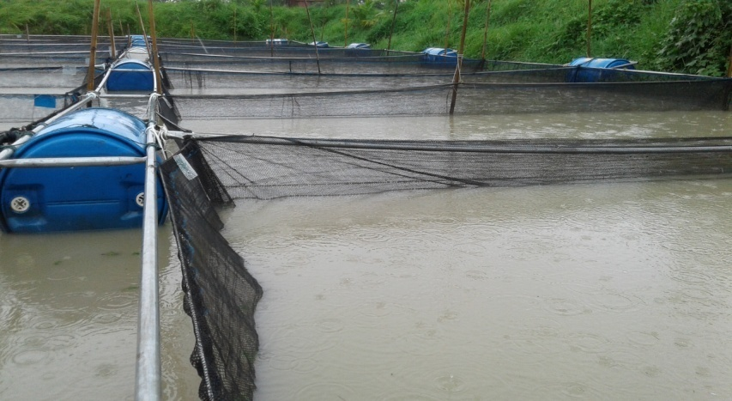

Plate1: Cage set up for Tilapia Culture

Plate 2: Tagged cages

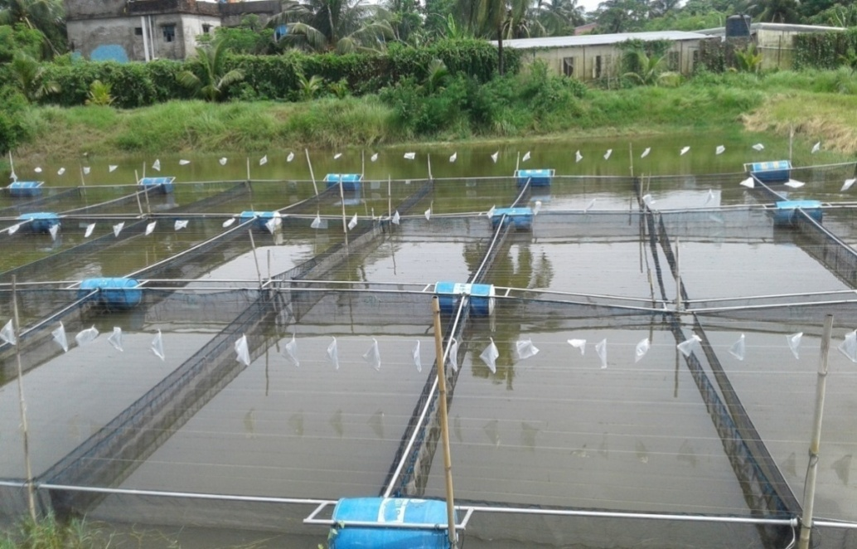

Plate 3: Adding Nylon Ropes over the cages

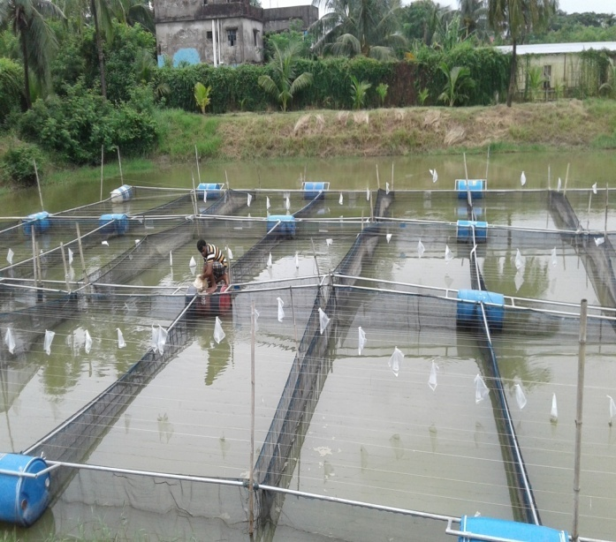

Plate 4: Feeding

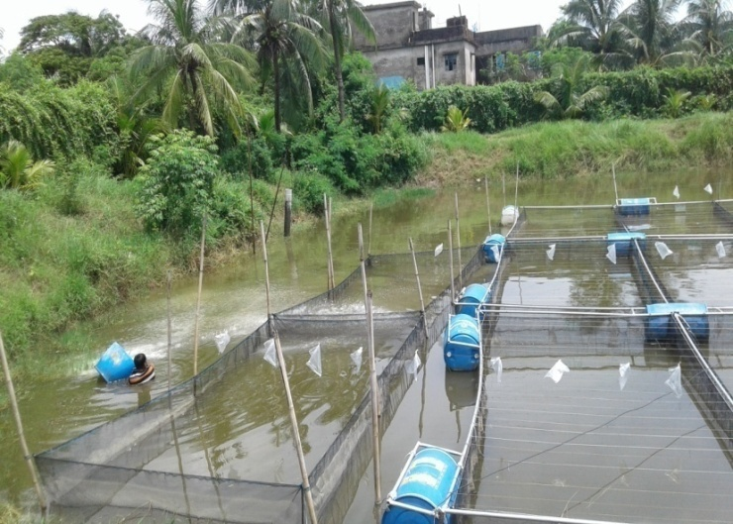

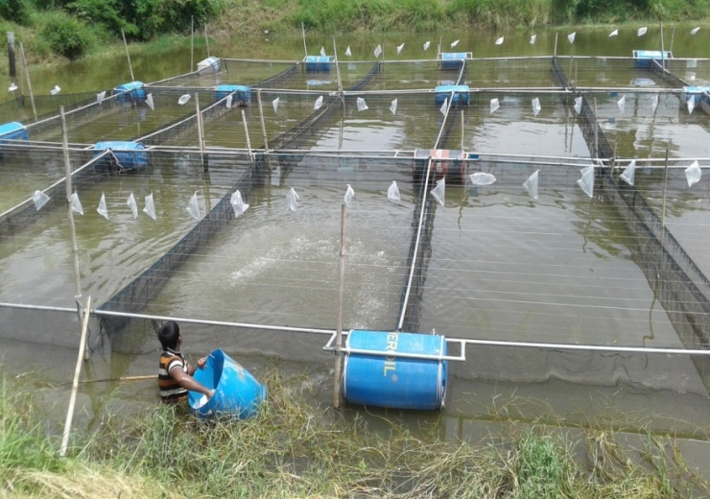

Plate 5: Liming

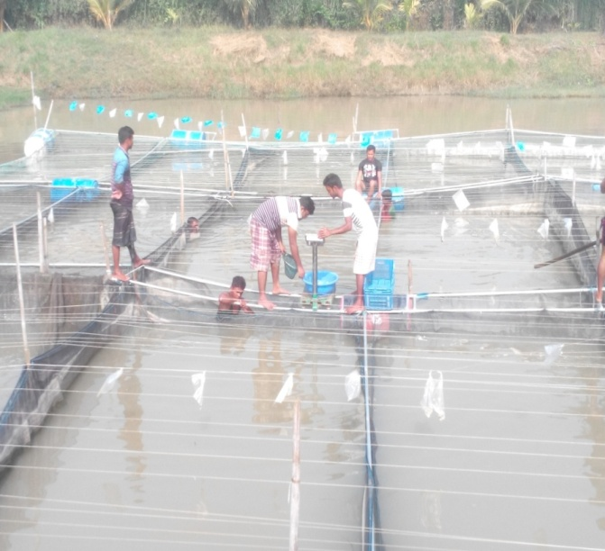
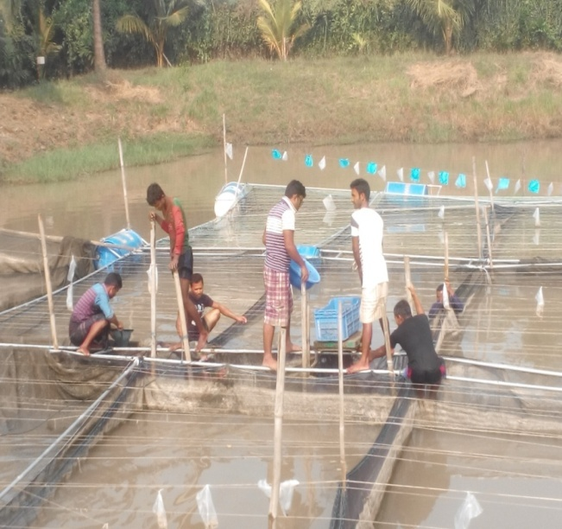

Plate 6: During Sampling

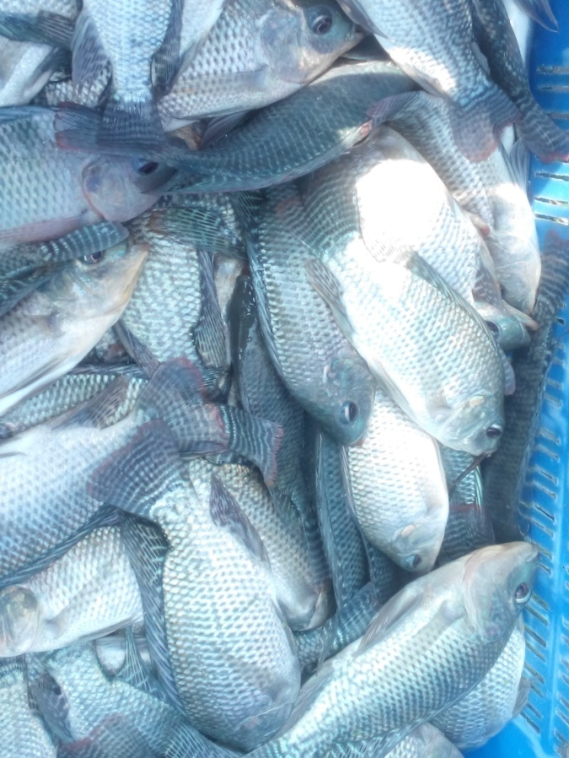

Plate 7: T₀ treated Tilapia

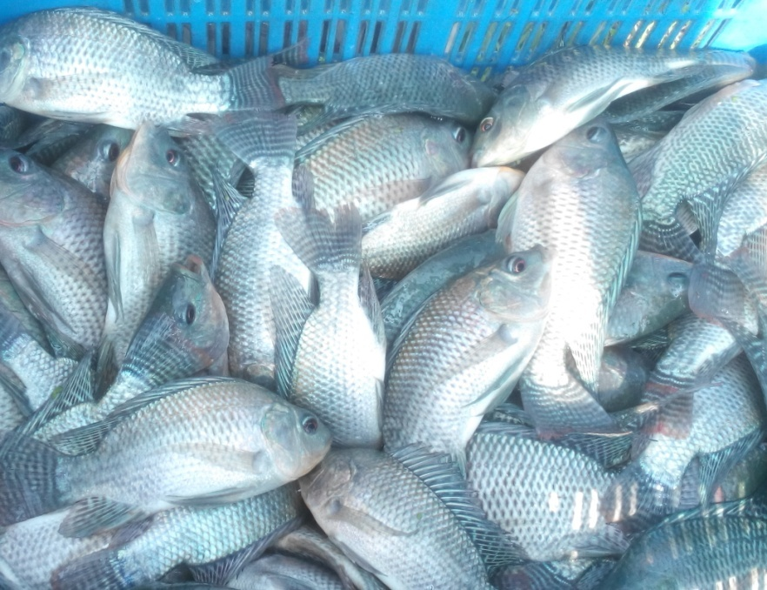

Plate 8: T₁ treated Tilapia

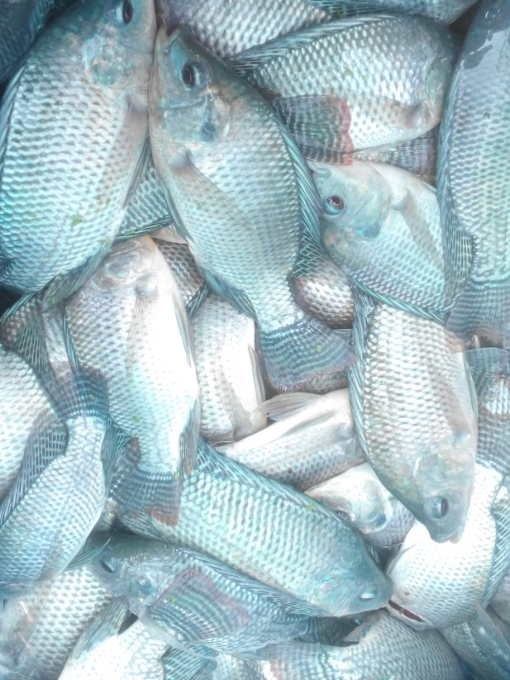

Plate 9: T₂ treated Tilapia

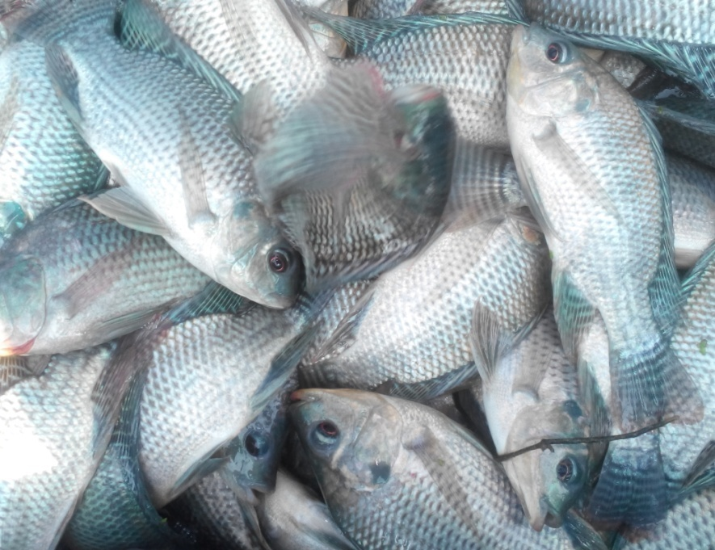

Plate 10: T₃ treated Tilapia

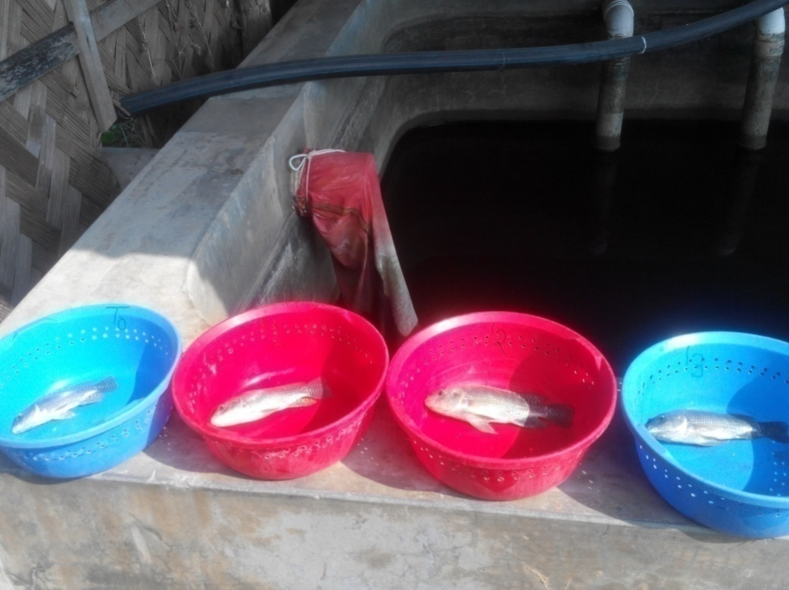

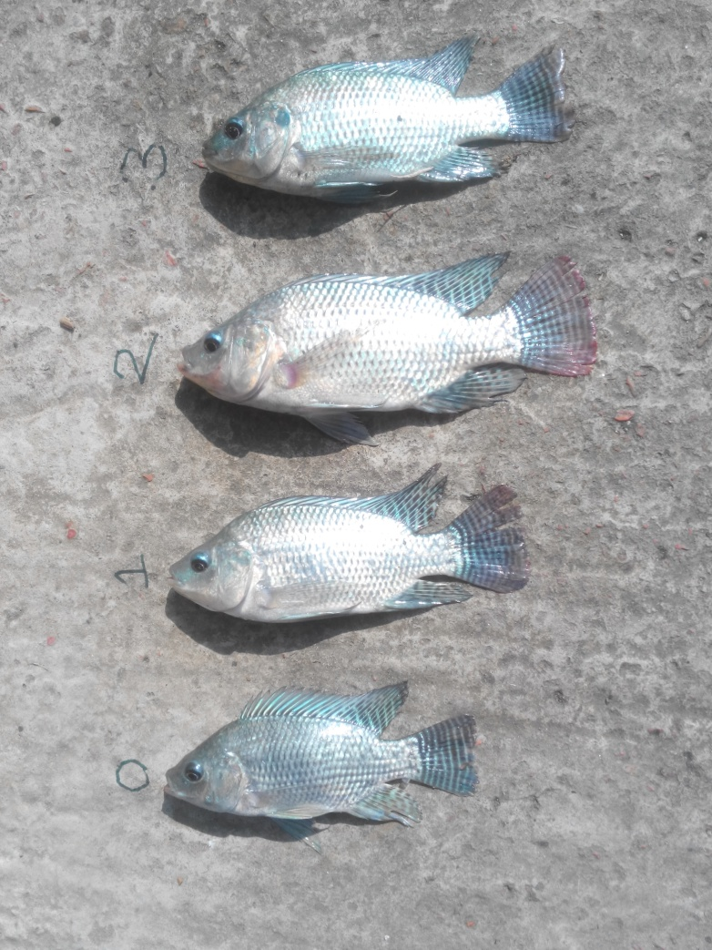

Plate 11: Comparison among T_{0,} T_{1,} T₂ and T₃ treated Tilapia

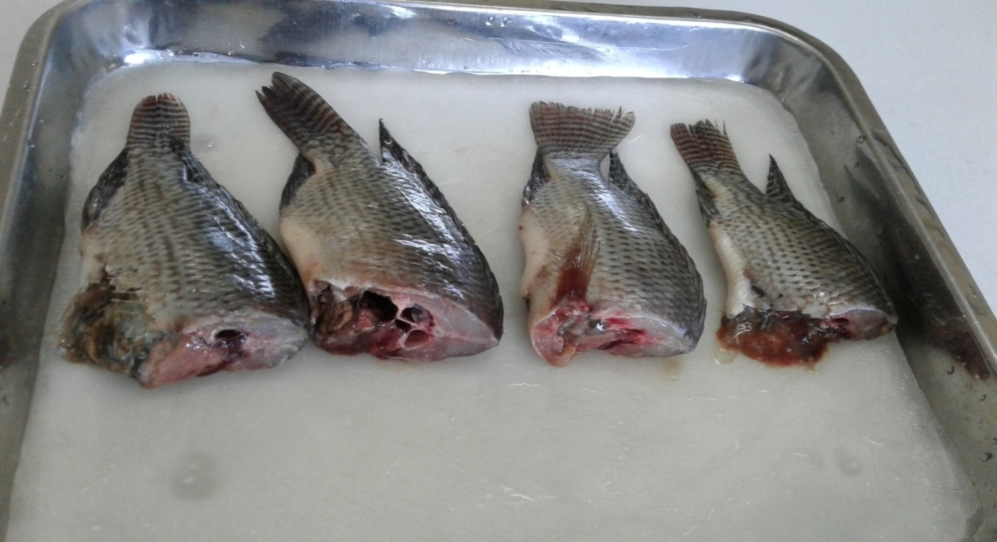

T₂
T₁
T₃
T₀

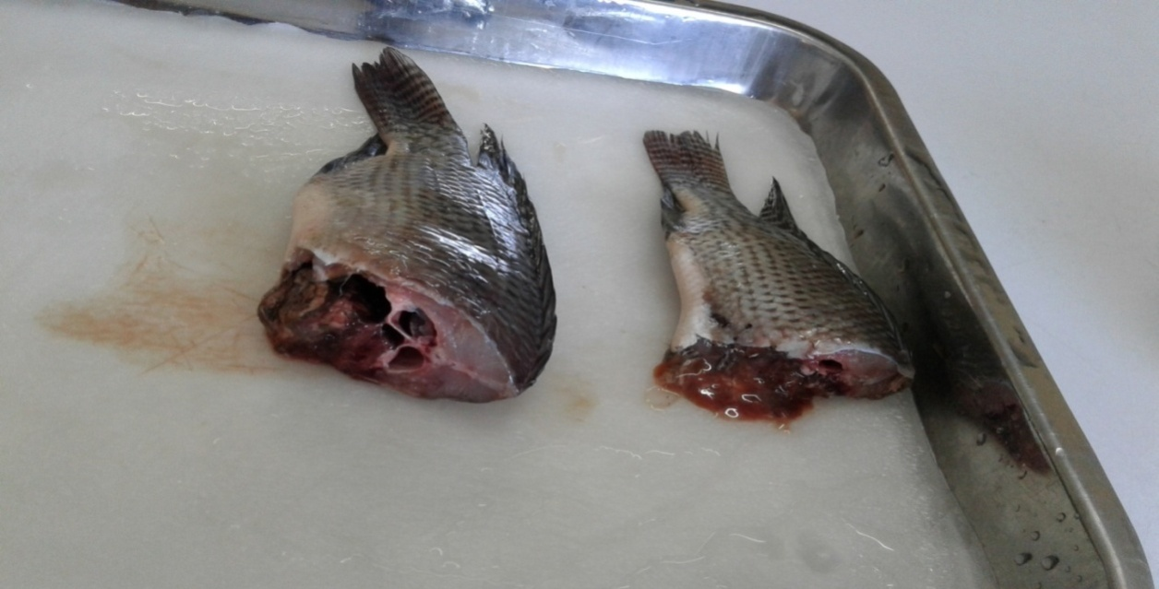

T₂
T₀

Plate 12: Muscle content of treated and control fish

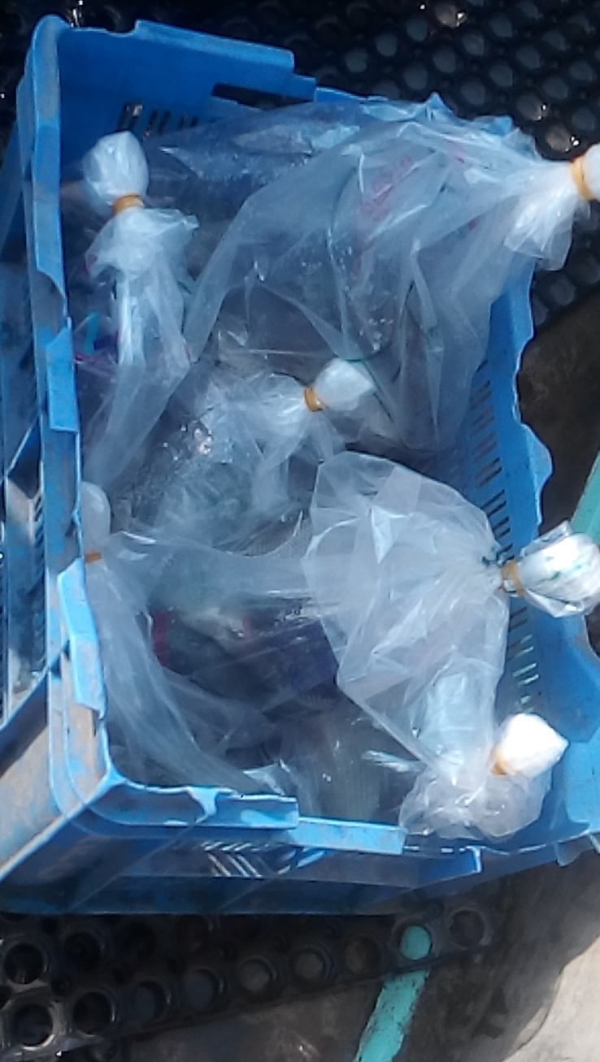

Plate 13: Packed tilapia for laboratory analysis

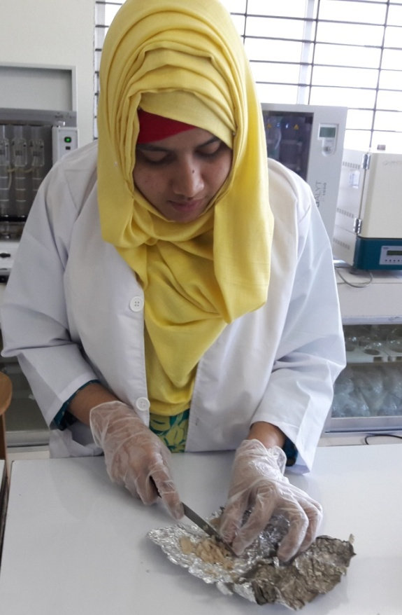
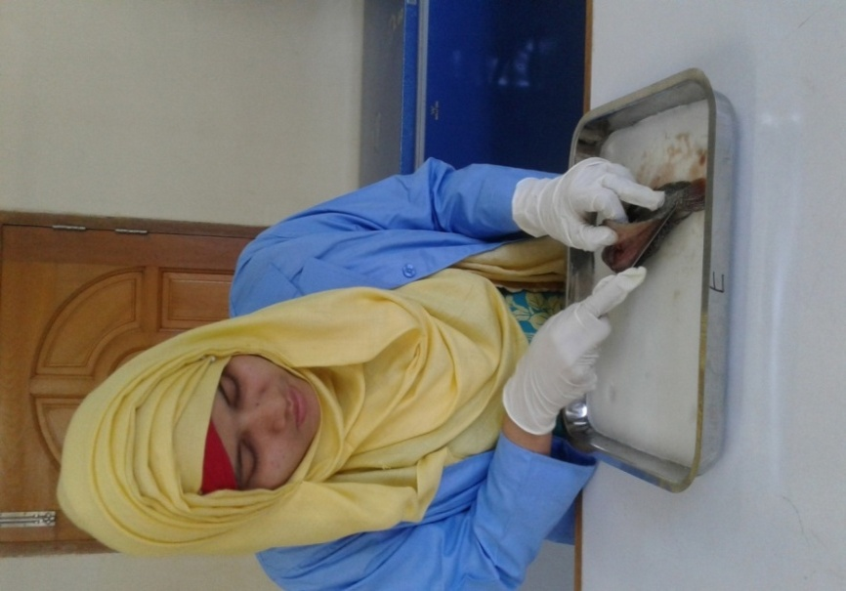

Plate 14: Preparation of sample for laboratory analysis

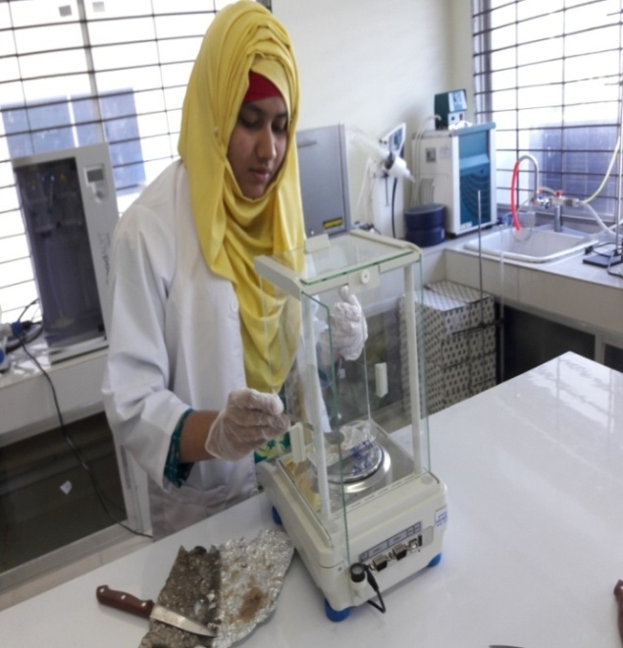

Plate 15: Weighing of sample

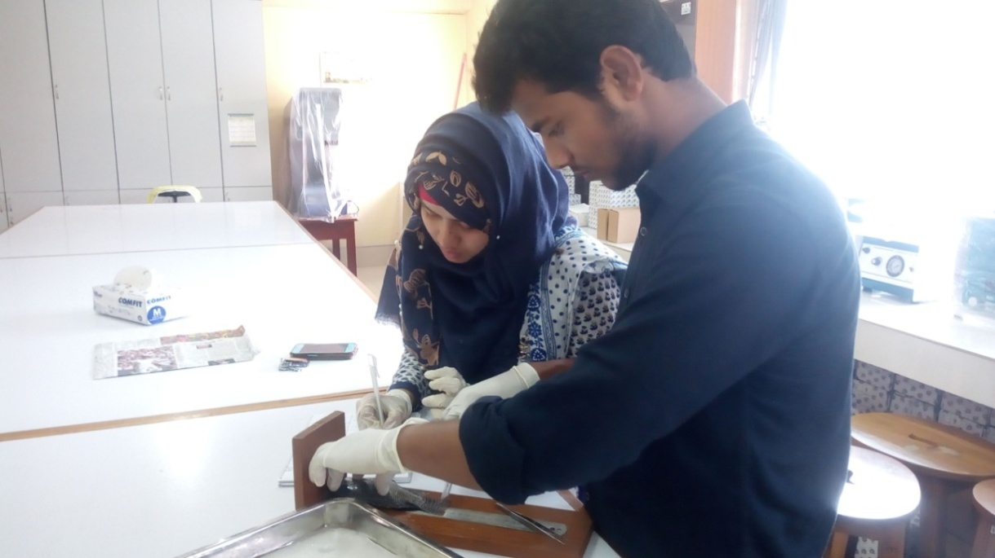

Plate 16: Measurement of body length

RESULTS
Polyphenol has a wide range of effects on human body and farmed animal. An attempt has been undertaken in the present study to demonstrate the effects of polyphenol on tilapia fish body.
4.1 Effects of polyphenol on fish weight
Sampling of the experimental fish was done in regular interval of one week where weights of fish were taken by weight machine. For conducting research, fish have been sampled for 16 times. During stocking of fish, the average weight of fish was 2.24 g. In final sampling, it showed that the average weight of each treatment such as T_{0,} T_{1,} T₂ and T₃ were 86.64±7g, 93.3± 7.4 g, 108.71±14 g and 89.78±10.8 g respectively. The data showed that the fishes provided with ‘Treatment-2 (T₂)’ feed have higher and even growth in terms of weight when comparing with other treatments (Figure 1).

Figure 1: Average growth chart in g (By weight)

4.2 Effects of polyphenol on fish length
The initial length of fish was 3.21 cm. In final sampling, it showed that the average length of each treatment such as T_{0,} T_{1,} T₂ and T₃ were 17.34±.25cm, 18±.41 cm, 18.25±.29 cm and 18.13±.25 cm respectively. The data showed that the fishes provided with ‘Treatment-2(T₂)’ feed have higher and even growth in terms of length when comparing with other treatments (Figure 2).

Figure 2: Average growth chart in cm (By length)

4.3 Effects of polyphenol on weight gain
Weight gain of fishes was calculated on weekly basis by subtracting of current sampling weight by immediate previous sampling fish weight. (Figure 3)

Figure 3: Weekly weight gain in g (week 1-16)

4.4 Effects of Polyphenol on length gain
Length gain of fishes was calculated on weekly basis by subtracting of current sampling length by immediate previous sampling fish length (Figure 4).

Figure 4: Weekly length gain in cm (week 1-16)
4.5 Growth performance
Growth performances of farmed tilapia are summarized in Table 5. Among dietary treatment, significant differences (p<0.05) were observed for final weight, weight gain, final length, length gain and condition factor. Except condition factor and SGR, growth parameters were significantly higher in fish fed with T₂ treated feed were shown in Figure 5, 6, 7 and 8.

Table 5: Growth performance of farmed Tilapia
Treatment | Weight | Length | Condition factor | Specific growth rate
Control | 86.64±7^{b}  ( 76.46-92.28) | 17.34±.25^{b}  ( 17-17.5) | 1.65±.07  ( 1.56-1.72) | 3.07±.07  ( 2.97-3.12)
T₁ (0.2 % Polyphenol) | 93.3± 7.4^{ab}  ( 87.16-103.05) | 18±.41^{ab}  ( 17.5-18.5) | 1.6±.06  ( 1.51-1.63) | 3.13±.07  ( 3.08-3.22)
T₂ ( 0.4% Polyphenol) | 108.71±14ª  ( 91.88-123.27) | 18.25±.29ª  ( 18-18.5) | 1.8±.25  ( 1.58-2.11) | 3.26±.11  (3.12-3.37)
T₃ ( 0.6 % Polyphenol) | 89.78±10.8 ^{ab}  ( 80-102) | 18.13±.25ª  ( 18-18.5) | 1.5±.17  ( 1.37-1.75) | 3.1±.1  ( 3.0-3.21)
Level of significance | 0.044 | 0.008 | 0.132 | 0.05

*Values are means ± S.D. Within a row, means with the same letters are not significantly different (P < 0.05).

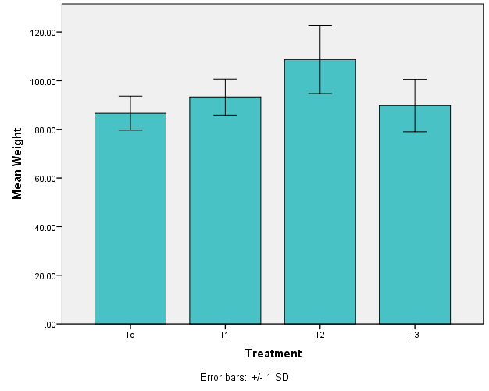
a
b
ab
ab

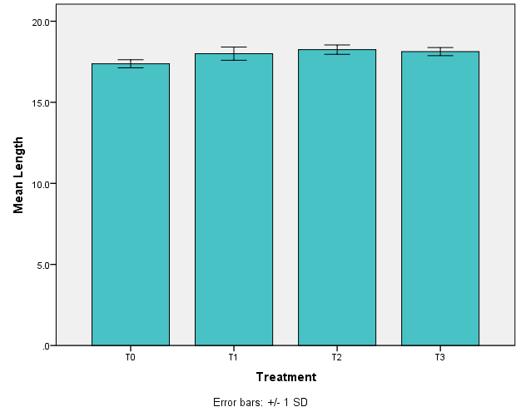
Figure 5: Effects of polyphenols on weight of fish body (Mean ± SD) after 4 months. The weight of fishes of T₁, T₂ and T₃ were compared to the control group. Values accompanied by different letters are statistically significantly different (p < 0.05, n=4)
b
a
a
ab

Figure 6: Effects of polyphenols on length of fish body (Mean ± SD) after 4 months. The length of fishes of T₁, T₂ and T₃ were compared to the control group. Values accompanied by different letters are statistically significantly different (p < 0.05, n=4)

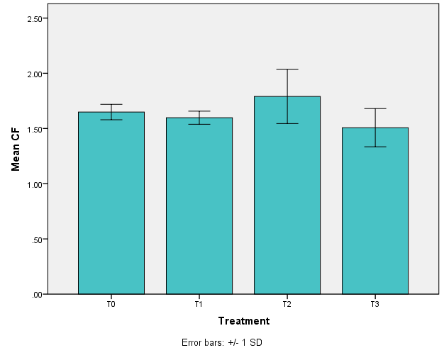

Figure 7: Effects of polyphenols on condition factor (Mean ± SD) after 4 months. The condition factor of fishes of T₁, T₂ and T₃ were compared to the control group.
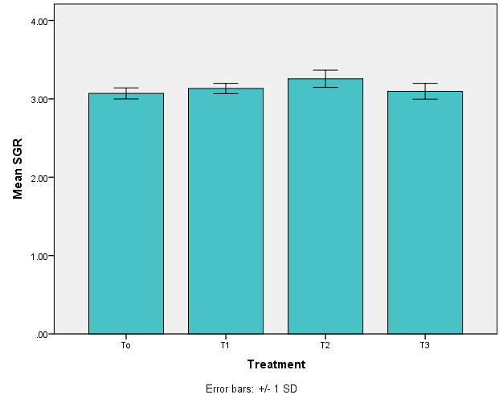

Figure 8: Effects of polyphenols on specific growth rate (Mean ± SD) after 4 months. The specific growth rate of fishes of T₁, T₂ and T₃ were compared to the control group.
4.6 Length measurement of Tilapia
Length of tilapia such as standard lengths, fork lengths, body lengths, head lengths were measured in laboratory and shown in Table 6.
Table 6: Length measurement of Tilapia
Treatment | Standard length (cm) | Fork length (cm) | Body length (cm) | Head length (cm)
T₀ | 13.04 | 16.63 | 5.3 | 4
T₁ | 14.1 | 16.8 | 5.8 | 4.1
T₂ | 16 | 17.5 | 6.5 | 4.5
T₃ | 14.5 | 16.5 | 6 | 4

4.7 Feed Conversion Ratio (FCR)
Experimental fish showed best FCR (1.59) in 0.4% polyphenol treated feed, whereas the FCR value of 0.2% and 0.6% polyphenol treated fish were 1.85 and 1.93 respectively. All polyphenol treated fish showed better FCR performance than control fish (2.00) (Table 7).
Table 7: FCR value
Treatment | FCR
T₀ | 2
T₁ | 1.85
T₂ | 1.59
T₃ | 1.93

4.8 Proximate composition analysis of fish muscle
Proximate composition such as protein, moisture, lipid and ash of experimental fish were listed in table 8, table 9, table 10 and table 11 respectively.

Table 8: Protein percentage
Treatments | Percentage (%)
Control (T₀) | 10.37
0.2 % polyphenol (T₁) | 21.37
0.4 % polyphenol (T₂) | 19.65
0.6 % polyphenol (T₃) | 17.5

Table 9: Moisture percentage
Treatments | Percentage (%)
Control (T₀) | 77.85
0.2 % polyphenol(T₁) | 79.57
0.4 % polyphenol (T₂) | 78.95
0.6 % polyphenol (T₃) | 80.33

Table 10: Lipid percentage
Treatments | Percentage (%)
Control (T₀) | 1.63
0.4 % polyphenol(T₂) | 1.25

Table 11: Ash percentage
Treatments | Percentage (%)
Control (T₀) | 1.07
0.2 % polyphenol (T₁) | 1.57
0.4 % polyphenol (T₂) | 1.64
0.6 % polyphenol (T₃) | 1.88

DISCUSSION
The present study was conducted to know the potentials of plant polyphenols for better performance of farmed Tilapia. A number of changes have been documented in this present study such as length, weight, FCR, condition factor and specific growth rate etc.
5.1 Effects of polyphenol on weight
After completion of research work, highest weight was found in T₂ (108.71±14) treated fish than the T₀ (86.64±7), T₁ (93.3± 7.4) and T₃ (89.78±10.8). The present work represents that fish fed without polyphenol show lower weight than the fish fed with polyphenol supplementation at 0.4% (p<0.05) which undoubtedly indicate that polyphenol has great effects on fish growth. During research period, 16 samplings were done where 1st four sampling (week 1 to week 4) showed lower growth rate and lower weight gain because of time taken for adjustment in new environment. And week 5 to week 11 showed higher weight gain in all experimental fish in which T₂ showed higher weight gain when comparing other treated fish. In week 12 to week 16 showed lower weight gain due to fluctuation of temperature, low temperature, rainfall and weather change. Due to the low temperature, the feed intake rate also reduced inhibiting growth. Polyphenol had great effects on extension growth of maize (Zea mays L.) shoot ooleoptile segments, lettuce (Lactuca sativa L.) roots, and on radish (Raphanus sativus L.) seed germination (Stoms, 1981). Majewska and Czeczot, 2009 suggested polyphenols has multiple function and act as plant hormones, inhibitors of enzymatic reactions and plant growth regulators. Gordon and Wareham 2010, reported that phenolic compounds have bactericidal and bacteriostatic properties. According to Viveros et al 2011; Polyphenol have the capacity minimizing adhesion of pathogenic bacteria (E. coli, Clostridium), inhibit the progression of infections in the digestive tract, and improve nutrient utilization and finally animal performance. Sorsanit et al 2002; conducted an experiment by using green tea extract (Polyphenol) in shrimp aquaculture. This work suggested that polyphenol of green tea in shrimps has positive effects on anti- microbial effects and has potential for use in shrimp aquaculture. The present study thus concludes that polyphenol has direct effects on increasing weight of farmed tilapia.

5.2 Effects of polyphenol on length
During stocking of fish, initial length was 3.21 cm. In final sampling, highest length was found in T₂ (18.25±.29) treated fish than the T₀ (17.34±.25), T₁ (18±.41) and T₃ (18.13±.25) treated fish. Polyphenol treated fish had higher length than the control fish (p<0.05).
5.3 Effects of polyphenol on growth performance
In the current study period, dietary supplementation of polyphenol improved the growth performances of tilapia and highest (p<0.05) final weight was found in 0.4 % polyphenol supplemented diet. 0.4% polyphenol treated fish has higher weight and weight gain than the control fish. 0.4% and 0.6% polyphenol treated fish has higher length and length gain than the control fish. Condition factor and SGR had no significant relation among treated fish. Fish fed with polyphenol has better growth performance than the fish fed without polyphenol. Because Polyphenol acts as attractants which enhance feed intake and growth rate. It showed to enhance feed consumption which ultimately increase the survival rate and also responsible for reduce wastage of feed that deteriorate water quality. All fish were attracted to the feed fighting and splashing to consume the feed containing polyphenol than the control. No feed residues were left in polyphenol treated fish containing cage than the control because polyphenol contains good smell which easily attracts fish and consume all feed and maintain good water quality. Magrone et al; (2016) attempted to administration of a polyphenol enriched feed to farmed sea bass which suggest that Polyphenol create lower levels of intestinal pro-inflammatory cytokines helping as an expression of a robust and protective adaptive immune response. Polyphenolic tannins show both positive and negative effects; they possess anti-nutritive properties, but are also beneficial for health due to their role as antioxidants and their ability to stimulate the immune system and various effectors (Chung et al., 1998; Makkar et al., 2007; Quideau et al., 2011). Polyphenol has also been reported to have antimicrobial activity against fish pathogens (Schrader, 2008). During research work, no mortality was occurred and occurrence of any disease outbreak was not seen. Before completion of research work, temperature was getting low due to coming of winter. But fishes compete against low temperature and remain alive. This might be happened because of polyphenols building strong immune system and helps sustain in extreme condition. As a result, present study concludes that, 0.4% Polyphenol containing diet has better growth performances than the other diet.
The condition factor of a fish is indicator of overall health status of a fish including physical and biological condition and fluctuations by interaction among feeding conditions, parasitic infections and physiological factors (Le Cren; 1951). Therefore, information on condition factor can be vital to culture system management because they provide the producer with information of the specific condition under which organisms are developing (Araneda et al., 2008). The values of condition factor recorded in the present study were 1.65±.07, 1.6±.06, 1.8±.25 and 1.5±.17 in T₀, T₁, T₂ and T₃ respectively. Condition factor of greater than one showed the well being of fishes fed with different experimental diets (Datta et al., 2013). But among treated fish had no significant relation (p<0.05). The values of ‘K’ in higher in T₂ than the T₀, T₁ and T₃ suggesting that fish fed with diet containing 0.4 % Polyphenol were much more nourished and strong than the fish fed with other treated diet. The results are equivalent with the study of Chandra and Jhan (2010) who recorded the K value of Channa punctata in the range of 1.05 – 1.89.
The specific growth rate is widely used dealing with the growth of aquatic organisms under experimental conditions. The SGR values were recorded in present study were 3.07±.07, 3.13±.07, 3.26±.11 and 3.1±.1 in T₀, T₁, T₂ and T₃ respectively. Higher SGR were found in T₂ treated fish. But among treated fish had no significant relation (<0.05).
5.4 Effects on Feed Conversion Ratio
Best FCR (1.59) was found in 0.4% polyphenol treated feed fed to fish, whereas the FCR value of 0.2% and 0.6% polyphenol treated fish were 1.85 and 1.93 respectively. All polyphenol treated fish show better FCR performance than control fish (2.00). According to Ahmad et al. 2013, broilers diet containing polyphenol (Black Tea Extract) showed significant result which concluded that efficient weight gain and lowering FCR value are found.

5.5 Effects of polyphenol on proximate composition of fish muscle
Polyphenol supplemented diet treated fish has greater percentage of moisture, protein, lipid and ash than the control fish.
Odor, flavor and taste experiments were performed by some panelists immediately after completing field research. Panelists declared that the polyphenol treated fish were tastier than the control fish and those treated fish had no odd flavor.

CONCLUSIONS
Tilapia has major specialties making as an ideal candidate for aquaculture. It has a wide range of benefit to meet the demand of protein source. The present study was conducted on the basis of analysis of effects on plant polyphenols on farmed tilapia which utilize natural resources. The results of this research showing that polyphenol has potential role in the better growth performance (weight, weight gain, length, length gain, SGR), immune response, lower FCR value and as well as disease free tilapia fishes. Polyphenol supplementation in fish diet may ensure the better profit for the farmer as well as food safety for the consumers. It is concluded that polyphenol has wide range of benefit to boosting fish growth which ultimately saves farmer time and produce nutritionally enriched and tasty fish. In addition, these types of research work will add a new dimension for progression of fisheries sector in Bangladesh.

.

RECOMMENDATION AND FUTURE PERSPECTIVES
According to this research work, the following recommendations may be done:
- Farmer may get lower FCR value and increased growth performance of tilapia fishes with regular use of polyphenols in fish feed.
- Polyphenols may holds burning issues for feed industries to create novel products, such as feed supplements and will represent an interesting resource for the feed industry sector.
- Polyphenols may be used in improving the total production and food safety.
- Polyphenol may add new dimension in fisheries and approved by governments and included it national policy level by maintaining consumer safety.
- As it is a pilot study, further studies may be conducted on similar field to make a concrete remark.

References
ADB 2005a. An evaluation of small-scale freshwater rural aquaculture development for poverty reduction. Operations Evaluation Department, Asian Development Bank, Manila, Philippines.
ADB 2005b. An impact evaluation of the development of genetically improved farmed tilapia and their dissemination in selected countries. Operations Evaluation Department, Asian Development Bank, Manila, Philippines.
Aguirre L., Portillo M.P., Hijona E., Bujanda L. 2014. Effects of resveratrol and other polyphenols in hepatic steato-sis. World Journal of Gastroenterology 20, 7366–7380.
Ahmad A., Mangaiyarkarasi R., Shahid W., Umar M., Shahina N., Rahmanullah S., Zahra Y. 2013. Effect of black tea extract ( Polyphenol) on performance of broilers. International Journal of Advanced Research, Volume 1, Issue 7, 563-566.
Ahmed M., Bimbao M.P., Gupta M.V. 1996. Economics of tilapia aquaculture in small water bodies in Bangladesh. The Third International Symposium on Tilapia in Aquaculture (R.S.V. Pullin, J. Lazard, M. Legendre, J.B. Amon Kothias and D. Pauly eds.), International Center for Living Aquatic Resources Management Conference Proceedings 41, 471-475.
Ahmed N., Ahmed S. 2009. Development of tilapia marketing systems in Bangladesh: potential for food supply. National Food Policy Capacity Strengthening Programme of the FAO, Dhaka
Alam F.M., Khan A.M., Huq A.A.S.M. 2012. Technical efficiency in tilapia farming of Bangladesh: a stochastic frontier production approach. Aquaculture International, Volume 20, Issue 4, pp 619–634
Alderman D.J., Hastings T.S. 1998. Antibiotic use in aquaculture: development of antibiotic resistance - potential for consumer health risks “. International Journal of Food Science and Technology, pp. 139-155.
Archivio M.D., Filesi C., Benedetto R.D., Gargiulo R., Giovannini C., Masel -la R. 2007. Polyphenols, dietary sources and bioavailability. Annali dell'Istituto Superiore Di Sanita journal, 43: 348–361.
Araneda M., Perez E.P., Gasca L.E 2008. White shrimp Penaeus vannamei culture in freshwater at three densities: condition state based on length and weight. Aquaculture. 2008; 283:13–18.
Bart A., Haque M., Wahab M.A. 2004. Tilapia culture in Bangladesh: Technological constraints. Paper presented at the workshop on tilapia culture in Bangladesh: constraints and potentials, Mohakhali, Dhaka.
Bart A., Yi Y., Shivakoti G.P., Wahab M.A., Diana J.S., Lin C.K. 2005. Tilapia (Oreochromis niloticus) production constraints in Bangladesh: A socioeconomic perspective. In: Twenty-Second Annual Technical Report (J. Burright, C. Flemming, and H. Egna eds.), Aquaculture Collaborative Research Support Programs, Oregon State University, Corvallis, Oregon, USA.
Baur J.A., Pearson K.J., Price N.L., Jamieson H.A., Lerin C., Kalra A., Prabhu V.V., Allard J.S., Lopez-Lluch G., Lewis K., Pistell P.J., Poosala S., Becker K.G., Boss O., Gwinn D., Wang M., Ramaswamy S., Fishbein K.W., Spencer R.G., Lakatta E.G., Le Couteur D., Shaw R. J., Navas P., Puigserver P., Ingram D.K., De Cabo R., Sinclair D.A. 2006. Resveratrol improves health and survival of mice on a high-calorie diet, Nature 444, 337–342.
Bennick A. 2002. Interactions of plant polyphenols with salivary protein. Critical Reviews in Oral Biology and Medicine, 13(2):184-196.
Beveridge M.C.M., Little D.C. 2002. The history of aquaculture in traditional societies. In B. A. Costa-Pierce (Ed.), Ecological aquaculture: The evolution of the Blue Revolution. Oxford: Blackwell Science Limited.
Bimbo A.P., Crowtber B. 1992. Fish meal and oil: Current uses. Journal of American Chemical Society, 69, 221-227.
Cabello C. 2006. Heavy use of prophylactic antibiotics in aquaculture: a growing problem for human and animal health and for the environment. In: Environmental microbiology. 8 (7), pp. 1137-44
Chandra R., Jhan N. 2010. The analysis of length-weight relationship of Channa punctata with relative physico-chemical parameters. Journal of Experimental Nanosciece,1(5):4–5
Chowdhury M.A.K., Bureau D.P., Bose M.L., Dey M.M. 2007. Relevance of a rapid appraisal approach to identify locally available feed ingredients to small-scale Nile tilapia (Oreochromis niloticus L.) aquaculture. Aquaculture Economics and Management 11, 151-169
Chuang C.C., McIntosh M.K. 2011. Potential mechanisms by which polyphenol-rich grapes prevent obesity-mediated inflammation and metabolic diseases. Annual Review of Nutrition 31, 155–176
Chung K.T., Wei C.I., Johnson M.G. 1998. Are tannins a double-edged sword in biology and health? Trends Food Science and Technology 9, 168–175.
Couto A., Kortner T.M., Penn M., Ostby G., Bakke A.M., Krogdahl A., Oliva-Teles A. 2015. Saponins and phytosterols in diets for European sea bass (Dicentrarchus labrax) juveniles: effects on growth, intestinal morphology and physiology. Aquaculture Nutrition 21, 180–193.
Cruz, P.S. 1996. Feed quality problems and management strategies. In: C.B. Santiago, R.M. Coloso, O.M. Millamena & I.G. Borlongan (Eds.). Feeds for Small-Scale Aaquaculture. Proceedings of the National Seminar-Workshop on Fish Nutrition and Feeds (pp. 64-73). Tigbauan, Iloilo, Philippines: Southeast Asian Fisheries Development Center Aquaculture Department.
Dada A.A. 2015. Improvement of tilapia (Oreochromis niloticus Linnaeus, 1758) growth performance fed three commercial feed additives in diets. Journal of Aquaculture Research and Development 6, 325-327.
Das N.G., Mamun F.A., Barua P., Siddique A.A.M., Chowdhury M.S.N., 2010. Survivality of mono-sex tilapia (Oreochromis niloticus) fry using 17-α methyltestosterone in a commercial hatchery of chittagong, bangladesh. Journal of Aquaculture Feed Science and Nutrition, 2: 16-24.
Datta S.N., Kaur V.I., Dhawan A., Jassal G. 2013. Estimation of length-weight relationship and condition factor of spotted snakehead Channa punctata (Bloch) under different feeding regimes. Springerplus; 2: 436.
Dey M.M. 2000. The impact of genetically improved farmed Nile tilapia in Asia. Aquaculture Economics and Management 4, 107-124.
Dey M.M., Rab M.A., Paraguas F.J., Piumsumbun S., Bhatta R., Alam M.F., Ahmed M. 2005b. Fish consumption and food security: A disaggregated analysis by types of fish and classes of consumers in selected Asian countries. Aquaculture Economics and Management 9(1&2):89-112.
Dey M.M., Rab M.A., Paraguas F.J., Piumsumbun S., Bhatta R., Alam M.F., Ahmed M. 2005c. Status and economics of freshwater aquaculture in selected countries in Asia. Aquaculture Economics and Management 9(1&2):11-38.
DoF 2017. Yearbook of Fisheries Statistics of Bangladesh 2016-2017. Fisheries Resources Survey System, Department of Fisheries. Bangladesh : Director General, DoF, 2017. Volume 34: p. 129.
Drew M.D., Borgeson T.L., Thiessen D.L. 2007. A review of processing of feed ingredients to enhance diet digestibility in finfish. Animal Feed Science and Technology 138, 118–136.
El-Sayed A.F.M. 2006. Tilapia culture. Oxford University Press, United Kingdom.
Erfanullah J.K., Jafri A.K. 1998. Growth rate, feed conversion ratio and body composition of Catla catla, Labeo rohita and Cirrhinus mrigala fry fed diets of various. Journal of the World Aquaculture Society 1998; 28(1):84-91. 6.
FAO 2010. The state of world fisheries and aquaculture. FAO, Fisheries and Aquaculture Department, Rome, Italy.
FAO 2016. The State of World Fisheries and Aquaculture 2016. Contributing to food security and nutrition for all. Rome. 200 pp.
Feng X., Ng K.V., Miks-Krajnik M., Yang H. 2017. Effects of fish gelatin and tea polyphenol coating on the spoilage and degradation of myofibril in fish fillet during cold storage. Food and Bioprocess Technology. Volume 10, Issue 1, pp 89–102
Francis G., Makkar H.P.S., Becker K. 2001. Anti-nutritional factors present in plant-derived alternate fish feed ingredients and their effects in fish. Aquaculture 199, 197–227.
Ganesh S., Majumder J. 2004. Constraints of tilapia production in Bangladesh: Looking from a socioeconomic perspective. Paper Presented at the Workshop on Tilapia Culture in Bangladesh: Constraints and Potentials, Mohakhali, Dhaka.
Gessner D.K., Ringseis R., Eder K. 2016. Potential of Plant Polyphenols to Combat Oxidative Stress and Inflammatory Processes in Farm Animals.
Ghose B. 2014. Fisheries and aquaculture in Bangladesh: challenges and opportunities. Annals of Aquaculture and Research, 1(1), 1-5.
Gladine C., Morand C., Rock E.,.Bauchart D., Duranda D. 2007. Plant extracts rich in polyphenols (PERP) are efficient antioxidants to prevent lipoperoxidation in plasma lipids from animals fed n − 3 PUFA supplemented diets. Animal Feed Science and Technology Volume 136, Issues 3–4, Pages 281-296.
Gordon N.C., Wareham D.W. 2010. Antimicrobial activity of the green tea polyphenol (−) epigallocatechin-3-gallate (EGCG) against clinical isolates of Stenotrophomonas maltophilia. International Journal of Antimicrobial Agents, 36: 129–131.
Gupta N., Haque M. M., Khan M. 2012. Growth performance of tilapia fingerling in cage in ponds managed by Adivasi households: An assessment through length-weight relationship. Journal of the Bangladesh Agricultural University 10(1): 149–155, 2012.
Hassan M.A., Jafri A.K., Alvi A.S., Rana S., Nazura U. 1996. Dietary energy and protein interaction and approach to optimizing energy, protein ratio in Indian major carps, Cirrhinus mrigala (Ham.) fingerlings. Journal of Aquaculture in the Tropics. 1996; 10(3):183-191. 7.
Hussain M.G., Kohinoor A.H.M., Islam M.S., Mazid M.A. 2004. Status and potential of tilapia production in Bangladesh. Paper Presented at the Workshop on Tilapia Culture in Bangladesh: Constraints and Potentials, Mohakhali, Dhaka.
Jahan K.M., Ahmed M., Belton B. 2009. The impacts of aquaculture development on food security: lessons from Bangladesh Aquaculture Research, 1-15
Janel N., Noll C. 2014. Protection and reversal of hepatic fibrosis by Polyphenols. Polyphenols in Human Health and Disease. Pages 665–679. Volume 1
Jena J.K., Aravidakshan P.K., Suresh C., Muduli H.K., Ayyappan S., Chandra S. 1998. Comparative evaluation of growth and survival of Indian major carps and exotic carps in raising fingerlings. Journal of Aquaculture in the Tropics. 1998; 13(2):143-149
Jiaojiao S., Lijun S., Yonghong M., Xingbin Y., Yurong G. 2017. Antioxidant activities of young apple polyphenols and its preservative effects on lipids and proteins in grass carp (Ctenopharyngodon idellus) fillets, CyTA - Journal of Food, 15:2, 291-300,
Kader A.M., Bulbul M., Abol-Munafia B.A., Asaduzzaman M., Miana S., Mat Noordina B.N., Alie E.M., Hossain S.M., Koshio S. 2018. Modulation of growth performance, immunological responses and disease resistance of juvenile Nile tilapia (Oreochromis niloticus) (Linnaeus, 1758) by supplementing dietary inosine monophosphate .Aquaculture Reports 10 (2018) 23–31.
Kanti B.P., Syed I.R. 2009. Plant polyphenols as dietary antioxidants in human health and disease. Oxidative Medicine and Cellular Longevity 2:5, 270-278.
Karim M., Ahmed M., Talukder R.K., Taslim M.A., Rahman H.Z. 2006. Dynamic agribusiness focused aquaculture for poverty reduction and economic growth in Bangladesh. World Fish Center Discussion Series No. 1. 44 p
Kathryn H.M., Kruger J.M., Smith C. 2014. Contusion Injury with Chronic In vivo Polyphenol Supplementation: Leukocyte Responses. Official Journal of the American College of Sports Medicine.
Kousoulaki K., Saerther B.S., Albrektsen S., Noble C. 2015. Review on European sea bass (Dicentrarchus labrax Linnaeus, 1758) nutrition and feed management: a practical guide for optimizing feed formulation and farming protocols. Aquaculture Nutrition 21, 129–151.
Krogdahl A., Penn M., Thorsen J., Refstie S., Bakke A.M. 2010. Important anti-nutrients in plant feedstuffs for aquaculture: an update on recent findings regarding responses in salmonids. Aquaculture Research 41, 333–344.
Le Cren E.D 1951. The length-weight relationships and seasonal cycle in gonad weight and condition in the perch (Perca fluviatilis) Journal of Animal Ecology. 1951; 20:201–219.
Lewis D.J., Gregory R. 1991. Social Research and Aquaculture in Bangladesh: A case study from the Northwest. Paper to Bangladesh Sociological Association Seminar on Environment and Natural Resource Management in Bangladesh.
Lim C.E., Webster C.D. 2006. Tilapia: biology, culture, and nutrition. The Haworth Press Inc., 10 Alice Street, Bringhamton, NY 13904-1580, USA.
Lim S.J., Jang E., Lee S.H., Yoo B.H., Kim S.K 2013. Antibiotic resistance in bacteria isolated from freshwater aquacultures and prediction of the persistence and toxicity of antimicrobials in the aquatic environment. Journal of Environmental Science and Health 48, 495-504.
Luckstadt C. 2006. Use of organic acids as feed additives-sustainable aquaculture production the non-antibiotic way. Int. Aquafeed, 9: 21-26.
Magrone T., Fontana S., Laforgia F., Dragone T., Jirillo E., Passantino L. 2016. Administration of a polyphenol-enriched feed to farmed Sea Bass (Dicentrarchus labrax L.) modulates intestinal and spleen immune responses. Oxidative Medicine and Cellular Longevity
Majewska M., Czeczot H. 2009. Flavonoids in prevention and therapy of diseases (in Polish).
Makkar H.P.S., Francis G., Becker K. 2007. Bioactivity of phytochemicals in somelesser-known plants and their effects and potential applications in livestock and aquaculture production systems. Animal 1, 1371–1391.
Mazid M.A. 1999. Developmental needs and research priorities for fisheries in Bangladesh. In: Gupta MV, Macawaris-Ele N (eds.). Priorities in aquatic resources research in the Asia-Pacific region. International Centre for Living Aquatic Resources Conference Proceeding 62. 39 p.
Mjoun k., Rosentrater K., Brown M.L. 2010. "TILAPIA: Profile and Economic Importance". Fact Sheets. Paper 163.
National Fisheries Institute (NFI) 2010. Top 10 consumed seafood’s. http://www.aboutseafood.com/about/about-seafood/top-10-consumed seafood’s.
Ng W.K., Romano N. 2013. A review of the nutrition and feeding management of farmed tilapia throughout the culture cycle.
Peschel W., Sanchez-Rabaneda F., Diekmann W., Plescher A., Gartzia I., 2006. An industrial approach in the search of natural antioxidants from vegetable and fruit wastes. Food Chemistry, 97: 137-150
Planning Commission 2016. Seventh five-year plan (FY 2016 -FY 2020), general economics division, Bangladesh planning commission. Government of People’s Republic of Bangladesh, pp. 283-291
Quideau S., Deffieux D., Douat-Casassus C., Pouysegu L. 2011. Plant polyphenols:chemical properties, biological activities, and synthesis. Angewandte Chemie International Edition.50, 586–621.
Rahman M.M. and Chowdhury M.B.R. 1996. Isolation of bacterial pathogen causing an ulcer disease in farmed carp fishes of Mymensingh. Bangladesh Journal of Fisheries Research, 19: 103-110.
Rashid M., Belton B., Phillips M., Karim M. 2013. The Current Status of Aquaculture and Aquafeed Production in Bangladesh. World Aquaculture.
Rasul M.G., Majumdar B.C. 2017. Abuse of Antibiotics in Aquaculture and it’s effects on human, aquatic animal and environment, Haya: The Saudi Journal of Life Sciences .; Vol-2, Iss-3:81-88
Rob M.G.M. 2008. Bangladesh Poultry Directory. 8th Edition. Dhaka Book House, Dhaka. 35 pp.
Saglam N., Yonar M. E. 2009. Effects of sulfamerazine on selected haematological and immunological parameters in rainbow trout (Onchorhynchus mykiss, Walbaum, 1792). Aquaculture Research, 40(4), 395-404.
Sanchez-Vazquez F.J., Munoz-Cueto J.A., 2014. Biology of European Sea Bass. CRCPress, London.
Schmidt A.S., Bruun M.S., Dalsgaard I., Pedersen K. and Larsen J.L. 2000. Occurrence of antimicrobial resistance in fish pathogenic and environmental bacteria associated with four danish rainbow trout farms. Applied and Environmental Microbiology, 66, 4908-4915.
Schrader K.K., 2008. Compounds with inhibitory activity against the channelcatfish pathogens Edwardsiella ictaluri and Flavobacterium columnare. North American Journal of Aquaculture. 70, 147–153.
Serrano P.H., 2005. Responsible use of antibiotics in aquaculture. FAO Fisheries Technical Paper. No. 469. Rome, FAO. 2005. 97p.
Shamsuzzaman M.M., Islam M.M., Tania N.J., Mamun M.A., Barman P.P., Xu X. 2017. Fisheries resources of Bangladesh: Present status and future direction. Aquaculture and Fisheries 2 (2017) 145-156.
Shelton W.L. 2002. Tilapia culture in the 21st Century. In: Guerrero RD III and Guerrero-del Castillo MR (Eds.). Proceedings of the International Forum on Tilapia Farming in the 21st Century (Tilapia Forum 2002), 184 p. Philippine Fisheries Association Inc. Los, Banos, Laguna, Philippines. pp. 1-20.
Sorsanit K., Nomura N., Matsumura M. 2002. Application of green tea extract in shrimp aquaculture. Fisheries Science, p: 998-999
Sorum H. 2006. Antimicrobial drug resistance in fish pathogens. In Antimicrobial resistance in bacteria of animal origin. American Society of Microbiology, (pp. 213-238).
Stoms D. J. 1981. Effect of polyphenols on shoot and root growth and on seed germination. Biologia Plantarum, 1982, Volume 24, Number 1, Page 1
Tacon A.G.J., Metian M. 2015. Feed matters: satisfying the feed demand of aquaculture. Reviews in Fisheries Science & Aquaculture. 23, 1–10.
Tangney C.C., Rasmussen H. E. 2013. Polyphenols, inflammation and cardiovascular disease. Current Atherosclerosis Reports 15, 324. Ter. Lek., 65: 369–377.
Thilsted S.H., Ross N, Hassan N. 1997. The role of small indigenous fish species in food and nutrition security in Bangladesh. NAGA, International Center for Living Aquatic Resources Management quarterly (supplement) July December. Pp 13-15.
Toufique K.A. 1997. Some observations on power and property rights in the inland fisheries of Bangladesh. World Development vol. 25 no. 3 pp 457-467.
Viveros A., Chamorro S., Pizarro M., Arija I., Centeno C., Brenes A. 2011. Effects of dietary polyphenol-rich grape products on intestinal microflora and gut morphology in broiler chicks. Poultry Science, 90: 566–578.
Yang C., Chowdhury M.A.K., Huo Y. and Gong J. 2015. Phytogenic compounds as alternatives to in-feed antibiotics: Potentials and challenges in application. Pathogens, 4: 137-15

APPENDICES
Appendix 1: Weight data of the fishes at different sampling
 | W-0 | W-1 | W-2 | W-3 | W-4 | W-5 | W-6 | W-7 | W-8 | W-9 | W-10 | W-11 | W-12 | W-13 | W-14 | W-15 | W-16
T R | Wt (g) | Wt (g) | Wt (g) | Wt (g) | Wt (g) | Wt (g) | Wt (g) | Wt (g) | Wt (g) | Wt (g) | Wt (g) | Wt (g) | Wt (g) | Wt (g) | Wt (g) | Wt (g) | Wt (g)
T₀R₁ | 2.24 | 5.11 | 8.83 | 12.5 | 15.24 | 26.67 | 30.69 | 40.84 | 43.38 | 45.71 | 56.34 | 64 | 68.85 | 70 | 74.39 | 78 | 88.11
T₀R₂ | 2.24 | 4.76 | 9.91 | 14 | 19.25 | 23.29 | 36.82 | 50 | 50.31 | 60 | 70.53 | 70.87 | 72.08 | 75 | 80 | 80 | 92.28
T₀R₃ | 2.24 | 5 | 8.33 | 12.14 | 14.67 | 21.62 | 23.53 | 31.94 | 38.05 | 40 | 51.67 | 58.75 | 60.44 | 62.5 | 65.15 | 76 | 76.46
T₀R₄ | 2.24 | 4.76 | 8.5 | 12.5 | 15.44 | 22.31 | 28.89 | 33.17 | 41.58 | 52.5 | 58.14 | 64 | 72.79 | 75.25 | 77.78 | 82 | 89.7
T₁R₁ | 2.24 | 4.54 | 9 | 10.95 | 16.52 | 25 | 32.33 | 40 | 49.44 | 52.5 | 68.75 | 70.56 | 72.85 | 74.5 | 84.29 | 86 | 87.16
T₁R₂ | 2.24 | 5 | 10.12 | 16 | 17.5 | 27.33 | 38.79 | 50.75 | 52.54 | 67.17 | 73.77 | 82.22 | 88.24 | 90 | 98 | 99 | 103.05
T₁R₃ | 2.24 | 5 | 8 | 12.94 | 14.89 | 24.54 | 30.4 | 48.75 | 48.94 | 50 | 65.33 | 68.75 | 70 | 82 | 92.31 | 92.67 | 95
T₁R₄ | 2.24 | 4.33 | 9.26 | 12.5 | 16.66 | 23 | 29.07 | 37.69 | 46.89 | 57 | 58.99 | 65 | 66.13 | 72.5 | 79.17 | 82.5 | 88
T₂R₁ | 2.24 | 5.92 | 10.89 | 15 | 18.83 | 34 | 35.5 | 47 | 47.62 | 55 | 81.35 | 85.5 | 91.67 | 96 | 105 | 120 | 123.27
T₂R₂ | 2.24 | 4.76 | 8.31 | 12.5 | 15.95 | 25.64 | 29.12 | 37.36 | 40.96 | 46 | 55.56 | 70 | 70.89 | 72 | 79.49 | 80 | 91.88
T₂R₃ | 2.24 | 5.26 | 8.41 | 14.35 | 15 | 22.29 | 30.54 | 45.58 | 48.15 | 56 | 65 | 70 | 73.17 | 75 | 90.57 | 100 | 103.02
T₂R₄ | 2.24 | 5.56 | 8.18 | 10.91 | 16.2 | 21.43 | 33.25 | 37.69 | 49.06 | 62.5 | 71.83 | 80 | 86.03 | 92 | 111.54 | 114.5 | 116.68
T₃R₁ | 2.24 | 4.76 | 8.06 | 12 | 16.25 | 29 | 29.84 | 46.25 | 49.52 | 52.5 | 54.17 | 65 | 70.41 | 73 | 78 | 79.5 | 80
T₃R₂ | 2.24 | 3.33 | 6.44 | 14 | 16.43 | 29 | 33.08 | 43.4 | 48.51 | 50.71 | 61.19 | 68.8 | 70.46 | 74 | 77.78 | 84 | 102.08
T₃R₃ | 2.24 | 5.56 | 8.75 | 12 | 17.45 | 27 | 31.78 | 40 | 46.15 | 54 | 58.62 | 69.67 | 75.95 | 77 | 81.95 | 90 | 95.58
T₃R₄ | 2.24 | 5 | 8.06 | 11.95 | 17.43 | 18 | 29.14 | 41.53 | 42.43 | 50 | 54.26 | 68.17 | 70.89 | 80 | 80 | 80 | 81.46
*W= Week, Wt= Weight, TR= Treatment × Replication
Appendix 2: Length data of the fishes at different sampling
 | W-0 | W-1 | W-2 | W-3 | W-4 | W-5 | W-6 | W-7 | W-8 | W-9 | W-10 | W-11 | W-12 | W-13 | W-14 | W-15 | W-16
T R | L (cm) | L (cm) | L (cm) | L (cm) | L (cm) | L (cm) | L (cm) | L (cm) | L (cm) | L (cm) | L (cm) | L (cm) | L (cm) | L (cm) | L (cm) | L (cm) | L (cm)
T₀R₁ | 3.21 | 5.5 | 8 | 10.5 | 11 | 12 | 12.2 | 13.5 | 14.5 | 15 | 16.5 | 16.5 | 16.5 | 16.5 | 17.5 | 17.5 | 17.5
T₀R₂ | 3.21 | 5.5 | 9 | 9.5 | 11.17 | 12.2 | 12.4 | 13.5 | 14.5 | 14.5 | 17 | 17 | 17 | 17 | 17.5 | 17.5 | 17.5
T₀R₃ | 3.21 | 5 | 8 | 9.5 | 10 | 11.5 | 11.5 | 13.5 | 14 | 14.5 | 15.5 | 15.5 | 16 | 16.5 | 17 | 17 | 17
T₀R₄ | 3.21 | 5 | 7.5 | 10.5 | 10.83 | 12.5 | 13 | 13.5 | 14 | 15 | 16.5 | 16.5 | 16.5 | 16.5 | 17.5 | 17.5 | 17.5
T₁R₁ | 3.21 | 6.5 | 8.5 | 10 | 11 | 12.5 | 12.6 | 14.5 | 15 | 15 | 15.5 | 16.5 | 17 | 17 | 17.5 | 17.5 | 17.5
T₁R₂ | 3.21 | 7 | 7 | 10.5 | 11 | 13 | 13.6 | 14 | 14.5 | 15 | 16 | 17 | 17 | 17 | 17 | 18 | 18.5
T₁R₃ | 3.21 | 5 | 7.5 | 9.5 | 11.3 | 12 | 13 | 14 | 14.5 | 15 | 16 | 16.5 | 16.5 | 17 | 18 | 18 | 18
T₁R₄ | 3.21 | 5 | 8 | 9 | 10.5 | 11 | 11.5 | 13.5 | 15 | 15 | 15 | 15.5 | 16.5 | 17 | 17 | 17.5 | 18
T₂R₁ | 3.21 | 6.5 | 7.75 | 9.5 | 11 | 13 | 13.9 | 14.5 | 15 | 15.5 | 16 | 17 | 17 | 17.5 | 18 | 18 | 18
T₂R₂ | 3.21 | 6 | 7.5 | 11 | 12 | 12 | 12.3 | 13.5 | 13.5 | 15 | 16 | 16.4 | 17 | 17 | 18 | 18 | 18
T₂R₃ | 3.21 | 4.5 | 8 | 10 | 11 | 11.5 | 13 | 14 | 15 | 15 | 16 | 16.5 | 17 | 17 | 17.5 | 17.5 | 18.5
T₂R₄ | 3.21 | 6 | 7.5 | 10 | 11.33 | 12 | 13.2 | 14 | 14 | 15 | 15.5 | 16 | 17 | 17.5 | 18 | 18 | 18.5
T₃R₁ | 3.21 | 6 | 8.5 | 11 | 11.5 | 13.5 | 13.7 | 14 | 15 | 15 | 16 | 16 | 17 | 17 | 17 | 17.5 | 18
T₃R₂ | 3.21 | 4.5 | 6.75 | 11.5 | 11.5 | 13 | 14 | 14 | 15 | 15 | 15.5 | 16 | 17 | 17 | 17.5 | 18 | 18
T₃R₃ | 3.21 | 6 | 9 | 10 | 11.67 | 12.5 | 13.5 | 14 | 15 | 15 | 16 | 16 | 16.5 | 16.5 | 17.5 | 18 | 18.5
T₃R₄ | 3.21 | 6 | 8.5 | 10 | 10.5 | 11.5 | 12.3 | 14 | 15 | 15.5 | 16 | 16 | 16.5 | 17 | 17 | 17.5 | 18
*W= Week, L= Length, TR= Treatment × Replication
Appendix 3: Weight gain (current sampling weight- immediate previous sampling weight) data of the fishes at different weeks
 | W-1 | W-2 | W-3 | W-4 | W-5 | W-6 | W-7 | W-8 | W-9 | W-10 | W-11 | W-12 | W-13 | W-14 | W-15 | W-16
TR | WG (g) | WG (g) | WG (g) | WG (g) | WG (g) | WG (g) | WG (g) | WG (g) | WG (g) | WG (g) | WG (g) | WG (g) | WG (g) | WG (g) | WG (g) | WG (g)
T₀R₁ | 2.87 | 3.72 | 2.87 | 3.72 | 11.43 | 4.02 | 10.15 | 2.54 | 2.33 | 10.63 | 7.66 | 4.85 | 1.15 | 4.39 | 3.61 | 10.11
T₀R₂ | 2.52 | 5.15 | 2.52 | 5.15 | 4.04 | 13.53 | 13.18 | 0.31 | 9.69 | 10.53 | 0.34 | 1.21 | 2.92 | 5 | 0 | 12.28
T₀R₃ | 2.76 | 3.33 | 2.76 | 3.33 | 6.95 | 1.91 | 8.41 | 6.11 | 1.95 | 11.67 | 7.08 | 1.69 | 2.06 | 2.65 | 10.85 | 0.46
T₀R₄ | 2.52 | 3.74 | 2.52 | 3.74 | 6.87 | 6.58 | 4.28 | 8.41 | 10.92 | 5.64 | 5.86 | 8.79 | 2.46 | 2.53 | 4.22 | 7.7
T₁R₁ | 2.3 | 4.46 | 2.3 | 4.46 | 8.48 | 7.33 | 7.67 | 9.44 | 3.06 | 16.25 | 1.81 | 2.29 | 1.65 | 9.79 | 1.71 | 1.16
T₁R₂ | 2.76 | 5.12 | 2.76 | 5.12 | 9.83 | 11.46 | 11.96 | 1.79 | 14.63 | 6.6 | 8.45 | 6.02 | 1.76 | 8 | 1 | 4.05
T₁R₃ | 2.76 | 3 | 2.76 | 3 | 9.65 | 5.86 | 18.35 | 0.19 | 1.06 | 15.33 | 3.42 | 1.25 | 12 | 10.31 | 0.36 | 2.33
T₁R₄ | 2.09 | 4.93 | 2.09 | 4.93 | 6.34 | 6.07 | 8.62 | 9.2 | 10.11 | 1.99 | 6.01 | 1.13 | 6.37 | 6.67 | 3.33 | 5.5
T₂R₁ | 3.68 | 4.97 | 3.68 | 4.97 | 15.17 | 1.5 | 11.5 | 0.62 | 7.38 | 26.35 | 4.15 | 6.17 | 4.33 | 9 | 15 | 3.27
T₂R₂ | 2.52 | 3.55 | 2.52 | 3.55 | 9.69 | 3.48 | 8.24 | 3.6 | 5.04 | 9.56 | 14.44 | 0.89 | 1.11 | 7.49 | 10.51 | 1.88
T₂R₃ | 3.02 | 3.15 | 3.02 | 3.15 | 7.29 | 8.25 | 15.04 | 2.57 | 7.85 | 9 | 5 | 3.17 | 1.83 | 15.57 | 9.43 | 3.02
T₂R₄ | 3.32 | 2.62 | 3.32 | 2.62 | 5.23 | 11.82 | 4.44 | 11.37 | 13.44 | 9.33 | 8.17 | 6.03 | 5.97 | 19.54 | 2.96 | 2.18
T₃R₁ | 2.52 | 3.3 | 2.52 | 3.3 | 12.75 | 0.84 | 16.41 | 3.27 | 2.98 | 1.67 | 10.83 | 5.41 | 2.59 | 5 | 1.5 | 0.5
T₃R₂ | 1.09 | 3.11 | 1.09 | 3.11 | 12.57 | 4.08 | 10.32 | 5.11 | 2.2 | 10.48 | 7.61 | 1.66 | 3.54 | 3.78 | 6.22 | 18.08
T₃R₃ | 3.32 | 3.19 | 3.32 | 3.19 | 9.55 | 4.78 | 8.22 | 6.15 | 7.85 | 4.62 | 11.05 | 6.28 | 1.05 | 4.95 | 8.05 | 5.58
T₃R₄ | 2.76 | 3.06 | 2.76 | 3.06 | 0.57 | 11.14 | 12.39 | 0.9 | 7.57 | 4.26 | 13.91 | 2.72 | 9.11 | 0 | 0 | 1.46
*W= Week, WG= Weight Gain, TR= Treatment × Replication
Appendix 4: Length gain (current sampling length- immediate previous sampling fish length) data of the fishes at different weeks
 | W-1 | W-2 | W-3 | W-4 | W-5 | W-6 | W-7 | W-8 | W-9 | W-10 | W-11 | W-12 | W-13 | W-14 | W-15 | W-16
TR | LG (cm) | LG (cm) | LG (cm) | LG (cm) | LG (cm) | LG (cm) | LG (cm) | LG (cm) | LG (cm) | LG (cm) | LG (cm) | LG (cm) | LG (cm) | LG (cm) | LG (cm) | LG (cm)
T₀R₁ | 2.29 | 2.5 | 2.5 | 0.5 | 1 | 0.2 | 1.3 | 1 | 0.5 | 1.5 | 0 | 0 | 0 | 1 | 0 | 0
T₀R₂ | 2.29 | 3.5 | 0.5 | 1.67 | 1.03 | 0.2 | 1.1 | 1 | 0 | 2.5 | 0 | 0 | 0 | 0.5 | 0 | 0
T₀R₃ | 1.79 | 3 | 1.5 | 0.5 | 1.5 | 0 | 2 | 0.5 | 0.5 | 1 | 0 | 0.5 | 0.5 | 0.5 | 0 | 0
T₀R₄ | 1.79 | 2.5 | 3 | 0.33 | 1.67 | 0.5 | 0.5 | 0.5 | 1 | 1.5 | 0 | 0 | 0 | 1 | 0 | 0
T₁R₁ | 3.29 | 2 | 1.5 | 1 | 1.5 | 0.1 | 1.9 | 0.5 | 0 | 0.5 | 1 | 0.5 | 0 | 0.5 | 0 | 0
T₁R₂ | 3.79 | 0 | 3.5 | 0.5 | 2 | 0.6 | 0.4 | 0.5 | 0.5 | 1 | 1 | 0 | 0 | 0 | 1 | 0.5
T₁R₃ | 1.79 | 2.5 | 2 | 1.8 | 0.7 | 1 | 1 | 0.5 | 0.5 | 1 | 0.5 | 0 | 0.5 | 1 | 0 | 0
T₁R₄ | 1.79 | 3 | 1 | 1.5 | 0.5 | 0.5 | 2 | 1.5 | 0 | 0 | 0.5 | 1 | 0.5 | 0 | 0.5 | 0.5
T₂R₁ | 3.29 | 1.25 | 1.75 | 1.5 | 2 | 0.9 | 0.6 | 0.5 | 0.5 | 0.5 | 1 | 0 | 0.5 | 0.5 | 0 | 0
T₂R₂ | 2.79 | 1.5 | 3.5 | 1 | 0 | 0.3 | 1.2 | 0 | 1.5 | 1 | 0.4 | 0.6 | 0 | 1 | 0 | 0
T₂R₃ | 1.29 | 3.5 | 2 | 1 | 0.5 | 1.5 | 1 | 1 | 0 | 1 | 0.5 | 0.5 | 0 | 0.5 | 0 | 1
T₂R₄ | 2.79 | 1.5 | 2.5 | 1.33 | 0.67 | 1.2 | 0.8 | 0 | 1 | 0.5 | 0.5 | 1 | 0.5 | 0.5 | 0 | 0.5
T₃R₁ | 2.79 | 2.5 | 2.5 | 0.5 | 2 | 0.2 | 0.3 | 1 | 0 | 1 | 0 | 1 | 0 | 0 | 0.5 | 0.5
T₃R₂ | 1.29 | 2.25 | 4.75 | 0 | 1.5 | 1 | 0 | 1 | 0 | 0.5 | 0.5 | 1 | 0 | 0.5 | 0.5 | 0
T₃R₃ | 2.79 | 3 | 1 | 1.67 | 0.83 | 1 | 0.5 | 1 | 0 | 1 | 0 | 0.5 | 0 | 1 | 0.5 | 0.5
T₃R₄ | 2.79 | 2.5 | 1.5 | 0.5 | 1 | 0.8 | 1.7 | 1 | 0.5 | 0.5 | 0 | 0.5 | 0.5 | 0 | 0.5 | 0.5
*W= Week, LG= Length Gain, TR= Treatment × Replication

Appendix 5: Average weight (g) data of fishes per treatment per week
T | W-0 | W-1 | W-2 | W-3 | W-4 | W-5 | W-6 | W-7 | W-8 | W-9 | W-10 | W-11 | W-12 | W-13 | W-14 | W-15 | W-16
T₀ | 2.24 | 4.10 | 8.9 | 12.79 | 16.15 | 23.47 | 29.98 | 38.98 | 43.33 | 49.55 | 59.17 | 64.54 | 68.54 | 70.69 | 74.33 | 79 | 86.64
T₁ | 2.24 | 4.71 | 9.1 | 13.1 | 16.39 | 24.97 | 32.65 | 44.1 | 49.45 | 56.67 | 66.71 | 71.63 | 74.31 | 79.75 | 88.44 | 90.04 | 93.3
T₂ | 2.24 | 5.37 | 8.1 | 13.19 | 16.5 | 25.84 | 32.1 | 41.9 | 46.45 | 54.88 | 68.44 | 76.38 | 80.44 | 83.75 | 96.65 | 106.12 | 108.71
T₃ | 2.24 | 4.66 | 7.83 | 12.49 | 16.9 | 25.75 | 30.96 | 42.8 | 46.65 | 51.8 | 57.06 | 67.91 | 71.93 | 76 | 79.43 | 83.38 | 89.78

Appendix 6: Average length (cm) data of fishes per treatment per week
T | W-0 | W-1 | W-2 | W-3 | W-4 | W-5 | W-6 | W-7 | W-8 | W-9 | W-10 | W-11 | W-12 | W-13 | W-14 | W-15 | W-16
T₀ | 3.21 | 5.25 | 8.13 | 10 | 10.75 | 12.05 | 12.28 | 13.5 | 14.25 | 14.75 | 16.38 | 16.38 | 16.5 | 16.63 | 17.38 | 17.38 | 17.38
T₁ | 3.21 | 5.88 | 7.75 | 9.75 | 10.95 | 12.13 | 12.68 | 14 | 14.75 | 15 | 15.63 | 16.38 | 16.75 | 17 | 17.38 | 17.75 | 18
T₂ | 3.21 | 5.75 | 7.69 | 10.13 | 11.33 | 12.13 | 13.1 | 14 | 14.38 | 15.13 | 15.88 | 16.48 | 17 | 17.25 | 17.88 | 17.88 | 18.25
T₃ | 3.21 | 5.63 | 8.19 | 10.63 | 11.29 | 12.63 | 13.38 | 14 | 15 | 15.13 | 15.88 | 16 | 16.75 | 16.88 | 17.25 | 17.75 | 18.13

* T = Treatment, W = Week

Appendix 7: Data of average weight gain (current sampling weight- immediate previous sampling weight) per treatment per week
 | W-1 | W-2 | W-3 | W-4 | W-5 | W-6 | W-7 | W-8 | W-9 | W-10 | W-11 | W-12 | W-13 | W-14 | W-15 | W-16
T | AWG | AWG | AWG | AWG | AWG | AWG | AWG | AWG | AWG | AWG | AWG | AWG | AWG | AWG | AWG | AWG
T₀ | 2.67 | 3.99 | 3.89 | 3.37 | 7.32 | 6.51 | 9.00 | 4.34 | 6.22 | 9.62 | 5.24 | 4.14 | 2.15 | 3.64 | 4.67 | 7.64
T₁ | 2.48 | 4.38 | 4.00 | 3.3 | 8.58 | 7.68 | 11.65 | 5.16 | 7.22 | 10.04 | 4.92 | 2.67 | 5.45 | 8.69 | 1.6 | 3.26
T₂ | 3.14 | 3.57 | 4.24 | 3.31 | 9.35 | 6.26 | 9.81 | 4.54 | 8.43 | 13.56 | 7.94 | 4.07 | 3.31 | 12.9 | 9.48 | 2.59
T₃ | 2.42 | 3.17 | 4.92 | 4.4 | 8.86 | 5.21 | 11.84 | 3.86 | 5.15 | 5.26 | 10.85 | 4.02 | 4.07 | 3.43 | 3.94 | 6.41

*T =Treatment, W=Week, AWG = Average Weight Gain (g)
Appendix 8: Data of average length gain (current sampling length- immediate previous sampling fish length) per treatment per week
 | W-1 | W-2 | W-3 | W-4 | W-5 | W-6 | W-7 | W-8 | W-9 | W-10 | W-11 | W-12 | W-13 | W-14 | W-15 | W-16
T | ALG | ALG | ALG | ALG | ALG | ALG | ALG | ALG | ALG | ALG | ALG | ALG | ALG | ALG | ALG | ALG
T₀ | 2.04 | 2.88 | 1.88 | 0.75 | 1.3 | 0.23 | 1.23 | 0.75 | 0.5 | 1.63 | 0 | 0.13 | 0.13 | 0.75 | 0 | 0
T₁ | 2.67 | 1.88 | 2 | 1.2 | 1.18 | 0.55 | 1.32 | 0.75 | 0.25 | 0.63 | 0.75 | 0.38 | 0.25 | 0.38 | 0.38 | 0.25
T₂ | 2.54 | 1.94 | 2.44 | 1.21 | 0.79 | 0.98 | 0.9 | 0.38 | 0.75 | 0.75 | 0.6 | 0.53 | 0.25 | 0.63 | 0 | 0.38
T₃ | 2.42 | 2.56 | 2.44 | 0.67 | 1.33 | 0.75 | 0.63 | 1 | 0.13 | 0.75 | 0.13 | 0.75 | 0.13 | 0.38 | 0.5 | 0.38
*T =Treatment, W=Week, ALG = Average Length Gain (cm)
Brief biography of the author
Shahida Arfine Shimul graduated in 2016 from the Faculty of Fisheries, Chittagong Veterinary & Animal Sciences University (CVASU) Khulshi-4225, Chittagong, Bangladesh. She is doing her Master of Science in Fisheries Resource Management, Faculty of Fisheries, CVASU. She is looking forward to carrying out research in her area of interest and enormous enthusiasm to develop her skills and expertise in the area of sustainable management of different aquatic bodies. She is also keen to deliver her intense observation for drawing outline of different water based culture systems in near future. In order to complete her research work, she conducted “tilapia culture in cages” ‘Halda Fisheries Ltd., Potenga, Chittagong’.

