CHAPTER: 1
INTRODUCTION
Bangladesh is a delta of three major river systems consist of the Ganga, the Brahmaputra, and the Meghna. Halda is one of the important rivers in Bangladesh which is originated and ended in Bangladesh. Halda River is a river in south-eastern Bangladesh. It originates at the Badnatali Hill Ranges in Ramgarh Upazila in Hill Tracts, flows through Upazila, Bhujpur Upazila, Hathazari Upazila, Raozan Upazila and Chandgaon Thana of the Chittagong Metropolitan City, and falls into the Karnaphuli River. Halda is popular river not only in Bangladesh but also in the world due to its speciality in natural spawning. Halda is source of pure gene bank of Indian Major Carp. So, Halda is important resource of Indian major carp for Bangladesh.

Limnology is the study of inland waters. It is often regarded as a division of ecology or environmental science. It covers the biological, chemical, physical, geological, and other attributes of all inland waters (running and standing waters, fresh and saline, natural or man-made). This includes the study of lakes and ponds, rivers, springs, streams and wetlands. A more recent sub-discipline of limnology, termed landscape limnology, studies, manages, and conserves these aquatic ecosystems using a landscape perspective.

Limnology is closely related to aquatic ecology and hydrobiology, which study aquatic organisms in particular regard to their hydrological environment. Although limnology is sometimes equated with freshwater science, this is erroneous since limnology also comprises the study of inland salt.

Life of water consist of three major group of organisms namely plankton, benthos and nekton among these plankton has fundamental importance to fisheries which influences the production. Actually the word ‘plankton’ is originated from the Greek ‘planktos’ which means ‘drifting’. Plankton is microscopic organisms that formulate the base of food chains and food webs in all aquatic ecosystems. It is an enormous group of aquatic organism drifting about in water under the action of water movement. They are mostly small, many of them are minute, and their structure can only be seen clearly with the aid of a binocular or compound microscope, with the exception of some large animals, such as certain medusae (Chynea, Physalia, etc), heteropods (Pterotrachea) and tunicates (Pyrosoma).

Plankton is the basis of primary production in all water bodies directly or indirectly. The qualitative and quantitative abundance of plankton indicate the productive status of water bodies whether it is oligotrophic or eutrophic one. Therefore, a thorough knowledge of abundance of planktons and its quality in time and space in relation to environmental condition has become a prerequisite for fish production. Zooplankton is a link in food chain between the primary producers and nektonic and benthic animal in higher tropic level. Their functions decrease phytoplankton populations through grazing (Raymont, 1963); accelerate phytoplankton growth exerting nutrient substances which are finally metabolized (Ketchum, 1962) and supply themselves as food of predators.

Biological potentiality of an aquatic ecosystem depends on the biomass of the plankton. The quality and quantity of phytoplankton population on which the fish subsist are immensely influence by inherent water quality parameters of habits. So, the factors controlling of water body should be understood. The enormous volume of pollutants discharged from different industries has greatly dislodged the biological rhythm of the lotic ichthyofauna. Information on the productivity of the lotic waters of Bangladesh in relation to the physic-chemical and biological factors is very scanty (Sarkar 1971, Islam et al. 1974, Islam and Haroon 1975, Patra and Azadi 1985).
Zooplankton is microscopic organisms that formulate the base of food chains and food webs in all aquatic ecosystems. All the secondary production in aquatic ecosystems directly or indirectly relies on plankton. They also play a major role in recycling nutrients as well as cycling energy within their respective environments. They are located in the pelagic zone of ponds, lakes, rivers and oceans where light penetrates. Plankton excretes large quantities of organic matter, which dissolves and integrates into the biomass of different bacteria. Zooplankton plays an important food item of omnivorous and carnivorous fishes (Alam et al., 1987). The larvae of carps feed mostly on zooplankton (Bardach et al., 1972), because zooplankton provide the necessary amount of protein requires for the rapid growth and development of different organs specially the ground of fishes. So I think this study is much important for these reason.
The relationship between fishes and their biotic and abiotic environment in not an isolated phenomenon but changes in one may affect other. Fishes are dependent on water temperature, dissolve oxygen, pH, free CO₂, alkalinity and some other salts for growth and development (Nikolsky, 1963). Any changes of these parameters may affect the growth, development and maturity of fish (Nikolsky, 1963 and Jhingran, 1985).
Limonological studies have been carried out elsewhere in the country but Halda River is still new the study. Primary productivity is related with the biodiversity of planktons. That is why qualitative and quantitative study of planktons along with physico-chemical parameters of water is so much important for fisheries science. So, this research will help anyone who wants to manage a water body.

Therefore, the present work was undertaken with the following objectives-
- To estimate the physical and chemical water quality parameters
- To identify and enumerate the phytoplankton and Zooplankton

CHAPTER: 2
Review of literature
Little information is available on limnologic study of Halda River. So, literature on planktons of other aquatic body has also been reviewed. Literature is reviewed in three portions namely, literature for ecology of aquatic water body, literature for water quality parameters, literature for planktons of aquatic water body of aquatic water body these are given below-
2.1 Ecology of Halda River
After all, Different research was conducted by different researcher in Halda River. The distribution of fish and biodiversity status in upper Halda River was studied by Shahidul et al., (2013). They found 63 species belonging to 24 families and 51 genera.
2.2 Water quality
Ellis (1937) reported that dissolve oxygen concentration below 3mg/l lead to asphyxia to fish and to maintain a favorable condition for fish 5mg/L is required.
Mookerjee and Bhattracharya (1949). suggested that a sharp fall of alkalinity of freshwater body might occur due to dilution of water, which resulted from maximum rainfall. He also identified that optimum pH level was 6.5 to 8.5 for any aquatic life.
Villadolid et al. (1954) recorded that the water with pH ranging from 4.8 to 8.4 provided an optimum level for growth of plankton. They stated that low pH adversely affected the plankton productivity and subsequently fish growth.
Roy (1955) stated that the periodicity and ecology of plankton flora and fauna on Hooghly River was a strong relationship physic-chemical parameter of water.
Islam et al. (1974) showed that neither long sunshine nor high temperature was favorable for algae growth. Temperature range between 29ºc to 30ºc and sunshine time ranges between 5.2 to 6.8 hours/day is good for algae growth.
Mazumder et al. (1997) carried out an experiment on water quality, plankton and periphyton assessment in different water body in west Bengal. The ranges of water temperature, pH, alkalinity, nitrate and DO recorded by them were 25-30⁰c, 7.1-7.5, 90 to 420 mg/L, 0.5 to 1.70 mg/L, 0.9 to 6.25 mg/L
2.3 Plankton
Islam and Haroon (1975) investigated the biological aspects of Burhiganga River. They made a description and illustration of about 137 species of planktons and 15 species of zooplanktons in June, July and October in Burhiganga.
Mirza et al. (1985) recorded an increase of chlorophyceae or green algae of old Brahmaputra from November but slight drop in December. The population was at its peak in February and March but it started to lower at the end at June.
Khtrai (1984) studied he seasonal variation in the ecosystem and observe inverse relationship between transparency and phytoplankton. pH has negative relationship with CO₂ and positive to biocarbonate. He further noted that number of phytoplankton and chlrofill-a has positive relationship with primary productivity.
Saha et al. (2002) identified 46 genera of phytoplanktons and 27 genera of Sadu beel. The most abundant phytoplankton and zooplankton were Chorella, Scenedesmus, Spyrogyra, Ulothrix, Navicula, Synedra, Phacus, Closterium, Oedogonium, Cyclotella, Amphora, Oscillatoria, Cymbella, Pinnularia, etc. and Cyclops and diaptomus, Bosmia, Dhapnia, Moina, Brachionus, Keratella, seda etc. respectively.
2.4 Halda River
In Bangladesh, the Halda River is one of the most important river due to natural breeding ground and major sources of seedling of fresh water fishes. Indian major carps spawn naturally which makes this river a unique heritage of this country (Tsai et al. 1981; Patra and Azadi 1987). Mostly, fishermen used to collect fertilized eggs (Ali et al. 2010) of Rohu (Labeo rohita), Katla (Gibelion catla), and Mrigal (Cirrhinus cirrhosus) from the Halda River (Tsai et al. 1981).

CHAPTER: 3
Materials and Methods
The experiment was carried out for 6 months from April, 2017 to October, 2017 in four spawning ground Estuary (Karnafully), Khondokiakhal, Modunaghat, and Sattarghat) of Halda River to carry out limnologic study of these areas.
3.1 Description of Study Area and Sample Collection
3.1.1 Location of Study in Halda River
SampleS were taken from four spawning grounds of Halda River named Estuary (Karnafully), Khondokiakhal, Modunaghat, and Sattarghat. Study point indicated in the 1 to 4.
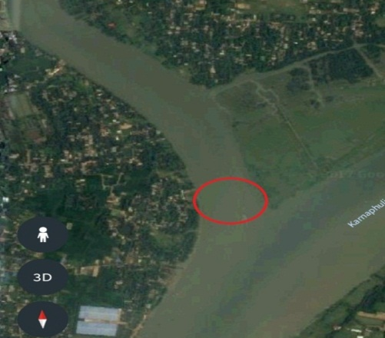
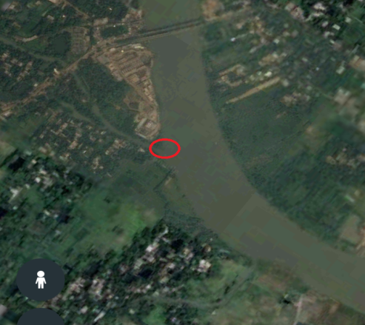

Figure 2: Base map of Khondokiakhal of Halda River

Figure 1: Base map of Estuary (karnafully, kalurghat)

Figure 4: Base map Sattarghat of Halda River
Figure 3: Base map of Modunaghat of halda River

3.1.2 Sample collection: Samples were collected both for water quality parameters and plankton. The samples was be kept in the plastic container and carried out to the aquatic ecology lab, Faculty of Fisheries, CVASU; for further analyses.
3.2 Studies on Water Quality Parameter
3.2.1 Procedure of Study
This research was done for six month. Six samples were collected in each of the month of research time frame. Sample was collected from each four points mentioned above both for planktons and water quality assessment. In every sample, water quality parameters such as Dissolve oxygen (DO), pH, Alkalinity, CO₂, Turbidity, Temperature (Both water and air), Depth of the sampling area, was measured and recorded.
A table is give below to describe methodology of this research. The following outlines helps to achieve the research objectives and logical order of the study-

Table 1: Total research procedure

Steps | Description
- Taking preparation to for sample | Necessary equipment was carried to collect sample such as pH meter, thermometer, DO meter, measuring tape, sechi disc, rope, sampling bottle and formalin etc.
- Collection of sample | At first water was collected to measure the water quality (mentioned above) and planktons in the lab in the lab. Water was collected from four places. Turbidity, Temperature (Both water and air), Depth of the sampling area and pH was be recorded in the spot.
- Assessing water quality in the lab | Carbon di oxide, Dissolve oxygen, and Alkalinity were measured in the lab by using renowned method which is practiced in lab. ( Rahman, 1992)
- Identifying the phytoplankton and zooplankton in lab | At first microscope was set. Then phytoplankton and Zooplankton were identified by observing the under microscope.
- Counting planktons in the lab | The numbers of phytoplankton and zooplankton were measured by counting 10 quadrates of sedgwick rafter cell. ( Rahman, 1992)
- Data collection | The data on water quality parameters, species of planktons and number of each species was recorded.
- Reporting | Final step for conducting this research was to make an overall report where all data was included Sequentially and statistically.

3.2.2 Assessment of Water quality parameters
Different water quality parameters was assessed in following ways-
3.2.2.1 Determination of water temperature
Water temperature was determined by using a Celsius thermometer.
      - Determination of pH
pH was measured by using a Hannah pen pH meter.
      - Determination of Transparency
Transparency was measured by using a secchi disk of 20 cm diameter equipped with graduated ropes.
      - Determination of Carbon-di-Oxide ( CO₂)
It was determined in the laboratory by using following procedure-
- At first 50ml water was taken in a conical flask
- Then 2-4 drops of phenolphthalein indicator was given in flasks. When color became pink then NaOH was added to determined amount of free CO₂.
- NaOH was added to the flask from a burette.
Specific table and calculating equation were used to determine the amount fee CO_{2.} Following equation was used

Calculation: We will calculate the amount free CO₂ by using following equation
ml of NaOH used× (N) of NaOH × Molecular wt. of NaOH×1000
= ------------------------------------------------------------------------------------
Sample Volume

      - Determination of Dissolve Oxygen
It will be determined in the laboratory by using following procedure (Winkler method)-
- At first, sample was collected sample from the surface of water body
- Then 2ml of Manganese sulphate was added to the water sample
- After that 2ml of Alkali-Iodide was added to the solution
- Then 2ml of Concentrated Sulpheuric Acid ( H₂SO₄) was also added
- After that 102 ml sample was titrated with sodium thiosulphate (Na₂S₂O₃). Sodium thiosulphate was preliminary set in burette
- At last 2ml of starch was added
- Specific table and calculating equation of winkler method were used to determine the amount of sodium thiosulphate which indicated the amount of dissolve oxygen. Following equation was used

ml of Na₂S₂O₃ × (N) of Na₂S₂O₃ × ml. equivalent wt. of O₂ ×1000
= -----------------------------------------------------------------------------------
Volume of sample

      - Determination of Alkalinity
It was determined in the laboratory by using following procedure-
- At first, Sample was collected from the surface of water body
- Then 50ml of water sample was taken in beaker
- After that 2-4 drops of Phenolphthalein indicator were added to the sample. The color didn’t change. It indicated that Phenolphthalein Alkalinity was absent.
- Again 50ml of water sample was taken in beaker
- After that 2-4 drops of Methyl Orange indicator were added to the sample. The coloe turned into yellow.
- Then burette was filled with Sulphuric acid.
- After that the contents was titrated against Sulphuric acid (0.02N), it was continued until color changed pink.
- After that the contents was again titrated with Sulphuric acid, it was continued until the color changed to red
- At last, Alkalinity was calculated
3.3 STUDY OF PLANKTON
Sample was collected from different spawning ground for qualitative and quantitative, study of plankton. Ten litters of water collected from each sampling area by using Kemmerer water sampler and passed through the plankton net. The mesh size of plankton net was 25µm. The collected sample (10liters) was concentrated into 50ml. Then the concentrated sample was preserved by using 5% formalin solution for further study.
3.3.1 Qualitative and quantitative determination of Phytoplankton
At first water sample was collected from four spawning ground of Halda River and carried out to laboratory. The sample was taken into the counting plate and cover slip was used to cover slide. After that different species of phytoplankton zooplankton was identified by using specific catalogue. The slide was taken under microscope at 10X power. For quantitative determination, S-R cell was used. Sample was taken in the S-R cell in the same way of qualitative method and placed under microscope at10X. There were about 1000 quadrates (square) in the S-R cell. Ten squares of S-R cell were counted. The number of plankton cell was calculated in the counting plate. Then the total number of plankton cell was calculated in the sample water by using following equation-

Calculation
The following formula (Rahman, 1992) was used to count plankton:
F*C
Number of plankton, N = ----------- * 1000
F*V*L

Where,
V = Volume of the S-R cell field
F = Number of field count
C = Volume of final concentration of sample
A = Total no. of plankton counted
L = Volume of original water
N = Number of plankton cells per liter

3.3.2 Qualitative and quantitative determination of Zooplankton
- Sample water was mixed with 1.5 ml Lucas reagent and kept in 100ml in a biker.
- Then was poured on S-R (sedgwick rafter) cell.
- Then it was set up with microscope to identify different species of zooplankton. Thus, a series of pencil and ink drawing on postcards of the species of the observed were prepared to identify the organisms.
- Counting plankton, the Sedgwick-Rafter (S-R) cell was used which is 50 mm long, 20 mm wide and 1 mm deep.
- Before filling the S-R cell with sample, the cover glasses were diagonally placed across the cell and then samples was transferred with a large bore pipette so that no air bubbles in the cell covers were formed.
- The S-R cell will let standard for at least 15 minute to settle plankton. Then plankton on the bottom of the S-R cell was counted enumerated by compound microscope.
- By moving the mechanical stage, the entire bottom of the slide area was examined carefully. Organisms lying between two parallel cross hairs were counted as they passed a vertical line. Number of plankton (Phytoplankton and Zooplankton) in the Physico-chemical parameters

3.4 Analysis of Data: All experimental results were analyzed by using Microsoft excel (Microsoft 2010)

Photo Gallery
- Phytoplankton
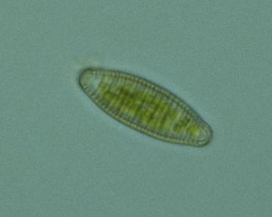
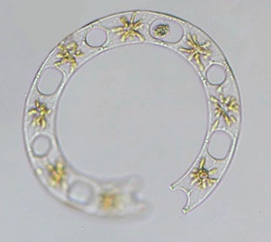
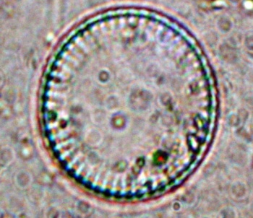

Plate 1: Cyclotella sp.
Plate 3: Diatoma sp.
Plate 2: Eucampia sp.

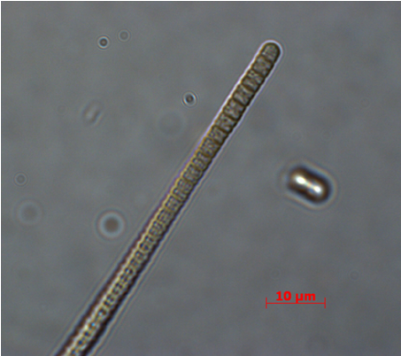

Plate: 5 Protoperidium sp.

P
P sp
Plate 4: Oscillatoria sp.
Plate 6: Navicula sp.

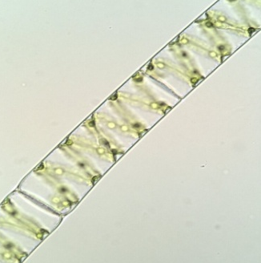
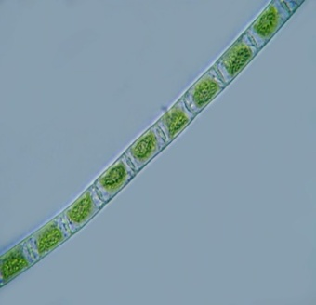
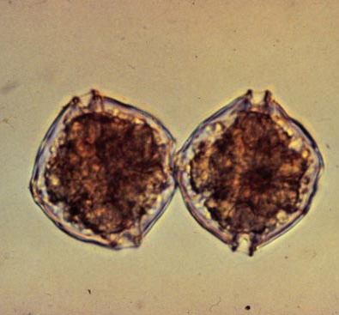

Plate 8:
Ulothrix sp.
Plate 9: Spyrogyra sp.
Plate 7: Alexandrium sp.

Photo Gallery (Cont’d)
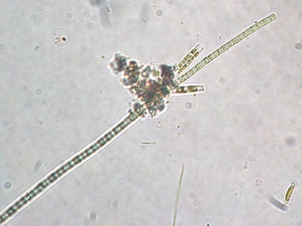
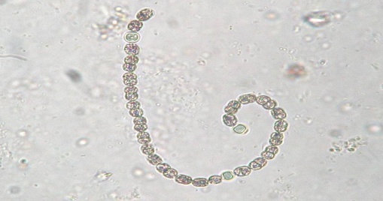
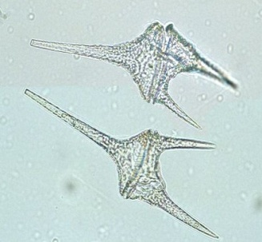

Plate 12: Aphanizomenon sp.
Plate 11: Anabaena sp.
Plate 10: Ceratium sp.
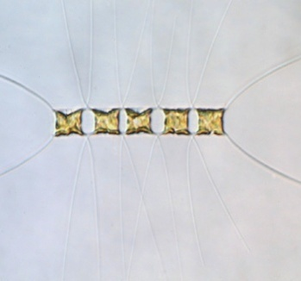
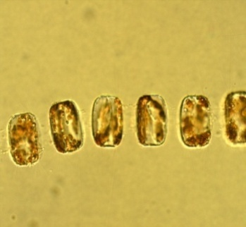

Plate 14: Coscinodiscus sp.
Plate 1 5: Chaetocheros sp.
Plate 1 3: Thalassiosira sp.

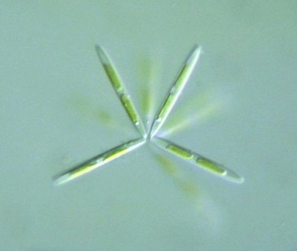
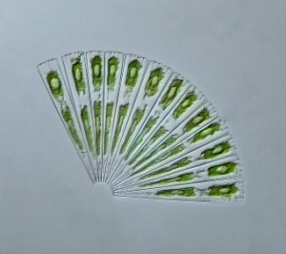
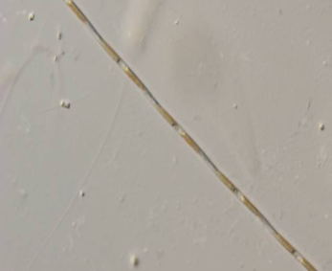

Plate 18: Licomphora sp.
Plate 17:
Bacillaria sp.
Plate 16: Nitzchia sp.

Plate 19: Chlorella sp.

Photo Gallery (Cont’d)
- Zooplankton
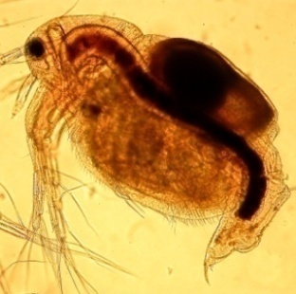
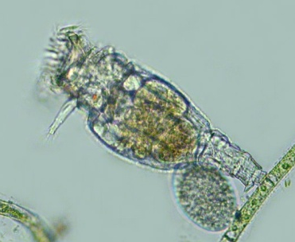
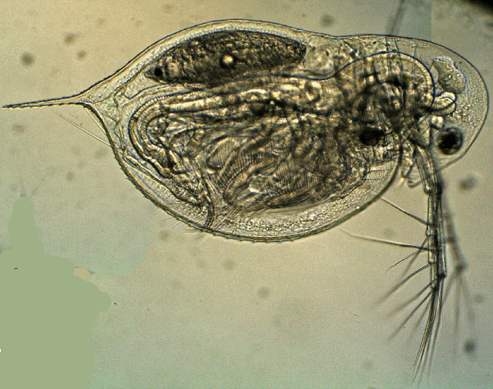

Plate 1: Daphnia sp.
Plate 3: Moyna sp.
Plate 2:
Philodina sp.

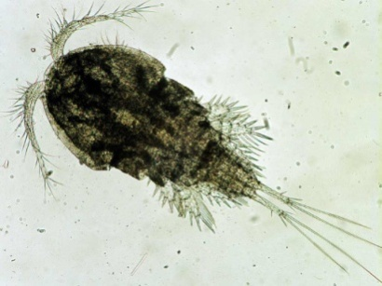
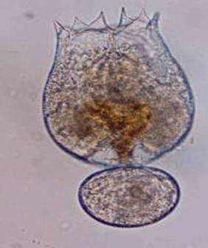

Plate 5: Cyclops sp.
Plate 4: Brachionus sp.

- Photo of working in the lab
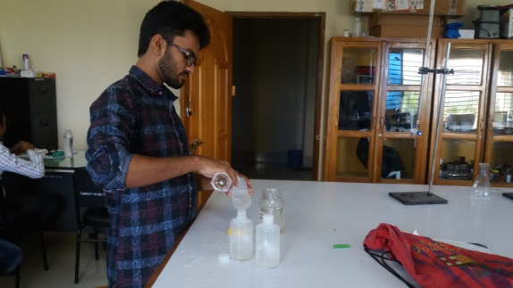
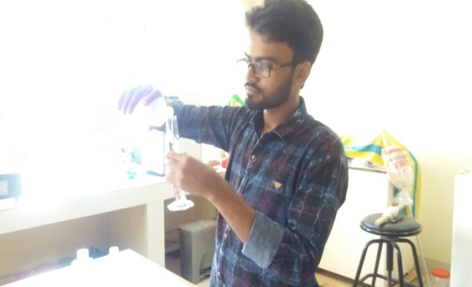

Plate 2: Mixing Chemical
Plate 1: Taking sample

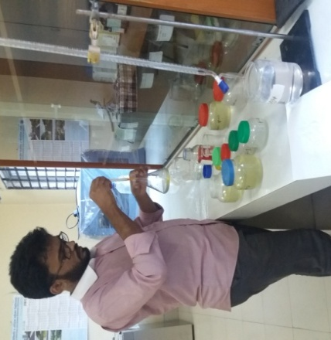
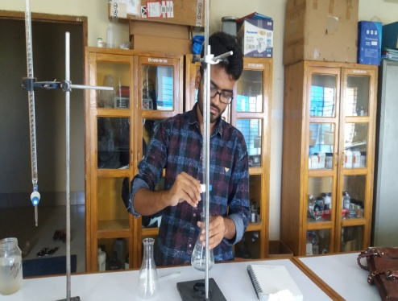

Plate 3: Titrating the sample
Plate 4: Titrating the solution
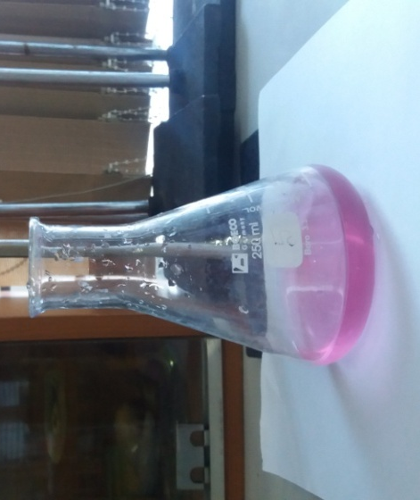
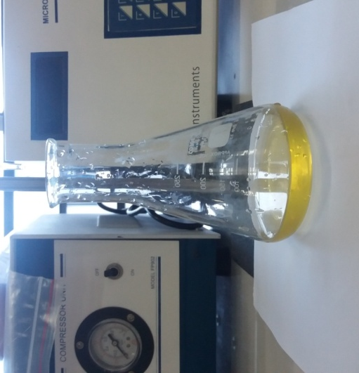

Plate 6: Solution after titration for CO₂
Plate 5: Solution after titration for alkalinity

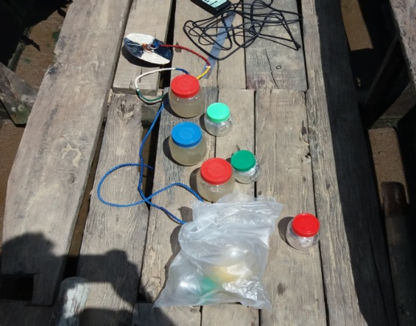
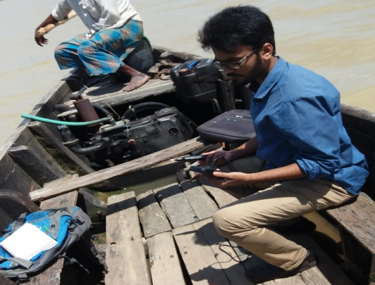

Plate 8: Making DO meter ready
Plate 7: Instrument for sample collection
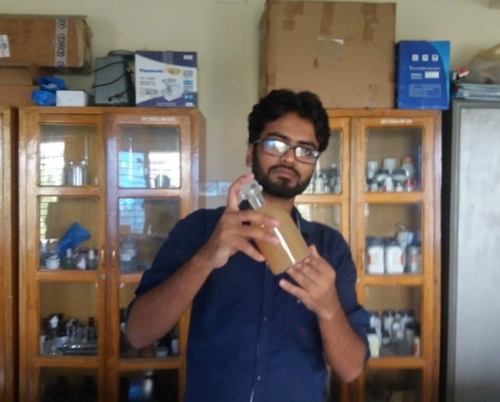
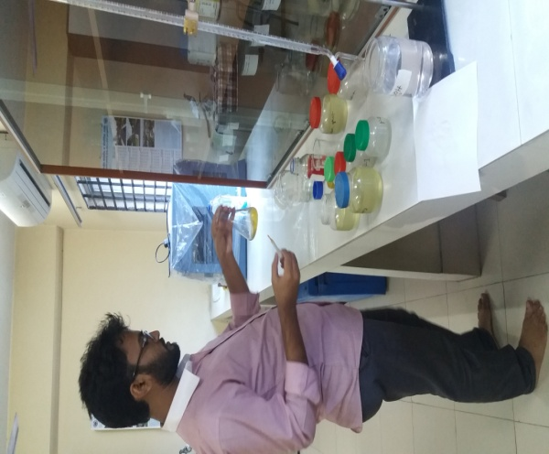

Plate 10: Mixing indicator with sample
Plate 9: Preparing solution for dissolve oxygen measurement

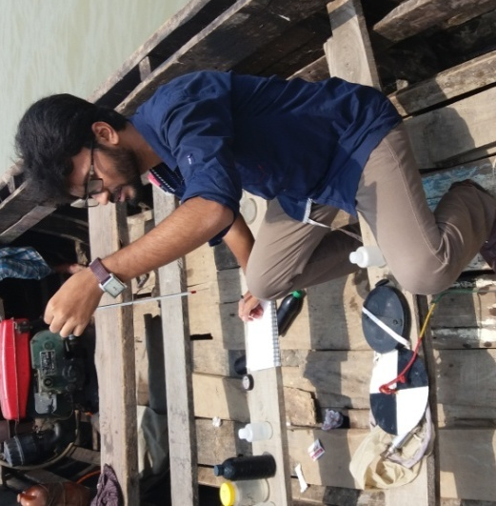
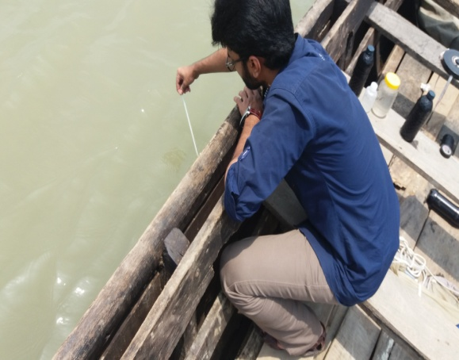

Plate 11: Measuring water temperature
Plate 11: Measuring air temperature
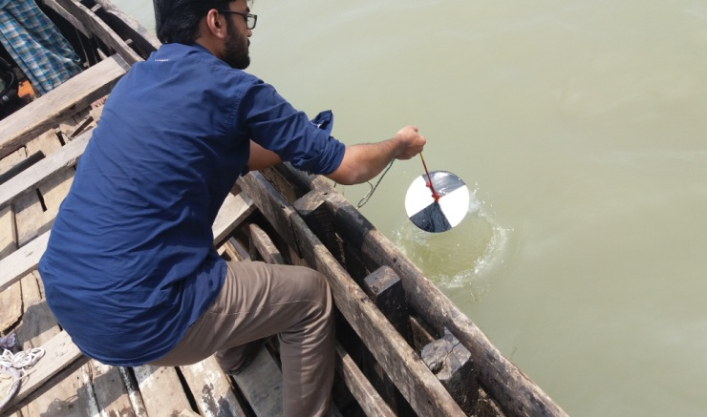
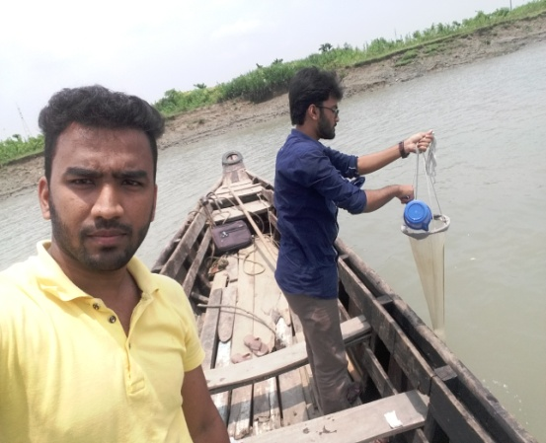

Plate 13: Measuring transparency
Plate 12: Taking sample for phytoplankton

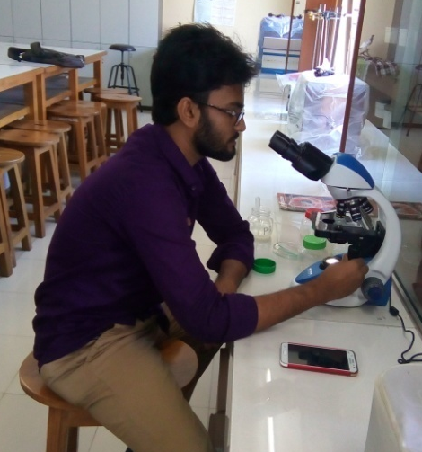
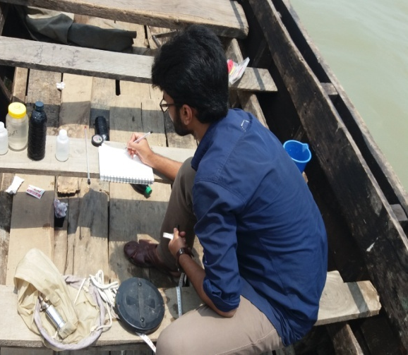

Plate 15: Preparing microscope
Plate14: Inputting data
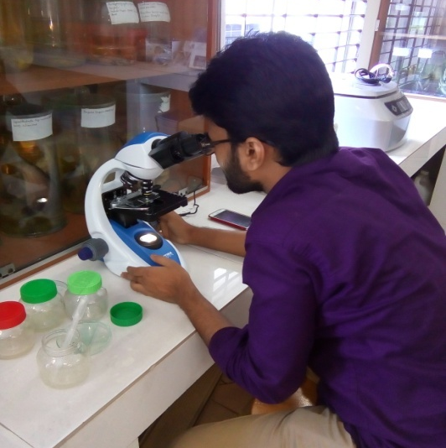

Plate 17: Assessing plankton
Plate 16: Assessing plankton

CHAPTER: 4
Results
The results of physico-chemical characteristics of water of four different spawning grounds in Halda River are shown in different table and graphs.
4.1 Water Quality Parameters
4.1.1 Temperature
The value of temperature ranged from 27⁰C to 32⁰C, 27⁰C to 31⁰C, 27⁰C to 31⁰C, 27⁰C to 31⁰C in Estuary, Khondokiakhal, Modunaghat and Sattarghat respectively. And the mean temperature ranges 29.97⁰C, 29.7⁰C, 29.72⁰C and 29.63⁰C in Estuary, Khondokiakhal, Modunaghat and Sattarghat respectively. Highest temperature was recorded in August and the lower temperature was recorded in July. Monthly variations of temperature in different spawning grounds have been shown in Table 2 and relationship between temperature and time with different places is shown in figure 5 below.

Figure 5: Monthly variation of Temperature in four different spawning grounds

4.1.2 Transparency
Transparency showed variations at different month of sampling as well as in spawning ground. It ranged from 12cm to 28cm, 15cm to 18.25cm, 17cm to 33.75cm and 15cm to 38cm in Estuary, Khondokiakhal, Modunaghat and Sattarghat respectively. The mean value was found 24.42cm, 15.33cm, 29.46cm, and 28.83cm. Water was highly transparent during June and turbidity was found in May. Khondokiakhal has highly turbid water and Sattarghat had the lowest. Monthly variation of transparency in different spawning grounds have been shown in table 2 and relationship between transparency and time with different places is shown in figure 6 below-

Figure 6: Monthly variation of Transparency in four different spawning grounds
Table 2: The average value of water quality parameters in Halda River
Parameters  Locations | pH | DO  (mg/L) | CO₂  (mg/L) | Alkalinity  CaCO₃ mg/L | Temperature  (⁰c) | Transparency  (cm)
Estuary (Karnafully) | 6.75 | 7.2 | 5.73 | 52.74 | 29.97 | 24.42
Khondokiakhal | 6.53 | 5.68 | 6.23 | 52.7 | 52.7 | 15.33
Maodunaghat | 6.87 | 6.83 | 5.16 | 55.49 | 29.72 | 29.46
Sattarghat | 6.8 | 6.25 | 4.98 | 57.15 | 29.63 | 28.83

4.1.3 Dissolved Oxygen
Dissolved Oxygen expresses with DO. The value of dissolve oxygen ranged from 6.5 to 7.2, 6.3 to 6.9, 6.4 to 7.3 and 6.5 to 7.3 mg/l in Estuary, Khondokiakhal, Modunaghat and Sattarghat respectively. The average found 6.75, 6.53, 6.87, and 6.80 mg/l. Highest dissolved oxygen was found in estuary in June and the lowest dissolved oxygen found in Khondokiakhal during May. Monthly variation of dissolved oxygen in different spawning grounds have been shown in table 2 and relationship between Dissolve Oxygen and time with different places is shown in figure 7 below.

Figure 7: Monthly variation of dissolve oxygen in four different spawning grounds
4.1.4 pH
The value of pH ranged from 5.5 to 7.8, 4.9 to 5.9, 5.8 to 6.7 and 5.9 to 7.34 in Estuary, Khondokiakhal, Modunaghat and Sattarghat respectively. The average found 6.5, 5.68, 6.83, and 6.35. Highest pH was found in both Modunaghat and Sattarghat in June and the lowest pH found in Khondokiakhal during July. Monthly variation of pH in different spawning grounds have been shown in table 2 and relationship between pH and time with different places is shown in figure 8 below-

Figure 8: Monthly variation of pH in four different spawning grounds
4.1.5 Total Alkalinity
The concentration of total alkalinity was not so much higher in those spawning ground from where sample was taken. It varied from 36 to 65.5, 37.5 to 63.9 33.33 to 66.80 and 35.33 to 66.1 mg/l in Estuary, Khondokiakhal, Modunaghat and Sattarghat respectively. The averages found 52.74, 52.70, 55.49, and 57.15 mg/l. Monthly variation total alkalinity in different spawning grounds have been shown in table 2 and relationship between total alkalinity and time with different places is shown in figure 9 below.

Figure 9: Monthly variation of total alkalinity in four different
spawning grounds

4.1.6 Free Carbon-di-oxide
Free Carbon-di-oxide express with CO₂. The value of dissolve oxygen ranged from 4.5 to 8.2, 5 to 9.5, 4.2 to 7.9 and 7.1 to 7.21 mg/l in Estuary, Khondokiakhal, Modunaghat and Sattarghat respectively. The average found 5.73, 6.23, 5.16, and 4.98 mg/l. Highest Carbon-di-oxide was found in Khondokiakhal in April during my first sampling and the lowest Carbon-di-oxide found in Sattarghat in September during last sampling of my research. Monthly variations of free Carbon-di-oxide in different spawning grounds have been shown in table 2 and relationship between Free Carbon-di-oxide and time with different places is shown in figure 10 below.
Figure 10: Variation of free carbon-di-oxide in four different spawning grounds
4.2 Plankton population
Phytoplankton population of experimented spawning grounds were enumerated and identified up to genera. It was composed of 20, 14, 19, and 20 genera in Estuary, Khondokiakhal, Modunaghat and Sattarghat respectively. Zooplankton plankton population was also identified. It was composed of 4, 4, 5, and 5 genera in Estuary, Khondokiakhal, Modunaghat and Sattarghat respectively. Five phytoplankton classes and four Zooplankton classes were identified. The number, percentage and presence of different planktonic species have been shown below with table chart and diagram etc.
The number of phytoplankton species in one liter was varied from 39 to 68, 15 to 44, 44 to 79 and 50 to 79 cell/l in Estuary, Khondokiakhal, Modunaghat and Sattarghat respectively during six months experiment. Highest number of cells/L was found in Modunaghat and Sattarghat in May and July respectively.
The phytoplankton communities in Halda River in sixth month of sampling were composed of 20 genera of 5 divisions. Division Bacillariophyceae had the highest number of species (11 species), followed by the division 3, 3, 3, and 1 species Chlorophyceae, Cyanophyta, Dinophyceae and Pyrrophyta. The maximum species number of phytoplankton at any sampling time was 17 species, which was recorded in July Species lists and abundance of phytoplankton are presented in Table below. The total number of phytoplankton ranged from a low density, 15 individual/ ml in April to 79 individual /ml in both May and June.
The Zooplankton communities in Halda River in sixth month of sampling were composed of 5 genera of 3 divisions. Division Cladocera had the highest number of species (2), followed by the 1 and 1 divisions of Copepoda and Rotifera. The maximum 4 species Zooplankton was recorded in June. Lists and abundance of phytoplankton are presented in Table below 3 to 6. The total number of Zooplankton ranged from 3 in April to 10 individuals/ ml in June.

4.2.1 Classes of Plankton
There are two types of planktons in water body such as phytoplankton and Zooplankton. Both planktons are described below

4.2.1.1 Phytoplankton
The class of phytoplankton was Bacillariophyceae, Chlorophyceae, Pyrrophyceae, Cyanophyceae, and Dinophyceae. On the other hand the class of zooplankton was Copepoda, Cladocera, Rotifera.

4.2.1.1.1 Bacillariophyceae
Under this group 11, 9, 10, and 11 genera were identified from four spawning ground namely Estuary, Khondokiakhal, Modunaghat and Sattarghat respectively. Among them Coscinodiscuss, Cyclotella, Thalassiosira, Eucampia, Spyrogyra were the most dominant groups in four spawning grounds. Monthly variation of this genera is shown in figure 11.

Figure 11: Monthly variation of Bacillariophyceae in four spawning grounds
4.2.1.1.2 Chlorophyceae
Under this group 3, 2, 3, and 3 genera were identified from four targeted spawning groundsrespectively. Among these Chlorella, Oscillatoria were more dominant species in four spawning grounds and Ulothrix was less dominant. Monthly variation of this species is shown in figure12.

Figure 12: Monthly variation of Chlorophyceae in four spawning grounds
4.2.1.1.3 Cyanophyceae
Under this group 3, 1, 2, and 3 genera were identified from four spawning ground namely Estuary, Khondokiakhal, Modunaghat and Sattarghat respectively. Among them Oscillatoria, and Aphanizomenon were comparatively dominant species than Anabaena in four spawning grounds. Monthly variation of this species is shown in figure13.

Figure 13: Monthly variation of Chlorophyceae in four spawning grounds

4.2.1.1.4 Dinophyceae
Under this group 2, 1, 2, and 2 genera were identified from four spawning grounds namely Estuary, Khondokiakhal, Modunaghat and Sattarghat respectively. Among them Ceratium and Alexandrium were rare species in four spawning grounds. 18 individual of Ceratium sp. and 16 individual of Alexandrium sp. from four spawning ground iover six months. Monthly variation of this species is shown in figure14.

Figure 14: Monthly variation of Dinophyceae in four spawning grounds
4.2.1.1.5 Pyrrophyceae
Only one genus was identified of this class. That identified species was Protoperidinium. This class was not so much dominant.
4.2.1.2 Zooplankton
The class of zooplankton was Copepoda, Cladocera, Rotifera. Under these three classes five genus were identified namely Philodina sp., Cyclops sp., Moyna sp., Daphnia sp. and Brachionus sp.

4.2.1.2.1 Cladocera
Under this group 2, 1, 2, and 2 genera were identified from four spawning grounds namely Estuary, Khondokiakhal, Modunaghat and Sattarghat respectively. Cyclops was identified from these locations. This species was dominant over four spawning grounds. Monthly variation of this species is shown in figure15.

Figure 15: Monthly variation of Cladocera in four spawning grounds
4.2.1.2.2 Copepoda
Under this group, 1 genera from each area were identified from four spawning ground namely Estuary, Khondokiakhal, Modunaghat and Sattarghat respectively. Among them Philodina, Cyclops and Moyna were more dominant species in four spawning grounds and Daphnia was less dominant. Monthly variation of this species is shown in figure16.
.
Figure 16: Monthly variation of Copepoda in four spawning grounds
4.2.1.2.3 Rotifera
Under this group 2, 1, 2, and 2 genera were identified from four spawning ground namely Estuary, Khondokiakhal, Modunaghat and Sattarghat respectively. Cyclops was identified from these locations. This species was dominant in four spawning grounds. Monthly variation of this species is shown in figure17.

Figure 17: Monthly variation of Rotifer in four spawning grounds
4.3 Monthly variation of phytoplankton and Zooplankton species in Halda River
Phytoplankton and Zooplankton numbers were not same at every month. There was variation in every month. Variations of planktons in different locations are shown in table 3 to 6.
4.3.1 Monthly variation in phytoplankton and Zooplankton species in Estuary (Karnafully, Kalurghat) of Halda River
The number of species was varied from time to time in Estuary (Karnafully, Kalurghat). These variations are shown in table 3 and relationship between species name and species number in estuary is shown in figure 18.

Table 3: Total number of phytoplankton class and genera shown for 10L water which was concentrated to 50ml
Class | Genus | Apr. | May | Jun. | Jul. | Aug. | Sep.
Bacillariophyceae | Coscinodiscuss | + | + | + | + | + | +
 | Cyclotella | + | + | + | + | +
 | Thalassiosira | + |  | + | + |  | +
 | Chaetocheros |  | + |  | + | + | +
 | Eucampia |  |  | + |  | +
 | Diatoma | + | + |  | + | + | +
 | Spyrogyra | + |  | + | + | + | +
 | Navicula |  | + | + | +
 | Nitzchia | + | + | + |  | + | +
 | Bacillaria |  |  |  |  | +
 | Licomphora | + | + | + | + | + | +
Chlorophyceae | Chlorella | + | + | + | + | + | +
 | Ulothrix | + | + | + | + |  | +
 | Oscillatoria | + | + |  | + | + | +
Pyrrophyceae | Protoperidinium | + | + | + | +
Cyanophyceae | Oscillatoria | + | + | + | + | + | +
 | Anabaena | + |  | + |  | + | +
 | Aphanizomenon |  | + | + | + | + | +
Dinophyceae | Ceratium |  | + |  | +
 | Alexandrium |  |  |  |  | +
Total no. genus |  | 13 | 14 | 15 | 16 | 15 | 13
Zooplankton
Copepoda | Cyclops |  | + |  | + | +
Cladocera | Daphnia sp. |  |  | + | + |  | +
 | Moyna sp. | + | + | + |  | + | +
Rotifera | Brachionus sp. |  | + | + | + | + | +
 | Philodina sp. | + | + | + | + | + | +
Totalspecies |  | 2 | 4 | 4 | 4 | 4 | 4

N.B. (+) indicates the presence of species

Figure 18: Number of different species in Estuary

4.3.2 Monthly variation in phytoplankton species in Khondokiakhal of Halda River
The number of species was varied from time to time in Khondokikhal. These variations are shown in table 4and relationship between species name and species number in estuary is shown in figure 19.

Table 4: Total numbers of phytoplankton class and genus is shown for 10L water which was concentrated to 50ml
Class | Genus | Apr. | May | Jun. | Jul. | Aug. | Sep.
Bacillariophyceae | Coscinodiscuss | + | + |  | + | + | +
 | Cyclotella |  | + | + | + | +
 | Thalassiosira | + |  | + | + |  | +
 | Chaetocheros
 | Eucampia |  |  | + |  | + | +
 | Diatoma | + | + | + | +
 | Spyrogyra | + |  | + | + |  | +
 | Navicula |  | + | + | +
 | Nitzchia
 | Bacillaria |  | + | + |  | +
 | Licomphora |  |  |  | + | + | +
Chlorophyceae | Chlorella | + | + | + | +
 | Ulothrix | + | + | + |  |  | +
 | Oscillatoria | + | + |  | + | + | +
Pyrrophyceae | Protoperidinium
Cyanophyceae | Oscillatoria | + | + | + | + | + | +
 | Anabaena | + |  | + |  | + | +
 | Aphanizomenon |  | + | + |  | + | +
Dinophyceae | Ceratium |  | +
 | Alexandrium |  |  | + | + | +
 | Protoperidium
Total no. species |  | 10 | 11 | 12 | 11 | 10 | 10
Zooplankton
Copepoda | Cyclops | + | + |  | + | +
Cladocera | Daphnia sp. |  |  | + | + |  | +
 | Moyna sp. | + |  | + |  | + | +
Rotifera | Brachionus sp. |  | + | + |  | + | +
 | Philodina sp. |  | + | + | + | + | +
Total species |  | 2 | 3 | 4 | 3 | 4 | 4

N.B. (+) indicates the presence of species

Figure 19: Number of different species in Khondokiakhal

4.3.3 Monthly variation in phytoplankton species in Modunaghat of Halda River
The number of species was varied from time to time in Modunaghat. The number of species was varied from time to time in Modunaghat. These variations are shown in table 5 and relationship between species name and species number in estuary is shown in figure 20.
Table 5: Total number of phytoplankton class and genera shown for 10L
water which was concentrated to 50ml
Class | Genus | Apr. | May | Jun. | Jul. | Aug. | Sep.
Bacillariophyceae | Coscinodiscuss | + | + | + | + | + | +
 | Cyclotella | + | + | + | + | + | +
 | Thalassiosira | + |  | + | + |  | +
 | Chaetocheros |  | + |  | + | + | +
 | Eucampia |  |  | + |  | +
 | Diatoma | + | + |  |  | + | +
 | Spyrogyra | + |  | + | + | + | +
 | Navicula |  | + | + | +
 | Nitzchia | + |  | + |  | + | +
 | Bacillaria |  |  |  |  | +
 | Licomphora | + | + | + | + | + | +
Chlorophyc-eae | Chlorella | + | + | + | + | + | +
 | Ulothrix | + | + | + |  |  | +
 | Oscillatoria | + | + |  | + | + | +
Pyrrophycea-e | Protoperidinium | + |  | + | +
Cyanophyce-ae | Oscillatoria | + | + | + | + | + | +
 | Anabaena | + |  | + |  | + | +
 | Aphanizomenon |  | + | + | + | + | +
Dinophycea-e | Ceratium |  | + |  | +
 | Alexandrium | + |  |  |  | +
Total no. genera |  | 14 | 12 | 14 | 13 | 15 | 14
Zooplankton
Copepoda | Cyclops | + | + | + | + | + | +
Cladocera | Daphnia sp. |  | + | + | + |  | +
 | Moyna sp. | + | + |  | + | +
Rotifera | Brachionus sp. |  | + | + |  | + | +
 | Philodina sp. | + | + | + | + | + | +
Total species |  | 3 | 5 | 4 | 5 | 4 | 4

N.B. (+) Indicates the presence of species

Figure 20: Number of different species in Modunaghat
4.3.4 Monthly variation in phytoplankton genera in Sattarghat of Halda River
The number of species was varied from time to time in Sattarghat. These variations are shown in table 5 and relationship between species name and species number in estuary is shown in figure 21.

Table 6: Total number of phytoplankton class and genera shown for 10L water which was concentrated to 50ml
Class |  | Genus | Apr. | May | Jun. | Jul. | Aug. | Sep.
Bacillariophyceae |  | Coscinodiscuss | + | + | + | + |  | +
 |  | Cyclotella | + | + | + | + | +
 |  | Thalassiosira | + |  | + | + |  | +
 |  | Chaetocheros |  | + |  | + | + | +
 |  | Eucampia |  |  | + |  | +
 |  | Diatoma | + | + |  | + | + | +
 |  | Spyrogyra | + |  | + | + | + | +
 |  | Navicula |  | + | + | +
 |  | Nitzchia |  | + | + |  | + | +
 |  | Bacillaria |  |  |  |  | +
 |  | Licomphora | + | + | + | + | + | +
Chlorophyceae |  | Chlorella | + | + | + | + | + | +
 |  | Ulothrix | + | + | + | + |  | +
 |  | Oscillatoria | + | + |  | + | + | +
Pyrrophyceae |  | Protoperidinium | + | + | + | +
Cyanophyceae |  | Oscillatoria | + | + | + | + | + | +
 |  | Anabaena | + |  | + |  | + | +
 |  | Aphanizomenon |  | + | + | + | + | +
Dinophyceae |  | Ceratium |  | + |  | +
 |  | Alexandrium | + | + |  | + | + | +
Total no. genera |  |  | 13 | 15 | 15 | 17 | 16 | 14
Zooplankton
Copepoda | Cyclops |  | + | + | + | + | +
Cladocera | Daphnia sp. |  | + | + | + | + | + | +
 | Moyna sp. |  | + | + | + |  | + | +
Rotifera | Brachionus sp. |  |  | + | + | + |  | +
 | Philodina sp. |  | + | + | + | + | + | +
Total genera |  |  | 4 | 4 | 5 | 4 | 5 | 4

N.B. (+) indicates the presence of species

Figure 21: Number of different genera in Sattarghat
4.4 Variation of Zooplankton species number
Number of phytoplankton genera was varied from time to time in four spawning ground. Monthly variation in number of species in Halda River is shown in table 7. Relationship between numbers of species with the time in different locations is shown in figure 22.
Table 7: Variation of species number in four spawning ground
Month | April | May | June | July | August | September
Estuary | 13 | 14 | 15 | 16 | 15 | 13
Khondokiakhal | 10 | 11 | 12 | 11 | 10 | 10
Modunaghat | 14 | 12 | 14 | 13 | 15 | 14
Sattarghat | 13 | 15 | 15 | 17 | 16 | 14

Figure 22: Monthly variation of genera number of Phytoplankton in Halda River
4.5 Variation of number of individual phytoplankton (cells/L)
Number of total phytoplankton was varied from spatially and temporally. The highest number of phytoplankton was identified in Sattarghat at September and the lowest number of phytoplankton was identified in Khondokiakhal at April. Monthly variation in number of species in Halda River is shown in table 8. Relationship between numbers of species with the time in different locations is shown in figure 23.
Table 8: Total number of individual of different species in 1 liter of four spawning ground is shown in table below-
Location  Months | Estuary | khondokiakhal | Modunaghat | Sattarghat
April | 39 | 15 | 44 | 50
May | 58 | 33 | 65 | 79
June | 68 | 44 | 60 | 62
July | 58 | 38 | 79 | 66
August | 61 | 31 | 69 | 59
September | 63 | 33 | 70 | 63

The variation of total number of individual of different species in 1 liter of four spawning grounds is shown graphically-

Figure 23: Total number of identified genera from every experimented area
From the graph, it is clear that highest number of phytoplankton individual was found in Sattarghat. And lowest number of species was found in khondokiakhal
4.6 Total identified phytoplankton species
Twenty (20) species were identified from those four spawning grounds. Among them Coscinodiscuss was the most abundant in Halda River. Chlorella and Cyclotella were also abundant in the Halda River. A list of species of phytoplankton and total number of phytoplankton individual which were identified from six sampling is shown in table 9 and species name number and species name shown graphically in figure 24 below-
Table 9: Total number of an individual phytoplankton species
Location  Months |  | Estuary | Khondokiakhal | Modunaghat | Sattarghat | Total
1 | Coscinodiscuss | 85 | 37 | 88 | 75 | 285
2 | Cyclotella | 48 | 21 | 45 | 48 | 162
3 | Thalassiosira | 21 | 7 | 27 | 18 | 73
4 | Chaetocheros | 27 | 11 | 29 | 16 | 83
5 | Eucampia | 10 | 9 | 11 | 15 | 45
6 | Diatoma | 15 | 9 | 16 | 18 | 58
7 | Spyrogyra | 10 | 9 | 11 | 16 | 46
8 | Navicula | 13 | 10 | 13 | 17 | 53
9 | Nitzchia | 12 | 6 | 12 | 11 | 41
10 | Bacillaria | 5 | 2 | 5 | 7 | 19
11 | Licomphora | 6 | 5 | 8 | 6 | 25
12 | Chlorella | 36 | 25 | 40 | 52 | 153
13 | Ulothrix | 12 | 9 | 15 | 17 | 51
14 | Oscillatoria | 15 | 10 | 17 | 19 | 61
15 | Protoperidinium | 7 | 5 | 10 | 7 | 29
16 | Oscillatoria | 10 | 8 | 13 | 10 | 41
17 | Anabaena | 9 | 6 | 13 | 9 | 41
18 | Aphanizomenon | 6 | 3 | 8 | 5 | 19
19 | Ceratium | 5 | 1 | 6 | 6 | 18
20 | Alexandrium | 4 | 1 | 6 | 5 | 16

Coscinodiscuss was abundant in Halda River. As a result, A lot of individual of this species was identified from four spawning ground during six sampling. So, number of different species has been shown in a graph 24.

Figure 24: Number of different genera in the river

4.6.1 Percentages of different phytoplankton species
A pie chart was prepared to measure the percentages of different species in Halda River. Percentage was calculated from table 9. From pie chart, it is clear that about 22% of total identified species was Coscinidiscus. Ceratium and Alexandrium were the lowest. They are less dominant in Halda River. They composed of only 1% of total identified species in Halda River. Percentage is shown in figure 25.
The pie chart related with the percentages of different species is shown below-

Figure 25: Percentage of different phytoplankton species

4.7 Variation of number of zooplankton genus
Five genus of zooplankton was identified during study. Highest number of genus was identified in Modunaghat during forth sampling at July. Five species was also identifies in Sattarghat during third sampling at June. Number of species in different locations is shown in table 10. Number of Zooplankton species was varied from time to time in four spawning ground. Relationship between zooplankton numbers with time is shown in figure 26.

Table 10: Monthly variation in number of species in Halda River is shown below-
Month | Apr. | May | Jun. | Jul. | Aug. | Sep.
Estuary | 2 | 4 | 4 | 4 | 4 | 4
Khondokiakhal | 2 | 3 | 4 | 3 | 4 | 4
Modunaghat | 3 | 5 | 4 | 5 | 4 | 4
Sattarghat | 4 | 4 | 5 | 4 | 5 | 4

These variation in number of species of zooplankton in different sampling month in four spawning ground

Figure 26: Monthly variation of species number of Zooplankton in Halda River
4.7.1 Percentages of different Zooplankton Species
Five species was identified from four spawning ground of Halda river. Among them, Philodina was more abundant. About 27% of total identified individual was Philodina. Daphina was less abundant among identified species. Percentages were calculated from table 10. Percentages of five different species is shown in figure 27 below-

Figure 27: Percentage of different phytoplankton species

4.8 Variation of number of individual of zooplankton Genus (cells/L)
Number of total Zooplankton was spatially and temporally. The highest number of Zooplankton was identified in Modunaghat at June and the lowest number of phytoplankton was identified in Khondokiakhal both at April and August. Number of Zooplankton individual of different species in 1 liter is shown in table 11. The relationship between total number of species and time with different place shown in figure28 below-
Table 11: Total number of Zooplankton individual of different species in 1 liter is shown below-
Month | Estuary | Khondokiakhal | Modunaghat | Sattarghat
April | 7 | 3 | 7 | 5
May | 9 | 6 | 5 | 8
June | 5 | 7 | 10 | 9
July | 7 | 6 | 9 | 8
August | 4 | 3 | 4 | 5
Sept. | 5 | 4 | 6 | 4
Total | 36 | 29 | 40 | 39

The variation of total number of individual of different species in 1 liter of four spawning grounds is shown graphically-

Figure 28: Total number of individual in one liter water during six
sampling in Estuary

4.9 Number of individual of different zooplankton Genus
Different species was dominant at different time and different places. Total five species was identified. But Philodina was highest in number. Highest number philodina was identified in Sattarghat. Number of indivisual of different zooplankton genus is in table.
Table 12: Total number of Zooplankton individual of different species
Name of species | Estuary | Khondokikhal | Modunaghat | Sattarghat | Total
Cyclops | 5 | 3 | 6 | 8 | 22
Daphnia sp. | 5 | 4 | 7 | 4 | 20
Moyna sp. | 9 | 7 | 10 | 9 | 35
Brachionus sp. | 7 | 7 | 8 | 7 | 29
Philodina sp. | 10 | 8 | 9 | 11 | 38

Figure 29: Number of different species in Halda River identified in six months

CHAPTER: 5
Discussion
Aquatic environment is a complicated connection of various Physico-chemical and Biological parameters of water with its biota. Physico-chemical and Biological parameters of water play role as factors for plankton diversity. A comparative discussion of Physico-chemical parameters and biota of four spawning ground (Estuary, khondokiakhal, Modunaghat and Sattarghat) of Halda river has been made and interrelationship between the physic chemical variables and plankton abundance has been discussed.
5.1 Water quality parameters
The suitable water quality parameters are prerequisite for a healthy aquatic environment and for the sufficient production of fish food organisms. The productivity of water body depends on the physical, chemical and other factors of environment (Rahman, 1992).
5.1.1 Water Temperature
Temperature is very important water quality parameters of all. All the parameters are more or less related with temperature. The growth of organisms depends on temperature. Metabolic activity of an organism also depends on temperature. If one degree of water temperature rises, the metabolic activity of fish will be rise by 10%. In the present study, the mean temperature ranges 29.97⁰C, 29.7⁰C, 29.72⁰C and 29.63⁰C in Estuary, Khondokiakhal, Modunaghat and Sattarghat respectively. Boyd (1990) stated that tropical and sub-tropical species do not grow well when temperature is below 26-28⁰C. So we can conclude, water of Halda River is suitable for the growth of fish and other organisms in aspects of temperature.

5.1.2 Transparency
Transparency showed variations at different month of sampling as well as in spawning ground. It ranged from 12 to 28, 15 to 18.25, 17 to 33.75cm and 15 to 38 cm and mean value were found 24.42, 15.33, 29.46, and 28.83cm in Estuary, Khondokiakhal, Modunaghat and Sattarghat respectively. That means it ranged from 12cm to 38cm which matched with Boyd statement. Boyd (1982) suggested that a transparency between 15cm and 40cm is good for fish heath and fish culture. During monsoon, transparency was less than 12cm due to high runoff from hill, and near land. So during monsoon, water is not quite productive. Except monsoon, transparency was more than 15 cm and highest transparency was recorded 38 cm which is good for fish. So, I can say water of Halda River is suitable for the growth of fish and other organisms in aspects of transparency
5.1.3 Dissolve Oxygen
The value of dissolve oxygen ranged from 6.5to 7.2, 6.3 to 6.9, 6.4 to 7.3 and 6.5 to 7.3 mg/l in Estuary, Khondokia khal, Moduna ghat and Sattar ghat respectively. The average found 6.75, 6.53, 6.87, and 6.80 mg/l. Md. Simul Bhuyan and Muhammad Bakar (Summer, 2017) stated that the average dissolve oxygen concentration of Halda river was 5.15 mg/L which is more or less similar to the present study. Ellis et al. (1946) stated that DO level of 3 mg/L or lower should be regarded as hazardous to lethal and 5 mg/L or more should be present in water. In the present study, the average of DO ranged from 6.53 to 6.87 which not lethal or hazardous according to Ellis et al. So, DO level of water is at satisfied level in Halda River.

5.1.4 pH
pH is considered as one of the important chemical factor of water quality. It indicates the acidity and basicity of eater. In the present study, the value of pH ranged from 5.5 to 7.8, 4.9 to 5.9, 5.8 to 6.7 and 5.9 to 7.34 and mean value found 6.5, 5.68, 6.83, and 6.35 in Estuary, Khondokiakhal, Modunaghat and Sattarghat respectively. An acidic pH reduces the growth rate, metabolic rate and other physiological activities of fishes ( Swingle, 1967). According to Boyd (1982), pH for fish culture should range from 7-9. So, present study is similar to the Boyd’s study. So, water of Halda river is suitable for fish in aspects of pH.
5.1.5 Alkalinity
The value of total alkalinity was not so much higher in those spawning ground from where sample was taken. It varied from 36 to 65.5, 37.5 to 63.9, 33.33 to 66.80 and 35.33 to 66.1 mg/l in Estuary, Khondokia khal, Moduna ghat and Sattar ghat respectively. The averages found 52.74, 52.70, 55.49, and 57.15 mg/l. Md. Simul Bhuyan and Muhammad Bakar (summer, 2017) stated that the average alkalinity of Halda River was varied from 35 to 67 mg/l which are more similar to present study. Nandy et al. (1990) was recorded that total alkalinity of Hoogly river ranged from 68 mg/l to 195 mg/l which is not similar to my work. It might be due to different of location. Alkanity was higher in Modunaghat due to entry of highly alkaline distillery effluent. The lowest alkalinity was in Khondokiakhal (33.33 mg/l).
5.1.6 Free Carbon di oxide
The value of Carbon di oxide ranged from 4.5 to 8.2, 5 to 9.5, 4.2 to 7.9 and 7.1 to 7.21 mg/l and the average found 5.73, 6.23, 5.16, and 4.98 mg/l in Estuary, Khondokiakhal, Modunaghat and Sattarghat respectively. Boyd (1982) suggested that Free Carbon di oxide between 1 and 10 mg/L is good for fish heath and fish culture. Highest Carbon-di-oxide was found in Khondokiakhal in April during my first sampling due to pollution through house hold waste. and the lowest Carbon di oxide found in Sattarghat in September during last sampling of my research.
5.2 Plankton cell
Plankton includes both phytoplankton and Zooplankton. In six month research, 19 species of phytoplankton and 5 species of zooplankton were identified. Brief discussion on plankton identification is given below-
5.2.1 Phytoplankton
Phytoplankton population of experimented spawning grounds were enumerated and identified up to genera. It was composed of 20, 14, 19, and 20 genera of five major classes in Estuary (Kornafully, kalurghat), Khondokiakhal, Modunaghat and Sattarghat respectively. Zooplankton plankton population was also identified. It was composed of 4, 4, 5, and 5 genera in Estuary, Khondokiakhal, Modunaghat and Sattarghat respectively.

The number of phytoplankton species in one liter was varied from 39 to 68, 15 to 44, 44 to 79, 50 to 79 cells/l, in Estuary, Khondokiakhal, Modunaghat and Sattarghat respectively during six month experiment. Highest number of cells/l was found in Modunaghat and sattarghat in May and July respectively. The present study is more similar to Razzaqure et al. (1995) in Halti beel (11.70± 4.60 to 47.70± 34.60 cells/L). The major groups of phytoplankton were identified in Meghna River by Md Robiul Awal Hossain et al. (2016) namely Bacillariophyceae, Chlorophyceae, Cyanophyceae, Dinophyceae, Euglenophyceae, Myxophyceae and Xanthophyceae. Present study is more similar to this research. But the genera of Myxophyceae and Xanthophyceae were not identified by the author. Probably because rhese genera are not common in Halda river system.
5.2.2 Zooplankton
Zooplankton plankton population was also identified. It was composed of 4, 4, 5, and 5 genera in Estuary, Khondokiakhal, Modunaghat and Sattarghat respectively. The Zooplankton communities in Halda River in sixth month of sampling were composed of 5 genera of 3 divisions. Division Cladocera had the highest number of species (2), followed by the 1 and 1 divisions of Copepoda and Rotifera. The maximum species number of Zooplankton at anyone sampling time was 4 species. The total number of Zooplankton ranged from a low density of 3 in April to 10 individuals /ml in June.
According to Robiul et al. (2016) Total 9 genera of zooplankton were identified from four families namely Rotifera with 2 genera, Cladocera with 3 genera, Copepoda with 3 genera and Ostracoda with 1 genus from the selected sampling spots. Present study is also partially similar to this study, because author of the paper identified 5 genera of Zooplankton.
Phytoplankton and zooplankton showed a direct relationship with each other. Similar relationships were also reported by Kalyamorthy (1974) in Pulikat Lake (India), Patra and Azadi (1987) in the Halda River, and Rahman (2004) in Borobila beel, Burulia beel and Ghawa beel.

CHAPTER: 6
Conclusion
This study of the limnologic study of Halda River was conducted to know the physical, chemical and Biological condition of Halda River. Whereas, Halda has a great importance for the pure gene bank of Indian Major Carp, so author was interested to study on Halda River. As a result, the experiment was done for six months.
Analyzing result and discussion, author can conclude that water quality was at satisfied level in three breeding grounds namely Estuary, Modunaghat, and Sattarghat. But the water quality of Khondokiakhal was not at satisfied level. Particularly at the mouthy portion of adjacent Khal.
Sample was collected for six times both for Phytoplankton and Zooplankton. 19 genus of phytoplankton and 5 genus of zooplankton were identified during six months experimental time.
Actually limnology is a very excited issue for the fisheries sector in present world. Bangladesh is a 5th country in aquaculture production. So these types of study are important for Bangladesh. This type of study always confirms important of determining whether biological control agents can hybridize with closely related native taxa and whether found, evaluating impact on biological control and native biodiversity.
This research on Halda River will help the people to get a concept on total number of plankton species available in the Halda River. This research will be helpful for any student to get knowledge about the planktonic biota and their condition in the Hilda River. This will also be an educative work for a researcher because it will include both field and laboratory work.

CHAPTER: 7
Recommendation and Future Perspective
- Responsible authority should ban the brick field nearby Halda river which is deteriorating the water quality
- Responsible authority should make aware of people about the importance of Halda River
- Responsible authority may get information for their future management of Halda river
- Any student can get overall on the limnology of Halda River
- Gained information will help anyone for their further research

REFERENCES
Ahmed, M., A. D. Capistrano and M. Hossain. 1997. Co- management of
Bangladesh Fisheries. Fisheries Manage. Ecol., 4(3):233-248

Alam, A.K.M.N., Islam,, M.A., Mollah, M,F.A and Hoque, M.S., 1987.
States of zooplankton in newly constructed pond and their rfelation
to some mateorolagical and limnologic factors. Bangladesh journal
of fisheries, 10(1):83-88.

Bardach, E.J., Ryther, H.J. and Melarny, O.W. 1972. The farming and
Husbandry of fresh water and marine orgnisms, John-Willey and
Sons, Inc. New York.
Boyd, C.E. 1982. Water Quality Management for Ponds fish culture.
Elsevier Sci. Pub.B.R.,1000AH. Ams-ox. New York, 318pp.

Boyd, C.E. 1990. Water Quality Management in Ponds for Aquaculture.
Birmingham Publishing Co., Birmingham, Alabama 482 pp.

Chakraborty, R.O.Roy, P. and Singh S.B. 1959. A quantitative study of
the Planktons and Physico-chemical Condition of the River Jamuna
and allahbad on 1954-55. Indian J.Fish. Soc, 6: pp.186-203.

Ellis, M.M. 1987. Detection and Measurement of Steam Pollution. U. S.
Bur. Fish. Bull.,48:265-437

Islam, A.K.M.N., A.K.Y. Haroon and K.M. Zaman. 1974. Limnological
study of river Burhiganga. I. Physical and Chemical aspects. Dhaka
University stud., Pt. B. XXII (2): 99- 111

Islam, A.K.M.N., and A.K.Y. Haroon. 1975. Limnological study of River
Burhiganga. II. Bioloical aspects, Dhaka university stud., Pt. B.
XXIII(2): 25-44

Jhingram,V.G. 1985. Fish and Fisheries of India. Hindustan publication
corporation, Delhi, 96 pp.

Ketchum, C. 1962. On the Study of Primary Production in the Sea by
Soviet Scientist. Intern. Rev. Ges. Hydrobiol., 45:107-111

K.K.U Ahmed, S.U Ahmerd, M.R.A. Hossain, T. Ahmed and S.Barman
2003. Quantitative and Qualitative assessment of plankton: Some
ecological aspects and water quality parameters of the River
Meghna, Bangladesh. Bangladesh J.Fish 7(2). (2003), pp, 131-
140

Khan, A.A., and Siddiqui, A.Q. 1974. Seasonal changes in the limnology
Of a perennial fish pond at Aligarh, India J. Fish, 21(2): 463-478

Khtrai, T.C. 1984. Seasonal variation in the ecosystem of the lakhotia lake
in rajasthan. India J. Fish. Res., 2(2): 119-126

M. kumar, P.K Khare (2013-2014). Diversity of plankton and their
seasonal variation of density in the Yumuna river at kalpi,District
Jalaun (U.P), India. Journal of GlobalBioscieces, 4(7), pp.2720-
2729.

Maraglef, R. 1968. Perspectives in ecological theory. University of
shicago press. Chiacgo. 111pp.

Mazumder, S., A. sengupta, K. pati, K.K. Sengupta, and S.C. Santra,
1997. Water quality. Plankton and periphyton assessment in
different bodies in West Bengal (India). In: K.K. Vass and M.M.
Sinha (eds.) Changing Perspective of inland fisheries, Proceeding
of nationa seminar, march, 16-17, IFSI, Barrackpore, India, 187-
190 pp.

Md. R. A. Hossain, Md M. H. Pramanik, Md I. Haidar, and Y.
Mahmud. (2016). Physicochemical Properties and Plankton
Composition of the River Meghna, Bangladesh.Asian J. Med. Biol. Res.
June 2016, 2(2): 324-331
M. A. Azadi and M. A. Alam (2004-2011),Ichthyofauna of river Halda,
Chittagong, Bangladesh. Bangladesh J, zool 41(2) (2013),
pp.113-133.

M. S. Alam, M. S. Hossaihn, Md. M. Monowar and M. E Hoque (2012).
Assessment of fish distribution and biodiversity status in upper
halda river, Chittagong, Banladesh. Academic Journal 5(6). (June

Mookerji, H.K. and N.K. Bhattracharya. 1949. Culture of fish in
temporary water hard water, Proc. Zool. Soc., Bangladesh; 2:164-
171

Mirza, J.A., M.R. Islam. A.K.M.A Hoque and M.Y. Chowdhury. 1985.
Studies in planktons of the river old Brahmaputra. Bangladesh J.
aquacult., 6(1): 25-29

Nikolsky, G.V. 1963. The Ecology of Fishes. Academic press, London and
New york, 352 pp.

Nandy, A.C., M.M. Bagehi and S.K. Majumder (1990). Observation on
the Phytoplankton Population of Hooghly Estuary. Jhingran A.G.,
V.K. Unnithun A. Ghosh (eds.) contributing to fisheries of inland
open water System in inland open water system in india. Part-1,
Inland Fisheries Society, India. CRIFA, Barrackpore, India, 58-
67pp.

Patra, R.W.R and M.A Azadi. 1987. Ecological Study Planktonic
Organisms in Halda river. Bangladesh j. zool., 15(2): 109-123.

Rahman, M.M. 2004. Comparative study on the physic-chemical
parameters and plankton populations of three beels situated in
Rangpur, Gaibandha and Nawabganj districts. An M.S. thesis,
Department of Fisheries Management, BAU, Mymensingh, 93 pp.

Rahman, M.S. 1992. Water quality Management in Aquaculture. BRAC
Prokashana, Dhaka, 83-84 pp.

Razzaque, A., M. S. Hossain, A.K.M.S. Islam, M. M. M. Hossain and M.
Ehshan. 1995. Study on Plankton population of Halti beel at
Natore, Bangladesh.Bangladesh aquacult., 17:19-23

Raymount, J. E. G. 1963. Plankton and productivity in the oceans.
Macmillan, New York,660 pp.

Roy, H.K. 1955. Plankton Ecology of River Hooghly in at Patna, West
Bengal. Ecology , 36: 169- 175

S. Alam, M. S. Hossain, Md. M. Monwar and Md. E. Hoque (2013).
Assessment of fish distribution and biodiversity status in Upper
Halda River, Chittagong, Bangladesh. International Journal of
Biodiversity and Conservation. Vol. 5(6), pp. 349-357

Swingle, H.S. 1967. Relationship of pH of Pond Water to their
Sustainability for Fish Culture. Proc. 9th Pacific Sci. Congr., 10: 72-
75.

Shafi, M. Quddus, M.M.A. and Islam N. 1978. Studies in the Limnology
of River Mehgna.Bangladesh J. Fish. 1(2). pp. 85-97.

Villaloid, D.V., M. Panganiban and T. G. Media. 1954. The Role of pH on
Pond Fertilization. Indo-pacific fish coun. Proc., 5(11): 109-111

Brief Biography
Md. Fakhruddin is a candidate for the degree of MS in Fisheries Resource Management under the department of Fisheries Resource Management, Faculty of Fisheries, CVASU. He is from Noakhali. He passed the Secondary School Certificate Examination in 2009 from Baitush Sharaf Ideal Kamil Madrasa, Chittagong. He also passed Higher Secondary Certificate Examination in 2011 From Chittagong College, Chittagong. He obtained his B.Sc. Fisheries (Hon’s) in 2017 from Chittagong Veterinary and Animal Sciences University (CVASU), Bangladesh.

Appendices
Appendix 1: Relationship between phytoplankton number and temperature
Location | Temperature (⁰C) | Phytoplankton
Estuary | 29.97 | 356
Khondokia khal | 52.7 | 194
Maoduna ghat | 29.72 | 387
sattar ghat | 29.63 | 379

Appendix 1: Average value of pH in different places of different
month
pH
Month |  | April |  | May |  | June |  |  | July |  |  | August |  |  | September
Estuary |  | 6.5 |  | 6.8 |  | 7.2 |  |  | 6.5 |  |  | 6.7 |  |  | 6.8
Khondokiakhal |  | 6.7 |  | 6.6 |  | 6.9 |  |  | 6.3 |  |  | 6.3 |  |  | 6.4
Maoduna ghat |  | 6.8 |  | 6.8 |  | 7.3 |  |  | 6.4 |  |  | 6.8 |  |  | 7.1
Sattarghat |  | 6.7 |  | 6.9 |  | 7.3 |  |  | 6.5 |  |  | 6.5 |  |  | 6.9
Appendix 1: Average value of Alkalinity in different places of different month

Alkalinity (mg/l)
Month |  |  | April |  | May |  | June |  |  | July |  |  | August |  |  | September
Estuary |  |  | 36 |  | 40 |  | 50.56 |  |  | 65.5 |  |  | 61.2 |  |  | 63.2
Khondokiakhal |  |  | 37.5 |  | 44.6 |  | 56 |  |  | 58 |  |  | 63.9 |  |  | 60.2
Maoduna ghat |  |  | 33.33 |  | 49.4 |  | 55 |  |  | 63.2 |  |  | 65.2 |  |  | 66.8
Sattarghat |  |  | 35.33 |  | 54 |  | 58.2 |  |  | 64 |  |  | 66.1 |  |  | 65.3
Appendix 1: Average value of CO₂ in different places of different month
CO₂ (mg/l)
Month | April |  |  | May |  | June |  | July |  |  | August |  |  | September
Estuary | 8.2 |  |  | 6.6 |  | 4.5 |  | 4.9 |  |  | 5 |  |  | 5.2
Khondokiakhal | 9.5 |  |  | 6 |  | 5.2 |  | 5.8 |  |  | 5.9 |  |  | 5
Modunaghat | 7.9 |  |  | 4.59 |  | 4.9 |  | 4.4 |  |  | 5 |  |  | 4.2
Sattarghat | 7.21 |  |  | 4.68 |  | 4.5 |  | 5 |  |  | 4.5 |  |  | 4.1
Appendix 1: Average value of DO in different places of different month

DO (mg/l)
Month | April | May | June | July | August | September
Estuary | 6.1 | 5.5 | 7.8 | 5.9 | 6.5 | 7.2
KhondokiaKhal | 5.9 | 4.9 | 7 | 5.2 | 5.8 | 5.3
Modunaghat | 6.7 | 5.9 | 7.6 | 5.8 | 6.1 | 6.2
Sattarghat | 6 | 5.7 | 7.4 | 5.9 | 6.2 | 6.9

