PREVALENCE OF DIFFERENT DISEASES IN KOTWALI WITH A SPLIT STUDY ON HAEMOLYTICAL PARAMETER OF SKIN DISEASE AFFECTED DOG

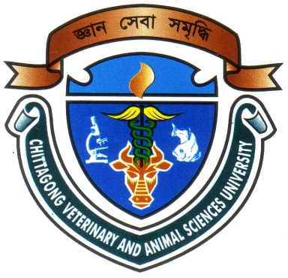

A Clinical Report Submitted by

Roll No: 10/56
Intern ID No : E-41
Reg. No : 534
Session : 2009-2010

Report Presented In Partial Fulfillment for the Degree of
Doctor of Veterinary Medicine (DVM)

Chittagong Veterinary and Animal Sciences University
Khulshi, Chittagong-4225.

September, 2015
PREVALENCE OF DIFFERENT DISEASES IN KOTWALI WITH A SPLIT STUDY ON HAEMOLYTICAL PARAMETER OF SKIN DISEASE AFFECTED DOG

A Clinical Report Submitted by

………………………………………………
Signature of Author
Name : Aditya Chowdhury Avi
Roll No: 10/56 Reg. No : 534
Intern ID No : E-41 Session : 2009-2010

Approved as to Style and Content by

………………………………………………
Signature of Co-Supervisor
Dr. Amir Hossan Shaikat
Assistant Professor
Department of Physiology, Biochemistry and Pharmacology

Chittagong Veterinary and Animal Sciences University
Khulshi, Chittagong-4225.

September, 2015

CONTENTS

SL. No |  | Chapter | Topics |  |  | Page No.
01 |  |  |  | Abstract | 01
02 | Chapter – I |  |  | Introduction | 03-04
03 | Chapter - II |  |  | Materials & Methods
 | 2.1 |  |  | Reference population | 05
 | 2.2 |  |  | Source of population | 05
 | 2.3 |  |  | Study population | 05
 | 2.4 |  |  | Population and tools for data collection | 05
 | 2.5 |  |  | Diagnosis of diseases | 06
 | 2.6 |  |  | Split study | 06
 | 2.7 |  |  | Data analysis | 06
04 | Chapter – III |  |  | Results | 07-09
05 | Chapter – IV |  |  | Discussion | 10-11
06 | Chapter – V |  |  | Conclusion | 12
07 | Chapter – VI |  |  | References | 13-14
08 |  |  |  | Biography | 15

CONTENTS OF TABLE

SL. No | Table | Page No.
01 | The percentage of cases each of the major groups of diseases at Kotwali Veterinary Hospital | 07
02 | The percentage of the infectious diseases in different species at Kotwali Veterinary Hospital. | 08
03 | Hematological findings of the skin disease affected dog from SAQTVH | 09

CONTENTS OF FIGURE

SL. No | Figure | Page No.
01 | Examination of the animals in Kotwali Veterinary Hospital | 06
02 | Collection and analysis the parameters of the blood of dog | 06

