**ABSTRACT**

A study of Contagious ecthyma of domesticated ruminants (Sheep & goat) were carried out at Upazilla Veterinary Hospital (UVH) under sadar thana veterinary hospital of Khagrachhari district from 13th January to 15th march in 2015. About 17 animals were found as positive case of contagious ecthyma out of 61 Cases. Younger animals were found to be more affected (70%) than older (30%) animals. and the prevalence (70%) was higher in black Bengal breed goats. The study showed that Contagious ecthyma was scatterdly distributed throughout the Chittagong hill tracts region. So proper control strategy should be taken from the authority.

**Key word:** UVH, Prevalence, Contagious ecthyma. Goats

**CHAPTER 1**

**INTRODUCTION**

Contagious ecthyma is an acute, contagious, debilitating and economically important zoonotic viral skin disease that affects sheep, goat and some other domesticated and wild ruminants. It is a non systematic eruptive skin disease having worldwide in distribution. The disease is also known as orf, sore mouth, contagious pustular dermatitis or scabby mouth **(Thomas et al., 2003)** and it is usually more severe in goats than in sheep. The disease is manifested by proliferative lesions on the mouth and muzzle that usually resolved in 1–2 months (**McKeever et al., 1988)**. Primary orf lesions are the most severe with a clinical progression of erythematous macule, papule, vesicle, pustule and scab formation in 4–6 weeks and young animals are at high risk. Severe facial and oral lesions in lambs may interfere with suckling, lesions on the udder may result in the avoidance suckling to offspring and foot lesions can cause transient lameness. Reinfection lesions progress through the same clinical stages but are generally smaller, not proliferative and resolve more rapidly usually within 2–3 weeks. Orf is not normally fatal but is a debilitating disease that can be fatal if lambs and kids are prevented from suckling or succumb to secondary bacterial or fungal infections **(Haig and McInnes, 2002)**. The morbidity of the disease may reach up to 100% and mortality due to secondary bacterial infections may reach to 15% **(Gumbrell and McGregor, 1997)**. Zoonoses occur most frequently during lambing, shearing, docking, drenching or slaughtering of affected animals. Most infections in humans are localized and heal spontaneously. However, large poorly healing lesions are usually seen in immunosuppressive individuals. Orf virus is robust in a dry environment and can survive for months or even years, but its lifespan may be shorter in cold and wet conditions. The virus remains viable on the wool of recovered animals for substantial periods. Orf virus enters via broken, scarified or otherwise damaged skin and replicates in epidermal cells. The disease is usually transmitted through contact from infected to susceptible animals. However, transmission of orf from clinically normal sheep to orf naive sheep and following plunge dipping has also been reported**(Sargison et al., 2007)**.. Iatrogenic transmission of orf virus may also occur during minor or major surgical intervention, hand contact, drenching and ear tagging **(Allworth et al., 1987)**. Natural cross infection of orf between sheep and goats can occur but experimental transmission of infection from one species to another may not be successful. Certain breeds of sheep and goat are more susceptible to the disease. Animal with immune defects and persistently infected animals play an important role in the maintenance of the orf virus in the nature. There is only partial protection following clinical disease or vaccination. Recurrent infections can occur in 1–3 months but are less severe and heal rapidly. **(Ndikuwera et al., 1992; Yeruham et al., 2000)**

**Aim of work:**

The study aimed-

* To know the prevalence of Contagious ecthyma in Goat in Chittagong hill tracts.
* Identification of health status of animals through clinical sign and history from owner.

**CHAPTER 2**

**MATERIALS AND METHODS**

**2.1 Location and duration of the study**

The study was conducted in different breeds of goats registered at the Upazilla Veterinary Hospital, Khagrachhari sadar, Khagrachhari from 13 january, 2015 to 15 March, 2015.

**2.2 Study population**

The study was conducted on contagious ecthyma infected goats of various age, sex and breed that were brought to the District Veterinary Hospital. During the study period about 61 goats were brought for treatment purpose among them 17 goats were contagious ecthyma, and rest of the other cases due to other diseases like goat pox, PPR etc.

**2.2 Study population**

The study was conducted on contagious ecthyma infected goats of various age, sex and breed that were brought to the District Veterinary Hospital. During the study period about 61 goats were brought for treatment purpose among them 17 goats were contagious ecthyma and rest of the other cases due to other diseases like goat pox, PPR etc.

**2.3 Case definition**

Diagnosis was made by means of anamnesis and clinical signs. A contagious ecthyma case was initially suspected if an animal showed formation of erythematous macule, papule, vesicle, pustule and scab in lips (fig.1a and 1b) , nostril, udder or hairless area of the body. Lesions often occurred first on the gum line as small, raised, red areas that become blisters. These blisters eventually rupture and combine into large scabs. Lesions were most common on the mouth of lambs/kids and on the udders of ewes/does. Animal loss their body weight due to inability to eat. All the clinical signs were properly noted in the record sheet.

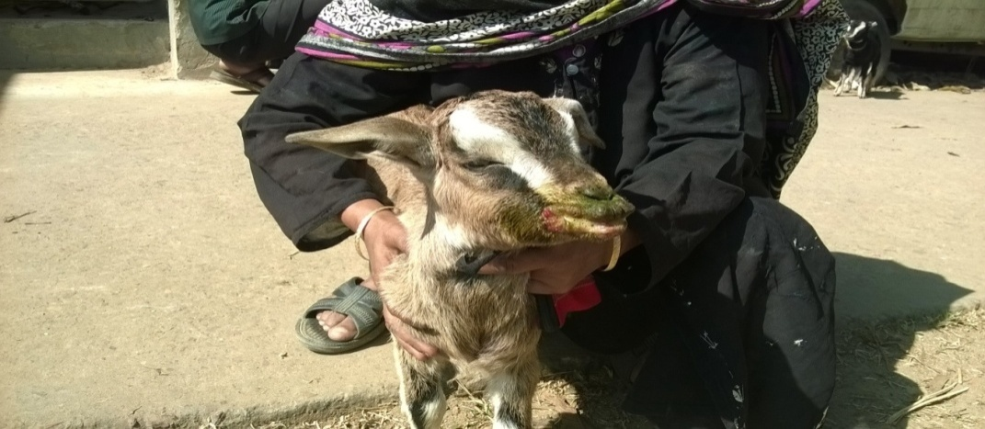 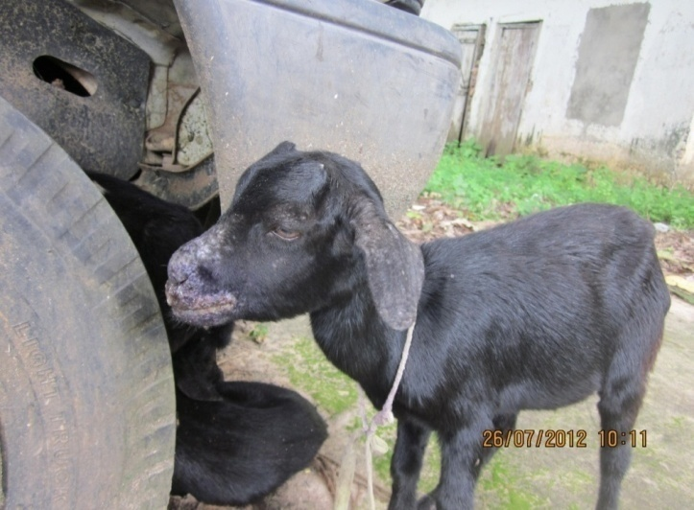

Fig 1b: Pustules in mouth

Fig 1a: Pustules in mouth

**2.4. Treatment**

After the presumptive diagnosis the animal was prescribed with antibiotic oxytetracycline (Otetravet®, Square Pharmaceuticals Ltd) 10 mg/kg body weights daily for 5 days. The oral lesions were also washed with providone iodine solution (Povisep, Jayson Pharmaceuticals Ltd) until recovery

Owners were advised to quarantine sick animals from herd, fed and treated after feeding the herd. They were also advised to use proper disinfection of premises of animal house and incineration of all infected materials extracted from sick animals to reduce the risk of new infection.

**2.5 Calculation of prevalence**

The prevalence (%) of Contagious ecthyma in the goats examined was calculated on the following formula Prevalence = $\frac{Total number of infected goats}{Total number of goats}$ ×100

**2.6 Data analysis**

All data were entered into Microsoft Excel 2007 and Data management was done. Data analysis was performed using SPSS statistical software (Ver.13 for windows, SPSS), Chi-square (χ2) Test for the explanatory variables (Age, Sex, Breed, Vaccination) and those having P-value ≤ 0.05 were considered significant.

**CHAPTER 3**

**RESULTS AND DISCUSSION**

In the UVH, during my placement 61 affected goats were investigated of which 17 were found positive for Contagious ecthyma. The diagnosis of Contagious ecthyma is done by observing erythematous macule, papule, vesicle, pustule and scab in lips, nostril, udder or hairless area of the body, mild temperature. The prevalence estimates of formation pastule from Contagious ecthyma by type of sex, age, breed and vaccination are summarized in table 1.

**Table 1:** Prevalence estimates of formation pastule from Contagious ecthyma by type of sex, age, breed in the investigated goats

|  |  |  |  |  |  |
| --- | --- | --- | --- | --- | --- |
| Variable | Category | Number | Prevalence % (No. of positive) | χ2- value | P- value |
| Sex | Male | 7 | 41.17% | 3.7491 | 0.290 |
| Female | 10 | 58.82% |
| Age | 0-6 months | 12 | 70% | 12.6351 | 0.049 |
| 6 months-1.5years | 05 | 30% |
| >1.5 years | 0 | 0% |
| Breed | Black Bengal | 12 | 70% | 4.740 | 0.577 |
| Local | 4 | 23.52% |
| Cross | 1 | 5.88% |
| Total |  | 17 |  |  |  |

Study reveals that the prevalence of contagious ecthyma is more in female (58.82%) than male (41.17%). Somewhat higher prevalence in female (61.23%) than male (38.77) of contagious ecthyma in another region in the country was reported by Rahman et al. (2011).

Compared with the age the prevalence of contagious ecthyma is higher (70%) in young age (0-6 months) than that of older age(p>.05). Similar result was described by Samad, (2000) who reported that 73% younger goats especially 0-4 months of goats could be affected with contagious ecthyma.

In case of breed the Black Bengal goats are more affected with contagious ecthyma about 43.21% on the other hand local and Cross are less. The reasons for this may be due to that Black Bengal breed are mostly reared at Khagrachari district area. Samad (2000) reported that 67.24% and 32.76% Black Bengal and Jamunapari goats could be affected with contagious ecthyma respectively. The P value of variables sex is 0.0490 which is significant and frequently affected younger than older.

**Table 2:** Prevalence estimates of contagious ecthyma from goat pox, PPR and others by type of sex, age and breed in the investigated goats

|  |  |  |  |  |  |  |
| --- | --- | --- | --- | --- | --- | --- |
| Variable | Category | Number | Contagious ecthyma positive | Goat pox positive | PPR positive | Others |
| Sex | Male | 18 | 38.89% (07) | 16.67%(3) | 11.11%(2) | 33.33%(6) |
| Female | 43 | 23.26% (10) | 23.26%(10) | 30.23%(13) | 23.26%(10) |
| Age | 0-6 month | 24 | 50% (12) | 8.33%(2) | 20.83%(5) | 20.83%(5) |
| 6 month-1.5years | 26 | 19.23% (5) | 30.77%(8) | 23.08%(6) | 26.92%(7) |
| >1.5 years | 11 | 0% (0) | 27.27%(3) | 36.36%(4) | 36.36%(4) |
| Breed | Black Bengal | 43 | 27.91% (12) | 20.93%(9) | 27.91%(3) | 23.26%(10) |
| Local | 11 | 36.36% (4) | 27.27%(3) | 18.18%(2) | 18.18%(2) |
| Cross | 07 | 14.29% (1) | 14.29%(1) | 14.92%(1) | 57.14%(4) |
| Total |  | 61 |  |  |  |  |

The prevalence of contagious ecthyma among different diseases of animal are demonstrated in Table 2. Study shows that the prevalence of contagious ecthmay is more in male (38.89%)in comparison to other diseases whereas got pox(16.67%),PPR (11.11%) and other (33.33%). In different age group the goats of more than 1.5 years goats are more affected with Goat pox (30.77%) than other diseases. In case of breed the prevalence of contagious ecthyma is in local (36.36%), and cross is somewhat less (14.29% ) whereas prevalence of goat pox in local (27.27%) is higher than other breed. Prevalence of goat pox (29%) has been reported in goat (Rahman *et al*., 1992; Alam *et al*., 1994)

Fig: Prevalence of contagious ecthyma in comparison to goat pox, PPR and others.

Percentage (%)of Prevalence of different diseases are shown in chart 2.The percentage of contagious ecthyma is little bit higher (27%) than other diseases.

**Limitations**:

1. The vaccination data were not recorded properly; Most of the farmer cannot say the vaccination history

2. Sensitive diagnosis like serological test was not possible to perform.

3. Need more no. of cases for having precise conclusion.

4. Management factors could have been correlated with contagious ecthyma.

**CHAPTER 4**

**CONCLUSION**

The prevalence of contagious ecthyma in goats was 27%. Younger goats under 6 months of age are more susceptible to become affected with contagious ecthyma. Black Bengal goats are more susceptible to contagious ecthyma than local and cross breed. Against the virus, there is no specific treatment. However, a combined therapy containing antibiotic, antihistamines as well as antiseptic wash might be some kinds of help for contagious ecthyma affected goats. Good managemental measure should be taken to control contagious ecthyma.

**REFERENCES**

Alam MM, Huque AKMF, Nigar S, Haque M, Chowdhury NS and Ahmed MU (1994). Rotavirus infection in children and calves in association with acute gastro-enteritis. *Bangladesh Veterinary Journal* 28: 35-40.

Allworth, M.B., Hughes, K.L., Studdert, M.J., 1987. Contagious pustular dermatitis (orf) of sheep affecting ear following ear tagging. Aust. Vet. J.64, 61–62.

Gumbrell, R.C., McGregor, D.A., 1997. Outbreak of severe fatal orf in lambs. Vet. Rec. 141, 150

Haig, D.M., McInnes, C.J., 2002. Immunity and counter immunity during infection with the parapoxvirus orf virus. Virus Res. 88,

McKeever, D.J., Jenkinson, D.M., Hutchison, G., Reid, H.W., 1988. Studies on the pathogenesis of orf virus infection in sheep. J. Comp. Pathol. 99, 317–328.

Ndikuwera, J., Odiawo, G.O., Usenik, E.A., Koch, N.D., Ogaa, J.S., Kuiper, R., 1992. Chronic contagious ecthyma and caseous lymphadenitis in two Boer goats. Vet. Rec. 131, 584ma an

Rahman MF, Ershaduzzaman M, Debnath NC, Rahman MM and Rahman MB (1992). Prevalence of Rotavirus infection in calves of Bangladesh. *Bangladesh Veterinarian* 9: 84-87.

Rahman, M.A., Shadmin, I., Noor, M., Parvin, R., Chowdhury, E.H. and Islam, M.R. 2011. virus infection in goats in Bangladesh: Pathological investigation, molecular detection and isolation virus. The Bangladesh Vet., 28(1): 1-7.

Samad, M.A. (2001). Observation of clinical Disease in Ruminants at the Bangladesh Agricultural University Clinic. Bangladesh Vet. J.35(3-4) 93-120

Samad MA (2000). Clinico-therapeutic management of severe complicated cases of contagious ecthyma in Black Bengal goats. Bangladesh Veterinary Journal 34: 39- 42.

Sargison, N.D., Scott, P.R., Rhind, S.M., 2007. Unusual outbreak of orf affecting the body of sheep associated with plunge dipping. Vet. Rec. 160, 372 body

Thomas, K., Tompkins, D.M., Sainsbury, A.W., Wood, A.R., Dalziel, R., Nettleton, P.F., McInnes, C.J., 2003. A novel poxvirus lethal to red squirrels (Sciurus vulgaris). J. Gen. Virol. 84, 3337

Yeruham, I., Perlb, S., Abrahamc, A., 2000. Orf infection in four sheep flocks. Vet. J. 160, 74-76.

# 

# BIOGRAPHY

|  |  |
| --- | --- |
| **Name** | Kushal Chakma |
| **Present status** | Intern student, Faculty of veterinary medicine, Chittagong Veterinary and Animal Sciences University (CVASU). |
| **Educational background and Year** | Has successfully completed his H.SC from Dhaka Board and S.S.C. from Chittagong Board. |
| **No. of publication** | Two |
| **Interest** | Wild life and wild animals. |