A REPORT ON HEALTH STATUS OF CVASU DOG DURING EXPERIMENTAL BISCUIT FEEDING

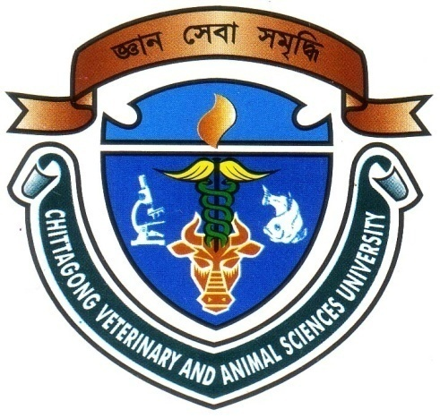

By
MANAS CHANDRA DAS
INTERN ID: E-43
ROLL NO: 10/59
REGISTRATION NO: 537
SESSION: 2009-2010

Report presented in partial fulfillment for the degree of
Doctor of Veterinary Medicine (DVM)

FACULTY OF VETERINARY MEDICINE
CHITTAGONG VETERINARY AND ANIMAL SCIENCES UNIVERSITY
A REPORT ON HEALTH STATUS OF CVASU DOG DURING EXPERIMENTAL BISCUIT FEEDING

This production report submitted as per approved style and contents

--------------------------------
APPROVED BY
DR. MD. HASANUZZAMAN
PROFESSOR
DEPARTMENT OF ANIMAL SCIENCE AND NUTRITION

CHITTAGONG VETRINARY AND ANIMAL SCIENCES UNIVERSITY

December, 2015

