Perception of Farmers on Disease Conditions of Local Goats in Bangladesh
A CLINICAL REPORT SUBMITTED BY
Intern ID : C-21
Roll No : 10/28
Registration No: 507

Approved as to style and content by

…………………………..
Signature of Supervisor
Dr. Mohammad Mahmudul Hassan
Associate Professor,
Department of Physiology, Biochemistry & Pharmacology,
Faculty of Veterinary Medicine (FVM)

……………………...
Signature of Author
Zaber MD Shaeef
Roll No : 10/28
Reg. No : 507
Intern ID: C-21

Chittagong Veterinary & Animal Sciences University
Khulshi, Chittagong-4225.
Perception of Farmers on Disease Conditions of Local Goats in Bangladesh

A CLINICAL REPORT SUBMITTED
BY
Intern ID : C-21
Roll No : 10/28
Registration No: 507

Report Presented In Partial Fulfillment for the Degree of
Veterinary Medicine (DVM)

Chittagong Veterinary and Animal Sciences University
Khulshi, Chittagong-4225

August, 2015

Table of Contents
Acknowledgement 1
Abstract 3
Introduction 4
Methodology 6
Study area and Duration 6
Study population 6
Study design 6
Statistical analysis 8
Result 9
Discussion 14
Conclusion 15
References 16
Biography……………………………………………………………………………………………………………………………………………….18

List of the Table:
Table 1: Prevalence of disease based on area and farmer’s status 10
Table 2: Association between management strategies and diseases outbreaks 12
List of Figures:
Figure I: Different clinical features of mastitis and PPR 7
Figure II: Different clinical features of Ecto-and endo-parasitic infestation 8
Figure III: Graph shows overall prevalence of different diseases among the goats 9

List of Abbreviations

Symbol | Abbreviation
% | Percentage
> | Greater than
< | Less than
et al. | And his associate
PPR | Peste des petits ruminants
WHO | World health organization
MVC | Madras Veterinary College
FVM | Faculty of veterinary of  Medicine

Acknowledgement

The author is grateful to the honorable supervisor Dr. Mohammad Mahmudul Hassan, Associate Professor, Department of Physiology, Biochemistry and Pharmacology, FVM, CVASU for the great support, supervision, guidance, advice and for offering numerous valuable ideas and suggestion who has devoted hours and hours of time and patience, motivation and immense knowledge for me.

The author is so much thankful to DR. Shariful Islam, EcoHealth Alliance, Bangladesh for his proper suggestion, advice and inspiration and also thankful to the rural farmer.

The author is also grateful to CVASU, friends and family members for continuous support and encouragement.

The Author

Abstract

Goat is the second most important livestock in term of production in Bangladesh. It’s also the major sources of income of small farmer in village area of Bangladesh. A cross sectional study was conducted to determine the prevalence of different diseases of goat and to identify the possible risk factors responsible for the diseases occurrence in small holding farm of five selected Upazilas at Chittagong district in Bangladesh. Data were collected in pre-prepared questionnaire by individual interview session from the farmers and visual observation of selected goat population and their management. Diagnosis of the cases was performed based on history and clinical manifestation showed by the animals. Descriptive statistics was performed to express the frequencies and chi-square tests were done to consider the variables. Highest proportion of goats were affected with ecto-parasitic infestation which was 45% where as the lowest frequencies were mastitis 2%. The occurrence of disease in different areas, between genders, among the different professions and different educational status differed significantly (p<0.05). While considering the management factors floor type and season had highly significant (p<0.01) effects on disease occurrence among the goat population. Sources of drinking water, Deworming, Vaccination and type of medicine had insignificant (p>0.05) effects on disease occurrence. The current study recommends that the regular scheduled visiting and education of the farmer might be beneficial to prevent the high prevalence of diseases in Chittagong area of Bangladesh.

Key words: Black Bengal goat, PPR, Brucellosis, Ecto-parasite, Endo-parasite, Prevalence.

Introduction

Goats are first domesticated farm animals. As indicated by the archaeological proof, they have been associated with man in a symbiotic correlation for up to 10,000 years (Ensminger and Parker, 1986). Goats are distributed all over the world because their great adaptability to varying environmental conditions and the different nutritional regimes under which they were evolved and subsequently maintained. They proved valuable to man throughout the ages due to their productivity, small size, and non-competiveness with him for food (Devendra, 1999). Bangladesh is a small country with large population. The total land of our country is 1, 47,570 square kilometers and the total population of our country is 16 crores (Toufique and Turton, 2002). Bangladesh is known as agricultural country in the world. Most of the people of our country live in the village. So Livestock has been an important component of the mixed farming system practiced in Bangladesh for centuries (Devendra, 1999). About 80% of our population is employed in agriculture and livestock farming. Twenty percent people are involved in livestock sector as permanent occupation (Ahmed et al., 2008). The goat is called the “Poor man’s cow” in our country and it’s the second important livestock in Bangladesh which plays an important role in the rural economy and earn substantial amount of foreign currency by exporting skin and others byproducts (Kamaruddin, 2003). Each year goat production provides 127,000 MT meat, which accounts for 25% of total red meat in Bangladesh (Ferdous et al., 2012). The contribution of Livestock in the magnitude of Gross Domestic Product (GDP) is about 16.23 % in Bangladesh (BBS, 2008). But the livestock diseases and disorders of animals are the most important hindrance towards livestock development in our country (Islam et al., 2001). The total population of goat in the world is 861.9 million. Among that in Asia the goat population is 514.4 million, Africa 291.1 million, Northern America 3 million, Central America 9 million, Caribbean 3.9 million, South America 21.4 million, Europe 18 million, Oceania 0.9 million (Aziz, 2010). From the data it’s seen that 60% of goat population found in the Asia. But in Asia most of the goat found in sub continent area like India, Bangladesh, Pakistan, Nepal, Myanmar (Shah et al., 2004). There are about 22.53 million cattle and 14.69 million goats in our country (DLS, 2008- 2009). There are a lot of breed of goat found throughout in the world. But the most common are Angora, alpine, Anglo Nubian, Barbaari, Beetal, Chigo, Damani, pygmy, Saanen. But in subcontinent the most common goat breed is Jamuna pari, Black bangal, kashmiri, Angora (Gall, 1996).From the data sheet of DLS it can be said that Goat also an important domestic animal in our country. Considering the possibilities, a participatory approach in rearing poultry and later goat as a small scale subsistent family enterprise has been promoted by the government and various non-government organizations with the credit and input support since 1980’s in this country (Hassan et al., 2007).
Bangladesh is divided into six divisions. Chittagong is one of them (Commission, 1991). It’s a hilly and sea coast based area. It’s known as the healthy city of the country (Hashemi, 2006). As like other division agriculture and business is the main occupation of the

People of this area. As like other division goat also an important domestic animal in this region (Kabir et al., 2010). The environment of Chittagong is so much suitable for goat rearing. The most important sources of income for majority of rural families are goat rearing in Chittagong (Chowdhury et al., 2002). Some upazilla of Chittagong like Raozan, Baskhali, Miresari, Fatickchari, Hathazari, Raozan, Chandanish, Satkanina , Pahartali, Patiya are famous for goat rearing. The village people of those upazilla make good profit by goat rearing (Hossain, 2001). The main breed of Chittagong is Black bangle Goats are generally reared in traditional backyard system allowing them to graze mainly surrounding homestead or open fields and are kept tethered. Besides, leaves of different trees, rice polish and wheat bran are also given to goats as feed (Moniruzzaman et al., 2002). Goats of the studied areas were weak, emaciated and non- satisfactory productive performance due to mainly malnutrition, diseases and un-consciousness of the farmer (Shaikat et al., 2013).
Goat are generally infected with ectoparasite like tick, mite and endoparasitic diseases (Hassan et al., 2007). Nutritional deficiency of kids, low birth weight, slow growth rate and in sufficient milk production by does were identified as the major constraints directly associated with higher kid mortality (Husain, 1993). Gastro-intestinal nematodiasis, fascioliasis and tapeworm causes less mortality but cause severe depression in the growth and reproductive rate of the goats (Islam and Taimur, 2008). Lack of proper care and overall faulty husbandry practices are also responsible for higher goat mortality in the prevailing production system and average growth potential are two factors for increasing meat production. In the rural areas high mortality rate of kids are regarded as the most important constraint in goat production (Kashem et al., 2012).
Objective:
- To know the prevalence of diseases in Small holding goats of Chittagong.
- To identify the risk factors associated with occurrence disease conditions in small holding goats.

Methodology

Study area and Duration
A six (6) month duration study was conducted between January to June, 2015 at five (5) Upazilas of Chittagong district in Bangladesh. The availability of goat population and easy communication were taken into consideration for the selection of study areas. The inhabitants of these areas are mostly depending on the mixed family farming and a mixed family farming consists of 1 to 2 cattle, 3 to 4 goats or 1or 2 sheep and few poultry.

Study population
Black Bengal goats of five selected upazilas of Chittagong district which are very much adaptable in Bangladesh were selected as study population. The study was commenced on 300 goats of the selected upazilas.

Study design
In Chittagong division there are 11 Districts. Five (5) Upazilas namely Satkania, Raozan, Banshkhali, Pahartali and Mirshari were selected from a complete list of Upazila of Chittagong District because of easy communication and goat population is highly dense there and then, 60 goat household were selected randomly from each Upazila based on the complete list of household goat keeper. A survey of goat population was done in the study area and preparation of list of different problems associated with indigenous goats rearing and different diseases condition they suffer usually was collected through pre-prepared questionnaire. Diagnosis of diseases was done by taking history from the farmers and their perception and observing the clinical findings.

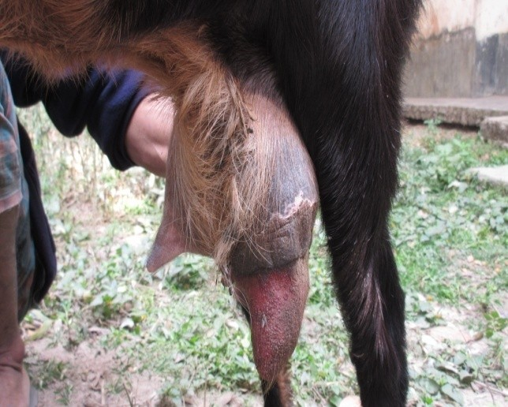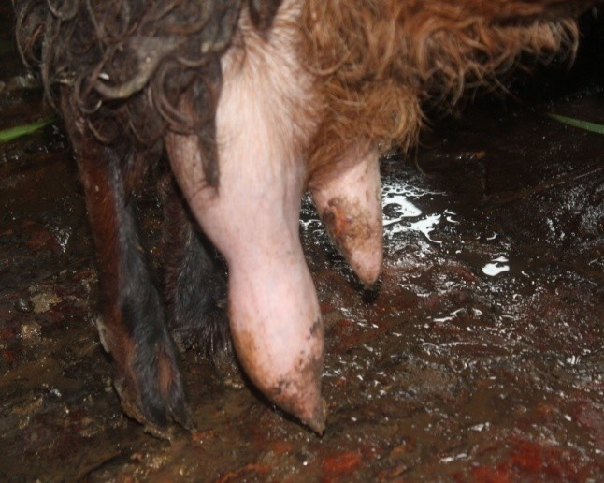
Fig: Abnormal udder and teat due to mastitis | Fig: Abnormal teat due to mastitis
Fig: Diarrhea and dehydration due to PPR | Fig: Nasal discharge due to PPR

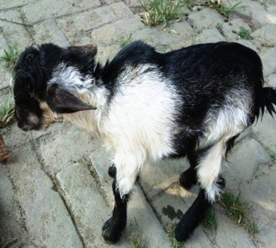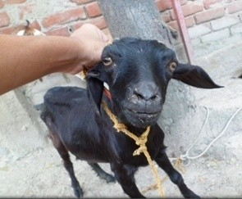Figure I: Different clinical features of mastitis and PPR

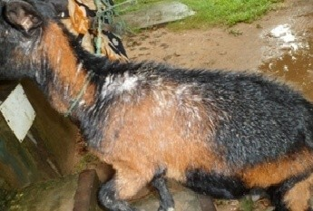
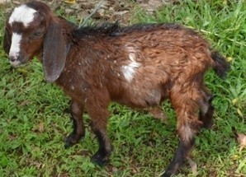

Fig: Ecto-parasitic infestation in goat | Fig: Ecto-parasitic infestation in goat
Fig: Endo-parasitic infestation in goat | Fig: Endo-parasitic infestation in goat
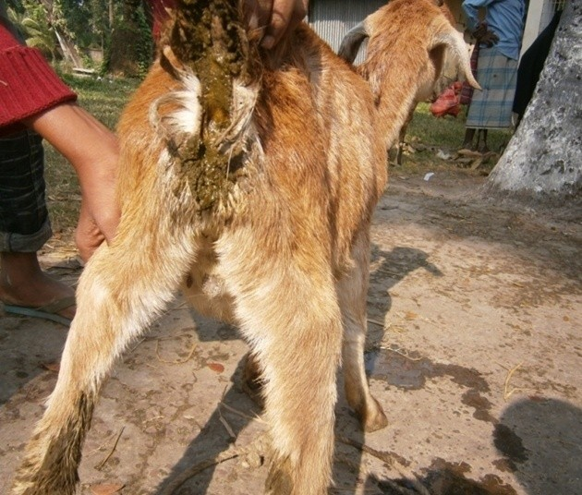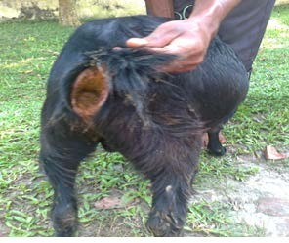Figure II: Different clinical features of Ecto-and endo-parasitic infestation

Statistical analysis
The obtained information was imported, stored and coded according to record keeping sheet using Microsoft Excel-2007 and then exported to STATA/IC-13 (Stata Corporation College Station) for epidemiological analysis. A descriptive analysis was performed for the data of socio-economic condition of goat owners, managemental practices and diseases frequencies. Chi-square test was applied for the data set of different diseases to detect the difference in proportions of diseases between various categories of education of farmers, farm size and location of goat housing. The results were expressed in frequencies with percentages. The differences between parameters were considered significant when the p-values were < 0.05 and highly significant when p- values were < 0.01.

Result

PREVALENCE OF DISEASES
Brucellosis 3%
Mastitis
2%
Endoparasite
19%
PPR
31%
Ectoparasite
45%

Figure III: Graph shows overall prevalence of different diseases among the goats

The graph 1 shows the overall prevalance of different diseases among the goats of five different selected Upazilas of Chittagong District. In general most of the goats were affected with parasitic infestration. Regarding the informaton on disease conditions of goat, the highest proportion of goats were affected with ectoparasitic infestration which was 45%. The prevalance of Pestides Petits Ruminant (PPR) that was 31% was comparatively higher than the endoparasite infestration (19%). Only 2% of goats were affected with Mastitis. Goats were also suffered from brucellosis 3%.

Table 1: Prevalence of disease based on area and farmer’s status

Variable (Factors) | Categories | Endo- Parasitic diseases% (n) | Ecto- parasitic diseases  %(n) | PPR  %  (n) | Brucellosis  %  (n) | Mastitis  %  (n) | P  value
Area | Bashkhali | 12.07 (7) | 32.84  (44) | 25.16  (9) | - | - | 0.001
 | Mirsarai | 01.72 (1) | 24.63  (33) | 46.47  (22) | - | 57.14  (4)
 | Pahartali | 03.45 (2) | 07.46  (10) | 90.98  (41) | 87.5  (7) | -
 | Raozan | 46.55 (27) | 13.48  (18) | 22.95  (14) | 12.50  (1) | -
 | Satkania | 36.21 (21) | 21.64  (29) | 14.45  (7) | - | 42.86  (3)
Gender | Female | 81.03 (47) | 91.79  (123) | 76.18  (83) | 62.50  (5) | 100  (7) | 0.037
 | Male | 18.97 (11) | 8.21 (11) | 23.83  (10) | 37.50  (3) | -
Profession | Agriculture | 50.00 (29) | 41.04  (55) | 60.83  (26) | 12.50  (1) | 71.43  (05) | 0.054
 | Business | 25.86 (15) | 41.79  (56) | 78.13  (39) | 75.00  (6) | 14.29  (01)
 | Job | 15.52 (9) | 09.70  (13) | 30.21  (12) | - | 14.29  (1)
 | Others | 8.62(5) | 7.47  (10) | 30.84  (15) | 12.50  (1) | -
Education | Primary | 75.44  (43) | 81.95  (109) | 75.46  (78) | 87.50  (7) | 100  (7) | 0.005
 | Secondary | 12.28  (7) | 10.53  (14) | 17.73  (9) | 12.50  (1) | -
 | Higher | 12.28  (7) | 7.52  (10) | 13.12  (6) | - | -

The table 1 shows the prevalence of diseases among the goats based on area and farmer’s status. Considering the data on area the greatest prevalence of Endoparasitic disease, Ectoparasitic disease, PPR, Brucellosis and Mastitis were found respectively, in Raozan (46.55%), Bashkhali (32.84%), Pahartali (90.98%), Pahartali (87.5%) and Mirsarai (57.14%). The lowest prevalence of these diseases were found as 1.72% in Mirsarai, 7.46% in Pahartali, 14.45% in Satkania, 12.5% in Raozan and 42.46% in Satkania, respectively. Endoparasitic diseases, ectoparasitic disease and PPR were also found in others selected Upazilas whereas in

case of brucellosis and mastitis no other Upazilas were affected. The occurrence of different diseases in different Upazilas differered significantly (p<0.01). Regarding the data on gender the highest prevalence of endoparasitic disease, ectoparsitic disease, PPR, Brucellosis and Mastitis were found respectively in female (81.03%), female (91.79%), female(76.18%) and female (100%) and the lowest prevalence of diseases were found all in the male as 18.97%, 8.21%, 23.83%, 37.50%. The occurrence of different diseases in different gender differed significant (p<0.05).
Based on the data of profession the premier prevalence of endoparasitic disease, ectoparsitic disease, PPR, Brucellosis and Mastitis were found respectively in agriculture (50%), in business (41.79%), business (78.13%), business (75.00%), in agriculture(71.43%) and the lowest prevalence of diseases were found in others profession 8.62%,in others 7.47%, in job 30.21%, in agriculture 12.50% and in job 14.29%.. The occurrence of different diseases in different profession differed insignificant (p is greater than 0.05).
Regarding on the data on education, the highest prevalence of endoparasitic disease, ectoparsitic disease, PPR, Brucellosis and Mastitis were found correspondingly in primary 75.44% ,81.95% in primary,75.45%,87.50% and 100% in primary education and the lowest prevalence of diseases were found in secondary education 12.28%, in higher education 7.52%, in secondary 12.50%. Brucellosis is absent in higher educated farmer farms and mastitis also absent in secondary and higher educated farmer farms. The occurrence of different diseases in different education differed highly significant (p<0.01).

.

Table 2: Association between management strategies and diseases outbreaks

Variable | Categories | Endo- Parasitic diseases% (n) | Ecto- parasitic diseases  % (n) | PPR  %  (n) | Brucellosis  %  (n) | Mastitis  %  (n) | P  value
Floor type | Slatted | 13.79 (08) | 20.9(28) | 11.17(5) | - | 42.86  (3) | 0.005
 | Muddy | 86.21 (50) | 79.10  (106) | 88.16(88) | 100.00 (08) | 57.14  (04)
Source of drinking water | Tubewell | 70.69 (41) | 70.90  (95) | 48.77  (69) | 50.00  (04) | 28.57  (02) | 0.149
 | Open Source | 29.31 (17) | 29.10 (39) | 51.33  (24) | 50.00  (08) | 71.43  (05)
Season | Summer | 10.34 (06) | 12.69  (17) | 47.95  (22) | 12.50 (01) | - | 0.0001
 | Rainy | 87.93 (51) | 87.31  (117) | 31.05  (60) | 87.50 (07) | 85.71  (06)
 | Winter | 01.72 (01) | - | 21.27  (11) | - | 14.29  (01)
Deworming | Yes | 63.79 (37) | 43.28  (58) | 52.21  (72) | 50.00 (04) | 100.0  (07) | 0.228
 | No | 36.21 (21) | 56.72  (76) | 47.8  (13) | 50.00 (04) | -
Vaccination | No | 63.79 (37) | 43.28  (58) | 67.62  (34) | - | 100.0  (07) | 0.0001
 | Yes | 36.21 (21) | 56.72  (76) | 32.38  (32) | 100.0 (08) | -
Types of medicine | Old | 15.52 (09) | 19.40  (26) | 25.61  (12) | 12.50 (01) | - | 0,663
 | Modern | 84.48 (49) | 80.60  (108) | 74.39  (81) | 87.50 (8) | 100.0  (07)

The table 2 shows the prevalence of diseases among the goats based on the association between management strategies and disease outbreaks. Considering the data on floor type the greatest prevalence of Endoparasitic disease, Ectoparasitic disease, PPR, Brucellosis and Mastitis were found all in muddy floor as 86.21%, 79.10%, 88.16%, 100% and 57.14%. The lowest prevalence of these diseases was found all in slatted floor like 13.79%, 20.9%, 11.17%, and 42.86%. Brucellosis was absent in slatted type floor management farm. The occurrence of different diseases in different floor type deferred significantly (p<0.01).
Regarding the data on source of drinking water the greatest prevalence of Endoparasitic disease, Ectoparasitic disease, PPR, Brucellosis and Mastitis were found tube well 70.69%, tube well 70.90%, open source 51.33%, tube well 50% and open source 71.43%. The lowest prevalence of these diseases were found in open source 29.13%, open source 29.13%, tube well

48.77%, open source 50.00% and tube well 28.57. The occurrence of different diseases in different source of drinking water deferred significantly (p<0.05).
Regarding the data on season the maximum prevalence of Endoparasitic disease, Ectoparasitic disease, PPR, Brucellosis and Mastitis were all found in rainy season 87.93%,in rainy87.31%, summer 47.95%, rainy 87.50%, 85.71% in rainy season.. The lowest prevalence of these diseases was found in 1.72% in winter, 12.69% in summer. 21,27% in winter, 12.50% in summer, 14.29% in winter. The occurrence of different diseases in different seasons deferred highly significantly (p<0.01).
Regarding the data on deworming and vaccination the highest prevalence of Endoparasitic disease, Ectoparasitic disease, PPR, Brucellosis and Mastitis were found high if the goats are not dewormed and not vaccinated. The lowest prevalence of these diseases was found the goats which were dewormed and vaccinated. The occurrence of different diseases in different floor type deferred significantly (p<0.05).
Regarding the data types of medicine the greatest prevalence of Endoparasitic disease, Ectoparasitic disease, PPR, Brucellosis and Mastitis all were found in modern medicine as 84.48%, 80.60%, 74.39%.87.50%, 100.00%. The lowest prevalence of these diseases was found in old medicine used in farm and the percentages are 15.52%, 19.40%, 25.61%, 12.50%. The occurrence of different diseases in different floor type deferred insignificant (p is greater than 0.05).

Discussion

The data was collected from 300 families of 5 upazilas in Chittagong district. The environment and ecological condition of Bangladesh is suitable for organisms to create disease in animal. The overall prevalence of endoparasite infestation in present study is 19% which is dissimilar to (Jugessur et al., 1999) in which the prevalence of endoparasite infestation in goat was 55.40%. This dissimilarity is might be due to differences in practices of the hygienic condition, literacy of the farmer, deworming of the animal and the managemental condition of the floor of the household farms.
The overall percentage of PPR is 31% in present study but it is dissimilar with the (Sarker and Islam, 2011) in which the prevalence of PPR is 20.7%. This dissimilarity might be due to the climate and other condition. We know that Chittagong is a district which is beside the Bay of Bengal. As a result so much rain fall happening here and muddy floor, vaccination of the goats also responsible for it. From the analysis, we see that the overall prevalence of ectoparasitic infestation in goats are 45% which is little dissimilar to (Rahman et al., 2000) and the prevalence of ectoparasitic infestation in goats was 15.71%. The dissimilarity also found with (Hassan et al., 2007) and (Jugessur et al., 1999) where the prevalence of ectoparasite infestation in goats were 20.45% and 17%, respectively. The prevalence of occurrence of ectoparasite infestation is dissimilar, might be due to not using deworming schedule to the animal by the farmers and people are not conscious about the deworming.

Present study shows that, the overall prevalence of Brucellosis is 3% which is quite similar to (Rahman et al., 2011) in which the prevalence of Brucellosis is 3.21%. From the present study we see that the overall prevalence of mastitis is 2% it is dissimilar to the other study (Razi et al., 2013) in which the overall prevalence of mastitis is 18.7%. From 60 goats they found mastitis in 12 goats. The main reason of dissimilarity might be due to the differences in the literacy of the farmer, hygienic condition and lack of proper treatment of the goats.

Commencing the present analysis we found the rainy season is suitable for the occurrence of goat diseases like PPR, Ectoparasite infestation, Endoparasite infestation which is similar to (Chowdhury et al., 2002) in which the overall prevalence of occurrence diseases is 60% in rainy season due to rainy season is suitable for multiplying the organism. Analyzing the present study we found that the occurrence of diseases is high in open source which is dissimilar with the (Ershaduzzaman et al., 2007) in which the overall prevalence of occurrence diseases in tubewell water 25% and open source is 45%. He took data from 200 families and found it. The main cause of dissimilarity might be due to open source water containing much organism than the tube well water. Commencing the present study, the overall prevalence of disease occurrence is high in illiterate farmer farms which is similar to (Kuhinur and Rokonuzzaman, 2009) in which they also saw that the prevalence of occurrence of diseases is 55% higher than the educated people. The reasons of that are illiterate people is not concern about the hygienic management of the farm.

Conclusion

PPR, Mastitis, Brucellosis, Ectoparasite and Endoparasite infections in goats are endemic and widespread in this 5 Thana of Chittagong. So the control measures should be taken by proper management of the farm, hygienic food and water should be supply in the farm. Avoiding low lying pastures have also significantly importance for controlling ectoparasite and endoparasite infestation. Periodic anthelmintic treatment should be given to get the maximum benefits from goats. However, this is an initial study; further study should be required to estimate the accurate prevalence of the disease and to prevent the infections of animals and maximizing the goat production in Chittagong.

References
Ahmed, N., Demaine, H., Muir, J.F., 2008. Freshwater prawn farming in Bangladesh: history, present status and future prospects. Aquaculture Research 39, 806-819.
Aziz, M.A., 2010. Present status of the world goat populations and their productivity. World 861, 1.
Chowdhury, S., Bhuiyan, M., Faruk, S., 2002. Rearing Black Bengal goat under semi-intensive management 1. Physiological and reproductive performances. ASIAN AUSTRALASIAN JOURNAL OF ANIMAL SCIENCES 15, 477-484.
Commission, C.H.T., 1991. " Life is Not Ours": Land and Human Rights in the Chittagong Hill Tracts Bangladesh: the Report of the Chittagong Hill Tracts Commission. IWGIA.
Devendra, C., 1999. Goats: challenges for increased productivity and improved livelihoods.
Outlook on Agriculture 28, 215-226.
Ershaduzzaman, M., Rahman, M., Roy, B., Chowdhury, S., 2007. Studies on the diseases and mortality pattern of goats under farm conditions and some factors affecting mortality and survival rates in Black Bengal kids. Bangladesh Journal of Veterinary Medicine 5, 71- 76.
Ferdous, M., Khan, M., Rashid, M., Kamruzzaman, M., 2012. Effect of different levels of concentrate supplementation on the performance of Black Bengal goat. Bangladesh Journal of Animal Science 40, 40-45.
Gall, C., 1996. Goat breeds of the world. Technical Centre for Agricultural and Rural Cooperation (CTA).
Hashemi, K.M.A., 2006. City report of Chittagong. In, Asian Urban Information centre of Kobe (AUICK) First workshop, japan.
Hassan, M.M., Mahmud, S.N., Islam, S.A., Miazi, O.F., 2007. A comparative study on reproductive performance and productivity of the Black Bengal and Crossbred goat at Atrai, Bangladesh. University Journal of Zoology, Rajshahi University 26, 55-57.
Hossain, M., 2001. Rural-urban migration in Bangladesh: a micro-level study. In, Brazil IUSSP conference. August, 20-24.
Islam, K., Taimur, M., 2008. Helminthic and protozoan internal parasitic infections in free ranging small ruminants of Bangladesh. Slov Vet Res 45, 67-72.
Islam, M., Shamsuddin, M., Das, P., Dewan, M., 2001. An outbreak of peste des petits ruminants in Black Bengal goats in Mymensingh, Bangladesh. The Bangladesh Veterinarian 18, 14- 19.
Jugessur, V., Ramjee, R., Ramnauth, R., 1999. THE EFFECTIVENESS OF SOME WIDELY USED ANTIHELMINTIC DRUGS ON ENDOPARASITIC NEMATODES OF VILLAGE GOATS. In, Third
Annual Meeting of Agricultural Scientists, 119.
Kabir, M., Reza, M., Razi, K., Parvez, M., Bag, M., Mahfuz, S., 2010. A report on clinical prevalence of diseases and disorders in cattle and goat at the Upazilla Veterinary Hospital, Ulipur, Kurigram. International Journal of BioResearch 2, 17-23.

Kashem, M., Hossain, M., Ahmed, S.U., Halim, M., 2012. Prevalence of diseases, morbidity and mortality of Black Bengal Goats under different management systems in Bangladesh. University Journal of Zoology, Rajshahi University 30, 01-04.
Kuhinur, S., Rokonuzzaman, M., 2009. Impact of Grameen Bank micro credit on change in livelihood status of women beneficiaries. Journal of the Bangladesh Agricultural University 7, 381-386.
Moniruzzaman, M., Hashem, M., Akhter, S., Hossain, M., 2002. Effect of different feeding systems on carcass and non-carcass parameters of Black Bengal goat. ASIAN AUSTRALASIAN JOURNAL OF ANIMAL SCIENCES 15, 61-65.
Rahman, M., Faruk, M., Her, M., Kim, J., Kang, S., Jung, S., 2011. Prevalence of brucellosis in ruminants in Bangladesh. Veterinarni Medicina 56, 379-385.
Rahman, M., Sharifuzzaman, J., Sarker, E., Shahiduzzaman, M., Mostofa, M., 2000. Prevalence of parasitic diseases of goat at Pirganj upazilla of Bangladesh.
Razi, K.M.A., Rahman, M.B., Flores-Gutiérrez, G.H., Rahman, M.T., 2013. Prevalence of caprine subclinical mastitis in Mymensingh area, Bangladesh and characterization of associated bacterial agents and the risk factors. Microbes and Health 1, 1-5.
Sarker, S., Islam, M.H., 2011. Prevalence and risk factor assessment of Peste des petits ruminants in goats in Rajshahi, Bangladesh. Vet World 4, 546-549.
Shah, C., Böni, J., Huder, J.B., Vogt, H.-R., Mühlherr, J., Zanoni, R., Miserez, R., Lutz, H., Schüpbach, J., 2004. Phylogenetic analysis and reclassification of caprine and ovine lentiviruses based on 104 new isolates: evidence for regular sheep-to-goat transmission and worldwide propagation through livestock trade. Virology 319, 12-26.
Shaikat, A., Hassan, M., Khan, S., Islam, M., Hoque, M., Bari, M., Hossain, M., 2013. Haemato- biochemical profiles of indigenous goats (Capra hircus) at Chittagong, Bangladesh. Veterinary World 6, 789-793.
Toufique, K.A., Turton, C., 2002. Hands not land: how livelihoods are changing in rural Bangladesh.

Biography:

The author name is Zaber md Shaeef and He is elder son of Late Md Abdus Salam and Shamim
Akter. He passed S.S.C in 2006 from Hathazari Parbati High School and passed H.S.C in 2008
From Govt. Hazi Mohammad Mohsin College. Now He works as an intern student in DVM
, Faculty of veterinary medicine in Chittagong Veterinary and Animal Sciences University. He
Went to Veterinary College and Research Institute, Namakkal, India and Madras veterinary
College, Chennai, India for Clinical Training. He also member of Chittagong Youth Society and
Animal welfare society in Bangladesh.

