Examine the lactation curve for crossbreed cows under intensive dairy farming condition

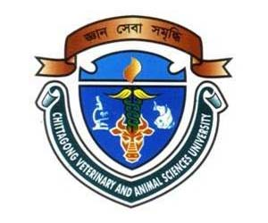

BY
Tamanna Suriya Turna
Roll No- 10/23
Reg No-0502
Intern Id- B-18
Session - 2009-10

A Production report
Submitted in partial satisfaction of the requirements for the degree of
Doctor of veterinary medicine
Faculty of Veterinary Medicine
CHITTAGONG VETERINARY AND ANIMAL SCIENCES UNIVERSITY

Examine the lactation curve for crossbreed cows under intensive dairy farming condition

BY
Tamanna Suriya Turna
Roll No- 10/23
Reg No-0502
Intern Id- B-18
Session - 2009-10

Approved

…………………………………………………………
Dr. Md. Kabirul Islam Khan
Professor
Department of Genetics and Animal Breeding
Chittagong Veterinary and Animal Sciences University

December 2015

