NEED ASSESSMENT FOR CAPACITY BUILDING OF DAIRY FARMERS IN POST DELIVERY MANAGEMENT OF CALF.

A Production Report is submitted for partial fulfillment of the Degree of
Doctor of Veterinary Medicine (DVM)

Submitted by:
Roll No: 2010/17
Regi. No: 0496
Intern I.D No: B-12
Session: 2009-2010

Faculty of Veterinary Medicine
Chittagong Veterinary and Animal Sciences University.
Khulshi, Chittagong – 4225
November, 2015
NEED ASSESSMENT FOR CAPACITY BUILDING OF DAIRY FARMERS IN POST DELIVERY MANAGEMENT OF CALF.

A Production Report Submitted as per Approved Style and Contents.

………………………………
Signature of Supervisor:
Sohel Rana
Assistant Professor
Department of Agricultural Economics and Social Sciences
Chittagong Veterinary and Animal Sciences University

Faculty of Veterinary Medicine
Chittagong Veterinary and Animal Sciences University
Khulshi, Chittagong – 4225

November, 2015

ACKNOWLEDGEMENT

The author is ever grateful and indebted to the Omnipotent, the creator and soul authority of universe, who enabled him to complete this work successfully.

The author feels proud in expressing his deep sense of great gratitude and indebtedness to respected teacher and supervisor Sohel Rana, Assistant Professor, Department of Agricultural Economics & Social Sciences, Chittagong Veterinary & Animal Sciences University for his trustworthy and scholastic supervision and untiring assistance throughout the work of sincere co-operation, helpful advice at all the stage of study period providing valuable suggestion, necessary correction in this study and for affectionate help in completing this work.

The author want to take the opportunities to express his deepest sense of respect and appreciations to the honorable Vice Chancellor Prof. Dr. Gautom Buddha Das and Dean Prof. Dr. Md. Ahsanul Haque, Faculty of Veterinary Medicine, Chittagong Veterinary and Animal Sciences University.

The author expresses his sincere gratitude and thanks to Prof. Dr. A.K.M Saifuddin, Director, External Affairs, (CVASU) for his constant inspiration, cordial co-operation and valuable suggestion for completion of the report.

Finally, the author wish to express his sincere gratefulness to his teachers, Parents and all other well wishers for their inspiration, appreciation & blessing throughout his academic life.

The Author
November, 2015

CONTENT

Chapter |  | Subject | Page no
 |  | ACKNOWLEDGEMENT | iii
 |  | CONTENT | iv
 | LIST OF TABLES & FIGURES |  | v
 | PLAGIARISM CERTIFICATE |  | vi
 |  | ABSTRACT | vii
Chapter I |  | INTRODUCTION | 1-3
Chapter II |  | MATERIALS & METHOD | 4-6
Chapter III |  | RESULTS & DISCUSSION | 7-12
Chapter IV |  | LIMITATION | 13
Chapter V |  | CONCLUSION | 14
 |  | REFERENCES | 15-17
 |  | BIOGRAPHY | 18

List of the Tables:

Table no. | Title | Page No.
01 | Opinion of need assessment for capacity building among the farmers of Faridpur & Chittagong district. | 11

List of the Figures
Figure no. | Title | Page No.
01 | Map of Study Area & Map of Bangladesh. | 04
02 | Level of Training in dairy activities among the farmers of two districts. | 09
03 | Data collection process from the farmer by using Questionnaire method. | 13
04 | Poor management Condition of calves in different Farms. | 13

List of Abbreviations:
DLS=Dept. of Livestock Services | NGO=Non Govt. Organization
WHO= World health Organization | %= percentage
FAO=Food & Agriculture Organization | N=Number
BBS=Bangladesh Bureau of Statistics. | > = greater than & < = smaller than

PLAGIARISM CERTIFICATE

I strongly assure that I have performed all works furnished here in this report. Data have been collected from different Dairy farmers of Faridpur & Chittagong Sadar Thana, National and International journals, Websites and others Reference materials. All references have been acknowledged duly. Data have been copied in due reference without citing.

Therefore, I hold entire responsibility of for collection, compilation, preservation and publication of all data accumulated here in this report. Any types of duplication, copying, cheating are strictly prohibited.

The Author
November, 2015

NEED ASSESSMENT FOR CAPACITY BUILDING OF DAIRY FARMERS IN POST DELIVERY MANAGEMENT OF CALF.

ABSTRACT

The present study was assigned to determine the present status the dairy farmers about their calf management as it is the entry point of dairy farm initiation to make recommendation for development of small scales dairy farm. With this view, the empirical data were collected by using pre-tested questionnaire. The study was conducted at preselected (25+25) small dairy farms in Faridpur and Chittagong suburban area, and two months-long survey from 13th February to 13th March, 2015 & 29th July to 29 August, 2015. It appeared from the study that 40% farm owners belong to business class and remaining 60% to different categories. 46% took dairying as a side-business whereas only 54% took it as a main business enterprise. Major percentage of farm owner education level was Higher Secondary 44% and the average number of animal per farm was 13.01. The average monthly income of farm owners found in the study area was Tk. 4387. It was observed that farm owners had 85.4% crossbred (Indigenous cattle crossed with Friesian and Jersey) and was 14.6% indigenous cattle. Among the farmer 44% are trained & 56% are not properly trained in calf management. In case of small dairy farming, the farms were facing a lot of problems such as scarcity of feeds and fodder, high price of concentrate and lack of technical knowledge. Although the dairy cow owners face problems, the study observed that there were potentials particularly for the small dairy farmers. The farmers keeping 8-10 no. of crossbred cows professionally could earn a modest livelihood. However, the aim of raising calves is to find the best way to raise a healthy calf so that she will become a productive cow. The objective of this literature review was to determine the ideal management practices for raising a healthy calf from birth to weaning. This literature analyzed numerous articles that covered all aspects of calf management to determine the best practices for raising a dairy calf from birth to weaning. Raising calves can be difficult task for someone who does not understand the different elements that compose calf management.

Key words: Calf Management, Dairy, Post Delivery

Chapter I
INTRODUCTION

Bangladesh is a densely populated country of more than 120 million people(currently 160 million) & 75% of whom live in rural villages, with a rural poverty rate of 63% (Hossain et al., 2004). It is estimated that the population is increasing at the rate of 1.21% (The World Bank, 2014).From the pattern of food imports it is evident that the rate of food production lagged way behind that of the population growth. In Bangladesh, livestock is one of the most potential sub-sectors of agriculture which plays an indispensable role in promoting human food, health and national economy of the country. About 36% of the total animal protein comes from the livestock products in our everyday life. However, livestock is an integral part of farming system which has a better contribution to enhance the economy of Bangladesh. Large ruminants (Cattle and Buffalo) and small ruminants (sheep and goat) constitute the major portion of livestock (Hossain et al., 2004). The present population of livestock is 23.12 million cattle, 1.39 million Buffalo, 24.15 million goat and 3.07 million sheep (DLS, 2010-11). The per capita number of cattle was o.16, goats 0.15, sheep 0.01, chicken 1.47 and ducks 0.27. The total contribution of livestock sub-sector to Gross Domestic Product (GDP) in Bangladesh is approximately 7.23% and livestock in agricultural production 17.32% (DLS, 2009). It also generates 13% of foreign currency and provides 20% fulltime employment and 50% partial employment of rural population (Alam, 1995). In this country, 80% rural people are involved with livestock farming (Shamsuddin et al., 2007). Most animals are reared in houses under the traditional husbandry practices (Hossain et al., 2004).This is why the dairy farm is raising day by day all over the Bangladesh. At present total number of livestock farms is 42367 of which 37180 (87.7%) are cow farms, 1376 (3.3%) are buffalo farms, 3203 (7.6%) are goat farms and 608 (1.4%) are sheep farms (DLS, 2009).
Development of dairy has generated considerable employment through the production and marketing of dairy and dairy related products (NEDELEA et al., 2010). 80% of the Country's 130 (currently 160) million people live in the rural areas and are highly dependent on agricultural system that is finely attuned to a tropical monsoon climate (UNDP, 2005).The contribution of the small-scale dairy farming to the welfare of the community is huge. Although, dairying is the most ancient occupation established in the rural setting of Bangladesh, its development is unsatisfactory due to several problems. The main problems concern breeding, feeding, management, diseases and marketing. The dairy sector has also not received adequate attention in respect of information and research with present policies and issues. From the economic developmental view, at present small holder farming in our country has been characterized by low productivity. This situation is partly attributed to lack of capital and uses poor farming technologies by smallholder farmers, inadequate veterinary facilities, excessive calf mortality due to disease & managemental causes, scarcity of bank loan, excessive cost of calf feed & necessary instruments for calf rearing, inadequate training facilities among the dairy farmers, drought, and lack of stable market for the dairy product, (Mwankemwa, 2004).
The success of any breeding program as well as the future of the mini dairy farms depends upon the rate of survival of calf crop produced (Gitau et al., 2010).The productivity of cattle depends largely on their reproductive performance and the survival of calf’s .Calf replacement should be given appropriate attention since the availability of replacements heifers for a dairy herd markedly influences the ability of a dairy man to increase milk production by allowing him to practice elective culling of low producing cow. Calf refers to the age group of young cattle from birth to six or nine month of age (West, 1995). Elsewhere it was defined as cattle up to six month of age after which in natural circumstances, it might be expected to be self-sufficient (Webster, 1984).
Calf morbidity and mortality are problems of major concern in all countries where cattle are raised under extensive husbandry practices, and the problem is more acute in developing countries due to bad calf management practices. High incidence of calf morbidity and mortality incurs great economic loss to dairy producers. This arises from death loss, treatment cost, decreased life time productivity and survivorship. It also causes the loss of genetic material for herd improvement and decreases the number of dairy heifers available for herd replacement and expansion. Calf diseases that cause morbidity and mortality are the results of complex interaction of the management practices and environment, infectious agents and the calf itself. Several environmental and managemental factors act as risk factors for the occurrence of calf morbidity and mortality (Waltner-Toews et al., 1986). But the calf morbidity and mortality have been recognized as a serious concern affecting the replacement rate and thereby genetic improvement in dairy animals (Debnath et al., 1990). In smallholder dairy farmers, calves are maintained just to induce letting down of milk in cows. Accordingly, calves are usually neglected as they do not bring any immediate financial return and the cost of their maintenance considerably adds to the production cost of milk. As a result, the calf is at greatest risk and the risk factors associated with calf morbidity and mortality. Calf mortality up to 12 months of age has been reported to be 9% under rural and 13.4% under a farm (Debnath et al., 1990) conditions in Bangladesh. Very limited data on the clinical aspects of calf diseases are currently available concerning the important constraints on calf health in Bangladesh (Huq, 1992)

Raising calves on most dairy farms in our country is a very important, detailed and expensive task. Having a successful calf raising operation is not only important financially, but also important for the future of the herd. In the farms, calf raising operations depend on the resources, natural environment and overall management of the farm. With all the minor and major details that go into raising calves it is difficult to determine the ideal way to raise calves. Needs assessment study provides a factual foundation for planning activities to be undertaken .In recent years, farmers have questioned what the best management practices are for raising dairy calves. With research, it has been proven that providing a calf with a healthy life can to lead to a successful and productive life once entering the milking herd (Mee, 2008). Therefore, figuring out the best way to raise calves in each aspect of their life is crucial. Many studies have been conducted throughout the years to define the best practices for all aspect of a calf’s life. Due to the high cost of raising calves, it is important that farmers find the most efficient way to ensure that it is in a financially beneficial in the long run. It is deciding that right practices for the cow and the calf immediately after birth, the proper nutrition for the young calf and the best way to keep the calf happy and healthy are all very difficult decisions without research. The main era of this study was to determine the best managemental practices for raising dairy calves starting from birth to adult. Various topics are discussed here to determine the best way to maintain and sustain a healthy calf.

On the above mentioned background this study was under taken with following objectives:
01. To assess the needs of the farmers for capacity building in post delivery calf management.
02. To observe the present status & overall practices regarding calf management in different dairy farms.

CHAPTER II
Materials & Method

2.1 Study area:

The study was conducted in Chittagong & Faridpur district of Bangladesh.
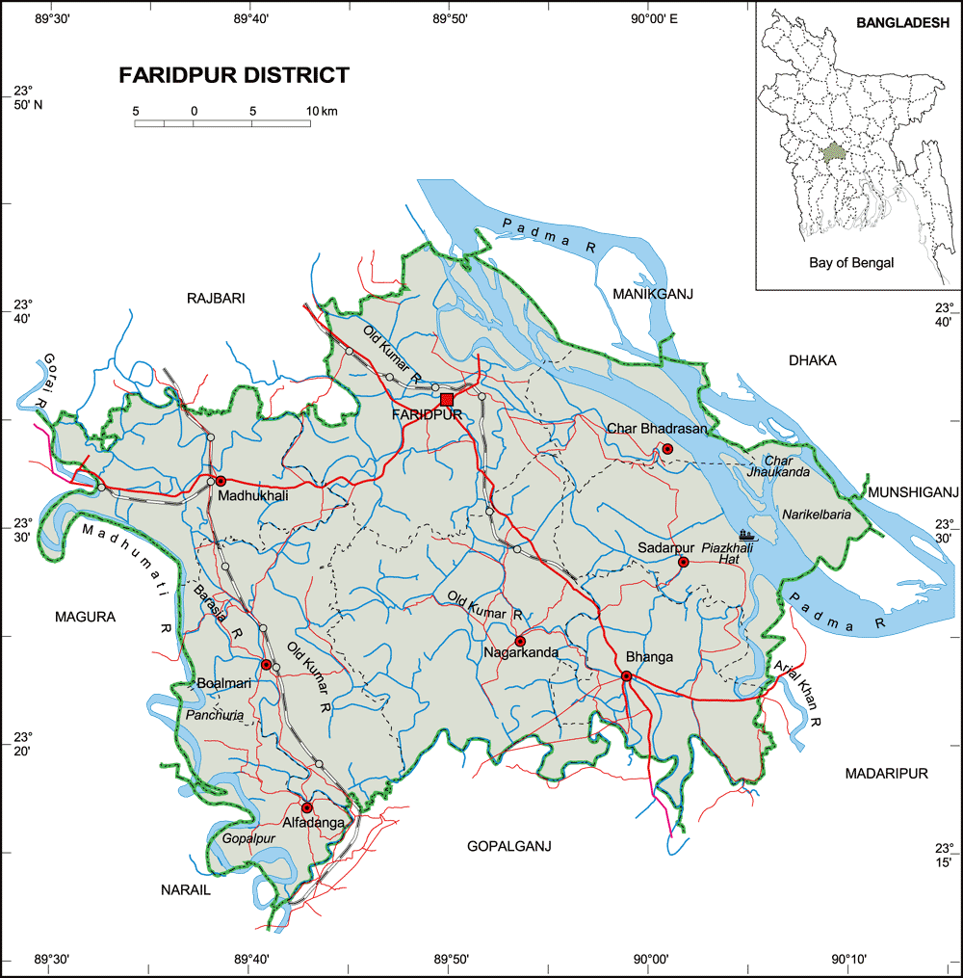
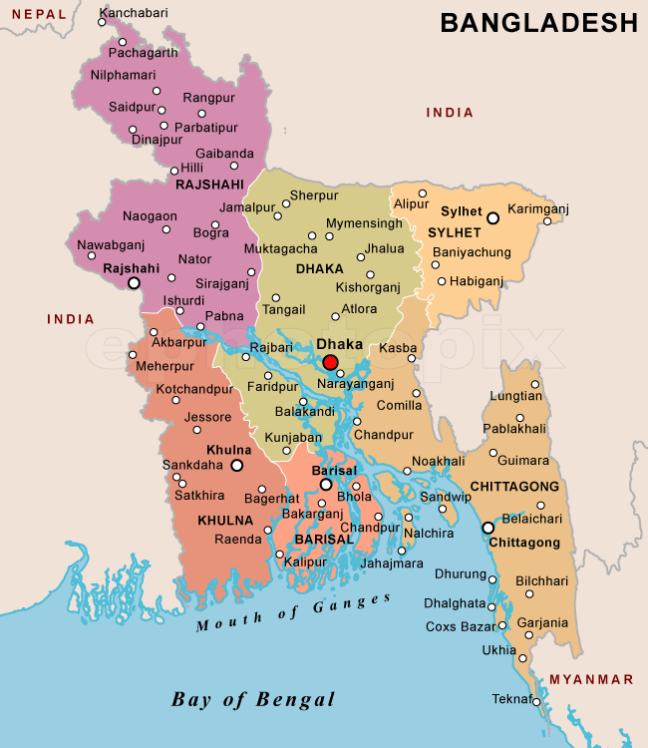

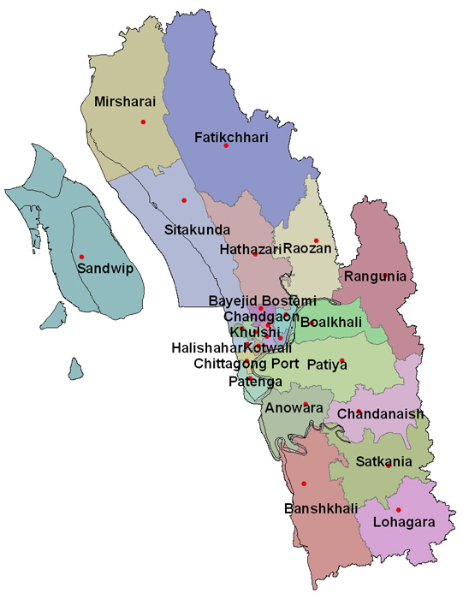

Chittagong District
Fig 1.a: Map of Study Area.
Fig 1.b: Map of Bangladesh.
Chittagong District: Faridpur District:
Total Area: 5282.92km² Total Area: 2072.02 km² (800.28 sq mi).
Total population: 7,616,352 Total populations: 19, 12,969.
Population density: 1400/ km² (3700 sq mi) Population density: 920/km² (2,400/sq mi).
Literacy rate: 43.2% Literacy rate: 37.44%

Source: Wikipedia, 2015
2.2 Study period:
The study was conducted between the period of 13th February t0 13th May, 2015 in Faridpur district & from 29th July to 29th august, 2015 in Chittagong District respectively.

2.3 Collection of Data:
In order to collect the data of various farms a structured questionnaire was formatted (Nauta et al., 2001); (De Jong and Van Soest, 2001). Data were collected through face to face interviewing of farmer and personal visits to the randomly selected dairy farming households involved in small scale dairy farming. A questionnaire was designed to capture information related to general characteristics of the household and the household head; farmland ownership and use housing pattern; production, inputs, costs and profits/income from dairy farming and other households activities; income from non-farm activities; expenditure of income from dairy farming; assets ownership; perceived benefits and constraints to dairy farming.
For this reason necessary tools or materials were needed. Actually overall data of individual farms were soul material in this occasion. This data were collected by using following techniques:
- Visiting of individual farms.
- Cross questioning to the owner/ farmer / employee.
- Records maintain by the farmers (if there any).

2.4 Sampling Procedure:
In an empirical investigation, it is impossible to collect information from the whole population. Therefore, the researchers are often forced to make inferences based on information derived from a representative sample of the population. The sample size and the degree of variation usually affect the quantity and quality of information obtained from the survey. Using appropriate sampling methods, both factors can be controlled (Hoffman et al., 1996).

2.5 Defining the Population:
Classification of the population is the first step in the sampling procedure, namely, the sector or element under investigation, the sampling unit, the area or extent of investigation, and the duration of investigation (Passmore and Baker, 2005). All the dairy farms of the district engaged in production were classified as population of the study.

2.6 Sample size:
On the basis of - nature of research and analysis; number of variables; resource constraints; and, the importance of decision, a sample size of 50 small scale Dairy farmers was selected among which 25 Farmers from Faridpur District & rest 25 Farmers are from Chittagong District.

2.7 Sampling methods:
Random sampling method was used for sample selection of this study.
2.8 Data Analysis:
After collecting the data of individual dairy farms, analyze some very much vital husbandry issues like Knowledge of farmer, financial status of farmer, various facilities given o the farmers , farm related factors such as housing, feeding, treatment & health status etc. Here we tried to make a comparative deviation on these key issues from a minimum standard that required for a dairy farm operation. These standards get through from various literatures. Actually percentage (%) of some special important husbandry practice is finding out here & graphically represent on some contrast.

2.9 Statistical Analysis:
The obtained data was stored in Excel-2000 and imported to software STATA/IC-11.0 for analysis. Stored data were tabulated and arranged as percent value. Descriptive statistics (i.e. means, frequencies etc) was done to estimate the different variables. Unpaired unequal t-test was used to determine the level of significance (p<0.05 and p<0.01) between categorical variables (Uddin et al., 2012).

CHAPTER III
RESULTS & DISCUSSION

4.1 General information of small dairy farm owners of two districts:
The general information of selected 50 dairy farm owners in Faridpur & Chittagong district showed in this study. The results showed that the highest percentage (60%) of the farmers in Faridpur district has agriculture as main occupation where as in farmers of Chittagong district had highest (52%) business as the principal occupation and rest of them are job seekers, or service holder etc. It was observed that (64% in Faridpur & 48% in Chittagong dist.) farmers had taken dairying as a main business and the rest as side business. Highest percentage (56%) of the farmers had Primary level of education & (32%) has Secondary or upper level of education in Chittagong dist. where as in Faridpur dist. (48%) farmers has primary level of education, (16%) has Secondary or above level of education & (36%) can sign only. This result was not agreed with (Uddin et al., 2012). Who reported that highest percentage (65%) of the farm householders had higher primary level of education followed by secondary level education (17.5%). (Hossain et al., 2004) stated that the average literacy rate of farm households in all farm categories was more than (60%) which had above primary level of education. Similar observations have also been reported by (Mollel et al., 1999). (Kabir, 1995) conducted an economic study and found that the average literacy rate of farm households in all farm categories was also sufficiently higher than the national average. More than 76% house numbers of family in all the farm categories had above primary level of education. The crossbred farm owners had relatively higher level of education. Farmers were further categorized based on land owner. The highest (52%) of farmers posses (1-2) acres of land and lowest (20%) of farmers posses more than 02 acres of land & rest (28%) farmers has (0-1) acre land in that’s area. It was found that (56%) farmers had training on dairy farms and (44%) farms had no training on dairy farm management. This result is contraindicated with (Sraïri et al., 2011) but agree with (Hossain et al., 2004)who reported that 18% farmers had training on dairy farms and 81% farms had no training on dairy farm management. For establishing dairy farms, 7% of dairy farmers were dependent on bank loan, 10% on their own sources and 83 % on bank loan and own source. The average capital investment was Tk. 45,000 to 2, 50,000. Among the farmers of two district current study showed that the farmers have relatively small herd size such as highest 44% farmers has herd size (1-15) no. of cattle where as 22% has (16-25) no. of cattle & 34% has a herd size of more than 25 no. of cattle. Most of the farmers have limited income. Some farmers who has another business along with Dairy farm or has a large size farm they can earn more but rest of them has very poor income. Our study showed that 32% farmers have a income of taka (1000-10,000) where as 48% farmers has income of Taka (11,000-20,000) & rest of 20% farmers has income of Taka above 20,000.
4.2: Information about the possession of Livestock:

The dairy farms under study area consisted of different types of cattle. It was observed that the percentages of milch indigenous and crossbred cows were 14.6 and 83.4 respectively. The average numbers of cows in the farms were 04.88 and 15.12 for indigenous and crossbreed, respectively. It was found in the study that the percentages of Indigenous calf and crossbred calf were 11.23% and 88.77% respectively.

4.3: General information about calf management & related problems:
Due to calf rising on traditional lines, up to 50 % calf mortality was found in the study area. The results of this study are in line with those of (Shah, 1994) and (Hoffman et al., 1996) who reported that at farmer's level calves is the neglected class of animals managed only traditionally. Survey findings indicated that none of the farmer was feeding the colostrums to the calf in time (within an hour post calving. The high calf mortality might be attributed to delay colostrums feeding as the calf is born without immunity and colostrums is the only weapon to develop immunity). Maximum farmers were feeding milk to the calves by natural method (direct sucking). Feeding the calves by natural means may lead to underfed or overfed calves. These findings agree with the observations of a review by (Salman and Meyer, 1987). Severe under feeding results into stunted growth of calves and over feeding leads to diarrhea that may cause death. This observation was also supported by (Ahmad et al., 2004)who pointed out that at dairy farms calf mortality is a real problem and about 50% deaths occur during the first three months of age.
Respondents were paying little attention towards the health management of calves. The vaccination against various diseases was being done by 36.67 % and 60% farmers respectively and only 43.33% were taking measures to control parasites. There was a common complaint from the farmers that every year so many calves die due to various diseases which is responsible for huge economic losses under field conditions. This might be due to climate factors, higher diseases prevalence, poor husbandry practices and lack of knowledge on the part of livestock farmers.
Maximum farmers did not maintain register to record animal status and did not keep their animal isolated while it becomes sick. In the study area, Veterinary Surgeon is not always available when they are needed. About 70% of the farmers faced difficulties to get loan from Bank. The major constraint facing small-scale dairy farmers in dairying was disease followed by high prices of medicines, calf feed & instruments. The result from the present study is in agreement with reports of (Duguma et al., 2011). Lacks of awareness & lack of proper supply of nutrition due to high prices on feed resources are the main causes of malnutrition in calves. The same findings were also revealed in a study by (Urassa and Raphael, 2002) in Tanzania.
4.4: Assessment of Training level in the Farmers in dairy farming technology:
Our current study shows that most of the farmers are not well trained so that they have no proper knowledge about dairy farming as well as calf management. Farmer is usually wanted to join the training programme but the training which is provided to them is not sufficient for improving their knowledge. Our study shows that (68%) farmers of Faridpur district & (44%) farmers of Chittagong district are not properly trained in dairy farming & calf management.

Graph 01: Level of training in dairy activities between the farmers of two districts.

4.5: Frequency of communication between the extension media & the farmers:

For the better production farmers need to communicate with the different types of communication media for getting more knowledge though it is found that the percentage of communication level is much lower than the expectation level. Our study showed that (46%) farmers has (1-2) times communication with Upazilla level officer such as UAO/AEO/UFO/ULO/VS in per 03 months. They have more communication with local quack or VFO for veterinary treatment & advice related to dairy farms. Farmers have highest (42%) communication (3-5) times in per 03 months with the Sub asst. Agri. Officer/ BS. Among the farmers highest (36%) take part in meeting in (3-5) times per year. In the study area highest (14%) farmers have practices of watching TV, (04%) has practices of listening Radio & (08%) farmers reads book related to agriculture & farming in per month.

4.6: Need assessment for the capacity building among the farmers:
Objectives of this study are to find out the needs of dairy farmers for building their capacity of post delivery management of calf. Here the result shows that among the farmers, their needs are more though they are not getting their service properly. Calf mortality is one of major problem in dairy farming. Our study shows that highest 76% & 88% farmers from Faridpur & Chittagong district want to reduce calf mortality by improving their knowledge & skill. Dairy farmers have less opportunity to get loan from the bank so that they can’t manage their farm due to lacking of money. Our current study shows that 80% of the farmers have necessity of bank loan for their farm. Beside this majority of the farmers want to get subsidy or compensation on calf feed & others necessary materials related to farming. Farmers have necessity of calf ration formulation, anthelmentics, vaccine & medicine from DLS. Highest 92% farmers of Faridpur & 84% farmers of Chittagong dist. want proper training about calf management.68% Farmers of Faridpur district & 14% of Chittagong district has opinion about reduction of calf mortality & morbidity during transportation. Most of the farmers have minimum education level so that they are not so interested about mass media for their knowledge sharing though it is one the best way to learn something.

Table 1: Opinion of need assessment for capacity building among the farmers of Faridpur & Chittagong district (N=25+25), (Fpr= Farmers of Faridpur & Ctg= farmers of Chittagong)

Sl No | Nature of services | Extent of need  ( no. of positive case , % of positive cases)
 |  | High |  | Moderate |  | Low |  | No need |  | P Value
 |  | Fpr | Ctg | Fpr | Ctg | Fpr | Ctg | Fpr | Ctg | Fpr | Ctg
1 | Reduction of calf mortality by improvement of knowledge. | 19  76% | 22  88% | 03  12% | 03  12% | 03  12% | 00  00% | 00  00% | 00  00% | 0.020 | 0.209
2 | Supply of Calf ration formulation | 05  20% | 08  32% | 15  60% | 15  60% | 03  12% | 02  08% | 02  08% | 00  00% | 0.409 | 0.409
3 | Subsidy/compensation on calf feed. | 21  84% | 21  84% | 04  16% | 03  12% | 00  00% | 01  04% | 00  00% | 00  00% | 0.505 | 0.565
4 | Free Vaccination, deworing & treatment by DLS. | 20  80% | 22  88% | 04  16% | 02  08% | 01  04% | 01  04% | 00  00% | 00  00% | 0.683 | 0.682
5 | Supply of housing materials. | 18  72% | 21  84% | 03  12% | 03  12% | 04  16% | 01  16% | 00  00% | 00  00% | 0.362 | 0.362
6 | Increase availability of Bank loan | 23  92% | 21  84% | 02  08% | 04  16% | 00  00% | 00  00% | 00  00% | 00  00% | 0.384 | 0.384
7 | Regular monitoring of calf by DLS. | 22  88% | 18  72% | 03  12% | 04  16% | 00  00% | 03  12% | 00  00% | 00  00% | 0.170 | 0.170
8 | Training on health management of calf. | 23  92% | 21  84% | 02  08% | 04  16% | 00  00% | 00  00% | 00  00% | 00  00% | 0.384 | 0.384
9 | Provide knowledge about disease prevention & cleanliness of farm. | 24  96% | 42  84% | 01  04% | 08  16% | 00  00% | 00  00% | 00  00% | 00  00% | 0.020 | 0.193
10 | Provide knowledge of routine farm works | 19  76% | 20  80% | 05  20% | 03  12% | 01  04% | 02  08% | 00  00% | 00  00% | 0.501 | 0.651
11 | Market stability of calf feed, medicine & others. | 21  84% | 22  88% | 04  16% | 03  12% | 00  00% | 00  00% | 00  00% | 00  00% | 0.683 | 0.684
12 | Round the hour door step service by VFA | 23  92% | 22  88% | 02  08% | 03  12% | 00  00% | 00  00% | 00  00% | 00  00% | 0.631 | 0.684
14 | Increase the no. of Veterinary hospital | 19  76% | 22  88% | 04  16% | 02  08% | 02  08% | 01  04% | 00  00% | 00  00% | 0.543 | 0.543
15 | Technical advice on managemental aspect | 23  92% | 21  84% | 02  08% | 04  16% | 00  00% | 00  00% | 00  00% | 00  00% | 0.384 | 0.384
16 | Increase NGO activity for better calf management. | 22  88% | 19  76% | 01  04% | 05  20% | 02  08% | 01  04% | 00  00% | 00  00% | 0.209 | 0.283
17 | Increase activity of mass media on this aspect. | 05  20% | 04  16% | 17  68% | 15  60% | 02  08% | 03  12% | 01  04% | 03  12% | 0.609 | 0.631

Picture 02: Data collection from the farmer by using Questionnaire method
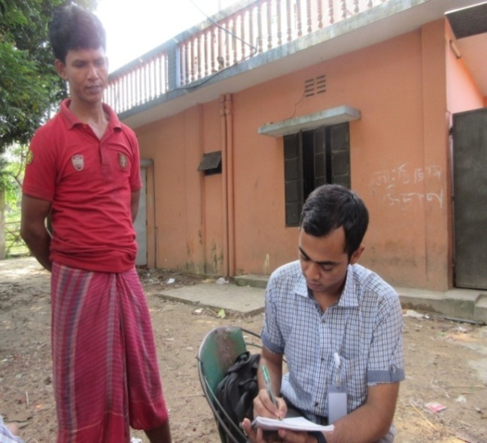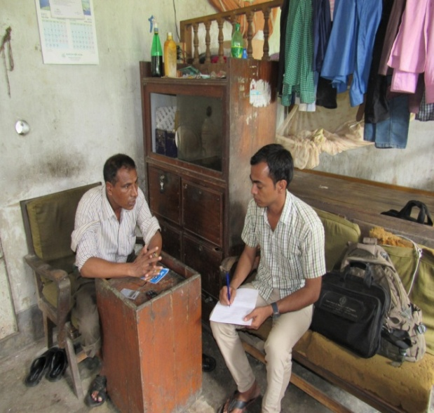

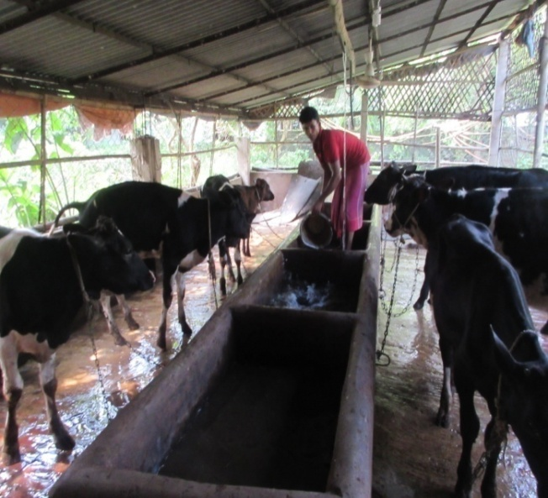
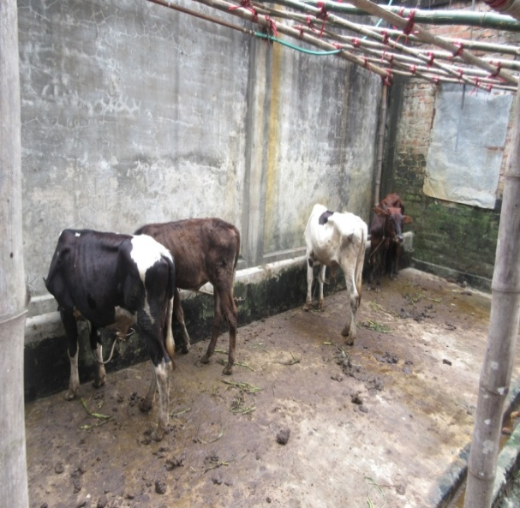
Picture 03: Poor Conditions of management in calves of different Farms
CHAPTER IV
LIMITATIONS

Being an undergraduate student I have some limitations that are:
- Shortage of time is the main constraint, because it reduces study population of the study, beside this if further study will carried out on the same topic & in same area then some unexplored things might be comes out.
- Single visit data is not sufficient to draw inference.
- Some of the farmer hesitates to give actual information.
- Most of illiterate Farmers don’t maintain their farm data record properly.

Chapter V
CONCLUSION & RECOMMENDATION

The entire dairy farmer in our country run their dairy farm for earns their livelihood from their farm. The main goal of dairy farm is to get the exponential benefit. Without providing good facilities to the animals it is not possible to earn better output. Most of the farmers of the study area do not maintain any standard husbandry practices due to their lacking of proper facilities & improper knowledge about farm management as well as management of their calf. But it seems to be that if these farmer could provide proper training, calf ration formula, bank loan, veterinary assistance then they will be benefitted & can go forward in the dairy industry like the others developed country. Then it would be possible to support the national economy by raising this potential industry in Bangladesh as well as meet up our daily demand of animal protein sources.
For the better & effective dairy farm practices we should take the following measures for post management of calf in dairy industry:
- Improvement of the knowledge of farmer about their calf management by providing adequate & necessary training.
- Ration formulation process should provide the farmers for their calf feeding.
- Subsidy or compensation should provide the farmers for calf rearing & purchasing.
- Proper vaccination & de-worming of calves should be done by the DLS.
- Bank loan, housing materials & treatment facilities should properly supply.
- Regular observation & monitoring of calf management should be done by DLS.
- Market of calf feeds & medicines should be stable & properly monitoring by DLS.
- NGO activities should be increased for the betterment of the dairy farmer.
- Activities of Mass media should be increase to help the dairy farmer.
- Improvement of calf transportation system & reduce mortality & illness during transportation of calf.
- Technical advice on manage mental aspects (routine activities of farm, weaning, fattening, selection of breeds, male-female separation, de-worming, dehorning, castration of male calves etc) should provide the farmer in proper time & in proper places.
All other’s Efforts should be made to fully incorporate. Joint efforts of Govt., NGO, farm owner & also general peoples can initiate the proper calf management programme throughout the country to secure the number of cattle population of the country.
Reference:

Ahmad, F., Jabbar, M., Ahmad, I., Rafique, M., Ahmad, I., 2004. Comparative Efficiency of calf starter and conventional rations in buffalo suckling calves. Pakistan Veterinary Journal 24, 169-176.
Alam, J., 1995. Livestock resources in Bangladesh: present status and future potential. University Press Ltd.
Alam, G.M., Hoque, K.E., Khalifa, M.T.B., Siraj, S.B., Ghani, M., 2009. The role of agriculture education and training on agriculture economics and national development of Bangladesh. Afr. J. Agric. Res 4, 1334-1350.
BBS. 2010. Bangladesh Bureau of Statistics. Farm poultry and Livestock survey, 2007-2008
De Jong, H., Van Soest, Y., 2001. De biologische melkveehouderijsector in kaart gebracht. Productschap Zuivel, Rijswijk.
Debnath, N., Sil, B., Selim, S., Prodhan, M., Howlader, M., 1990. A retrospective study of calf mortality and morbidity on smallholder traditional farms in Bangladesh. Preventive Veterinary Medicine 9, 1-7
Del Rosario, B., Aquino, A., Tidon, A., Gerpacio, R., 2008. Livestock sector training needs assessment report for Southeast Asia, China and Papua New Guinea.
DLS. 2009. Department of Livestock Services, Bangladesh, Organization’s details.
Duguma, B., Kechero, Y., Janssens, G., 2011. Analysis of constraints facing urban dairy farmers and gender responsibility in animal management in Jimma town. African Journal of Basic and Applied Sciences 3, 313-318.
FAO. 2010. Food and Agricultural Organization Division of Animal Production and Health, International consultation reports.
Fulwider, W., Grandin, T., Rollin, B., Engle, T., Dalsted, N., Lamm, W., 2008. Survey of dairy management practices on one hundred thirteen North Central and Northeastern United States dairies. Journal of dairy science 91, 1686-1692.
Goodger, W.J., Theodore, E.M., 1986. Calf management practices and health management decisions on large dairies. Journal of Dairy Science 69, 580-590.
Heinrichs, A., Kiernan, N., Graves, R., Hutchinson, L., 1987. Survey of calf and heifer management practices in Pennsylvania dairy herds. Journal of Dairy Science 70, 896-904.
Hemme, T., Otte, J., 2010. Status and prospects for smallholder milk production: a global perspective. Food and Agriculture Organization of the United Nations (FAO)
Hoffman, P., Brehm, N., Price, S., Prill-Adams, A., 1996. Effect of accelerated postpubertal growth and early calving on lactation performance of primiparous Holstein heifers. Journal of dairy science 79, 2024-2031.
Hossain, Z., Hossain, S., Rashid, M., Sultana, N., Ali, M., 2004. Study on the present management condition of private dairy farm at Rangpur Sadar Thana in Bangladesh. J. Biol. Sci 3, 135-154.
Hung, M.-C., Hwang, H.-G., Hsieh, T.-C., 2007. An exploratory study on the continuance of mobile commerce: an extended expectation-confirmation model of information system use. International Journal of Mobile Communications 5, 409-422.
Huq, M., 1992. Livestock development in Bangladesh for rural poverty alleviation. In, Proceedings of the International Workshop Livestock Production in Rural Development: Development of Livestock Policies, Wageningen (Netherlands), 20-31 Jan 1992.
Imtiaz, M., Rana, S., 2014. Problems faced by the small scale dairy owners in receiving veterinary services in selected areas of Chittagong. Bangladesh Journal of Veterinary Medicine 12, 63-65.
Kabir, M., 1995. An economic study of subsidized private dairy farming in selected area of Bangladesh. Unpublished MS thesis submitted to the Department of Agricultural Economics, Bangladesh Agricultural University, Mymensingh.
Mee, J.F., 2008. Newborn dairy calf management. Veterinary Clinics of North America: Food Animal Practice 24, 1-17.
Miyan, H., 1996. Towards sustainable development: The national conservation strategy of Bangladesh. Consultancy report on the livestock sector. Ministry of Environment and Forestry, Dhaka, Bangladesh.
Mollel, E., Lekule, F., Kurwijila, R., Turuka, F., Petersen, P., 1999. A Socioeconomic study on the role of gender in small scale crop-livestock farming in Turiani, Morogoro. In, Proceedings of the 26th Scientific Conference LITI-TENGERU Arusha. TSAP conferences series.
Mwankemwa, A., 2004. Performance of saving and credit co-operative societies and their impact on rural livelihoods: A case study of Morogoro rural and Mvomero districts, Tanzania. Msc. Dissertation, Sokoine University of Agriculture, Morogoro, Tanzania. 132pp.
Nauta, W., Baars, N., Groen, A., Veerkamp, R., Roep, D., 2001. Animal breeding in organic farming: Discussion paper.
Nedelea, A., GROSU, V., SHAMSUDDOHA, M., 2010. Dairy Farming-an Alternative Income Generating Activity. Bulletin of University of Agricultural Sciences and Veterinary Medicine Cluj-Napoca. Horticulture 66, 352-355.
Passmore, D.L., Baker, R.M., 2005. Sampling strategies and power analysis. Research in organizations: Foundations and methods of inquiry, 45-56.
Saadullah, M., 2001. Smallholder dairy production and marketing in Bangladesh. In, Smallholder diary production and marketing—opportunities and constraints: Proceedings of a South-South Workshop, 13-16.
Salman, M., Meyer, M., 1987. Animal Brucellosis, diseases caused by Brucella spp. Prev. vet. med 4, 485.
Shah, S., 1994. Animal Husbandry. National book foundation publ. Co. Islamabad.
Shamsuddin, M., Alam, M., Hossein, M., Goodger, W., Bari, F., Ahmed, T., Hossain, M., Khan, A., 2007. Participatory rural appraisal to identify needs and prospects of market-oriented dairy industries in Bangladesh. Tropical animal health and production 39, 567-581.
Shamsuddoha, A., Edwards, G., 2000. Dairy Industry in Bangladesh: Problems and Prospects. In, AARES 2000 Conference. School of Business, La Trobe University.
Sraïri, M.T., El Jaouhari, M., Saydi, A., Kuper, M., Le Gal, P.-Y., 2011. Supporting small-scale dairy farmers in increasing milk production: evidence from Morocco. Tropical animal health and production 43, 41-49.
Uddin, M.N., Uddin, M.B., Al Mamun, M., Hassan, M.M., Khan, M.M.H., 2012. Small Scale Dairy Farming for Livelihoods of Rural Farmers: Constraint and Prospect in Bangladesh. Journal of Animal Science Advance 2, 543-550.
Urassa, J., Raphael, E., 2002. The contribution of small scale dairy farming to community welfare: a case study of Morogoro Municipality. Online at: http://www. fiuc. org/esap/morog/morog5/General/dairyfarming. pdf (accessed 2 March 2010).

Biography

The Author was born in 31th December 1991 in Faridpur district of Bangladesh.

Currently, He is an intern student of Faculty of Veterinary Medicine of Chittagong Veterinary & Animal Sciences University (CVASU). Previously, He was an ex-student of Komorpur Abdul Aziz institution & Govt. Yasin College, Faridpur for his Primary, Secondary & Higher Secondary education courses respectively.

During his university life he has got “Clinical Award” from S.A.Q Teaching Veterinary Hospital, (CVASU) for his best performance in Hospital related activities.

During his internship programme, he took participation in various activities of different institution & organization in his country & abroad also.

The author has more interest on Veterinary Medicine & Theriogenology, Veterinary Microbiology & public health related field area. He wants to be a Veterinary Surgeon of the Dept. of Livestock Services in the future life for serves the nation & also the livestock population.

The Author
November, 2015

