**Chapter-1: Introduction**

Poultry farming, a strong agro-based industry, is emerging in Bangladesh during the last two decades. This industry is an important component in agricultural economy and faces heavy economic losses due to many infectious diseases (Islam et al., 2009). Among them fungal diseases have their own importance and seem to one of the greatest obstacles for the poultry farmers for high morbidity, mortality and production losses. Aspergillosis is the most common fungal disease of the avian respiratory system which has economic impact on poultry industries (Singh et al., 2012) either due to their direct infectious nature (Dahlhausen, 2006) or production of mycotoxins on poultry feed (Dhama et al., 2013). It is an infectious, non-contagious fungal disease caused by species in the ubiquitous opportunistic saprophytic genus *Aspergillus,* in particular *Aspergillus fumigatus* (Barnes and Denning, 1993).

The warm, humid environment of the farm shed, feed stores, floor etc. favor its growth. The disease affects mainly the respiratory tract of birds and has a worldwide distribution (Iran, Siberia, West Indies, Nigeria, Pakistan, Bangladesh etc.) having been reported in almost every farmed bird as well as in wild species (Uddin et al., 2011). Aspergillosis affets young, mature, immunocompetent or immunosuppressed poultry in captive or free-ranging states. However, young birds appear to be much more susceptible than adults (Suleiman et al., 2012). Generally dyspnea, gasping, cyanosis of un-feathered skin and hyperemia are usually associated with this disease. On necropsy, lesions usually confined to lungs and air sacs, although oral mucosa, trachea, eyes may be affected. Typical lesions are fungal nodules or plaques within the lungs and onthe air sacs and also in syrinx to a lesser extent (Barnes and Denning, 1993).

*Aspergillus* *spp*. tends to initially colonize the lower respiratory tract (Tell, 2005) following blood infection to other organs leading to macroscopic lesions in a wide range of organs or tissues. In spontaneous cases, lesions range from miliary to larger granulomatous foci (Beernaert et al., 2010). Typical lesions are characterized by granulomatous inflammation with necrosis and haemorrhage. The pathogenesis of aspergillosis appears to be complicated. In recent past years, aspergillosis has also emerged as a significant disease in immunocompromised humans with AIDS, neoplasia, or chemotherapy (Denning et al., 1991).

Antifungal drugs have been used for the treatment of aspergillosis in several poultry species. Many studies have been conducted to investigate the efficacy of various drugs, such as Amphotericin-B against *Aspergillus spp* (Galiger et al., 2013; Bonar and Lewandowski, 2004). Another therapeutic intervention against *Aspergillus* is the use of voriconazole, clotrimazole, miconazole, ketoconazole, itraconazole, fluconazole, 5-fluorocytosin and nystatin sulphate (Dhama et al., 2012; Burhenne et al., 2008; Scope et al., 2007; Pericard, 2005). Treating litter with Nystatin sulphate and 0.1% CuSO4 can reduce fungal content while 0.1% CuSO4 alone as treatment has been shown fungicidal activity against *Aspergillus spp.* (Johnson and Fiske, 1935).

However many commercial drugs have been developed and used treating systemic and superficial mycoses (Uno et al., 1982), but all of them were ideal in terms of availability, efficacy, safety and antifungal spectrum for use by the poultry industry (Domenico, 1998). Therefore, there is a great interest in developing natural alternatives as a therapeutic agent in order to maintain both bird performance and health. So it is necessary to explore other alternatives specially phytomedicine to treat the disease which may be a more natural mean of treating infections as well as cheap, ecologically sound and environmentally safe to eliminate or reduce aspergillosis.

The Neem tree (*Azadirachta indica*) is a tropical evergreen tree native to Indian sub-continent (Girish and Bhatt, 2008). The components of this tree have reputed value for their medicinal, spermicidal, antiviral, antibacterial, antiprotozoal, insecticidal, insect repellent, antifungal and antinematode properties (SaiRam et al., 2000). Several active substances from different parts of the tree have already been identified.

As an antifungal agent the crude aqueous extracts of Neem has an inhibitory effect on the growth of *A. flavus* and *A. parasiticus* (Thanaboripat et al., 2000). The crude aqueous and alcoholic leaf extracts of neem was more effective in inhibitions of growth of the *Aspergillus.* The alcoholic extract of neem leaf was more effective in comparison to aqueous extract for retarding the growth of *Rhizopus* and *Aspergillus* (Mondali et al., 2009).

Previously comparative efficacy of different medicinal plant (Neem, Tulsi, Onion, and Garlic) had been investigated against aspergillosis but effects of specific dosage of neem leaf extract (aqueous and ethanolic) have not been carried out. Therefore, this study was aimed to find out a specific dose of neem leaf extract against aspergillosis in broiler.

**1.1 Specific objectives**

1. To estimate specific dosage of neem leaf extract (ethanolic and aqueous) against aspergillosis in broiler.
2. To evaluate the effect of neem leaf extract on haematological parameters.
3. To explore the effect of neem leaf extract on biochemical parameters of serum.
4. To know the effect of neem leaf extract on feed conversion ratio and growth performance of broilers.

**Chapter-2: Review of literature**

**2.1 Drug**

A drug is defined as: A substance recognized by an official pharmacopoeia or formulary which is intended for use in the diagnosis, cure, mitigation, treatment, or prevention of disease. On other word, a substance (other than food) intended to affect the structure or any function of the body. Moreover a substance intended for use as a component of a medicine but not a device or a component, part or accessory of a device. Biological products are included within this definition and are generally covered by the same laws and regulations, but differences exist regarding their manufacturing processes (chemical process versus biological process) (Smith, 2014).

**2.1.1 Antifungal Drug**

The drugs which have been used for the treatment of fungal infections are called antifungal drug. Many drugs such as Amphotericin-B, voriconazole, clotrimazole, miconazole, ketoconazole, itraconazole, fluconazole, 5-fluorocytosine and nystatin sulphate are used against treatment of aspergillosis (Dhama et al., 2012; Beernaert et al., 2009b). Nystatin sulphate has been used for the management of mucocutaneous candidiasis now-a-days which is also active against *Aspergillus*, *Histoplasma* and *Coccidioides spp*. to a lesser extent (Wallace and Lopez-Berestein, 1998). Treating litter with Nystatin sulphate and 0.1% CuSO4 can reduce fungal content while 0.1% CuSO4 alone as treatment has been shown fungicidal activity against *Aspergillus spp.* (Johnson and Fiske, 1935).

**2.1.2 Antifungal Resistance**

Over the past quarter of a century, invasive fungal infections have emerged as an important cause of morbidity and mortality in immunocompromised patients. Although several new antifungal drugs have been licensed in recent years, antifungal drug resistance is becoming a major concern during treatment of such patients. The resistance may be intrinsic, acquired or clinical. The overall resistance in *Candida* spp. to fluconazole and voriconazole is considered to be around 3-6% and level of resistance has remained constant over a decade. However, a recent report from India revealed panazole resistance in ~10% of *Candida* species. Triazole resistance in *A. fumigatus* is increased gradually (Chakrabarti, 2011).

**2.2 Aspergillosis**

Aspergillosis is one of the important fungal infections mainly affects the respiratory tract of the birds caused by *Aspergillus fumigatus* and less commonly by other *Aspergillus* species (Barnes and Denning, 1993). The disease can occur as an acute form with high mortality and morbidity especially in brooding age called brooder pneumonia (Badhy et al., 2003). The warm, humid environment of the farm sheds, feed stores, floor etc. favor its growth.

**2.2.1 Epidemiology**

*Aspergillus fumigatus* infection occurs more frequently in poultry as the spores are smaller than other *Aspergillus* spp.(Arne et al., 2011) such as *A. terreus, A. glaucus, A. nidulans* and *A. niger* (Dhama et al., 2012; Beernaert et al., 2010). Mainly spores of the fungi are resistant in nature. Poultry birds coming in contact with the spores through contaminated feed or dry litter, gets affected after inhaling the spores (Cacciuttolo et al., 2009). The predisposing factors for spore generation and dissemination in the air/environment include warm environment, humidity, poor ventilation and sanitation along with long term storage of feed (Khosravi et al., 2008; Tell, 2005). Besides direct extension of the infection through air sac wall, disseminated mycosis also occurs by haematogenous spread. Hyphae, which are known as tissue, are angio-invasive (Dahlhausen et al., 2004) and as well as host cells play a role in this spreading mechanism. The disease develops in brooder stages in chicks as well as passerine birds, especially below 3 days of age (Chauhan and Roy, 2008). High humidity and moderate temperature contributes significantly towards the occurrence and spread of aspergillosis (Dhama et al., 2008). Contaminant like lead acts as a precipitating factor, especially in geese (Kapetanov et al., 2011). Aspergillosis primarily causes high morbidity and mortality especially in young chicks (Arne et al., 2011). Acute aspergillosis occurs as a result of inhaling high number of spores, wherein severe disease outbreaks in young birds are characteristically observed. Morbidity and mortality are high (30-90%) in it and can be seen within 24-48h of infection. Chronic form occurs sporadically and generally observed in adult breeder birds (particularly turkeys).

**2.2.2 Clinical signs**

Common signs associated with Aspergillosis infection include difficulty with breathing in which forced or labored breathing may occur. There may be increased thirst, fever, diarrhea, blindness and inflammation of the brain and membranes surrounding the brain may occur in the later stages resulting in increased morbidity and mortality (Pattron, 2006).

Cutaneous aspergillosis with necrotic granulomatous dermatitis was observed in chicken and pigeons (Beernaert et al., 2010; Cacciuttolo et al., 2009). Survivors often develop chronic disease due to pulmonary insufficiency or neurological disorders as lethargic and stunted growth (Beernaert et al., 2010). Rapid death due to aspergillosis can flare up avian influenza even though there is no connection between the two diseases and requires laboratory attention to distinguish them (Kradin and Mark, 2008).

**2.2.3 Diagnosis**

The clinical signs depend on the form of the disease and involvement of organ, thereby requiring the disease to be differentiated from other systemic diseases of respiratory tract (Jones and Orosz, 2000). On necropsy, pulmonary lesions are characterized by multiple hard creams to yellow colored, circumscribe plaques a few mm to several cm in diameter seen throughout the lungs surface, inside the lungs, scattered in ventral surface of sternum and air passages on gross examination (Vanderheyden, 1993). Definitive diagnosis requires demonstration of the organisms by cytology or histopathology and subsequent identification by culture (Dahlhausen et al., 2004). Isolation of the fungus alone does not confirm the infection status because *Aspergillus* organisms are ubiquitous contaminants (Flammer and Orosz, 2008). However, plentiful culturing from any organ should be considered for diagnosis (Redig, 2005). Heart along with organs of respiratory system like larynx, trachea and lungs are important for histopathological examination. Microscopic lesions are suggestive but not helpful in species identification because *in vivo* hyphae of hyaline filamentous fungi are very similar and their *in situ* manifestations are not pathognomonic (Cray et al., 2009). Thus, immunohistochemistry usually can provide confirmatory diagnosis where few reports are demonstrated using monoclonal or polyclonal antibodies for diagnosing aspergillosis in birds (Beytut et al., 2004).

### 2.2.4 Treatment, prevention and control

Table 1: Route of administration and doses of some antifungals against avian aspergillosis

|  |  |  |
| --- | --- | --- |
| **Antifungal agent** | **Administration route** | **Dose** |
| Amphotericin B | Intravenous  Intrathecal  Nebulization  Into air sac  Topical (Wound) | 1.5mg/kg every 8h interval 3-5 days (Joseph et al., 1994), 10-14 days (Jenkins, 1991) |
| 1.35mg/kg 24h interval (liposomally encapsulated amphotericin B) (Bonar and Lewandowski, 2004) |
| 1mg/kg 24h interval 10-14 days (Jenkins, 1991) |
| 1mg/ml 15min 5-7 days every other week (Orosz and Frazier, 1995) 12h interval (Joseph et al., 1994) |
| Dose not specified (Flammer, 1993) |
| Nystatin Sulphate | Oral | 20000IU/ml every 12h interval 4 days (Flammer, 1993) |
| Clotrimazole | Topical  Nebulization | Dose not specified (Flammer, 1993) |
| 10mg/ml polyethylene glycol for 30-45min 24h interval 3 days on/2 days off (1-4 months) (Orosz and Frazier, 1995; Joseph et al., 1994) |
| Enilconazole | Topical  Nebulization  Disinfection | Dose not specified (Flammer, 1993) |
| 0.1ml/kg for 30 min interval 24h 5 days on/2days off (raptors) (Heatly et al., 2007) |
| Environment: flush with solutions as recommended for use in poultry houses (Flammer, 1993) |
| Fluconazole | Oral, Intravenous | 5mg/kg 24h interval 7 days (Flammer, 1993) |
| 15mg/kg 12h interval (psittacines) (Pericard, 2005) |
| Itraconazole | Oral | 5-15mg/kg 12h interval with food for 7-21 days (Bauck et al., 1992) |
| 10mg/kg 24h interval 3 weeks (Verstappen and Dorrestein, 2005) (falcons) (Jones et al., 2000) |
| 15mg/kg per orally 12/24h interval (Abrams et al., 2001), 10-20mg/kg 12/24h interval (Flammer, 1993) |
| 5mg/kg 24h interval 30 days (African grey parrots) (Orosz and Frazier, 1995) |
| 5-10mg/kg 24h interval (Amazon parrots) (Orosz et al., 1996), 6mg/kg 12h interval (pigeons) (Lumeij et al., 1995) |
| Preventive: 10mg/kg 24h interval 10 days (Forbes, 1992), 20mg/kg 24h interval (Meredith, 1997), 15-25mg/kg/day for 1 week (Xavier, 2008) |
| Ketoconazole | Oral | 10-30mg/kg 12h interval 21 days (re-suspending in orange juice 5 days interval) (Bauck et al., 1992) |
| 20-30mg/kg 12h interval (Flammer, 1993), 30mg/kg 12h interval 14-30 days (Orosz and Frazier, 1995) |
| Miconazole | Topical  Intrathecal  Nebulization | 12h interval (Abrams et al., 2001) |
| pH balanced solution, aqueous base, dilute in saline: 15-20min 12h interval (Orosz and Frazier, 1995) |
| 5mg/kg, 10mg/ml, 12h interval (diluted to maximum 0.5ml with saline) (Westerhof, 1995) |
| Terbinafine | Oral  Nebulization | 10mg/kg 12-24h interval, 15mg/kg 12h interval (psittacines) (Flammer and Orosz, 2008) |
| Combined with itraconazole (Flammer, 2006). |
| Voriconazole | Oral | 10mg/kg 12h interval (pigeon), 24h interval (chickens) (Burhenne et al., 2008) (African grey parrots) (Scope et al., 2007) |
| 12-18mg/kg 12h interval (African grey parrots) (Flammer and Orosz, 2008) |
| 12.5mg/kg 12h interval, 3 days loading dose, then 24h interval (raptors) (Di Somma et al., 2007). |
| 5-fluorocytosine | Oral | 50-100mg/kg 12h interval (Flammer, 1993) |
| 60-250mg/kg 12h interval (cage birds); 40mg/kg 6-8h interval (raptors) (Jenkins, 1991) |
| 150-250mg/kg for 21 days (Bauck et al., 1992) |
| 120mg/kg 12h interval 3 weeks (Westerhof, 1995) |
| 120mg/kg 6h interval (Joseph et al., 1994) |

**2.3 Medicinal plants of Bangladesh**

In Bangladesh 5000 species of angiosperm are reported to occur (IUCN, 2003). The number of medicinal plants included in “Materia medica” of traditional medicine in this subcontinent is about 2000 at present stands. More than 500 of such medicinal plants have so far been enlisted as growing in Bangladesh (Ghani, 2003; Saha et al., 2006). About 58 different medicinal plants are being used in various lesions, itching, dysentery, skin disease, cold/cough, headache, fever, appetizer etc. in rural Bangladesh (Hossain, 2003). The knowledge of using herbal medicine was disseminated by local kabiraj (Amin et al., 2008).

**2.3.1 Antifungal activity of medicinal plants**

Various South-East Asian medicinal plants such as Asiatic Pennywort (*Centella asiatica*), Betel Nut (*Areca catechu*), Betel Vine (*Piper betle*), Bitter Cucumber (*Momordica charantia*), Chaa Phluu (*Piper sarmentosum*), Chinese Radish (*Raphanus sativus*), Clove (*Syzygium aromaticum*), Eucalyptus (*Eucalyptus globules*), False Coriander (*Eryngium foetidum*), Hedge Flower (*Lantana camara*), Indian Mulberry (*Morinda citrifolia*), Madagascar Periwinkle (*Catharanthus roseus*), Aloe (*Aloe vera*), Mangosteen (*Garcinia mangostana*), Mandarin (*Citrus reticulate*), Onion (*Allium cepa*), Ginger (*Zingiber officinale*), Pepper (*Piper nigrum*), Pomegranate (*Punica granatum*), Roselle (*Hibiscus sabdariffa*), Non-taai Yaak (*Stemona tuberosa*), Tomato (*Lycopersicon esculentum*), Raang Chuet (*Thunbergia laurifolia*), Turmeric (*Curcuma longa*), Peppermint (*Mentha piperita*), Basil (*Ocimum basillicum*), Thyme (*Thymus vulgaris*) and Water Primrose (*Jussiaeda repens*) were tested to control the growth of *A. flavus* (Thanaboripat et al., 2006). Crude ethanolic extracts of some medicinal plants inhibited fungal growth to various degrees (Mondali et al., 2009).

**2.4 Neem (*Azadirachta indica*)**

*Azadirachta indica* (Neem) which is a mother of all therapeutical plants has been used extensively many decades ago and still been using for ritual and medicinal purposes. It’s easy availability and low cost has allowed many people to gain benefit from this dynamic plant. It is commonly known as Neem belongs to the family of Meliaceae and has been used in ayurvedic treatment for more than 4000 years ago (Pankaj et al., 2011) and its usage was recorded around 4500 years ago (Khatkar et al., 2013)

Neem tree is about 12-18 metres in height with a circumference up to 1.8-2.4metres. Neem is a flowering plant which will produce flower on 3-5 years of age (Bempah et al., 2011) in which the flowers are 4-7mm in length and 6-10mm in width (Sultana et al., 2011). The flower has a jasmine like odour and white in colour (Bempah et al., 2011). The leaves are dark green in colour up to 30 cm in length and have 3 lobed stigmata and seeded drupes (Bempah et al., 2011). The fruit of Neem is about 2 cm long with white kernels and when mature it is able to produce 50 kg of fruit yearly (Bempah et al., 2011). The branch of Neem is dense with up to 10 cm in length and has a dark brown bark (Sultana et al., 2011). Futhermore, neem tree is able to adapt very dry condition (Bempah et al., 2011; Sultana et al., 2011) which is up to 120°C with minimal rain fall of 18 inches per year (Kumar et al., 2013). Besides that, these plant can grow well in calcareous soil with the pH up to 8.5 (Debashri and Tamal, 2012).

**2.4.1 Biological activities of Neem**

Nimbidin is the primary crude extract which is obtained from the oil of seed kernels from the Neem. From Nimbidin some tetranortriterpenes can be separated which includes Nimbin, Nimbinin, Nimbidinin,Nimbolide and Nimbidic acid. Nimbidin and sodium Nimbidate poses an anti-inflammatory activity in formalin induced arthritis in rats and has antiulcer effects, antihistamine by blocking H2 receptor. Nimbidin shows spermicidal activity in human and rats. Furthermore , studies have been done on fasting rabbits by administrating oral Nimbidin which results in reduced blood glucose level. It also poses antifungal activity against *Tinea rubrum* and *Mycobacterium tuberculosis*. In dogs, administration of Sodium Nimbidinate causes diuresis indicating it as a diuretic agent. Nimbolide poses anti-malarial activity against *Plasmodium falciparum* and antibacterial activity against *Staphylococcus aureus* and *Staphylococcus coagulase* and Gedunin also contains anti fungal and anti malarial activity (Kumar et al., 2010). Azadirachtin, is a tetranortriterpenoid which encompass primary and secondary antifeedant and disrupt moulting, inhibiting the growth and causes malformation of larval of certain insects. Mahmoodin which is a deoxygedunin obtained from seed oil of Neem plant has moderate anti bacterial action. Condensed tannin which obtain from the bark of *Azadirachta indica* has the ability to restrain the generation of chemiluminescence by activated human polymorphonuclear neutrophils (PMN), in which this compound point out the inhibition of oxidative burst of PMN during inflammation (Nishan and Subramanian, 2014).

**Table 2: Some bioactive compounds from neem**

|  |  |  |
| --- | --- | --- |
| **Neem compound** | **Source** | **Biological activity** |
| Nimbidin  Sodium nimbidate  Nimbin | Seed oil | Anti-inflammatory  Antiarthritic  Antipyretic  Hypoglycaemic  Antigastric ulcer  Spermicidal  Antifungal  Antibacterial  Diuretic  Anti-inflammatory  Spermicidal |
| Nimbolide | Seed oil | Antibacterial  Antimalarial |
| Gedunin | Seed oil | Antifungal  Antimalarial |
| Azadirachtin | Seed | Antimalarial |
| Mahmoodin | Seed oil | Antibacterial |
| Gallic acid, epicatechin  and catechin | Bark | Anti-inflammatory Immunomodulatory |
| Margolone, margolonone  and isomargolonone | Bark | Antibacterial |
| Cyclic trisulphide and  cyclic tetrasulphide | Leaf | Antifungal |
| Polysaccharides  Polysaccharides GIa, GIb | Bark | Anti-inflammatory  Antitumour |
| Polysaccharides GIIa, GIIIa | Bark | Anti-inflammatory |
| NB-II peptidoglycan | Bark | Immunomodulatory |

(Biswas et al., 2002)

The three tricyclic diterpenoids, margolone, margolonone as well as isomargolonone which is obtained from the stem bark poses antibacterial activity against *Klebsiella*, *Staphylococcus,* and *Serratia* species (Pankaj et al., 2011). Separation of compound from the fresh and matured leaf’s through stem distillation such as cyclic trisulphide, tetrasulphide; has antifungal activity against *Trichophyton mentagrophytes*. A-polysaccharide from the bark of neem prevent the inflammation of the induced carrageenin into the mouse. NB II which is peptidoglycan of low molecular weight encompasses anticomplement activity which is obtained from the bark of neem through aqueous extract. The phytosterol fraction, found from the lipid part of the neem fruits reveals antiulcer activity in stress or serotonin induced gastric lesions or due to drugs such as indomethacin or acetylsalicyclic acid (Kumar et al., 2010; Pankaj et al., 2011).

**2.4.2 Pharmacological activity**

Several pharmacological activities and medicinal applications of various parts of neem are well known (Biswas et al., 2002). Biological activity of neem is reported with the crude extracts and their different fractions from leaf, bark, root, seed and oil. However, crude extract of different parts of neem has been used as traditional medicine for the treatment of various diseases (Nishan and Subramanian, 2014). Neem plant poses variety of pharmacological effects such as antipyretic, antiviral, analgesic, antibacterial, contraceptive and hepatoprotective effect and many more.

**Table 3: Some medicinal uses of neem**

|  |  |
| --- | --- |
| **Part** | **Medicinal Use** |
| Leaf | Leprosy, eye problem, epistaxis, intestinal worms, anorexia, biliousness, skin ulcers. |
| Bark | Analgesic, alternative and curative of fever. |
| Flower | Bile suppression, elimination of intestinal worms and phlegm. |
| Fruit | Relieves piles, intestinal worms, urinary disorder, epistaxis, phlegm, eye problem, diabetes, wounds and leprosy. |
| Twig | Relieves cough, asthma, piles, phantom tumour, intestinal worms, spermatorrhoea, obstinate urinary disorder, diabetes. |
| Gum | Effective against skin diseases like ring- worms, scabies, wounds and ulcers. |
| Seed pulp | Leprosy and intestinal worms. |
| Oil | Leprosy and intestinal worms. |
| Root, bark, leaf, flower, fruit | Blood morbidity, biliary afflictions, itching, skin ulcer, burning sensation and leprosy. |

(Biswas et al., 2002)

**2.4.3 Safety evaluation of neem leaves**

Methanolic extract of neem leaf exhibits oral toxicity in mice (Kanungo 1996), showing signs of ill health and discomfort, gastrointestinal spasms, apathy, hypothermia and terminal convulsions, leading to death. Intravenously administered aqueous leaf extract at a dose greater than 40 mg/kg body weight produces toxic manifestation leading to death in guinea pigs (Kanungo, 1996). Successive dose of 5–200 mg/kg reduce heart rate and increased the arterial pulse rate in guinea pigs (Jacobson, 1995). Aqueous leaf extract also shows antifertility effect in mice when given through the oral route.

Brown hisex chicks, when fed with a diet containing 2% and 5% neem leaf from their 7th to 35th day after birth developed hepatonephropathy and significant change in blood parameters (Ibrahim et al., 1992). Crude neem leaf extracts cause genotoxicity in male mice germ cell at a dose of 0.5– 2 g/kg body weight for 6 weeks. Some structural change in meiotic chromosomes along with chromosome strand breakage or spindle disturbances and abnormal regulation of genes controlling sperm shape were observed (Kasutri et al., 1997). Neem leaf extract when administered for 48 days in albino rats causes decrease in sperm count, sperm motility and forward velocity, probably due to androgen deficiency (Aladakatti et al., 2001). Oral administration of 20–60 mg dry leaf powder for 24 days in rats causes decrease in the weight of seminal vesicle and ventral prostrate and regressive changes of the histological parameters through its antiandrogenic property (Kasutri et al., 1997). Some toxicological manifestations of various parts of neem have been presented in Table 4.

**Table 4: Safety evaluation of different parts of neem**

|  |  |  |
| --- | --- | --- |
| **Part** | **Toxic/adverse effect** | **Animal in which toxicity**  **is manifested** |
| Bark | Lethal toxicity | Snail and fish  Mice |
| Seed | Lethal toxicity | Tilapia and carp  White leghorn chicks |
| Mild to severe changes in liver,  kidney, lung, heart | Chickens |
| Trypsin inhibitory activity | Weaning rat |
| Antispermatogenesis | Rat |
| Reduced haemoglobin content and growth depression | Calf |
| Oil | Lethal toxicity | Tilapia and carp |
| Acute toxicity | Rat, rabbit |
| Severe hypoglycaemia | Rat |
| Vomiting, diarrhea,  drowsiness, acidosis, encephalopathy | Human |
| Spermicidal | Rhesus monkey and human |
| Antifertility | Baboons and monkey  Rodent |
| Leaf | Lethal toxicity | Mice, guinea pig |
| Reduced heart rate and increased  pulse rate | Guinea pig |
| CNS-depressant | Mice |
| Hepatonephropathy | Hisex chick |
| Genotoxicity | Mice |
| Antifertility | Mice |
| Decreased sperm count and motility | Rat |
| Antiandrogenic | Rat |
| Hypoglycaemia | Rat, rabbit |

(Biswas et al., 2002)

**2.4.4 Poultry Uses**

Neem oil is used to prevent aflatoxin which is produced by *Aspergillus flavus* due to contamination of the poultry feed and the Neem leave extract antagonises the production of Patulin caused by *Penicillium expansium*. The processed Neem cake poses a good appetizer characteristic together with wormicidal activity which is used as poultry feed. Futhermore, Neem leaves have a significant amount of protein, minerals (except Zinc) and digestable amounts of crude protein and total digestible proteins which serves a better nutrition to the poultry (Girish and Bhat, 2008). Neem leave water extract shows a potential to reduce the egg counts of *Haemonchus contortus* which is the major helminth infecting the goat farming in Malaysia (Chandrawathani et al., 2013). The Neem leave water extract shows the ability as an antihelminth for just two weeks and for the next upcoming weeks, there is an increase in the egg count upon examining the feces via microscope. Therefore the dosage should be revised and optimising the dosage on the tested animal should be done (Nishan and Subramanian, 2014).

**2.4.5 Antifungal activity of neem leaf**

The ethanolic extract of *Azadirachta indica* leaves is more effective against *Rhizopus* and *Aspergillus* compared to aqueous leaf extract. Aqueous and ethanolic extract of neem leaves were found effective against *Candida albicans* by which these organisms show sensitivity at the concentration of 15% and 7.5% on aqueous extract and the Minimum Inhibitory Concentration (MIC) was 7.5% (Mondali et al., 2009). In the ethanolic extraction *Candida albicans* were found to be susceptible at the concentration of 15%, 7.5% and 3.75%, besides that the MIC was 3.75% (Aarati et al., 2011).

The effect of different concentrations of aqueous Neem leaf extract was assayed through TLC on fungal growth and aflatoxin production by *Aspergillus parasiticus* at different incubation times (Ghorbanian et al., 2007). Extracts of Neem leaf, Neem oil and seed kernels are effective against certain fungi, including *Trichophyton*, *Epidermophyton*, *Microsporum*, *Trichosporon*, *Geotricum*, *Aspergillus* and *Candida* (Mondali et al., 2009). High antimycotic activity with Neem leaf extracts of different parts was recorded (Bansod and Rai, 2008). Crude aqueous extracts of Neem (*Azadirachta indica*) were found to have an inhibitory effect on the growth of *A. flavus* and *A. parasiticus* (Thanaboripat et al., 2000).

**2.4.6 Hematological and biochemical effect**

The mean values for PCV, Hb and red blood cell in treatments group were not significantly differed from control group (Aruwayo et al*.*, 2011). On the other hand, the white blood cell values in control group were similar to the treatments group. The values for neutrophil, eosinophil and basophil in the control treatment were not significantly different from the Neem treatment except lymphocytes and monocytes. Monocyte count was higher in Neem treated group (Gangar et al., 2006).

In a limited clinical trial, oral administration of 100mg nimbidin three times daily for 10 consecutive days to tropical eosinophilia patients, caused 25% reduction in total eosinophil count with a marked symptomatic relief. For biochemical parameters, level of ALT and creatinine in the control and treated group did not show any significant difference while AST values showed significant difference between the control and neem treated group (Aruwayo et al., 2011). Higher doses of Neem extract showed significant increase in activity of ALT of albino rats (Dafalla et al., 2012).

**2.4.7 Effect of Neem leaves on growth performance**

Supplementation of garlic and neem leaf powder alone and their combination significantly (p<0.05) improved the body weight gain and FCR supplementation of garlic powder alone showed poor performance, but when it was supplemented in combination with neem leaf powder there was improvement in performance parameters (Kharde and Soujanya, 2014). It can be concluded that supplementation with 1% aqueous extract of neem leaves in drinking water cause significant increase in live body weight and improvement in weekly weight gain in broilers as compared to control group. Therefore, 1% aqueous extract of neem leaves could use as a growth promoter in broiler industry (Mostafa et al., 2014).

**2.5 Conclusion**

According to literature cited in this chapter it is clearly apparent that plant has been one of the important sources of medicines since the beginning of human civilization. Every parts of neem plant are used as an antioxidant, antidiabetics, hepatoprotective, antitumor, antifungal, antibacterial, antiviral and anthelmintic agents. A structured and systematic study is authentic in order to assess appropriate antifungal efficacy of medicinal neem plants to control the fungal infection in broilers of Bangladesh.

**Chapter-3: Materials and Methods**

**3.1 Study area and study period**

The study was conducted from July to December, 2015 at Chittagong Veterinary and Animal Sciences University (CVASU), Bangladesh. The experimental farm shed was located at the 2nd floor, opposite to Physiology laboratory in academic building. The shed was selected based on location, easy convenience to regular data recording and availability of specialized veterinarian.

**3.2 Study design**

This study was undertaken to evaluate the effects of ethanolic and aqueous neem leaf extracts at different concentrations against aspergillosis in broiler.

**Figure 1: Flow chart of study design**

**3.3 Plant used in this study**

|  |  |  |  |  |
| --- | --- | --- | --- | --- |
| **Scientific name** | **Local name** | **Family** | **Plant part used** | **Medicinal use** |
| *Azadirachta indica* | Neem | Meliaceae | Leaves | Antibacterial, Antiviral, Antifungal |

(Bansod and Rai, 2008)

**3.4 Collection of plant materials**

Mature and disease free fresh neem leaves were collected from the medicinal plants garden of CVASU.

**3.5 Drying and grinding**

Collected plant leaves were thoroughly cleaned by washing and discarding of all the unwanted materials and aged leaves were discarded. Initially the leaves were air dried at room temperature for 10 days and then in an oven (Miyako, Japan) at 100°C for half an hour to remove moisture. The dried leaves were milled to fine powder with a blender and then a 25-mesh diameter sieve was used to obtain fine dust, and preserved them into air tight plastic bag in the dark until used.

**3.6 Preparation of ethanolic neem leaf extracts (ENLE)**

Sixty (60) g of neem leaves powder were taken into a bottle with 600 ml ethanol. Then the mixture was stirred for 30 minutes by a magnetic stirrer (1000 rpm) (GFL 3015) and left for 30days. Whole mixture of neem was filtered through Whatman no.1 filter paper separately. Then the filtrates were taken into a round bottom flask of rotator vacuum evaporator and condensed by evaporation of solvent from filtrate in a water bath at 50°C for ethanol to make final volume. After the evaporation of solvent from filtrate, the condensed greenish extracts were preserved in tightly corked-labeled bottle and stored in a refrigerator (4°C). The extract was dissolved in 0.2% aqueous dimethylsulphoxide (DMSO) (Suleiman et al., 2012).

**3.7 Preparation of Aqueous neem leaf extracts (ANLE)**

Collected plant leaves were thoroughly cleaned by washing and discarding of all the unwanted materials. To make 5%, 10% and 15% of aqueous neem leaf extract 5g, 10g and 15g fresh neem leaves were mixed with upto 100 ml distill water and then blended by grinder (Miyako) until complete blending. Then it was taken in a beaker and filtrated with whattman no.1 filter paper and centrifuged by a centrifuge machine (DSC 1512T), then filtered again through whattman no. 1 filter paper. After that solution was kept in different tubes according to different concentrations and preserved in refrigerator at 4°C (Mondali et al., 2009).

**3.8 Collection of *Aspergillus fumigatus***

*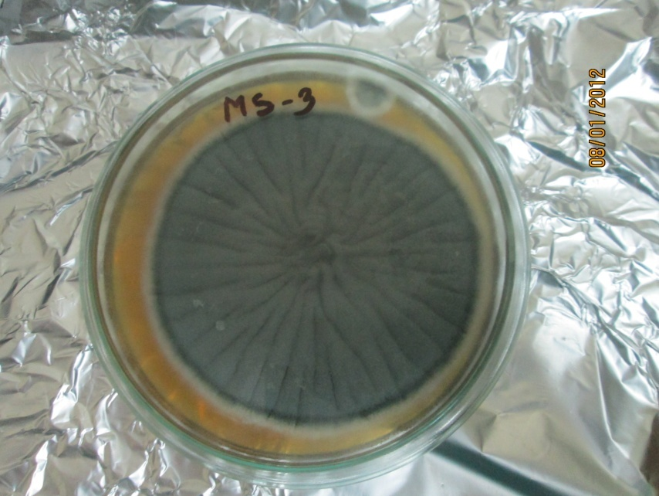Aspergillus fumigatus* isolate was collected from a repository of the Department of Microbiology and Veterinary Public Health, CVASU. These collected samples were inoculated on to Sabouraud Dextrose Agar (SDA) (Oxoid) and growth of fungi, hyphal tips and spores were observed after incubation for 3 days at 37°C (Figure 2). This isolated strain of *Aspergillus fumigatus* was used for experimental purposes in the study.

**Figure 2: Mother culture of *Aspergillus fumigatus***

**3.9 Selection of chicks as study population**

A total of 75 day-old “A” grade healthy chicks (Cobb-500) were purchased from M. M. Agha Poultry (Raufabad, Oxygen, Chittagong) as pre-contract basis for this study.

**3.9.1 Management of chicks**

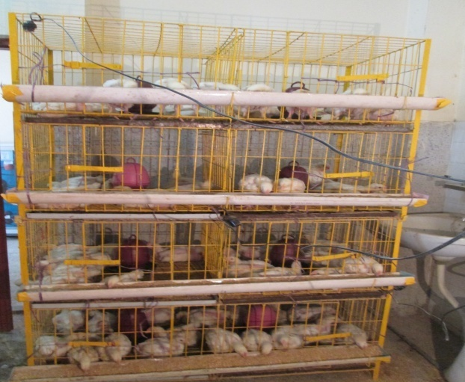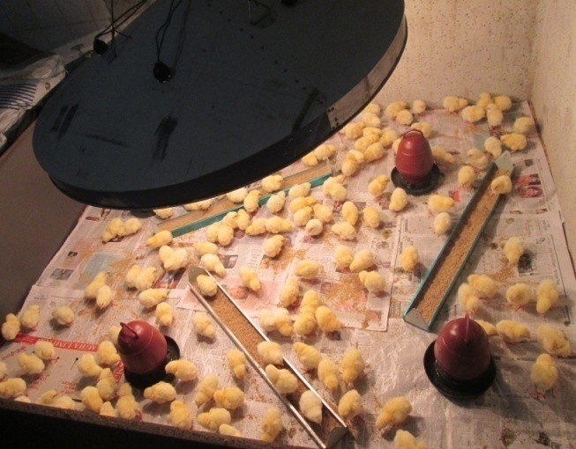Chicks were kept in a chick guard (brooding house) (Figure 3). The brooding temperature and humidity were at 95°F and 65% respectively in the 1st week and 88-90°F and 70% for the next week. Commercially available starter feeds from M. M. Agha Poultry were provided for 12 days (2950 Kcal/Kg ME; 22.7% CP). From 13 to 29 days, they were provided manually mixed balanced mash feed (3080Kcal/Kg ME and 21% CP) (Appendix-B). At Day-15 grower chicks were housed into cage (Figure 3). Vaccination schedule was as Mareks vaccine at Day-0, Baby Chick Ranikhet Disease Vaccine (BCRDV) at Day-4 and Day-21 and Gumboro vaccine at Day-15. Drinking water, mixed with various vitamins, minerals, electrolytes, enzymes, glucose and saline were provided to chicks every day.

**Figure 3: Brooding of day old chick and grower chick in cage**

**3.9.2 General monitoring task**

In brooding period, chicks were monitored every two hours interval. The floor of chick guard was maintained by rice husk and paper materials. For first 5 days of brooding stage, papers were replaced with new paper every six hours interval and after 5 days only rice husk was used as bedding material and changed every 12 hours interval until Day-15. Proper ventilation was maintained for ensuring the comfort of the birds.

**3.9.3 Infection exposure**

The infection of *Aspergillus fumigatus* was introduced at Day-12 to all birds (T0 to T7 group) through water with dropper. Infective dose was 5 ppm on water according to Moss, 1998.

**3.9.4 Treatment intervention**

The eight bird groups (T0-T7) were designed as follows (Figure 4). Each group consisted of 9 birds.

**Figure 4: Layout of treatment intervention**

**3.9.5 Diagnosis by clinical signs after infection**

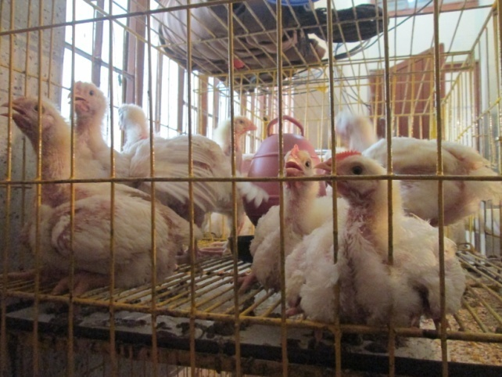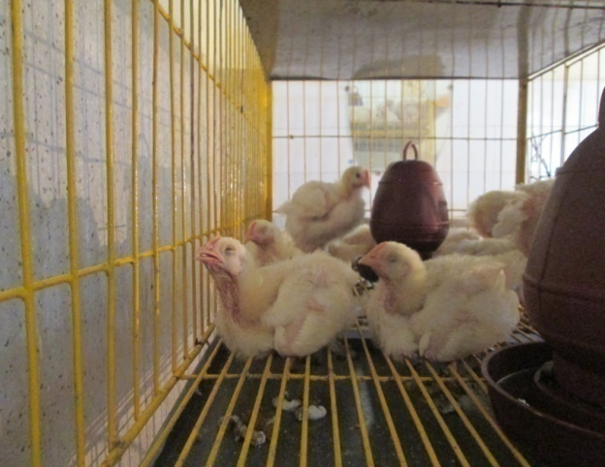At day 16 broilers started to show clinical sign like gasping, dyspnoea, and drowsiness. They were suffered from coughing and mucus through nostrils. Infected birds were thirsty, decreased feed intake (Figure 5).

**Figure 5: Infected birds with suffocation, dyspnoea and dizziness**

**3.9.6 Diagnosis by post mortem**

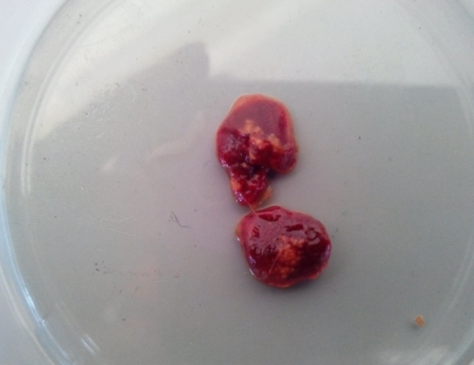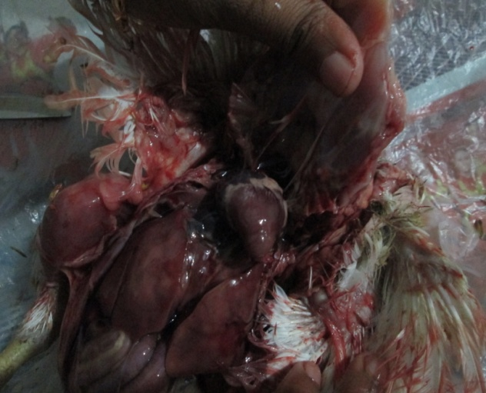After post mortem, characteristics whitish/yellowish nodules or plaques within the lungs and on the air sacs with congested lung in dead birds were observed (Figure 6).

**Figure 6: Nodules in lung and congested heart, liver of infected birds**

**3.9.7 Confirmation by culture of sample**

Clinical signs and pathologic findings are not sufficient for diagnosis, thus laboratory confirmation by isolation of *Aspergillus fumigatus* is necessary. Nodular lung sample was collected from dead birds; was inoculated onto Sabouraud Dextrose Agar (SDA) (Oxoid) and growth of fungi, hyphal tips and spores were observed after incubation for 3 days at 30°C (Moss, 1998) producing green to green-blue colored colonies.

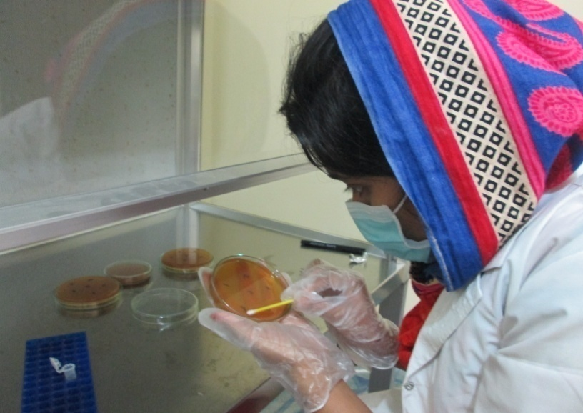

**Figure 7: Culture of *Aspergillus sp.* on SDA**

**3.9.8 Treatment and post monitoring**

After showing sign-symptom, treatment was started from 22nd day age of the birds. In groups (T1 to T7), birds were treated according to their treatment lay out (Figure 4). On every group except control untreated (T0) group ethanolic and aqueous neem leaf extract were administered through water as treatment layout and continued up to Day-27.

**3.9.9 Collection and preservation of sample**

Blood was collected at Day-22 and Day-28 from jugular vein of three randomly selected chicks in each group and 1.5ml blood was placed into both vacutainer containing anticoagulant and without anticoagulant with identity number and group name in each vacutainer After collection, samples were immediately shipped to Physiology laboratory of CVASU for hematological evaluation and Biochemistry laboratory of CVASU for serum separation and biochemical analysis.

**3.9.10 FCR calculation**

Every chick was weighed to measure appropriate growth and weighed at day 12, day 22 and day 28. Feed Efficiency or Feed Conversion Ratio (FCR) was calculated according to the following formula-

Feed consumed

FCR=

Weight gain

**3.9.11 Evaluation of hematological parameters**

EDTA containing blood samples were used to determine the hematological parameters such as ESR, PCV, Hb, TEC and DLC at day 28.

***Erythrocyte Sedimentation Rate (ESR)***

Collected blood samples were filled with the special loading pipette. The tip of the pipette was inserted to the bottom of the hematocrit tube/wintrobe tube and blood was expelled by the pressure on the rubber bulb. ESR value was determined according to the method explained by Coffin (1955).

***Haematocrit or Packed Cell Volume (PCV)***

The haematocrit tube was filled up with well-mixed blood by special loading pipette. Then the tube was centrifuged at 3000 rpm for half an hour and reading was taken. The PCV was determined as per method described by Coffin (1955).

***Hemoglobin (Hb) concentration***

The Hb estimation was performed by the acid Hematin method with the Shali’s Hemometer. The result was read as per method described by Coffin (1955).

***Total Erythrocytes Count (TEC)***

Thomas red blood cell pipette was used and pipette was filled up to 0.5 marks with blood and diluting fluid (Hayem’s solution). The dilution of the contents was 1:200. The counting chamber was filled with the contents and was placed under microscope. Counting of cells and calculation of TEC was performed as per method indicated by Coffin (1955).

***Differential Leucocytes Count (DLC)***

A thin blood film was made by spreading a blood drop evenly on clean grease free slide and modification of Romanowsky’s stain namely Leishman’s stain was used. For Giemsa’s staining the air dried blood smears were prefixed with acetone free methanol for five minutes (Conn and Darrow, 1960). The DLC results obtained were compared with the estimated normal values of Simmons et al. (1974) and Schalm et al. (1975).

**3.9.12 Separation of serum**

After 24 hours the coagulated blood which was kept in vacutainer was centrifuged (Capp Rondo, CR-68X, Denmark) for 20 minutes at 3000 rpm. Obtained serum samples were shifted to the eppendorf tube by using micropipette and given unique identification number. The obtained serum samples were stored at -20°C until analysis for biochemical test.

**3.9.13 Biochemical assay of serum sample**

Serum and all reagents were thawed by keeping at room temperature approximately for 30 minutes before the analysis. The serum samples were vortexed for mixing component of serum uniformly. The Serum Glucose, TP, Albumin, TG, Cholesterol, HDL, LDL, AST, ALT, Creatinine (Appendix-D) were assayed by using automated Biochemical analyzer (Humalyzer-3000, Germany) following manufacturer’s instruction. Randox kits were used to determine glucose, TP, Alb, TG, Cholesterol, AST, ALT, Creatinine; Biorex kits for HDL, LDL. A total number of 63 serum samples were analyzed.

***Serum Glucose assay***

Colorimetric spectrophotometric method was used for determination of glucose Concentrations (Barham and Trinder, 1972).

***Total Protein assay***

Colorimetric spectrophotometric method was used for determination of albumin and total protein (Doumas et al., 1975).

***Albumin assay***

Albumin is based on the principle of competitive bindings between albumin and albumin reagent. Bromocresol green forms with albumin in citrate buffer a colored complex. The absorbance of this complex is proportional to the albumin concentration in the sample.

***Lipid profile***

*(a) Cholesterol assay*

Colorimetric spectrophotometric method was used for determination of cholesterol concentrations (Roeschlau et al., 1974).

*(b) Triglyceride assay*

Triglyceride was determined after enzymatic hydrolysis with lipases. The indicator is a quinoneimine formed from hydrogen peroxide, 4- aminophenezone and 4- Chlorophenol under the catalytic influences of peroxidease.

***Liver function tests [Aspartate aminotransferase (AST) and alanine aminotransferase (ALT)]***

AST and ALT activity was determined according to the method described by Reitman and Frankel (1957).

***Creatinine concentration***

Creatinine was determined by the method described by Husdan and Rapoport (1968).

**3.9.14 Statistical analysis**

Data were entered into a spread sheet of MS Excel-2007. The data were sorted, cleaned and coded using the excel program before exporting to STATA/IC-11.0 (STATA Corp, USA) for analysis. T-test was used to compare the result among different groups. *p* values of ≤0.05 were considered statistically significant.

**Chapter-4: Results**

This experiment was conducted to evaluate the activity of ethanolic and aqueous neem leaves extract against avian aspergillosis at different concentrations on the basis of growth performance, biochemical and hematological alterations.

**4.1 Findings after infection exposure and treatment**

After 3-6 days of infection exposure various clinical signs such as dyspnoea, gasping, drowsiness, depression, less feed intake with death of few chickens had been observed. These signs became less distinct following treatment with the ethanolic and aqueous neem leaf extracts whereas in control group these signs were more prominent with mortality of chicks. The control group chickens were continually suffered in gasping, suffocation, dyspnoea, sitting silently and had a huge thirst. Post mortem findings of dead birds revealed the characteristics whitish/yellowish “sagu” nodules at lungs, air sacs, pericardium, heart and other different organs, and congested lung was also observed. On other hand while sacrificing some treated group birds, there were no characteristic whitish/yellowish nodules or plaques within the lungs and on the air sacs.

**Table 5: Gross lesion (whitish/yellowish nodule) found after ending of treatment (day 28)**

|  |  |  |
| --- | --- | --- |
| **Group and Concentration** | **Total number of birds (N)** | **Lesion observed (%)** |
| T0 (untreated control) | 9 | 7 (77.78) |
| T1 (0.6mg/ml of ENLE) | 9 | 5 (55.55) |
| T2 (0.7mg/ml of ENLE) | 9 | 4 (44.44) |
| T3 (0.8mg/ml of ENLE) | 9 | 2 (22.22) |
| T4 (0.9mg/ml of ENLE) | 9 | 4 (44.44) |
| T5 (50mg/ml of ANLE) | 9 | 5 (55.55) |
| T6 (100mg/ml of ANLE) | 9 | 4 (44.44) |
| T7 (150mg/ml of ANLE) | 9 | 3 (33.33) |

**4.2 Effects of extracts on growth performances**

In the study, after infection exposure more or less similar weight gain was observed in all groups of broiler (Table 6). After treatment intervention (Day 22-28) all treated groups raised their weight whereas control group had less weight gain (Table 7). In T3 group the highest body weight gain (586.4±13.6) was observed whereas the lowest body weight gain was found in T7 group (542.6±11.3). In the present study, the body weight gain was differed significantly (*p* ≤0.05) between control group (T0) and three treated groups (T2, T3, T7) at after treatment (Day 22-28) period.

Total feed consumption of different treated or control groups of broiler were illustrated on Table 6 & 7. In infection exposure period feed intake was similar to all groups (Table 6). After treatment period total feed consumption was increased in all treated groups other than control group T0 (Table 7). In T5 group (Figure 9) total feed consumption was higher than other treated group at treatment period which had no significance (*p≥*0.05) between two groups (T0 and T5). Total feed consumption of all treated groups showed insignificant (*p≥*0.05) change with control group (T0).

On the table 6, FCR of all groups in infection exposure period (Day 12-22) was ranged from 2.09-2.2 (Table 6). After treatment period better FCR was 1.86 on T3 group and poor FCR was on T5 group (2.06±0.01) which showed insignificance (*p≥*0.05) variation. On the other hand FCR value in control (T0) group was 2.2 which showed inferior performance than treated groups (Figure 10).

**Figure 8: FCR on live weight of all group between pre-treatment and post treatment**

Table 6: Growth performances of infected broilers (Day 12-22)

|  |  |  |  |  |  |  |  |  |
| --- | --- | --- | --- | --- | --- | --- | --- | --- |
| **Parameters** | **Groups (Mean±SD)** | | | | | | | |
| **T0** | **T1** | **T2** | **T3** | **T4** | **T5** | **T6** | **T7** |
| Weight gain (g) | 430.6±10.2 | 425.1±16.4 | 432.8±12.3 | 423.5±13.3 | 439.3±12.4 | 432.2±17.4 | 428.7±15.4 | 438.4±19.3 |
| Total Feed consumption  (g) | 935.6±21.6 | 942.3±22.4 | 918.3±34.5 | 933.8±29.5 | 927.4±37.4 | 934.3±26.4 | 920.7±32.4 | 918.4±23.5 |
| FCR | 2.17±0.03 | 2.2±0.01 | 2.12±0.03 | 2.21±0.02 | 2.11±0.02 | 2.16±0.01 | 2.14±0.03 | 2.09±0.01 |

**Table 7: Effects of extract on growth performances (Day 22-28)**

|  |  |  |  |  |  |  |  |  |
| --- | --- | --- | --- | --- | --- | --- | --- | --- |
| **Parameters** | **Treatment Groups (Mean±SD)** | | | | | | | |
| **Control**  **(T0)** | **Ethanolic extract** | | | | **Aqueous extract** | | |
| **T1** | **T2** | **T3** | **T4** | **T5** | **T6** | **T7** |
| Weight gain (g) | 438.5±9.7 | 578.4±16.6 | 560.3±21.7 | 586.4±13.6 | 551±14.6 | 577.1±18.3 | 566.9±17.4 | 542.6±11.3 |
|  | ***p*** | 0.6 | **0.05** | **0.03** | 0.37 | 0.09 | 0.73 | **0.05** |
| Total Feed consumption (g) | 967.8±26.7 | 1126.6±26.8 | 1075.7±22.6 | 1095.4±31.5 | 1079.4±43.2 | 1189±35.4 | 1100.5±28.5 | 1073.4±26.4 |
|  | *p* | 0.12 | 0.07 | 0.2 | 0.6 | 0.57 | 0.83 | 0.4 |
| FCR | 2.2±0.01 | 1.95±0.02 | 1.92±0.01 | 1.86±0.03 | 1.95±0.02 | 2.06±0.01 | 1.94±0.02 | 1.97±0.02 |
|  | ***p*** | 0.2 | 0.2 | 0.13 | 0.3 | 0.5 | 0.2 | 0.2 |

T0= Control group, T1= 0.6mg/ml of ENLE, T2= 0.7mg/ml of ENLE, T3= 0.8mg/ml of ENLE, T4= 0.9mg/ml of ENLE, T5= 50mg/ml of ANLE, T6= 100mg/ml of ANLE and T7= 150mg/ml of ANLE.

SD= Standard Deviation

Significant variation (*p*≤0.05) and highly significant variation (*p*≤0.01)

**4.3 Effects of neem leaf extracts on hematological parameters**

**4.3.1 Erythrocyte Sedimentation Rate (ESR)**

Slight alteration of ESR (mm/1st hr) was observed in different treated groups than control group (T0) at post treatment period. The mean values of ESR ranged from 1.5 to 2.5 at post treatment period which is 1.9 in control group. Significant (*p* ≤0.05) alteration of ESR was observed between control and T3, T7 group whereas insignificant alteration found in other treated groups when compare with control group (Table 8).

**4.3.2 Packed Cell Volume (PCV)**

PCV (%) level was increased in treated groups than the control group at post treatment period. In this period, the mean values of PCV of different treated groups were fluctuated. The PCV (%) was significantly increased between control and T3 (31.6%); T7 (30%) group, respectively. Though mean value of other treated group also higher than control group but there was no significant change (Table 8).

**4.3.3 Hemoglobin (Hb) concentration**

The mean value of Hb concentration was slightly increased in all treated groups after treatment with neem extracts. The highest Hb concentration (11.2g/dl) was observed in T4 group than any other treated groups but had no significance (*p*≥0.05) difference between control and these groups. There was significant increase of Hb between control and T3 group (Table 8).

**4.3.4 Total Erythrocyte Count (TEC)**

The mean value of TEC was slightly increased in all groups at post treatment period other than control (T0) group. There was significant (*p*≤0.05) increased of total erythrocyte count in between control and T7 group after treatment (Table 8).

**4.3.5 Effects of neem leaf extracts on leucocytes**

The mean values of lymphocyte (%) and eosinophil (%) were varied insignificantly (*p* ≥0.05) at post treatment period between control and treated group T1, T2, T3, T4, T5, T6 and T7 individually.

In the present study the average value of heterophil (%) were fluctuated in all treated group at post treatment period. Significant (*p* ≤0.05) alteration was found between control and T5 group at post treatment period. Basophil (%) of T7 group significantly (*p* ≤0.05) differs at post treatment period between control and T7 group. At post treatment period monocyte (%) count was significantly (*p* ≤0.05) changed between control and T1, T3 group respectively.

Table 8: Effects of neem leaf extract on selected hematological parameters

|  |  |  |  |  |  |  |  |  |
| --- | --- | --- | --- | --- | --- | --- | --- | --- |
| **Para-meters** | **Treatment groups at 28th day (Mean±SD)** | | | | | | | |
| **Control**  **(T0)** | **Ethanolic extract** | | | | **Aqueous extract** | | |
| **T1** | **T2** | **T3** | **T4** | **T5** | **T6** | **T7** |
| ESR (mm/1st hour) | 1.9±0.29 | 2.4±0.49 | 2.5±1.1 | 1.8±1.04 | 2.5±0.76 | 2±1.3 | 1.7±0.29 | 2.1±0.69 |
| ***p*** | 0.7 | 0.06 | **0.03** | 0.68 | 0.46 | 0.09 | **0.02** |
| PCV (%) | 21±3.6 | 29.4±1 | 29.7±2.9 | 31.6±1 | 30.0±2 | 24.3±3.2 | 29.7±4.7 | 20.7±3.1 |
| ***p*** | 0.13 | 0.6 | **0.03** | 0.24 | 0.14 | 0.16 | 0.13 |
| Hb (g/dl) | 6.1±0.2 | 8.8±0.6 | 10.9±0.9 | 9.6±1.8 | 11.2±1.4 | 8.1±1.1 | 9.6±0.6 | 8.9±1.5 |
| ***p*** | 0.1 | 0.28 | **0.04** | 0.13 | 0.09 | 0.08 | 0.17 |
| TEC(million/mm3) | 1.7±0.4 | 2.9±0.1 | 2.5±0.5 | 2.3±0.4 | 2.5±0.4 | 2.2±0.5 | 2.2±0.5 | 2.5±0.2 |
| ***p*** | 0.11 | 0.14 | 0.18 | 0.13 | 0.16 | 0.23 | **0.02** |
| Lymphocytes (%) | 63±3.6 | 69.3±4.5 | 74±3.6 | 66±4.5 | 66.3±4.04 | 64.7±3.2 | 65.7±5.5 | 74.3±3.8 |
| ***p*** | 0.13 | 0.57 | 0.22 | 0.41 | 0.37 | 0.55 | 0.13 |
| Heterophil (%) | 21.3±2.5 | 16.3±2.1 | 18±3.6 | 14.7±5.03 | 20±2 | 24.3±1.5 | 22.3±2.5 | 27±1 |
| *p* | 0.12 | 0.37 | 0.24 | 0.2 | 0.5 | **0.05** | 0.57 |
| Eosinophil (%) | 3.7±2.1 | 2.2±.8 | 4.7±2.3 | 4.2±1 | 2.3±1.2 | 3.7±2.1 | 3.9±1 | 3.3±2.5 |
| ***p*** | 0.74 | 0.32 | 0.31 | 0.7 | 0.6 | 0.9 | 0.6 |
| Basophil (%) | 1.7±0.6 | 1.5±1 | 0.7±.5 | 1.0±0 | 2.3±1.5 | 2.3±1.1 | 1.4±0.6 | 2±0 |
| *p* | 0.42 | 0.4 | 0.9 | 0.6 | 0.18 | 0.4 | **0.05** |
| Monocytes (%) | 3.9±2 | 4.3±1.6 | 3.3±1.1 | 4.3±2.5 | 3.7±2.5 | 2.9±1 | 4.9±2.6 | 2.7±1.5 |
| ***p*** | **0.03** | 0.3 | **0.03** | 0.8 | 0.38 | 0.22 | 0.6 |

T0= Control group, T1= 0.6mg/ml of ENLE, T2= 0.7mg/ml of ENLE, T3= 0.8mg/ml of ENLE, T4= 0.9mg/ml of ENLE,

T5= 50mg/ml of ANLE, T6= 100mg/ml of ANLE and T7= 150mg/ml of ANLE.

SD= Standard Deviation

Significant variation (*p*≤0.05) and highly significant variation (*p*≤0.01)

**4.4 Effect of neem leaf extracts on biochemical parameters**

**4.4.1 Glucose**

The glucose level was slightly reduced at after treatment period in different groups than control group (Table 9). Though there had fluctuating trends but had no significant association between control group and treated group.

**4.4.2 Total Protein**

On total protein (g/l), it was observed that the average value of all treated groups was fluctuating at post treatment period. The mean value of T3 group increased from 19.0 to 25.5 (g/l). Moreover, there had no significant (*p* >0.05) variation all over the study (Table 9).

**4.4.3 Albumin**

After treatment period the average value of albumin was slightly higher than control group. This value was significantly varied between control and T3 group whereas other treated groups expose insignificant variation between control and treated group individually.

#### 4.4.4 Aspartate Aminotransferase (AST) and Alanine Aminotransferase (ALT)

Both AST and ALT value was slightly higher in control group which indicate liver damage. In post treatment period mean value was slightly decrease compare to control group. AST and ALT value of T3 and T7 group varied significantly (*p≤*0.05) at post treatment period.

**4.4.5 Creatinine**

Creatinine (mg/dl) level was 0.4 to 0.6 among all groups in post treatment period. The variation was insignificantly (*p* ≤0.05) associated between control and different treated group.

**4.4.6 Cholesterol and Triglycerides (TG)**

Insignificant (*p*>0.05) variation of cholesterol (mg/dl) and triglyceride (mg/dl) level were observed between control and treated groups at post treatment period.

**Table 9: Effect of neem leaf extract on selected biochemical parameters**

|  |  |  |  |  |  |  |  |  |
| --- | --- | --- | --- | --- | --- | --- | --- | --- |
| **Para-meters** | **Treatment groups at 28th day** | | | | | | | |
| **Control T0** | **Ethanolic extract** | | | | **Aqueous extract** | | |
| **T1** | **T2** | **T3** | **T4** | **T5** | **T6** | **T7** |
| Glucose (mg/dl) | 322±9.54 | 299.1±30.6 | 319.5±21.7 | 336.8±21.7 | 296.5±32.0 | 307.4±26.2 | 317.1±18.2 | 305.1±22.2 |
|  | *p* | 0.41 | 0.25 | 0.48 | 0.41 | 0.35 | 0.12 | 0.17 |
| Total Protein (g/l) | 19.0±0.11 | 20.3±0.50 | 24.1±0.61 | 25.5±0.15 | 23.3±0.73 | 25.1±0.18 | 22.5±0.53 | 24.0±0.66 |
|  | ***p*** | 0.8 | 0.49 | 0.13 | 0.41 | 0.25 | 0.61 | 0.2 |
| Albumin (g/l) | 7.77±2.4 | 11.2±3.9 | 11.2±4.9 | 10.9±3.2 | 12.1±1.2 | 13.5±6.3 | 9.4±.90 | 13.6±3.5 |
|  | ***p*** | 0.2 | 0.45 | **0.05** | 0.13 | 0.34 | 0.4 | 0.09 |
| AST/SGOT (u/l) | 212.7±18.3 | 214.9±26.8 | 216.4±49.7 | 192.2±23.4 | 219.3±19.2 | 210±31.8 | 191.7±31.0 | 188.1±31.5 |
|  | ***p*** | 0.9 | 0.91 | **0.05** | 0.09 | 0.94 | 0.9 | 0.41 |
| ALT/SGPT (u/l) | 7.9±1.1 | 7.1±1.3 | 8.6±3.3 | 8.4±.9 | 6.7±2.7 | 7.2±3.8 | 6.9±3.9 | 5.7±.8 |
|  | ***p*** | 0.55 | 0.2 | 0.39 | 0.57 | 0.72 | 0.08 | **0.03** |
| Creati-nine (mg/dl) | 0.4±0.2 | 0.5±0.1 | 0.5±0.1 | 0.6±0.1 | 0.5±0.1 | 0.5±0.1 | 0.4±0.06 | 0.5±0.2 |
|  | ***p*** | 0.18 | 0.69 | 0.45 | 0.42 | 0.57 | 0.9 | 0.82 |
| Chole-sterol (mg/dl) | 109.2±32.2 | 126.1±17.7 | 138.9±11.9 | 114.1±31.0 | 115.3±18.0 | 129.4±11.0 | 135.9±18.5 | 111.8±18.6 |
|  | ***p*** | 0.18 | 0.19 | 0.07 | 0.58 | 0.28 | 0.86 | 0.29 |
| Tri-glycer-ides (mg/dl) | 158.4±41.5 | 128.1±85.6 | 123.9±25.9 | 134.4±47.6 | 127.3±42.7 | 150.6±55.7 | 166.4±11.1 | 122.9±35.3 |
|  | ***p*** | 0.72 | 0.84 | 0.11 | 0.54 | 0.1 | 0.62 | 0.92 |

T0= Control group, T1= 0.6mg/ml of ENLE, T2= 0.7mg/ml of ENLE, T3= 0.8mg/ml of ENLE, T4= 0.9mg/ml of ENLE,

T5= 50mg/ml of ANLE, T6= 100mg/ml of ANLE and T7= 150mg/ml of ANLE.

SD= Standard Deviation

Significant variation (*p*≤0.05) and highly significant variation (*p*≤0.01)

**Chapter-5: Discussion**

Infection by *Aspergillus sp.* has been reported in almost all domesticated avian species and *Aspergillus fumigatus* is considered as a major respiratory pathogen. Arne et al. (2011), described that *Aspergillus fumigatus* causes the disease namely brooder pneumonia in young poultry. The number of researchers like Dhama et al. (2012), Beernaert et al. (2010), Martin et al*.* (2007), Kunkle (2003), Akan et al. (2002) and Joseph (2000) isolated other species of molds such as *A. flavus*, *A. niger*, *A. nidulans* and *A. terreus* from avian aspergillosis.

In the current study, infected broilers were suffered in gasping, suffocation, dyspnoea, coughing and mucus through nostrils and the observation was found similar to that previously identified in different birds by Dhama et al. (2011), Cacciuttolo et al. (2009), Nardoni et al. (2006), Atasever and Gumussoy (2004), Jones and Orosz (2000). Evidence of clinical signs associated with *A. fumigatus* infection was quite evident in this study, which is in agreement with literature. Chicks in this study started showing clinical sign in 3-6 days post infection in different group. Furthermore, *A. fumigatus* was re-isolated from the lungs and air sacs of infected chicks which is similar to Suleiman et al. (2012). Our data indicated that ethanolic and aqueous neem extract has activity against aspergillosis in broiler chicks and could serve as anti-Aspergillus agents.

Yellow colored uniform pin point lesions were visible on the lungs, which ranged from miliary to larger granulomatous foci as “Sagu” appearance. On the other hand, walls of air sacs were thickened and bronchioles filled with mucus and congested lungs were found. These lesions are similar to the post mortem findings of aspergillosis affected birds described earlier (Cacciuttolo et al., 2009; Nardoni et al., 2006; Shivaprasad, 2000; Calnek et al., 1997). Untreated control (T0) group of this study found similar whitish nodule in lung, air sac after sacrificing of birds.

The present *in-vivo* experimental study showed antifungal activity at different doses of neem leaf extracts and this type of activity was found in in-vitro study performed by Bansod and Rai (2008).

Ethanolic neem leaf extract had a greater inhibitory effect on *Aspergillus spp.* which supports previous *in vitro* studies (Margaret et al., 2013; Mahmoud et al., 2011; Mondali et al., 2009). The fungicidal and bactericidal properties of extracted neem leaf contain several antimicrobial active ingredients such as desactylimbin, quercetin and sitosterol either *in vitro* or *in vivo* trials (Singh et al., 1980) whereas other researchers (Ghorbanian et al., 2007; Bhatnagar, 1988) explained this activity by the presence of active ingredients like triterpenes or the limonoids such as meliantriol, azadirachtin, desactylimpin, quercetin, sitosterol, nimbin, nimbinin, nimbidin, nimbosterol and margisine.

Mahmoud et al. (2011) revealed that in in-vivo experiment the highest concentration (15%) of aqueous neem leaf extract effectively suppressed the mycelia growth of *A. fumigates.*

Natarajan et al*.* (2003) noticed that the ethanol extracts of *A. indica* had fungitoxic properties against five pathogenic fungi when tested *in vitro* under laboratory conditions at concentrations ranging between500 and 1000 μg/ml and the higher concentration gave more inhibition of *A. flavus* than other concentration.

Radhika and Michael (2013) observed results obtained during assay with organic extracts from *A. indica* leaves showed their inhibitory effect and this effect was found to increase with concentration 125μg/ml to 500μg/ml.

In a study done by Mondali et al*.*,(2009) showed that the ethanolic extract of *A. indica* leaves is more effective against *Aspergillus spp.* compared to aqueous leaf extract *in vitro* on the culture medium. The results of present study also revealed that ethanolic neem extract had better antifungal activity than aquous neem extract when observed gross lesion in post mortem after end of treatment.

Durani et al. (2008) stated that the highest neem leaf infusion group had significantly (*p*<0.05) higher body weight gain than the rest of the groups. An increasing trend was found in body weight gain with increased levels of neem leaves infusion. The results of the present study are in agreement with the study of Chakeravarty and Prasad (1991), who reported that broiler fed on diet containing neem (*A. indica*) leaves, had higher body weight gain. Similar findings had been reported by Tipu et al*.* (2002), who used salinomycine and neem (*A. indica*) fruit as feed additive and anticoccidial in broilers and reported better results in terms of weight gain. The higher body weight gain in broilers consumes neem leaves infusion could be due to its diversified effect on intestinal micro flora, thereby avoiding stressful conditions.

Birds supplemented with neem leaves extract improved body weight, weekly gain in weight and FCR in treated group which agreed with Rahman et al. (2014), Ansari et al. (2008), Manwar et al. (2005), Durani et al. (2008) and contrary to Nayaka et al. (2013). In this study we showed that body weight gain was increased in all treatment groups than untreated control group. The highest body weight gain was found on T3 (0.8mg/ml) group and FCR also improved in that group than untreated control group. However, no marked variations in FCR of birds fed neem leaf were reported by earlier a researcher (Kabeh and Jalingo, 2007) which is similar to the present study.

Dhanasekaran et al. (2011) stated that in aspergillosis infection, hematopoietic suppression and anemia observed as decreases in total erythrocytes, packed-cell volume and hemoglobin which also observed in this study where the mean value of control group decreased than normal value. After neem leaves treatment, both ESR and PCV have significantly changed in post treatment (Day 28) period. The mean value of PCV and Hb in post treatment period on T3 group is more or less close to normal level (PCV% 29.85±.5; Hb 12.23±.3). Significant alteration of ESR and PCV in post neem treatment period on T3 group indicates similarity to Mostafa et al. (2014), Nayaka et al. (2013) where they observed that the neem leaves treatment has significantly changed some of the hematological parameters, i.e. TEC, PCV and ESR in neem treated groups. TEC level was also slightly increased in some treated groups than control one. In our study after infection exposure differential leucocytic counts vary among studies with concurrent lymphopenia, monocytoses and heterophilia which are in agreement to Dhanasekaran et al. (2011) who stated fungal infection in broilers. Moreover, Nayaka et al. (2013) showed that there was insignificantly increased lymphocytes and lowered heterophil with slight decrease of monocytes were revealed on neem treated group which is varied from Esonu et al. (2006). Gangar et al. (2006) and Borjesson et al. (2000) reported higher monocyte count in neem treated group which is opposite to the current study.

Total serum proteins contents of all groups are depressed due to reduced values of alpha and beta globulins and albumen (Pier, 1973) in fungal infected birds which is agree with Dhanasekaran et al. (2011).

Increased activities of aspartate aminotransferase and alanine aminotransferase were reported in aflatoxicated chickens which are in accordance current study where both enzymes were increased in control group at post infection period (Dafalla et al.,1987; Rao and Joshi, 1993; Leeson et al.,1995) due to hepatocyte degeneration. On neem treated group, significant variation was found in ALT by Aruwayo et al. (2011) which supports our study on T7 (150mg/ml of aquous neem leaf extract) group. Moreover, Musalia et al. (2000) reported insignificant alteration in ALT and significant deviation in AST. On other hand, Dafalla et al. (2012) observed significant increase of ALT level in albino rats using higher doses of neem extract and it is due to development of hepatonephropathy in liver (Razzaghi-Abyaney et al., 2005). Neem causes mild to severe changes in kidney, liver, spleen, intestine and heart of chicks (Aruwayo et al., 2011; Musalia et al., 2000; Jacobson, 1995) which is not supported by present study due to insignificant variations in creatinine level at post treatment period. Moreover, during neem treatment, significant elevation of lipid metabolites (cholesterol) indicated fat deposition in broilers which is not an agreement with Nnenna and Okey (2013), Ogbuewu et al. (2010a, b), Uko and Kamalu (2008), Chattopadhyay et al. (1993) where they showed significant reduction of serum cholesterol without changing serum protein, blood urea, uric acid and suggested a general decrease in lipid metabolism. On other hand, reduction in Triglyceride with neem extract compare with control group had also been reported and lower levels of triglyceride may be due to the inhibition of fatty acids synthesis (Pesti, 1997) which supports our study.

**Chapter-6: Limitations**

1. Lack of proper farming place.
2. Lack of proper brooding system.
3. Total population size must be less in no. in case of clinical trial.
4. Active ingredients which act as antifungal were not identified due to lack of lab facility
5. Toxicity and safety evaluation indices were not examined.

**Chapter-7: Conclusion**

Broiler chicks are susceptible to the infection with *A. fumigatus* and the extract of neem leaf appears to be beneficial in treating and curing it. In the present study 0.8mg/ml of ethanolic and 150mg/ml of aqueous extract of neem leaves cause significant increase in live body weight gain and improved feed conversion ratio (FCR) in broilers as compared to control group. In 0.8mg/ml of ethanolic neem leaf extract group showed less gross lesion of specific after ending of treatment period. In this group packed cell volume, hemoglobin, albumin and aspertate aminotransferase was varied significantly. Finally it can be conferred that 0.8mg/ml of ethanolic neem leaf extract had better antifungal activity against aspergillosis. Further study is needed to know the adverse effects and active ingredient of neem leaf extract against *A. fumigatus* in broiler.

# Chapter-8: Recommendations and Future Perspective

Antifungal activity was observed in both ethanolic and aqueous neem leaf extract against aspergillosis in broiler. On the basis of this experiment following recommendations are given-

1. Exact active ingredients which act as antifungal is imperative to elucidate in further study.
2. Toxicity studies of the effectual plants should be done to establish the safety indices of the extract
3. Need to find out the mechanisms of the action, compatibility with other drugs, such as Amphotericin B, Itraconazole etc side effects and other important parameters
4. Plants should be further studied to investigate the appropriate antifungal efficacy on *Aspergillus spp.* as well as diversified fungal infection and also for antibacterial or anthelmintic or anticytotoxic properties.

**REFERENCES**

Abrams GA, Paul-Murphy J, Ramer JC, Murphy CJ. 2001. Aspergillus blepharitis and dermatitis in a peregrine falcon-gyrfalcon hybrid (*Falco peregrinus* X *Falco rusticolus*). Journal of Avian Medicine and Surgery. 15 (2): 114-120.

Akan M, Hazroˇglu R, Ilhan Z, Sareyy¨upoˇglu B, Tunca R. 2002. A case of aspergillosis in a broiler breeder flock. Avian Diseases. 46 (2): 497-501.

Aladakatti RH, Ahmed RN, Ahmed M, Ghosewami MG. 2001. Journal of Basic Clinical. Physiology and Pharmacology. 12: 69–76.

Amin MR, Mostofa M, Awal MA, Hossain A. 2008. Effects of neem (*Azadirachta indica*) leaves against gastrointestinal nematodes in cattle. Journal of Bangladesh Agricultural University. 6 (1): 87-99.

Ansari JZ, Haq A, Yousaf M, Ahmad T, Khan S. 2008. Evaluation of different medicinal plants as growth promoters for broiler chicks. Sarhad Journal of Agriculture. 24 (2): 323-330.

Aarati N, Ranganath NN, Soumya GB, Kishore B, Mithun K. 2011. Evaluation of Antibacterial and Anticandidal efficacy of aqueous and alcoholic extract of Neem (*Azadirachta Indica)* an in vitro study. International Journal of Research in Ayurveda & Pharmacy 2(1): 230-235.

Arne P, Thierry S, Wang D, Deville M, Le Loch G, Desoutter A, Femenia F, Nieguitsila A, Huang W, Chermette R, Guillot J. 2011. *Aspergillus fumigatus* in poultry. International Journal of Microbiology. 2011: Article ID 746356, 14 pages. Available from: <http://dx.doi.org/10.1155/2011/746356>

Aruwayo A, Maigandi SA, Malami BS, Daneji AI. 2011. Haematological and Biochemical Parameters of Uda Lambs Fed Graded Levels of Alkali-Treated Neem Kernel Cake. Nigerian Journal of Basic and Applied Science. 19 (2): 277-284.

Atasever A, Gumussoy KS. 2004. Pathological, clinical and mycological findings in experimental aspergillosis infections of starlings. Journal of Veterinary Medicine. 51 (1): 19-22.

Badhy SC, Amin KMR, Kabir SML, Paul BK, Das SK. 2003. Brooders pneumonia: histopathological changes in the lungs of broiler chickens. International Journal of BioResearch. 1(1): 55-58.

Bansod S, Rai M. 2008. Antifungal activity of essential oils from Indian medicinal plants against human pathogenic *Aspergillus fumigatus* and *A. niger*. World Journal of Medical Sciences. 3 (2): 81-88.

Barham D, Trinder P. 1972. An improved color reagent for the determination of blood glucose by the oxidase system. Analyst-Royal Society of Chemistry. 97 (1151): 142-145.

Barnes AJ, Denning DW.1993. Aspergilli-Significance as pathogens. Review of Medical Microbioogy. 4:176-180.

Bauck L, Hillyer A, Hoefer H. 1992. Rhinitis: case reports. Proceedings of the Annual Conference of the Association of Avian Veterinarians New Orleans LA, USA 134.

Beernaert LA, Baert K, Marin P, Chiers K, De Backer P, Pasmans F, Martel A. 2009a. Designing voriconazole treatment for racing pigeons: balancing between hepatic enzyme auto induction and toxicity. Medical Mycology. 47 (3): 276-285.

Beernaert LA, Pasmans F, Baert K, Van Waeyenberghe L, Chiers K, Haesebrouck F, Martel A. 2009b. Designing a treatment protocol with voriconazole to eliminate *Aspergillus fumigatus* from experimentally inoculated pigeons. Veterinary Microbiology. 139 (3): 393–397.

Beernaert LA, Pasmans F, van Waeyenberghe L, Haesebrouck F, Martel A. 2010. Aspergillosis infection in birds: A review: Avian Patholology. 39 (5): 325-331.

Bempah KC, Buah-Kwofie A, Asomaning J. 2011. Morphological studies of Neem *(Azadirachta indica* A. Juss.) seed and physicochemical properties of its oil extracts collected in Accra metropolis of Ghana. Elixir Applied Botany. 39: 4951-4953.

Beytut E, Ozcan K, Erginsoy S. 2004. Immunohistochemical detection of fungal elements in the tissues of goslings with pulmonary and systemic aspergillosis. Acta Veterinaria Hungarica. 52 (1): 71-84.

Bhatnagar D. 1988. The inhibitory effect of neem (*Azadirachta indica*) leaf extracts on aflatoxin synthesis in *Aspergillus parasiticus.* Journal of the American Oil Chemists’ Society. 65 (7): 1166-1168.

Biswas K, Chattopadhyay I, Banerjee RK, Bandyopadhyay U. 2002. Biological activities and medicinal properties of Neem (*Azadirachta indica*). Current Science 82 (11): 1136 -1345.

Bonar CJ, Lewandowski AH. 2004. Use of a liposomal formulation of amphotericin B for treating wound aspergillosis in a Goliath heron (*Ardea goliath*). Journal of Avian Medicine and Surgery. 18 (3): 162–166.

Borjesson DL, Christopher MM, Boyce WM. 2000. Biochemical and Haematological reference intervals for free-ranging Desert Bighorn sheep. Journal of Wildlife Diseases. 36 (2): 294-300.

Burhenne J, Haefeli WE, Hess M, Scope A. 2008. Pharmacokinetics, tissue concentrations and safety of the antifungal agent voriconazole in chickens. Journal of Avian Medicine and Surgery. 22 (3): 199-207.

Cacciuttolo E, Rossi G, Nardoni S, Legrottaglie R, Mani P. 2009. Anatomo-pathological aspects of avian aspergillosis. Veterinary Research Communications. 33 (6): 521-527.

Calnek BW, Barnes HJ, Beard CW, McDougald LR, Saif YM. 1997. Diseases of Poultry. 10th Ed. Iowa State University Press, Ames, IA. pp. 1080.

Chakrabarti A. 2011. Drug resistance in fungi – an emerging problem. Regional Health Forum. 15:1

Chakravarty A, Prasad J. 1991. Study on the effect of neem leaf extract and neem cake extract on the performance of broiler chicks. Poultry Adviser. 24 (9): 37-38.

Chandrawathani P, Zary Shariman Y, Premaalatha B, Rahimah H, Norhafiza NH, NurulAini R Nor Andilla I, Wahab AR. 2013. Evaluation of Neem leaf (*Azadirachta* indica) product for worm control on goats. Malaysian Journal of Veterinary Research 4(1), 5-12.

Chattopadhyay RR, Chattopadhyay RN, Maitra SK. 1993. Effects of neem on hepatic glycogen in rats. Indian Journal of Pharmacology. 25 (3): 174-175.

Chauhan HVS, Roy S. 2008. Fungal Diseases. In: Chauhan HVS, Roy S, editors. Poultry Diseases, Diagnosis and Treatment. 3rd ed. New Age International (P) Ltd., New Delhi. pp. 127-132.

Coffin DL. 1955. Manual of Veterinary Clinical Pathology. Coinstock Publishing Associates. *Inc. Ithaca* New York. 3: 116-157.

Conn HJ, Darrow MS. 1960. Staining procedure used by the Biological Staining Commission, 2nd Baltimore, the Williams and Wilkins Company.

Cray C, Reavill D, Romagnano A, van Sant F, Champagne D, Stevenson R, Rolfe V, Griffin C, Clubb S. 2009. Galactomannan assay and plasma protein electrophoresis findings in psittacine birds with aspergillosis. Journal of Avian Medicine and Surgery. 23 (2): 125-135.

Dafalla MB, Konozy EH, Saad HA. 2012. Biochemical and histological studies on the effects of *Azadrichta indica* seeds kernel extract on albino rats. International Journal of Medicinal Plant Research. 1 (6): 82-92.

Dafalla R, Yagi AI, Adam SEI. 1987. Experimental aflatoxicosis in Hybro-type chicks: Sequential changes in growth and serum constituents and histopathological changes. Veterinary Human Toxicology. 29: 222-225.

Dahlhausen B, Abbott R, Van Overloop P. 2004. Rapid detection of pathogenic *Aspergillus* species in avian samples by real-time PCR assay: A preliminary report. Proceedings of the 25th Annual Conference and Expo of the Association of Avian Veterinarians, 17th-19th August, 2004. New Orleans, LA, USA. Abstract Book, p 37.

Dahlhausen RD. 2006. Implications of Mycoses Clinical Disorders. In: Harrison GJ, Lightfoot TL, editors. Clinical Avian Medicine. Spix Publishing Incorporation, Palm Beach, FL. pp: 691-704.

Debashri M, Tamal M. 2012. A review on efficacy of *Azadirachta indica* A. Juss based biopesticides: an indian perspective. Research Journal of Recent Sciences. 1(3): 94-99.

Denning DW, Follansbee SE, Scolaro M, Norris S, Edelstein H, Stevens DA. 1991. Pulmonary aspergillosis in the acquired immunodeficiency syndrome. New English Journal Medicine 324:654–662.

Despande VY, Mendulkar KN, Sadre NL. 1980. Journal of Postgraduate Medicine (Bombay). 26: 167–170.

Dhama K, Chakraborty S, Verma A. K, Tiwari R, Barathidasan R, Kumar A, Singh SD. 2013. Fungal/Mycotic Diseases of Poultry-diagnosis, Treatment and Control: A Review: Pakistan Journal of Biological Sciences. 16: 1626-1640.

Dhama K, Anjaneya, Hansa A, Singh SD. 2011. Fungal diseases of poultry. Poultry Fortune. 12: 30-35.

Dhama K, Barathidasan R, Tiwari R, Singh SD. 2012. Aspergillosis: An important fungal disease of poultry and other birds. Poultry World. 9: 7-9.

Dhama K, Chauhan R S, Mahesh M, Singh KP, Telang AG, Lokesh S, Simmi T. 2007. Aflatoxins-hazard to livestock and poultry production: A review. Journal of Immunology and Immunopathology. 9: 1-15.

Dhama K, Mahendran M, Tomar S, Nandi S. 2008. Mycotoxicosis in livestock and poultry: An overview of Livestock Line. 2: 7-15.

Dhanasekaran D, Shanmugapriya S, Thajuddin N, Panneerselvam A. 2011. Aflatoxins and Aflatoxicosis in Human and Animals, Aflatoxins - Biochemistry and Molecular Biology, Dr. Ramon G. Guevara-Gonzalez (Ed.), ISBN: 978-953-307-395-8, InTech, Available from: <http://www.intechopen.com/books/aflatoxinsbiochemistry-and-molecular-biology/aflatoxins-and-aflatoxicosis-in-human-and-animals>.

Di Somma A, Bailey T, Silvanose C, Garcia-Martinez C. 2007. The use of voriconazole for the treatment of aspergillosis in falcons (*Falco* species). Journal of Avian Medicine and Surgery. 21 (4): 307–316.

Domenico DB. 1998. Novel antifungal drugs. Current Microbiology. 2:509–515.

Doumas BT. 1975. Standards for total serum protein assays- a collaborative study. Clinical Chemistry. 21 (8): 1159-1166.

Durani FR, Chand N, Jan M, Sultan A, Akhter S. 2008. Immunomodulatory and growth promoting effects of neem leaves infusion in broiler chicks. Sarhad Journal of Agriculture. 24:655-659.

Esonu BO, Opara MN, Okoli IC, Obikaonu HO, Udedibie C, Iheshiulor OOM. 2006. Physiological responses of laying birds to Neem (Azadirachta indica) leaf meal based diets, body weight, organ characteristics and hematology. Online Journal of Health Allied Science. 2:4-4.

Flammer K, Orosz S. 2008. Avian mycoses: Managing these difficult diseases. Proceedings of the 29th Annual Conference and Expo of the Association of the Avian Veterinarians. 11th-14th August, 2008. Savannah, GA, USA. FL. 691-704.

Flammer K. 1993. An overview of antifungal therapy in birds. In: Jackson G. editor. Proceedings of the Annual Conference of the Association of Avian Veterinarians 1. Nashville, TN, USA.

Flammer K. 2006. Antifungal drug update. In: Bergman E. editor. Proceedings of the 27th Annual Conference and Expo of the Association of Avian Veterinarians. San Antonio, TX, USA. Abstract Book, 3.

Forbes, NA. 1992. Diagnosis of avian aspergillosis and treatment with itraconazole. The Veterinary Record. 130 (23): 519-520.

Galiger C, Brock M, Jouvion G, Savers A, Parlato M, Ibrahim-Granet O. 2013. Assessment of Efficacy of Antifungals against *Aspergillus fumigatus*: Value of Real-Time Bioluminescence Imaging. Antimicrobial Agents and Chemotherapy. 57 (7): 3046-3059.

Gangar S, Sandhir R, Rai D, Koul A. 2006. Modulatory effects of *Azadirachta indica* on benzo(a)pyrene induced forestomach tumorigenesis in mice. The World Journal of Gastroenterology. 12 (17): 2749-2755.

Ghani A. 2003. Medicinal Plants of Bangladesh: Chemical constituents and uses. Asiatic Society of Bangladesh, Dhaka-1000. pp. 69-70.

Ghorbanian M, Razzaghi-Abyaneh M, Allameh A, Shams-Ghahfarokhi M, Qorbani M. 2007. Study on the effect of neem (*Azadirachta indica* A. juss) leaf extract on the growth of *Aspergillus parasiticus* and production of aflatoxin by it at different incubation times. Mycoses. 51 (1): 35–39.

Girish K, Bhat SS. 2008. Neem – A Green Treasure. Electronic Journal of Biology. 4(3):102-111.

Heatly JJ, Gill H, Crandall L, Hoerr F. 2007. Enilconazole for treatment of raptor aspergillosis. In: Bergman E. editor. Proceedings of the 28th Annual Conference and Expo of the Association of Avian Veterinarians with the Association of the European College of Avian Medicine and Surgery. Providence, RI, USA. Abstract Book, p 287.

Hossain Z. 2003. People’s awareness about medicinal values of plants and prospect in Bangladesh. BRAC, Research and Evaluation division, Dhaka, Bangladesh.

Husdan H, Rapoport A. 1968. Estimation of creatinine by the Jaffe reaction. A comparison of three methods. Clinical Chemistry. 14 (3): 222-238.

Ibrahim IA, Khalid SA, Omer SA, Adam SE. 1992. Journal of Ethnopharmacology. 35: 267–273.

Islam MN, Rashid SMH, Juli MSB, Rima UK, Khatun M. 2009. Pneumomycosis In Chickens: Clinical, Pathological And Therapeutical Investigation. International Journal of Sustainable Crop Production. 4(3):16-21.

IUCN. 2003. The World Conservation Union. Bio-ecological Zones of Bangladesh.

Jacobson M. 1995. In The Neem Tree: Source of Unique Natural Products for Integrated Pest Management, Medicine, Industry and Other Purposes (ed. Schmutterer, H.). pp. 484–495.

Jenkins J. 1991. Aspergillosis. Proceedings of the Annual Conference of the Association of Avian Veterinarians. 23rd-28th September, 1991. Chicago, IL, USA. Abstract Book, p 328.

Johnson, Fiske G. 1935. The Early History of Copper Fungicides. Agricultural History. 9 (2): 67-79.

Jones MP, Orosz SE, Cox SK, Frazier DL. 2000. Pharmacokinetic disposition of itraconazole in red-tailed hawks (*Buteo jamaicensis*). Journal of Avian Medicine and Surgery. 14 (1): 15-22.

Jones MP, Orosz SE. 2000. The diagnosis of aspergillosis in birds. Seminars in Avian and Exotic Pet Medicine. 9 (2): 52-58.

Joseph V, Pappagianis D, Reavill DR. 1994. Clotrimazole nebulization for the treatment of respiratory aspergillosis. In: Kornelsen MJ. editor. Proceedings of the Annual Conference of the Association of Avian Veterinarians. Reno, NV, USA. Abstract Book, p. 301.

Joseph V. 2000. Aspergillosis in raptors. Seminars in Avian and Exotic Pet Medicine. 9 (2): 66-74.

Kabeh JD, Jalingo MGDSS. 2007. Mini review: Exploiting Neem (*Azadirachta indica*) resources for improving the quality of life in Taraba State, Nigeria. International Journal of Agriculture and Biology. 9 (3): 530-532.

Kanungo D. 1996. in *Neem* (eds Randhawa and Parmar, B. S.). 2: 77–110.

Kapetanov MC, Potkonjak DV, Milanov DS, Stojanov IM, Balos MZ, Prunic BZ. 2011. Investigation of dissemination of aspergillosis in poultry and possible control measures. 120: 269-278.

Kasutri M, Ahmed RN, Pathan KM, Shaikh PD, Manivannan B. 1997. Indian Journal of Physiology and Pharmacology. 41: 234– 240.

Kharde KR, Soujanya S. 2014. Effect of garlic and neem leaf powder supplementation on growth performance and carcass traits in broilers. Veterinary World 7(10): 799-802.

Khatkar S, Dhiman P, Sachin, Malik N, Khatkar A, Redhu N. 2013. Biological and medicinal properties of *Azadirachta Indica*: A review. International Journal of Pharma Professional Research 4(2): 979- 985.

Khosravi AR, Shokri H, Ziglari T, Naeini AR, Mousavi Z, Hashemi H. 2008. Outbreak of severe disseminated aspergillosis in a flock of ostrich (*Struthio camelus*). Mycoses. 51 (6): 557-559.

Kradin RL, Mark EJ. 2008. The pathology of pulmonary disorders due to *Aspergillus sp*. Archives of Pathology and Laboratory Medicine. 132 (4): 606-614.

Kumar PS, Mishra D, Ghosh G, Panda CS. 2010. Biological action and medicinal properties of various constituent of *Azadirachta indica* (Meliaceae) an overview. Annals of Biological Research. 1(3): 24-34.

Kumar VS, Navaratnam V. 2013. Neem (*Azadirachta indica*): Prehistory to contemporary medicinal uses to humankind. Asian Pacific Journal of Tropical Biomedicine. 3(7): 505-514.

Kunkle RA. 2003. Fungal Infections. In: Saif YM, Barnes HJ, Fadly AM, Glisson JR, McDougald LR, Swayne DE, editors. Diseases of Poultry. 11th ed. Iowa State University Press, Ames, IA. pp. 883-902.

Lumeij JT, Gorgevska D, Woestenborghs R. 1995. Plasma and tissue concentrations of itraconazole in racing pigeons (*Columba livia domestica*). Journal of Avian Medicine and Surgery. 9 (1): 32-35.

Mahmoud DA, Hassanein NM, Youssef KA, Abou Zeid MA. 2011. Antifungal activity of different neem leaf extracts and the nimonol against some important human pathogens. Brazilian Journal of Microbiology. 42 (3): 1007-1016.

Manwar SJ, Thirumurugan P, Konwar D, Chidanandaiah, Karna DK. 2005. Effect of *Azadirachta indica* leaf powder supplementation on broiler performance. Indian Veterinary Journal. 84: 159-162.

Margaret A, Yolanda H, Wibisono LK. 2013. Antifungal activity of neem leaf ethanol extract on *Aspergillus flavus*. Universa Medicina. 32 (2): 80-85.

Martin MP, Bouck KP, Helm J, Dykstra M, Wages DP, Barnes HJ. 2007. Disseminated *Aspergillus flavus* infection in broiler breeder pullets. Avian Diseases. 51 (2): 626-631.

Meredith A. 1997. Prophylactic administration of itraconazole for the control of aspergillosis in gentoo penguins (*Pygoscelis papua*). In: The 4th Conference of the European Committee of the Association of Avian Veterinarians. London, UK. Abstract Book, p 227.

Mondali NK, Mojumdar A, Chatterje SK, Banerjee A, Datta JK, Gupta S. 2009. Antifungal activities and chemical characterization of neem leaf extracts on the growth of some selected fungal species *in vitro* culture medium. Journal of Applied Sciences Environmental Management. 13 (1): 49-53.

Moss MO. 1998. Recent studies of mycotoxins. Journal of Applied Microbiology, 84 (Suppl.): 62S-76S.

Mostofa M, Akter F, Rahman MM, Sultana MR, Sarker SK. 2014. Effects of aqueous extract of Neem (*Azadirachta indica*) leaves as growth promoter and anti-colibacillosis in broilers. Bangladesh Journal of Animal Science. 43 (2): 138-141.

Musalia LM, Anandan S, Sastry VRB, Agrawal DK. 2000. Urea treated Neem (*Azadiracta indica*) seed kernel cake as a protein supplement for lambs. Small Ruminants Research. 35 (2): 107-116.

Nardoni S, Ceccherelli R, Rossi G, Mancianti F. 2006. Aspergillosis in Larus cachinnans micaellis: Survey of eight cases. Mycopathologia. 161 (5): 317-321.

Natarajan V, Venugopal PV, Menon T. 2003. Effect of azadirachta indica (neem) on the growth pattern of dermatophytes. Indian Journal of Medical Microbiology. 21: 98-10.

Nayaka HBS, Umakantha B, Ruban SW, Murthy HNN, Narayanaswamy HD. 2013. Performance and hematological parameters of broilers fed neem, turmeric, vitamin E and their combinations. Emirates Journal of Food and Agriculture. 25 (6): 483-488.

Nishan M, Subramanian P. 2014. Pharmacological and non pharmacological activity of Azadirachta indica (Neem) – A review. International Journal of Bioscience. 5(6): 104-112.

Nnenna OP, Okey AA. 2013. Toxicity and nutritional assessment of aqueous Azadirachta indica (neem) leaf extract in broiler chicks. International Journal of Biosciences. 3 (6): 172-180.

Ogbuewu IP, Okoli IC, Iloeje MU. 2010a. Evaluation of toxicological effects of leaf meal of an ethnomedicinal plant-neem on blood chemistry of puberal Chinchilla Rabbit does. Report and Opinion. 2 (2): 29-34.

Ogbuewu IP, Uchegbu MC, Okoli IC, Iloeje MU. 2010b. Toxicological effects of leaf meal of ethnomedicinal plant-neem on serum biochemistry of crossbred New Zealand white typed rabbit bucks. Report and Opinion. 2 (2): 54-57.

Orosz SE, Frazier DL, Schroeder EC, Cox SK, Schaeffer DO, Doss S, Morris PJ. 1996. Pharmacokinetic properties of itraconazole in blue-fronted Amazon parrots (*Amazona aestiva aestiva*). Journal of Avian Medicine and Surgery. 10 (3): 168-173.

Orosz SE, Frazier DL. 1995. Antifungal agents: a review of their pharmacology and therapeutic indications. Journal of Avian Medicine and Surgery. 9 (1): 8-18.

Pankaj S, Lokeshwar T, Mukesh B, Vishnu B. 2011. Review on neem (*Azadirachta indica)*: Thousand problems one solution. International Research Journal of Pharmacy. 2(12): 97-102.

Pattron DD. 2006. *Aspergillus*, Health Implication & Recommendations for Public Health Food Safety. Internet Journal of Food Safety. 8: 19-23.

Pericard JM. 2005. Clinical assessment on the use of fluconazole per os in 24 African grey parrots (*Psittacus erithacus*): acceptance, side effects and efficiency. In: Bailey T, Chitty J, Harcourt-Brown N, Samour J. editors. Proceedings of the 8th European Conference of the Association of Avian Veterinarians, 6th Scientific ECAMS Meeting of the European College of Avian Medicine and Surgery. Arles, France. Abstract Book, p 222.

Pesti G. 1997. Poultry meat with lower cholesterol. International Poultry Production. 5 (2): 1-31.

Pier AC. 1973. Effects of aflatoxin on immunity. Journal of American Veterinary Medicine Association. 163: 1268-1269.

Radhika SM, Michael A. 2013. *In vitro* antifungal activity of leaf extracts of *Azadirachta indica.* International Journal of Pharmacy and Pharmaceutical Science. 5(4): 723-725.

Rahman S, Mostofa M, Fatema MN, Latif MA, Afrin S. 2014. Effects of neem leaves, turmeric and cinnamon extract as a growth promoter in broilers. Bangladesh Research Publications Journal. 10 (1): 7-13.

Rao VN, Joshi HC. 1993. Effect of certain drugs on acute induced aflatoxicosis in chicken (4 mg AFB1/ kg b.wt.). Indian Veterinary Journal. 70;344-347.

Razzaghi-Abyaneh M, Allameh A, Tiraihi T, Shams-Ghahfarokhi M, Ghorbanian M. 2005. Morphological alterations in toxigenic *Aspergillus parasiticus* exposed to neem (*Azadirachta indica*) leaf and seed aqueous extracts. Mycopathologia. 159 (4): 565-570.

Redig P. 2005. Mycotic infections in birds I: Aspergillosis. Proceedings of the North American Veterinary Conference. 8th-12th January, 2005. Eastern States Veterinary Association, Orlando, FL, USA. p 1192-1194.

Reitman S, Frankel S. 1957. A colorimetric method for the determination of serum glutamic oxalacetic and glutamic pyruvic transaminases. American Journal of Clinical Pathology. 28 (1): 56-63.

Roeschlau P, Bertnt E, Gruber WA. 1974. Enzymatic determination of total cholesterol in serum. Journal of Clinical Chemistry and Clinical Biochemistry. 12 (5): 226.

Saha BN, Islam W, Khan AR. 2006. Effect of Azadirachtin on the growth and development of the pulse beetle, *Callosobruchus chinensis* L*.* Journal of the Asiatic Society of Bangladesh, Science. 32 (1): 69-65.

SaiRam M, Ilavazhagan G, Sharma SK, Dhanraj SA, Suresh B, Parida M, Devendra K, Selvamurthy W. 2000. Anti-microbial activity of a vaginal contraceptive NIM-76 and neem oil (*Azadirachta indica*). Journal of Ethnopharmacology. 71:377- 382.

Schalm OW, Jain WC, Carrol EJ. 1975. Veterinary hematology. Lea and Febieger, Philadelphia. 3: 807.

Scope A, Burhenne J, Haefel WE, Hess M. 2007. Species dependent differences and evaluation of possible influences on the enteral absorption of voriconazole in birds. In Proceedings of the 9th European Conference of the Association of Avian Veterinarians, 7th Scientific ECAMS Meeting of the European College of Avian Medicine and Surgery. Zürich, Switzerland. Abstract p 236.

Shivaprasad HL. 2000. Fungal Diseases. In: Charlton BR, American Association of Avian Pathologists editors. Avian Disease Manual. 5th ed. Order from American Association of Avian Pathologists, Poultry Pathology Laboratory, University of Pennsylvania, Athens, GA. pp. 131-140.

Simmons A, Leverton P, Elbert G. 1974. Normal laboratory values for differential white cell counts established by manual and automated cytochemical methods (Hemalog D). American journal of Clinical Pathology. 27 (1): 55-58.

Singh SD, Tiwari R, Dhama K. 2012. Mycotoxins and mycotoxicosis - impact on poultry health and production: An overview of Poultry Punch. 28: 35-52.

Singh UP, Singh HB, Singh RB. 1980. The fungicidal effect of neem (*Azadirachta indica*) extracts on some soil borne pathogens. Mycologia. 72 (6): 1077-1093.

Smith BT. 2014. Pharmacology for Nurses. Jones & Bartlett Publishers.

Suleiman MM, Duncan N, Eloff JN, Naidoo V. 2012. A controlled study to determine the efficacy of Loxostylis alata (Anacardiaceae) in the treatment of aspergillus in a chicken (Gallus domesticus) model in comparison to ketoconazole. BMC Veterinary Research. 8:210.

Sultana S, Khan MA, Ahmad M, Bano A, Zafar M, Shinwari ZK. 2011. Authentication of herbal medicine neem (*Azadirachta Indica* A. JUSS.) by using taxonomic and pharmacognostic techniques. Pakistan Journal of Botany. 43: 141-150.

Tell LA. 2005. Aspergillosis in mammals and birds: Impact on veterinary medicine. Medical Mycology. 43 (1): 71-73.

Thanaboripat D, Chareonsettasilp S, Pandee K, Udomwongsup K. 2006. Inhibitory effect of kaffir lime, bitter cucumber and tobacco extracts on the growth of *Aspergillus flavus*. KMITL Science and Technology Journal. 6 (1): 18-24.

Thanaboripat D, Cheunoy W, Petcharat U, Ruangrattametee V, Kraisintu K. 2000. Control of aflatoxigenic fungi by Thai neem. Government Pharmaceutical Organization Journal. 21: 41-49.

Thanaboripat D, Mongkontanawut N, Suvathi Y, Ruangrattametee V. 2004. Inhibition of aflatoxin production and growth of *Aspergillus flavus* by citronella oil. KMITL Science and Technology Journal. 4 (1): 1-8.

Tipu MA, Pasha TN, Ali Z. 2002. Comparative efficacy of salinomycin sodium and neem fruit (Azadiracht indica) as feed additive anticoccidials in broilers. International Journal of Poultry Science.1(4): 91-93.

Uddin MZ, Samad MA, Kabir SML. 2011. Mortality and disease status in Hy-line and ISA-Brown strains of broiler chickens reared in cage system in Bangladesh. Bangladesh Journal of Veterinary Medicine. 9(1): 1-16.

Uko OJ, Kamalu TN. 2008. Trend of food consumption and efficiency of broiler production with raw or heat-treated neem kernels. Archivos de zootecnia. 57 (220): 489-496.

Uno J, Shigematsu ML, Arai T. 1982. Primary site of action of ketoconazole on Candida albicans. Antimicrob Agents. 21:912–918.

Vanderheyden N. 1993. Aspergillosis in psittacine chicks. Proceedings of the Annual Conference of the Association of Avian Veterinarians. September, 1993. Nashville, TN, USA. p 207.

Verstappen FALM, Dorrestein GM. 2005. Aspergillosis in Amazon parrots after corticosteroid therapy for smoke-inhalation injury. Journal of Avian Medicine and Surgery. 19 (2): 138-141.

Wallace TL, Lopez-Berestein G. 1998. Nystatin and liposomal nystatin. In: Yu VL, Merigan TC, Barriere S, White NJ. editors. Antimicrobial therapy and vaccines. Williams and Wilkins, Baltimore, MD. pp. 1185-1191.

Westerhof I. 1995. Treatment of tracheal obstruction in psittacine birds using a suction technique: a retrospective study of 19 birds. Journal of Avian Medicine and Surgery. 9 (1): 45-49.

Xavier MO. 2008. A review of aspergillosis in penguins. Available from: <http://www.aspergillus.org.uk/secure/articles/aspergillo.pdf>.

# 

# Appendix-A

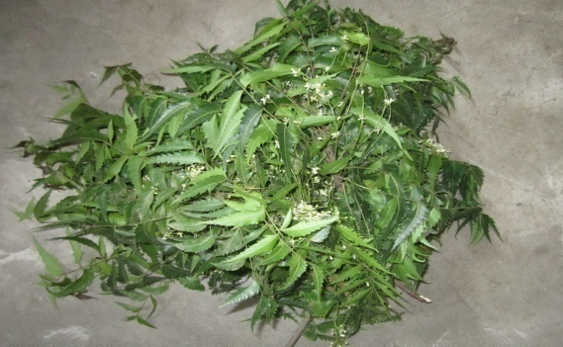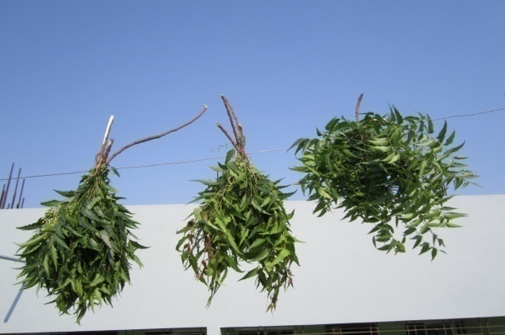

**B**

**A**

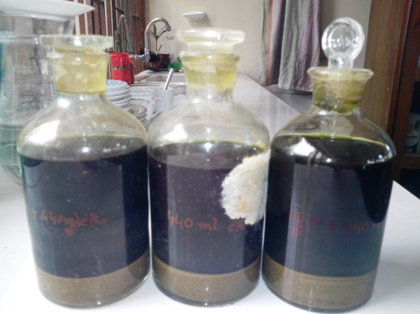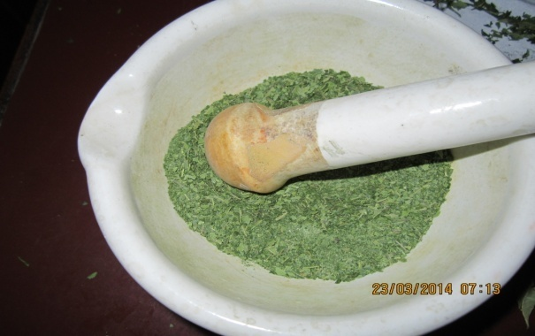

**C**

**D**

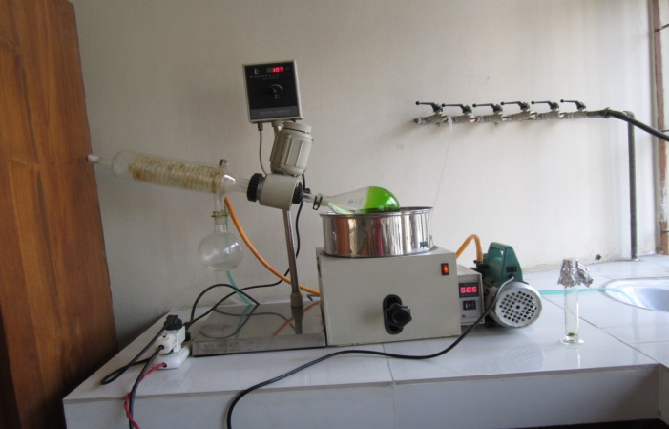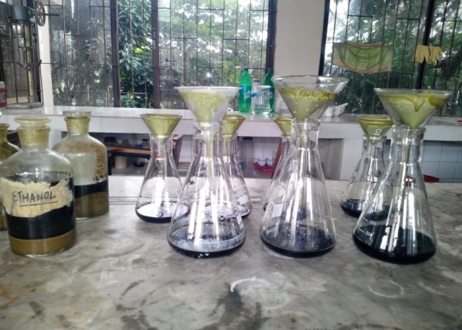

**F**

**E**

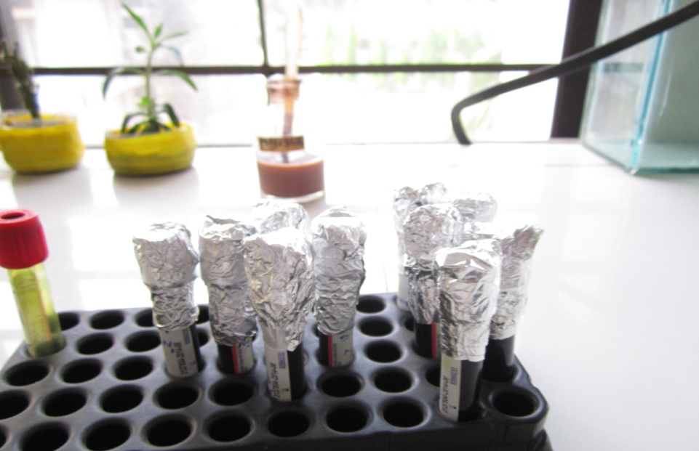

**H**

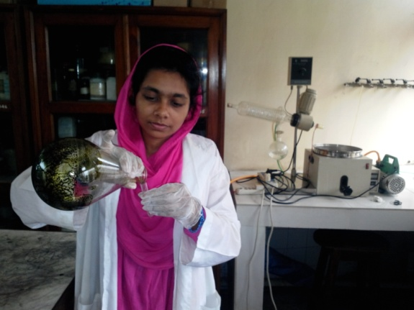

**G**

Figure 9: Preparation of ethanol extract of Neem leaves

1. Collection of leaves, B. Sun drying, C. Grinding, D. Powder mixed with ethanol, E. Mixture filtration, F. Evaporation of solvent, G. Collection of extracts, H. Preserved with 0.2% DMSO.

# Appendix-B

Table 2: Composition of the broiler grower diets

|  |  |
| --- | --- |
| **Ingredients** | **Grower ration (13-28 days) (Kg/100Kg)** |
| Maize | 58.0 |
| Auto Rice Polish | 3.75 |
| Soybean oil | 3.2 |
| Molasses | 0.6 |
| Soybean Meal | 27.5 |
| Protein Concentrate | 3.0 |
| Meat and Bone meal | 2.0 |
| Limestone | 1.0 |
| DCP | 0.5 |
| Salt | 0.25 |
| Vitamin mineral premix | 0.25 |
| Cholin Chloride | 0.10 |
| L-lysin | 0.05 |
| DL-Methionine | 0.10 |
| Antioxidant | 0.0125 |
| Total | 100.3125 |

# Appendix-C

**Serum Biochemical Assays**

**Glucose assay**

**Assay principle**

The principles outcome of glucose is based on the principle of competitive binding between glucose in the test specimen and GOD-PAP reagent of glucose. The glucose is determined after enzymatic oxidation in the presence of glucose oxidase. The formed hydrogen peroxide reacts under catalysis of peroxidase with phenol and 4- aminophenazone to a red-violet quinoneimine dye as indicator.

**Reaction**

GOD

Glucose + O2 + H2O Gluconic acid + H2O2

POD

2H2O2 + 4-aminophenazone + Phenol Quinoneinine + 4 H2O

**Materials and reagents**

1. Serum sample

2. Glucose conjugate reagent

3. Precision pipettes 10µl, 1.0ml

4. Eppendorf tube, eppendorf tube holder, disposable pipette tips, distilled water, 70% alcohol, absorbent paper or paper towel or cotton and gloves.

**Procedure**

The sterile eppendorf tubes were taken. 1000μl of Glucose conjugate reagent was taken each into each eppendorf tube. Then 10μl of Glucose standard was added in with the reagent in eppendorf tube and 10μl of samples serum were taken in each sample eppendorf tube. The eppendorf tube was then incubated at 37ºC for 10 minutes. Glucose standards with conjugate reagent were examined first to determine the standard value. Then all eppendorf tubes containing sample serum with Glucose conjugate reagent was examined by Biochemical analyzer and the reading was taken. The standard value was used as a compared tool.

**Total protein assay**

**Assay principle**

The principle outcome of total protein is based on the principle of competitive bindings between cupric ions react with protein in alkaline solution to form a purple complex. The absorbance of this complex is proportional to the protein concentration in the sample.

**Materials and reagents**

1. Serum sample

2. Total protein conjugate reagent

3. Precision pipettes: 20μl and 1.0ml

4. Eppendorf tube, eppendorf tube holder, disposable pipette tips, distilled water, 70% alcohol, absorbent paper or paper towel or cotton and gloves.

**Procedure**

This was a photometric colorimetric test for total proteins, called Biuret method. The sterile eppendorf tubes were taken. Then 20μl of total protein standards was taken in an eppendorf tube and 20μl of sample serums were taken in each 24 eppendorf tube. 1000μl of total protein conjugate reagent was then added to each eppendorf tube. The eppendorf tube was then incubated at 37ºC for 10 minutes. Total protein standards with conjugate.

**Albumin assay**

**Assay principle**

The principles outcome of albumin is based on the principle of competitive bindings between albumin and albumin reagent. Bromocresol green forms with albumin in citrate buffer a colored complex. The absorbance of this complex is proportional to the albumin concentration in the sample.

**Materials and reagents**

1. Serum sample

2. Albumin conjugate reagent

3. Precision pipettes

4. Eppendorf tube, eppendorf tube holder, disposable pipette tips, distilled water, 70% alcohol, absorbent paper or paper towel or cotton and gloves.

**Procedure**

This was a photometric colorimetric test for albumin is called Bromo Cresol Green method. The sterile eppendorf tubes were taken. Then 10μl of albumin standards was taken in an eppendorf tube and 10μl of sample sera were taken in each eppendorf tube. 1000μl of albumin conjugate reagent was then added to each eppendorf tube. The eppendorf tube was then incubated at 37ºC for 5 minutes. Albumin standards with conjugate reagent were examined first for determined of the standard value. Then all 100 eppendorf tubes containing sample serum with albumin conjugate reagent was examined using automated humalyzer and the reading was taken. The standard value was used as a compared tool.

**Cholesterol assay**

**Assay principle**

The principles outcome of cholesterol is based on the principle of competitive bindings between cholesterol and cholesterol reagent. The cholesterol is determined after enzymatic hydrolysis and oxidation. The indicator quinoneimine is formed hydrogen peroxide and 4-aminophenazone in the presence of phenol and peroxidase.

The absorbance of this complex is proportional to the cholesterol concentration in the sample.

**Reaction**

Cholesterol esterage

Cholesterol ester +H2O Cholesterol +Fatty acid

Cholesterol oxidase

Cholesterol+O2 Cholesterol-3-one+H2O2

Peroxidase

2H2O2+Phenol+4-Aminoantipyrine quinoneimine+4H2O

**Materials and reagents**

1. Serum sample

2. Cholesterol conjugate reagent

3. Precision pipettes

4. Eppendorf tube, eppendorf tube holder, disposable pipette tips, distilled water, 70% alcohol, absorbent paper or paper towel or cotton and gloves.

**Procedure**

This was an enzmatic colorimetric test for cholesterol, called CHOD-PAP method. The sterile eppendorf tube was taken. Then 10μl of cholesterol standards was taken in an eppendorf tube and 10μl of sample serums were taken in each eppendorf tube. 1000μl of cholesterol conjugate reagent was then added to each eppendorf tube. The eppendorf tube was then incubated at 37ºC for 10 minutes. Cholesterol standards with conjugate reagent were examined first for determined of the standard value. Then all eppendorf tubes containing sample serum with cholesterol conjugate reagent was examined by automated humalyzer and the reading was taken. The standard value was used as a compared tool.

**Triglyceride**

**Assay Principle**

The triglycerides were determined after enzymatic hydrolysis with lipases. The indicator is a quinoneimine formed from hydrogen peroxide, 4 – aminophenezone and 4 – chlorophenol under the catalytic influences of peroxidease.

**Materials and reagent**

1. Serum sample

2. TG conjugate reagent

3. Precision pipettes

4. Eppendorf tube, eppendorf tube holder, disposable pipette tips, distilled water, 70% alcohol, absorbent paper or paper towel or cotton and gloves

**Procedure**

The sterile eppendorf tubes were taken. Then 1000μl TG standards was taken in an eppendorf tube and 10μl of sample serums were taken in each eppendorf tube The eppendorf tube was then kept in room temperature for 10 minute. TG standards with conjugate reagent were examined first for determined of the standard value. Then all eppendorf tubes containing sample serum reagent was examined by automated humalyzer and the reading was taken. The standard value was used as a compared tool.

**AST (Aspartate Aminotransferase) or SGOT**

**Procedure:**

Aspirate fresh ddH2O and perform a new Gain Calibration in flow cell mode. Select AST in the Run Test screen and carry out water blank as instructed.

|  |  |
| --- | --- |
| Pipette into a test tube: |  |
| Sample | 0.05ml |
| Reagent | 0.5ml |

Mix and aspirate into the Rx Monza.

|  |  |  |
| --- | --- | --- |
| Pipette into cuvette: |  |  |
|  | Macro | Micro |
| Sample | 0.2ml | 0.1ml |
| R1 Enzyme/ Coenzyme/ α-oxoglutarate | 2.0ml | 1.0ml |

Mix, read initial absorbance after 1 min. Read again 1, 2 and 3 minutes. Note if the absorbance change per minute is between

0.11 and 0.16 at 340/Hg 334nm

0.06 and 0.08 at Hg 365nm

Use only the values for the first 2 minutes for the calculation.

**ALT (Alanine Aminotransferase) or SGPT**

**Procedure:**

Aspirate fresh ddH2O and perform a new Gain Calibration in flow cell mode. Select ALT in the Run Test screen and carry out water blank as instructed.

|  |  |
| --- | --- |
| Pipette into a test tube: |  |
| Sample | 0.05ml |
| Reagent | 0.5ml |

Mix and aspirate into the Rx Monza.

|  |  |  |
| --- | --- | --- |
| Pipette into cuvette: |  |  |
|  | Macro | Micro |
| Sample | 0.2ml | 0.1ml |
| R1 Enzyme/ Coenzyme/ α-oxoglutarate | 2.0ml | 1.0ml |

Mix, read initial absorbance after 1 min. Read again 1, 2 and 3 minutes. Note if the absorbance change per minute is between

0.11 and 0.16 at 340/Hg 334nm

0.06 and 0.08 at Hg 365nm

Use only the values for the first 2 minutes for the calculation.

Reference: Randox Laboratories Limited, 55 Diamond Road, Crumlin, Country Antrim, BT29 4QY, United Kingdom. www.randox.com

**Brief Biography**

Farhana Hossain passed Secondary School Certificate (SSC) examination from Silver Bells Girls’ High School in 2005 and then Higher Secondary Certificate (HSC) examination from Govt. Haji Mohammad Mohsin College in 2007. She obtained her Doctors of Veterinary Medicine (DVM) Degree in 2012 from Chittagong Veterinary and Animal Sciences University (CVASU), Bangladesh. Now, she is a Candidate for the degree of MS in Pharmacology under the Department of Physiology, Biochemistry and Pharmacology, Faculty of Veterinary Medicine, CVASU.