ABSTRACT
The study was conducted on the management including housing, feeding, productive and reproductive performance of peafowl in an intensive peafowls farm at Chittagong, Bangladesh. In Chittagong a peafowl farm has been established from private since 2013. Data were collected for a period of five months from 12 June to 12 September on all age and sex group. The owner brought 20 eggs of which 18 eggs were hatched out after 30days of incubation by using an automatic incubator. During brooding about 3 chicks had been died due to faulty management and feeding. From the observation of 2 years records more 4 adult peafowl’s got dead due to same reasons. the peafowls were reared in modified Natural environment by wire fence from different four side and top with net cages. For the movements of peafowls, area of 40 x 45 ft was provided in the farm. Available feed supplied to the peafowls were banana, papaya, vegetable leaf, wheat, mustard oil cake, germinating gram and lentil as grain mix and oyster shell, broiler redimate feed, dicalcium phosphate and salt as mineral mix. The supplied diet containing 180 g crude proteins,11.3 millijoules metabolizable energy and CP (11.3 %) and 30 g calcium per kg diet (Islam et al., 2002).. there was significant difference of body weights between male and female peafowls. It was observed that the age of maturity, incubation period and productive life were ranging from 2-3 years, 28-30 days and 20-30 years respectively. The production of chicks was ranging from 3-6 per year. Mostly prevailing diseases were New Castle disease, fowl Pox, Mycoplasma, Coryza and Parasitic infestation accordingly. From the study, it was observed that the owner of that farm reared peafowls as his hobby and the body size level was also satisfactory. Presently the population among of 4 males and 7 females. Now they are in mature stages with color full feathers and good attractive to peoples.As there is an increased demand of peafowls as ornamental birds in this Bangladesh .So, he can take the chance to earn money.In the future, further extensive studies on peafowls of larger population and of different areas should be done to know the management practice of individual.

Key words: Peafowl, Management, Rearing, Bangladesh.

CHAPTER -1

INTRODUCTION

The peafowl, being a poultry, is actually treated as an ornamental bird. it falls under the kingdom Animalia, phylum chordate, class Aves, order Gillaformes, Family phasianidae, genera pavo and the species is pava cristatus through there is more species, Indian or blue peafowl (Pavo cristatus) of India and Sri Lanka and the green peafowl (Pavo muticus) of Burma, Indochina, and Java, whereas the second group is the Congo peafowl (Afropavo congensis) of African species (Sun et al., 2014). Moreover, the Indian blue peafowl have a strain of white peafowl. The male peafowl is called peacock and a female known as peahen. Historically, till now peafowl in jungle are distributed in India, Pakistan, Sri Lanka, Nepal and Myanmar. But now a days, have been maintained in captivity across the world (Khursheed et al., 2014). According to Darwin's theory on sexual selection, peafowls developed their intricate tails in order to attract surrounding peafowl and indicate they are a healthy match. Results from various experiments have actually showed that peafowls with the largest tails and more plentiful eyespots have a better chance at survival than those who don't . But alas, according to Darwin's theory of sexual selection, It is found in moist and dry-deciduous forests, but can adapt to live in cultivated regions and around human habitations and is usually found where water is available. In many parts of northern India, they are protected by religious practices and will forage around villages and towns for scraps. Some have suggested that the peafowl was introduced into Europe b Indian peafowl breeds from April through October. Peafowl is polygynous and generally has two to three breeding peahens in its harem (Roberts, 1992). A recent study of a feral population suggests that peafowl does not defend its harem due to small breeding territory (Rands et al., 1984). Clutch size is usually 4 to 9 eggs in natural habitat but in captivity the hen lays 8-20 eggs and the incubation period is about 28- 30 days (Anon., 2002). Hunting of Indian peafowl is prohibited under the Punjab Wildlife (Protection, Preservation, Conservation and Management) Act-1974.. Peafowls are a larger sized bird with a length from bill to tail of 100 to 115 cm (40 to 46 inches) and to the end of a fully grown train as much as 195 to 225 cm (78 to 90 inches) and weigh 4–6 kg (8.8–13.2 lbs). The females, or peahens, are smaller at around 95 cm (38 inches) in length and weigh 2.75–4 kg (6–8.8 lbs). Indian peafowl are among the largest and heaviest representatives of the Phasianidae. Their size, colour and shape of crest make them unmistakable within their native distribution range. The male is metallic blue on the crown, The tail is dark brown and the "train" is made up of elongated upper tail coverts (more than 200 feathers, the actual tail has only 20 feathers) and nearly all of these feathers end with an elaborate eye-spot. A few of the outer feathers lack the spot and end in a crescent shaped black tip. The underside is dark glossy green shading into blackish under the tail. The thighs are buff coloured. The male has a spur on the leg above the hind toe.( McKeever et al.,2003) The adult peahen has a rufous-brown head with a crest as in the male but the tips are chestnut edged with green. The upper body is brownish with pale mottling. The primaries, secondaries and tail are dark brown. ( Yoshiok et al.,2002)

The Objective of the study are :
-To know the management of peafowl in Bangladesh ;
-To know their different behavioral and physiological characteristics ; and
-To know their diseases , treatment and prevention

CHAPTER – 2

METHODS AND MATERIALS

- Study area:

2.1 study location.
The location of Peafowl rearing in the Chittagong district is located at Banshkhali, 5 km east, from Banshkhali town.
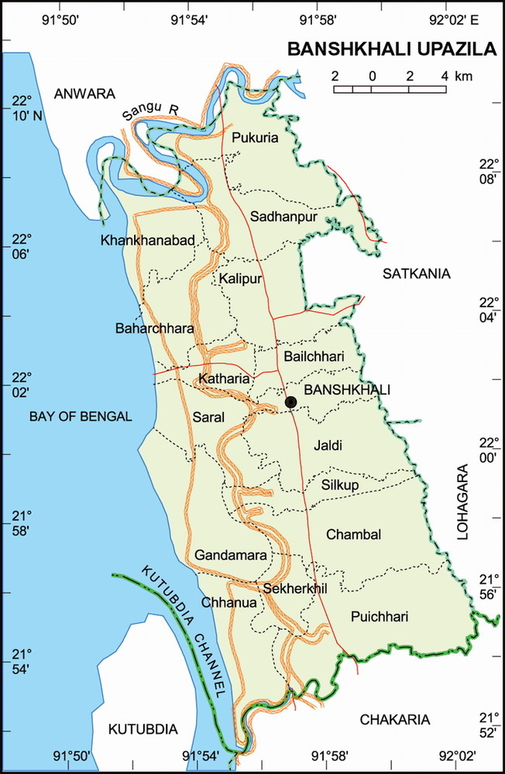
Figure 1: Map, study area

2.2 Study period.
The study was conducted 12 June to 12 septmber 2015. Regular observations were made during the period to collect necessary data from the selected farm.

2.3 Collection of Data.
Data were collected by using a interview schedule (Annex 1.) Interview schedule was carefully designed towards the farm owner and attendant keeping the objectives in view. Most easy, simple and direct questions were asked to obtain information.

Varieties of the peafowls were identified by observing their body characteristics and behavior. The parameters such as feeds, feeding pattern and management system were recorded by interviewing with the owner and the attendant. Some information was also taken by me such as the measurement of house; height and nest place and weight of the peafowls on the farm. The reproductive parameters like age of sexual maturity, incubation period, productive life of male and female pigeons and number of eggs production were collected from the record book of the farm. Disease prevalence on the farm was observed physically and data regarding this were collected from the farm record book.

2.3. Study Procedures
During the study period, the farm was visited in every alternative day. Most of the management practices were observed physically and required data were collected from the record books of the farm with the coordination of the owner in addition to current data.

2.4 Observing behavior
Indian peafowl stay in small flocks (harems) of 1 peacock (male) and 3-5 peahens (females). Peafowl run more than they fly. Peafowl physically interact with each other usually during territorial disputes. They will attack eachother with their beaks and claws, chasing and pecking at each other. Peafowl warn each other when danger approaches with loud, shrieking cries and honks. They also call during mating season. They usually roost in the same tree every night. They fly to the top branches of dead trees just a little after sunset and leave just before sunrise. Peafowl are best known for the male's extravagant display feathers which, despite actually growing from their back, are thought of as a tail. The "train" is in reality made up of the enormously elongated upper tail coverts. The tail itself is brown and short as in the peahen. The colours result not from any green or blue pigments but from the micro-structure of the feathers and the resulting optical phenomena. The long train feathers (and tarsal spurs) of the male develop only after the second year of life. Fully developed trains are found in birds older than four years. In northern India, these begin to develop each February and are moulted at the end of August. ( Johnsingh et al,.1978).

CHAPTER -3

RESULT AND DISCUSSION

A total of 20 number of eggs were incubated but only 18 eggs (80%) were hatched out. Out of this about 03 Chicks died mortality (16.66%) after words 04 adult birds died (mortality rate 26.66%) died.

Table 1: Different parameters of farm
Total eggs | Egg weight  (gm) | Incubation period  (Days) | Hatchability of fertile eggs (%) | Mortality of chick (%) | Mortality of adult birds (%) | Age of Sexual maturity  (years) |  | Live birds present In farm
20 | 17 | 30 | 18(80%) | 3(16.66%) | 4(16.66%) | male | female | Male | female
 |  |  |  |  |  | 3 | 2 | 4 | 6

3.1 Geographical Range
Historically, till now peafowl in jungle are distributed in India, Pakistan, Sri Lanka, Nepal and Myanmar. But now a days, have been maintained in captivity across the world (Khursheed et al., 2014).

3.2 Behavioral characteristics.
Peafowl is polygynous and generally has two to three breeding peahens in its harem (Roberts, 1992). A recent study of a feral population suggests that peafowl does not defend its harem due to small breeding territory (Rands et al., 1984). Clutch size is usually 4 to 9 eggs in natural habitat but in captivity the hen lays 8-20 eggs and the incubation period is about 28- 30 days (Anon.,002). Hunting of Indian peafowl is prohibited under the Punjab Wildlife (ProtectionPreservation, Conservation and Management) Act-1974.. Peafowls are a larger sized bird with a length from bill to tail of 100 to 115 cm (40 to 46 inches) and to the end of a fully grown train as much as 195 to 225 cm (78 to 90 inches) and weigh 4–6 kg (8.8–13.2 lbs). The females, or peahens, are smaller at around 95 cm (38 inches) in length and weigh 2.75–4 kg (68.8 lbs). Indian

peafowl are among the largest and heaviest representatives of the Phasianidae. Their size, colour and shape of crest make them unmistakable within their native distribution range. The male is metallic blue on the crown, The tail is dark brown and the "train" is made up of elongated upper tail coverts (more than 200 feathers, the actual tail has only 20 feathers) and nearly all of these feathers end with an elaborate eye-spot. A few of the outer feathers lack the spot and end in a crescent shaped black tip. The underside is dark glossy green shading into blackish under the tail. The thighs are buff coloured. The male has a spur on the leg above the hind toe.( McKeever et al.,2003) The adult peahen has a rufous-brown head with a crest as in the male but the tips are chestnut edged with green. The upper body is brownish with pale mottling. The primaries, secondaries and tail are dark brown. ( Yoshiok et al.,2002)

3.3. Housing of peafowls.
In case of domestic peafowl farming, ensure adequate housing and good environment. are Primary needs for rearing. Usually 100 square feet space required for each bird.. The housing space was adjested according to the length of peacock’s trains. In Chittagong farm. The house, in which peafowls reared, was a type of captivily under natural environment with fenching and net covering. The size of the house was about 45x50 ft(excluding net) with 15ft height. There was an open nest area at the back of the house which was about 10 ft in length and 10ft in width and enclosed by wire net. It was used for the rest of peafowls at night time. The house face was southern direction where as reported that for maximum production and minimum disease risk the peafowls house should be preferably facing north-east.
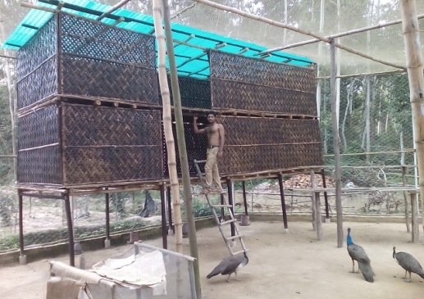
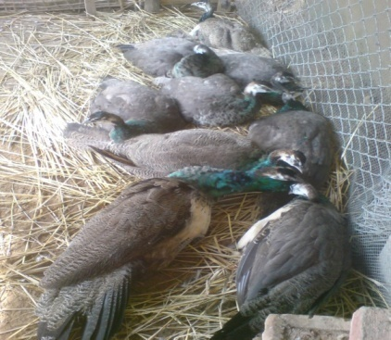

Nest

Figure 2 : Housing Structure

3.4 Feeding and nutrition of peafowls.
Peafowls were given an adaptation period of one week and were fed on breeder hen diet containing 180 g crude proteins,11.3 millijoules metabolizable energy and 30 g calcium per kg diet (Islam et al., 2002). Feed was offered to peafowls daily at 09:00, whereas water for drinking was given at 09:00 and 17:00 daily. Cages were cleaned every day to save the peafowls from any disease. Medication/vaccination of peafowls was done at the start and middle of the trial. Water soluble premixes were added for 4 days in drinking. This process was repeated after every two weeks. Weighed quantity of breeder ration @200g/peafowl was offered to each replicate as per ration schedule of Punjab Wildlife Department. Unconsumed feed was weighed and removed from each feeding pot to record feed intake by each replicate (Khan et al., 2006). The Peafowl feeds on a variety of food items. Grain is one of the most common items that they eat. They will also consume fruits and seeds that they find but those items aren’t always available year round for them to consume. They consume plants, petals, small reptiles, and even amphibians.(Burton et al.,1884)) In the Gir forest of Gujarat, a large percentage of their food is made up of the fallen berries of Zizyphus. Around cultivated areas, peafowl feed on a wide range of crops such as groundnut, tomato, paddy, chilly and even bananas. Around human habitations, they feed on a variety of food scraps and even human excreta. In the countryside, it is particularly partial to crops and garden plants. In the wild they eat on seeds, grains, berries, insects, small reptiles, small mammals and cultivated crops. At the zoo free-ranging peafowl forage on zoo grounds. ( Khan et al,.2001).

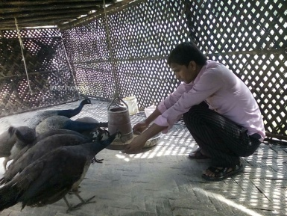
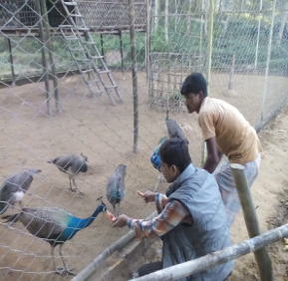

Poultry feed feeding
Papaya feeding

Figure 3 : Feed Supplements

3.5 Breading and clutch size
.Indian peafowl breeds from April through October. Peafowl is polygynous and generally has two to three breeding peahens in its harem (Roberts, 1992). A recent study of a feral population suggests that peafowl does not defend its harem due to small breeding territory (Rands et al., 1984). Clutch size is usually 4 to 9 eggs in natural habitat but in captivity the hen lays 8-20 eggs and the incubation period is about 28-30 days (Anon., 2002). Hunting of Indian peafowl is prohibited under the Punjab Wildlife (Protection, Preservation, Conservation and Management) Act-1974.

3.6 Incubation
Environmental conditions, handling, sanitation and record keeping are all important factors when it comes to incubating and hatching eggs. eggs should not be more than 7 days old when they are set (placed in an incubator). Beyond that point, hatchability declines.If it is necessary to hold the eggs before you set them, turn them daily and keep them in a room in which the temperature is around 55°F and the relative humidity is 70 – 80 percent. (Khan, 2001) (The vegetable section of your refrigerator could be used for holding the eggs until it is time to place them in the incubator.) Temperatures below 40°F reduce hatchability. Under no circumstances should the eggs be held at room temperature because temperatures of this level are detrimental to hatchability. Embryos will begin to develop at subnormal rates when the temperature reaches above 80°F.Location of Incubator Locate you incubator in a room in which the temperature is between 70 – 75°F, and which is free from drafts and excessive variations in temperature. Do not place the incubator near windows so it will be exposed to the direct rays of the sun. The sun’s rays may raise the temperature so much that the embryos all will be destroyed. Readying the Incubator for Operation Before you set the eggs be sure that the incubator is in good working order. Put some warm distilled water in the water pan, place the thermometer so that the bulb of the thermometer is 1 inch above the screen, close the top of the incubator, and then operate the incubator until the temperature inside it hold at 99 to 103°F.The recommended temperature is 100.5°F.( Lal et al,. 2007).
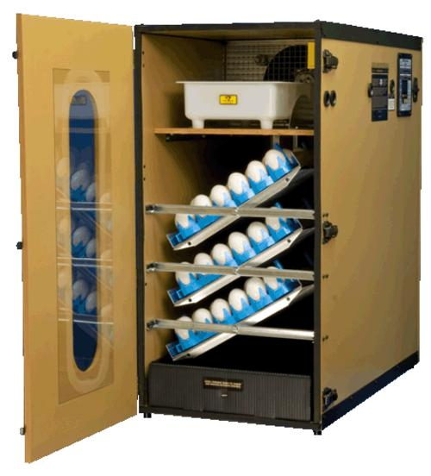

Figure 4: Automatic incubator

3.7 Reasons for Poor Hatches
The reasons for poor hatchability were infertile eggs,Eggs too old when set, weak Parent stock , unhealthy, improper care of eggs prior to incubation,contamination shell, . faulty turning of Eggs , improper incubatation temprature, improper humidity, etc. (Koenig et al,.1982).

3.8 Fertile Egg Quality
A fertile egg s are required for good hatchability.eggs quality and embryo survival are influenced by hen and cock. the importanr factors are aaaage, health and nutrition etc.(jackson et al,.)

3.9 Diseases of peafowls.
Nutritional diseases
These diseases result from a deficiency in the diet of essential required vitamins or minerals. Nutritional disorders most often seen in young birds are: Rickets - Calcium, phosphorus, vitamin D deficiency;.Curled Toe Paralysis - Riboflavin deficiency; Nutritional Roup - Vitamin A deficiency; Perosis - Manganese deficiency; Crazy Chick Disease - Vitamin E deficiency; and .Gizzard Myopathy (white muscle disease) - Selenium deficiency.
In Chittagong farm we haven’t face problem. Due to continue supplement of vitamins.
Virus and virus-like diseases
NewcastleDisease(ND),Fowl\Pox,HemorrhagicEnteritis(HE) Mycoplasmosis

Bacterial diseases. Pullorum and Fowl typhoid ,Paratyphoid Staphylococcosis Fowl Cholera (FC) Avian tuberculosis (TB) ( Rao,et.al ,.1981)

Protozian diseases. Coccidiosis . Histomoniasis Trichomoniasis Leucocytozoonosis Haemoproteusis

Internal parasites. Ascaridia Heterakis Gapeworm ( Syngamus trachea) Capillaria worms Tapeworms (numerous species)
External parasites
Lice , Mite
In chittagong farm we faced mycoplasmosis, coccidiosis, and ascaridia spp.

3.10 VACCINATION
In Chittagong farm we fellow;
Disease | Type of Vac. | Age(days) | Dosage(ml) | Route
Markes | Live | 1 | 0.16 ml | I/M
BCRDV | Live | 7 | 0.16 ml | Eyes
RDV | Live | 180 | 1 ml | I/M
Anthelmintic |  | 45 | 1gm/2litre | Oral
RDV(Booster) | Live | 180 | 1 ml | I/M

3.11 MORTALITY FACTORS
After observing the data of previous 2years, we found,mortality of peafowls was 14.58%.The mortality rate was not same in all varieties. The mortality rate of different varieties presented.

Table-2 : Mortality Factors.
Infertile eggs (%) | Mortality of chick (%) | Mortality of adult birds (%)
15% | 16.66% | 16.66%

Percentage of Mortality rate

Figure 5: Mortality rate of peafowls in the farm.

3.12 Regular sanitation in the farm
Timson®, Kerosene and Fitkari® (Potash Alum) were used for cleaning the floors and the cages.Timson®, Fitkari® (Potash Alum) and Kerosene were mixed with 4 liter of water and then sprayed regularly with a 2 days interval. In rainy season it was used daily.

3.13 Disposal of the waste and Carcass
The waste materials from the peafowls were collected regularly and then disposed into a pit. The death birds are buried into the soils. But indicated that peafowls manure could be an organic fertilizer resource.

CHAPTER -4

CONSERVATION AND STATUS

Indian peafowl are widely distributed in the wild across South Asia and protected both culturally in many areas and by law in India. Conservative estimates of the population put them at more than 100,000.Illegal poaching for meat however continues and declines have been noted in parts of India. Peafowl breed readily in captivity and as free-ranging ornamental fowl. Zoos, parks, bird-fanciers and dealers across the world maintain breeding populations that do not need to be augmented by the capture of wild birds.

Poaching of peafowls for their meat and feathers and accidental poisoning by feeding on pesticide treated seeds are known threats to wild birds. Methods to identify if feathers have been plucked or have been shed naturally have been developed as Indian law allows only the collection of feathers that have been shed.

In parts of India, the birds can be a nuisance to agriculture as they damage crops.Its adverse effects on crops, however, seem to be offset by the beneficial role it plays by consuming prodigious quantities of pests such as grasshoppers. They can also be a problem in gardens and homes where they damage plants, attack their reflections breaking glass and mirrors, perch and scratch cars or leave their droppings. Many cities where they have been introduced and gone feral have peafowl management programmes. These include educating citizens on how to prevent the birds from causing damage while treating the birds humanely.

CHAPTER -5

CONCLUSIONS

In Bangladesh context, peafowl rearing under captive condition under good management system results in death of some number due to diseases and anti rearing environment. But still there is a hope for peafowl farming here in Bangladesh if we create more farms continuously and if the veterinarian professionals come forward and again the feed companies should produce feed with special formula given by the nutritionist. Hence gradually the environment will favor so that they can adapt well and may the diseases be resistant to the peafowl as well.

REFERENCES

Ali, S and Ripley, S D (1980). Handbook of the birds of India and Pakistan 2 (2 ed.). Oxford University Press. PP. 123–126.

Blanford, WT (1898). The Fauna of British India, Including Ceylon and Burma. Birdsand Francis, London. PP. 681–70.

Burton, R F (1884). The book of the sword. Chatto and Windus, London. P. 155.

Galusha, JG; Hill, LM (1996) A study of the behaviour of Indian Peafowls Pavo Cristatus on Protection Island, Jefferson County, Washington, USA. Pavo 34(1&2):23–31.

Ganguli, U (1965) A Peahen nests on a roof. Newsletter for Birdwatchers . 5(4):4–6.

Haldane, J. B. S. (1922). "Sex ratio and unisexual sterility in hybrid animals". J. Genet. 12 (2): 101–109.

Hehn, Victor; James P. Mallory (1976). Cultivated plants and domesticated animals in their migration from Asia to Europe: historico-linguistic studies Volume 7 of Amsterdam studies in the theory and history of linguistic science Amsterdam studies in the theory and history of linguistic science. Series I, Amsterdam classics in linguistics,1800-1925. John Benjamins Publishing Company. P. 263.

Jackson, CE (2006). Peafowl. Reaktion Books, London. pp. 10–11.

Johnsgard, P.A. (1999). The Pheasants of the World: Biology and Natural History. Washington, DC: Smithsonian Institution Press. P 374.

Johnsingh, AJT; Murali, S (1978). "The ecology and behaviour of the Indian Peafowl (Pavo Cristatus) Linn. of Injar". J. Bombay Nat. Hist. Soc. 75 (4): 1069–1079

Khan, ML (2001). Poultry feeds and nutrition. 38-Urdu Bazar, Lahore, Kitabistan Publis Co. 99: 526-536.

Koenig, WD (1982). Ecological and social factors affecting hatchability of eggs. The Auk.

Lal, Krishna (2007). Peafowl in Indian art, thought and literature. Abhinav Publications. PP. 11,26,139.

Linnaeus, Carl (1758). Systema naturae per regna tria naturae, secundum classes,ordines, genera, species, cum characteribus, differentiis, synonymis, locis. Tomus I. Editio decima, reformata. Holmiae. (Laurentii Salvii).

Long, John L. (1981). Introduced Birds of the World. Agricultural Protectio Board of Western Australia, 21-493.

Prakash, M (1968) Mating of Peafowls Pavo Cristatus. Newsletter for Birdwatchers . 8(6), 4-5.
Roberts, TJ (1992). The birds of Pakistan. Vol. 1, Nonpasseriformes. Karachi,
Pakistan,Oxford University Press. Elite Publications limited. P: 617.

Rands, MRW; Ridley, MW and Lelliott, AD (1984). The Social organization of feral
peafowl. Anim. Behav., 32: 830-835.

Rao MS; Zaki S; Ganesh T (1981):Colibacillosis in a Peafowl. Current Science 50(12):550–551.

Seth-Smith, D (1940). "Peafowl". Avicultural Magazine 5: 205–206.

Sharma IK (1969) Habitat et comportment du Pavon (Pavo Cristatus). Alauda 37(3):219 223.

Sharma, IK (1970: Analyse ecologique des parades du paon (Pavo Cristatus) 38(4):290–294.

Sharma, IK (1972) Etude ecologique de la reproduction de la paon (Pavo Cristatus). Alauda 40(4):378–384.

Sharma, IK (1973) Ecological studies of biomass of the Peafowl (Pavo Cristatus). Tori 22(93–94):25–29.

Sharma, IK (1974) Notes ecologique sur le paon bleu, Pavo Cristatus. Les Carnets de Zoologie 34:41–45.

Sharma, IK (1981) Adaptations and commensality of the Peafowl (Pavo Cristatus) in the Indian Thar Desert. Annals Arid Zone. 20(2):71–75.

Shrivastava, AB; Nair,NR; Awadhiya, RP; Katiyar, AK (1992) Traumatic ventriculitis in Peafowl (Pavo Cristatus). Indian Vet. J. 69(8):755.

Somes, RG Jr. and R. E. Burger (1991). "Plumage Color Inheritance of the Indian Blue Peafowl (Pavo Cristatus): Blue, Black-Shouldered, Cameo, and Oaten". Journal of Heredity 82: 64–68. doi:10.1093/jhered/82.1.64.

Weekley, E (1921). An etymological dictionary of modern English. John Murray, London.

Whistler, Hugh (1949). Popular handbook of Indian birds (4 ed.). Gurney and Jackson, London. pp. 401–410.

ANNEX-1
Questionnaire for Data Collection
Serial No
Breed/Variety
Sex | Male  Female
Age (year)
Body weight(gm)
Age at sexual maturity(months)
Incubation period (days)
Productive life (years)
No. of chick production per year
No. of eggs per laying
Daily feed intake (gm)
Disease
Others

BIOGRAPHY

I am by saroj kumar yadav sons of Mr.Ram hirday yadav and Mrs .khola devi. I passed secondary school certificate examination in 2006 followed by higher secondary certificate examination in 2008 .now I am as intern veterinarian under the faculty of veterinary medicine in Chittagong veretinary and sciences University.in the future I would like to work as a veterinary practitioner and research on clinical animal diseases in Bangladesh

