**Chapter 1: Introduction**

Poultry is essential to the national economy of Bangladesh and the welfare of human beings. Several constraints such as the diseases, poor husbandry, low productivity and shortage of feed affect the optimal performance of poultry industry in Bangladesh (Haque et al., 1991). The poultry industry is in a new phase of development, with an increasing number of poultry giants going for integrated farming to market chicken meat and eggs. The GDP contribution of Livestock and Poultry subsector in Bangladesh has been 1.66% and GDP growth rate has been 3.21% in the Fiscal Year 2015-16 (DLS, 2016). Poultry sub-sector is an integral part of farming system and has created direct, indirect employment opportunities, including support services for about 6 million people (Rahman, 2003).

Salmonellosis, an important disease in chickens, is caused by *Salmonella* Pullorumand *Salmonella* Gallinarum and is referred to as pullorum disease and fowl typhoid, respectively (Haider et al., 2008). *Salmonella* are gram negative, short plump shaped rods, non-spore forming, non-capsulated, aerobic and facultative anaerobic organisms and classified under the family Enterobacteriaceae (OIE, 2004). Pullorum disease and fowl typhoid are caused by *Salmonella enterica* subspecies *enterica* serovar Gallinarum biovars Pullorum and Gallinarum (OIE, 2008). More than 2500 serotypes of *Salmonella* spp.have been identified, only about 10% of which have been isolated from poultry (Gast, 1997). *Salmonella* infections are major problems for poultry industry in Bangladesh and have public health importance (Haider et al., 2008).

Among various diseases of poultry, pullorum disease or bacillary white diarrhoea is one of the major diseases lowering the production leading to heavy economic losses and transmitted vertically from parent to offspring. It mostly affects 2-3 weeks old chickens and turkeys (Barrow and Neto, 2011). Pullorum disease occurs in chicks during their first few days of life and causes severe enteritis and bacteremia (Mozaffor et al., 2010). Whereas, fowl typhoid is a disease of mature chickens and causes either acute enteritis with greenish diarrhoea or a chronic disease and reduces egg production (Proux et al., 2002).

Fowl typhoid, caused by *Salmonella* Gallinarum, is an acute or chronic disease, that most often affects mature birds, and is a serious problem resulting in mortality and lowered egg production and hatchability (Khan et al., 1998). With the expansion of poultry rearing and farming, pullorum disease and fowl typhoid have become wide spread problems in Bangladesh (Rahman et al., 1997). Salmonellosis in poultry causes significant economic loss due to mortality and reduced production (Rahman et al., 2011). *Salmonella* Gallinarum can produce lesions in chicks, indistinguishable from those associated with pullorum disease (Medewewa et al., 2012).

The epidemiology of fowl typhoid and pullorum disease in poultry, particularly with regard to transmission from one generation to the next are known to be closely associated with infected eggs (Wigley et al., 2001). Among many sources, from where *Salmonella* spp. can be introduced into poultry flocks, infected hatchery is a crucial one (Hoover et al., 1997; Amick-Morris, 1998). Contaminated eggs produced by infected laying hens are thought to be one of the main sources of human infection with *Salmonella* Enteritidis (Humphrey et al., 1989). Any salmonellae carried in or on eggs can spread extensively in hatcheries. As chicks pip through egg shells, salmonellae are released into the air and circulated around hatching cabinets on contaminated fluff and other hatchery debris (Volkova et al., 2011).

Indigenous chickens also act as a reservoir of salmonellosis (Bouzoubaa et al., 1992). Transmission is primarily through eggs but also via direct or indirect contact with infected birds. Infection transmitted via egg or hatchery contamination usually results in death up to 2-3 weeks of age (Shivaprasad, 1997). The prevalence of salmonellosis in breeder flocks and specially layer flocks is increasing in Bangladesh (Ahmed et. al., 2008). The incidence of Salmonellosis in Bangladesh was found to be 9.28% (Bhattacharjee et al., 1996). Age wise prevalence of avian salmonellosis showed highest infection rate in adult layers (53.25%) in comparison to brooding (14.55%), growing (16.10%) and pullet (16.10%) (Rahman et al., 2004).

The morbidity and mortality of fowl typhoid are highly variable in poultry and are influenced by host age, host susceptibility, nutrition, flock management and virulence of *Salmonella* Gallinarum, which is a major factor affecting the severity of the disease (Sato et al., 1997). Older birds show signs of anaemia, depression, labored breathing and diarrhoea causing adherence of faeces to the vent (Proux et al., 2002). In older birds disease may be mild or inapparent. In breeding and laying flocks susceptibility is increased at the point of laying (Wigley et al., 2005), but reduced egg production and hatchability may be the only signs of *Salmonella* Pullorum (Snoeyenbos, 1991). Trans-ovarian infection resulting in infection of the egg and hatched chicks or poults is one of the most important transmission routes for both diseases (Wigley et al., 2001; World Poultry VIV, 2008).

Most pathological changes are found in the subacute and chronic stages of the disease in liver and spleen; multiple white foci, severe swelling, and discoloration (Gast, 1997). Postmortem signs of pullorum disease in newly hatched chicks are those of peritonitis with generalized congestion of tissues and inflamed unabsorbed yolk sac (Gast., 2003). Longer standing infections commonly lead to typhlitis with development of necrotic caecal casts and small necrotic foci in the liver, lungs and other viscera (Manoj et al., 2015). Adult birds develop misshapen or shrunken ovaries with follicles attached by pedunculated fibrous stalks. Variant strains of *S*. Pullorum do not normally cause clinical disease or may result in mild, nonspecific signs but may lead to seroconversion. In fowl typhoid, as well as generalized signs of septicemia, the liver is usually enlarged, dark and friable with a distinctive coppery bronze sheen that may only develop after exposure to air (OIE, 2012).

To identify the pathogens of the genus *Salmonella,* laboratory methods include pathogen isolation and characterization along with histopathology considered as the gold standard (Prasanna et al. 2001). *Salmonella* Pullorum may grow slowly and produce very small colonies on selective media so incubation of plates for 48 hours has been recommended. Some complex media may have an inhibitory effect on these organisms, so use of both non-selective and selective media is necessary for isolation from tissues (Gorski, 2012). *Salmonella* Gallinarum grows more rapidly than *S.* Pullorum and produces larger colonies with a distinctive smell resembling that of seminal fluid on most media. Broths include buffered peptone water and nutrient and meat infusion broths or universal pre-enrichment broth (OIE, 2010).

The present study was conducted to identify and isolate, histopathologically and through molecular diagnosis, salmonellosis from commercial layer and broiler birds in Chittagong. Many researches including histopathological and biochemical changes due to salmonellosis have been described by many authors but a very few works on molecular detection of *Salmonella* from chickens have been conducted at Chittagong district in Bangladesh. The present study was intended with following objectives:

1. To determine the prevalence of *Salmonella enterica* in poultry (layers and broilers) in Chittagong.
2. To understand the gross and microscopic changes in different organs of chickens.
3. To identify *Salmonella* isolated from different organs of dead chickens using PCR.

**Chapter 2: Review of Literature**

**2.1. Historical background of the genus *Salmonella*:**

The genus *Salmonella*, within the family Enterobacteriaceae, consisted of only two major genetically distinct species: *S. enterica* and *S. bongori* (Grimont and Weill, 2007), is a morphologically and biochemically homogenous group of facultatively anaerobic, non-spore forming, oxidase-negative, catalase-positive Gram-negative rod-shaped bacteria (Grimont and Weill, 2007); *Salmonella* Pullorum and *S.* Gallinarum belong to the Kauffmann–White scheme serogroup D, along with *S.* Enteritidis, which is thought to be closely related . The organisms are Gram negative nonsporogenic rods, 1.0– 2.5 µm in length and 0.3–1.5 µm in width (Schwartz,1999; OIE 2009). Most strains are motile due to peritrichous flagella and ferment glucose with production of both acid and gas (Bisping et al., 1988; Grimont et al., 2000; Schwartz, 1999).

**2.2. Taxonomy and nomenclature:**

Domain: Bacteria

Kingdom: Eubacteria

Phylum: Proteobacteria

Class: Gammaproteobacteria

Order: Enterobacteriales

Family: Enterobacteriaceae

Genus: Salmonella

Species: *Salmonella bongori*

*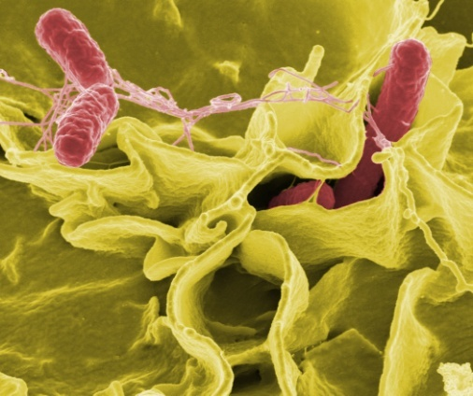 Salmonella enterica* (NCBI, 2009)

**Figure 1: *Salmonella***

**(source: http://en.wikipedia.org)**

*Salmonella enterica* includes 6 subspecies (Table 1) determined by patterns of biochemical reactions and susceptibility to lysis by bacteriophage Felix O1 (Malorny et al., 2011).

**Table 1: Subspecies of *Salmonella enterica***

|  |  |
| --- | --- |
| Original subgenera | Current nomenclature |
| I | *Salmonella enterica* subsp. *enterica* |
| II | *Salmonella enterica* subsp. *salamae* |
| IIIa | *Salmonella enterica* subsp. *arizonae* |
| IIIb | *Salmonella enterica* subsp. *diarizonae* |
| IV | *Salmonella enterica* subsp. *houtenae* |
| VI | *Salmonella enterica* subsp. *indica* |

(Source: OIE, 2012)

Only one of these subspecies (*S. enterica* subspecies *enterica*) is associated with disease in warm-blooded animals, and includes more than 2,500 motile and non-motile phases and host specific and non-host adapted serotypes such as *S. enterica* subspecies *enterica* serovar Gallinarum and *S. enterica* subspecies *enterica* serovar Pullorum.

**2.3. Morphology of *Salmonella* organisms:**

*Salmonella* organisms are facultative anaerobic gram-negative rods within the family Enterobacteriaceae (Yan et al., 2003). Classically, the members of this genus are motile by peritrichous flagella except *Salmonella* Pullorum and *Salmonella* Gallinarum, which lack flagella, however, the long standing fact that *Salmonella* Pullorum is non motile has been disproved and it has been shown that the motility can be induced under special medium conditions (Holt and Chaubal, 1997).

**2.4. Growth requirements of *Salmonella*:**

*Salmonella* spp. grow optimally at 35oC to 37oC, catabolize a variety of carbohydrates into acid and gas, use citrate as the sole carbon source, produce H2S and decarboxylate lysine and ornithine to cadaverine and putrescine respectively (Barbara et al., 2000). Historically *Salmonella* catabolized glucose and lysine, but failed to metabolize lactose, sucrose and urea, however due to the widespread exchange of genetic elements between compatible bacterial strains in the environment, atypical *Salmonella* biotypes that cannot decarboxylate lysine (Morita et al., 2006) or that readily use lactose (Glosnicka et al., 1987), sucrose (Reid et al., 1993) and urea, have been isolated. *Salmonella* can grow within a pH range of 4.0–9.0, with an optimum pH around 7.0. The nutritional requirements of salmonellae are relatively simple, and most culture media that supply sources of carbon and nitrogen can support their growth (Kohbata et al., 1983, Glosnicka et al., 1987).

**2.5. Colony morphology of *Salmonella*:**

Typical *Salmonella* colonies on agar media are 2–4 mm in diameter, round with smooth edges, slightly raised and glistening. On Xylose-lysine-deoxycholate (XLD) agar colonies are red colored with black centres. On Brilliant Green Agar (BGA) colonies are pink or red surrounded by pink to red medium. On Salmonella-Shigella (SS) agar colonies are colorless usually with black centres. On Rambach agar *Salmonella* produce red colonies (Quinn et al., 2011). Different characteristics of colonies grown by *Salmonella* are described in Table 2.

**Table 2: Appearance of *Salmonella* on most commonly used selective agars** (Waltman, 2000).

|  |  |
| --- | --- |
| **Medium** | **Appearance of *Salmonella* colonies** |
| Bismuth sulphite agar | Black, metallic sheen |
| Brilliant green agar | Red |
| Deoxycholate citrate agar | Colourless, Black center (H2S production) |
| Gassner agar | Yellow |
| Hektoen enteric agar | Blue-green, Black center (H2S production) |
| MacConkey agar | Colourless |
| Rambach agar | Crimson with pale borders |
| Salmonella-Shigella agar | Colourless, Black center (H2S production) |
| Xylose lysine desoxycholate agar | Red, Black center (H2S production) |
| Xylose lysine tergitol 4 | Red, Black center (H2S production) |

(Source: Somyanontanagul et al., 2008)

**2.6. Antigenic structure of *Salmonella*:**

*Salmonella* express flagellar, polysaccharide and capsular antigens which determine strain pathogenicity and therefore variation of these antigens has formed the basis for *Salmonella* serotyping. The Kauffmann-White-Le Minor scheme, first published in 1929, divides *Salmonella* into more than 2500 serotypes according to their antigenic formulae (Mortimer et al., 2004). At present, 57 O antigens and 117 H antigens have been identified and more than 2500 serotypes have been described. *Salmonella* H antigens are expressed in different phases. Most serotypes are diphasic, i.e. they express two flagella antigens, and a minor part are monophasic, i.e. express one flagella antigen. *Salmonella* Gallinarum is the only serotype in the Kauffmann-White-Le Minor scheme that does not express any flagella antigen and is therefore non-motile (Sonne-Hansen and Jenebian. 2005). *Salmonella* Gallinarum and *Salmonella* Pullorum are considered to be non-motile under normal conditions but inducement of flagellar proteins and motility has been shown in some strains of *S.* Pullorum when grown in special media (Holt and Chaubal, 1997).

**2.7. *Salmonella* infections in poultry**

**2.7.1. Infection caused by *Salmonella* Gallinarum:**

Fowl typhoid is caused by *Salmonella* Gallinarum, and it is a serious systemic disease that affects birds (Shivaprasad, 2000). Fowl typhoid in chickens and turkeys is caused by *Salmonella enterica* subspecies *enterica* serovar Gallinarum biovar Gallinarum (*Salmonella* Gallinarum) and is more often observed in the later growing period and in mature stock. Disease is often characterised by rapid spread with high morbidity and acute or subacute mortality. Red mites may be involved in the transmission of disease and persistence in poultry houses (OIE, 2008).

**2.7.2. Infection caused by *Salmonella* Pullorum:**

Pullorum disease of chickens is caused by *Salmonella enterica* subspecies *enterica* serovar Gallinarum biovar Pullorum (*Salmonella* Pullorum) (Barrow, 1992). In its acute form, Pullorum disease is almost exclusively a septicaemic disease of young chickens. However, the organism may also be associated with disease in turkey poults and may be carried subclinically or lead to reduced egg production and hatchability plus a range of atypical signs in older birds. Ovarian transmission is a major route by which the organism can spread. Game birds and ‘backyard’ poultry flocks may act as reservoirs of infection, and wild birds may act as vectors for the organism and as such are important in the epidemiology of the disease (OIE, 2010). *Salmonella* Pullorum usually only causes mortality in birds up to 3 weeks of age. Occasionally it can cause losses in adult birds, usually brown-shell egg layers. It affects chickens most commonly, but also infects turkeys, game birds, guinea fowls, sparrows, parrots, ring doves, ostriches and peafowl (Chauhan and Roy, 1996).

**2.8. Sources, Vectors and Transmission:**

*Salmonella* can be transmitted horizontally or vertically relying on some predisposing factors like poor ventilation, overcrowding, high brooding temperature, nutritionally imbalance diet, responsible for increasing the possibilities of infection. Generally Salmonellae have tendency to colonize in the lower part of the gut of chicken, Cloaca, which effects external opening of the oviduct. There are evidences that *Salmonella* organism can become established in ova which results in vertical transmission of *Salmonella* through yolk. Once infected, other chickens become quickly infected by the horizontal transmission. This infection further spread rapidly through the contaminated feed and water (Manojet al., 2015).

Birds are mainly contaminated with fowl typhoid by horizontal route (Shivaprasad, 2000). The contact between healthy and sick birds, cannibalism, and the presence of dead birds, wild birds, and workers contribute for dissemination of *Salmonella* Gallinarum in flocks (Berchieriet al., 2000).

The bacterium is fairly resistant to normal climate, surviving months, but is susceptible to normal disinfectants (Dey et al., 2016). Ovarian transmission is a major route by which the organism of pullorum disease can spread. Game birds and ‘backyard’ poultry flocks may act as reservoirs of infection, and wild birds may act as vectors for the organism and as such are important in the epidemiology of the disease (OIE, 2008).

Red mites may be involved in the transmission of disease and persistence in poultry houses. In breeding flocks reduced egg production and hatchability may be the only signs, and trans-ovarian infection resulting in infection of the egg and hatched chicks or poults is one of the most important transmission routes for pullorum disease (OIE, 2008).

Both vertical and horizontal (Paiva et al., 2009) modes of transmission, presence of carrier stage and multiple drug resistance, endemicity of the disease and facultative intracellular nature of the causative organisms make control of fowl typhoid difficult (Kumari et al., 2013).

**2.9. Prevalence of salmonellosis in poultry:**

*Salmonella* organismswere isolated from 400 imported chicken carcasses in Bhutan for antibiotic resistance analyzed on a random basis against 14 antimicrobial agents. Among the poultry samples tested, 13% were positive for *Salmonella* (Ellerbroek et al., 2010).

*Salmonella enterica* serovar Gallinarum(*Salmonella* Gallinarum) is the causative agent of fowl typhoid (FT), a severe systemic disease of chickens that resulted in high mortality since 1992, in Korea. According to the analysis based on the chicken breeds, the incidence of FT in commercial broilers, Baeksemi (a mixed breed of male meat-type breeder and female commercial layer), commercial layers, native chickens, and broiler breeders was 47.7, 28.4, 17.2, 5.1, and 1.3%, respectively. Of the affected broilers, over 90% birds were under 2 wk of age, indicating it was possible that they were infected with *Salmonella* Gallinarumvia vertical transmission (Kwon et al., 2010). The materials used for serological test were blood sample, cloacal and liver swabs from live and dead birds respectively and visceral organs (liver, lungs, spleen and intestine). The detection methods used were serum plate agglutination (SPA) test; necropsy and histopathology; cultural, morphological and biochemical test. The isolation rate of Salmonellae was higher in seronegative (31.6%) group than seropositive (3.2%) group. Out of 33 Salmonella isolates, 25 were *Salmonella* Pullorum, 3 were *Salmonella* Gallinarum and the rest 5 were motile Salmonellae(Islam et al., 2006).

The *Salmonella* spp. identified were *Salmonella* Pullorum (3.3%), *Salmonella* Gallinarum (0.8%), *S.* Typhi (1.6%), *S*. Choleraesuis(0.8%) and *Salmonella* spp. of subgenus I or II group (4.9%). The seasonal prevalence of *Salmonella* was highest in the months of April/May (Mahendra et al., 2006).

According to Hossain and Islam (2004), the seroprevalence and mortality in chickens caused by pullorum disease and fowl typhoid, the overall seroprevalence of salmonellosis, especially pullorum disease and fowl typhoid was 26.67%. *Salmonella* Gallinarum, the agent causing fowl typhoid, was the most predominant organism accounting for the isolates.

*Salmonella* Gallinarumwasisolated from poultry in and around Hyderabad and Secunderabad cities in India and was characterized. Six isolates of *Salmonella* Gallinarumwere obtained from 21 clinical samples by employing both preenrichment and selective media. Percentage of positive isolation was 28.67% (Sujatha et al., 2003).

The prevalence of *Salmonella* Gallinarumand *Salmonella* Pullorum was studiedin commercial layer farms in the southwestern region of Poland and the characteristics of the isolated strain were studied (1999-2000). The presence of both microorganisms was detected in 10 farms of brown laying hens aged 18-55 weeks old. The lesions observed were typical of acute fowl typhoid. Ten strains (62.5%) of *S.* Gallinarumand 6 strains (37.5%) of *S.* Pullorumwere isolated (Wieliczko et al., 2001).

**2.10. Pathogenesis:**

The pathogenesis and pathogenicity of *Salmonella* depend on the invasive properties and the ability of the bacteria to survive and multiply within the cells, particularly macrophages. The bacteria infect and multiply within the cells of mononuclear phagocytic systems of the chicks and turkey. The principal site of multiplication of these bacteria is the digestive tract which may result in widespread contamination of the environment due to bacterial excretion through faeces. Following invasion through the intestinal mucosa, cecal tonsils and Peyer’s patches, the organisms are taken up by macrophages, and through the blood stream and/or lymphatic systems, spread to organs rich in reticuloendothelial tissues, such as liver and spleen, which are the main sites of multiplication (Barrow et al., 1994). In case of inadequate body defence mechanism, they may lead to second invasion and be localized in other organs, particularly ovary, oviduct, myocardium, pericardium, gizzard, yolk sac and/or lungs (Barrow, 1993). Both biovars can cause septicemic infections, which may be acute or chronic, but unlike *Salmonella* Pullorum, *Salmonella* Gallinarum is capable of producing peracute-acute infection and haemolytic anaemia in both young and adults (Christensen et al., 1992).

**2.11. Clinical signs:**

Clinical signs are typical of a septicaemic condition in poultry and include increased mortality and poor chicks hatched from infected eggs. In mature fowl, fowl typhoid and pullorum disease are manifested by decreased egg production, fertility, hatchability and anorexia, and increased mortality (Shivaprasad, 2000).

Infections with *Salmonella* Pullorum usually cause very high mortality (potentially approaching 100%) in young chickens and turkeys within the first 2–3 weeks of age. In adult chickens, mortality may be high but frequently there are no clinical signs. The disease may be seen in all age groups, but birds <4 wk old are most commonly affected. Birds may die in the hatchery shortly after hatching. Affected birds huddle near a heat source, are anorectic, appear weak, and have whitish fecal pasting around the vent (diarrhea) (Hoque et al., 1996).

*Salmonella* Gallinarum affects production parameters, resulting in high mortality and lower laying rates, causing economic losses (Pomeroy and Nagaraja, 1991; Berchieri et al., 2000). Older birds show signs of anaemia, depression, laboured breathing and diarrhoea causing adherence of faeces to the vent. The highest mortality occurs in birds of 2-3 weeks of age. In older birds disease may be mild or inapparent (Shivaprasad, 2000). In breeding flocks reduced egg production and hatchability may be the only signs, and trans-ovarian infection resulting in infection of the egg and hatched chicks or poults is one of the most important transmission routes of the disease (OIE, 2008).

**2.12. Morbidity and mortality:**

Morbidity and mortality vary in chickens due to age, strain susceptibility, nutritional status, management and sex of the chickens (Shivaprasad, 2003). Morbidity is 10-100% in case of fowl typhoid and 10-80% in pullorum disease; mortality is increased in stressed or immunocompromised flocks and may be up to 100% (Saleque et al., 2003). Mortality due to pullorum disease varies from 0% to 100% whereas, that of 10% to 93% due to fowl typhoid in chicks depending on above factors and morbidity is often much higher than mortality (Shivaprasad et. al., 2013).

**2.13. Gross Pathology:**

In peracute cases of pullorum disease and Fowl typhoid, birds that die suddenly in the early stages of brooding may show no gross lesions (Shivaprasad et. al., 2013).

In acute cases of pullorum disease and fowl typhoid, enlarged and congested liver, spleen, and kidneys may be seen. Livers may have white foci of 2–4 mm in diameter (Shivaprasad et. al., 2013). Grossly, the livers were friable, with bronze colouration and necrotic foci, there was severe congestion in the lung, congested haemorrhagic egg follicles with stalk formation and enlarged discoloured spleen (Rahman et al., 2011). The liver is usually enlarged, dark and friable with a distinctive coppery bronze sheen that may only develop after exposure to air. The bone marrow is also often dark brown (OIE, 2008). The lesions found most frequently in chronic carrier hens with Pullorum disease and Fowl typhoid are a few misshapen, discolored cystic or nodular ova among a few normal-appearing ovules. The involved ova may contain oily and caseous material enclosed in a thickened capsule. These degenerative ovarian follicles may be closely attached to the ovary, but frequently they are pedunculated and may become detached from the ovarian mass (Erbeck et. al., 1993). In fowl typhoid, pathological lesions observed were bronze discolouration of liver, splenomegaly and necrotic foci on liver, spleen and heart (Kumari et al., 2013). About 53% livers of *Salmonella* Gallinarumaffected birds were enlarged, congested, friable and bronze coloured with white necrotic foci (Saha et. al.,2012).

Post-mortem signs of pullorumdisease in newly hatched chicks are those of peritonitis with generalized congestion of tissues and an inflamed unabsorbed yolk sac. Longer standing infections commonly lead to typhlitis with development of necrotic caecal casts and small necrotic foci in the liver, lungs and other viscera. Small lesions in the liver and spleen of *S.* Pullorum infected birds may show ‘white spot’ appearance that is not seen in birds infected with *S.* Gallinarum; however, this lesion is not pathognomic. Adult birds may develop misshapen or shrunken ovaries with follicles attached by pedunculated fibrous stalks (OIE, 2008). In protracted cases, interference with yolk absorption occurs. In such cases, the yolk sac contents may be of creamy or caseous consistency (Shivaprasad et. al., 2013). About 59% egg follicles were congested, hemorrhagic, discoloured with stalk formation and 70.6% intestines showed hemorrhagic to catarrhal enteritis (Saha et. al., 2012).

Occasionally, birds with respiratory signs may have white nodules in the lung and white nodules, resembling Marek’s disease tumors, may be present in the cardiac muscle or pancreas. Caseous granulomas can be found in the lungs and air sacs (Erbeck et. al., 1993). These nodules in the heart may become so large they distort the shape of the heart. Some birds may exhibit swollen joints containing yellow viscous fluid (Beaudette et. al., 1930); this was one of the most commonly reported gross lesions in the 1990–1991 outbreak of pullorum disease in commercial broilers in the United States (Salem et. al., 1992).

Although clinical signs and post mortem findings of pullorum disease and fowl typhoid may be highly suggestive of the conditions, they are not sufficiently distinct from other causes of septicaemia to be pathognomic. It is therefore necessary to confirm disease by isolation of the organisms. Serological tests can be used to establish the presence of the disease in a flock (OIE, 2008).

**2.14. Histopathology of different organs collected from affected poultry at postmortem:**

Microscopically, there was focal necrosis and degeneration with leukocytic infiltration in liver, congestion and pneumonic lesions in the lung and various degrees of catarrhal to haemorrhagic enteritis in the intestine. In the egg follicles, congestion and haemorrhage with leukocytic infiltration and enlarged spleen with white necrotic foci were detected (Rahman et al., 2011).

At histopathology, 76.5% livers were congested with formation of multifocal nodules and 82.4% egg follicles were congested with huge leukocytic infiltration. Infiltration of heterophils in intestinal mucosa was found in 47.1% cases. Lungs were severely congested and hemorrhagic with inflammatory cells in alveoli and bronchi (Saha et. al., 2012). The intestinal mucosa exhibited congestion and hemorrhages with infiltration of mononuclear cells in the submucosa (Hossain and Islam, 2004; Haider et al., 2004; Habib-ur-Rahman et al., 2003).

Microscopically, hepatitis characterized by leucocytic infiltration at perivascular areas along with hydropic vacuolation in hepatocytes is found, multiple necrotic foci is found with kupffer cell hyperplasia. Coagulation necrosis of hepatocytes with focal aggregation of heterophils, lymphocytes and macrophages is also found in chickens (Kumari et al., 2013). Livers were congested and formed multifocal nodules with coagulation necrosis and showed hepatitis (Saha et al., 2012).

**S**evere depletion of lymphoid cells in white pulp along with reticuloendothelial cell hyperplasia and a number of secondary lymphoid follicles were noticed in spleen (Kumari et al., 2013). Severe lymphocytic depletion and focal necrosis in the spleen was found (Saha et al., 2012).

In intestine, desquamation of mucosal epithelium within denuded villi filled with necrotic mass in lumen is observed. Secretory glands are also found atrophied at some places due to severe infiltration of heterophils and mononuclear cells associated with goblet cell hyperplasia and focal fibroblastic connective tissue proliferation between the glands (Kumari et al., 2013). Infiltration of heterophils and lymphocytes in the mucosa of intestines were found (Saha et al., 2012).

**2.15. Diagnosis of *Salmonella* organisms from various samples:**

**2.15.1. Sample collection:**

To identify non-typhoidal *Salmonella* in poultry flocks, samples are obtained and cultured from a variety of sources principally from post-mortem samples as liver, spleen, small intestine and cecum); environment in the poultry house (e.g. feaces, litter, dust) or from the birds themselves (e.g. blood, cloacal swabs) (Carrique-Mas and Davies, 2008). The methods for recovering *S*. Pullorum and *S.* Gallinarum vary according to the origin of the samples. Although their isolation from cloacal swabs and faeces may be unrewarding, examination of tissues (spleen, liver, gall bladder contents, alimentary canal) and egg contents and dead embryos taken at post-mortem is usually more successful (OIE, 2008).

Swabs or segments of tissues are taken in an aseptic manner from individual tissues and lesions and cultured on to nonselective and selective media, and into similar nonselective and selective broths. These are incubated at 37°C and subcultured on to selective agar after 24 and 48 hours. Intestinal material in selective broths may also be incubated at 40°C; *S.* Gallinarum grows well but there may be some inhibition of *S.* Pullorum at this temperature. In practice it is usually best to pool samples from a variety of tissues including the spleen (OIE, 2008; Sivula et al., 2008; Temelli et al., 2012).

**2.15.2. Isolation and identification of *Salmonella* in bacterial cultural media:**

*Salmonella* organisms showed different cultural characteristics in different media. These were turbidity in Tetra Thionate broth, pink white color colonies in Brilliant Green agar, gray white colony in Nutrient agar, black centered colonies on XLD agar, slightly grayish color colonies in Salmonella Shigella agar, black color colony in Tripple Suger Iron agar, pale color colonies in MaConkey’s agar, well defined glistening colonies in Blood agar and pinkish colonies in EMB agar (Muktaruzzaman et al., 2010).

The liver of chicken was reported to be the most suitable organ for isolation of *S.* Gallinarum. Use of pre-enrichment media was better than conventional media for the successful isolation of the bacteria. Isolates revealed moist, pin-sized, circular, non-lactose fermenting colonies on MacConkey, S-S, BGA, and BHI agar media (Sujatha et al., 2003).

Upon enrichment, three different selective broths as tetrathionate broth, selenite cystine broth and Rappaport Vassiliadis broth, inoculated on xylose-lysine-deoxycholate (XLD) and Rambach agars after incubation, were used for isolation. The poorest results were found in tetrathionate broth. *Salmonella* spp.isolation on XLD agar and Selenite cystine broth proved to be more reliable where Rappaport Vassiliadis broth yielded the best results (Habrun and Mitak, 2003).

The core of the standard method is pre-enrichment in buffered peptone water, enrichment on modified semi-solid Rappaport-Vassiliadis (MSRV) and isolation on Xylose-lysine-deoxycholate (XLD) and an additional plate medium of choice (OIE, 2008).

**2.16. Serological diagnosis:**

Specific antibodies to Salmonellae can be found in infected poultry with high sensitivity using diverse agglutination and enzyme immune assay (EIA) methods. Detectable serum antibody titers are often present long after clearance of all salmonellae from tissues and cessation of fecal shedding (Hassan et al., 1990). Because antibody tests only document prior *Salmonella* exposure, and do not provide unequivocal evidence of ongoing infection in flocks, positive serologic results must be followed by bacteriologic culturing for confirmation. Serology also yields positive results much later after infection than bacteriologic culturing (Jouy et al., 2005). Other serologic testing limitations include subclinical infections which lead to fecal shedding without eliciting detectable antibody responses, immunologic unresponsiveness in very young birds (Weinack et al., 1979), cross reactions between antibodies to similar PT serotypes (Biswas et al., 2010; Gast et al., 2002), and vaccine-induced antibody responses which confound serologic differentiation of vaccinated and infected birds (Mizumoto et al., 2004). Agglutination assays are performed on both whole blood and serum in plate, tube, and microwell formats. All of these tests rely on the ability of specific antibodies to visibly agglutinate killed whole *Salmonella* cells, which are stained (except in tube tests) to improve visualization of agglutination reactions. *Salmonella* infections in poultry can be detected using diverse EIA approaches. EIA using LPS, flagella, or outer membrane protein antigens has identified chickens infected naturally or experimentally with *S.* Typhimurium or *S.* Enteritidis (Barrow, 1992; Betancor et al., 2010).

**2.17. Characterization of *Salmonella* through molecular test:**

An increasingly prominent approach to rapid testing for *Salmonella* spp. is based on detecting genus-specific or even serotype-specific genetic sequences by hybridization of specific probes with target DNA extracted from samples. DNA hybridization assays are procedurally complex and are more expensive than other available methods. The development of PCR technology has allowed amplification of specific target segments of DNA, thereby enabling hybridization reactions with probes to detect *Salmonella* organisms in tissues, environmental swabs, feces, and eggs with a high level of sensitivity (Mainali et al., 2011; Charlton et al., 2005; Seo et al., 2004).

After enrichment culturing, PCR methods have detected initial contamination loads of less than 10 Salmonella cells in eggs and poultry environmental samples (Liu et al., 2002). In recent years Duplex PCR primer has been designed to target polymorphic regions of glgC and speC genes showing multiple mutations in the sequenced *S.* *enterica* subsp. *enterica* serovar Gallinarum 287/91 genome and was applied to the specific identification of biovars Gallinarumand Pullorum. Boiled lysates of 131 reference and field strains of *Salmonella* and other related Gram-negative bacteria were tested to validate the duplex PCR assay (Kang et al., 2011).

Digestion of PCR amplicons of the fimH gene from *S*. Gallinarum biovar Gallinarum strains with SacI gave two DNA fragments of 554 and 472 bp and only one fragment of 1026 bp for *S.* Gallinarum biovar Pullorum. This allows a clear differentiation between these two biovars(Kisiela et al., 2005). Variable regions of the flagellin C gene from biotype Pullorum and biotype Gallinarum were amplified by colony-PCR and analyzed by single strand conformational polymorphism (SSCP) method. Differences in SSCP electrophoretic patterns were confirmed by nucleotide sequencing. In addition, PCR-RFLP with Hinp1I was also successfully applied to differentiate the two biotypes. These results suggested that the variable regions of fliC could be used as a genetic marker to differentiate biotype Gallinarumfrom biotype Pullorum(Kwon et al., 2002).

**2.18. Overview of Salmonellosis in chickens in Bangladesh:**

Poultry is considered a major reservoir of many serotypes of *Salmonella* spp. Very few reports are available on the presence of salmonellosis in Bangladesh. A study was conducted by Hossain and Islam (2004)to determine the occurrance and pathology of pullorum disease, fowl typhoid and salmonellosis (paratyphoid infection) in dead chickens at necropsy and found overall prevalence of *Salmonella* infection 11.42% of which fowl typhoid was 62.5%, pullorum disease 12.5% and salmonellosis (paratyphoid infection) found 25% in Mymensingh district of Bangladesh. Mozaffor et al. (2010) conducted a serological survey on the prevalence of antibodies against *Salmonella* in layer birds in Rajshahi and prevalence of *Salmonella* was recorded the highest (37.6%) in adult compared to young (16.7%). Seroprevalence of *Salmonella* Gallinarum and *S*. Pullorum was estimated by Akter et al. (2007) in Dinajpur and overall seroprevalence was recorded 23.11%. According to Islam et al. (2006) the overall seroprevalence of salmonellosis in layer birds in Dhaka and Gazipur region was 43.4%. Multi-drug resistancy of *Salmonella enterica* was estimated by Parvej et al. (2016) suggesting that the multidrug resistant *Salmonella enterica* serovars occurring in commercial layers are highly clonal in Bangladesh. However, according to the author’s knowledge any report on prevalence and molecular diagnosis of *Salmonella enterica* from commercial layers and broilers in Chittagong district is not available.

**Chapter 3: Materials and Methods**

**3.1. Study population and study period**

For the isolation of *Salmonella enterica* from the organs of broiler and layer birds and for histopathological identification and molecular detection of *Salmonella*, an investigation was undertaken between January and June, 2016 at Chittagong, Bangladesh. All the related laboratory investigations were performed at Clinical Pathology Laboratory at Department of Pathology and Parasitology in CVASU.

**3.2. Study design and data collection tool**

A cross sectional survey design was followed to collect data from farmers. A questionnaire (for data collection) was formulated before initiation of the survey. A thorough literature review was done before formulating the questionnaire to gather information. A pilot study was done that included samples from dead birds brought for postmortem to CVASU and was modified accordingly. The questionnaire is attached as appendix.

**3.3. Collection of samples**

A total of 90 samples (38 Layers, 37 Broilers and 15 Sonali birds) were collected during the study period. Samples consisted of liver and spleen swabs from chickens for isolation of bacteria and organs as liver, spleen, lungs, kidney, ceca were collected for identifying histopathological changes. Samples from each chicken were collected separately in plastic zipper bag with proper labeling and samples for histopathological examination were kept in 10% natural buffered formaline.

**3.4. Isolation of *Salmonella* from swab sample**

**3.4.1. Media used**

1. Primary selective enrichment media: Selenite Cysteine Broth (Oxoid Ltd., pH: 7.0±0.2)
2. Selective media: Xylose lysine deoxycholate agar (XLD) (Oxoid Ltd., pH: 7.4±0.2).

**3.4.2. Isolation and identification of *Salmonella***

Conventional bacteriological procedures were followed for isolation of *Salmonella* from samples. Briefly, samples from zipper bag were taken on sterilized petridish and after searing the surface of the samples (liver and spleen) incisions were made and swabs were taken using sterilized cotton swabs which were then transferred in the selective enrichment media Selenite Cysteine Broth (Oxoid Ltd., pH: 7.0±0.2). Subsequently the falcon tubes of Selenite Cysteine Broth containing cotton swabs were incubated at 37°C for 24 hours. Then following turbidity in the broth, showing growth of organisms, the enriched samples were picked up and streaked on to Xylose Lysine Deoxycholate agar (XLD) (Oxoid Ltd., pH: 7.4±0.2) with an inoculating loop and incubated aerobically at 37°C overnight. After development of characteristic black centered colonies, indicating the positive growth, suspected *Salmonella* colonies were transferred onto Blood agar (Oxoid Ltd., pH: 7.3±0.2) and then incubated at 37°C for 24 hours (Adapted from Bacteriological analytical manual, US FDA, 2009; OIE, 2012; Rybolt et al., 2005; Haider et.al., 2004).

**3.4.3. Preservation of the bacterial culture**

Well isolated 4-5 colonies from blood agar plate were picked up by inoculating loop and inoculated into 10 ml of Tryptone Soya Broth (TSB) (Oxoid Ltd.). After that the inoculated TSB were kept in incubator overnight at 37°C. Following overnight incubation 700μl of culture was transferred to1.5 ml eppendorf tubes containing 300μl of 50% glycerol and stored at -20°C until further testing (Adapted from Bacteriological analytical manual, US FDA, 2009; OIE, 2012).

**3.5. DNA extraction from bacterial culture for PCR**

The preserved identified isolates, using conventional bacteriological culture, were removed from the freezer and thawed at room temperature. Then each of the isolates was again streaked onto the 5% bovine blood agar and incubated at 37ºC overnight. For DNA extraction classical boiling method (Queipo-Ortuno et al., 2008) was followed as below:

1. Using a sterile inoculating loop, a loop full of fresh single colony was picked up from each of the plates and transferred to 1.5 ml eppendorf tubes containing 100 µl deionized water. The tubes were then vortexed to have a homogenous cell suspension.

1. Using a sterile needle a ventilation hole was made on the lids of each of the eppendorf tubes. The tubes with the cell suspension were then boiled in a water bath at 100ºC for 10 minutes and immediately thereafter the cell lysate were cooled by placing them into flake ice for 10 minutes. This process of boiling and sharp cooling allowed the bacterial cell wall to break down and release DNA.
2. Then the eppendorf tubes with the suspension were centrifuged at 10000 rpm for 2 minutes and 90 μl of supernatant containing DNA from each tube was transferred to another sterile eppendorf tube and preserved at -20 ºC until using further. An aliquot of 3μl of extraction products containing the DNA was subjected to PCR assay.

**3.6. Identification of *Salmonella* by PCR**

PCR assay was conducted for the final detection of isolates (Rahn et al., 1992) by PCR using the set of primers described in Table 3.

**3.6.1. Primers and PCR assay**

**Table 3. Sequences of oligonucleotide primers used in detection of *Salmonella* through PCR**

|  |
| --- |
|  |

|  |  |  |  |  |  |
| --- | --- | --- | --- | --- | --- |
| **Primer** | **Sequences of primer (5’-3’)** | **G/C content (%)** | **Melting temp** ºC | **Size of amplified product** | **Referrence** |
|  |  |  |  |  |  |
| *InvA*F | GTGAAATTATCGCCACGTTCGGGCAA | 50 | 59.5 | 284 | (Rahn et al., 1992) |
| *InvA*R | TCATCGCACCGTCAAAGGAACC | 55 | 56.7 |

A stock of each primer with a concentration of 100pmol/µl was diluted by adding nuclease-free molecular grade water to make a 20 picomole per μl concentration to run PCR assays. PCR was done in a 25 μl total reaction volume. Composition of each reaction mixture is shown in Table 4.

**Table 4. Composition of each reaction mixture for PCR**

|  |  |
| --- | --- |
| **Ingredients** | **Amount** |
|  |  |
| Thermo Scientifiq dream Taq PCR master mix (2x) | 13 μl |
| Forward Primer | 1 μl |
| Reverse Primer | 1 μl |
| DNA template | 3 μl |
| Deionized water (Nuclease free) | 7 μl |
| Total | 25 μl |

Ampification (PCR) was performed in a thermal cycler (Applied Biosystem®, 2720). The cyclic conditions used for PCR are shown in Table 5.

**Table 5. Cyclic conditions used for PCR of *Salmonella* spp.**

|  |  |  |
| --- | --- | --- |
| **Serial No.** | **Steps** | **Time consumption** |
| 1 | Initial denaturation | 94°C for 60sec |
| 2* | Final denaturation  Annealing  Extension | 94°C for 60sec  64°C for 30sec  72°C for 30sec |
| 3 | Final extension | 72°C for 7min |
| 4 | Final holding | 4°C |
| 5 | Cycle of **2\*** | 30 times |

Adapted from Rahn et al. (1992) and Alveraz et al. (2004).

For a negative control master mix without any DNA template and for a positive control a previously isolated positive strain were used. PCR products (amplicons) were stored at 4°C until analyzed by electrophoresis in 1.5% agarose gel containing ethidium bromide.

**3.6.2. Procedure of agar gel electrophoresis**

1. For 1.5% agarose gel, 500 mg of agarose powder and 50ml of 1X TAE buffer was mixed thoroughly in a conical flask.
2. The mixture was heated in a microwave oven until agarose was completely dissolved.
3. The agarose –TAE buffer solution was then allowed to cool in room temperature.
4. Gel casting was prepared by sealing ends of gel chamber with appropriate casting system and placed combs in the gel tray.
5. 10μl of ethidium bromide was added to the agarose –TAE buffer mixture, shaked well and poured into the gel tray.
6. The gel was then allowed to be cool at room temperature for about 30 minutes.
7. The combs were removed and the electrophoresis chamber was filled with 1X TAE buffer to drown the casted gel.
8. 4μl of PCR product and 2μl of 100bp marker (ladder) were loaded into the gel.
9. The electrophoresis was run at 120V and 90mA for 20 minutes.
10. Then the gel was taken to the UV transilluminator for image acquisition and analysis.

**3.7. Histopathological investigation**

Organs; liver, spleen, lungs, kidney and ceca from chickens for identifying histopathological changes were preserved in 10% buffered formalin. Fixed tissues were sectioned at 5 μm thickness and stained with Hematoxylin and Eosin (H&E) stain as per standard method (Luna, 1968).

**3.7.1. Collection of tissue and tissue processing**

During tissue collection the following points were taken into consideration; the tissues were collected in conditions as fresh as possible.  Normal and diseased tissues were collected side by side. The thickness of the tissues were as less as possible (5mm approximately). Formalin fixed tissues were processed by following protocol.

1. **Fixation:**10% neutral buffered formalin was added in the plastic container (10 folds of the tissue size and weight) and fixed for 3-5 days.
2. **Washing:**The tissues were trimmed into a thin section and washed over night in running tape water to remove formalin.
3. **Dehydration:**The tissues were dehydrated by ascending ethanol series to prevent shrinkage of cells as per following schedule. The tissues were dehydrated in 50%, 70%, 80%, 95%, 100%, 100%, 100% ethanol for one hour in each.
4. **Cleaning:**The tissues were cleaned in chloroform for 3 hours to remove ethanol (two changes; one and half hour in each).
5. **Impregnation:**Impregnation was done in melted paraffin (56- 60°C) for 3 hours.
6. **Sectioning:**Then the tissues were sectioned with a microtome at 5-µm thickness. A small amount of gelatin was added to the water bath for better adhesion of the section to the slide. The sections were allowed to spread on warm water bath at 40-42°C. Then the sections were taken on grease free clear slides.
7. **Drying:**The slides containing section were air dried and kept in cool place until staining**.**

**3.7.2. Routine hematoxylin and eosin staining procedure**

The sectioned tissues were deparaffinized in three changes of xylene (three minutes in each). Then the sectioned tissues were rehydrated through descending grades of alcohol (three changes in absolute alcohol, three minutes in each; 95% alcohol for two minutes; 80% alcohol for two minutes; 70% alcohol for two minutes) followed by distilled water for five minutes. The tissues were stained with Harris hematoxylin for fifteen minutes and then washed in running tap water for 10-15 minutes. The tissues were differentiated in acid alcohol by 2 to 4 dips (1 part HCL and 99 parts 70% alcohol) and washed in tap water for five minutes followed by 2-4 dips in ammonia water until sections were bright blue. Stained with eosin for one minute and differentiated and dehydrated in alcohol (95% alcohol: three changes, 2-4 dips each; absolute alcohol: three changes 2-3 minutes for each). Cleaned by xylene and three changes were made in every five minutes in each. Tissues were mounted with cover slip by using DPX. The slides were dried at room temperature and examined under a low (10X) and high (40X, 100X) power objectives.

**3.8. Statistical analysis**

Data from questionnaire and test results from laboratory were entered, collated, coded and stored in Microsoft Excel spreadsheet. For statistical analysis, satatistical software STATA version 12.1(StataCorp LP, College Station, Texas, USA) was used.

**Chapter 4: Results**

**4.1. Prevalence of *Salmonella* isolates based on cultural properties**

Out of the 90 samples tested, 16 isolate (17.8%) (Table 6) were found to be positive with *Salmonella* spp. based on cultural properties. Characteristic growth of *Salmonella* spp. on XLD agar and blood agar are displayed in Figure 2 and the percentage is shown in Table 6.

**Table 6. Prevalence of *Salmonella* based on cultural properties**

|  |  |  |  |
| --- | --- | --- | --- |
| Production type | **No. of observations** | **Number of positive isolates on XLD agar media** | **Prevalence (%) (95% CI)** |
| Broiler | 37 | 4 | 10.8% (3.0-25.4%) |
| Layer | 38 | 10 | 26.3% (13.4-43.1%) |
| Sonali | 15 | 2 | 13.3% (1.7-40.4%) |
| Overall | 90 | 16 | 17.8% (10.5-27.3%) |
|  |  |  |  |

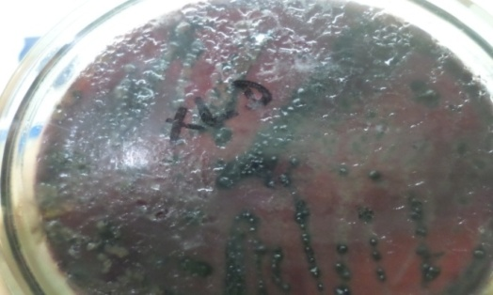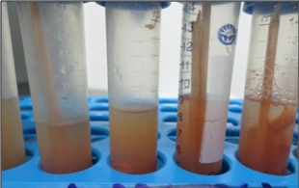

**A**

**B**

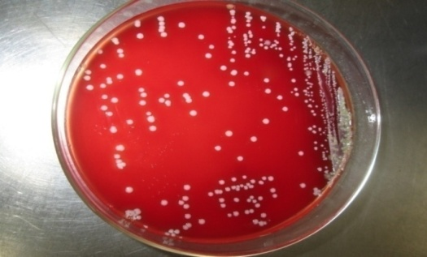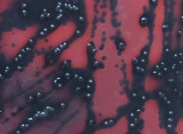

**D**

**C**

**Figure 2: Characteristic growth of *Salmonella* on agar media**

A: Turbidity shown in selenite cysteine broth; B&C: Black centered colony on XLD agar; D: Growth on blood agar.

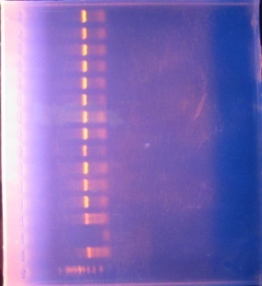**4.2. PCR amplification of *invA* gene of *Salmonella***

All the positive isolates found on cultural media were tested for the presence of *invA* gene. Among the 16 isolates, 13 were positive for the *invA* gene. Amplicons, 284 bp each, of the *inv*A gene are portrayed in Figure 3 and the prevalence is shown in Table 7.

M P N 1 2 3 4 5 6 7 8 9 10 11 12 13

Wells

Positive bands of 284 bp size

300 bp

200 bp

100 bp

**Figure 3: PCR amplification of invA gene**

PCR amplification of *invA* gene of *Salmonella* showing positive amplicon at 284 bp on 1.5% agarose gel with ethidium bromide; M: DNA size marker (100-1000 bp), Lane P: Positive control, Lane N: Negative control, Lane (1-13): Conventional bacterial culture positive isolates.

**Table 7. Prevalence of *Salmonella* isolates based on number of positive in PCR**

|  |  |  |  |
| --- | --- | --- | --- |
| Production type | **No. of observations** | **Number of positive in PCR** | **Prevalence (%) (95% CI)** |
|  |  |  |  |
| Broiler | 37 | 03 | 8.1% (1.7-21.9%) |
| Layer | 38 | 10 | 26.3% (13.4-43.1%) |
| Sonali | 15 | 0 | **_** |
|  |  |  |  |
| Overall | 90 | 13 | 14.4% (7.9-23.4%) |
|  |  |  |  |

**4.3. Gross lesions found in necropsed birds during study**

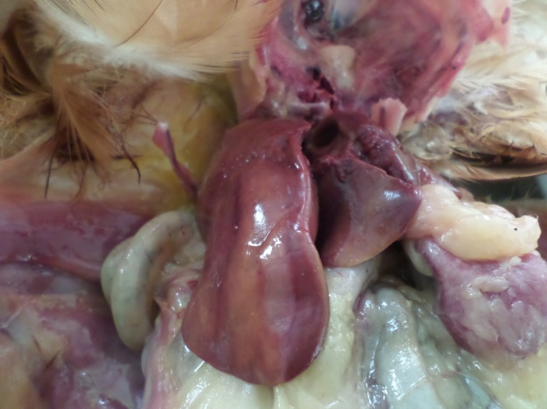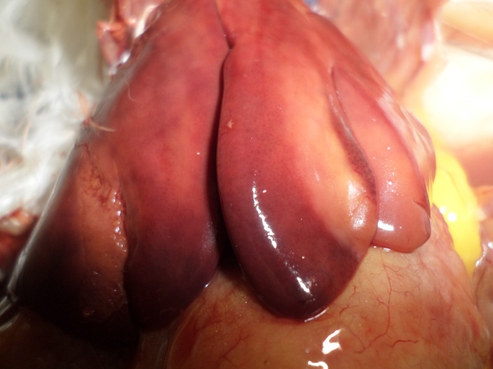

**B**

**A**

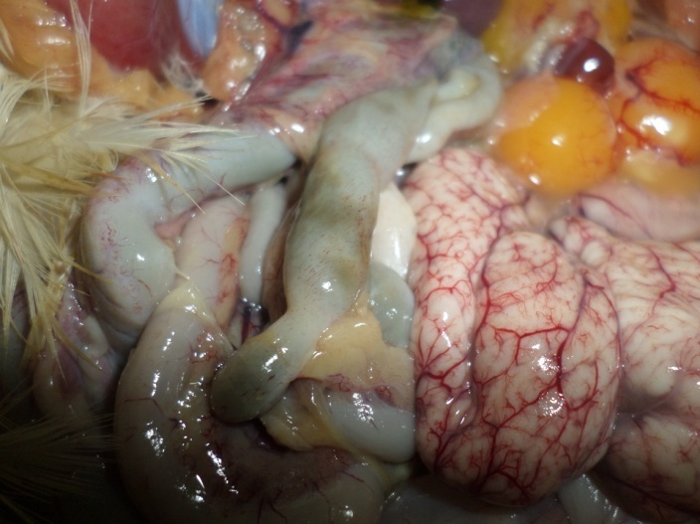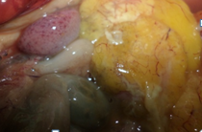

**D**

**C**

**Figure 4: Gross lesions found in chickens (liver, spleen and intestine)**

A & B: Bronze discoloration of liver (arrow) in layer birds with fatty change; C: Haemorrhages in spleen (arrow); D: Haemorrhage and necrotic foci in intestine (arrows).

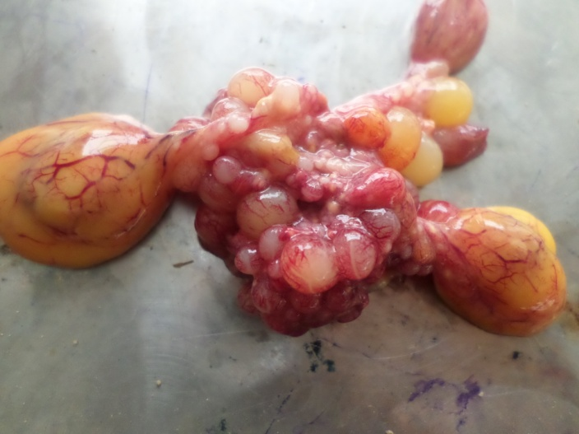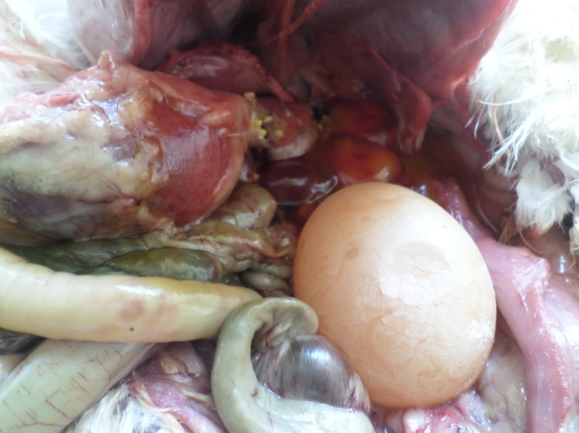

**A**

**B**

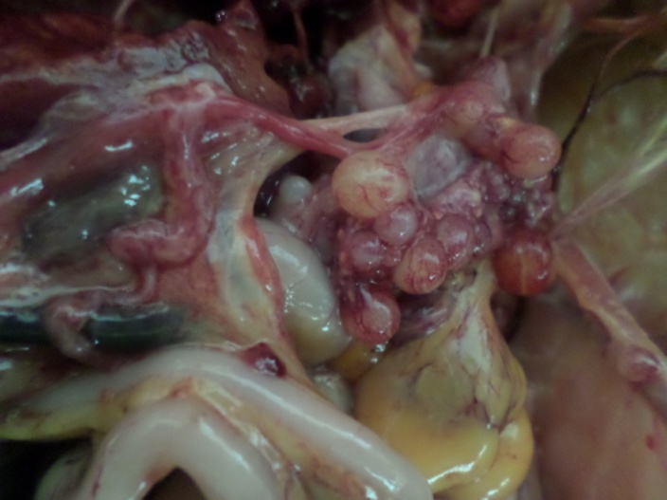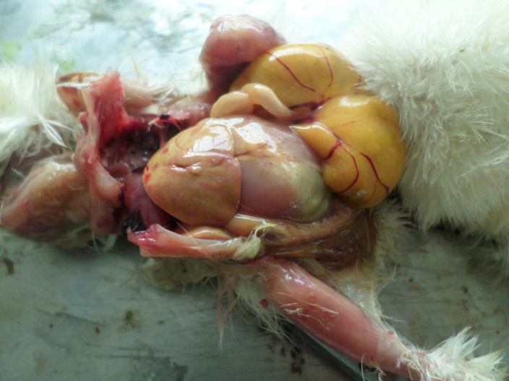

**C**

**D**

**Figure 5: Gross lesions found in chickens**

A: Presence of thin shelled egg within abdominal cavity; B: Misshapened ova from layer birds; C: Unabsorbed yolk in chick (7 days old broiler chick); D: Haemorrhagic and misshapened ova in 17 weeks layer bird.

**4.4. Histopathological changes found in different organs of chickens**

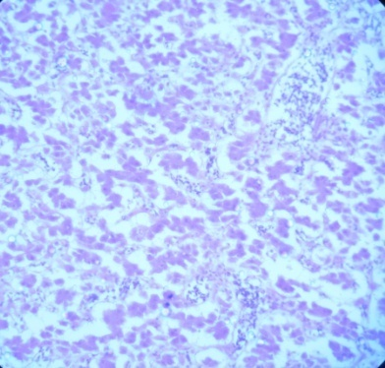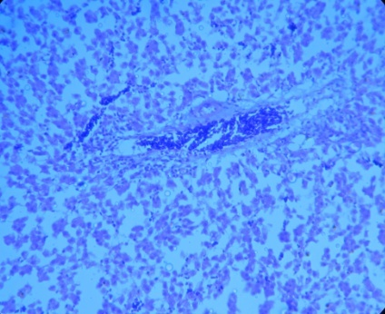

**B**

**A**

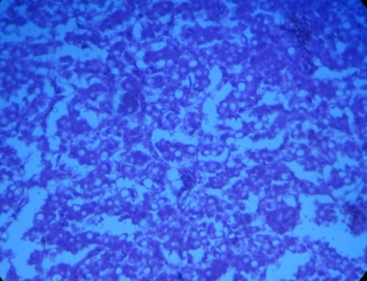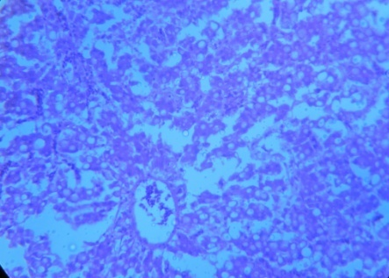

**D**

**C**

**Figure 6: Histopathological changes found in liver**

A: Congestion in liver (arrow) (10x); B: Coagulation necrosis of liver (10x); C&D: Fatty change in liver (40x) (arrow).

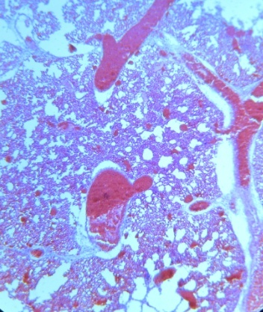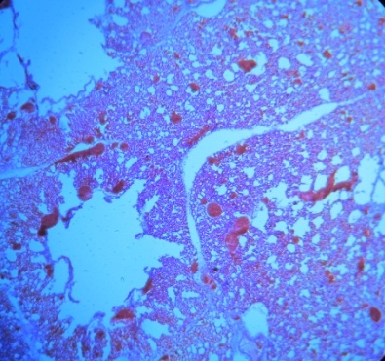

**B**

**A**

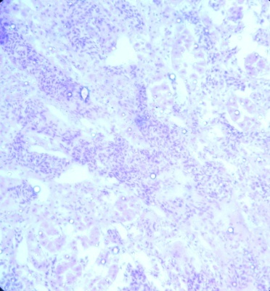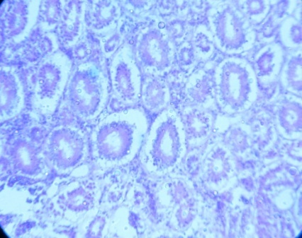

**C**

**D**

**Figure 7: Histopathological changes found in lungs & kidney**

A&B: Congestion (large arrow) and haemorrhages (small arrow) in lungs (10x & 40x); C: Congestion & haemorrhage in kidney (arrow) (10x); D: Degeneration (arrow) and mild fatty change in renal tubule (40x).

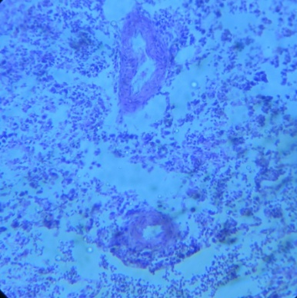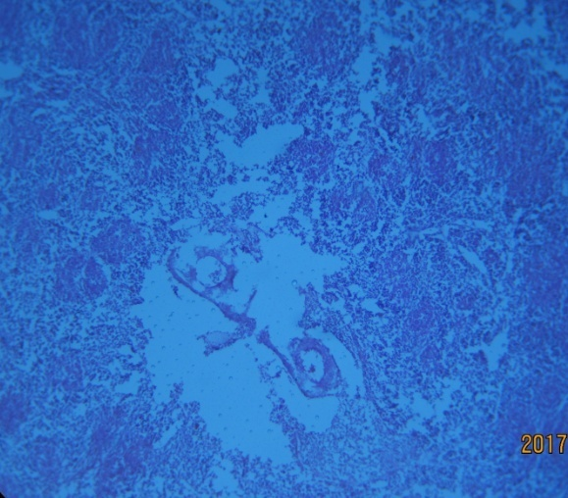

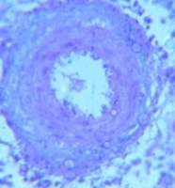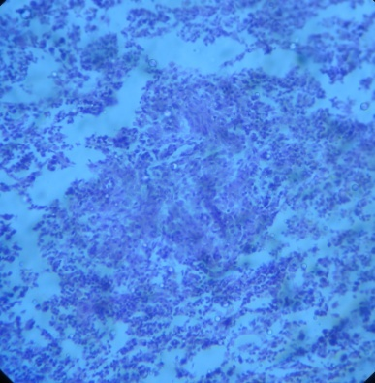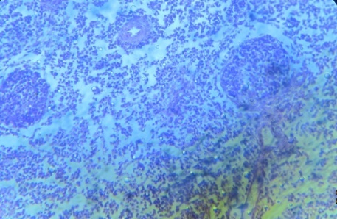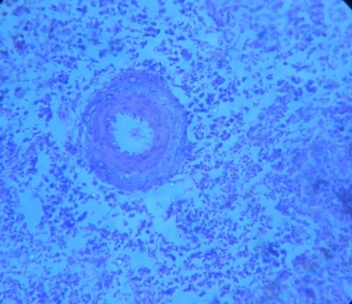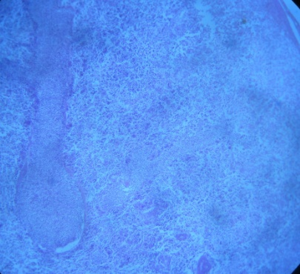

**Figure 8: Histopathological changes found in spleen**

A: Depletion of lymphocyte in spleen (arrow) (10x); B: Depletion of lymphocytic nodule (small arrow) with vascular thickening (large arrow); C: Congestion in spleen (40x); D: Vascular thickening (inset: vascular thickening; 100x) with necrosis (arrow) in spleen (40x); E: Presence of secondary follicles (arrows) in spleen (40x); F: Proliferation of RE cells (40x) in spleen.

**D**

**F**

**E**

**C**

**A**

**B**

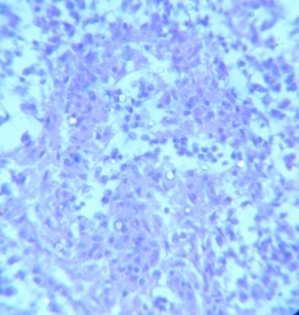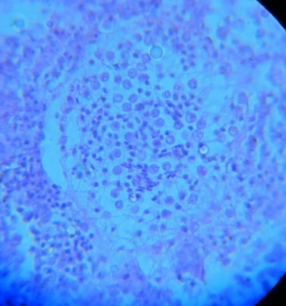

**G**

**H**

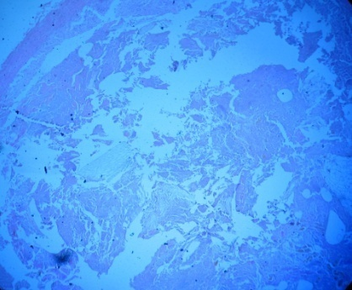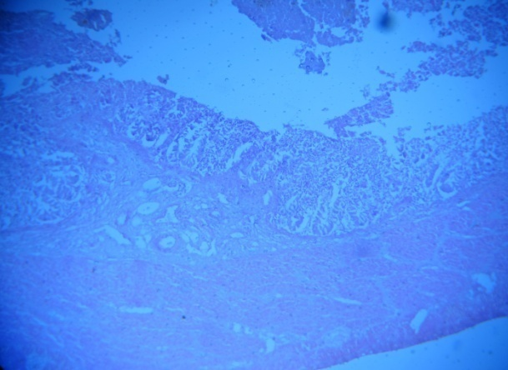

**J**

**I**

**Figure 9: Histopathological changes found in spleen & intestine**

G&H: Proliferation of RE cells (arrows) in spleen (100x); I: Haemorrhage and necrosis in intestinal villi with necrosed tissue within the lumen of intestine (arrow); J: Marked destruction of intestinal epithelia (large arrow) with caseous mass (small arrow) in intestinal lumen.

**4.5. Statistical analysis**

**Table 8: Univariable analysis (logistic regression) to identify statistically significant variables influencing the occurrence of S*almonella* in the study area**

|  |  |  |  |  |  |
| --- | --- | --- | --- | --- | --- |
| Variable | Level | Observation | Number positive (percentage) | OR | P-value |
| Area | Outside CMA* | 49 | 4 (8) | 1 | 0.12 |
|  | CMA | 36 | 7 (19) | 2.71 |
| Production type | Broiler | 37 | 3 (8) | 1 | 0.03 |
|  | Layer | 38 | 10 (26) | 4.04 |
|  | Sonali | 15 | 0 | 0 |
| Farm size | >500-1500 | 35 | 4 (11) | 1 | 0.53 |
|  | ≤500 | 45 | 7 (16) | 1.50 |
| Death of birds | 0 | 22 | 4 (18) | 1 | 0.56 |
|  | 1 to 5 | 37 | 4 (11) | 0.54 |
|  | >5 | 25 | 5 (20) | 1.12 |
| Vaccination (any type) | No | 10 | 0 | 0 | 0.17 |
|  | Yes | 77 | 12 (16) | - |

*CMA = Chittagong Metropolitan Area, OR= Odds Ratio

**Result of logistic regression:**

5 variables were tested with univariable logistic regression models to identify the effect of these variables on the estimated prevalence (14.44%) of *Salmonella.* Among the variables, production type (broiler, layer and sonali) showed a statistically significant relationship with the outcome (presence/absence of *Salmonella* in PCR). Prevalence in layer (26.3%, OR=4) was significantly higher compared to broiler (8.1%, OR=1) and Sonali (0%) birds. Prevalence was higher in birds reared in CMA (19%, OR=2.71) compared to birds from outside of the CMA (8%); however the relationship was not significant statistically. Other variables did not show any significant relationship (table 8).

**Chapter 5: Discussion**

**5.1. Prevalence of salmonellosis in chickens**

Salmonellosis is one of the most important bacterial diseases in poultry causing heavy economic loss through mortality and reduced production (Haider et al., 2004; Talha et al., 2001). The prevalence found in the present study is higher than 11.42% found by Hossain et al. (2006) and lower than 21.02% found by Islam et al. (2006) in Bangladesh. In the present study the prevalence of *Salmonella* infection in poultry was found 14.44%. Higher prevalence rate was found in summer 14.4% and lower in winter 11.2% in Rajshahi district (Mozaffor et al., 2010), which is relevant to the findings of the present study. The difference in the prevalence percentage calculated might be due to differences in the presence of risk factors in the study area.

**5.2. Risk factors associated with salmonellosis in chickens**

With univariable logistic regression models to identify the effect of different variables on the estimated prevalence (14.44%) of *Salmonella,* production type (broiler, layer and sonali) showed a statistically significant relationship with the outcome (presence/absence of *Salmonella* in PCR). Statistically significant difference (p<0.05) was observed in the prevalence of salmonellosis found positive from the samples collected from different production type of chickens. Prevalence in layer (26.3%, OR=4) was significantly higher compared to broiler (8.1%, OR=1). According to Kindu and Mekonnen (2013) the prevalence of *Salmonella* in female chicken flocks was higher than in male chicken flocks. Layers and cocks were proved to be highly infected with *Salmonella* (46.2%) followed by broilers (41.3%). Sikder et al. (2005) reported the prevalence of *Salmonella* was 38.9% in male and 41.4% in female local chicken flocks in Patuakhali district in Bangladesh. Prevalence of *Salmonella* in exotic chicken flocks was 39.1% in males and 44.2% in females. Landers et al. (2005) agreed to the fact that the higher prevalence of *Salmonella* infection in laying hens during this study might be attributed with the reality that layers are physiologically stressed egg production and molting which significantly depress the immune response of layers and increase the susceptibility to *Salmonella* infection.

**5.3. Pathological study**

Gross pathological changes found in chickens during this study were bronze colouration of liver associated with fatty change, haemorrhages in spleen, haemorrhages and necrotic foci in intestine, unabsorbed yolk in chicks, presence of thin shelled egg within abdominal cavity and haemorrhagic and misshapened ova from layer birds. Kumari et al. (2013) observed the lesions, bronze colouration of liver, splenomegaly and necrotic foci on liver, spleen and heart, catarrhal enteritis with thick, slimy mucus on mucosal surface, enlarged kidneys with necrotic foci on surface in broiler chickens. The findings are relevant to the pathological changes found in the present study. According to Saha et al. (2012), livers of *Salmonella* affected birds were enlarged, congested, friable and bronze coloured with white necrotic foci. Egg follicles were congested, hemorrhagic, discoloured with stalk formation and intestines showed hemorrhagic to catarrhal enteritis. Rahman et al. (2011) found as postmortem findings friable livers with bronze colouration and necrotic foci, severe congestion in lungs, congested haemorrhagic egg follicles with stalk formation and enlarged discoloured spleen. Deshmukh et al. (2007); Islam et al. (2006); Msoffe et al. (2006) and Habib-ur-Rahman et al. (2004) described similar pathological findings. Hossain et al. (2006) found in a study that the liver was enlarged and congested and in few cases, liver discoloration with focal necrosis. Other important findings were old raised hemorrhages in the caecal tonsil, congested deformed ova and haemorrhagic, darker ovary with stalk formation, catarrhal inflammation in the intestine. According to Islam et al. (2006), during necropsy, congested and enlarged liver with focal necrosis, haemorrhagic and discoloured ovary with stalk formation and mild haemorrhagic to catarrhal enteritis in intestine were detected. These types of necropsy findings were also supported by Habib-ur-Rahman sstudies, hemorrhages in ovary with stalk formation and bronze coloration of liver with focal necrosis found as postmortem lesions could indicate the presence of *Salmonella* infection in chickens.

Histopathological changes found in chickens during this study were congestion and coagulation necrosis of liver, fatty change in liver. Coagulation necrosis and fatty change in kidney, degeneration in renal tubule, congestion & haemorrhage in kidney have been found. The intestine revealed necrosed tissue within the lumen associated with marked destruction of intestinal epithelia with caseous mass in intestinal lumen and haemorrhage and necrosis in intestinal villi. Congestion and haemorrhages in lungs have been found. Depletion of lymphocyte in spleen, depletion of lymphocytic nodule with vascular thickening, congestion in spleen, vascular thickening with necrosis in spleen, proliferation of RE cells and presence of secondary follicles in spleen are significant microscopic findings in the study. According to Kumari et al. (2013), liver and spleen revealed aggregation of heterophils, lymphocytes and macrophages besides hepatitis is characterized by leucocytic infiltration at perivascular areas along with hydropic vacuolation in hepatocytes, multiple necrotic foci was noticed with Kupffer cell hyperplasia. Interstitial nephritis, necrotic enteritis and serofibrinous pneumonia were also found. According to Saha et al. (2012), livers were congested with formation of multifocal nodules and egg follicles were congested with huge leukocytic infiltration. Infiltration of heterophils in intestinal mucosa was found. Rahman et al. (2011) found that there was focal necrosis and degeneration with leukocytic infiltration in liver, congestion and pneumonic lesions in the lung and various degrees of catarrhal to haemorrhagic enteritis in the intestine. In the egg follicles, congestion and haemorrhage with leukocytic infiltration and enlarged spleen with white necrotic foci were detected. Msoffe et al. (2006); Deshmukh et al. (2007) and Ahmed et al. (2008) also found similar type of microscopic lesions. Islam et al. (2006) found in a study that the liver showed congestion, focal necrosis with multifocal infiltration of histiocytes in liver parenchyma. In ovum, infiltration of leukocytes, bacterial colony, RE cell proliferation and fibrinoid necrosis were recorded. The spleen showed severe congestion, mild hyperplasia of RE cells and fibrinoid necrosis. The intestinal mucosa exhibited infiltration of mononuclear cells in mucosa and submucosa. These types of histological lesions for Salmonella infection were also found by Habib-ur-Rahman et al. (2004) and Refsum et al. (2002). Hossain et al. (2006) reported in a study that as histopathological lesions the liver showed congestion, hemorrhages, focal degeneration and focal necrosis with infiltration of mononuclear cells. The intestinal mucosa exhibited congestion and hemorrhages with infiltration of mononuclear cells in the submucosa. Haider et al. (2004); Habib-ur-Rahman et al. (2003) and Talha et al. (2001) also found relevant types of histological lesions to the present study. According to Hossain et al. (2006), microscopically multi focal necrosis with infiltration of mononuclear cells in the liver could indicate the presence of *Salmonella* infection. The findings of the present study are nearly relevant to the histopathological changes reported by other authors.

**5.4. Molecular detection of *Salmonella* spp. in poultry**

In the present study, PCR enabled identification of *Salmonella* spp. in layer and broiler chickens. Amplicons, 284 bp each, of the *invA* gene for the presence of *Salmonella* spp. has been detected through PCR. Sharma and Das (2016) reported that *Salmonella* strains were isolated from poultry specimens, by culturing in selenite F and then transferring to Salmonella-Shigella agar, when subjected to Salmonella specific-PCR using primers *invA* F and *invA* R where all isolates including positive control and a single 284 bp amplified DNA fragment, on 1.2% agarose gel. According to Pal et al. (2017), PCR technique was used, using standard methodology, for detection of *invA* genes for detection of strains of *Salmonella enterica* serovar Gallinarum isolates obtained from an outbreak of fowl typhoid. Ezzat et al. (2014); El-Tawwab et al. (2013); Malorny et al. (2003) and Rahn et al. (1992) reported that molecular identification of *Salmonella* spp. with *invA* gene primer set conforms to be international standard with very high specificity. High prevalence of *invA* virulence gene in *Salmonella* serovars has also been reported by Chaudhary et al. (2015) and Karmi (2013).

**Chapter 6: Conclusion**

Salmonellosis has emerged as one of the most serious problems having adverse effects on poultry. The intent of the present study was to describe the histopathological and molecular detection of *Salmonella* in commercial chickens in Chittagong district. Univariable logistic regression was framed to identify the effect of different risk factors on the estimated prevalence (14.44%) of *Salmonella*. Statistically significant difference (p=0.03) was observed in the prevalence of salmonellosis found positive from the samples collected from different production type of chickens. Prevalence in layer was found significantly higher (OR=4) compared to broiler. The result of the present study indicates the importance of PCR as a rapid and reliable tool alongside conventional cultural techniques for confirmation of *Salmonella.* The data in this study suggest the prevalence of *Salmonella enterica*, highly specific for commercial layers in Chittagong in Bangladesh.

**Chapter 7: Recommendation and Limitations**

The present study was conducted to identify and isolate, histopathologically and through PCR, salmonellosis from commercial layer and broiler chickens in Chittagong. In the present study, only one risk factor associated with salmonellosis was found significant. There could be more remarkable results of significant risk factors if the sample size was larger and the locations of the farms covered more around the district Chittagong. Visit to the farms from where the samples came to DPP, CVASU could give more precious information about the risk factors and make the result more accurate. Based on above limitations future approaches can be as below:

1. For more specific result typing of *Salmonella* spp. should be done using molecular techniques like RFLP.
2. Sequencing of identified genes and phylogenic analysis of sequenced data through bioinformatics analysis
3. Developing disease model based on identified risk factors.

**References**

Ahmed AKM, Islam MT, Haider MG, Hossain MM. 2008. Seroprevalence and pathology of naturally infected salmonellosis in poultry with isolation and identification of causal agents. Journal of Bangladesh Agricultural University, 6: 327-334.

Akter MR, Choudhury KA, Rahman MM, Islam MS. 2007. Seroprevalence of salmonellosis in layer chickens with isolation, identification and antibiogram study of their causal agents. Bangladesh Journal of Veterinary Medicine, 5: 39–42

Alveraz J, Sota M, Vivanco AB, Perals I, Cisterna R, Rementeria A, Garaizar J. 2004. Development of a multiplex PCR technique for detection and epidemiological typing of *Salmonella* in human clinical samples. Journal of Clinical Microbiology, 42: 1734-1738.

Amick-Morris J. 1998. Insects’ contribution to *Salmonella* transmission in turkey flocks. MS thesis, West Virginia University, Morgantown, WV, USA.

Bacteriological analytical manual, US Food and Drug Administration, 2009.

Barbara ML, Baird-Parker TC, Grahame WG. 2000. The microbiological safety and quality of food (II). Gaithersburg, Maryland, USA. Aspen Publishers Inc, pp. 1234.

Barrow PA, Huggins MB, Lovell MA. 1994. Host specificity of *Salmonella* infection in chickens and mice is expressed in vivo primarily at the level of the reticuloendothelial system. Infection and Immunity, 62: 4602-4610.

Barrow PA. 1992. ELISAs and the serological analysis of *Salmonella* infections in poultry: a review. Epidemiology and Infection, 109: 361–369.

Barrow PA. 1993. *Salmonella* control- past, present and future. Avain pathology, 22: 651 - 669.

Barrow PA and Neto OF. 2011. Pullorum disease and fowl typhoid – new thoughts on old diseases: a review. Avian Pathology, 40: 1–13.

Beaudette FR. 1930. Fowl typhoid and bacillary white diarrhoea. Proceedings of the 11th International Veterinary Congress, London, England. pp. 705–723.

Berchieri JA, Oliveira GH, Pinheiro LAS, Barrow, P. 2000. Experimental *Salmonella* Gallinarum infection in light laying hen lines. Brazillian Journal of Microbiology, 31: 50-52.

Betancor L, Pereira M, Martinez A, Glossa G, Faces M, Flores K, Barrios P, Repiso V, Vignoli R, Cordeiro N, Algorta G, Thomson N, Maskell D, Schelotto F, Chabalgoity JA. 2010. Prevalence of *Salmonella enterica* in poultry and eggs in Uruguay during an epidemic due to *Salmonella enterica* serovar Enteritidis. Journal of Clinical Microbiology, 48: 2413–2423.

Bhattacharjee PS, Kundu RL, Biswas RK, Mazumder JU, Hossain E, Miah AH. 1996. Retrospective analysis of chicken diseases diagnosed at the Central Disease Investigation Laboratory, Dhaka. Bangladesh Veterinary Journal, 30: 105-113.

Bisping WG, Amtsberg W, Siller, Phillips J. 1988. Oxidase-negative and fermentative bacteria, Genus Samonella. Colour atlas for the diagnosis of bacterial pathogens in animals, pp. 171-182.

Biswas D, Herrera P, Fang L, Marquardt RR, Ricke SC. 2010. Cross-reactivity of anti Salmonella egg yolk antibodies to *Salmonella* serovars. Journal of Environmental Science and Health, part B, 45: 790–795.

Bouzoubaa K, Lemainguer K, Bell JG. 1992. Village chickens as a reservoir of *Salmonella* Pullorumand *Salmonella* Gallinarumin Morocco. Preventive Veterinary Medicine, 12: 95-100.

# Carrique-Mas JJ and Davies RH. 2008. Sampling and bacteriological detection of *Salmonella* in poultry and poultry premises. A review. Revue Scientifique et Technique, 27: 665-677.

Charlton BR, Walker RL, Kinde H, Bauer CR, Channing-Santiago SE, Farver TB. 2005. Comparison of a *Salmonella* Enteritidis-specific polymerase chain reaction assay to delayed secondary enrichment culture for the detection of *Salmonella* Enteritidis in environmental drag swab samples. Avian Disease, 49, 418–422.

Chaudhary JH, Nayak JB, Brahmbhatt MN, Makwana PP. 2015. Virulence genes detection of *Salmonella* serovars isolated from pork and slaughter house environment in Ahmedabad, Gujarat. Veterinary World, 8(1): 121-124.

Chauhan HVS and Roy S. 1996. Poultry diseases, diagnosis and treatment. 2nd ed. New age international (P) ltd. publishers, New Delhi, India.

Christensen JP, Olsen JE, Hansen HC, Bisgaard M, 1992. Charaterization of *Salmonella enterica* serovar Gallinarum biovar Gallianrum and Pullorum by plasmid profiling and biochemical analysis. Avian Pathology, 21: 461-470.

Deshmukh S, Asrani RK, Ledoux DR, Rottinghaus GE, Bermudez AJ, Gupta VK. 2007. Pathologic changes in extrahepatic organs and agglutinin response to *Salmonella* Gallinarum infection in Japanese quail fed *Fusarium verticillioides* culture material containing known levels of fumonisin B1. Avian Diseases, 51: 705-712.

Dey S, Mahanti A, Batabyal K, Joardar SN, Samanta I, Isore DP, Pakhira MC. 2016. Identification and antimicrobial susceptibility of *Salmonella* Gallinarum isolated from fowl typhoid outbreak in backyard poultry. Exploratory Animal and Medical Research, 6: 63-67.

DLS, 2016. Livestock Economy at a glance 2015-2016. Department of Livestock Services, Dhaka, Bangladesh.

Ellerbroek L, Narapati D, Phu Tai N, Poosaran N, Pinthong R, Sirimalaisuwan A, Tshering P, Fries R, Zessin KH, Baumann M, Schroeter A, 2010. Antibiotic resistance in Salmonella isolates from imported chicken carcasses in Bhutan and from pig carcasses in Vietnam Journal of Food Protection, 73: 376-379.

El-Tawwab AAA, Ammar AM, Ali AR, El-Hofy FI, Sayed AME. 2013. Detection of common (*invA*) gene in Salmonellae isolated from poultry using polymerase chain reaction technique. Benha Veternary Medical Journal, 25: 70-77.

Erbeck DH, McLaughlin BG, Singh SN. 1993. Pullorum disease with unusual signs in two backyard chicken flocks. Avian Disease, 37: 895–897.

Ezzat ME, Shabana II, Esawy AM, Elsotohy ME. 2014. Detection of virulence genes in Salmonella serovars isolated from broilers. Journal of Animal and Veterinary Science, 2: 189-193.

Gast RK, Nasir MS, Jolley ME, Holt PS, Stone HD, 2002. Serologic detection of experimental *Salmonella* Enteritidis infections in laying hens by fluorescence polarization and enzyme immunoassay. Avian Disease, 46: 137–142.

Gast RK. 1997. Detecting infections of chickens with recent *Salmonella* Pullorum isolates using standard serologic methods. Journal of Poultry Science, 76: 17–23.

Gast RK. 2003. Salmonella Infections. In. Diseases of poultry, 11th ed. Iowa state press, Blackwell publishing company, UK. pp. 575-578.

Glosnicka R, Pienkowska D, Dera-Tomaszewska B, Ilnicka MJ. 1987. Characteristics of lactose-fermenting Salmonella strains from Poland. Bulletin of the Institute of Maritime and Tropical Medicine in Gdynia, 38: 69-75.

Gorski L. 2012. Selective enrichment media bias the types of *Salmonella enterica* strains isolated from mixed strain cultures and complex enrichment broths. PLoS ONE, 7: e34722.

Grimont PAD, Grimont F, Bouvet P. 2000. Taxonomy of the Genus Salmonella. In: Wray C. and Wray A. ed. Salmonellain domestic animals. CABI Publishing, Wallingford, UK. pp. 1-17.

Grimont PAD and Weill F-X. 2007. Antigenic formulae of the Salmonella serovars (9th ed). WHO Collaborating Centre for Reference and Research on Salmonella. In. Pasteur, Paris, France.

Habib-ur-Rahman S, Khan MS, Hamayun K, Nazir A, Bhatii WM. 2004. Incidence and gross pathology of *Salmonella* Gallinaruminfection in chicken. Journal of Animal and Veterinary Advances, 3: 175-178.

Habib-ur-Rahman S, Sirzanin, Hamayun K, Saleem K, Nazir A, Bhatti WM. 2003. Incidence and gross pathology of salmonellosis in chicken in Hyderabad. Journal of Association of Veternary Advances, 2: 581-584.

Habrun B and Mitak M. 2003. Monitoring for faecal *Salmonella* spp. in poultry. Zagreb, Croatia: Croatian Veterinary Institute, Poultry Centre. V-Simpozij- Peradarski-Dani, Zbornik, Radova, Porec, Hrvatska, 14-17-svibnja, pp. 161-163.

Haider MG, Chowdhury EH, Khan MAHNA, Hossain MT, Rahman MS, Song HJ, Hossain MM. 2008. Experimental pathogenesis of pullorum disease with the local isolate of *Salmonella enterica* serovar *enterica* subspecies Pullorum in pullets in Bangladesh*.* Korean Journal of Poultry Science, 35: 341-350.

Haider MG, Hossain MG, Hossain MS, Chowdhury EH, Das PM, Hossain MM. 2004. Isolation and characterization of Enterobacteria associated with health and disease in Sonali Chickens. Bangladesh Journal of Veterinary Medicine, 2 (1): 15-21.

Haque ME, Hamid MA, Howleder MAR, Haque QME. 1991. Performance of native chicks and hens reared together or separately under rural condition in Bangladesh. Bangladesh Veterinary Journal, 8: 11-13.

Hassan JO, Barrow PA, Mockett APA, McLeod S. 1990. Antibody response to experimental *Salmonella* Typhimurium infection in chickens measured by ELISA. The Veterinary Record, 126: 519–522.

Holt PS. and Chaubal LH. 1997. Detection of motility and putative synthesis of flagellar proteins in *Salmonella* Pullorum cultures. Journal of Clinical Microbiology, 35: 1016-1020.

Hoover NJ, Kenney PB, Amick JD, Hypes WA. 1997. Preharvest sources of *Salmonella* colonization in turkey production. Journal of Poultry Science, 76: 1232–1238.

Hoque MM, Biswas HR, Rahman L. 1996. Isolation, identification and production of *Salmonella* Pullorumcoloured antigen in Bangladesh for the rapid whole blood test. Asian Australian Journal of Animal Science, 10: 141-146.

Hossain MA, Aalbaek B, Christensen JP, Elisabeth H, Islam MA, Pankaj K. 2003. Observations on experimental infection of *Salmonella* Gallinarum in Fayoumi and Hyline layer chickens in Bangladesh. Progressive Agriculture, 14: 85-89.

Hossain MA. and Islam MA. 2004. Seroprevalence and mortality in chickens caused by pullorum disease and fowl typhoid in certain government poultry farms in Bangladesh. Bangladesh Journal of Veterinary Medicine, 2: 103-106.

Hossain MS, Chowdhury EH, Islam MM, Haider MG and Hossain MM. 2006. Avian *Salmonella* infection: isolation and identification of organisms and histopathological study. Bangladesh Journal of Veterinary Medicine, 4: 07–12.

Humphrey TJ, Baskerville A, Chart H, Rowe B. 1989. Infection of egg-laying hens with *Salmonella* Enteritidis PT4 by oral inoculation. The Veterinary Record, 125: 531–532.

Islam MM, Chowdhury EH, Haider MG, Kamruzzaman M and Hossain MM. 2006. Seroprevalence and pathological study of *Salmonella* infections in layer chickens and isolation and identification of causal agents. Bangladesh Journal of Veterinary Medicine, 4: 79-85.

Jouy E, Proux K, Humbert F, Rose V, Lalande F, Houdayer C, Picault UP, Salvat G. 2005. Evaluation of a French ELISA for the detection of *Salmonella* Enteritidis and *Salmonella* Typhimurium in flocks of laying and breeding hens. Preventive Veterinary Medicine, 71: 91–103.

Kang MS, Kwon YK, Jung BY, Kim A, Lee KM, An BK, Song EA, Kwon JH, Chung GS. 2011. Differential identification of *Salmonella enterica* subsp. *enterica* serovar Gallinarum biovars Gallinarum and Pullorum based on polymorphic regions of *glgC* and *speC* genes. Veterinary Microbiology, 10: 181-185.

Karmi M. 2013. Detection of virulence gene (*invA*) in *Salmonella* isolated from meat and poultry products. International Journal of Genetics, 3: 7-12.

Khan AHMNA, Bari ASM, Islam MR, Das PM, Ali MY. 1998. Pullorum disease in semi mature chickens and its experimental pathology. Bangladesh Veterinary Journal, 32: 124-128.

Kindu A. and Mekonnen A. 2013. A Survey on *Salmonella* Infection among chicken flocks in Jimma Town, Ethiopia. World Applied Sciences Journal, 21: 1415-1420.

Kisiela D, Kuczkowski M, Kiczak L, Wieliczko A, Ugorski M. 2005. Differentiation of *Salmonella* Gallinarum biovar Gallinarum from *Salmonella* Gallinarum biovar Pullorum by PCR-RFLP of the *fimH* gene. Journal of Veterinary Medicine, B52: 214-218.

Kohbata S, Takahashi M, Yabuuchi E. 1983. Lactose-fermenting, multiple drugresistant *Salmonella* t*yphi* strains isolated from a patient with postoperative typhoid fever. Journal of Clinical Microbiology, 18: 920-925.

Kumari D, Mishra SK, Lather D. 2013. Pathomicrobial studies on *Salmonella* Gallinarum infection in broiler chickens. Veterinary World, 6: 725-729.

Kwon HJ, Kim TE, Cho SH, Seol JG, Kim BJ, Hyun JW, Yoo HS. 2002. Distribution and characterization of class 1 integrons in *Salmonella enterica* serotype Gallinarum biotype Gallinarum. Veterinary Microbiology, 89: 303-309.

Kwon YK, Kim A, Kang MS, Her M, Jung BY, Lee KM, Jeong W, An BK, Kwon JH. 2010. Prevalence and characterization of *Salmonella* Gallinarum in the chicken in Korea during 2000 to 2008. Poultry Science, 89: 236-242.

Landers K, Woodward F, Kubena D, Ricke S. 2005. Alfalfa as a single dietary source to induce molting in laying hens. Poultry Science, 96: 565-570.

Liu GR, Rahn A, Liu WQ, Sanderson KE, Johnston RN, Liu SL. 2002. The evolving genome of *Salmonella enterica* serovar Pullorum. Journal of Bacteriology, 184: 2626–2633.

Luna LG. 1968. Manual of histologic staining methods of the Armed Forces Institute of Pathology. 3rd ed. McGraw Hill Book Co., New York, USA.

Mahendra M, Vandana J, Joshi DD, Poornima M, 2006. Prevalence of *Salmonella* spp. in various raw meat samples of a local market in Kathmandu. Annals of the New York Academy of Sciences, 1081: 249-256.

Mainali C, McFall ME, King RK. 2011. Validation of a real-time polymerase chain reaction assay for the detection of *Salmonella* in crops of broiler chickens. Poultry Science, 90: 660–664.

Malorny B, Bhunia A, Aarts H, Löfström C, Hoorfar J. 2011. *Salmonella*in pork, beef, poultry and egg. pp. 179-194. In. Hoorfar J. (ed). Rapid detection, characterization and enumeration of foodborne pathogens. ASM Press, Washington, DC.

Malorny B, Hoorfar J, Bunge C, Helmuth R. 2003. Multicenter validation of the analytical accuracy of *Salmonella* PCR: towards an international standard. Applied and Environmental Microbiology, 69: 290-296.

Manoj J, Singh MK, Singh YP. 2015. The role of poultry in food borne salmonellosis and its public health importance. Advances in Animal and Veterinary Sciences, 3(9): 485-490.

Medewewa P, Priyantha MAR, Gunawardana G, Vipulasiri AA, Liyanagunawardana N. 2012. Comparison of local *Salmonella* Pullorum antigen with imported product in whole blood agglutination test. Veterinary World, 5: 546-548.

Mizumoto N, Toyota-Hanatani Y, Sasai K, Tani H, Ekawa T, Ohta H, Baba E. 2004. Detection of specific antibodies against deflagellated *Salmonella* Enteritidis and *S.* Enteritidis fliC-specific 9 kDa polypeptide. Veterinary Microbiology, 99: 113–120.

Morita M, Mori K, Tominaga K, Terajima J, Hirose K, Watanabe H, Izumiya H. 2006. Characterization of lysine decarboxylase-negative strains of *Salmonella enterica* serovar Enteritidis disseminated in Japan. FEMS Immunology and Medical Microbiology, 46: 381-385.

Mortimer CKB, Peters MT, Gharbia SE, Logan JMJ, Arnold C. 2004. Towards the development of a DNA-sequence based approach to serotyping of *Salmonella enterica*. BioMed Central Microbiology, 4: 31.

Mozaffor KM, Hossain M, Hossain T, Yamato I. 2010. Seroprevalence of *Salmonella* and *Mycoplasma gallisepticum* infection in chickens in Rajshahi and surrounding districts of Bangladesh. International Journal of Biology, 2: 74-80.

Msoffe PLM, Minga UM, Mtambo MMA, Gwakisa PS, Olsen JE. 2006. Differences in resistance to *Salmonella enterica* serovar Gallinarum infection among indigenous local chicken ecotypes in Tanzania. Avian Pathology, 35: 270-276.

Muktaruzzaman M, Haider MG, Ahmed A KM, Alam KJ, Rahman MM, Khatun MB, Rahman MH, Hossain MM. 2010. Validation and refinement of (SP) colored antigen for diagnosis of *Salmonella* infections in the field. International Journal of Poultry Science, 9: 801-808.

National Center for Biotechnology Information (NCBI). 2009. www.ncbi.nlm.nih. gov/ pubmed.

Paiva JB, Penha F, Anguello YMS, Siva MD, Gardin Y, Resende F, Berchieri A, Sestsi L. 2009. Efficacy of several *Salmonella* vaccination programme against experimental challenge with *Salmonella* Gallinarum in commercial brown breeder hens. Brazilian Journal of Poultry Science, 11: 65-72.

Pal S, Dey S, Batabyal K, Banerjee A, Joardar SN, Samanta I, Isore DP. 2017. Characterization of *Salmonella* Gallinarum isolates from backyard poultry by polymerase chain reaction detection of invasion (*invA*) and *Salmonella* plasmid virulence (*spvC*) genes. Veterinary World, 10: 814-817.

Parvej MS, Nazir KHMNH, Rahman MB, Jahan M, Khan MFR, Rahman M. 2016. Prevalence and characterization of multi-drug resistant *Salmonella enterica* serovar Gallinarum biovar Pullorum and Gallinarum from chicken. Veterinary World,9: 65-70.

Pomeroy BS and Nagaraja KV. 1991. Fowl Typhiod. In: Diseases of Poultry,9th ed., BW Calnek, HJ Barnes, CW Beard, WM Reid and HW Yoder Jr. eds., Iowa State University Press, Ames, Iowa. pp. 87-99.

Prasanna K, Somvanshi R, Paliwal OP. 2001. Experimental fowl typhoid and pullorum disease infection in chicken: histopathological and ultrastructural studies of small intestine and liver. Indian Journal of Veterinary Pathology, 21: 18-20.

Proux K, Humbert F, Jouy E, Houdayer C, Lalande F, Oger A, Salvat G. 2002. Improvements required for the detection of *Salmonella* Pullorum and Gallinarum. Canadian Journal of Veterinary Research, 66: 151-157.

Queipo-Ortuno MI, Colmenero JDD, Macias M, Bravo MJ, Morata P. 2008. Preparation of bacterial DNA template by boiling and effect of immunoglobulin G as an inhibitor in real time PCR for serum samples from patients with brucellosis. Clinical and Vaccine Immunology, 15: 293–296.

Quinn PJ, Markey BK, Leonard FC, FitzPatrick ES, Fanning S, Hartigan PJ. 2011. Veterinary Microbiology and Microbial Disease, 2nd edition. Willey and Blackwell, pp. 700.

Rahman M. 2003. Growth of poultry industry in Bangladesh: poverty alleviation and employment. In: Proceedings of 3rd International Poultry Show and Seminar, held in Bangladesh China Friendship Conference Centre (BCFCC), pp. 1-7.

Rahman MA, Samad MA, Rahman MB, Kabir SML. 2004. Bacterio-path­ological studies on salmonellosis, colibacillosis and pasteurellosis in natural and experimental infections in chickens. Bangladesh Journal of Veterinary Medicine, 2: 01-08.

Rahman MM, Chowdhury TIMF, Rahman MM, Hossain WIMA. 1997. Surveillance of *Salmonella* & *Escherichia* organisms in poultry feed. Bangladesh Veterinary Journal, 15: 59-62.

Rahman MR, Shahinuzzaman ABM, Saha AK, Sufian MA, Rahman MH, Hossain MM. 2011. Prevalence of Salmonella infection in naturally infected layer birds in Bangladesh. The Bangladesh Veterinarian, 28: 8 – 18.

Rahn K, De Grandis SA, Clarke RC, McEwen SA, Galan JE, Ginocchio C, Curtiss R and Gyles CL. 1992. Amplification of an *invA* gene sequence of *Salmonella* Typhimurium by polymerase chain reaction as a specific method of detection of *Salmonella*. Molecular and Cellular Probes, 6: 271-279.

Refsum T, Handeland K, Baggesen DL, Holstad G, Kapperud G. 2002. Salmonellae in avian wild life in Norway from 1969 to 2000. Veterinary Bulletin, 73: 360.

Reid RL, Porter RC, Ball HJ. 1993. The isolation of sucrose-fermenting *Salmonella* Mbandaka. Veterinary Microbiology, 37: 181-185.

Rybolt ML, Wills RW, Bailey RH. 2005. Use of secondary enrichment for isolation of *Salmonella* from naturally contaminated environmental samples. Poultry Science, 84: 992-997.

Saha KA, Sufian MA, Hossain MI and Hossain MM. 2012. Salmonellosis in layer chickens: pathological features and isolation of bacteria from ovaries and inner content of laid eggs. Journal of Bangladesh Agricultural University, 10: 61–67.

Salem M, Odor EM, Pope C. 1992. Pullorum disease in Delaware roasters. Avian Disease, 36: 1076–1080.

Saleque MA, Rahman MH and Hossain MI. 2003. Seasonal variation in the prevalence of poultry disease in Bangladesh. 9th Bangladesh Society for Veterinary Education and Research (BSVER) Annual Scientific Conference held at BAU, Mymensingh. Bangladesh Society for Veterinary Education and Research Publication, 24: 23-24.

Sato Y, Sato G, Tuchili L, Pandey GS, Nakajima A, Chimana H, Sinsungwe H. 1997. Status of *Salmonella* Gallinarum-Pullorum infections in poultry in Zam­bia. Avian Disease, 41: 490-495.

Schwartz KJ. 1999. Salmonellosis. In: Straw BE, D‟Allaire S, Mengeling WL, Taylor DJ. Disease of swine, 8th ed. Iowa State University Press, USA, pp. 535-551.

Seo KH, Valentin-Bon IE, Brackett RE, Holt PS. 2004. Rapid, specific detection of *Salmonella* Enteritidis in pooled eggs by real-time PCR. Journal of Food Protection, 67: 864–869.

Sharma I. and Das K. 2016. Detection of *invA* gene in isolated *Salmonella* from marketed poultry meat by PCR assay. Journal of Food Process Technology, 7: 564.

Shivaprasad HL, Methner U, Barrow PA. 2013. *Salmonella* infections in the domestic fowl. In: Methner U and Barrow PA. 2013. Salmonella in Domestic Animals, CABI, Oxfordshire, UK. pp. 162–192.

Shivaprasad HL. 1997. Pullorum disease and fowl typhoid. In. Calnek BW, Barnes HJ, Beard CW, McDougald LR, Saif YM.. Diseases of Poultry. 10th ed., Iowa State University Press, Ames, USA.

Shivaprasad HL. 2003. Pullorum disease and fowl typhoid. In Saif YM, Barnes HJ, Glisson JR, Fadly AM, McDougald LR, Swayne DE. Diseases of poultry 11th ed. Iowa State University Press, Ames, USA. pp. 568-582.

# Shivprasad HL. 2000. Fowl typhoid and pullorum disease. Revue Scientifique et Technique, 19: 405-424.

Sikder A, Islam M, Rahman M, Rahman M. 2005. Seroprevalence of *Salmonella* and *Mycoplasma gallisepticum* infection in the six model breeder farms at Patuakhali district of Bangladesh. International Journal of Poultry Science, 4: 905-910.

Sivula CP, Bogomolnaya LM, Andrews-Polymenis HL. 2008. A comparison of cecal colonization of *Salmonella* Typhimurium in white leghorn chicks and *Salmonella* resistant mice. BMC Microbiology, 8: 182.

Snoeyenbos GH. 1991. Pullorum disease. In: Calnek BW, Barnes HJ, Beard CW, Reid WM, Yoder HWJ. Diseases of Poultry. 9th ed. Wolfe publishing Ltd. London. pp. 87-99.

Somyanontanagul N, Heiko N, Tegeler R, Blaha T. 2008. Comparison between detecting *Salmonella* spp.by bacteriological method and Real-Time PCR assay in samples from pig herds. In: Oral Proceedings of the 20th International Pig Veterinary Society Congress, Durban, South Africa.

Sonne-Hansen J, Jenabian SM. 2005. Molecular serotyping of *Salmonella*: Identification of the phase 1H antigen based on partial sequencing of the fliC gene. Acta Pathologica, Microbiologica et Immunologica Scandinavica, 113: 340-348.

Sujatha K, Dhanalakshmi K, Rao AS. 2003. Isolation and characterisation of *Salmonella* Gallinarumfrom chickens. Indian Veterinary Journal, 80: 473-474.

Talha AFSM, Hossain MM, Chowdhury EH, Bari ASM, Islam MR, Das PM. 2001. Poultry diseases occurring in Mymensingh district of Bangladesh. The Bangladesh Veterinarian, 18: 20-23.

Temelli S, Eyigor A, Carli KT. 2012. *Salmonella* detection in poultry meat and meat products by the Vitek immunodiagnostic assay system easy *Salmonella* method, a light cycler polymerase chain reaction system, and the International Organization for Standardization method, 65-79. Journal of Poultry Science, 91: 724-31.

Volkova VV, Bailey RH, Hubbard SA, Magee D, Byrd JA, Robert WW. 2011. Risk factors associated with *Salmonella* status of broiler flocks delivered to grow-out farms. Zoonoses and Public Health, 58: 284–298.

Waltman WD. 2000. Methods for the cultural isolation of Salmonella. In: Wray C. and Wray A. Salmonellain domestic animals. eds. Cabi Publishing, Oxon. pp. 335-372.

Weinack OM, Smyser CF, Snoeyenbos GH. 1979. Evaluation of several methods of detecting Salmonellae in groups of chickens. Avian Disease, 23: 179–193.

Wieliczko A, Kuczkowski M, Chmielewski R, Mazurkiewicz M, Ugorski M, 2001. Phenotypic characteristics of *Salmonella* Gallinarum and *Salmonella* Pullorum isolated from layers. Med-Vet-Net, 57: 671-675.

Wigley P, Berchieri A Jr, Page KL, Smith AL, Barrow PA. 2001. *Salmonella enterica* serovar Pullorum persists in splenic macrophages and in the reproductive tract during persistent, disease free carriage in chickens. Infection and Immunology, 69: 591-592.

Wigley P, Hulme S, Powers C, Beal R, Smith A, Barrow P. 2005. Oral infection with the *Salmonella* *enterica* serovar Gallinarum 9R attenuated live vaccine as a model to characterize immunity to fowl typhoid in the chicken. Veterinary Research, 2: 1-9.

Wikepedia. Source: <http://en.wikipedia.org>.

World Organization for Animal Health (OIE). 2004. Pullorum diseases and fowl typhoid. IN: OIE manual diagnostic tests and vaccines for terrestrial animals. Office Interna­tional des Epizooties (OIE), 4th ed. Paris, France.

World Organization for Animal Health (OIE). 2008. Fowl typhoid and pullorum disease. In: Terrestrial Manual. Office Interna­tional des Epizooties (OIE), Paris, France. pp. 538-548.

World Organization for Animal Health (OIE). 2009. Fowl typhoid. World animal health information database [database online]. Paris, France. Available at [http://www.oie.int/wahid-prod/public.php. Accessed 16 Jun 2009](http://www.oie.int/wahid-prod/public.php.%20Accessed%2016%20Jun%202009).

World Organization for Animal Health (OIE). 2010. Prevention, detection and control of salmonellosis in poultry. Terrestrial Animal Health Standards Commission (September, 2010) report.

World Organization for Animal Health (OIE). 2012. Fowl typhoid and pullorum disease. In: Manual of Diagnostic Tests and Vaccines for Terrestrial Animals. Office International des Epizooties (OIE), 7th ed. Paris, France. pp. 1-14.

World Poultry VIV, 2008. www. world poultry. net/poultry. *Salmonella* Pullorum.

Yan SS, Pandrak ML, Abela-Rider B, Punderson JW, Fedorko DP, Foley SL. 2003. An overview of Salmonella typing public health perspectives. Clinical and Applied Immunology Reviews, 4: 189-204.

**Annex I**

**Questionnaire for factors associated with salmonellosis in chickens**

1. Serial no. : ………………. Date: ………………………………………..
2. Name of the Owner/ Farm/ other sources …………………..
3. Location of the farm ………………………………………………….
4. Mobile No …………………………………………………………………
5. Species ……………………… Breed ………………… Sex …………………

Age …………………………..

1. Flock size …………………………………………………………………….
2. Feeding system …………………………………… Watering system...............
3. Onset of clinical signs (Date)………………….. Symptom …………………...
4. No. affected ……………… No. of death ……………Time of Death ………..
5. Vaccination ………………………………..Treatment (given any) …….……
6. Necropsy findings ………………….................................................................
7. Tentative diagnosis ……………….....................................................................
8. Referred to: Cytopathology/ Histopathology/ PCR/ RT-PCR/ ELISA
9. Collected samples (organs) …………………………………………………….
10. Tag No ………………………………………………………………………
11. Histopathological changes found ……………………………………………

Signature of the Interviewer

**Annex II**

**Composition of different media used in bacterial isolation**

**Selenite Cysteine Broth**

|  |  |
| --- | --- |
| Composition | gm/liter |
| Tryptone | 5.0 |
| Lactose | 5.0 |
| Disodium phosphate | 10.0 |
| L-cystine | 0.01 |

**Blood Agar Base**

|  |  |
| --- | --- |
| Composition | gm/liter |
| Tryptone | 14.0 |
| Peptone Neutralised | 4.5 |
| Yeast Extract | 4.5 |
| Sodium Chloride | 5.0 |
| Agar | 12.0 |

**Xylose –Lysine_Deoxycholate Agar**

|  |  |
| --- | --- |
| Composition | gm/liter |
| Yeast Extract | 3.0 |
| L-Lysine HCL | 5.0 |
| Xylose | 3.75 |
| Lactose | 7.5 |
| Sucrose | 7.5 |
| Sodium Deoxycholate | 1.0 |
| Sodium Chloride | 5.0 |
| Sodium Thiosulphate | 6.8 |
| Sodium Ammonim Citrate | 0.8 |
| Phenol red | 0.08 |
| Agar | 12.5 |