A STUDY ON SUCCESS OF ESTRUS SYNCHRONIZATION AND ARTIFICIAL INSEMINATION IN CATTLE
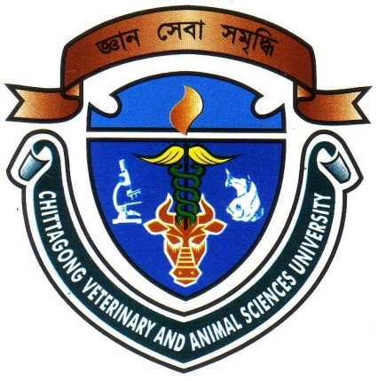

A CLINICAL REPORT SUBMITTED BY
Roll No.2005/22
Reg.No.213
Intern ID: C-20
Session: 2004-2005

A clinical report presented in partial fulfillment of the requirement for the degree of Doctor of Veterinary Medicine (DVM)

CHITTAGONG VETERINARY AND ANIMAL SCIENCES UNIVERSITY KHULSHI, CHITTAGONG-4202
February, 2011
A STUDY ON SUCCESS OF ESTRUS SYNCHRONIZATION AND ARTIFICIAL INSEMINATION IN CATTLE

A clinical report submitted as per approved style and content

----------------------------------- -----------------------------------
Signature of Author Signature of supervisor
Md. Harisul Abid Dr. Azizunnesa
Roll No: 2005/22 Assistant Professor
Reg.No: 213 Department of Medicine and Surgery
Intern ID: C-20 Chittagong Veterinary and Animal Sciences
University, Chittagong-4202

CHITTAGONG VETERINARY AND ANIMAL SCIENCES UNIVERSITY KHULSHI, CHITTAGONG-4202.

